Size and Liquidity Effects in Nigeria: An industrial sector study

Bruce Hearn*
University of Sussex, U.K.

Abstract

This study estimates liquidity premiums using the recently developed Liu (2006) measure within a multifactor capital asset pricing model (CAPM) including size premiums and a time varying parameter model for the West African emerging market of Nigeria. The evidence suggests that liquidity factors are relevant only for financial and basic materials sector stocks while size factor is more generally relevant in explaining the cross section of stock returns in the Nigerian domestic equity market. Costs of equity estimates are high further underlining the limitations of this market as a capital-raising venue in contrast to the dominant banking sector.

JEL Classifications: G11, G12, G15, O55
Keywords: Liquidity, Asset Pricing, CAPM, Africa, Nigeria
Corresponding Author’s Email Address: b.a.hearn@sussex.ac.uk

Introduction

Standard mean-variance asset pricing theory centred on the capital asset pricing model (CAPM) first introduced by Sharpe (1964) and Linter (1965) states that the cross section of expected returns of an asset or portfolio is related to the expected returns on the market portfolio composed of an infinite number of assets and derived from infinite number of market trading participants. However more recently Fama and French (1993), henceforth FF, propose additional returns-based factors capturing size and accounting book to market value ratio effects as being representative of economic state variables having an impact on investor welfare over and above that of solely the market portfolio. Size in particular captures the differential impact on small as opposed to large firms, in terms of listed shares, arising from periods of economic downturn and recession where FF argue the former are more susceptible to decreased earnings than the latter. FF attribute returns differences over the cross section of stock returns between those with high accounting book to market ratio, termed as value stocks, and those with low ratios, termed as growth stocks, as a third factor for inclusion in CAPM alongside size factor. However yet more recently Amihud (2002), Pastor and Stambaugh (2003) and Liu (2006) propose liquidity as an economic state variable and find evidence that this largely subsumes the accounting book to market factor introduced by FF. In particular Liu (2006) ascribes liquidity as a multidimensional phenomenon incorporating more singular information deficiency, transactions cost, and paucity in trading activity definitions and importantly exerting a substantial impact on investor welfare. In the light of evidence from Kenny and Moss (1998), Hearn and Piesse (2009) and Hearn (2012) that listings in Sub Saharan African stock markets are formed from a mixture of small and medium enterprises (SMEs) and larger former state owned enterprises (SOEs) and evidence of marked illiquidity and segmentation between and within the regions markets (Hearn, 2012) I am motivated to ask whether both size and liquidity are priced. As such I ask whether differences in cross sectional expected returns can be better explained by fluctuations in aggregate market size and liquidity effects as opposed to the market factor alone.
A comprehensive definition of liquidity has remained elusive in the finance literature which is largely because of its ability to transcend a variety of transactional properties of stock markets including more conventional notions of tightness, depth and resiliency (Kyle, 1985) as well as more recent notions regarding informational efficiency (O’Hara, 2003). It is worth noting that these characteristics of liquidity are derived from the development finance literature definition of this phenomenon which is based on stock market trading activity and associated transactions costs. As such these are distinct from other unrelated definitions of liquidity effects in economic literature in relating levels of money to interest rates (see Carpenter and Demiralp, 2008) or from banking literature in terms of the completeness of credit markets and ability of commercial banks to convert excess reserves into investment (see Khemraj, 2009).
Stock markets are attributed by O’Hara (2003) in undertaking two principal functions: facilitating price discovery and the provision of liquidity. While these two concepts are interdependent they refer to distinct phenomena. Liquidity itself can be viewed as a transaction cost or tax borne by investors that reflects the intertemporal probability of finding a buyer or seller in a market (Demsetz, 1968). The asset pricing literature traditionally views the liquidity-based transaction cost as simply being too small in relation to the expected return on the market, itself characterised by infinite participants and full information revelation of prices (see Aiyagari and Gertler (1991); Heaton and Lucas (1996); Vayanos (1998) and Vayanos and Vila (1999)) which is embodied in the assumptions behind the traditional CAPM. However the microstructure literature deviates from this view in regarding liquidity to be systematic in nature and thereby an additional state variable with impact on investor overall welfare and utility. In this light studies such as Amihud and Mendelson (1986), Pastor and Stambaugh (2001) and Amihud (2002) find substantial empirical evidence regarding the impact of liquidity on stock prices using a variety of measures such as spreads, depths and volumes. The immediate market microstructural inferences from this literature are that improvements to the design and operation of exchanges should impact on greater liquidity. The bid-ask spread measure outlined by Amihud and Mendelson (1986) captures the compensation required by a hypothetical market intermediary prepared to alleviate the intertemporal risks associated for traders in locating a counterparty. In practice bid and ask prices are commonly posted by brokers or even the exchange itself in an attempt to undertake the role of intermediary. However this measure is reduced in effectiveness in the light of evidence uncovered by Lee (1993) revealing that many large trades occur outside the bid-ask spread while many small trades are undertaken within it leading to potential bias. Furthermore evidence from Akotey (2007) and Oliveira (2007) reveal that a particularly pertinent issue in SSA markets is from trading undertaken out of hours with the exchange being used merely to post pre-agreed prices. Volume-based measures are introduced by Pastor and Stambaugh (2003) and Amihud (2002). These are centred on the concept of price impact arising from order flow (Kyle, 1985) and while promoting the systematic nature of liquidity as an economic state variable are limited in focussing on only one aspect or dimension of liquidity.
However building on the second role of stock exchanges in their facilitation of price discovery and O’Hara (2003) proposes a theoretical market model based on differential, as opposed to asymmetric information, between informed traders on one hand, who have access to private and public information, and a combination of uninformed and noise traders on other hand, who solely have access to information in public domain. Furthermore in the light of informational inefficiencies where prices do not reveal full information (a feature prevalent to almost all African markets – see Alagadede and Panagiotidis (2009)) and segmentation causing significant constraints of effective diversification, O’Hara (2003) argues that informed traders will seek to profit at the expense of their uninformed and noise counterparts through buying up undervalued stocks and selling overvalued. As such there is a consequential impact on utility and investor welfare on both informed and uninformed (including noise) traders which if prices are non-revealing and public information is imperfect then non-diversifiable risk remains inducing traders to demand a premium to induce them to hold assets where information risk is greatest (O’Hara, 2003). This price-discovery premium is a deviation from the theoretical antecedents developed in the market microstructural literature (see Glosten and Milgrom (1985); Kyle (1985) and Lesmond et al (1999)) where transactions costs are deemed as the principal focal issue determining whether trade takes place between informed traders and their uninformed and noise counterparts (O’Hara, 2003). This has led to the formation of the Lesmond Ogden Trzcinka (LOT) frequency of zero returns measure (Lesmond et al, 1999) which is theoretically focussed on trading occurring only when the accumulated value of information held by informed traders on the margin, which is not reflected in the prices, being greater than the transactions costs in the market. If transactions costs are too great then trading will not occur leading to higher frequency of occurrence in zero returns. The theoretical underpinnings behind the recently developed liquidity construct of Liu (2006) starts from this market microstructural model in its ability to capture both adjusted turnover and zero trading volume days and thereby has similar roots in the microstructural models of adverse selection advanced by Glosten and Milgrom (1985) and Kyle (1985). However the Liu (2006) measure extends this focus to take account of the multidimensional nature of liquidity and in particular the concept of being able to transact large quantities quickly with negligible price-impact, otherwise referred to as trading speed, as well as consideration of solvency risks faced by individual traders in their portfolio inventories. This latter aspect is also represented in the “lock-in” risk associated with assets where in particularly thin markets investors are unable to liquidate positions owing to a more universal lack of participation (Liu, 2006). As such this is particularly applicable in SSA market environments where there is commonly a paucity of activity (Hearn and Piesse (2010); Hearn (2012)). Liu (2006) argues that liquidity is systematic in nature and forms a returns-based valuation factor, based on the difference in returns between those from the highest illiquid to those of least illiquid portfolio, after having sorted universe of stocks into decile portfolios based on levels of illiquidity. Furthermore the empirical evidence from a two-factor CAPM model including market and liquidity factors reveals that this is more robust in explaining cross section of expected stock returns than the FF three factor model including the additional size and book to market value ratio factors.
The literature regarding liquidity in African financial markets is almost exclusively focussed on a pan-continental basis with little addressing the nuances of regional or individual stock markets. Hearn and Piesse (2009) construct a three-factor CAPM augmented with size and illiquidity returns-based factors developed themselves from the application of the Liu (2006) measure in a pan-African context. However while Nigeria is included within a designated Sub-Saharan African market universe it is largely subsumed by the contemporaneous effects from the highly illiquid markets of Botswana, Zambia and the Namibian local exchange. Returns in these much smaller markets are often largely driven by the size and illiquidity factors alone. Equally the study only extended to the Nigerian consumer non-cyclical, finance and energy industries as well as a top stocks and overall portfolio finding mixed evidence regarding the significance of size and illiquidity factors. Hearn (2009) found evidence of liquidity factor being a key driver of returns across the East African region and in particular in the smaller market of Uganda while illiquidity was so severe in Tanzania that the model was not effective in capturing any cross-sectional effects. More recently Hearn and Piesse (2010) applied a size and liquidity augmented CAPM as well as GARCH methodology in modelling returns across the West African markets of BRVM (Cote d’Ivoire), Ghana, Nigeria, the North African markets of Morocco and Tunisia in addition to London (FTSE100 constituents) and Paris (CAC40 constituents). This study was based on the Amihud (2002) price impact measure and while finding evidence of liquidity driving returns in Nigeria, Morocco and Tunisia omitted the markets of Ghana and BRVM owing to severity on illiquidity. Furthermore the focus extended only as far as consideration of top stocks and an overall local market aggregate portfolio. A shortfall in this research was the lack of focus on industry categories and a focus on the Nigerian market itself given its size and dominance within West Africa. Consequently I focus this study on whether size and illiquidity effects are present in the domestic Nigerian market and across industry sub-sectors.
The asset pricing literature conventionally considers time invariant mean-variance relationships between the expected returns of individual stocks or portfolios and those of the market, or the market plus various additional valuation factors. However a more recent innovation to this literature has been through the consideration of time varying relationships between expected returns of individual stocks and portfolios and various systematic factors. This has evolved through evidence regarding increasing violation of assumptions underscoring linear time invariant models such as those alluding to normality as well as identical nature and interdependence of stock returns (Grout and Zalewska, 2006). Pettengill et al (1995) used time varying methods to study the relationship between risk and return in “up” as opposed to “down” markets while Bekeart and Harvey (1995) used two-state Markov-switching models to study the time varying nature of integration between a heterogeneous sample of emerging markets with the world market. Brooks et al (1998) used time varying methods centred on the Kalman-filter to study Australian industry portfolios finding evidence substantiating their use through improved in and out of sample performance. More recently Grout and Zalweska (2006) argue that Kalman-filter methods are preferable to Markov-switching models as the necessity for specifying the point of switch is omitted. Consequently I apply Kalman-filter time varying techniques in modelling the time path evolution of betas associated with systematic risk factors following Brooks et al (1998).
In this study I find only limited evidence of the size and illiquidity factors in significantly explaining the cross section of stock returns in the Nigerian domestic equity market. As such the three factor size and illiquidity augmented CAPM offers only incremental increases in explanatory power in contrast to the single-factor traditional CAPM model. Furthermore the results from the application of the time varying parameter model including market, size and illiquidity returns-based factors are in line with those from the time invariant CAPM regression study in indicating the market factor alone is preferable in explaining returns. Costs of equity estimates using these techniques are very high inferring the equity market is relatively uncompetitive as a finance-raising venue in contrast to the dominant banking sector and relationship-based finance (Aboagye, 2012). Overall these results do provide some limited support for the continued use of mean-variance methodology in valuation within developing stock markets.
The paper is structured as follows. Section 2 reviews the institutional features of the Nigerian capital market and outlines data sources before introducing the liquidity measure, its construction and some descriptive statistics. Section 3 outlines the two modelling approaches used: the size and liquidity augmented CAPM and its time varying parameter analogue. Section 4 discusses the empirical results. The final section concludes.

Nigerian stock exchange and liquidity measurement

The Nigerian Stock Exchange (NSE)

The Nigerian stock exchange (NSE) was established in 1960 with trading in 19 originally listed securities having been initiated on the Lagos floor in 1961 (NSE website (2010); Adjasi et al (2011)). While the principal NSE trading floor is in Lagos the exchange operates a network of eight branches across Nigeria that assist in the precipitation of order flow for ultimate execution on the centralised Automated Trading System (ATS) (NSE website, 2010). The NSE operates on a self-regulatory basis with oversight to a licensed brokerage community and members while it is itself subject to regulatory oversight of the Nigerian Securities and Exchange Commission (SEC). Corporate governance legislation takes the form of the Companies & Allied Matters Act of 1990 and Investments & Securities Act of 1999 (NSE website (2010); Adjasi et al (2011) although this has fallen short of universal adoption given only 40% of listed firms have implemented these directives in practice (CBN Corporate Governance report, 2006). A further complication in the application of a universal and effective corporate governance regime is the co-presence of Nigerian Accounting Standards (NAS) alongside International Accounting Standards (IAS) with different terminology and definition of firm balance sheet items (Hearn and Piesse, 2010). These issues compounded with order flow to the exchange being highly concentrated amongst a mere handful of brokerage firms of those 219 registered (Hearn and Piesse, 2012), as well as up to 70% of the brokerage industry being severely undercapitalized and technically insolvent (BBC news, 2010), has led to the Nigerian market being largely segmented from other exchanges both regionally and worldwide (Hearn and Piesse, 2012). It is also a key issue underscoring recent evidence of a lack of informational efficiency in stock prices both in Nigeria as well as more generally across Africa (Alagidede and Panagiotidis, 2009).
These issues notwithstanding and the NSE is the third largest exchange in Africa in terms of listings and market capitalization (Hearn and Piesse, 2010) and largely dominates the Anglophone West African region. However the evidence from Hearn (2012) reveals that both capitalization and traded value is overwhelmingly concentrated in the listed financial sector of the NSE which is in line with other African stock exchanges (see Hearn (2011) for characterization of North African markets and Hearn (2012) for those of Sub Saharan Africa)) which is largely a reflection of indigenous financial institutions attempts in complying with Basle II regulatory accords regarding liquid assets (Hearn and Piesse, 2010). Furthermore evidence from portfolio holdings of major asset managers focussing on the Nigerian capital market reveal the significance of the financial sector, alongside basic materials, in terms of composition of fund segments based on Nigerian listed equities (see Africa Alliance pan-Africa fund (Africa Alliance, 2012), Imara Africa Pioneer Fund (Imara, 2012) for detailed breakdown of portfolio holdings). This would underscore the relative importance of these two industrial sectors in more internationally focussed investor portfolios. Equally better known and more liquid assets are more likely to be included in regional benchmark indices and thus attract the attention of domestic, as well as foreign, institutional investors such as pension funds (Pfau, 2011).
More generally there are considerable informational asymmetries present in the NSE with these ranging from historical macroeconomic instability to a lack of adherence to internationally recognized accounting, auditing and corporate governance measures. The costs associated with these latter issues are especially pertinent in Nigeria where studies often report a reduction in sample size owing to unavailability of data or inconsistencies in data integrity for smaller listed firms (see Hearn and Piesse (2010) and Hearn (2012)). This is similar to findings in the Egyptian stock exchange (Hearn, 2011) which is the second largest market in Africa (Hearn and Piesse, 2009) where data is unavailable or not disseminated for a majority of listed firms. Equally the majority of listed stocks in the Nigerian market exhibit severe price-rigidity (Hearn and Piesse (2012); Hearn (2012)) which is in line with findings from neighbouring West African markets of Ghana and Cote d’Ivoire’s regional bourse (BRVM) as well as many smaller markets in Africa such as Uganda, Tanzania (Hearn, 2011), Zambia and Namibia (Hearn, 2012) and Egypt (Hearn, 2011). This evidence would lend support to O’Hara’s (2003) theoretical market model of differential information where a differential of information exists between uninformed and noise traders on one hand and informed traders on other. Trading will only be undertaken if the expected profits attributable to private information of informed traders exceeds the transactions costs of the market (Lesmond et al (1999); Lesmond (2005)) resulting in price-rigidity. It also lends support to O’Hara and Easley’s (2010) theoretical model of the freezing in market activity by traders non-participation in markets where uncertainties are sufficiently high to render traders unable in being able to rank portfolio opportunity sets in terms of expected utility resulting in freezing of activity.
The evidence in Table 1 reveals the historical evolution of the market capitalization and trade value of the NSE. There are clear differences between levels of trading activity (traded value) and market capitalization with the former being overwhelmingly dominated by the equities market while the latter is divided between equities and government debt issues. The fledgling industrial loans market remains a minor component of both trading and listed capitalization. However there is some more recent evidence of increasing encroachment of exchange listed capitalization by government securities which accounted for approximately one third of equity market capitalization by 2008. This crowding out effect is especially evident from the growth of NSE listed government debt as a proportion of money markets as a whole in 1991 in contrast to the relatively equal level in 2008. The very low levels of savings to GDP ratios, commonly under 17% and the low levels of money-plus-quasi money to GDP and equity capitalization to GDP infers that neither the banking system nor stock market are major sources of business finance domestically in Nigeria in preference to internal sources of capital for firms (Udoh, 2011).

Table 1. Characteristics of the Nigerian Financial Market

 | 1991 | 1996 | 2001 | 2002 | 2003 | 2004 | 2005 | 2006 | 2007 | 2008
Stock Exchange
Traded Value (UK £m)
Govt. | 0.70 | 0.09 | 0.20 | 0.01 | 0.01 | 1.28 | 32.43 | 6.07 | 0.00 | 0.00
Industrial Loan | 0.05 | 0.38 | 0.00 | 0.00 | 25.55 | 6.97 | 4.13 | 0.27 | 4.74 | 17.29
Equities | 1.08 | 52.15 | 321.68 | 283.36 | 446.42 | 901.80 | 1,128.25 | 1,785.32 | 4,482.27 | 8,210.49
Mkt. Cap (UK £m)
Govt. | 24.88 | 22.62 | 46.31 | 60.58 | 98.78 | 717.74 | 1,619.17 | 3,386.71 | 12,412.42 | 12,395.04
Industrial Loan | 10.56 | 22.62 | 32.36 | 16.70 | 32.93 | 31.84 | 49.17 | 13.34 | 70.89 | 142.59
Equities | 138.74 | 2,109.69 | 3,618.07 | 3,571.30 | 5,196.74 | 7,763.80 | 11,179.11 | 16,110.97 | 42,955.17 | 34,091.75
Money Market Total (UK £m) | 701.84 | 933.87 | 3,018.99 | 3,189.26 | 3,522.98 | 4,043.21 | 4,835.45 | 4,992.93 | 9,840.24 | 13,810.75
Savings Total (UK £m) | 284.55 | 1,014.15 | 2,723.29 | 2,824.29 | 2,570.50 | 3,213.99 | 5,829.69 | -- -- | 11,232.12 | 20,179.05
Ratios (%)
Govt. Mkt. Cap./GDP | 1.06% | 0.11% | 0.18% | 0.18% | 0.30% | 1.56% | 2.51% | 4.79% | 14.27% | 10.61%
Ind. Loan/GDP | 0.45% | 0.11% | 0.12% | 0.05% | 0.10% | 0.07% | 0.08% | 0.02% | 0.08% | 0.12%
Equities/GDP | 5.89% | 10.35% | 13.72% | 10.83% | 15.62% | 16.88% | 17.32% | 22.78% | 49.39% | 29.18%
Money Market/GDP | 29.82% | 4.58% | 11.45% | 9.67% | 10.59% | 8.79% | 7.49% | 7.06% | 11.31% | 11.82%
Savings/GDP | 12.09% | 4.98% | 10.33% | 8.57% | 7.73% | 6.99% | 9.03% | -- -- | 12.91% | 17.27%
Money + Quasi Money/GDP | -- -- | -- -- | 27.85% | 23.14% | 23.39% | 19.84% | 19.32% | 21.70% | 27.86% | 38.45%

Source: Compiled by author from Central Bank of Nigeria Annual Report 2008
Notes: (1) Money Market total category includes Treasury Bills and Certificates, Development Stocks, Certificates of Deposit, Commercial Paper, Bankers Acceptance
and Federal Government of Nigeria Bonds
(2) Total savings includes Savings, Time and Savings Deposits with Commercial and Merchant banks, National Provident Fund, Federal Savings Bank, Premium Bonds
Savings Certificates Stamps, Life Insurance Funds and Other Depository Institutions
(3) Quasi-Money consists of Time, Savings and Foreign Currency Deposits of Commercial and Merchant Banks excluding Takings from Discount Houses
(4) Demand Deposits consist of state, local and parastatals deposits at the CBN; state, local and private sector deposits as well as demand deposits of
non-financial public enterprises at Commercial and Merchant banks

The evidence from Table 2 provides further evidence of the minimal impact of the NSE in the sourcing of new capital for industrial projects and development. While new debt issues are dominated largely by government and state securities (NSE annual report, 2008) with commercial bank lending of all maturities dominating financing and dwarfing levels of new equity issuance on the NSE. This alone underscores the importance of the domestic banking sector in commercial finance. The evidence also reveals that Nigeria is recipient to large inflows of foreign direct investment (FDI) which overwhelmingly dominate overall levels of national outward FDI. However in terms of inflows of overseas portfolio investment and the evidence reveals that this is largely characterised by equity as opposed to debt while long term capital is more prevalent to that of a shorter duration. This would indicate that foreign investors seek ownership-based trading positions of longer duration adding further substantiation to the earlier evidence that overseas FDI financing is a major contributor to Nigerian industry. However in terms of domestic indigenous funding the banking sector overwhelmingly dominates financing arrangements with the stock exchange undertaking a significantly lesser role.

Data: Sources

Daily stock closing prices in local currency were obtained from Bloomberg and Datastream. Total number of shares outstanding were obtained from a combination of Bloomberg with values reported on NSE website used as a data integrity check. Traded volumes and dividend per share were obtained both from Bloomberg, the NSE website and the NSE 2005 Fact book that provides some historical data for each listed entity. All data were cross checked with other sources to ensure accuracy. These data were used to calculate the daily return variance, market capitalization, and the liquidity constructs. The total returns series for each stock were constructed using Standard & Poors methods in assuming reinvestment of dividends and taking account of stock splits and rights issues. Exchange rate and UK - Gilt/Treasury yield data were from Datastream. The 5 year UK-Gilt/Treasury Bill yield rate represents the risk free rate although this is adjusted to monthly equivalent values. The total returns series and prices were converted to sterling which assumes long term parity between the domestic currency (Naira) and sterling. In many cases companies were deleted from the sample owing to either data inconsistencies or the lack of data to compute the total returns. As such despite the 234 listed ordinary shares in Nigeria, 60 do not have data and a further 45 firms are missing one critical determinant needed for the total returns indices. Consequently the sample size for Nigeria is 129 firms.

Table 2. Sources of Long term finance in Nigeria, UK £m

 | NSE new equity listing | NSE new debt listing | Comm. bank lending to business | Foreign direct investment |  |  |  |  |  | Net balance of inward portfolio investment
 | NSE new equity listing | NSE new debt listing | Comm. bank lending to business | Direct investment abroad |  |  | Direct investment in Nigeria |  |  | Long term capital | Short term capital | Equity | Debt
 | NSE new equity listing | NSE new debt listing | All maturities | Equity capital | Reinvested earnings | Other capital | Equity capital | Reinvested earnings | Other capital
2005 | -- -- | -- -- | 17,531.31 | -8.51 | -- -- | -- -- | 1,875.38 | 1,022.70 | -- -- | 77.43 | 0.00 | 436.61 | 0.84
2006 | 1,310.64 | 0.00 | 19,841.49 | -8.07 | -- -- | -- -- | 3,935.39 | 2,844.87 | -- -- | 522.25 | 14.64 | 650.99 | 464.27
2007 | 5,675.37 | 0.00 | 41,807.12 | -243.48 | -- -- | -- -- | 2,067.85 | 1,098.77 | -- -- | 499.18 | 17.04 | 2,418.12 | 444.20
2008 | 7,990.72 | 0.00 | 78,249.73 | -560.97 | -- -- | -- -- | 2,543.66 | 1,389.16 | -- -- | 349.26 | 16.48 | 1,353.76 | -33.68

Source: Compiled by author from Central Bank of Nigeria annual report 2008 and NSE Annual reports (2009, 2007 and 2006)
Notes: New equity listing includes IPO, supplementary and seasoned offerings, placements, rights and bonus issues

Liu (2006) Liquidity Construct

Daily price and volume data are collected from Bloomberg and Datastream. The measure is derived from the recent work of Liu (2006) and is defined as LM_{x} which is the standardized turnover-adjusted number of zero daily trading volumes over the prior x months (x = 1, 6, 12) i.e.

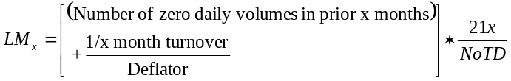 (1)
where x month turnover is the turnover over the prior x months, calculated as the sum of the daily turnover over the prior x months, daily turnover is the ratio of the number of shares traded on a day to the number of shares outstanding at the end of the day, NoTD is the total number of trading days in the market over the prior x months, and Deflator is chosen such that,

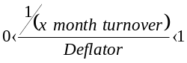 (2)

for all sample stocks. Given the turnover adjustment (the second term in brackets in first expression), two stocks with the same integer number of zero daily trading volumes can be distinguished: the one with the larger turnover is more liquid. As such the turnover adjustment acts as a tie-breaker when sorting stocks based on the number of zero daily trading volumes over the prior x months. Because the number of trading days can vary from 15 to 23, multiplication by the factor (21x/ NoTD) standardizes the number of trading days in a month to 21 which makes the liquidity measure comparable over time. LM1 can be interpreted as the turnover-adjusted number of zero daily trading volumes over the prior 21 trading days, which is the approximate average number of trading days in a month. The liquidity measure, LM_{x} is calculated at the end of each month for each individual stock based on daily data. Daily data is available for all markets across entire sample period.

Data: Summary Statistics Relating to Liquidity Measures

Table 3 contrasts the descriptive statistics from equally weighted industry portfolios across both the overall market of 230 listed stocks as well as the smaller sample group of 129 firms for which sufficient data is available to generate total returns series. This in itself is representative of the Nigerian market microstructure being compromised by severe informational deficiencies. Generally levels of illiquidity are very high, as would be expected for a developing market, with high levels of percentage daily zero returns in excess of 55% indicating substantial price-rigidity. Trading activity in terms of mean traded volumes as well as market capitalization levels are largely concentrated in the finance sector with the majority of remainder spread evenly across diversified, energy and consumer non-cyclical sectors. However much of the capitalization for the financial sector is likely due to the necessity for the sector to comply with international best practice and governance standards enshrined in the Basle I and II accords relating to liquidity and deposit insurance.
Table 3. Summary Statistics of Nigerian Stock Exchange, 2008

 |  |  | Local market |  |  |  |  | £UK equivalent
Industry | Market | No. Listings | Volatility (%) | Zero Return (%) | Price | Volume (‘000) | Mkt. Cap. (millions) | Price | Mkt. Cap. (millions)
Nigeria Overall | Sample | 129 | 3.44 [2.52] | 63.68 [78.26] | 18.65 [2.05] | 30691.47 [1967.36] | 22058.47 [917.28] | 0.08 [0.01] | 94.53 [3.86]
Nigeria Overall | Overall | 233 | 10.23 [2.26] | 78.14 [93.55] | 10.45 [1.57] | 39,564.31 [2,549.41] | 22,402.90 [737.11] | 0.05 [0.01] | 96.56 [3.21]
Basic Materials | Sample | 10 | 3.13 [2.85] | 67.39 [75.00] | 5.20 [2.04] | 5,177.40 [1,002.75] | 1,258.25 [521.59] | 0.02 [0.01] | 5.50 [2.33]
Basic Materials | Overall | 19 | 2.54 [2.30] | 84.59 [96.77] | 4.88 [1.36] | 6,776.37 [572.49] | 5,955.05 [288.25] | 0.02 [0.01] | 25.95 [1.28]
Finance | Sample | 26 | 2.91 [2.81] | 55.07 [55.00] | 31.90 [2.17] | 117,070.90 [16,147.73] | 54,776.41 [4,548.01] | 0.13 [0.01] | 233.32 [19.80]
Finance | Overall | 61 | 2.61 [2.48] | 70.40 [77.42] | 4.76 [2.11] | 115,720.97 [29,323.94] | 46,232.49 [4,648.25] | 0.02 [0.01] | 198.16 [20.4]
Industrials | Sample | 20 | 4.14 [2.34] | 73.50 [90.91] | 7.96 [1.93] | 8,932.41 [818.91] | 11,563.66 [394.89] | 0.03 [0.01] | 49.61 [1.70]
Industrials | Overall | 36 | 2.95 [2.04] | 84.50 [98.39] | 6.60 [1.49] | 9,264.29 [676.69] | 11,497.14 [397.33] | 0.03 [0.01] | 49.82 [1.67]
Comm. | Sample | 2 | 2.41 [2.12] | 69.64 [77.50] | 5.47 [2.46] | 1,959.72 [563.34] | 3,538.4 [1,459.12] | 0.02 [0.01] | 15.51 [7.37]
Comm. | Overall | 5 | 2.12 [1.99] | 83.16 [87.10] | 2.36 [1.55] | 8,134.93 [1,352.88] | 2,707.03 [412.26] | 0.01 [0.01] | 12.45 [2.12]
Consumer cyclical | Sample | 19 | 5.90 [2.58] | 71.46 [90.48] | 3.62 [1.39] | 7,120.06 [505.51] | 1,848.48 [368.25] | 0.02 [0.01] | 7.99 [1.51]
Consumer cyclical | Overall | 37 | 4.30 [2.23] | 84.28 [100.00] | 3.68 [1.19] | 8,239.76 [423.06] | 6,017.24 [284.30] | 0.02 [0.01] | 26.18 [1.21]
Consumer Non-cyclical | Sample | 37 | 2.70 [2.52] | 62.03 [78.26] | 15.40 [3.03] | 7,969.27 [2,421.31] | 21,677.13 [1,480.36] | 0.07 [0.01] | 93.42 [6.07]
Consumer Non-cyclical | Overall | 58 | 2.28 [2.18] | 77.64 [95.16] | 12.39 [2.52] | 10,945.01 [2,058.97] | 24,615.65 [761.09] | 0.05 [0.01] | 106.62 [3.53]
Diversified | Sample | 3 | 2.73 [2.51] | 54.18 [61.90] | 8.94 [2.59] | 7,686.33 [3,324.77] | 31,356.97 [1,840.96] | 0.04 [0.01] | 135.65 [8.18]
Diversified | Overall | 4 | 2.30 [2.16] | 73.77 [78.33] | 8.49 [3.85] | 7,263.86 [3,244.8] | 32,719.4 [2,324.49] | 0.06 [0.02] | 141.5 [10.02]
Energy | Sample | 9 | 2.89 [2.49] | 48.89 [31.82] | 74.13 [58.19] | 6,225.85 [2,050.52] | 26,578.80 [18602.55] | 0.32 [0.24] | 115.39 [79.18]
Energy | Overall | 10 | 2.46 [2.15] | 66.62 [54.84] | 70.35 [55.15] | 5,799.00 [1,791.48] | 29,133.76 [28,765.05] | 0.31 [0.23] | 127.5 [123.17]
Technology | Sample | 1 | 1.90 [1.75] | 82.99 [90.69] | 3.03 [1.66] | 246.41 [115.89] | 327.35 [179.15] | 0.01 [0.01] | 1.42 [0.76]
Technology | Overall | 3 | 1.86 [1.82] | 83.21 [89.12] | 2.81 [1.62] | 13,316.84 [245.73] | 780.95 [191.42] | 0.01 [0.01] | 3.53 [0.79]

Source: Compiled by authors from Bloomberg, Datastream and Nigerian stock exchange (Lagos floor)

Empirical Models

This section considers first the construction of valuation factors, namely size and liquidity, and then the two conditional modelling strategies, namely the three-factor linear CAPM and its time varying parameter counterpart.

Valuation Factor and Industry Portfolio Construction

Following Shum and Tang (2005) and Martinez et al (2005) size and liquidity factors were formed through a three-by-three sorting process with portfolio and model rebalancing occurring in December of each year for the sample period, 2002 to 2008. First all 129 stocks in the Nigerian market universe were sorted according to their size, in terms of market capitalization, into three portfolios. At this stage the size valuation factor was formed from the mean returns across big size sorted portfolio less those from across the small size sorted portfolio. These three size-sorted portfolios were then individually resorted in accordance with their level of illiquidity, captured by Liu (2006) liquidity measure, and ranked into a further three sub-sorted illiquidity portfolios, ranging from high to medium to low illiquidity, for each of the three initial size-sorted portfolios. At this stage the liquidity valuation factor was formed from the mean returns across the three respective high illiquidity portfolios less the mean returns from across the three low illiquidity portfolios. This size and liquidity two factor creation through three-by-three sorting process (leading to a final set of nine size-illiquidity sorted portfolios) follows in the spirit of the original five-by-five sorting process employed by Fama and French (1993) which led to a total of twenty five size and accounting book to market value factor sorted portfolios. Fama and French (1993) attribute the importance of the size valuation factor to its ability to capture the differential impact on earnings growth between smaller and larger firms during periods of prolonged recession or economic downturn. Consequently the inclusion of this factor is justified in the context of Sub Saharan Africa and other developing regions which are vulnerable to considerable macroeconomic instability and economic downturn while stock exchange listings are commonly made up from either very large former state owned enterprises or small and medium enterprises (Hearn (2012); Kenny and Moss (1998)). Finally industry portfolios were formed from the mean returns across stocks sorted into portfolios by industry classification, with these having been designated by Bloomberg.

Size and Liquidity Augmented CAPM

Following in the spirit of the above Fama and French model I augment the one-factor CAPM with size (SMB) and liquidity (ILLIQ) factors in order to create a size-liquidity three factor model in line with Shum and Tang (2005) and Martinez et al (2005). Therefore, the expected excess returns on a portfolio p of emerging market stocks can be written as
(3)

In line with the above this can be transformed in order to test historical data into the following equation:

(4)
where the variables are described above and 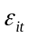 is an independently identically distributed (iid) disturbance term. The model is estimated on a time series basis using standard Ordinary Least Squares (OLS) techniques, as opposed to the Fama and Macbeth (1973) rolling cross section approach, with the expectation that the Jensen alpha, or regression intercept, should not be statistically different from zero given the theoretical relationship between an individual portfolios expected returns and those of the market (Markowitz, 1959). However Scholes and Williams (1977) provide evidence against the employment of standard OLS techniques with findings that beta estimations are biased downwards for securities infrequently trading and upwards for those traded more often. Dimson (1979) builds on this evidence in the inefficiency of beta estimation in thinly traded stocks and proposes a correction technique based on the aggregation of betas from lagged and leading regression coefficients. Dimson and Marsh (1983) propose a second correction technique which uses a trade-to-trade method measuring and matching returns between individual stocks or portfolios and the market index between the times of the last trades in successive months. I justify the use of standard OLS techniques here in order to closely follow the literature of Pastor and Stambaugh (2003), Liu (2006) and Martinez (2005) who use these techniques extensively in their studies involving multifactor CAPM models capturing liquidity effects. However the limitations of standard OLS techniques must be taken into account particularly when they are applied to developing markets such as Nigeria where there are substantial cross sectional differences between value and growth stocks and in extremes of illiquidity.

Time Varying Parameter CAPM Model

Following Brooks et al (1998) the time varying parameter analogue of the linear CAPM employs the Kalman filter and relies on the notion of “state space” in estimating the conditional constant term and market beta of the multifactor analogue of CAPM. This is represented by an observation, or measurement/signal, equation and a transition, or state, equation, that in combination express the structure and dynamics of a time varying system. A state space model is specified where an observation at time t is a linear combination of a set of variables, known as state variables, which compose the state vector at time t. Assuming the number of state variables is m and the (m x 1) vector is θ_{t} then the observation equation can be represented by:

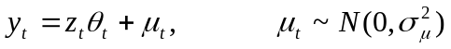 (5)

where 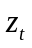 is assumed to be known (m x 1) vector, and 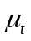 is the observation error. The disturbance is assumed to be normally distributed with zero mean. The set of state variables is defined from the minimum set of information from past and present data and future values of time series are completely determined by the present values of the state variables, known as the Markov property. The state space model incorporates unobserved variables within, and estimates them alongside the observable model, in imposing a time varying structure of the CAPM beta. The conditional betas are estimated using the following observation, or signal equation:

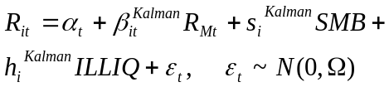 (6)
where R_{it} and R_{Mt} are the excess returns of individual portfolio and market portfolios at time t and 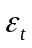 is disturbance term. The exact form of the related transition equation depends on the form of stochastic process the betas are assumed to follow and in this case a simple random walk process is imposed as outlined in Brooks et al (2000). The transition equation is defined:

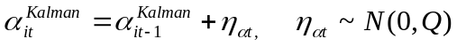 (7)
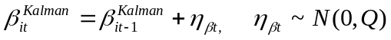 (8)
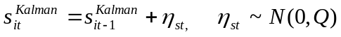 (9)
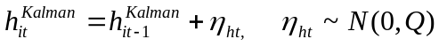 (10)

Together equations 6 and the combination of 7 to 10 constitute a Kalman filter state space model. However a set of prior conditional values are necessary for the Kalman filter to forecast the future value and is expressed as:

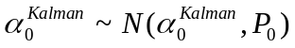 (11)
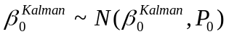 (12)
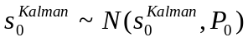 (13)
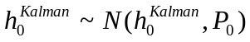 (14)

Brooks et al (1998) cite that this technique uses the first two observations to establish the prior conditions and then recursively estimates the entire series providing conditional estimates of 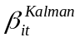,,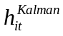 and 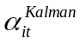.

Results

Summary Statistics Relating to Size-liquidity Sorted Portfolios

Table 4 presents the descriptive statistics for the nine size-illiquidity sorted portfolios. The evidence from panel A reveals that mean returns are generally higher in the larger as opposed to smaller size portfolios while volatility, or standard deviation generally increases from high illiquidity to low illiquidity providing further evidence that price-rigidity is a potential issue in this market. However the greatest distortions to Normality assumptions in the returns-distribution arise from the values for skewness, excess kurtosis and particularly in the Jarque-Bera statistics. While these are generally high across the sample portfolios these are excessively high for the big size – high illiquidity portfolio where Jarque-Bera values reach 6,323.96 with kurtosis of 44.48. This would indicate severe distortions from Normality which would question the applicability of conventional pricing and valuation methodology in this case. The evidence in panel B reveals that there is a largely even distribution of stocks across the nine size-illiquidity sorted portfolios though there are notably fewer stocks in the early 2002 sample owing largely due to the very recent start of the data.
Panel C details the descriptive statistics for the equally weighted industry portfolios and shows clear evidence that the consumer cyclical industry portfolio is distorted with non-Normal returns given a kurtosis value of 69.47 and a skewness value of 8.23. However these distortions are considerably lower in the aggregate market, size (SMB) and illiquidity (ILLIQ) returns-based factor portfolios and the negative values of mean returns for the SMB and ILLIQ factors indicate the presence of likely reverse size and illiquidity effects where returns steadily decrease as a stock’s size increase (Martinez et al, 2005). The low levels of correlation between the market, SMB and ILLIQ factors is in line with theory (Pastor and Stambaugh, 2003) where zero cost portfolios proxying underlying state variables should have little or no correlation which also mitigates concerns over potential multicollinearity.

Performance of Traditional CAPM Against Three-factor CAPM

The evidence from Table 5 reveal the results from the time series regressions of the traditional CAPM and its three-factor size (SMB) and illiquidity (ILLIQ) augmented counterpart. The addition of the SMB and ILLIQ factors causes an increas4e in explanatory power (R-squared) across each of the size-illiquidity sorted portfolios although this is greatest in the three big size portfolios and the small size – medium illiquidity portfolio. The only notable exception is in the medium size – medium illiquidity portfolio where there is an incremental decrease in explanatory power and the size and liquidity based factors are not statistically significant. Generally across all portfolios the additional size and liquidity factors are statistically significant with the only other exception being in the small size low illiquidity portfolio where size only dominates. The addition of the size and liquidity factors also causes a reduction in the statistical significance of the Jensen alpha terms in each of the nine portfolio regressions with the only exceptions again being the medium size – low illiquidity and medium size – medium illiquidity portfolios indicating a generally good fir with theory (Markowitz, 1959).
However the negative size betas in the medium size – low illiquidity portfolio and in all three big size portfolios indicates the presence of a reverse size effect where returns decrease as stock size increases (Martinez et al, 2005). This is the opposite of what would be expected and does not provide investors with good hedging opportunities. Similarly the positive illiquidity betas in the case of all three high illiquidity portfolios also indicates the presence of a reverse illiquidity effect where as stock illiquidity increases so do returns which also infers that the model does not provide investors with optimal hedging possibilities. These reverse effects are especially prevalent in smaller emerging markets and particularly those in the African continent (Hearn (2009); Hearn and Piesse (2010)). However the benefits arising from the substantially increased explanatory power across eight of the nine size – illiquidity sorted portfolios and the lack of alternative modelling methodologies justifies the continued use of the three-factor CAPM.

Table 4. Summary statistics for equally weighted monthly excess returns on 9 size-illiquidity portfolios for period 2002 to 2008

Portfolio | S/L | S/M | S/H | M/L | M/M | M/H | B/L | B/M | B/H
Panel A: Summary statistics for portfolios
Mean | 0.0305 | 0.0050 | 0.0053 | 0.0390 | 0.0493 | 0.0199 | 0.0447 | 0.0461 | 0.0446
Median | 0.0063 | 0.0035 | -0.0029 | 0.0159 | 0.0297 | 0.0060 | 0.0386 | 0.0179 | 0.0243
Std. Dev. | 0.1153 | 0.0812 | 0.0725 | 0.1257 | 0.1176 | 0.1075 | 0.0989 | 0.1057 | 0.1607
Skewness | 1.66 | 1.94 | 1.93 | 1.65 | 2.38 | 1.78 | 1.98 | 2.17 | 5.70
Excess Kurtosis | 8.53 | 11.27 | 10.74 | 6.60 | 13.95 | 7.64 | 10.01 | 10.46 | 44.48
Jarque-Bera statistic | 142.57 | 285.59 | 255.90 | 81.53 | 487.75 | 117.28 | 221.54 | 255.06 | 6,323.96
Panel B: Average Number of stocks per size-illiquidity sorted portfolio
2002 Mean | 15.92 | 4.33 | 7.67 | 12.58 | 6.58 | 6.08 | 7.00 | 9.00 | 5.08
2003 Mean | 20.00 | 13.00 | 14.00 | 17.25 | 11.00 | 12.00 | 8.08 | 11.00 | 12.00
2004 Mean | 20.00 | 13.00 | 14.00 | 17.25 | 11.00 | 12.00 | 15.00 | 10.08 | 9.83
2005 Mean | 20.00 | 13.00 | 14.00 | 18.00 | 11.00 | 11.83 | 18.00 | 11.00 | 11.83
2006 Mean | 20.00 | 13.00 | 14.00 | 18.00 | 11.00 | 12.00 | 18.00 | 11.00 | 12.00
2007 Mean | 20.00 | 13.00 | 14.00 | 18.00 | 11.00 | 12.00 | 18.00 | 11.00 | 12.00
2008 Mean | 20.00 | 13.00 | 14.00 | 18.00 | 11.00 | 12.00 | 18.00 | 11.00 | 12.00
Overall Mean | 19.41 | 11.75 | 13.08 | 17.00 | 10.36 | 11.12 | 14.54 | 10.58 | 10.66
Panel C: Summary statistics for markets portfolios and valuation factors
 | Mean | Std. Dev. | Skewness | Excess Kurtosis
Nigeria Overall | 0.040 | 0.081 | 1.93 | 8.25
Basic Materials | 0.054 | 0.136 | 2.32 | 9.73
Finance | 0.028 | 0.081 | 0.74 | 3.46
Industrials | 0.038 | 0.084 | 1.98 | 9.42
Communications | 0.043 | 0.182 | 1.26 | 5.39
Consumer cyclical | 0.144 | 0.919 | 8.23 | 69.47
Consumer Non-cyclical | 0.036 | 0.092 | 2.61 | 11.52
Diversified | 0.053 | 0.167 | 2.02 | 9.41
Energy | 0.055 | 0.133 | 2.67 | 13.87
Technology | 0.057 | 0.303 | 3.03 | 14.68
 |  |  |  |  |  | MARKET | SMB | ILLIQ
MARKET | -0.019 | 0.077 | 1.63 | 12.57 | MARKET | 1.000
SMB | 0.033 | 0.080 | 1.84 | 8.29 | SMB | -0.090 | 1.000
ILLIQ | -0.035 | 0.086 | -1.21 | 6.12 | ILLIQ | -0.242 | -0.198 | 1.000

Table 5. Time series regressions using equally weighted monthly contemporaneous market excess returns for 9 portfolios formed on size and illiquidity for 2002 – 2008

Portfolio | S/L | S/M | S/H | M/L | M/M | M/H | B/L | B/M | B/H
CAPM-adjusted performance
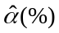 | -0.0099  [-1.17] | -0.0160  [-1.70] | -0.0142  [-2.91] | -0.0041  [-0.62] | 0.0135  [1.83] | -0.0134  [-1.82] | 0.0157  [2.39] | 0.0211  [2.24] | 0.0078  [1.02]
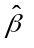 | 1.2330  [15.57] | 0.6385  [3.29] | 0.5968  [3.08] | 1.3145  [8.85] | 1.0882  [4.83] | 1.0146  [7.70] | 0.8811  [5.69] | 0.7597  [6.95] | 1.1182  [2.46]
Adj R² (1) | 0.7321 | 0.3902 | 0.4289 | 0.6998 | 0.5445 | 0.5670 | 0.5046 | 0.3234 | 0.3027
Three-factor Size and Illiquidity CAPM performance
 | 0.0031  [0.54] | 0.0034  [0.49] | 0.0009  [0.20] | -0.0184  [-2.84] | 0.0128  [1.60] | -0.0021  [-0.30] | -0.0020  [-0.37] | 0.0028  [0.46] | -0.0046  [-0.58]
 | 1.2620  [12.29] | 0.7203  [8.70] | 0.6828  [4.75] | 1.1530  [10.12] | 1.0666  [5.17] | 1.1528  [11.81] | 0.7170  [4.18] | 0.6487  [4.22] | 1.2979  [8.09]
 | 0.4286  [7.72] | 0.5682  [6.37] | 0.4054  [5.75] | -0.2434  [-2.26] | 0.0092  [0.08] | 0.1738  [1.67] | -0.3653  [-2.56] | -0.4745  [-3.10] | -0.7586  [-5.81]
 | -0.0544  [-0.29] | 0.1138  [2.05] | 0.1995  [1.84] | -0.5905  [-4.97] | -0.0962  [-0.51] | 0.5198  [5.70] | -0.5509  [-4.92] | -0.2779  [-1.55] | 1.0862  [4.51]
Adj R² (4) | 0.8382 | 0.73296 | 0.6521 | 0.8219 | 0.5370 | 0.6884 | 0.7152 | 0.4653 | 0.8203
Notes: (1) Eviews statistical software is used for estimation in all cases
(2) Numbers in parentheses are t-statistics.
(3) 5 Year UK T-bill risk free rate for month t

MODELLING SECTOR PORTFOLIOS

Industry portfolios were formed from the simple equally-weighted averages of stock returns across stocks aggregated into industries. The time invariant CAPM, size-illiquidity augmented CAPM models were applied to the portfolios with results reported in Table 6.

Average Returns in Finance

The results for the finance industry portfolio of stocks indicate only marginal improvements arising from the addition of the size and liquidity factors over and above the use of the single factor CAPM model. Explanatory power only marginally increases from 60.46% to 60.60% while the size beta is not significant and the liquidity beta is only marginally significant. However the Jensen alpha remains as not being statistically significant indicating the model is appropriate for this industry portfolio.

Average Returns in Basic Materials and Industrials

The results from the application of the three-factor size and liquidity CAPM on the basic materials and industrials portfolios of stocks indicates minimal benefits from the addition of the additional size and liquidity factors over and above the employment of the one-factor CAPM. Explanatory power is only marginally increased in from 57.07% to 57.83% in basic materials and actually incrementally decreases from 77.25% to 76.81% in industrials. However the regression Jensen alphas in both cases are not significant indicating a reasonable fit with theory while the lack of statistical significance of either of the size or liquidity factors indicates the one-factor CAPM is sufficient in explaining the cross section of returns.

Average Returns in Consumer Cyclical and Consumer Non-cyclical

The inclusion of the additional size and liquidity factors has differential effects between the consumer cyclical and consumer non-cyclical industries. The former is characterised by a reduction in explanatory power from a minimal 3.37% to an even lower 1.57% with both factors not being statistically significant from zero. The latter however is characterised by a increase in explanatory power from 82.73% to 86.08% with both factors being marginally significant while the Jensen alpha is not significant. This would infer potential benefits in the latter case from the application of both additional factors.

Average Returns in Communications and Technology

The results from the addition of both factors for the communications and technology industries reveal that in both cases there is a marginal increase in explanatory power. In the former case explanatory power increases from 16.76% to 18.40% while the size factor is marginally significant in contrast to the lack of significance in its liquidity counterpart. In contrast in the latter industry (technology) explanatory power is also increased, this time from 18.94% to 22.12% while the liquidity factor is significant and the size term lacks significance.

Average Returns in Diversified and Energy

The additional two size and liquidity factors infer increases in explanatory power to both the diversified and energy industry portfolios from 50.34% to 54.08% in the former to 31.39% to 31.57% in the latter. However while the Jensen alpha terms are not statistically significant in both three-factor models only the size factors are significant in the case of the diversified industry model while both extra factors lack significance in the energy industry model. The increases in explanatory power from the addition of the extra two factors would justify the use of the three factor model in preference to the single factor CAPM.

Modelling Industry Portfolios with Time Varying Techniques

The time varying coefficient model based on the augmented CAPM was estimated using market, size and liquidity returns-based factors. These results are generally in line with those of the time-invariant regressions in terms of where maximum likelihood convergence is achieved and for which factors are included in this model. As such the lack of significance of size and liquidity factors in the consumer cyclical regression (in Table 6) is largely reflected in the lack of these factors in the model achieving convergence in Table 7. Overall these results would provide some support for the retention of the size factor in the time varying model based on multifactor CAPM in preference to the liquidity factor.
Figures 1 to 8 provide the time series loci of the evolution of the liquidity and size betas for all those industries where maximum likelihood convergence was achieved using the Kalman filter methodology. The evidence from these plots is largely in line with that from the regression models (in Table 6) regarding statistical significance and increases in explanatory power arising from the addition of the extra size and liquidity factors. The time varying size betas for financials, basic materials, consumer non-cyclical and industrials while exhibiting considerable variation generally have their lower standard error below zero inferring a lack of statistical significance which is largely in line with the regression evidence for this factor. However the time varying size beta for diversified and technology do have lower error bands greater than zero for much of the profile which is also in line with the earlier evidence from time-invariant regressions in Table 6. The time varying liquidity beta profiles are also significant for much of their duration though they gradually lose significance and value. In general all loci with the exception of the financial industry tend to decrease in value and significance towards the end of the sample period which corresponds with the onset of the global financial crisis and recession. However while there is a similar loss in value and significance of the financial industry liquidity beta the size beta increases in value and significance revealing a potential widening gap between value and growth stocks across the financial sector. The presence of only two time varying liquidity beta profiles, for financial and basic material industries, is indicative that stocks in these industry categories are more sensitive to systematic liquidity in the Nigerian market than other industrial sectors. This would be very much in line with evidence that these two sectors are principally the only sectors that feature in foreign investor portfolios and thus the significance of the liquidity beta may be closely tied with the prevalence of foreign investors in these industrial sectors and their solvency constraints.
Table 6. Time series regressions for equally weighted monthly excess returns on sector portfolios with size and illiquidity for 2002 to 2009
 | Basic Materials | Finance | Industrials | Communications | Consumer cyclical | Consumer Non-cyclical | Diversified | Energy | Technology
Panel 1: CAPM
 | 0.0017  [0.17] | -0.0027  [-0.47] | 0.0007  [0.15] | 0.0039  [0.26] | 0.0479  [0.88] | -0.0024  [-0.84] | -0.0031  [-0.30] | 0.0154  [1.12] | -0.0102  [-0.28]
 | 1.2675  [7.32] | 0.7706  [5.73] | 0.9284  [12.90] | 0.9340  [4.25] | 2.3139  [1.75] | 1.0170  [11.71] | 1.4355  [6.45] | 0.9192  [11.58] | 1.6838  [3.62]
Adj R²(1) | 0.5707 | 0.6046 | 0.7725 | 0.1676 | 0.0337 | 0.8273 | 0.5034 | 0.3139 | 0.1894
Panel 2: Size-Liquidity CAPM
 | -0.0052  [-0.67] | -0.0048  [-1.03] | 0.0018  [0.42] | 0.0187  [0.92] | 0.0739  [1.01] | -0.0039  [-1.08] | 0.0086  [0.62] | 0.0080  [0.74] | 0.0160  [0.34]
 | 1.2034  [5.48] | 0.7414  [5.45] | 0.9397  [15.31] | 1.0153  [4.40] | 2.5680  [1.58] | 1.0461  [16.79] | 1.4561  [9.14] | 0.8856  [7.10] | 1.9351  [4.62]
 | -0.1436  [-0.50] | -0.0258  [-0.26] | 0.0217  [0.39] | 0.3976  [1.76] | 0.5129  [1.22] | -0.1048  [-1.51] | 0.3917  [2.48] | -0.2116  [-1.23] | 0.6681  [1.21]
 | -0.2150  [-1.14] | -0.1143  [-1.57] | 0.0394  [0.52] | 0.1825  [0.99] | 0.8750  [0.69] | 0.1683  [1.47] | -0.0749  [-0.52] | -0.0554  [-0.33] | 0.6627  [1.75]
Adj R²(4) | 0.5783 | 0.6060 | 0.7681 | 0.1840 | 0.0157 | 0.8608 | 0.5408 | 0.3157 | 0.2212
Notes: (1) Eviews statistical software is used for estimation in all cases
(2) Numbers in parentheses are t-statistics.

Table 7 Time varying CAPM model parameters

Sector |  | Overall Mean | Overall High/ low | 2004 | 2005 | 2006 | 2007 | 2008 | Convergence (Iterations)
Basic Materials | Constant | 0.004535 | 0.1012/ -0.1220 | -0.00492 | -0.01705 | 0.004985 | 0.030725 | -0.00741 | 27
Basic Materials | Market Beta | 1.22811 | 2.5894/ -0.1255 | 0.889941 | 1.423884 | 1.027042 | 1.048415 | 1.265489 | 27
Basic Materials | Size Beta | -0.0752 | 0.9934/ -1.8398 | -0.33297 | 0.038946 | 0.252265 | -0.17036 | -0.80458 | 27
Basic Materials | Illiquidity Beta | 0.25636 | 1.5787/ -0.5819 | 0.408752 | 0.638979 | 0.010165 | -0.24698 | -0.38381 | 27
Finance | Constant | -0.00911 | 0.0451/ -0.0686 | -0.00739 | 0.00058 | 0.00159 | 0.00066 | -0.03669 | 27
Finance | Market Beta | 0.92762 | 1.7652/ 0.0020 | 1.38305 | 1.20605 | 0.75469 | 1.03556 | 0.41922 | 27
Finance | Size Beta | -0.1147 | 0.7475/ -0.8201 | 0.06801 | -0.37666 | -0.14147 | -0.14765 | 0.06151 | 27
Finance | Illiquidity Beta | 0.09646 | 0.3547/ -0.1634 | 0.30510 | 0.20692 | 0.21472 | -0.09543 | -0.05600 | 27
Industrials | Constant | 0.005763 | 0.0550/ -0.0605 | -0.00351 | 0.026235 | -0.00699 | 0.012034 | 0.011432 | 24
Industrials | Market Beta | 0.87663 | 2.0926/ -0.4051 | 0.67156 | 0.905473 | 1.387001 | 0.931266 | 0.905022 | 24
Industrials | Size Beta | 0.16633 | 1.1226/ -0.0105 | 0.099537 | 0.085423 | 0.075021 | 0.030259 | 0.010117 | 24
Industrials | Illiquidity Beta | -- -- | -- -- | -- -- | -- -- | -- -- | -- -- | -- -- | 24
Communications | Constant | -0.00791 | 0.6145/ -0.3550 | -0.02707 | -0.0008 | 0.053652 | -0.01828 | -0.01436 | 15
Communications | Market Beta | 1.57474 | 2.7373/ 0.0047 | 1.532249 | 2.044461 | 1.93176 | 1.305042 | 1.106529 | 15
Communications | Size Beta | -- -- | -- -- | -- -- | -- -- | -- -- | -- -- | -- -- | 15
Communications | Illiquidity Beta | -- -- | -- -- | -- -- | -- -- | -- -- | -- -- | -- -- | 15
Consumer cyclical | Constant | -0.00815 | 0.0700/ -0.1384 | -0.01166 | -0.00736 | -0.00562 | -0.00303 | 0.025573 | 14
Consumer cyclical | Market Beta | 2.30899 | 66.4349/ -5.6748 | 1.790767 | 0.59066 | 1.124367 | 1.038783 | 10.25284 | 14
Consumer cyclical | Size Beta | -- -- | -- -- | -- -- | -- -- | -- -- | -- -- | -- -- | 14
Consumer cyclical | Illiquidity Beta | -- -- | -- -- | -- -- | -- -- | -- -- | -- -- | -- -- | 14
Consumer Non-cyclical | Constant | -0.00634 | 0.0515/ -0.0498 | -0.00497 | -0.00379 | -0.00604 | -0.02181 | -0.01743 | 17
Consumer Non-cyclical | Market Beta | 0.90224 | 1.7662/ 0.0010 | 0.935397 | 0.689734 | 0.737626 | 0.987399 | 0.873843 | 17
Consumer Non-cyclical | Size Beta | -0.1746 | 0.6038/ -1.0102 | -0.2253 | -0.2124 | -0.14302 | 0.082407 | -0.09692 | 17
Consumer Non-cyclical | Illiquidity Beta | -- -- | -- -- | -- -- | -- -- | -- -- | -- -- | -- -- | 17
Diversified | Constant | 0.019581 | 0.3919/ -0.2066 | 0.014093 | 0.035076 | 0.015166 | 0.03448 | 0.01454 | 12
Diversified | Market Beta | 1.02518 | 1.4658/ 0.0028 | 0.963049 | 0.919779 | 0.92749 | 1.158277 | 1.290291 | 12
Diversified | Size Beta | 0.56238 | 1.6274/ -0.3525 | 1.207707 | 1.202722 | -0.01592 | 0.549502 | 0.377573 | 12
Diversified | Illiquidity Beta | -- -- | -- -- | -- -- | -- -- | -- -- | -- -- | -- -- | 12

Sector |  | Overall Mean | Overall High/ low | 2004 | 2005 | 2006 | 2007 | 2008 | Convergence (Iterations)
Energy | Constant | -- -- | -- -- | -- -- | -- -- | -- -- | -- -- | -- -- | No convergence achieved
Energy | Market Beta | -- -- | -- -- | -- -- | -- -- | -- -- | -- -- | -- -- | No convergence achieved
Energy | Size Beta | -- -- | -- -- | -- -- | -- -- | -- -- | -- -- | -- -- | No convergence achieved
Energy | Illiquidity Beta | -- -- | -- -- | -- -- | -- -- | -- -- | -- -- | -- -- | No convergence achieved
Technology | Constant | 0.012588 | 0.7468/ -0.3051 | 0.122643 | -0.00328 | 0.066841 | -0.08629 | 0.062254 | 10
Technology | Market Beta | 1.09499 | 2.9459/ 0.0000 | 2.017171 | 1.444594 | 1.220871 | 0.816029 | 0.895896 | 10
Technology | Size Beta | 0.85276 | 11.1243/ -2.5847 | 4.423471 | 0.338535 | -0.33539 | 0.015023 | 1.703389 | 10
Technology | Illiquidity Beta | -- -- | -- -- | -- -- | -- -- | -- -- | -- -- | -- -- | 10

Notes: (1) Eviews statistical software is used for estimation in all cases
(2) Means calculated both annually and across entire sample period. High/ Low values given for the entire sample period

Figure 1. Time varying size beta for Basic Materials

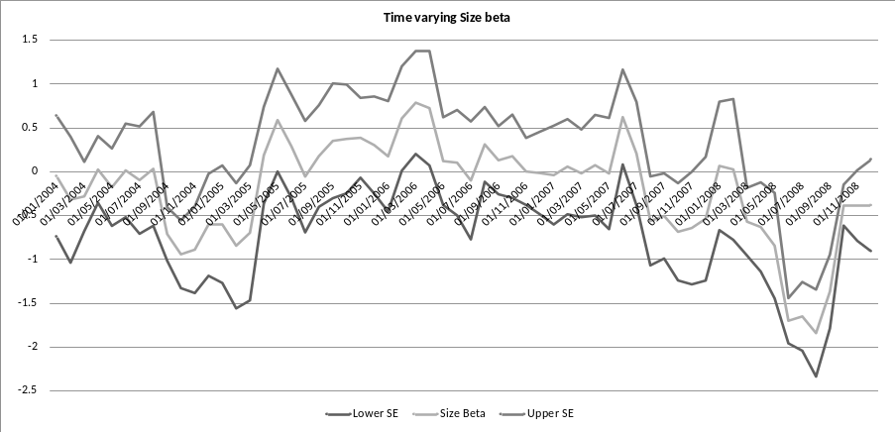

Figure 2. Time varying liquidity beta for Basic Materials

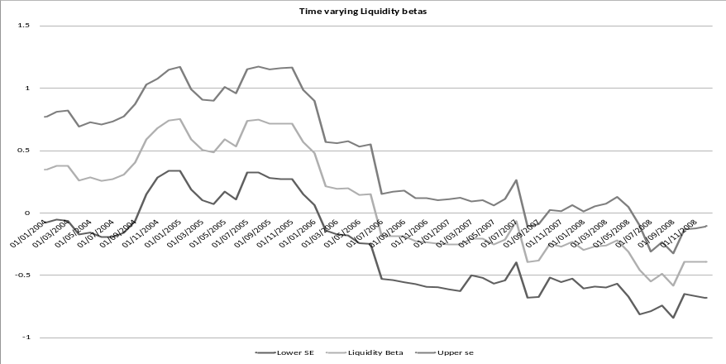

Figure 3. Time varying size beta for Financials

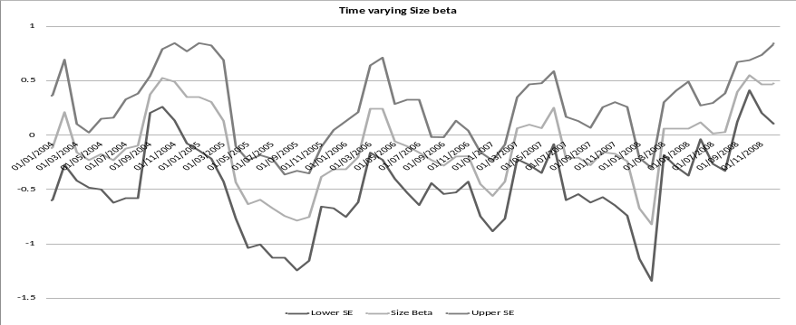

Figure 4. Time varying liquidity beta for Financials

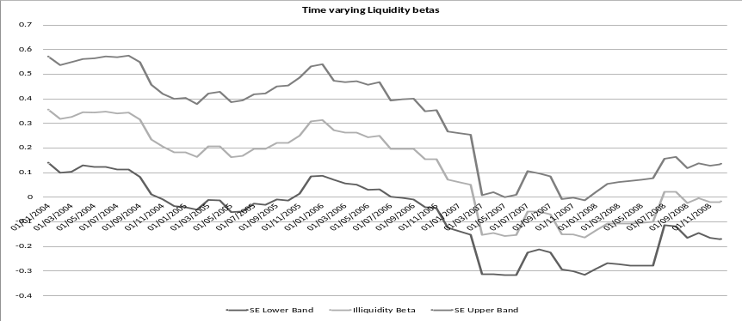

Figure 5. Time varying size beta for Industrials

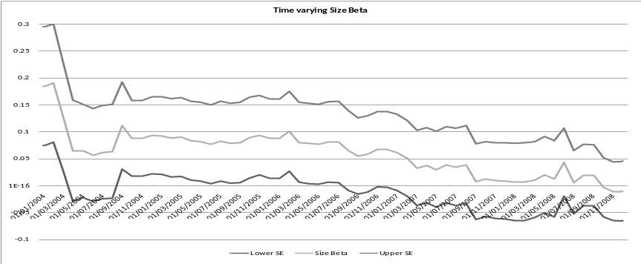

Figure 6. Time varying size beta for Diversified

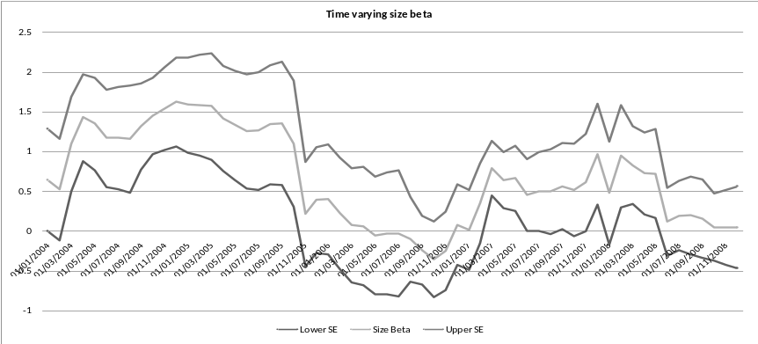

Figure 7. Time varying size beta for Technology

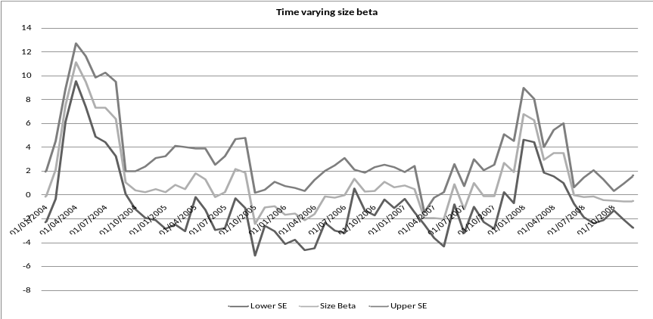

Figure 8. Time varying size beta for Consumer non-cyclical

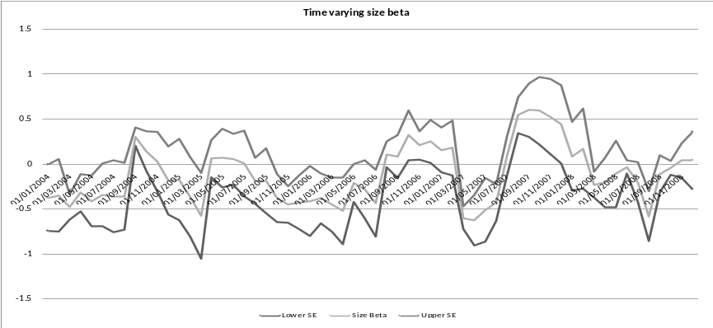

Costs of Equity Estimation

The evidence from Table 8 reveals the estimates of cost of equity for industry portfolios across the sample universe calculated from both the time-invariant three-factor CAPM and its time varying counterpart. All estimates are very high and show considerable variation across industries those generated by both modelling techniques are broadly in line with each other. These would reveal that cost of equity calculated by market-based techniques in Nigeria would be lowest for finance (44.40% by regression and 47.94% by time varying technique) and industrials (44.74% by regression and 37.43% by time varying technique). However while diversified, energy, technology and consumer non-cyclical are all around the 50% - 55% level, as estimated using regression method, basic materials is much higher with a discount value of 67.91% or 57.15% as estimated by time varying methods. This result would be intuitively expected given the additional uncertainty over future cash flows associated with projects in the basic materials industry which includes the sub-categories of construction, extractive and mining industries. However the highest estimate of all is that for the consumer cyclical industry at 85.28% using regression and 109.33% with time varying methods. This would correspond to the extremely high skewness and excess kurtosis levels in the earlier Table 4 as well as the excessively high standard deviation of 91.90%. These values are likely caused by the presence of significant outliers in the returns series which is an especially common feature of the financial time series in much smaller developing countries (Hearn, 2009). It would also infer that other accounting methods would be likely used in practice for the estimation of this industries discount rates. Overall the high values of estimated cost of equity are in line with previous evidence in the literature and in particular with those in a broader African sample of Hearn and Piesse (2009) and the West African sample of Hearn and Piesse (2010).

Table 8. Cost of Equity estimates derived from multi-factor regression (original)

 | Regression Cost of Equity (%) | Time varying coefficient Cost of Equity (%)
Basic Materials | 67.91 | 57.15
Finance | 40.40 | 47.94
Industrials | 44.74 | 37.43
Communications | 31.85 | 75.53
Consumer cyclical | 85.28 | 109.33
Consumer Non-cyclical | 51.59 | 50.85
Diversified | 57.52 | 30.05
Energy | 52.52 | -- --
Technology | 54.84 | 22.84

Notes: Annualized cost of equity estimates generated at 12/2008 from the total risk premium. The UK Gilt/ Treasury 5 Year rate is used in each case for risk free rate

Conclusions

This paper investigates the presence of significant size and illiquidity effects using both time varying and time-invariant pricing models based on the augmented three-factor CAPM structure for the Nigerian equity market. Overall I find mixed evidence regarding the enhanced benefits from the inclusion of these additional size and illiquidity factors in preference to the simple one-factor market term of the standard CAPM in the context of the domestic Nigerian equity market. The use of the time varying augmented three factor pricing model in estimating cost of equity for industry portfolios results in an accentuation of the values obtained from the employment of standard time invariant augmented CAPM. However both estimation methods result in extremely high costs of equity across Nigerian industries. Furthermore it is notable that liquidity has a significant impact in the case of financial and basic material industries which is more a reflection of firms in these industrial categories being of greater interest to investors than firms in other sectors where firms are more susceptible to size effects, or greater variability in earnings during periods of economic downturn and recession which have been more prevalent over the last decade in Nigeria.
The very high costs of equity for all domestic industries however reduces the economic viability of the exchange as a cost effective source of finance against finance sourced from either the banking industry, which has a dominant role in the Nigerian capital market, or internal sources. This would question the effectiveness of the role of the stock exchange as a viable source of development finance in the wider economy. While reforms aimed at improving market microstructure are extremely costly to enact for developing countries their effectiveness heavily relies on congruous values permeating both informal and formal institutional frameworks with social values engendered in the former facilitating the promotion of the latter, where this commonly takes the form of legal, political and governmental framework. Nigeria is one such developing country where informal institutions engender social and economic outcomes based on communitarian systems with conflict resolution and property rights enshrined through consultation as opposed to deference to formal institutions, such as legal and governmental systems, bequeathed by former colonial metropole. Consequently where costly reforms do take place and legislation enacted to enhance market microstructure this will only lead to the stock exchange being a sustainable source of development finance where a combination of political will and universally recognized informal social values act to provide on-going support for external market-orientated financial solutions. However in the light of the incongruous nature of informal and formal institutions in Nigeria the relationship focus of the banking industry is more likely to provide a better institutional fit and thus is likely to have a continued prominent role in development finance in contrast to the stock exchange.
Overall the findings would indicate that development policy designed to enhance market microstructure is more likely to have an uneven impact in terms of enhancing the liquidity of stocks already of interest to investors rather than across the wider market. In particular the costs of reform, which are particularly high in environments lacking the institutional and political support for external market-orientated finance, would infer that the promotion of banking sector is preferable as a source of sustainable longer term finance to facilitate economic growth.

ENDNOTES

1. The dominant position of the NSE in the Anglophone West African region has enabled the exchange to actively participate in the recent establishment of a stock exchange in Freetown, Sierra Leone (NSE website,2010) which formalised the existing informal OTC inter-bank share market (Bank of Sierra Leone, 2010)
2. In line with Liu (2006) a deflator of 1,000 is used in constructing estimates for LM1

Acknowledgements

The author is grateful for useful comments and advice from Ron Smith, Jenifer Piesse, Roger Strange, David Storey, Ian Davidson, Martin Meyer and Igor Filatotchev as well as the participants of the Economic Development in Africa annual conference, St Catherine’s College, University of Oxford, March 2009 and the Academy of International Business – UK and Ireland Chapter, Trinity College Dublin, Ireland, March 2010.

References

Aboagye, A. Q. Q. (2012), “Bank Concentration And Economic Costs Of Deposit Mobilization And Credit Extension In Ghana”, Journal of Developing Areas, 46(2), 351-370
Adjasi, C. K. D., Osei, K. A., and Fiawoyife, E. U. (2011), “Explaining underpricing of IPOs in frontier markets: Evidence from the Nigeria Stock Exchange”, Research in International Business and Finance, 25, 255-265
African Alliance (2012). “Fund Fact sheets: Pan Africa”, http://www.africanalliance.com/asset-management/fund-fact-sheets Accessed 16 April 2012
Aiyagari, S. R., and Gertler, M. (1991), “Asset returns and transactions cost and uninsured individual risk: A stage III exercise”, Journal of Monetary Economics, 27, 309-331
Akotey, A.J. (2007), “Interview with Armah Akotey”, Vice President of Investments, Databank Brokerage Ltd, Accra, Ghana. 23 December 2008.
Alagidede, P., and Panagiotidis, T. (2009), “Modelling stock returns in Africa's emerging equity markets”, International Review of Financial Analysis, 18, 1-11
Amihud, Y., and Mendelson, H. (1986), “Asset pricing and the bid-ask spread”, Journal of Financial Economics, 17, 223-249
Amihud, Y. (2002), “Illiquidity and stock returns: cross section and time series effects”, Journal of Financial Markets, 5, 31-56
Bank of Sierra Leone (2010), “A guide to the Sierra Leone Stock Market”, Available at http://www.bankofsierraleone-centralbank.org/pdf/guide-capmkt.pdf (accessed 31 may 2010).
BBC news (2010), “Nigeria's iron lady takes on fraudsters by Caroline Duffield”, http://www.bbc.co.uk/news/10464725 Accessed 16 April 2012
Bekaert, G. and Harvey, C. (1995), “Time-varying world market integration”, Journal of Finance, 50, 403-444
Brooks, R. D., Faff, R.W. and McKenzie, M. D. (1998), “Time-varying beta risk of Australian industry portfolios: A comparison of modelling techniques”, Australian Journal of Management, 23, 1-22.
Carpenter, S. and Selva, D. (2008), “The liquidity effect in the federal funds market: evidence at the monthly frequency”. Journal of Money, Credit and Banking, 40(1), 1-24
CBN Corporate Governance report (2006), “Code of Corporate Governance for Banks in Nigeria post Consolidation”, Central Bank of Nigeria: Lagos, Available at http://www.cenbank.org/OUT/PUBLICATIONS/BSD/2006/CORPGOV-POSTCONSO.PDF (accessed 31 may 2010).
Datar, V.T., Naik, N.Y. and Radcliffe, R. (1998), “Liquidity and stock returns: An alternative test”, Journal of Financial Markets, 1, 203-219.
Demsetz, H. (1968), “The cost of transacting”, Quarterly Journal of Economics, 82, 33-53
Dimson, E. (1979), “Risk measurement when shares are subject to infrequent trading”, Journal of Financial Economics, 7, 197-226.
Dimson, E. and Marsh, P. (1983), “The stability of UK risk measures and the problem of thin trading”, Journal of Finance, 38, 753-783.
Fama, E.F. and Macbeth, J.D. (1973), “Risk, return and equilibrium: empirical tests”, Journal of Political Economy, 81, 607-636.
Fama, E. and French, K. (1993), “Common risk factors in the returns on stocks and bonds”, Journal of Financial Economics, 33, 3-56.
Glosten, L., and Milgrom, P. (1985), “Bid, as and transaction prices in a specialist market with heterogeneously informed traders”, Journal of Financial Economics, 14, 71-100
Grout, P.A. and Zalewska, A. (2006), “The impact of regulation on market risk”, Journal of Financial Economics, 80, 149-184.
Heaton, J., and Lucas, D. (1996), “Evaluating the effects of incomplete markets on risk sharing and asset prices”, Journal of Political Economy, 104, 443-487
Hearn, B. (2009), “Liquidity and valuation in East African Securities Markets”, South African Journal of Economics, 77(4), 1-24.
Hearn, B., and Piesse, J. (2010), “Performance of Size and Liquidity portfolios in West Africa”, Applied Financial Economics, 20, 1010-1030
Hearn, B. (2011), “Modelling size and liquidity in North African industrial sectors”, Emerging Markets Review, 12, 21-46
Hearn, B., and Piesse, J. (2012), “The law of one price: an examination of price integration between Europe and regional markets in Africa”, Applied Economics, 44, 3169-3193
Hearn, B. (2012), “Size and liquidity effects in African frontier equity markets”, Applied Financial Economics, 22, 681-707
Imara (2012), “Imara Investing in Africa: Nigeria Fund”, http://www.imara.co/imara-funds/imCo65/73 Accessed 16 April 2012
Kenny, C. J., and Moss, T. J. (1998), “Stock markets in Africa: Emerging lions or white elephants?” World Development, 26(5), 829-843
Khemraj, T. (2009), “Excess liquidity and the foreign currency constraint: the case of monetary management in Guyana”, Applied Economics, 41(16), 2073-2084
Kyle, A. (1985), “Continuous auctions and insider trading”, Econometrica, 53, 1315–1336.
Lee, C. (1993), “Market fragmentation and price-execution in NYSE-listed securities”, Journal of Finance, 48, 1009-1038.
Lesmond, D., Ogden, J., and Trzcinka, C. (1999), “A new estimate of transactions costs”, Review of Financial Studies, 12, 1113-1142.
Lesmond, D. A. (2005), “Liquidity of emerging markets”, Journal of Financial Economics, 77, 411-452
Lintner, J. (1965), “The valuation of risk assets and the selection of risky investments in stock portfolios and capital budgets”, Review of Economics and Statistics, 17, 13-37.
Liu, W. (2006), “A Liquidity-augmented capital asset pricing model”, Journal of Financial Economics, 82, 631-671.
Markowitz, H. (1959), “Portfolio Selection: Efficient Diversification of Investments”. New York: John Wiley and Sons; London: Chapman and Hall.
Martinez, M.A., Nieto, B., Rubio, G. and Tapia, M. (2005), “Asset pricing and systematic liquidity risk: An empirical investigation of the Spanish stock market”, International Review of Economics and Finance, 14, 81-103.
NSE annual report (2008), “Nigerian stock exchange annual report 2008”, Available at http://www.nigerianstockexchange.com/downloads/nseannual.pdf (accessed 31 may 2010)
NSE website (2010), “The Nigerian Stock Exchange”, Available at http://www.nigerianstockexchange.com/ (accessed 31 may 2010)
O’Hara, M. (2003), “Presidential address: liquidity and price discovery”, Journal of Finance, 58, 1335-1354
O’Hara, M., and Easley, D. (2010), “Liquidity and valuation in an uncertain world”, Journal of Financial Economics, 97, 1-11
Oliveira, F. (2007), “Interview with Fernando Oliveira”, Standard Bank Research, Maputo, Mozambique. 12 July 2007.
Pastor, L. and Stambaugh, R. (2003), “Liquidity risk and expected stock returns”, Journal of Political Economy, 111, 642-685.
Pettengill, G., Sundaram, S. and Mathur, I. (1995), “The conditional relation between beta and Returns”, Journal of Financial and Quantitative Analysis, 30, 101-116.
Pfau, W. D. (2011), “Emerging Market Pension Funds and International Diversification”, Journal of Developing Areas, 45, 1-17
Scholes, M. and Williams, J.T. (1977), “Estimating betas from nonsynchronous data”, Journal of Financial Economics, 5, 309-327.
Sharpe, W. F. (1964), “Capital asset prices: A theory of market equilibrium under conditions of risk”, Journal of Finance, 19, 425-442.
Shum, W.C. and Tang, G.Y.N. (2005), “Common risk factors in returns in Asian emerging stock Markets”, International Business Review, 14, 695-717.
Udoh, E. (2011), “Optimal Seigniorage and Tax-Smoothing in West African Monetary Zone (WAMZ): An Econometric Assessment”, Journal of Developing Areas, 445, 251-277
Vayanos, D. (1998), “Transactions costs and asset prices: A dynamic equilibrium model”, Review of Financial Studies, 11, 1-58
Vayanos, D., and Vila, J-L. (1999), “Equilibrium interest rates and liquidity Premium with transactions costs”, Economic Theory, 13, 509-539

