**Supplementary Figure 1. Selection of study group sample from the SWS cohort**

**3158** Total SWS live singleton births

8 Neonatal death

7 Major congenital abnormality

215 Gestational age <37 weeks

114 Missing eczema data at 6 and/or 12 months

**2814** Live singleton, term, no congenital abnormalities, no neonatal death, no missing eczema data

1055 Uncertain menstrual data and/or discrepant or missing scan data

**1759** Known menstrual data and consistent scan data*

*Non assisted conception, regular cycle, sure/certain of last menstrual period (LMP), not on oral contraceptive pill prior to LMP, dating range scan data available, LMP consistent with date of conception, first positive pregnancy test, scan data and gestation at birth)

**Supplementary Figure 2. Fetal and Infant Growth and atopic eczema DAG**

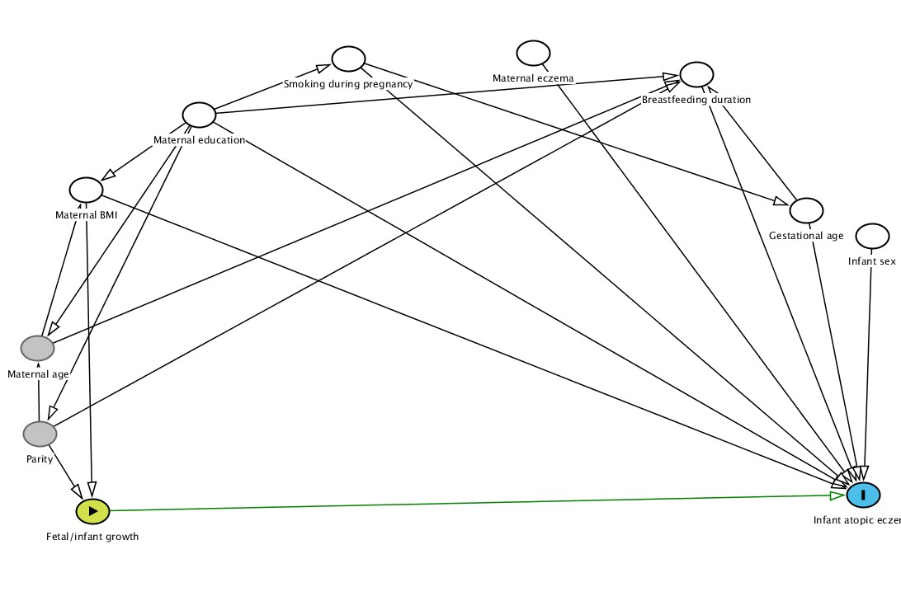

Confounding variables: maternal BMI, maternal education, gestational age and breastfeeding duration.

Competing exposures (variables adjusted for to improve precision of model): maternal eczema, smoking during pregnancy and infant sex.

|  |  |  |  |
| --- | --- | --- | --- |
| **Supplementary table 1. Comparison of the study population with the remainder of the SWS participants** | | | |
|  | Study population  (n = 1759)  Median (IQR), Mean (SD) or % | Other SWS participants*  (n = 1169)  Median (IQR), Mean (SD) or % | P value for difference between the two groups |
| *Maternal* |  |  |  |
| Age at child’s birth(y) | 31.0 (3.7) | 30.2 (4.0) | <0.001 |
| % A level or higher degree | 63.3% | 52.6% | <0.001 |
| % Smoking in pregnancy | 11.7% | 22.3% | <0.001 |
| % Primiparous | 52.2 % | 47.8% | 0.021 |
| % Eczema in the last 12 months | 6.7% | 7.3% | 0.56 |
| Pre-pregnancy BMI (kg/m2) | 24.1 (21.9- 27.4) | 24.2 (21.9-27.3) | 0.86 |
| *Infant* |  |  |  |
| % Male | 51.1% | 52.0% | 0.65 |
| Gestational age (weeks) | 40.1 (39.3- 41.0) | 40.2 (39.2-41.0) | 0.71 |
| Birth weight (kg) | 3.52 (0.47) | 3.49 (0.47) | 0.08 |

*Includes live singleton infants born at term, with no congenital abnormalities and who survived the neonatal period.

**Supplementary Table 2. Static size measurements in relation to eczema at age 6 and 12 months**

|  |  |  |  |  |  |  |  |  |  |  |  |  |  |  |  |  |
| --- | --- | --- | --- | --- | --- | --- | --- | --- | --- | --- | --- | --- | --- | --- | --- | --- |
|  | Eczema at age 6 months eczema | | | | | | | | Eczema at age 12 months eczema | | | | | | | |
|  | Univariate | | | | Multivariate* | | | | Univariate | | | | Multivariate* | | | |
|  | n | OR | 95% CI | P value | n | OR | 95% CI | P value | n | OR | 95% CI | P value | n | OR | 95% CI | P value |
| **Linear size (SD)** |  |  |  |  |  |  |  |  |  |  |  |  |  |  |  |  |
| 11 weeks (CRL) | 1434 | 1.00 | 0.84-1.18 | 0.96 | 1254 | 1.01 | 0.83-1.23 | 0.90 | 1426 | 1.08 | 0.91-1.28 | 0.41 | 1232 | 1.17 | 0.97-1.42 | 0.10 |
| 19 weeks (FL) | 1667 | 0.89 | 0.75-1.05 | 0.18 | 1445 | 0.90 | 0.75-1.09 | 0.30 | 1655 | 1.09 | 0.92-1.29 | 0.30 | 1418 | 1.16 | 0.97-1.40 | 0.11 |
| 34 weeks (FL) | 1686 | 0.86 | 0.74-1.01 | 0.07 | 1457 | 0.81 | 0.69-0.96 | 0.017 | 1671 | 0.96 | 0.82-1.12 | 0.57 | 1427 | 0.98 | 0.83-1.16 | 0.85 |
| Birth (CHL) | 1620 | 0.91 | 0.77-1.09 | 0.32 | 1425 | 0.85 | 0.71-1.03 | 0.09 | 1595 | 0.92 | 0.78-1.09 | 0.34 | 1396 | 0.92 | 0.77-1.11 | 0.40 |
| 6 months (CHL) | 1324 | 0.79 | 0.66-0.94 | 0.007 | 1263 | 0.78 | 0.65-0.93 | 0.006 | 1252 | 0.80 | 0.67-0.96 | 0.017 | 1212 | 0.81 | 0.67-0.97 | 0.021 |
| 12 months (CHL) | 1538 | 0.88 | 0.74-1.05 | 0.16 | 1350 | 0.86 | 0.72-1.03 | 0.11 | 1591 | 0.79 | 0.67-0.94 | 0.007 | 1372 | 0.82 | 0.69-0.98 | 0.028 |
| **Head circumference (SD)** |  | | | | | | | |  | | | | | | | |
| 11 weeks | 1078 | 1.04 | 0.85-1.27 | 0.69 | 942 | 1.07 | 0.85-1.34 | 0.56 | 1076 | 1.17 | 0.96-1.42 | 0.12 | 927 | 1.25 | 1.00-1.56 | 0.045 |
| 19 weeks | 1665 | 0.96 | 0.82-1.14 | 0.68 | 1443 | 0.98 | 0.82-1.19 | 0.86 | 1653 | 1.16 | 0.98-1.37 | 0.08 | 1416 | 1.26 | 1.05-1.51 | 0.012 |
| 34 weeks | 1628 | 1.02 | 0.86-1.21 | 0.80 | 1404 | 1.03 | 0.85-1.24 | 0.78 | 1614 | 1.00 | 0.84-1.18 | 0.97 | 1375 | 1.06 | 0.88-1.27 | 0.55 |
| Birth | 1635 | 0.89 | 0.75-1.05 | 0.15 | 1439 | 0.87 | 0.73-1.04 | 0.13 | 1609 | 0.94 | 0.80-1.11 | 0.45 | 1409 | 0.95 | 0.80-1.13 | 0.56 |
| 6 months | 1335 | 0.88 | 0.74-1.05 | 0.16 | 1273 | 0.88 | 0.73-1.06 | 0.18 | 1263 | 1.00 | 0.83-1.20 | 0.96 | 1222 | 1.01 | 0.83-1.22 | 0.94 |
| 12 months | 1588 | 0.89 | 0.75-1.05 | 0.16 | 1385 | 0.89 | 0.75-1.06 | 0.19 | 1644 | 0.90 | 0.77-1.06 | 0.20 | 1407 | 0.92 | 0.78-1.09 | 0.35 |
| **Abdominal circumference (SD)** |  | | | | | | | |  | | | | | | | |
| 11 weeks | 999 | 0.94 | 0.77-1.16 | 0.59 | 875 | 0.96 | 0.76-1.21 | 0.72 | 1002 | 1.16 | 0.94-1.43 | 0.16 | 863 | 1.21 | 0.96-1.52 | 0.10 |
| 19 weeks | 1657 | 0.97 | 0.82-1.16 | 0.76 | 1436 | 0.94 | 0.78-1.14 | 0.53 | 1647 | 1.10 | 0.93-1.30 | 0.28 | 1411 | 1.14 | 0.95-1.38 | 0.15 |
| 34 weeks | 1687 | 0.81 | 0.69-0.96 | 0.014 | 1458 | 0.78 | 0.65-0.93 | 0.006 | 1672 | 0.87 | 0.74-1.03 | 0.11 | 1428 | 0.88 | 0.74-1.05 | 0.16 |
| Birth | 1633 | 0.86 | 0.73-1.02 | 0.08 | 1437 | 0.83 | 0.70-1.00 | 0.045 | 1607 | 0.96 | 0.81-1.13 | 0.62 | 1407 | 0.92 | 0.77-1.10 | 0.37 |
| 6 months | 1340 | 0.99 | 0.84-1.17 | 0.93 | 1278 | 1.01 | 0.85-1.20 | 0.90 | 1268 | 1.07 | 0.90-1.28 | 0.43 | 1227 | 1.10 | 0.92-1.31 | 0.31 |
| 12 months | 1580 | 0.90 | 0.76-1.05 | 0.19 | 1380 | 0.87 | 0.73-1.03 | 0.11 | 1635 | 1.06 | 0.90-1.24 | 0.48 | 1402 | 1.04 | 0.88-1.23 | 0.66 |
| **Head: abdominal circumference ratio Z scores (SD)** |  | | | | | | | |  | | | | | | | |
| 11 weeks | 945 | 1.09 | 0.88-1.35 | 0.44 | 823 | 1.04 | 0.83-1.30 | 0.74 | 949 | 1.06 | 0.86-1.30 | 0.61 | 813 | 1.02 | 0.81-1.27 | 0.90 |
| 19 weeks | 1654 | 1.04 | 0.88-1.22 | 0.67 | 1433 | 1.09 | 0.92-1.29 | 0.34 | 1644 | 1.07 | 0.91-1.26 | 0.40 | 1408 | 1.09 | 0.92-1.29 | 0.31 |
| 34 weeks | 1628 | 1.32 | 1.12-1.56 | 0.001 | 1404 | 1.37 | 1.15-1.63 | 0.001 | 1614 | 1.20 | 1.02-1.41 | 0.030 | 1375 | 1.22 | 1.03-1.46 | 0.025 |
| Birth | 1633 | 1.13 | 0.96-1.33 | 0.15 | 1437 | 1.13 | 0.95-1.35 | 0.16 | 1607 | 1.02 | 0.87-1.20 | 0.82 | 1407 | 1.07 | 0.89-1.28 | 0.47 |
| 6 months | 1334 | 0.96 | 0.81-1.14 | 0.66 | 1272 | 0.94 | 0.79-1.13 | 0.52 | 1262 | 0.93 | 0.77-1.11 | 0.41 | 1221 | 0.91 | 0.76-1.09 | 0.32 |
| 12 months | 1570 | 1.07 | 0.90-1.26 | 0.45 | 1371 | 1.09 | 0.92-1.30 | 0.33 | 1625 | 0.89 | 0.76-1.05 | 0.17 | 1393 | 0.91 | 0.76-1.08 | 0.28 |

*Adjusted for maternal BMI, education, smoking and eczema; and infant sex, gestational age and breastfeeding duration. SD: standard Deviation

**Supplementary Table 3. Growth velocities in relation to eczema at age 6 and 12 months**

|  |  |  |  |  |  |  |  |  |  |  |  |  |  |  |  |  |  |
| --- | --- | --- | --- | --- | --- | --- | --- | --- | --- | --- | --- | --- | --- | --- | --- | --- | --- |
|  | Eczema at age 6 months. | | | | | | | | Eczema at age 12 months. | | | | | | | | |
|  | Univariate | | | | Multivariate* | | | | Univariate | | | | | Multivariate* | | | |
|  | n | OR | 95% CI | P value | n | OR | 95% CI | P value | n | OR | 95% CI | | P value | n | OR | 95% CI | P value |
| **Linear growth (SD)** |  |  |  |  |  |  |  |  |  |  |  | |  |  |  |  |  |
| 11 weeks | 1003 | 1.02 | 0.84-1.24 | 0.87 | 973 | 1.01 | 0.82-1.25 | 0.91 | 1005 | 1.15 | 0.94-1.40 | | 0.18 | 975 | 1.22 | 0.98-1.52 | 0.07 |
| 11 - 19 weeks | 1003 | 0.75 | 0.61-0.93 | 0.008 | 973 | 0.75 | 0.61-0.93 | 0.010 | 1005 | 0.94 | 0.77-1.16 | | 0.58 | 975 | 0.94 | 0.76-1.16 | 0.55 |
| 19 - 34 weeks | 1003 | 0.85 | 0.69-1.04 | 0.12 | 973 | 0.83 | 0.67-1.02 | 0.07 | 1005 | 0.99 | 0.81-1.22 | | 0.96 | 975 | 0.98 | 0.79-1.20 | 0.81 |
| 34 weeks - Birth | 1003 | 0.95 | 0.78-1.16 | 0.61 | 973 | 0.93 | 0.76-1.15 | 0.51 | 1005 | 0.84 | 0.69-1.04 | | 0.11 | 975 | 0.83 | 0.68-1.02 | 0.08 |
| Birth - 6 months | 1003 | 0.81 | 0.66-0.99 | 0.040 | 973 | 0.82 | 0.67-1.01 | 0.07 | 1005 | 0.81 | 0.66-0.99 | | 0.039 | 975 | 0.81 | 0.66-1.00 | 0.052 |
| 6 - 12 months | 1003 | 1.11 | 0.91-1.36 | 0.31 | 973 | 1.12 | 0.91-1.38 | 0.29 | 1005 | 0.91 | 0.74-1.12 | | 0.36 | 975 | 0.90 | 0.73-1.11 | 0.34 |
| **Head circumference (SD)** |  | | | |
| 11 weeks | 748 | 1.09 | 0.86-1.38 | 0.49 | 726 | 1.08 | 0.84-1.40 | 0.54 | 749 | 1.30 | 1.02-1.66 | | 0.033 | 727 | 1.31 | 1.01-1.70 | 0.039 |
| 11 - 19 weeks | 748 | 0.85 | 0.66-1.08 | 0.19 | 726 | 0.82 | 0.64-1.06 | 0.14 | 749 | 0.95 | 0.74-1.21 | | 0.66 | 727 | 0.94 | 0.73-1.20 | 0.63 |
| 19 - 34 weeks | 748 | 1.10 | 0.87-1.40 | 0.44 | 726 | 1.06 | 0.83-1.36 | 0.64 | 749 | 0.95 | 0.75-1.21 | | 0.70 | 727 | 0.93 | 0.72-1.19 | 0.55 |
| 34 weeks - Birth | 748 | 0.84 | 0.66-1.06 | 0.15 | 726 | 0.85 | 0.66-1.08 | 0.19 | 749 | 0.88 | 0.69-1.12 | | 0.29 | 727 | 0.88 | 0.69-1.12 | 0.30 |
| Birth - 6 months | 748 | 1.03 | 0.81-1.31 | 0.79 | 726 | 1.05 | 0.82-1.34 | 0.68 | 749 | 1.06 | 0.83-1.35 | | 0.64 | 727 | 1.07 | 0.84-1.37 | 0.56 |
| 6 - 12 months | 748 | 0.91 | 0.72-1.16 | 0.47 | 726 | 0.89 | 0.69-1.15 | 0.37 | 749 | 0.90 | 0.71-1.15 | | 0.41 | 727 | 0.91 | 0.70-1.17 | 0.45 |
| **Abdominal circumference (SD)** |  | | | | | | | | | | |
| 11 weeks | 723 | 0.97 | 0.76-1.23 | 0.78 | 703 | 0.94 | 0.73-1.22 | 0.66 | 724 | 1.24 | 0.97-1.60 | | 0.09 | 704 | 1.24 | 0.95-1.62 | 0.11 |
| 11 - 19 weeks | 723 | 0.98 | 0.78-1.25 | 0.90 | 703 | 0.96 | 0.76-1.22 | 0.75 | 724 | 0.97 | 0.76-1.24 | | 0.82 | 704 | 0.97 | 0.76-1.24 | 0.82 |
| 19 - 34 weeks | 723 | 0.79 | 0.62-1.00 | 0.051 | 703 | 0.71 | 0.55-0.92 | 0.009 | 724 | 0.73 | 0.57-0.93 | | 0.012 | 704 | 0.67 | 0.51-0.88 | 0.003 |
| 34 weeks - Birth | 723 | 1.09 | 0.86-1.38 | 0.47 | 703 | 1.14 | 0.89-1.46 | 0.29 | 724 | 1.13 | 0.88-1.44 | | 0.35 | 704 | 1.17 | 0.91-1.51 | 0.23 |
| Birth - 6 months | 723 | 1.08 | 0.85-1.37 | 0.53 | 703 | 1.09 | 0.86-1.40 | 0.47 | 724 | 1.12 | 0.87-1.44 | | 0.37 | 704 | 1.11 | 0.86-1.43 | 0.42 |
| 6 - 12 months | 723 | 0.85 | 0.68-1.08 | 0.18 | 703 | 0.83 | 0.66-1.05 | 0.13 | 724 | 1.00 | 0.78-1.27 | | 0.98 | 704 | 0.99 | 0.77-1.26 | 0.91 |

*Adjusted for maternal BMI, education, smoking and eczema; and infant sex, gestational age and breastfeeding duration.

SD: standard Deviation.