Tables and Figures
Table 1 Comparisons of Gelsomino et al. (2016) and our paper
 | Gelsomino et al. (2016) | Our paper
Time limit set | A specific time frame (2000-2014) | No time limit (1970-2016)
Keywords | A selected list of keywords and strings | A comprehensive list of supply chain related and finance related keywords
Journals | Major logistics and supply chain management journals and top finance and management journals | AJG 3, 4, and 4* for content analysis;  No constrain for bibliometric analysis
Focus | SCF concepts and solutions | All aspects of SCF
Review methods | Content analysis | Bibliometric analysis, network analysis and content analysis
Findings | Definitions of SCF reflect the “finance oriented” perspective and the “supply chain oriented” perspective | The two perspectives of SCF are reflected in keywords selection.  Four clusters with different research focus are identified.
Gaps and future directions (Numbers refer to the sequences of contents in both papers) | Four gaps/directions: | Seven directions:
 | - No general theory of SCF
 | (2) Weak empirical-based holistic analyses on the application of SCF | (7) More researches using empirical and case study methods are needed.
 | (3) Few assessment models consider the impact of SCF programs on supply chain financial performance. | (1) SCF of multi-tier supply chains and more complex forms of trade credit policies need to be considered;  (4) More forms of financing mechanisms should be introduced.
 | (4) Lack of tools for choosing SCF solutions for different supply chains and objectives | (3) Scholars needs adjust and extend the research models for SCF practice, and the function of SCF changes
 |  | (2) Assumptions of models can be relaxed
 |  | (5) Combining SCF with sustainable supply chain management
 |  | (6) Combining SCF with specific industry sectors

Table 2 The search string and keywords
Supply chain-related keywords: (supply chain) OR (value chain) OR logistics OR inventory OR procurement OR purchasing OR sourcing
AND
Finance-related keywords: finance OR financing OR (trade credit) OR (bank credit) OR (early payment) OR (dela* payment) OR (advanc* payment) OR (capital constraint) OR (financial constraint) OR factoring OR (limited liability) OR (cash conversion cycle)

Table 3 Inclusion and exclusion criteria in the refinement
Inclusion criteria | Exclusion criteria
Focus on SCF | Supply chain management not related to finance
Peer-reviewed journal paper in English | Finance not related to supply chain
 | Non-English language journals

Table 4 Top 12 journals contributing to SCF (N=348)
Journals | Total
International Journal of Production Economics (IJPE) | 39
European Journal of Operational Research (EJOR) | 20
Applied Mathematical Modelling (AMM) | 18
International Journal of Systems Science (IJSS) | 13
International Journal of Operational Research (IJPR) | 12
Computers & Industrial Engineering (CIE) | 10
International Journal of Information and Management Sciences (IJIMS) | 10
Management Science (MS) | 10
Journal of the Operational Research Society (JORS) | 8
Asia-Pacific Journal of Operational Research (APJOR) | 7
Yugoslav Journal of Operations Research (YJOR) | 7
OPSEARCH | 7

Table 5 Top 11 papers by local citation
Author (year) | Local citation | Global citation
Goyal (1985) | 187 | 1309
Abad and Jaggi (2003) | 60 | 300
Chung and Liao (2004) | 59 | 233
Teng et al. (2005) | 57 | 288
Chung et al. (2005) | 54 | 189
Huang (2007) | 51 | 209
Teng and Chang (2009) | 50 | 189
Sarker et al. (2000) | 49 | 350
Liao (2008) | 48 | 176
Ho et al. (2008) | 48 | 153
Shinn and Hwang (2003) | 48 | 250

Table 6 Top 10 papers by PageRank
Author (year) | PageRank | Local citation | Global citation
Goyal (1985) | 0.01638354 | 187 | 1309
Jaggi et al. (2008) | 0.01065293 | 46 | 205
Huang (2007) | 0.01061392 | 51 | 209
Abad and Jaggi (2003) | 0.01048360 | 60 | 300
Teng and Chang (2009) | 0.01030263 | 50 | 189
Buzacott and Zhang (2004) | 0.01016512 | 37 | 579
Huang and Hsu (2008) | 0.01007087 | 47 | 156
Liao (2008) | 0.00999925 | 48 | 176
Ho et al. (2008) | 0.00972325 | 48 | 153
Chung and Liao (2004) | 0.00964314 | 59 | 233
(Note: Local citation: citation within the 348 papers; Global citation: citation in all databases)

Table 7 Literature classification: the primary research clusters (N=214)
Cluster | No. of papers | No. of selected papers | Area of research focus
1 | 63 | 34 | Deteriorating inventory model under trade credit policy based on EOQ/EPQ model
2 | 31 | 11 | Inventory decision with trade credit policy under more complex situations
3 | 63 | 25 | Interaction between replenishment decisions and delay payment strategies in the supply chain
4 | 57 | 26 | Roles of financing service in the supply chain
Total | 214 | 96
(Note: selected papers refer to papers published in journals of ABS Grade 3, 4 and 4*)

Table 8 The lead papers using a PageRank measure
Cluster 1 | Cluster 2
Goyal (1985)  Abad and Jaggi (2003)  Liao (2008)  Ho et al. (2008)  Chung and Liao (2004)  Ouyang et al. (2009)  Huang (2007)  Teng (2009)  Haley and Higgins (1973)  Chung et al. (2005) | Huang (2007)  Teng and Chang (2009)  Huang and Hsu (2008)  Mahata (2012)  Chang et al. (2010)  Kreng and Tan (2011)  Su (2012)  Thangam (2012)  Mahata and Goswami (2007)  Soni and Patel (2012)
Cluster 3 | Cluster 4
Jaggi et al. (2008)  Chen et al. (2014)  Chern et al. (2013)  Wu et al. (2014)  Zhou et al. (2013)  Ouyang and Chang (2013)  Wang et al. (2014)  Tsao and Sheen (2008)  Chen et al. (2014)  Zhou et al. (2012) | Buzacott and Zhang (2004)  Raghavan and Mishra (2011)  Lee and Rhee (2011)  Kouvelis and Zhao (2012)  Gupta and Wang (2009)  Jing (2012)  Chen (2015)  Protopappa-Sieke and Seifert (2010)  Chen (2012)  Zhang et al. (2014)
Note: only papers published in journals of ABS Grade 3, 4 and 4* are included.

Table 9 Key contributing journals in each research area (N= 214)
Clusters | Top journals | Number of papers
1. Deteriorating inventory model under trade credit policy based on EOQ/EPQ model | International Journal of Production Economics | 15
 | European Journal of Operational Research | 7
 | Journal of the Operational Research Society | 4
 | Computers & Operations Research | 3
 | Production Planning & Control | 2
2. Inventory decision with trade credit policy under more complex situations | International Journal of Production Economics | 5
 | European Journal of Operational Research | 2
 | Expert Systems with Applications | 2
3. Interaction between replenishment decisions and delay payment strategies in the supply chain | International Journal of Production Economics | 12
 | European Journal of Operational Research | 6
 | Computers & Operations Research | 2
 | Journal of the Operational Research Society | 2
4. Roles of financing service in the supply chain | Management Science | 5
 | European Journal of Operational Research | 5
 | International Journal of Production Economics | 5
 | Operations Research | 2
 | Production and Operations Management | 2

Table 10 The number of published papers in each cluster (1973–2016)
Year | Number of published articles
 | Cluster 1 | Cluster 2 | Cluster 3 | Cluster 4
1973 | 1
1981 |  |  |  | 1
1985 | 1
1986 | 1
1987 | 1
1994 | 1
1995 | 1
1999 | 1
2000 | 1
2001 | 2
2002 | 2
2003 | 3
2004 | 5 |  |  | 2
2005 | 8 |  | 1
2006 | 3 |  |  | 1
2007 | 8 | 2
2008 | 5 | 1 | 3 | 2
2009 | 5 | 6 |  | 9
2010 | 5 | 3 | 5 | 4
2011 | 2 | 6 | 2 | 8
2012 | 3 | 7 | 9 | 7
2013 | 3 | 5 | 14 | 4
2014 |  | 1 | 14 | 5
2015 |  |  | 9 | 8
2016 | 1 |  | 6 | 6
Total | 63 | 31 | 63 | 57

Table 11 Identifying research directions in SCF research
Category | Gap/issue | Research direction
Number of SCF levels | Focus on one-level or two-level trade credit | Studying multi-level SCF
Assumption for modeling | Existing assumptions are strict. | Relaxing existing assumptions and introducing new assumptions
Models and functions of SCF | - Certain demand is limited.  - Only considering cost reduction  - Limited forms of models  - Only as a marketing tool | - Considering more forms of demand  - Considering profit increase  - Adopting game theory  - Working as a coordination tool  - Considering co-operation
Forms of financing | Lack of financing forms | Studying the impact of tax or exchange rates on SCF
Link to SCM topics | Few papers study the sustainable SCF. | Relating sustainability with SCF
Industry sector | Few papers consider SCF in a specific industry. | Studying SCF in agricultural sectors
Research method | Dominated by modelling | Calling for empirical analysis e.g. case study, statistical analysis

Fig. 1 Publishing trend in SCF (N=348)

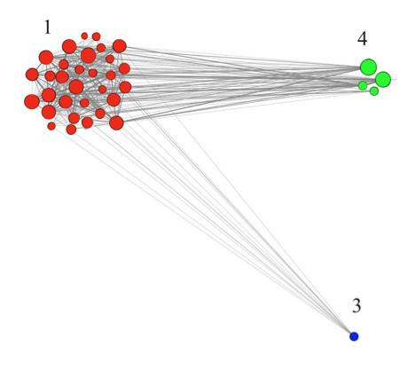 | 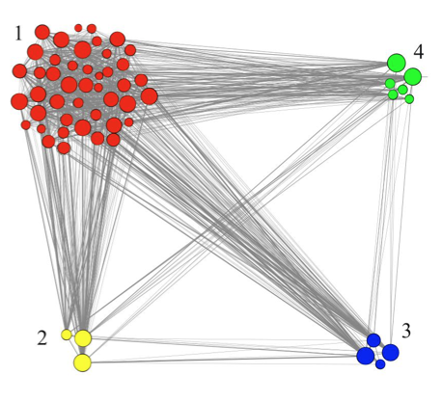
(i)1973–2006 | (ii)1973–2008
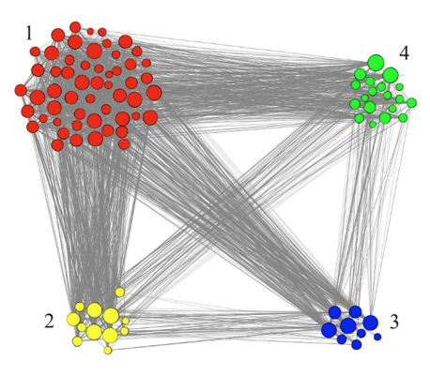 | 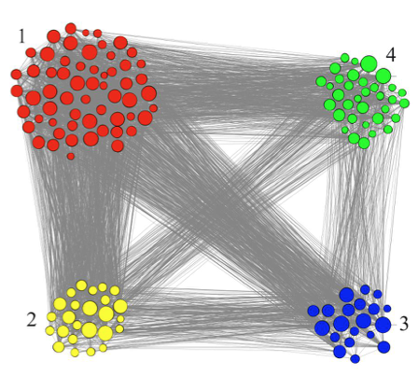
(iii)1973–2010 | (iv)1973–2012
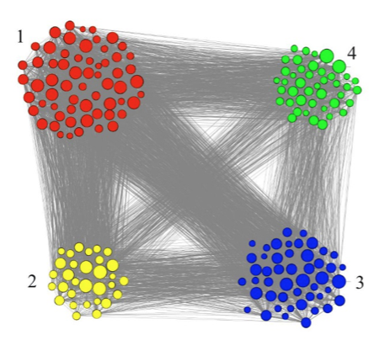 | 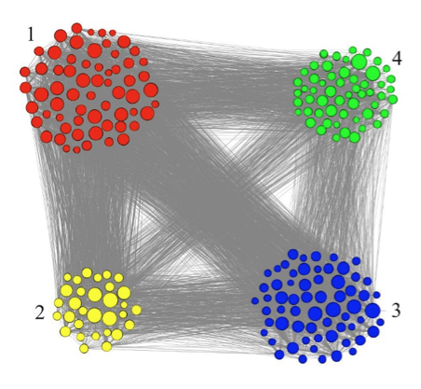
(v)1973–2014 | (vi)1973–2016

Fig. 2 The evolution of SCF research over time
(i)1973–2006, (ii)1973–2008, (iii)1973–2010, (iv)1973–2012, (v)1973–2014, (vi)1973–2016

