**Understanding the charge storage mechanism of conductive polymers as hybrid battery-capacitor material in ionic liquids by *in-situ* atomic force microscopy and electrochemical quartz crystal microbalance**

Theresa Schoetza,[1]*, Mario Kurniawanb, Michael Stichb, Ralf Peipmannb, Igor Efimovc,  
Adriana Ispasb, Andreas Bundb, Carlos Ponce de Leona and Mikito Uedad

*a Faculty of Engineering and the Environment; University of Southampton; Highfield Southampton SO17 1BJ; United Kingdom*

*b Electrochemistry and Electroplating Group; Technische Universität Ilmenau;  
 Gustav-Kirchhoff-Straße 6; 98693 Ilmenau; Germany*

*c Department of Chemistry; University of Leicester; Leicester, LE1 7RH; United Kingdom*

*d Faculty of Engineering; Hokkaido University; Kita-13, Nishi-8, Kita-ku, 060-8628 Hokkaido, Sapporo; Japan*

# Abstract

Safe and sustainable energy storage systems with the ability to perform efficiently during large number of charge/discharge cycles with minimum degradation, define the main objectives of the near future energy storage technologies. Closing the gap between high power and energy per unit weight, demands new materials acting as battery and capacitor at the same time. Conductive polymers attracted attention as hybrid battery-capacitor material. However, their potential impact has not been fully investigated, as their behaviour, especially in non-aqueous electrolytes such as ionic liquids, is not completely understood. Here, we aim to clarify the fundamental functionality of the hybrid characteristics while studying the interaction between a conductive polymer and an ionic liquid by *in-situ* atomic force microscopy and electrochemical quartz crystal microbalance. The main achievement is the visualisation of morphological modifications of the conductive polymer depending on the state of charge. These modifications influence the viscoelastic material properties of the polymer, significantly. The combination of the findings provides a model, which is able to explain why conductive polymers behave like a (pseudo)-capacitor at a high and as battery at a low state of charge. This understanding enables the application-orientated synthesis and the use of conductive polymers as high-performance energy storage material.

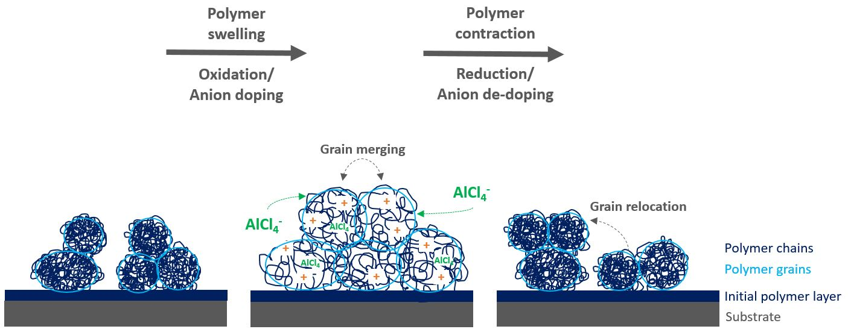

*Graphical abstract: Schematic model of the morphological changes of a conductive polymer in ionic liquid during charging (oxidation, anion doping) and discharging (reduction, anion de-doping).*

# Keywords

Conductive polymers; electrochemical quartz crystal microbalance (EQCM); hybrid battery-(pseudo)-capacitor; *in-situ* atomic force microscopy (AFM); ionic liquids; poly(3,4-ethylenedioxythiophene) (PEDOT)

1. **Broader Context**

High-performance energy storage devices such as lithium-ion batteries are characterised by the highest practical specific energy 80-175 Wh kg-1 and power 200-300 W kg-1 among the state-of-the-art rechargeable batteries 1. Nevertheless, there are some major concerns about the safety and sustainability of lithium. These include flammability, difficult recycling and limited availability of raw materials, which raise issues against the future viability of electric cars.

Therefore, there is a strong tendency in the battery community to investigate alternative batteries beyond lithium-ion, enhancing safety and sustainability as well as reducing costs. Raising the acceptance and wide access to electromobility could mean a course correction towards a more sustainable and cleaner future 2,3.

There are great efforts to implement batteries based on more sustainable materials such as aluminium, magnesium or sodium. However, pure metal batteries are not able to reach high-performances such as high specific energy or power and compete with state-of-the art batteries 4. In order to increase the performance, these negative metal electrodes need to be combined with a positive electrode characterised as charge-storage-material. Charge-storage-electrodes can accommodate additional ions by intercalation or doping. These types of electrodes combine faradaic behaviour like a battery due to oxidation and reduction of an active electrode species and at the same time, show capacitive (non-faradaic) behaviour by inserting anion species in a three-dimensional electrode structure 5.

Carbon materials, especially graphene, have an important role as electrode material due to their relatively inert electrochemistry, wide potential stability window and low costs as well as environmental friendly properties 5. However, carbon-based materials can reach only a limited charge storage capacity. Another type of charge-storage-material are the conductive polymers 6,7, which stand out for their low-weight, low cost, relatively high conductivity and capacity and straight forward electrochemical synthesis.

Compared to batteries, capacitors have less energy per unit weight and store energy only for short periods. Nevertheless, capacitors have a higher specific power and a faster response time than batteries. In order to improve the specific energy and power of an energy storage system, the characteristics of batteries and capacitors need to be combined in a hybrid system at the same time 8. Battery and capacitor properties can be linked with electrodes that operate under different charge storage mechanisms: the main storage mechanisms base on faradaic charge storage, which is typical for a battery, and the non-faradaic or capacitive charge storage by electrostatic interactions at the electrode double layer vicinity or pseudo-capacitive charge storage 9–11. Pseudo-capacitive charge storage refers to a surface-bound process, contributing to the total capacitance of the system 10,11.

Conductive polymers such as poly(3,4-ethylenedioxythiophene) (PEDOT) are typical examples of hybrid battery-(pseudo)-capacitors materials 8. They have the unique characteristic to undergo a redox reaction like a battery (Equation 1), generating positive charged sites in the polymer structure during the oxidation (charge reaction). When the polymer is reduced (discharge reaction), the charged sites return to their neutral state. In parallel to this redox reaction, the generated charged centres are compensated/doped (decompensated/de-doped) by anions from the electrolyte and incorporated into the nano/micro-porous polymer structure as electrical charges like in a capacitor 12–14.

The amount of doped charges per monomer unit is determined by the generated and accessible charged sites in the polymer, increasing with the doping potential. The number of doped anions per monomer unit is described as degree of doping *α* (*α* = 0 to 1) 15–17.

(1)

Furthermore, the formation of the doping/de-doping sites depends also on the polymer morphology, which is predetermined by the electro-polymerisation method, the applied potential and the doping anion 17.

In contrast to conductive polymers synthesised in aqueous solution or in organic solvents such as acetonitrile, polymer films obtained in ionic liquids show higher cycle stability with a highly reversible doping/de-doping reaction and formation of doping/de-doping sites at high electrode potentials leading to better battery performance 17–19.

This study aims to investigate the anion doping/de-doping process of the conductive polymer PEDOT while performing charge/discharge cycles and evaluating their capacitive and faradaic behaviour by Cyclic voltammetry (CV) coupled with electrochemical quartz crystal microbalance (EQCM) experiments. *In-situ* atomic force microscopy (AFM) measurements will show the morphological change of the polymer surface while charging and discharging. Combining these results will allow drawing a model of how the polymer morphology determines the battery and capacitor characteristics of the conductive polymer.

1. Experimental Methods
   1. **Electro-Polymerisation**

The electro-polymerisation of PEDOT was performed by cyclic voltammetry from -0.5 V to 2.5 V *vs.* Al|Al(III) in Lewis neutral 1-ethyl-3-methylimidazolium chloride-aluminium chloride (EMImCl-AlCl3) with 0.1 mol dm-3 3,4-ethylenedioxythiophene (EDOT) (Alfa Aesar, 97%) at 100 mV s-1, over 20 cycles at 25 °C 17. The polymer surface was rinsed with monomer-free Lewis neutral EMImCl-AlCl3 after the polymerisation to remove residual monomer on the surface and cycled 10 times 0 V to 2.5 V *vs.* Al|Al(III) at 100 mV s-1 at 25 °C in monomer-free Lewis neutral EMImCl-AlCl3.

* 1. **Electrochemical Quartz Crystal Microbalance Measurements**

The EQCM set-up (Figure 1) comprises a three-electrode arrangement in a PTFE-cell controlled by a potentiostat (Princeton Applied Research 263A). A quartz crystal with AT-cut and sputtered gold (KVG, 10 MHz, 0.22 cm2) is used as working electrode and substrate for the polymer. The polymer film was electro-polymerised on the gold quartz crystal as described in paragraph 2.1. A vitreous carbon rod (Micro to Nano, diameter 0.3 cm) placed opposite to the quartz acts as counter electrode, whereas an aluminium ring was used as reference electrode (Alfa Aesar, 99.999% metal basis, diameter 0.5 mm).

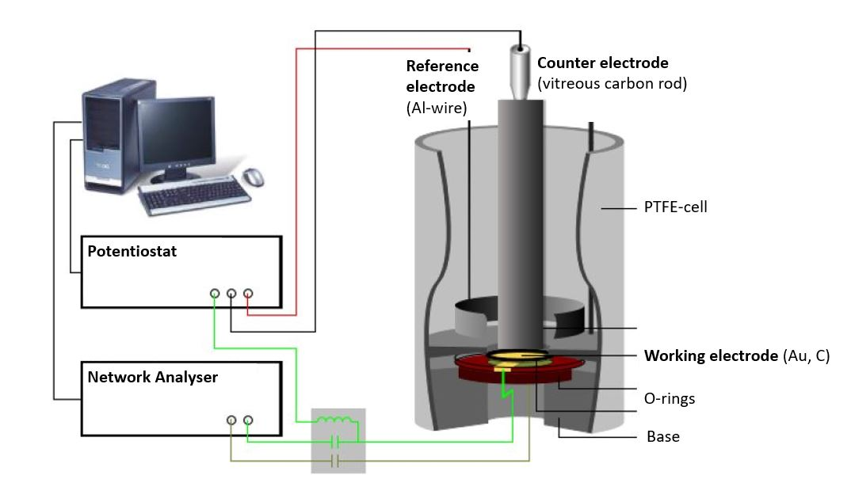

Figure 1: Illustration of the experimental set-up of the quartz crystal microbalance.

By combining electrochemical and EQCM measurements, two electrical signals overlap at the working electrode: a DC voltage, applied by the potentiostat and a high frequency AC voltage from the network analyser (Agilent E5100A), which causes the oscillation of the quartz.

The changes of the quartz resonance frequency caused by mass changes of the polymer film due to anion doping/de-doping are determined by the admittance (reciprocal of the impedance) with the network analyser. The spectrum of the admittance has the form of a Lorentz curve, so that the resonance frequency *f* and the quartz damping *w*, which is defined as the width at half the height of the admittance peak, can be determined by curve fitting.

The resonance frequency and the damping provide information about the properties of the quartz crystal and the polymer film as they are mechanically coupled. Therefore, the mechanical properties of the polymer can be combined with the quartz to obtain a single mechanic system, which can be read as one electrical signal. The most accurate electrical description of a quartz crystal is currently given by the Electric Line Model (Transmission Line Model), based on a Mason 3-port model 20,21. Changes of the electric impedance of the quartz can be translated into a film impedance of the polymer. The oscillation of the quartz causes a shear wave on the surface of the quartz, which is reproduced on the polymer film. Depending of the polymer properties, such as film density *ρf*, the shear wave is dampened. Therefore, the film impedance *Zf* is related to the shear modulus *G* of the system (Equation 2) 20.

(2)

The shear modulus describes the linear elastic deformation of the polymer film and provides information about changes of the polymer stiffness or softness.

* + 1. **Determination of the Shear Modulus**

Ideal planar and rigid films move in phase with the quartz surface of area A. In this case the change of resonance frequency *Δf* is proportional to the negative mass change *Δm* of the polymer film and the Sauerbrey equation (Equation 3) 20,22 can be applied. The parameter *f0* indicates the resonance frequency of the unloaded quartz, which has a shear modulus *µQ* of 2,957×1011 g cm s-² and a density *ρQ* of 2,648 g cm-3.

(3)

Since conductive polymers are not ideal planar rigid films, their viscoelastic properties cause a shift and damping of the shear wave propagation. Furthermore, the contact of the polymer film with the electrolyte causes an additional film impedance *Zl*. If the electrolyte is inside the polymer pores and on the rough polymer surface, its impedance needs to be considered as it contributes to the overall impedance, which depends on the film thickness *hf*.

A complex shear modulus *G\** for viscoelastic materials can be defined (Equation 4). *G\** comprises a real part *G’*, presenting the deformation energy, which can be recovered (elastic behaviour) and an imaginary part *G’’*, describing the amount of energy, which is lost due to frictional heat.

In this work, the changes of the shear modulus are studied instead of the quantitative mass changes of the polymer during charging/discharging cycles as the damping change of the viscoelastic polymer film is expected to be higher than the resonance frequency changes.

$G^{*}=G^{'}+iG^{''}$ (4)

The final equation 20,23–36 for solving numerically the film impedance and shear moduluswas calculated 20,24,25 (Equation 5 and 6) by the software package Mathematica® (supplementary information) by using FindRoot[]-function.

$0=fn\left(Z_{f}\right)=\frac{\sqrt{i}+\frac{Z_{f}}{X_{l}}\tanh\left(i\frac{bZ_{fSB}^{m}}{Z_{f}}\right)}{1+\sqrt{i}\frac{X_{l}}{Z_{f}}\tanh\left(i\frac{bZ_{fSB}^{m}}{Z_{f}}\right)}-[Re+iIm]$ (5)

$G^{*}=G^{'}+iG^{''}=\frac{Z_{f}^{2}}{ρ_{f}}=\frac{{Re}^{2}\left(Z_{f}\right)-{Im}^{2}(Z_{f})}{ρ_{f}}+i\frac{2Re\left(Z_{f}\right)Im(Z_{f})}{ρ_{f}}$ (6)

The film impedance *Zf* includes the unknown parameter shear modulus *G\** and the film density *ρf*, whereas the motional film impedance, which is estimated by the Sauerbrey equation, $Z_{fSB}^{m}$, includes the film thickness *hf* and density (Equation 7).

$Z_{fSB}^{m}=ω_{0}ρ_{f}h_{fSB}$ (7)

The reactance of the electrolyte is represented by *Xl* (Equation 8).

$X_{l}=\sqrt{2πf_{0}ρ_{l}η_{l}}$ (8)

In order to determine the shear modulus, assumptions for the film thickness and density of the polymer film need to be made. For the polymer density, the monomer density is assumed. The film thickness needs to be estimated. As a first step, it is assumed that the polymer consists of a rigid planar film and the film thickness *hfSB* is estimated by the Sauerbrey equation. In a second step, the polymer film thickness is corrected by multiplying with the correction factor *b* (Equation 9), accounting for all deviations of a viscoelastic to an ideal film such as film roughness and density differences (Equation 3).

${bh}_{fSB}=h_{f}$ (9)

A correction factor b=1 would indicate a rigid and planar surface. The upper limit should be slightly larger than one. In order to determine the correction factor and the complex shear modulus *G\**, the *b* value was varied. The correction factor *b* was determined by finding the maximum of *G’*, as *G’*  is a function of *b* 20. In this study an interval of *b* from 0.5 to 5.5 was selected.

This is the main task of the developed algorithm script (supplementary information). Since *b* is a parameter for the calculation of *G\**, a list “databb” is generated, which contains all b-values. First the Mathematica FindRoot[]-function determines *Zf* and then *G\** for each *b* in databb. Afterwards, the maximum and the associated *bGmax* are determined for *G'*. If both components of the shear modulus for *bGmax* are greater than zero, they are added to the result list.

* 1. ***In-Situ* Atomic Force Microscopy**

The experimental set-up (Figure 2) consists of a self-designed PTFE three-electrode cell with a vitreous carbon disc (Micro to Nano, 6.3 cm2) as substrate/ working electrode, a vitreous carbon ring (Micro to Nano, diameter 3 cm) as counter and an aluminium wire (Alfa Aesar, 99.999% metal basis, diameter 0.5 mm) as reference electrode. The electrochemical experiments were controlled by a Biologic SP-240 potentiostat.

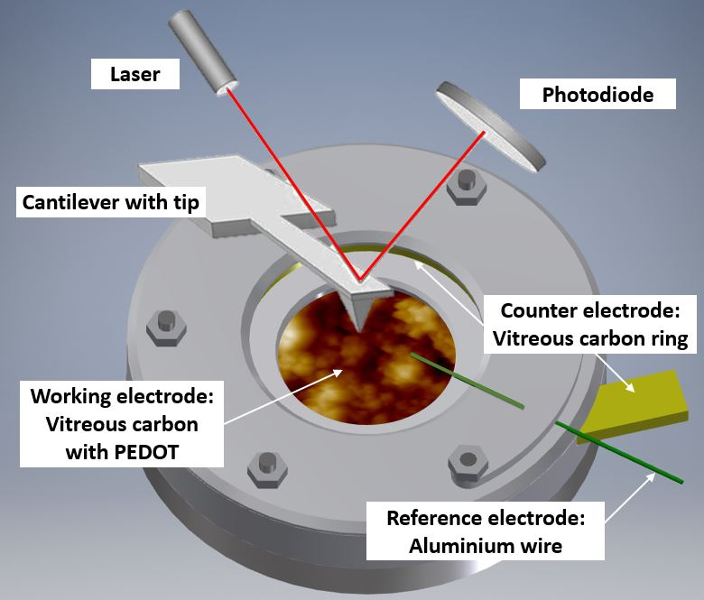

Figure 2: Illustration of the in-situ AFM cell with PEDOT on vitreous carbon covered in Lewis neutral EMImCl-AlCl3 ionic liquid.

The AFM (Dimension ICON, Bruker Co., Billerica, MA, USA) located in a glove box (MBraun, Inertgas-Systeme GmbH, Garching, Germany), using argon atmosphere (water and oxygen level below 10 ppm). The AFM measurements were carried out with a silicon probe coated with diamond-like carbon and a reflective aluminium layer at the back (Windsor Scientific, Multi75DLC, spring constant 3 N m-1, resonance frequency 75 KHz, tip radius < 10 nm). The probe was completely covered by the electrolyte during the duration of the electrochemical experiment.

Before the polymer film was charged/discharged, an initial AFM image of the PEDOT surface in the uncharged state was captured. The polymer surface was scanned horizontally over an area of of 5 µm × 5 µm at 0.5 Hz, 512 samples per line and 0.05 V force set point. The feedback gain has been adapted automatically as the images were taken in ScanAsyst mode (peak force tapping mode).

The initial position of the polymer surface was set as fixed scanning position and charged/discharged by linear sweep voltammetry (LSV) with 100 mV s-1 from 0 V to 2.5 V *vs.* Al|Al(III) and reverse to the uncharged state at 0 V. The LSV was stopped after every 500 mV and the potential was held at the OCP for capturing the AFM image with the same set of parameter as in the initial image. The OCP remained stable for the time spent to capture the image.

All AFM images were post-edited by a third-order polynomial flattening procedure using the Nanoscope Analysis software (Bruker Co., Billerica, MA, USA) to remove tilt and curvature. A movie combining the AFM images obtained at every step of the charge/discharge cycles is available at the supplementary information material.

1. Results and Discussion
   1. Electrochemical Quartz Crystal Microbalance Measurements
      1. Electro-Polymerisation

The resonance frequency and damping of the quartz in the EQCM were recorded during electro-polymerisation in Lewis neutral EMImCl-AlCl3 with 0.1 mol dm-3 EDOT between -0.5 V and 2.5 V *vs.* Al|Al(III) (Figure 3 A). The damping change is significantly larger than the frequency change, which indicates a viscoelastic behavior of the polymer film in ionic liquid. Therefore, a quantitative value of the polymerised mass as well as the doped/de-doped anion mass is rather vague, as the mass change cannot be considered directly proportional to the frequency change (Equation 3). Nevertheless, a qualitative evaluation of the mass change depending on the polymerisation time/cycle can be made.

The temporal course of the resonance frequency shows an overall decrease and stabilisation around 740 s (~cycle 12), indicating the continuous growth of the polymer film on the quartz crystal Figure 3 A). Each polymerisation cycle is characterised by a decrease followed by an increase of the resonance frequency, which is associated to the anion doping and de-doping. The anion doping during the monomer oxidation causes a decrease of the resonance frequency due to an increase of the polymer mass with inserted doping anions. The increase of the resonance frequency relates to the decrease of the polymer mass by removing the doping anions from the film during the reduction.

The calculated real *G’* and imaginary *G’’* parts of the shear modulus (Figure 3 B) show a similar trend like the frequency change. The overall increase of the shear modulus indicates a stiffening of the polymer film, whereas with every polymerisation cycle a decrease followed by an increase is present. The anion doping causes an increase of polymer softness (decrease of *G’*) while the polymer film regains stiffness during anion de-doping (increase of *G’*).

The calculated film thickness of the whole polymer film (Figure 3 C) increases up to 360 nm while polymerising. During doping/de-doping at every polymerisation cycle the film thickness fluctuates by about 100 nm.

The mass of the polymer film (Figure 3 C) increases constantly by adding a PEDOT layer with every polymerisation cycle.

The correction factor *b* (Figure 3 D) in the oxidised/doped state is 2.3 and in the reduced/de-doped state 1.8 after 12 cycles. A correction factor > 1 means that the film is very porous.



*Figure 3: (A) Frequency (black line) and damping (red line) change of a gold coated quartz crystal, (B) calculated shear moduli (real part, black line and imaginary part, red line), (C) polymer film thickness (black line) and mass (red line) and (D) correction factor during the polymerisation of EDOT in Lewis neutral EMImCl-AlCl3 with 0.1 mol dm-3 EDOT from -0.5 V to 2.5 V vs. Al|Al(III), 100 mV s-1, 25 °C.*

* + 1. Cycling in Ionic Liquid

The PEDOT films electro-polymerised in Lewis neutral ionic liquid were cycled in monomer-free Lewis neutral EMImCl-AlCl3. The overall frequency and damping change (Figure 4 A) remain approximately constant over time during all measured cycles. The decrease of the resonance frequency indicates anion doping during polymer oxidation/charging whereas the increase shows the anion de-doping during reduction/discharging. The damping change is significantly larger than the frequency change, making the quantitative determination of the exchanged mass difficult, as the Sauerbrey equation (Equation 3) cannot be applied.

The real part of the shear modulus (Figure 4 B) shows an overall decrease, pointing to a slight increase of the polymer softness with time. Every charging cycle shows a clear decrease while every discharging cycle is characterised by an increase of the shear modulus. Thus, the anion doping (charging reaction) causes a softening of the polymer film, which regains its stiffness when the anions are de-doped (discharge reaction).

The thickness of the PEDOT film (Figure 4 C) fluctuates about ±45 nm from its average value of 340 nm during charging and discharging cycles, indicating polymer swelling (increase film thickness) during doping and contraction (decrease film thickness) during de-doping, of AlCl4- anions.

There is nearly no net mass change of the polymer film during cycling time (Figure 4 C). The mass of the polymer increases when the film is doped with anions and decreases when it is de-doped. The PEDOT film reaches a reversibility in terms of the anion doping/de-doping >95%. Therefore, the doping anion AlCl4- is not trapped in the polymer backbone during charging and discharging.

The electro-polymerised PEDOT film has a calculated correction factor *b* (Figure 4 D) between 2.0 and 2.6, indicating a very rough surface area 32. Assuming that meaningful values were used for the physical properties of the system these values are two to three times larger than that reported for aqueous systems (b ~ 0.8) 20 due to a stronger interaction of PEDOT with the doping anion AlCl4-, which doping is not hindered by hydrate shielding.



*Figure 4: (A) Frequency (black line) and damping (red line) change of a gold coated quartz crystal, (B) calculated shear modulus (real part), (C) polymer film thickness (black line) and mass (red line) and (D) correction factor during the cycling of PEDOT in monomer-free Lewis neutral EMImCl-AlCl3 from 0 V to 2.5 V vs. Al|Al(III), 100 mV s-1, 25 °C.*

Each charging and discharging cycle can be divided in four potential areas with different behaviour shown by cyclic voltammetry (Figure 5 A), the change of resonance frequency (Figure 5 B) and the calculated shear modulus (Figure 5 C) as shown for cycle 10.

*Oxidation potential window I (0 V - 0.5 V):*

In the beginning of the polymer charging (oxidation) from 0 V to 0.5 V *vs.* Al|Al(III), the current density increases slightly. The frequency change shows also only a slight increase, which implies no significant anion doping or de-doping. The shear modulus shows a clear decrease, indicating a softening of the polymer.

*Oxidation Potential window II (0.5 V - 1.5 V):*

The following potential window from 0.5 V to 1.5 V *vs.* Al|Al(III) shows a wide oxidation peak of PEDOT, indicating the generation of positive charges in the polymer backbone. The frequency change reaches a maximum after a slight increase but shows no anion doping yet. The shear modulus decreases further up to its minimum. Thus, the polymer is softest at this potential window.

*Oxidation potential window III (1.5 V – 2.1 V):*

The further oxidation from 1.5 V to 2.1 V *vs.* Al|Al(III) shows another oxidation peak of PEDOT. At this potential window the resonance frequency decreases significantly which is a clear indicating of anion doping. The shear modulus increases slightly, indicating a stiffening of the polymer backbone due to the large number of doping with anions entering the polymer structure.

*Oxidation potential window IV (2.1 V - 2.5 V):*

The last potential window from 2.1 V to 2.5 V *vs.* Al|Al(III) is characterised by a phase-out of the oxidation peak and a further significant decrease of the resonance frequency, showing a clear anion doping. The polymer softens once again as the shear modulus decreases.

*Reduction potential window IV (2.5 V - 2.1 V):*

The discharge reaction (towards reduction) shows that the current density decreases and the resonance frequency increases strongly, indicating the reverse anion de-doping. The shear modulus decreases further, which might be related to the enhanced anion movement in the polymer backbone, opening the paths between the polymer chains due to the de-doping.

*Reduction potential window III (2.1 V - 1.5 V):*

The current density decreases almost linearly from 2.1 V to 1.5 V *vs.* Al|Al(III). Furthermore, there is almost no change in resonance frequency, pointing out no significant anion de-doping. However, the polymer is stiffening as the shear modulus increases.

*Reduction potential window II (1.5 V - 0.5 V):*

The potential window from 1.5 V to 0.5 V *vs.* Al|Al(III) shows a reduction peak of PEDOT, indicating the removal of repulsive forces between the polymer chains. This leads to the contraction of the polymer paths, accompanied with anion de-doping shown by increasing resonance frequency and further stiffening of the polymer as the shear modulus increases up to a maximum.

*Reduction potential window I (0.5 V - 0 V):*

The current density increases from 0.5 V to 0 V *vs.* Al|Al(III) and the frequency change is almost constant, showing that the anion de-doping is completed. The shear modulus increases again to its initial value, showing the regain of the original stiffness of the polymer.



*Figure 5: (A) Cyclic voltammogram, (B) frequency change of a gold coated quartz crystal, (C) calculated shear modulus (real part) and film thickness of the polymer film during charging (black lines) and discharging (red lines) of PEDOT in monomer-free Lewis neutral EMImCl-AlCl3 from 0 V to 2.5 V vs. Al|Al(III) at cycle 10, 100 mV s-1 at 25 °C.*

In order to better understand the dependence of the capacitive and faradaic behaviour of PEDOT with the state of charge/discharge, the scan rate of the CV of the polymer film was varied between 10 mV s-1 and 200 mV s-1 in monomer-free Lewis neutral EMImCl-AlCl3 (Figure 6).



*Figure 6: Cyclic voltammograms of PEDOT in monomer-free Lewis neutral EMImCl-AlCl3 at different scan rates, cycle 3 at 25 °C. Inset diagram shows relationship between Log(anodic current)- Log(scan rate) at 1.1 V and 2.1 V vs. Al|Al(III).*

The anodic and cathodic current density increases with the scan rate from 10 mV s-1 to 200 mV s-1. The cathodic peak at 0.6 V *vs.* Al|Al(III) for 200 mV s-1 shifts towards higher potentials with decreasing scan rate. This indicates that the anion de-doping occurs at high electrode potentials and low scan rates, which demonstrates capacitive behaviour at higher potentials.

The slope of the linear function, resulting from the power-law relation (Equation 10) by plotting the logarithm of the anodic current *vs.* logarithm of the scan rate at 1.1 V and 2.1 V *vs.* Al|Al(III), provides information about the transport dynamics of the underlying charge-storage mechanism 11,37 (Figure 6 inset diagram).

$I\left(V\right)=zγ^{x}$ (10)

The calculated slope *x* at 1.1 V and 2.1 V *vs.* Al|Al(III) is 0.6 and 0.7, respectively. A slope of 0.5 corresponds to a process limited by semi-infinite diffusion (faradaic behaviour) and a slope of 1 shows a surface-limited process, such as the adsorption of ions at a surface (pseudo-capacitive behaviour). The calculated values show that the oxidation of PEDOT (faradaic reaction) is accompanied by the anion doping (pseudo-capacitive reaction) and that at higher anodic potentials (higher state of charge) the (pseudo)-capacitive behaviour is predominant. It means that PEDOT as electrode material can provide high specific energies and a low state of charge and high specific power at a high state of charge.

* 1. *In-Situ* Atomic Force Microscopy

The *in-situ* AFM measurements of PEDOT films in monomer-free Lewis neutral chloroaluminate ionic liquid provided information about the morphological changes of the polymer surface during charging/discharging (anion doping/de-doping) cycles.

PEDOT polymerised in Lewis neutral chloroaluminate ionic liquid appears morphologically very porous and granular (Figure 7), when PEDOT is in its uncharged or un-doped state. The agglomerated grains have an average size of 100 nm and the maximum height difference between the agglomerated areas reaches up to 1 µm (Figure 7) (brighter areas have a larger height). The average surface roughness *Ra* is between 180 and 190 nm.

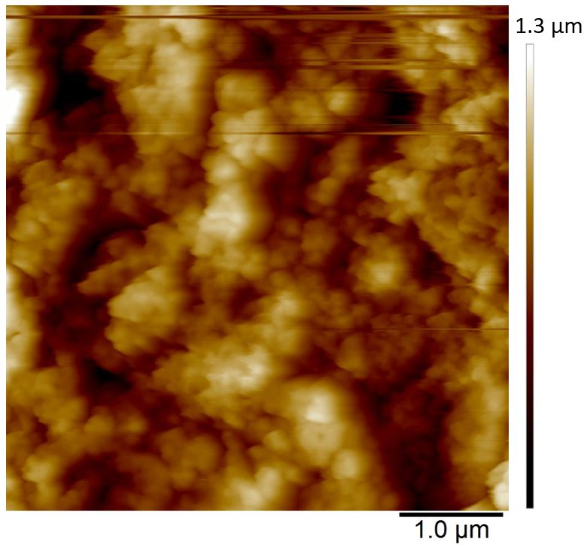

*Figure 7: Initial state AFM image of uncharged PEDOT in monomer-free Lewis neutral EMImCl-AlCl3. PEDOT was polymerised by CV from -0.5 V to 2.5 V vs. Al|Al(III) in Lewis neutral EMImCl-AlCl3 with 0.1 mol dm-3 EDOT at 100 mV s-1, 20 cycles and 25 °C.*

The polymer surface shows also local differences in terms of deformability (Figure 8) in the uncharged state. It has been shown that PEDOT grows as vertically aligned granular pillars, which are directly connected to the substrate. These pillars, which appear as grains on the surface (Figure 8 A), are partially connected horizontally by a granular polymer layer. This layer has no direct contact to the substrate and is visible as stretched areas (Figure 8 A) 14. The stretched areas are caused by the strong force applied between the tip and the polymer surface, which was needed to measure the deformability. It is assumed that the polymer pillars have a lower deformability due to the direct contact with the substrate and appear as darker areas (Figure 8 B) and the brighter areas with a higher deformability can be lead back to horizontally connecting polymer layers (Figure 8 B).

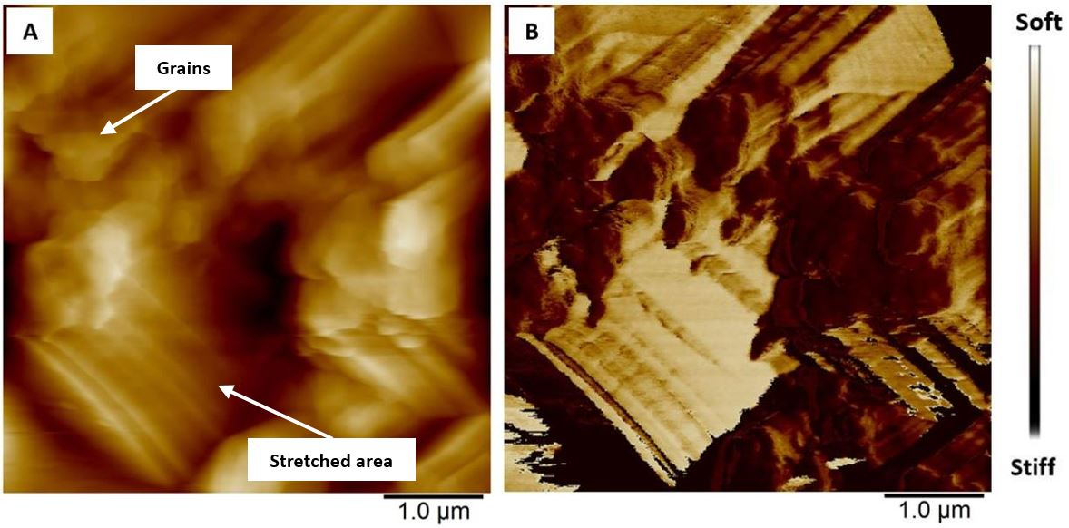

Figure 8: AFM images showing differences in (A) height and (B) deformability of uncharged PEDOT in monomer-free Lewis neutral EMImCl-AlCl3.

During the charging of un-doped PEDOT (Figure 9 A-E), the polymer oxidation and anion doping reaction, causes the merging of the polymer granules. Reversely, during discharging (Figure 9 F-J), the polymer reduces and anion de-doping reaction takes place. This is characterised by a renewed separation of the granules, whereas the grain shape and position are not identical with the previous grain morphology before the charging reaction. Four areas indicated as squares a, b, c, and d (Figure 9) clearly demonstrate the morphological changes and the merging of the granules and the reversible separation. The newly emerged grains have approximately the same size (~ 100 nm) similar to the initial grains. Most areas show the recovery of the initial morphology. However, area d seems not regain its initial surface morphology after discharging. The overall surface roughness *Rq* decreases from 180 to 190 nm up to ~160 nm during charging and increases during discharging again up to ~180 nm, which indicates high morphological reversibility during cycling.

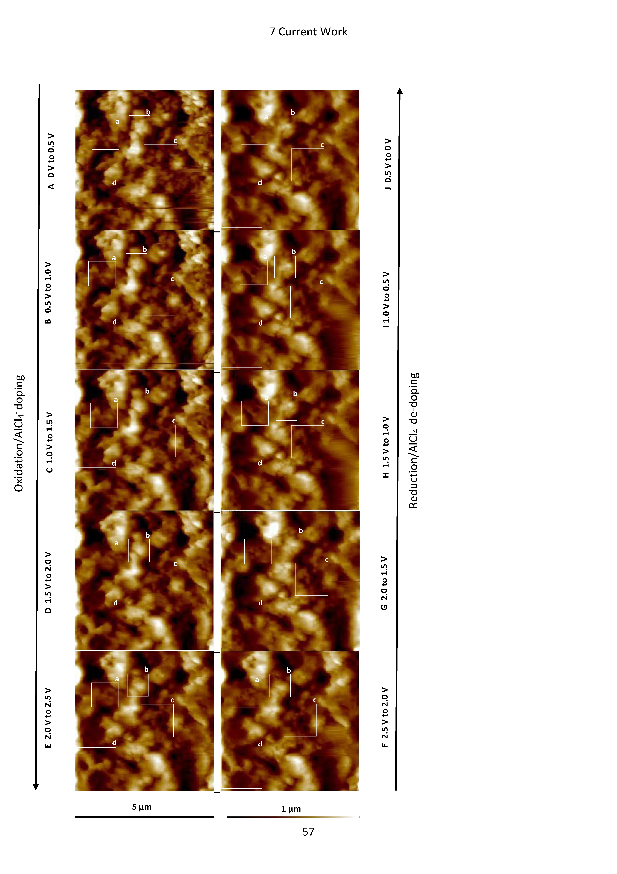

*Figure 9: AFM images at different state of charge (A-E) and discharge (F-J). The squared areas (a-d) show morphological surface changes of the PEDOT in detail.*

* 1. Suggested Model

The previously discussed EQCM and AFM results suggest that the change of polymer stiffness/softness, morphology as well as the faradaic and (pseudo)-capacitive behaviour, depending on the state of charge, are associated with each other.

The overall charging behaviour of PEDOT is characterised by a swelling and softening of the grainy morphology accompanied by anion doping. Similarly, the discharging reaction shows contraction of the polymer grains, which regain stiffness. At the same time the anions are fully de-doped. A closer look on each charging and discharging cycle reveals that the charge storage mechanisms depend on the state of charge.

*Polymer charging (oxidation):*

It is known that the oxidation of PEDOT (Figure 10 A) generates positively charged centres on the monomer units in the polymer backbone 20,38, which appear as peaks in the CV (Figure 5 A). During polymer charging, the number of positive charge carriers increases in the polymer backbone, leading to repulsive forces between the charged centres and the polymer chains (Figure 10 C). This implies a gradual opening of transport paths between the polymer chains, providing access for doping anions to the positive charges which are consequently neutralised in the polymer backbone. The anion doping into the polymer has been demonstrated by the decrease of the resonance frequency (Figure 5 B) with EQCM, whereas the polymer oxidation (faradaic behaviour) occurs first and is followed by the anion doping (pseudo-capacitive behaviour) at a lower state of charge. The calculated shear modulus decreases gradually during the charging reaction up to a minimum, outlining a softening effect of the polymer (Figure 5 C) due to the gradual opening of the transport paths. The opening of the transport paths and softening correlates with the overserved polymer swelling and grain merging shown by AFM measurements (Figure 9 A to E).

The slight increase of the shear modulus and stiffening of the polymer at a high state of charge accompanies the polymer oxidation with simultaneous strong anion doping (pseudo-capacitive behaviour), which stretches and expands the polymer backbone to its boundaries. The strong anion doping at a high state of charge (>2.1 V *vs.* Al|Al(III)) suggests a predominant pseudo-capacitive behaviour of the polymer.

*Polymer discharging (reduction):*

*Vice versa*, the polymer reduction (Figure 10 B) is accompanied by the removal of positive charges and therefore repulsive forces in the polymer backbone. This causes the reversible anion de-doping (Figure 5 B) and the contraction of the polymer morphology to its original grainy morphology, as shown by the AFM images (Figure 9 F to J). Simultaneously the shear modulus increases to its initial value, indicating the regain of the polymer stiffness (Figure 5 C).

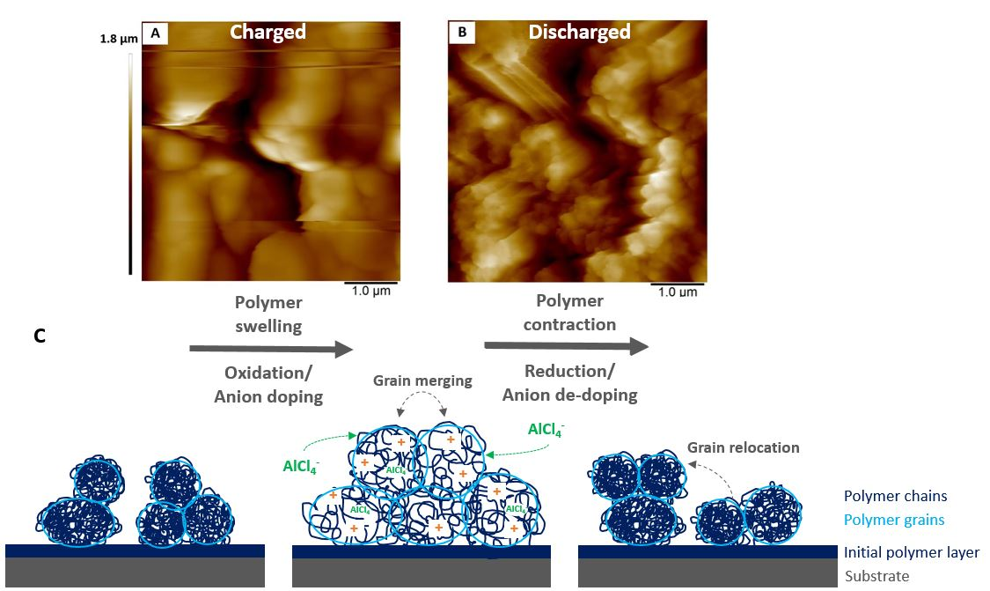

Figure 10: AFM images of PEDOT in monomer-free Lewis neutral EMImCl-AlCl3 in the fully (A) charged and (B) discharged state and (C) schematic model of the morphological changes of a conductive polymer in ionic liquid during charging (oxidation, anion doping) and discharging (reduction, anion-de-doping).

Furthermore, it is assumed that, the polymer swelling causes a stronger inter chain charge transport due to the merged polymer grains. For instance, the anion doping/de-doping at a higher state of discharge (2.1 V to 2.5 V *vs.* Al|Al(III)) seems to be more pronounced as the resonance frequency decreases/increases significantly (Figure 5 B). This might be related to the swollen polymer morphology with opened transport paths for anions between the polymer chains. The anions would have the ability to move in and out the polymer backbone easier. Furthermore, PEDOT shows a more (pseudo)-capacitive behaviour due to the enhanced anion doping/de-doping at this higher electrode potential (>2.1 V *vs.* Al|Al(III)). This has been proven by a steeper slope calculated by the power-law relation (Figure 6).

It can be concluded that an increasing state of charge is accompanied with an increase of (pseudo)-capacitive behaviour of PEDOT and a lower state of charge is characterised by faradaic or battery-like behaviour.

1. Conclusions and Foresight

In this work, the morphological and viscoelastic changes of the conductive polymer PEDOT in Lewis neutral EMImCl-AlCl3 ionic liquid have been studied by *in-situ* atomic force microscopy and electrochemical quartz crystal microbalance measurements in order to create a model for the fundamental understanding of the hybrid battery-(pseudo)-capacitor characteristic of conductive polymers.

It has been shown that:

1. PEDOT undergoes a reversible morphological modification during charging (polymer oxidation) and discharging (polymer reduction) while its viscoelastic properties change simultaneously.
2. The change of polymer characteristics is caused by a polymer swelling and contraction phenomena, which has been explained by the generation and removal of repulsive forces between the monomer units, accompanied by anion doping and de-doping of the polymer backbone.
3. The charging reaction causes a swelling and merging of the polymer grains as well as a softening of the film. This enables a fast charge transfer of doping anions at a high state of charge, which applies non-faradaic behaviour like a capacitor.
4. The discharging reaction is characterised by contraction and separation of the previously merged polymer grains, whereas the grains relocate from its initial position with a decreasing state of charge. At the same time, the polymer regains its stiffness and pronounced faradaic behavior like a battery.

These fundamental insights suggest that electro-polymerised conductive polymers, containing no extra weight due to additives or binders, can be used as safe and sustainable energy storage material in non-aqueous systems. Furthermore, the understanding of the polymer properties in accordance to the state of charge has an important influence on the polymer synthesis and design as the polymer morphology determines the performance and predominant electrode behaviour. A systematic structuring of the polymer can emphasise the battery or capacitor characteristics, depending on the wide range of applications.

**Acknowledgements**

This study is supported by the Centre for Doctoral Training in Sustainable Infrastructure Systems from the University of Southampton [EP/L01582X/1] and the International Consortium of Nanotechnology of the Lloyd’s Register Foundation [G0086]. EFRE (European Regional Development Fund) and DFG (German Research Foundation) are kindly acknowledged for the financial support provided for the purchase of the AFM device. The row data presented in this paper can be found at the repository DOI: 10.5258/SOTON/D0635 of the University of Southampton.

# Figure Captions

Figure 1: Illustration of the experimental set-up of the quartz crystal microbalance.

Figure 2: Illustration of the in-situ AFM cell with PEDOT on vitreous carbon covered in Lewis neutral EMImCl-AlCl3 ionic liquid.

Figure 3: (A) Frequency (black line) and damping (red line) change of a gold coated quartz crystal, (B) calculated shear moduli (real part, black line and imaginary part, red line), (C) polymer film thickness (black line) and mass (red line) and (D) correction factor during the polymerisation of EDOT in Lewis neutral EMImCl-AlCl3 with 0.1 mol dm-3 EDOT from -0.5 V to 2.5 V *vs.* Al|Al(III), 100 mV s-1, 25 °C.

Figure 4: (A) Frequency (black line) and damping (red line) change of a gold coated quartz crystal, (B) calculated shear modulus (real part), (C) polymer film thickness (black line) and mass (red line) and (D) correction factor during the cycling of PEDOT in monomer-free Lewis neutral EMImCl-AlCl3 from 0 V to 2.5 V *vs.* Al|Al(III), 100 mV s-1, 25 °C.

Figure 5: (A) Cyclic voltammogram, (B) frequency change of a gold coated quartz crystal, (C) calculated shear modulus (real part) and film thickness of the polymer film during charging (black lines) and discharging (red lines) of PEDOT in monomer-free Lewis neutral EMImCl-AlCl3 from 0 V to 2.5 V *vs.* Al|Al(III) at cycle 10, 100 mV s-1 at 25 °C.

Figure 6: Cyclic voltammograms of PEDOT in monomer-free Lewis neutral EMImCl-AlCl3 at different scan rates, cycle 3 at 25 °C. Inset diagram shows relationship between Log(anodic current)- Log(scan rate) at 1.1 V and 2.1 V *vs.* Al|Al(III).

Figure 7: Initial state AFM image of uncharged PEDOT in monomer-free Lewis neutral EMImCl-AlCl3. PEDOT was polymerised by CV from -0.5 V to 2.5 V *vs.* Al|Al(III) in Lewis neutral EMImCl-AlCl3 with 0.1 mol dm-3 EDOT at 100 mV s-1, 20 cycles and 25 °C.

Figure 8: AFM images showing differences in (A) height and (B) deformability of uncharged PEDOT in monomer-free Lewis neutral EMImCl-AlCl3.

Figure 9: AFM images at different state of charge (A-E) and discharge (F-J). The squared areas (a-d) show morphological surface changes of the PEDOT in detail.

Figure 10: AFM images of PEDOT in monomer-free Lewis neutral EMImCl-AlCl3 in the fully (A) charged and (B) discharged state and (C) schematic model of the morphological changes of a conductive polymer in ionic liquid during charging (oxidation, anion doping) and discharging (reduction, anion-de-doping).

**List of Symbols**

A Area [cm2]

b Sauerbrey correction factor

C Capacity [mA s]

c Concentration [mol dm-3]

E Potential [V]

E0 Standard potential [V]

Espec Specific energy [Wh kg-1]

F Faraday constant [As mol-1]

f Resonant frequency [Hz]

f0 Resonant frequency of the unloaded quartz [Hz]

fs Resonant frequency of the quartz in fluid [Hz]

G Shear modulus [Pa]

G* Complex shear modulus [Pa]

G’ Storage modulus, real part of the shear modulus [Pa]

G“ Loss modulus, imaginary part of the shear modulus [Pa]

h Film thickness [nm]

hf Film thickness of the polymer [nm]

hfSB Film thickness of the polymer, calculated by Sauerbrey [nm]

hrl Film thickness for a rigid layer [nm]

I Current [mA]

i Imaginary unit ($i=\sqrt{-1}$)

Im Imaginary part

j Current density [mA cm-2]

K2 Electromechanical linking factor for the quartz

L Inductivity [Vs A-1]

m Mass [µg]

M linking factor [Ω]

MEDOT  Molar mass of EDOT [g mol-1]

MIL Molar mass of ionic liquid [g mol-1]

N Amount of AlCl3

n Amount of substance [mol]

Pspec Specific energy [W kg-1]

Q Transferred amount of charges [mA s]

Qspec Specific capacity [mA s kg-1]

R Resistance [Ω]

Rq Overall surface roughness (root mean squared) [nm]

Re Real part

T Temperature, absolute [K]

t Time [s]

v Scan rate [mV s-1]

w Damping [Hz]

w0 Damping of the unloaded quartz [Hz]

ws Damping of the quartz in fluid [Hz]

Xl Reactance of the electrolyte [g cm-2s-1]

z Number of charge carrier

Zf, Zs Film impedance [g cm-2s-1]

Mechanical impedance of the film, calculated by Sauerbrey [g cm-2s-1]

Zl Impedance of films in electrolyte [g cm-2s-1]

ZQ, Zq Characteristic impedance of the quartz [g cm-2s-1]

Ztr Impedance of films with trapped electrolyte [g cm-2s-1]

*α* Degree of doping

*Δf* (Resonant-)frequency change [Hz]

*Δw* Damping change [Hz]

*ηl* Kinematic viscosity of the electrolyte [g cm-1s-1]

*µQ,* *µq* Shear modulus of the quartz [g cm-1s-2]

*ρ* Density [g cm-3]

*ρf*  Density of the polymer film [g cm-3]

*ρl* Density of the electrolyte [g cm-3]

*ρQ, ρq*  Density of the quartz [g cm-3]

*ρrl* Density for a rigid layer [g cm-3]

*χ* Molar ratio [mol-%]

*ω* Radial frequency [s-1]

# References

1. R. Korthauer. Handbook lithium-ion-batteries. *Springer-Verlag Berlin Heidelberg* (2013).

2. D. Larcher & J.-M. Tarascon. Towards greener and more sustainable batteries for electrical energy storage. *Nature Chemistry* **7,** 19–29 (2015).

3. C.P. Grey & J.M. Tarascon. Sustainability and in situ monitoring in battery development. *Nature Materials* **16,** 45–56 (2017).

4. H.D. Yoo, E. Markevich, G. Salitra, D. Sharon & D. Aurbach. On the challenge of developing advanced technologies for electrochemical energy storage and conversion. *Materials Today* **17,** 110–121 (2014).

5. B.E. Conway & W.G. Pell. Double-layer and pseudocapacitance types of electrochemical capacitors and their applications to the development of hybrid devices. *Journal of Solid State Electrochemistry* **7,** 637–644 (2003).

6. J. Heinze, B.A. Frontana-Uribe & S. Ludwigs. Electrochemistry of conducting polymers-persistent models and new concepts. *Chemical Reviews* 4724–4771 (2010).

7. J.L. Bredas & G.B. Street. Polarons, Bipolarons, and Solitons in Conducting Polymers. *Accounts of Chemical Research* **18,** 309–315 (1985).

8. P. Simon & Y. Gogotsi. Materials for electrochemical capacitors. *Nature Materials* **7,** 845–854 (2008).

9. D.P. Dubal, O. Ayyad, V. Ruiz & P. Gomez-Romero. Hybrid energy storage: the merging of battery and supercapacitor chemistries. *Chemical Society Reviews* **44,** 1777–1790 (2015).

10. T. Brousse, D. Belanger & J.W. Long. To Be or Not To Be Pseudocapacitive? *Journal of the Electrochemical Society* **162,** A5185–A5189 (2015).

11. J.S. Ko, M.B. Sassin, D.R. Rolison & J.W. Long. Deconvolving double-layer, pseudocapacitance, and battery-like charge-storage mechanisms in nanoscale LiMn2O4 at 3D carbon architectures. *Electrochimica Acta* **275,** 225–235 (2018).

12. C. Peng, S. Zhang, D. Jewell & G.Z. Chen. Carbon nanotube and conducting polymer composites for supercapacitors. *Progress in Natural Science* **18,** 777–788 (2008).

13. G.A. Snook, P. Kao & A.S. Best. Conducting-polymer-based supercapacitor devices and electrodes. *Journal of Power Sources* **196,** 1–12 (2011).

14. T. Schoetz, C. Ponce de Leon, A. Bund & M. Ueda. Electro-polymerisation of 3,4-ethylenedioxythiophene on reticulated vitreous carbon in imidazolium-based chloroaluminate ionic liquid as energy storage material. *Electrochemistry Communications* **89,** 52–56 (2018).

15. J.H. Park & O.O. Park. Hybrid electrochemical capacitors based on polyaniline and activated carbon electrodes. *Journal of Power Sources* 185–190 (2002).

16. P. Damlin, C. Kvarnström & A. Ivaska. Electrochemical synthesis and in situ spectroelectrochemical characterization of poly(3,4-ethylenedioxythiophene) (PEDOT) in room temperature ionic liquids. *Journal of Electroanalytical Chemistry* **570,** 113–122 (2004).

17. T. Schoetz, C. Ponce de Leon, A. Bund & M. Ueda. Electro-polymerisation and characterisation of PEDOT in Lewis basic, neutral and acidic EMImCl-AlCl3 ionic liquid. *Electrochimica Acta* **263,** 176–183 (2018).

18. T. Schoetz, C. Ponce de Leon, M. Ueda & A. Bund. State of the art of rechargeable aluminium batteries in non-aqueous systems. *Journal of the Electrochemical Society* **164,** A1–A4 (2017).

19. N.S. Hudak. Choroaluminate-doped conducting polymers as positive electrodes in rechargeable aluminium batteries. *The Journal of Physical Chemistry* **118,** 5203–5215 (2014).

20. R. Peipmann. In situ Charakterisierung der viskoelastischen und elektrochemischen Eigenschaften von Poly(3,4-ethylendioxythiophen). *Dissertation* (2011).

21. H.L. Bandey, S.J. Martin, R.W. Cernosek & A.R. Hillman. Modeling the responses of thickness-shear mode resonators under various loading conditions. *Analytical Chemistry* **71,** 2205–2214 (1999).

22. G. Sauerbrey. Verwendung von Schwingquarzen zur Wägung dünner Schichten und zur Mikrowägung. *Zeitschrift für Physik* **155,** 206–222 (1959).

23. S.J. Martin, H.L. Bandey, R.W. Cernosek, A.R. Hillman & M.J. Brown. Equivalent-circuit model for the thickness-shear mode resonator with a viscoelastic film near film resonance. *Analytical Chemistry* **72,** 141–149 (2000).

24. V. Edwards Granstaff & S.J. Martin. Characterization of a thickness‐shear mode quartz resonator with multiple nonpiezoelectric layers. *Journal of Applied Physics* **75,** 1319–1329 (1994).

25. H.L. Bandey, A.R. Hillman, M.J. Brown & S.J. Martin. Viscoelastic characterization of electroactive polymer films at the electrode/solution interface. *Faraday Discussions* **107,** 105–121 (1997).

26. R. Lucklum, C. Behling, P. Hauptmann, R.W. Cernosek & S.J. Martin. Error analysis of material parameter determination with quartz-crystal resonators. *Sensors and Actuators A: Physical* **66,** 184–192 (1998).

27. A.R. Hillman, A. Jackson & S.J. Martin. The Problem of Uniqueness of Fit for Viscoelastic Films on Thickness-Shear Mode Resonator Surfaces. *Analytical Chemistry* **73,** 540–549 (2001).

28. E.J. Calvo & R. Etchenique. Viscoelastic Changes in Os-Containing Poly(allylamine) Based Redox Hydrogels for Amperometric Enzyme Electrodes:  An EQCM Study. *Journal of Physical Chemistry B* **103,** 8944–8950 (1999).

29. A. Ispas, R. Peipmann, A. Bund & I. Efimov. On the p-doping of PEDOT layers in various ionic liquids studied by EQCM and acoustic impedance. *Electrochimica Acta* **54,** 4668–4675 (2009).

30. I. Efimov, A. Ispas & A. Bund. Taking into account of surface roughness for the calculation of elastic moduli of polymer films from acoustic impedance data. *Electrochimica Acta* **122,** 16–20 (2014).

31. V.-T. Gruia, A. Ispas, M. Wilke, I. Efimov & A.Bund. Application of acoustic impedance method to monitoring of sensors:Metal deposition on viscoelastic polymer substrate. *Electrochimica Acta* **118,** 88–91 (2014).

32. S. Koehler, A. Bund & I. Efimov. Shear moduli of anion and cation exchanging polypyrrole films. *Journal of Electroanalytical Chemistry* **589,** 82–86 (2006).

33. I. Efimov, S. Koehler & A.Bund. Temperature dependence of the complex shear modulus of cation and anion exchanging poly(pyrrole) films. *Journal of Electroanalytical Chemistry* **605,** 61–67 (2007).

34. A. Ispas, E. Wolff & A.Bund. An Electrochemical Quartz Crystal Microbalance Study on Electrodeposition of Aluminum and Aluminum-Manganese Alloys. *Journal of the Electrochemical Society* **164,** 5263–5270 (2017).

35. L. Daikhin, E. Gileadi, G. Katz, V. Tsionsky, M. Urbakh & D. Zagidulin. Influence of Roughness on the Admittance of the Quartz Crystal Microbalance Immersed in Liquids. *Analytical Chemistry* **74,** 554–561 (2002).

36. M. Urbakh & L. Daikhin. Roughness effect on the frequency of a quartz-crystal resonator in contact with a liquid. *Physical Review B* **49,** 4866–4870 (1994).

37. Y. Yan, B. Hao, D. Wang, G. Chen, E. Markweg, A. Albrecht & P. Schaaf. Understanding the fast lithium storage performance of hydrogenated TiO2 nanoparticles. *Journal of Materials Chemistry A* **1,** 14507–14513 (2013).

38. L.T.T. Kim, C. Gabrielli, A. Pailleret & H. Perrot. Ions/Solvent Exchanges and Electromechanical Processes in Hexasulfonated Calix[6]Arene Doped Polypyrrole Films: Towards a Relaxation Mechanism. *Electrochemical and Solid-State Letters* **14,** F9–F11 (2011).

1. * Corresponding author.

   E-mail: T.Schoetz@soton.ac.uk, Tel: +44 (0) 2380 5989 31, Fax: +44 (0) 2380 5970 51