Location-specific Stock Market Indices: An Exploration

Surendranath Rakesh Jory¹, Tapas Mishra¹ and Thanh N. Ngo²

¹ Department of Banking and Finance,

Southampton Business School,

University of Southampton, UK

² Department of Finance, College of Business
East Carolina University

Abstract
This article develops an alternative location-specific stock market index driven by investors’ ‘attachment’ towards investment at a specific location. We evaluate the performance of hypothetical stock market indices that track companies based on their state of registration, taking the US stock market as our case. Using annual data since 1980 we present raw, risk-adjusted and value-weighted state portfolios’ returns to study the extent to which stock market performance varies by state-level demographics and economic factors. A dynamic panel data estimation – with and without spatial spillover effects – is employed to establish a strong association between stock price performance and the state-level (or geography-weighted) factors. We find that spatial effects are strong and that the ‘spatial attachment’ of companies in interaction with the various location-specific variables imparts an overarching influence on stock-price performance. Comparison of model performances further supports our claims.

JEL CLASSIFICATION: G10; G11
KEYWORDS: State Index; State Portfolios; Portfolio Choice; Investment Decisions; Spatial Spillover Effects; Dynamic spatial panel estimation.

Location-specific Stock Market Indices: An Exploration

I. Introduction
1.1. Segregate or integrate ‘location’-specific effects?
The demography-weighted psychological aspects of an investor’s decision to invest in a specific ‘location’ are now well-documented research topics. The extant research in this regard lays great emphasis on the importance of ‘state pride’ instead of ‘national pride’ forming the basic foundation underpinning investors’ proclivity towards ‘location-specific’ investment. Such a ‘pride’ factor embodies an inherent economic gradient as it is often argued that partisan sentiments trigger investors’ interest in local businesses, where sentiment plays an important role in investments (Bathia and Bredin 2013). Heinkel, Kraus and Zechner (2001) show that exclusionary ethical investment by polluting firms is held in check by investors since green investors eschew polluting companies’ stock. Renneboog, Ter Horst and Zhang (2008) argue that socially responsible investments have experienced explosive growth worldwide, reflecting investors’ increasing awareness of social, environmental, ethical and corporate governance quality standards. Thus, in addition to financial considerations, ‘sentiments’ or ‘attachment’ that nudge investors to favor their local companies over others are befitting. If sentiments – reflecting persistent financial value-building on strong ‘social ties’ – can determine location-specific investment decisions, then an indicator of the investors’ performances would require inclusion of the dynamic aspects of this ‘sentiment’ as the driving factor in the stock performances. Despite its centrality in the study of ‘regional’ financial development, there is a clear lack of research in this direction.
This paper addresses a gap in the literature by proposing a location-specific stock market index, the study of which can reveal the associative effects of ‘attachment’ values of investors in a specific location. We compile a list of US publicly traded companies by state and create hypothetical stock market indices. We analyze the performance of the state indices over time as well as the factors that affect their performance. This study thus sheds light on the contribution of each state to the overall stock market performance, implicitly allowing us to gauge the effects of essential – but hard-to-measure – variables determining share prices at the state level.
The important question of course concerns whether ‘sentimental’ or ‘attachment’ values shift investors’ focus to ‘localization’ rather than ‘nationalization’ or ‘globalization’. Indeed, the sentimental binding force that limits transcendental mobility of investors due to the dynamic movements of opportunities across ‘space’ is an important determinant in the study of stock index. Segregating the location-specific attributes from the main determinants of stock index offers valuable insights on the risk management, tenacity, and risk proliferation aspects of an investment decision. Conventional work in this regard holds demographic, location-specific, attachment-attributable factors as exogenous/constant to the growth of stock price. We argue that these factors endogenously determine stock market performance due to the intertwined nature of these factors with financial and economic variables. Eventually, this adds complexity to the identification of the true nature of stock performances, resulting in significant measurable bias. In this paper, we innovate upon the extant literature by proposing a location-specific stock market index and empirically study the effects of various determinants in a space-time setting.

1.2. ‘Space’ as a determinant
Because ‘locational-attachment’ is a major driving force in the overall performance of stock market, a logical step to estimate its effects is to embed ‘location’ in an empirical model. Toward this objective, this paper builds an empirically testable analytical model to demonstrate that ‘space’ – as a determinant – governs performance of the stock market in a given location and, at the same time, impacts dynamic interdependence among other stocks markets, in response to spillover effects that is a natural outcome in such a model. In other words, ‘space’, in our setting, plays dual roles viz., (a) a (sentimental) location-specific value where the geographic-specific demographic and economic factors determine the extent of performance of some stock markets, and (b) due to the ubiquity of space, spillover effects cannot be overruled. In other words, inclusion of the ‘spatial’ attribute in our empirical model can enrich model dynamics and minimize potential endogeneity bias. The existence of spatial dependence can be motivated by two different concepts, one that relies on omitted explanatory variables and a second that is based on spatial spillovers stemming from contagion effects (see, for example, LeSage and Pace (2010)). Our study focusses on the latter concept. In our construct, each location-specific stock-market is bound to experience ripple effects from any overarching change in the ‘neighborhood’. Our aim is to identify to what extent different linkages between state stock markets affect the degree of market co-movements.
In light of the above, we estimate a spatial dynamic panel model of the stock price performance driven by state-level demographics and economic factors. A conventional non-spatial dynamic model is used as a benchmark case. Our ‘gravity-type’ geographic empirical model indeed demonstrates that spatial effects are strong and positive and that their interactions with demographic and economic factors render expected and stronger effects on stock-price performances.
Our study makes three important contributions to the literature. First, to the best of our knowledge, the research undertaken in this paper is probably among the first to undertake an in-depth analysis of the location-specific but demography-and-economic dynamics-driven financial market performance, particularly in the case of the US stock markets. Second, our consideration of the ‘geographic’ neighborhood structure and its interactions with demographic and economic factors is a novel approach. Third, by identifying various linkages through which state-level stock markets in the US relate to each other, and by assessing the relative importance of these linkages, we provide new insights which can be used by financial investors for risk hedging through global diversification. As we already know, a critical issue in risk management is to obtain precise estimates of the future co-variances between markets, such as the one in our case, viz., state-level stock price performances.
Our empirical exercise gives rise to several interesting findings: we observe clear differences in states’ stock-index performances, with some states consistently outperforming the rest. Besides, the distribution of the states’ returns series depicts visible patterns of cluster formations, which infers the relevance of location-specific effects. The analysis of the temporal movements in the states’ stock-portfolios’ return series shows that they are related to state variables including unemployment, population growth and a host of business indicators that include the state coincidence index, corporate debt, business formations, and takeovers. Moreover, we are able to identify and estimate the extent to which ‘size effects’ of firms are sensitive to the location of headquarters (i.e. whether larger multinational firms are affected less than smaller firms with more local exposure are). The rest of the paper proceeds as follows. We review the literature in section 2. We present our data and describe the methods used in Section 3, and discuss our findings in Section 4. Results from robustness exercises are discussed in Section 5. Comparison of model performances is presented in Section 6 and, finally, Section 7 summarizes the main findings of our paper with some discussions of their implications.

2. Synoptic review of the literature
Proximity (i.e. the factor that we use to build stock market portfolios) plays an important role in investments. Hong, Kubik and Stein (2005) find that fund managers are more likely to trade a stock if other managers in the same city are trading the same stock. They interpret their findings in terms of an epidemic model in which investors disseminate information about stocks to one another by word of mouth. Strong and Xu (2003) find that fund managers from the US, the UK, Europe and Japan show a significant relative optimism towards their home equity market. Parwarda (2008) concludes that start-ups are located close to the origins of their founders and finds a strong local bias in the equity holdings of new money managers. The presence of local institutional investors further strengthens the preference for local stocks.
It is important to undertake a study of the performance of local companies regrouped in an index as several studies show a preference for local share investments among retail investors. Using data on the investments of 78,000 US retail investors of a broker firm between 1991 and 1996, Ivkovic and Weisbenner (2005) find that households exhibit a strong preference for local investments. On average, 30% of households’ portfolio comprise stocks of companies headquartered within 250 miles of their location. While investors face less information asymmetry on local firms compared to nonlocal ones, some are naturally inclined to invest in companies that they know even though they are not necessarily well-informed.
To the extent that investors’ preference for local stocks is not motivated by issues of information asymmetry, their inclination is a behavioral matter; otherwise we should find evidence of superior performance by local companies to support behavioral bias. Ivkovic and Weisbenner (2005) find that local investments outperformed nonlocal ones by 3.2% per year over the one-year horizon, which suggests that locally available information is value-relevant. Brown, Ivković, Smith and Weisbenner (2008) find strong causal community effects in stock market investments; they demonstrate that an increase in community stock ownership makes individuals more likely to participate in the stock market. Consistent with a word-of-mouth interpretation, the community effect is stronger in more sociable communities.
Coval and Moskowitz (2002) find that – akin to international investment portfolios – the preference for investing close to home applies equally to portfolios of domestic stocks. They find that US investment managers exhibit a strong preference for locally headquartered firms. The authors determine that asymmetric information between local and nonlocal investors drives the preference for geographically proximate investments.
For businesses, the choice of a state location also depends on the nature of the company’s products or services. For instance, companies engaged in shale oil production prefer North Dakota. Manufacturing firms in the auto industry favor the Rust Belt states of Illinois, Indiana, Michigan and Ohio, while Tech companies elect the state of California as their area of choice. Thus, despite their openness, we find that state characteristics affect companies’ decision to locate their businesses. To the extent that state characteristics affect the choices to locate corporations, we expect to find a strong association between business performance and state characteristics.
A limited number of previous studies have attempted to explain the impact of various factors on financial market co-movements or correlations. These studies have relied primarily on the estimation of panel gravity models. For example, Beine and Candelon (2011) and Wälti (2011) regress the correlation or co-exceedance among national stock markets on economic sizes (GDP or market capitalization) and distances between the markets (measured by cross-country-specific variables). They find that correlations depend on trade linkages, monetary integration, geographical variables, and the industrial compositions of markets.
We focus on the ‘geographic’ aspect of ‘spatial connectedness’, instead of ‘relational connectedness’ via measures of economic metrics such as trade, industrial compositions of markets, and human capital appropriation in the production technology. Given that our objective is to capture ‘sentimental’ or ‘attachment’ aspects of firms, which might govern their stock performances, ‘geographical proximity’ can model these aspects better. Indeed, according to Tobler’s law, ‘everything is related to everything else, but near things are more related than distant things’. Here ‘near’ is defined as a physical proximity term. In our context, some firms may ascribe attachment value to a specific location, such as a state, where these firms may value ‘state pride’ over ‘national pride’ (Heinkel et al. 2001; Renneboog et al. 2008). Within the boundaries of geographic proximity, however, one can impose relational proximity, defined in an economic sense as where consideration of such an interaction within a modeling framework may strengthen the role of ‘geographic’ distance. Compared with the gravity model approach, our study is not purely bilateral, i.e. we do not capture the average effect of distances on any purely bilateral correlation but rather the average effect of distances on the correlations between one state and many other states concurrently. More importantly, our study allows for feedback effects among related markets.

3. Data (description) and methodology

3.1 Data
We download historical data on US companies’ state of incorporation from the COMPUSTAT Back Data file. Our sample period starts in 1980 and ends in 2012. The stock markets of the companies include NYSE, AMEX and NASDAQ. In January of each year, we create value-weighted portfolios of the listed stocks per state using market capitalization as weight. We use the value of the market capitalization as at the last trading day of the preceding December. We rebalance the portfolio every January.

3.2 Model
To study the performance of the stock market indices by state, first, we compute two measures of stock return – i.e. a simple average return and a geometric average return. The simple average return (AR) is the yearly average of the monthly portfolio return (R). The geometric return is the product of the 12 monthly returns as follows:
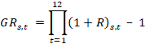, | (1)
where is the geometric rate of return for the year, is the average of the monthly returns of the stocks comprising the state () portfolio, and represents months 1, 2,…,12.
Second, we compute measures of excess returns, where positive values indicate superior performance and negative values indicate inferior performance. We use the Market Model (MM) and the Fama and French (1993) Three-Factor Model (FF3F) to derive two alternative measures of yearly excess returns. To estimate the parameters of the two models, we use the 36-monthly state portfolio returns prior to the year we measure the portfolio’s performance. We use the parameters to calculate the portfolio’s excess return over the following 12 months. We present the simple and geometric 12 months’ average of each of the MM and FF3F. The models are as follows:

MM Model:

, | (2)
and
FF3F Model:
, | (3)

where is the market rate of return, is a portfolio of small stocks minus big stocks; is a portfolio of high book-to-market stocks minus low book-to-market stocks; stands for state, stands for month, and the error term () represents the monthly excess return for state .

3.3 Estimation
Due to the cross-sectional and temporal features of our data, our estimation is carried out within a panel-data environment. Among various available approaches, we employ the dynamic panel data method with spatial consideration. Dynamics bring into consideration the relevance of ‘history’ in shaping stock prices. Past stock prices are expected to determine their future movements. At the same time, we also assume that only temporal consideration masks the explicit impact of ‘space’ – the main consideration of our paper. Therefore, a dynamic method but with spatial effects considering temporal movements is considered suitable for our purpose. A spatial dynamic panel model with endogeneity corrections has thus been employed.
Next, we present a spatial model that explicitly considers ‘location-specific’ effects on state-level stock-price performances.

3.3.1 Spatial consideration: Theoretical justification
To present our spatial framework, we assume that there are N states, indexed by . Each state’s stock price performance (RT) is assumed to be characterized by three factors:
- M for demographic factors;
- X for economic factors; and,
- for spatial attributes.
The model for state index stock returns is as follows:
, (4)
where is a technology or mechanism that transforms M and X into RT. α delineates the importance of demographic/locational factors M in stock market performance RT.
We impose two conditions: (i) is the contaminated performance transmission effects, and (ii) various other control variables (such as population and other demographic factors) exert constant effect in each region. The latter can allow us to use (denoted as ) to indicate the proportion of demographic factors’ variations with respect to changes in economic variables. We can then express:
. (5)
Externalities from demographic variations, transmission and learning-by-doing for each company in each state is captured by 0 < δ < 1 in equation (5). Stock market performance (across states) is represented by the parameter 0 < β < 1. It is assumed that the interdependence is not perfect because of the presence of possible frictions between the state and other states , which is captured by . Elements of are assumed to be positive, such that . Values of , i.e. higher (the limit being 1) or lower (the limit being 0), imply the strength of relationship or distance among states. The greater the strength, the higher the spillover.
Equation (5) can be re-written by taking the natural logarithm on both sides as follows:
Suppressing , and in equation (5) and denoting 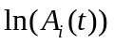 by 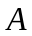, 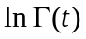 by , 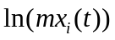 by , 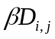 by 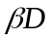 and 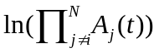 by , we can re-express equation (5) in compact form as
. (6)
Re-arranging common terms (i.e. and the on the left side of equation (6)), we obtain (assuming that and . Replacing in equation (4) and expanding this further leads to:
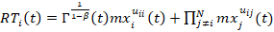, (7)
where
(8)
and
. (9)
The above results generate the following proposition:

Define . Then spatial frictions determine the extent to which demographic and economic factors affect stock market performances across states.

The proof of the proposition follows from the analytical equations, and assumes that spatial frictions affect stock market performance dynamics among states , and that the effect of demographic/economic variations depends upon the strength of β. Higher β represents greater interdependence, and would ensure faster movements of demographic/economic shocks across borders. Therefore, interdependent states will experience greater and similar effects of shocks than would have been the case under an atomistic environment. The analytical model presented above is estimated using a spatio-temporal method, which combines instrumentality of ‘space’ with the dynamics of stock market performance following LeSage and Pace (2010). Equation (7) needs to be estimated not only with `spatial’ weight but also by adding location-specific determinants. Equation (10) below is designed to accommodate the required characteristics.
3.3.2 Empirical presentation, identification issues, and estimation strategy
The analytical expression in equation (7) can have an empirical representation with or without adding control variables that might affect long-run behavior. We hold that the equilibrium status of state portfolio return is a function of an intercept, a spatial dependence from the endogenous variable, the independent variables both within spatial boundaries and across spatial adjacent locations, and spatial dependence among the error terms. Moreover, we also allow the dependent variable, , to be governed by both its temporal and spatially temporal lagged values. These specifications are akin to what is known as the dynamic spatial panel data model. Following Anselin et al. (2008), Debarsy et al. (2012) and Elhorst (2014), among others, the general specification of the dynamic spatial model is as follows:
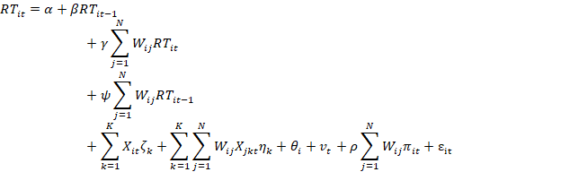
(10)
Following Elhorst (2014), three different types of the spatial panel model are estimated – i.e. spatial autoregressive model (SAR) including spatial endogenous dependence; spatial Durbin model (SDM) including spatial endogenous and exogenous dependencies; and spatial error model (SEM) allowing spatial residual dependence – respectively. A detailed description of the empirical model is presented in the Appendix.
Literature employs a number of strategies to estimate equation (10), depending on, for instance, whether one is adding (endogenous and exogenous) spatial interaction terms in the spatial Durbin model, whether there are spatial and temporal dynamics in the model specification, and whether the heteroscedasticity (if present) is in known or unknown forms. Our preferred specification is a spatial Durbin model (SDM) as we can add spatial endogenous and exogenous interactions (Lee and Yu 2016). We note below its key advantages in relation to our empirical analyses. First, it complies with the identification requirements as noted in Manski (1993) and only suffers the minimum cost of exclusion of spatial residual interactions compared with other spatial models. Second, SDM offers unbiased and consistent estimation irrespective of the real data-generating process (either SAR or SEM) (Elhorst 2014). Third, it distinguishes the explanatory power of the exogenous variables not only within spatial boundaries (direct effect), but also across spatially contiguous locations (indirect effect). Elhorst (2014) demonstrates that the non-spatial model seriously biases the coefficient estimations and is unable to shed light on the indirect effects (spatial spillover effects) from spatially neighboring units. Fourth, SDM enables us to account for not only spatial dependencies but also spatial heterogeneity across spatial locations by incorporating the spatially lagged dependent variable and spatially lagged independent variables, respectively. Fifth, in terms of the endogeneity problem (which is typical in an empirical context such as ours), the SDM helps ameliorate endogeneity issues and omitted variable bias.
In addition, in terms of the comparison of spatial model specifications, Lee and Yu (2016) show that disregarding Durbin terms (spatial exogenous interactions) leads to serious estimation biases, while adding irrelevant Durbin terms only leads to indistinct efficiency loss. This is consistent with the theoretical viewpoint discussed above in that SDM is superior to other spatial models. In our estimation, we employ a series of likelihood ratio (LR) tests as used by Elhorst (2010) to examine whether the SDM is our preferable specification among a set of competitive spatial panel models.
In a specific context, if we suspect that the variances are non-constant and are not homoscedastic, or that there is a high-order spatial correlation where the space and time interact in a complex way, then the estimation of quasi-MLE is computationally burdensome but not completely invalid. The moment-based GMM estimation often resolves this computational issue. In our robustness exercise section, we employ the methodologies as in Wang and Lee (2018) along with Lin and Lee (2010) to re-estimate our benchmark model.

3.3.3 Endogeneity concerns
Our empirical specification might suffer from possible endogeneity bias. It is necessary to employ strategy to overcome such a bias to guarantee consistent and unbiased estimates of the parameters (for discussion, see Fingleton and Le Gallo (2010)). Particularly, in our context, this can be resolved by adding both contemporaneous spatial endogenous and exogenous lags to the estimated model. In terms of the parameter identification, Lee and Yu (2016), however, doubt the validity of the identification strategy in the dynamic SDM by arguing that the effect of spatial lag of the dependent variable (WY_{t}) cannot be identified in the presence of both spatial independent (WX_{t}) and spatially weighted temporal lags of the dependent variables (WY_{t−1}). Instead, they demonstrate that model parameters in the dynamic SDM are identifiable by either GMM or quasi maximum likelihood (ML). In our estimation, we have followed Lee and Yu (2016) and Lee (2004) and have employed the quasi-maximum likelihood method as it is well-known that this estimation method is defined for a well-behaved likelihood function of the relationship among dependent and explanatory variables. Moreover, the ML method is known to overcome the problem of the imprecise and inappropriate coefficients produced by the OLS or even the moment-based GMM method while estimating the (dynamic) spatial panel model (see, for instance, Elhorst (2010) and Lee (2004), among others). Furthermore, the ML method applied to our SDM specification provides us with consistent estimates of coefficients when numbers of both time periods and spatial units are large (which is typically the case in our setting). Bias corrections of the aforementioned estimated coefficients can also be measured and can be used to adjust the deviations in the initial ML estimators. In addition, estimating the spatial panel model by the ML technique allows practitioners to investigate whether, jointly, the specific group of estimated coefficients is significant by using the likelihood ratio (LR) test. This imposing property of the ML method is important for identifying the right model specification, thereby determining whether the selected spatial panel model is (i) static or dynamic and (ii) SAR, SDM or SEM.
An alternative method to derive consistent estimates of spatial panel models is based on the instrumental variables regression (IV /2SLS) approach. In general, the estimators of either the ML or the IV/2SLS for the spatial panel model can be reliable as long as specific assumptions of each method are satisfied, viz., consistent and asymptotically distributed estimators for the ML method, and correlated explanatory variables for the IV/2SLS method (Lee 2004). We do not employ the IV/2SLS method in our estimation because, despite its potential to eliminate endogeneity, it still fails to account for issues such as the effects of additional endogenous variables in the regression (Fingleton and Le Gallo 2010). Moreover, the specification of the SDM in Fingleton and Le Gallo (2010) not only contains spatial endogenous and exogenous interactions but also adds spatial residual interactions, which may further cause the problem of parameter identification raised by Manski (1993). Finally, in contrast with the ML method, the IV/2SLS method could not contribute to the joint significance test of the regressors. For these reasons, we choose the ML estimation method for our SDM specification.

3.3.4 Stability of parameters
Since our data span more than three decades, it is possible that both endogenous and exogenous break points can impact the stability of the parameter estimates. Unstable parameters face serious identification problems in a model; hence, following Andrews (1993, 2003), we apply a sequential break-point test to our data. This involves introducing a dummy variable, with a coefficient δ in equation (10) above and testing for whether this coefficient is statistically significant for identified break points. Andrews’ (1993, 2003) Sup-Wald test is used which iteratively performs break-point test with identified values. To decide on a break point, one compares the value from, say, the first iteration with a critical value and further check whether the value is smaller/greater than the second iteration, and so on. The results from this test are presented in the robustness exercise section (Section 6).

4. Empirical results and discussion

4.1 Sample
We report the sample distribution by year in Panel A of Table 1 and by state in Panel B. The distribution is well spread over the years. We exclude state-years with less than five monthly returns; however, due to data restrictions, we are unable to compile state index data consistently over the years for all the 50 US states. For instance, in the case of Nebraska, Idaho, and Iowa, we could only compute annual state returns for three, five and eight years, respectively as these are the only periods for which consistent data are available. The states for which we could obtain data consistently over the 33 years covering the sample period include California, Colorado, Connecticut, Florida, Georgia, Indiana, Massachusetts, New Jersey, New York, Texas and Virginia.
[Insert Table 1 about here]
We use the Fama-French 12-sector classification codes to regroup the firms by industry sectors. We present the distribution of the industry sectors by state in Table 2. The common industries are as follows: Retail (16 states including Alabama, Arizona, Connecticut, Delaware, Florida, Idaho, Kansas, Kentucky, Louisiana, Maryland, Missouri, Nebraska, Nevada, New Mexico, New York, South Carolina); Computers and Electronics (10 states including California, Georgia, Iowa, Massachusetts, Minnesota, New Hampshire, North Carolina, Utah, Virginia, Washington); Manufacturing, Machinery, Trucks and Furniture (eight states including Connecticut, Illinois, Indiana, Michigan, Mississippi, Pennsylvania, Tennessee, Wisconsin); Healthcare, Medical Equipment, and Drugs (four states including Arkansas, Ohio, Oklahoma and Rhode Island); Oil, Gas, and Coal (three states including Colorado, Oregon and Texas); Chemicals and Allied Products (two states including Maryland and New Jersey); Food, Tobacco, Textiles and Apparel (Rhode Island); and, Telecommunications (Arkansas).

[Insert Table 2 about here]

Note that we have excluded the financial and utility sectors as they tend to be heavily regulated. Our sample consists of 190,776 firm-year observations. The top five states with the most registered publicly-traded corporations are Texas (21,778 firm-year observations), California (16,952), New York (15,590), New Jersey (12,960) and Florida (12,245).

4.2 State Characteristics
In this section, we identify state characteristics that would affect corporate performance. States’ contributions to the nation’s wealth vary in part because they are endowed differently in terms of resources, culture, politics, and practices. Porter (2003) examines the role of clusters in the US economy. He regroups clusters of traded industries using co-location patterns into traded, local and resource-dependent. He finds that the strength of the local clusters positively affects the performance of the regional economies.
Mullen and Williams (1994) find that marginal tax rates impede the speed at which a state business sector grows. Levitt and Poterba (1999) find that states represented by senior Democratic congressmen grew more rapidly than states represented by more junior congressional delegates. Robbins, Pantuosco, Parker and Fuller (2000) contend that states’ growth is linked directly to the health of their small business sector. For these reasons, we expect state characteristics to affect state-portfolios’ stock market performance. To characterize the states, we use the following variables:
State Coincidence Index Change – This is published by the Federal Reserve Bank of St. Louis and is a composite index of four state-level indicators on nonfarm payroll employment, average hours worked in manufacturing, the unemployment rate, and wage and salary disbursements, respectively (see Crone and Clayton-Matthews (2005)). The index is positively associated with a state’s economic growth rate and, as a result, we expect it to be positively associated with a state’s stock market index.
Business Establishments Entry Rate – This is published by the Bureau of Labor Statistics (BLS) and tracks the number of new business establishments “born” in a year. The data are reported quarterly and form part of the BLS Business Employment Dynamics (BED) program. The higher the rate, the more businesses are incorporated in the state, leading to the creation of more wealth and prosperity. Thus, we expect to find that this variable is positively related to the state’s index return.
State Unemployment Rate – This measures the number of unemployed as a percentage of the labor force by state and is published by the BLS. People are classified as unemployed if they do not have a job, have been actively looking for work, and are available to work. Deteriorating business conditions lead to higher unemployment rates and declining stock market performance.
Population Size – We expect to find a positive association between business prosperity and populous areas. It is well documented that wealthier locations tend to attract many migrants as they leave depressed areas where commercial and employment prospects are weak.
We report summary statistics on the four state variables in Table 3. In terms of the business establishment entry rates, Arizona, Florida and Utah top the list. In terms of the change in the state coincidence index, Oregon, New Hampshire and Nebraska top the list. Michigan tops the list of states with the highest unemployment rate over the sample period. California is by far the most populous state.
[Insert Table 3 about here]
We survey the number of acquisitions, delistings and new issues performed by the companies over the sample period and regroup the findings by state. We present the annual averages in Table 4. In terms of M&As, the companies headquartered in Texas and New Jersey top the list (annual averages of 13 and 10, respectively). In terms of the number of companies delisted from a stock market, California and Texas dominate the list with an annual average of 18 and 16, respectively. The same two states top the list of new share issues but in reverse order (i.e. Texas with seven issues annually and California with five). The average firm in the states of Texas and Virginia is the largest in our sample (mean market capitalization of $91 billion and $65 billion, respectively). We also report summary statistics on the debt ratio, the ratio of EBITDA-to-Assets and the market-to-book ratio. We use these variables as control ones in our regressions.
[Insert Table 4 about here]

4.3 Preliminary analyses
In this section, we present our main empirical results. We begin with an analysis of the distribution of returns series. The temporal movements of the main determinants along with the returns series are also discussed to gain insights into how the returns might be co-moving with various location-specific factors. Our second set of results involves estimation of the Market model and the Fama-French three-factor model, and computation of the excess returns of the state portfolio indices. Our third set of results corresponds to a dynamic panel regression of both Market model and the Fama-French three-factor model with and without the introduction of the ‘spatial’ element.

4.3.1 Distribution and trend
In Figure 1, we present the kernel density plots of the returns series for four decades – i.e. 1980 (left upper panel), 1990 (right upper panel), 2000 (left lower panel), and 2010 (right lower panel). It is evident that in the decade 1990, the distribution of RT displayed greater skewness; there is a greater spread on the right, showing clusters of possibly high-return companies. The direction of the bias seems to have reversed (from right- to left-skewed) in the year 2000, demonstrating the existence of smaller modes for many companies. This role reversal could be a result of state-specific incentives, which lead to many smaller companies clustering to form a ‘class’. In the aftermath of the financial crisis, in 2010, we find visible clusters of companies with smaller returns (left-skewed but several smaller modes with clusters (refer to the humps)). We also find some distinct modes on the right, but these are fewer in number. The distribution of the return series, in sum, depicts visible patterns of cluster or club formations, possibly pointing at the relevance of location-specific effects (demographic dividend and/or economic incentives).
[Insert Figure 1 about here]
In Figure 2, we present the temporal movement of the RT series with key demographic and economic variables. The RT series appears to co-move with state unemployment rate, state coincidence index, debt ratio and business establishment entry rate (with some lead and lag). With population growth, the movement depicts greater variation in the earlier decades (greater gap in the magnitude of growth) whereas, with the number of acquisitions, the correlation appears countercyclical.
[Insert Figure 2 about here]

4.3.2 State index returns
In Table 5, we report the annual averages of monthly returns and yearly geometric returns of each state portfolio. Figures based on average monthly returns across the sample years suggest that Rhode Island, South Carolina, Alabama, Nevada and Virginia earn the highest monthly returns (1.864%, 1.759% and 1.664%, 1.628, and 1.595%, respectively). The worst performers using that metric include Iowa (monthly average of -1.709%), Arkansas (-0.637%) and New Mexico (-0.602%).
[Insert Table 5 about here]
We also present the mean of the yearly geometric returns by state and Rhode Island still tops the list (average annual geometric rate of return of 33.849%). Alabama and Virginia follow with 22.425% and 20.841%, respectively.
In terms of the states with the most volatile rates of return, Arkansas, Mississippi, Nevada and Oregon come out on top. The standard deviations in their annual geometric return rates are 54.42%, 44.67%, 43.93% and 40.98%, respectively.
To create additional measures of state portfolio return by controlling for size effects of firms and certain local economic factors, our first strategy is to adjust the firm’s raw return by the industry return. Towards this, first, we calculate the monthly industry-adjusted return of individual firms (e.g., monthly firm return minus returns on the value-weighted portfolio of all firms in the same Fama-French 12-sector classification). Second, we weight the monthly industry-adjusted return of individual firms into value-weighted (or equally-weighted) portfolios by state. Therefore, we now have three measures of state return:
- Value-weighted returns of state portfolios: average monthly return and 12-month buy-and-hold returns.
- State Index Excess Returns.
- Value-weighted state portfolios of industry-adjusted returns: This measure is used in our re-estimation of both the spatial and non-spatial dynamic panel models.
Recalling that Table 5 reported value-weighted returns of state portfolios, we now produce value-weighted industry-adjusted returns of state portfolios (Table 6 presents these estimates). Using both mean and median figures and either average monthly returns or buy-and-hold returns, Idaho and Rhode Island remain the top two best performing states. Moreover, to create long-short portfolios on state-local characteristics, there are four state-local characteristics that we used in the paper; these are (i) Establishments’ Entry Rate, (ii) State Coincidence Index Change, (iii) State Unemployment Rate, and (iv) Population. Recall that we have already created portfolios of firms for each state and achieved 41 portfolios in total. Since the state-local characteristics are unique for each state in each year, creating portfolios based on these state-local characteristics is the same as creating portfolios of firms for each state. For example, there are 41 unique values of Population in a year corresponding to 41 states; thus creating 41 portfolios based upon the 41 values of population is the same as creating 41 portfolios for the 41 states. Nonetheless, we attempted to create quartiles based upon each of the four state-local characteristics. We then calculated the returns for each of the quartiles/portfolios. All these estimates are reported in Table 7. The results show no significant difference in the returns between the lowest quartile and the highest quartile based upon these state-local characteristics. Thus, there is no significant return to the long-short portfolio.
[Insert Tables 6 & 7 about here]

We run the Market model and the Fama-French three-factor model and compute the excess returns of the state portfolio indices. We present our findings in Tables 8 and 9. Our goal is to rank the performance of the state portfolio indices after accounting for known factors that affect stock returns. Similar to the findings based on raw returns, the state of Rhode Island exhibits the most stellar performance. We compound the monthly excess returns and compute the yearly geometric excess rate. Rhode Island is the highest based on both models. Using the Market model, the mean and median yearly geometric rates of excess return are 31.471% and 20.531%, respectively. Using the Fama-French model, they are 17.047% and 14.623%, respectively.

[Insert Tables 8 & 9 about here]

In contrast, Utah’s performance disappoints. Using the Market model, the mean and median geometric rates of excess return are -5.199% and -11.006%, respectively. Using the Fama-French model, they are -9.486% and -15.936%, respectively.

4.3.3 Dynamic panel data estimation results
Before we run (spatial) panel estimation, it is important to check whether our variables are non-stationary. As in the time-series case, regression of non-stationary variables in the panel context also generates spurious results. Hence, correct specification of the empirical model in our case requires us to perform a series of unit root tests in the panel setting. Table 10 presents the results from these tests. We present three sets of test results; the LLC test (Levin et al. 2002), the IPS test (Im et al. 2003) and the PESCADF test (Pesaran 2007). The first panel presents the results using the variables in level and the second panel presents the results using the variables in first differences. Our findings in Panel A suggest that only the variable representing average market capitalization of the firms in a state is stationary, while the remaining ones are not. Based on the test results with first differences (d = 1) in Panel B, we find that all variables appear to be stationary in each unit root test. Due to the overlapping results, we prefer to choose the first-difference of the variables in our following empirical estimation. Therefore, unless mentioned otherwise, the variables appear in first-differenced form henceforth.

[Insert Table 10 about here]

Table 11 examines whether dynamic panel estimation (without spatial effects) provides reasonable estimates of the parameters and their direction of impacts on the returns series. The Sargan test suggests that our models are not over-identified. The AR (1) and AR (2) coefficients suggest that autocorrelated error terms are not significant. Using returns from both the Market and Fama-French three-factor models we find that the average coincidence index exerts a negative influence on the returns series, albeit statistically insignificant. Among demographic and factors with spatial characters, we find that population has a negative effect on returns and the results are consistent across model specifications; but the significant negative effects of population are observed in the Market model. When we consider average market capital utilization we find that, across models, the coefficients are positive, implying that a one-per-cent increase in capital utilization can ‘on average’ exert a positive impact, but again these coefficients are statistically insignificant.
One of the state-specific factors – that is, number of acquisitions by firms in the state – is found to have a positive impact on returns as its coefficients are positive and statistically significant at the 5% level. While the results from Table 11 suggest that there is evidence of expected localization effects on stock returns, they are however not robustly significant across the models. The next section examines the findings of spatial panel estimations.

[Insert Table 11 about here]

We now turn to our spatial panel estimation results. The results in Tables 12 and 13 summarize the importance of ‘space’ and its interaction with the local- (state-) level variables. We have estimated both the Market model and the Fama-French three-factor model in a panel data setting. In view of our theoretical argument that disregarding ‘space’ from our estimation may under-/over-estimate the determinants and that these estimates may be biased, our primary interest lies in understanding the impact of ‘space’ in our estimation. As a part of the estimation, we report two-sets of results here; first, results in Table 12 correspond to conventional OLS estimation and Spatial Durbin estimation method. This table thus summarizes the effects of various state-specific determinants on returns series (for both MM and FF3F models) within states’ spatial boundaries. Second, in Table 14, the results correspond to the estimation of MM and FF3M models with spatial spillover effects. There are two columns in Table 14 and these correspond to the estimation of MM and FF3M models using the Spatial Durbin approach (recall that we have already estimated a non-spatial model (Model I and Model III in Table 12)). Thus, our spatial estimation is undertaken using the Spatial Durbin Method which produces two distinct sets of results; one ‘within’ effect (that is, within the spatial boundary of each state) and one ‘across’ the effects (that is, a spillover effect). Tables 12 through 14 form a broad set of results. The results in Tables 12 and 13 (as well as in Table 11) can be directly compared with those in Table 14 so that the importance of ‘spatial attachment’ can be gauged.
There are four columns in Tables 12 and 13 as follows: the first two columns (i.e. Models I and II) refer to the Market Model with and without spatial considerations, respectively. The last two columns (i.e. Models III and IV) refer to the Fama-French three-factor model (with and without spatial attributes, respectively). To check whether fixed effects are better than random effects in the case of SDM, we employ the Hausman specification test. The estimated Hausman test statistic is 965.20, which is significantly greater than the critical value of 25.00 at the 5% level of significance, denoting that SDM with fixed effects should be preferred. Following Elhorst (2010) we use two likelihood ratio (LR) tests to further ascertain the suitability of SDM. First, the null hypothesis H₀: tests whether SDM can be simplified to SAR. The LR statistic is 22.95, which exceeds the critical value of 14.07 at the 5% significance level. The second null hypothesis H₀: examines whether SDM can be simplified to SEM (see Appendix for full model description). The LR statistic is 22.43, which is larger than 14.07 at the 5% significance level. Due to the rejections of both null hypotheses, SDM is demonstrated to best fit our data.
Next, we perform an LR test to examine whether static SDM can be extended to be dynamic. The null hypothesis H₀: , and the LR statistic = 283.93. The LR statistic is greater than the critical value of 5.99 at the 5% significance level, which strongly rejects the null hypothesis. Thus, the use of the dynamic SDM is preferred. Overall, after the model selection process, dynamic SDM with spatial fixed effects has been selected as the spatial panel specification in our empirical research.
[Insert Tables 12 & 13 about here]

The signs of the estimated coefficients are consistent across the models and with our theoretical expectations. Dynamic parameters have significant effects on returns. For instance, the coefficients of the temporal lag of returns in Models II and IV are positive and highly significant.
Regression results with spatial spillover effects are presented in Table 14. Each variable in this case is weighted geographically (the W matrix). The spatially weighted variables represent the extent to which spatial spillover (that is, across-the-border effects) might impact parameter estimates. In general, the estimates of the economic and demographic factors, such as the state coincidence index, unemployment rate and population size evince significant spatial spillover over time. They represent significant direct effects in the same direction as their corresponding indirect effects. Overall, and based on our spatial framework, the significant spillover effect of various demographic and spatially-weighted economic variables explains why intra-region returns series are synchronized and why ‘space’ matters. With respect to the coefficient of the temporally spatial lag, we find that returns are negative, which tends to offset the positive effect provided by contemporaneous spatial lag returns. The negative sign is not abnormal as, based on the non-linear restriction of the dynamic spatial panel model, Elhorst (2011) proposed a theoretical framework whereby the coefficient of the temporally spatial lag returns can be negative when the coefficients of both the temporal lag and the contemporaneous spatial lag of the returns series are positive. In addition, the summation of effects of temporally spatial lag and contemporaneous spatial lag of returns triggers a significantly positive effect as expected, which indicates a positive spatial autocorrelation of returns series. The presence of such a spatial transmission mechanism offers direct evidence on the synchronization of returns series across regional borders.
[Insert Table 14 about here]

In the absence of spatial spillover effects, absolute values of expected effects on returns would be markedly biased. ‘Space’ as a determinant has a significant quantitative value – the omission of which can undermine the true impact of the coefficients. That can be gauged from studying the absolute values of the estimated coefficients. Consider for instance Models I and II from Table 12, and the estimates provided by business establishment. The panel fixed effects estimation of the return series for the Market model provides an estimate of -0.414, whereas the estimate for the Spatial Durbin Model is -0.455. Considering their absolute values – i.e. 0.414 and 0.455, respectively – the estimated coefficients will be underestimated if one does not consider spatial spillover effects. In terms of over-estimation, the spillover effect of Value-weighted EBITDA-to-asset ratio of firms returns is smaller in Model II (-0.446) than in Model I (-0.384) using the market model. Similar conclusions can be drawn for the Fama-French three-factor model. To sum up, one can conclude that the absolute values of estimated coefficients without considering spatial spillover effects tend to be significantly over-/under-estimated.
Moreover, due to the co-movement of economic factors and some demographic factors such as population (via migration), the returns series appears to ‘catch-up’ with other regions and evinces a spatial clustering. In addition, the highest R² of Model II also conveys an additional inference that both spatial spillover effects and demographic-economic factors are of paramount importance in determining the way the returns series depict growth across regions.

5. Robustness checks
In this section, we undertake a number of robustness checks to ascertain the validity of our results. Our first exercise is to examine whether certain local economic factors predict future returns even after controlling for industry-related factors. In particular, it might be the case that our results (dynamic panel estimation (in Table 11) and spatial dynamic panel estimation (in Tables 12, 13 and 14) are not driven, to some extent, by particular industries that are associated with certain geographic locations. A net long-short portfolio that longs stocks associated with certain local factors and shorts stocks associated with other, net of their industry average return, can be one way to resolve this issue. Our second robustness check involves re-estimation of the spatial panel regression with an assumption of heteroscedasticity in the data in an unknown form, where we perform a GMM estimation of the spatial panel data approaches as in Lin and Lee (2010) and Wang and Lee (2018). These authors argue that due to the complex structure of the overall disturbances, the maximum likelihood approach will be computationally demanding. GMM and robust GMM methods provide computationally tractable approaches which are consistent and asymptotically normal. The stability issue of parameters is also discussed.

5.1 Impacts of local economic factors, size effects of firms and parameter stability in the regression
Prior to our re-estimation, we have employed Andrews’ (1993, 2003) sequential break test procedure, where we estimate the full sample (1980-2012), and the system identifies three break points, viz., 1988, 1999, and 2009. Hence, we undertook estimation for the following sample spans, 1980-1987 with a break point at 1988, a span of 1983-1998 with a break point at 1999, and finally for a span of 1999-2012 with a break point at 2009. The Sup-Wald statistics are rejected as the estimated chi-square values are 201.662 (standard error: 178.310), 179.098 (standard error: 98.321) and 167.112 (standard error: 95.045), respectively. None of these break points was found significant at the 5% level with only 2009 accepted at slightly above the 10% level. Hence, considering these break point test results, we assume that our parameter estimates are stable.
We use the new measure, value-weighted state portfolios of industry-adjusted returns, in our spatial panel estimation (Table 13). Since our interest is in the effect of space, we omit the results of non-spatial regression (for the sake of brevity). We find no significant difference in the results in general, the only change being in the locational effects of unemployment variable, which we found to be smaller in the re-estimated model. This is possibly due to the migration effects of unemployment across states, which, after controlling for size effects of firms and the industry-adjustment in the full sample, produced a smaller coefficient. The rest of the variables have quantitatively similar implications to those of the benchmark model (although the estimates are in general smaller than the unadjusted data).

5.2 Alternative estimation method: spatial GMM, economic distance
We created an ‘economic distance’ measure among states based on the age-structured human capital; for instance, the proportion of population above 15-64 category and the ones below this category. A similar approach has been used in Azomahou, Diebolt and Mishra (2009) as the authors argued that regions’ appropriate percentages of demographic dividend in their regional production process. Following the authors and similar other work in the literature, we calculate an economic distance metric where two states are assumed to be close to each other, if they have similar percentage of age-structured population; otherwise, they are distant. This new measure of distance is used in our spatial panel estimation. The results along with the GMM estimation of the spatial panel model are reported in Table 15.
[Insert Table 15 about here]
We find that economic measure of distance has a positive impact on spatial interdependence (a magnitude of 0.101), whereas its interaction with spatial and spatio-temporal terms reduces the overall impact of various predictors. The net effects of all coefficients are as expected and are quantitatively similar to the benchmark SDM estimation where the quasi-ML method was used.

6. Model performance
In Section 4, we presented and discussed results from spatial panel estimation. In this section, we examine the predictive ability of these models. Because this paper underlined the importance of ‘location’ in stock market performances, a comparison of model performances of both spatial and non-spatial panel estimation results is thus useful. Our purpose is to show that a spatial panel approach – applied in our context – provides better results than a non-spatial model does. With this objective in mind, we examine the predictive performance of the dynamic SDM model with spatial fixed effects. This requires us to implement two types of post-estimation routine based on the idea of differences from the estimated density (see Belotti et al (2017)). First, we study the predictive performance of the spatial fixed effects as a deviation between true value (which is estimated from our dynamic SDM model), and its estimated value. Second, we calculate predicted values of the dependent variable, i.e. returns (for convenience and to avoid repetition, we have used FF3M model) by using a reduced form as well as a naive form, respectively. We summarize the results in Figure 3.
[Insert Figure 3 about here]

We note that the distributions of both true and estimated spatial fixed effects are highly overlapping. In addition, our expectation is that our main model (dynamic SDM model) should demonstrate a better performance in predicting the values of the dependent variable. In Figure 3, while slight deviations exist between true returns and two different predicted returns, it might be because both predictions are computed without considering the contemporaneous spatial exogenous interactions as well as all the temporally dynamic terms of the dependent variable. Overall, the predictive powers of SDM are associated with both the spatial fixed effects and dependent variable point over the superiority of the spatial panel method in our estimation.

7. Conclusions and discussions
An important investment maxim is to ‘buy what you know’, which is also endorsed by the Financial Industry Regulatory Authority (FINRA). We propose an alternative way to enable investors to navigate the thousands of stocks that are listed on the major US stock exchanges. Applying the investment maxim, we regroup stocks by their state of incorporation. For many people, their welfare is related to the fortunes of the state they live in, and they possess local knowledge of the companies registered in their state. To assist investors that base their investment decisions on statewide factors, we examine the stock performance of hypothetical portfolios of publicly listed companies regrouped by state.
Among several important results, we find that the stock market performances are measurably heterogeneous and that the heterogeneity varies by state. We find evidence of states that consistently over-perform, while some states consistently underperform in terms of stock market performance. There are also states characterized by high volatility in stock returns over time compared to the rest. Our results are robust across alternative definitions of the variables, controlling for the size effects of firms and exploitation of GMM methodology along with an interactive term for economic distance.
Despite the loss in significance of the state boundaries, national forces will fail to explain all the variations in the performances of state-based portfolios of stocks. Besides economic and demographic factors, our findings suggest that spatial spillover effects cannot be ignored in measuring stock performance across states. ‘Space’ as a determinant has a significant quantitative value – the omission of which can undermine the true impact of other explanatory variables. Our findings suggest that the absolute values of estimated coefficients without considering spatial spillover effects tend to be significantly over-estimated or under-estimated. Results from model performance comfortably demonstrated the superiority of the spatial panel specification of our empirical model over a non-spatial specification. The overall implication is that ‘location’ attribute – measured whichever way (geographic or geography-weighted socio-economic and demographic factors) – has a crucial role to play in our attempt to design an alternative stock market index. Our results echo with premises in economic geography, where locational advantages – in the form of, say, transportation costs – affect growth of certain industries in some locations. In our empirical construct, our emphasis was on the relevance of locational attachment value towards financial performances of many companies. We demonstrated that geography-driven locational attributes occupy a significant place in companies’ stock market performance.
Our results have implications for investment. State governments devote considerable resources to attract businesses, and diversified portfolios ought to reflect the changing nature of the various states across the US. Every state offers a unique blend of resources, weather conditions, sets of rules, customs and market conditions, which – when combined – would lead to a truly diversified portfolio.
The geographic approach remains an important pillar of the asset allocation process. At a national level, this strategy takes even more importance as states decouple from each other and become less correlated over time. This study presents a supplementary way of looking at companies – i.e. according to their locations. New investment approaches require the investment manager to look beyond the traditional building blocks and consider new ways to allocate assets. We suggest that state allocation should be part of the modern investment toolkit.
The results obtained in our work are not without a few shortcomings. First, the location of a company’s registered office may well differ from the place where it conducts most of its business. Alas, the way we regroup the companies (i.e. based on the location of registration) is not exactly representative of the location where most of the company’s business is done.
Besides, measuring state performance is not straightforward. States have open economies and, consequently, their performances are subject to economic forces beyond their control (see Brace (1994)). Thus, states’ openness complicates the assessment of their true performance. Nonetheless, our study should be of importance to investors who favor companies headquartered close to their location. This also allows firms to assess the viability of their decisions to locate to a specific state and provides reasons to people looking for an additional level of financial autonomy at the state level.

Declaration of Interest
The authors report no conflicts of interest. The authors alone are responsible for the content and writing of the paper.

References
Andrews, DWK. 1993. “Test for parameter instability and structural change with unknown change point”. Econometrica 61(4): 821–856.
Andrews, DWK. 2003. “Test for parameter instability and structural change with unknown change point: a corrigendum.” Econometrica 71(1): 395–397.
Anselin, L., J. Le Gallo, and H. Jayet. 2008. Spatial panel econometrics. In The econometrics of panel data, 625-660. Springer Berlin Heidelberg.
Arellano, M., and O. Bover. 1995. “Another look at the instrumental variable estimation of error-components models.” Journal of Econometrics, 68(1): 29-51.
Azomahou, T., C. Diebolt, and T. Mishra. 2009. “Spatial persistence of demographic shocks and economic growth.” Journal of Macroeconomics 31(1): 98-127.
Bathia, D., and D. Bredin. 2013. “An examination of investor sentiment effect on G7 stock market returns. ” European Journal of Finance 19(9): 909-937.
Beine, M., and B. Candelon. 2011. “Liberalisation and stock market co-movement between emerging economies.” Quantitative Finance 11(2): 299-312.
Belotti, F., G. Hughes, and A. P. Mortari. 2017. “Spatial panel-data models using Stata” Stata
Journal 17(1): 139–180.
Bond, S. R. 2002. “Dynamic panel data models: a guide to micro data methods and practice.” Portuguese Economic Journal 1(2): 141-162.
Brace, P. 1994. State government and economic performance. JHU Press.
Brown, J. R., Z. Ivković, P. A. Smith, and S. Weisbenner. 2008. “Neighbors matter: Causal community effects and stock market participation.” The Journal of Finance, 63(3): 1509-1531.
Coval, J. D., and T. J. Moskowitz. 1999. “Home bias at home: Local equity preference in domestic portfolios.” The Journal of Finance 54(6): 2045-2073.
Crone, T. M., and A. Clayton-Matthews. 2005. “Consistent economic indexes for the 50 states.” Review of Economics and Statistics 87(4): 593-603.
Debarsy, N., Ertur, C. and LeSage, J.P., 2012. Interpreting dynamic space–time panel data models. Statistical Methodology, 9(1-2), pp.158-171.
Elhorst, J.P. (2003), “Specification and estimation of spatial panel data models.” International Regional Science Review 26(3): 244-268.
Elhorst, J.P. 2014. Spatial panel models. In Handbook of Regional Science, 1637-1652, Springer.
Fama, E. F., and K. R. French. 1993. “Common risk factors in the returns on stocks and bonds.” Journal of Financial Economics 33(1): 3-56.
Fingleton, B., and J. Le Gallo. 2010. Endogeneity in a spatial context: Properties of estimators. In Progress in Spatial Analysis, 59–73, Springer.
Heinkel, R., A. Kraus, and J. Zechner. 2001. “The effect of green investment on corporate behavior. Journal of Financial and Quantitative Analysis 36(04): 431-449.
Hong, H., J. D. Kubik, and J.C. Stein. 2005. “Thy neighbor's portfolio: Word‐of‐mouth effects in the holdings and trades of money managers.” The Journal of Finance 60(6): 2801-2824.
Im, K. S., M. Pesaran, and Y. Shin. 2003. “Testing for unit roots in heterogeneous panels.” Journal of Econometrics 115(1):53–74.
Ivković, Z., and S. Weisbenner. 2005. “Local does as local is: Information content of the geography of individual investors' common stock investments.” The Journal of Finance 60(1): 267-306.
Lee, L.-F. 2004. “Asymptotic distributions of quasi-maximum likelihood estimators for spatial autoregressive models.’’ Econometrica 72: 1899-1926.
Lee, L.-F., and J. Yu. (2016), “Identification of spatial Durbin panel models.’’ Journal of Applied Econometrics 31(1): 133-162.
LeSage, J. P., and R. K. Pace. 2010. “Spatial econometric models.” Handbook of Applied Spatial Analysis 355-376.
Levin, A., C-F. Lin, and C-S. J. Chu. 2002. “Unit root tests in panel data: asymptotic and finite-sample properties.” Journal of Econometrics 108(1):1– 24.
Levitt, S. D., and J. M. Poterba. 1999. “Congressional distributive politics and state economic performance.” Public Choice 99(1-2): 185-216.
Lin, Xu and L. Lung-fei. 2010. “GMM Estimation of Spatial Autoregressive Models with Unknown Heteroskedasticity.” Journal of Econometrics 157: 34-52.
Manski, C.F. 1993. “Identification of endogenous social effects: The reflection problem.” The Review of Economic Studies 60(3): 531-542.
Mullen, J. K., and M. Williams. 1994. “Marginal tax rates and state economic growth.” Regional Science and Urban Economics 24(6): 687-705.
Parwada, J. T. 2008. “The genesis of home bias? The location and portfolio choices of investment company start-ups.” Journal of Financial and Quantitative Analysis 43(01): 245-266.
Pesaran, M. H. 2007. “A simple panel unit root test in the presence of cross- section dependence.” Journal of Applied Econometrics 22(2):265–312.
Porter, M. 2003. “The economic performance of regions.” Regional Studies 37(6-7): 545-546.
Renneboog, L., J. Ter Horst, and C. Zhang. 2008. “Socially responsible investments: Institutional aspects, performance, and investor behavior. Journal of Banking & Finance, 32(9): 1723-1742.
Robbins, D. K., L.J. Pantuosco, D. F. Parker, and B. K. Fuller. 2000. “An empirical assessment of the contribution of small business employment to US State economic performance.” Small Business Economics 15(4): 293-302.
Strong, N., and X. Xu. 2003. “Understanding the equity home bias: Evidence from survey data.” Review of Economics and Statistics 85(2): 307-312.
Wälti, S. 2011. “Stock market synchronization and monetary integration.” Journal of International Money and Finance 30(1): 96-110.
Wang, W., and L-F. Lee. 2018. “GMM estimation of spatial panel models with common factors and a general space-time filter.’’ Spatial Economic Analysis 13(2): 247-269.

Appendix: Spatial Dynamic Panel Model
Our estimation involves a spatio-temporal method, which combines instrumentality of ‘space’ with the dynamics of stock market performance. Based on the idea from LeSage and Pace (2009, pp.190-191), the extended spatio-temporal partial adjustment model can be presented as follows.
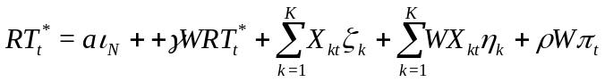. (11)
We can re-write the above as:
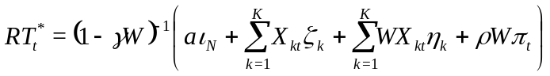 (12)
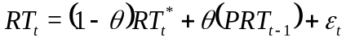 (13)
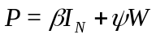. (14)

The above three equations present the specification for a basic spatio-temporal partial adjustment model: The parameter in equation (13) describes the degree of spatio-temporal adjustment between equilibrium variable (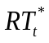) and lagged values for both temporal and spatially temporal adjustments (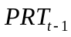). Error terms (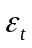) are identical and independent distributed by 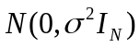. 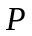 is the parameter that captures both spatial and temporal dependencies of the dependent variable. Specifically, as shown before, the equilibrium status of dependent variable, , can be explained as the intercept (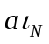), spatial dependence from endogenous variable (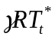), the independent variables both within spatial boundaries (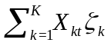) and across spatial adjacent locations (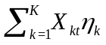), and spatial dependence among the error terms (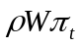), respectively. Moreover, the dependent variable, 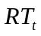, can be interpreted by its equilibrium level () and both its temporal and spatially temporal lagged values 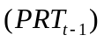. After some algebraic manipulation, we arrive at the following equation:

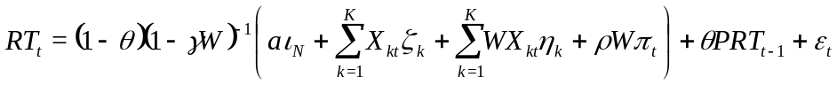. (15)

To summarize, we showed that the dependent variable RT is determined by its equilibrium level and both lagged temporal and spatially temporal dependencies. In other words, the spatio-temporal partial adjustment model enables us to explain the disequilibrium shock of 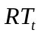 through its spatial and temporal lagged values, respectively. The dynamic spatial Durbin model (that we adopt for the purpose and discuss below) also enables us to recognize and interpret the disequilibrium shocks for the dependent variable via its dynamic components (both temporal and spatially temporal). In other words, it affords us a mechanism to free the strict limitation of fully competitive equilibrium by admitting the existence of disequilibrium variations.
Given that our study involves panel data, the general specification of the dynamic spatial panel model follows:
(16)
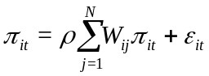 (17)
.

It can be seen that the following three different spatial dependencies are considered in the above model, viz., endogenous interactions (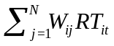), exogenous interactions (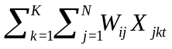) and residual interactions (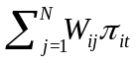). In addition, is the constant parameter vector;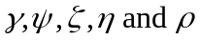 are coefficients for these above spatial dependencies separately; and 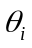 and 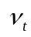 refer to entity-fixed and time-fixed effects with respect to the panel dataset. The above model can be termed as dynamic spatial panel model by controlling the coefficients of time lags and spatial time lags (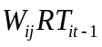) of the endogenous variable to be non-zero (Debarsy et al. 2012). 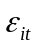 indicates a vector of identical independent distributed error terms with a zero mean and constant variance.
Most importantly, it has been shown that the temporal lag terms for both 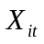 and 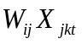, and for both 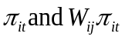 cannot be incorporated into the above model simultaneously, otherwise this will cause non-identification problems for the parameter (Anselin et al. 2008; Elhorst 2014). Hence, the three different types of spatial panel model are mainly derived by considering different types of spatial dependencies (Elhorst 2014), which are thhe spatial autoregressive model (SAR) including spatial endogenous dependence; the spatial Durbin model (SDM) including spatial endogenous dependence and spatial exogenous dependencies, and the spatial error model (SEM) allowing spatial residual dependence, respectively. Besides, whether the model is dynamic or not should be further determined by examining whether both 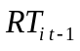 and are jointly equal to zero. The appropriate specification of the spatial panel model in this paper is selected from SAR, SDM and SEM.
SAR : 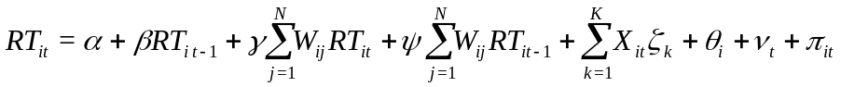 (18)
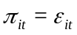
SDM: (19)
SEM: 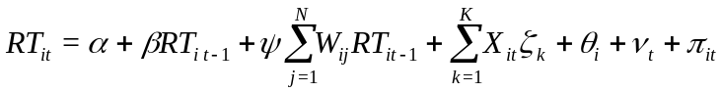 (20)
and,
. (21)

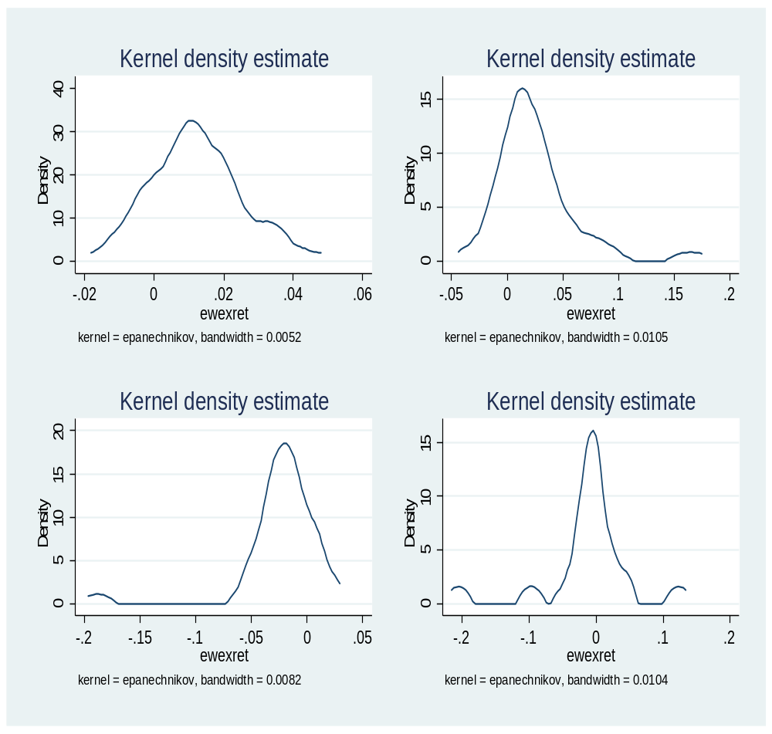
Figure 1. Kernel Density Plots of Returns Series (Decade-wise): 1980 (left upper panel), 1990 (right upper panel), 2000 (left lower panel), and 2010 (right lower panel).

- State coincidence index (X-axis) and equally weighted state index return (ewexret) (secondary X-axis)
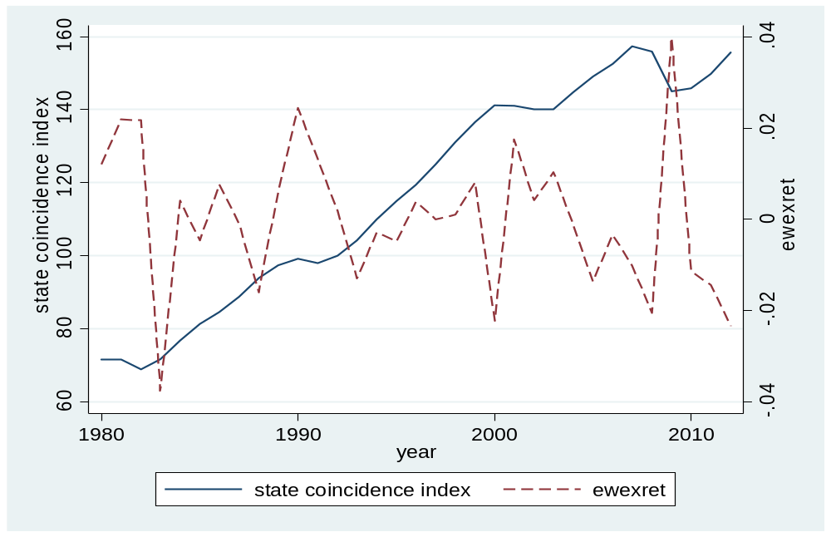
- State employment rate (X-axis) and equally weighted state index return (ewexret) (secondary X-axis)
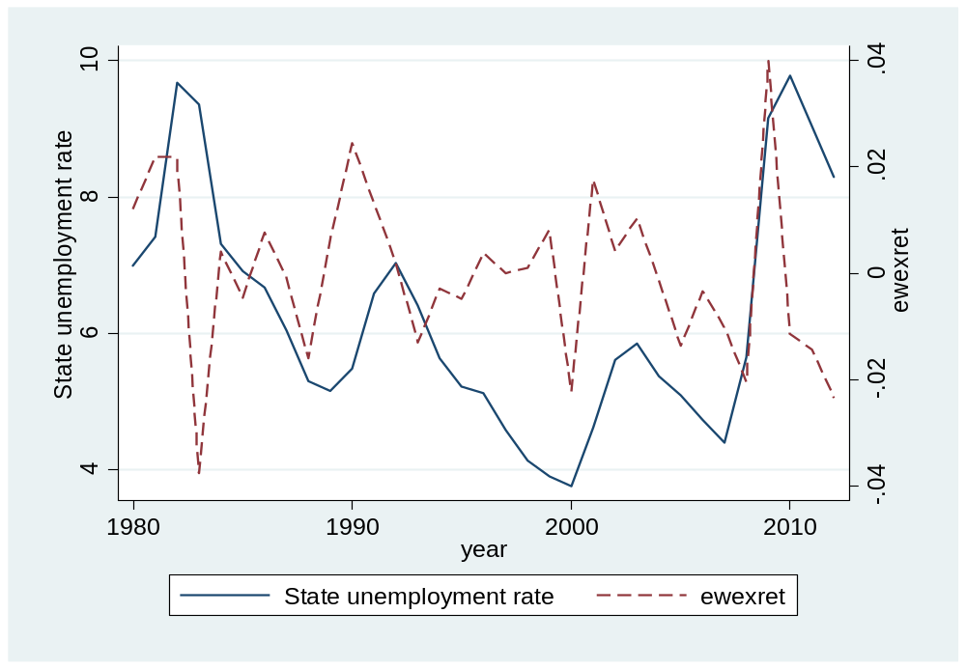

- Business establishment rate (X-axis) and equally weighted state index return (ewexret) (secondary X-axis)

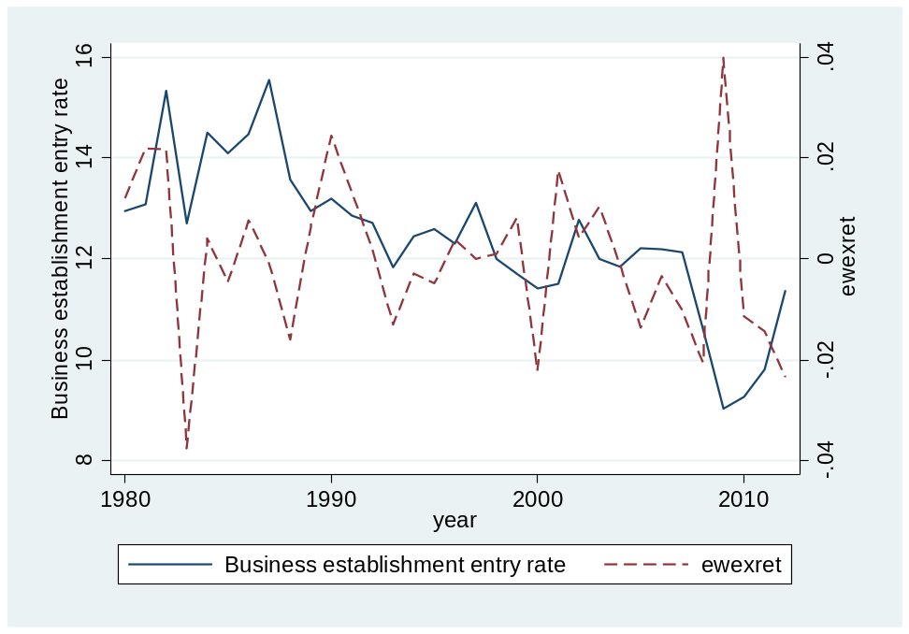
- Population (log) (X-axis) and equally weighted state index return (ewexret) (secondary X-axis)
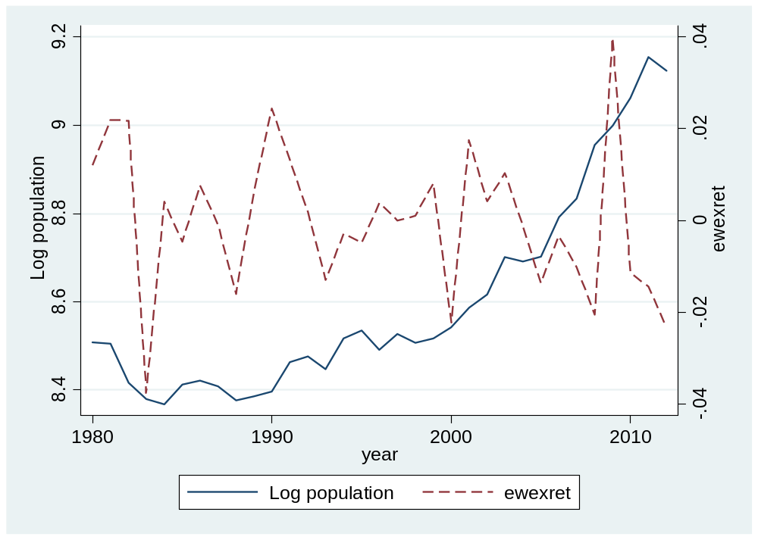
- Number of acquisitions (X-axis) and equally weighted state index return (ewexret) (secondary X-axis)
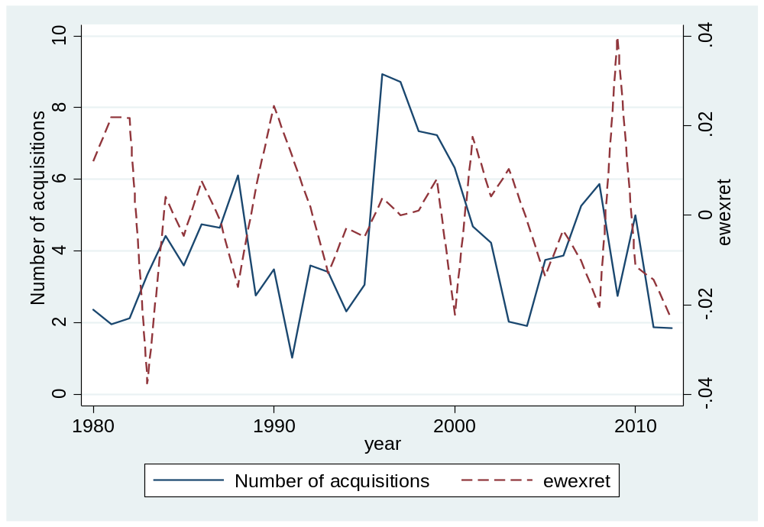
- Debt ratio (X-axis) and equally weighted state index return (ewexret) (secondary X-axis)

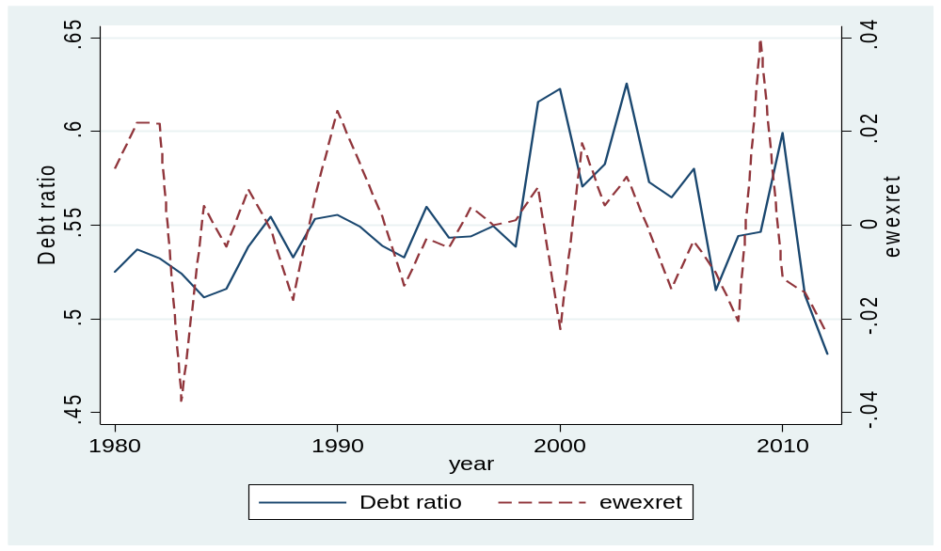
Figure 2. Trend and co-movements.

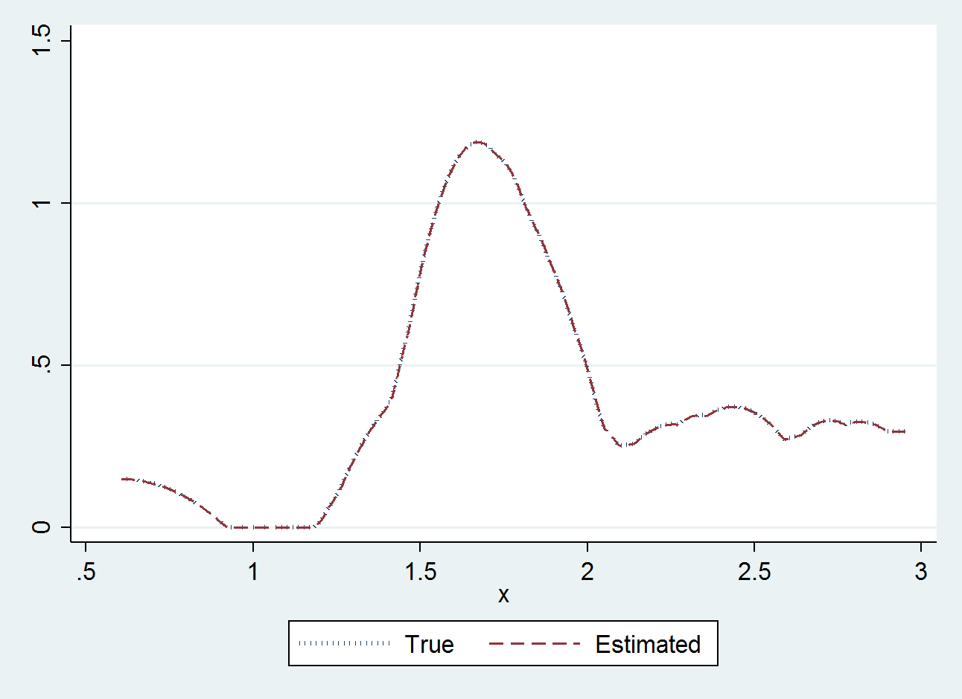
Table 3a. Predicted fixed effects.

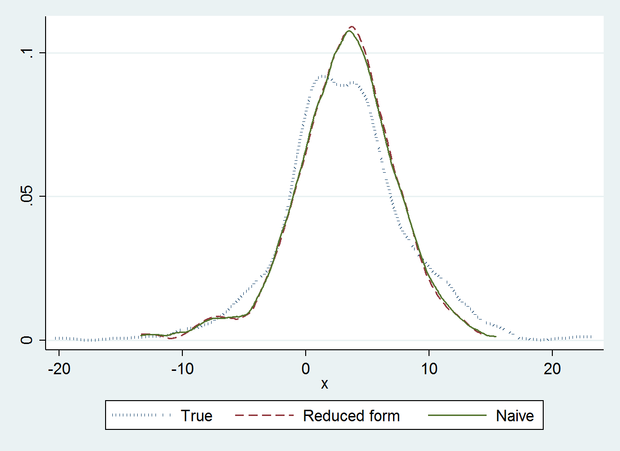
Table 3b. Reduced form and naïve predictors.
Figure 3. Comparison of model performances.
Table 1. Sample distribution.

Panel A - Number of state index return observations by year |  |  | Panel B – Number of annual returns by state
Year | N | Per cent | State | N | Per cent
1980 | 27 | 2.56 | Alabama | 14 | 1.33
1981 | 28 | 2.65 | Arizona | 31 | 2.94
1982 | 32 | 3.03 | Arkansas | 12 | 1.14
1983 | 35 | 3.31 | California | 33 | 3.13
1984 | 35 | 3.31 | Colorado | 33 | 3.13
1985 | 35 | 3.31 | Connecticut | 33 | 3.13
1986 | 35 | 3.31 | Delaware | 28 | 2.65
1987 | 35 | 3.31 | Florida | 33 | 3.13
1988 | 36 | 3.41 | Georgia | 33 | 3.13
1989 | 37 | 3.50 | Idaho | 5 | 0.47
1990 | 37 | 3.50 | Illinois | 31 | 2.94
1991 | 35 | 3.31 | Indiana | 33 | 3.13
1992 | 35 | 3.31 | Iowa | 8 | 0.76
1993 | 36 | 3.41 | Kansas | 28 | 2.65
1994 | 35 | 3.31 | Kentucky | 23 | 2.18
1995 | 34 | 3.22 | Louisiana | 15 | 1.42
1996 | 36 | 3.41 | Maryland | 30 | 2.84
1997 | 36 | 3.41 | Massachusetts | 33 | 3.13
1998 | 38 | 3.60 | Michigan | 27 | 2.56
1999 | 37 | 3.50 | Minnesota | 32 | 3.03
2000 | 37 | 3.50 | Mississippi | 29 | 2.75
2001 | 36 | 3.41 | Missouri | 30 | 2.84
2002 | 35 | 3.31 | Nebraska | 3 | 0.28
2003 | 33 | 3.13 | Nevada | 32 | 3.03
2004 | 33 | 3.13 | New Hampshire | 24 | 2.27
2005 | 33 | 3.13 | New Jersey | 33 | 3.13
2006 | 31 | 2.94 | New Mexico | 11 | 1.04
2007 | 27 | 2.56 | New York | 33 | 3.13
2008 | 24 | 2.27 | North Carolina | 32 | 3.03
2009 | 24 | 2.27 | Ohio | 32 | 3.03
2010 | 20 | 1.89 | Oklahoma | 17 | 1.61
2011 | 16 | 1.52 | Oregon | 25 | 2.37
2012 | 13 | 1.23 | Pennsylvania | 32 | 3.03
Total | 1,056 | 100 | Rhode Island | 10 | 0.95
 |  |  | South Carolina | 19 | 1.80
 |  |  | Tennessee | 29 | 2.75
 |  |  | Texas | 33 | 3.12
 |  |  | Utah | 25 | 2.36
 |  |  | Virginia | 33 | 3.12
 |  |  | Washington | 28 | 2.65
 |  |  | Wisconsin | 31 | 2.94
Note: This table reports the distribution of the sample by year in Panel A and by state in Panel B. Panel A reports the number of annual averages of monthly state return observations for each sample year. Panel B reports the number of annual average returns (which are calculated using monthly state returns) for each state. States with less than five observations of monthly returns are excluded.
Table 2. Number of firms for each state by Fama-French 12-sector classification

State | BUSEQ | ENRGY | MANUF | NODUR | SHOPS | HLTH | DURBL | CHEMS | TELCM | OTHER |  | Total
Alabama | 94 | 117 | 34 | 40 | 256 | 21 | 28 | 0 | 0 | 0 |  | 590
Arizona | 998 | 6 | 664 | 54 | 1,571 | 656 | 0 | 215 | 0 | 0 |  | 4,164
Arkansas | 18 | 0 | 24 | 111 | 0 | 124 | 0 | 72 | 120 | 0 |  | 469
California | 5,290 | 364 | 1,472 | 1,258 | 2,359 | 1,467 | 765 | 3,093 | 508 | 376 |  | 16,952
Colorado | 1,172 | 1,481 | 1,375 | 554 | 759 | 524 | 471 | 725 | 62 | 515 |  | 7,638
Connecticut | 869 | 105 | 1,490 | 162 | 1,519 | 440 | 369 | 388 | 624 | 297 |  | 6,263
Delaware | 555 | 108 | 161 | 12 | 747 | 78 | 0 | 126 | 0 | 0 |  | 1,787
Florida | 2,812 | 122 | 1,643 | 861 | 2,969 | 1,661 | 126 | 1,109 | 380 | 562 |  | 12,245
Georgia | 1,890 | 0 | 1,050 | 1,469 | 1,493 | 1,038 | 298 | 513 | 346 | 158 |  | 8,255
Idaho | 21 | 0 | 0 | 21 | 76 | 54 | 0 | 0 | 0 | 12 |  | 184
Illinois | 1,005 | 33 | 3,163 | 452 | 1,043 | 1,949 | 58 | 499 | 126 | 0 |  | 8,328
Indiana | 419 | 51 | 878 | 119 | 244 | 110 | 0 | 57 | 297 | 33 |  | 2,208
Iowa | 78 | 0 | 63 | 96 | 0 | 0 | 0 | 72 | 9 | 12 |  | 330
Kansas | 216 | 42 | 87 | 65 | 459 | 134 | 109 | 286 | 23 | 0 |  | 1,421
Kentucky | 21 | 83 | 206 | 63 | 475 | 212 | 139 | 144 | 122 | 0 |  | 1,465
Louisiana | 186 | 42 | 0 | 173 | 273 | 0 | 92 | 64 | 0 | 84 |  | 914
Maryland | 873 | 0 | 275 | 37 | 1,116 | 256 | 30 | 1,088 | 24 | 108 |  | 3,807
Massachusetts | 2,780 | 0 | 809 | 647 | 870 | 375 | 394 | 1,402 | 120 | 75 |  | 7,472
Michigan | 734 | 0 | 1,056 | 21 | 583 | 269 | 9 | 21 | 1,044 | 0 |  | 3,737
Minnesota | 772 | 0 | 183 | 513 | 244 | 426 | 0 | 425 | 0 | 168 |  | 2,731
Mississippi | 244 | 0 | 406 | 122 | 258 | 104 | 120 | 0 | 0 | 53 |  | 1,307
Missouri | 201 | 109 | 78 | 250 | 530 | 251 | 29 | 501 | 0 | 464 |  | 2,413
Nebraska | 0 | 0 | 12 | 21 | 55 | 36 | 0 | 0 | 0 | 0 |  | 124
Nevada | 583 | 43 | 75 | 278 | 1,641 | 288 | 83 | 331 | 85 | 0 |  | 3,407
New Hampshire | 703 | 0 | 90 | 204 | 49 | 321 | 0 | 154 | 54 | 0 |  | 1,575
New Jersey | 1,257 | 107 | 1,656 | 1,446 | 2,052 | 1,037 | 930 | 3,881 | 207 | 387 |  | 12,960
New Mexico | 67 | 0 | 126 | 0 | 282 | 0 | 0 | 0 | 0 | 0 |  | 475
New York | 2,715 | 621 | 1,272 | 1,751 | 3,558 | 1,829 | 1,233 | 1,171 | 1,028 | 412 |  | 15,590
North Carolina | 810 | 289 | 1,457 | 422 | 761 | 577 | 2 | 528 | 619 | 94 |  | 5,559
Ohio | 555 | 0 | 1,169 | 160 | 754 | 1,752 | 161 | 104 | 142 | 225 |  | 5,022
Oklahoma | 90 | 479 | 105 | 0 | 3 | 50 | 0 | 12 | 0 | 0 |  | 739
Oregon | 676 | 0 | 449 | 108 | 120 | 0 | 0 | 299 | 0 | 0 |  | 1,652
Pennsylvania | 1,616 | 20 | 2,118 | 796 | 802 | 806 | 817 | 1,247 | 87 | 382 |  | 8,691
Rhode Island | 58 | 0 | 0 | 114 | 12 | 111 | 0 | 36 | 0 | 0 | 331
South Carolina | 0 | 0 | 229 | 78 | 243 | 192 | 7 | 0 | 110 | 111 | 970
Tennessee | 376 | 3 | 755 | 718 | 684 | 401 | 235 | 271 | 534 | 0 | 3,977
Texas | 2,900 | 5,240 | 2,388 | 1,175 | 3,501 | 2,738 | 721 | 2,284 | 286 | 545 | 21,778
Utah | 367 | 103 | 153 | 177 | 365 | 89 | 0 | 131 | 0 | 0 | 1,385
Virginia | 2324 | 28 | 875 | 591 | 1055 | 840 | 423 | 607 | 55 | 58 | 6,856
Washington | 893 | 0 | 199 | 0 | 381 | 300 | 156 | 437 | 0 | 0 | 2,366
Wisconsin | 102 | 0 | 1168 | 435 | 195 | 200 | 0 | 81 | 220 | 238 | 2,639
Total | 37,340 | 9,596 | 29,413 | 15,574 | 34,357 | 21,716 | 7,805 | 22,374 | 7,232 | 5,369 | 190,776
Note: This table reports the number of firm-year observations in each state by each Fama-French 12-factor classification. Financial and utility firms (SIC codes = 6000-6999 and 4900-4999, respectively) are excluded.
Table 3. State characteristics.
State | N | Business Establishments Entry Rate | State Coincidence Index Change (%) | State Unemployment Rate (%) | Population (thousand)
Whole Sample | 1056 | 12.573 | 0.209 | 6.0564 | 7233.39
Alabama | 14 | 11.943 | 0.213 | 6.009 | 4,337.020
Arizona | 12 | 15.532 | 0.268 | 6.058 | 4,445.420
Arkansas | 31 | 13.033 | 0.287 | 7.027 | 2,410.260
California | 33 | 13.685 | 0.202 | 7.434 | 31,218.070
Colorado | 33 | 14.746 | 0.225 | 5.597 | 3,940.330
Connecticut | 33 | 10.733 | 0.177 | 5.271 | 3,345.530
Delaware | 28 | 13.071 | 0.245 | 4.654 | 729.620
Florida | 33 | 15.352 | 0.219 | 6.295 | 14,708.400
Georgia | 33 | 13.658 | 0.255 | 5.871 | 7,545.770
Idaho | 8 | 14.500 | 0.146 | 7.680 | 999.120
Illinois | 5 | 11.287 | 0.135 | 7.012 | 11,974.990
Indiana | 31 | 10.870 | 0.177 | 6.229 | 5,896.270
Iowa | 33 | 10.663 | 0.270 | 5.507 | 2,803.380
Kansas | 28 | 11.854 | 0.181 | 4.684 | 2,564.520
Kentucky | 23 | 11.826 | 0.294 | 6.702 | 3,867.600
Louisiana | 15 | 11.280 | 0.183 | 6.263 | 4,353.070
Maryland | 33 | 12.370 | 0.173 | 5.018 | 4,990.640
Massachusetts | 30 | 10.912 | 0.209 | 5.514 | 6,161.610
Michigan | 27 | 11.507 | 0.191 | 7.670 | 9,549.670
Minnesota | 32 | 11.347 | 0.187 | 5.020 | 4,708.680
Mississippi | 30 | 11.841 | 0.119 | 8.117 | 2,720.750
Missouri | 29 | 12.067 | 0.134 | 5.849 | 5,358.280
Nebraska | 32 | 9.933 | 0.313 | 2.725 | 1,680.210
Nevada | 3 | 16.628 | 0.290 | 6.772 | 1,740.660
New Hampshire | 24 | 13.179 | 0.341 | 4.298 | 1,134.680
New Jersey | 33 | 11.846 | 0.179 | 6.140 | 8,109.190
New Mexico | 11 | 13.782 | 0.324 | 7.170 | 1,591.900
New York | 32 | 11.764 | 0.145 | 6.474 | 18,445.970
North Carolina | 33 | 12.369 | 0.215 | 5.848 | 7,494.030
Ohio | 32 | 10.341 | 0.154 | 6.933 | 11,135.600
Oklahoma | 17 | 12.594 | 0.150 | 5.761 | 3,256.230
Oregon | 25 | 13.940 | 0.378 | 6.846 | 3,097.460
Pennsylvania | 32 | 10.291 | 0.125 | 6.463 | 12,132.360
Rhode Island | 10 | 11.170 | 0.153 | 4.819 | 1,008.950
South Carolina | 19 | 12.995 | 0.250 | 6.316 | 3,766.210
Tennessee | 29 | 12.528 | 0.205 | 6.471 | 5,263.950
Texas | 33 | 13.494 | 0.222 | 6.372 | 19,656.940
Utah | 25 | 15.108 | 0.294 | 4.720 | 1,980.370
Virginia | 33 | 12.446 | 0.192 | 4.682 | 6,732.910
Washington | 28 | 14.143 | 0.230 | 6.732 | 5,423.830
Wisconsin | 31 | 10.558 | 0.169 | 5.570 | 5,146.180

Note: This table reports the summary statistics of state characteristics for each state over the sample period 1980-2012. The data for business establishment entry rate, unemployment rate and population are obtained from the Longitudinal Business Databases from the US Bureau of Labor Statistics website. State coincidence index data that track the overall economic conditions of each state are obtained from the Federal Reserve Bank of St. Louis website. The index is a composite index constructed from data on employment, real earnings, the unemployment rate and average weekly hours worked in manufacturing.

Table 4. Characteristics of firms by states.

State | N | Number of acquisitions | Number of delisting | Number of new issues | Market cap. | Debt ratio | EBITDA / Asset | Market-to-book ratio
Whole Sample | 1,056 | 4.049 | 5.457 | 2.435 | 13,586.770 | 0.539 | 0.132 | 753.490
Alabama | 14 | 1.929 | 1.500 | 0.000 | 892.880 | 0.662 | 0.107 | 15.760
Arizona | 12 | 2.903 | 2.645 | 2.710 | 4,784.240 | 0.498 | 0.152 | 5.570
Arkansas | 31 | 0.750 | 1.250 | 0.000 | 79.540 | 0.464 | 0.108 | 6,474.420
California | 33 | 9.849 | 18.303 | 5.727 | 18,465.150 | 0.502 | 0.145 | 11,852.890
Colorado | 33 | 3.242 | 4.394 | 2.788 | 9,083.270 | 0.573 | 0.132 | 48.630
Connecticut | 33 | 2.273 | 4.909 | 1.212 | 18,206.640 | 0.604 | 0.135 | -1.430
Delaware | 28 | 1.500 | 1.679 | 0.321 | 2,034.500 | 0.594 | 0.101 | 11.240
Florida | 33 | 8.636 | 14.818 | 5.333 | 9,456.790 | 0.604 | 0.103 | 523.710
Georgia | 33 | 5.212 | 6.121 | 5.091 | 9,071.550 | 0.511 | 0.143 | 204.320
Idaho | 8 | 7.200 | 8.600 | 0.000 | 391.410 | 0.561 | 0.135 | 5.870
Illinois | 5 | 6.290 | 6.419 | 3.548 | 26,399.270 | 0.565 | 0.135 | 70.840
Indiana | 31 | 1.273 | 2.939 | 2.061 | 1,359.770 | 0.403 | 0.147 | 2,659.080
Iowa | 33 | 1.875 | 2.625 | 1.500 | 185.410 | 0.453 | 0.102 | 4.600
Kansas | 28 | 1.071 | 2.036 | 0.429 | 1,680.140 | 0.523 | 0.124 | 167.790
Kentucky | 23 | 0.391 | 1.304 | 1.043 | 921.080 | 0.450 | 0.158 | 14.900
Louisiana | 15 | 0.600 | 1.333 | 3.000 | 14,586.020 | 0.531 | 0.195 | 24.980
Maryland | 33 | 3.600 | 4.633 | 2.167 | 4,103.290 | 0.680 | 0.161 | 6.640
Massachusetts | 30 | 4.576 | 6.061 | 3.333 | 12,298.680 | 0.466 | 0.224 | 3,098.360
Michigan | 27 | 2.963 | 3.815 | 2.333 | 10,531.470 | 0.565 | 0.183 | 8.500
Minnesota | 32 | 2.938 | 2.156 | 2.281 | 2,526.620 | 0.566 | 0.097 | 16.210
Mississippi | 30 | 0.724 | 1.517 | 0.414 | 1,168.660 | 0.497 | 0.135 | 1.260
Missouri | 29 | 2.800 | 4.433 | 0.767 | 3,489.330 | 0.517 | 0.151 | 13.810
Nebraska | 32 | 0.000 | 3.000 | 0.000 | 13,320.460 | 0.701 | 0.078 | 0.610
Nevada | 3 | 1.344 | 2.313 | 3.156 | 1,735.720 | 0.480 | 0.042 | 120.480
New Hampshire | 24 | 1.292 | 2.417 | 0.500 | 1,172.210 | 0.514 | 0.115 | 8.690
New Jersey | 33 | 10.970 | 9.242 | 5.667 | 70,458.200 | 0.582 | 0.129 | 15.210
New Mexico | 11 | 0.000 | 1.364 | 4.364 | 181.700 | 0.436 | 0.086 | 14.500
New York | 32 | 8.364 | 14.394 | 5.273 | 29,110.550 | 0.541 | 0.119 | 115.730
North Carolina | 33 | 3.969 | 4.969 | 1.031 | 5,202.110 | 0.538 | 0.151 | 473.450
Ohio | 32 | 5.844 | 8.094 | 0.375 | 5,083.540 | 0.550 | 0.137 | 9.860
Oklahoma | 17 | 1.412 | 1.588 | 2.588 | 1,508.490 | 0.522 | 0.042 | 16.870
Oregon | 25 | 0.760 | 0.800 | 1.440 | 481.260 | 0.600 | 0.020 | 17.380
Pennsylvania | 32 | 6.594 | 8.000 | 4.063 | 9,337.870 | 0.578 | 0.115 | 8.950
Rhode Island | 10 | 2.000 | 0.600 | 0.000 | 1,958.420 | 0.482 | 0.180 | 2.200
South Carolina | 19 | 1.526 | 1.526 | 0.000 | 898.900 | 0.483 | 0.114 | 2,080.710
Tennessee | 29 | 3.966 | 5.138 | 2.172 | 7,005.140 | 0.541 | 0.157 | -0.390
Texas | 33 | 13.727 | 16.697 | 7.000 | 91,004.820 | 0.538 | 0.188 | 5.970
Utah | 25 | 2.640 | 2.680 | 0.840 | 1,185.200 | 0.460 | 0.098 | 1,448.900
Virginia | 33 | 4.485 | 5.667 | 2.515 | 65,574.520 | 0.654 | 0.180 | 5.390
Washington | 28 | 1.893 | 3.393 | 0.321 | 5,920.700 | 0.552 | 0.141 | 9.520
Wisconsin | 31 | 3.419 | 3.226 | 0.387 | 4,571.980 | 0.504 | 0.118 | 1.980

Note: This table reports the summary statistics of the firms included in the calculation of the state index returns. For each state in each year, we aggregate the number of acquisitions, number of delistings and number of new equity issuances that involve the firms included in the state portfolio. Market capitalization is the average market capitalization of the firms in the state portfolio in a year. Debt ratio, EBITDA/asset and market-to-book ratios are the value-weighted averages of the firms in the state portfolio at the end of the fiscal year preceding the year when the state return index is calculated, whereby the weight is based upon the market capitalization of the firm.
Table 5. Value-weighted returns of state portfolios.

 |  | Average returns |  |  | Buy-and-hold returns
States | N | Mean | Median | Stdev | Mean | Median | Stdev
Whole sample | 1,056 | 1.033% | 1.118% | 2.652% | 11.951% | 11.104% | 30.176%
Alabama | 14 | 1.664% | 1.176% | 3.114% | 22.425% | 16.900% | 34.241%
Arizona | 31 | 1.028% | 1.134% | 3.041% | 14.012% | 14.490% | 35.465%
Arkansas | 12 | -0.637% | -0.697% | 4.751% | -6.298% | -13.95% | 54.422%
California | 33 | 1.379% | 1.369% | 2.641% | 14.141% | 9.541% | 29.532%
Colorado | 33 | 0.709% | 0.829% | 2.430% | 10.653% | 11.654% | 31.630%
Connecticut | 33 | 0.996% | 1.119% | 2.529% | 13.010% | 12.158% | 31.116%
Delaware | 28 | 1.020% | 0.855% | 2.878% | 17.281% | 13.088% | 34.570%
Florida | 33 | 1.044% | 0.892% | 2.250% | 12.654% | 7.962% | 29.800%
Georgia | 33 | 1.288% | 1.707% | 1.951% | 14.585% | 20.185% | 25.306%
Idaho | 5 | 0.972% | 3.075% | 4.924% | 21.571% | 21.571% | 27.098%
Illinois | 31 | 1.229% | 1.406% | 1.820% | 13.652% | 15.498% | 23.747%
Indiana | 33 | 1.065% | 1.137% | 2.607% | 11.359% | 12.614% | 29.996%
Iowa | 8 | -1.709% | -2.182% | 3.455% | -6.374% | 15.417% | 33.959%
Kansas | 28 | 0.588% | 1.139% | 3.000% | 8.626% | 9.333% | 30.188%
Kentucky | 23 | 0.947% | 1.140% | 2.903% | 12.652% | 13.384% | 38.234%
Louisiana | 15 | 0.825% | 0.999% | 2.599% | 7.221% | 6.541% | 27.038%
Maryland | 30 | 1.440% | 1.434% | 2.310% | 13.781% | 13.041% | 29.048%
Massachusetts | 33 | 1.146% | 1.216% | 2.624% | 16.120% | 13.343% | 34.420%
Michigan | 27 | 1.208% | 1.181% | 1.295% | 13.464% | 12.840% | 17.802%
Minnesota | 32 | 1.217% | 0.990% | 3.281% | 7.111% | 6.416% | 30.530%
Mississippi | 29 | 1.204% | 0.694% | 3.564% | 10.935% | -0.115% | 44.671%
Missouri | 30 | 0.793% | 0.962% | 2.991% | 7.060% | 9.082% | 29.166%
Nebraska | 3 | -0.976% | -0.523% | 2.091% | 3.861% | 3.861% | NA
Nevada | 32 | 1.628% | 1.086% | 3.577% | 16.537% | 10.116% | 43.934%
New Hampshire | 24 | 0.780% | 0.894% | 1.969% | 6.111% | 5.836% | 24.221%
New Jersey | 33 | 0.970% | 1.160% | 2.028% | 12.731% | 12.800% | 25.061%
New Mexico | 11 | -0.602% | 0.111% | 3.259% | 0.189% | 3.729% | 30.961%
New York | 33 | 0.878% | 0.947% | 2.392% | 11.288% | 8.510% | 29.666%
North Carolina | 32 | 1.003% | 0.889% | 1.770% | 12.199% | 7.544% | 24.294%
Ohio | 32 | 1.061% | 1.240% | 2.123% | 11.187% | 12.157% | 27.780%
Oklahoma | 17 | 1.223% | 0.980% | 2.801% | 6.694% | 6.003% | 23.928%
Oregon | 25 | 1.219% | 0.800% | 3.434% | 8.408% | -0.491% | 40.980%
Pennsylvania | 32 | 1.053% | 1.230% | 2.200% | 13.575% | 14.917% | 27.851%
Rhode Island | 10 | 1.864% | 2.975% | 2.972% | 33.849% | 33.465% | 17.218%
South Carolina | 19 | 1.759% | 2.136% | 2.422% | 13.892% | 14.666% | 22.800%
Tennessee | 29 | 1.088% | 0.989% | 2.095% | 10.479% | 7.877% | 26.599%
Texas | 33 | 1.088% | 1.267% | 1.675% | 13.569% | 15.126% | 22.581%
Utah | 25 | -0.213% | -0.907% | 3.591% | -9.340% | -17.07% | 34.120%
Virginia | 33 | 1.595% | 1.740% | 2.012% | 20.841% | 20.581% | 26.700%
Washington | 28 | 1.224% | 1.359% | 2.957% | 9.937% | 14.758% | 26.946%
Wisconsin | 31 | 1.138% | 1.400% | 2.273% | 16.187% | 16.348% | 28.554%
Note: This table reports the summary statistics of the average returns and the buy-and-hold returns of the 12 monthly returns of each state index in each year. Stdev stands for standard deviation.

Table 6. Value-weighted industry-adjusted returns of state portfolios.
States | N | Average monthly industry-adjusted returns |  |  | Buy-and-hold industry-adjusted returns
 |  | Mean | Median |  | Mean | Median
All states | 1,056 | -0.014% | 0.005% |  | -0.358% | -1.143%
Alabama | 14 | 0.269% | 0.508% |  | 1.140% | -0.463%
Arizona | 31 | 0.341% | -0.017% |  | 3.394% | -1.634%
Arkansas | 12 | -1.133% | -1.431% |  | -9.965% | -18.721%
California | 33 | 0.176% | 0.322% |  | 2.147% | 1.358%
Colorado | 33 | -0.120% | -0.209% |  | -1.474% | -3.235%
Connecticut | 33 | 0.031% | 0.082% |  | 0.354% | 0.721%
Delaware | 28 | 0.131% | 0.417% |  | 1.375% | 0.773%
Florida | 33 | 0.074% | -0.020% |  | 0.630% | -1.102%
Georgia | 33 | 0.173% | 0.092% |  | 1.305% | -1.296%
Idaho | 5 | 0.368% | 0.918% |  | -1.089% | -2.193%
Illinois | 31 | 0.105% | 0.150% |  | 1.420% | 1.645%
Indiana | 33 | 0.072% | 0.063% |  | -0.890% | -1.121%
Iowa | 8 | -1.863% | -0.713% |  | -21.779% | -14.047%
Kansas | 28 | -0.271% | 0.369% |  | -3.723% | 0.673%
Kentucky | 23 | -0.042% | 0.251% |  | -0.231% | 0.051%
Louisiana | 15 | 0.003% | 0.162% |  | 1.753% | 0.772%
Maryland | 30 | 0.296% | 0.162% |  | 2.876% | 0.390%
Massachusetts | 33 | 0.336% | -0.095% |  | 3.342% | -2.536%
Michigan | 27 | 0.062% | 0.043% |  | 1.097% | 0.167%
Minnesota | 32 | -0.074% | 0.228% |  | -0.813% | 0.127%
Mississippi | 29 | -0.270% | -0.644% |  | -0.787% | -9.687%
Missouri | 30 | -0.224% | -0.244% |  | -1.955% | -3.932%
Nebraska | 3 | -1.100% | -0.593% |  | -13.431% | -12.055%
Nevada | 32 | 0.303% | 0.485% |  | 4.022% | 0.027%
New Hampshire | 24 | -0.432% | -0.339% |  | -6.717% | -4.815%
New Jersey | 33 | -0.225% | -0.041% |  | -2.289% | -0.606%
New Mexico | 11 | -0.809% | -0.241% |  | -9.152% | -18.421%
New York | 33 | -0.109% | -0.031% |  | -1.383% | -0.987%
North Carolina | 32 | -0.134% | 0.040% |  | -1.637% | -0.232%
Ohio | 32 | 0.132% | 0.083% |  | 1.441% | -0.077%
Oklahoma | 17 | -0.179% | -0.076% |  | -7.198% | -4.833%
Oregon | 25 | -0.177% | -0.479% |  | -1.796% | -10.545%
Pennsylvania | 32 | 0.052% | 0.025% |  | 0.793% | -0.043%
Rhode Island | 10 | 0.865% | 0.594% |  | 7.520% | 2.979%
South Carolina | 19 | 0.128% | -0.012% |  | 3.262% | -1.156%
Tennessee | 29 | 0.261% | -0.366% |  | 3.447% | -5.022%
Texas | 33 | -0.097% | -0.060% |  | -1.156% | -0.803%
Utah | 25 | -1.016% | -0.483% |  | -10.901% | -7.157%
Virginia | 33 | 0.114% | 0.120% |  | 1.296% | 0.922%
Washington | 28 | 0.320% | 0.170% |  | 0.785% | -0.316%
Wisconsin | 31 | 0.253% | 0.326% |  | 2.205% | 2.670%
Note: This table reports the summary statistics of the value-weighted industry-adjusted returns of state portfolios.

Table 7. Returns to portfolios based upon quartiles of state local characteristics.
 | By ECONINDEX |  |  | By ESTABLISHMENT |  |  | By POPULATION |  |  | By UNEMPLOYMENT
Groups | Raw return | Industry-adjusted returns |  | Raw return | Industry-adjusted returns |  | Raw return | Industry-adjusted returns |  | Raw return | Industry-adjusted returns
Quartile 1 | 1.227% | 0.114% |  | 1.214% | 0.091% |  | 0.987% | 0.035% |  | 1.352% | 0.107%
Quartile 2 | 1.240% | 0.073% |  | 0.984% | -0.061% |  | 1.153% | 0.005% |  | 1.052% | 0.045%
Quartile 3 | 1.118% | -0.002% |  | 1.253% | -0.031% |  | 1.067% | 0.097% |  | 1.169% | -0.034%
Quartile 4 | 1.153% | 0.017% |  | 0.866% | 0.031% |  | 0.875% | -0.065% |  | 1.276% | 0.125%
(4) minus (1) | -0.074% | -0.097% |  | -0.348% | -0.061% |  | -0.112% | -0.099% |  | -0.076% | 0.018%
p-value from t-tests | 0.759 | 0.529 |  | 0.115 | 0.654 |  | 0.570 | 0.392 |  | 0.742 | 0.896
p-value from sign rank test | 0.974 | 0.773 |  | 0.064 | 0.406 |  | 0.960 | 0.578 |  | 0.527 | 0.745
Note: This table reports the performance of quartile portfolios based on various state characteristics. ECONINDEX represents the State Coincidence Index Change; ESTABLISHMENT represents the Business Establishments Entry Rate; POPULATION represents the size of the state population; and UNEMPLOYMENT represents the state unemployment rate.

Table 8. Parameter estimates from the 36-month rolling regressions of monthly state index returns.
Panel A: Market Model Panel B: Fama-French 3-Factor Model
States | Number of obs.
States | Number of obs. | Market beta | Adj.R-squared | Market beta | SMB beta | HML beta | Adj. R-squared
Alabama | 251 | -11.881 | 0.386 | 1.266 | -0.881 | 0.568 | 0.523
Arkansas | 199 | 0.707 | 0.167 | 0.736 | 0.640 | 0.421 | 0.319
Arizona | 411 | 1.568 | 0.499 | 1.440 | 0.907 | 0.121 | 0.578
California | 421 | 1.384 | 0.675 | 1.198 | 0.509 | -0.203 | 0.742
Colorado | 421 | 1.103 | 0.498 | 1.102 | 0.493 | 0.206 | 0.576
Connecticut | 421 | 1.189 | 0.622 | 1.230 | 0.088 | 0.368 | 0.669
Delaware | 375 | 1.304 | 0.358 | 1.573 | 0.922 | 0.822 | 0.494
Florida | 421 | 1.186 | 0.594 | 1.163 | 0.467 | 0.169 | 0.659
Georgia | 421 | 1.287 | 0.521 | 1.085 | 0.481 | -0.309 | 0.583
Iowa | 163 | 1.119 | 0.423 | 0.816 | 0.616 | -1.323 | 0.552
Idaho | 147 | 0.466 | 0.264 | 0.423 | 3.838 | 0.558 | 0.587
Illinois | 417 | 1.157 | 0.583 | 1.158 | 0.258 | 0.160 | 0.649
Indiana | 421 | 1.246 | 0.363 | 1.115 | 0.564 | 0.075 | 0.441
Kansas | 380 | 1.190 | 0.207 | 1.085 | 1.182 | 0.932 | 0.304
Kentucky | 314 | 1.307 | 0.328 | 1.171 | 1.100 | -0.006 | 0.475
Louisiana | 245 | 1.270 | 0.317 | 1.021 | 0.457 | -0.442 | 0.404
Massachusetts | 421 | 1.261 | 0.499 | 1.027 | 0.417 | -0.189 | 0.603
Maryland | 405 | 1.206 | 0.393 | 3.542 | -5.422 | -2.379 | 0.458
Michigan | 366 | 1.081 | 0.513 | 1.077 | 0.228 | 0.007 | 0.612
Minnesota | 421 | 1.343 | 0.396 | 1.281 | 0.752 | -0.304 | 0.489
Missouri | 405 | 1.266 | 0.454 | 3.209 | -4.235 | -1.843 | 0.515
Mississippi | 377 | 1.229 | 0.259 | 1.090 | 1.200 | 0.141 | 0.405
North Carolina | 421 | 1.245 | 0.585 | 1.227 | 0.504 | 0.391 | 0.651
Nebraska | 62 | 1.031 | 0.332 | 0.701 | 0.112 | -0.343 | 0.422
New Hampshire | 318 | 1.089 | 0.330 | 0.863 | 1.116 | 0.046 | 0.446
New Jersey | 421 | 0.878 | 0.393 | 0.908 | -0.139 | 0.198 | 0.458
New Mexico | 173 | 0.929 | 0.156 | 0.091 | 1.398 | -1.520 | 0.397
Nevada | 421 | 1.396 | 0.320 | 1.268 | 0.950 | -0.446 | 0.434
New York | 421 | 1.263 | 0.604 | 1.312 | 0.267 | 0.077 | 0.645
Ohio | 421 | 1.266 | 0.502 | 1.216 | 0.710 | 0.252 | 0.590
Oklahoma | 245 | 0.749 | 0.130 | 0.613 | -0.170 | -0.902 | 0.277
Oregon | 323 | 1.410 | 0.218 | 1.329 | 1.026 | 0.557 | 0.341
Pennsylvania | 421 | 1.234 | 0.617 | 1.085 | 0.409 | -0.217 | 0.681
Rhode Island | 242 | 0.728 | 0.306 | 0.848 | 0.612 | 0.764 | 0.455
South Carolina | 294 | 0.812 | 0.245 | 1.428 | 1.920 | 0.911 | 0.410
Tennessee | 399 | 1.181 | 0.465 | 1.511 | -1.807 | 0.208 | 0.566
Texas | 421 | 0.942 | 0.526 | 1.040 | -0.075 | 0.248 | 0.625
Utah | 365 | 3.810 | 0.194 | 2.200 | 2.650 | 0.172 | 0.366
Virginia | 421 | 0.874 | 0.368 | 0.928 | -0.117 | 0.043 | 0.419
Washington | 405 | 1.018 | 0.185 | 11.194 | -24.524 | -10.789 | 0.291
Wisconsin | 411 | 0.998 | 0.429 | 1.013 | 0.190 | 0.392 | 0.500
Note: This table reports the summary statistics of the parameter estimates from the 36-month rolling regressions of state index returns. Monthly state index return is the value-weighed returns of all the portfolio firms in the states. The monthly excess returns in a year (from January to December) for a state is the difference between the actual returns and the predicted returns whereby the predicted returns are calculated based upon the parameter estimated from either the market model (in Panel A) or the Fama-French 3-factor model (in Panel B) over the 36-month prior to the December of the year preceding return year.

Table 9. Summary statistics of state index excess returns.

 | Average excess returns from market model |  | Buy-and-hold excess returns from market model |  | Average excess returns from Fama-French 3-factor model |  | Buy-and-hold excess returns Fama-French 3-factor model
States | Mean | Median | Mean | Median | Mean | Median | Mean | Median
 | 0.358% | 0.328% | 3.609% | 1.947% | 0.187% | 0.270% | 2.317% | 1.540%
Alabama | 2.568% | 1.712% | 15.628% | -0.439% | 1.592% | 1.294% | 6.876% | -3.256%
Arkansas | 0.743% | -0.146% | 8.015% | -8.916% | 0.192% | 0.791% | 9.350% | 3.444%
Arizona | -0.029% | 0.131% | 2.667% | -0.313% | -0.102% | -0.074% | 2.682% | -0.853%
California | 0.321% | 0.408% | 2.868% | 4.225% | 0.274% | 0.343% | 1.999% | 3.249%
Colorado | 0.258% | 0.092% | 4.196% | 0.779% | 0.425% | 0.442% | 6.676% | 5.044%
Connecticut | 0.194% | 0.605% | 3.487% | 7.542% | 0.085% | 0.145% | 1.999% | 1.833%
Delaware | 0.206% | 0.259% | 6.091% | 2.213% | -0.064% | 0.390% | 0.873% | 3.251%
Florida | 0.263% | 0.163% | 2.630% | 1.694% | 0.172% | 0.231% | 1.787% | 0.848%
Georgia | 0.436% | 0.539% | 4.933% | 5.951% | 0.277% | 0.369% | 2.542% | 2.692%
Iowa | 1.101% | 0.614% | 15.743% | 16.118% | 0.633% | 1.548% | 17.047% | 14.623%
Idaho | 3.104% | 1.843% | 1.037% | 1.037% | -0.674% | 2.080% | 3.286% | 3.286%
Illinois | 0.414% | 0.297% | 4.810% | 2.390% | 0.282% | 0.329% | 2.846% | 1.898%
Indiana | 0.266% | 0.289% | 1.725% | -1.657% | 0.139% | 0.158% | 0.714% | -0.577%
Kansas | -0.094% | 0.336% | 1.388% | -2.152% | 0.299% | 0.882% | 5.280% | 5.375%
Kentucky | -0.241% | 0.118% | 0.193% | 0.405% | 0.113% | -0.163% | 1.273% | -0.816%
Louisiana | -0.081% | 0.187% | 5.054% | 2.311% | 0.578% | 0.064% | 6.589% | -1.476%
Massachusetts | 0.008% | 0.485% | 2.754% | 5.351% | -0.039% | 0.100% | 1.591% | 2.029%
Maryland | 0.450% | 0.231% | 2.824% | -2.270% | 0.437% | -0.213% | 3.056% | -4.465%
Michigan | 0.609% | 0.694% | 6.430% | 3.252% | 0.453% | 0.725% | 4.589% | 5.151%
Minnesota | 0.422% | 0.454% | 0.775% | -0.339% | 0.072% | -0.028% | -2.333% | -3.104%
Missouri | 0.481% | 0.180% | 1.980% | -0.068% | 0.451% | 0.379% | 2.359% | 2.546%
Mississippi | 0.432% | 0.095% | 0.645% | -6.201% | -0.180% | -0.720% | 0.055% | -14.376%
North Carolina | 0.222% | 0.179% | 3.748% | 0.590% | 0.166% | 0.178% | 2.073% | 1.577%
Nebraska | 0.328% | 0.311% | -2.004% | -2.004% | -2.782% | -1.187% | -18.737% | -18.737%
New Hampshire | 0.490% | 0.228% | 0.957% | -1.284% | 0.568% | 0.407% | 0.564% | 0.852%
New Jersey | 0.236% | 0.374% | 4.391% | 4.236% | 0.168% | 0.217% | 3.454% | 2.184%
New Mexico | 0.122% | 0.685% | 10.817% | 12.987% | 0.260% | 1.666% | 16.105% | 18.581%
Nevada | 0.231% | 0.417% | 5.782% | -5.142% | -0.079% | -0.163% | 0.394% | -8.900%
New York | 0.307% | 0.326% | 3.811% | 2.572% | 0.051% | 0.277% | 0.554% | 1.927%
Ohio | 0.346% | 0.383% | 3.915% | 3.486% | 0.319% | 0.749% | 1.972% | 5.355%
Oklahoma | 0.405% | 0.715% | -1.787% | 1.453% | -0.329% | 0.043% | -1.038% | -4.741%
Oregon | 0.798% | 0.416% | -0.247% | -4.150% | 0.330% | 0.088% | -0.627% | -4.405%
Pennsylvania | 0.384% | 0.409% | 4.400% | 3.960% | 0.345% | 0.453% | 4.288% | 4.728%
Rhode Island | 0.444% | -0.147% | 31.471% | 20.531% | -0.389% | 0.766% | 2.779% | 6.367%
South Carolina | 0.973% | 1.063% | 11.543% | 8.928% | 0.713% | 0.448% | 7.465% | -0.572%
Tennessee | 0.385% | 0.169% | 5.183% | 1.034% | 0.112% | 0.142% | 1.580% | 0.676%
Texas | 0.287% | 0.384% | 3.444% | 3.728% | 0.397% | 0.317% | 5.175% | 2.927%
Utah | 0.035% | -0.628% | -5.199% | -11.006% | -0.473% | 0.094% | -9.486% | -15.936%
Virginia | 0.387% | 0.363% | 4.794% | 2.143% | 0.178% | 0.186% | 1.879% | 1.502%
Washington | 0.418% | 0.252% | -0.559% | -0.046% | 0.211% | 0.271% | -0.060% | 1.421%
Wisconsin | 0.219% | 0.234% | 5.388% | 2.980% | -0.020% | 0.191% | 3.498% | 1.944%
Note: This table reports the average monthly excess returns and the buy-and-hold excess returns in a year for each state.

Table 10. Results of Panel Unit Root Test.
Test |  | State Coincidence Index | Business Establishment | Unemployment | Population | Average market capitalization of firms | Value-Weighted debt-ratio | Value-Weighted EBITDA-to-Assets | Value-Weighted Market-to-Book
Panel A: d = 0
 | LLC test:
 | No Panel Means | 2.72 | -3.38*** | 8.20 | -1.62* | -4.98*** | 1.47 | 0.16 | 1.65
 | Panel Means | -0.60 | -2.28** | -1.71** | -5.44*** | 0.23 | 0.97 | -1.18 | -2.57***
 | Trend & Panel Means | -3.29*** | -1.06 | -1.91** | -6.08*** | -2.40*** | 0.70 | -0.67 | -3.81***
 | IPS test:
 | Demean | 8.58 | -0.26 | 6.04 | 0.49 | -5.89*** | 3.23 | 0.45 | 2.50
 | PESCADF test:
 | No Trend | -0.71 | -1.79 | -0.81 | -1.17 | -2.86*** | -1.48 | -1.37 | -1.04
 | Trend | -0.41 | -2.36 | -1.04 | -1.24 | -3.33*** | -1.82 | -1.98 | -0.96
Panel B: d = 1
 | LLC test:
 | No Panel Means | -7.07*** | -14.81*** | -4.21*** | -13.70*** | -16.94*** | -8.40*** | -13.47*** | -11.42***
 | Panel Means | -3.97*** | -8.31*** | -6.12*** | -9.05*** | -8.76*** | -3.21*** | -8.65*** | -7.61***
 | Trend & Panel Means | -2.96*** | -6.26*** | -5.26*** | -6.99*** | -6.12*** | -3.24*** | -7.34*** | -6.28***
 | IPS test:
 | Demean | -3.00*** | -11.75*** | -7.40*** | -5.65*** | -14.38*** | -7.75*** | -9.34*** | -5.40***
 | PESCADF test:
 | No Trend | -2.22** | -4.85*** | -3.54*** | -2.95*** | -6.12*** | -3.73*** | -4.39*** | -2.72***
 | Trend | -2.63* | -4.92*** | -3.83*** | -2.95*** | -6.22*** | -3.96*** | -4.53*** | -2.77**
Note: In the top panel, d=0, i.e. variables are presented in levels. In the bottom panel, d=1, i.e. the variables are in first-difference format. *, ** and *** denote statistical significance at the 10%, 5% and 1% levels, respectively.

Table 11. Dynamic panel fixed-effect regressions of state index excess returns.

 | Panel A: Average returns |  | Panel B: Buy-and-hold returns
Variables | Market model | Fama-French 3-factor model | Market model | Fama-French 3-factor model
Average state coincidence index returns | -0.172 | -0.129
Average state coincidence index returns | (2.223**) | (-0.268)
Buy-and-hold state coincidence index returns |  |  | 0.098 | 0.038
Buy-and-hold state coincidence index returns |  |  | (2.541***) | (0.299)
Business establishment entry rate | -0.251 | -0.126 | -0.189 | 0.192
Business establishment entry rate | (-2.09**) | (-0.249) | (-1.107) | (1.329)
Unemployment rate | -0.111 | -0.132 | -0.142 | -0.179
Unemployment rate | (0.202) | (1.768*) | (1.888*) | (1.899*)
Ln(population) | -0.732 | -0.655 | -0.404 | -0.451
Ln(population) | (-2.922***) | (-2.704**) | (-1.148) | (-1.137)
Ln(number of firms in the state) | 0.048 | 0.075 | 0.112 | 0.089
Ln(number of firms in the state) | (0.411) | (0.578) | (1.099) | (0.181)
Number of industries in the state | 0.126 | 0.090 | 0.128 | 0.169
Number of industries in the state | (2.342**) | (1.212) | (2.176**) | (1.850*)
Number of acquisitions by firms in the state | 0.013 | 0.018 | 0.027 | 0.021
Number of acquisitions by firms in the state | (0.187) | (0.258) | (0.939) | (0.452)
Number of delisted firms in the state | 0.032 | 0.029 | 0.053 | 0.065
Number of delisted firms in the state | (1.209) | (0.674) | (0.921) | (0.470)
Number of equity issuances by firms in the state | -0.062 | -0.029 | -0.054 | -0.024
Number of equity issuances by firms in the state | (-1.994*) | (-1.170) | (-1.859*) | (-0.903)
Average market cap. of the firms in the state | -0.089 | -0.076 | -0.136 | -0.108
Average market cap. of the firms in the state | (-2.179**) | (-2.074**) | (-3.563***) | (-2.610**)
Value-weighted debt ratio of the firms in the state | 0.075 | 0.066 | 0.1129 | 0.099
Value-weighted debt ratio of the firms in the state | (1.599) | (1.142) | (3.484***) | (1.936*)
Value-weighted EBITDA-to-asset ratio of the firms in the state | -0.088 | -0.056 | -0.091 | -0.068
 | (-1.424) | (-1.164) | (-2.071**) | (-1.093)
Value-weighted market-to-book ratio of the firms in the state | 0.016 | 0.010 | 0.020 | -0.008
 | (0.791) | (0.208) | (0.804) | (-0.012)
Constant | 0.260 | 0.563 | 0.799 | 0.452
 | (2.120**) | (1.852**) | (0.761) | (0.575)
F-statistics | 9.187*** | 7.896*** | 6.667*** | 6.871***
Adjusted R-squared | 0.132 | 0.112 | 0.130 | 0.134
Number of states | 41 | 41 | 41 | 41
Number of observations | 1,056 | 1,056 | 972 | 972
Sargan test (p-value) | 0.1816 | 0.5053 | 0.2026 | 0.5865
AB test AR (1) (p-value) | 0.2031 | 0.4451 | 0.1890 | 0.3833
AB test AR (2) (p-value) | 0.6721 | 0.5096 | 0.5322 | 0.5521

Note: This table reports the results from the dynamic panel fixed-effect regressions of the annual average excess returns (in Panel A) and of the annual buy-and-hold excess returns (in Panel B) of each state index. *, ** and *** denote statistical significance at the 10%, 5% and 1% levels, respectively.

Table 12. Non-spatial model and dynamic spatial Durbin model (within-border effects).
 | Model I | Model II | Model III | Model IV
 | Market Model |  | Fama-French 3-Factor Model
 | Dynamic Panel Fixed Effects | Spatial Durbin Model | Dynamic Panel Fixed Effects | Spatial Durbin Model
State Coincidence Index | 0.117  (0.100) | 0.125  (0.098) | 0.023  (0.078) | 0.034  (0.078)
Business establishment | -0.414***  (0.100) | -0.455***  (0.100) | -0.123  (0.083) | -0.143*  (0.080)
Unemployment | 0.382***  (0.202) | 0.373***  (0.200) | 0.431***  (0.186) | 0.422***  (0.181)
Population | -0.174***  (0.083) | -0.169***  (0.059) | -0.143***  (0.060) | -0.142***  (0.055)
No. of firms in the state | 0.055*  (0.030) | 0.060*  (0.034) | 0.062**  (0.029) | 0.081***  (0.033)
No. of industries in the state | 0.250***  (0.045) | 0.224***  (0.041) | 0.228***  (0.042) | 0.303***  (0.051)
No. of acquisitions by firms in the state | 0.112  (0.113) | 0.117  (0.193) | 0.121  (0.114) | 0.122  (0.224)
No. of delisted firms in the state | 0.444***  (0.052) | 0.336***  (0.101) | 0.298***  (0.041) | 0.452***  (0.119)
No. equity issuance by firms in the state | 0.367***  (0.052) | 0.404***  (0.059) | 0.255***  (0.041) | 0.446***  (0.089)
Avg. market cap. of firms in the state | -0.092**  (0.046) | -0.219**  (0.028) | -0.078**  (0.038) | -0.223***  (0.039)
Value-weighted debt-ratio of firms in the state | 0.071  (1.599) | 0.113  (1.120) | 0.049  (1.142) | 0.152  (1.129)
Value-weighted EBITDA-to-asset ratio of firms in the state | -0.384***  (0.052) | -0.446**  (0.202) | -0.302***  (0.041) | -0.501***  (0.198)
Value-weighted market-to-book ratio of firms in the state | 0.051  (0.091) | 0.117*  (0.06) | 0.092**  (0.044) | 0.122**  (0.058)
Lag returns |  | 0.504***  (0.028) |  | 0.633***  (0.028)
Constant | 1.451***  (0.341) |  | 1.317***  (0.339)
State FE | Included | Included | Included | Included
Observations | 1056 | 1056 | 1056 | 1056
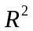 | 0.406 | 0.656 | 0.391 | 0.640
No. of States | 41 | 41 | 41 | 41

Note: *, ** and *** denote statistical significance at the 10%, 5% and 1% levels, respectively.

Table 13. Spatial model and dynamic spatial Durbin model (within-border effects): alternative definition (value-weighted state portfolios of industry-weighted returns).
 | Model I | Model II | Model III | Model IV
 | Market Model |  | Fama-French 3-Factor Model
 | Dynamic Panel Fixed Effects | Spatial Durbin Model | Dynamic Panel Fixed Effects | Spatial Durbin Model
State Coincidence Index | 0.104  (0.084) | 0.131  (0.082) | 0.039  (0.076) | 0.041  (0.064)
Business establishment | -0.239***  (0.098) | -0.103***  (0.055) | -0.098  (0.077) | -0.149*  (0.078)
Unemployment | 0.186***  (0.015) | 0.271***  (0.080) | 0.266***  (0.084) | 0.222***  (0.081)
Population | -0.104***  (0.043) | -0.133***  (0.049) | -0.144***  (0.050) | -0.148***  (0.051)
No. of firms in the state | 0.097*  (0.031) | 0.076*  (0.024) | 0.053**  (0.021) | 0.062***  (0.011)
No. of industries in the state | 0.202***  (0.040) | 0.211***  (0.038) | 0.262***  (0.032) | 0.198***  (0.037)
No. of acquisitions by firms in the state | 0.110  (0.110) | 0.098  (0.109) | 0.116  (0.114) | 0.112  (0.114)
No. of delisted firms in the state | 0.303***  (0.052) | 0.398***  (0.101) | 0.377***  (0.041) | 0.382***  (0.110)
No. equity issuance by firms in the state | 0.223***  (0.050) | 0.234***  (0.055) | 0.250***  (0.040) | 0.244***  (0.071)
Avg. market cap. of firms in the state | -0.161**  (0.046) | -0.141**  (0.022) | -0.191**  (0.033) | -0.200***  (0.032)
Value-weighted debt-ratio of firms in the state | 0.069*  (0.040) | 0.110  (0.120) | 0.198  (0.140) | 0.197  (0.133)
Value-weighted EBITDA-to-asset ratio of firms in the state | -0.307***  (0.059) | -0.300**  (0.102) | -0.302***  (0.046) | -0.301***  (0.101)
Value-weighted market-to-book ratio of firms in the state | 0.049  (0.061) | 0.116*  (0.060) | 0.099**  (0.044) | 0.107**  (0.058)
Lag returns |  | 0.469***  (0.024) |  | 0.422***  (0.022)
Constant | 2.333***  (0.112) |  | 2.698***  (0.179)
State FE | Included | Included | Included | Included
Observations | 1056 | 1056 | 1056 | 1056
 | 0.412 | 0.588 | 0.460 | 0.559
No. of States | 41 | 41 | 41 | 41

Note: *, ** and *** denote statistical significance at the 10%, 5% and 1% levels, respectively.

Table 14. Spatial Durbin model estimation with spatial weights (spillover effects).

 | Market Model | Fama-French 3-Factor Model
State Coincidence Index | 0.521***  (0.113) | 0.629***  (0.122)
Business establishment | -0.303***  (0.101) | -0.466*  (0.111)
Unemployment | -0.220***  (0.088) | -0.339***  (0.100)
Population | -0.077***  (0.021) | -0.089***  (0.024)
No. of firms in the state | 0.151**  (0.066) | 0.176***  (0.025)
No. of industries in the state | 0.298***  (0.056) | 0.332***  (0.062)
No. of acquisitions by firms in the state | 0.122**  (0.054) | 0.139***  (0.024)
No. of delisted firms in the state | 0.398***  (0.103) | 0.522***  (0.122)
No. equity issuance by firms in the state | 0.444***  (0.124) | 0.497***  (0.092)
Avg. market cap. of firms in the state | -0.322***  (0.031) | -0.364***  (0.042)
Value-weighted debt-ratio of firms in the state | 0.118**  (0.511) | 0.158**  (0.622)
Value-weighted EBITDA-to-asset ratio of firms in the state | -0.546**  (0.208) | -0.599***  (0.202)
Value-weighted market-to-book ratio of firms in the state | 0.221***  (0.055) | 0.324***  (0.087)
Returns | 0.345***  (0.033) | 0.403***  (0.042)
Lag returns | -0.289***  (0.022) | -0.289***  (0.022)
Residual variance (σ²) | 8.215***  (0.520) | 8.403***  (0.540)
State FE | Included | Included
Observations | 1056 | 1056
 | 0.406 | 0.656
No. of States | 41 | 41

Note: This table was estimated together with Table 10. *, ** and *** denote statistical significance at the 10%, 5% and 1% levels, respectively.

Table 15. GMM estimation of spatial panel with unknown heteroscedastic errors: Fama-French Three-Factor Model.
 | GMM | Robust GMM
State Coincidence Index | 0.321***  (0.109) | 0.329***  (0.108)
Business establishment | 0.0102  (0.108) | 0.080  (0.111)
Unemployment | -0.106***  (0.008) | -0.112***  (0.000)
Population | -0.102***  (0.019) | -0.122***  (0.024)
No. of firms in the state | 0.108**  (0.024) | 0.123***  (0.020)
No. of industries in the state | 0.169***  (0.050) | 0.182***  (0.060)
No. of acquisitions by firms in the state | 0.202*  (0.108) | 0.197***  (0.022)
No. of delisted firms in the state | 0.266***  (0.098) | 0.259***  (0.111)
No. equity issuance by firms in the state | 0.389***  (0.133) | 0.399***  (0.099)
Avg. market cap. of firms in the state | -0.303***  (0.029) | -0.303***  (0.020)
Value-weighted debt-ratio of firms in the state | 0.117**  (0.067) | 0.122**  (0.062)
Value-weighted EBITDA-to-asset ratio of firms in the state | -0.540**  (0.109) | -0.579***  (0.102)
Value-weighted market-to-book ratio of firms in the state | 0.119***  (0.023) | 0.131***  (0.026)
Returns | 0.244***  (0.040) | 0.269***  (0.039)
Distance: Human capital | 0.101**  (0.008) | 0.102**  (0.006)
Average of the spatial weight * Human capital | 0.404*  (0.179) | 0.393***  (0.176)
State FE | Included | Included
Observations | 1020 | 1020
 | 0.562 | 0.569
No. of States | 41 | 41

Note: Standard errors are in parentheses. The t-statistics are calculated under i.i.d. disturbances assumption. The t-statistic for robust GMM estimator is calculated from the robust variance formula. The estimated coefficients are weighted by both ‘W’ matrix (geographic) and ‘W1’ matrix (human capital distance). The panel estimation involved this new spatially weighted matrix.

Corresponding authors: Surendranath R. Jory (Southampton Business School, University of Southampton, UK. E-mail: s.r.jory@soton.ac.uk ); Tapas Mishra (Southampton Business School, University of Southampton, UK. E-mail: t.k.mishra@soton.ac.uk ); Thanh N. Ngo (Department of Finance, East Carolina University, USA. E-mail: ngot@ecu.edu). Acknowledgement: We sincerely thank Prof. Chris Adcock - the editor, an associate editor, and three anonymous referees for many insightful comments. These have improved the quality of the work significantly. We take sole responsibility for any remaining errors and omissions.
Such as ‘state pride’ instead of ‘national pride’. See, for instance, Heinkel et al. (2001) and Renneboog et al. (2008), among others.
Thanks to an anonymous referee who pointed out this aspect of ‘spatial interaction’.
Many thanks to an anonymous referee for asking us to investigate this point.
We thank an anonymous referee for suggesting this point.
All the derivations are available upon request from the corresponding author.
Source: http://mba.tuck.dartmouth.edu/pages/faculty/ken.french/Data_Library/det_12_ind_port.html
EBITDA stands for Earnings Before Interest, Taxes, Depreciation and Amortization.
In Figure 2, there is evidence of the rising trend for state coincidence index and a fluctuation of equally-weighted return around a mean value. However, following the advice of an anonymous referee, we have employed Andrews’ (1993, 2003) sequential break point test and found that although there were three break points identified by the system (1988, 1999 and 2009), none of them was statistically significant at the 5% level.
We also tried quintiles and deciles; the results are qualitatively similar.
Not all firms are created equal and some firms may be affected more by their headquarters’ location economic factor. We indeed control for firm characteristics in the panel regressions (Tables 11 through 14); however as a robustness check, we create, instead of just only one portfolio per state in a given time period, four portfolios for each state in each period. The four portfolios are based upon the lowest quartile to the high quartile of a firm characteristic. The four firm characteristics are (i) market capitalization (ii) market-to-book ratio, (iii) profitability /asset and (iv) debt ratio. So, at the end of each year, we classify all firms in each state into four groups using each of the four firm characteristics alternatively (four portfolios based on market capitalization, four portfolios based on debt, etc.) and then we create four portfolios. Thus, we create four new tables in which we report the average monthly returns in a year (raw returns and industry-adjusted returns) on state portfolios formed by four firm characteristics’ quartiles. In addition, we create four additional tables in which we report the 12- month buy-and-hold returns (raw returns and industry-adjusted returns) on state portfolios formed by four firm characteristics’ quartiles. To preserve space, we do not report the tables although they are available upon request from the authors.
It is important to note the distinction between Table 11 and Table 12. Table 11 involved Arellano-Bond type dynamic panel estimation. This method is known to account for endogeneity bias. Table 12 introduces the dynamic aspect, but the estimation follows conventional OLS. The spatial-panel method is robust and uses GMM-type estimation with dynamics running from both temporal and spatial domains.
Many thanks to the anonymous referee for suggesting these important points.
Stock Up on Information Before Buying Stock. Retrieved from http://www.finra.org/investors/alerts/stock-information-buying-stock
In this case, the subscript of cross-section has been ignored as we mainly focus on the effect offered by time dimension.
Moreover, the three types of spatial dependencies described above have been shown to not appear simultaneously so as to ensure identifiability of the parameter (Manski 1993).

