**Structural Loop Analysis of Complex Ecological Systems.**

Joseph J. Abram1,2, James G. Dyke1,2.

**1** Institute for Complex Systems Simulation, Highfield Campus, University of Southampton, Southampton SO17 1BJ, UK

**2** Geography and Environment, University of Southampton, Highfield Campus, Southampton SO17 1BJ, UK

**Abstract**

Ecosystems are complex and dynamic making them challenging to understand. We urgently need to assess human impacts on ecosystems which cause changes in structural feedbacks producing large, hard to reverse changes in state and functioning. System dynamics has proven to be a useful and versatile methodology for modelling complex systems given the comparative ease with which feedback loops can be modelled. However, a common issue arises when models become too large and structurally complex to understand the causal drivers of system behaviour. There is a need for an intermediate level of analysis capable of identifying causal driving structures and dynamics, regardless of model complexity. This study investigates Loop Eigenvalue Elasticity Analysis, a structural analysis technique commonly used in business and economic system dynamics models, and evaluates its utility for identifying feedback loop structures responsible for behavioural changes in complex ecological systems. The approach is demonstrated by analysing a simple lake system model that has been extensively studied in the past for its capacity to undertake critical transitions between alternative stable states. We show how the dominance of feedback loops can be tracked through time building influence over the system’s behaviour decades prior to the actual collapse in the system. We discuss our findings in the context of studying complex ecosystems and socio-ecological systems.

***Keywords****:* Complexity, Ecosystem**,** Socio-Ecology, Structural Analysis, Feedback Loop, Critical Transition, Modelling.

**Abbreviations:**

LEEA - Loop Eigenvalue Elasticity Analysis

SILS – Shortest Independent Loop Set

PLUM – Phosphorus Loops in (U)Soil and (M)Sediment model

DDWA - Dynamic Decomposition Weights Analysis

This work was supported by an EPSRC Doctoral Training Centre grant (EP/G03690X/1)

**Introduction**

Socio-ecological system models represent the interconnected nature of society and the environment. These systems are complex, able to exhibit emergence and self-organisation, with behaviours arising endogenously through non-linear dynamics (Güneralp 2006). A defining characteristic of socio-ecological systems is multiple feedback loops which collectively form the internal structure of the system (Meadows 2009), but disentangling and prioritising those feedbacks in order to understand system behaviour and develop effective policy is no simple task. Indeed, a necessary condition for labelling a system a socio-ecological system is that of a feedback loop operating between social and ecological elements. It is such feedback loops that are often the primary drivers of emergent system behaviour (Sterman 2001). Here, we use the term ‘driver’, in the context of structural feedback loops, to mean the main endogenous cause of a system’s behaviour. Systems may exhibit strong non-linear dynamics which are explored with the concepts of critical transitions between alternative stable states, regime shifts, and tipping points with potentially hard or effectively impossible to reverse changes in state due to properties of hysteresis (Scheffer 2009; Carpenter 2005). Consequently socio-ecological systems are hard to understand, hard to predict and difficult to manage (Meadows 2009). Maintaining socio-ecological systems in desirable states and understanding why their behaviours change through time is fundamental for economic growth, poverty alleviation and general wellbeing (United Nations 2015; Scheffer 2009).

Process based, mechanistic, bottom up modelling has been used to understand socio-ecological systems (Verburg et al., 2016). System dynamics is one methodology that can be used to increase our understanding of such systems. System dynamics models are structural representations of dynamic real world systems. They take a resource based view of the world, characterising a system through a set of stocks and flows in order to represent its structure. Stocks are often, but not only, material goods, and flows are pathways of material between stocks (Ford 2010).

System dynamics has an established track record of being applied to ecological and socio-ecological modelling (e.g. Ford 2010; Meadows 2009; Dyson & Chang 2005; Saysel et al., 2002; Vezjak et al., 1998). Powerful and intuitive software packages such as Vensim (Ventana Systems, Inc. 2006) and STELLA (isee systems 2016), the exchange of established models and modelling libraries allows potentially very complex systems to be represented with models that produce output via computationally efficient numerical integration schemes. Whilst this has allowed a wide range of system dynamic models to be developed, it has, at times, produced models that are difficult to assess with regards to their overall utility in increasing our understanding of real world systems. Such models can be challenging to parameterise, validate and interpret (Voinov & Shugart 2013). The risk is that some system dynamics models are essentially black box representations of the target system making them effectively as hard to interpret as their real world counterparts (Voinov & Shugart 2013).

In this study, we investigate a methodology that could increase our understanding, and potentially prediction, of large changes in system structure and functioning through a quantitative analysis of feedback loops as endogenous determinants of system behaviour. Rather than searching system-level properties and variables for statistical properties of impending critical transitions (Scheffer 2009; Scheffer & Carpenter 2003), we instead focus on the structural properties of the system which drives such behaviour.

We are motivated to understand how these sub-processes function collectively in producing system behaviour. One analogy is that if the system dynamics model is an organism that we can observe via its output, then we seek to understand the processes that drive such behaviour by peering within the model in order to identify ‘organs’ and ‘physiological processes’. This analysis can be used in conjunction with evaluation of the system output, the system’s stability, and identification of the most important components with respect to specific behaviours. In this study we investigate the mechanisms responsible for generating stability and instability within a system, how these change through time, whether stability or instability is dominated by an individual driver or generated by several, and how these drivers change in dominance as a system undergoes a transition between alternative stable states.

The technique explored within this study is known as Loop Eigenvalue Elasticity Analysis (LEEA). LEEA expands on the knowledge gained from linear stability analysis and graph theory, identifying a set of feedback loops within a system’s structure known as the Shortest Independent Loop Set or SILS (Oliva 2015; Oliva 2004), which are collectively responsible for generating stability and instability within the system. A description of SILS, what it does and, and how it is applied can be found within the Supplementary Information Section 1 of this paper. LEEA then structurally analyses the loop set, identifying which feedback loops are dominating the system’s behaviour at any point in time, generating a hierarchy of the influential feedback loops of the system.

Exploring ecosystem dynamics through the study of feedback loops has already shown potential to improve our mechanistic understanding of critical transitions and stability within lake systems (Kuiper et al., 2015). While the methodology of Kuiper et al. (2015) focusses primarily on food webs, their motivations of finding feedback loops within a lake ecosystem in order to determine stability and critical transitions between two regimes is similar to this study.

Previous research has demonstrated that LEEA can increase understanding of system behaviour and causal drivers across a range of model systems (Oliva 2015; Kampmann 2012; Kampmann and Oliva 2008; Güneralp 2006; Güneralp 2005). Thus far the method has only seen limited use in the field of socio-ecology in the context of agriculture (Bueno 2013; Bueno 2012) and the Baltic cod fishery as a potential practice to be undertaken after conducting generalized modelling (Lade 2015). Here we extend this work and evaluate LEEA in the context of critical transitions and regime shifts, implementing loop analysis of a small lake model which can undergo critical transitions between clear and turbid states as a consequence of human drivers.

A full explanation of the limitations of the LEEA technique, along with many solutions to these limitations have been addressed by Güneralp (2006). Efforts to make the technique more automated have been conducted by Sergey Naumov and Rogelio Oliva and can be found online (Naumov & Oliva, Accessed 2017).

*The model*

The model chosen to demonstrate the application of LEEA has been developed from Carpenter (2005) which formulated a simple model of a shallow lake, Lake Mendota in Wisconsin, USA, using empirical data for soil, lake and sediment phosphorus levels. The model was bistable as increasing phosphorus input in the lake produced a critical transition with a sudden shift from a clear to a turbid state. Shallow lakes are classic examples of bistable systems, capable of discrete transitions from clear to eutrophic conditions (Wang et al., 2012) and their properties are relatively well known (Carpenter et al., 2011; Carpenter 2005; Ludwig et al., 2003; Scheffer & Carpenter 2003; Scheffer 1998) with current theories attributing many eutrophic regime shifts to large influxes of phosphorus through anthropogenic activity such as fertiliser runoff from farms in the lake catchment area. The model has been chosen for two principle reasons: 1) The main focus of the model’s dynamic behaviour is a critical transition, allowing for an investigation of feedback loop behaviour around the point of a critical transition. 2) The model is relatively simple, allowing for a quantitative account of LEEA to be presented, and assessment of LEEA’s utility for the analysis of such systems.

**Background**

*Lake Eutrophication*

Lake Mendota is a shallow freshwater lake surrounded by agricultural fields which receive ample supplies of phosphorus fertiliser. Soil erosion leads to excess phosphorus from the fertiliser, not taken up by vegetation, to be washed into surrounding streams and rivers, eventually leading to the lake. This process concentrates phosphorus runoff from the lake’s catchment area into lake water where the excess of nutrients causes algal blooms to form. The formation of these blooms leads to plant death by blocking sunlight, fish death by generating anoxic conditions and phosphorus recycling from the lake sediment, which increases the already high levels of phosphorus in the system (Scheffer 2009; Scheffer & Carpenter 2003; Scheffer 1998). Combined, these events can cause a lake to undergo a critical transition from a nutrient poor, high biodiversity, clear water state to a nutrient rich, low biodiversity, eutrophic state.

Lake Eutrophication is not only detrimental for the lake biota and biodiversity, it can have adverse effects on the system’s provision of ecosystem services. Provisioning services are impacted primarily through the collapse of fisheries. Cultural services such as recreation and tourism are also affected (Dodds et al., 2009; Scheffer 2009). Attempts to return a eutrophic lake to its previous clear conditions require the levels of phosphorus in the lake to be reduced but these systems can have large hysteresis loops, making them very challenging to recover (Carpenter et al., 1999). If nutrient levels are reduced sufficiently, the lake becomes capable of undergoing a reverse critical transition, returning to its former low nutrient, clear state, however such a reverse in conditions may take many years (McCrackin et al., 2016; Wang et al., 2012).

*Feedback Loops*

Feedback loops can emerge in systems as coincidental structures when multiple interactions form between components that link an output back to its original source. Feedback loops are capable of existing in one of two forms, positive or negative. Positive feedback loops are known for generating reinforcing behaviour in a system and are associated with exponential growth or collapse, and are often found to be the causes of system instability. Negative feedback loops generate balancing behaviour within a system; they are associated with oscillatory trends or dampening and are often found to be the cause of system stability (Ford 2010). While the premise of positive and negative feedback can be easily understood, it is the interconnected nature of multiple feedback structures together that makes the behaviour they generate difficult to predict.

Feedback loops can be represented in models by constructing connections between variables that interact with each other, where multiple connections join together to form a loop. These can be represented as coupled ordinary differential equations. Here we focus on the structural properties of the model system and the feedback loops which drive their behaviour. In 1982, Forrester (1982) first used concepts established within classical control theory, using eigenvalues to describe the behaviour of linear systems, to decompose the behaviour of linearized system dynamic models into simple reference modes. Forrester (1983; 1982) then used this method to develop the concept of eigenvalue elasticity of model parameters which became known as Eigenvalue Elasticity Analysis (EEA). Loop Eigenvalue Elasticity Analysis (LEEA) was introduced in 1996, by Kampmann (2012) who extended the work of EEA, formally linking the strength of individual feedback loop structures to system eigenvalues. LEEA has since been applied to economic and industry modelling, with methodological refinements being made over this period (Saleh et al., 2010; Güneralp 2006; Kampmann and Oliva 2006). LEEA is based on the ability to describe a system’s behaviour through a set of eigenvalues at any moment of time and relate changes in output to influential feedback loop structures within the system.

The strength and sometimes even sign of feedback loops can alter in response to external drivers. Changes which occur to a system can generate changes to the strengths (i.e. the change in output from a change in input) of individual links (the structural connection held between two system variables). Changes to the strength of individual links consequently change the strength of feedback loops, which as a result are able to generate changes to the system’s eigenvalues. The ‘strength’ of a link may be referred to as the link gain and likewise the ‘strength’ of a feedback loop may be referred to as the loop gain, further explained in the Methodology section (see below) (Güneralp 2006). Changes in feedback loop gain which create large changes to eigenvalues indicate high influence of that feedback loop on the current behaviour, while changes in loop gain which produce small changes to eigenvalues indicate little to no influence of that feedback loop on the current behaviour. LEEA is therefore able to identify how much an individual feedback loop has dominance over the current system behaviour, allowing the user to identify a hierarchy of loop influence.

**Methodology**

The following section gives an overview of the steps required to undertake LEEA. The formalism and expansions on the following steps can be found in the Supplementary Information Section 1.

Calculation of loop eigenvalues and loop influence values is conducted via the following process:

1. The Jacobian Matrix of the linearized dynamical system model
2. Eigenvalues of the Jacobian matrix
3. Loop Gain
4. Loop Elasticity & Loop Influence
5. *The Jacobian Matrix* is an $n$ x $n$ square matrix where each element of the matrix is a partial differential equation that represents how one stock variables of the system affects another stock’s derivative, when all other variables are kept constant. The coefficients of the matrix therefore represent the links that exist between stocks (Gonçalves 2009).
6. *Eigenvalues* are calculated from a system’s Jacobian matrix and therefore the number of eigenvalues of a system is equal to the number of stocks in that system. From linear stability theory, eigenvalues can be used to determine if a system at a fixed point is stable or unstable (Glendinning 1994). Eigenvalues are capable of being real, or complex numbers with a real and imaginary part. An eigenvalue with a real, negative value is associated with the system converging towards a fixed point. If the real part of all eigenvalues are negative, then the fixed point is stable. An eigenvalue with a real, positive value is associated with the system diverging away from a fixed point. Therefore, if the real parts of any of the eigenvalues are positive, then the fixed point is unstable. Eigenvalues which are complex are associated with oscillatory behavior and means the system will express either sustained oscillations, expanding oscillations or dampening oscillations if the real part of the complex eigenvalue is zero, positive or negative respectively.

Eigenvalues which sit at or close to zero play a vital role in determining the system’s state of stability. A system is determined to be unstable for any given time period while at least one eigenvalue holds a real positive value. This means that large changes in negative eigenvalues which remain negative, portray less information about a system’s state of stability than small changes which happen to eigenvalues at or around zero.

When interpreting output from LEEA, it is possible to gain a different hierarchy of loop dominance from each eigenvalue within a system as different elements will be responsible for generating each eigenvalue (Oliva 2016). This can lead to multiple outputs with apparent contrasting results as different feedback loops are capable of expressing dominance across different eigenvalues. To reduce confusion, eigenvalues holding the largest real positive values may be prioritised first for interpretation. The greater the value of an eigenvalue, the more it determines the system’s current behaviour. While this allows the elasticity and influence plots of some eigenvalues to be prioritised and others largely ignored, attention must be paid to eigenvalues switching dominance and to eigenvalues at or close to zero as this would change which eigenvalues which must be prioritised.

1. *Loop Gain* reflects the overall strength of a feedback loop and is the product of the link gains whose associated links join together to form a loop. Link gains reflect the strength of influence of one variable upon another. An increase in an output with a fixed input infers an increase of gain within that link. Loop Gain is required to compare changes within the system’s feedback loops against the system’s eigenvalues.
2. *Loop Elasticity* is the change in an eigenvalue relative to change in loop gain (Kampmann & Oliva 2008, Kampmann & Oliva 2006). Thus loop elasticity indicates how much a loop contributes to changes within an eigenvalue. Loops with high absolute values of elasticity contribute the most to changes within an eigenvalue.

Loop Elasticity derives from an inherent connection that exists between system eigenvalues and loop gain through a system’s characteristic polynomial ( $P(λ))$ (Kampmann 2012). A characteristic polynomial takes the form $P\left(λ\right)=|λI-J|$, where $I$ is an Identity Matrix and $J$, the systems Jacobian Matrix. Loop gains make up the coefficients of the characteristic polynomial, while eigenvalues are determined as its roots. This connection between the two means that changes which occur in the gain of a loop can have a direct impact on the system’s eigenvalues and the extent to this impact can be measured in the form of Loop Elasticity.

*Loop Influence* values determine the type of contribution a loop is having over an eigenvalue. A positive value of loop influence indicates a loop generating instability within an eigenvalue, while negative values indicate the generation of stability (Kampmann & Oliva 2006). Similar to loop elasticity, the greater the absolute value of a loop’s influence, the greater the contribution that loop makes to the system’s current behaviour.

**Results**

*The PLUM model*

Carpenter’s study of Lake Mendota (Carpenter 2005) is represented using system dynamic terms in the form of the PLUM model ((P)Phosphorus (L)Loops in (U)Soil and (M)Sediment) (Figure 1).

System dynamic modelling is carried out using Vensim, which numerically integrates Carpenter’s series of ordinary differential equations. The model allows the user to visualise the number, polarity, position and interaction of the system’s feedback loops alongside providing the ability to easily implement and manipulate the system’s structure and dynamics. While representing the system’s internal structure in this manner is not necessary for LEEA as it can be computed purely numerically; it is easy to do the computation in a software such as Vensim, so it is worth the effort of building a system dynamic model. Vensim is not necessary for this analysis, but it allows for easy manipulation of loop structures and numerical solutions, which facilitates model construction. Vensim also compliments the online materials Naumov & Oliva (Accessed 2017), which have been designed to streamline the analysis process, including the ability to extract time series data from each simulation quickly and effectively. The packages used to calculate the results within this article were from the 2017 online material and require Vensim and Mathematica to reproduce, a link to the PLUM model and Mathematica codes used to generate the results can be found in the Supplementary Information, Section 2.

Carpenter’s (2005) study describes dynamic properties of phosphorus levels within a lake system as a set of coupled differential equations. This simple model, which is typically parameterised to empirical data, relates changes in the concentration of phosphorus in the water as phosphorus input into the lake increases over time. These equations model changes of phosphorus within the soil of the land (U), the water of the lake (P) and the lake sediment (M). A table listing all terms, units and descriptions is given in Table 1. The change of soil phosphorus over time if defined thus:

|  |  |
| --- | --- |
| $$\frac{dU}{dt}=W+F-H-cU,$$ | (1) |

with the runoff parameter *c* being important in driving the dynamics of concentrations of phosphorus in the water:

|  |  |
| --- | --- |
| $$\frac{dP}{dt}=cU-\left(s+h\right)P+rM\frac{P^{q}}{m^{q}+P^{q}}.$$ | (2) |

Phosphorus can be stored or released in the lake sediment thus:

|  |  |
| --- | --- |
| $$\frac{dM}{dt}=sP-bM-rM\frac{P^{q}}{m^{q}+P^{q}}$$ | (3) |

Derivation of the values used can be found in Carpenter (2005). The equations themselves have been developed from previous studies of lake dynamics (Carpenter & Kinne 2003; Ludwig et al., 2003; Carpenter et al., 1999).

The sigmoidal function, the last term of equation 2 and 3 represents high levels of phosphorus being reintroduced to the system from the sediment through phosphorus recycling, as phosphorus levels in the water column become enriched from agricultural and non-agricultural sources. Phosphorus recycling involves stored phosphorus, which has been accumulating in the lake sediment over year to decadal timescales, being released back into lake water as a consequence of chemical reactions driven by anoxic conditions at the bottom of the lake. The anoxic conditions are generated by populations of bacteria, which deplete oxygen during their decomposing of organic matter. The increase in organic matter, and so bacterial decomposition and bottom water anoxia, is a consequence of increased populations of algae and other lake biota taking advantage of the increasing levels of phosphorus in the lake water (Scheffer 2009; Carpenter 2005; Ludwig et al., 2003; Scheffer 1998).

|  |  |  |  |
| --- | --- | --- | --- |
| Symbol | Definition | Units | Nominal Value |
| *b* | Permanent burial rate of sediment P | y-1 | 0.001 |
| *c* | P runoff coefficient | y-1 | 0.00115 |
| *F* | Annual agricultural import of P to the watershed per unit lake area | g.m-2.y-1 | 31.6 |
| *h* | Outflow rate of P | y-1 | 0.15 |
| *H* | Annual export of P from the watershed in farm products, per unit lake area | g.m-2.y-1 | 18.6 |
| *m* | P density in the lake when recycling is 0.5 r | g.m-2 | 2.4 |
| *r* | Maximum recycling rate of P | y-1 | 0.019 |
| *q* | Parameter for steepness of f(P) near m | Unitless | 8 |
| *s* | Sedimentation rate of P | y-1 | 0.7 |
| *W* | Nonagricultural inputs of P to the watershed prior to disturbance, per unit lake area | g.m-2.y-1 | 0.147 |
| *WD* | Nonagricultural inputs of P to the watershed after disturbance, per unit lake area | g.m-2.y-1 | 1.55 |

Table 1. Modified from Carpenter (2005). Model parameters, nominal values and units used to implement PLUM.

Numerical solutions for the model were computed for 1000 years to recreate Scenario 1 from Carpenter’s model (Carpenter 2005). Scenario 1 undergoes the following changes:

0-100 years, presettlement conditions, *F* = *H* = 0 and *W* is set to undisturbed conditions.

100-200 years, advent of agriculture, *W* changes to its disturbed value (WD).

200-250 years, intensive industrialized agriculture, *F* > *H*, values shown in table 1.

250-1000 years, management to balance phosphorus budget of agriculture, *F* = *H* and *W* maintained at *WD*

The system has a single steady state value of lake phosphorus concentrations providing that non-agricultural inputs lie between *W* and *WD* and agricultural inputs do not exceed the annual export of phosphorus through farming products (*F=H*). Beyond this regime, the system becomes bistable, having two stable equilibrium between an unstable equilibrium, with a single steady state value of high lake water phosphorus concentrations being found when *F* is 1.7 times greater than *H*. Analytical solutions and graphical representation of the system’s bistability can be found in Carpenter (2005).

Assuming a constant input of additional agricultural phosphorus over time, the lake system undergoes a critical transition at ~450 years. Critical transition theory and resilience research often associate a change in system states with a shift in dominant feedback loops, where positive feedbacks drive a system into an alternative state through reinforcing behaviour, but due to the often very complex dynamics involved, little research has been done to actively show this happening (Scheffer 2009; Scheffer & Carpenter 2003). The mechanism driving the critical transition within this system is phosphorus recycling, which reinforces the amount of phosphorus within the lake water and is capable of causing large influxes of phosphorus to enter the water column long after attempts to control phosphorus input through the soil have been in place (Scheffer 2009).

Carpenter (2005) provides analytical solutions showing when the system is bistable, The bistable state allows for a reverse transition from turbid-water to clear-water conditions to be possible but this recovery is slowed by the steady release of phosphorus from the lake’s sediments. Carpenter notes that in order to induce a transition back to a clear-water attractor, either a stochastic event or deliberate management of phosphorus sediment recycling would have to take place.

A reverse transition was achieved within the model system by maintaining *F* = *H* and converting W back to its undisturbed conditions at 1000 years. Overall, this reduces the amount of phosphorus entering the lake water, creating a net output of phosphorus from the system over time. The reductions in phosphorus within the lake water undergo a linear decrease through time. However, a critical transition back to a clear water state does not occur until much later, around year 2050, when phosphorus levels have reduced well below levels of the original forward transition. The disparity between the point at which the forward and reverse critical transition occurs is known as hysteresis. In shallow lakes the hysteresis effect is often a result of different levels of nutrient loading (Scheffer 2009) i.e. how much phosphorus is able to enter the system within a given period of time. Results of the reverse critical transition are shown in figure 1c. LEEA was used to investigate which loop structures were generating stability and instability prior to, at and post both the forward and reverse critical transitions.



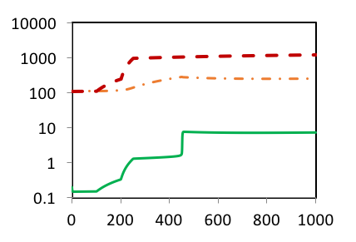

**b**

**Sediment**

**Soil**

**Water**

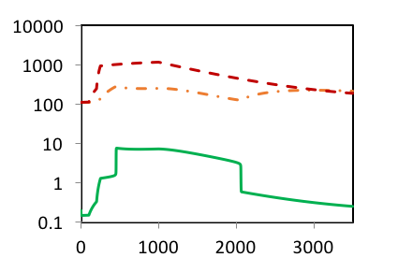

**c**

**Soil**

**Sediment**

**Water**

**1a**

Phosphorus Density (g/m2)

Figure 1. 1a. The PLUM model – a structural representation of Carpenter’s phosphorus equations (Carpenter 2005) containing the stocks (black boxes) water phosphorus density (P), soil phosphorus density (U) and sediment phosphorus density (M). The figure also contains system flows (black double arrows) going into and out of each stock, sources and sinks (cloud shapes) and component interactions (blue arrows). The recreation of Scenario 1 can be seen in figure 1b. The extension to the Carpenter simulation, to invoke a reverse critical transition in the system can be seen in 1c.

Time (Years)

The model’s three stocks U, P and M, shown as black boxes within figure 1a, relate to differential equations 1, 2 and 3 of the system. Each stock has an inflow and outflow (i.e. Uinput or Uoutput) shown by black double lined arrows which determine the level of material within the stock, which in this case is phosphorus density. Cloud shapes within the figure represent sources and sinks of the phosphorus, the specific locations of which are determined to be outside the scope of the model. Finally, blue arrows represent the interactions held between all model components which link together to form the feedback loops that occur between stocks. The model holds a total of six feedback loop structures which have been identified by the Shortest Independent Loop Set (SILS) and are labelled in figure 1a. A breakdown of the components within each of the SILS loops can be seen in table 2.

|  |  |  |
| --- | --- | --- |
| Loop No. | Structure | Feedback Type |
| 1 | M → Moutput → M | Negative |
| 2 | P → Poutput → P | Negative |
| 3 | U → Uoutput → U | Negative |
| 4 | M → phosequ→ Moutput → M | Negative |
| 5 | P → phosequ → Pinput → P | Positive |
| 6 | M → phosequ → Pinput → P → Minput → M | Positive |

Table 2: Loop numbers, structures and loop type within the PLUM model.

Eigenvalues, loop gains and loop influences were calculated once per year. For the forward critical transition, LEEA was calculated from the years 250-999 and for the reverse critical transition, LEEA was calculated from years 1000-2250. Outputs for the forward critical transition are shown in figure 2 a, b, c & d and reverse critical transition outputs are shown in figure 3 a, b, c, d & e.

*Forward Critical Transition*

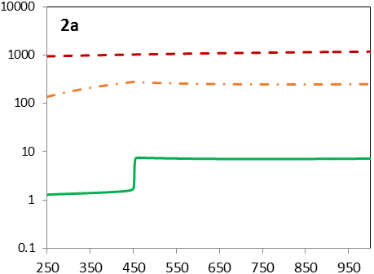

**Soil**

**Sediment**

**Water**

Phosphorus Density (g/m2)

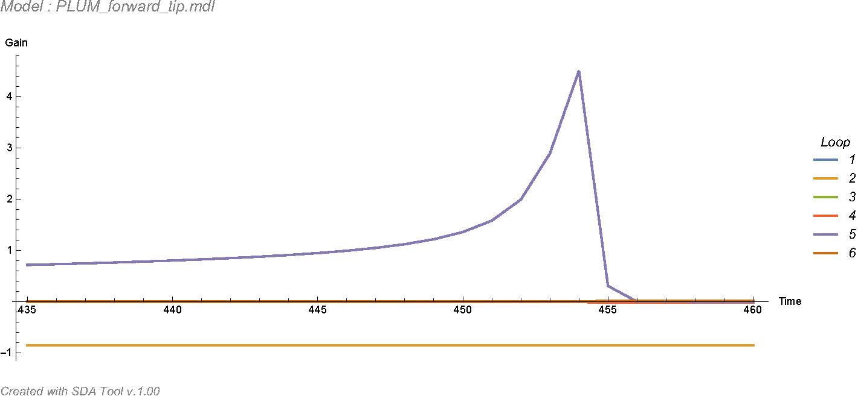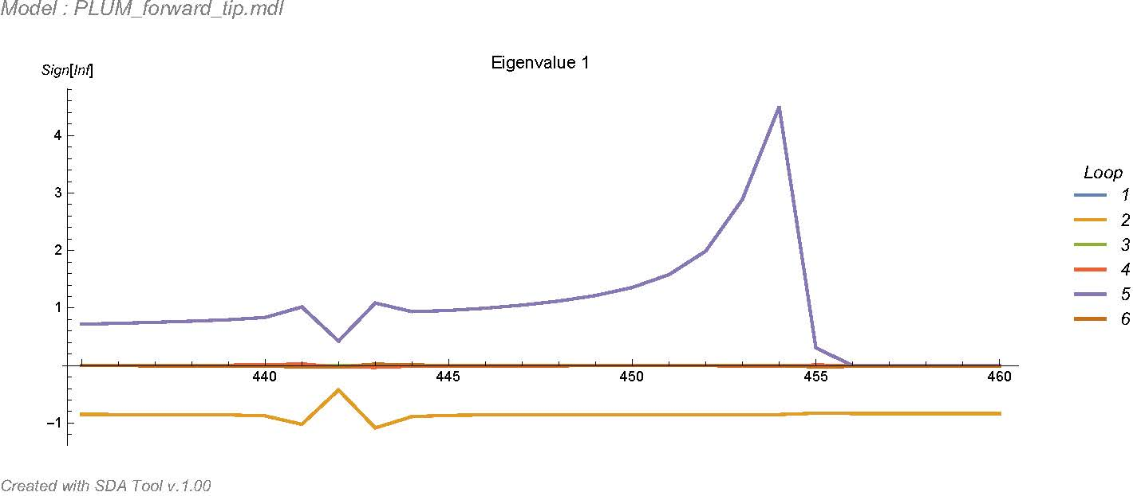

**b**

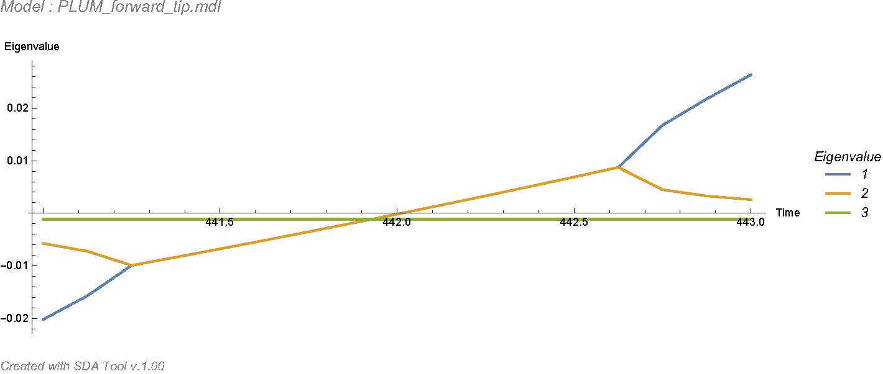

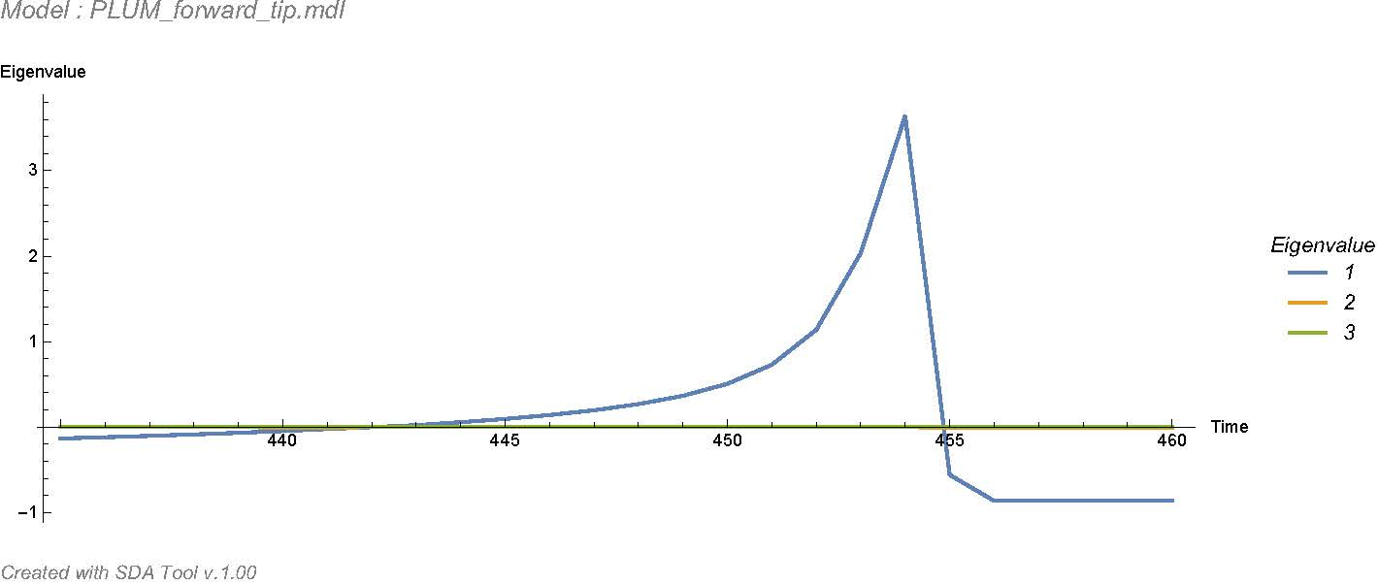

**c**



Eigenvalue



**d**



Loop Influence

Eigenvalue 1

Figure 2. a) Shows the forward critical transition from years 250-999 from Scenario 1 of Carpenter (2005). b) Loop Gain values for the forward critical transition between years 435-460. c) The system’s three eigenvalues calculated and plotted through time for the forward critical transition. The red box shows a zoom of the eigenvalues changing to positive polarity. d) Loop influence values within Eigenvalue 1 for years 435-460. Plots b, c and d are generated from Naumov & Oliva (Accessed 2017) online material.

Time (Years)

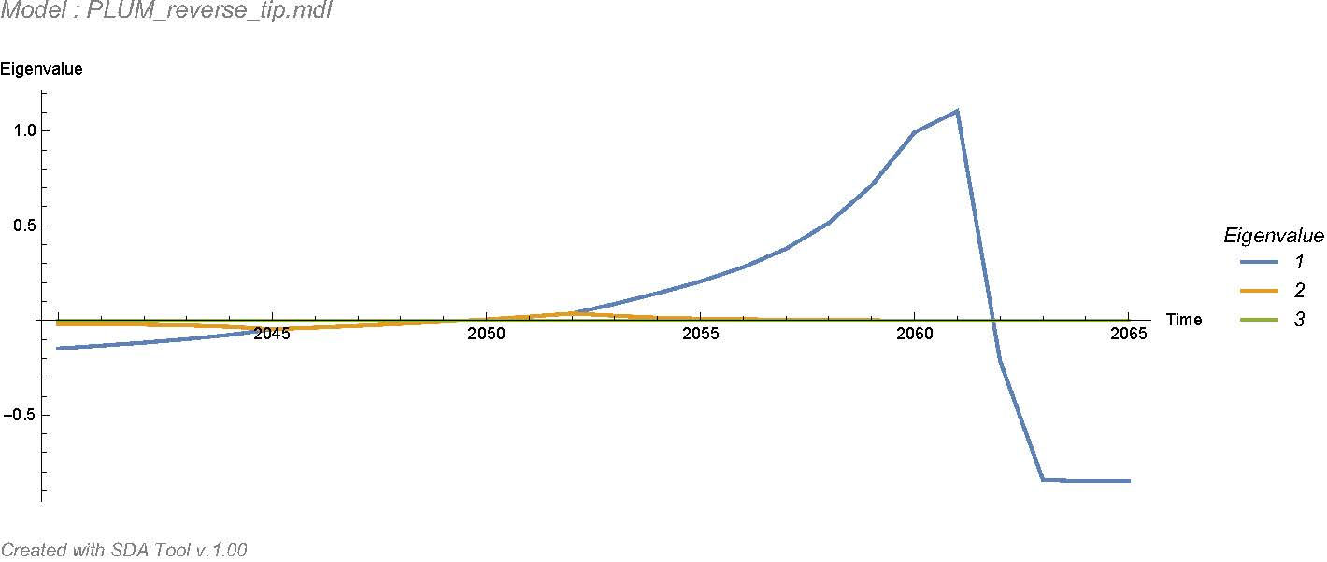

**c**

Eigenvalue

Figure 3. a) Shows the reverse critical transition from years 1000-2500 from the extension to Scenario 1 of Carpenter (2005). b) Loop Gain values for the reverse critical transition between years 2040 and 2065. c) The system’s three eigenvalues calculated and plotted through time for the reverse critical transition. d) Loop influence values within Eigenvalue 1 for years 2040 to 2065. e) Loop influence values within Eigenvalue 2 for years 2040 to 2065. Plots b, c, d and e are generated from Naumov & Oliva (Accessed 2017) online material.

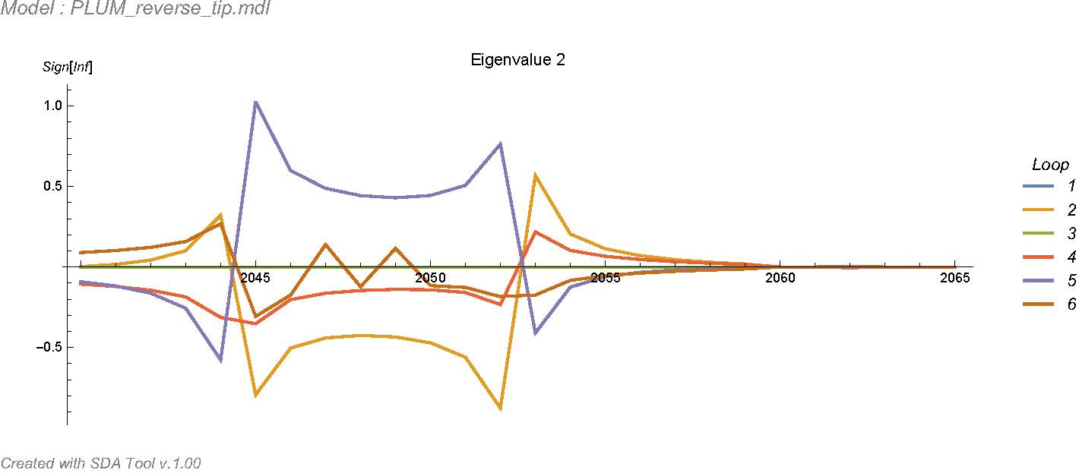

Eigenvalue 2

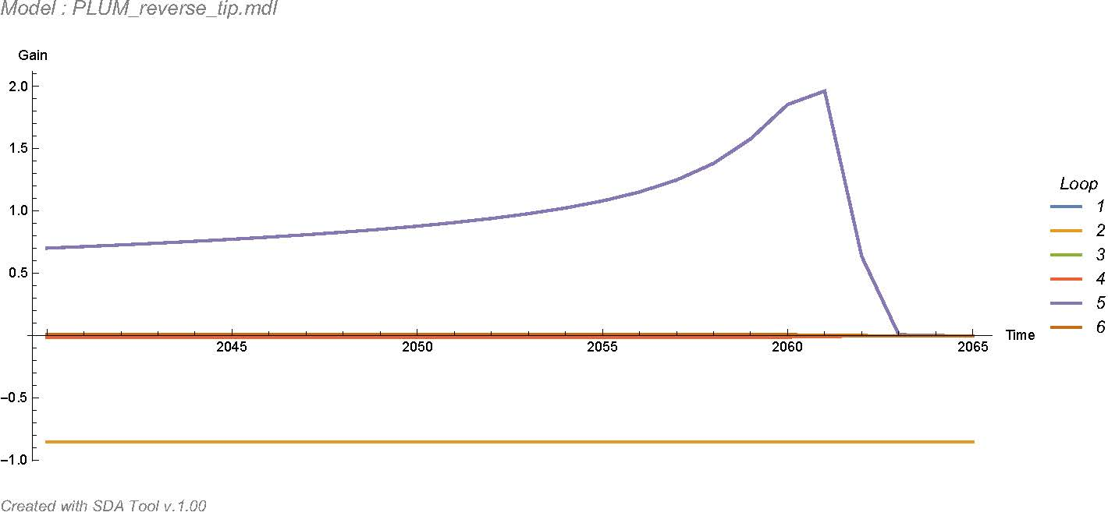

**e**

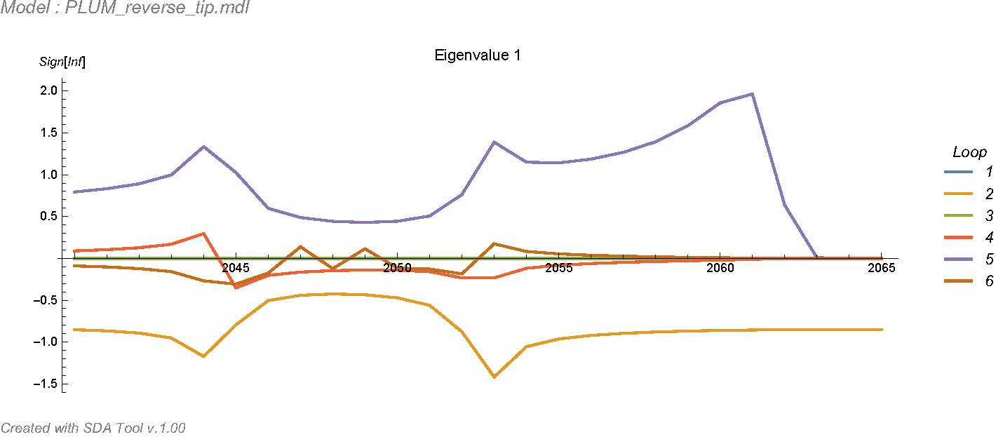

Loop Influence

Eigenvalue 1

**d**



**b**



Time (Years)

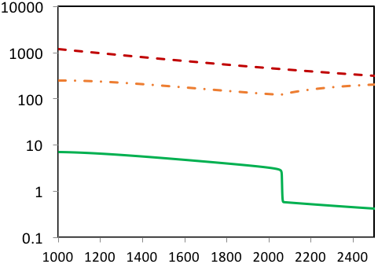

**3a**

**Sediment**

**Soil**

**Water**

Phosphorus Density (g/m2)

*Reverse Critical Transition*

In the forward and reverse critical transitions of the PLUM model, we are concerned with the feedback loops responsible for maintaining the system’s stable behaviour before and after the critical transition, while also understanding what changes occur to dominant feedback loops which then lead to the change of state. It is therefore important that all three eigenvalues are considered throughout the time series, for those dominating at times of stability and those changing polarity leading up to and during critical transition of the system.

*Forward critical transition*

Figure 2a shows the lake system after 250 years, whereby sufficient phosphorus has been added to the system to produce a regime shift from a clear to turbid water. The transition is sharp and represented by a sudden increase of phosphorus density within the lake water at ~450 years. As seen in figure 2a, there is little indication from the data that this transition is about to occur until a very narrow time window prior to the transition.

System loop gains for the six feedback loops of the forward critical transition between the years 435 to 460 can be seen in figure 2b. Loop gain values can give an initial impression of how the loop structures may influence the behaviour of the system, but cannot be used to directly infer drivers of system behaviour without first linking them to the system’s eigenvalues.

In the forward critical transition, the real part of Eigenvalue 1 holds the greatest negative real value for the first 192 years (t = 250-442) with the real part of eigenvalue 2 and eigenvalue 3 sitting just below zero at -0.00427 and -0.00115 respectively. The imaginary parts for all three eigenvalues are zero. In this time, the feedback loops producing the most influence within each eigenvalue are loop 2 (phosphorus water output) in eigenvalue 1, loop 3 (phosphorus soil output) in eigenvalue 2 and loop 1 (phosphorus sediment output) in eigenvalue 3. Loops 2, 3 and 1 all represent negative feedback loops within the system and express the highest values of loop influence which are all negative between 250-442 years, showing that these loops are generating stability within the system at this time. Over this initial period, the value of the real part of eigenvalue 1 becomes less negative, exponentially increasing towards zero, with the influence of feedback loop 5 within this eigenvalue exponentially increasing in positive value, indicating an increasing level of instability building from this feedback structure.

At year 442, eigenvalue 1 and eigenvalue 2 switch to positive values, holding the same values between time steps 441-443 (figure 2c). At this point, eigenvalues 1 and 2 combine to form a complex conjugate pair which would lead to oscillations. On closer inspection of the loop influence values for these time steps, both eigenvalues 1 and 2 are dominated by loop 2 and loop 5 which hold equal and opposite polarity values in the build up to the systems critical transition. Feedback loop 2 acts to stabilize the system, but is counteracted by the growing destabilizing influence of loop 5. At time step 444, eigenvalue 3 also changes to hold positive values alongside eigenvalues 1 and 2. This switch indicates all eigenvalues now represent the system diverging away from a fixed point, but note that this is still approximately 10 time steps prior to the critical transition being expressed within the water phosphorus of the system beginning around year 453.

The dominant loops within all three eigenvalues, while they hold positive values within the system, are consistently loop 5 (phosphorus recycling linked to phosphorus levels in the water) and loop 2 (phosphorus water output). Loop 5 always holds positive influence values showing it is generating instability within the system and loop 2 always holding negative values showing it is acting to keep the system stable. Note that the positive values held by eigenvalues 2 and 3 are only brief and are lower in real positive value in comparison to eigenvalue 1 (figure 2c, red outline). The values of eigenvlaues 2 and 3 also drop back below zero to negative values at years 444 and 445 respectively, before the critical transition, while eigenvalue 1 remains positive until year 454, right up to the critical transition of the system. The build-up to and the forward critical transition of the system is therefore largely represented by eigenvalue 1, with feedback loop 5 being a dominant influence over the systems instability across all eigenvalues leading up to the transition and loop 2 attempting to act as a counterbalace during this time (figure 2d). The build-up of eigenvalue 1 towards the critical transition is primarily dominated by the rising influence of feedback loop 5, with all other feedback loops maintaining relatively low and consistent influence levels throughout the time series As the system reaches its critical transition, loop 5 can be seen spiking in positive values, thus becoming the most dominant feedback structure within the system at the point of transition.

During the critical transition (years 445 – 458) and post the transition (458 – 999) we see all eigenvalues dropping to negative values as the system stabalises into its new eutrophic regime. In this new state, eigenvalue 1 falls to the largest negative values of the three eigenvalues once more, being dominated by feedback loop 2 with all other feedback influence values sitting at or close to zero showing little to no influence within this mode. Eigenvalue 2 shows some instability generated from loop 6, but not enough to override the stabilizing influence from loops 4 and 2, which are both negative feedbacks. Eigenvalue 3 becomes solely dominated by the stabilizing influence of negative feedback loop 3 with all other feedbacks sitting at or close to zero.

*Reverse critical transition*

Figure 3a shows how a gradual decline in phosphorus levels into the water over time eventually leads to a reverse critical transition, which can be seen occurring at 2050 years. Similar to the forward critical transition, there is little indication that the reverse critical transition is going to take place from the simulated data up until a very small time window beforehand. Once the reverse critical transition occurs, the system remains in its new clear state for the remainder of the simulation as phosphorus levels in the water continue to decrease. System loop gains for the six feedback loops of the reverse critical transition between years 2040 to 2065 can be seen in figure 3b.

The reverse transition tells a very similar story to the forward transition in terms of the feedback loops which are influencing the change of state. In the reverse transition, the critical transition back to a clear water state occurs just after year 2050, despite phosphorus input being cut from the system back in year 1000. The loop influence of eigenvalue 1 between years 1000-2049 is dominated by loop 2 with all other loops sitting at or near zero, eigenvalue 2 has high influence from loop 6 holding positive values, but being dominated by loops 2 and 4 with negative values and eigenvalue 3 has only loop 3 influencing it holding a constant negative value. At year 2049 eigenvalues 1 and 2 first show a positive real value (figure 3c), prior to this only negative feedback loops dominate the system.

Between years 2049 and 2052 both eigenvalues 1 and 2 transition into positive values holding the same real values with equal, but opposite imaginary values, once again forming a conjugate pair inferring oscillatory system behaviour in the build up to the system’s reverse transition. In this period, similar to the forward transition, eigenvalue 1 is dominated by a stabilising influence of loop 2 and a growing destabilising influence of loop 5 (figure 3d). At the same time, eigenvalue 2 is also being dominated by loop 2 and loop 5 (figure 3e). At year 2052, the positive value of eigenvalue 1 begins to increase, while eigenvalue 2 falls back to negative values and eigenvalue 3 only takes on positive values at year 2059, when eigenvalue 1’s real value is already much greater. Eigenvalue 1 can therefore be concentrated on for the remainder of the reverse transition as it holds dominance over the long term behaviour within the system. The growing influence of feedback loop 5 continues in eigenvalue 1 until year 2061, just at the start of the transition of the system back into a clear water state, whereby its influence spikes and then falls down to zero upon the system stabilizing into its new state.

From years 2061 onwards all eigenvalues drop back into negative values with eigenvalue 1 holding the highest negative value. From 2061 to the end of the simulation, eigenvalue 1 is dominated by loop 2, eigenvalue 2 is dominated by loop 3 and eigenvalue 3 is dominated by loop 1 all of which hold constant negative values throughout the clear state.

*Overview:*

Across both the forward and reverse transitions of the system, the behaviour of the system leading up to and during the transitions can largely be seen expressed by eigenvalue 1, which is primarily dominated by the stabilizing influence of negative feedback loop 2 (phosphorus output from the water). However, leading up to both critical transitions, positive feedback loop 5 can be seen growing in influence, overtaking the stabilizing influence of loop 2 years prior to both critical transition events. In both scenarios, once the critical transition has started its relatively sudden shift into the alternative state, the influence of loop 5 undergoes dramatic decline back to zero, whereby feedback loop 2 begins to dominate the system once again as it settle into its alternative state.

All eigenvalues and loop influence plots can be recreated using Naumov & Oliva (Accessed 2017) online material using the PLUM forward and reverse transition Vensim models, the locations of which can be found in Supplementary Information section 2.

**Discussion**

Overall the results of LEEA between the forward and reverse critical transition present very similar results. The instability that is seen building up in the system years prior to the critical transition events can largely be attributed to Loop 5, a positive feedback loop (figure 4a) containing phosphorus recycling, while stability in the system is maintained by Loop 2, a negative feedback loop (figure 4b) responsible for the outflow of phosphorus from the lake.

**Phosphorus runoff from the lake**

**Phosphorus density in the lake water**

**+**

**-**

**4a**

**b**

**Phosphorus recycling from the sediment**

**Phosphorus input to the lake water**

**+**

**+**

**Phosphorus density in the lake water**

**+**

**Loop 2**

**Loop 5**

Figure 4. a) Shows Loop 5, the positive feedback loop shown from LEEA to generate instability within the system leading up to the critical transitions. B) Shows Loop 2, a negative feedback loop responsible for most of the stability within the system.

In this study, LEEA has been shown to reinforce existing knowledge about phosphorus recycling as a key driver of critical transitions during system bistability through the analysis of a shallow lake model from Carpenter (2005). The analysis is able to show instability being generated within the system years prior to any indication of a critical transition from the simulated data, shown in figures 2d and 3d. Of particular interest was the ability to track the influence and dominance of the phosphorus recycling loop (Loop 5) through time as the system nears its forward and reverse critical transition. While instability within this system and its change of state are known to be driven by phosphorus recycling activating from the lake sediment, LEEA allowed the observation of the growing influence of this key feedback loop through time, with respect to all other feedback mechanisms in the model. Loop 5 represents a latent self-reinforcing mechanism which always exists within the system, but only becomes dominant within the system near its transition. Using LEEA, the dominance of the phosphorus recycling loop can be tracked simultaneously with the output of the model, showing the exact point in time at which phosphorus recycling becomes the dominant mechanism within the system overriding the stability generated through phosphorus outflow.

LEEA has been shown to have utility exploring a critical transition within a small eutrophic lake model within this study. It is important to consider LEEA’s potential in other projects of ecological economics. Examples of classic models where LEEA could be applied include Wonderland (Milik et al., 1996) and subsections of WORLD3 (Meadows et al., 2004), alongside Early Warnings of Catastrophe (Boerlijst et al., 2013).

Penn et al. (2017) and Penn et al. (2013) describe a process known as Participatory Complexity Science which builds models with a focus on system structure and component interactions, similar to that of PLUM. The process involves local companies and authority figures in the model building process from the beginning of a project, ensuring they are part of the project’s goals and discussion through the entire process and importantly, that they understand how the model works. LEEA could be utilised during policy testing and discussion of leverage points (Meadows 2009) to help distinguish between highly influential feedback mechanisms within the system (effective leverage points) identified through the analysis vs. the economical, physical and ethical viability for a company or authority figure to make changes to the system.

LEEA has already shown high potential for use in system management and policy implementation through the identification of system leverage points using an extension to the base analysis known as Dynamic Decomposition Weights Analysis (DDWA) (Oliva 2015; Saleh et al., 2010). Identifying leverage points is thought to be a key practice in order to control the behaviour of ecological systems (Meadows 2009) and is of particular interest when concerned with economic development and ecological sustainability. Future exploration of socio-ecological dynamics using both LEEA and DDWA for the purpose of quantitative identification of leverage points will be a natural and justified progression to the work presented within this study.

Van de Leemput et al. (2016) explore how hysteresis and alternative stable states may be generated within an ecological coral reef model through the implementation of three separate feedback mechanisms. Whether coral reefs are capable of alternative stable states in the real world continues to be an ongoing debate (Mumby et al 2013; Fung et al. 2011; Scheffer and Carpenter 2003) and is important in the context of coral reef conservation and recovery (Knowlton 2004). LEEA has potential use in such projects as a comparison tool to assess the influence of feedback loops when implemented individually with negligible impact vs. simultaneously when their combined presence changes the system’s ability to express alternative stable states.

*A breakdown of LEEA Benefits and Limitations*

|  |  |
| --- | --- |
| **Benefits** | **Limitations** |
| * Tracks a system’s behavioural drivers through time, with potential to inform policy implementation, scenario testing and overall control of the system. * Increases structural understanding of model through identification of feedback loops, loop lengths, locations and components. * Can be used with empirical data input into the system dynamic model to track system change in parallel with a model’s real world counterpart. * Alongside identifying key structures, LEEA is able to identify structures not contributing to system behaviour, with potential to improve model efficiency by identifying unnecessary model components and structures. * Able to show changes in behavioural drivers prior to a critical transition when no changes are expressed in model output. * Technique can be applied to both whole system models and simple models alike as it is not affected by subject matter. | * Computationally demanding: At each time step the system must be linearized, the Jacobian Matrix must be generated and eigenvalues must be calculated. * Analysis of results gets increasingly difficult with increasing model size as eigenvalue number increases 1:1 with model stock number (Kampmann & Oliva 2006). * A lack of automation or availability as part of a software programme. This is being improved with each iteration of LEEA’s associated algorithms (see ‘Analysis of more complex models’ below). * Eigenvalues can express similar levels of dominance simultaneously, reducing one's ability to specify individual behavioural drivers. |

.

*Analysis of more complex models*

In the early stages of LEEA’s development, analysis automation was low and output generation time was a serious limitation of the technique. Algorithms specifically designed to help with LEEA’s automation greatly improved the techniques accessibility (Oliva Accessed 2015), but the computational power and run time, particularly concerning large, complex models (>10 stocks), limited the LEEA’s utility to an extensive range of system models. In recent years, advancements made to the algorithms associated with LEEA and its companion technique, DDWA, have made vast improvements to the speed of execution (Naumov & Oliva, Accessed 2017). Development of better heuristics and display formatting has also been introduced to support the interpretation of the output, with recent studies showing the techniques successfully being executed and interpreted on models of 13 and 10 stocks (Oliva 2016; Oliva 2015).

**Conclusion**

This study has shown how a structural loop analysis technique known as Loop Eigenvalue Elasticity Analysis (LEEA) can be applied to analyse the dynamics of a simple model of a shallow lake system that undergoes critical transitions between clear and turbid states. Analysing a system which contains feedback loops can help reveal significant loop structures operating within a system’s behaviour: a non-trivial problem even with apparently simple systems. LEEA is able to show how feedback loops can be identified and classified in terms of their dominance, stabilising, and destabilising contributions. The results of this particular study show how growing levels of instability within the system can be largely attributed to an individual feedback loop, where the instability began to grow years prior to a critical transition. There is global significance for model scenario testing, policy implementation and ecological conservation to enhancing our understanding of socio-ecological systems, and the mechanisms for which they can be managed. LEEA was shown to be capable of providing benefits across multiple levels of prior system knowledge, allowing the user to identify key structural drivers of system stability and dynamic behaviour. Careful interpretation of LEEA output is required for more complex models. This can be regarded as a limitation of the technique, or alternatively a more robust and effective methodology for the analysis of complex models given that there are often no simple explanations for system’s behaviour under such situations.