Investigating the impact of overlying vegetation canopy structures on fire radiative power (FRP) retrieval through simulation and measurement

Roberts, G¹*, Wooster, M. J²³., Lauret, N⁴., Gastellu- Etchegorry, J-P⁴., Lynham, T⁵. and McRae, D⁵.
*corresponding author
1) Geography and Environment, University of Southampton, Southampton, UK
2) Kings College London, Department of Geography, London, UK, WC2R 2LS.
3) NERC National Centre for Earth Observation (NCEO), Kings College London, UK
4) CESBIO, Toulouse University, CNES, CNRS, IRD, UPS (Toulouse),France
5) Canadian Forest Service, Great Lakes Forestry Centre, 1219 Queen Street East, Sault Ste. Marie, ON, Canada

Abstract
Fire radiative power (FRP) retrievals are now routinely made from polar and geostationary instruments, providing a means to estimate fuel consumption and trace gas and aerosol emissions directly from remotely sensed observations. This study presents the first investigation of the impact of vegetation canopy structure (percentage canopy cover and leaf area index, LAI) on FRP retrievals, based on 3D radiative transfer model simulations. The Discrete Anisotropic Radiative Transfer (DART) model is used to simulate above-canopy observations made through 3D vegetation canopies with different structural arrangements, under which a centrally positioned uniform landscape fire is burning. The vegetation canopy is modelled in two ways, as an opaque structure and as a hybrid turbid medium. The percentage canopy cover in each simulated scene is varied between 5-95%, and the FRP retrieved above the canopy is found to decrease in proportion to percentage canopy cover when the canopy is opaque, a finding that is in agreement with a series of small scale outdoor measurements conducted to evaluate the realism of the simulations. However, when the canopy is modelled as a turbid medium, which is in some ways a more realistic representation of a real ‘gappy’ vegetation canopy, the degree of FRP interception occurring at any particular canopy cover decreases by ~ 14%, due to some fire emitted thermal energy being transmitted through the canopy gaps. The simulations also reveal the impact of canopy LAI on above-canopy FRP retrievals, reducing these by 6% when both canopy cover and LAI are low (5% and <1.0 respectively), but by up to 92% when canopy cover and scene LAI are high (95% and ~8 respectively). We use the derived relationships between FRP interception and canopy structure, along with MODIS LAI and percentage tree cover data, to adjust 2004-2012 fire radiative energy (FRE) estimates calculated from FRP data collected by the geostationary Meteosat Spinning Enhanced Visible and Infrared Imager (SEVIRI) instrument. The adjusted annual FRE is on average 15% greater than estimated, and is characterized by low inter-annual variability as result of the majority of fire activity occurring in areas where percentage tree cover remains below 40%. Landscape burning occurs more frequently in areas of higher tree cover in southern hemisphere rather than northern hemisphere Africa, leading to a larger annual FRE adjustment (18.5% compared to 16.3%). This study illustrates the impact that canopy interception has on FRP for the first time at the satellite scale, and over Africa demonstrates a large but temporally consistent underestimation which can be accounted for using LAI and percentage tree cover metrics when estimating fuel consumption and atmospheric emissions from the FRP retrievals.

2. Introduction
Landscape fire is a global, highly dynamic Earth system process, altering surface structural and radiative properties and releasing aerosols and trace gases into the atmosphere (Arora and Boer, 2005; Bowman et al., 2009). Satellite Earth Observation (EO) has been widely applied to study landscape fires, either through measurements of burned area based on surface spectral reflectance change (Pereira, 1999; Giglio et al., 2013), or via the detection of the thermal energy radiated as the fire burns (Robinson, 1991; Zhukov et al., 2005; Xu et al., 2010). The ‘active fire’ approach uses thermal infrared observations to estimate the rate at which thermal energy is being radiated away from a fire (the fire radiative power). Retrievals of FRP are then used to back-calculate the rate of fuel consumption that must have been ongoing to produce the observed rate of thermal radiant energy release (Kaufman et al., 1996). Small scale experiments have shown strong links between the temporal integral of FRP (so-called Fire Radiative Energy; FRE) and fuel consumption that appear to be independent of vegetation type (Wooster et al., 2005). Landscape fire fuel consumption is most typically derived using burned area (Chuvieco et al., 2016; Giglio et al., 2013) or FRE (Ellicott et al., 2009; Kaiser et al., 2012) based methods, and we focus here on canopy cover impacts on the latter approach and the resulting effect this may have on the information derived from satellite-based FRP retrievals. Numerous studies have utilized FRP retrievals from polar-orbiting (e.g. Vermote et al., 2009; Andela et al., 2016; Schroeder et al., 2014; Ellicott et al., 2009) and geostationary sensors (e.g. Li et al., 2018; Mota and Wooster, 2018) to estimate fuel consumption, and/or smoke emissions, and in terms of fuel consumption many have typically been lower than those from burned area based approaches (Roberts et al., 2011), and also lower than expected from ground-based measures (Andela et al., 2016). A variety of factors may contribute to this apparent underestimation, and to the uncertainty of FRE estimates more generally, for example satellite orbital constraints that limit the number of FRP observations in a given time-period (Andela et al., 2015), sensor optical characteristics (e.g. spatial resolution, point spread function and sensor saturation; Calle et al., 2009; Wooster et al., 2015), active fire detection algorithm performance (Giglio et al., 2016, Freeborn et al., 2014b) and FRP retrieval random error (Boschetti and Roy, 2009; Freeborn et al., 2014a). Vegetation canopy cover masking some of the emitted FRP from view is a further possible and potentially highly significant effect that has so far not been quantitatively studied. We focus on this issue herein, which typically does not affect burned area based estimates of fuel consumption unless the canopy cover results in special approaches being required to identify sub-canopy burned areas (e.g. in thick forests; Morton et al., 2011). A further key advantage of the burned area based approach to fuel consumption estimation is that this method enables identification of short duration fires which may be missed by active fire methods, which is important as it is typically the omission of these fires which is a significant source of FRP underestimation (e.g. Roberts and Wooster, 2008; Zhukov et al., 2006; Freeborn et al., 2014b; Zhang et al., 2017). However, on the other hand, burned area based approaches to total fuel consumption estimation require separate information on fuel consumption per unit area within the burn scar to be provided, which is often difficult to obtain for particular fire-affected locations (van Leeuwen et al., 2014). Recent studies based on satellite-derived FRPs have also suggested a biome-dependence in the relationship between FRP and fuel consumption that remains unexplained (Kaiser et al., 2012; Schroeder et al., 2014; Li et al., 2018). Spaceborne retrievals of FRP are made through the full depth of the atmosphere and through any overlying vegetation canopy that may lie above a surface fire, and these may be responsible for some of the biome-dependence on the FRP-to-fuel consumption relations noted when using spaceborne observations (Kremens et al., 2012; Mathews et al., 2016; Mota and Wooster; 2018).
We investigate the canopy cover impact on FRP and FRE retrievals using a 3D radiative transfer model. Such models provide key tools for understanding interactions between solar and terrestrially emitted VIS to LWIR radiation and Earth’s surface and atmosphere, including the elucidation of atmospheric effects on the measured remotely sensed signals. Radiative transfer models have been applied to simulate fire impacts on surface spectral properties (Disney et al., 2011), to develop algorithms to quantify fire impacts on the land surface from such signals (Chuvieco et al., 2006), and to characterise the detectability of burned areas occurring under forest canopies (Pereira et al., 2004). Here we use the Discrete Anisotropic Radiative Transfer (DART) model (Gastellu-Etchegorry et al., 1996) to simulate the thermal 3D radiative transfer within and above landscapes to investigate canopy impacts on FRP, and to understand the degree to which spaceborne observations of surface fire FRP may be influenced by overlying canopy interception.

3. FRP Background
Vegetation is comprised mainly of cellulose, hemi-cellulose, proteins, lignin and water (Stott, 2000), and is approximately 50% carbon by dry mass (Grigal and Ohmann, 1992). During complete combustion the carbon is oxidized to CO₂, with the concomitant release of water vapour, and thermal energy. The heat of combustion (MJ.kg⁻¹) represents the total energy available for release upon burning completely in oxygen, and this figure is rather constant between vegetation types, with a minimum of around 16.2 MJ kg⁻¹ for senesced grass and a maximum of around 23.7 MJ kg⁻¹ for oil-rich eucalyptus leaves (Jenkins et al., 1998; Johnson, 1992; Stott, 2000). The radiative component of this heat yield can be retrieved via remote sensing, and the rate of emission of this from a fire containing multiple thermal components, each having different temperatures and areas, is the fire radiative power (FRP, Watts):

${FRP}_{true}=εσ\sum_{n=1}^{N}{A_{n}T_{n}^{4}}$ [1]

where ${FRP}_{true}$ is the fire radiative power (Wm⁻²), N is the number of temperature components in the fire, σ is the Stefan-Boltzmann constant (5.67x10⁻⁸ J s⁻¹ m⁻² K⁻⁴), ε is fire graybody emissivity,$A_{n}$ is the fractional area and $T_{n}$ is the temperature of the n^{th} thermal component (K). An important assumption in Equation 1 is that flame behaves as a graybody (i.e. constant emissivity with wavelength). Johnston et al. (2013) provide a recent assessment of flame LWIR and MWIR spectral emissivity, and confirm that the graybody assumption is valid (and that flame emissivity increases with flame depth). They also suggest that the absolute value of flame emissivity at any particular flame depth varies with soot volume fraction, whilst the depth as viewed by a remote sensing instrument depends on the viewing geometry and the flame geometry.
Kaufman et al. (1998) first suggested the use of FRP retrievals to back calculate smoke emission and fuel consumption rates, and the link between the two has since been quantified in numerous studies (e.g. Wooster et al., 2005; Freeborn et al., 2008; Pereira et al., 2011; Kremens et al., 2012; Smith et al., 2013). Fire radiative energy (FRE; Joules) is the temporal integral of FRP, and the type of linear relationship between FRE and fuel consumption shown by Wooster et al. (2005) and Kremens et al. (2012) has been exploited with both polar-orbiting and geostationary satellites to estimate the amount of dry matter consumed and the smoke emissions released by landscape fires (Polar Orbiting: e.g. Ichoku and Kaufman, 2005; Ellicott et al., 2009; Vermote et al., 2008; Freeborn et al., 2009; Kaiser et al., 2012; Schroeder et al., 2014; Boschetti and Roy, 2009; Pereira et al., 2009; Geostationary: e.g. Andela et al., 2016; Mota and Wooster, 2018; Roberts et al., 2005, 2011; Zhang et al., 2012; Roberts et al., 2015; Li et al., 2018; Baldassarre et al., 2015).
The FRE approach a more direct route to estimating landscape scale fuel consumption than burned area based methods, which still require estimates of fuel load per unit area and combustion completeness from models or field data (e.g. Korontzi et al., 2004; Ito and Penner, 2004; Lehsten et al., 2008; van der Werf et al., 2010; Randerson et al., 2012). Whilst FRP retrievals from the MODIS sensor onboard the Terra and Aqua satellites are used for routine fuel consumption and fire smoke emissions calculations however, the linear FRE-to-fuel consumption relationship derived by Wooster et al. (2005) during small scale experiments have tended to strongly underestimate landscape scale fuel consumption when applied to these data (Roberts et al., 2011; Andela et al., 2016). This is expected to be particularly significant in more forested regions (Kaiser et al., 2012), and it is assumed to occur as a result of infrared radiation emitted from the surface fires being intercepted by the overlying tree canopy. Additional interception of the above canopy radiation may also come from atmospheric absorption, and these two effects alone may mean that spaceborne FRP retrievals of surface vegetation fires burning below tree canopies maybe significantly lowered compared to what under-canopy observations would provide.
Recent studies have investigated certain fuel characteristics that impact the retrieval of FRP. Smith et al. (2013) found that fuel moisture reduced the amount of energy released per unit of fuel consumed (MJ. kg⁻¹), up to a maximum of ~25% at the highest vegetation moisture contents (14% moisture content). Using a similar small-scale measurement approach, Mathews et al. (2016) investigated the impact of vegetation percentage cover, finding that it reduced FRP in direct linear proportion to the areal coverage of the overlying vegetation. This suggests both that vegetation may be opaque at the thermal IR wavelengths concerned, and that a proportion of the FRP emitted by surface fires will be blocked by this process. Here, we go beyond this laboratory experiment, and explore the landscape scale impact of overlying tree canopies on surface vegetation fires via simulations that include a 3D landscape of fire and vegetation. We explore how the tree canopies may block a certain proportion of the fire-emitted infrared radiation from a spaceborne sensor, and also how different vegetation structures may result in increasingly non-lambertian behaviour in the observed FRP fields. We supplement this with an assessment of the relative importance in controlling the biome-dependent differences seen in FRP-to-fuel consumption relations.

4. The Discrete Anisotropic Radiative Transfer (DART) model
We use the DART 3D radiative transfer model to simulate three dimensional Earth-surface scenes at visible to thermal infrared wavelengths (Gastellu-Etchegorry et al., 1996). DART simulations are based on either ray tracing or discrete ordinates methods (Grau and Gastellu-Etchegorry, 2013; Gastellu-Etchegorry et al., 2015). For thermal IR wavelengths, emission of individual surface elements is modelled using the Planck or Stefan Boltzmann Laws and is assumed to be isotropic (Gullevic et al., 2003). The resulting representations enable analysis of the Bidirectional Reflectance Distribution Function (BRDF) and Bidirectional Temperature Distribution Function (BTDF) of the scene to be derived from the simulations, as shown for example by Kallel and Gastellu-Etchegorry (2017) and Gullevic et al. (2003).
DART is capable of simulating atmospheric radiative transfer at the surface and in the atmosphere, so in addition to canopy interception can also be used to quantify the impact of atmospheric attenuation on spaceborne FRP observations, including accounting for Earth-atmosphere radiative coupling. Grau and Gastellu-Etchegorry (2013) provide a detailed description of the atmospheric model within DART, and it is only briefly summarized here. The DART atmosphere is simulated using up to three vertical slabs; (1) the upper atmosphere composed of horizontal layers, (2) the middle atmosphere composed of higher resolution vertical and horizontal cells, and (3) a lower atmosphere having the same vertical and horizontal cell dimensions as those used to simulate Earth surface objects. Atmospheric cells are characterized by trace gas and aerosol particle densities, along with their respective optical properties (extinction coefficients and single scattering albedo). DART contains six predefined atmospheric representations taken from the widely used MODerate resolution atmospheric TRANsmission (MODTRAN) model (Berk et al., 2005), for example Midlatitude summer, Sub-Arctic Winter etc, along with a series of aerosol models (e.g. rural 25km visibility, urban 5km visibility).
DART simulates the near-surface of a 3D scene as an array of rectangular cells having a defined spatial cell size. Three dimensional objects, such as trees and buildings, can be simulated using plane surfaces (triangles and parallelograms) or as turbid media. Turbid cells can be used to simulate vegetation (e.g. leaves, woody material) or fluids (e.g. air, soot, water) using defined statistical distributions in which radiation attenuation is described using Beer’s Law (Ross, 1981). Surface cells composed of triangles are used to simulate solid objects, such as walls and roofs, vegetation trunks and branches and the materials at the surface (e.g. soils).
Vegetation canopies can be described using turbid cells, facet cells or combinations of both. DART can both import landscape elements (e.g. trees, buildings) or directly simulate them using schematic shapes. For example, DART created tree crowns can be described using pre-defined shapes (e.g. ellipsoid, trapezoid cone) filled with a turbid medium or facets with any dimension can be randomly distributed within the scene or with a pre-defined spatial distribution. Figure 1 illustrates a tree, simulated by DART as part of the RAMI-4 radiative transfer intercomparison exercise (Widlowski et al., 2013), using a combination of turbid grid cells for leaves and opaque triangles for the trunk and branches (Figure 1b) which is derived from the tree model where leaves are described as individual scattering elements (Figure 1c). Turbid cells are described using an infinite number of infinitely small plane surfaces whose 3D distribution is described by the leaf and twig angle distribution, leaf area index (m²/m²) or leaf area density (u_{f}; m²/m³) and twig area index (TAI, m²/m²). In a schematic tree crown, the vertical and horizontal distribution of leaves and holes (empty cells) can be varied to simulate within crown clumping and defoliation. Cells in a scene have defined optical and thermal properties for each wavelength or spectral band simulated. The optical properties of vegetated cells are described by reflectance and direct and diffuse transmittance profiles, whilst the cells’ thermal properties are described by emissivity and temperature. Depending on cell dimensions and on the number of triangles that are used to simulate a tree, the transformation of the ‘triangle tree’ into ‘turbid tree’ can decrease computer time while maintaining model accuracy for computing the tree canopy optical properties. This transformation allows one to retain the general tree 3D architecture, conversely to the use of trees that are simulated with schematic crown shapes. This point is important when considering the transmittance of tree canopies. DART provides a range of outputs including 2D arrays representing the spatial distribution of spectral radiance, bidirectional reflectance factor (BRF) and brightness temperature (BT), including for each wavelength or spectral band and viewing geometry simulated.
The flexibility provided by DART has seen it applied to simulate the radiative regime of heterogeneous 3D vegetation canopies in the visible (Malenovsky et al., 2008; Sepulcre-Canto et al., 2009; Schneider et al., 2014) and thermal (Guillevic et al., 2003; Sepulcre-Canto et al., 2009) domains and urban areas (Lagouarde et al., 2010; 2012). DART was also used in the RAdiation transfer Model Intercomparison (RAMI; Widlowski et al., 2007; 2008) exercise, and was shown to have very similar performance in the visible and near infrared (NIR) to other 3D RT models. Sobrino et al. (2011) compared DART simulated scenes against ground, airborne and spacebone (Advanced Spaceborne Thermal Emission and Reflection Radiometer; ASTER) imagery in the LWIR spectral (8-13 µm), indicating the DART simulations had an absolute RMSE < 2K when compared to ground radiometric temperature measurements. Lagouarde et al. (2010) used DART to model the LWIR BTDF of an urban area and also found generally good agreement between simulated and observed temperatures, with the error bounds identified by these other studies. Though DART has been widely validated in the VIS to SWIR and LWIR spectral region (e.g. Gastellu-Etchegorry et al., 2015; Kallel et al., 2017; Morton et al., 2016; Laguarde et al., 2012), its abilities within the middlewave infrared (MWIR) are yet to be fully assessed.

5. Methodology to simulate canopy effects on FRP retrieval
5.1 DART Setup
A series of DART 3D simulations were conducted in the MODIS MWIR spectral waveband (Band 21; 3.929-3.989 µm), which is the primary waveband used for both active fire detection and FRP retrieval in the official MODIS active fire products (Giglo et al., 2016). To investigate canopy interception of upwelling surface fire-emitted radiation, a 50m × 50m scene was simulated at a 0.25 m spatial resolution, with each simulation covering 500 different viewing directions (0-80° view zenith and 0-360° view azimuth angles. A fixed solar zenith (30°) and azimuth (225°) angle were assumed since the focus of the study concerns the impact of overlying vegetation on FRP retrieval.
Scene cells had defined optical (i.e. hemispherical directional reflectance and transmittance) and thermal properties, parametrised according to their material type. Ground surface temperature was set to 310 K and its optical properties set to that of a gravelly loam soil (Figure 1a). For this material, scattering in the 3-5 µm wavelength range is dominated by the fine grain size and mineral composition (Salisbury and D’Aria, 1994; Boyd and Petitcolin, 2004).
A fire was positioned centrally in each scene and covering a planimetric area of the surface 25 m × 25 m in size. The thermal emissions from burning vegetation have complex radiative characteristics, varying significantly with wavelength. The thermally radiated energy is typically composed of semi-blackbody type emissions radiated by the hot fuel bed over a wide wavelength range, narr0w-band emissions constrained between certain wavelength ranges and coming from hot water vapour, CO₂ and other gases generated by the combustion process, and further wide-band emissions coming from the heated soot particles in the flames whose semi-greybody characteristics and radiative significance depend on characteristics such as flame depth and soot volume fraction (Boulet et al., 2011; Johnson et al. 2014). All these processes contribute within the MWIR (3-5 µm) region of the electromagnetic spectrum on which we focus, but the narrowband region (3.929-3.989 µm) used for FRP retrieval in the MODIS fire products and which we simulate here was specifically used as it lies outside most gaseous absorption and emission regions of the electromagnetic spectrum (Kaufman et al., 1998). Therefore, for our simulations, the narrowband thermal emission from hot gases can be ignored, which is confirmed by the spectral measurements of flames shown in Parent et al. (2010). The radiation from hot soot particles is still relevant to this wavelength region however, but Parent et al. (2010) show that the intensity of this radiation is far lower than that from the heated fuel bed for the small-scale fires examined therein. Boulet et al. (2011) show that the significance of radiation from hot soot increases for larger fires with greater flame depth and height, but still the radiation from the burning fuel bed dominates in the MWIR region even under the conditions shown therein. The simulation of the thermal emissions from the hot soot within the flames would significantly complicate our study, as these flames have a complex and changing 3D structure which would affect the magnitude of interception of the radiation by the canopy. Since our primary interest is in providing the first model-based simulations of the of impact of tree canopies on thermal radiation interception from surface fires, our simulations focus on the emissions from the fuel bed only, which Boulet et al. (2011) show are the most significant component for fires with flames of even a few meters depth and which are modelled as a 2D, high temperture Lambertian emitter located at ground level below our tree canopies. Future work will extend the simulations to include consideration of the flames 3D structure and the emission by hot soot and gases within the flame itself (Boulet et al., 2011).
Temperatures found at actively combusting vegetation sites range from 600 to 1100 K (Dennison et al., 2006), and we selected a uniform brightness temperature of 1000K for our simulation. At this temperature, the approximations used within the MWIR radiance method of FRP retrieval, as used in the MODIS fire products for example, have negligible impact on FRP bias (Wooster et al., 2003). This allowed us to focus on the biases introduced by vegetation interception of the upwelling thermal radiation, and our simplification of a real vegetation fire situation is sufficient to assess the impact of vegetation canopy structure on FRP retrieval.
Trees surrounding and overlying the fire were modelled using a 2.3m width, 2.3m length and 2.8m height tree model (Figure 1b), which are appropriate physical dimensions relative to the dimensions of the simulated scene. In each tree, turbid cells containing leaf material were described using the optical properties of green deciduous leaves. Their emissivity varies somewhat with water content, being higher during dry, senescent periods (Salisbury and D’Aria, 1994; Monod et al., 2009), but in general leaf reflectivity and transmissivity are both uniformly low across the 3-5 µm wavelength range (0.9-2.5% and 0.6-1.7% respectively), with the exception of reststrahlen reflectance peaks at 3.44 µm and 3.52 µm (Salisbury and D’Aria, 1994). The former optical properties were all obtained from the DART spectral library, but those of the tree’s woody material (i.e. trunks and branches) were taken from the University of California Santa Barbara Emissivity Library (www.icess.ucsb.edu/modis/EMIS/html/em.html), where the spectral reflectance of eucalyptus bark was used, this being higher than green leaf material (mean of 18%) in the MWIR spectral region due to the effect of surface texture on scattering (Salisbury and D’Aria, 1994). Infrared transmittance was assumed to be zero for these fully opaque components, which were simulated using opaque cylinders. The trees leaves and woody material were assigned surface temperatures of 300 K and 295K respectively, whilst the surrounding atmosphere was assigned a value of 300K. A sensitivity analysis of this parameter indicates its impact on FRP retrievals is minimal (<<0.01 % change when atmospheric temperature reduced to 220K). Table 1 outlines the parameters used to describe the scene and scene objects in the DART simulations.

5.2 Simulation Approaches
The leaf angle distribution (LAD) describes the angle between the leaf surface normal and the view zenith, and is a key parameter characterising radiative transfer through a vegetation canopy, described by the gap frequency model (Nilson, 1971). To select a representative leaf angle distribution (LAD) for the turbid medium simulations, and to assess the impact of changing LAD on the interception of FRP by the canopy, a simulation of a horizontally homogeneous vegetation canopy was varied to include uniform, spherical, erectophile, planophile, extremeophile, plagiophile, horizontal and vertical LAD functions. The canopy leaf area index (LAI, m².m⁻²), which describes the ratio of the one-sided leaf surface area to ground area, was set to 2.0 in each of these simulations, and Figure 2 shows the results. LAD choice can clearly have a large impact on the degree of canopy interception of FRP, and at extreme view zenith angles (>70°) most LAD functions result in a large FRP deficit compared to the no canopy situation. When viewing at nadir, the largest differences are found between the horizontal and vertical LADs (Fig. 2g and 2h respectively). However, whilst significant differences can exist in the FRP retrieved between different LAD simulations at any particular view zenith angle, differences in the total FRP retrieved above canopy is typically less than 4% (with the exception of horizontal and vertical leaf angle distributions, which differ by ~ 9%). All subsequent simulations were conducted with a spherical LAD because this is the most widely assumed in modelling canopy radiative transfer (Pisek et al., 2013) and because it has a statistically uniform distribution of leaf directions.
To reduce computational load, simulated leaves from the discrete element simulation (Figure 1c) were converted to a turbid medium based on the tree models leaf area density (m².m⁻³) and the aforementioned spherical leaf angle distribution (LAD) (Figure 1b). Modelling the leaves as a turbid medium (Figure 1b), as opposed to explicitly describing the 3D location, size and orientation of each scattering element (Figure 1c), reduces the computational time required to simulate a scene with 30% tree cover (173 trees) significantly (from 38 to 3 hrs on a 3.4Ghz quad-core desktop CPU). Figure 3 shows that the ‘through-canopy’ FRP retrieval, expressed as a percentage of that in the ‘no canopy’ situation, differs by in most cases less than 1% and at the maximum 3.5% between the canopy described by discrete scattering elements and that described as a turbid medium. Therefore, the turbid medium canopy representation was used for all further experiments.
To determine percentage canopy cover, simulations were conducted for scenes with no trees, and with an effectively opaque tree canopy developed by setting the tree LAI of the turbid canopy to an extreme value (which, given the very low leaf MWIR transmittance shown in Figure 1a, effectively prevents radiation transmission through the grid cell). Cells containing vegetation were readily separable from non-canopy cells, and these two contrasting simulations enabled percentage canopy cover to be calculated at each sensor viewing direction.
Two approaches are taken to calculate total scene FRP for each simulation. In the first, the opaque canopy simulations (where the tree LAI was set to an extreme value) were used to identify the fire and non-fire surface cells observable at a given viewing geometry, and these were respectively used to determine the background and fire radiance respectively (Equation 1). In the second, FRP in simulations where the canopy is described as a turbid medium was calculated by identifying all fire affected cells (e.g. those that are canopy obstructed and unobstructed) whose temperature is elevated above that of the ‘background’ surface temperature. The difference between these two approaches is that only the latter accounts for the transmission of MWIR radiation through the canopy.
Finally, to quantify the impact of vegetation interception on above-canopy FRP retrieval, 14 scenes were simulated where the percentage canopy cover was varied between 6 and 95%. Figure 4 illustrates the variation in apparent canopy cover with viewing geometry for canopies with a nadir canopy cover of (a) 6% and (b) 72%, calculated over the fire affected area itself (i.e. the 25m² area positioned centrally in the scene).

6. Results of simulating canopy effects on FRP retrieval
In DART, when converting 3D leaves to a turbid medium, the LAI can be user defined either relative to the total scene area or by the objects’ vertical ground projection. In the simulations here, the latter approach is taken for defining canopy LAI, as this ensures the LAI of each tree is constant as the number of trees in the scene increases. This consequently results in the scene LAI increasing with increasing tree cover. For example, the LAI of scenes that have 6% canopy cover when viewed at nadir is 0.11, whilst that for scenes with 95% tree cover when viewed at nadir is 4.3.
For simulations conducted in a nadir-viewing situation, Figure 5 highlights the reduction in retrieved FRP as canopy cover increases, and compares the simulation-derived results from partly transmissive (e.g. turbid) and fully opaque canopy situations. The turbid and opaque canopy models are described using the same optical properties (Figure 1a) and canopy structural parameters (e.g. leaf, branches and trunk), but the LAI of the opaque canopy is set sufficiently high so that no energy is transmitted through the crowns, whereas the scene LAI of the turbid canopy simulations increases from low values at low canopy covers (e.g. LAI = 0.1 and 6% canopy cover) to high values at high canopy covers (e.g. LAI = 4.3 at 95% canopy cover).
For the opaque canopy case, retrieved FRP decreases linearly in response to increasing canopy cover (Figure 5), and is simply a function of the area of fire observed sensor. This agrees with the relationship found by Mathews et al. (2016) via physical experimentation, denoted by the dotted line in Figure 5, and suggests that in those experiments the vegetation density in areas covered by vegetation elements was sufficiently high for the canopy to be effectively opaque. However, the turbid media simulations of Figure 5 show a reduced level of FRP interception (by around 14%), due to the fact that’s some fire emitted MWIR radiation is actually transmitted through the canopy components.
Figure 6 explores the difference between opaque and partly transmissive canopies further, showing the ratio of FRPs retrieved at the sensor in these two situations and at a range of view angles as well as percentage canopy covers. As percentage canopy cover increases, the ratio tends to zero since the turbid canopy becomes increasingly dense and less transparent, and effectively acts to block the FRP emitted by the fire in the same way as in the opaque canopy case. The opaque trunks and branches reduce the retrieved FRP, and this is greatest at 95% canopy cover where FRP is reduced by 11% at nadir and by ~50% at 68° view zenith relative to the ‘no canopy’ simulation.

6.1 Canopy density (leaf area index)
To quantify the impact of canopy density, rather than canopy percentage cover, on retrieved FRP, tree LAI was varied between 0.25 and 4.0 in the simulations. Incrementing tree LAI rather than scene LAI ensures that all trees maintain the same vegetation structural characteristics, irrespective of canopy cover. For a tree LAI of 0.25, scene LAI was 0.005 (6% canopy cover), whilst for a tree LAI of 4.0 the scene LAI was 8.3 (95% canopy cover). Figure 7 highlights how nadir retrieved FRP emitted from surface fires is increasingly intercepted as overlying canopy cover increases. The relationship is well described by a 2nd order polynomial. Where canopy cover is <50% and LAI is < 1.0 less than 35% of the FRP is typically intercepted by the canopy. Once scene LAI exceeds unity and canopy cover is >70%, typically more than 45% of the FRP is intercepted, and the relationship starts to asymptote. Irrespective of canopy cover, for scene LAI >1.0 FRP is underestimated by ≥ 25%, and by >45% when the LAI exceeds 2.0.
Figure 8 illustrates the variation in sensor retrieved FRP as a function of view zenith angle and scene LAI for scenes of different percentage canopy covers. A reduction in retrieved FRP with view zenith angle is evident in all cases, and increases sharply with increasing canopy cover and scene LAI. At 6% canopy cover, the percentage of FRP intercepted at nadir and at 68.5° view zenith ranges from 0.8 to 3% and 5 to 16% with an LAI values of 0.01 and 0.21. At 95% canopy cover, the percentage of FRP intercepted at nadir and at 68.5° view zenith ranges is much greater; ranging between 32 - 60.5% at nadir (LAI 0.52) and between 92 - 99% at 68.5° view zenith (LAI 8.33). The latter represents an extreme case as active fire detections reduce significantly at large view zenith angles due to the larger pixel area (Freeborn et al., 2011; Zhang et al., 2017).

7.0 Physical Experiments in FRP canopy interception
To test our simulations, a series of small scale outdoor experiments were conducted to measure the impact of vegetation interception on FRP retrieval. Two AGEMA 550 thermal infrared cameras operating with a narrowband 3.9 μm MWIR filter very similar to that of MODIS Band 21 were used. The application of these cameras in FRP experiments has been described previously by Paugam et al. (2013) and Wooster et al. (2005). One camera was positioned at nadir 7 m above the fuel bed, and a second at the same distance but with a view zenith of 45° off-nadir. The fuel bed consisted of grass and pine needles evenly distributed across a 2 m × 2 m area. The two cameras were first used to retrieve the FRP during burns with no overlying canopy present, and a very strong linear relationship (r²=0.99) seen between the two FRP retrievals. The off-nadir camera consistently recorded an FRP 12% lower than the nadir camera during the flaming (high FRP) period of the fire, caused by the differences in pixel area and heterogeneity of the fires 3D structure, and this upward adjustment was subsequently made to all the off-nadir camera’s FRP retrievals in order to remove the angular dependence. The adjustment does not account for variations in FRP as a result of changing flame geometry over time, and therefore different path lengths through the flames, but it does provide a good bulk correction for the off-nadir FRE. Using a similar experimental design, Paugam et al. (2013) found differences between nadir and off-nadir FRE of 14 to 22% for fires where flaming activity was particularly strong, which reduced to 7 - 11% when flaming activity was less. In the experimental fires described here, flaming activity was present, which is evident at the start of the time series shown in Figure 9.
For the overlying canopy, freshly cut pine branches having live, green needles were positioned 4 m above the fuel bed, to create 53.5% vegetation cover when viewed by the nadir camera, but still giving the off-nadir camera an uninterrupted view. A fire with the same fuel type and load as previously described was conducted, but now with the nadir camera viewing through the canopy. Active combustion continued for around 10 minutes and Figure 9a presents the FRP data retrieved by the nadir and off-nadir cameras, along with the ratio of the nadir to off-nadir FRP for the period of active combustion (Figure 9b). The mean ratio between the canopy-obscured and unobscured FRP retrievals is 0.49 (σ=0.057), meaning that the FRP is underestimated by 51% due to the 53.5% vegetation cover. This is close to the level of underestimation modelled in Figure 5, where FRP is underestimated by 54% when a 52.5% canopy cover was modelled using an opaque canopy element assumption. When the tree crowns were modelled as a turbid medium however, the FRP underestimation was less (38%) for the same canopy cover. In a further three outdoor physical experiments with the same vegetation cover, the underestimation remained relatively constant (54 - 58%), again in close agreement with the simulations conducted using the opaque canopy assumption. Similar results were found when the vegetation canopy cover was then increased to 60.1%, where during three fires the thermal camera retrieved FRP was underestimated by 56% - 62%, again far closer to that of the opaque canopy simulation (62% underestimation) than the turbid medium simulation (44%).
An important distinction between the turbid canopy simulations and the results of the physical experiment stems from the representation of the canopy leaf material in the simulations. When the canopy is described as a turbid medium, the vegetation density within each of the 0.25 cm³ cells which cover the tree crown varies widely, and many cells do not have sufficiently dense vegetation within them to prevent the transmittance of MWIR radiation, despite the very low transmittance of the individual leaves within this waveband (Figure 1a). Only when the percentage canopy cover and LAI are very high do the transmittance characteristics of the turbid cells approach those of an opaque canopy (Figure 6). In contrast, the opaque canopy tree crown grid cells have very high leaf area densities, which largely controls MWIR transmittance through the canopy. This setup better approximates the very high spatial resolution MWIR thermal camera measurements made during the outdoor experiments (7.8 mm pixels). At this very high spatial resolution and with the vegetation sufficiently clumped, pixels in the thermal imagery are effectively opaque at MWIR wavelengths, which is better simulated by DART when the canopy is modelled as a collection of opaque objects. Overall, it is clear that differences exist between the simulations able to be run using DART and the real situation represented by the physical experiment, for example in vegetation structure, type, and horizontal and vertical arrangement, as well as in the use of a uniform heat source for the simulations as opposed varying temperatures in the real fire case. However, modelling tree crowns as opaque does not accurately reflect the transmittance characteristics of a real canopy, where there are varying leaf area densities and attenuation profiles as you move through the canopy. Hence, our simulations were conducted using the turbid medium assumption that better represents this type of canopy characteristic.

8.0 Significance for Satellite-derived FRP Retrievals
Above canopy FRP retrievals can be adjusted for canopy interception using the functions illustrated in Figures 7 and 8. This in theory enables satellite-derived FRP retrievals to be adjusted for the impact of intervening tree canopies, and this was investigated using the geostationary Meteosat SEVIRI FRP-PIXEL product available from the EUMETSAT LSA SAF (Wooster et al., 2015). This product is available over Africa every 15 minutes at a 3 km spatial sampling distance at the sub-satellite point, and we use the 2004-2012 time series here. Daily fire radiative energy (FRE) was calculated from these nine years of data by integrating the FRP values over the diurnal cycle at each pixel (Roberts and Wooster, 2014). To account for the influence of the overlying vegetation canopy and its associated LAI, the 8-day temporal resolution and 500m spatial resolution MODIS LAI product (MCD15A2H; Myneni et al., 2002), was remapped to the SEVIRI measurement grid and used to calculate the mean LAI within each SEVIRI pixel. The percentage tree canopy cover for each SEVIRI pixel was similarly derived from the 1 km tree cover dataset (DeFries et al., 2000).
To correct the FRE values for the effect of tree canopy interception we used the LAI value closest in time to each FRP retrieval. The relationship between FRP and canopy structure (LAI and canopy cover) is described by a 2nd order polynomial, where the model parameters vary with the LAI and canopy cover. The polynomial fits obtained between LAI and canopy cover at nadir are shown in Figure 7 which were similarly derived as a function of view zenith angle and illustrated in Figure 8. For each retrieved FRP, the polynomial applied to correct the SEVIRI FRP is that which is closest in value to the pixel LAI and percentage cover. All DART simulations conducted thus far assumed a MWIR spectral band representing that of MODIS Band 21 (3.929-3.989 µm). We made further simulations of the impact of 20% and 40% tree cover based on the Meteosat SEVIRI MWIR spectral band (nominal spectral range 3.44 - 4.36µm) instead of the MODIS spectral band, and these show differences of less than 1% between the SEVIRI and MODIS simulations. In general, SEVIRI retrieved slightly less FRP than MODIS (a mean of -0.38 % less at 20% tree cover and -0.87% less at 40% tree cover), but these are considered negligible for our work and primarily stem from the greater spectral variability of the bark and soil optical properties across the wider SEVIRI spectral range.
Figure 10a shows the annual estimated FRE for African fires, and the figure once adjusted for canopy interception along with their percentage difference (Figure 10b) which varies between 14 and 16.3% (mean of 15%). Marginally greater interannual variation was present in the northern hemisphere (15.5% to 18.2%) than in the southern hemisphere (17%-19.1%), and the impact of tree canopy cover can be seen to be significant but cannot be responsible for the much larger difference between the FRE to fuel consumption conversion factors derived from spaceborne data (Kaiser et al., 2012; Mota and Wooster, 2018) and small-scale laboratory experiments on ‘perfectly observed’ fires (Wooster et al., 2005) identified in Section 1. The relatively modest impact of canopy cover on the overall African FRE budget comes about because the vast majority (96%) of fire emitted radiant energy occurs in areas with less than 40% tree cover, and with peak fire activity confined to areas with only 10 to 20% tree cover (Figure 11). Areas with more than 50% tree cover show minimal fire activity, likely a result of the high relative humidity under such dense canopies (Cochrane, 2003), but perhaps also because there is an increased probability of active fire detection omissions in such situations (Freeborn et al., 2014b). Spatially the greatest increase in FRE as a result of the adjustment occurs in (southern hemisphere) northern Angola and southern Democratic Republic of the Congo whilst northern Zambia, southern Angola and central Mozambique, and (northern hemisphere) in southern Sudan, northern Central Africa Republic, northern Ghana, southern Guinea and Sierra Leone. The largest increase in FRE as a result of the correction for canopy cover and LAI is found in Equatorial Guinea (32%) and Liberia (32%). However, the total FRE from fires burning in these countries is low compared to other countries such as Angola and Democratic Republic of Congo (DRC) where lower FRE increases of 17% and 22% respectively were found but which experience much greater levels of fire activity.
Of course, simply adjusting sensor retrieved FRP in this way makes a number of assumptions, both in relation to the thermal emissions source (i.e. the fire) and the vegetation canopies. Regarding the former, as discussed in Section 5.1, the DART simulations assume a 2D Lambertian thermal source positioned at the ground surface level, neglecting the thermal radiation emitted by gases and soot within the flames (Boulet et al., 2011). With the latter, the modelling assumes tree cover is uniformly distributed within the pixel, and since pixels are around 10× larger for SEVIRI than for MODIS this may be less likely, particularly in woodland transition zones. The approach also assumes that all fires remain as surface burns and don’t transition to crown fires, though this is indeed rare in most of Africa (Trollope and Trollope, 2010). Finally, the MODIS LAI data used to correct the FRP includes contributions from both the tree and herbaceous layers although the latter is largely senescent and therefore doesn’t have a large LAI during the fire season. Kahui and Hanan (2017a) partitioned MODIS LAI estimates over sub-Saharan Africa into woody and herbaceous LAI using allometric relationships between canopy LAI and the dominant tree species. An annual average (2003-2015) tree and herbaceous LAI dataset (Kahui and Hanan, 2017b) is available at an 8 day temporal resolution, and use of the tree LAI component of this dataset in place of the basic MODIS LAI has very little impact on the results (overall mean uplift in FRE due to the correction for canopy interception increasing from the 15% of Figure 10b to 15.6%). The slightly higher adjustment found when using the tree LAI dataset largely results from the gap filling and temporal filtering applied to the MODIS LAI product in developing the tree LAI dataset which can result in higher LAI estimates.

9.0 Conclusion
This study has quantified the impact of overlying tree canopies on the retrieval of fire radiative power (FRP) from surface vegetation fires for the first time. We have used a 3D radiative transfer model to quantitatively demonstrate the impact of canopy interception on above canopy (i.e. airborne or spaceborne) retrievals of FRP, and have confirmed with small scale experiments that FRP decreases in direct proportion to percentage vegetation cover as seen from the sensor viewing direction. Our 3D radiative transfer simulations using the DART model of Gastellu-Etchegorry, J-P. et al. (2015) show this same relationship when the vegetation canopy is modelled as opaque, but when represented as a turbid medium (which is generally more representative of real vegetation canopy situations), the degree of FRP interception occurring at any particular canopy cover decreases by around 14% compared to the opaque canopy case, and thus the level of FRP underestiamtion is itself underestimated. Analysis of the influence of scene LAI, through variation of the tree LAI metric, indicates nadir FRP is reduced by at least 20% when the LAI exceeds 1.0 and by >45% when the LAI is >2.0, irrespective of percentage tree cover.
The relationships found herein were used to adjust real geostationary FRE estimates made over Africa using the Meteosat SEVIRI sensor. Adjustments for the influence of tree canopy interception of the upwelling FRP were based on MODIS LAI and percentage tree cover products, and indicate that around 15% of surface fire emitted FRP is intercepted by tree canopies in Africa, with very little interannual variation (<2%). This assessment provides a route to adjust airborne and spaceborne FRP retrievals for the influence of canopy interception when developing fire emission inventories that incorporate FRP metrics, though other factors such as active fire detection errors of omission, and in particular the inability of active fire detection products to include the (often very numerous) low FRP fires must be responsible for the bulk of the significant regional-scale FRP underestimation seen with some FRP-based retrievals (e.g. Kaiser et al., 2012; Mota and Wooster, 2018). Campaigns, such as the Prescribed Fire Combustion and Atmospheric Dynamics Research Experiment (RxCADRE) and the Fire And Smoke Model Evaluation Experiment (FASMEE; Ottmar et al., 2017) will help elucidate further of these impacts.

10.0 Acknowledgements
MODIS LAI and MODIS active fire data are distributed freely as part of NASA's EarthData system (https://search.earthdata.nasa.gov/search). The SEVIRI FRP-PIXEL data were provided by the EUMETSAT Land Surface Analysis Satellite Application Facility (LSA SAF; https://landsaf.ipma.pt/). The MODIS derived tree and herbaceous LAI dataset was downloaded from http://datadryad.org/resource/doi:10.5061/dryad.v5s0j. The DART model was provided freely by Paul Sabatier University (http://www.cesbio.ups-tlse.fr/us/dart.html). We would like to thank the reviewers for their comments for improving the manuscript. Funding for parts of this research was provided by NERC grant (NE/M017958/1) and NERC's National Centre for Earth Observation (NCEO).

11.0 References
Andela, N., Kaiser, J. W., van der Werf, G. R., and Wooster, M. J. (2015) New fire diurnal cycle characterizations to improve fire radiative energy assessments made from MODIS observations. Atmospheric Chemistry and Physics. 15, 8831-8846. doi:10.5194/acp-15-8831-2015

Andela, N., van der Werf, G. R., Kaiser, J. W., van Leeuwen, T. T., Wooster, M. J. and Lehmann, C. E. R. (2016) Biomass burning fuel consumption dynamics in the tropics and subtropics assessed from satellite. Biogeosciences. 13. 12, 3717-3734, doi:10.5194/bg-13-3717-2016

Baldassarre, G., Pozzoli, L., Schmidt, C. C., Unal, A., Kindap, T., Menzel, W. P., Whitburn, S., Coheur, P.-F., Kavgaci, A., and Kaiser, J. W. (2015). Using SEVIRI fire observations to drive smoke plumes in the CMAQ air quality model: a case study over Antalya in 2008. Atmospheric Chemistry and Physics. 15. 14. 8539–8558.

Berk, A., Anderson, G.P., Acharya, P.K., Bernstein, L.S., Muratov, L., Lee, J., Fox, M., Adler-Golden, S.M., Chetwynd, J.H., Hoke, M.L., Lockwood, R.B., Gardner, J.A., Cooley, T.W., Borel, C.C., and Lewis, P.E. (2005). MODTRAN (TM) 5, a reformulated atmospheric band model with auxiliary species and practical multiple scattering options: Update. Algorithms and Technologies for Multispectral, Hyperspectral, and Ultraspectral Imagery XI, 5806, 662-667

Boschetti, L. and Roy, D. P. (2009) Strategies for the fusion of fire radiative power with burned area data for fire radiative energy derivations. Journal of Geophysical Research. 114. D20302. doi:10.1029/2008JD011645.

Boulet, P., Parent, G., Acem, Z., Kaiss, A., Billaud, Y., Porterie, B.,, Pizzo, Y. and Picard, C. (2011) Experimental investigation of radiation emitted by optically thin to optically thick wildland flames. Journal of Combustion. doi:10.1155/2011/137437

Boyd, D. S. and Petitcolin, F. (2004) Remote sensing of the terrestrial environment using middle infrared radiation (3.0-5.0µm). International Journal of Remote Sensing. 25. 17. 3343-3368. doi: 10.1080/01431160310001654356

Calle, A., Casanova, J-L. and Gonzales-Alonso, F. (2009) Impact of point spread function of MSG SEVIRI on active fire detections. International Journal of Remote Sensing. 30. 17. 4567-4579.

Chuvieco, E., Yue, C., Heil, A., Mouillot, F., Alonso-Cana, I., Padilla, M., Pereira, J. M., Oom, D., and Tansey, K. (2016) A new global burned area product for climate assessment of fire impacts. Global Ecology and Bioogeography. 25. 5. 619-629.

Chuvieco, E., Riano, D., Danson, F. M., and Martin, P. (2006) Use of a radiative transfer model to simulate the post-fire spectral response to burn severity. Journal of Geophysical Research. 111. GS04S09. Doi:10.1029/2005JG000143.

Cochrane, M. A., Fire science for rainforests. Nature. 421.913-919.

DeFries, R., M. Hansen, J.R.G. Townshend, A.C. Janetos and T.R. Loveland (2000) A new global 1km data set of percent tree cover derived from remote sensing. Global Change Biology. 6. 247-254.

Dennison, P. E., Charoensiri, K., Roberts, D. A., Peterson, S. H., Green, R., O. (2006) Wildfire temperature and land cover modeling using hyperspectral data. Remote Sensing of Environment. 100. 212-222. doi:10.1016/j.rse.2005.10.007

Disney, M. I., Lewis, P., Gomez-Dans, J., Roy, D., Wooster, M. J., and Lajas, D. (2011) 3D radiative transfer modelling of fire impacts on a two-layer savanna system. Remote Sensing of Environment. 115. 1866-1881.

Ellicott, E., Vermote, E., Giglio, L., and Roberts, G (2009) Estimating biomass consumed from fire using MODIS FRE. Geophysical Research Letters. 36. L13401, doi:10.1029/2009GL038581.

Freeborn, P. H., Wooster, M. J., Hao, W. M., Ryan, C. A., Nordgren, B. L, Baker, S. P. and Ichoku, C. (2008) Relationships between energy release, fuel mass loss, and trace gas and aerosol emissions during laboratory biomass fires. Journal of Geophysical Research. 113. D01301. doi:10.1029/2007JD008679

Freeborn, P.H., Wooster, M.J., Roberts, G., Malamud, B.D., & Xu, W.D. (2009). Development of a virtual active fire product for Africa through a synthesis of geostationary and polar orbiting satellite data. Remote Sensing of Environment, 113, 1700-1711

Freeborn, P.H., Wooster, M.J., & Roberts, G. (2011). Addressing the spatiotemporal sampling design of MODIS to provide estimates of the fire radiative energy emitted from Africa. Remote Sensing of Environment, 115, 475-489.

Freeborn, P. H., Wooster, M. J., Roy, D. P., and Cochrane, M. A. (2014a) Quantification of MODIS fire radiative power (FRP) measurement uncertainty for use in satellite-active fire characterisation and biomass burning estimation. Geophysical Research Letters. 41. 6. 1988-1994.

Freeborn, P. H., Wooster, M. J., Roberts, G. and Xu, W. (2014b) Evaluating the SEVIRI Fire Thermal Anomaly Detection Algorithm across the Central African Republic Using the MODIS Active Fire Product. Remote Sensing. 6. 1890-1917. Doi:10.3390/rs6031890.

Gastellu-Etchegorry, J. P., Demarez, V., Pinel, V. and agolski, F. (1996) Modelling radiative transfer in heterogeneous 3-D vegetation canopies. Remote Sensing of Environment. 58. 131-156.

Gastellu-Etchegorry, J-P., Yin, T., Lauret, N., Cajgfinger, T., Gregoire, T., Grau, E., Feret, J-B., Lopes, M., Guilleux, J., Dedieu, G., Malenovsky, Z., Cook, B. D., Morton, D., Rubio, J., Durrieu, S., Cazanave, G., Martin, E. Ristocelli, T. (2015) Discrete Radiative Transfer (DART 5) for modelling airbone and satellite spectrometer and LiDAR acquisitions of natural and urban landscapes. Remote Sensing. 7. 2. 1667-1701. Doi:10.3390/rs70201667.

Giglio, L. Randerson, J. T. and van der Werf, G. R. Kasibhatla (2013) Analysis of daily, monthly and annual burned area using the fourth-generation global fire emissions database (GFED4). Journal of Geophysical Research : Biogeosciences. 118. 1. 317-328.

Grau, E. and Gastellu-Etchegorry, J. P. (2013) Radiative transfer modelling in the Earth-Atmosphere system with DART model. Remote Sensing of Environment. 130. 149-170.

Grigal, O. F. and Ohmann, L. F. (1992) Carbon storage in upland forests of the lake states. Soil Science Society of America Journal. 56: 935-943.

Guillevic, P., Gastellu-Etchegorry, J. P., Demarty, J. and Prevot, L (2003) Thermal infrared radiative transfer within three-dimensional vegetation covers. Journal of Geophysical Research. 108. D8. Doi:10.1029/2002JD002247.

Ichoku, C. and Kaufman, Y.J. (2005). A method to derive smoke emission rates from MODIS fire radiative energy measurements. IEEE transactions on Geoscience and Remote Sensing. 43. 11. 2636-2649.

Ito, A. and Penner, J. E. (2004) Global estimates of biomass burning emissions based on satellite imagery for the year 2000. Journal of Geophysical Research. 109. D14S05. Doi:10.1029/2003JD004423.

Jenkins, B. M., Baxter, L. L., Miles Jr, T. R., and Miles, T. R. (1998) Combustion properties of biomass. Fuel Processing Technology. 54. 17 – 46

Johnson, E. D. (1992) Fire and Vegetation Dynamics: Studies from the North American Boreal Forest. Cambridge University Press. Cambridge.

Johnston, J.M., Wooster, M. J., and Lynham, T. J. (2014) Experimental confirmation of the MWIR and LWIR grey body assumption for vegetation fire flame emissivity. International Journal of Wildland Fire. 23. 4. 463-479.

Kahiu, M. N. and Hanan, N. P. (2017a) Estimation of woody and herbaceous leaf are index in sub-Saharan Africa using MODIS data. Journal of Geophysical Research : Biogeosciences. 122. Doi:10/1002/2017JG004105

Kahiu M. N and Hanan, N. P. (2017b) Data from: Estimation of woody and herbaceous leaf area index in Sub-Saharan Africa using MODIS data. Dryad Digital Repository. https://doi.org/10.5061/dryad.v5s0j

Kaiser. J. W., Heil, A., Andrae, M. O., Benedettie, A., Chubarova, N., Jones, L., Morcrette, J-J., Razinger, M., Schultz, M. G., Suttie, M. and van der Werf, G., R. (2012) Biomass burning emissions estimates with a global fire assimilation system based on observed fire radiative power. Biogeosciences. 9. 5125-5142. doi:10.5194/bg-9-5125-2012

Kallel, A. and Gastellu-Etchegorry, J. P. (2017) Canopy polarized BRDF simulation based on non-stationary Monte Carlo 3-D vector RT modelling. Journal of Quantitative Spectroscopy and Radiative Transfer. 189. 149-167.

Kaufman, Y. J., Justice, C. O., Flynn, L. P., Kendall, J. D., Prins, E. M., Giglio, L., Ward, D. E., Menzel, P., Setzer, A. W. (1998) Potential global fire monitoring from EOS-MODIS. Journal of Geophysical Research. 103. D24. 32215-32238.

Kaufman, Y. J., Remer, L., Ottmar, R., Ward, D., Rong-R, L., Kleidman, R., Frase, R., Flynn, L., McDougal, D., and Shelton, G. (1996) Relationship between remotely sensed fire intensity and rate of emission of smoke : SCAR-C experiment. In J, Levine (Ed.), Global biomass burning (pp. 685 – 696). MA: MIT Press.

Kaufman Y., L. Remer, R. Ottmar, D. Ward, L. Rong-R, R. Kleidman, R. Fraser, L. Flynn, D. McDougal, and G. Shelton (1996) Relationship between remotely sensed fire intensity and rate of emission of smoke: SCAR-C experiment, in Global Biomass Burning, Levine, J. (ed), 685-696, MIT Press, Mass.

Kremens, R.L., Dickinson, M.B., & Bova, A.S. (2012). Radiant flux density, energy density and fuel consumption in mixed-oak forest surface fires. International Journal of Wildland Fire, 21, 722-730

Laguarde, J-P., Henon, A., Kurz, B., Moreau, P, Irvine, M, Voogt, J. and Mestayer, P. (2010) Modelling daytime thermal directional anisotropy over Toulouse city centre. Remote Sensing of Environment. 114. 87-105. doi:10.1016/j.rse.2009.08.012

Laguarde, J-P., Henon, A., Irvine, M., Voogt, J., Pigeon, G., Moreau, P., Masson, V., and Mestayer, P. (2012) Experimental characterisation and modelling of the nighttime directional anisotropy of thermal infrared measurements over an urban area : Case study of Toulouse (France). Remote Sensing of Environment. 117. 19-33. doi:10.1016/j.rse.2011.06.022

Li, F., Zhang, X., Kondragunta, S., Roy, D.P., 2018, Investigation of the ﬁre radiative energy biomass combustion coefﬁcient: A comparison of polar and geostationary satellite retrievals over the Conterminous United States. Journal of Geophysical Research: Biogeosciences, 123, 722–739.

Mathews, B.J., Strand, E.K., Smith, A.M., Hudak, 846 A.T., Dickinson, B. & Kremens, R.L. (2016). Laboratory experiments to estimate interception of infrared radiation by tree canopies. International Journal of Wildland Fire. 25. 9. pp.1009-1014.

Malenovsky, Z., Martin, E., Homolova, L., Gastellu-Etchgorry, J-P., Zurita-Milla, R., Schaepman, M. E., Pokorny, R., Clevers, J. G. P. W., and Cudlin, P. (2008) Influence of woody elements of a Norway spruce canopy on nadir reflectance simulated by the DART model at very high spatial resolution. Remote Sensing of Environment. 112. 1-18.

Morton, D. D. C., Rubio, J., Cook, B. D., Gastellu-Etchegorry, J-P., Longo, M., Choi, H., Hunter, M., and Keller, M. (2016) Amazon forest structure generates diurnal and seasonal variability in light utilization. Biogeosciences 13. 2195-2206.

Morton, D. C., DeFries, R. S., Nagol, J., Souza Jr, C. M., Kasischke, E. S., Hurtt, G. C., and Dubayah, R. (2011) Mapping canopy damage from understory fires in Amazon forests using annual time series of Landsat and MODIS data. Remote Sensing of Environment. 115. 1706-1720.

Mota, B. and Wooster, M. J. (2018) A new top-down approach for directly estimating biomass burning emissions and fuel consumption rates and totals from geostationary satellite fire radiative power (FRP). Remote Sensing of Environment. 206. 45-62. Doi:10.1016/j.rse.2017.12.016.

Mu, M., Randerson, J. T., van der Werf, G. R., Giglio, G., Kasibhatla, P., Morton, D., Collatz, G. J., DeFries, R. S., Hyer, E. J., Prins, E. M., Griffith, D. W. T., Wunch, D. Toon, G. C., Sherlock, V., Wennberg, P. O. (2011) Daily and 3-hourly variability in global fire emissions and consequences for atmospheric model predictions of carbon monoxide. Journal of Geophysical Research : Atmospheres. 116. D24. Doi: 10.1029/2011JD016245

Myneni, R.B., Smith, G.R., Lotsch, A., Friedl, M., Morisette, J.T., Votava, P., Running, S.W., Hoffman, S., Knyazikhin, Y., Privette, J.L., Glassy, J., Tian, Y., Wang, Y., Song, X., Zhang, Y., Smith, G. R., Lotsch, A., Friedl, M., Morisette, J. T., Votava, P., Nemani, R. R., and Running, S. W., (2002) Global products of vegetation leaf area and fraction absorbed PAR from year one of MODIS data. Remote Sensing of Environment. 83. 214–231.

Nilson, T. (1971) A theoretical analysis of the frequency of gaps in plant stands. Agricultural Meteorology. 8. C. 25-38.

Ottmar R, Brown, T. J., French, N. H. F. and Larkin, N. K. (2017). Fire and Smoke Model Evaluation Experiment (FASMEE) study plan. Joint Fire Sciences Program Project 15-S-01-01, 148 pp

Parent, G., Acem, Z., Lechene, S., and Boulet, P. (2010) Measurement of infrared radiation emitted by the flame of a vegetation fire. International Journal of Thermal Sciences. 49. 555-562.

Pereira, J. M. C., (1999) A comparative evaluation of NOA/AVHRR vegetation indexes for burned surface detection and mapping. IEEE Transactions on Geosciences and Remote Sensing. 37. 1 . 217-226. DOI: 10.1109/36.739156

Pereira, J. M. C., Mota, B., Privette, J. L., Caylor, K. K., Silva, J., M. N., Sa, A. C. L. and Ni-Meister, W. (2004) A simulation analysis of the detectability of understory burns in Miombo woodlands. Remote Sensing of Environment. 93. 296-310.

Pereira, G., Freitas, S. R., Moraes, E. C., Ferreira, N. J., Shimabukuro, Y. E., Brahmananda, V. Longo, K. M. (2009) Estimating trace gas and aerosol emissions over South America : Relationship between fire radiative energy released and aerosol optical depth observations. Atmospheric Environment. 43. 40. 6388-6397.

Pereira, G., Shimabukuro, Y. E., Moraes, E. C., Freitas, S. R., Cardozo, F., S., and Longo, K. M. (2011) Monitoring the transport of biomass burning emission in South America. Atmospheric Pollution Research. 3. 247-254.

Paugam, R, Wooster, M. J., and Roberts, G. (2013) Use of handheld thermal imager data for airborne mapping of Fire Radiative Power and energy and flame front rate of spread. IEEE Transactions on Geoscience and Remote Sensing. 99. 1-15. doi: 10.1109/TGRS.2012.2220368

Pisek, J. Sonnentag, O., Richardson, A. D. and Mottus, M. (2013) Is the spherical leaf inclination angle distribution a valid assumption for temperate and boreal broadleaf species? Agricultural and Forest Meteorology. 169. 186-194.

Stott, P. (2000) Combustion in tropical biomass fires : a critical review. Progress in Physical Geography. 24. 3. 355-377

Randerson, J.T., Chen, Y., Werf, G.R., Rogers, B.M. & Morton, D.C. (2012). Global burned area and biomass burning emissions from small fires. Journal of Geophysical Research: Biogeosciences. 117. G4. doi:doi.org/10.1029/2012JG002128

Roberts, G. and Wooster. M., J. (2008) Fire Detection and Fire Characterization over Africa using Meteosat SEVIRI. IEEE Transactions on Geoscience and Remote Sensing. 48. 4. 1200-1219

Roberts, G., Wooster, M. J., Freeborn, P. H. and Xu, W. (2011) Integration of geostationary FRP and polar-orbiting burned area datasets for an enhanced emissions inventory. Remote Sensing of Environment. 115. 2047-2061. doi:10.1016/j.rse.2011.04.006

Roberts, G., Wooster, M. J., Xu, W., Freeborn, P. H., Morcrette, J-J., Jones, L., Benedetti, A. and Kaiser, J. (2015) LSA SAF Meteosat FRP Products : Part 2 – Evaluation and demonstration of use in the Copernicus Atmosphere Monitoring Service (CAMS). Atmospheric Chemistry and Physics. 15. 13241-13267.

Robinson, J. M., (1991) Fire from space: global fire evaluation using infrared remote sensing. International Journal of Remote Sensing. 12. 3-24.

Ross, J. (1981) The radiation regime and architecture of plant stands. The Hague : Dr Junk Publishers.

Salisbury, J. W. and D’Aria, D. M. (1994) Emissivity of terrestrial materials in the 3-5 µm atmospheric window. Remote Sensing of Environment. 47. 345-361.

Schneider, F. D., Leiterer, R., Morsdorf, F., Gastellu,-Etchegorry, J-P., Lauret, N., Pfeifer, N., and Schaepman, M. E. (2014) Simulating imaging spectrometer data : 3D forest modelling based on LiDAR and in situ data. Remote Sensing of Environment. 152. 235-250.

Schroeder, W., Ellicott, E., Ichoku, C., Ellison, L., Dickinson, M. B., Ottmar, R. D., Clements, C., Hall, D., Ambrosia, V., Kremens, R. (2014) Integrated active fire retrievals and biomass burning emissions using complementary near-coincident ground, airborne and spaceborne sensor data. Remote Sensing of Environment. 140. 719-730. Doi: dx.doi.org/10.1016/j.rse.2013.10.010

Sepulcre-Canto, G., Zarco-Tejeda, P. J., Sobrino, J. A., Berni, J. A. J., Jiminenez-Munoz, J. C., Gastellu-Etchegorry, J. P. (2009) Discriminating irrigated and rainfed olive orchards with thermal ASTER imagery and DART 3D simulation. Agricultural and Forest Meteorology. 149. 962-975. doi:10.1016/j.agriformet.2008.12.001.

Smith, A.M.S., Tinkham, W.T., Roy, D.P., Boschetti, L., Kremens, R.L., Kumar, S.S., Sparks, A. and Falkowski, M.J. (2013) Quantification of fuel moisture effects on biomass consumed derived from fire radiative energy retrievals. Geophysical Research Letters. 40. 1-5. doi:10.1002/2013GL058232

Sobrino, J. A., Mattar, C., Gastellu-Etchegorry, J-P., Jimenez-Munoz, J. C. and Grau, E. (2011) Evaluation of the DART 3D model in the thermal domain using satellite/airborne imagery and ground-based measurements. International Journal of Remote Sensing. 32. 22. 7453-7477. Doi:10.1080/01431161.2010.524672

Trollope, W., S., W and Trollope, L. A., (2010) Fire effects and management in African grasslands and savannas. In Squires, V. R., (Ed) Range and animal sciences and resources management. Volume II. Encyclopedia of life support systems. Eolss Publisgers Co. Ltd. United Kingdon. Pp 121-146.

van der Werf, G. R., Randerson, J. T., Collatz, G. J., and Giglio, L. (2003) Carbon emissions from fires in tropical and subtropical ecosystems. Global Change Biology. 9. 4. 547 – 562.

van der Werf, G. R., Randerson, J. T., Giglio, L., Collatz, G. J., Mu, M., Kasibhatla, P. S., Morton, D. C., DeFries, R. S., Jin, Y. and van Leeuwen, T. T. (2010) Global fire emissions and the contribution of deforestation, savanna, forest, agricultural, and peat fires (1997-2009). Atmospheric Chemistry and Physics. 10. 11707-11735.

van Leeuwen, T. T., der Werf, G. R., Hoffmann, A. A., Detmers, R. G., Rucker, G., French, N. H. F., Archibald, S., Carvalho Jr., J. A., Cook, G. D., de Groot, W. J., Hely, C., Kasischke, E. S., Kloster, S., McCarty, J. L., Pettinari, M. L., Savadogo, P., Alvarado, E. C., Boschetti, L., Manuri, S., Meyer, C. P., Siegert, F., Trollope, L. A. and Trollope, W. S. W (2014) Biomass burning fuel consumption rates: a field measurement database. Biogeosciences. 11.24. 7305-7329.doi:10.5194/bg-11-7305-2014

Vermote, E., Ellicott, E., Dubovik, O., Lapyonok, T., Chin, M., Giglio, L. and Roberts, G. (2009) An approach to estimate global biomass burning emissions of Organic and Black Carbon from MODIS Fire Radiative Power. Journal of Geophysical Research. 114. D18205. doi:10.1029/2008JD011188.

Widlowski, J.-L., Taberner, M., Pinty, B., Bruniquel-Pinel, V., Disney, M., Fernandes, R., Gastellu-Etchegorry, J-P., Gobron, N., Kuusk, A., Lavergne, P., Leblamc, S., Lewis, P. E., Martin, E., Mottus, M., North, P. R. J., Qin, W., Robustelli, M., Rochdi, N., Ruiloba, R., Soler, C., Thompson, R., Verhoef, W., Verstraete, M. M. and Xie, D. (2007) Third radiation transfer model intercomparison (RAMI) exercise : Documenting progress in canopy reflectance models. Journal of Geophysical Research. 112. D09111. Doi:10.1029/2006JD007821

Widlowski, J-L., Robustelli, M., Disney, M., Gastellu-Etchegorry, J-P.,Lavergne, P., Lewis, P., North, P. R. J., Pinty, B., Thompson, R. and Verstraete, M. M. (2008) The RAMI On-line Model Checker (ROMC) : A web-based benchmarking facility for canopy reflectance models. Remote Sensing of Environment. 112. 3. 1144-1150.

Widlowski, J-L., Pinty, B., Lopatka, M., Atzberger, C., Buzica, D., Chelle, M., Disney, M., Gastellu-Etchegorry, J-P., Gerboles, M., Gobron, N., Grau, E., Huang, H., Kallel, A., Kobayashi, H., Lewis, P. E., Qin, W., Schlerf, M., Struckens, J., Xie, D. (2013) The fourth radiation transfer model intercomparison (RAMI-IV) : Proficiency testing of canopy reflectance models with ISO-13528. Journal of Geophysical Research : Atmospheres. 118. 13. 6869-6890

Wooster, M.J., Zhukov, B. and Oertel, D. (2003) Fire radiative energy for quantitative study of biomass burning: Derivation from the BIRD experimental satellite and comparison to MODIS fire products, Remote Sensing of Environment, 86, 83-107
Wooster, M. J., Roberts, G., Perry, G. L. W. and Kaufman, Y. J. (2005) Retrieval of biomass combustion rates and totals from fire radiative power observations: FRP derivation and calibration relationships between biomass consumption and fire radiative energy release. Journal of Geophysical Research. 110, D24311. doi:10.1029/2005JD006318

Wooster, M. J., Roberts, G., Freeborn, P. H., Xu, W., Govaerts, Y., Beeby, R., He, J., Lattanzio, A. and Mullen, R. (2015) Meteosat SEVIRI Fire Radiative Power (FRP) products from the Land Surface Analysis Satellite Applications Facility (LSA SAF) – Part 1 : Algorithms, product contents and analysis. Atmospheric Chemistry and Physics. 15. 9815-9895.

Xu, W., Wooster, M. J., Roberts, G., and Freeborn, P. (2010) New GOES imager algorithms for cloud and active fire detection and fire radiative power assessment across North, South and Central America. Remote Sensing of Environment. 114. 9. 1876-1865. https://doi.org/10.1016/j.rse.2010.03.012

Yin, Y., Cais, P., Chevallier, F., van der Werf, G. R., Fanin, T., Broquet, G., Boesch, H., Cozic, A., Hauglustaine, D., Szopa, S. And Wang, Y. (2016) Variability of fire carbon emissions in equatorial Asia and its nonlinear sensitivity to El Nino. Geophysical Research Letters. 43. 19. 10472-10479. Doi: 10.1002/2016GL070971

Zhang, X., Kondragunta, S., Ram, J., Schmidt, C. and Hung, H-C. (2012) Near-real-time global biomass burning emissions product from geostationary satellite constellation. Journal of Geophysical Research : Atmospheres. 117. doi:10.1029/2012JD017459.

Zhang., T., Wooster, M. J., and Xu, W. (2017) Approaches for synergistically exploiting VIIRS I- and M-Band data in regional active fire detection and FRPO assessment : A demonstration with respect to agricultural residue burning in Eastern China. Remote Sensing of Environment. 198. 407-424. Doi: 10.1016/j.rse.2017.06.028

Zhukov, B., Lorenz, E., Oertel, D., Wooster, M. and Roberts, G. (2006) Spaceborne detection and characterisation of fires during the bi-spectral infrared detection (BIRD) experimental small satellite mission (2001-2004). Remote Sensing of Environment. 100. 29-51. doi:10.1016/j.rse.2005.09.019

Zhukov, B., Lorenz, E., Oertel, D., Wooster, M., & Roberts, G. (2005). Spaceborne detection and characterization of fires during the bi-spectral infrared detection (BIRD) experimental small satellite mission. DLR-Forschungsberich. 96pp

Scene Parameters | Parameter Value
Scene Area | 50m x 50m
Cell Dimensions | 0.25m x 0.25m x 0.25m
Surface Temperature | 310 K
Fire Area | 25m x 25m
Fire Temperature | 1000 K
Viewing Geometry | 0-80° (view zenith), 0-360° (view azimuth)
Solar Geometry | 30° (solar zenith), 225° (solar azimuth)
Spectral Range | 3.929-3.989 µm
Vegetation Parameters
Tree Dimensions | 2.3m (length) x 2.3m (width) x 2.8m (height)
Leaf Angle Distribution | Spherical
Leaf Temperature | 300 K
Trunk & Branch Temperature | 295 K
Tree Leaf Area Index (LAI) | - – 4.0 m².m⁻²
Canopy Percentage Cover | 6% - 95%
Number of trees per scene | 25 - 948
Tree LAI | 0.25 – 4.0 m².m⁻²
Scene LAI | 0.005 – 8.3 m².m⁻²
Table 1 : Structural parameter values used to describe scenes and objects in the DART simulations

Figure 1: DART simulation information. (a) Spectral reflectance of leaf, bark and soil materials used within the simulations, (b) turbid representation of the tree object composed of discrete elements consisting of discrete scattering elements (c) at 3cm spatial resolution and where branches are represented as triangles and vegetation as a turbid medium.

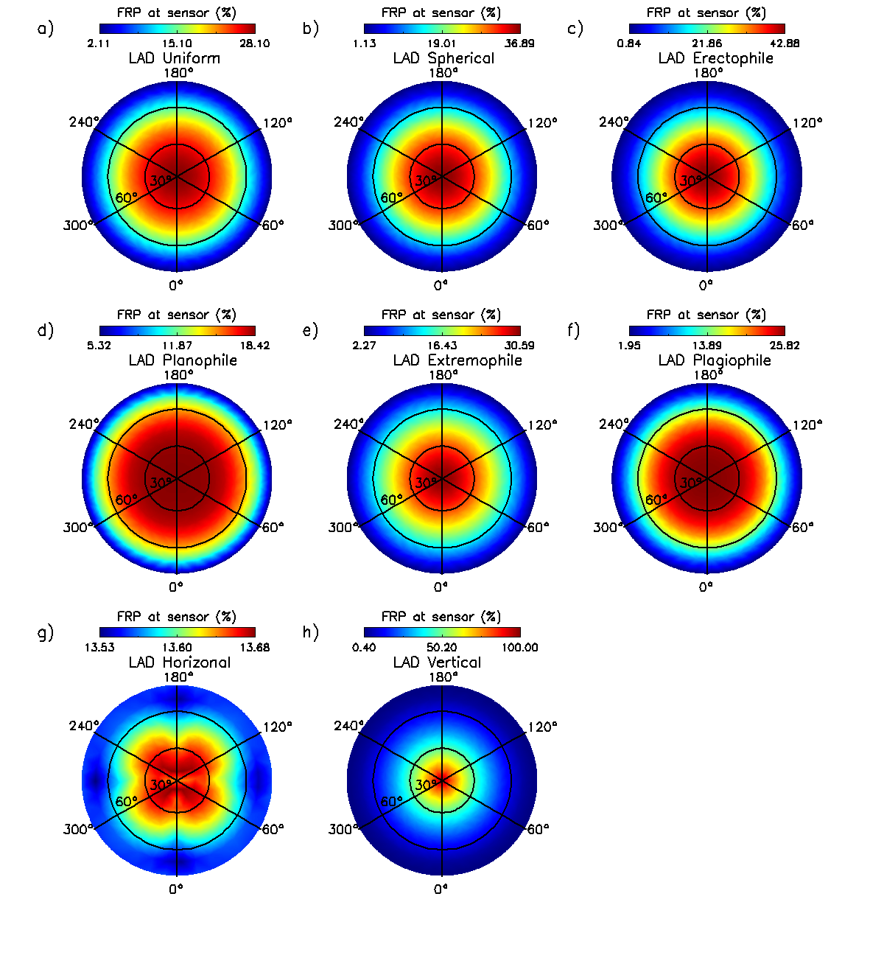
Figure 2: The amount of surface fire FRP retrieved when viewing through an overlying tree canopy, expressed as a percentage of the ‘no-canopy’ FRP value made from the same sensor observing from the same viewing direction. Each polar plot represents a canopy described using one of eight leaf angle distributions (LADs). In these polar plots, the view azimuth angle (0-360°) is indicated by the azimuth axis whilst the view zenith angle (0-80°) is described by the polar axis.
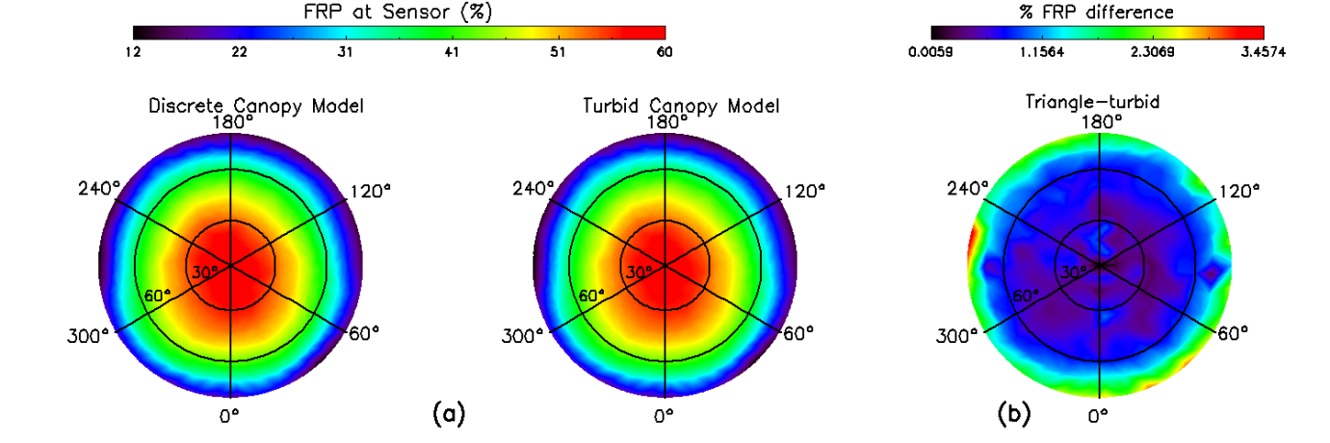
Figure 3: The amount of surface fire FRP retrieved when viewing through an overlying tree canopy, expressed as a percentage of the ‘no-canopy’ FRP value made from the same sensor observing from the same viewing direction. Here the canopy cover over the fire is 30% when observed from nadir, and the simulations were conducted using (a) both discrete element simulations based on tree canopy representations of the type shown in Figure 1c, and turbid media canopy simulations of the type shown in Figure 1b. (b) Differences in the results obtained with these simulations is small (<4%). In these polar plots, the view azimuth angle (0-360°) is indicated by the azimuth axis whilst the view zenith angle (0-80°) is described by the polar axis.

- b)
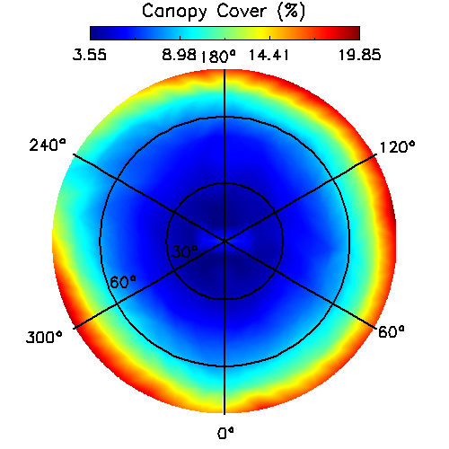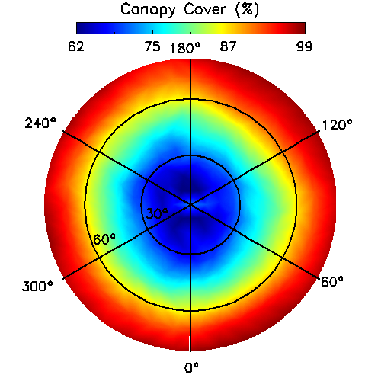

Figure 4: Angular variation in percentage canopy cover with viewing geometry for scenes simulated with (a) 6% and (b) 72% tree cover at nadir over the active fire area. Canopy cover is not symmetric as the trees are randomly distributed around the scene. A spherical leaf angle distribution was assumed.

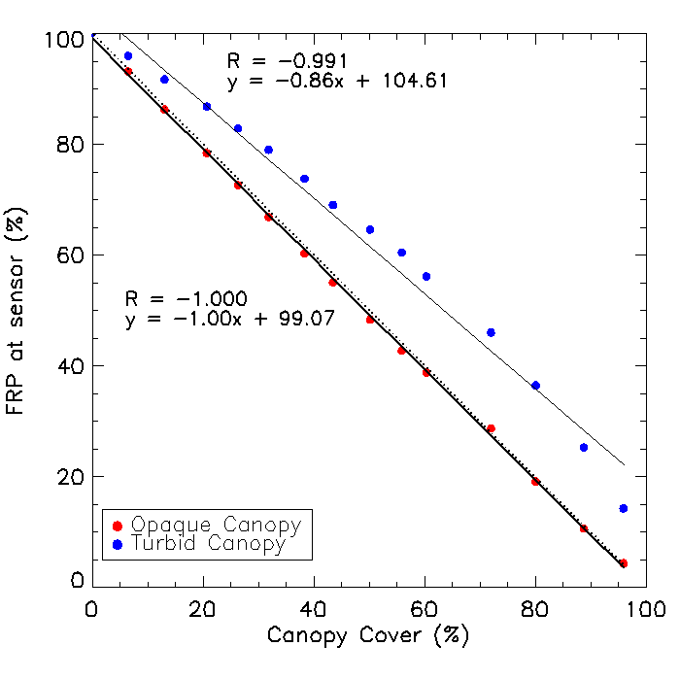
Figure 5: The impact of retrieving FRP through a vegetation canopy modelled as both an opaque and turbid media. FRP retrieved though the canopy is expressed as a percentage of that retrieved in the ‘no canopy’ situation by the same sensor observing with the same viewing geometry (here assumed to be nadir in both cases). Also shown (dotted line) is relationship found by Mathews et al. (2016), which is nearly identical to the opaque canopy situation modelled herein.

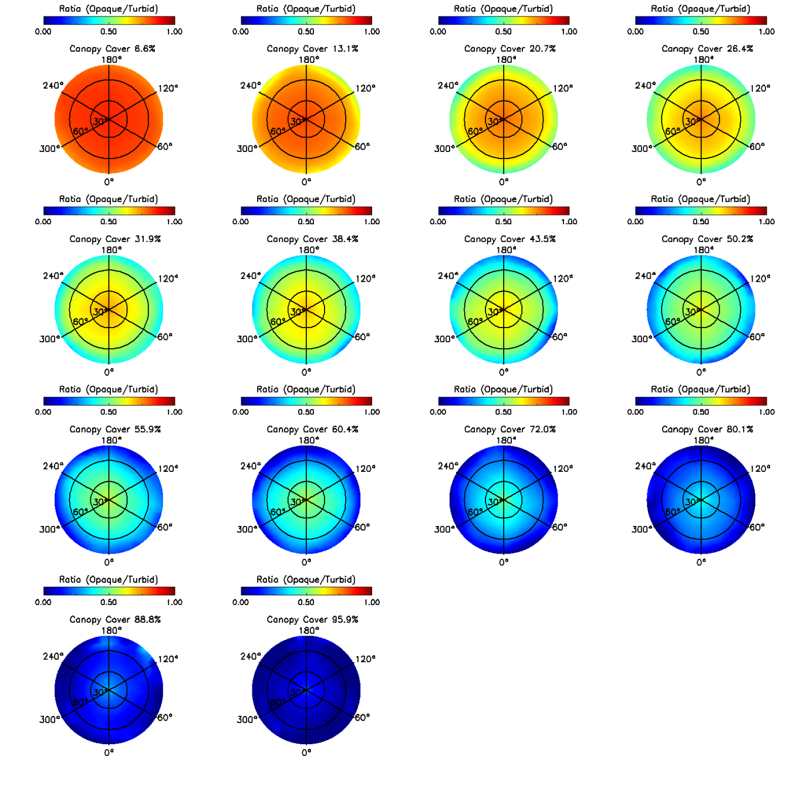
Figure 6: Ratio of the surface fire FRP retrieved when the vegetation canopy viewed through is assumed to be opaque and a turbid media, expressed for different viewing directions and different percentage canopy covers. The difference between the opaque and turbid medium simulations decreases with both view zenith angle and canopy cover.

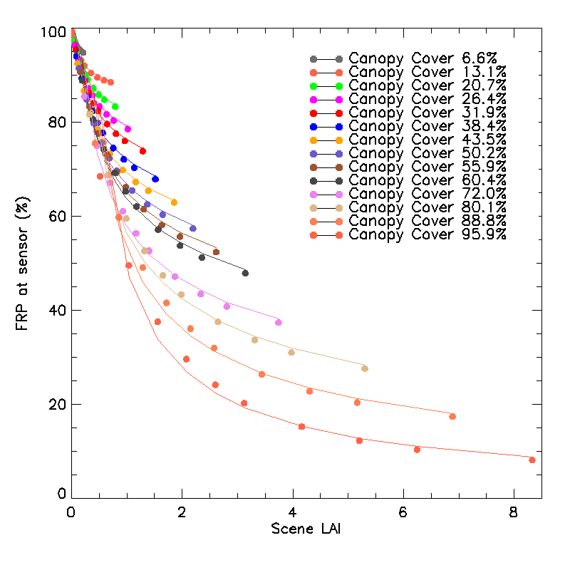
Figure 7: The amount of surface fire FRP retrieved through the canopy, expressed as a function of scene LAI for different percentage canopy covers. FRP is expressed as a percentage of that retrieved in the ‘no canopy’ situation by the same sensor observing with the same viewing geometry, and the relationships are fitted with best fit 2nd order polynomial.

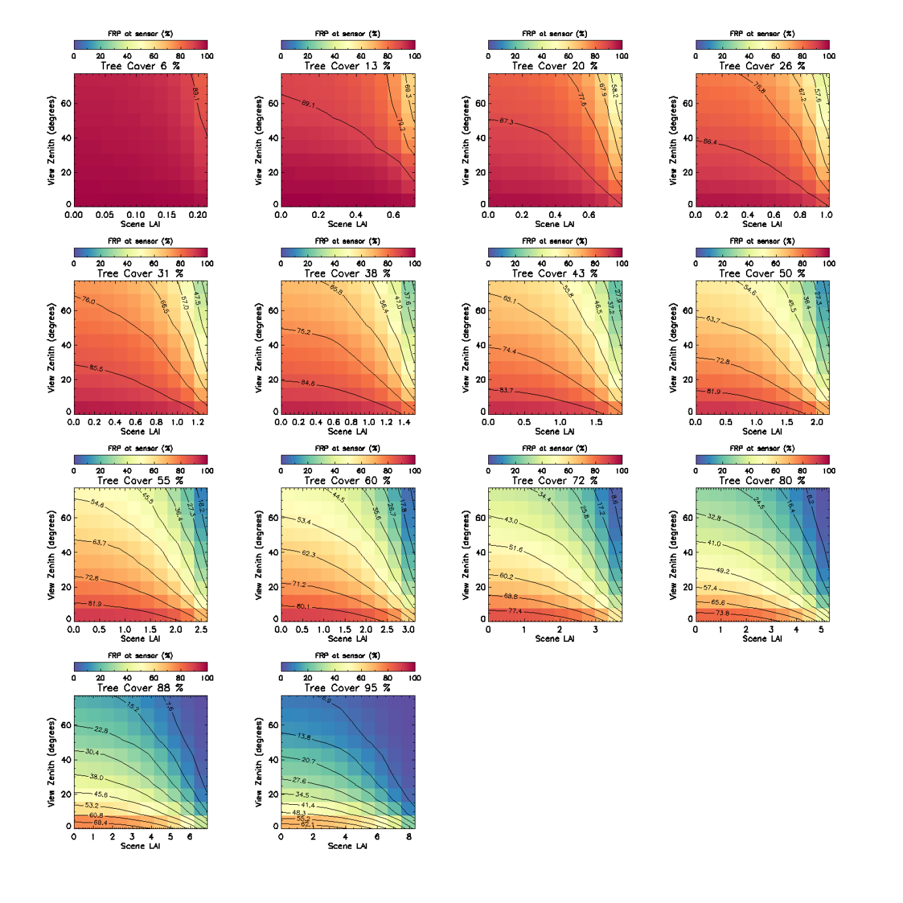
Figure 8: FRP retrieved through the canopy and expressed as a percentage of that retrieved in the ‘no canopy’ situation by the same sensor observing with the same viewing geometry, and shown as a function of view zenith angle and scene LAI for different percentage canopy covers

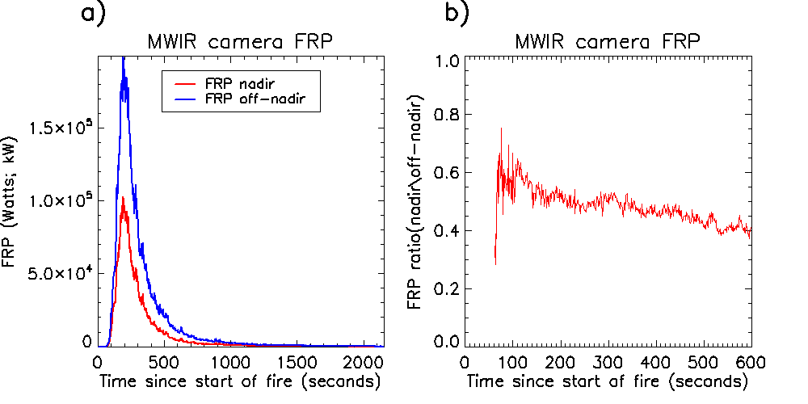
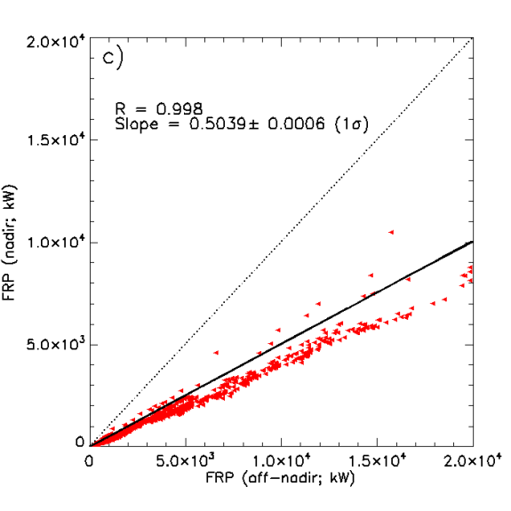
Figure 9: a) Timeseries of nadir and off-nadir FRP retrievals (kW) of a small experimental fire where the nadir camera view was obscured by pine needles and branches (53.5% vegetation cover) where flaming combustion was present until 185 seconds and b) the temporal variation in the ratio between the obscured and unobscured camera FRP c) Scatter plot of the FRP retrieved by the obscured (nadir) and unobscured (off-nadir) thermal cameras for an experimental fire.

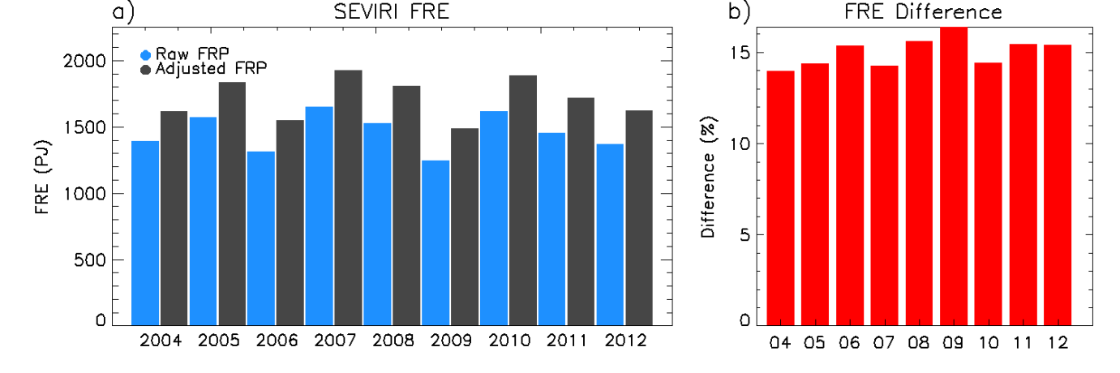
Figure 10: Times series of annual SEVIRI FRE and annual FRE adjusted for canopy interception using percentage tree cover and MODIS LAI estimates (a) and the percentage difference between these two FRE estimates (b).

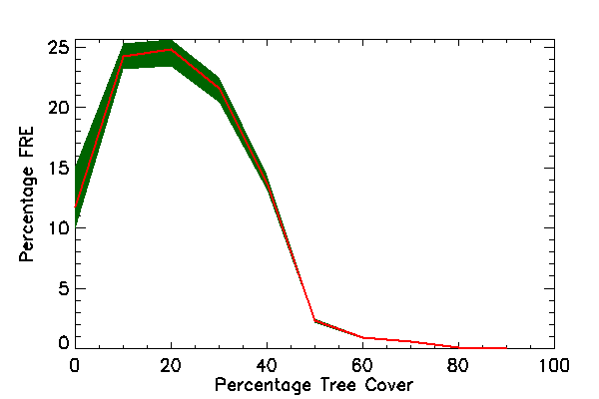
Figure 11: Percentage of SEVIRI FRE (2004-2012) estimated within different percentage tree cover regions (10% bins). The red line indicates the mean percentage of annual FRE whilst the green shaded area indicates the minimum and maximum percentage SEVIRI FRE between 2004 and 2016.

