The Dielectric Effect of Xylene on an Organoclay-Containing Composite
Allison V. Shaw, Alun S. Vaughan and Thomas Andritsch
School of Electronics and Computer Science,
University of Southampton,
Highfield,
Southampton, SO17 1BJ, UK

ABSTRACT
The influence of a non-polar solvent, xylene, on the electrical properties of a system containing polypropylene, a copolymer of ethylene and vinyl acetate and an organoclay has been considered, since the production of such materials may often involve exposure to a solvent. Although, in isolation, neither the organoclay nor the xylene has a marked effect on the dielectric response of the system, when combined, synergistic effects can be seen. We interpret this in terms of solvent-mediated relaxation of amphiphilic compatibilizer moieties introduced into the organoclay to aid processability. These local relaxation processes appear adversely to affect the AC breakdown strength of the system, which is recoverable upon the removal of xylene from the material.
Index Terms — Composite insulation, Dielectric losses, Dielectric Breakdown

INTRODUCTION
THE electrical properties of nanocomposite materials has been an active area of research for almost three decades. While numerous reports exist of improved properties on addition of a nanofiller, many others indicate that their inclusion can have negative consequences. For example Zilg et al. [1] reported an increase in DC breakdown strength when an organophilic layered silicate was added to polypropylene and a slight decrease when the same filler was added to an ethylene/(vinyl acetate) (EVA) copolymer. Montanari et al. [2] reported on a similar nanofiller and, although a comparable trend was seen, the overlapping error bars mean that the addition of the filler could not be said significantly to affect the breakdown strength. Elsewhere, Montanari et al. [3] reported that the addition of an organophilic clay nanofiller introduced a new relaxation process to the dielectric response of an EVA matrix and ascribed this to the interface created between the matrix and the filler. This was also found in a study involving silica nanoparticles and polyethylene [4]. In contrast to both aforementioned papers concerning the dielectric response of nanocomposites, Roy et al. [5] found there to be a decrease in the permittivity of their nanocomposite at 1 kHz upon the addition of the nanofiller. While the precise mechanistic origins of these various effects are uncertain, what is clear is that small changes in processing or composition can exert a major effect on macroscopic electrical properties [6].
Manuscript received on xx Month 20yy, in final form xx Month 20yy, accepted xx Month 20yy. Corresponding author: A. V. Shaw.
While the bulk of the literature concerning the dielectric response of nanocomposite materials has focused on particulate systems such as silica, alumina, titanium dioxide and gold, in other areas, plate-like nanofillers, such as clays, nickel oxide, boron nitride, and graphene, have received great attention. Indeed, the current interest in nanocomposites is frequently attributed to pioneering work on systems based upon organoclays, where the initial interest concerned the production of material systems with improved mechanical performance. To improve the compatibility of such systems with a polymer matrix, and thereby aid dispersion, amphiphilic organic moieties are often introduced into the clay galleries, which interact favorably with both the clay and the polymer and, by increasing the separation between adjacent clay layers, ease dispersion [7]. Commonly used compounds often take the form of organic ammonium salts [8]. Another approach that has seen much work involves altering the chemical composition of the matrix through grafting groups such as maleic anhydride or glycidyl methacrylate onto non-polar polymers [2, 6, 9]. An alternative strategy, used herein, employs a second polymer that is compatible with both the non-polar polymer and the organoclay as a means of creating a homogeneous system [10].
Compatibilizing agents allow the polymer chains to intercalate between the stacks/sheets present in the clay. When the intercalation reaches a point whereby the sheets are completely separated and dispersed into the continuous polymer matrix, the clay is exfoliated [9]. In doing so, the filler transitions from the micro- to the nano-scale, which can fundamentally change the properties of the system due to the massively increased interfacial area combined with minimizing the phase separation of the overall system [7]. When considering the melt processing of nanocomposites by extrusion, the level of dispersion has been related to the order of material addition and the number of times the material was passed through the extruder [9]. Processing via a solvent phase is a common alternative strategy, whereupon the solvent can mediate the mixing of the materials, such that the final extent of dispersion is influenced by factors such as the filler loading level, temperature and length of solution reflux time [11].
The work described here set out to examine a factor that is intrinsic to solution processing of materials, namely the influence of retained labile species on the electrical characteristics of a polymeric nanocomposite. While the influence of absorbed water has been considered in detail [12, 13] and shown to be capable of greatly influencing dielectric parameters, charge transport and breakdown strength, the effect of non-polar moieties has not attracted comparable attention. Specifically, this study concerns a tertiary polymer blend system based on isotactic polypropylene (iPP) and an EVA copolymer, combined with an organically functionalized nanoclay (organoclay). The objective of the work was to examine the influence of xylene, used for processing, on the electrical response of the system.

EXPERIMENTAL

Materials and Processing
The following commercial materials were used as supplied in the study described here. The iPP and organoclay were both purchased from Sigma Aldrich (product numbers 427888 and 682624 respectively), while the EVA was supplied by DuPont (Elvax 750, containing 9 wt. % of VA). All of the samples considered here contained, by weight, 80:20 of iPP to EVA plus a nominal 0, 2.5 or 5 wt. % of organoclay. The material processing procedure was adapted from published studies [14] and involved the following sequential steps. First, the organoclay was sonicated in xylene for 30 min to promote dispersion, before being added, along with the EVA, into a rotary evaporator and heated to 140 °C. When the polymer had completely dissolved, the iPP was then introduced and the temperature was increased to 155 °C to dissolve the iPP. The mixture was left stirring for 30 min before, finally, the solvent was removed under vacuum.
From the resulting product, samples of the required thickness were melt-pressed using a hydraulic press. After being held in the melt phase for 5 min, the films were crystallized isothermally at 120 °C for 10 min, before being quenched into a room temperature water bath. The required temperature and time for the crystallization process was determined from a preliminary study of the crystallization behavior of this polymer blend by differential scanning calorimetry (DSC) and was chosen to ensure maximum crystallization of the iPP. All of the resulting sample films were then further dried for one week under dynamic vacuum at 70 °C, whilst monitoring the mass change, to minimize residual solvent and absorption of environmental water in the resulting specimens. These initial specimens will hereafter be referred to as dried samples. In order to explore any potential effects relating to the presence of unwanted labile species, further batches of samples were exposed to xylene followed by a subsequent re-drying phase. This involved immersion in xylene for one week (termed immersed samples), followed by drying under dynamic vacuum at 70 °C for two weeks (termed re-dried samples). Variations in sample mass throughout this process were monitored. For convenience, the above samples are hereafter referred to using the following nomenclature: PP/EVA9-20/X/Y, where PP/EVA9-20 indicates a blend system based on iPP with 20 parts by weight of EVA containing 9% VA, X indicates the nominal clay loading level (0, 2.5 or 5 wt. %) and Y indicates the imposed treatment (D, dried; I, immersed; R, re-dried).

2.2 material characterisation
Thermogravimetric analysis (TGA) was performed in air up to 800 °C at a heating rate of 10 °C min⁻¹, using a Perkin Elmer Pyris 1 instrument. Fourier-transform infrared (FT-IR) spectra were acquired using a Thermo Scientific Nicolet iS5 instrument; data were acquired with the instrument operating in both transmission mode and attenuated total internal reflection (ATR) mode. AC breakdown strength was measured in accordance with ASTM D149-97a. For this, the sample was immersed in silicone oil between vertically opposed spherical electrodes (6.3 mm in diameter). Each system was tested twenty times using a ramp rate of 500 V/s and the results were analyzed using two-parameter Weibull statistics with 90 % confidence limits within the Origin software package. Dielectric spectra were acquired using a Solartron 1296 dielectric interface together with a Schlumberger SI1260 impedance/phase gain analyzer system. For this, an AC voltage of amplitude 1 V_{rms} was applied across electrodes 30 mm in diameter with a guard ring electrode; a frequency range of 10⁻¹ to 10⁵ Hz was considered. In the case of samples tested following xylene immersion, these were removed from the solvent bath and allowed to dry naturally in the fume cupboard for 30 min before being tested, such that no residual xylene remained on the sample surface during testing.

3 results and discussion

3.1 Sample/Xylene Interactions
Figure 1 shows TGA data obtained from both dried and immersed samples. Consider first the results obtained from the dried samples, where three aspects of the data are significant. At low temperature, the absence of any detectable changes in mass in the dried samples indicates that the concentration level of any volatile species that remained entrained within the systems after drying is below the sensitivity of TGA. The bulk of the decomposition then occurs within the temperature range 300-500 ºC, which corresponds to the decomposition of the iPP, the EVA and the organic compatibilizer within the organoclay. In line with previous work, the observed displacement of decomposition to higher temperatures in the presence of the organoclay was as expected [15]. At high temperatures (>600 ºC), residual mass occurred only when organoclay had been present in the sample and corresponds to the remnant inorganic components of the organoclay. By considering the decomposition of the organoclay in isolation, it is possible to evaluate the included organic fraction and, from this, we conclude that the true initial loading level of the organoclay equates to 1.5 and 4.7 wt. % of the system for the composition goals of 2.5 and 5 wt. % respectively. This discrepancy is due to experimental limitations during sample production, meaning that some organoclay was lost from the final system. Nevertheless, for simplicity, the paper will still refer to the samples by the nomenclature described above, which was based on the nominal target compositions. The inset in Figure 1 shows low temperature TGA data obtained from the samples that had been immersed in xylene, from which it is evident that all three systems lose about 5% of their initial mass on heating from room temperature up to 150 ºC. Since the reported boiling temperature of the various isomers of xylene range from 138-144 ºC, this feature, together with the absence of any comparable mass losses in the PP/EVA9-20/X/D sample set, strongly implies that this change in mass is related to desorption of xylene, which occurs progressively up to ~150 ºC.
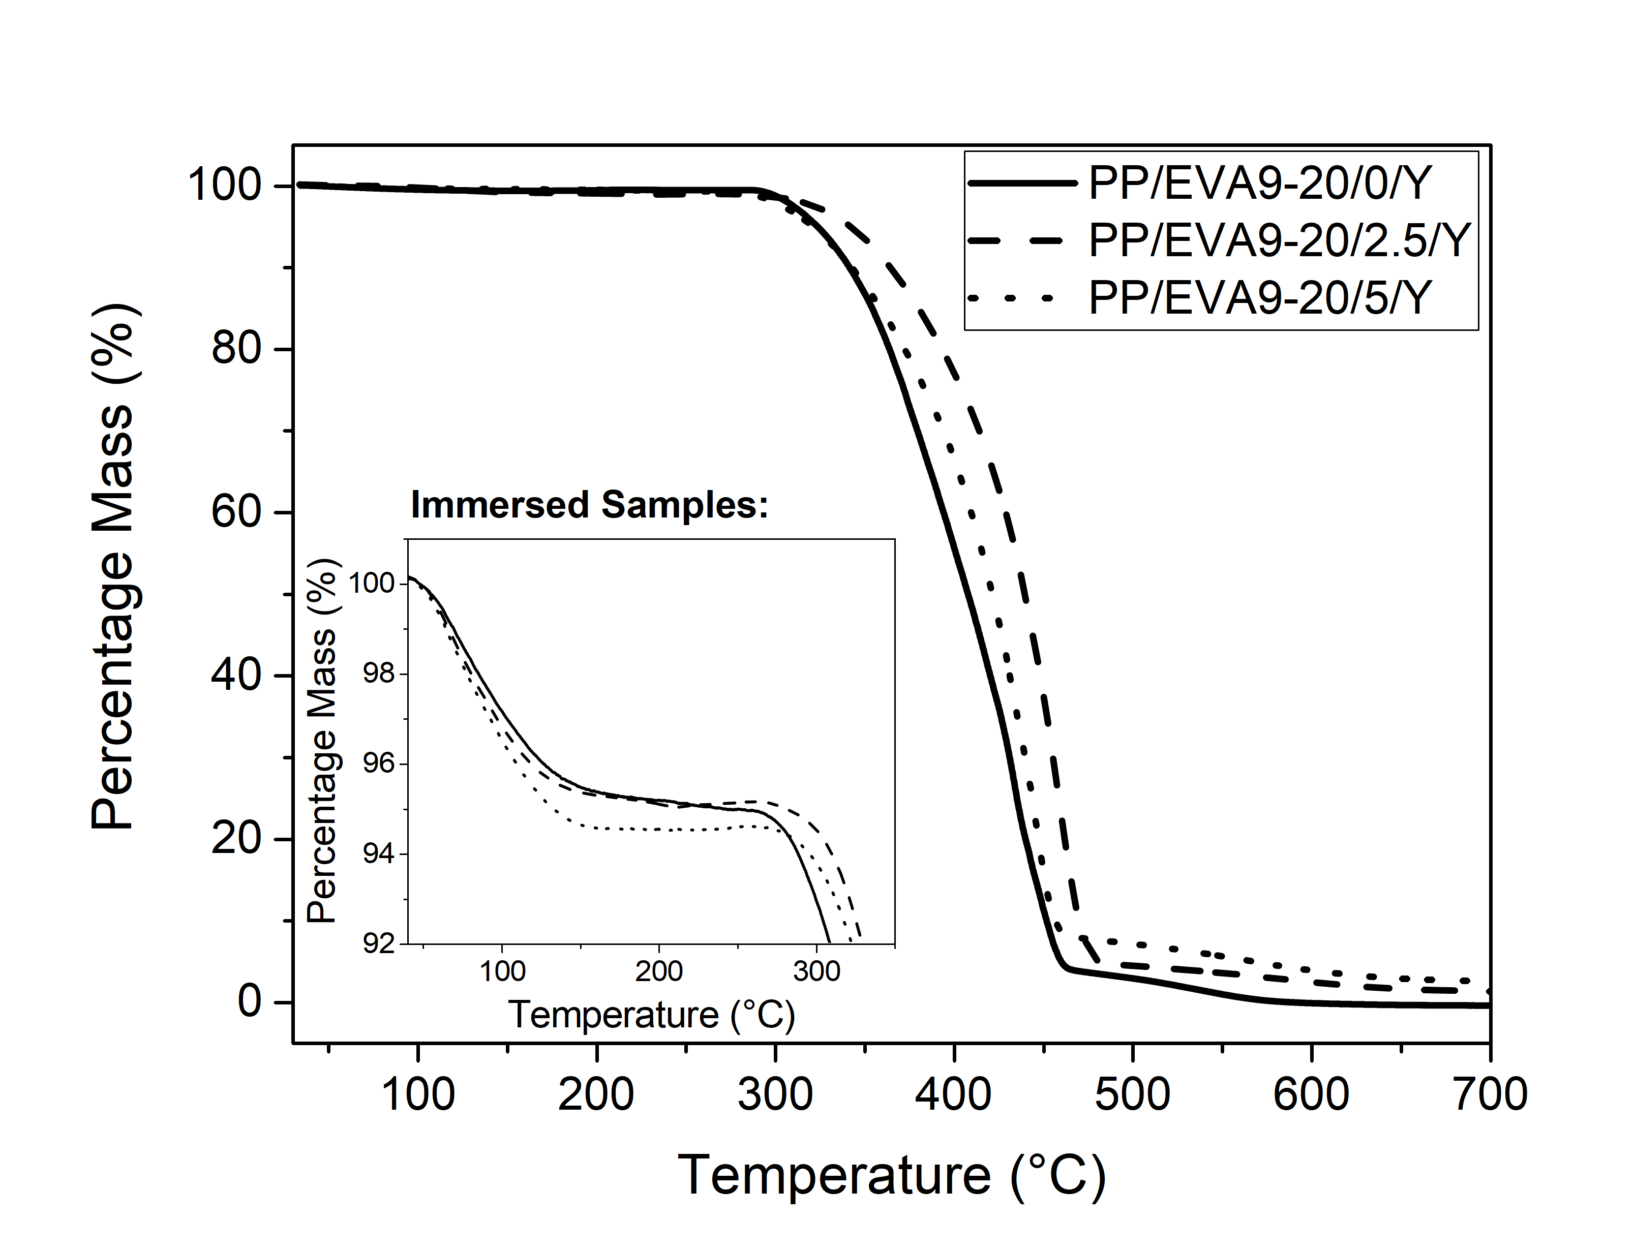
Figure 1. Data from TGA conducted in air on the dried samples, where Y=D and the immersed samples, where Y=I (inset).
Indeed, FT-IR data (see Figure 2) obtained from the PP/EVA9-20/5/Y sample set indicates the presence of absorption peaks associated with xylene in PP/EVA9-20/5/I, which are absent in PP/EVA9-20/5/D. In PP/EVA9-20/5/R, some very weak, broad absorption features remain, suggesting retention of traces of xylene. Since comparison of the FT-IR spectra obtained from these three systems revealed no other differences, we conclude that within the sensitivity limits of the technique, the process of xylene immersion did not affect the system in any way other than to introduce this species.
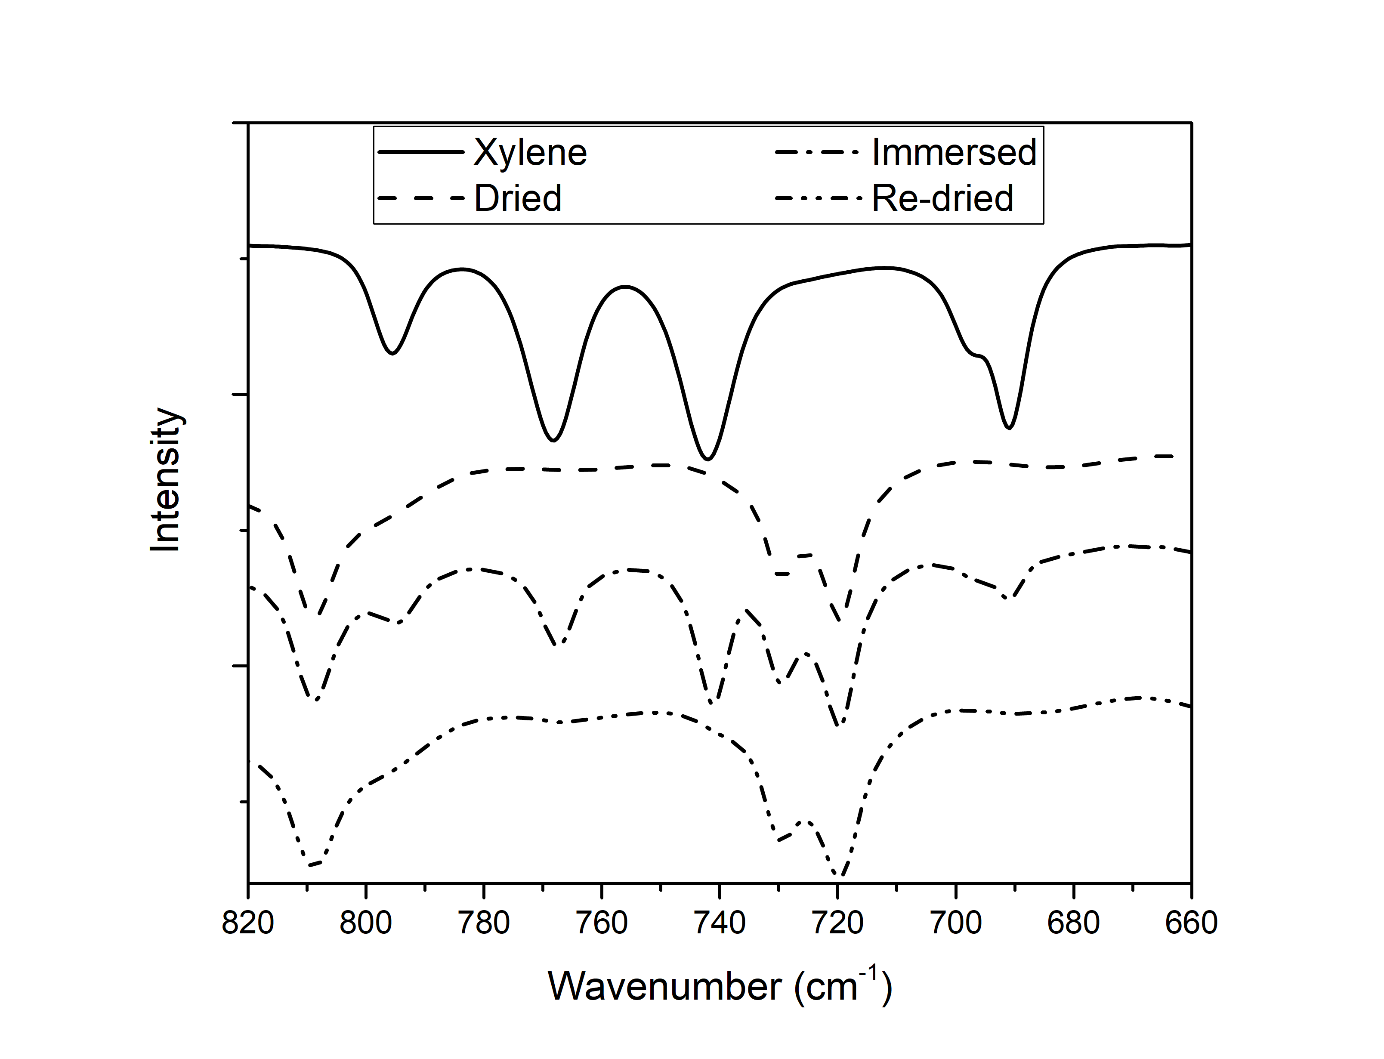
Figure 2. FT-IR data from the fingerprint region acquired in transmission mode from PP/EVA9-20/5/Y samples containing 5 wt % organoclay compared to xylene. The various spectra are off-set for clarity.
Finally, Figure 3 shows the variation in sample mass during immersion in xylene and during subsequent drying, which reveals a number of features of the xylene absorption process. First, in equilibrium, the mass of the samples can be seen to have increased by 5-7 %. Second, the initial data points acquired after just 4 h reveal a comparable mass increase to that seen after 7 days. Likewise, the majority of the xylene desorbed after 4 h of the re-drying process As such, the key aspects of these data are that xylene absorption and desorption occurs rapidly and that the mass of the absorbed xylene is largely independent of the amount of organoclay present. While the former necessarily indicates that any associated measurement of sample mass will be subject to uncertainties derived from the process used to remove xylene from the sample surface prior to measurement of the sample mass, the TGA and mass change measurements are, nevertheless, still in broad quantitative agreement.
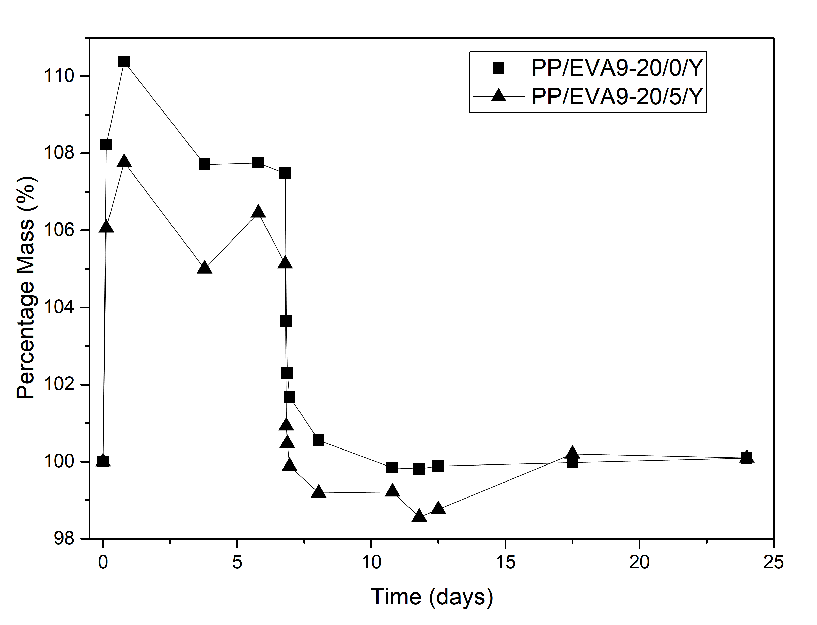
Figure 3. Xylene uptake monitored through mass change, measured 30 min after being removed from the xylene bath. Data for PP/EVA9-20/2.5/Y fitted the same trends but has been omitted for clarity of the graph.

3.2 dielectric response
Figure 4 shows dielectric spectroscopy data acquired from PP/EVA9-20/0/Y after different immersion times in xylene. Prior to immersion, PP/EVA9-20/0/D primarily contains propylene, ethylene and vinyl acetate units and, therefore, it is possible to estimate the value of the real part of the relative permittivity, εˊ, using any one of a number of effective medium mixing theories. Using the Lichtenecker logarithmic mixing rule [16], for example, results in a value of 2.4, using permittivity values of 2.3 for iPP [17] and 2.7 for an EVA copolymer containing 12 % of VA [18]. Evidently, the precise permittivity of PP/EVA9-20/0/D shown in Figure 4a falls somewhat below this value, which is a consequence of uncertainties/variations in the sample thickness and the impact this has on deriving a permittivity value from the measured capacitance. Exposure to xylene appears to have no significant effect on εˊ. Indeed, para-xylene is reported to exhibit a real relative permittivity value of 2.26 at 1 kHz [19] and, as such, the inclusion of a small quantity of such a solvent would not be expected dramatically to affect the measured value of εˊ for the polymer system considered here.
All the imaginary permittivity data shown in Figure 4b fall close to the sensitivity limit of our spectrometer, which, is unsurprising for a system that is largely composed of non-polar propylene and ethylene units. However the increase in the imaginary permittivity, ε̋, seen at higher frequencies can be related to the presence of polar carbonyl groups in the EVA, as reported by Mujal-Rosas et al. [20]. As for the influence of absorbed xylene, dielectric relaxation studies of systems containing chemically similar solvents have been undertaken and, in the case of solutions of polystyrene in toluene, a weak β relaxation has been reported and attributed to rotation of toluene molecules [21]. To conclude, the data shown in Figure 4 indicate that neither the real nor the imaginary part of the permittivity is significantly affected by the presence of xylene, a result that is entirely in line with published work.
Figure 5 shows dielectric data obtained from the two systems containing the organoclay. First, consider the data obtained prior to exposure to xylene, from which it is evident that the addition of the organoclay has little effect on the measured absolute value of εˊ, with high frequency values falling in the range 2.0 to 2.2. At low frequencies, a small increase in εˊ is evident for both PP/EVA9-20/2.5/D and PP/EVA9-20/5/D; this is accompanied by an increase in ε̋ and may be associated with Maxwell-Wagner polarization processes that result from the presence of the polymer/organoclay interfaces and/or enhanced charge transport, possibly, due to ionic species present within the clay. Nevertheless, it is evident that, like xylene, addition of the organoclay does not, in itself, markedly affect the dielectric response of the system.
However, when both xylene and the organoclay are present, dramatic changes in the dielectric response of the system are evident, despite the fact that the results presented above demonstrate that neither component, in isolation, has a marked effect. Specifically, a pronounced increase in ε´ is evident with decreasing frequency which, from the ε̋ data, appears to be associated with two processes: a distinct dielectric loss process around 10-10³ Hz; a low frequency dispersion which may be related to Maxwell-Wagner interfacial polarization and/or charge transport effects. However, from Figures 5c and 5d, the variation of ε̋ at low frequencies is consistent with a power law dependence on frequency in which the exponent is <1. This suggests that charge transport is not the dominant contribution, an assertion that is consistent with comparable published work. For example, Izci et al. [22] reported that, at 10⁻² Hz, the permittivity of their polypropylene-based nanocomposite increased with organoclay loading; Zazoum et al. [23] reported similar findings for a polyethylene-based nanocomposite. In these studies, the effect of including the organoclay was discussed in terms of low frequency Maxwell-Wagner interfacial polarization at organoclay/polymer interfaces, together with higher frequency losses associated with dipolar relaxations arising from the compatibilizing intercalant molecules.
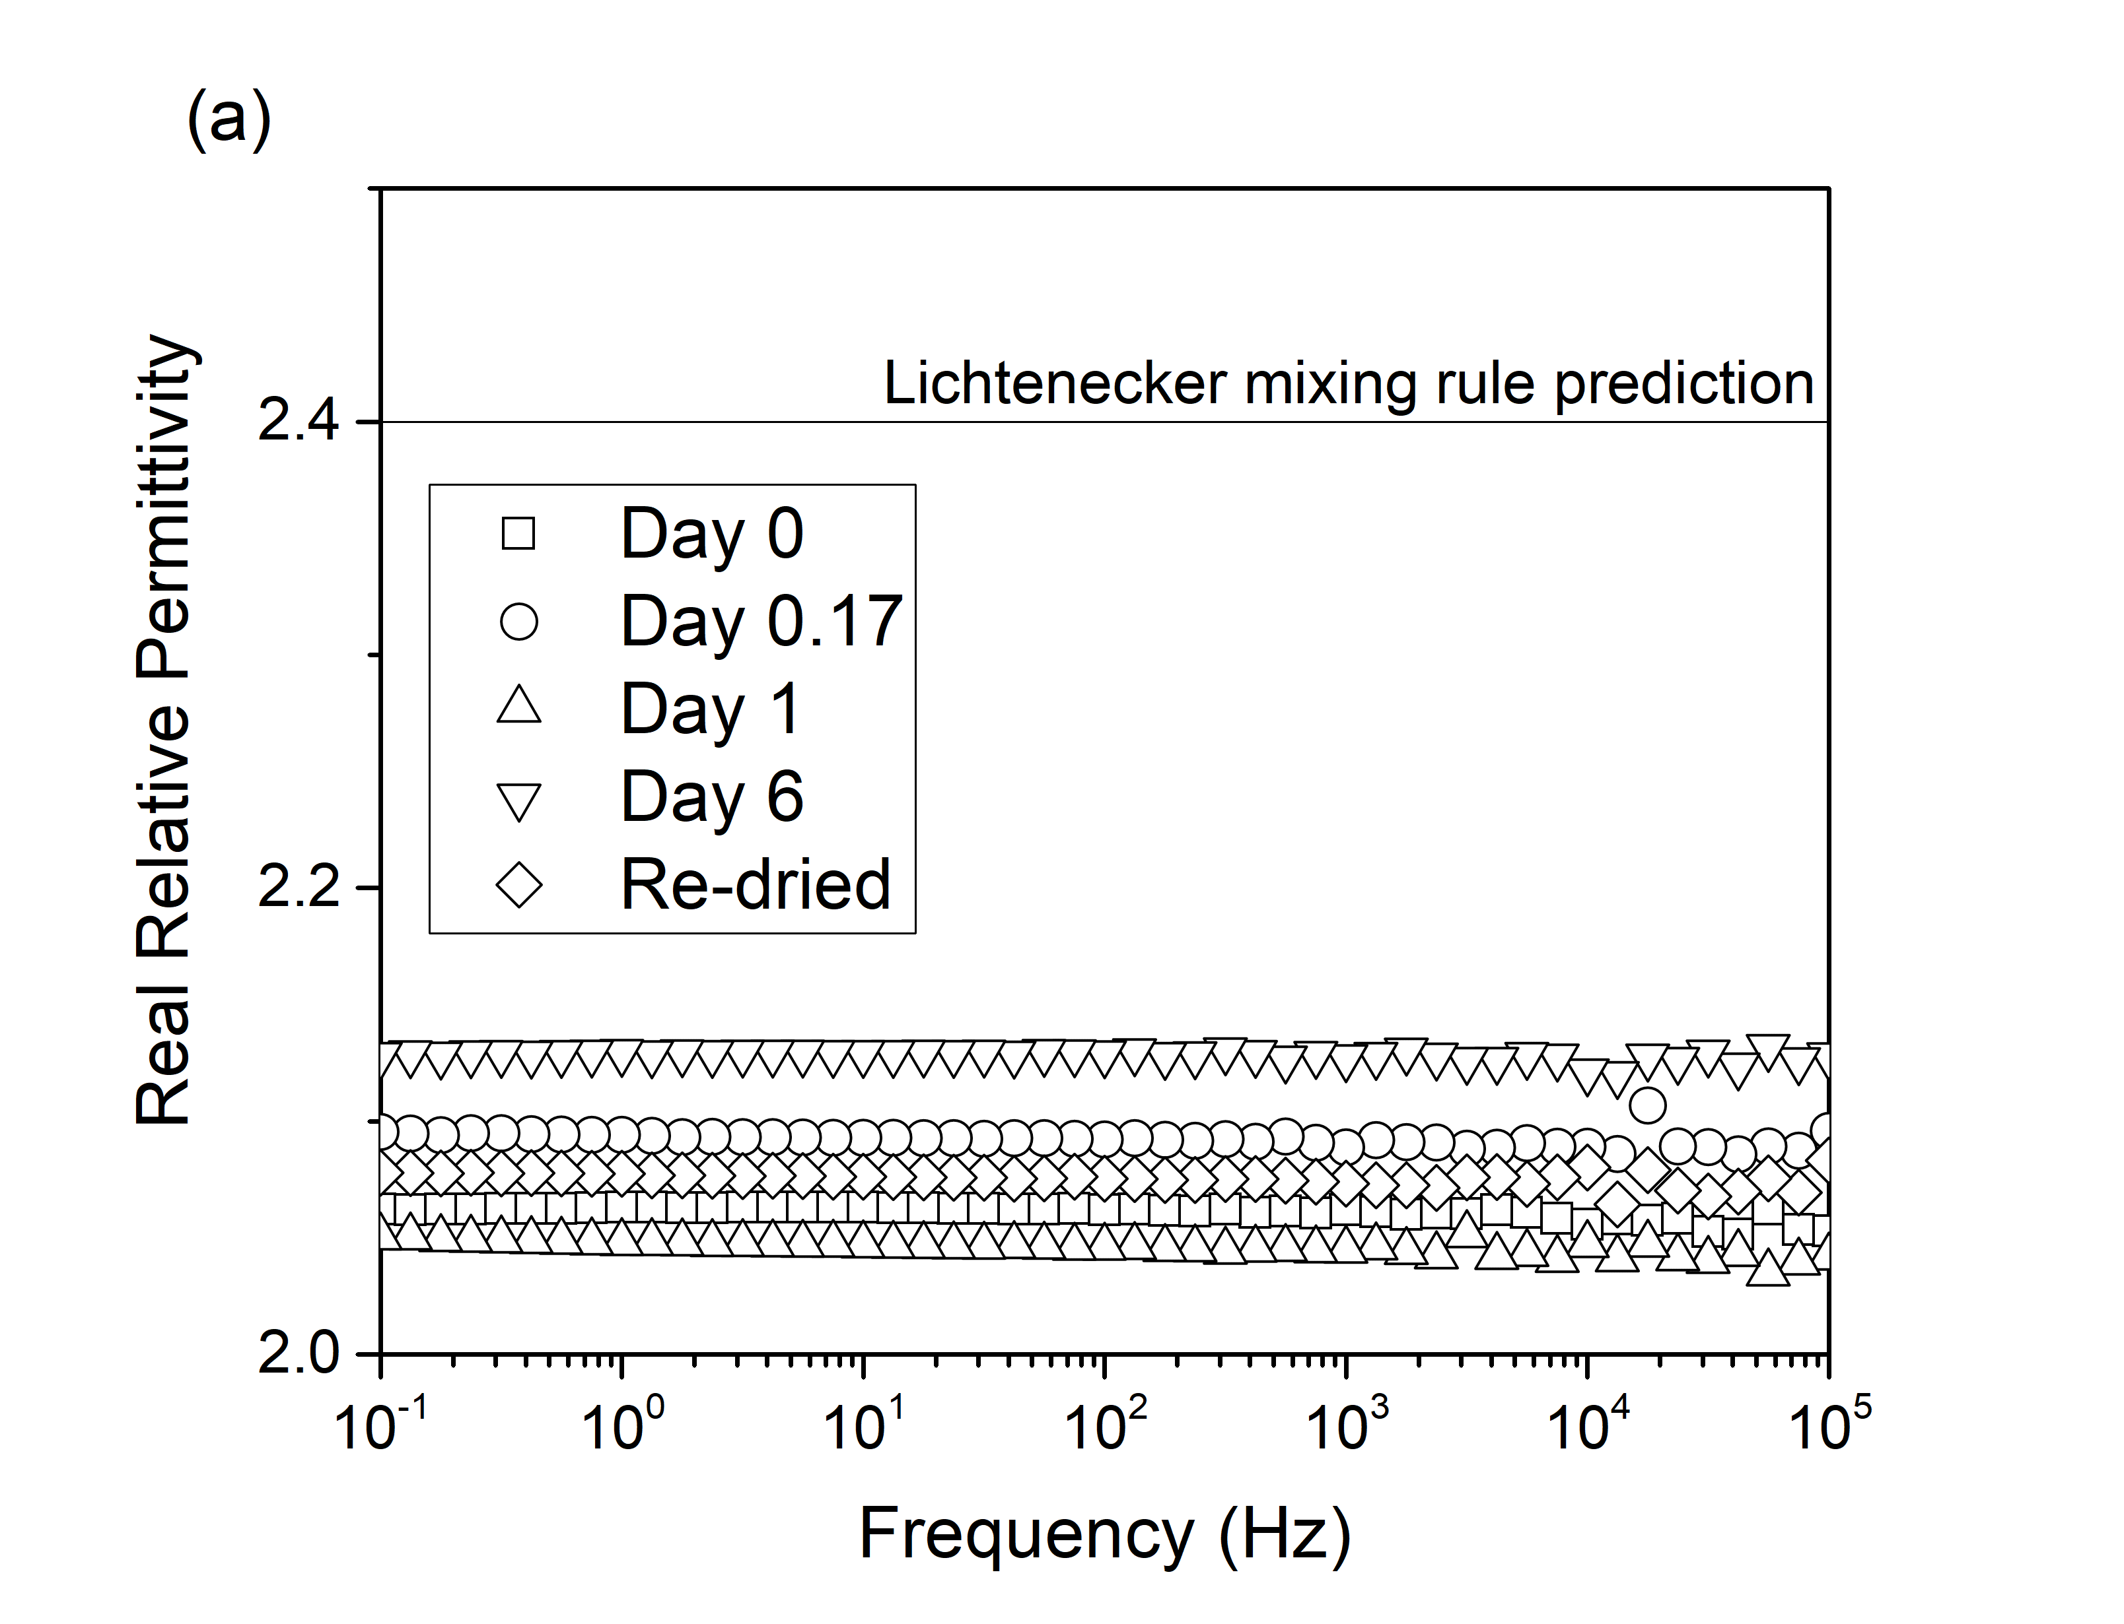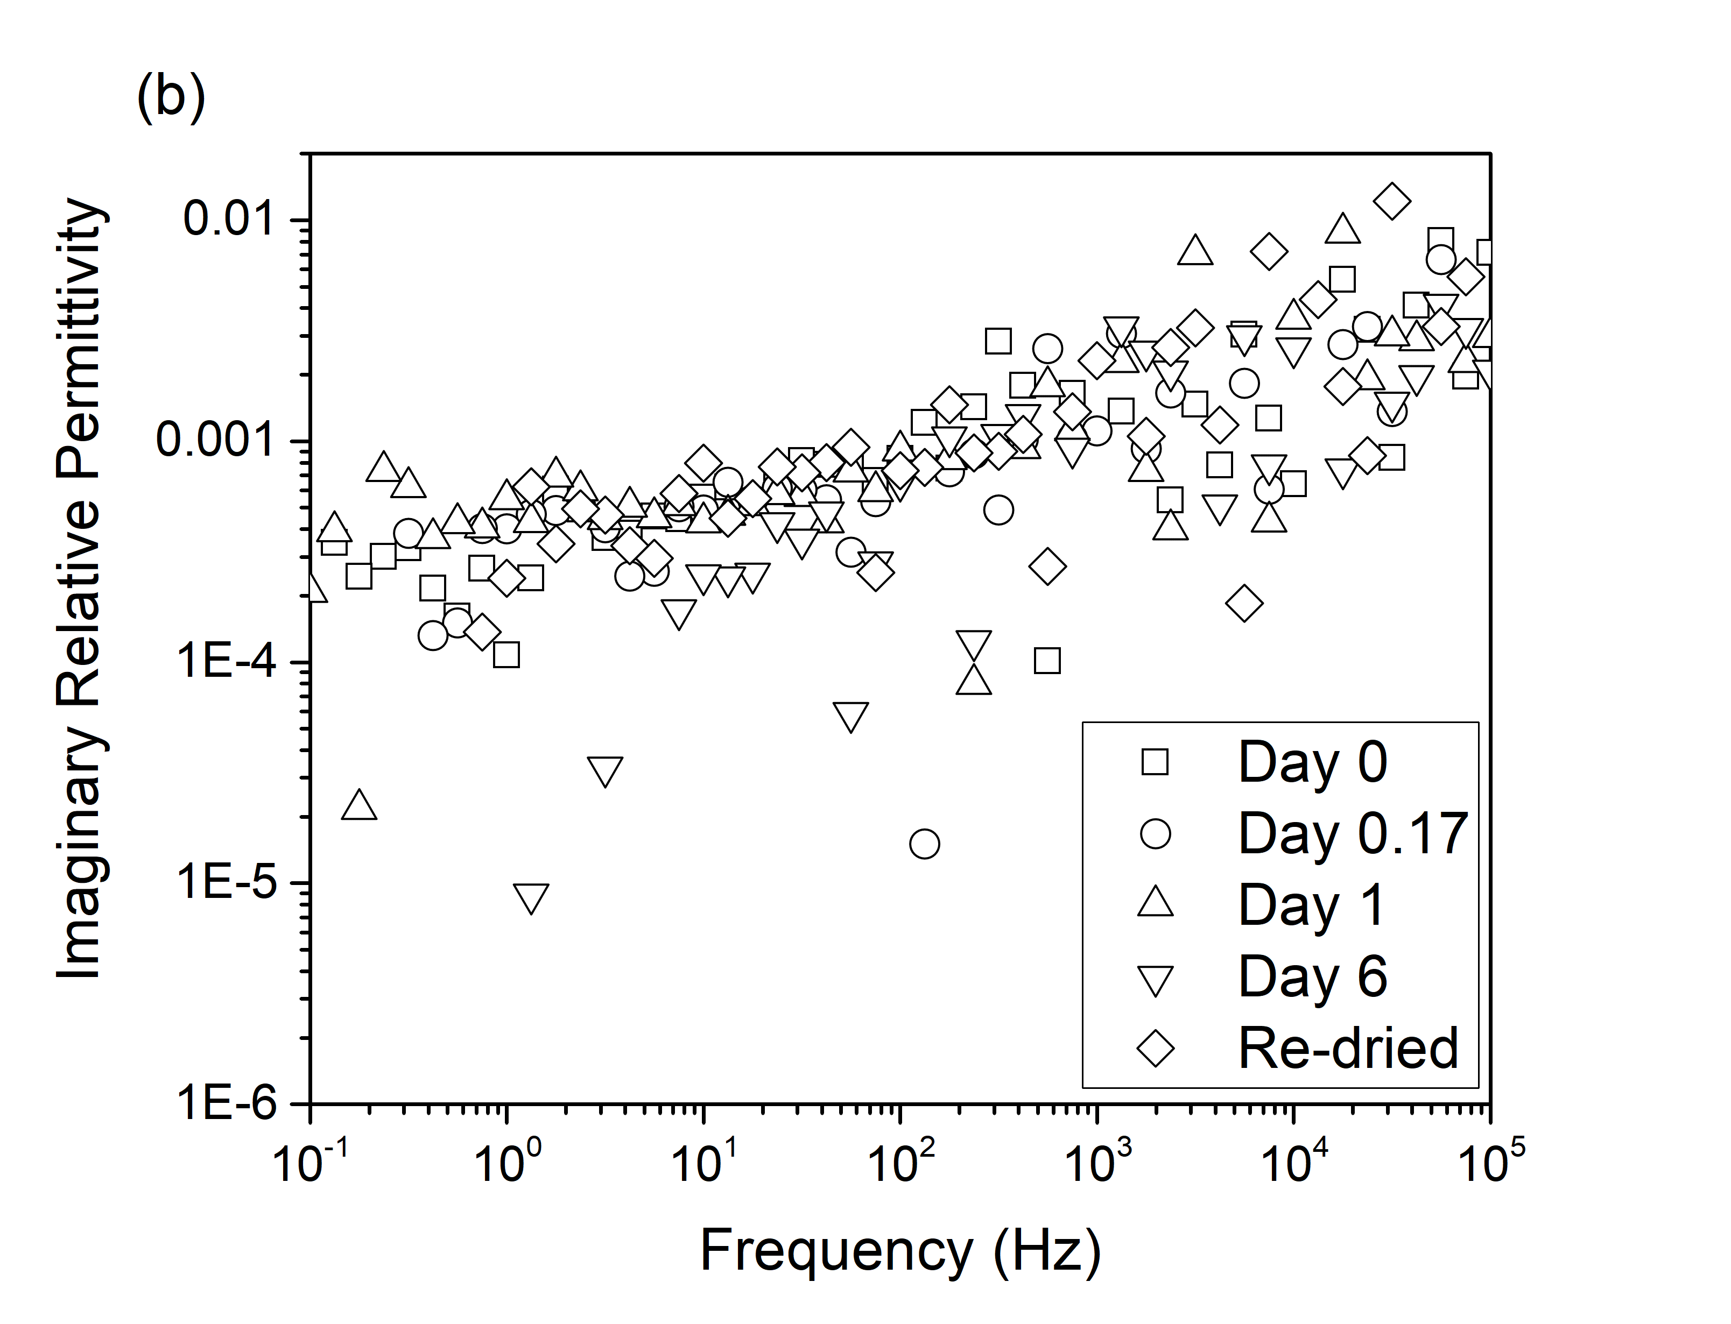
Figure 4. The (a) real and (b) imaginary parts of the relative permittivity of PP/EVA9-20/0/D after different time intervals of immersion in xylene.
Consider now, the effect of xylene immersion time on the dielectric response of the two systems shown in Figure 5. From these data, it would appear that permittivity varies with xylene immersion time in a non-monotonic manner, an effect we explain as an artefact of the chosen sample handling methodology. As discussed above in connection with Figure 3, absorption and desorption of xylene occurs relatively rapidly in these systems. Consequently, by ensuring that no xylene remained on the sample surface prior to making the dielectric measurements, we suggest that varying degrees of desorption occurred during the 30 min drying time during which the sample was exposed to the uncontrolled ambient laboratory environment.
Now consider the dielectric data shown in Figure 5 obtained from the samples that were re-dried. Comparison of the behavior of PP/EVA9-20/X/D and PP/EVA9-20/X/R reveals increased low frequency losses in the latter systems. This may indicate that some xylene remained entrained within the PP/EVA9-20/X/R systems, an interpretation that is consistent with the presence of vestigial xylene absorption peaks in the FT-IR data discussed above. Alternatively, it is possible that the xylene absorption/desorption cycle may have increased the free volume present in the system, through material removal or structural reorganization, thereby effectively reducing local constraints within the system such that dipolar motion could occur at frequencies that were not, initially, possible [24]. Clear parallels for the effect of local interactions on dielectric loss peaks have previously been reported in connection with the dielectric response of nanocomposites containing water molecules. For example, Zhang et al. [12] exposed a range of nanocomposites containing nanoalumina to ambient conditions and found that in both their epoxy and polyethylene based systems, a water-related relaxation process resulted at the polymer/filler interface. Notably, in the absence of the nanoalumnina, the relaxation of water was significantly slowed within the epoxy matrix, while no comparable relaxation was observed in the polyethylene matrix. This difference in behavior was related to the polarity of the polymer – in polyethylene, being, non-polar the concentration of water will be very low. Elsewhere, Lau et al. [13] considered the effect of water uptake in a morphologically-designed polyethylene blend containing nanosilicas with different surface chemistries, which revealed, with increasing water uptake: increased permittivity values; the development of dielectric loss processes that increased in strength and frequency. These effects were ascribed to accumulation of water molecules at nanoparticle/matrix interfaces, whereupon the variations seen are a consequence of changes in the aggregation state of the interfacial water and the different interactions that consequently result. That is, initially, water molecules are tightly bound to the polar nanoparticle surface through hydrogen bonding while, as the water content increases, the influence of direct interfacial interactions decreases as more loosely bound water structures form. These are, consequently, characterized by the associated peaks being displaced to higher frequencies. In the work of Lau et al. [13], the absorbed species directly interacts with the applied electric field, the reduction in the frequency of the response from the characteristic dielectric response of free water in the GHz range, to values in the hertz to kilohertz range being due to local environmental effects. While the data shown in Figure 5 exhibit certain parallels, in toto the data presented here clearly demonstrate that the dielectric response of the overall system is not due to the presence of any single component. Rather, since the observed dielectric loss processes require the presence of both xylene (dielectrically inactive, in isolation, from Figure 4,) and the organoclay (dielectrically inactive from Day 0 data in Figure 5), we suggest that the dielectric effects shown above occur as a result of organoclay-xylene interactions. That is, the presence of the xylene effectively solvates dipolar species in the clay so facilitating a molecular response to the applied electric field, which leads to the increased losses that are observed. In general, organoclays contain amphiphilic molecules that are introduced within the galleries, both to increase compatibility with the host matrix and to increase the interlayer spacing and, thereby, ease exfoliation [7]. As such, we suggest a potential molecular explanation for the increased losses seen in Figure 5, namely, that they stem from solvation of the compatibilizer by the absorbed xylene. While we do not preclude the possibility of solvation of ions also leading to some increased charge transport, both as a result of the frequency dependence of the low frequency losses seen here and in the light of other published work [22, 23], we do not believe that solvent mediated ionic conduction is the dominant process.
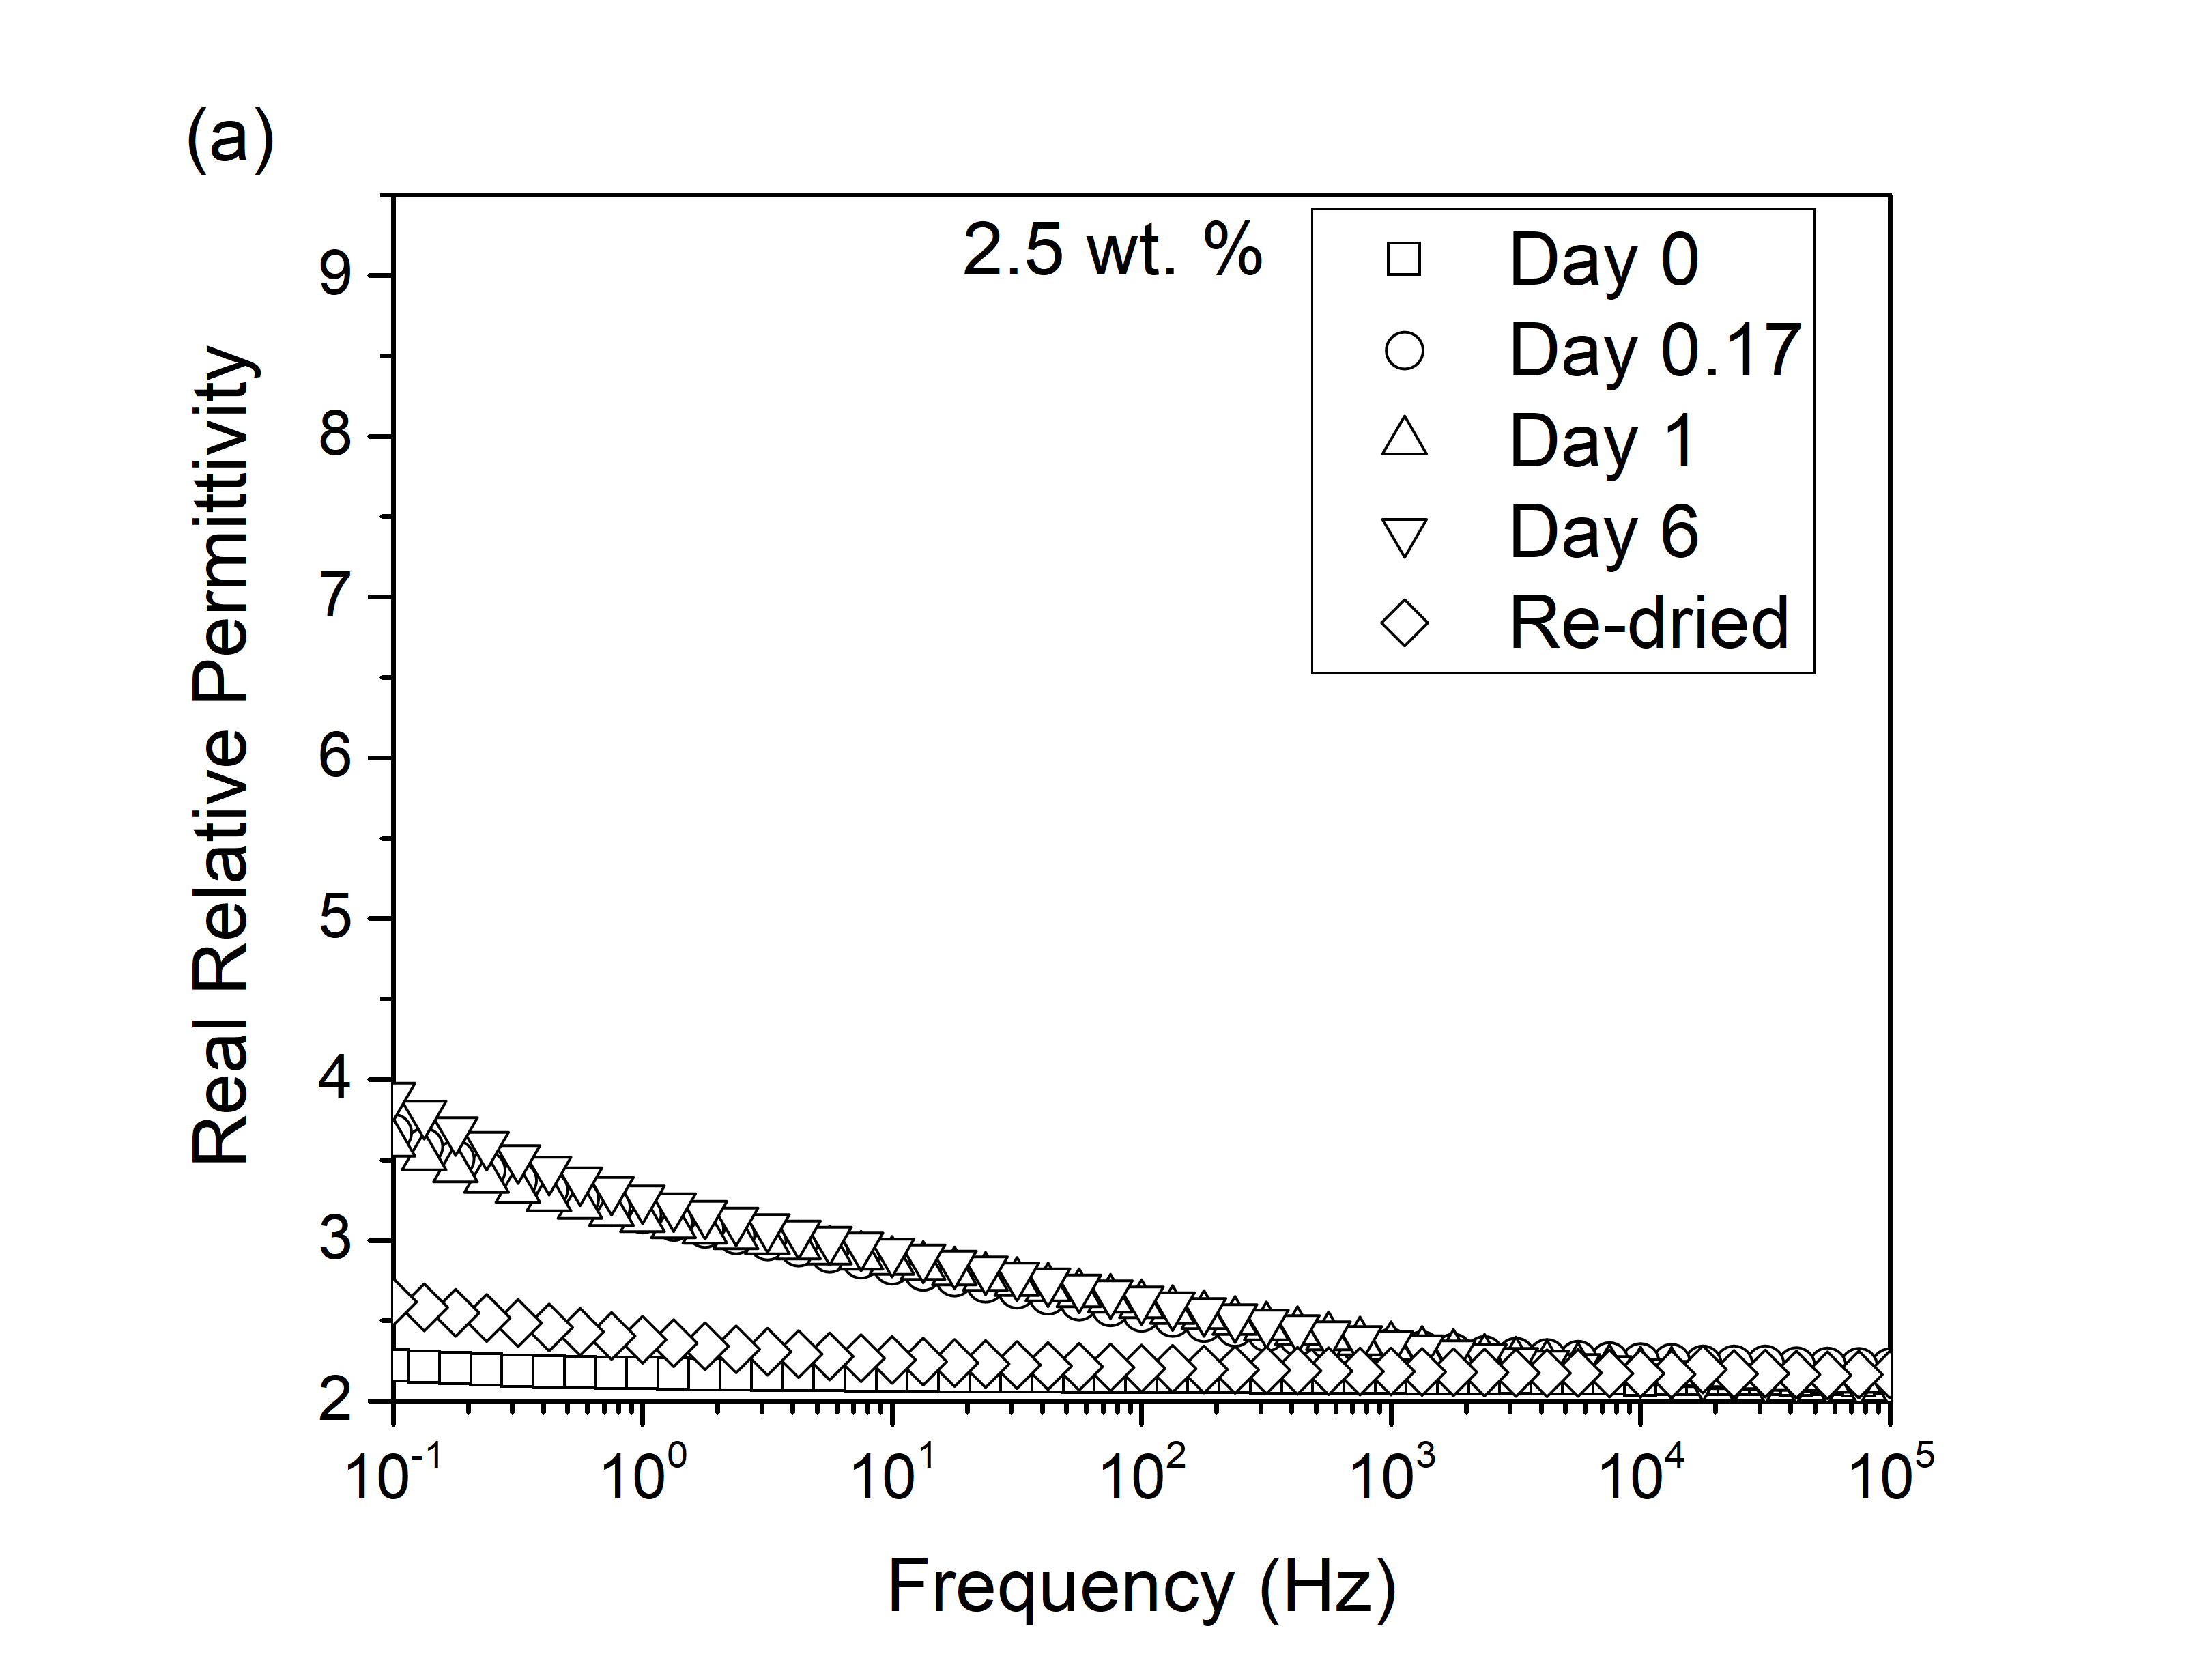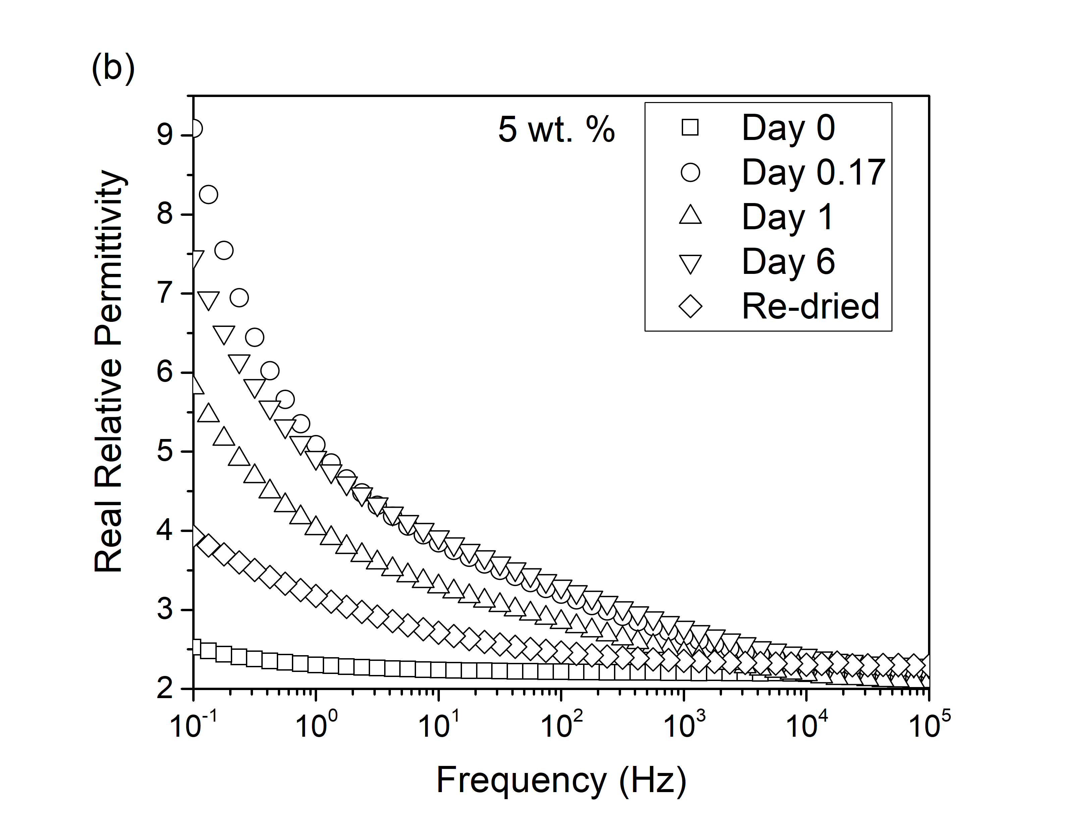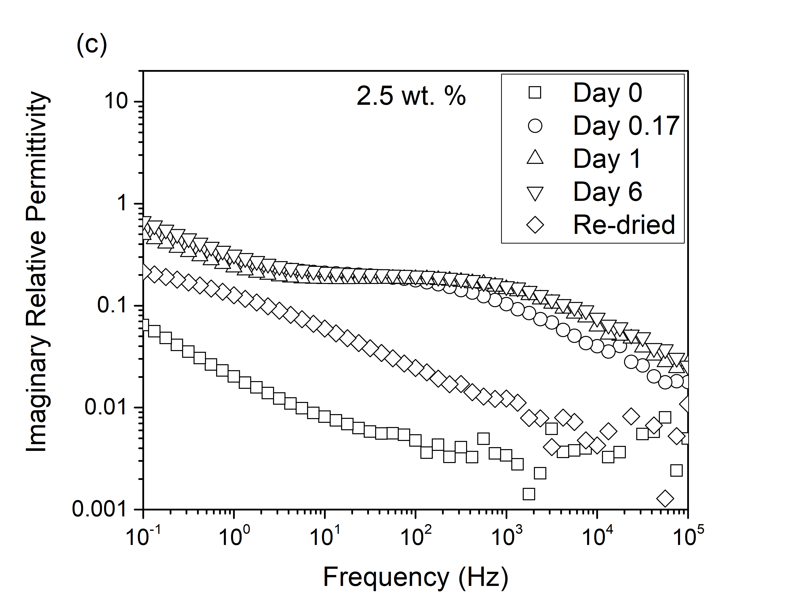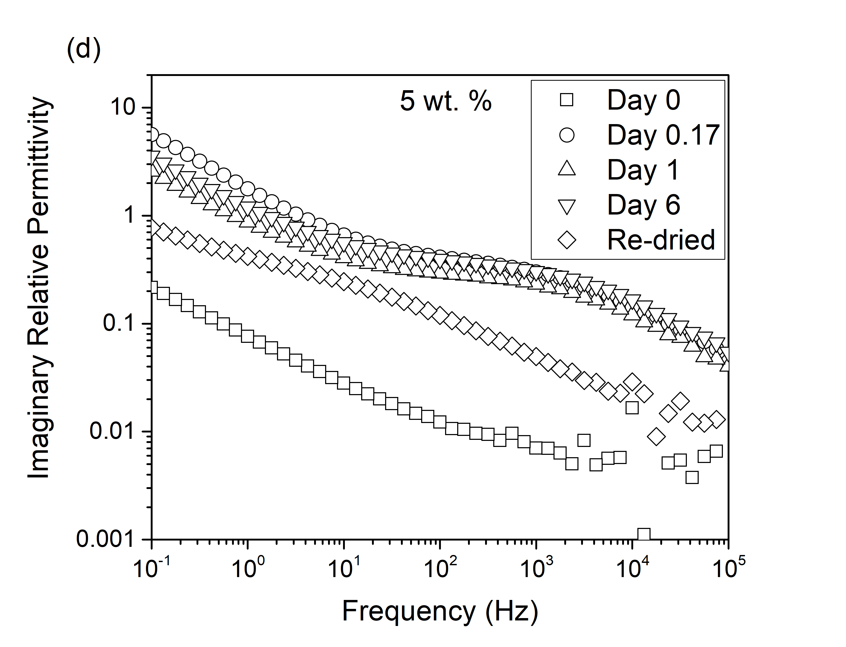
Figure 5. The real relative permittivity of the composites containing (a) 2.5 wt. % and (b) 5 wt. % organoclay and the imaginary permittivity of the composites containing (c) 2.5 wt. % and (d) 5 wt. organoclay after different time intervals of immersion in xylene.

3.3 dielectric breakdown
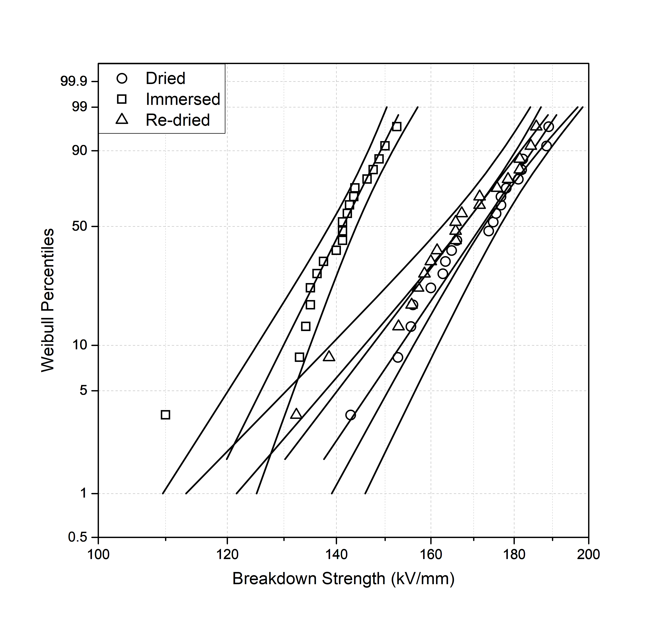
Figure 6. Representative Weibull plots, here comparing data obtained from the PP/EVA9-20/2.5/Y sample set.
Figure 6 contains representative AC breakdown data obtained from the three PP/EVA9-20/2.5/Y specimens, presented in the form of Weibull plots. Parameters derived from such an analysis for all systems considered here are listed in Table 1, where the quoted uncertainty in the Weibull scale parameter corresponds to the 90 % confidence interval.
In the case of the unfilled samples, the variation in breakdown strength is comparable to the uncertainties in these measurements, which indicates that, in isolation, the presence of the xylene in PP/EVA9-20/0/I does not significantly affect the breakdown strength. However, in the systems containing the organoclay, the presence of xylene, which in the unfilled system is benign, leads to a significant reduction in breakdown strength, indicating that interactions between the xylene and the organoclay serve to promote a mechanism that causes breakdown to occur at a reduced electric field. This phenomenon is similar to work described elsewhere, which reported on the effects of absorbed water on breakdown strength [4]. In the case of water, it is possible to propose a number of mechanisms by which its presence could adversely affect breakdown strength, involving dipolar relaxations and/or ionic conduction processes. Here, the critical role played by the non-polar xylene combined with the mediating effect of this solvent in increasing dielectric losses at 50 Hz (the frequency of the applied voltage used for breakdown testing), suggests that the former is most pertinent. In all cases, the re-dried samples exhibited a breakdown strength that was somewhat lower than the respective, dried samples, which is again consistent with the increased dielectric losses seen in Figure 5 for the PP/EVA9-20/X/R systems. Such correlations suggest that, here, the observed changes in AC breakdown strength are driven by changes in the permittivity and polarizability of the samples and, therefore, we suggest two permittivity-based mechanisms. First, increases in ε̋ of some two orders of magnitude, as are evident in Figure 5, provide a direct means by which energy can be deposited within the system. Second, associated localized increases in permittivity will lead to local increases in electric field within the system. Both these mechanisms will serve to accelerate failure. Nevertheless, we accept that while it is not possible categorically to discount the role of conduction processes in general and effects related to solvation of ionic species in particular, for the reasons presented above, we feel that compelling evidence for this does not exists at present. Indeed, recent studies have reported that while DC conductivity is well correlated with DC breakdown strength, DC conductivity and AC breakdown are not necessarily related [25].
Table 1. Summary of AC Breakdown data of the samples.
Sample | Weibull Scale Parameter / kV/mm | Shape Parameter
PP/EVA9-20/0/D  PP/EVA9-20/0/I | 144 ± 8  140 ± 6 | 6.9  9.3
PP/EVA9-20/0/R | 136 ± 6 | 8.6
PP/EVA9-20/2.5/D  PP/EVA9-20/2.5/I  PP/EVA9-20/2.5/R  PP/EVA9-20/5/D  PP/EVA9-20/5/I  PP/EVA9-20/5/R | 176 ± 4  144 ± 4  171 ± 6  160 ± 6  133 ± 4  153 ± 6 | 16.6  22.5  14.7  10.5  13.9  11.9

4 conclusionS
The influence of a labile, non-polar molecule on dielectric response and breakdown behavior has been examined in a polymer blend system containing varying loading levels of an organoclay. In the absence of xylene, addition of the organoclay has little effect on the dielectric response of the system and, at low loading levels, leads to a significant increase in the breakdown strength of the system. Equally, in the absence of the organoclay, the presence of xylene has an insignificant effect on both dielectric response and breakdown. However, when both the organoclay and the xylene are present together, strong synergistic effects are seen. Specifically, the dielectric losses are markedly increased and, in parallel, the AC breakdown strength is reduced. We propose that these effects are associated with solvation of amphiphilic species that are added to the virgin clay in order to render it more compatible with the host polymer and ease dispersion during processing.
While it is generally accepted that in nanocomposite systems optimal properties require good dispersion of the nanoclay, the work presented here, we suggest, indicates that where dielectric and electrical properties are concerned, improved dispersion is not the panacea it may be elsewhere. Rather, the mechanisms that determine bulk properties can be influenced by local physical and chemical factors. While it is conceptually simple to envisage how absorbed water can couple with an applied electric field and, thereby, affect dielectric response, it is less obvious that the presence of a non-polar species can serve to facilitate comparable effects. Here, the presence of the non-polar xylene leads, indirectly, to phenomena that mirror the direct effects of absorbed water. While both are, practically, deleterious, this does not eliminate the possibility of other labile species acting in some advantageous way, by which macroscopic electrical properties are enhanced.

ACKNOWLEDGMENT
The authors would like to acknowledge the support of AWE plc, EPSRC and the support of Dr Matthew A. Brown.
All data supporting this study are openly available from the University of Southampton repository at: http://dx.doi.org/10.5258/SOTON/D0537

References
[1] C. Zilg, D. Kaempfer, R. Thomann, R. Muelhaupt, and G. C. Montanari, “Electrical Properties of Polymer Nanocomposites based upon Organophilic Layered Silicates,” Electr. Insul. Dielectr. Phenomena, 2003. Annu. Report. Conf., pp. 546–550, 2003.
[2] G. C. Montanari, D. Fabiani, F. Palmieri, D. Kaempfer, R. Thomann, and R. Mülhaupt, “Modification of electrical properties and performance of EVA and PP insulation through nanostructure by organophilic silicates,” IEEE Trans. Dielectr. Electr. Insul., vol. 11, no. 5, pp. 754–762, 2004.
[3] G. C. Montanari et al., “Dielectric spectroscopy analysis of EVA-silicate nanocomposite insulating materials,” Proc. 2005 Int. Symp. Electr. Insul. Mater. 2005. (ISEIM 2005)., vol. 1, p. 247–250 Vol. 1, 2005.
[4] I. Hosier, M. Praeger, A. Holt, A. Vaughan, and S. Swingler, “On the Effect of Functionaliser Chain Length and Water Content in Polyethylene/Silica Nanocomposites: Part I – Dielectric Properties and Breakdown Strength,” IEEE Trans. Dielectr. Electr. Insul., vol. 24, no. 3, pp. 1698–1707, 2017.
[5] M. Roy, J. K. Nelson, R. K. Maccrone, L. S. Schadler, C. W. Reed, and R. Keefe, “Polymer nanocomposite dielectrics-the role of the interface,” Dielectr. Electr. Insul. IEEE Trans., vol. 12, no. 4, pp. 629–643, 2005.
[6] M. Bhattacharya, “Polymer nanocomposites-A comparison between carbon nanotubes, graphene, and clay as nanofillers,” Materials (Basel)., vol. 9, no. 4, pp. 1–35, 2016.
[7] Y. Prachum, R. H. A. Strauss, and S. Kiatkamjornwong, “The Physical and Mechanical Properties of Beta-Nucleated Polypropylene/Montmorillonite Nanocomposites,” J. Appl. Polym. Sci., vol. 122, pp. 1066–1076, 2011.
[8] E. M. Araújo, R. Barbosa, C. R. S. Morais, L. E. B. Soledade, A. G. Souza, and M. Q. Vieira, “Effects of organoclays on the thermal processing of PE/clay nanocomposites,” J. Therm. Anal. Calorim., vol. 90, pp. 841–848, 2007.
[9] M. L. López-Quintanilla, S. Sánchez-Valdés, L. F. Ramos De Valle, and F. J. Medellín-Rodríguez, “Effect of some compatibilizing agents on clay dispersion of polypropylene-clay nanocomposites,” J. Appl. Polym. Sci., vol. 100, no. 6, pp. 4748–4756, 2006.
[10] M. Zanetti and L. Costa, “Preparation and combustion behaviour of polymer/layered silicate nanocomposites based upon PE and EVA,” Polymer (Guildf)., vol. 45, no. 13, pp. 4367–4373, 2004.
[11] S. V. Krishna and G. Pugazhenthi, “Properties and Thermal Degradation Kinetics of Polystyrene/Organoclay Nanocomposites Synthesized by Solvent Blending Method: Effect of Processing Conditions and Organoclay Loading,” J. Appl. Polym. Sci., vol. 120, p. 1322, 2011.
[12] C. Zhang and G. C. Stevens, “The dielectric response of polar and non-polar nanodielectrics,” IEEE Trans. Dielectr. Electr. Insul., vol. 15, no. 2, pp. 606–617, 2008.
[13] K. Y. Lau, A. S. Vaughan, G. Chen, I. L. Hosier, and a F. Holt, “On the dielectric response of silica-based polyethylene nanocomposites,” J. Phys. D. Appl. Phys., vol. 46, no. 9, 2013.
[14] K. Y. Lau, A. S. Vaughan, G. Chen, and I. L. Hosier, “Polyethylene nanodielectrics: The effect of nanosilica and its surface treatment on electrical breakdown strength,” in Annual Report - Conference on Electrical Insulation and Dielectric Phenomena, CEIDP, 2012, pp. 21–24.
[15] P. Meneghetti and S. Qutubuddin, “Synthesis, thermal properties and applications of polymer-clay nanocomposites,” Thermochim. Acta, vol. 442, pp. 74–77, 2006.
[16] G. Peng, C.-C. Wu, C.-C. Diao, and C.-F. Yang, “Investigation of the composites of epoxy and micro-scale BaTi4O9 ceramic powder as the substrate of microwave communication circuit,” Microsyst. Technol., vol. 24, pp. 343–349, 2018.
[17] D. R. Lide, “Dielectric Constant of Selected Polymers”, in CRC Handbook of Chemistry and Physics, Internet Version 2005. Boca Raton, FL: CRC Press, 2005.
[18] AZoM, “AZo Materials,” 2001. [Online]. Available: https://www.azom.com/article.aspx?ArticleID=410. [Accessed: 16-Apr-2018].
[19] P. Perez, T. E. Block, and C. M. Knobler, “Refractive Index and Dielectric Constant of Mixtures of Carbon Tetrachloride with Benzene, p-Xylene, and Mesitylene,” J. Chem. Eng. Data, vol. 16, no. 3, pp. 333–335, 1971.
[20] R. Mujal-Rosas, J. Orrit-Prat, X. Ramis-Juan, M. Marin-Genesca, and A. Rahhali, “Study on dielectric, thermal, and mechanical properties of the ethylene vinyl acetate reinforced with ground tire rubber,” J. Reinf. Plast. Compos., vol. 30, no. 7, pp. 581–592, 2011.
[21] N. Taniguchi, O. Urakawa, and K. Adachi, “Calorimetric study of dynamical heterogeneity in toluene solutions of polystyrene,” Macromolecules, vol. 37, no. 20, pp. 7832–7838, 2004.
[22] E. Izci and N. Bowler, “Dielectric Properties of Isotactic Polypropylene and Montmorillonite Nanocomposites,” in Procedings of the 2010 IEEE International Conference on Solid Dielectrics (ICSD 2010), 2010, pp. 1–4.
[23] B. Zazoum, E. David, and A. D. Ngô, “LDPE / HDPE / Clay Nanocomposites : Effects of Compatibilizer on the Structure and Dielectric Response,” J. Nanotechnol., 2013.
[24] R. Ramani, R. Ramachandran, G. Amarendra, and S. Alam, “Direct correlation between free volume and dielectric constant in a fluorine-containing polyimide blend,” J. Phys. Conf. Ser., vol. 618, no. 1, pp. 0–4, 2015.
[25] F. N. Alhabill, R. Ayoob, T. Andritsch, and A. S. Vaughan, “Effect of resin/hardener stoichiometry on electrical behavior of epoxy networks,” IEEE Trans. Dielectr. Electr. Insul., vol. 24, no. 6, pp. 3739–3749, 2017.

BIOGRAPHIES

Allison V. Shaw (S’18) graduated from the University of Southampton in the UK with a first class MChem degree in Chemistry in 2016. She is currently a PhD candidate working in the Tony Davies High Voltage Laboratory at the University of Southampton and was awarded “Best Presentation” at the IEEE ICD 2018 in Budapest.

Thomas Andritsch (M’11) was born in Innsbruck, Austria in 1980. He received the Dipl.-Ing. Degree in Electrical Engineering from Graz University of Technology in 2006 and his Ph.D. degree in the same field from Delft University of Technology in 2010. He is currently working as a Lecturer at the University of Southampton with focus on advanced materials for high voltage applications and plant. He has extensive experience with preparation and testing of polymer-based electrical insulation materials, including nanodielectrics, electroactive polymers and syntactic foams, as well as liquid insulation systems and nanofluids. Thomas is currently the chair of the UK & Ireland IEEE DEIS Chapter. He is member of the IEEE DEIS working group on nanodielectrics, developing recommended practices for nanocomposite synthesis and preparation, and was contributing to Cigre WG D1.40 on the subject of functional nanomaterials for the electrical power industry.

Alun Vaughan (SM’07) has a B.Sc. degree in chemical physics and a Ph.D. degree in polymer physics. After working at the UK’s Central Electricity Research Laboratories and spending a period as an academic at The University of Reading, he is now Professor of Dielectric Materials at the University of Southampton. He is a former chair of The Dielectrics Group of the Institute of Physics, a Fellow of the Institute of Physics, a Fellow of the IET and delivered the 2016 IEEE DEIS Eric O. Forster Memorial Lecture.

