Note: this is a draft of the journal article:

Peter R. Worsley, Dan Rebello, Sally Webb, Silvia Caggiari, Dan L. Bader (2017) “Monitoring the biomechanical and physiological effects of postural changes during leisure chair sitting. Journal of Tissue Viability in press 10.1016/j.jtv.2017.10.001
The final, fully proofed and peer-reviewed journal article is available from the publisher online, via
the following link:
http://authors.elsevier.com/sd/article/S0965206X17301249

Journal of Tissue Viability

Special Issue Seating Biomechanics

Title: Monitoring the biomechanical and physiological effects of postural changes during leisure chair sitting.

Peter R. Worsley, Dan Rebello, Sally Webb, Silvia Caggiari, Dan L. Bader

ª Clinical Academic Facility, Faculty of Health Sciences, University of Southampton, Southampton, SO17 1BJ, UK

Corresponding Author: Dr Peter Worsley, MP 11 South Academic Block, Southampton General Hospital, Southampton, UK. Email: p.r.worsley@soton.ac.uk Tel: +44(0)2381 208957

Word Count
Abstract: 250
Manuscript: 3293

Abstract
Background: Individuals with limited mobility can spend prolonged periods in leisure chairs, increasing their risk of developing a seated acquired pressure ulcer. The present study aims to use objective measures of posture and tissue viability to identify the associated risks of leisure chair related pressure ulcers.

Methods: Healthy participants (n=13) were recruited to sit on a leisure chair with either a viscoelastic foam or air cushion. Participants were asked to adopt four different postures for a period of 10 minutes followed by a 10 minute refractory period. Measurements at the leisure chair-participant interface included interface pressure, transcutaneous tissue gas tensions at the ischial tuberosities, accelerometer data collected from the sternum and subjective comfort levels.

Results: Results indicated that interface pressures remained consistent, with peak pressure index values of less than 60mmHg across all conditions. A proportion of participants exhibited decreased oxygen tensions associated with increased carbon dioxide tensions during one or more test condition. This was particularly prevalent during the right lean posture on the air cushion (46%). In all cases, normal tissue viability was restored during standing. The accelerometer was able to detect significant changes (p<0.05) in relative trunk angles during slump and right lean when compared to optimal sitting posture.

Conclusion: Commercially available leisure chairs have little evidence to support their pressure relieving properties. This study revealed that a proportion of healthy individuals demonstrated a compromised tissue viability in specific postures. Further research is required to assess the impact of these sitting conditions in vulnerable individuals.

- Background

In the seated position a high proportion of body weight is supported by the ischial tuberosities and buttocks, the sacrum and upper thighs. Further body weight may by supported by the arms, via arm-rests, and the feet via footrests or the floor [1]. Prolonged sitting in association with high mechanical loads exerted over relatively small body support areas gives rise to mechanically-induced soft tissue damage in vulnerable individuals, typically those who are immobile and/or present with neurological impairment. This condition, commonly termed Sitting-Acquired Pressure Ulcers (SAPUs), has major implication on an individual’s quality of life and the financial burden on health services [2].
Recent European and UK prevalence studies have highlighted an obvious disparity in the management of high risk patients when seated, in comparison with how they are cared for in bed [3, 4]. Most specifically, it was found that over 50% of at risk patients did not receive specialist chair equipment when seated and were repositioned at irregular time intervals [3]. In addition, recent cross-sectional studies in Europe have revealed that only a very small proportion of patients are given care plans to prevent pressure ulcers in the seated environment [5]. This represents a patient safety issue given that the correlation between prolonged sitting and the presence of pressure ulcers has frequently been reported [2]. While these correlations have often been reported in cross- sectional studies, direct causal association between sitting and the development of pressure ulcers has also been reported [6]. Additionally, those who are wheelchair dependent often experience pressure ulcers at a relatively young age.

The literature reveals a significant number of papers examining the effects of prolonged sitting in wheelchair bound individuals, typically focused on the Spinal Cord Injured [7-10], who are known to be at high risk of developing pressure ulcers throughout their lifetime. By contrast, there are only a few studies which have examined the effects of sitting in static chairs, involving specific subject groups with vulnerable skin [6, 11, 12]. This is surprising given the fact that many hospitalized patients e.g. trauma and post-surgical, who have reduced mobility are regularly transferred into a chair where they may remain for 8 hours and longer [13]. In addition, there are many situations in the community, both in residential and private homes, where vulnerable individuals spend most of their daily lives sat in their “preferred” leisure chairs, often choosing to sleep in them overnight. In each case, the lack of mobility and monitoring of posture can lead to the development of SAPUs. Indeed, a recent review found that the majority of individuals at risk of developing pressure ulcers do not adhere with the pressure relieving frequency or magnitude of movements currently recommended [14, 15]. Studies have combined interface pressure measures with accelerometers to assess the efficacy of pressure relieving behaviours. The study revealed that the magnitude of movement required to offload vulnerable tissues was substantive and typically not achieved with traditional repositioning activities [16].

The literature review also highlighted the need for further research investigating the effect of recommended pressure relieving movements on the pressures around the ischial tuberosities [14]. The authors have recently adopted an approach where combined measures of biomechanics and the physiological response of tissues are investigated to assess the performance of support surfaces and postures in the lying environment. This approach will now be translated into the seating environment to assess the effects of seat cushion type and posture on the ischial tubersoities of young able-bodied volunteers supported on a commercial leisure chair. The aim of the study is to provide a robust means of identifying postures and support surfaces which put the tissues at risk of pressure ulcers and determine how tissue recover during periods of offloading.

- METHODS

The present study adopted a prospective randomised cross-over design in a cohort of healthy participants.

  - Description of the Leisure Chair and Cushion Properties
A standard Rise and Recline leisure chair (Configura®, Accora, United Kingdom), also known as a lounge chair or easy chair, was maintained in a neutral position, without tilt or recline, throughout the test protocols for each participant. Two cushions specifically designed for the leisure chair were used, namely, a static viscoelastic foam cushion and a dynamic air cushion (CushionAir). The chair and each of the cushions were set-up and fitted in accordance with the manufacturer’s guidelines [17]. The inflation pressure of the air cushion was maintained at a mid-setting for all subjects and postures. The CushionAir device is a seat pad that consisted of an array of 64 individual air cells contained within a 4-way stretch, vapour-permeable cover. The air-cell array is constructed such that side-to-side rows of interlinked cells fill and empty in a 1-in-2 alternating sequence. The leisure chair was designed with a hollow insert for cushions. Both the foam and air cushions were the same thickness (4”) resulting in the same height for chair for both conditions, which was standardised for all participants.

2.2 Participants
Participants were recruited from the local community at the University of Southampton if they had no history of skin-related conditions, no history of neurological or vascular pathologies which could affect tissue health and were able to sit for a period of 90 minutes. Institutional ethics was granted for the study (ERGO-FOHS-4972) and informed consent was obtained from each participant prior to testing.

2.3 Test Equipment
Physiological measures of transcutaneous oxygen and carbon dioxide tensions (T_{c}PO_{2,} T_{c}PCO₂) were monitored at the right and left ischial tuberosities using a transcutaneous gas electrodes (Model 841, Radiometer A/S, Denmark) heated to 43.5°C to ensure maximum vasodilation [9]. Each electrode was attached to a separate monitor (TCM4, Radiometer, Denmark), recording at a frequency of 0.5Hz. Interface pressure measurements were recorded using a Pressure Measurement System (Tekscan CONFORMat®, Boston, MA). The mat incorporates a flexible grid based array of 1024 pressure measuring sensors, with a spatial resolution of 10mm. Each sensor was set to operate within the range of 5-250 mmHg (accuracy ± 10%) with a data acquisition rate of 1 Hz . An accelerometer (Shimmer Platform, Realtime Technologies Ltd, Dublin, Ireland) was used to measure trunk movement. The tri-axial accelerometer was attached to the sternum with a Velcro strap. This device represents a small wireless sensor (53mm x 32mm x 25mm) that recorded real-time kinematic data at 51Hz . In addition, subjective comfort scores were recorded for each participant using a 5 point verbal rating scale, with 0 representing the lowest score and 5 representing the highest score.

2.4 Test Protocol
All test procedures were performed in a laboratory where room temperature was maintained at 20 ±2°C. Participants, who wore loose fitting clothing during data collection, were asked to lie on their side with their hips flexed to 90° for a 15 minute period to establish baseline unloaded TcPO₂ and TcPCO₂ levels at each ischial tuberosity. Each participant was then carefully positioned in a stable posture on the leisure chair, incorporating either the viscoelastic foam or the air cushion, as randomly selected. Participants were then asked to adopt four randomly allocated postures; optimal sitting (hips positioned 90° relative to trunk), slump (hips positioned 135° relative to trunk), right lean (trunk leaned over to the right 15°) and feet up (hips positioned 80° relative to trunk with feet raised). Subjects sat with their forearms resting on their laps and were instructed not to re-adjust their posture once seated (Figure 1). The feet of participants were supported by the floor or a standard box for each posture. The pelvis was kept in a neutral tilt angle and the trunk was supported by the back of the leisure chair. The knees were bent to 90° for all postures apart from the raised feet. Each posture was checked with a hand held goniometer, measuring at the trunk, hip and knees by two researchers.

Fig. 1. Frontal and sagittal views of sitting postures: Optimal (A, B), Slumped (C, D), Right lean (E, F), and Feet up (G, H).

Each posture was assessed by two researchers to check hip and trunk angles and then maintained for a 10 minute period. After each test condition, participants were asked to stand for a 10 minute refractory period to allow reperfusion of the soft tissues, with the aim of restoring basal levels of transcutaneous gas tensions prior to the next test condition. The process was then repeated for the second cushion (air or viscoelastic foam), with a total of eight test conditions lasting a period of 160 minutes (Figure 2). Transcutaneous gas measurements were continuously monitored at the ischial tuberosities throughout the test period. Accelerometer data was also captured continuously at the sternum. After five minutes of each posture, interface pressures were recorded for a 60 second period. Single measures of subjective comfort scores were also noted at the end of each test posture, with scores of 1 representing ‘very uncomfortable’ and 5 representing ‘very comfortable’.

Fig. 2. Schematic of data collection, detailing the randomisation process for cushion and posture.

2.5 Outcome Measures
Values of interface pressures, transcutaneous gas tensions and accelerometer data were processed and analysed using Matlab (MathWorks, US). Peak pressure index (mean of 10 peaks), contact area of sensors recording a pressure of above 5mmHg and pressure gradients were estimated from the 60 seconds of recordings between the chair and the individual. The transcutaneous gas data were normalised to baseline unloaded values, measured in the side lying position, and then categorised according to the following established characteristic responses (Chai and Bader, 2013); Category 1 (minimal changes in both TcPO₂ and TcPCO₂ values), Category 2 (>25% decrease in TcPO₂ with minimal change in TcPCO₂) and Category 3 (>25% decrease in TcPO₂ associated with a >25% increase in TcPCO₂). With the Category 3 response being indicative of compromised tissue viability. In order to assess the relative change in accelerometer outputs for each participant, data were normalised to the optimal posture (Figure 1A and 1B). The root mean squared (RMS) of the anterior-posterior and medial-lateral angles was estimated for each posture.

2.6 Statistical Analysis

Statistical analysis of the data was performed using the Statistical Package for Social Sciences (SPSS, 21). All data were examined for normal distribution prior to analysis using the Shapiro-Wilk test. In the case of normal distribution of the data a two factor repeated measures ANOVA was used to test for differences in transcutaneous gas responses and interface pressure values. A Friedman test was used if data was not normally distributed. Sphericity was tested with Mauchly's test for sphericity and a Bonferroni post hoc correction was used to reduce the risk of Type I error associated with multiple comparisons. The relationship between interface pressure and transcutaneous values were examined using linear regression. A level of 5% was considered statistically significant (*P ≤ 0.05).

- Results

Thirteen healthy participants (8 male and 5 female) were recruited aged between 21-27 years (mean = 24 years) with a mean ± standard deviation in height and weight of 1.78±0.1m and 73.0 ±13.2kg, respectively. The corresponding body mass index (BMI) ranged between 18.1-27.1kg/m².

3.1 Monitoring physiological parameters
The category responses from the right ischial tuberosity for each of the participant during each test conditions are summarised in Table 1. Comparisons between right and left ischial tuberosities revealed similar trends in the data, although within individuals there were asymmetries in categorical responses particularly during the right lean activity. There were a higher number of Category 3 responses associated with the air cushion (31%) compared with the viscoelastic foam (25%), with a corresponding reduced number of Category 1 responses (31% vs. 42%, respectively). Close examination of the postural data, revealed that right lean yielded the highest proportion of Category 3 responses for both cushions. For these Category 3 responses the transcutaneous data revealed that TcPO2 levels had significantly reduced to below 12mmHg, with an associated increase in TcPCO2 values, ranging between 53-104mmHg. A high proportion of males had one or more Category 3 responses during the postures, which was only exhibited by one female participant (P13), who had a very low BMI of 18.1kg/m².
Table 1. Summary of the transcutaneous Category responses from the right ischial tuberosity of 13 participants, according to Chai and Bader 2013 criteria
 |  | Viscoelastic Cushion |  |  |  | Air cushion
Participant | BMI (kg/m²), Gender | Optimal | Slump | Right Lean | Feet up | Optimal | Slump | Right Lean | Feet up
1 | 21.4, M | 2 | 2 | 2 | 3 | 1 | 3 | 2 | 3
2 | 25.4, M | 2 | 1 | 3 | 2 | 1 | 2 | 2 | 2
3 | 24.3, M | 3 | 3 | 3 | 2 | 3 | 2 | 3 | 2
4 | 23.3, M | 2 | 3 | 2 | 3 | 3 | 3 | 3 | 2
5 | 27.1, M | 3 | 2 | 2 | 1 | 3 | 3 | 3 | 2
6 | 25.7, M | 1 | 3 | 3 | 2 | 3 | 2 | 3 | 1
7 | 22.2, M | 3 | 1 | 3 | 1 | 3 | 3 | 3 | 3
8 | 21.6, F | 1 | 1 | 1 | 1 | 1 | 1 | 1 | 1
9 | 20.4, F | 1 | 1 | 1 | 1 | 1 | 1 | 1 | 1
10 | 26.2, F | 1 | 1 | 1 | 1 | 2 | 1 | 2 | 1
11 | 20.1, M | 2 | 1 | 2 | 1 | 1 | 1 | 2 | 2
12 | 21.7, F | 2 | 1 | 2 | 1 | 2 | 2 | 2 | 2
13 | 18.1, F | 1 | 2 | 2 | 3 | 2 | 2 | 3 | 1

There were clear differences between participants with some (P8&9) exhibited a Category 1 responses in all test conditions (Figure 3a), while others (P3&4) consistently exhibited either a Category 2 or 3 responses (Table 1). It is noteworthy that in some participants movement between postures clearly influenced the viability of the soft tissues. Figure 3b demonstrates how an individual reacted with a Category 2 response during the right lean and slumped postures and a Category 3 response during feet up posture. However, during the refractory periods in standing, transcutaneous gas tension values recovered to basal levels.

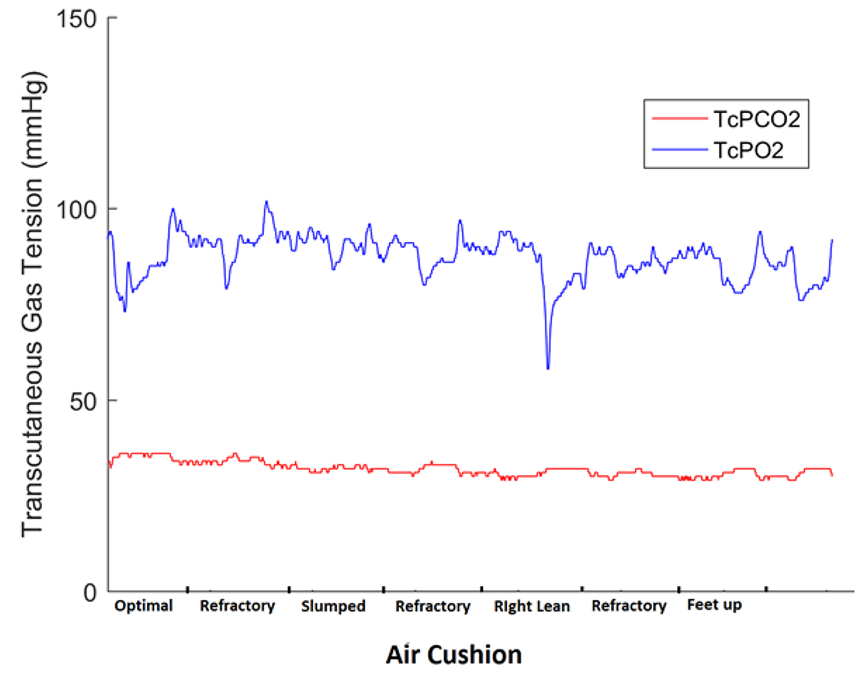A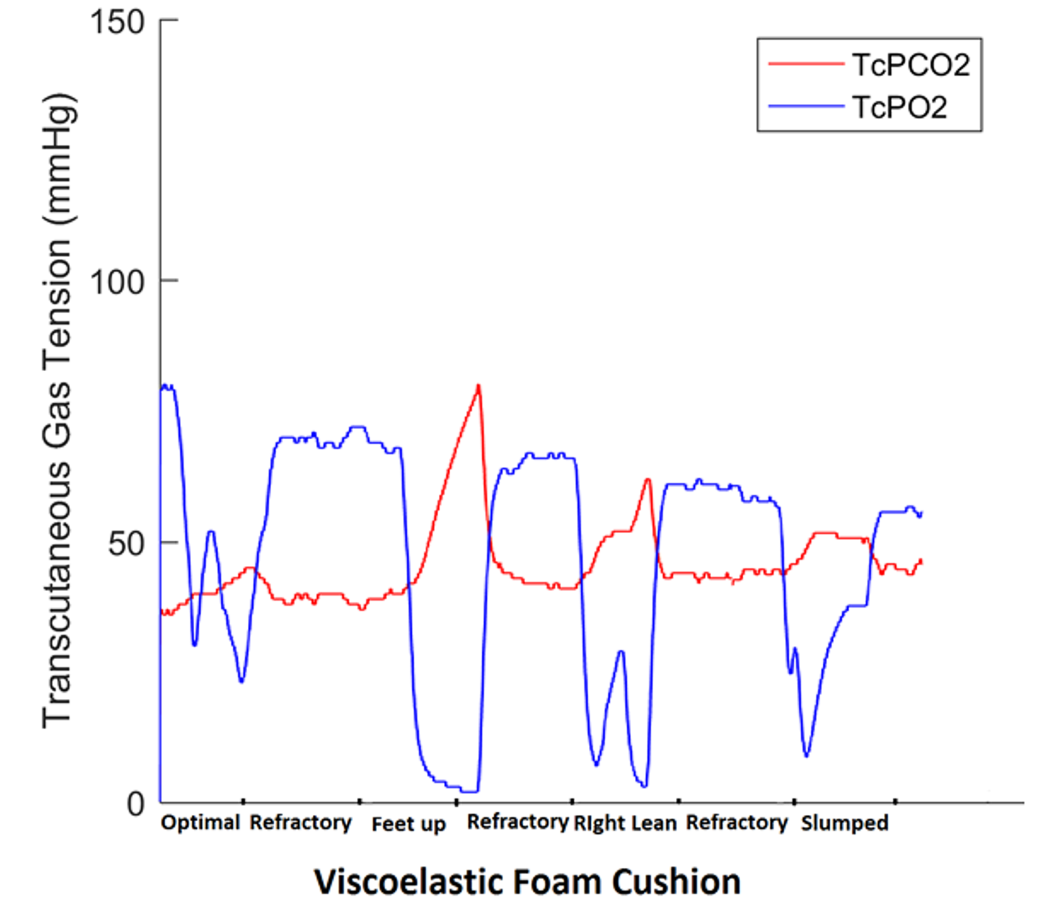B
Figure 3: Transcutaneous tissue gas tensions from (a) Participant 8 who exhibited a Category 1 response throughout the test session (b) Participant 13 who exhibited a Category 2 and 3 response during the test session

3.2 Biomechanical Assessment
Table 2 summarises the results of the interface pressure measurements. The mean of ten peaks were consistently below 60mmHg, with no significant differences (p>0.05) between cushion types or postures. In addition, pressures were uniformly distributed between right and left buttocks during neutral sitting, slump and feet up postures. However, in the right lean posture there was a significant increase (p<0.05) in mean peak pressures on the right hand buttocks. There were no significant differences in contact area and peak pressure gradients between the cushion types and postures.

Table 2. Summary of Interface Pressures for all participants during sitting on different cushions in four separate postures
 |  | Ten Peak Mean (mmHg) | Ratio of right to left buttocks | Peak Pressure gradient (mmHg/mm) | Total Contact Area (m²)
Cushion | Posture | Mean (std.) | Mean (std.) | Mean (std.) | Mean (std.)
Air | Optimal | 54.5 (13.3) | 1.2 (0.1) | 2.54 (0.71) | 0.45 (0.16)
 | Slumped | 55.2 (15.9) | 1.2 (0.2) | 2.39 (0.81) | 0.42 (0.14)
 | Right Lean | 55.2 (10.6) | 1.7 (0.3) | 2.32 (0.62) | 0.47 (0.16)
 | Feet up | 53.8 (15.5) | 1.0 (0.1) | 2.37 (0.86) | 0.43 (0.16)
Viscoelastic Foam | Optimal | 58.6 (15.2) | 0.9 (0.2) | 2.64 (0.75) | 0.49 (0.15)
 | Slumped | 51.4 (11.9) | 1.2 (0.2) | 2.23 (0.62) | 0.47 (0.17)
 | Right Lean | 57.0 (13.4) | 1.8 (0.3) | 2.30 (0.76) | 0.44(0.13)
 | Feet up | 55.5 (19.6) | 1.1 (0.1) | 2.35 (0.92) | 0.42 (0.17)

Close analysis of the pressure data showed a significant relationship between ten peak mean interface pressure and the percentage change from basal levels of TcPO₂ at left and right ischial tuberosities (R=0.46, P < 0.01) (Fig. 4a). There was also a relationship between ten peak mean interface pressure and carbon dioxide accumulation (percentage change from basal levels TcPCO₂) at both ischial tuberosities (R= 0.41, P < 0.03) (Fig. 4b).

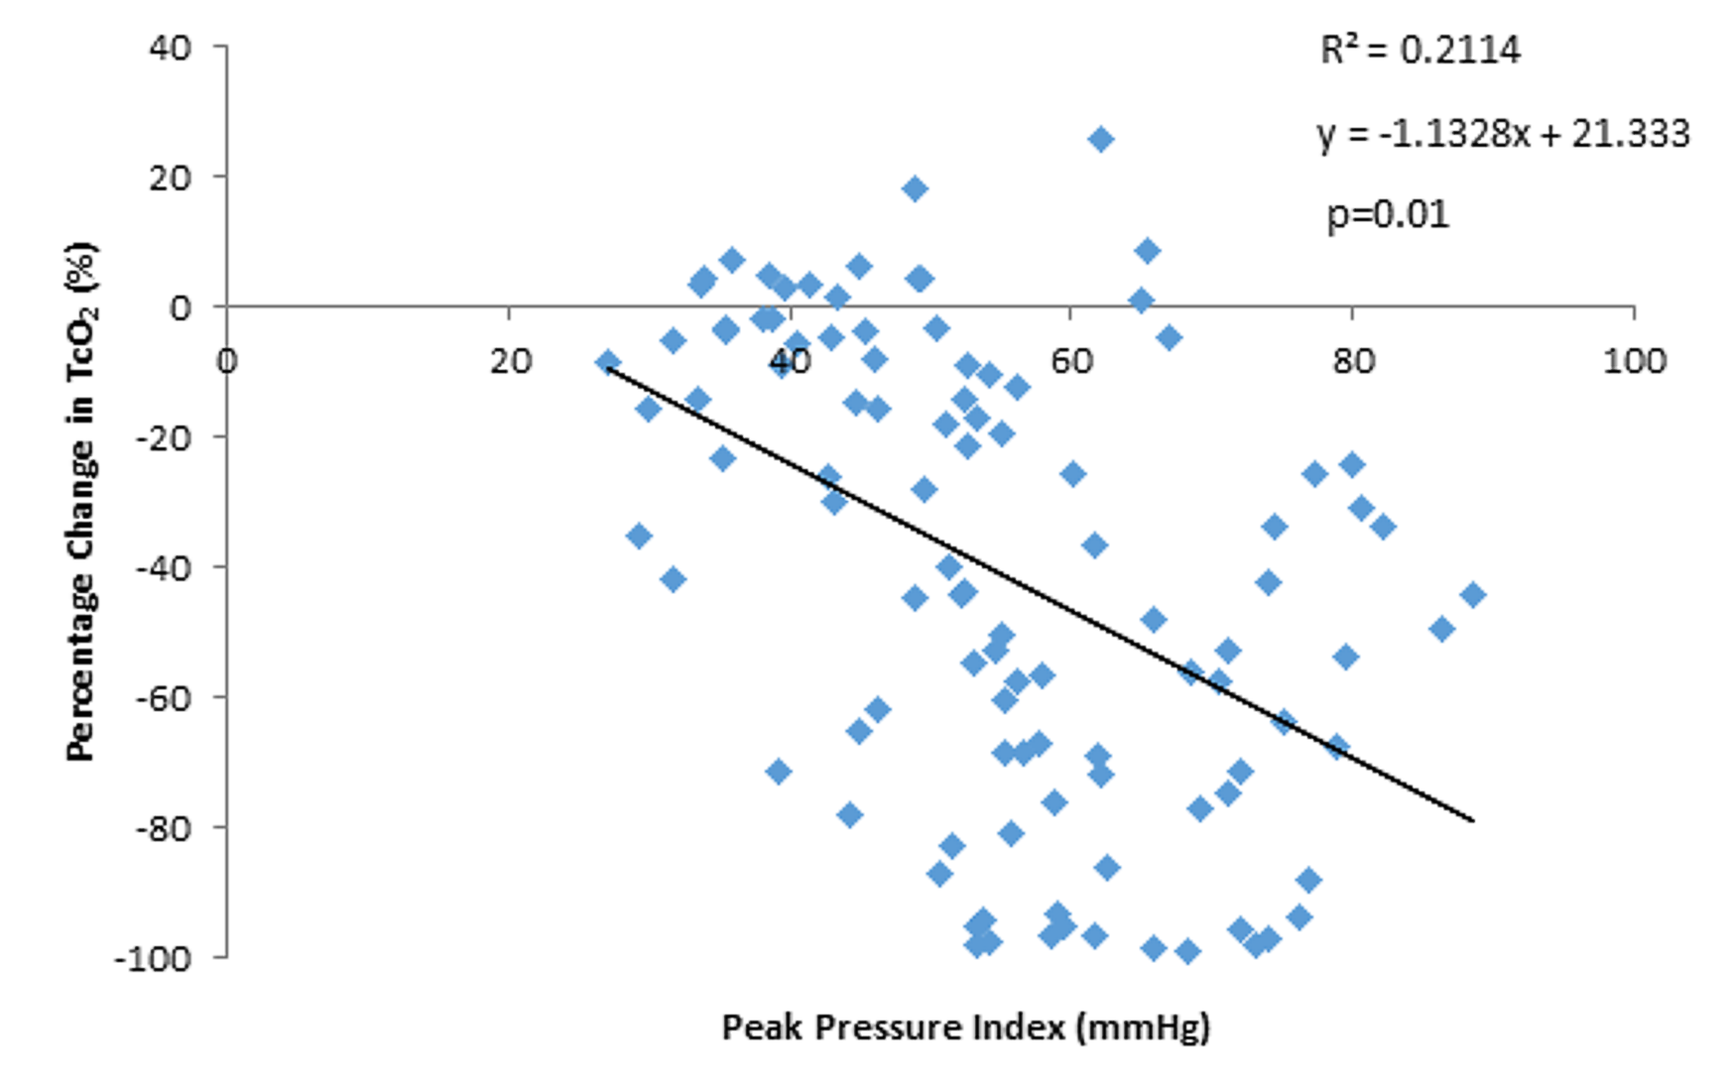A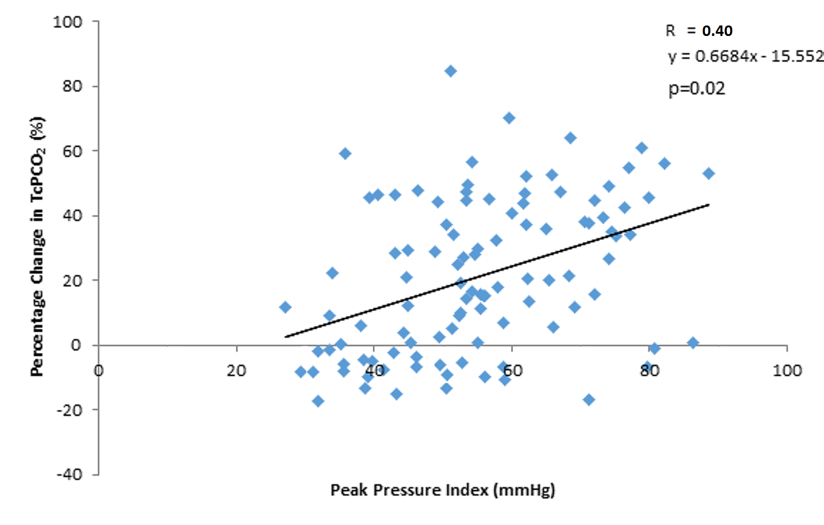B
Figure 4. Correlation analysis between interface peak pressure index and a) percentage change in TcPO2 b) percentage change in TcPCO2.

3.3 Accelerometer
Figure 5 indicates the angular deviations in the sagittal and coronal planes from slump, right lean and feet up, relative to the neutral posture. Accelerations measured at the sternum revealed significant changes (p<0.05) in the sagittal plane during the slump activity (median = 29.1°) compared to right lean (median = 1.5°) and feet up (median = 2.2°). In the coronal plane the largest change in trunk angle was observed during right lean (median = 21.2°), which was significantly (p<0.05) greater than angular changes during slump (median = 0.5°) and feet up (median = 2.1°).

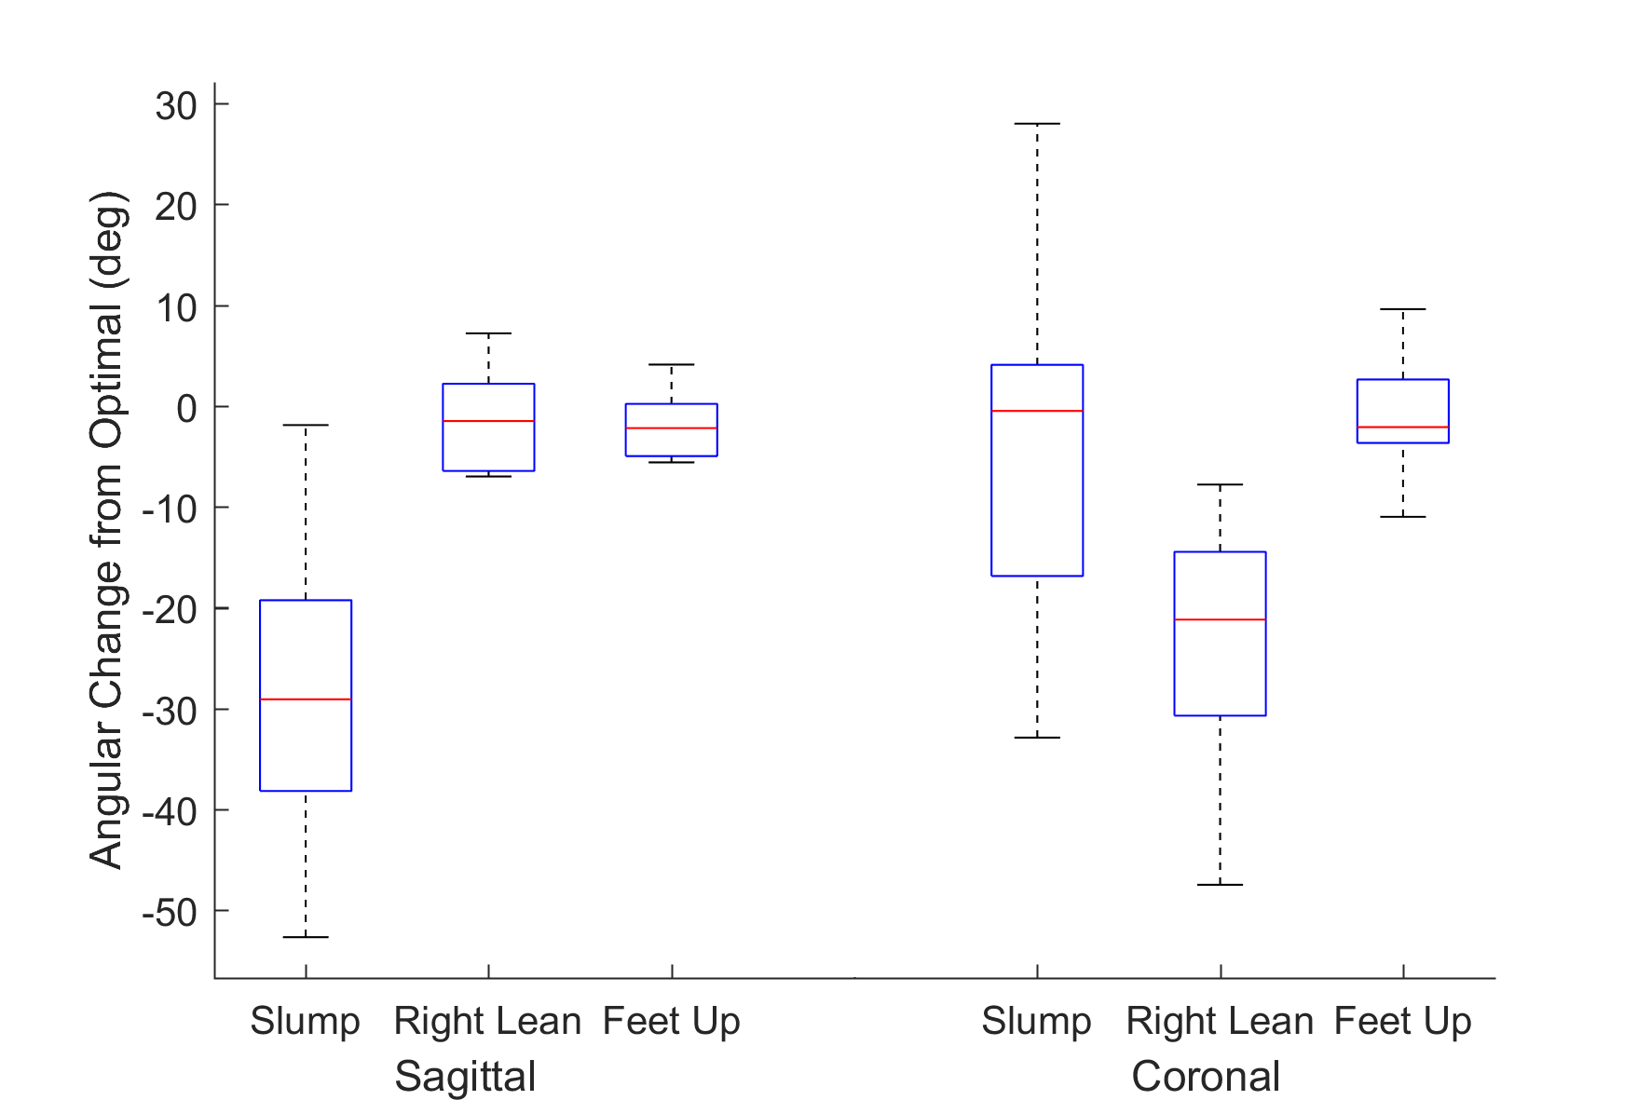
Figure 5. Box and Whisker plot of sagittal and coronal plane angular changes from neutral sitting, during slump, right lean and feet up postures. Data has been normalised to optimal posture, with deviations from 0° reflecting trunk movement away from this position.

3.4 Comfort Scores
The results from the comfort survey suggested that the most favourable was the neutral posture with all participants reporting to be either ‘comfortable (4)’ or ‘very comfortable (5)’. During slump, right lean and feet up postures some individuals reported to be uncomfortable (2). This was most prevalent during the slump position with 10/13 and 8/13 participants reporting to be uncomfortable in this posture when supported on air and viscoelastic foam cushions, respectively. Overall there were no significant differences between cushion types.

- Discussion
The present study investigated the effects of cushion type and posture while young able-bodied participants sat in a leisure chair. The results revealed that a proportion of individuals exhibited compromised tissue viability in specific sitting postures, reflected in a significant decrease in local transcutaneous oxygen tensions, with an associated increase in carbon dioxide tensions at the ischial tuberosities. Although no statistically significant differences in interface pressure parameters were found for either cushion type or posture, there were weak correlations with changes in transcutaneous tissue gas tensions (Figure 4). This study reiterates the relative risk of prolonged sitting of soft tissues adjacent to bony prominences, typically the ischial tuberosities, while maintaining postures commonly employed in the clinical setting (Figure 1).

These findings can be compared with previous studies assessing mattress performance using the same transcutaneous categorisation approach [18-20]. It is evident that there was a much higher proportion of Category 3 responses at the ischial tuberosities (29%) compared to the sacrum during prolonged lying (2-18%). It is of note that the Category 3 responses are defined by a significant accumulations of TcPCO2, e.g. response in Figure 3B. A recent review article highlighted that carbon dioxide gas tensions might be indicative of early tissue damage during both mechanical-induced ischaemia and subsequent reperfusion [21]. Interestingly, the individuals who showed a Category 3 response were typically males, by also included the one female with a relatively low Body Mass Index. This may be indicative of the reduced tissue coverage over the bony prominences, which could increase the compromise on tissue viability, as reflected in the Category 3 response. Indeed recent studies have suggested that individuals with low BMI (<19 kg/m²) present with an increased risk of a hospital-acquired pressure ulcers [22, 23]. In addition, anatomical factors such as tissue composition (skin, fat, muscle) and bony prominence shape can influence the translation of support pressures to internal strains within the soft tissues [24].
The present study revealed limited discriminative potential in the interface pressures between both cushion type and posture. This is in agreement with a previous study, which suggested that relying on the numerical output of pressure mapping systems may not provide practical benefits to the clinician/end user in minimising the risk of SAPUs [25]. It could also be hypothesized that there was no difference in performance between the cushions, despite the technological and financial differences between air and foam designs. On further analysis of the peak pressure index data, a weak relationship was identified with changes in TcPO₂ and TcPCO₂. Indeed, this correlation supported the fact the increased interface pressures is associated with ischemic response. The period of time in which these pressures are maintained is also a critical parameter for tissue viability [26]. If the cell niche is exposed to prolonged anaerobic respiration, a build-up of bi-products in the form of carbon dioxide and metabolites, such as lactate, can ultimately cause cell death [21]. Indeed, previous research has correlated lactate concentrations found in sweat in loaded tissues, with a decrease in TcPO₂ and an associated increase in T_{c}PCO₂ [27]. This indicates the importance of regular repositioning/offloading to restore perfusion to tissues compromised by prolonged loading. In the present study this was achieved by including a refractory phase in-between loading periods.

Relative movements in the trunk were measured using a single accelerometer placed on the sternum. This was shown to discriminate changes in posture in two planes, in particular during the slump and right lean (Figure 5). By contrast, the feet up position could not be discriminated from neutral sitting. Previous research states an accelerometer on the thigh is the optimal location to determine sitting [28] and lying postures [29]. Our findings indicate a series of accelerometers on the trunk, thigh and pelvis may be required to define segmental changes in body posture during sitting.
The current study is limited in its use of a cohort of able-bodied individuals, which prevents the findings to be generalised to specific sub-populations deemed to be at risk of developing SAPUs. In addition, each posture was only adopted for a relatively short time period and thus future studies should examine physiological responses to extended periods of sitting. Indeed, the ten minute period in which the postures were adopted accommodated about 85% of the cycle time for the air cushion (total of 12 minutes). There was no evidence that this protocol influenced the overall assessment of the cushion. The air cushion was reset for each posture, so the cycle was standardised for each participant.
A significant proportion of individuals residing in residential care or private homes spend prolonged periods in leisure chairs. The present study has highlighted the importance of offloading vulnerable areas regularly to allow tissues to recover from periods of ischemia observed in some individuals who adopt a range of sitting postures. Sensing technologies such as accelerometers could provide a solution to monitor positioning and provide prompts to mobilise the patient. In addition, pressure monitors which can be left in-situ for prolonged periods (days) could provide spatial information regarding patient movement and vital feedback for patients and carers. More research is needed to provide a systematic means of reducing data from pressure mapping and actimetry data in order to provide meaningful information at minimal computational expense. It is advocated in international guidelines that regular skin checks are performed by a trained healthcare professional [30], this could also provide an early warning of skin damage when individuals are exposed to harmful postures.

- Conclusion

The present study has revealed that a standard leisure chair provided similar pressure redistribution using both foam and air cell cushions in a number of postures. Despite this level of support, bony prominences such as the ischial tuberosities remain a vulnerable site, with ischemic events observed in a number of the participants. Periods of offloading provided full recovery of this ischemia, advocating the importance of regular repositioning and mobilisation for individuals spending prolonged periods in leisure chairs. Accelerometer and pressure monitoring technologies can provide a means to assess repositioning strategies to inform both the individual and carer to the level of risk for SAPUs.

Author Disclosure Statement
The work was supported by the EPSRC-NIHR “Medical Device and Vulnerable Skin” Network and NetworkPLUS (refs. EP/M000303/1 and EP/N02723X/1).

References
[1] Stockton L, Gebhardt KS, Clark M. Seating and pressure ulcers: clinical practice guideline. Journal of tissue viability. 2009;18:98-108.
[2] Gefen A. The biomechanics of sitting-acquired pressure ulcers in patients with spinal cord injury or lesions. International Wound Journal. 2007;4:222-31.
[3] Vanderwee K, Clark M, Dealey C, Gunningberg L, Defloor T. Pressure ulcer prevalence in Europe: a pilot study. Journal of Evaluation in Clinical Practice. 2007;13:227-35.
[4] Phillips L, Buttery J. Exploring pressure ulcer prevalence and preventative care. Nursing times. 2009;105:34-6.
[5] Moore Z, Johansen E, Etten M, Strapp H, Solbakken T, Smith BE, et al. Pressure ulcer prevalence and prevention practices: a cross-sectional comparative survey in Norway and Ireland. J Wound Care. 2015;24:333-9.
[6] Gebhardt K, Bliss MR. Preventing Pressure Sores in Orthopaedic Patients - is Prolonged Chair Nursing Detrimental? Journal of Tissue Viability. 1994;4:51-4.
[7] Jan YK, Brienza DM, Boninger ML, Brenes G. Comparison of skin perfusion response with alternating and constant pressures in people with spinal cord injury. Spinal Cord. 2011;49:136-41.
[8] Brienza D, Kelsey S, Karg P, Allegretti A, Olson M, Schmeler M, et al. A Randomized Clinical Trial on Preventing Pressure Ulcers with Wheelchair Seat Cushions. J Am Geriatr Soc. 2010;58:2308-14.
[9] Bogie KM, Nuseibeh I, Bader DL. Early progressive changes in tissue viability in the seated spinal cord injured subject. Paraplegia. 1995;33:141-7.
[10] Stockton L, Gebhardt K, Clark M. Seating and pressure ulcers: Clinical practical guideline. Journal of Tissue Viability. 2009;18:98-108.
[11] Geyer MJ, Brienza DM, Karg P, Trefler E, S. K. A randomized control trial to evaluate pressure-reducing seat cushions for elderly wheelchair users. Advances in Skin & Wound Care. 2001;14:131-2.
[12] Stinson MD, Porter-Armstrong AP. Seating and pressure support needs of people with cancer in the cervix or rectum: a case series on the clinical usefulness of pressure mapping assessment. European Journal of Cancer Care. 2008;17:298-305.
[13] Miller SK, Aberegg L, Blasiole K, Parker M, J F. A prospective assessment of sacral pressures in healthy volunteers seated upright and reclined with legs elevated in a recliner. Ostomy Wound Management. 2014;60:52-9.
[14] Schofield R, Porter-Armstrong A, Stinson M. Reviewing the Literature on the Effectiveness of Pressure Relieving Movements. Nursing Research and Practice. 2013;2013:13.
[15] Stinson M, Gillan C, Porter-Armstrong A. A Literature Review of Pressure Ulcer Prevention: Weight Shift Activity, Cost of Pressure Care and Role of the Occupational Therapist. British Journal of Occupational Therapy. 2013;76:169-78.
[16] Stinson M, Schofield R, Gillan C, Morton J, Gardner E, Sprigle S, et al. Spinal Cord Injury and Pressure Ulcer Prevention: Using Functional Activity in Pressure Relief. Nursing Research and Practice. 2013;2013:8.
[17] Accora. Accora: Innovators in Care. 2013.
[18] Chai CY, Bader DL. The physiological response of skin tissues to alternating support pressures in able-bodied subjects. Journal of the Mechanical Behavior of Biomedical Materials. 2013.
[19] Woodhouse M, Worsley PR, Voegeli D, Schoonhoven L, Bader DL. The physiological response of soft tissue to periodic repositioning as a strategy for pressure ulcer prevention. Clinical Biomechanics. 2015;30:166-74.
[20] Worsley PR, Parsons B, Bader DL. An evaluation of fluid immersion therapy for the prevention of pressure ulcers. Clinical Biomechanics. 2016;40:27-32.
[21] Mirtaheri P, Gjøvaag T, Worsley P, Bader D. A Review of the Role of the Partial Pressure of Carbon Dioxide in Mechanically Loaded Tissues: The Canary in the Cage Singing in Tune with the Pressure Ulcer Mantra. Ann Biomed Eng. 2015;43:336-47.
[22] Gardiner JC, Reed PL, Bonner JD, Haggerty DK, Hale DG. Incidence of hospital-acquired pressure ulcers – a population-based cohort study. International Wound Journal. 2014:n/a-n/a.
[23] Kottner J, Gefen A, Lahmann N. Weight and pressure ulcer occurrence: A secondary data analysis. Int J Nurs Stud. 2011;48:1339-48.
[24] Levy A, Kopplin K, Gefen A. An air-cell-based cushion for pressure ulcer protection remarkably reduces tissue stresses in the seated buttocks with respect to foams: Finite element studies. Journal of Tissue Viability. 2014;23:13-23.
[25] Stinson MD, Porter-Armstrong AP, Eakin PA. Pressure mapping systems: reliability of pressure map interpretation. Clin Rehabil. 2003;17:504-11.
[26] Gefen A, van Nierop B, Bader D, Oomens C. Strain-time cell-death threshold for skeletal muscle in a tissue-engineered model system for deep tissue injury. J Biomech. 2008;41:2003-12.
[27] Knight S, Taylor R, Polliak A, Bader DL. Establishing predictive indicators for the status of loaded soft tissues. J Appl Physiol. 2001;90:2231-7.
[28] Gao L, Bourke AK, Nelson J. Sensor Positioning for Activity Recognition Using Multiple Accelerometer-Based Sensors. European Symposium on Artificial Neural Networks, Computational Intelligence and Machine Learning (ESANN)2013.
[29] Rodriguez-Martin D, Samà A, Perez-Lopez C, Català A, Cabestany J, Rodriguez-Molinero A. SVM-Based Posture Identification with a Single Waist-Located Triaxial Accelerometer. Expert Systems with Applications. 2013.
[30] European Pressure Ulcer Advisory Panel. Prevention of Pressure Ulcers: Quick Reference Guide. 2009.

