Prognostic value of end-of-induction PET response after first-line immunochemotherapy for follicular lymphoma (GALLIUM): secondary analysis of a randomised, phase 3 trial
Judith Trotman, Sally F Barrington, David Belada, Michel Meignan, Robert MacEwan, Carolyn Owen, Václav Ptáčník, András Rosta, Günter R Fingerle-Rowson, Jiawen Zhu, Tina Nielsen, Deniz Sahin, Wolfgang Hiddemann, Robert E Marcus, Andrew Davies, for the PET investigators from the GALLIUM study
Haematology Department, Concord Repatriation General Hospital, University of Sydney, Sydney, NSW, Australia (Prof J Trotman MBChB); King’s College London and Guy’s and St Thomas’ PET Centre, School of Biomedical Engineering and Imaging Sciences, King’s College London, King’s Health Partners, London, UK (Prof S F Barrington MD); 4th Department of Internal Medicine—Hematology, University Hospital Hradec Králové, Hradec Králové, Czech Republic (D Belada MD); Faculty of Medicine in Hradec Králové, Hradec Králové, Czech Republic (D Belada); LYSA Imaging, Hôpital Henri Mondor and Université Paris Est Créteil, Créteil, France (Prof M Meignan MD); University of Alberta, Cross Cancer Institute, Edmonton, AB, Canada (R MacEwan MD); Foothills Medical Centre and Tom Baker Cancer Centre, Calgary, AB, Canada (C Owen MD); Institute of Nuclear Medicine, First Faculty of Medicine, Charles University, Prague, Czech Republic (V Ptáčník MD); Department of Medicine, National Institute of Oncology, Budapest, Hungary (A Rosta MD); Pharma Development Clinical Oncology, F Hoffmann-La Roche, Basel, Switzerland (G R Fingerle-Rowson MD,
T Nielsen MD, D Sahin BSc); Pharma Development Biometrics Biostatistics, F Hoffmann-La Roche, New York, NY, USA (J Zhu PhD); Department of Medicine III, LMU, University Hospital LMU, Munich, Germany (Prof W Hiddemann MD); Department of Haematology, Kings College Hospital, London, UK (R E Marcus MD); and Cancer Research UK Centre, University of Southampton, Southampton, UK (A Davies MD)

Correspondence to:
Prof Judith Trotman, Concord Repatriation General Hospital, Hospital Road, University of Sydney, Sydney, NSW 2139, Australia
judith.trotman@health.nsw.gov.au

Summary
Background Initial results from the ongoing GALLIUM trial have shown that patients with follicular lymphoma have a longer progression-free survival after first-line immunochemotherapy with obinutuzumab than with rituximab. The aim of this secondary analysis was to evaluate the prognostic value of PET–CT responses after first-line immunochemotherapy in the GALLIUM study.
Methods GALLIUM is an open-label, parallel-group randomised, phase 3 trial, which recruited previously untreated patients with CD20-positive follicular lymphoma (grades 1–3a; disease stage III/IV, or stage II with largest tumour diameter ≥7 cm) who were aged 18 years or older and met the criteria for needing treatment. Eligible patients were randomly assigned in a 1:1 ratio to receive intravenous administration of obinutuzumab (1000 mg on days 1, 8, and 15 of cycle 1, then day 1 of subsequent cycles) or rituximab (375 mg/m² on day 1 of each
cycle), in six 21-day cycles with cyclophosphamide, doxorubicin, vincristine, and prednisone (known as CHOP; oral administration) followed by two 21-day cycles of antibody alone, or eight 21-day cycles cyclophosphamide, vincristine, and prednisone (known as CVP; oral administration), or six 28-day cycles with bendamustine, followed by maintenance antibody every 2 months for up to 2 years. The primary endpoint of the trial, investigator-assessed
progression-free survival, has been reported previously. This secondary analysis reports PET and CT-based responses at end-of-induction therapy and explains their relation with progression-free and overall survival outcomes in patients with available scans. As per protocol, during the trial, PET scans (mandatory in the first 170 patients enrolled at sites with available PET facilities, and optional thereafter), acquired at baseline and end of
induction (PET population), were assessed prospectively by investigators and an independent review committee (IRC) applying International Harmonisation Project (IHP) 2007 response criteria, and retrospectively by the IRC only applying current Lugano 2014 response criteria. IRC members (but not study investigators) were masked to treatment and clinical outcome when assessing response. The landmark analyses excluded patients who died or
progressed (contrast enhanced CT-based assessment of progressive disease, or started next anti-lymphoma treatment) before or at end of induction. GALLIUM is registered at ClinicalTrials.gov, number NCT01332968.
Findings 1202 patients were enrolled in GALLIUM between July 6, 2011, and Feb 4, 2014, of whom 595 were included in the PET population; 533 (IHP 2007; prospective analysis), and 508 (Lugano 2014; retrospective analysis) were analysed for progression-free survival (landmark analysis). At end of induction, 390 of 595 patients (65·5% [95% CI 61·6–69·4]) achieved PET complete response according to IHP 2007 criteria, and 450 (75·6% [95% CI 72·0–79·0]) obtained PET complete metabolic response according to Lugano 2014 criteria. With a median of 43·3 months of observation (IQR 36·2–51·8), 2·5-year progression-free survival from end of induction was 87·8% (95% CI 83·9–90·8) in PET complete responders and 72·0% (63·1–79·0) in non-complete responders according to IRC-assessed IHP 2007 criteria (hazard ratio [HR] 0·4, 95% CI 0·3–0·6, p<0·0001). According to Lugano 2014 criteria, 2·5-year progression-free survival in complete metabolic responders was 87·4% (95% CI 83·7–90·2) and in non-complete metabolic responders was 54·9% (40·5–67·3; HR 0·2, 95% CI 0·1–0·3, p<0·0001).
Interpretation Our results suggest that PET is a better imaging modality than contrast-enhanced CT for response assessment after first-line immunochemotherapy in patients with follicular lymphoma. PET assessment according to Lugano 2014 response criteria provides a platform for investigation of response-adapted therapeutic approaches. Additional supportive data are welcomed.
Funding F. Hoffmann-La Roche.
Research in context
Evidence before this study
On Dec 12, 2017, we searched PubMed using combinations of the terms “fluorodeoxyglucose OR fludeoxyglucose OR 2-fluoro-2-deoxy-d-glucose OR 2-[F-18]-fluoro-2-deoxy-D-glucose OR FDG OR 18F-FDG OR positron emission tomography OR positron emission tomography-computed tomography OR PET OR PET–CT OR PET/CT”, “follicular lymphoma OR FL OR indolent”, “prognostic OR prognosis”, “predictive”, “progression-free survival OR PFS”, and “overall survival OR OS”, with no restrictions on language. Several studies have suggested that 2-¹⁸F-fluoro-2-deoxy-D-glucose (¹⁸F-FDG) PET response at the end of induction therapy is prognostic for progression-free survival in patients with follicular lymphoma primarily treated with first-line R-CHOP (rituximab plus cyclophosphamide, doxorubicin, vincristine, and prednisone) without maintenance therapy. There is also some evidence that end of induction PET response could be prognostic for overall survival, although small sample sizes have prevented a robust assessment. In this secondary analysis of the GALLIUM trial, the first randomised study to compare first-line immunochemotherapy with obinutuzumab versus rituximab plus maintenance therapy in patients with follicular lymphoma, we further investigate the potential prognostic role of PET in this setting.
Added value of this study
This secondary analysis from GALLIUM provides prospective PET data from a large population of patients with follicular lymphoma receiving a wide spectrum of modern
immunochemotherapies, including bendamustine-based treatment and different anti-CD20 maintenance antibodies. The results of retrospective analysis applying the current, internationally accepted Lugano 2014 response criteria (which incorporates the ordinal 5-point scale [Deauville criteria] for evaluating PET scans) presented here suggests that, for patients with follicular lymphoma, achieving a complete metabolic response is prognostic for improved progression-free and overall survival in this indolent but heterogeneous lymphoma. These data support the use of end-of-induction PET response status as a practical, early predictor of progression-free and overall survival, helping to identify patients with the greatest risk of relapse.
Implications of all the available evidence
Evidence from this secondary analysis and previous studies suggest PET as a superior imaging modality compared with contrast-enhanced CT for response assessment in patients
with follicular lymphoma treated with first-line immunochemotherapy. PET-response assessment at the end of induction therapy could inform patients and their clinicians of the probability of both progression-free and overall survival. The data also support the use of PET assessment according to Lugano 2014 response criteria as a platform to study response-adapted therapeutic approaches in future clinical trials to improve outcomes for patients with follicular lymphoma.
Introduction
Follicular lymphoma is the most common indolent non-Hodgkin lymphoma, and has heterogeneous clinical behaviour. Follicular lymphoma is highly sensitive to initial therapy, but is characterised by recurrent relapses and risk of histological transformation. In the modern era of combined immunochemotherapy, with the promise shown with the type 2 anti-CD20 antibody obinutuzumab in the ongoing GALLIUM trial in this setting,¹ the lengthy remission and overall survival for some patients (possibly beyond 20 years after diagnosis) now challenges the perception of follicular lymphoma as incurable.^{2,3} Many patients are more likely to die from other causes while in remission or with asymptomatic disease than from the diagnosed follicular lymphoma itself. Nonetheless, a substantial minority of patients (approximately 20%) have a poor prognosis, and these patients are not reliably identified at diagnosis by conventional response assessment based on CT and bone marrow analyses.^{4,5} There is preliminary evidence from studies suggesting that 2-¹⁸F-fluoro-2-deoxy-D-glucose (¹⁸F-FDG) PET–CT response after induction therapy is prognostic for outcomes in follicular lymphoma. Findings from three prospective studies of first-line immunochemotherapy for high-tumour-burden follicular lymphoma showed almost universal ¹⁸F-FDG uptake in follicular lymphoma, and progression-free survival was significantly longer in those patients with a negative PET at end of treatment compared with those with a positive PET.^{4,6,7} In one study, patients remaining PET positive had a significantly (p=0·001) inferior progression-free survival at 42 months of 32·9% (95% CI 17·2–49·5) compared with 70·7% (59·3–79·4) in those who became PET negative.⁴ In another study, with a median follow-up of 23 months, 2-year progression-free survival was 51% for patients who remained PET-positive versus 87% for patients who became PET-negative (p<0·001).⁶ In the third study, with a median follow-up of 34 months, the 3-year progression-free survival was 35% and 66%, respectively, for patients with positive and negative postinduction PET (p<0·001).⁷ A pooled analysis of these studies with longer follow-up was conducted; scans were centrally reviewed by three independent PET physicians. Post-treatment PET with a cutoff score of four or greater (defined as ¹⁸F-FDG uptake in tumour higher than that in the liver) on the 5-point scale (also known as the Deauville criteria)^{8,9} was prognostic (4-year progression-free survival was only 23·2% [95% CI 11·1–37·9] in patients remaining PET-positive, compared with 63·4% [55·9–70·0] for those who had a negative postinduction-PET; p<0·0001). Patient numbers were too small and duration of follow-up too short to make robust estimates of overall survival (4-year overall survival was 87·2% [95% CI 71·9–94·5] vs 97·1% [93·2–98·8], respectively; p<0·0001).⁵ Furthermore, most of these patients did not receive rituximab maintenance, which has been shown to provide a progression-free survival benefit after first-line treatment. The findings from these studies led to a recommendation by the International Conference on Malignant Lymphomas Imaging Working Group to include follicular lymphoma in the most recent Lugano 2014 classification for response assessment of ¹⁸F-FDG-avid lymphomas (lymphomas that take up FDG during PET scans), which incorporated the established cutoff score on the 5-point scale.^{4,5,7,8,10–15}
The phase 3 GALLIUM study (NCT01332968) was designed to compare the efficacy and safety of induction therapy with obinutuzumab versus induction therapy with rituximab, combined with chemotherapy (bendamustine, CHOP [cyclophosphamide, doxorubicin, vincristine, and prednisone], or CVP [cyclophosphamide, vincristine, and prednisone]) in both groups and followed by maintenance with the same antibody alone, in responding patients with previously untreated, advanced, indolent non-Hodgkin lymphoma. The study was powered to evaluate investigator-assessed progression-free survival in patients with follicular lymphoma, enrolling 1202 such patients between July 6, 2011 and Feb 4, 2014. Despite a similar proportion of patients achieving an overall response based on contrast- enhanced CT assessment, obinutuzumab chemotherapy and maintenance significantly reduced the risk of relapse, progression, or death compared with rituximab chemotherapy and maintenance (hazard ratio [HR] 0·66, 95% CI 0·51–0·85, p=0·001), thus meeting the primary endpoint of the study (no medians were reached).¹
On the basis of the above mentioned findings from several cohort studies suggesting the prognostic value of post-treatment PET in follicular lymphoma,^{4−7,10} we hypothesised that patients with follicular lymphoma who achieved PET negativity in the GALLIUM trial could have better prognosis in terms of both progression-free and overall survival than PET-positive patients. The aim of the current prespecified secondary analysis was to evaluate the PET response at end of induction with immunotherapy and to explore its prognostic value in patients with follicular lymphoma treated within the GALLIUM study.

Methods

Study design and participants
This is a secondary analysis of PET results from GALLIUM, an ongoing randomised, open-label, parallel-group, phase 3 trial. An early protocol amendment on July 26, 2011 made PET mandatory at baseline and at the end-of-induction therapy for a minimum of 170 patients recruited for the GALLIUM trial at sites where PET scanning was available, becoming optional thereafter. The updated study protocol is available in the appendix (pp 9–235).
The study design and patient population for GALLIUM including full eligibility criteria have been described previously.¹ Briefly, eligible patients were aged 18 years or older; had previously untreated, histologically confirmed, CD20-positive follicular lymphoma (grades 1–3a); advanced disease (stage III/IV, or stage II with largest tumour diameter ≥7 cm); an Eastern Cooperative Oncology Group performance status of 0, 1, or 2; adequate haematological function (haemoglobin ≥9·0 g/dL, absolute neutrophil count ≥1·5 × 10⁹/L, platelet count ≥75 × 10⁹/L); and required treatment according to Groupe d’Etude des Lymphomes Folliculaires criteria. Details of previous and concomitant permitted treatments are provided in the appendix (p 1).
The study is being done in accordance with the International Conference on Harmonisation guidelines for Good Clinical Practice, and the protocol was approved by the ethics committee at each participating centre. Patients provided written informed consent before any study-specific procedures were performed.

Randomisation and masking
During GALLIUM, patients were randomly assigned 1:1 to receive intravenous infusions of obinutuzumab or rituximab plus chemotherapy of choice. Randomisation was done by means of an interactive voice-response or online response system with the use of a hierarchical dynamic randomisation scheme and stratified by induction chemotherapy regimen (bendamustine, CHOP, or CVP), Follicular Lymphoma International Prognostic Index (FLIPI) risk category (low, intermediate, or high), and geographical region. The trial was open label, and only the independent review committee (IRC) were masked to treatment assignment.

Procedures
Patients received either intravenous infusions of obinutuzumab (1000 mg on days 1, 8, and 15 of cycle 1, then day 1 of subsequent cycles) plus chemotherapy of choice or rituximab (375 mg/m² on day 1 of each cycle) plus chemotherapy of choice, for six 28-day cycles for those receiving bendamustine-containing chemotherapy or six 21-day cycles for those receiving CHOP or eight 21-day cycles for CVP as chemotherapy. Patients receiving CHOP received six cycles of obinutuzumab or rituximab plus CHOP and two cycles of antibody monotherapy, for eight cycles in total. The choice of chemotherapy was stipulated by each site, with all patients at that site receiving the same regimen. Doses of chemotherapy were as follows: for CHOP, cyclophosphamide 750 mg/m², doxorubicin 50 mg/m², and vincristine 1·4 mg/m² (maximum dose 2 mg) by intravenous infusion on day 1 plus prednisone 100 mg orally per day on days 1–5 of six 21-day cycles; for CVP, the same doses of cyclophosphamide, vincristine, and prednisone as in CHOP for eight 21-day cycles; and for bendamustine, 90 mg/m² by intravenous infusion on days 1 and 2 of six 28-day cycles.

Patients with a CT-based complete response or partial response at end of induction received maintenance treatment with the antibody they received during induction (1000 mg obinutuzumab or 375 mg/m² rituximab) every 2 months for 2 years, or until progressive disease or study withdrawal; no crossover was permitted. Those with stable disease at end of induction were followed on the same schedule as patients receiving maintenance, but were not prescribed antibody maintenance. Disease assessments including CT scans were done every 4 months for the first year and every 6 months for the second year of maintenance. Patients were then followed up every 3 months for 3 years (with CT scans every 6 months), then every 6 months for 2 years (with annual CT scans) until the end of the study or until disease progression. Patients with disease progression were followed up for overall survival every 6 months until the end of the study, and were treated at the discretion of the investigator, according to institutional practice.
PET scans were done at baseline (≤35 days before randomisation) and at end of induction (6–8 weeks after day 1 of the last cycle of chemotherapy) or early study termination. Scans were assessed by investigators and an IRC, comprising two radiologists who were masked to clinical outcome, and a third adjudicating radiologist whose role was to resolve any disagreements between the radiologists relating to the attributed response; the final IRC response was determined by an independent clinician (masked to treatment and outcome) who considered the final radiological response in addition to bone marrow and other biopsy information.
CT and PET response was evaluated for patients achieving a partial response or complete response as per the International Harmonisation Project (IHP) 2007 response criteria.^{12,13} Both investigator and IRC reporting adhered to IHP 2007 response criteria. According to these criteria, any end-of-induction PET with ¹⁸F-FDG uptake greater than or equal to uptake in the mediastinum in lesions of 2 cm or larger, or uptake greater than that of adjacent background tissue in lesions smaller than 2 cm, was defined as PET positive. These assessments were prespecified in the GALLIUM study protocol (appendix pp 9–235). PET scans to assess metabolic response were also retrospectively assessed by the IRC only according to the more recent Lugano 2014 response criteria,^{8,11} incorporating the 5-point scale as an exploratory analysis. By these criteria, positive scans were defined by a residual ¹⁸F-FDG uptake score of 4 or greater (ie, uptake greater than the maximum standardised uptake value in a large region of normal liver). In accordance with the Lugano 2014 criteria, recognised causes for ¹⁸F-FDG uptake other than follicular lymphoma were assigned as unrelated to follicular lymphoma. For CT scans, as per IHP 2007 criteria, patients formerly assigned to unconfirmed complete response¹⁴ are generally classified as partial response. Bone marrow biopsy was done in all patients at baseline and was required in patients with conventional CT-based complete response at end of induction.

Outcomes
The primary endpoint of the GALLIUM trial was investigator-assessed progression-free survival (defined as the time from randomisation to the first occurrence of progression or relapse) in patients with follicular lymphoma. Key secondary efficacy endpoints were progression-free survival in all randomised patients, overall survival (defined as the time from the date of randomisation to the date of death from any cause) in all patients with follicular lymphoma and all randomised patients, and the proportion of patients achieving an overall and complete response in all patients with follicular lymphoma and all randomised patients, as previously reported.¹
This secondary analysis, which will report CT and PET-based responses at end-of-induction therapy and explore their relation with progression-free and overall survival outcomes in patients with available scans, was prespecified as an exploratory analysis of the trial in a protocol amendment on July 26, 2011.

Statistical analysis
The data reported in the primary GALLIUM study report were from a preplanned interim analysis, when the prespecified significance level for the primary endpoint had been crossed (cutoff Jan 31, 2016).¹ The results reported in this Article are from an updated analysis (cutoff Sept 10, 2016).
As a secondary analysis of the GALLIUM trial, the analyses presented in this report are not powered. Demographic and baseline characteristics were summarised using descriptive statistics in the PET population (defined as all randomly assigned patients with available baseline and end-of-induction PET scans; the non-PET population included all other randomly assigned patients).
Response was reported in the PET population only. Complete response was compared between the two treatment groups using Cochran–Mantel–Haenszel tests, with FLIPI and chemotherapy regimen used as stratification factors. Concordance between response as assessed by investigator versus IRC with IHP 2007 criteria was assessed through cross-tabulation tables and Cohen’s Kappa estimates. PET complete response or complete metabolic response was compared with baseline characteristics, including individual components of the FLIPI and FLIPI2 prognostic indices, conventional CT-based response, progression-free survival, and overall survival. Progression-free survival and overall survival were analysed by complete response (assessed by CT alone), complete response or complete metabolic response (assessed by PET) status, or both, and by treatment group. All patients with an end-of-induction PET available for central review were included in the IHP response assessment. Patients in whom baseline scans were unavailable but with end-of-induction scans available for central review were excluded from IRC assessment in accordance with Lugano 2014 criteria.
Kaplan–Meier methodology was used to estimate landmark progression-free and overall survival distributions from end-of-induction therapy for each group. Landmark analyses of progression-free and overall survival, which considered response at a fixed point in time and removed patients with an event (or censored) before the landmark analysis, were used to avoid immortal bias.¹⁵ The starting point of the landmark analysis of progression-free survival was the end-of-induction tumour assessment. Patients with progressive disease before the end-of-induction assessment were excluded. The starting point for the landmark analysis of overall survival was the same as for the progression-free survival analyses, except that patients with progressive disease were not excluded. If a patient had IRC-assessed progressive disease on the basis of IHP 2007 assessment, or any antilymphoma medication before the last dose of study treatment, then the start date for the landmark analysis was set to the randomisation date plus 180 days (the planned duration of the induction therapy phase). Patients with end-of-induction visits who had started maintenance therapy were excluded from the landmark analyses.
Estimates of the differences between groups were determined using a stratified Cox proportional hazards analysis and expressed as HRs and 95% CIs. Estimated 2·5-year probabilities, including 95% CIs, were also used to describe progression-free and overall survival. Exploratory univariate and multivariable Cox analyses were undertaken to investigate factors that were prognostic for progression-free and overall survival. Investigated covariables included Lugano 2014 PET-based response (non-complete metabolic response [partial metabolic response, no metabolic response, or progressive metabolic disease] vs complete metabolic response), treatment group (rituximab chemotherapy vs obinutuzumab chemotherapy), and the prespecified stratification factors: induction chemotherapy (bendamustine vs CHOP or CVP), FLIPI risk category (low vs intermediate, low vs high), and geographical region. The covariates were entered simultaneously into the Cox model. The level of statistical significance was set at 0·05 (two-sided test) and analyses were done with SAS version 9.4.
GALLIUM is registered at ClinicalTrials.gov, number NCT01332968.

Role of the funding source
The funder was involved in trial design, and in data collection, analysis, and interpretation. Authors who were employees of the funder (TN, DS, and GRF-R) contributed to the writing and approval of the manuscript. JZ and DS have full access to the raw data, and all authors had limited access to the data and statistical results. All authors have approved the final draft of the manuscript and the corresponding author had the final responsibility to submit for publication.

Results
Patients were enrolled into GALLIUM between July 6, 2011, and Feb 4, 2014. The trial profile for the primary study population has been published previously.¹ Compared with a median follow-up of 34·5 months (IQR 0–54·5) in the original report, this updated analysis reports after a median follow-up of 43·3 months (IQR 36·2–51·8). PET scans were done in 669 (65%) of 1029 patients enrolled after July 26, 2011, at 103 of the 177 recruiting centres (appendix pp 6–8). Of 609 patients with a baseline PET scan, 595 (98%) also had an end-of- induction scan (PET population; figure 1). Among these 595 patients, 543 (91%) qualified for landmark assessment of overall survival by IHP 2007 response criteria; 10 (2%) of 543 had disease progression before the end-of-induction therapy and were excluded from progression-free survival analyses. 519 (87%) of 595 patients had both baseline and end-of-induction PET scans available for central review, and qualified for landmark assessment of overall survival by Lugano 2014 response criteria; 11 (2%) of 519 progressed before end of induction and were excluded from the landmark progression-free survival analyses (figure 1).
End-of-induction PET scans were done a median of 19 days (IQR 14–25) after the end of the last cycle of rituximab chemotherapy and 20 days (IQR 15–26) after the end of the last cycle of obinutuzumab chemotherapy.
Baseline disease and demographic characteristics are provided in table 1. Baseline characteristics for patients in the PET IHP 2007 and Lugano 2014 response populations were well balanced (appendix p 2).
End-of-induction bone marrow biopsy results were available for 247 (55%) of 450 patients who had a complete metabolic response on standard Lugano 2014 response assessment; of these, five (2%) patients had their response downgraded to partial metabolic response due to a positive bone marrow biopsy.
IRC-assessed end-of-induction CT response and PET response by IHP 2007 and Lugano 2014 response criteria for the PET population are shown in table 2. On CT assessment alone, the proportion of patients achieving an overall response in the PET population was 539 (90·6%; 95% CI 88·0–92·8) of 595 patients (table 2). When PET was included in the response assessment, 517 (86·9%; 95% CI 83·9–89·5) of 595 patients had an overall response according to IHP 2007 response criteria and 486 (81·7%; 95% CI 78·3–84·7) of 595 according to Lugano 2014 response criteria (table 2). The proportion of patients achieving a PET complete response and complete metabolic response more than doubled compared with the proportion achieving CT complete response (table 2). Among the patients who qualified for the landmark analysis of progression-free survival, the proportion with complete metabolic response was 88% (448/508) as assessed by Lugano 2014. By IRC assessment, the proportion with complete response was higher for patients who received obinutuzumab-based chemotherapy than for those who received rituximab-based chemotherapy when assessed by IHP 2007 response criteria; the proportion of patients achieving complete metabolic response according to Lugano 2014 criteria was similar (tables 2, 3). For all patients, 17 patients who had a complete metabolic response did not have a partial response on CT assessment: four had stable disease, two had progressive disease, evaluation was impossible in nine patients, and data were missing in two patients.
Investigator-assessed overall responses according to IHP 2007 response criteria in the PET population were achieved in 496 (83·4%; 95% CI 80·1–86·3) of 595 patients, and complete responses were achieved in 353 (59·3%; 55·3–63·3) patients; there was 72·4% agreement between investigator and IRC assessments, with a Kappa coefficient of 0·49 (95% CI 0·43–0·56). Overall concordance between IHP 2007 and Lugano 2014 PET assessment by IRC was 0·46 (95% CI 0·40–0·52; appendix p 3). Patients who achieved IRC-assessed PET complete response according to IHP 2007 or complete metabolic response as per Lugano 2014 criteria at end of induction were younger than those who did not (median age 55·0 years [IQR 47·0–64·0] for responders vs 60·0 years [51·0–67·0] for non-responders as per IHP 2007; p=0·0019; and 56·0 years [47–65] for responders vs 63·0 years [52–66] for non-responders as per Lugano 2014; p=0·0044). A higher percentage of patients who did not achieve a complete response or complete metabolic response had bulky disease (≥7 cm) at baseline (79 [55%] of 144 vs 168 [43%] of 390, p=0·015 for complete response; and 39 [57%] vs 198 [44%], p=0·039 for complete metabolic response), and extranodal involvement was more common (116 [80%] for non-complete response vs 256 [66%] for complete response; p=0·0013 for IHP 2007 response criteria). Using both criteria (IHP 2007 and Lugano 2014), FLIPI was similar between patients who achieved complete response or complete metabolic response compared with those who did not (88 [23%] of 390 for complete response vs 25 [17%] of 145 for no complete response for FLIPI low; 153 [39%] vs 54 [37%] for FLIPI intermediate; and 149 [38%] vs 66 [46%] for FLIPI high; and 94 [21%] of 450 for complete metabolic response vs 12 [17%] of 69 for no complete metabolic response for FLIPI low; 178 [40%] vs 23 [33%] for FLIPI intermediate; and 178 [40%] vs 34 [49%] for FLIPI high).
Median observation time was 43·3 months (IQR 36·17–51·8) in the PET population. Having a CT-based complete response at end of induction, as assessed by the IRC, was significantly prognostic for progression-free survival when comparing responders versus non-responders (figure 2A); but not for overall survival (2·5-year overall survival for patients who had a complete response was 97·7% [95% CI 94·0–99·1] vs 93·5% [90·5–95·6] for those who did not; HR 0·5, 95% CI 0·3–1·2, p=0·124). According to IRC-assessed IHP 2007 response criteria, end-of-induction complete response status on PET was prognostic for both progression-free survival (figure 2B) and overall survival (2·5-year overall survival for patients with complete response 96·9% [95% CI 94·5–98·2] vs non-complete response 90·6% [84·6–94·3]; HR 0·4, 95% CI 0·2–0·9, p=0·011). The results for investigator-assessed progression-free survival according to PET status by IHP 2007 response criteria are in the appendix (p 4). When the IRC applied the Lugano 2014 response criteria, end-of-induction complete metabolic response was also prognostic for progression-free survival (figure 2C). Patients obtaining complete metabolic response at end-of-induction PET as per IRC assessment according to Lugano 2014 criteria also had significantly improved overall survival compared with those who did not (figure 3). 37 of the 519 patients included in the landmark overall survival analysis per PET Lugano 2014 criteria died (13 [19%] of 69 who did not have a complete metabolic response before the end-of-induction therapy and 24 [5%] of 450 of those who had a complete metabolic response). The cause of death was adverse event in 16 patients (43%), progressive disease in 14 (38%), and other reasons in seven (19%). Nine (13%) of 69 patients not achieving complete metabolic response and five (1%) of 450 achieving complete metabolic response died from lymphoma.
The improvement in progression-free survival observed in patients who achieved a complete metabolic response was irrespective of whether or not they achieved a complete response on CT (figure 4).
Progression-free survival according to IRC-assessed PET status by Lugano 2014 response criteria in patients who received rituximab-based chemotherapy versus those treated with obinutuzumab-based chemotherapy is presented in the appendix (p 5). Irrespective of the antibody used, having a complete metabolic response was associated with improved progression-free survival (at 2·5 years from end of induction, progression-free survival in those who achieved a complete metabolic response was 89·5% [95% CI 84·5–93·0] for those who received obinutuzumab vs 85·0% [95% CI 79·3–89·3] for those treated with rituximab; HR 0·7, 95% CI 0·4–1·1, p=0·0078). Among patients who did not achieve a complete metabolic response, progression-free survival at 2·5 years from end of induction was 69·7% (95% CI 46·5–84·3) for those treated with obinutuzumab compared with 43·5% (95% CI 25·2–60·4) in the rituximab-treated group (HR 0·5, 95% CI 0·2–1·3, p=0·14). 12% (60/508) of patients in the landmark population of GALLIUM did not obtain complete metabolic response at the end-of-induction landmark but had a median progression-free survival of approximately 32 months, despite the use of maintenance.
An exploratory multivariate analysis confirmed the univariate analysis (table 4), showing that complete metabolic response status and obinutuzumab treatment group were the only significant independent predictors of progression-free survival. Complete metabolic response status was the only significant independent predictor of overall survival.
The safety data for this updated analysis have been reported elsewhere.¹⁶

Discussion
This secondary analysis of GALLIUM is, to our know-ledge, the first large study of PET response assessment in follicular lymphoma. The secondary endpoint of PET-based response as assessed with the IHP 2007 response criteria was prognostic in terms of progression-free survival; however, the more recent Lugano 2014 response criteria served as a better tool for prognosis, detecting a five-times increase in risk of progression and early death in patients who did not achieve a complete metabolic remission compared with those who did not achieve a complete metabolic response.
The proportion of patients achieving a complete metabolic response as per PET assessment established with the current, internationally accepted Lugano 2014 criteria,^{8,11} incorporating the 5-point scale, was more than two-times higher than the proportion achieving complete response determined by CT-based assessment by the IHP 2007 criteria. We suggest that this discrepancy between the two imaging modalities might be due to PET imaging more accurately distinguishing between viable lymphoma and non-lymphoma residual lesions than CT. Most patients who qualified for the landmark analysis achieved a complete metabolic response. Notably, there was a significant separation of the progression-free and overall survival curves between patients achieving a complete metabolic response and those who did not. Of considerable importance was the worse overall survival in patients who did not achieve a complete metabolic response. With a five-times increased risk of death in these patients on multivariate analysis, and 16% of this population dying within just 2·5 years of the end of induction (13% due to their lymphoma), this finding suggests PET status as an early predictor of decreased overall survival in this disease. With better predictive ability than CT-based response assessment, PET status could be used to guide patients in making important life decisions and to assist physicians in determining the frequency of clinical follow-up.
This study has a few limitations. We acknowledge that the Lugano 2014 analysis was performed retrospectively in response to updated international guidelines and that valid
per-protocol PET scans were only available in half of the follicular lymphoma population from GALLIUM. We also acknowledge that there was a higher frequency of CT scans during the 2-year maintenance period of the GALLIUM study than would currently be considered standard of care. Another limitation of this study is the effect on management of patients with stable disease, who were not mandated antibody maintenance. However, only four patients in the PET population had stable disease by CT as assessed by investigators, three of whom also received maintenance therapy, which suggests little effect on the results.
When assessing the GALLIUM data in the context of earlier research, we note findings from a previous retrospective pooled analysis⁵ of three multicentre studies, consisting of patients with follicular lymphoma predominantly treated with rituximab and CHOP without maintenance therapy, showing that the 17% (41/246) of patients who remained PET-positive (with scores of 4–5 on the 5-point scale) had worse progression-free survival than those who became PET-negative. The 12% (60/508) of patients in the landmark population of GALLIUM who did not obtain complete metabolic response at the end-of-induction landmark had a median progression-free survival of approximately 32 months, despite the use of maintenance. Similarly, although the absolute number of patient deaths during early follow-up was low, the worse overall survival of patients who did not obtain complete metabolic response in GALLIUM is consistent with the decreased overall survival documented previously.
There was no difference between the proportion of patients achieving a complete metabolic response according to Lugano 2014 response criteria when comparing those treated with obinutuzumab-based chemotherapy and those who received rituximab-based chemotherapy. No difference in end-of-induction complete metabolic response between the three chemotherapy backbones was observed.¹⁶ However, we note that GALLIUM was not designed to compare differences between the different chemotherapy backbones.¹⁶
Faced with a heterogeneous disease, clinicians treating follicular lymphoma have previously lacked robust and clinically useful early post-induction predictors of survival. With modern immunochemotherapy, the median progression-free survival after first-line therapy and maintenance is estimated to be approximately 10 years,¹⁷ making progression-free survival per se an increasingly impractical endpoint in clinical trials, which require more than 1000 participants and several years of follow-up to demonstrate incremental advances.¹⁸ Similarly, overall survival is not a feasible primary endpoint in this setting. Although studies published since 2015 have shown the value of disease progression within 2 years of diagnosis and 30-month complete response on CT as prognostic indicators,^{18–21} both parameters require an extended waiting time before they can be applied. By contrast, end-of-induction PET status provides clinicians with an immediate marker of prognosis at a timepoint when there is potential to study early intervention approaches. It will be important to conduct a formal trial-level surrogacy analysis of pooled data from the GALLIUM study and other prospective studies to confirm if PET response assessment can be used as an earlier surrogate for progression-free and overall survival, and thus can become a legitimate primary endpoint in trials of first-line therapy for follicular lymphoma. Given the cost implications, inconvenience, and radiation dose concerns, the undertaking of both full-dose, contrast-enhanced CT and PET scanning after first-line therapy is impractical for most patients with follicular lymphoma. Furthermore, with cumbersome calculations to compare up to six target lesions, CT scans are rarely reported in accordance with formal response assessment criteria in routine clinical practice. Our results suggest that combined PET–low-dose CT is the preferred imaging that should be done in patients after initial immunochemotherapy to assess response. Contrast-enhanced CT at end of induction should, therefore, be reserved only for the small number of patients requiring subsequent radiotherapy. Bone marrow biopsy was required in GALLIUM only to confirm a CT-based complete response after induction therapy. Of this population, the incidence of persisting bone marrow involvement was documented in 2% of patients achieving a complete metabolic response, suggesting little additional value of bone marrow biopsy in this population. Our data suggest that prognostic value could be obtained with PET alone for the purposes of clinical decision-making. Notwithstanding this finding, minimal residual disease analysis is showing some promise as a prognostic tool in follicular lymphoma,^{22–24} and a future combined analysis of PET and minimal residual disease from GALLIUM²⁵ might provide additional prognostic value. Nevertheless, there are concerns that the lack of sensitivity of minimal residual disease markers, multicompartmental nature of follicular lymphoma, and complexity of this expensive and time-consuming detection technique might preclude the implementation of minimal residual disease detection as a prognostic tool beyond clinical trials.
There is a growing body of evidence to suggest that quantitative PET measures could be prognostic in follicular lymphoma.^{26,27} Analysis of baseline total metabolic tumour volume, incorporated with pretreatment prognostic indices and metabolic response, might increase separation between the progression-free survival curves of the patients with or without a complete metabolic response, specifically to better identify the 10–15% of patients with complete metabolic response who do progress early. Further PET analyses might also contribute to improved understanding of why some patients without complete metabolic response do not progress early, particularly the obinutuzumab-treated population, for whom we hypothesise that residual ¹⁸F-FDG-avidity could reflect inflammation related to ongoing antibody-dependent cellular cytotoxicity (one of the mechanisms of action of obinutuzumab)^{28,29} immediately after induction therapy. Future studies of sequential PET scans in the months following obinutuzumab chemotherapy induction might show a similar effect and clarify the optimal time for PET assessment after obinutuzumab-based therapy.
In conclusion, these data suggest that PET is a better assessment modality than contrast-enhanced CT in patients with follicular lymphoma treated with first-line immunochemotherapy. Further studies, combining PET with other prognostic tools, might help to identify patients at high risk of both relapse and early death to optimise risk-adapted follow-up. Although additional validation is required, PET might be a useful, early surrogate marker of progression-free and overall survival in clinical trials, and provide the platform to guide response-adapted therapy in follicular lymphoma.

Contributors
JT, REM, WH, GRF-R, and AD were involved in the study design. JT, REM, WH, and GRF-R were involved in the study conduct. JT, DB, RM, REM, CO, WH, AR, and AD were involved in the recruitment or follow-up of patients. TN, GRF-R, and VP were involved in data collection. JZ, TN, DS, and GRF-R were involved in data analysis. JT, DS, DB, SFB, RM, TN, JZ, WH, GRF-R, MM, AR, and AD were involved in data interpretation. JT wrote the first draft of the report. All authors critically reviewed the manuscript for scientific content and approved the final version for submission.

Declaration of interests
JT reports no financial interests; she reports unremunerated participation in Roche, Celgene, Janssen, and Takeda advisory boards. SFB has received research funding from AstraZeneca, Hermes Medical Solutions, and Siemens, and has received fees for healthcare consultancy from Roche Pharmaceuticals. DB has participated in advisory boards for Roche, Janssen-Cilag, and Gilead Sciences, and has received travel grants from Roche and Gilead Sciences. MM has provided unremunerated consultancy for Roche Pharmaceuticals, and has received honoraria for lectures and preparation of educational materials from Roche China. CO has received honoraria from F Hoffmann-La Roche, Lundbeck, AbbVie, Merck, Janssen, Gilead, and AstraZeneca. VP has received honoraria from F Hoffmann-La Roche, and personal fees from Quintiles Eastern Holdings Gmb, Janssen-Cilag, Bristol-Myers Squibb, and F Hoffmann-La Roche. JZ and DS are employed by F Hoffmann-La Roche. GRF-R and TN are employed by and own stock in F Hoffmann-La Roche. WH has received consultancy fees, research funding, and honoraria from F Hoffmann-La Roche, Janssen, and Gilead. REM has received research funding, travel support, and honoraria for advisory boards and lectures from F Hoffmann-La Roche. AD has received research support from Roche, Celgene, Gilead, Takeda, GlaxoSmithKline, Bayer, Janssen, Karyopharma, Pfizer, Acerta, and MSD; has attended advisory boards for Roche, Celgene, Gilead, Takeda, CTI, Mundipharma, and Karyopharma; has received honoraria from Roche, Celgene, Gilead, Takeda, CTI, Mundipharma, Janssen, and Pfizer; and has received support for travel to scientific conferences from Roche, Takeda, CTI, and Mundipharma. RM and AR declare no competing interests.

Data sharing
Qualified researchers can request access to individual patient level data through the clinical study data request platform. Further details on Roche’s criteria for eligible studies and on Roche’s Global Policy on the Sharing of Clinical Information and how to request access to related clinical study documents are available.

Acknowledgments
GALLIUM is sponsored by F Hoffmann-La Roche. We thank the patients, investigators, and study nurses, and PET centres taking part in GALLIUM. The first draft was written by JT; additional writing assistance was provided by Lynda McEvoy and Louise Profit (Gardiner-Caldwell Communications, Macclesfield, UK), funded by F Hoffmann-La Roche. SFB acknowledges support from the National Institute of Health Research (NIHR; RP-2-16-07-001). King’s College London and UCL Comprehensive Cancer Imaging Centre is funded by the Cancer Research UK and Engineering and Physical Sciences Research Council in association with the Medical Research Council and Department of Health (England). The views expressed are those of the author(s) and not necessarily those of the National Health Service, the National Institute of Health Research, or the Department of Health.

References
- Marcus R, Davies A, Ando K, et al. Obinutuzumab for the first-line treatment of follicular lymphoma. N Engl J Med 2017; 377: 1331–44.
- Swenson WT, Wooldridge JE, Lynch CF, Forman-Hoffman VL, Chrischilles E, Link BK. Improved survival of follicular lymphoma patients in the United States. J Clin Oncol 2005; 23: 5019–26.
- Tan D, Horning SJ, Hoppe RT, et al. Improvements in observed and relative survival in follicular grade 1–2 lymphoma during 4 decades: the Stanford University experience. Blood 2013; 122: 981–87.
- Trotman J, Fournier M, Lamy T, et al. Positron emission tomography-computed tomography (PET-CT) after induction therapy is highly predictive of patient outcome in follicular lymphoma: analysis of PET-CT in a subset of PRIMA trial participants. J Clin Oncol 2011; 29: 3194–200.
- Trotman J, Luminari S, Bousetta S, et al. Prognostic value of PET-CT after first-line therapy in patients with follicular lymphoma: a pooled analysis of central scan review in three multicentre studies. Lancet Haematol 2014; 1: e17–27.
- Dupuis J, Berriolo-Riedinger A, Julian A, et al. Impact of [(18)F]fluorodeoxyglucose positron emission tomography response evaluation in patients with high-tumor burden follicular lymphoma treated with immunochemotherapy: a prospective study from the Groupe d’Etudes des Lymphomes de l’Adulte and GOELAMS. J Clin Oncol 2012; 30: 4317–22.
- Luminari S, Biasoli I, Versari A, et al. The prognostic role of post-induction FDG-PET in patients with follicular lymphoma: a subset analysis from the FOLL05 trial of the Fondazione Italiana Linfomi (FIL). Ann Oncol 2014; 25: 442–47.
- Barrington SF, Mikhaeel NG, Kostakoglu L, et al. Role of imaging in the staging and response assessment of lymphoma: consensus of the International Conference on Malignant Lymphomas Imaging Working Group. J Clin Oncol 2014; 32: 3048–58.
- Meignan M, Gallamini A, Haioun C. Report on the first international workshop on interim-PET-scan in lymphoma. Leuk Lymphoma 2009; 50: 1257–60.
- Tychyj-Pinel C, Ricard F, Fulham M, et al. PET/CT assessment in follicular lymphoma using standardized criteria: central review in the PRIMA study. Eur J Nucl Med Mol Imaging 2014; 41: 408–15.
- Cheson BD, Fisher RI, Barrington SF, et al. Recommendations for initial evaluation, staging, and response assessment of Hodgkin and non-Hodgkin lymphoma: the Lugano classification. J Clin Oncol 2014; 32: 3059–68.
- Cheson BD, Pfistner B, Juweid ME, et al. Revised response criteria for malignant lymphoma. J Clin Oncol 2007; 25: 579–86.
- Juweid ME, Stroobants S, Hoekstra OS, et al. Use of positron emission tomography for response assessment of lymphoma: consensus of the Imaging Subcommittee of International Harmonization Project in Lymphoma. J Clin Oncol 2007; 25: 571–78.
- Cheson BD, Horning SJ, Coiffier B, et al. Report of an international workshop to standardize response criteria for non-Hodgkin’s lymphomas. NCI Sponsored International Working Group. J Clin Oncol 1999; 17: 1244.
- Anderson JR, Cain KC, Gelber RD. Analysis of survival by tumor response. J Clin Oncol 1983; 1: 710–19.
- Hiddemann W, Barbui AM, Canales MA, et al. Immunochemotherapy with obinutuzumab or rituximab for previously untreated follicular lymphoma in the GALLIUM study: influence of chemotherapy on efficacy and safety. J Clin Oncol 2018; 36: 2395–404.
- Salles GA, Seymour JF, Feugier P, et al. Long term follow-up of the PRIMA study: half of patients receiving rituximab maintenance remain progression free at 10 years. Blood 2017; 130 (suppl 1): 486.
- Shi Q, Flowers CR, Hiddemann W, et al. Thirty-month complete response as a surrogate end point in first-line follicular lymphoma therapy: an individual patient-level analysis of multiple randomized trials. J Clin Oncol 2017; 35: 552–60.
- Casulo C, Byrtek M, Dawson KL, et al. Early relapse of follicular lymphoma after rituximab plus cyclophosphamide, doxorubicin, vincristine, and prednisone defines patients at high risk for death: an analysis from the National LymphoCare Study. J Clin Oncol 2015; 33: 2516–22.
- Launonen A, Hiddemann W, Duenzinger U, Fingerle-Rowson G, Nielsen T, Marcus R. Early disease progression predicts poorer survival in patients with follicular lymphoma (FL) in the GALLIUM study. Blood 2017; 130 (suppl 1): 1490.
- Casulo C, Le-Rademacher J, Dixon J, et al. Validation of POD24 as a robust early clinical endpoint of poor survival in follicular lymphoma: results from the Follicular Lymphoma Analysis of Surrogacy Hypothesis (FLASH) investigation using individual data from 5453 patients on 13 clinical trials. Blood 2017; 130 (suppl 1): 412.
- Gritti G, Pavoni C, Rambaldi A. Is there a role for minimal residual disease monitoring in follicular lymphoma in the chemo-immunotherapy era? Meditter J Hematol Infect Dis 2017; 9: e2017010.
- Luminari S, Galimberti S, Versari A, et al. Positron emission tomography response and minimal residual disease impact on progression-free survival in patients with follicular lymphoma: a subset analysis from the FOLL05 trial for the Fondazione Italiana Linfomi. Haematologica 2016; 101: e66–68.
- Galimberti S, Luminari S, Ciabatti E, et al. Minimal residual disease after conventional treatment significantly impacts on progression-free survival of patients with follicular lymphoma: the FIL FOLL05 trial. Clin Cancer Res 2014; 20: 6398–405.
- Trotman J, Davies A, Hiddemann W, et al. Relationship between MRD and PET responses and PFS in previously untreated follicular lymphoma in the GALLIUM trial. Abstract accepted for poster presentation at the ASCO Annual Meeting 2018. J Clin Oncol 2018; 36 (suppl): 7557.
- Meignan M, Cottereau AS, Versari A, et al. Baseline metabolic tumor volume predicts outcome in high-tumor-burden follicular lymphoma: a pooled analysis of three multicenter studies. J Clin Oncol 2016; 34: 3616–26.
- Kostakoglu L, Goy A, Martinelli G, et al. FDG-PET is prognostic and predictive for progression-free survival in relapsed follicular lymphoma: exploratory analysis of the GAUSS study. Leuk Lymphoma 2017; 58: 372–81.
- Herter S, Herting F, Mundigl O, et al. Preclinical activity of the type II CD20 antibody GA101 (obinutuzumab) compared with rituximab and ofatumumab in vitro and in xenograft models. Mol Cancer Ther 2013; 12: 2031–42.
- Mössner E, Brünker P, Moser S, et al. Increasing the efficacy of CD20 antibody therapy through the engineering of a new type II anti-CD20 antibody with enhanced direct and immune effector cell-medicated B-cell cytotoxicity. Blood 2010; 115: 4393–402.

Tables and figures

Table 1: Patient demographics and baseline characteristics
PET population (n=595)
Age, years
Sex
Male Female
Ann Arbor stage at diagnosis I
II III IV
Missing
FLIPI risk category, number of adverse factors Low (0–1)
Intermediate (2) High (≥3)
FLIPI2 risk category, number of adverse factors Low (0–1)
Intermediate (2) High (≥3)
Bone marrow involvement Bulky disease (≥7 cm)
Time from initial diagnosis to randomisation, months
Chemotherapy regimen Bendamustine
CHOP
CVP
56 (48–65)
Non-PET population
(n=607)
60 (51–67)
270 (45%)
325 (55%)
293 (48%)
314 (52%)
9 (2%)
41 (7%)
201 (34%)
340 (57%)
4 (<1%)
9 (1%)
44 (7%)
216 (36%)
335 (55%)
3 (<1%)
124 (21%)
233 (39%)
238 (40%)
128 (21%)
215 (35%)
264 (43%)
54 (9%)
289 (49%)
234 (39%)
320/591 (54%)
269/594 (45%)
1·5 (0·89–2·99)*
52 (9%)
295 (49%)
241 (40%)
293/599 (49%)
257/606 (42%)
1·5 (0·85–4·80)†
338 (57%)
206 (35%)
51 (9%)
348 (57%)
192 (32%)
67 (11%)
Data are median (IQR), n (%), or n/N (%). CHOP=cyclophosphamide, doxorubicin, vincristine, and prednisone.
CVP=cyclophosphamide, vincristine, and prednisone. FLIPI=Follicular Lymphoma International Prognostic Index.
*n=593 (patient data missing from FLIPI2). †n=606 (patient data missing from FLIPI2).

Table 2: Patients with IRC-assessed response at end of induction by imaging technique, response criteria, and treatment group.

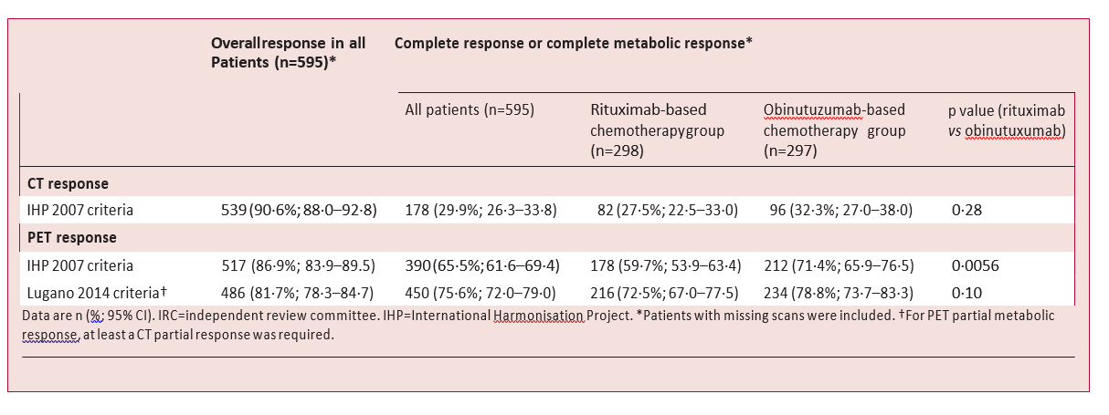

Table 3: IRC-assessed response at end of induction per treatment group.

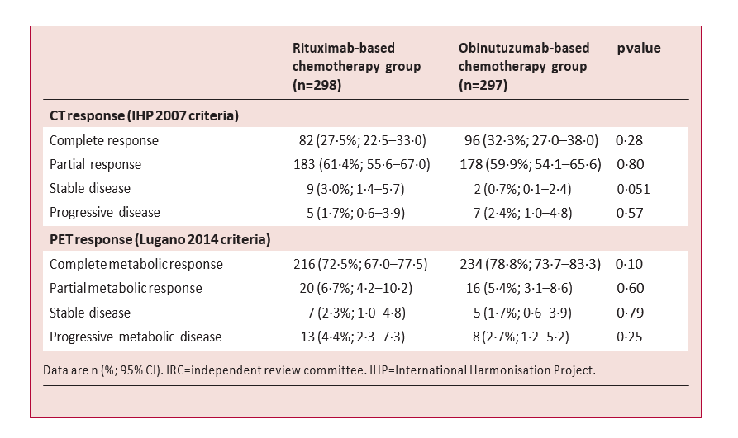

Table 4: Cox multivariate and univariate analyses for progression-free survival and overall survival in the landmark analysis populations.

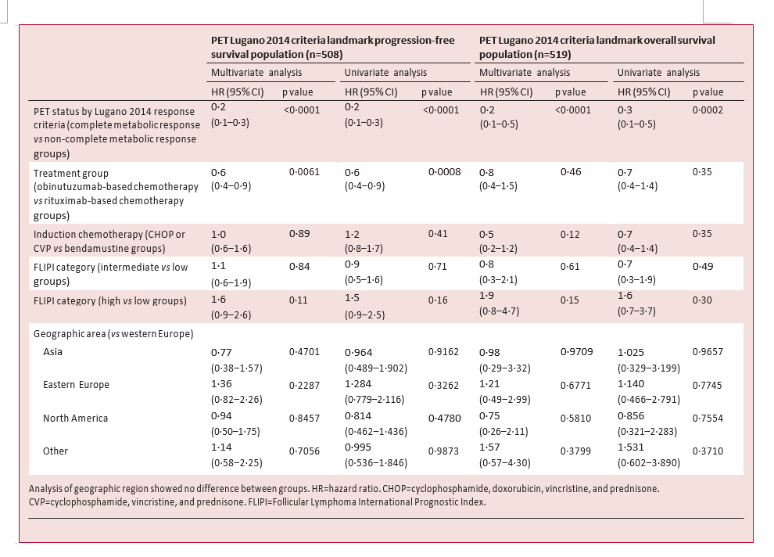

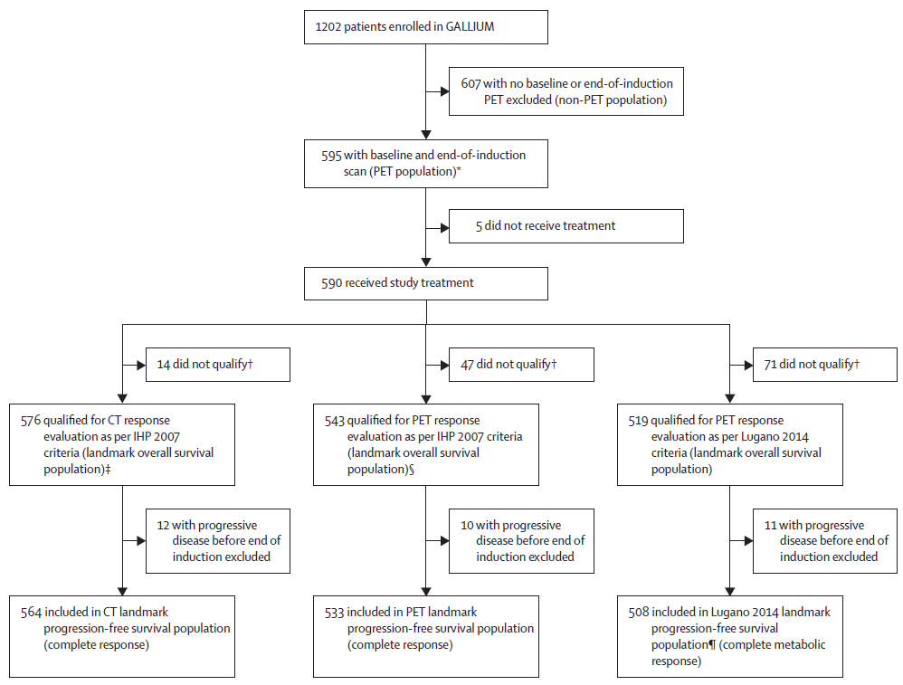

Figure 1: Study profile
IHP=International Harmonisation Project. IRC=independent review committee. *All patients with a baseline PET showing at least one PET-avid lesion were included in the PET population. †No valid IRC end-of-induction CT or end-of-induction visit after maintenance started. ‡Valid IRC end-of-induction CT or end-of-induction visit after maintenance started. §Valid IRC end-of-induction PET or end-of-induction visit after maintenance started. ¶Paired baseline and end-of-induction visit after maintenance started.

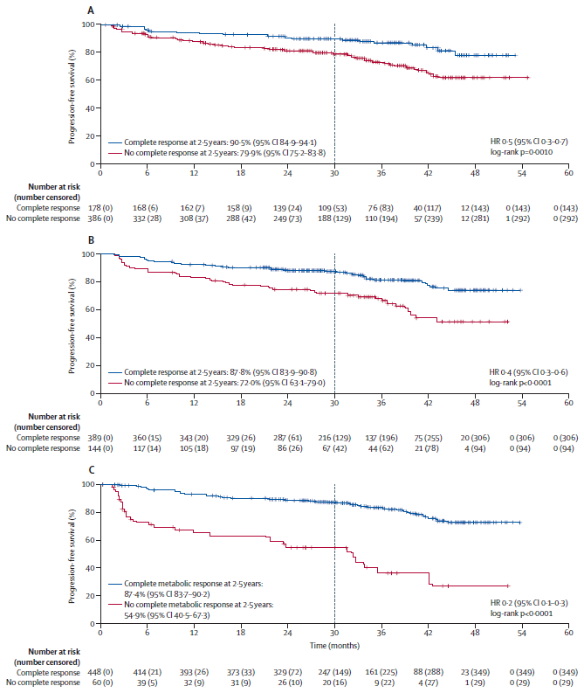

Figure 2: Landmark analysis of progression-free survival by IRC-assessed response status at end of induction therapy
Figure shows progression-free survival at 2·5 years (vertical dashed line) and 95% CIs by complete response status by CT as per IHP 2007 response criteria (A), complete response status by PET according to IHP 2007 criteria (B), and complete metabolic response status assessed by Lugano 2014 criteria (C). HR=hazard ratio. IHP=International Harmonisation Project. IRC=independent review committee.
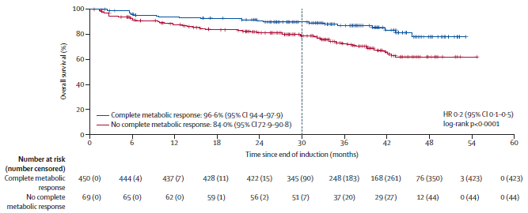
Figure 3: Landmark analysis of overall survival by IRC-assessed metabolic response status at end of induction therapy
2·5-year timepoint (vertical dashed line) and 95% CIs are shown. PET metabolic response was assessed as per Lugano 2014 response criteria. IRC=independent review committee. HR=hazard ratio.

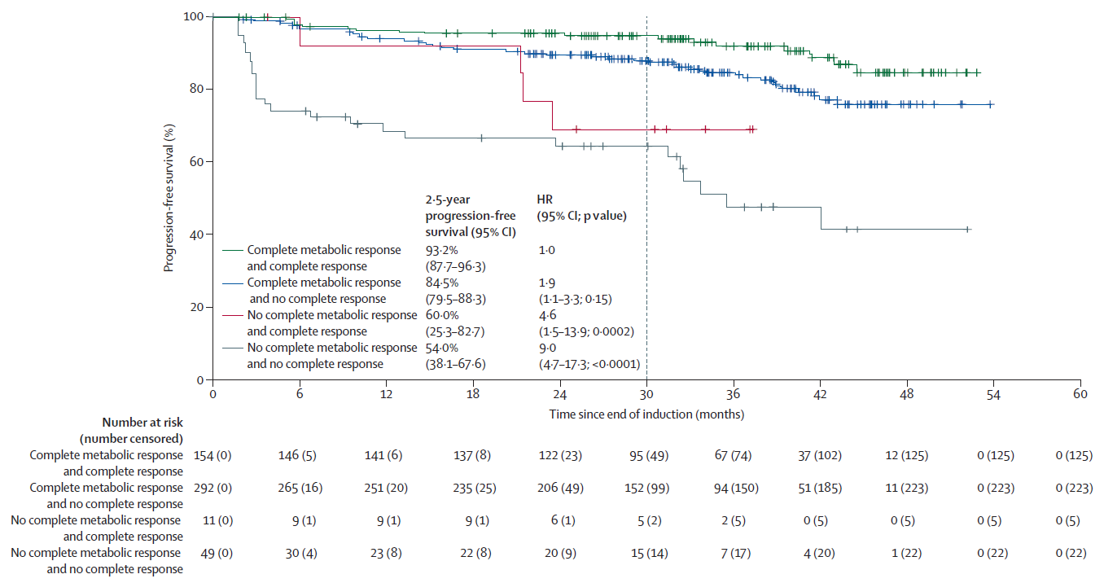

Figure 4: Landmark analysis of progression-free survival by IRC-assessed response status at end of induction therapy
2·5-year progression-free survival (vertical dashed line) and 95% CIs are shown. Complete responses were assessed on CT scans as per International Harmonisation Project 2007 response criteria and complete metabolic responses on PET scans as per Lugano 2014 response criteria. HR=hazard ratio. IRC=independent review committee.

