The Divergent Dynamics of Cities and Towns: Geographical Polarisation After Brexit

Will Jennings, University of Southampton
Gerry Stoker, University of Canberra and University of Southampton

Abstract
While the EU referendum vote put the political divide between Britain’s towns and cities into the spotlight, this divide is the product of long-term forces of social and economic change. In this chapter, we show how geographical polarisation has and continues to reshape British politics, in the diverging trends between those places that have experienced relative decline and those that have thrived. Not only do these changes have electoral consequences for the major parties in Westminster they pose particular challenges in terms of public policy.
The Brexit vote revealed a country divided by place, reflecting the diverging trajectories of economic development and politics taken by locations that have prospered in a globalised knowledge economy – predominantly cities – contrasted with places on the periphery, in towns and rural areas. The same dynamics are observed in the United States, where support for the Democratic Party is increasingly concentrated in urban areas while the Republicans have lately made electoral inroads across the rural and small-town America that is shrinking or stagnating in terms of its population and jobs – creating a polarized politics that is divided by demographics and geography. In Europe, there has been a clear spatial pattern in electoral support for populist parties and candidates. There are ways in which the British case has distinct features – due to its particular geography and institutions – but it largely reflects a wider trend where ‘place’ is increasingly consequential for political change and public policy.
While the EU referendum vote put the political divide between Britain’s towns and cities into the spotlight, this divide is the product of long-term forces of social and economic changes. In this chapter, we show how geographical polarisation has and continues to reshape British politics, in the diverging trends between those places that have experienced relative decline and those that have thrived. Not only do these changes have electoral consequences for the major parties in Westminster they pose particular challenges in terms of public policy.
Our argument proceeds as follows. Firstly, we demonstrate the trend towards geographical polarisation in voting behaviour, as the populations of big cities have voted in increasing numbers for Labour, while the residents of towns and rural areas increasingly have opted for the Conservatives. Secondly, we argue and show that this trend reflects economic as well as cultural forces: the schism between places reflects both divergent paths of demographic and economic change and related variation in the cultural and social outlooks of voters. Thirdly, we discuss the major challenge – amplified by Brexit – that this geographical polarisation presents for each of the parties as they seek to build electoral coalitions that reach beyond their existing strongholds. In concluding, we explore how the parties are presently responding to the place-based divergence of voting behaviour and policy problems.

Part I. The trend towards geographical polarisation
The thesis of bifurcated politics, or ‘Two Englands’, that we set out in previous work argues that social and economic change is fundamentally reshaping electoral politics in England and Wales (with Scotland having undergone a nationalism-based realignment in the past decade). Specifically, cities are becoming younger, more ethnically diverse, more educated and more socially liberal – while towns are aging, are less diverse, more nostalgic and more socially conservative. These dynamics, we argue, have led to tilting of Britain’s political axis towards the cosmopolitan-communitarian dimension, as both voters and places change, though a full-blown realignment has not yet materialised. These processes are being inexorably driven by a number of social and economic trends.
- Economic divergence through urban agglomeration: a defining feature of today’s global knowledge economy is the gravitational pull that clustering exerts on creation of jobs and economic activity – increasing the geographical divide between economic winners and losers. Cliffe argues that those places that have found a way to thrive typically ‘have some combination of transport links, housing, natural resources, skills, international connections, open-mindedness, existing industrial clusters and political can-do’. At the same time, other places have experienced the loss of skills, jobs and investment, degradation of infrastructure and the urban environment, and low levels of entrepreneurship, becoming locked into a long-term spiral of economic decline – often following deindustrialisation. These economic forces have left towns and cities on different tracks.
- Education: the ‘great divergence’ described by Moretti is a function both of urban agglomeration and geographical sorting of workers on educational lines. In Britain, expansion of higher education since the 1990s has led to growing numbers of younger people leaving home and, after university, seeking employment and settling in or near cities and large towns where skilled jobs are increasingly located. Those not in higher education face a similar dilemma as to whether to move to major towns or cities where jobs and business opportunities are clustered. Economic geographers have long discussed the London and South East ‘escalator’, which sucks in young people and deposits their exhausted middle-aged remains in outlying regions. Cities also tend to offer greater access to both ‘highbrow’ and ‘emerging’ cultural capital’, exerting another pull factor on younger populations attracted to the bright lights, entertainment and culture. Crucially, education is also an important predictor of political values, in particular growing social liberalism, and thus this demographic trend contributes to divides in the social outlooks of places as well as their demographics.
- Immigration and diversity: rising immigration, in particular since the 1990s, has seen an inflow of people – heavily concentrated in cities – who are younger and more economically active than average. Immigration on the scale experienced in recent decades has had transformative effects on the communities and places in different ways. It also has increasingly structured electoral politics. At the same time, areas of low ethnic diversity have tended to see higher levels of opposition to immigration and social change. Place provides the opportunity for regular engagement with others nearby and a process of social exchange encourages a search for shared ground and a common understanding. Cultural stereotypes come to define the understanding of place where people live. It defines who they are and what they represent. Other places and their populations become defined as different, alien and not to be trusted. Politicians can play on and reinforce this felt sense of difference to bolster their support and so place-based identity becomes politically weaponised and a symbol to drive a more polarized politics.
- Changing class structures and social ecology: For many years, deindustrialisation has driven the shrinking of Britain’s traditional working class, and erosion of its political representation. The perceived loss of social status among the white working class, most acutely felt in those places where communities were organised around large local industries/employers, is associated with support for the radical right. At the same time, the changing structure of economic activity has seen emergence of classes of ‘new service workers’ and others employed in precarious service industries (e.g. call centres, bar staff, fitness instructors) – with such jobs most concentrated in densely populated urban areas. Not only has the traditional working class declined, then, but the whole social class ecosystem has changed – as the old working class gradually dies out in the former manufacturing heartlands, being replaced by the new working class – the Uber drivers and call centre operators of today – most commonly located in the big cities.

In combination, these trends are gradually reshaping the geography of electoral politics – in transforming patterns of support for Labour and the Conservatives (as well as substantially impacting on spatial distribution of the Brexit vote). Figure 1 plots the Labour Party lead in terms of percentage vote share over the Conservatives for all parliamentary constituencies in England and Wales in the 1979 and 2017 general elections against the population density of the constituency. This reveals that urban density has over this nearly forty-year period increasingly become associated with voting behaviour. In 1979, Labour did slightly worse (and the Conservatives slightly better) in areas with low population density – for instance, rural areas and small towns, but electoral contests were more balanced at higher levels of density. By 2017, this pattern remained at low levels of urban density but Labour performed substantially better in areas with high population density, i.e. large towns and cities, as is indicated by the steeper slope of the line-of-best-fit. As population density rises by an additional person per hectare, so Labour’s lead over the Conservatives increased by about one percentage point (up until those constituencies with about 60 people per hectare, at which point the average lead levels off at around 40 per cent). This provides us evidence of a clear geographical polarisation of voting behaviour – as places change, so too does their politics (and the particular mix of problems facing policymakers).

Figure 1. Urban density and election results, England and Wales, 1979 and 2017
Part II. Economic decline, cultural values and geographic polarisation
So how does geographic polarisation lead to political difference? There has been substantial debate recently as to whether the rise of populism, and the Brexit vote, can be attributed to ‘cultural backlash’ (relating to anti-immigrant, racial resentment and authoritarian attitudes) or ‘economic insecurity’ (partly as a response to events of the global financial crisis and stagnation of the neoliberal growth model). We consider this a false dichotomy, and believe that place allows us to better understand the intersection of economic change and cultural values. Our central argument is that places that have experienced relative decline have become more ‘closed’ on the ‘open-closed’, or ‘cosmopolitan-communitarian’, dimension. At the same time, places that have enjoyed relative growth have become more socially liberal. It is difficult to disentangle the precise mechanisms that lead to different political outlooks in different locations. The main candidates are the processes of demographic change (leading to changes in the sorts of people living in different places), self-selection (leading people to move to places where there are people who share their values) and neighbourhood effects and social contact (leading people to adopt the values of other people in their area).
If fundamental changes in the economic trajectory of places are behind this emerging divide in contemporary politics, then it should be possible to relate decline affecting places to voting behaviour. To do this, we adapt a measure of relative decline (and growth) developed by Pike et al., which uses indicators for a range of population and employment factors to determine the relative rate of decline of constituencies in England and Wales compared to one another. These indicators are designed to capture the rate of population growth, economic activity and enterprise, the inflow of younger workers and students, and the level of education of the workforce – critical factors for success in the global economy. As such this measures the trajectory of particular places in terms of both human and economic capital.
In Figure 2 we plot this measure against change in the Labour and Conservative vote share between 2005 and 2017 (parliamentary boundaries were revised in 2010, and we have the notional results for 2005 but not before, meaning our analysis cannot go further back in time). It reveals a striking pattern where Labour has tended to make gains in areas subject to least decline and experience losses in areas of most decline. The reverse is observed for the Conservatives – who tend to do better in places that have experienced relative decline in recent years. While there is plenty of noise around the trend, the findings suggest that geographical polarisation is being influenced by the relative demographic and economic trajectory of different places.

Figure 2. Relative decline and Labour and Conservative vote, England and Wales, 2005 to 2017
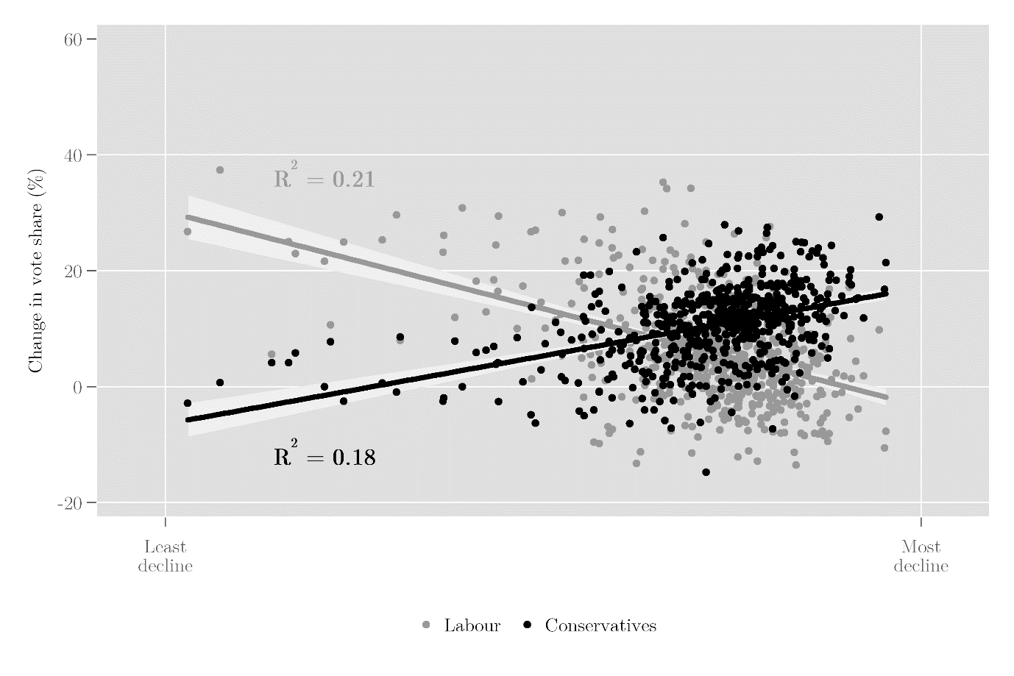
To what extent might decline also be associated with particular values or policy preferences? It is possible to consider the degree to which our measure of relative decline corresponds to the open-closed dimension. For this, we use estimates of constituency opinion produced by Hanretty et al. on the issues of immigration and same-sex marriage using survey data from the British Election Study online panel in 2014 – which are standardised and combined to capture ‘open-closed’ dimension (with higher values corresponding to more closed attitudes on these issues). Figure 3 plots how open or closed a given constituency is on these issues (on the y-axis) against the level of relative decline (on the x-axis). This again reveals a distinct pattern whereby areas that have experienced most decline are those that are most ‘closed’ (i.e. opposed to immigration and/or same-sex marriage) in their attitudes. Areas subject to least decline are most open (i.e. most socially liberal) on these issues. It seems, then, that the demographic and economic condition of places are linked to the particular cultural outlooks of their populations. (Although the observed relationship is correlational the temporal structure of our data makes it unlikely that open-closed attitudes would be a significant driver of decline over the preceding time period.)

Figure 3. Relative decline and open-closed opinions, England and Wales
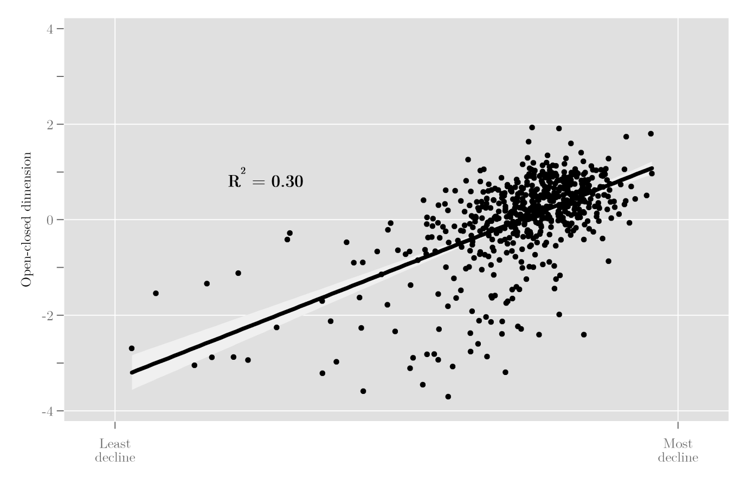

Part III. Implications for the future of British politics
These processes – of demographic and economic change – present both political disruption (the ‘revenge of places that don’t matter’) and major problems in terms of public policy (designing and funding the right social and economic policies for locations that have both different needs and resources). This schism between places forms a backdrop to post-Brexit politics over the next decade or so that the major parties will have to confront. Labour is struggling to sustain support in smaller towns while it piles up votes in metropolitan areas. The Conservatives on the other hand are losing in cities – among younger and more educated voters – and gaining in towns and rural areas. To build a broad electoral coalition, neither party can afford to ignore the places where they have been losing ground, nor wait for ‘demographic destiny’ to run its course. In short, our major national parties are facing tricky problems posed by this trend of geographical polarisation. How can they appeal across the divide to win votes? Can they design policy measures to deal with divergent issues faced in different locations? Should struggling places be written off, condemned to a process of inexorable decline, while a few lucky cities are selected as the engine of economic growth, or should the aim be a more equitable policy offer? Is it possible to craft political messages that speak to the distinctive local, regional and national identities of Britain’s towns and cities? The early indications are that the parties are struggling to meet the challenge both politically and in policy terms.
To frame the political challenge, it is helpful to recognise that the shifting voting patterns are a tilting of the axis, not a complete realignment. Labour retains support in towns and likewise the Conservatives retain some electoral presence in cities. The rise of nationalism outside England has added new dimensions to Britain’s electoral arithmetic and in Scotland has resulted in distinct party politics – with the SNP landslide in 2015 breaking Labour’s long-held dominance of Scottish seats in Westminster. The drop in the vote share of other parties in England in the general election of 2017 marked a seeming return to the old days of two-party politics. However, a re-emergence of support for an alternative political force beyond the two main parties in England cannot be ruled out because of the continued persistence of strong negativity in public opinion towards mainstream parties and politics. Voters may yet be receptive to a “new” offering by challenger parties or breakaways – especially in the wake of any Brexit-related chaos or perceived backsliding on the referendum. Our focus in on the prospects of Labour and the Conservatives but they do not possess a guaranteed monopoly over the future of British politics.
For the two parties the dilemma is whether to adopt a minimalist or maximalist approach to electoral coalition building. Should a party look to consolidate its current vote and make just enough gains to win a parliamentary majority or should it seek a radical transformation that extends its appeal outside its base or ‘core vote’. When parties are popular they are more able to reach outside their comfort zone. At the Labour Party conference in 1999, Tony Blair declared ‘the class war is over’. That he was able to do so reflected the impregnable position of Labour in the polls and also that the social base of the party’s electoral coalition was slowly changing, masked by the success of the New Labour electoral machine. Neither party today is in a commanding position that would allow it to make such a claim, to steal the clothes of its opponents without risk of alienating its core vote. Electoral realignments come with substantial risks and transition costs for parties, not least as newer supporters tend to have weaker partisan attachments (the dramatic rise and fall of the Liberal Democrats between 2010 and 2015 serving as a good example of the potential fickleness of voters).
A further complicating factor beyond the difficulties of securing a convincing parliamentary majority in light of the geographical polarisation of electoral politics is the unprecedented level of public disaffection and cynicism about politics and politicians in Britain. In The Good Politician, we use survey data and diaries from Mass Observation to show that negativity towards political elites and the practices of politics is more widespread and more intense that in any period since 1945. Brexit has further polarised the electorate through the emergence of new identities – of ‘Leavers’ and ‘Remainers’. Parties must therefore find a way to widen their electoral coalitions at a time when public trust is at an all-time low and a new cross-cutting cleavage means that attempts to win over some groups risk alienating others.
For the Conservatives, the rhetorical ambition of the May government – launched with May’s ‘burning injustices’ speech on the steps of Downing Street on 13 July 2016 – was to construct a maximalist coalition that reached out to Labour’s Brexit-voting heartlands (the ‘tanks on Labour’s lawn’ strategy). This maximalist agenda survived until the disastrous 2017 general election, where results in constituencies like Canterbury and Kensington & Chelsea revealed the perils of this strategy; and even before then there had been U-turns on new policies like energy price caps and workers on company boards. Since then, the Conservatives have stuck to a more minimalist approach – with their attention dominated by Brexit and internal party wrangling over how hard or soft Brexit will be. Burnt by the experience of trying to appeal far beyond core supporters, the Conservatives will likely make token efforts to attract supporters from declining towns and may offer up occasional policies (such as relating to the environment) aimed at the social liberalism of city dwellers. Fundamentally, however, under May’s leadership the focus is on delivering a pragmatic Brexit, maintaining some semblance of party discipline, shoring up the party’s core vote and avoiding economic meltdown in the aftermath of the UK leaving the European Union. Only failure on one of these fronts, and a leadership change, is likely to open up the prospects of a more maximalist coalition strategy again.
For Labour, the unexpectedly good result in the 2017 general election has also locked the party into a minimalist strategy as well. This continues to exploit Corbyn’s projected image of authenticity and economic populism (e.g. nationalisations, attacks on offshore tax havens), combined with a critique of austerity, which has particular appeal to voters in cities. The party also has been helped by its association with a softer version of Brexit (although its position remains tortuously ambiguous). Again, it would appear that only a significant electoral failure and the election of a new party leader would create conditions ripe for a more maximalist strategy that was able to recover losses in places that have drifted away from Labour.
A major problem in developing a more maximalist strategy is that neither of the parties appears comfortable in developing policy agendas that resonate with different parts of the country or speaks a language that reconciles identity politics and social liberalism. In many ways this is not surprising given the high degree of centralisation of Britain’s political system. Yet if our analysis is correct, and profound economic and social forces are generating divergent conditions in different geographical locations, then a differentiated policy response is required with a politics to match. Different parts of the country face distinct sets of policy problems. Areas that have enjoyed relative growth tend to face demands associated with that, such as in terms of housing costs, congestion, pollution and lack of educational and other infrastructure. For areas that have experienced relative decline, the issue is how to develop innovative responses that manage to exploit a new niche for economic dynamism, but at the same time meet the health and social care needs of an ageing and relatively unhealthy population. Economic, planning, housing and social needs interventions need to be tuned to the circumstances faced in different locations but, despite recent devolution initiatives, our current system of governance is ill-equipped to deal with that prospect. Austerity measures since 2010 have greatly undermined capacity of local government across the board and cuts are continuing to impact. Failure to reform local government finance has left a local taxation system that is not progressive and not robust enough to garner the resources required in areas of either growth or decline. Yet if anything, what appetite there was for devolution and decentralisation has weakened with the departure of Osborne from the Conservative government and the rise of a Corbyn-led Labour policy platform focused more on rekindling state direction of the economy.
Our main political parties are stuck in minimalist positions, focused on shoring up their core vote and managing internal party conflicts, unable to articulate a unifying vision in terms of policy or identity. Yet our analysis of the spatial political economy of 21st Century Britain lends support to the idea that what is needed is the vision and leadership to deliver a more maximalist position that offers a very different type of governance and policy dynamic. In the present context – of a politics that is divided, parties and leaderships that are becalmed, a state that is under strain, and an electorate that is discontented – such an outcome seems unlikely but not impossible. The geographical polarisation which now lies at the heart of British politics presents opportunities as well as challenges. These will be reaped by the party that is best able to offer hope for places of relative decline and at the same time can articulate a political message that is inclusive in terms of identity – bridging the divergent outlooks of the Two Englands.
As the moment of Brexit Day in 2019 approaches, we are faced with a situation where – no matter the outcome of the final negotiations – there is no straightforward path for either of the two main parties in Westminster to secure a large parliamentary majority from a divided and disenchanted electorate. That is even before any disappointment felt by voters regarding the precise form and delivery of Brexit. The parties are in an even more invidious position when it comes to the task of designing policy responses that address the disparate social and economic challenges confronting different parts of the country.
If we are correct about the new dynamics driving British politics, it will eventually reach a breaking point: based on their actions since 23rd June 2016, both the Conservatives and Labour are struggling to reach a position on Brexit that is viable either in terms of satisfying their supporters or in terms of securing a deal with the EU. At the moment, both party leaderships are engaged in dangerous fantasies of the sunlit uplands that await for British politics after Brexit. On Brexit, neither party is being straight with their supporters. The Conservatives remain in thrall to their Eurosceptic wing, not facing up to the compromises that need to be made, while Labour is offering the meekest of opposition on Brexit, despite the majority of their voters supporting Remain. Neither party seems able to tackle the pressing challenges facing the country, instead offering a sad mix of infighting and cynical posturing. Given the tide of change in electoral politics we identify, it may take time for the parties to adjust their strategies, but time may be running out for a political class who appear so dramatically out of touch.

W. Jennings and G. Stoker, ‘The Bifurcation of Politics: Two Englands’, Political Quarterly, vol. 87, no, 3, 2016, pp. 372-82; W. Jennings and G. Stoker, ‘Tilting towards the cosmopolitan axis? Political change in England and the 2017 general election’, Political Quarterly, vol. 88, no. 3, 2017, pp. 359-369; W. Jennings, A. Bua, R. Laurence and W. Brett. Cities and Towns: the 2017 General Election and the Social Divisions of Place. London: New Economics Foundation, 2017.
E.g. A. Rodríguez-Pose, ‘The revenge of the places that don’t matter (and what to do about it)’, Cambridge Journal of Regions, Economy and Society, vol. 11, no. 1, 2018, pp. 189-209.
Jennings and Stoker, ‘The Bifurcation of Politics’, ‘Tilting towards the cosmopolitan axis?’.
S.B. Hobolt, ‘Brexit and the 2017 UK General Election’, JCMS: Journal of Common Market Studies, 2018.
P.R. Krugman, Geography and Trade, 1991, Boston: MIT Press.
J. Cliffe, ‘England’s cosmopolitan future: Clacton versus Cambridge’, The Economist, September 6th, 2014.
C. Martinez-Fernandez, I. Audirac, S. Fol, and E. Cunningham-Sabot, ‘Shrinking Cities: Urban Challenges of Globalization’, International Journal of Urban and Regional Research, vol. 36, no. 2, 2012, pp.213-225.
E. Moretti, The New Geography of Jobs, London, 2012.
P. Surridge, ‘Education and Liberalism: Pursuing the Link’, Oxford Review of Education, vol. 42, no. 2, 2016, pp. 146-164.
A.F.Heath, S.D.Fisher, G. Rosenblatt, D.Sanders, and M.Sobolewska, The Political Integration of Ethnic Minorities in Britain, Oxford, 2013.
J. Gest, The New Minority White Working Class Politics in an Age of Immigration and Inequality, 2016, Oxford: Oxford University Press.
R. Inglehart and P. Norris, ‘Trump and the populist authoritarian parties: the silent revolution in reverse’, Perspectives on Politics, vol. 15, no. 2, 2017, pp. 443-454.
A. Pike, D. MacKinnon, M. Coombes, T. Champion, D. Bradley, A. Cumbers, L. Robson and C. Wymer, Uneven growth: tackling city decline, 2016, York: Joseph Rowntree Foundation.
To construct this measure values for each of the following indicators are first standardised (i.e. rescaled by subtracting the mean ($μ$) from the observed value ($x$) and dividing by the standard deviation ($σ$): $z=\frac{(x-μ)}{σ}$ ) across all 573 parliamentary constituencies in England and Wales: - Change in the rate of economic activity (%), 2001 to 2011. - Change in the number of businesses (all firms), 2010 to 2016. - Change in the number of jobs, 2009 to 2015. - Change in total population, 2001 to 2011. - Change in net inward migration of 15–19 year olds, 2001 to 2011. - Change in proportion of population with a degree, 2001 to 2011. The final index takes the average of the six standardised indicators for each constituency and is then inverted so that higher values indicate greater decline. (Pike et al.’s original measure uses ranks of the constituencies on each of the indicators, whereas we standardise the indicators to provide a more fine-grained measure of relative decline.)
C. Hanretty, B. Lauderdale, and N. Vivyan, ‘Dyadic Representation in a Westminster System.’ Legislative Studies Quarterly, vol. 42, no. 2, 2017, pp. 235-267.
Rodríguez-Pose, ‘The revenge of the places that don’t matter (and what to do about it)’.
W. Jennings, A. Lent and G. Stoker, Place-based Policymaking After Brexit, 2017, London: New Local Government Network.
J. Green and W. Jennings, ‘Party Reputations and Policy Priorities: How Issue Ownership Shapes Executive and Legislative Agendas’, British Journal of Political Science, 2017, pp.1-24. doi:10.1017/S0007123416000636
N. Clarke, W. Jennings, J. Moss and G. Stoker, The Good Politician: Folk Theories, Political Interaction, and the Rise of Anti-Politics, 2018, Cambridge: Cambridge University Press.

