TiO₂ nanopowder as a high rate, long cycle life electrode in aqueous aluminium electrolyte.
A.W. Holland, R. McKerracher, A. Cruden and R.G.A. Wills
Energy Technologies Research Group, University of Southampton, Highfield, Southampton, SO171BJ. United Kingdom.

Abstract
TiO₂ nanopowders have been used to manufacture negative electrodes and their cycle life, efficiency and rate capability investigated for use in aqueous Al-ion cells. A high efficiency of 99% was measured when an electrode was cycled at 7.2 A g⁻¹ (360C) in 1 mol dm⁻³ AlCl₃/1 mol dm⁻³ KCl and a discharge capacity of 20 mA h g⁻¹ could be maintained for nearly 4000 cycles at 100 C. Also explored is the low coulombic efficiency seen for TiO₂ in previous aqueous Al-ion publications, while mass loading and electrolyte O₂ content affect coulombic efficiency. The high coulombic efficiency and charge/discharge current make these electrodes suitable for use in charge storage devices targeted at high power/low capacity applications, such as capturing bursts of power during regenerative breaking.

Keywords:
Aluminium ion battery, TiO₂

Corresponding author:
Dr Richard Wills
rgaw@soton.ac.uk
Energy Technologies Research Group, University of Southampton, Highfield, Southampton, SO171BJ. United Kingdom.

1.0 Introduction
The aqueous aluminium-ion (Al-ion) cell is a recent addition to the more widely investigated aqueous metal-ion chemistries [1-4]. The use of aqueous electrolytes promise improvements to safety, cost and power capability compared to Li-ion batteries which employ highly flammable organic electrolytes. Anatase TiO₂, copper-hexacyanoferrate (CuHCF) and xerogel-V₂O₅ have been investigated as potential intercalation electrodes for Al³⁺ from an aqueous electrolyte, with some promising characteristics having been reported, especially for anatase TiO₂ [5-11]. Cyclic voltammetry (CV) scans of several TiO₂ electrodes suggest an insertion redox mechanism [12]. He et al were able to achieve a capacity of 271 mA h g⁻¹ at a specific current of 50 mA g⁻¹ with black TiO₂ nanoleaves, while TiO₂ nanospheres produced a capacity of 180 mA h g⁻¹ at a low specific current of 50.25 mA g⁻¹. However, given the domination of Li-ion chemistries for high energy density (specific energy) applications, more important metrics for aqueous-ion cells are cycle life, efficiency and rate capability. Improving these characteristics would allow them to be competitive for a number high power applications such as regenerative braking or high power grid services [13]. Despite this, only limited focus has been given to cycle life, efficiency and rate capability in the recent aqueous Al-ion literature. Only 30 cycles are presented by He et al and Kazazi et al for their black TiO₂ nanoleaves and TiO₂ nanospheres respectively (although He et al show 300 cycles from black nanoleaves in their supplementary material) [6, 10]. Cycling data for TiO₂ nanotubes were presented up to cycle 13 by Liu et al [5]. Recently, a graphene enhanced TiO₂ electrode was shown to produce a capacity between 10-25 mA h g⁻¹ at a current density of 6.25 A g⁻¹. However, only 125 cycles were possible and coulombic efficiency was observed to be very low at approximately 50% (estimated from figures) [11]. Similarly, the charge discharge profiles observed for the nanospheres and nanotubes show low coulombic efficiencies of around 80-85%. The reason for the low efficiency of TiO₂ in aqueous Al³⁺ electrolyte has yet to be explicitly mentioned but are suggested here to be due to possible:
- Oxidation of Ti³⁺ due to dissolved O₂ in electrolyte
- H₂ evolution
- Irreversible reduction of Ti⁴⁺ to Ti²⁺ during charge phases
This paper therefore focusses on high rate capability and extended cycle life as the primary metrics of importance for aqueous Al-ion electrodes.

2.0 Experimental
2.1 Electrode preparation and electrochemical measurements
Materials and electrodes were prepared as previosuly reported [12]. Inks for the negative electrode were produced by mixing 87.5 wt% TiO₂ nanopowder, 5 wt% carbon black and 7.5 wt% Nafion in propanol and water. The inks contained either TiO₂ with a nominal particle size of 25 nm or 5 nm, herein named 25nm-TiO₂ or 5nm-TiO₂, purchased from Sigma Aldrich and US research nanomaterials respectively. For both compositions, a uniform ink was achieved using a Silverson shear blade mixer at 5000 rpm for 30 minutes. The inks were coated onto SIGRACELL PV15 carbon polymer (natural graphite and flouropolymer composite), manufactured by SGL used to ensure a corrosion resistant current collector, and allowed to dry overnight. A variety of mass loadings were tested up to a maximum of 6.7 mg cm⁻². Electrodes were then studied in 3-electrode cells in 1 mol dm⁻³ AlCl₃/ 1 mol dm⁻³ KCl, unless otherwise stated, using a saturated calomel electrode (SCE) as reference and an oversized CuHCF electrode used to provide a reversible counter electrode to minimise O₂ evolution. Electrolytes were sparged with dry N₂ (99.9%) for a minimum of 1 hour using a porous frit. Specific capacities and currents were calculated based on the mass of active material, including that of carbon black conductive additive and Nafion binder. Measurements were taken using a Solartron battery analyser. A 10C C-rate corresponds to 0.158 A g⁻¹ and 0.20 A g⁻¹ for 25nm-TiO₂ and 5nm-TiO₂ respectively.

2.2 Characterisation
X-ray diffraction (XRD) patterns were obtained using a Bruker D2 Phaser powder diffaractomoter with Cu Kα radiation (average wavelength = 1.5418 Å). Powder was obtained from the composite electrodes described in the previous section with 2800 data points collected in the 2θ range 20° to 80°, a 0.0202572° increment and 0.4 s time step. d-spacings were obtained using Bragg’s law with the (200) and (004) peaks used to calculate the unit cell parameters, $a$ and $c$, of tetragonal anatase TiO₂ using equation 1.

$$\frac{1}{d^{2}}= \frac{h^{2}+k^{2}}{a^{2}}+\frac{l^{2}}{c^{2}}$$
…(1)

A scanning electron microscope was operated at 15 kV to obtain images of the composite TiO₂ electrodes before and after cycling. The cycled electrode was washed in de-ionised water and allowed to dry before analysis via SEM or XRD.
3.0 Results and Discussion
A selection of mono- and multi-valent ions were assessed for their effect on TiO₂ electrode capacity. Separate 25nm-TiO₂ electrodes were immersed in 1 mol dm⁻³ KCl, NaCl, MgCl₂ and AlCl₃ and charged to a minimum of -1.10 V vs SCE at a specific current of 945 mA g⁻¹. The resulting capacities, compared to ion charge and charge density, can be seen in Table 1. With 1 mol dm⁻³ AlCl₃ a capacity of 15.6 mA h g⁻¹ was achieved. 1 mol dm⁻³ MgCl₂ produced the second highest capacity but was only 2.97 mA h g⁻¹ with a small linear increase in capacity in the order Mg²⁺ > Na⁺ > K⁺. These results demonstrate that an appreciable charge storage machanism is reliant on the presence of AlCl₃.

Table 1. Discharge capacity of composition 1 immersed in chloride salt electrolytes containing cations with differing ionic radii, charges and charge densities: K⁺, Na⁺, Mg²⁺, Al³⁺. Only 1 mol dm⁻³ AlCl₃ resulted in an appreciable charge storage capacity from the TiO₂ electrode.
Ion | Charge (e) | Ionic radius (pm) | Discharge capacity (mA h g⁻¹)
K⁺ | +1 | 152 | 1.57
Na⁺ | +1 | 116 | 1.76
Mg²⁺ | +2 | 86 | 2.97
Al³⁺ | +3 | 67.5 | 15.6

Previous studies on LiTiPO₄ have shown a marked improvement in stability with the removal of O₂ from electrolyte with poor stability attributed to the reoxidation of Ti³⁺ by dissolved O₂ [14]. As such, a 25nm-TiO₂ electrode (25 nm) was galvanostatically cycled at 20C (316.7 mA g⁻¹ for 180 s) in 1 mol dm⁻³ AlCl₃/1 mol dm⁻³ KCl electrolyte in the presence and absence of dissolved O₂ in the electrolyte. Figure 1 presents the capacity vs. electrode potential for electrodes cycled in de-oxygenated and aerated electrolytes. During the charge phase, the two potential/capacity profile for both de-oxygenated and aerated electrolytes are broadly similar. The potential starts at circa 0.35 V vs. SCE at zero state of charge and rapidly becomes more ngative towards -0.6 V vs. SCE at circa 1 mA h g⁻¹ before the gradient flattens and steadily approaches -0.98 V vs. SCE at 16 mA h g⁻¹. During the discharge process, however, there is a marked diffence bewteen the aerated and de-oxygenated electrolytes. In the aerated electrolyte, the voltage is circa 20 mV lower at the start of discharge compared to the de-oxygenated electrolyte. This difference widens to 100 mV after 10 mA h g⁻¹ discharge, after which the voltage rapidly decays. The coulombic efficiency therefore increases from 77.2% to 95.1% at 20C in aerated to de-oxygenated 1 mol dm⁻³ AlCl₃ containing electrolyte.
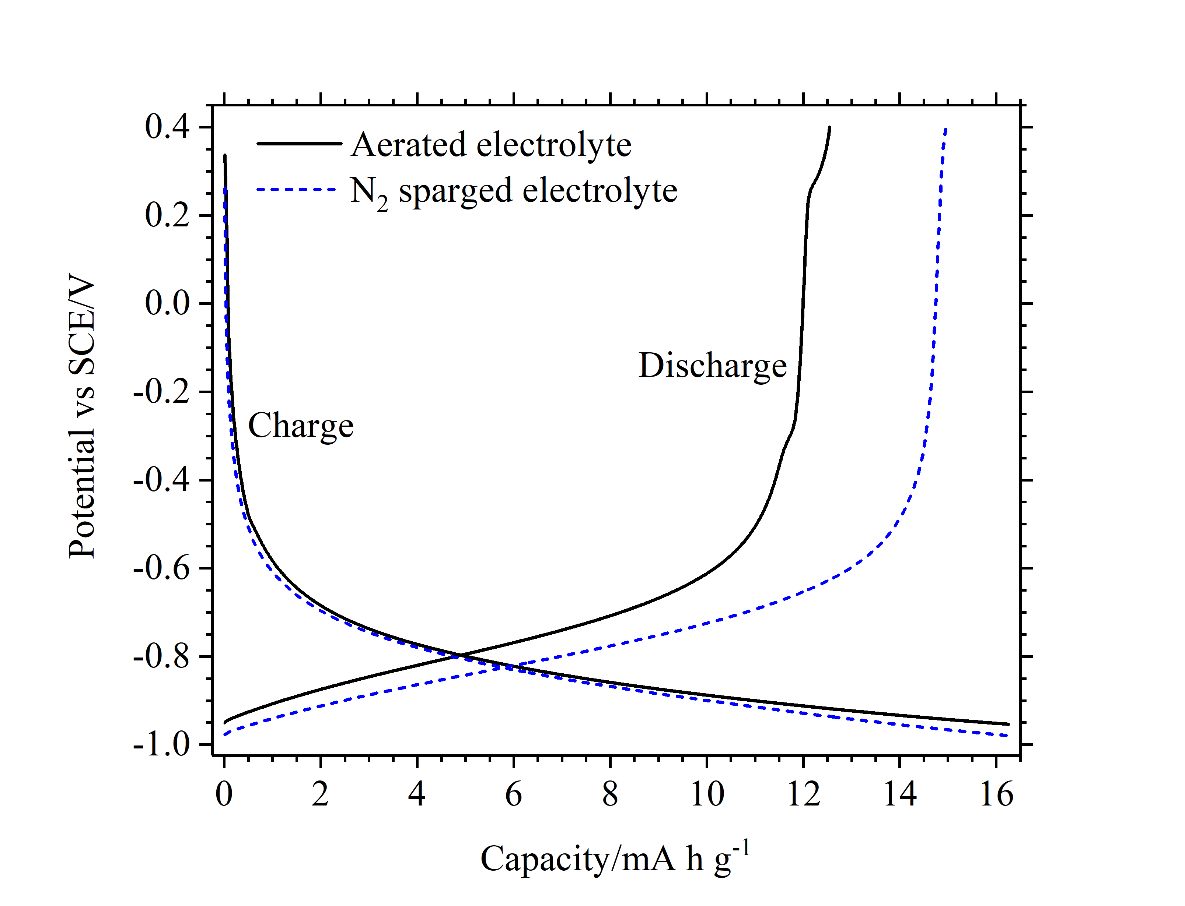
Figure 1. Voltage profile of a TiO₂ (25 nm) electrode in a 3-electrode cell in de-oxygenated electrolyte and electrolyte exposed to air for over 24h. Cycles were performed at 20C.

A 25nm-TiO₂ (figure 2a) and 5nm-TiO₂ (figure 2b) electrode were then galvanostatically cycled at various C-rates in 1 mol dm⁻³ AlCl₃/ 1 mol dm⁻³ KCl. 10 cycles were performed at each C-rate. Figure 2 shows the discharge capacity and coulombic efficiency for both electrodes as a function of C-rate. 25nm-TiO₂ has a coulombic efficiency of 89.4% at 10C but increases to 98.5% at 90C with a steady increase to 99.4% at 180C. Discharge capacity increases from 14.4 mA h g⁻¹ at 10C to 15.8 mA h g⁻¹ at 180C. For the 5nm-TiO₂ electrode, a coulombic efficiency and discharge capacity of 79.9% and 15.8 mA h g⁻¹ are achieved at 5C. At 360C, which corresponds to a high specific current of 7.2 A g⁻¹, coulombic efficiency and discharge capacity remain at 98.9% and 19.8 mA h g⁻¹ respectively. Figure 2 shows discharge capacity and therefore coulombic efficiency increasing with C-rate. Since this efficiency approahes 100% at high C-rates, H₂ evolution is likely ruled out as the dominant cause for <100% coulombic efficiency, despite the electrodes being operated outside the thermodynamic potential stability window of water. This is likely due to the high charge density of Al³⁺ resulting in a strong water solvation shell limiting water decomposition. Instead, given that lower C-rates correspond to longer charge-discharge times, a time-dependent self-discharge process is suggested to be at least partially responsible for the <100% coulombic efficiencies measured. This could also account for the higher discharge capacities measured at higher C-rates. Further work is currently being carried out in order to analyse the processes responsible for the low coulombic efficiency.
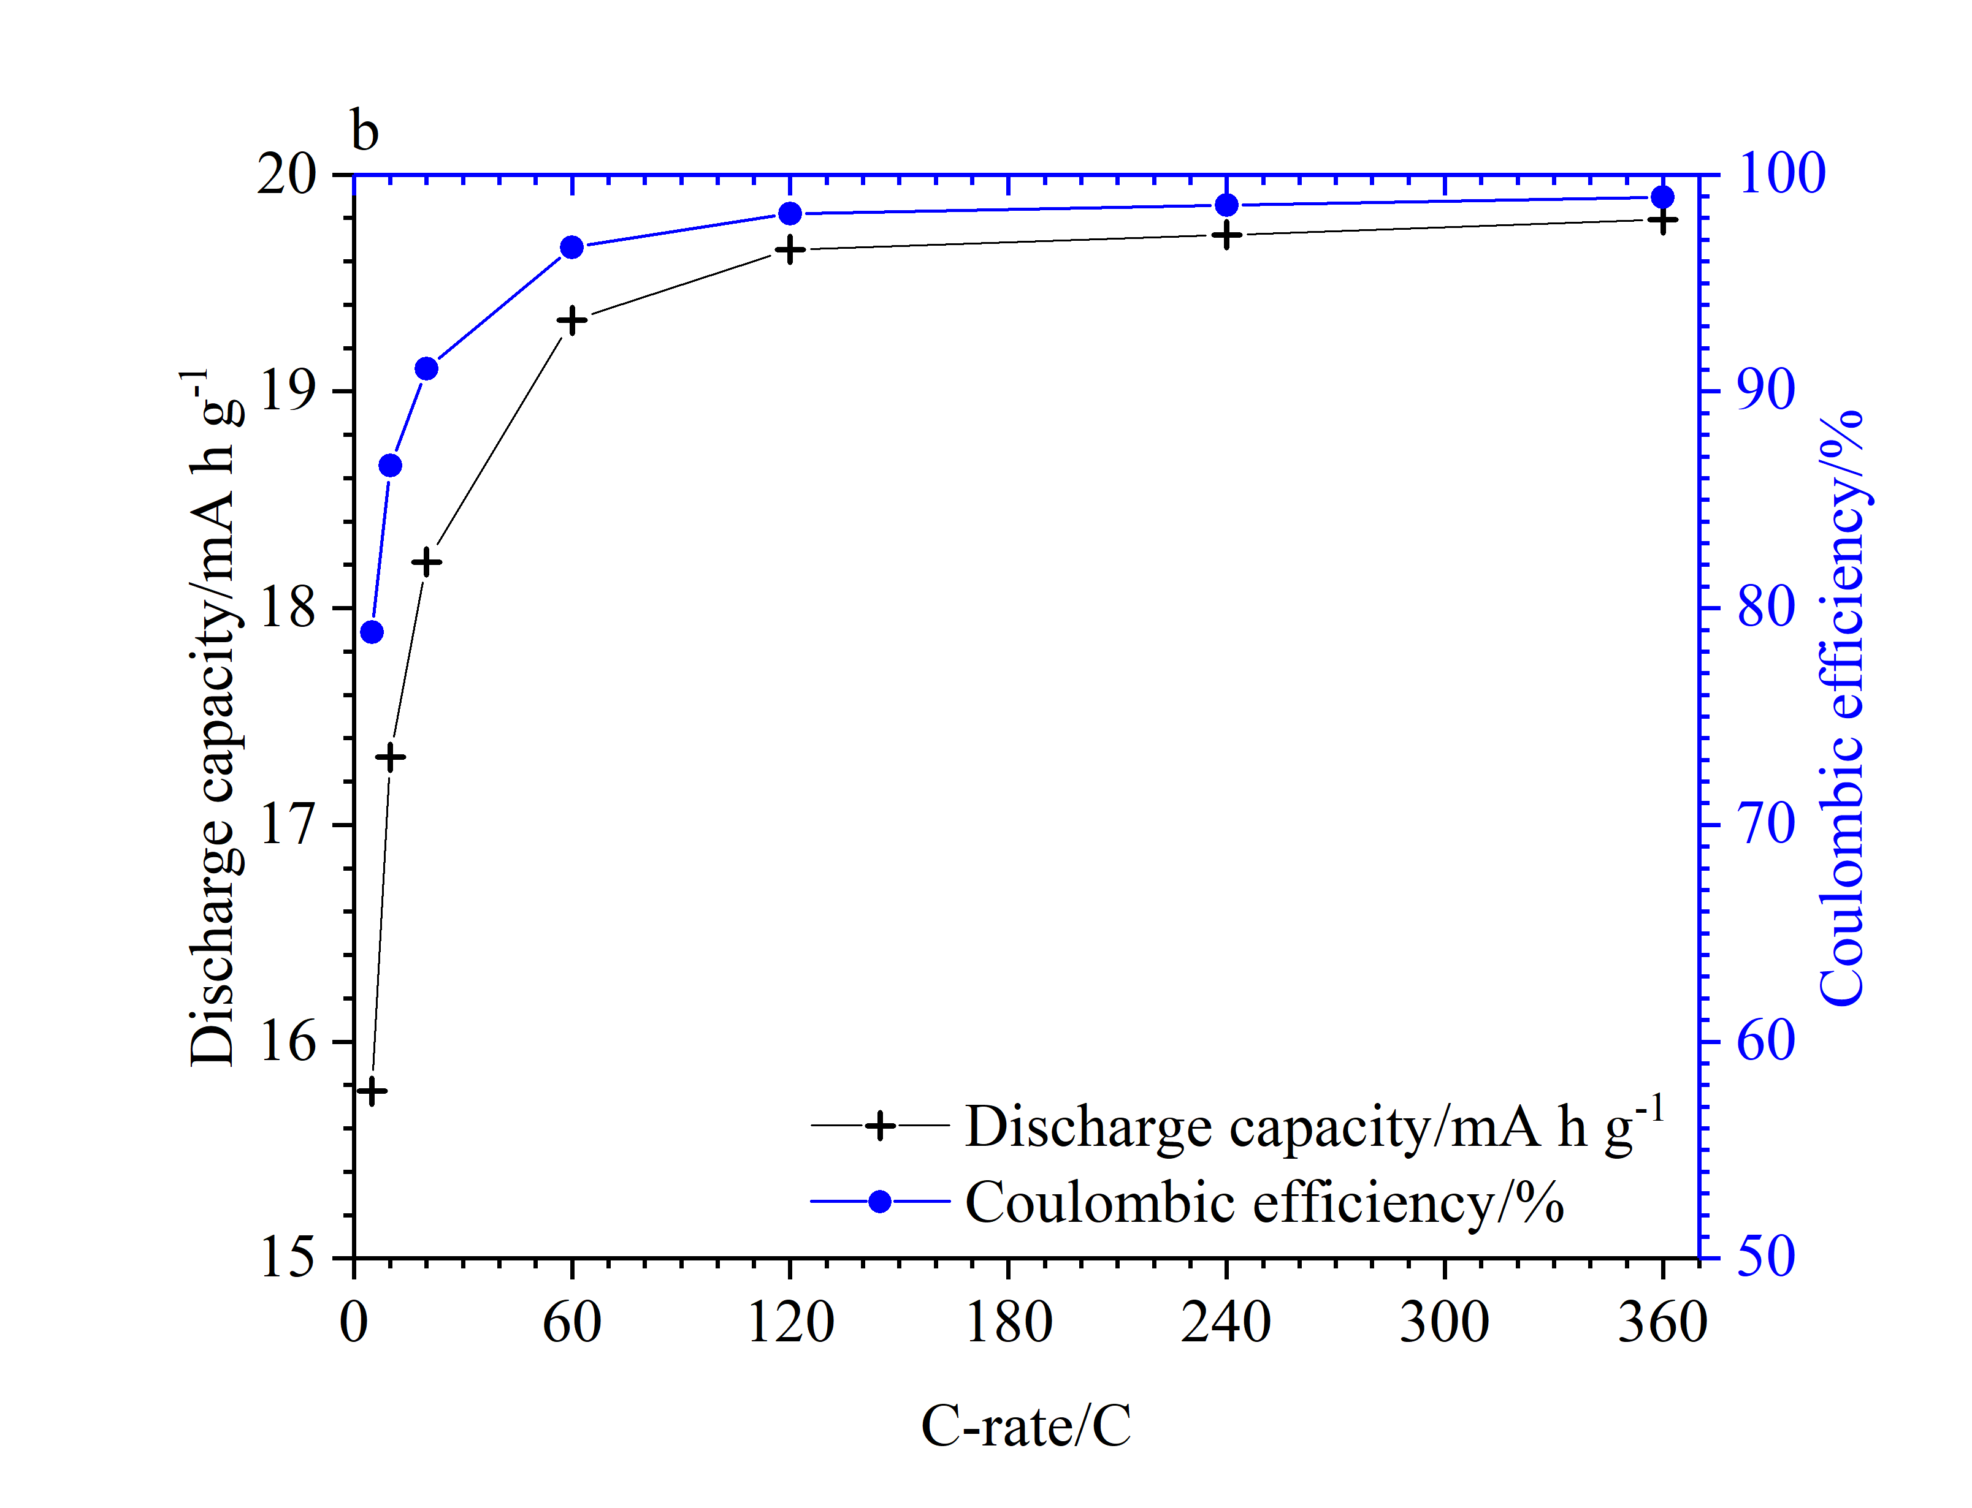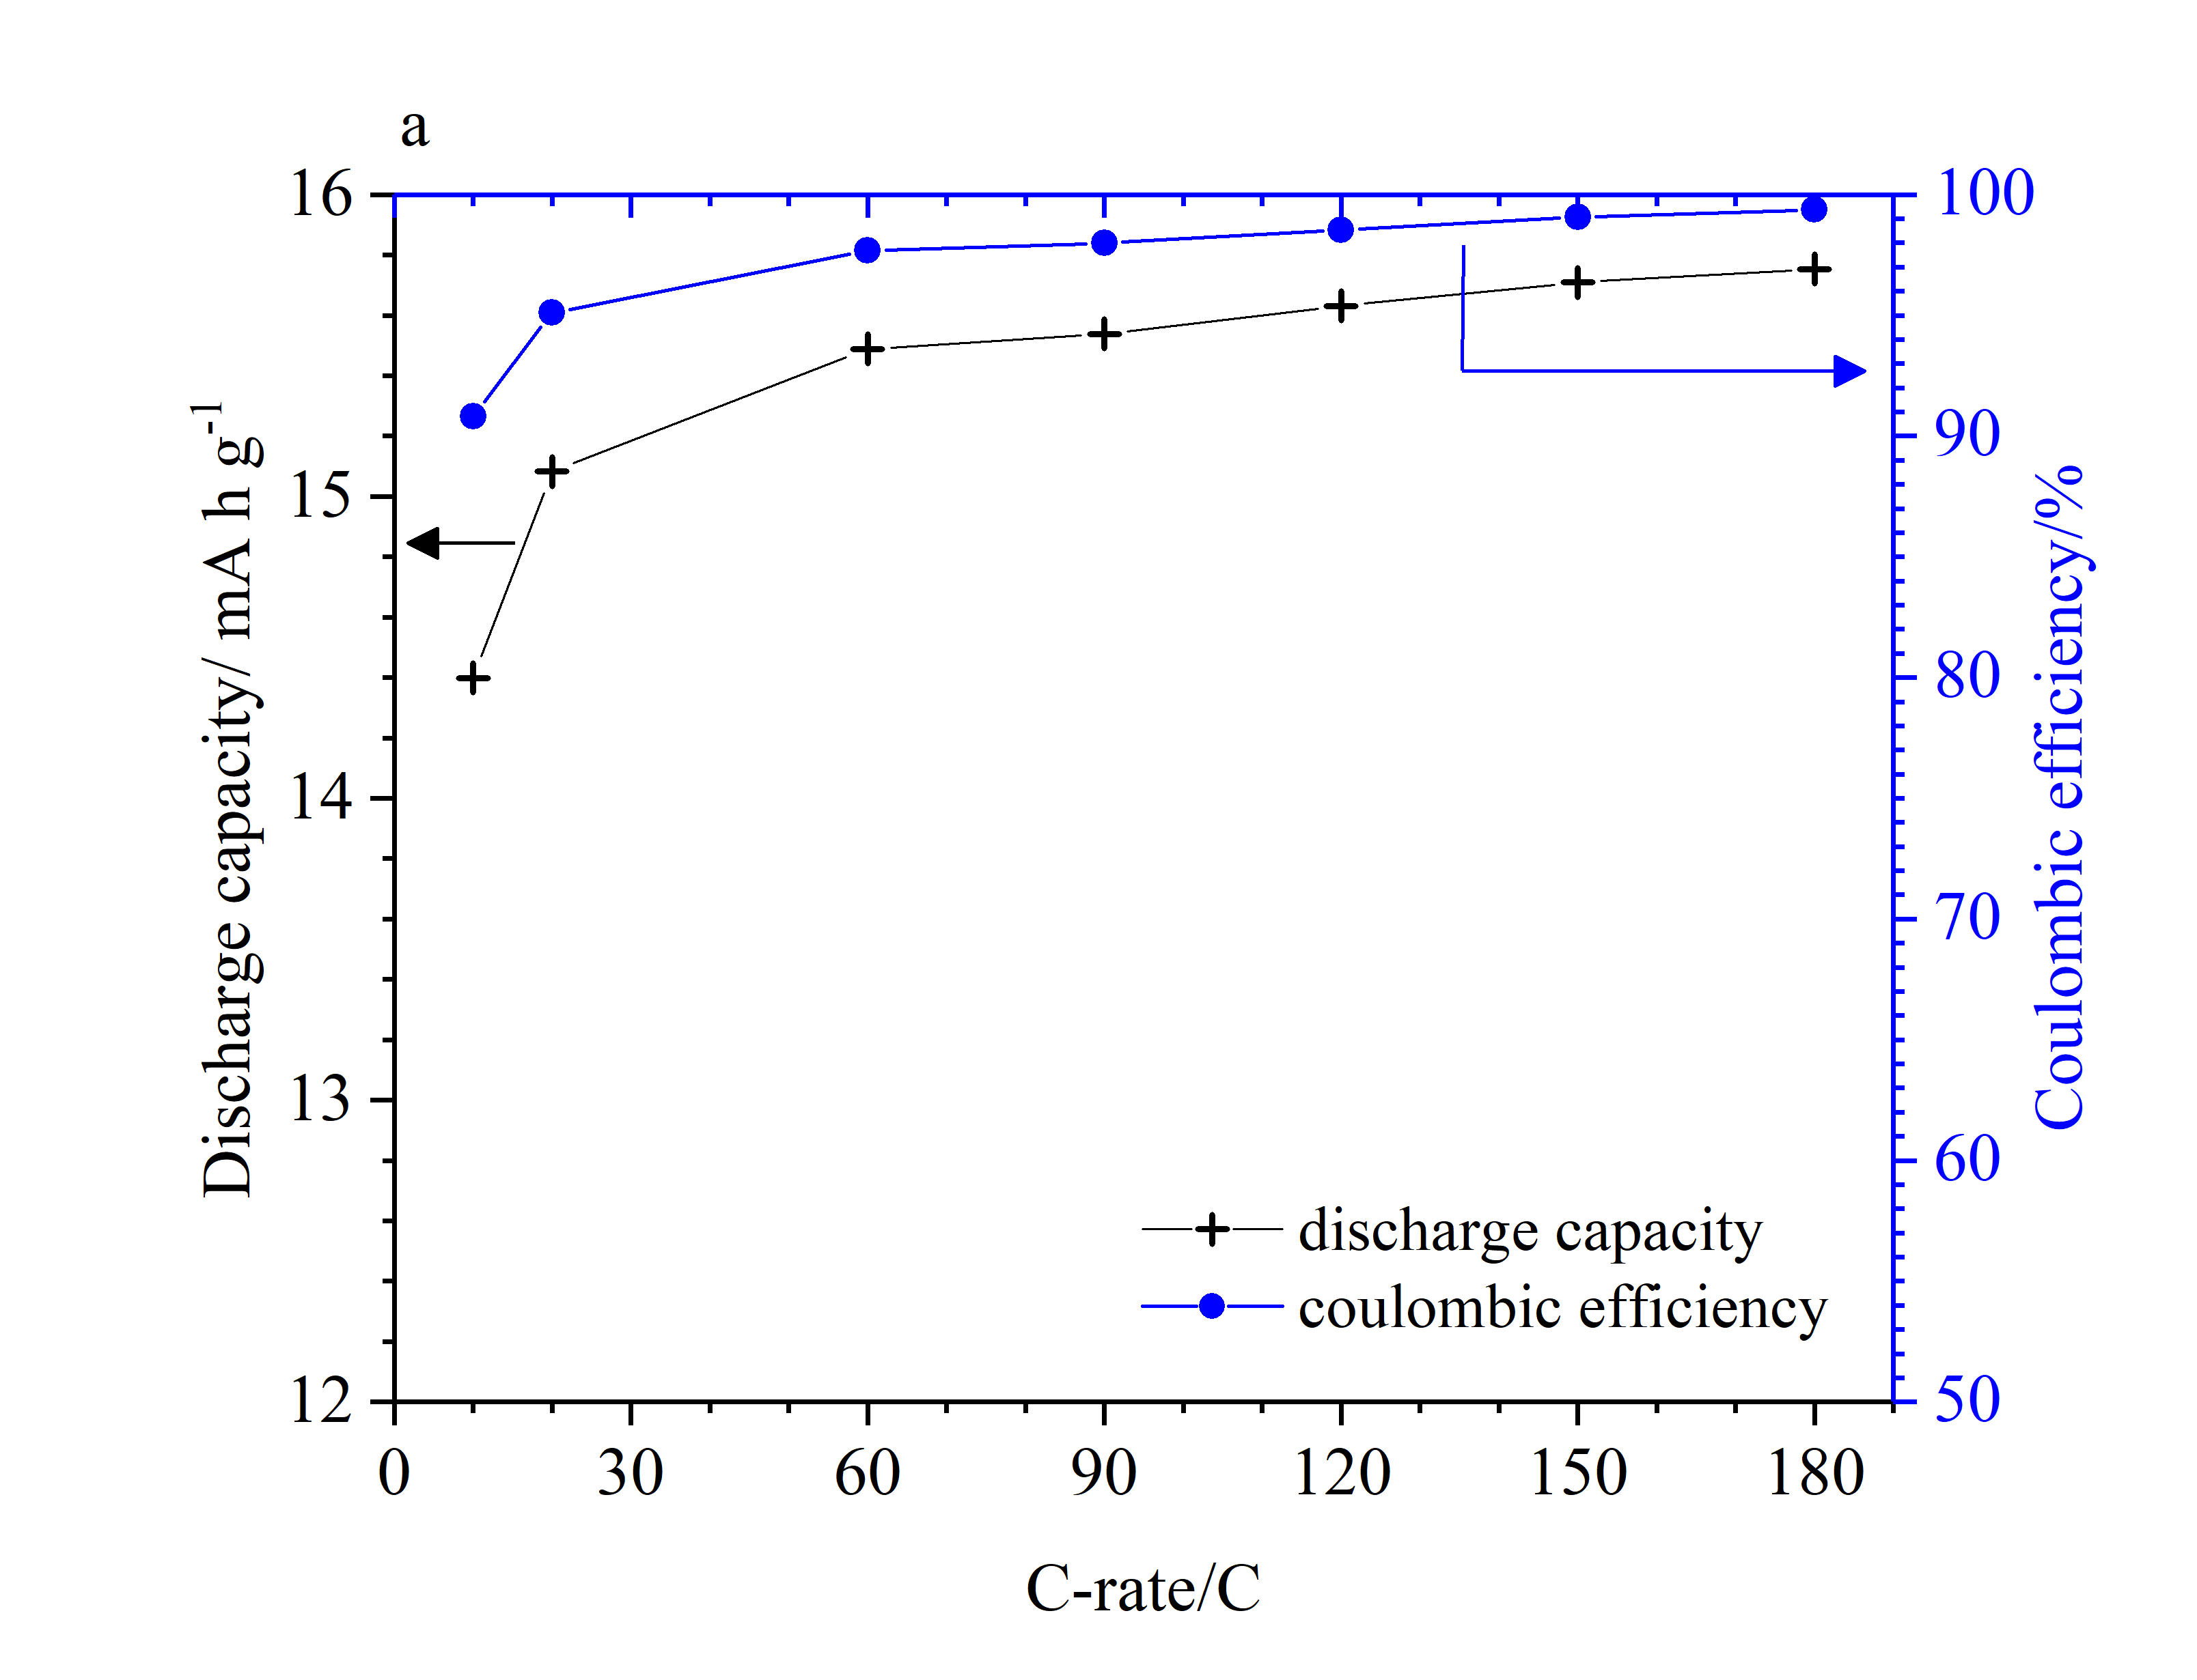
Figure 2. Coulombic efficiency and discharge capacity vs C-rate of a 25-nm TiO₂ (a) and a 5-nm-TiO₂ (b) electrode in a 3-electrode configuration against a SCE reference and CuHCF counter electrode in 1 mol dm⁻³ AlCl₃/ 1 mol dm⁻³ KCl.

The effect of electrode mass loading was also investigated on 25nm-TiO₂ electrodes given its importance in determining scalability of high rate electrodes. Loadings >1 mg cm⁻² are necessary for practical devices [15]. Five electrodes with mass loadings of 1.3, 2, 3.6, 5 (also used for figure 2) and 6.7 mg cm⁻² were cycled at a number of C-rates. Mass loadings greater than 6.7 mg cm⁻² could not be easily achieved with this particular ink composition. Figure 3 shows SEM images of electrodes with 3.6 and 6.7 mg cm⁻² of active material. At 3.6 mg cm⁻², see figure 3a and 3b, an even particle distribution can be seen across the surface of the electrode while only very minimal cracking can be seen. At 6.7 mg cm⁻², see figure 3c and 3d, both a less even distribution and a greater level of cracking are evident.
Figure 4a shows the effect of mass loading on coulombic efficiency at 10C and 60C with figure 4b giving the voltage profile of electrodes two electrodes at 60C. Coulombic efficiency can be seen to increase with mass loading up to 5 mg cm⁻² with a small reduction in coulombic efficency seen between electrodes from 5 mg cm⁻² to 6.7 mg cm⁻². At 10C, efficiency increases from 65% for electrode a to 90.5% from 1.3 mg cm⁻² to 5 mg cm⁻² before a decrease to 86.8% at a mass loading of 6.7 mg cm⁻². At 60C coulombic efficiency increases from 89% to 97.6% between 1.3 mg cm⁻² and 5 mg cm⁻², decreasing to 93.9% at at 6.7 mg cm⁻². The reason for improved performance up to 5 mg cm⁻² is still unclear, however, it may be possible that H⁺ diffusion to the current collector is lowered thus reducing H₂ evolution. It may also be possible that higher mass loadings result in greater adhesion between electrode constituents with each other and the current collector, improving conductivity. Of the mass loadings tested, an optimum of 5.0 mg cm⁻² has been identified, peak perfomance may be between 5.0 and 6.7 mg cm⁻². With these relatively high loadings, scalability of electrode performance with size can be reasonably expected. Clearly, further work is required to elucidate the nature of the <100% coulombic efficiency of anatase TiO₂ in 1 mol dm⁻³ AlCl₃/1 mol dm⁻³ KCl. However, the good performance of these electrodes at these mass loadings suggest the scale-up of these electrodes into a practical device to be possible.

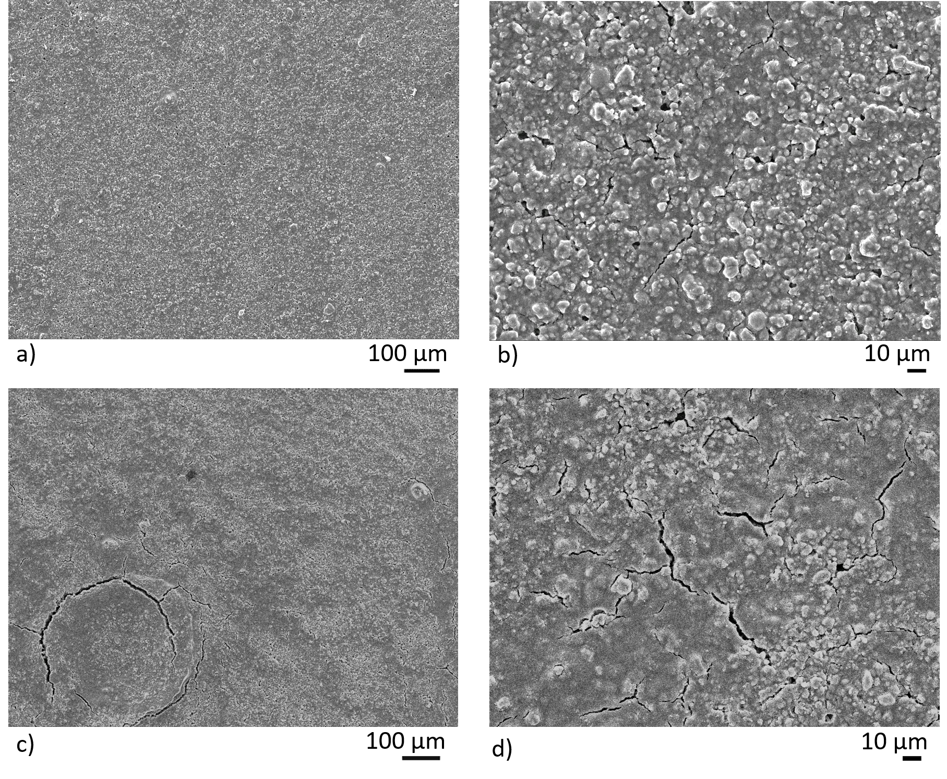
Figure 3. SEM images of an as-prepared 25nm-TiO₂ electrodes. Images a) and b) are of an electrode with a 3.6 mg cm⁻² mass loading with c) and d) from a 6.7 mg cm⁻² electrode.

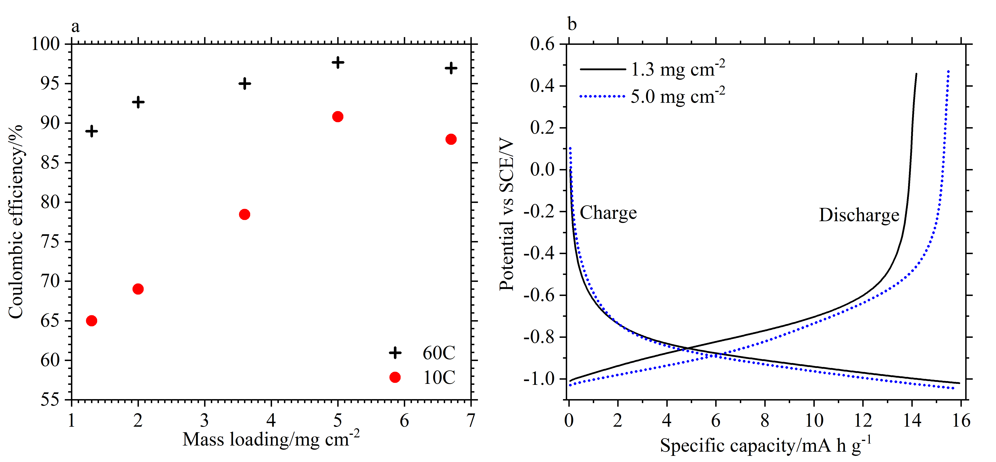
Figure 4. Left: coulombic efficiency as a function of electrode mass loading when cycled at 60C and 10C. Right: Voltage profiles of two electrodes, with different mass loadings of active material, cycled at 60C.
Extended cycling was then performed on both electrode compositions. Without an obvious end of state-of-charge seen in the potential charge-discharge profiles of TiO₂, seen in Figure 1, it was decided to limit charge capacity to 15.8 mA h g⁻¹ and 20 mA h g⁻¹ for the 5 nm and 25 nm electrodes respectively. Figure 5 gives coulombic efficiency and discharge capacity against cycle number. Figure 5a shows 25nm-TiO₂ to have an initial discharge capacity and coulombic efficiency of 15.7 mA h g⁻¹ and 99.37% that remains stable up to 4000 cycles when cycled at 120C. Electrolyte replacement after 2000 cycles marginally improves performance since cycling was performed in air, such that O₂ may become present over time due to air exposure or O₂ evolution from the CuHCF counter electrode. Between cycles 4000 and 5000, a decrease in coulombic efficiency and discharge capacity is observed. Figure 5b shows a capacity of 20 mA h g⁻¹ remaining stable up to 3600 cycles for the 5nm-TiO₂ electrode cycled at 100C. Both show cycle lives that are considerably greater than previously reported for TiO₂ in aqueous Al³⁺ electrolytes.
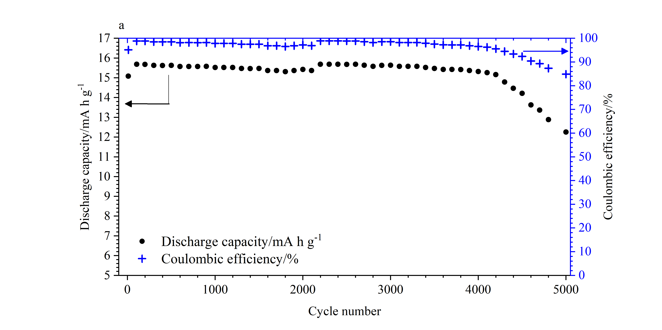
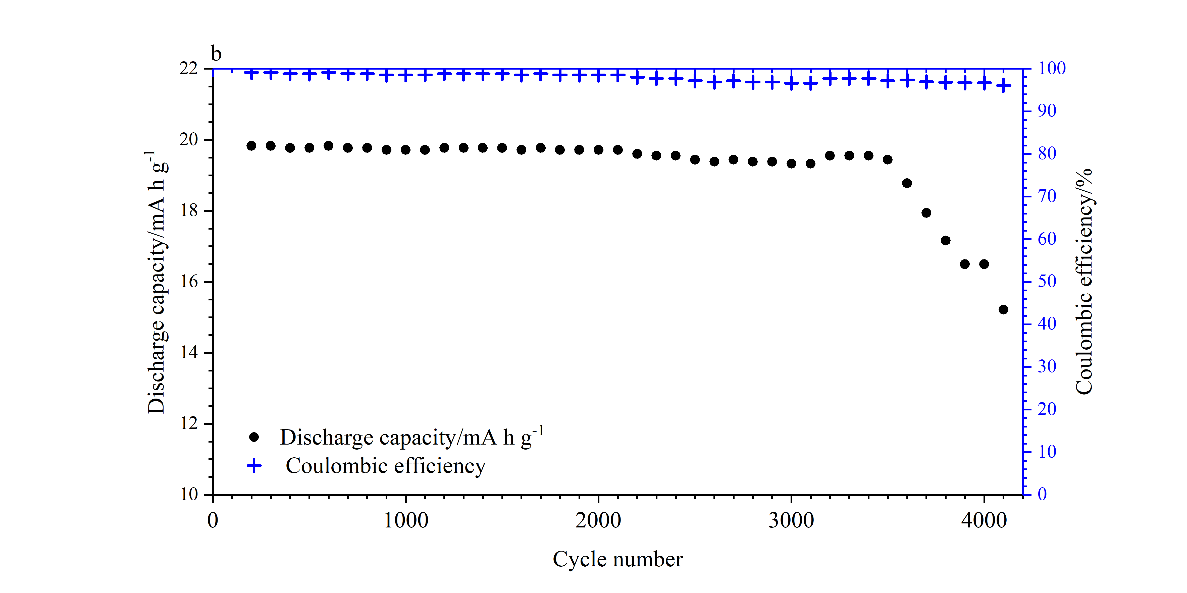

Figure 5. Extended cycling of a 25nm-TiO₂ (a) at 120C and a 5nm-TiO₂ (b) electrode at 100C in de-oxygenated 1 mol dm⁻³ AlCl₃/1 mol dm⁻³ KCl. 120C corresponds to a specific current of 1.90 A g⁻¹ for 25nm-TiO₂ and 100C to 2.0 A g⁻¹ for 5nm-TiO₂.

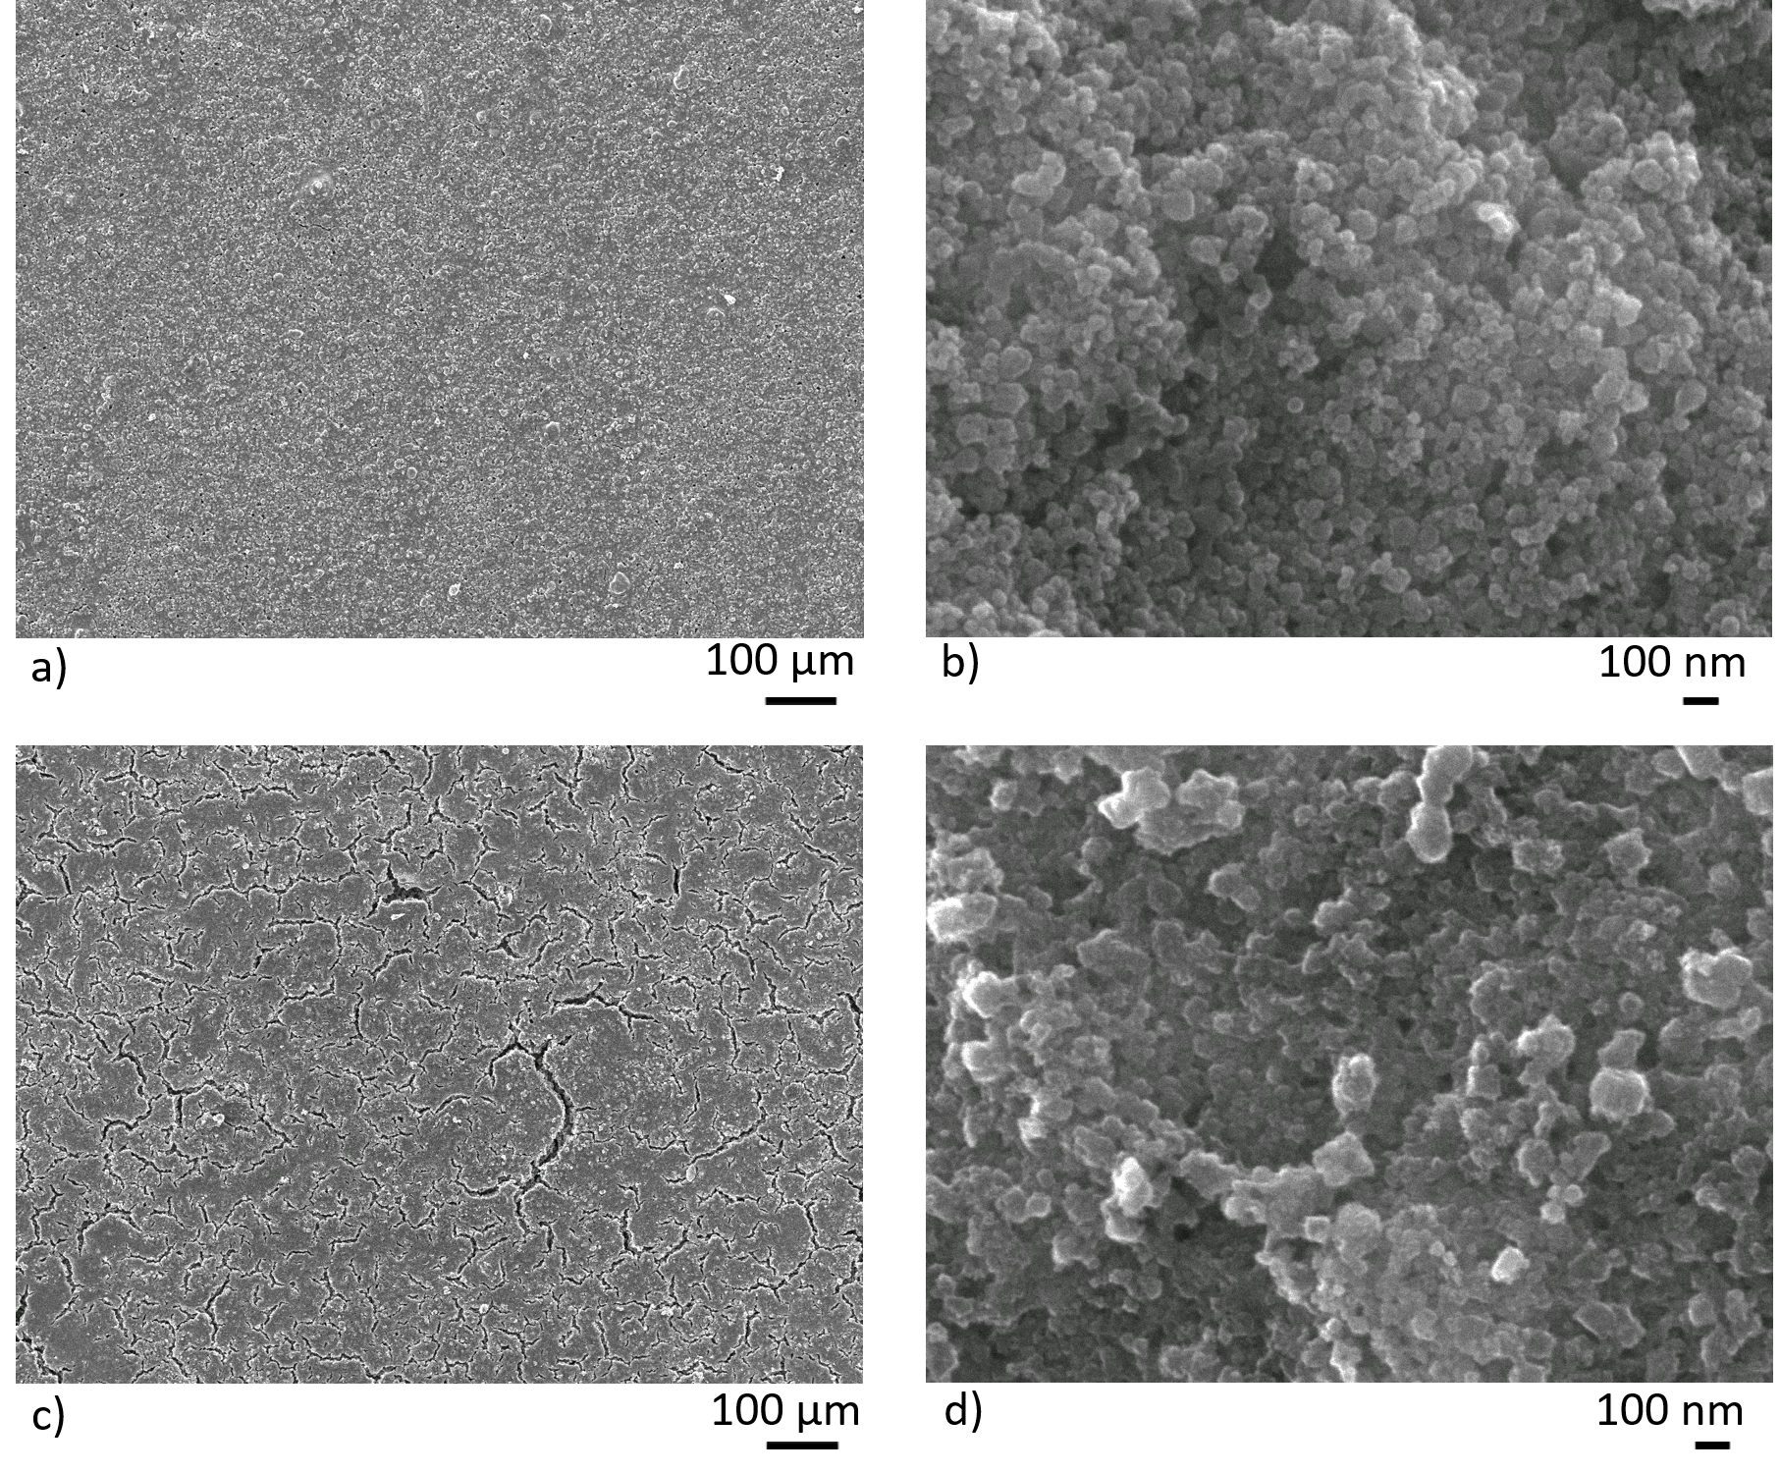
Figure 6. SEM images of two 25nm-TiO₂ electrodes (87.5wt% TiO₂, 5wt% carbon black, 7.5wt% Nafion). Images a) and b) are of a pristine electrode with c) and d) of an electrode after 5000 cycles in 1M AlCl₃/1M KCl. Top and bottom images are at x100 and x75000 magnification respectively.

Figure 6 presents SEM images of a pristine electrode (prior to charge/discharge cycling) and after 5000 cycles. Figure 6b shows the appearance of cracking after extensive cycling. This could be due to H₂ evolution at the current collector and within the active electrode. It may also be due to repeated expansion/contraction of TiO₂ due to possible Al³⁺ insertion/extraction, however, post-mortem XRD analysis suggests this may not be the case. Figure 6d shows signs of flocculation after cycling while definition of spherical particles is less clear. This may indicate dissolution of the electrode into electrolyte upon repeated cycling.

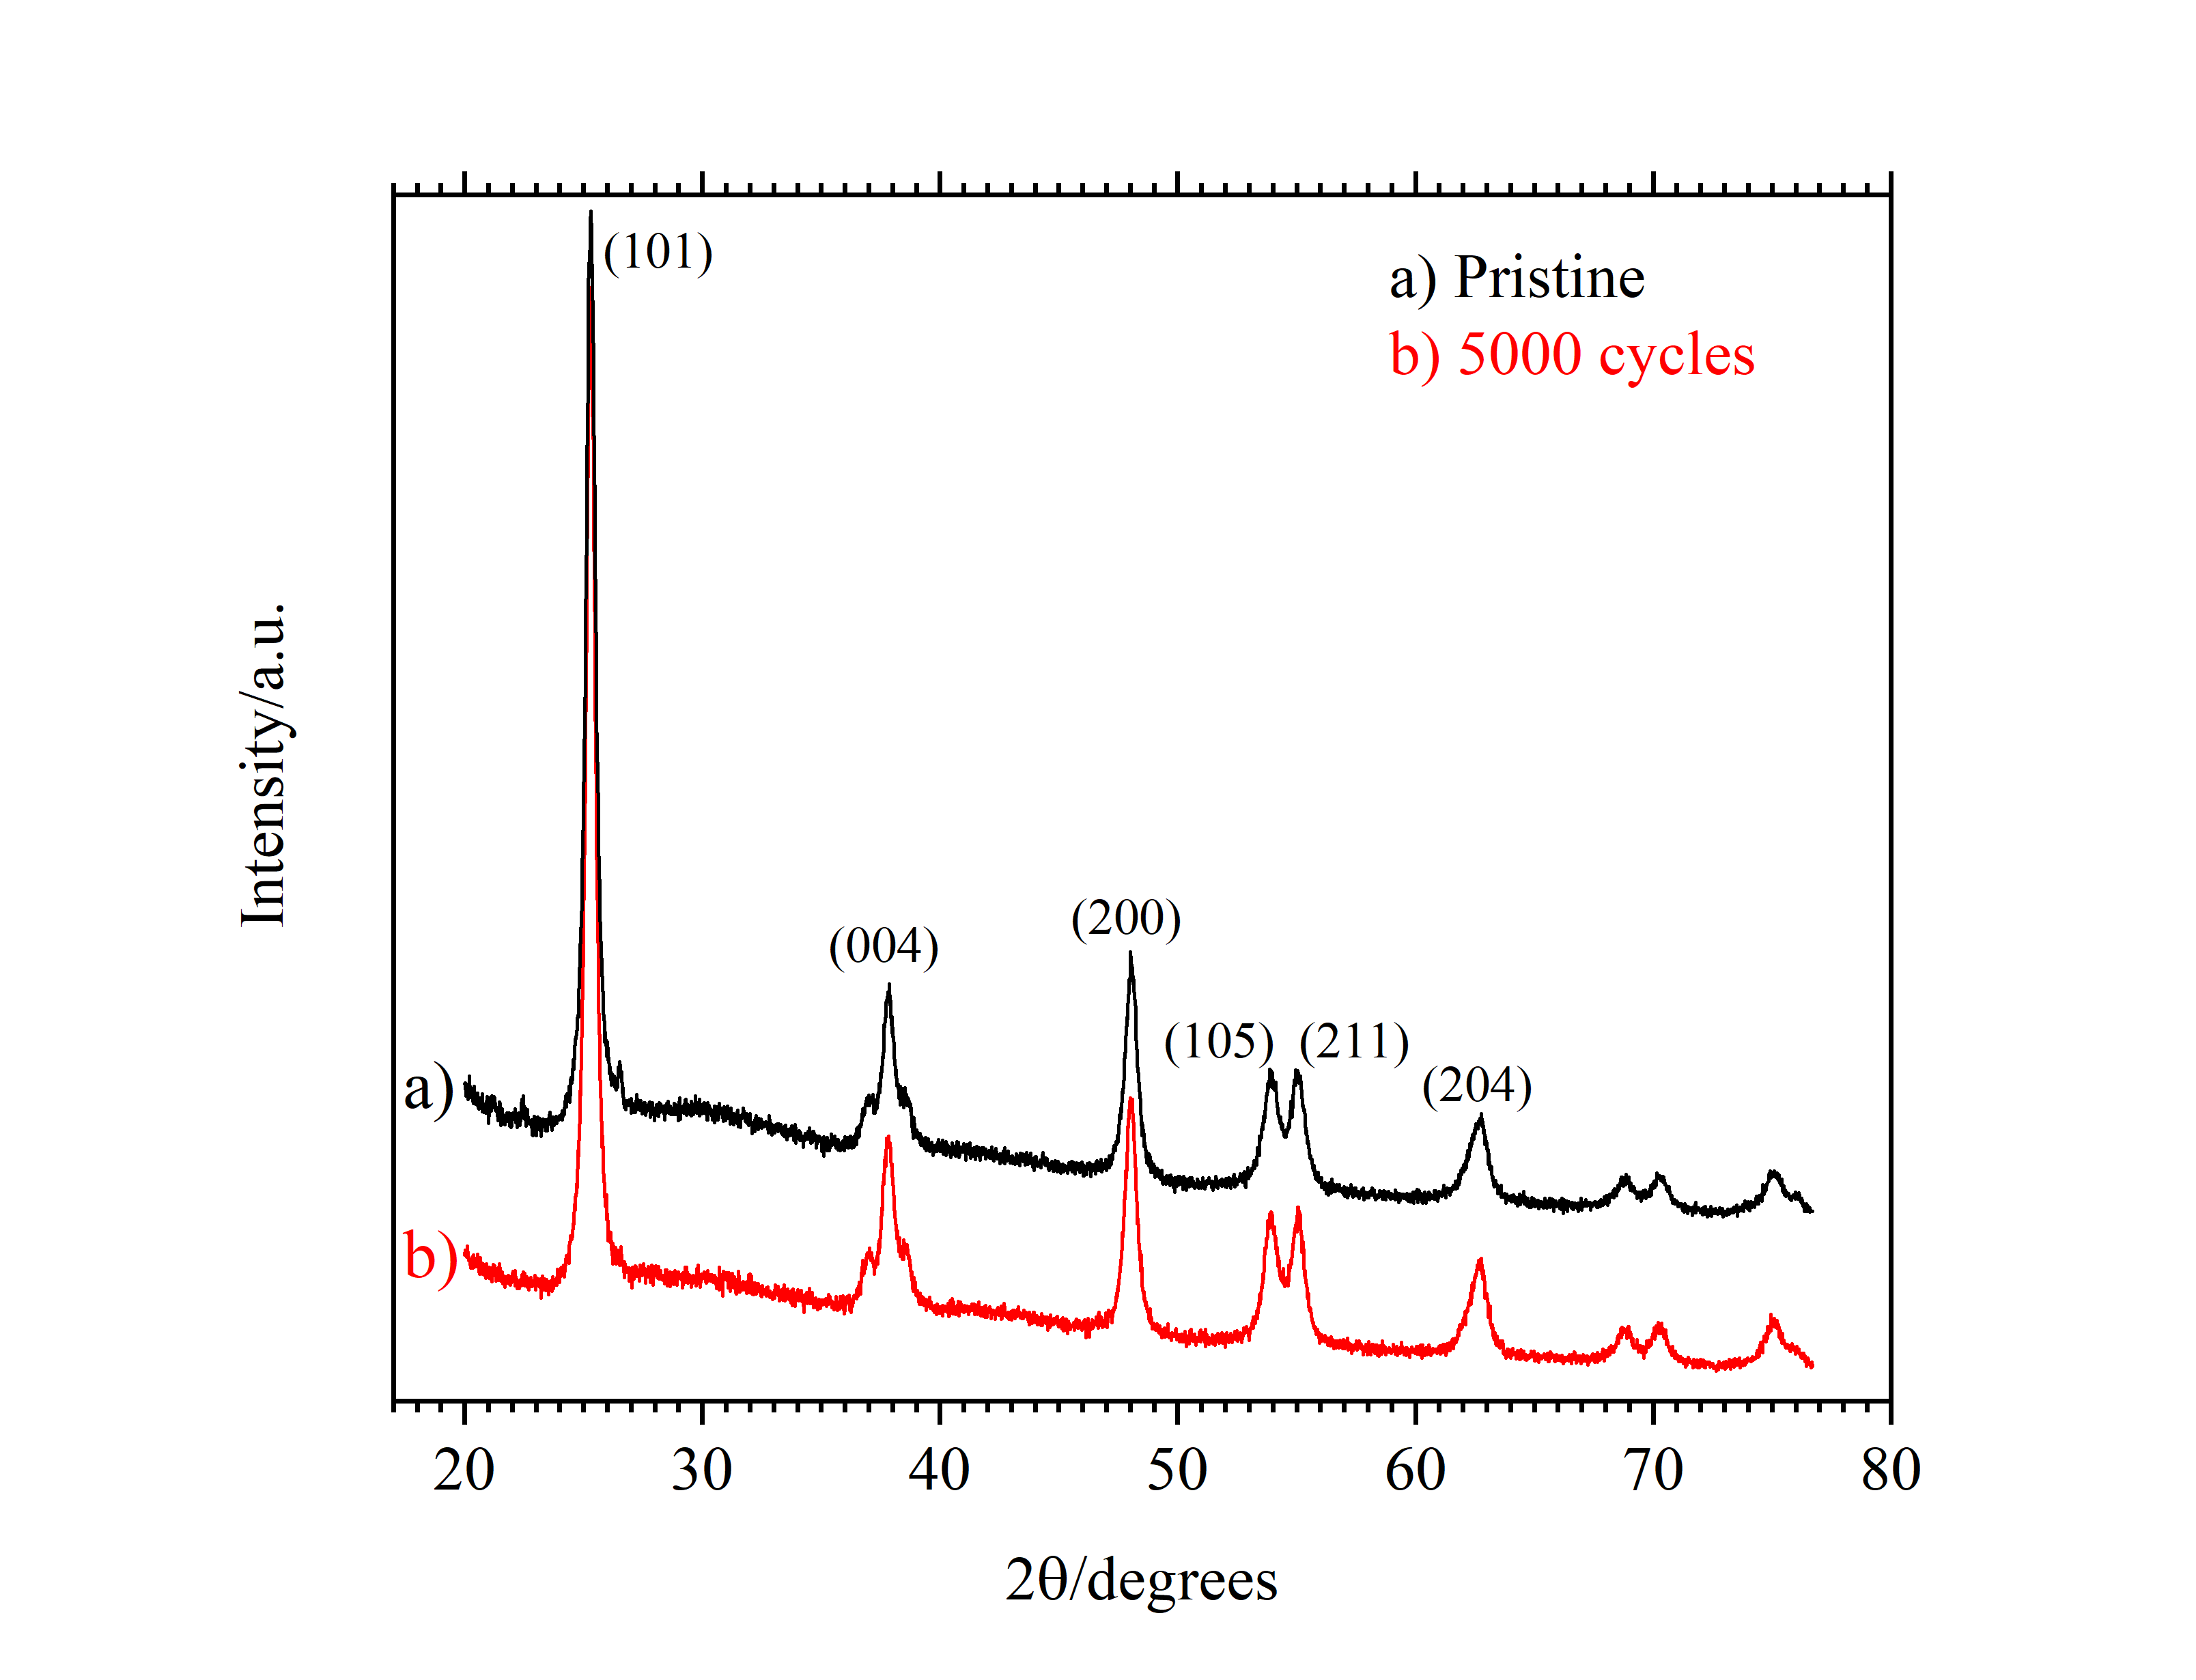
Figure 7. XRD patterns of two 25nm-TiO₂ electrodes, pristine and after 5000 cycles in 1 mol dm⁻³ AlCl₃/1 mol dm⁻³ KCl.

The Miller indices (004) and (200) were used to calculate the crystal lattice parameters of the tetragonal anatase TiO₂ powders via equation (1). Crystal lattice parameters a and c were calculated to be 3.787 nm and 9.513 nm for the pristine electrode powder and 3.789 nm and 9.512 nm for the cycled electrode powder. Differences of 0.001 nm and 0.002 nm are unlikely to be experimentally significant and coupled with the pattern above indicates a lack of phase or lattice parameter change during extended cycling.
The C-rate, specific current, coulombic efficiency and cycle life of the two electrode materials prepared in this paper are compared to literature reported materials in Table 2. Only CuHCF has been shown in the literature to have appreciable cycle life (1000 cycles) with all other materials falling below 200 cycles. This contrasts with the 3000 to 5000 cycles demonstrated by the electrodes presented in this paper. The C-rate of materials is not routinely provided, however specific current is more generally provided and ranges from the mA g⁻¹ range to 6.25 A g⁻¹. The electrodes presented in this work have been demonstrated to be stable up to 7.20 A g⁻¹, equivalent to a rate of 360C.

Table 2. Previous electrodes investigated in aqueous Al salts compared with results given in this report.
Paper | Electrode material | C-rate | Specific current | Coulombic efficiency (specific current) | Cycles
Lahan et al, J. Phys. Chem. C, 121, 2017 [11] | TiO₂ particles | - | 6.25 A g⁻¹ | 50% | 125
Kazazi et al, Solid state Ionics 300, 2017 [10] | TiO₂ nano-spheres. | 6.0 C | Not given. Approx. 0.6 A g⁻¹ | 85%1 | 30
Gonzalez et al, RSC Advances 6, 2016 [9] | V₂O₅ aerogel. | - | 0.2 A g⁻¹ | 99%1 | 13
Liu et al, J. Mater. Chem. 3, 2015 [8] | CuHCF. | - | 0.4 A g⁻¹ | ≈100%1 | 1000
He et al, J. Mater. Chem. 2, 2014 [6] | TiO₂ nano-leaves. | - | 2.0 A g⁻¹ | ≈100% | 30  (300 in supplementary material)
Y. Liu et al, Electro. Acta 143, 2014 [7] | TiO₂ nano-wire array film. | - | *0.4 mA cm⁻² (1cm² electrode) | 82%1 | -
S. Liu et al, Energy and Environ. Science 5, 2012 [5] | TiO₂ nano-tube array film. | - | *0.4 mA cm⁻² | 82%1 | 13
This Work. | 25nm-TiO₂ | 180 C | 2.85 A g⁻¹ | 99.37% | 5000
This Work. | 5nm-TiO₂ | 360 C | 7.2 A g ⁻¹ | 99.0% | 4000
4.0 Conclusions
In summary, mechanically, chemically and electrochemically stable electrodes for an aqueous aluminium ion secondary battery have been demonstrated. Composite TiO₂ nanopowder electrodes with high mass loadings (up to 6.7 mg cm⁻²) have superior performance to TiO₂ electrodes recently reported for use in the aqueous Al-ion chemistry. This can be attributed to both the morphology of the TiO₂ nanopowder and electrode manufacture process, which allows for even distribution of electrode consituents. Small particle size and a large electrolyte-electrode interface can allow for fast Al³⁺ diffusion and many surface sites for potential capacitive contributions. The flat voltage profile under galvanostatic cycling along with CV profiles (both previously reported and for these specific electrodes) suggest an insertion redox process. However, a capacity of 20 mA h g⁻¹ coupled with a high rate capability of 7.2 A g⁻¹ and lack of crystal structure changes during extended cycling could suggest a surface storage mechanism. Clearly, further work is required to understand this. The described electrodes demonstrated the possibility of 5000 cycles, 99% coulombic efficiency and high specific current of up to 7.2 A g⁻¹. Additionally, dissolved O₂ in the electrolyte was found to be detrimental to the performance of the electrode with coulombic efficiency of the electrode increasing in de-oxygenated electrolyte. However, coulombic efficiencies still decreased at low C-rates, thus suggesting a significant self-discharge mechanism, the full nature of which is currently unknown.

The specific current density and long cycle life are higher than recently reported TiO₂ electrodes for use in the aqueous Al-ion chemistry. Importantly, the use of commercially available powders provides potential advantages in terms of material availability, cost and simplicity of scale-up towards a new battery system. Further work needs to be undertaken to elucidate the full charge storage mechanism and to then tailor the electrode materials for optimum capacity and power.

5.0 Acknowledgements
The authors acknowledge funding from the EU commission under the Horizon 2020 grant agreement No 646286 “ALION: A low-cost aluminium-ion battery”. A. Holland acknowledges the funding from the EPSRC Centre for Doctoral Training in Energy Storage and its Applications (grant No EP/L016818/1).

References

1. Li, W., J.R. Dahn, and D.S. Wainwright, Rechargeable Lithium Batteries with Aqueous Electrolytes. Science, 1994. 264(5162): p. 1115-1118.
2. Kim, H., et al., Aqueous Rechargeable Li and Na Ion Batteries. Chemical Reviews, 2014. 114(23): p. 11788-11827.
3. Wang, Y., et al., Ultra-low cost and highly stable hydrated FePO4 anodes for aqueous sodium-ion battery. Journal of Power Sources, 2018. 374: p. 211-216.
4. Wang, L.-P., et al., Prussian blue nanocubes as cathode materials for aqueous Na-Zn hybrid batteries. Journal of Power Sources, 2017. 355: p. 18-22.
5. Liu, S., et al., Aluminum storage behavior of anatase TiO2 nanotube arrays in aqueous solution for aluminum ion batteries. Energy & Environmental Science, 2012. 5(12): p. 9743-9746.
6. He, Y.J., et al., Black mesoporous anatase TiO2 nanoleaves: a high capacity and high rate anode for aqueous Al-ion batteries. Journal of Materials Chemistry A, 2014. 2(6): p. 1721-1731.
7. Liu, Y., et al., The electrochemical behavior of Cl− assisted Al3+ insertion into titanium dioxide nanotube arrays in aqueous solution for aluminum ion batteries. Electrochimica Acta, 2014. 143: p. 340-346.
8. Liu, S., et al., Copper hexacyanoferrate nanoparticles as cathode material for aqueous Al-ion batteries. Journal of Materials Chemistry A, 2015. 3(3): p. 959-962.
9. Gonzalez, J.R., et al., Reversible intercalation of aluminium into vanadium pentoxide xerogel for aqueous rechargeable batteries. RSC Advances, 2016. 6(67): p. 62157-62164.
10. Kazazi, M., P. Abdollahi, and M. Mirzaei-Moghadam, High surface area TiO2 nanospheres as a high-rate anode material for aqueous aluminium-ion batteries. Solid State Ionics, 2017. 300: p. 32-37.
11. Lahan, H., et al., Anatase TiO2 as an Anode Material for Rechargeable Aqueous Aluminum-Ion Batteries: Remarkable Graphene Induced Aluminum Ion Storage Phenomenon. The Journal of Physical Chemistry C, 2017. 121(47): p. 26241-26249.
12. Holland, A., et al., An aluminium battery operating with an aqueous electrolyte. Journal of Applied Electrochemistry, 2018. 48(3): p. 243-250.
13. EPRI, Electricity energy storage options: A white paper on applications, costs and benefits. 2010, EPRI: Palo Alto, CA.
14. Luo, J.-Y., et al., Raising the cycling stability of aqueous lithium-ion batteries by eliminating oxygen in the electrolyte. Vol. 2. 2010. 760-5.
15. Augustyn, V., P. Simon, and B. Dunn, Pseudocapacitive oxide materials for high-rate electrochemical energy storage. Energy & Environmental Science, 2014. 7(5): p. 1597-1614.

Coulombic efficincies have had to be approximated from charge/discharge curves.

