The retrenchment of public pension provision in the liberal world of welfare during the age of austerity - and its unexpected reversal, 1980-2017

Abstract

Pension system adaption during the “age of austerity” since 1980 is expected to vary between industrialized countries broadly in line with their membership of conservative, liberal or social democratic worlds of welfare. Empirical testing on the liberal world focuses on the later period and differs in its conclusions. This paper is based on a systematic study of the scale, nature and trajectory of change in six liberal pension systems between 1980 and 2017 using expenditure, economic, demographic and social rights data. This data is analysed using a framework developed through critical engagement with Pierson’s three welfare state change criteria and the welfare state “dependent variable problem”. The paper finds a significant retrenchment of public pension provision in most liberal welfare states after 1980, but largely during the first half of the period. This has been partly reversed in most countries since the mid-1990s, though the scale of this reversal varies between countries. The recent rise of the state in liberal systems has been noted by some commentators, but to be properly understood, the paper argues, it must be considered in the context of the significant retrenchment which preceded it. There is scope especially for research on the broader social context of recent reforms, particularly how middle-income groups were affected by retrenchment and how recent reforms have mitigated this.

Keywords: liberal pension systems; regime theory, retrenchment

1.INTRODUCTION

Most comparative research on welfare state adaption suggests existing policy institutions will determine to a significant extent reform paths in the face of structural challenges ie population ageing, labor market change and economic globalisation. The starting point for much of this research is regime theory which classifies national welfare provision based on dominant features and shared sets of underlying principles (eg Esping-Andersen, 1990; Pierson, 2001). Policy developments in the “age of austerity” are thus expected to vary between countries in a way broadly consistent with their membership of conservative, liberal or social democratic worlds.

On pension policy, this framework has been debated in recent years mainly in relation to large conservative and social democratic public pension systems of continental Europe (eg Häusermann, 2010; Pailer, 2011). Here significant political resistance to retrenchment was expected because broadly encompassing public pensions would ensure cross-class opposition (Esping-Andersen, 1990). To these obstacles, Pierson added opposition from existing recipients of public provision (“welfare constituencies”) and path dependencies, generated by existing policy and associated networks (2001). Recent work has shown significant change is possible despite these obstacles, generally characterising reforms as dualizing ie leading to varying provision for different categories of recipients (eg Palier, 2011; Emmenegger et al., 2012).

Far less attention has been given to the liberal pensions world. Here, regime theory expected greater vulnerability to retrenchment: liberal systems were less encompassing, founded on weak working-class power resources and had little cross-class support; they depended on “the loyalties of a numerically weak, and often politically residual, social stratum” (Esping-Andersen, 1990: 33; also Korpi/Palme, 2003: 426). Pierson concurred, having initially emphasized the obstacles to retrenchment generated by welfare constituencies and policy legacies. In liberal welfare systems these obstacles were smaller: means-testing and the “institutionalization” of market provision weakened the former, crucially reducing “pivotal voters … attachments to social provision” (Pierson, 2001: 434). Policy legacies were also weaker because systems with significant non-state provision included powerful market-related networks (ie commercial providers and employers) prepared to sanction retrenchment.

Research testing these predictions focusses on the period since 2000 and has reached different conclusions. Asyan and Beaujot’s five country study (2009) finds developments everywhere consistent with the “liberal path”. Using Pierson’s three welfare state change categories – cost containment, re-commodification and re-calibration (see below) – the authors argue all countries have focussed on the first two (2009: 711). “Social transfers” have been reduced and/or targeted, state pension ages have risen, and private saving has been encouraged. Lain et al(2013) disagree. They find little evidence of re-commodification in three of their four countries (Canada, New Zealand and the UK) and that such efforts in the USA focussed only on the poorest. Private saving has increased, but not as a substitute for public provision. Where systems were more consistent with the liberal ideal type retrenchment has generally been greater (Lain et al,2013).

These differences are caused in part by the different criteria and data used to measure retrenchment, the “dependent variable problem” that has plagued research on welfare state change (Clasen & Siegel, 2007). Neither study fully engages with this problem nor does either use much data beyond descriptions of policy developments in the countries they study.

The contribution of this paper is founded on a systematic study of the scale, nature and trajectory of change in six liberal pension systems between 1980 and 2017 using expenditure, economic, demographic and social rights data. A starting date of 1980 has been chosen based on the coming to power around this time in most of the six cases of governments avowedly committed to liberalisation after the economic slow-down of the 1970s (see below). The data collected is analysed using a clearly specified framework developed through critical engagement with Pierson’s three change criteria and the welfare state “dependent variable problem” (Clasen & Siegel, 2007). *Cost containment* is thus assessed using pension expenditure trajectories covering the whole period which are adjusted for social need and compared to change in national income per head (Clayton & Pontusson, 1998). *Re-commodification* is assessed using the Comparative Welfare Entitlements Dataset (CWED) with systematic consideration given to how this has been *targeted* (see Häusermann, 2010). Finally, following Häusermann, *capitalisation* is assessed in terms of countries’ success or otherwise in increasing personal private saving as a substitute for public provision. Due to constraints of space, the study focuses on changes to the public provision of the ‘golden age’, not recalibrations to reflect “new social risks” (Bonoli, 2005).

The main finding of the study is that a significant retrenchment of public pension provision occurred in most liberal welfare states after 1980, but this was largely confined to the first half of the period. Cost containment was generally successful during this time, with pension expenditure per population over 65 falling in real terms in two countries (Australia and New Zealand) and failing to rise in line with national income per head in three others: Ireland, the UK and the USA. Replacement rates also show long periods of decline in all but Canada and the UK, where the gradual maturation of reforms passed before the period began boosted them. In three countries (Australia, the UK and USA), these developments were accompanied by significant governments-encourage efforts to increase private personal saving. Since the mid-1990s, retrenchment has been reversed at least in part in most countries, though the scale of reversal varies between countries and retrenchment pressures are still strong, not least because of the financial crisis. The state has risen in liberal pensions system in the past twenty years, as some commentators have suggested (Gelepithis, 2018a and 2018b); but, the paper argues, if the social basis of this rise is to be properly understood it must be contextutalized based on the significant retrenchment which preceded it. Attention should focus on the impact of this retrenchment on middle-income citizens. When combined with significant retrenchments of non-state provision in most settings from the late 1990s (eg Bridgen and Meyer, 2005), this seems likely to have extended by the early 2000s the ‘risk category’ (Baldwin, 1990) supportive of a redistributive state. Recent reforms increasing the state’s role seem at least in part a response to this development.

The paper is organized in the following way. In the next section, the features and principles are outlined which identify welfare systems as liberal. The challenges involved in analysing changes to these systems are then examined and it is explained how this study sought to overcome them. The results are then reported before their theoretical significance is discussed in the final section.

2. THE LIBERAL PENSION WORLD

In terms of underpinning principles, liberal welfare states are said to involve limited public provision with emphasis placed on individuals to secure market-based social protection (Esping-Andersen, 1990). The delivery of provision accordingly involves specific mechanisms which, following Bonoli and Palier (1998), can be differentiated as liberal based on four main parameters: the rules and criteria governing eligibility; the form taken by benefits; the financial mechanism; the organisation and management of the scheme.

Thus, a liberal system involves:

1/ widespread means-testing of public provision with market determination of access and eligibility above the state minimum;

2/ Flat rate public provision mainly designed to prevent poverty;

3/ Financing dominated by general taxation;

4/ Little if any role for social partners in the governance of public provision (Esping-Andersen, 1990).

The liberal regime - like the other two - is an ideal type which encompasses in distilled form the essential features of its kind. No individual countries are expected precisely to conform to their regime features either in their institutional design or policy dynamics. However, it is expected that systems further away from the ideal type will develop less consistently with theoretical expectations (eg Lain et al, 2013).

Membership of the liberal welfare state group has been debated (see below) but the six Anglo-Saxon countries - Australia, Canada, Ireland, New Zealand, United Kingdom and United States - have generally been classified as members. Their public pension systems certainly had many liberal features in 1980, the starting point for this study.[1] As can be seen in table one, the public systems of Australia and New Zealand were most consistent. Here public provision was limited to a flat rate, tax-financed pension, which had up to the mid-1970s entailed some degree of means-testing (Starke, 2008). The generosity of New Zealand’s flat-rate National Superannuation pension had been significantly enhanced in the 1970s increasing its divergence from the ideal type. Notwithstanding this close institutional congruity with the liberal pension type, Australia’s and New Zealand’s status as liberal welfare states has been questioned by some commentators (eg Castles, 1985). Their low level of public provision masks, it is suggested, a more statist commitment to working class incomes than exists in mainstream liberal welfare states, which operates through collectively organized wage regulation. Yet, while there is no doubt this “wage-earner” framework has generated important differences in the organisation and outcomes of income maintenance, these differences seem least significant in public pensions, though as will be seen in Australia collective bargaining has had an important impact on occupational pension provision.

Table one here

Public pensions in Ireland in 1980 also had strong liberal features: they were flat rate and low level but divergent in being contributory. In Canada and the UK public provision was more divergent because of greater public involvement above the flat-rate level. Canadian flat-rate provision was tax-financed but universal and based on residency. But the bigger divergence was the Canada/Ouebec Pension Plan (C/QPP) introduced in 1965 (Myles, 2013). A public earnings-related pension, this was projected to replace 25 per cent of wages on retirement. In the UK, a flat-rate contributory Basic State Pension (BSP) was complemented by an earnings-related pension (SERPs) after 1975 projected to replace 20 per cent of wages on retirement (Bridgen, 2010). Finally, the US pension system was the most inconsistent with the liberal ideal type. Public provision included no flat-rate pension, was contributory, and earnings-related. Consequently, US public provision has sometimes been compared with conservative, continental European systems (eg Germany and Austria) and labelled “Bismarckian lite” (eg Esping- Andersen, 1990: 29; Bonoli/Shinkawa, 2005). Notwithstanding this rather marked divergence, the US public system is included in the analysis because it is significantly less generous than typical conservative systems, such as Austria and Germany,[2] and consequently like in the other liberal systems, many citizens have been reliant for income protection on market provision. Such provision, mainly in the form of occupational, employer-sponsored pensions, existed in all six countries by the early 1980s with varying degrees of coverage (see table one). In none, however, was provision mandatory nor were employers obliged to pay a contribution.

As has been seen, regime theory leads to the expectation that pension retrenchment since 1980 will be widespread in the six countries detailed above, particularly those whose systems are closest to the liberal idea type. But in testing this prediction, how should pension system change be conceptualized and measured?

3. CONCEPTUALISING AND MEASURING WELFARE STATE CHANGE

3.1 Conceptualisation

Concerns about the conceptualisation of the welfare state first arose in relation to the primacy accorded to social expenditure in explaining its expansion (Esping-Andersen, 1990; see also Clasen & Siegel, 2007). This missed essential aspects of the welfare state, it was argued (Esping-Andersen, 1990: 2), such as its distributional logic and whether and how social rights were extended (Siegel, 2007). It also ignored fiscal and regulatory interventions affecting income distribution and welfare outcomes. Esping-Andersen’s construction of three welfare regimes used measures (decommodification and stratification) which sought more fully to capture these essential aspects.

An influential way of managing this conceptual issue in the post-austerity context has been Paul Pierson’s conceptualisation of welfare state change into three dimensions - *cost-containment, recommodification, and recalibration* (2001: 422-8). These are recommended as means to delineate the nature of change in each system and determine its scale. Thus, *cost containment* is concerned primarily with social expenditure and reflects the fact that, while welfare states are about more than expenditure, structural pressures in the age of austerity have created a strong concern simply to reduce costs. *Re-commodification* involves the reversal of de-commodification processes evident during welfare state expansion (Esping-Andersen, 1990) ie diminishing individuals’ social rights by increasing market reliance*.* Recalibration reflects the fact that some reforms are designed not to reduce welfare provision but adjust it to “new social risks” (Bonoli, 2005; Häusermann, 2010) and/or to new ways of achieving traditional ends.

This study uses an analytical framework based on these categories but amended based on two important limitations identified in the literature. These are that: (i) the categories reveal little about how welfare state change is targeted (ie which social groups are affected most); and (ii) the treatment is rather vague of the state’s engagement with non-state provision. On the former, Häusermann (2010) adds a *targeting* category to Pierson’s list, based on continental welfare state’s occupationally-segmented schemes, but this category can also be used in the context of income eg to indicate whether the poorest are protected during retrenchment. This category directs attention, for example, to whether governments have concentrated more on reducing benefit generosity for all recipients or have focussed on limiting access for wealthier citizens through means or asset testing. On state involvement in non-state provision, this has sometimes been regarded as re-commodifying given its emphasis on market provision (Häusermann, 2010: 26-7), but it has also been judged as recalibration (Pierson, 2001: 426; Lane et al, 2013). Following Häusermann, in the analysis below a separate *capitalisation* category is used. This delineates the various types of *capitalisation* (eg between personal and occupational pensions) and considers whether its development substitutes for or complements public provision.

In what follows, therefore, *cost containment, recommodification and targeting* and *capitalisation* will be used to analyse change in the six liberal pension systems. Given the paper’s focus on the public pension systems of the golden age recalibration in relation to new social risks will not be part of the analysis.

2.2 Operationalisation and measurement

To operationalize these analytical categories in relation to the available data, the analysis takes the following approach. To assess *cost containment*, comparative pension expenditure data is used from the OECD’s Social Expenditure (SOCX) database (2018). Using this data in its raw form is problematic because:

* The data is expressed as a percentage of GDP, meaning the relative contributions of expenditure and GDP to movement over time are not clear;
* No allowance is made for changes in social need (Clayton & Pontusson, 1998; Kangas & Palme, 2007);
* No indication is provided of how expenditure on the older population relates to changes in national income per capita;
* Expenditure changes might be the product of policies passed before the period of interest which still determine welfare entitlement;
* Tax expenditures are not included in the OECD’s figures (De Deken & Kittel, 2007).[3]

To deal with the first two of these problems, the OECD’s figures have been converted into real expenditure per head of population above 65 using time series data for the six countries on GDP (World Bank, 2018), population (United Nations, 2017) and inflation (World Bank, 2018). Real decreases and increases in this adjusted expenditure data are traced across five-year periods. These expenditure changes are then compared with changes in GDP/capita to gauge the extent to which they reflect increases in national income (Clayton & Pontusson, 1998). Unfortunately, reliable comparable data on fiscal support for non-state pensions is unavailable, so the results are likely to underestimate the overall public cost of provision in our six countries for most of the period. However, this is of less concern given that our focus is cost containment in the *public* sphere; whether the state’s financial commitment to public provision has decreased.

In terms of *decommodification* and *targeting*, two databases now exist - the Comparative Welfare Entitlements Dataset (CWED; Scruggs et al, 2017a) and the Social Policy Indicators Dataset (SPIN; Korpi & Palme, 2008a) - providing detailed time series indicators of welfare state generosity across a large number of dimensions eg entitlement conditions, benefit generosity, replacement rates etc.. These datasets address particularly well expenditure data limitations with respect to welfare states’ distributional logic. However, the following important limitations remain.

* Replacement rate data is subject to variation based on factors unrelated to public pension policy ie changing wage rates.
* Replacement rates, like pension expenditure data, might reflect entitlements based on schemes from an earlier period.[4]

These problems can be surmounted by care in data interpretation. All findings are thus contextualized below using qualitative descriptions of pension system change, particularly to explain the ongoing impact of reforms passed prior to 1980. Increases in the public pension age are also recorded. The CWED dataset is used over the SPIN dataset mainly because it includes data for each year, thus providing a more precise indication of replacement rate trajectories. Two measures are chosen: the standard pension replacement rate for a single average production worker in manufacturing (code SPS100) and the minimum pension replacement rate for a single average production worker in manufacturing (code MPS100). These show the most basic benefit entitlement for individuals from the public pension system before adjustments for marriage etc. Replacement rates are based on this worker earning the same wage throughout their working life from age 20 to 65 (Scruggs et al, 2017b: 9-11). Replacement rates for the standard pension are chosen because they are likely to represent circumstances close to a large number of retired workers. Minimum replacement rates are included (when they are different from those of the standard pension) to compare the impact of system change on more peripheral workers with fewer entitlements to the main public system. Uncertainty analysis was undertaken on the results using other CWED datasets (ie standard and minimum replacement rates for families; codes SPC100 and MPC00) and similar data from the SPIN dataset (codes pnermisi and pnerswsi). This did not reveal substantially different results from those summarized below. On capitalisation, reliable comparative data on private personal pension provision is unavailable for the earlier part of the period and only available for some countries after 2000 (OECD, 2016). The analysis below thus concentrates on detailing the state’s changing regulatory engagement with private provision in the six countries, using national data where this available and referring to OECD data for the later period. It assesses particularly how these developments related to public system change.

A starting date of 1980 has been chosen for all forms of analysis on the basis that it was around this date or soon after that governments came to power in most of the six countries committed to a strong liberalising agenda after the economic shocks of the mid/late-1970s. Thus, the Reagan presidency started in the US in 1980; Margaret Thatcher came to power in the UK in 1979; the Conservative, Brian Mulroney, became Canadian prime minister in 1984; the liberalising ‘Rodgernomics’ agenda was adopted by David Lange’s Labour government in New Zealand in 1984; with a similar approach begun from this date in Australia by Paul Keating, the Treasurer in Bob Hawke’s first Labor administration.

3. RETRENCHMENT OF LIBERAL PENSION SYSTEMS

3.1 Cost Containment

Table two details changes in real pension expenditure in our six countries in five yearly periods from 1980 using OECD data adjusted to reflect changes in social need. This adjustment is made using UN data on the population over 65 in each country in the stated year. These results are compared to changes in real GDP per capita.

Table two here

The results in table two show the six countries were reasonably successful in containing expenditure after 1980, but that this success was more apparent earlier than later. New Zealand shows the sharpest falls: real pension expenditure as a proportion of the population fell here in every five-year period but two and in total by just over 126.1 per cent. It fell particularly sharply between 1985 and 1995. It has risen in more recent years but by quite small an amount. In only one five-year period (1980-85) was the rise in real expenditure greater than the rise in GDP/capita and then by less than one percentage point. Australia was second most successful at containing public pension costs: real pension expenditure per population over 65 declined significantly here during the 1980s. It bounced back strongly in the 1990s but dipped again in the early 2000s. Overall the increase in real expenditure was significantly below the increase in GDP/capita during the period. In the four other countries, real pension expenditure per population over 65 was more robust, with no five-year period between 1980 and 2010 showing a fall. In Ireland, indeed, this metric increased substantially over the period. However, in all cases other than Canada this rise was lower during the earlier period. Moreover, only in the UK has real expenditure per population over the entire period kept up with the rise in national income per head, though the USA comes close.

Overall, therefore, while we see no blanket fall in real public pension expenditure per population over 65 over the whole period, two countries quite successfully contained this cost, the other four did this in the early part of the period, and in only one country did this metric increase consistently with the rise in national income per head.

3.2 Decommodification and targeting

In this section we consider how efforts to contain costs in liberal pension systems map onto changes in their structure. To what extent was system change recommodifying based on replacement rate data? When it was, on which groups was recommmodification targeted? We start with the two countries where cost containment was most successful – New Zealand and Australia.

3.2.1 New Zealand

New Zealand’s initial success in containing costs was achieved by curtailing earlier expansionary reforms. This involved recommodifying reforms affecting all recipients but with a focus on richer groups (Starke, 2008). The former involved indexation changes, with benefits shifted in 1979 from gross to net average wages (Kritzer, 2007; Harris, 2012). A decade later the link between National Superannuation benefits and wages was loosened (Starke, 2008; Preston, 2001). The effects of these changes are evident in the standard CWED replacement rate data which shows replacement rates declining up to 1983, then on a bumpy trajectory up to 1990, before declining steadily up to 1998.

Figure one here

Increased targeting reinforced recommodification for richer groups. This began in 1984 with the introduction of a tax surcharge. This added a 20 per cent tax (25 per cent from the early 1990s) to any additional income pensioners had above the level of the public pension, with the result that in its first year of operation ten per cent of all pensioners received no National Superannuation benefit (Starke, 2008: 12).

However, recommodification peaked around the mid-1990s. A strong political reaction against targeting, manifested particularly by the rise of a new populist political party – New Zealand First -, saw the tax surcharge abolished in 1996 (Starke, 2008). Further tightening of indexation has also generally been resisted, with moves in the reverse direction occurring for a brief period under Helen Clark’s Labour government (Kritzer, 2007; Ashton & St John, 2008). Thus, after 2001, standard CWED replacement rates show a steady rise, finishing in 2010 slightly above where they were in 1980.

3.2.2 Australia

Re-commodification of public provision in Australia also involved reversals to the earlier changes. This mainly focused on wealthier citizens, with means-testing re-introduced in 1983 and asset-testing arrangements added in 1984 (Nielson, 2010). For those receiving public provision, benefit levels were protected. Thus, standard CWED replacement rates for the average production worker[5] increased slightly from 1980 to 1991, before dipping slightly thereafter up to 2005 (see figure two).

Figure two here

Further attempts to extend re-commodification for wealthier citizens were made through tightening of the income and asset test in the late 1990s as pension expenditure began to rise, but in recent years, this has been reversed. The so-called “Santa Claus” budget of 2006 saw the asset test relaxed (Gelepithis, 2014) and in 2009 further easing took place. The latter year also saw the Labor government increase the “adequacy benchmark” of the Age Pension from 25 per cent of average wages to 27.7 per cent, making indexing arrangements more generous (Nielson, 2010: 14). These changes explain the rise in pension expenditure since 2005 and the very sharp increase in standard CWED replacement rates between 2008 and 2010 (see figure two). To contain the former, an incremental increase in the pension age was announced in 2017, to 70 by 2035 (Collett, 2017).

3.2.3 United Kingdom

The pension expenditure data showed levels of spending robust in the UK throughout the period but this masks quite significant re-commodification, particularly earlier in the period. This re-commodification was general and targeted. On the former, wage indexation of the BSP was removed in 1979 and replaced with a link to prices (Timmins, 1995:375). Targeted recommodification took the form of a scaling back in 1983 of accrual arrangements for SERPs (Timmins, 1995: 402). Standard CWED replacement rates do not fully reflect these changes because increasing numbers of workers throughout the 1980s retired having built up SERPs entitlements, and even with its curtailment, this continued up to 1999 (see figure three). This situation also explains the robust expenditure data during this period.

Under the Blair government, provision above the minimum standard was further curtailed in 1999 but provision for the poorest was boosted using a more generous means-tested benefit, Pension Credit (Bridgen, 2010). The latter is reflected in the minimum CWED replacement rates which rise markedly from the late 1990s to 2010 (see figure three).

Figure three here

Since the report of a special Pensions Commission, set up in 2002 by the Blair government (Meyer & Bridgen, 2011), greater emphasis has been placed on the BSP rather than means-testing. Thus, the earnings link for the BSP was re-introduced from 2012 (Bridgen, 2012), a reform financed by transforming what was left of SERPs into a flat-rate pension (which was later combined with the BSP) and increasing the state pension age.

3.2.4 Canada

The consistent rise shown above in Canadian public pension expenditure since 1980 mainly reflects the gradual coming to maturity of the second pillar pension (Canada/Quebec Pension Plans). This situation is also reflected in the standard CWED replacement rates which rise consistently for most of the period as entitlements are increasingly secured from the C/QPP. By 2010, they are 17 percentage points higher than they were in 1980. The Canadian system generally underwent few major changes during the period. The only formal recommodifications that occurred were focused on wealthier citizens and of a relatively minor nature. Thus, in 1989 a tax-based ‘clawback’ arrangement for the OAS was introduced affecting only five per cent of income earners at the top end by 2001 (Myles, 2013: 320-4). In addition, in the early 1990s employees’ C/QPP’s contributions were increased and the calculation of earnings-related benefits altered, mainly affecting higher income recipients (Myles, 2013, 327).

However, for workers mainly reliant on the OAS and its means-tested supplement, some recommodification by drift did occur during the period. Replacement rates for this benefit, which was indexed to inflation, fell very slightly during the mid-1980s to the early 2000s as increases in benefits marginally failed to keep up with wage rises, but they rose up to 2010, finishing the period above their level in 1984 (see figure four).

Figure four here

Recent years have seen some reversals, particularly for wealthier citizens. Thus, significant phased reforms to C/QPP in 2016, mean replacement rates should rise to one-third of a worker’s average monthly pensionable earnings by 2025. This will be financed in part by increased employee contributions (OECD, 2017). In addition, a proposed increase in the retirement age has been reversed.

3.2.5 Ireland

In structural terms, the Irish system remained largely unchanged between 1980 and 2010. The rapid rise in pension expenditure detailed above was largely a consequence of Ireland’s substantial economic growth during this period, combined with decommodifying indexation changes in the late 1990s that ensured pensioners received a bigger share of this growth. Changes to standard CWED replacement rates reflect these developments (see figure five). They drifted up and down during the 1980s and 1990s due to the interaction of year-by-year indexing decisions and broader economic conditions. Thus, the value of pensions in relation to average wages increased up to the mid-1980s, during a period of very high inflation, but began to drift downwards as Ireland experienced a period of rapid economic expansion and average incomes grew very rapidly (Hughes & Stewart 2111: 82). In the late 1990s, concerns about the impact of policy drift on pensioner poverty led to a political consensus in favour of benefit rises (Hughes, 2009). This was maintained by all governments up to 2012 (OECD, 2013: 25), though it was accompanied by an increase in the pubic pension age from 2014 due to the economic impact on Ireland of the financial crisis (O’Brien, 2014). This is evident in the CWED data which shows standard replacement rates rising by more than twelve percentage points between 1999 and 2010. Means-tested support, available to those retiring without entitlement to the Irish Basic State Pension, followed an almost identical trajectory but generally at a replacement rate about five percentage points lower (see figure five).

Figure five here

3.2.6: USA

The generally stable level of US public pension expenditure was also accompanied by structural stability. After a significant re-commodifying reform under the Reagan presidency in the early 1980s, few further reforms occurred. The Reagan recommodification had a general and targeted element. The former involved a six-month delay in Social Security cost of living adjustments (COLA); the latter involved the taxing of pensions such that individuals with gross incomes over $25,000 had to pay tax on 50 per cent of their pension (Pierson, 1994: 67), affecting by the early 1990s under 20 per cent of pensioners. A secondary threshold of $34,000 was added in 1993, above which tax was payable on 85 per cent of the individual’s pension (De Witt, 2010). More ambitious reform efforts came to nothing, and after the early 1980s pension indexing in line with inflation ensured standard replacement rates remained steady, and even rose somewhat from the mid-1990s given that real median wages for middle income earners were largely stagnant during this period (Semega et al, 2017).

Recommodification focused instead on the means-tested supplement to Social Security, access to – and the generosity of - which was made increasingly stringent (see figure six; Lain et al, 2013). This is evident in the CWED replacement rates of the minimum pension (see figure six).

Figure six here

3.3 Capitalisation

Attempts to expand private savings have occurred in all six countries since 1980. In most countries, these efforts were limited, until recently, to fiscal incentives and market regulation, with emphasis generally placed on encouraging more individualized forms of private saving, separate from existing occupational provision. This approach has been particularly evident in Canada, Ireland, the UK and the USA where a range of fiscal and regulatory initiatives were taken at various times between 1980 and the early 2000s to promote increased saving in personal pension products.

Limitations of space preclude a full description of these efforts and their outcome,[6] but what is clear in terms of the concerns of this paper is that in Canada, the UK and the USA, these initiatives were explicitly regarded (particularly on the political right) as substitutive of, rather than complementary to, public provision. In the USA the rise of IRAs and 401(k) pensions successfully increased quite substantially more personalized forms of private saving from the late 1980s (Hacker, 2002). Thus, between 1984 and 2000 total contributions to 401(k) pensions increased by more than 900 per cent (US Department of Labor, 2018: 25). In the UK, financial inducements in the late 1980s encouraging contracting-out from SERPS using personal pensions were also initially very successful, with individual contributions increasing by more than 300 per cent (Her Majesty’s Revenue and Customs, 2018: 18; Waine, 1995; on Canada, see Myles, 2013: 326).

Nevertheless, despite these successes, subsequent attempts to use them as the foundation for greater privatization of public schemes failed. In the US, Social Security reform under the Reagan and Bush presidencies gained no traction (Hacker, 2001; Lain et al, 2013). In Canada, similar efforts sponsored by conservative think tanks and media in the late 1990s were repulsed (Myles, 2013: 326). In the UK the personal pension ‘revolution’ ran into a “misselling” scandal in the 1990s which inhibited its further development (Waine, 1995). By the early 2000s, while private personal savings rates were higher than they had been at the start of the period they were flat-lining in most settings (OECD, 2016: 24, 26, 27).

Developments in New Zealand and Australia have been rather different. In the former, the separation of public and private provision remained clearly distinct up to 1980s, a situation which was strongly reinforced between 1988 and 1990 when all tax incentives for private saving were removed. The type of regulated public-to-private policy shifts tried elsewhere in the liberal world was thus not on the New Zealand policy agenda (Ashton & St John, 2008: 132-8). Australia took the opposite approach: it substantially increased its involvement with the non-state sphere, focussing mainly on employer-based provision. Capitalisation thus occurred within the context of the country’s strong collective bargaining tradition (see above), with an employers’ pension contribution of three per cent agreed as part of wage bargaining for the first time in 1986. This raised coverage but to raise it even further the Superannuation Guarantee (SG) Charge Act was passed in 1992 which mandated all employers, not already doing so, to pay a 3 per cent contribution to workers’ individual retirement savings accounts held in defined contribution superannuation funds (Gelepithis, 2014). This mandate was progressively increased during the next decades, most recently in May 2010, when Labor announced further incremental increases to such that contributions would reach 12 per cent. By 2007, 81 per cent of men and 74 per cent of women aged 15–69 were covered (Borowski, 2013). There is little doubt that some Australian policy-makers regarded this reform as a way of substituting private provision for public (Gelepithis, 2014). However, as has been seen, in recent years, public provision has expanded together with mandated non-state pensions. Moreover, unlike the reforms proposed in Canada, Ireland, the UK and the USA, the Australian initiative retained strongly collective and redistributive features, exemplified for example by the employer mandate.

Recent years have seen other liberal countries adopting more collectivized capitalisation approaches similar to that in Australia. This has occurred in the context of stagnant private personal pension coverage referred to above and, from the late 1990s, increasing structural pressures on occupational provision manifested most obviously in a general shift away from defined benefit to defined contribution provision (eg Bridgen and Meyer, 2005). In New Zealand (Ashton & St John, 2008), the UK (Meyer & Bridgen 2009), and most recently Ireland (Reeve, 2018), reforms have been passed involving increased state regulation of non-state provision including greater compulsion, using auto-enrolment, and some form of employer mandate (Clark, 2012). In the UK, this has also involved the insertion of a “public option” (Benish et al, 2017) into the private pensions market through the establishment of a quasi-public pension trust (the National Employment Savings Trust - NEST) into which employees can chose to pay their contributions. (Pensions Commission 2004). While no such developments have occurred at a national level in Canada and the United States, similar reforms have occurred at province/state level with smaller scale regulatory changes designed to increased non-state pension coverage progressing at national level (eg Myles, 2013). Thus, overall, in recent years more collective, regulated forms of capitalised provision have been promoted as complements to public provision which, as the previous two sections have shown, began to bounce back during this period.

4. DISCUSSION

The results sections above show retrenchments of varying extents occurring in all six countries after 1980 but generally earlier rather than later in the period. Since the turn of the century, the state’s providing and regulatory role has grown (see also Gelepithis 2018a and b), a development that has largely been maintained notwithstanding the 2008 financial crisis. These results are inconsistent with the crudest regime theory prediction of blanket and enduring retrenchment in all liberal pension systems, but they do show pressures to reduce provision were strong in most settings. Cost containment was largely successful, particularly during the earlier period, with real pension expenditure per population over 65 falling in Australia and New Zealand (where it also fell over the period as a whole) and failing to rise in line with national income per head in Ireland, the UK and the USA. Only in the UK did real expenditure per population over 65 rise faster than national income per head over the whole period, and this was mainly due to entitlements built up before 1980 and more generous means-tested benefits from 1998. The impact of pre-1980s entitlements also explains why Canadian real expenditure per population over 65 rose faster than national income per head in the early part of the period.

Cost containment was achieved by recommodification. This balanced, to varying degrees in each country, indexing changes affecting all recipients with targeted reforms that increased means and/or asset testing and/or reduced earnings-related provision for richer citizens. The former meant standard replacement rates for the average production worker dipped for prolonged periods in most countries during the 1980s and 1990s, although in Canada and the UK this process was masked by the maturation of pre-1980 schemes. The latter involved increased means-testing in Australia, New Zealand and the UK, where earnings related provision was also curtailed, and the use of the tax system in Canada and the USA. These developments were accompanied in the Canada, the UK and the USA by concerted, but unsuccessful, efforts to increase the role of private personal pensions as substitutes for public provision.

Retrenchment was generally greater in systems that were closer at the beginning of the period to the liberal ideal type, confirming to an extent previous work (eg Lain et al, 2013). New Zealand’s flat rate system had only recently become universal in 1980. It experienced post-1980 the most significant and enduring retrenchment of the six countries, particularly in terms of cost containment. Similarly, Australia, close to the liberal archetype in 1980, successfully contained costs well below the rise in national income post-1980 and was the only public system to end the period with means-testing central to its operation. Conversely, the USA and Canada, whose systems were furthest away from the liberal ideal type in 1980, experienced overall the least amount of retrenchment over the period.

Yet, confirmation of this thesis is only partial. First, Ireland is anomalous: its system was close to the liberal ideal type in 1980 but expanded significantly in cost and generosity over the period, largely due to Ireland’s precipitous economic growth. More fundamentally anomalous to all regime theory expectations, however, is the growth of the state’s role in most countries in the period after retrenchment occurred. Regime theory, even in amended form, provides no reason to expect such developments. Yet, in most countries standard and minimum replacement rates for the average production worker were higher in 2010 than they had been in 1975, and where means- or asset-testing was increased (eg New Zealand, Australia and the UK), this was later reversed or mitigated.

How should these reversals be explained? Gelepithis explains moves towards more universalising public pension schemes in the Anglo-Saxon world during the last two decades as the result of an institutional mismatch between means-testing and private savings (2018a). The former reduced savings incentives leading financial actors to convince right-wing parties to reduce it in favour of public universalism (see also Meyer & Bridgen 2009). She explains increased regulated non-state provision (2018b) as a product of increased trade union influence, notwithstanding labour’s generally weak position in liberal systems.

Both explanations are plausible but rather narrowly focused on the immediate policy-making process and actors involved. There is scope particularly for research on the broader social context within which recent reforms have occurred - how retrenchment might have extended, for example, the “risk categories” supportive of increased public redistribution into middle-income groups (Baldwin, 1990: 12-13; see also Overbye, 1994). Such a line of enquiry is promising because it provides a social explanation for recent state expansions in circumstances where working class power, welfare constituencies and path dependencies are weaker. Middle income groups were certainly targeted to a significant extent in recent public retrenchment processes; and this public retrenchment was quickly followed in most countries by a retrenchment of non-state occupational provision, to which middle income groups had disproportionate access (see eg Bridgen & Meyer, 2005). Subsequent reforms, particularly in Canada, New Zealand and the UK, seem primarily designed to shore up middle earners’ retirement income in the face of these changes.

More generally, there is scope for research that compares and explains pension system dynamics in the different worlds of welfare. This paper has shown liberal pension systems to be more resilient than expected; the literature on conservative and social democratic systems generally shows the contrary, with dualizing (eg Emmenegger et al, 2012) or liberalizing (Bridgen & Meyer 2011) processes evident. Overall, it has been suggested, we are witnessing a ‘middle-of-the-road convergence’ in welfare states (Achterberg &Yerkes, 2009; see also Overbye 1994) rather than the neo-liberal one predicted by the globalization thesis (see Pierson, 2001: 81). How consistent are the motive forces behind these unexpected dynamics within and between regime types? Intriguingly, the findings of this paper imply the interests of middle-income standard workers have been crucial to post-austerity developments in liberal pension systems, interests which have also been instrumental in driving the dualizing processes in the other welfare worlds. Yet, considerably more work is required to explore such apparent similarities and how they interact with ideas and institutions in different settings. What seems clear, however, are the deficiencies of regime theory in addressing such questions. The empirical developments in liberal pension systems outlined in this paper strongly reinforce this conclusion.

Bibliography

Achterberg, P. & Yerkes, M. (2009). One welfare state emerging? Convergence versus divergence in 16 western countries. *Journal of Comparative Social Welfare, 25*, 189-201. doi: 10.1080/17486830903189931

Ashton, T. & St John, S. (2008). New Zealand: The expansion of the state in a liberal welfare regime. In D. Béland, & B. Gran, *Public and private social policy: health and pensions policies in a new era* (pp.123-146). Basingstoke: Palgrave Macmillan.

Aysan, M.F. & Beaujot, R. (2009). Welfare regimes for aging population: no single path for reform. *Population and Development Review, 35*, 701-720. doi:10.1111/j.1728-4457.2009.00305

Baldwin, P. (1990). *The politics of social solidarity. class bases of the European welfare state 1875-1975*. Cambridge: Cambridge University Press.

Benish A., Haber H. & Eliahou R. (2017). The regulatory welfare state in pension markets: mitigating high charges for low-income savers in the United Kingdom and Israel. *Journal of Social Policy*, *46*, 313-30. [doi: 10.1017/S0047279416000593](https://doi.org/10.1017/S0047279416000593)

Bonoli, G. (2005). The politics of new social policies: providing coverage against new social risks in mature welfare states. *Policy and Politics*, *33*, 431-439. doi:10.1332/0305573054325765

Bonoli, G. & Palier, B. (1998). Changing the politics of social programmes: innovative change in British and French welfare reforms? *Journal of European Social Policy*, *8,* 333-352. doi:10.1177/09589287980080040

Bonoli, G. & Shinkawa, T. (Eds.) (2005). *Ageing and pension reform around the world: evidence from eleven countries*. Cheltenham: Edward Elgar Publishing.

Borowski, A. (2013). Risky by Design: The Mandatory Private Pillar of Australia’s Retirement Income System. *Social Policy and Administration, 47,* 749–764. doi:[10.1111/spol.12041](https://doi.org/10.1111/spol.12041)

Bridgen, P. (2010). Towards a social democratic pension system? Assessing the significance of the 2007 and 2008 Pensions Acts. In I. Greener, C. Holden and M. Kilkey (Eds.) *Social policy review 22: Analysis and debate in Social Policy 2010.* (pp.71-96).Bristol: Policy Press.

Bridgen, P. & Meyer, T. (2005). When do benevolent capitalists change their mind? Explaining the retrenchment of defined benefit pensions in Britain. *Social policy and administration*, *39,* 764-785. doi:[10.1111/j.1467-9515.2005.00468](https://doi.org/10.1111/j.1467-9515.2005.00468.x)

Bridgen, P. and Meyer, T. (2014). The liberalisation of the German social model: public–private pension reform in Germany since 2001. *Journal of Social Policy*, *43*, 37 – 68. [doi.org/10.1017/S0047279413000597](https://doi.org/10.1017/S0047279413000597)

Castles, F. G. (1985). *The Working Class and Welfare: Reﬂections on the Political Development of the Welfare State in Australia and New Zealand, 1890–1980*. Wellington and Sydney: Allen & Unwin.

Clasen, J. & Siegel, N. (Eds.) (2007). *Investigating welfare state change: the ‘dependent variable problem’ in comparative analysis*. Cheltenham: Edward Elgar.

Clark, G. L. (2012). [From corporatism to public utilities: workplace pensions in the 21st Century](http://dx.doi.org/10.1111/j.1745-5871.2011.00701.x). *Geographical Research*, 50, 31-46. doi: 10.1111/j.1745-5871.2011.00701

Clayton, R. & Pontusson, J. (1998). Welfare state retrenchment revisited – entitlement cuts, public sector restructuring, and inegalitarian trends in advanced capitalist societies. *World Politics*, *51*, 67-98.

Collett. J. (2017). Coalition won't retire its policy to lift pension age to 70. *Sydney Morning Herald,* 19 June*.*

De Deken, J. & Kittel, B. (2007). Social expenditure under scrutiny: the problems of using aggregate spending data for assessing welfare state dynamics. In J. Clasen & N. Siegel, (Eds.) *Investigating welfare state change: the ‘dependent variable problem’ in comparative analysis* (pp.72-105). Cheltenham: Edward Elgar.

De Witt, L. (2010). The development of Social Security in America. *Social Security Bulletin, 70,* 1-26.

Emmenegger, P., Häusermann, S., Palier, B. & Seeleib-Kaiser, M. (Eds.) (2012). *The age of aualization: the changing face of inequality in deindustrializing societies.* Oxford: Oxford University Press.

Esping Andersen, G. (1990). *The three worlds of welfare capitalism*, Cambridge: Polity Press.

Gelepithis, M. (2014). Explaining trends towards universal coverage in market-heavy pension systems. Unpublished thesis submitted to Department of Management, London School of Economics and Political Science.

Gelepithis, M. (2018a). Three paths to more encompassing supplementary pensions, *Journal of Social Policy*, forthcoming. doi:10.1017/S0047279417000770

Gelepithis, M. (2018b). Institutional Mismatch, Party Reputation, and Industry Interests: Understanding the Politics of Private-Heavy Pension System. *Political Studies*, forthcoming.doi: 10.1177/0032321717726923

Hacker, J. (2002). *The divided welfare state. The battle over public and private social benefits in the United States.* Cambridge: Cambridge University Press.

Harris, P. (2012). New Zealand’s retirement income framework: trends, continuity, change.

Background paper prepared for the 2013 review of retirement income policy. Available at https://www.cffc.org.nz/assets/Documents/RI-Review-2013-History-of-NZ-Retirement-Income-Harris.pdf.

Häusermann, S. (2010). *The Politics of Welfare State Reform in Continental Europe: Modernization in Hard Times.* Cambridge: Cambridge University Press.

HM Revenue and Customs (2018). *Personal Pensions Statistics*.

Available at https://assets.publishing.service.gov.uk/government/uploads/system/uploads/attachment_data/file/683928/February_2018_Pensions_publication.pdf

Hughes, G. (2007). Delivering pensions: the performance of public and private providers and the National Pensions Review, In G. Hughes & J. Stewart, (Eds.), *Choosing your future: How to reform Ireland's pension system*. Dublin: New Island Press.

Hughes, G. & Stewart, J. (2011). Public and private provision of pensions and the ideal system for Ireland. In D. M. Muir & J. A. Turner (Eds.), *Imagining the ideal pension system: international perspectives* (pp.77-12). Kalamazoo, MI: W. E. Upjohn Institute for Employment Research.

Kangas, O. & Palme, J. (2007). Social rights, structural needs and social expenditure: a comparative study of 18 OECD countries 1960-2000. In J. Clasen & N. Siegel, (Eds.) *Investigating welfare state change: the ‘dependent variable problem’ in comparative analysis* (pp.106-132). Cheltenham: Edward Elgar.

Kritzer, B. (2007). Kiwisaver: New Zealand’s new subsidised retirement savings plan. *Social Security Bulletin, 67,* 113-119. Available at https://www.ssa.gov/policy/docs/ssb/v67n4/67n4p113.html

Lain, D., Vickerstaff, S. & Loretto, W. (2013). Reforming state pension provision in ‘Liberal’ Anglo-Saxon countries: re-commodification, cost-containment or recalibration? *Social Policy and Society, 121,* 77-90. doi:10.1017/S1474746412000450.

Meyer, T. & Bridgen, P. (2012). Business, regulation and welfare politics in liberal capitalism, *Policy and Politics*, *40,* 387-403.doi:10.1332/030557312X645748

Myles, J. (2013). Income security for seniors: system maintenance and policy drift. In K. Banting K. & J. Myles, (Eds.), *Inequality and the fading of redistributive politics* (pp.312-334). Vancouver: UBC Press.

Myles, J. & Pierson, P. (2001). The comparative political economy of pension reform. In P. Pierson (Ed.), *The new politics of the welfare State* (pp.305-333). Oxford: Oxford University Press.

O’Brien, C. (2014). State pension age increases to 66. *Irish Times,* 2 January.

OECD (2014). *OECD reviews of pensions systems: Ireland*. Paris: OECD.

OECD (2016). *OECD Pensions Outlook.* Paris: OECD.

OECD (2017). *Pensions at a glance*. Paris: OECD.

OECD (2018). Social Expenditure - Aggregated data. [Public expenditure on old-age and survivors cash benefits, in % GDP](https://stats.oecd.org/index.aspx?queryid=30197). Available at <https://stats.oecd.org/Index.aspx?DataSetCode=SOCX_AGG>

Overbye, E. (1994). Convergence in Policy Outcomes: Social Security Systems in Perspective. *Journal of Public Policy, 14*: 147-174.

Pailer. B. (Ed.) (2011). *A long goodbye to Bismarck: the politics of welfare reform in continental Europe*. Amsterdam: Amsterdam University Press.

Pensions Commission (2004). *Pensions: challenges and choices. The first report of the Pensions Commission.* London: The Stationery Office.

Pierson, P. (1994). *Dismantling the Welfare State?* Cambridge: Cambridge University Press.

Pierson, P. (2001). Coping with permanent austerity: welfare state restructuring in affluent democracies. In P. Pierson (Ed.), *The new politics of the welfare state* (pp.410-456). Oxford: Oxford University Press.

Pierson, P. (2001). Post-industrial pressures on the mature welfare states. In P. Pierson (Ed.), *The new politics of the welfare State* (pp.80-104). Oxford: Oxford University Press.

Preston, D. (2001). The compulsory retirement savings scheme referendum of 1997. *Social policy journal of New Zealand*, 9. Available at

<https://www.msd.govt.nz/about-msd-and-our-work/publications-resources/journals-and-magazines/social-policy-journal/spj09/compulsory-retirement-savings-scheme-referendum.html>

Reeve, N. (2018). Auto-enrolment comes to Ireland in sweeping pension reforms. IPE.com, 2 March. Available at https://www.ipe.com/countries/ireland/auto-enrolment-comes-to-ireland-in-sweeping-pension-reforms/10023494.article

Semega, J. L., Fontenot, K. R. & Kollar, M. A. (2017). *Income and Poverty in the United States: 2016 Current Population Report.* Current Population Reports, U.S. Department of Commerce. Available at: <https://www.census.gov/content/dam/Census/library/publications/2017/demo/P60-259.pdf>

Siegel, N. (2007). When (only) money matters: the pros and cons of expenditure analysis. In J. Clasen, J. & N. Siegel, (Eds,), *Investigating welfare state change: the ‘dependent variable problem’ in comparative analysis* (pp.43-71). Cheltenham: Edward Elgar.

Scruggs, L., Detlef J. & Kuitto, K. (2017a). Comparative Welfare Entitlements Dataset 2. Version 2017-09. University of Connecticut & University of Greifswald.

Scruggs, L., Detlef J. & Kuitto, K. (2017b). Comparative Welfare Entitlements Dataset 2 Codebook. Version 2017-09. University of Connecticut & University of Greifswald.

Starke, P. (2008). *Radical welfare state retrenchment: a comparative analysis*. Basingstoke: Palgrave, Macmillan.

Timmins, N. (1995). *The five giants: a biography of the welfare state*. London: Harper Collins

United Nations (2017) *World Population Prospects: The 2017 Revision.* United Nations. Available at <https://www.un.org/development/desa/publications/world-population-prospects-the-2017-revision.html>

United States Department of Labor (2018). *Private Pension Plan Bulletin Historical Tables and Graphs 1975-2015.* Available at https://www.dol.gov/sites/default/files/ebsa/researchers/statistics/retirement-bulletins/private-pension-plan-bulletin-historical-tables-and-graphs.pdf

Waine, B. (1995). A disaster foretold? The case of personal pension. *Social policy and administration*, *29,* 317-34. doi:[10.1111/j.1467-9515.1995.tb00472](https://doi.org/10.1111/j.1467-9515.1995.tb00472.x).

World Bank (2018). World Bank open data. Available at https://data.worldbank.org/

Table and figures





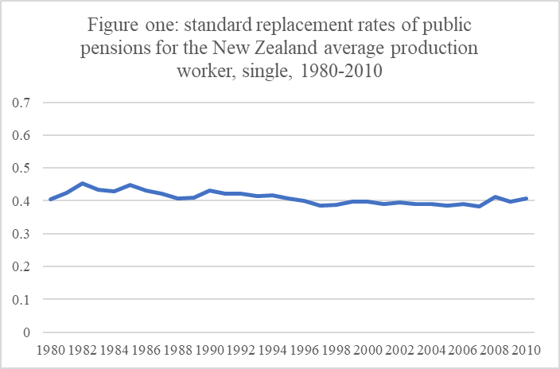

Source: CWED dataset

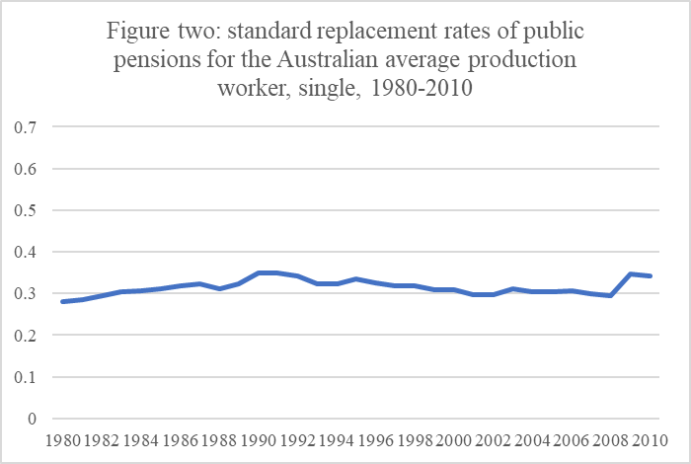

Source: CWED dataset

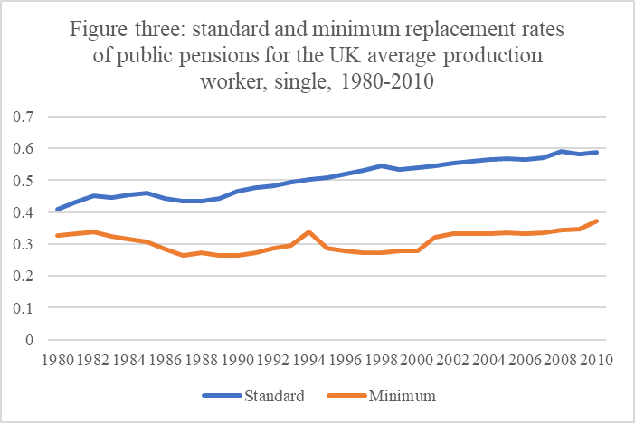

Source: CWED dataset

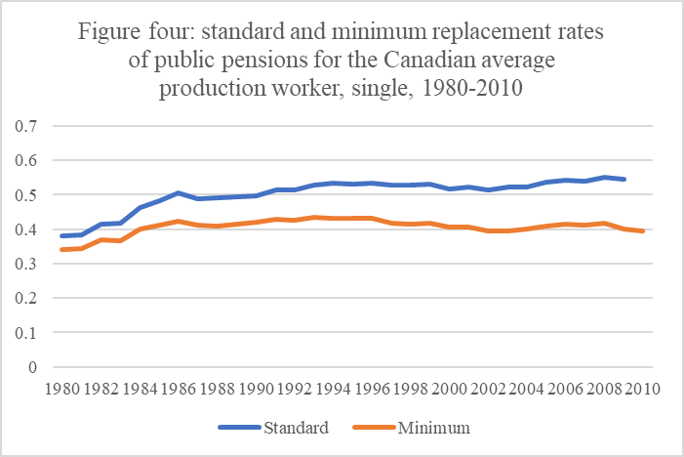

Source: CWED dataset

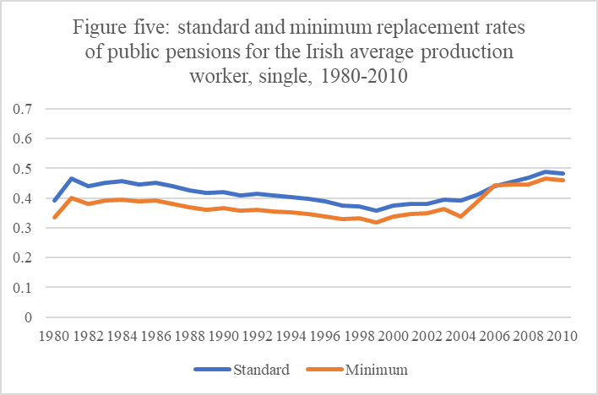

Source: CWED dataset

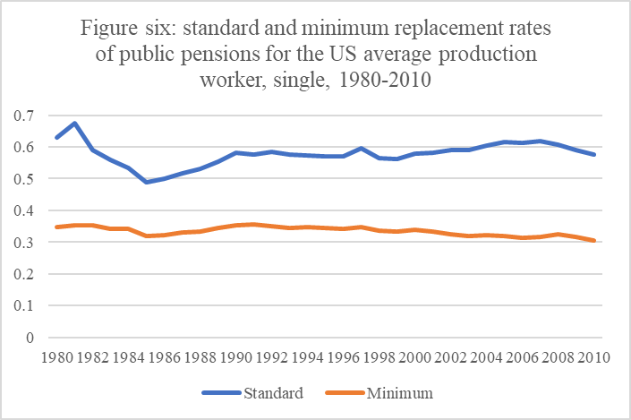

Source: CWED dataset

Notes

1. The Swiss and Danish pension systems in 1980 could also be considered to have significant liberal features, but constraints of space preclude their inclusion in this study.
2. **The CWED replacement rates of the public pension systems in Austria and Germany for the single standard production worker in 1980 were 77 per cent and 73 per cent respectively (Scruggs et al, 2014).**
3. Concerns about the reliability of the OECD’s pension data in relation to the consistency of the benefits measured between countries (De Deken and Kittel 2007: 82-4) have been addressed by the OECD by aggregating pension and survivors’ expenditure.
4. This problem can be addressed by the policy simulation of pension entitlements for hypothetical workers assuming they live their entire working life under current pension arrangements (eg OECD 2017), but unfortunately such data is only available from 2003.
5. The minimum pension an average production worker could receive in Australia is the same.
6. Full details are available in Myles and Pierson (2001).