Text for Parliamentary and Science committee
Can we end the threat of Anti-Microbial Resistance once and for all?
What is Anti-Microbial Resistance?
Microbes that exhibit Anti-Microbial Resistance (AMR) are resistant to existing disinfection cleaning or antimicrobial medication. Specifically, that is when bacteria, viruses, fungi and parasites (of, for example, the type that cause malaria) becoming respectively resistant to antibiotics, antivirals, anti-fungals, and anti-parasite drugs (the four categories of anti-microbial medication).
The inexorable increase of AMR threatens us as a society because (i) our increased expectations from healthcare (e.g. we expect treatments that would not be possible without effective antibiotics) and (ii) our overuse and in appropriate use of antimicrobial medication causes us increasingly to see more infections exhibiting AMR.
For thousands of years we relied on our skin to be our shield to protect us from the billions of microbes in our fields, food, and water. Infections did of course occur, usually when microbes got past the skin barrier via wounds and penetration, or when ingested or carried (often on dirty hands) to natural openings in our body (eyes, nose etc.). Prior to the second half of the 20th century, our use of antimicrobials was not on an industrial scale, so that whilst treatment affected the microbes present at the site of infection, it did not significantly affect the resistance of the billions of microbes in the reservoirs from which the infection usually originated (fields and forests, water supplies, sewage, food sources, people and animals etc.). Indeed, it could be argued that some bacteria already had some antibiotic resistance characteristics because of millions of years co-habiting with and fighting antibiotic-producing fungi, or surviving in environments that contained dilute forms of the agents we now use to kill microbes, and that the mechanisms they have to remove such chemicals from their cells coincidentally remove antibiotics as well.
Now, however, modern treatment has exacerbated the development of resistance in that reservoir, as a consequence of natural selection. When we inject or swallow anti-microbials, or use them routinely to wash hands and food etc., a dilute form of the chemical is urinated or washed into the water and sewage systems. From there it passes out into the vast reservoir of microbes in the wider world. There, the microbes that are susceptible to that drug or disinfectant are killed, shifting the balance of the surviving reservoir population so that a greater proportion are resistant to that agent, ready to cause future infections. Over time we therefore see an increased occurrence of AMR in infections that originate in that reservoir. (There are other routes by which a species can develop AMR, including direct transfer of genetic material, but here we will focus on the one outlined above because it is the a sufficient springboard for the arguments that follow and, in many ways, an engine that makes these other routes so much more devastating to society).

What are the implications of AMR?
Government-sponsored studies showed that, unless Anti-Microbial Resistance is tackled, it will by 2050 be causing more deaths than cancer and have cost the world economy more than the current size of the global economy [].
In my opinion the most important word in the above paragraph is ‘unless’. One view of ‘unless’ is optimistic, containing a tacit assumption that scientists will find new antibiotics etc., then pharmaceutical companies will roll these out to billions of people and animals in an affordable way, and when resistance to these develops (as it will, being prone to natural selection as described above), scientists will again find another antimicrobial drug. Note that treatment must be global, since (with for example increased air travel) your next serious infection could have originated from elsewhere on the planet [] (Figure 1).
Therefore, the yet-to-be-made discovery of a future new antibiotic (and news stories of such discoveries tend to be exaggerated) is only the start of the problem: the delivery of this new antibiotic on a global scale faces challenges, and if all this is accomplished, it might shift the 2050 date of the apocalypse on to perhaps 2065. As we approach this apocalypse, the political choices become particularly unpalatable: whilst it is excellent practice to avoid the unnecessary use of anti-microbials (to reduce the amount going into the wider world and promoting AMR through the natural selection process outlined above), as the apocalypse looms, logic raises horrific choices that cannot be forever postponed: do we ban the use of anti-microbials for pets? for farming and aquaculture? do some procedures for some patients become unsupported? Whilst logic produces these options, they are ethically appalling.
Figure 1. Maps showing increasing occurrence of resistance to the macrolide class on antibiotic as seen in samples of Streptococcus pneumoniae. The maps show the percentage (%) of invasive isolates non-susceptible to macrolides, by EU/EEA country, in (a) 2009 (from []) and (b) in 2016 (from [2]).

Can we avoid the apocalypse?
It is not enough simply to throw money at chemists and pharmaceutical companies, trusting in the optimistic interpretation of ‘unless’ outlined above. We must address the fact that the 32 years to the 2050 apocalypse is close on the timescale for scientific discovery and global roll-out: and indeed in 10 years the pain of climbing the foothills of the AMR mountain will be obvious to all. After all, it is not the case that the alarm bell has just been rung, so scientists can quickly marshal solutions: on his acceptance of the Nobel Prize for discovering penicillin, the first antibiotic, in 1945, Fleming spelled out the threat of AMR, saying ‘The time may come when penicillin can be bought by anyone in the shops. Then there is the danger that the ignorant man may easily underdose himself and by exposing his microbes to non-lethal quantities of the drug make them resistant’ []. Despite that warning 73 years ago, we have no solution, and indeed have discovered we promote AMR in other ways. Taking examples only from resistance to antibiotics, we promote AMR through use of antibiotics against viruses, and against bacteria that are not sensitive to that particular antibiotic; by using antibiotics as growth promoters in livestock and aquaculture and any changes in behaviour to circumvent rules against this []. Behaviour, and the social, cultural and financial pressures that drive this, underpin these drivers.
One way to hinder the development of AMR via natural selection is to prevent dilute forms of the agent that kills the microbes from reaching the reservoir population in the wider world. Whilst established internalized infections require drug treatment, one invention, StarStream, is aimed at preventing microbes from passing through our ‘skin shield’ by cleaning food, skin, surgical instruments and open wounds before those infections can become established, without the use of chemicals that act as ‘smoking guns’ in run-off that promote resistance developing in the wider world. StarStream is a handheld device (Figure 2) that sends microscopic air bubbles in a gentle stream of water, onto surfaces we wish to clean []. It is currently being used in an NIHR-funded trial for gently decontaminating surgical instruments and endoscopes without the need for aggressive chemicals. Sound, produced in the handheld unit, is projected down StarStream’s stream of water. That sound converts the spherical microbubbles into spiky, shimmering micro-scrubbing machines (Figure 3) which actively seek out the cracks and crevices that are particularly difficult to clean with chemicals, brushes and wipes. The scrubbing action of the bubbles removes the microbes and dirt from these crevices. StarStream’s air, water and sound are active only when combined at the tip of the water stream, when it reaches the surface to be cleaned. By the time they reach the drain, they have reconverted back to simply air and water (with no sound) so that no ‘smoking gun’ clues go down the drains to drive natural selection in the wider world’s microbe reservoir, and therefore no Anti-Microbial Resistance can develop.
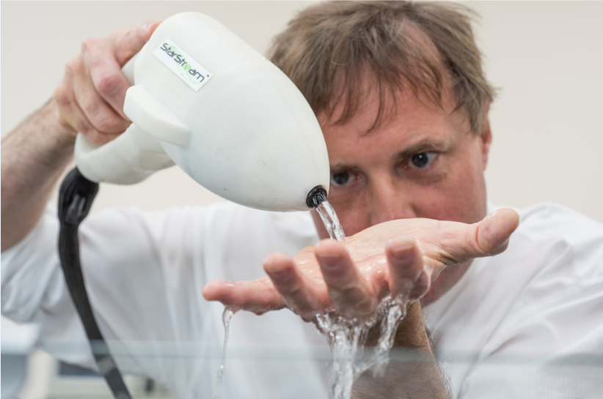
Figure 2. Professor Leighton demonstrates his invention by washing his hands with cold water and no soap.
Figure 3. A bubble containing ultrasonically-induced surface waves which move rapidly over the bubble surface, ‘scrubbing’ the surroundings
The automatic response to, say, a bacterium, is to think about killing it, but we are in fact used to thinking in terms of beneficial bacteria in the gut, and know that our gut will not work perfectly if we harm these through, for example, taking oral antibiotics. A large proportion of our skin is also made up of beneficial bacteria, and if we harm these our skin will suffer, and we could (ironically) become more open to infection. We are working on ultrasonic devices which preserve these beneficial bacteria, whilst dislodging harmful ones from our skin.
Another device, StarHealer, not only cleans wounds, but also causes skin to grow over the wound very much more rapidly than would normally occur, restoring the ‘skin shield’ and so preventing infection. Equipped with a StarHealer nozzle that can attach to any bottle of drinking water, an army medic, rescue worker, rural healthcare worker or first responder could not only clean a wound prior to transportation to hospital, but promote rapid regrowth of skin over it, preventing further infection (Figure 4). This would reduce the likelihood of sepsis setting in in the time between injury and transportation to hospital (500,000 patients with severe sepsis are treated annually in US emergency departments [], 100,000 of which are children [, ]).
 |  | 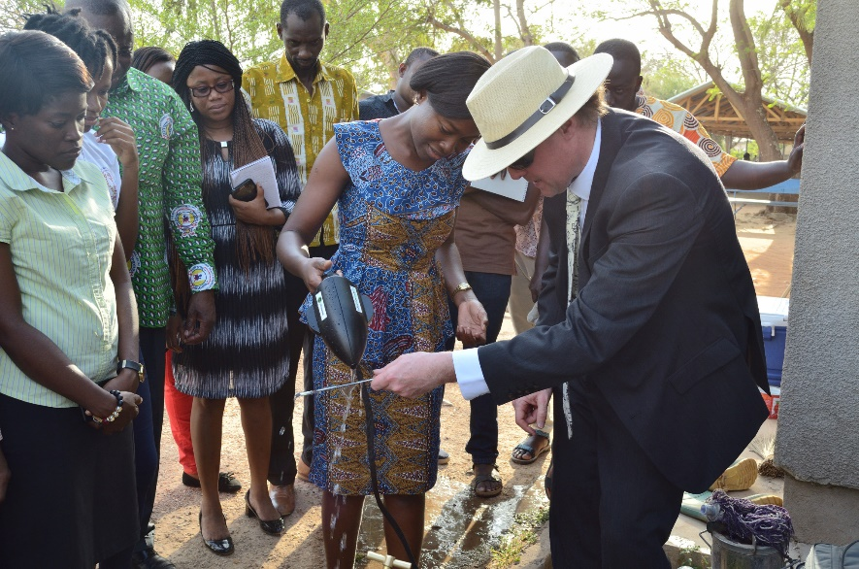
(a) | (b) | (c)
Figure 4. (a,b) Concept for a battery-powered solar-charged UAS device that can fit onto any bottled drinking water unit. For the video see https://youtu.be/o903Yey71L4 (c) Professor Leighton in rural Ghana in March 2018 demonstrating to healthcare and demographic surveillance staff how his technology can clean using just cold water.

These examples, all of which focus on infection prevention to avoid treatment of an established infection, illustrate that there are sometimes options to the use of anti-microbials, options that reduce the risk of resistance developing. However, to enable research breakthroughs to benefit society, they need to be designed to be easy-to-use by the end-user, cost-effective, and amenable for manufacturing on a large scale in the form of reliable products. Conducting game-changing research and translating it to benefit society are at the core of NAMRIP, the Network for Anti-Microbial Resistance and Infection Prevention [], a network of over 200 researchers including engineers, chemists, microbiologists, environmental scientists, veterinary and human medics, clinicians, experts in food, ethics and law, crucially networked with economists, geographers, health scientists and experts from other social sciences. Our members also include people from hospitals, veterinarian practices, industries, charities and policy-making bodies, because of the imperative to translate research as well as conduct and publish it. Membership has spread across the UK, and one year ago we formed Global-NAMRIP [], with members across four continents. NAMRIP builds the right multidisciplinary consortium to identify (with end user input) the real problem, and design an effective solution that is not going to be unusable because of end user constraints in terms of training, infrastructure, economics, scalability, culture, social mores etc.
In NAMRIP, we have an award-winning programme for engagement with the Public and Policymakers, which includes a permanent exhibition that was mentioned by Steve Brine MP, the Under-Secretary of State for Health [, ] (Figure 5). Dialogue with the public is vital because many people outside of science have been poorly educated to believe AMR is the development of resistance to antibiotics by humans. This is not only incorrect, but encourages the very behaviour that promotes the growth of AMR. We have not learned the lesson Fleming gave us, more than 70 years ago, in his 1945 Nobel Prize acceptance speech.

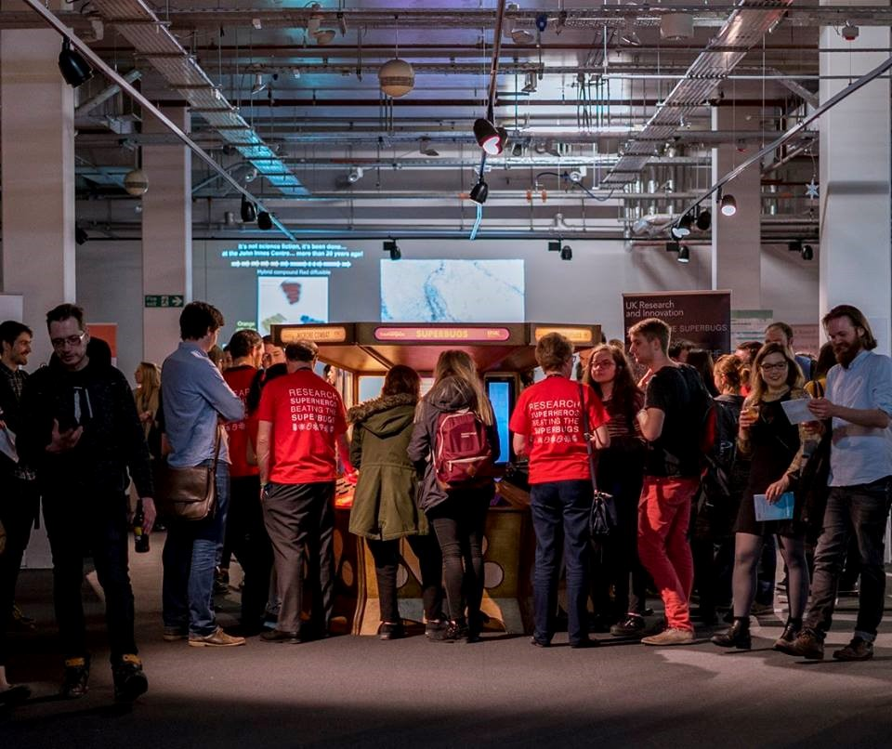
Figure 5. The public play ‘The Most Dangerous Game in the World’ at the Science Museum to learn about AMR.

O’Neill J et al. (2016) Tackling drug-resistant infections globally: final report and recommendations. Final report of the Review of AntiMicrobial Resistance (May 2016), https://amr-review.org/sites/default/files/160525_Final%20paper_with%20cover.pdf (last accessed 11 June 2017).
European Centre for Disease Prevention and Control (2017). Antimicrobial resistance surveillance in Europe 2016. Annual Report of the European Antimicrobial Resistance Surveillance Network (EARS-Net). Stockholm: ECDC; 2017. doi 10.2900/296939 https://ecdc.europa.eu/en/publications-data/antimicrobial-resistance-surveillance-europe-2016
European Centre for Disease Prevention and Control (2010). Antimicrobial resistance surveillance in Europe 2009. Annual Report of the European Antimicrobial Resistance Surveillance Network (EARS-Net). Stockholm: ECDC; 2010. doi 10.2900/35994 https://ecdc.europa.eu/en/publications-data/antimicrobial-resistance-surveillance-europe-2009
Fleming, A (1945) Penicillin. Nobel Lecture, December 11, 1945. https://www.nobelprize.org/nobel_prizes/medicine/laureates/1945/fleming-lecture.pdf
Cogliani, C, Goossens H and Greko C (2011) Restricting Antimicrobial use in food animals: Lessons from Europe. Microbe, 6(6), 274-279 http://emerald.tufts.edu/med/apua/about_us/publications_21_3573465644.pdf
Leighton, T. G. (2018) Cold water cleaning in the preparation of food and beverages: The power of shimmering bubbles. Baking Europe Summer 2018, pp. 24-28 http://www.bakingeurope.eu/previews/2018/BakingEurope-Summer-2018.pdf
Wang H E, Shapiro N I, Angus D C and Yearly D M (2007) National estimates of severe sepsis in United States emergency departments Crit. Care. Med. 35(8) 1928–36.
Singhal S, Allen M W, McAnnally J R, Smith K S, Donnelly J P and Wang H E (2013) National estimates of emergency department visits for pediatric severe sepsis in the United States PeerJ. 1 e79. doi: 10.7717/peerj.7
Horeczko T, Green J P and Panacek E A (20)14 Epidemiology of the Systemic Inflammatory Response Syndrome (SIRS) in the emergency department West J Emerg Med. 15(3) 329-36 doi: 10.5811/westjem.2013.9.18064
NAMRIP (2015) NAMRIP home page http://www.southampton.ac.uk/namrip/index.page (last accessed 11 June 2017).
NAMRIP (2016b) Global NAMRIP web page http://www.southampton.ac.uk/namrip/about/globalnamrip.page? (last accessed 11 June 2017)
https://parliamentlive.tv/event/index/0dbfadce-2829-4ed1-b45a-82bb41c4ed70?in=14:34:58&out=14:35:56
https://hansard.parliament.uk/Commons/2017-11-16/debates/141BEBCB-C1F8-4BA7-ABF5-9186CAAC49F9/WorldAntibioticsAwarenessWeek

