**Investigation on the orientation dependence of elastic response in Gyroid cellular structures**

Lei Yang a, b, Chunze Yan a,[1], Haiyang Fan b, Zhaoqing Li a, Chao Cai a, Peng Chen a, Yusheng Shi a, Shoufeng Yang b, c,*

*a State Key Laboratory of Materials Processing and Die & Mould Technology, School of Materials Science and Engineering, Huazhong University of Science and Technology, Wuhan 430074, China*

*b Department of Mechanical Engineering, KU Leuven (Catholic University of Leuven), Leuven 3001, Belgium, Member of Flanders Make*

*c Materials Research Group, Faculty of Engineering and the Environment, University of Southampton, Southampton, UK, SO17 1BJ*

**Abstract:** Materials used for hard tissue replacement should match the elastic properties of human bone tissue. Therefore, cellular structures are more favourable for the use of implants than solid materials for their custom-designed mechanical properties. The superimposed load from various directions in vivo makes uniaxial compression testing insufficient for describing the mechanical responses. In this paper, the rotational symmetry of Gyroid cellular structure (GCS) was discussed. An approach using structural simplification and analytical solution was presented to investigate the relationship between Young's modulus and volume fraction, as well as the orientation dependence of the mechanical responses for GCS loaded in various orientations. It is concluded that the analytical solution is reasonable for a low volume fraction, through the comparison between analytical results, finite element (FE) and experimental data. Gained polar diagrams illustrate the anisotropic property of GCS and also confirm the superiority for their stable mechanical responses of diverse loading directions.

**Keywords:** Triply Periodic Minimal Surface, Gyroid cellular structure, analytical solution, Young's modulus

**Nomenclature**

|  |  |
| --- | --- |
| *a* | Unit cell size of GCS |
| *D* | Minimum diameter of struts in GCS |
| *L* | Strut length of GCS |
| *θ* | The angle between inclined struts and the horizontal plane, which is perpendicular to the loading direction |
|  | Volume of GCS |
|  | Total volume of the cubic occupied by GCS |
|  | Volume fraction of GCS, equal to |
|  | Compression stress of GCS along the loading direction |
|  | Compression strain of GCS along the loading direction |
| *P* | Total force applied to an arbitrary unit cell |
| *F* | The force applied to an inclined strut |
| *M* | The moment of force |
|  | The deflection of a cantilever beam |
|  | The deflection of the inclined strut |
| *I* | The inertia moment of struts |
|  | Timoshenko shear coefficient |
|  | Shear modulus of matrix material |
|  | Young’s Modulus of GCS |
|  | Young’s Modulus of matrix material |
|  | Relative modulus of GCS, equal to |
|  | Poisson’s ratio of matrix material |

## 1 Introduction

Biological metal materials, like stainless steel (International, 2003), Co-Cr alloy (Delaunay et al., 2010), titanium and its alloys (Nag et al., 2005; Sidambe et al., 2012), are widely used in clinical applications for orthopedic implants for a long time due to their high biocompatibility and non-allergic tissue response. Nevertheless, there are still some complications associated with mismatching of elastic properties between implants and surrounding tissue, known as stress shielding (Engh et al., 1987). In order to release the stress shielding as well as enhance the stability of the implants, the structure and Young's modulus should be optimized to the same level of surrounding tissue. Recently, low-modulus, non-toxic β-type titanium alloys, regarded as the next generation implant materials, have been developed for biomedical applications, such as Ti-24Nb-4Zr-8Sn (Ti2448) (Hao et al., 2005), Ti-35Nb-7Zr-5Ta (TNZT) (Qazi et al., 2005), and Ti-29Nb-13Ta-4.6Zr (TNTZ) (Niinomi, 2003). However, they still possess Young’s moduli (33-60 GPa) higher than that of human bone (ranging from 3.07 to 20 GPa for cortical bone and 3.27 to 10.58 GPa for trabecular bone) (Choi et al., 1990; Grimal et al., 2009; Heinl et al., 2008; Sevilla et al., 2007; Yang et al., 2001, 2002).

Cellular structures can be custom-designed and fabricated to arbitrary geometrical structures with a wide range of materials, shapes and mechanical properties, via additive manufacturing (AM) technologies, such as selective laser melting (SLM) (Hasan and Mines, 2016; Vivien J. Challis et al., September 2010; Wysocki et al., 2016), electron beam melting (EBM) (Stevenson et al., 2016; Yanez et al., 2016; Zhao et al., 2016b), extrusion free forming (Grida and Evans, 2003; Lu et al., 2009; Yang et al., 2006; Zhong et al., 2017), etc. Furthermore, the porosity of cellular structures provides an excellent environment for osteoblast proliferation and tissue growing, which will facilitate vascularization (Karageorgiou and Kaplan, 2005). All these advantages make cellular structures a promising solution for biological applications of implants. The mechanical properties, as well as the biological performance of cellular structures are dependent on their geometric features such as the type of unit cell, unit cell size, porosity, loading direction (Li et al., 2014; Van Bael et al., 2012). It is, therefore, crucial to generating a library including all kinds of cellular structures that could be used for tissue engineering and also study all the influencing factors.

To date, through uniaxial compressive tests, most efforts have been made in establishing the correlation of Young's modulus of the cellular structure with unit cell topology (Campoli et al., 2013b; Li et al., 2014; Maskery et al., 2016; Zhao et al., 2016a), unit cell size (Maskery et al., 2015; Yan et al., 2012; Yan et al., 2015b) and porosity (Amin Yavari et al., 2015; Campoli et al., 2013b; Smith et al., 2013), etc. However, little attention has been paid to the orientation dependence of different unit cells (Choy et al., 2017; Luxner et al., 2005; Weißmann et al., 2016). Moreover, the physiological environment is dissimilar from that of uniaxial mechanical testing (Wieding et al., 2013). The implants are presented within a superimposed loading situation with load vectors coming from different directions (Weißmann et al., 2016). For most cellular structures, the strut orientation and the loading angle play crucial roles in the evaluation of cellular structures (Campoli et al., 2013a; Gibson et al., 1982). Therefore, the mono-directional mechanical behavior determined solely from uniaxial testing does not fully represent the elastic property of anisotropy materials in elusory environments.

Gyroid belongs to Triply Periodic Minimal Surfaces (TPMS) that are considered as versatile sources of biomorphic scaffold designs. The Gyroid cellular structure (GCS), inheriting the smooth surface and uniform curvature radius from TPMS, shows biomorphic design and high manufacturability in AM technologies (Hao et al., 2012; Yan et al., 2012). Elastic properties of GCS with specific designs are close to those of trabecular and cortical bones, as verified from experiments (Yan et al., 2015a), making it one of the most promising biomaterial structures. However, most studies on GCS have focused only on the mechanical responses of cellular structures in three equivalent principal directions with experiments (Kapfer et al., 2011; Maskery et al., 2017; Montazerian et al., 2017; Yan et al., 2012). The correlation of the mechanical response and loading direction has not been well understood yet.

For most commonly used biomaterial cellular unit cells, the manufacturability, mechanical responses, fatigue and fracture properties have been extensively studied, and analytical relationships were reported for evaluating the mechanical properties of cellular structures made from those unit cells (Ahmadi et al., 2014; Alsalla et al., 2016; Gibson and Ashby, 1997; Hedayati et al., 2016b). However, to the best of our knowledge, there is currently little investigation on analytical relationships to predict the mechanical properties of GCS. In this paper, Young's moduli of GCS at different loading directions were analyzed via analytical and finite element (FE) methods, trying to gain knowledge about the anisotropic mechanical behavior of GCS. Models of GCS were designed by commercial software MATLAB. The rotational symmetry property was discussed and a simplified lattice structure with identical cell size and topology relationship was obtained by structural optimization. Then, the relationships between volume fraction and Young's modulus at each direction were investigated, respectively. Furthermore, the anisotropic property of GCS was studied by comparing modulus values at different orientations in planes. Besides, one of the GCS Ti-6Al-4V was manufactured by SLM and used to verify the analytical and FE methods.

## 2 Methodologies and experiments

2.1 Geometric properties of GCS

The surface of GCS can be expressed as:

 (1),

where *a* is the unit cell size, and parameter *t* controls the volume surrounded by the Gyroid surface (Scherer, 2013).

Fig. 1(a) shows the mathematically modelled Gyroid unit cell. Based on the knowledge of material crystallography, the directions of [100], [010] and [001] are defined in the figure. Inherited the I4132 symmetric property from the Gyroid surface, the directions of the same crystallographic family are equivalent for GCS, which means that GCS in the directions of [001], [010], [100], [00], [00], and [00] present identical mechanical properties. Similarly, GCS in the directions of <110> crystallographic family and <111> crystallographic family show the same elastic properties, respectively. Besides, GCS inherits the rotational symmetry properties which have a series of  ,  and  rotation axes of symmetry. Fig. 1 (b) to (d) show different rotational symmetry properties along different view directions of [100], [111] and [110], respectively. In this paper, the orientation dependence of elastic response in GCS was investigated via analytical method through defining the three axes of symmetry as the load bearing direction.

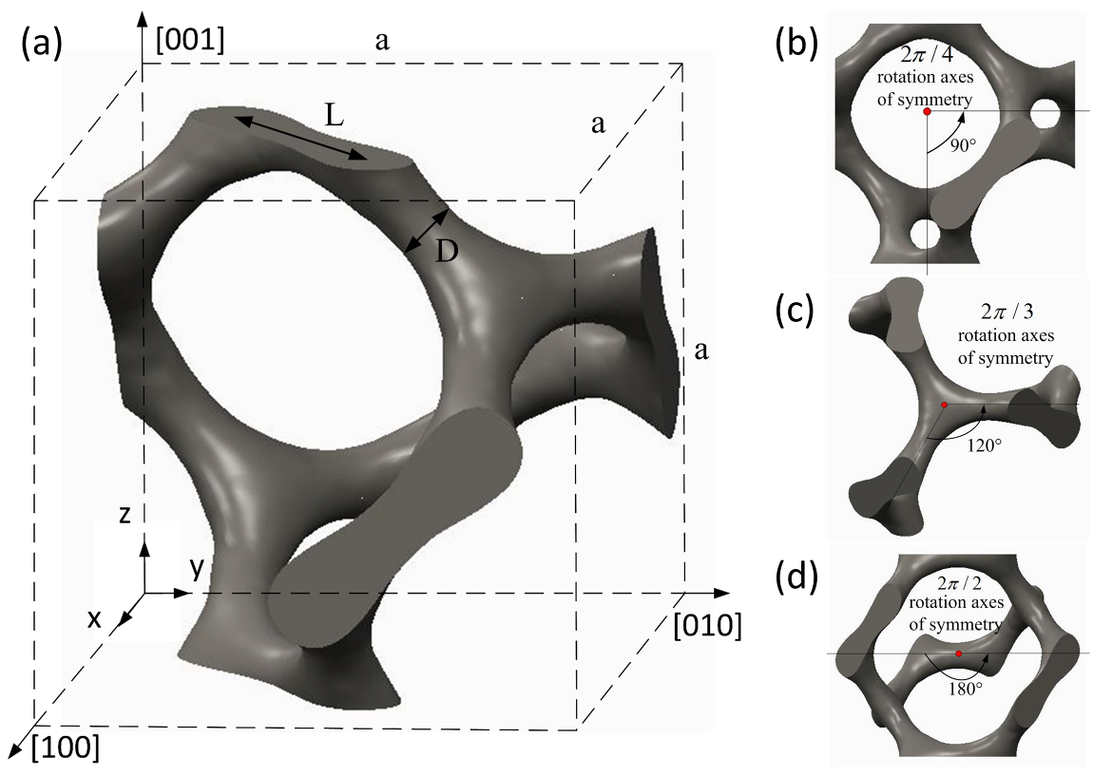

Fig. 1. The mathematically modelled Gyroid unit cell: (a) a Gyroid unit cell with the cell size of *a*, (b) view along [001] direction, (c) view along [111] direction, and (d) view along [110] direction.

2.2 Simplification of GCS

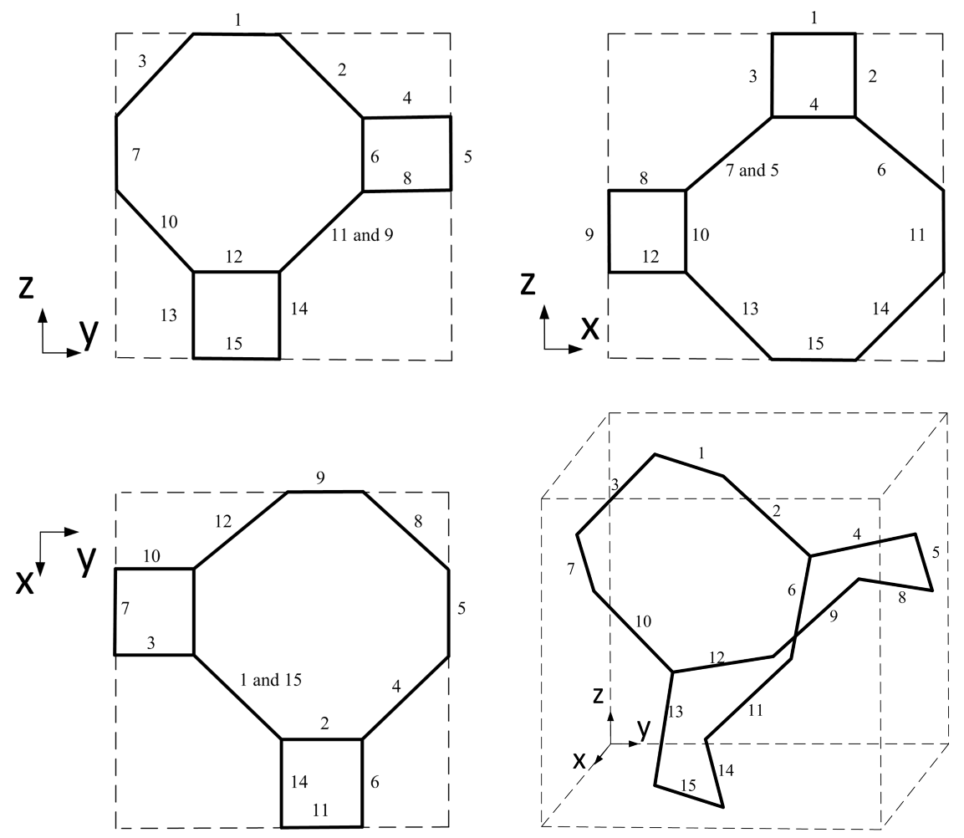

Fig. 2. Schematics of the Gyroid unit cell with different views. All the struts in the unit cell are numbered in figures.

Since the geometrical characteristics of GCS with continuously changing surface are complicated, the calculation of Young's modulus directly through the analytical model, as what has been done in other strut-based lattice structures (Ahmadi et al., 2014; Hedayati et al., 2016a; Wieding et al., 2014), is difficult to be employed herein. In this paper, the central axis of each strut was extracted and a schematic of one Gyroid unit cell was gained to show the topology relation of struts in Fig. 2, which is also observed straightforwardly when the volume fraction of GCS is less than 4% (Khaderi et al., 2014).

As shown in Fig. 2, there are 15 struts in one Gyroid unit cell, while each joint is connected to three other joints and the angle between every two struts is 120°. Six struts with the number 1, 5, 7, 9, 11, and 15 are on the six surfaces of the cubic, meaning that these struts are shared by both the unit cell and the neighbor unit cell. Every strut is parallel to one datum plane and owns 45°included angle with the other two datum planes. For example, strut number 1 is parallel to the x-y datum plane and at an angle of 45°with respect to the x-z and y-z datum planes. Define z axis as the loading direction, then the relationships between the length of each strut, *L*, the length of the unit cell, *a*, and the angle between struts and the horizontal plane, *θ*, can be expressed as:

 (2)

Based on the topology relationships shown in Fig. 2, simplified models of GCS is established, where struts with continuously changing diameter are simplified to circular struts with a uniform diameter, shown in Fig. 3(a). In the simplified model, it is supposed that the stiffness mostly depends on the minimum cross-section, thus, the diameter of struts is equal to the minimum diameter of the original Gyroid struts. Meanwhile, topology relations in GCS have been preserved in the simplified model.

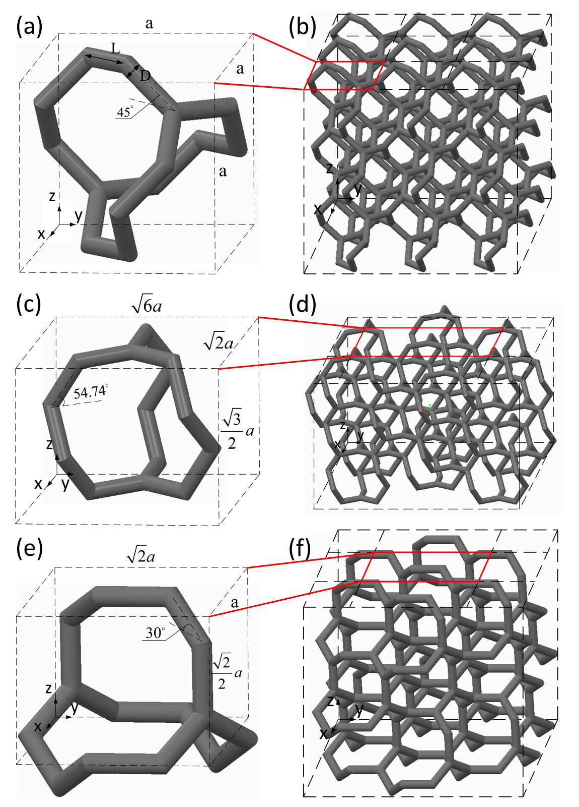

Fig. 3. Schematic of simplified Gyroid unit cells and GCS: (a) unit cell and (b) GCS with [001] loading direction, (c) minimum repeatable cubic and (d) GCS with [111] loading direction, and (e) minimum repeatable cubic and (f) GCS with [110] loading direction

To investigate the orientation dependence of GCS, three axes of symmetry in Fig. 1 were defined as the loading directions, respectively. Regenerated Simplified Gyroid (SG) unit cells and Simplified Gyroid cellular structures (SGCS) at different loading directions were shown in Fig. 3. As shown, Fig. 3(a) and (b) are the original orientation with the [001] direction as the loading direction, while Fig. 3(c) - (f) define [111] and [110] as the loading directions, respectively. In all figures, the loading directions are along z axis.

The volume fraction or relative density of the cellular structure is defined as the ratio of cellular density to the density of the bulk material or the ratio of total volume of the cellular to the volume of the corresponding bulk material (Gibson and Ashby, 1997). The SG unit cell with the original orientation is used to calculate volume fraction. Since every Gyroid unit cell is connected to additional 6 unit cells by a shared strut on each surface of the cubic, the shared strut should be considered as half strut. Thus, the total volume of all struts in one unit cell is given by:

 (3)

Here the overlaps of the end of struts have been ignored in the first instance. The influence of the overlaps will be discussed in section 3.1.

The total volume of the cubic,, is given by:

 (4)

The volume fraction is, therefore, given by:

 (5)

where D is the minimum diameter of struts, as shown in Fig. 1(a).

2.3 Young's modulus calculations

In this paper, the bulk material is assumed to be linear elastic. The Young's moduli of GCS are calculated using both the Euler–Bernoulli and Timoshenko beam theories (Timoshenko and Goodier, 1970; Young and Budynas, 2002).

**2.3.1 Load bearing direction of [001]**

As shown in Fig. 4, let be the compression stress along the z direction. Then the total force transmitted to an arbitrary unit cell is. Suppose there are infinite unit cells in three repeating directions, then due to symmetry, there is no difference between the point A and C in the horizontal strut AC and each inclined strut carries  with a bending moment.

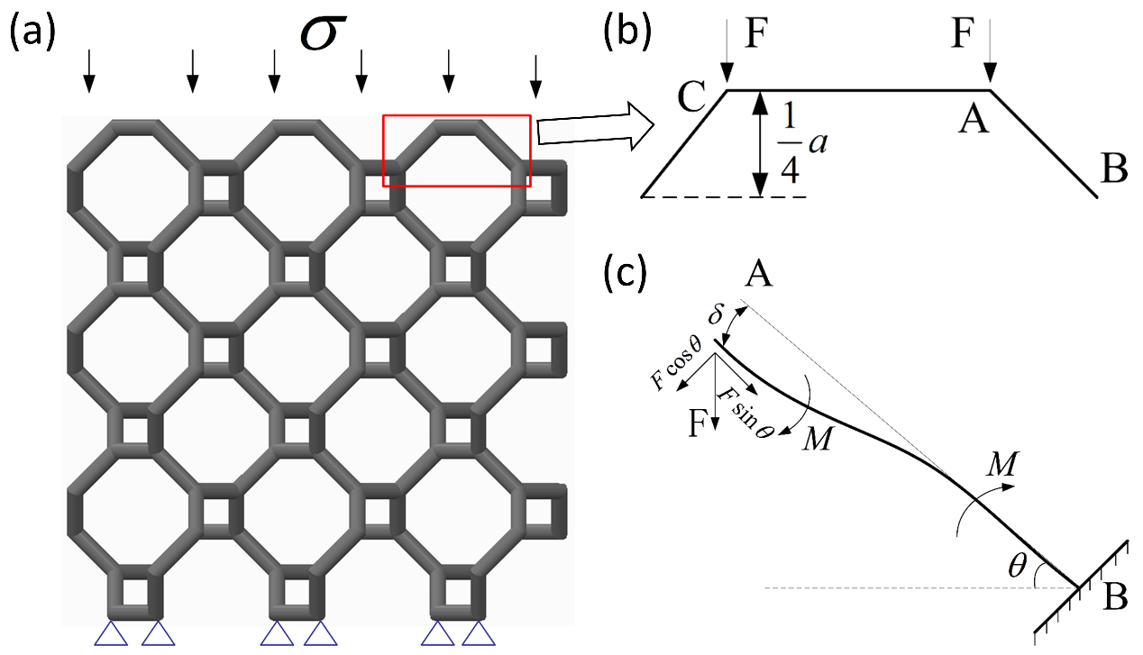

Fig. 4. Schematic of SGCS loaded in [001] direction: (a) The boundary conditions of the cellular structure with [001] loading direction, (b) the forces applied to a quarter model of an arbitrary unit cell, and (c) free body diagram of an inclined strut.

The total deformation of a unit cell in the z direction consists of 4 times of the structural deformation indicated in Fig. 4(b). For strut AB, the force condition was shown in Fig.4 (c). There are two types of deformations, that is bending and stretching, which are due to the bending moment and axial force, respectively. As for the bending deformation, according to the Euler-Bernoulli beam theory (Young and Budynas, 2002), the deflection at the end of a cantilever beam with the length of *l* and loading force of *F1* can be calculated as:

 (6)

So, for beam AB in Fig. 4(c), the deflection at point A caused by bending is:

 (7)

The displacement component in z direction is:

 (8)

where  is the inertia moment of the strut and is the Young's modulus of the matrix material.

For the struts of SGCS investigated in this paper, the slenderness ratio is not as large as the value, at which shear deformation of a beam could justifiably be ignored (Brassey et al., 2013; Turner and Burr, 1993). Thus, deformation values of struts calculated using Euler–Bernoulli theory are likely to be underestimated. Therefore, considering the deflection caused by shear deformation, the final deflection calculated by Timoshenko beam theory (Timoshenko and Goodier, 1970) can be given by：

 (9)

where  is Timoshenko shear coefficient, and according to Cowper (Cowper, 1966) for the solid circular cross-section, .  is the shear modulus, and *A* is the cross-section area of the strut. Thus, the displacement component of strut AB caused by shear deformation at z direction is:

 (10)

Besides, the deformation of a strut as a result of the axial force is given by:

 (11)

The displacement component at z direction is:

 (12)

So, the total deformation of the strut in the z direction can be obtained as the sum of above-mentioned deformations at z direction:

 (13)

The total deformation of the unit cell at the z direction is 4 times of the deformation:

 (14)

For the unit cell, the strain is defined as the ratio of the deformation of the unit cell in the z direction and the length of the unit cell: .

So the Young's modulus of GCS can be calculated by dividing the stress by the strain:

 (15)

Thus, it is possible to derive the ratio of the Young's modulus of the unit cell to that of the matrix materials as:

 (16)

Substituting the value of *θ*, the equation was obtained as:

 (17)

**2.3.2** **Load bearing direction of [111]**

For [111] direction, the minimum repeatable cubic and the final dimension used to calculate the Young's modulus is shown in Fig. 3(c), in which the struts on the border of the unit cell is hidden.

Compared to the above analysis for [001] loading direction, the dimension is changed to, and the angle between inclined struts and the horizontal plane is.

Being the same as the above analysis, let be the compression stress in the z direction, so the total force transmitted to an arbitrary unit cell is. Due to symmetry, there would be 6 inclined struts (2 struts and 2 half struts have been hidden in Fig. 3(c)) bearing the force and each inclined struts carries, as shown in Fig. 5(a) and (b).

Through using the beam theory and substituting the value of *θ*, the final equation of relative modulus can be expressed by:

 (18)

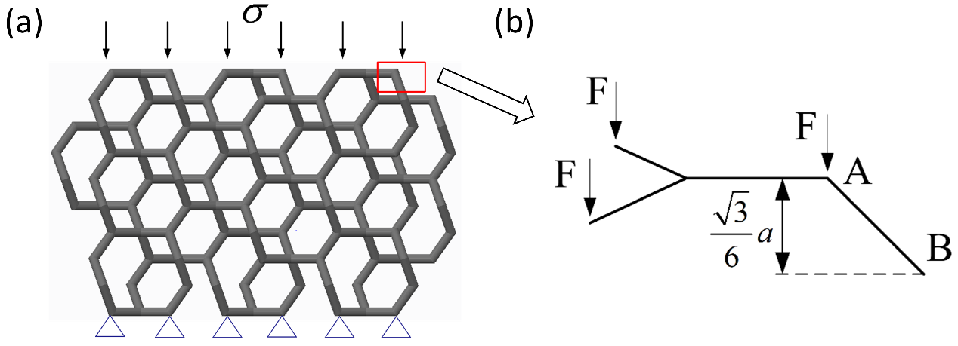

Fig. 5. Schematic of SGCS loaded in [111] direction: (a) The boundary conditions of the cellular structure with [111] loading direction and (b) the forces applied to one-third model of an arbitrary unit cell.

**2.3.3 Load bearing direction of [110]**

Being similar with the analysis for [111] direction, the minimum repeatable cubic was gained and shown in Fig. 3 (e). The dimension is, and the angle between inclined struts and the horizontal plane is. The total force transmitted to an arbitrary unit cell is. Due to symmetry, there would be 4 inclined struts (4 half struts have been hidden in Fig. 3(e) bearing the force and each inclined strut carries.

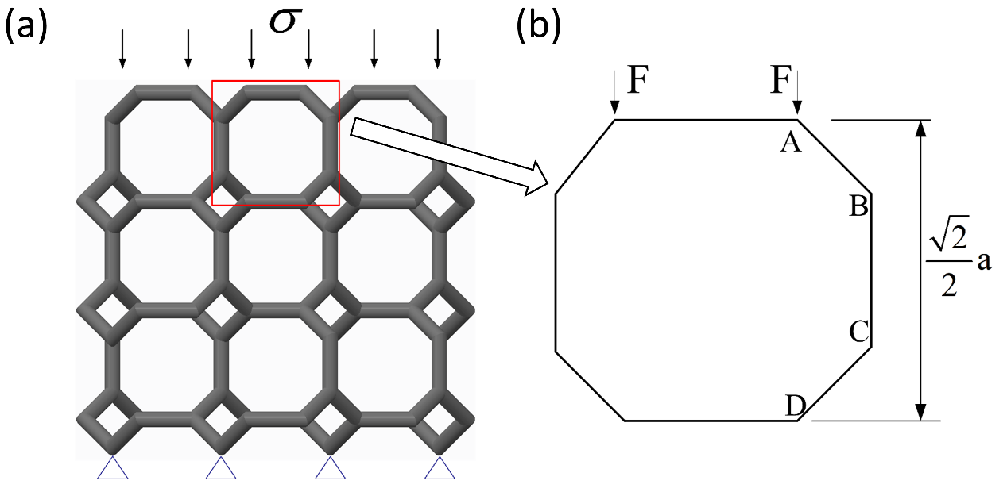

Fig. 6. Schematic of SGCS loaded in [110] direction: (a) The boundary conditions of the cellular structure with [110] loading direction and (b) the forces applied to an arbitrary unit cell.

The total deformation of the unit cell at the z direction comprises the deformations of two inclined struts and one upright strut, as shown in Fig.6. For each inclined strut, the total deformation is the sum of the deformation caused by the bending moment and axial force:

 (19)

For the upright strut, the axial deformation is:

 (20)

In consequence, the total deformation of the unit cell in the z direction is:

 (21)

The final equation can be obtained as:

 (22)

2.4 Finite element methods

To investigate the moduli of SGCS with different relative densities, a series of models with volume fractions of 5%, 7.5%, 10%, 12.5%, and 15% were generated at three loading directions of [001], [111], and [110], respectively. The unit cell size of these models is 3mm and the final dimension of each model is 12mm×12mm×12mm with 4 unit cells in three repeating directions, above which the number of unit cells does not significantly influence the stiffness of cellular structure (Vijayavenkataraman et al., 2017). FE method was used to estimate the mechanical properties of GCS with commercial software, DEFORM-3D (DEFORM, 2006).

SG cellular models were placed between two parallel plates which were regarded as rigid material. The bottom plate remained stationary while the top plate moved downward at a constant speed to compact the specimen by 30%. A strain rate of 0.1% was used to represent the steady-state response of GCS under uniaxial compressive testing, according to ISO 13314 (Standard). The strengthening mechanism adopted in this work is Johnson-Cook (JC) strength (Johnson and Cook, 1985), which is commonly used in the dynamic response analysis of materials. The 3D solid element of the 4-node tetrahedral type was employed to mesh the lattice models with six degrees of freedom per node in this simulation process. A convergence study was conducted to determine the element size, and 0.15mm was chosen.

Table 1

Models for assessing the orientation dependence in the (100), (110), and (111) planes.

|  |  |  |  |  |  |  |  |
| --- | --- | --- | --- | --- | --- | --- | --- |
| (100) plane | | | | | | | |
| Orientation | [001] | Rotate 15° | Rotate 30° | [011] | Rotate 60° | Rotate 75° | [010] |
| Unit cell  coordinate | ROTATE-0 | ROTATE-15 | ROTATE-30 | ROTATE-45 | ROTATE-60 | ROTATE-75 | ROTATE-90 |
| Cellular  coordinate | C:\Users\yangl\AppData\Local\Microsoft\Windows\INetCache\Content.Word\100-rotate-0.tif | C:\Users\yangl\AppData\Local\Microsoft\Windows\INetCache\Content.Word\100-rotate-15.tif |  |  | C:\Users\yangl\AppData\Local\Microsoft\Windows\INetCache\Content.Word\100-rotate-30.tif | C:\Users\yangl\AppData\Local\Microsoft\Windows\INetCache\Content.Word\100-rotate-15.tif | C:\Users\yangl\AppData\Local\Microsoft\Windows\INetCache\Content.Word\100-rotate-0.tif |
| (110) plane | | | | | | | |
| Orientation | [001] | Rotate 15° | Rotate 30° | Rotate45° | Rotate 60° | Rotate 75° | [110] |
| Unit cell  coordinate | 110 | 110-rotate15 | 110-rotate30 | 110-rotate45 | 110-rotate60 | 110-rotate75 | 110-rotate90 |
| Cellular  coordinate | C:\Users\yangl\AppData\Local\Microsoft\Windows\INetCache\Content.Word\100-rotate-0.tif | C:\Users\yangl\AppData\Local\Microsoft\Windows\INetCache\Content.Word\110-rotate-15.tif |  |  |  |  | C:\Users\yangl\AppData\Local\Microsoft\Windows\INetCache\Content.Word\100-rotate-45.tif |
| (111) plane | | | | | | | |
| Orientation | Rotate 0° | Rotate 15° | $$[\overline{1}0\overline{1}]$$ | Rotate45° | Rotate 60° | Rotate 75° | $$[\overline{1}10]$$ |
| Unit cell  coordinate |  |  |  |  |  |  |  |
| Cellular  coordinate |  |  |  |  |  |  |  |

For the characterization of anisotropic material properties of GCS, spatial orientation in (100) plane of the unit cell has been rotated gradually to make the loading direction varying from [001] to [010]. The final cellular structures are shown in Table 1. These models were utilized to simulate and studied the direction dependence of GCS in the (100) plane. Other loading directions were also modelled and simulated analogously to study the direction dependence in the (110) and (111) planes, as shown in Table 1. For (111) plane, all the calculated models are shown in Fig. 11 and not fully listed here.

2.5 Experimental verifications

The Ti-6Al-4V GCS specimens with the dimension of 25mm×25mm×12.5mm were fabricated using HK M250 selective laser melting (SLM) machine (Huake 3D Technology Co. Ltd. China). The SLM processing parameters were optimized and summarized in Table 2. The whole processing procedure was in a nearly anaerobic environment with less than 0.1% oxygen and a pre-heating temperature of 150℃. An alternating hatch pattern was applied as the scanning strategy, where the direction of scanning was rotated 67° between consecutive layers. One of the final GCS is shown in Fig. 7. Due to limited resources in this project, only the [001] loading direction with a volume fraction of 10% is experimentally tested to verify the analytical and FE results. More experimental verification will be reported in another related work (Yang et al.). Uniaxial compression tests were carried out on AG-IC100 KN Electronic Universal Testing Machine (SHIMADZU, Japan), with a constant loading rate of 0.0125mm/s, which is equal to an axial strain rate of about 10-3/s. The compression responses were recorded and used to calculate the stress-strain curves of TMPS cellular structures.

Table 2

SLM processing parameters for the Ti-6Al-4V alloy powder

|  |  |  |  |  |
| --- | --- | --- | --- | --- |
| Laser power  (W) | Scanning speed  (mm/s) | Spot size  ($μm$) | Layer thickness  ($μm$) | Hatch spacing  ($μm$) |
| 170 | 1250 | 100 | 30 | 60 |

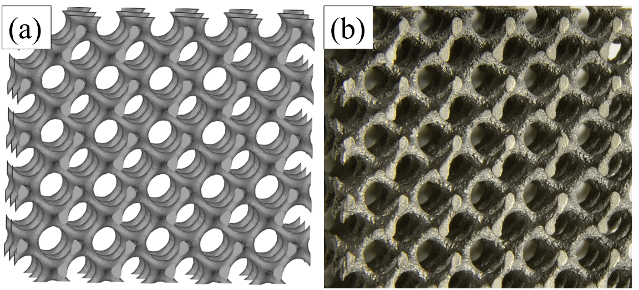

Fig. 7. a) The CAD model used for manufacturing GCS and b) one of the resulting samples.

## 3 Results and Discussion

3.1 Volume fractions of GCS

For the original GCS, Eq. (1) describes the 3D surface, which is considered as the boundary between void and solid material. There is a nearly linear relationship between volume fraction and parameter *t*, which has already investigated by Scherer et al. (Scherer, 2013).

In this work, a series of GCS was generated using commercial software MATLAB and simplified to strut-based SGCS. The volume fractions of SGCS were derived through Eq. (5). The results were presented in Fig. 8 and compared with those of original GCS. As shown in Fig. 8, the prediction by Eq. (5) is reasonable when the volume fraction of GCS is below 20%, otherwise, there will be a considerable overestimate. Further observation shows that volume fraction value of SGCS is a little bit lower than that of the original GCS when the volume fraction of GCS is below 20%. This two phenomena could be attributed to double factors. Firstly, there is a volume lost in the simplifying process by changing from variable cross-section struts to uniform cross-section struts with the minimum cross-section. Additionally, Eq. (5) does not account multiple volumes of overlapping domains, thereby overrating the volume fraction of GCS (Luxner et al., 2005). When the volume fraction is small, the overlapping can be ignored, and thus the losing volume dominates the volume change. On the contrary, with increasing the volume fraction, the repeated calculation of the overlapping becomes larger and even exceeds the lost volume for simplification.

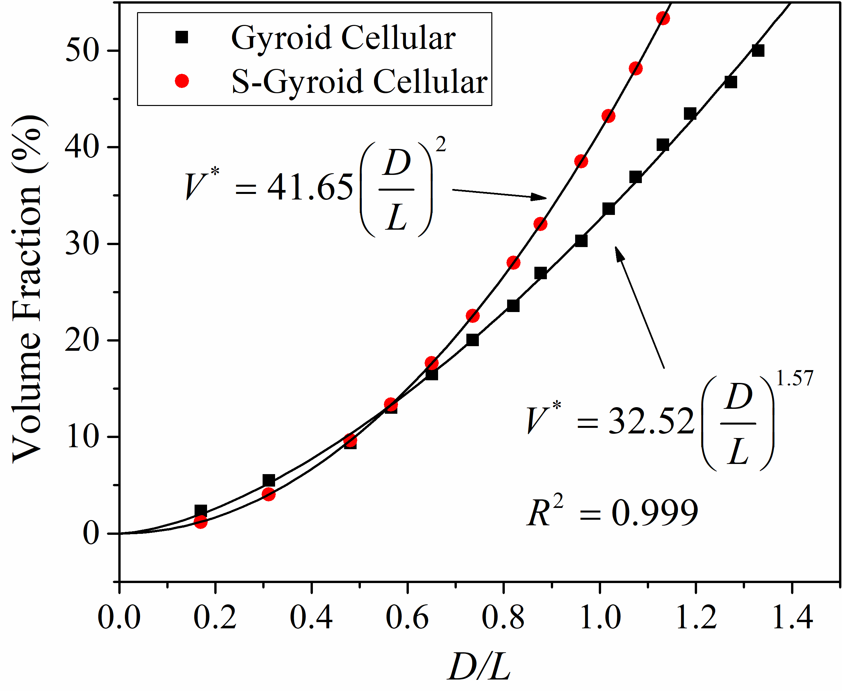

Fig. 8. Relationships between volume fractions of GCS and the value of *D/L*

3.2 Comparison of the calculated Young's moduli with FE results

Using Eqs. (17), (18) and (22) with the Young's modulus of the Ti-6Al-4V bulk material (110 GPa), the Young's moduli of GCS in three different directions, i.e., spindle direction [001], the diagonal direction [110], and the cube’s diagonal direction [111] were calculated. The results are plotted in Fig. 9 and compared with the FE results.

For each direction and method, the data are fitted by the exponential regression function, which is well known as the Gibson-Ashby equation (Gibson, 2000):

 (23)

The results demonstrate that Young's moduli of GCS correlate well with their volume fraction. For the loading directions of [001] and [110], the results gained from analytical and FE methods are in good agreement as the deviation is under 20%. The fitted exponential regression functions for analytical method own the exponents of 2.059 and 2.052 in the loading directions of [001] and [110] respectively, while those for FE method own exponents of 2.307 and 2.325, respectively.

In Fig. 9(a), the elastic moduli gained by both two methods are compared with those of Gyroid cellular and Gyroid foam investigated by Khaderi et al. (Khaderi et al., 2014) and Abueidda et al. (Abueidda et al., 2016), respectively. The curves show that the Gyroid foam possesses remarkably higher moduli than that of Gyroid cellular. The fitted curves by both analytical and FE methods show a certain deviation with the curve predicted by Khaderi et al. This deviation is mainly caused by the relative density (or volume fraction) range of study as well as the FE models. The volume fraction of sample collection by Khaderi et al. was below 4% and beam element was used in this FE model, while in this paper, the volume fraction ranges from 5% to 15%, and tetrahedron element was utilised.



Fig. 9. Comparison of the calculated Young's moduli at the different loading directions of (a) [001], (b) [111] and (c) [110].

However, at the loading direction of [111], the analytical values agree well with the FE results only when the relative density is under 10% and the fitted exponential regression functions possess exponents of 1.990 and 2.157 respectively for analytical and FE methods. As the relative density increases, there is a considerable difference between the elastic properties obtained from two methods, which is mainly caused by the simplification of GCS.

In this paper, the TPMS was simplified to the strut-based lattice with straight edges and sharp turnings, as shown in Fig. 10. The removed volume in TPMS actually plays a key role in improving the manufacturability, alleviating the sharp turning as well as strengthening the stiffness. For GCS with low volume fractions, the removed part concentrate only at the joint area, thus exerting limited influence on the deformation of bending-dominated struts. However, as the volume fraction increases from 5% to 10%, the inclined struts gradually have an overlapped district along the loading direction. These overlaps provoke a stretching-dominated rather than bending-dominated deformation behaviour. Furthermore, the cellular structure presents a sharp change in mechanical responses as deformation transfers from stretching to bending mode (Li et al., 2014). Thus, in this paper, as the circular bead was removed in the simplified model, it would highly affect the calculated deformation for GCSs loaded in [111] direction with higher volume fractions.



Fig. 10. Schematic of the overlapped district of GCS along the [111] loading direction

For GCS loaded in all three loading directions, the fitted equations of Young's modulus calculated by FE method show higher exponents than that calculated by the analytical method. It means that there will be a considerable deviation between the values predicted by analytical and FE results, as the volume fraction reaches a threshold, i.e. the value where there are overlapped districts between struts in the loading direction. As the formation of overlapped districts, the dominated deformation mode changes from bending to stretching, and thus the beam theory is no longer applicable. Apparently, for the loading directions of [001] and [110], the range of 5% to 15% in volume fraction is reasonable by using the analytical method to predict Young’s modules, because no analogous overlap is found for these structures. However, for the loading direction of [111], the inclined struts possess a larger angle with respect to the horizontal plane, and thus the struts would be easy to form an overlap as the volume fraction increases, making it difficult to predict the accurate value with the analytical method based on beam theories.

3.3 Polar diagrams of relative moduli

To develop a complete description of Young's moduli of GCS in different orientations, polar diagrams were used to plot the direction dependence property of the relative modulus, *E\**. As shown in Fig. 11, the radial distance from the origin, in any direction, indicates the magnitude of the relative modulus in that direction, for GCS with the same volume fraction of 10%.

**3.3.1 Polar diagrams in (100) plane**

Fig. 11(a) shows the rotational dependence of GCS in (100) plane. As discussed above, from the view of [100] direction, GCS is rotationally symmetrical with a degree of . Thus, a quarter of the circle is sufficient to assess the rotational dependence of GCS and the mechanical responses are equal to that at loading directions of [001] and [010]. In Fig. 11(a), the data of GCS in different loading directions from the FE results were fitted to curves, while the analytical results and the experimental data were presented and compared with each other.

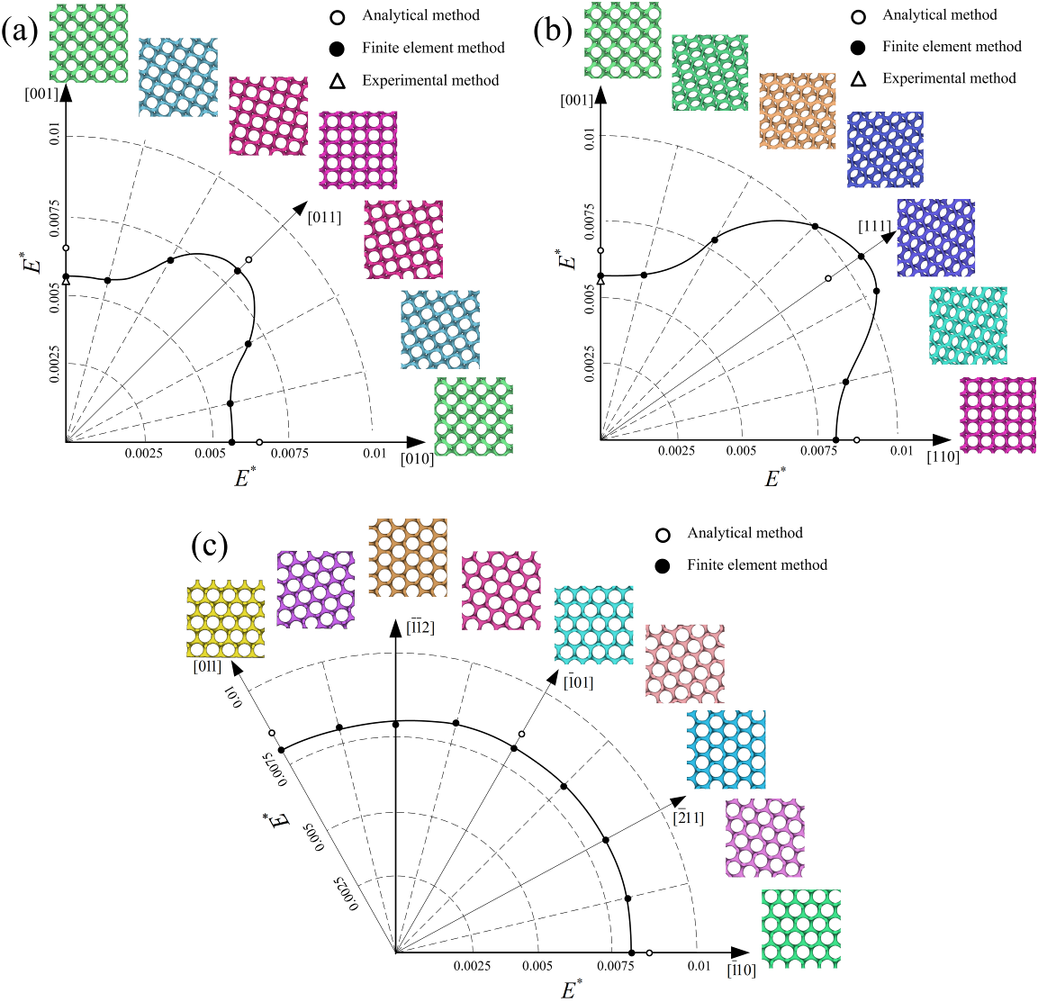

Fig. 11. Polar diagrams of relative moduli of GCS with the volume fraction of 10% in planes of (a) (100), (b) (110), and (c) (111) gained by the analytical, finite element and experimental methods.

The modulus values of GCS in the loading direction of [001] are 728.4 MPa, 622.9 Mpa, and 601.9±16.3 MPa gained by analytical, FE, and experimental methods, respectively. Relative modulus values are defined as the ratio of elastic modulus of cellular structures to that of bulk material 110 GPa. As shown in Fig. 11(a), the results from both numerical methodologies highly agree with the experimental result, with a deviation less than 15%.

It is observed that the values of Young's modulus are symmetric along the centre line of [110] direction, since the models at the double sides of the symmetric line are almost symmetrical with each other, as shown in Table 1. It indicates that not only the GCS in (100) plane is rotationally symmetrical with a degree of , but the mechanical response owns symmetric properties along the diagonal plane as well.

Besides, as the loading direction changes from [100] to [011], the relative modulus increases gradually. The loading direction of [110] owns the highest stiffness with a relative modulus of 0.0080, which is 1.40 times of that of [001] and [010], with a value of 0.0057. Meanwhile, the analytical results show that the relative modulus in the loading direction of [110] is 0.0087, which is 1.32 times of that of [001] and [010], with a value of 0.0066. Both results reveal a consistency with the finding in our previous work (Yan et al., 2014), in which the Young's modulus of the [110] orientation cellular structure is 20.37% larger than that of the [001] orientation cellular structure, due to the presence of the vertical struts in the [110] orientation cellular structure, which are parallel to the loading direction, as shown in Fig. 6.

**3.3.2 Polar diagrams in (110) and (111) planes**

Similarly, the generated polar diagrams of the relative moduli in (110) and (111) planes were shown in Fig. 11(b) and (c). From the view of [110] direction, GCS is rotationally symmetrical with a degree of π, and also owns symmetric properties for the mechanical responses. Thus, a quarter of the circle is also sufficient to investigate the rotational dependence. The analytical results show that the highest stiffness loading direction is along [111], with a relative modulus of 0.0090, which is a little bit higher than 0.0087 of [110] direction and 1.36 times of the value of softest direction [100]. The FE results also verify that the [111] loading direction owns the highest stiffness, and relative modulus value is higher than that predicted by the analytical method. The deviation is caused by the simplification, as mentioned above.

However, Fig. 11(c) shows that in (111) plane there is nearly no difference for different loading directions. The relative moduli are ranging from 0.0076 to 0.0082. The average value is 0.0080 with a small fluctuation. The nearly isotropic elastic response may come from the regular hexagon structures from the perspective of [111] direction, which had been proved to have stable mechanical properties in the 2D plane by Gibson and Ashby(Gibson and Ashby, 1997).

**3.3.3 Anisotropic property of GCS**

As GCS has cubic symmetry, the macroscopic elastic behaviours of the cellular structure derived directly from Eq. (1) are identical along three axial directions, as discussed above. Thus, GCS was assumed to be isotropic in some occasions (Ellison et al., 2006; Khaderi et al., 2014; Melchels et al., 2011). However, in this paper, the polar diagrams in both (100) and (110) plane show that GCS is anisotropic. The mechanical response differs in different loading directions. GCS in loading directions with more stretch deformation display higher resistance to deformation and thus higher stiffness, as confirmed by previous experimental study (Yanez et al., 2016).

Abueidda et al. (Abueidda et al., 2016) and Jung et al. (Jung and Buehler, 2018) studied the mechanical properties of TPMS foams through calculating the Zener anisotropy index (Ranganathan and Ostoja-Starzewski, 2008) and universal elastic anisotropy index of different structures and found that the Gyroid foam has nearly isotropic elasticity and shows superior and robust relative to other TPMS foams. However, to the knowledge of the authors, there is still no literature to quantitatively assess the degree of anisotropy of Gyroid cellular by calculating the anisotropy index.

To reveal the degree of anisotropy of GCS, the mean relative modulus values and standard deviation of GCSs with different loading direction were calculated. The values were utilized to determined coefficients of variation as shown in Fig. 12. The mean relative modulus values show the average elastic response of GCS and the figure shows the same trend with the uniaxial results in Fig. 9. The coefficient of variation, the ratio of the standard deviation to the mean value, is a standardized measure of dispersion of a probability distribution. Hereby, the coefficient of variation of GCS with different volume fractions could be used to qualitatively show the degree of anisotropy, although the number of data is limited. Coefficients of variation gained from both analytical and FE methods shows stable value while varying volume fractions, which means that the degree of anisotropy of Gyroid cellular structures are nearly constant when the volume fraction varies between 5% and 15%.



Fig. 12. The mean relative moduli of Gyroid cellular structures loading in [100], [110], and [111] with different volume fractions and coefficients of variation.

The stiffness of lattice structure is mainly decided by the included angle between struts and loading direction. For instance, while the loading direction gradually changes from [001] to [011], strut BC turn to be parallel to the loading direction and show stretch-dominating properties without bending deformation, as shown in Fig. 6. Thus, GCS shows higher relative modulus at the loading direction of [011]. However, the topology of the struts in Gyroid unit cell determines that if some struts become stretch-dominated from bending-dominated, some other struts will show much severe bending deformation behaviour or become bending-dominated from stretch-dominated. Thus, the deviation of Young's modulus is negligible in different loading directions.

This stable mechanical property makes GCS to be different from some other lattice structures. For instance, Luxner et al. (Luxner et al., 2005) found that there are rapid declines of the modulus value for the simple cubic cellular while the loading direction changing from [001] to [011] direction. Meanwhile, in the work of Weißmann et al. (Weißmann et al., 2016), the Young's modulus value of FCC cellular with orientation type I was more than 5 times of that with orientation type V. In conclusion, in spite of the anisotropy, Gyroid is much suitable and can be a promising structure to withstand complex service conditions. For instance, for large bone, the loads do not tend to follow the direction of the bone’s longitudinal axis, thus, the implants should own not only comparable porosity and elastic modulus, but also stable mechanical properties along different directions, which can be satisfied by GCS.

## 4 Conclusions

A novel approach combining structural simplification with analytical solution was presented to predict the Young's moduli of GCS loaded in different orientations. The results were compared with FE results, and verified with experimental results. The correlation between the Young's modulus and the volume fraction was obtained according to Gibson-Ashby model. Furthermore, the orientation dependence of the elastic response in GCS was discussed, and findings are as follows:

1. Geometric and rotational symmetry properties of GCS, a typical TPMS structure, was discussed in this paper. Three rotation axes of symmetry with different symmetrical angles, inherited from TPMS, were found to be along the directions of [001], [111] and [110] based on the knowledge of material crystallography.
2. GCS was simplified to strut-based lattice structure based on the same geometric characteristics and topology relationships. The relationship between the volume fraction of SGCS and the value of *D/L* was formulated, and the predicted results are reasonable in comparison to the original GCS when the volume fraction is below 20%.
3. Analytical solution based on Euler–Bernoulli and Timoshenko beam theories was used to calculate the relative moduli of GCS with different volume fractions, and the results were fitted to Gibson-Ashby model. Regardless of loading direction, the Young's moduli of GCS correlate well with their relative densities. The obtained results for the loading directions of [001] and [110] are consistent with FE analysis when the volume fraction is between 5% and 15%, while for [111] direction, the consistency is observed only as the relative density is lower than 10%.
4. Polar diagrams of the relative moduli of GCS with the volume fraction of 10% in planes of (100) and (110) were gained. The polar diagrams show that GCS in the loading directions with more stretch deformation own higher stiffness compared with other loading directions. Small deviations between different loading directions also illustrate that GCS is superior to other strut-based cellular structures for the stable mechanical response in different loading directions.

These significant findings hereby illustrate the possibility of predicting the elastic response using an analytical solution and shows the orientation dependence of GCS. The analytical solution could be used for easy and fast prediction of the mechanical properties of cellular structures. There is, however, a limitation of an investigation including the Zener anisotropy index and universal elastic anisotropy index that could be used to further analyse the degree of anisotropy of GCS. Besides, it is still important to thoroughly study the accuracy of the analytical models presented in the current study before proceeding to use the models in the design of cellular.

## 5 Acknowledgements

The study was supported by the National Natural Science Foundation of China (Grant No. 51671091), the independent R&D subjects of Huazhong University of Science and Technology (Grant No. 2017JYCXJJ005), and the program of China Scholarships Council (No.201706160036).

## References

1. Abueidda, D.W., Al-Rub, R.K.A., Dalaq, A.S., Lee, D.-W., Khan, K.A., Jasiuk, I., 2016. Effective conductivities and elastic moduli of novel foams with triply periodic minimal surfaces. Mechanics of Materials. 95, 102-115.
2. Ahmadi, S.M., Campoli, G., Amin Yavari, S., Sajadi, B., Wauthle, R., Schrooten, J., Weinans, H., Zadpoor, A.A., 2014. Mechanical behavior of regular open-cell porous biomaterials made of diamond lattice unit cells. Journal of the mechanical behavior of biomedical materials. 34, 106-115.
3. Alsalla, H., Hao, L., Smith, C., 2016. Fracture toughness and tensile strength of 316L stainless steel cellular lattice structures manufactured using the selective laser melting technique. Materials Science and Engineering: A. 669, 1-6.
4. Amin Yavari, S., Ahmadi, S.M., Wauthle, R., Pouran, B., Schrooten, J., Weinans, H., Zadpoor, A.A., 2015. Relationship between unit cell type and porosity and the fatigue behavior of selective laser melted meta-biomaterials. Journal of the mechanical behavior of biomedical materials. 43, 91-100.
5. Brassey, C.A., Margetts, L., Kitchener, A.C., Withers, P.J., Manning, P.L., Sellers, W.I., 2013. Finite element modelling versus classic beam theory: comparing methods for stress estimation in a morphologically diverse sample of vertebrate long bones. Journal of the Royal Society Interface. 10, 20120823.
6. Campoli, G., Borleffs, M., Yavari, S.A., Wauthle, R., Weinans, H., Zadpoor, A.A., 2013a. Mechanical properties of open-cell metallic biomaterials manufactured using additive manufacturing. Materials & Design. 49, 957-965.
7. Campoli, G., Borleffs, M.S., Amin Yavari, S., Wauthle, R., Weinans, H., Zadpoor, A.A., 2013b. Mechanical properties of open-cell metallic biomaterials manufactured using additive manufacturing. Materials & Design. 49, 957-965.
8. Choi, K., Kuhn, J.L., Ciarelli, M.J., Goldstein, S.A., 1990. The elastic moduli of human subchondral, trabecular, and cortical bone tissue and the size-dependency of cortical bone modulus. J. Biomech. 23, 1103-1113.
9. Choy, S.Y., Sun, C.-N., Leong, K.F., Wei, J., 2017. Compressive properties of Ti-6Al-4V lattice structures fabricated by selective laser melting: Design, orientation and density. Additive Manufacturing. 16, 213-224.
10. Cowper, G., 1966. The shear coefficient in Timoshenko's beam theory. ASME.
11. DEFORM, T., 2006. 3D Version 6.1 (sp1) User’s Manual. Scientific Forming Technologies Corporation, Columbus OH.
12. Delaunay, C., Petit, I., Learmonth, I., Oger, P., Vendittoli, P., 2010. Metal-on-metal bearings total hip arthroplasty: the cobalt and chromium ions release concern. Orthopaedics & Traumatology: Surgery & Research. 96, 894-904.
13. Ellison, L., Michel, D., Barmes, F., Cleaver, D., 2006. Entropy-driven formation of the gyroid cubic phase. Phys. Rev. Lett. 97, 237801.
14. Engh, C.A., Bobyn, J., Glassman, A.H., 1987. Porous-coated hip replacement. The factors governing bone ingrowth, stress shielding, and clinical results. Bone & Joint Journal. 69, 45-55.
15. Gibson, L., 2000. Mechanical behavior of metallic foams. Annual review of materials science. 30, 191-227.
16. Gibson, L.J., Ashby, M., Schajer, G., Robertson, C., 1982. The mechanics of two-dimensional cellular materials, Proceedings of the Royal Society of London A: Mathematical, Physical and Engineering Sciences. The Royal Society, pp. 25-42.
17. Gibson, L.J., Ashby, M.F., 1997. Cellular solids: structure and properties. Cambridge University Press, Cambridge;New York;.
18. Grida, I., Evans, J.R., 2003. Extrusion freeforming of ceramics through fine nozzles. Journal of the European Ceramic Society. 23, 629-635.
19. Grimal, Q., Haupert, S., Mitton, D., Vastel, L., Laugier, P., 2009. Assessment of cortical bone elasticity and strength: mechanical testing and ultrasound provide complementary data. Medical engineering & physics. 31, 1140-1147.
20. Hao, L., Raymont, D., Yan, C.Z., Hussein, A., Young, P., 2012. Design and additive manufacturing of cellular lattice structures. Innovative Developments on Virtual And Physical Prototyping, 249-254.
21. Hao, Y., Li, S., Sun, S., Zheng, C., Hu, Q., Yang, R., 2005. Super-elastic titanium alloy with unstable plastic deformation. Applied Physics Letters. 87, 091906.
22. Hasan, R., Mines, R., 2016. Variations in diameter of struts for micro-lattice structure manufactured using selective laser melting. Proceedings of the Mechanical Engineering Research Day.
23. Hedayati, R., Sadighi, M., Mohammadi-Aghdam, M., Zadpoor, A.A., 2016a. Effect of mass multiple counting on the elastic properties of open-cell regular porous biomaterials. Materials & Design. 89, 9-20.
24. Hedayati, R., Sadighi, M., Mohammadi-Aghdam, M., Zadpoor, A.A., 2016b. Mechanics of additively manufactured porous biomaterials based on the rhombicuboctahedron unit cell. Journal of the mechanical behavior of biomedical materials. 53, 272-294.
25. Heinl, P., Müller, L., Körner, C., Singer, R.F., Müller, F.A., 2008. Cellular Ti–6Al–4V structures with interconnected macro porosity for bone implants fabricated by selective electron beam melting. Acta biomaterialia. 4, 1536-1544.
26. International, A., 2003. Handbook of materials for medical devices. ASM international.
27. Johnson, G.R., Cook, W.H., 1985. Fracture characteristics of three metals subjected to various strains, strain rates, temperatures and pressures. Engineering fracture mechanics. 21, 31-48.
28. Jung, G.S., Buehler, M.J., 2018. Multiscale Mechanics of Triply Periodic Minimal Surfaces of Three-Dimensional Graphene Foams. Nano letters.
29. Kapfer, S.C., Hyde, S.T., Mecke, K., Arns, C.H., Schroder-Turk, G.E., 2011. Minimal surface scaffold designs for tissue engineering. Biomaterials. 32, 6875-6882.
30. Karageorgiou, V., Kaplan, D., 2005. Porosity of 3D biomaterial scaffolds and osteogenesis. Biomaterials. 26, 5474-5491.
31. Khaderi, S., Deshpande, V., Fleck, N., 2014. The stiffness and strength of the gyroid lattice. International Journal of Solids and Structures. 51, 3866-3877.
32. Li, S.J., Xu, Q.S., Wang, Z., Hou, W.T., Hao, Y.L., Yang, R., Murr, L.E., 2014. Influence of cell shape on mechanical properties of Ti-6Al-4V meshes fabricated by electron beam melting method. Acta biomaterialia. 10, 4537-4547.
33. Lu, X., Lee, Y., Yang, S., Hao, Y., Evans, J.R.G., Parini, C.G., 2009. Fine lattice structures fabricated by extrusion freeforming: Process variables. Journal of Materials Processing Technology. 209, 4654-4661.
34. Luxner, M.H., Stampfl, J., Pettermann, H.E., 2005. Finite element modeling concepts and linear analyses of 3D regular open cell structures. Journal of Materials Science. 40, 5859-5866.
35. Maskery, I., Aboulkhair, N.T., Aremu, A.O., Tuck, C.J., Ashcroft, I.A., 2017. Compressive failure modes and energy absorption in additively manufactured double gyroid lattices. Additive Manufacturing. 16, 24-29.
36. Maskery, I., Aremu, A.O., Simonelli, M., Tuck, C., Wildman, R.D., Ashcroft, I.A., Hague, R.J.M., 2015. Mechanical Properties of Ti-6Al-4V Selectively Laser Melted Parts with Body-Centred-Cubic Lattices of Varying cell size. Experimental Mechanics. 55, 1261-1272.
37. Maskery, I., Hussey, A., Panesar, A., Aremu, A., Tuck, C., Ashcroft, I., Hague, R., 2016. An investigation into reinforced and functionally graded lattice structures. Journal of Cellular Plastics.
38. Melchels, F.P., Tonnarelli, B., Olivares, A.L., Martin, I., Lacroix, D., Feijen, J., Wendt, D.J., Grijpma, D.W., 2011. The influence of the scaffold design on the distribution of adhering cells after perfusion cell seeding. Biomaterials. 32, 2878-2884.
39. Montazerian, H., Davoodi, E., Asadi-Eydivand, M., Kadkhodapour, J., Solati-Hashjin, M., 2017. Porous scaffold internal architecture design based on minimal surfaces: A compromise between permeability and elastic properties. Materials & Design. 126, 98-114.
40. Nag, S., Banerjee, R., Fraser, H., 2005. Microstructural evolution and strengthening mechanisms in Ti–Nb–Zr–Ta, Ti–Mo–Zr–Fe and Ti–15Mo biocompatible alloys. Materials Science and Engineering: C. 25, 357-362.
41. Niinomi, M., 2003. Fatigue performance and cyto-toxicity of low rigidity titanium alloy, Ti–29Nb–13Ta–4.6 Zr. Biomaterials. 24, 2673-2683.
42. Qazi, J., Marquardt, B., Allard, L., Rack, H., 2005. Phase transformations in Ti–35Nb–7Zr–5Ta–(0.06–0.68) O alloys. Materials Science and Engineering: C. 25, 389-397.
43. Ranganathan, S.I., Ostoja-Starzewski, M., 2008. Universal elastic anisotropy index. Phys. Rev. Lett. 101, 055504.
44. Scherer, M.R.J., 2013. Double-Gyroid-Structured functional materials: synthesis and applications. Springer Science & Business Media.
45. Sevilla, P., Aparicio, C., Planell, J.A., Gil, F.J., 2007. Comparison of the mechanical properties between tantalum and nickel–titanium foams implant materials for bone ingrowth applications. J. Alloy. Compd. 439, 67-73.
46. Sidambe, A., Figueroa, I., Hamilton, H., Todd, I., 2012. Metal injection moulding of CP-Ti components for biomedical applications. Journal of Materials Processing Technology. 212, 1591-1597.
47. Smith, M., Guan, Z., Cantwell, W.J., 2013. Finite element modelling of the compressive response of lattice structures manufactured using the selective laser melting technique. International Journal of Mechanical Sciences. 67, 28-41.
48. Standard, I., ISO 13314: 2011 (E)(2011) Mechanical testing of metals—ductility testing—compression test for porous and cellular metals. Ref Number ISO. 13314, 1-7.
49. Stevenson, G., Rehman, S., Draper, E., Hernandez-Nava, E., Hunt, J., Haycock, J.W., 2016. Combining 3D human in vitro methods for a 3Rs evaluation of novel titanium surfaces in orthopaedic applications. Biotechnol. Bioeng. 113, 1586-1599.
50. Timoshenko, S., Goodier, J.N., 1970. Theory of Elasticity. McGraw-Hill.
51. Turner, C.H., Burr, D.B., 1993. Basic biomechanical measurements of bone: A tutorial. Bone. 14, 595-608.
52. Van Bael, S., Chai, Y.C., Truscello, S., Moesen, M., Kerckhofs, G., Van Oosterwyck, H., Kruth, J.-P., Schrooten, J., 2012. The effect of pore geometry on the in vitro biological behavior of human periosteum-derived cells seeded on selective laser-melted Ti6Al4V bone scaffolds. Acta biomaterialia. 8, 2824-2834.
53. Vijayavenkataraman, S., Shuo, Z., Fuh, J.Y.H., Lu, W.F., 2017. Design of Three-Dimensional Scaffolds with Tunable Matrix Stiffness for Directing Stem Cell Lineage Specification: An In Silico Study. Bioengineering (Basel). 4.
54. Vivien J. Challis, Anthony P. Roberts, Joseph F. Grotowski, Lai-Chang Zhang, Sercombe, T.B., September 2010. Prototypes for Bone Implant Scaffolds Designed via Topology Optimization and Manufactured by Solid Freeform Fabrication. Advanced engineering materials.
55. Weißmann, V., Bader, R., Hansmann, H., Laufer, N., 2016. Influence of the structural orientation on the mechanical properties of selective laser melted Ti6Al4V open-porous scaffolds. Materials & Design. 95, 188-197.
56. Wieding, J., Souffrant, R., Mittelmeier, W., Bader, R., 2013. Finite element analysis on the biomechanical stability of open porous titanium scaffolds for large segmental bone defects under physiological load conditions. Medical engineering & physics. 35, 422-432.
57. Wieding, J., Wolf, A., Bader, R., 2014. Numerical optimization of open-porous bone scaffold structures to match the elastic properties of human cortical bone. Journal of the mechanical behavior of biomedical materials. 37, 56-68.
58. Wysocki, B., Idaszek, J., Szlązak, K., Strzelczyk, K., Brynk, T., Kurzydłowski, K., Święszkowski, W., 2016. Post Processing and Biological Evaluation of the Titanium Scaffolds for Bone Tissue Engineering. Materials. 9, 197.
59. Yan, C., Hao, L., Hussein, A., Raymont, D., 2012. Evaluations of cellular lattice structures manufactured using selective laser melting. International Journal of Machine Tools and Manufacture. 62, 32-38.
60. Yan, C., Hao, L., Hussein, A., Young, P., 2015a. Ti-6Al-4V triply periodic minimal surface structures for bone implants fabricated via selective laser melting. Journal Of the Mechanical Behavior Of Biomedical Materials. 51, 61-73.
61. Yan, C., Hao, L., Hussein, A., Young, P., Huang, J., Zhu, W., 2015b. Microstructure and mechanical properties of aluminium alloy cellular lattice structures manufactured by direct metal laser sintering. Materials Science And Engineering a-Structural Materials Properties Microstructure And Processing. 628, 238-246.
62. Yan, C.Z., Hao, L., Hussein, A., Young, P., Raymont, D., 2014. Advanced lightweight 316L stainless steel cellular lattice structures fabricated via selective laser melting. Materials & Design. 55, 533-541.
63. Yanez, A., Herrera, A., Martel, O., Monopoli, D., Afonso, H., 2016. Compressive behaviour of gyroid lattice structures for human cancellous bone implant applications. Materials Science and Engineering: C. 68, 445-448.
64. Yang, H., Yang, S., Chi, X., Evans, J.R., 2006. Fine ceramic lattices prepared by extrusion freeforming. Journal of Biomedical Materials Research Part B: Applied Biomaterials. 79, 116-121.
65. Yang, L., Yan, C., Han, C., Chen, P., Yang, S., Shi, Y., Mechanical response of a triply periodic minimal surface cellular structures manufactured by selective laser melting. To be printed.
66. Yang, S., Leong, K.-F., Du, Z., Chua, C.-K., 2001. The design of scaffolds for use in tissue engineering. Part I. Traditional factors. Tissue Eng. 7, 679-689.
67. Yang, S., Leong, K.-F., Du, Z., Chua, C.-K., 2002. The design of scaffolds for use in tissue engineering. Part II. Rapid prototyping techniques. Tissue Eng. 8, 1-11.
68. Young, W.C., Budynas, R.G., 2002. Roark's formulas for stress and strain. McGraw-Hill New York.
69. Zhao, S., Li, S.J., Hou, W.T., Hao, Y.L., Yang, R., Misra, R.D., 2016a. The influence of cell morphology on the compressive fatigue behavior of Ti-6Al-4V meshes fabricated by electron beam melting. Journal of the mechanical behavior of biomedical materials. 59, 251-264.
70. Zhao, S., Li, S.J., Hou, W.T., Hao, Y.L., Yang, R., Murr, L.E., 2016b. Microstructure and mechanical properties of open cellular Ti–6Al–4V prototypes fabricated by electron beam melting for biomedical applications. Materials Technology, 1-10.
71. Zhong, G., Vaezi, M., Liu, P., Pan, L., Yang, S., 2017. Characterization approach on the extrusion process of bioceramics for the 3D printing of bone tissue engineering scaffolds. Ceramics International. 43, 13860-13868.

1. *Corresponding author

   Tel.: +86 027 87558155, E-mail address: [c_yang@hust.edu.cn](mailto:c_yang@hust.edu.cn) (Chunze Yan).

   Tel.: +32 16 324999, E-mail address: [shoufeng.yang@kuleuven.be](mailto:shoufeng.yang@kuleuven.be) (Shoufeng Yang).