Power of Paradox: Grassroots Organizations’ Legitimacy Strategies over Time

Rashedur Chowdhury
Southampton Business School, University of Southampton
Email: r.r.chowdhury@soton.ac.uk

Arno Kourula
University of Amsterdam Business School
Email: a.e.kourula@uva.nl

Marjo Siltaoja
Jyväskylä University School of Business and Economics
Email: marjo.siltaoja@jyu.fi

Accepted: Business & Society (ABS 3)

Abstract
Fringe stakeholders with limited resources, such as grassroots organizations (GROs), are often ignored in business and society literature. We develop a conceptual framework and a set of propositions detailing how GROs strategically gain legitimacy and influence over time. We argue that GROs encounter specific paradoxes over the emergence, development, and resolution of an issue, and they address these paradoxes using cognitive, moral, and pragmatic legitimacy strategies. While cognitive and moral strategies tend to be used consistently, the flexible and paradoxical use of pragmatic strategies has important consequences, both for GROs’ legitimacy and for their potential influence over powerful organizations associated with them. We enrich our framework with the help of two illustrative cases and discuss the implications of the framework for GROs’ legitimacy strategies in business and society literature.

Introduction
An emerging theme within business and society literature has been the relationship between firms and fringe stakeholders, who are generally considered to be poor, weak and isolated (Hart & Sharma, 2004, p. 8; Derry, 2012). These aforementioned characteristics of fringe stakeholders mean that they tend to struggle with limited resources and influence, and have difficulty in gaining legitimacy and in getting their voices heard. In this article, we examine a fringe stakeholder by focusing on grassroots organizations (GROs); a form of local and/or community group (Sutherland et al., 2013; Walker, 2009). GROs play an important role in creating and maintaining plurality in public discourse. However, they often lack a formal position in institutional decision-making processes, such as taking part in meetings with government agencies, nongovernmental organizations (NGOs), or multinational corporations (MNCs). Consequently, GROs often struggle to gain legitimacy (van Bommel & Spicer, 2011). However, we argue GROs can be flexible in their use of paradoxical – seemingly confusing and contradictory – approaches to achieve legitimacy over time.
Within business and society research, scholars mostly consider a managerial perspective, examining which groups count as stakeholders (e.g., Mitchell et al., 1997). This results in an overarching focus on stakeholders with power and legitimacy, who are thought of as resourceful actors. Their potential to engage in strategic activity with firms is very high (Frooman, 1999). In contrast, the role of fringe stakeholders has received less attention (see Daudigeos et al., 2018; Derry, 2012; McCarthy & Muthuri, 2018). Fringe stakeholders, such as local GROs, are often perceived as reactionary, ad hoc actors, seeking to challenge the status quo with few strategic capabilities, limited legitimacy, and little influence (Jenkins & Perrow, 1977; McCarthy & Zald, 1977). Contrary to more powerful stakeholders, fringe stakeholders are often more embedded in their geographical and cultural context, and lack coordinated political support (Keck & Sikkink, 1998). However, changes in the political and social context may create opportunities for fringe stakeholders to increase their influence. Therefore, we propose that the capacity of GROs to challenge the existing power relations and gain legitimacy in terms of their concerns needs to be better understood to acknowledge the diverse range of voices that exist.
We argue that even GROs strategize activities for gaining legitimacy. Thus, we perceive legitimacy as a consequence of strategic behavior, instead of an institutionally oriented norm (Suchman, 1995). By adopting this view, we continue a line of burgeoning research on legitimacy struggles and contestation. Our research focuses on the dynamic and relational nature of legitimacy processes in business–society relations (Barros, 2014; Erkama & Vaara, 2010; Haack et al., 2014; Joutsenvirta & Vaara, 2015). More specifically, we explore the paradoxical nature of GROs’ quest for legitimacy, which derives from GROs’ tendency to engage in seemingly contradictory approaches while simultaneously trying to address the paradoxical situations they face (Smith & Lewis, 2011). In other words, when GROs encounter paradox, they can respond paradoxically. Smith and Lewis (2011, p. 387) define paradox as “contradictory yet interrelated elements (dualities) that exist simultaneously and persist over time; such elements seem logical when considered in isolation, but irrational, inconsistent, and absurd when juxtaposed.” Accordingly, our research question is: When encountering paradoxes, what kinds of strategies do GROs use to legitimize themselves and their position on a particular issue throughout its life cycle? We address this question by developing a conceptual framework and a set of propositions.
Our key contribution to the business and society literature is the understanding of GROs’ legitimacy struggles and strategies. We also advance the novel notion of the paradox approach of legitimacy (Baumann-Pauly et al., 2015; Scherer et al., 2013). This perspective has received an increasing amount of attention from management scholars in recent years (Hahn et al., 2014; Smith & Lewis, 2011). We demonstrate how a paradox approach is central to achieving legitimacy and influence by conceptualizing contradictory strategies that are utilized to address temporally salient paradoxes. Whereas legitimacy literature has generally assumed that multiple legitimacy strategies are reserved only for influential and resource-rich participants (e.g., Baumann-Pauly at al., 2015; Scherer et al., 2013; Vaara & Tienari, 2008), we suggest that a paradox approach is particularly important for fringe stakeholders in business and society relations. This is because these stakeholders need to adopt multiple strategies over time to gain legitimacy and salience for both themselves and their position on an issue. To highlight this argument, while conceptualizing how GROs encounter the paradoxes of developing an identity vs. establishing routines, developing routines vs. achieving impact, and retaining authenticity vs. spreading their reach, we also propose a dynamic perspective to suggest that GROs aim to advance their influence over the life cycle of social issues (Bigelow et al., 1991). This influence is crucial in the issue-selling process (Dutton et al., 2001). We argue that moral and cognitive strategies play an important role from the early stages of an issue, and pragmatic ones become more important as it develops. At the later stages of the issue’s life cycle, paradoxical approaches become more useful.

GROs as Fringe Stakeholders and their Characteristics
We examine GROs as coalitions of people who are often business stakeholders on the fringe, drawn together by a problem (i.e., an issue) that is in their personal and community interest. GROs resist their marginalization in this issue through various (strategic) activities. They are further considered marginalized because the claims and rights of these fringe stakeholders differ greatly from those of powerful counterparts (e.g., corporations), which leads to their exclusion from meaningful discussions (Chowdhury & Wilmott, 2018; Ehrström-Fuentes, 2016). We consider four key GRO characteristics – locality, authenticity, moderate formality, and lack of resources – and, in doing so, distinguish GROs from NGOs (such as Amnesty International and Oxfam) and social movement organizations (SMOs) (such as the civil rights, women’s rights, and LGBTQ rights movements). In contrast to GROs, SMOs tend to tackle broader societal issues as part of multiple organizations.

Locality
“Grassroots” used to mean the basic local building blocks of society (Uphoff, 1993) i.e., the small rural communities or urban neighborhoods where the “common man” – or woman – lives (Batliwala, 2002). Uphoff (1993, p. 609) defines GROs as “any and all organizations at the group, community or locality level, though usually one is referring to membership or voluntary organizations.” McCambridge (2006) extends this idea by highlighting that GROs not only reflect “the voices of those people most affected by the issue being addressed but are responsive to and largely led by these constituencies.” Thus, we consider GROs as organizations of the people coming from particular regions to address a common issue. They are not only mission-driven, but also represent their local constituents’ core values and interests (Cole & Foster 2001), often as a response to dissatisfaction with the status quo (Avelino & Rotmans, 2009). For example, many GROs that focus on the right to food have developed to challenge the dominance of MNCs and support local production operations and microbusinesses (Kirwan et al., 2013). Globalization has also widened the original meaning of grassroots; it is now seen as a local or trans-local phenomenon that emerges in both democratic and non-democratic contexts (Sutherland et al., 2013; Walker, 2009). As Figure 1 indicates, in comparison to NGOs and SMOs, GROs are more locally grounded and embedded.
---------------------------------

Insert Figure 1 about here
---------------------------------
Authenticity
One of the main characteristics of GROs is that they are perceived to possess authenticity (Eliasoph, 2014; Walker, 2009). Authenticity is understood as having the feature of being true to organizational values. Accordingly, there is no discrepancy between the public claims of an organization and the true objective conditions underlying such a claim (Walker, 2016). Authenticity is an important characteristic of civil society agencies, which is also why many organizations aim to establish direct links with GROs, or may pretend to be one (Walker, 2009), hence why some MNCs use astroturfing. This corporate practice masks a firm’s intentions by covertly sponsoring members of GROs or creating their own GROs to advance corporate goals (Walker, 2016).

Moderate formality
To achieve their goals, GROs have a moderate level of formality and they maintain a high-level of internal democracy by fighting oligarchies, avoiding bureaucracy (e.g., by limiting membership if necessary), and upholding their autonomy from external organizations or networks (Smith, 2000). Hence, they rely more on relational, informal contracts than formal contracts; however, this often means that, without explicit formal contracts with other organizations, GROs are more likely to be perceived as fringe stakeholders (Clarkson, 1995). Thus, GROs often choose to focus on narrow issues at the expense of addressing wider problems (Brown & Kalegaonkar, 2002). Therefore, GROs tend to be more formal and possess clearer membership bases than SMOs, but are less formal and bureaucratic than NGOs, as depicted in Figure 1. SMOs do share some features of (in)formality with GROs, but SMOs are defined as more complex actors on the basis that they follow their ideological preferences for social change (McCarthy & Zald, 1977) and pursue complex sets of collective actions (Marwell & Oliver, 1993). Over time, GROs can become SMOs and change into NGOs as they become more institutionalized. For example, Greenpeace International started as a local GRO, acted as an SMO up to a point, and finally formalized itself as a professional NGO.

Lack of resources
GROs are organizations with limited resources. This means that GROs typically have relatively limited access to (in)tangible resources (in particular, financial capacities and technical capabilities), and possess less social capital in terms of connections with more powerful actors (Jenkins and Perrow, 1977). Accordingly, they are likely to receive limited support from powerful groups, such as large NGOs, government agencies, and firms (Piven, 2008). Larger and more established actors typically enjoy significant resource advantages (material, political, and cultural) over issue challengers, and generally count on the support of loyal allies (Fligstein & McAdam, 2011). Large NGOs feature business-like activities characterized by some blend of profit motivation, the use of managerial and organization design tools developed in for-profit business settings, and broadly framed business thinking to organize activities (Dart, 2004, p. 294).

The Relationship between Social Issues and GRO Legitimacy Strategies
Social issues are related to societal problems requiring attention “when they are defined as being problematic to society or an institution within society by a group of actors or stakeholders capable of influencing either governmental action or company policies” (Mahon & Waddock, 1992, p. 20). Social issue life cycle literature maintains that issues follow an evolutionary pattern, unless an issue fades away at any point, having not gained enough salience (Mahon & Waddock 1992). We simplify Bigelow et al.’s (1991) framework and adopt a three-stage issue life cycle: 1) emergence, 2) development, and 3) resolution. While that is a simplification of the highly complex interactions between societal actors and discourses, it is useful to understand how GROs gain legitimacy for or even influence over an issue over time.
Issues do not merely develop by themselves: They require agency. Issue selling is a type of influence activity defined as “the process by which individuals affect others’ attention to and understanding of the events, developments, and trends that have implications for (organizational) performance” (Dutton et al., 2001, p. 716). Successful issue sellers present their issues as strategically important, legitimate, and relevant to an organization, use formal authority, relationships, expertise, and normative knowledge. In cases where power relationships are highly asymmetrical – for instance in the case of MNC and GRO interaction – issue selling is a necessity (Dörrenbächer & Gammelgaard, 2016). When selling their issue, GROs tend to lack legitimacy and shy away from formal authority while seeking to challenge the status quo (Smith, 2000). Therefore, GROs’ innovative approaches in developing and sustaining legitimacy over time are crucial for an issue to reach the resolution stage (Coombs, 1992) in a way that embraces the original concerns that initiated the organization. Although legitimacy does not guarantee success, without it GROs are ignored and further marginalized (van Rooy, 2004).
Legitimacy literature acknowledges that organizations gain legitimacy to attract societal support and resources for themselves or to fulfill their agendas (Ashforth & Gibbs, 1990; Pache & Santos, 2010; Scherer et al., 2013; Suchman, 1995; Zimmerman & Zeitz, 2002). Suchman (1995, p. 574) defines legitimacy as “a generalized perception or assumption that the actions of an entity are desirable, proper, or appropriate within some socially constructed system of norms, values, beliefs, and definitions.” Furthermore, Suchman (1995) introduces three forms of legitimacy: Moral, cognitive, and pragmatic. Moral legitimacy is based on normative approval and refers to an explicitly moral discourse about the acceptability of an organization and its activities. Cognitive legitimacy is based on comprehensibility and a taken-for-granted nature, representative of the “normal” status quo. Pragmatic legitimacy is driven by the self-interest of the actor seeking legitimacy. Cognitive and moral legitimacy are assumed to derive from cultural and social values.
A dominant assumption in the literature has been that legitimacy is an asset that organizations strategically deploy and manage to gain access to resources (Deephouse & Suchman, 2008; Oliver, 1991; Suchman, 1995). Nevertheless, some actions are perceived as illegitimate if they go against social norms. For example, when an organization is unable to sustain social support (Zuckerman, 1999) and attracts social disapproval (Elsbach & Sutton, 1992) or is labeled as tainted and spoiled, its core organizational attributes, such as identity and image, are difficult to manage in a positive manner (Hudson, 2008). Most prior conceptualizations thus suggest that legitimacy and illegitimacy are bipolar, formed by a continuum of attributes.
However, there is a need to better understand legitimacy and illegitimacy beyond the attributional type of conceptualization. Issue selling and legitimacy building both rely on material and discursive framing in the issue-acceptance process within organizational and institutional settings (Howard-Grenville, 2007; Maguire et al. 2004). This perspective focuses on the processual and dynamic nature of (il)legitimacy: How legitimacy struggles, takes place in multiple social arenas, and involves multiple voices (Ehrström-Fuentes, 2016). In other words, a GROs’ activities are evaluated as legitimate or illegitimate simultaneously by different parties. More specifically, such evaluations depend on the social evaluators’ values and use of discourses, as well as existing relationships and interests in an issue. Therefore, we argue that gaining legitimacy or being perceived as illegitimate is neither symmetrical nor dichotomous (Martin et al., 1990; Suddaby et al., 2017); it is a processual, plurivocal, and relational phenomenon that captures GROs’ struggles for gaining legitimacy.
We recognize that legitimacy is not only a resource to attract societal support; societal support itself helps to establish organizational legitimacy: Even though legitimacy would be an asset for an organization, it remains a social evaluation made by different actors (Bitektine, 2011). Henceforth, for issue selling and legitimacy building, organizational members must learn to navigate the context, learn about recipients’ schemas, acquire relevant assets, and experiment while moving forward (Howard-Grenville, 2007; Navis & Glynn, 2010). Legitimacy-seeking behaviors facilitate greater resource flow, social acceptance, and fulfillment of organizational goals, but these benefits are likely to come at the expense of a coherent collective identity, with the relinquishing of some control of the organizational activities to other powerful actors (Lee et al., 2017). GROs encounter situations in which they need to bend to the will of more powerful actors or defend their demands while simultaneously putting their existence and identity at greater risk (Zietsma & Lawrence, 2010).
The above trade-offs is minimized partially through the use of legitimacy strategies (Ashforth & Gibbs, 1990; Suchman, 1995; Lefsrud & Meyer, 2012) by referring to organizations’ deliberate efforts to gain social acceptance of themselves and their position on issues. Scherer et al. (2013) argue that organizations simultaneously employ moral, cognitive, and pragmatic legitimacy strategies and manage them in complex and sometimes contradictory ways. They offer three alternative approaches to combine three different legitimacy strategies: The “one best way” approach, the “contingency” approach, and the “paradox” approach. The one best way approach picks the best single approach to maintain legitimacy with stakeholders. The “contingency” approach acknowledges that multiple stakeholders necessitate multiple different legitimacy strategies to adapt to a particular situation. The paradox approach involves simultaneous, often contradictory, responses to stakeholder claims. However, the existing literature is unclear about how GROs gain and maintain legitimacy through this paradox perspective, as it only considers the MNCs’ context (Scherer et al., 2013). We argue that GROs also use a flexible and audience-specific paradox approach to legitimacy, including the use of both consistent and contradictory elements over time.

A Framework of GRO Legitimacy Strategies over an Issue Life Cycle
---------------------------------

Insert Figure 2 about here
---------------------------------
Figure 2 provides a framework of GRO legitimacy strategies over an issue life cycle. The three stages of the life cycle – emergence, development, and resolution – are listed on the right-hand side and divide the figure horizontally. We divide the figure vertically using Suchman’s (1995) typology of legitimacy strategies (moral, cognitive, and pragmatic). This framework is informed by previous theoretical and empirical work on GROs. In this section, we mention and elaborate upon possible empirical examples (i.e., the well-documented cases of the Movement for the Survival of the Ogoni People (MOSOP) affected by Shell’s oil exploration in the Niger Delta (Boele et al., 2001a,b) and the Committee to Save the Farmland of Singur fighting Tata’s acquisition of land in India (Bommakanti, 2016; Nagchoudhury, 2008; Singh, 2008). In short, the 1990s saw MOSOP mobilizing a movement against Shell in the Niger Delta, accusing the firm of environmental destruction and of taking away the livelihoods of local people. This GRO also claimed that Shell sought assistance from the military-led Nigerian government to explore oil sites, and, in doing so, violated human rights. Furthermore, West Bengal farmers protested against Tata, claiming they had been forcefully removed from their land to make way for a new plant intended to produce Nano cars. Due to the intense mobilization of farmers, Tata had to relocate its plant to another part of India (Singh, 2008). As is common practice in management scholarship (e.g., Scherer et al., 2013; Whiteman et al., 2013), the later part of this article will see us use examples to further illustrate our conceptualization. The two more extensive examples are based on existing published research on these organizations.
Furthermore, Figure 2 shows the interaction of different approaches to highlight how the legitimacy strategies employed by the GROs develop across life cycle stages. We argue that GROs’ moral and cognitive legitimacy strategies are important in the early stages of the issue (at the stage when it is of benefit to maintain a consistent approach) and remain consistent over time (indicated by vertical boxes of the same color/shading). In the later stages, GROs use pragmatic legitimacy strategies to adapt to complex circumstances (paradoxical approach indicated by boxes in different shades of gray). In part, this change is due to the shifting aims of the legitimacy strategies, moving away from internal and local constituents to encompass a wider set of actors and power, as the organization and issue develops.
Over time, GROs encounter specific types of paradoxes and respond to them using the paradox approach to legitimacy strategies. The key paradoxes that GROs face when they grow are the simultaneous needs to develop an identity in relation to the issue and to routinize activities (belonging vs. organizing), to continue developing organizational routines and practices while trying to achieve impact through coalitions (organizing vs. performing), and to maintain local authentic roots while trying to adapt to multiple localities and achieve a broader reach (belonging vs. learning) (cf., Smith & Lewis, 2011).

The Emergence Stage of GRO Legitimacy Strategies
We explore GROs as a focal point for social and environmental problems that influence the lives of local people where business plays a central role (Cole & Foster, 2001). At the emergence stage, an issue arises due to grievances among local people who are affected by a firm’s or government’s activities (Gray & Hertel, 2009; Cho et al., 2011). Such grievances develop over time or are provoked by a more sudden decision taken by powerful actors (Norris & Cable, 1994). The local grievance works as a trigger, either for an existing GRO to take action against powerful actors, or for a newly developed GRO to work for local people’s interests and start problematizing an issue (Crable & Vibbert, 1985). Although in this phase the issue has low salience for the general public, it has high salience for the locals (e.g., Boele et al., 2001a).
At this early stage, GROs try to develop an identity in relation to the local issue emerging from a grievance (Polletta & Jasper, 2001). They also encounter the challenges of attempting to organize their members and trying to routinize their activities (Elsbach & Sutton, 1992). When these two aims occur simultaneously – the belonging vs. organizing paradox described by Smith and Lewis (2011) – it becomes a paradoxical situation for a GRO. This is because GROs often go through a lengthy identity-formation process, during which it is necessary to balance members’ differing views by choosing the best path(s) possible. In other words, GROs must be able to simultaneously absorb contradicting views while acting (e.g., prioritize and routinize the issue at hand) in a harmonious and efficient manner. For example, in the early stages of organizing, and in line with the belonging vs. organizing paradox, MOSOP had to align its multiple interests and viewpoints with an identity that was formed on the basis of non-violence (Boele et al., 2001a) to mobilize its members’ actions (Smith and Lewis, 2011).
Proposition 1a: In the emergence stage of an issue, GROs encounter the paradox of belonging vs. organizing (i.e., the simultaneous need to develop an identity in relation to the issue and routinize their activities).
In response to the belonging vs. organizing paradox, GROs employ a moral legitimacy strategy to serve as a key resource (cf., Scherer & Palazzo, 2007; van Bommel & Spicer, 2011). In using this strategy, a GRO aims to create legitimacy for itself and its position on an issue. Specifically, GROs emphasize how they fight for a morally relevant cause so that public awareness of the GRO’s cause becomes clearer (Rohlinger, 2002). GROs normally use the universal themes of injustice, exploitation, violence, or negligence of local people’s rights as triggers and strategic frames within which they problematize an issue (Chua, 2012). While GROs use strategic framing to sell an issue by emphasizing the vulnerability of locals and highlighting the need for a universally accepted moral position, they simultaneously aim to challenge the status quo and delegitimize the role of other powerful agencies. For example, when the Tata wanted to acquire a significant amount of poor farmers’ land in West Bengal, it was able to do so as the political party in power – the Communist Party of India (Marxist) (CPIM) – supported the project (Bommakanti, 2016). The farmers were able to gain the support of the Trinamool Congress; a political party in opposition and a leading critic of the party in power. The GRO and Trinamool helped overthrow the government and enabled Trinamool to win the subsequent election after decades of CPIM rule. This example shows that GROs can take on powerful actors that claim to represent the vulnerable. In this case, by delegitimizing the political party in power, farmers were able to represent themselves.
Keck and Sikkink (1998) argue that issue-based networks (where multiple GROs participate) that develop their campaigns on short, clear causal chains and stimulate support for their cause by perpetuating images of damage, especially to vulnerable members of the population, are likely to succeed in their agenda. Accordingly, the GROs frame the issue through the individualization of a problem, as a local individual becomes a representative for the collective, especially if members of a group perceive that a GRO representative has a compelling story to tell (Gray & Hertel, 2009). For example, in the case of MOSOP, Ken Saro-Wiwa addressed the United Nations Working Group on Indigenous Populations in Geneva and came to personify the plight of the Ogoni people (Rowell et al., 1996).
An increased level of local participation supports the cognitive legitimacy of an issue, which is linked with the activities that help to frame the issue’s public image. In turn, this association boosts a GRO’s image and the level of local interest in the issue. Cognitive legitimacy building, therefore, mixes with moral concerns. Depending on the issue at hand, leaders or members of GROs sometimes draw on moral sentiments (Becker, 1963; Faulkner, 2007) if the issue stems from an injustice affecting a community. Such a strategy mainly aims to delegitimize the activities of other powerful organizations. For example, with the mobilization of farmers against the Tata, the ruling political party was put in a difficult position. Farmers claimed the ruling party represented elite interests rather than the interest of the poor (Nagchoudhury, 2008). At the same time, a GRO generally initiates an internal dialog between members to decide how to perceive and form a position around such an issue (Dixon & McGregor, 2011). This activity contributes to the identity-building of the GRO (Polletta & Jasper, 2001). Moreover, while the focal GRO fortifies its identity, it also decides how to organize internal activities (Gray & Hertel, 2009). For example, the initial choices of governance, leadership, roles, and tasks of the GRO develop as the issue progresses.
At the emergence stage, GROs have likely not developed strong coalitions with powerful agencies as they are not attractive partners. Eventually, political ties and the use of pragmatic legitimacy strategies play an important role in determining whether the focal GRO will be able to move to the next stage of developing strong coalitions (Myllylä, 2014; Stevenson & Greenberg, 2000). Nevertheless, issues do not always develop further if the GRO does not gain a minimum level of legitimacy from local stakeholders (McAdam, 1982; Meyer, 2004), which means that GROs try to use a range of consistent cognitive and moral legitimacy strategies to gain the support of local communities and agencies who might be able to influence an issue.
Proposition 1b: GROs emphasize the use of moral and cognitive legitimacy strategies rather than pragmatic legitimacy strategies in the early stages of an issue life cycle.

The Development Stage of GRO Legitimacy Strategies
At the development stage, a GRO continues to improve its internal organizational routines and practices (McAdam, 1982) and impact the issue to ensure that interest in it remains consistent. Smith and Lewis (2011) view this point as the organizing vs. performing paradox. Following the previously described identity work, the GRO is assumed to have agreed on a common identity to be able to move forward with the practical organization of its activities. At this stage, the GRO shifts from having a coherent identity towards achieving impact. Paradoxically, while routinizing activities in the form of assigning roles and procedures defines the boundaries of organizational action, the GRO has to be flexible enough to adapt to various situations and coalition partners to impact the issue through different actors.
Proposition 2a: In the development stage of an issue, GROs encounter the paradox of organizing vs. performing (i.e., the simultaneous need to continue developing organizational routines and practices while trying to impact the issue using coalitions).
As an issue develops, various media start discussing the GRO’s purposes and activities (Andrews & Caren, 2010). The role of social media, or so-called stakeholder media, is to serve, reflect, and advance certain communities’ interests in the process of defending and building their communities. These types of process (Dutton et al., 2001) are crucial when gaining visibility in formal communication channels. While certain local media may support GROs because they feel part of the same community (or, alternatively, local media may not support GROs for having different stakeholders as the focal audience), the support of mainstream media (i.e., large, established national media outlets) depends on whether GROs and their issues are acknowledged as legitimate in the first place. The media then co-constructs a GRO’s legitimacy and issue salience in the eyes of multiple audiences (Ryan, 1991; Rohlinger, 2002; Andrews & Caren, 2010). While the means of communication develop over time, we argue that the moral and cognitive aspects of a GRO’s activities remain consistent even while its identity evolves.
GROs downplay moral and cognitive legitimacy strategies depending on their use of pragmatic legitimacy strategies, helping them gain significance in the development stage: Supporting organizations often seek strategic opportunities from coalitions that make the presence of outside organizations relevant, particularly in cases where there is no obvious resolution (Brown & Kalegaonkar, 2002; Thomas et al., 2010; Tanaka, 2011). Coalition-building enables the development of a GRO’s pragmatic legitimacy strategies and its involvement in issue selling. The salience of an issue alone does not guarantee that more prominent civil society parties, such as larger national or international NGOs, have sufficient incentive to engage with local GROs (Tanaka, 2011; Chua, 2012). Unless larger NGOs perceive that a problem must be addressed urgently, or unless an issue becomes a national or global problem with potential media visibility, they are less willing to divert their resources to make the issue salient (King, 2008). Nonetheless, if an issue raised by a GRO seems appealing to international NGOs, they are likely to become part of a coalition and support the GRO in its concerns (Gray & Hertel, 2009; Tanaka, 2011). When the complexity of an issue increases, issue selling becomes an opportunity – or a threat – for a concerned organization, and struggles occur over the framing process (McCormick, 2006). If civil society activists support the cause of the GRO, these parties may do so either because they have vested or strategic interests against firms or governments, or because the moral appeals of the GRO are inescapable in the public domain (Brown & Kalegaonkar, 2002). Therefore, through a strategic approach, GROs aim to appeal to these interests in their coalition development.
During this stage, all the organizations, including GROs and large NGOs, compete for power and visibility, and strategize accordingly, which creates tension among powerful organizations and peripheral GROs (McCormick, 2006; Gray & Hertel, 2009; Tanaka, 2011; Chua, 2012). For example, if some of the prominent NGOs have already committed their resources to a cause, they will want to see a substantial outcome from their investment (e.g., Chowdhury, 2017). At this stage, there is more incentive for a GRO to frame an issue by mobilizing instrumental behavior, especially if the GRO wants to play a central role in an issue-based coalition (Finnemore & Sikkink, 1998). For GROs, therefore, it becomes important to act strategically to avoid the influence of powerful groups and be able to voice their opinions on an issue development (Gray & Hertel, 2009).
As the issue develops, GROs are often in danger of losing their influence, either due to the counter-strategies of firms (Cho et al., 2011) or because donors and larger NGOs seek influence by disregarding GROs and taking over the role of informing the public (Contu & Girei, 2014; Dixon & McGregor, 2011). Here, whether the GRO allies with radical or reformative actors is also crucial (den Hond & de Bakker, 2007): For example, established institutional actors are less likely to support radically framed issues (Dutton et al., 2001). If a GRO allies with radical partners, its approach against powerful organizations can be violent and/or non-participatory, as in the case of the farmers in India, where a non-participatory approach was chosen to block Tata’s acquirement of the land in West Bengal (Singh, 2008). If a GRO allies with reformative partners, its approach can be non-violent and/or may have more participatory elements (McCormick, 2006; den Hond & de Bakker, 2007; Thomas et al., 2010). Such coalition-building has implications for the legitimacy of GROs. For example, when a tangible political threat occurs with the potential to destabilize a GRO, the GRO uses a coalition to advance its own political and media goals and safeguard its own survival (Rohlinger, 2002). Alternatively, the GRO voluntarily withdraws from the scene because, at this stage, a heated public debate does not favor the GRO or its issue selling (Rohlinger, 2002).
Furthermore, GROs can seek to downplay their ideological identity and try to enforce issue selling by combining radical and reformist elements in their legitimacy strategies. It is a way to influence a complex situation so that the GRO uses the best possible pragmatic legitimacy strategy to secure its influence over powerful agencies or coalition partners. In contrast, coalition partners may use strategies that are considered to be illegitimate by the wider public; however, the purposes of such strategies may be considered legitimate by a GRO (Elsbach & Sutton, 1992). In this situation, the identity of the GRO becomes less of an issue: The priority becomes solving an issue-specific problem. Additionally, coalition building with both radical and reformist groups contributes to issue complexity, which reduces the likelihood of the issue becoming dominated by more powerful actors. In this flexible paradox approach, GROs’ strategies create confusion and contestation between GROs and various actors over time. An underlining assumption of this mobilization is that it helps GROs to capture and use ad hoc opportunities in an optimal way (Navis & Ozbek, 2016). Henceforth, GROs need to recognize opportunities (Alvarez et al., 2013, p. 307), learn about powerful actors (Lant et al., 1992), and evaluate and act on chosen opportunities (Weick, 1979) to weaken the position of powerful actors.
We suggest that, through this flexible adoption of a paradox approach, GROs explore tensions as an opportunity, and intensify the use of those tensions at the development stage. By mixing various paradoxical elements, such as mixed messages, confrontation, contradiction, and ambivalence (Lewis, 2000), GROs highlight their demands and weaken the standpoints of powerful actors. Thus, GROs have a better chance of displaying unpredictable reactions (cf., Poole & van de Ven, 1989). If GROs fail to make use of this flexible paradox approach, it becomes harder for them to move to the resolution stage, or, even if the issue reaches the resolution stage, the focal GROs cannot participate in conversations with powerful actors about the issue in question and would be excluded from such participatory conversations.
Proposition 2b: In the development stage of an issue, GROs’ adoption of a flexible paradox approach to pragmatic legitimacy increases their legitimacy and influence.

The Resolution Stage of GRO Legitimacy Strategies
Diverse outcomes are possible, depending on how different actors (including GROs) negotiate and compromise with firms when they are dealing with an issue. For example, in examining soccer ball manufacturing in Pakistan, Khan et al. (2007) observed that affected laborers were marginalized by international NGOs and MNCs during the resolution stage. In other cases, a GRO can gain influence over powerful groups in the final stages of issue development (Chua, 2012).
At the resolution stage, GROs encounter yet another form of paradox (i.e., belonging vs. learning) (Smith and Lewis, 2011). They need to stay true to their local identity while continuing to grow their influence. Simultaneously, they adapt to multiple localities while maintaining their originality. At this stage, while identity formation and a certain level of impact on the issue is achieved, a flexible approach can come at a cost. GROs operate at multiple fronts during such a period, meaning the focus of members needs to be aligned with the organizational identity grounded in the original locality of said members. Even though an increased number of members and subsequent influence often brings advantages, the existence of the organization is paradoxically threatened if its identity is seen to have become inconsistent. Therefore, while GROs derive new insights from different localities with the aim of achieving a wider reach, such a process needs to be consistently built upon the organization’s identity.
Proposition 3a: In the resolution stage of an issue, GROs face the paradox of belonging vs. learning (i.e., the simultaneous need to maintain local authentic roots while trying to adapt to multiple localities).
The resolution phase builds on the flexible and paradoxical nature of legitimization strategies and advances the issue in question. GROs maintain their coalitions with multiple partners with contradictory interests in order to advance their own views and, thus, use multiple strategies simultaneously. For example, GROs negotiate with powerful groups while building a coalition against some of them (Gray & Hertel, 2009; Chua, 2012). Because of the ambiguity involved in their procedures, some supporters of GROs continue to work with them, but others are likely to leave the coalition (Chua, 2012). Often, powerful participants do not leave a coalition, as they find themselves locked in. Specifically, if a coalition partner has high, positive media visibility, it is careful about its decision to leave that coalition (Piven & Cloward, 1979). Moreover, even if the coalition partner believes that it has no prominent role to play, it might remain in the coalition to avoid delegitimizing itself (cf., Meyer, 2012). In this sense, a GRO’s pragmatic strategies capitalize on the lock-in effect of powerful partners and influences them to consent to GRO initiatives that go against their wishes.
The abovementioned scenario represents a success story for a GRO and does not hold in all contexts. Whether a GRO becomes legitimate and plays an important role in issue development – often by influencing an issue – or becomes marginalized, depends on how it becomes influential at the development stage (Piven & Cloward, 1979). If prominent NGOs, firms, government agencies, and the media take control of an issue, a GRO becomes marginalized and a top-down approach takes precedence over a bottom-up approach (Khan et al., 2010). In the resolution phase of an issue, the success of GRO legitimacy strategies, and their role in general, depends on continued political participation in wider coalitions. In other words, those GROs that are capable of fortifying the flexible paradox approach and continually utilizing various legitimacy strategies for strategic advantages have a greater chance of success. It is worth mentioning that some GROs may not compromise on issues or demands and avoid engaging with certain powerful actors altogether (cf., den Hond & de Bakker, 2007). Such a strategy does not allow GROs to achieve the end goal, but they make an important statement that might, in future, give opportunities to other GROs to revitalize the concerned issue.
Irrespective of which direction GROs take as an issue develops, they can follow a pragmatic legitimacy strategy of multi-local engagement: The GRO continues to attempt to gain legitimacy in its own local environment while expanding to other localities to develop coalitions across regions or countries (Chua, 2012). Without multi-local support, a GRO does not attract attention from competing actors, such as larger NGOs. For example, in the case of MOSOP against Shell, the international media paid enormous attention to the Ogoni crisis after the killing of nine activists (Boele et al., 2001a, b). The Ogoni people were able to connect with other Nigerian communities and secure consistent support from other powerful groups, such as Western law firms. In 2009, Shell agreed to pay US$15.5 million in a settlement in New York (Pilkington, 2009) and the firm also paid later settlements for environmental destruction in the Niger Delta (Vidal, 2015). This example shows that whether a GRO can influence firms to agree with its demands depends on how flexibly they maneuver their strategies with essential partners over time.
Proposition 3b: The GRO’s legitimacy and influence in the resolution phase depends on the continued flexible nature of the paradox approach.

Illustrative Examples
We illustrate the GRO legitimacy strategy framework and related propositions developed in the previous section through the use of two examples: AIDS Coalition to Unleash Power (ACT UP) from the US and the Treatment Action Campaign (TAC) from South Africa. These GROs are interesting examples for several reasons. First, both started with the same social problem: The need for access to low-cost HIV/AIDS drugs for poor local populations (Elsbach & Sutton, 1992; Jones, 2009). Both groups later became part of a larger social movement. Second, ACT UP (Elsbach & Sutton, 1992; Morris, 2012; Everhart, 2014; Shotwell, 2014) and TAC (Heywood, 2001; Nattrass, 2006; 2007; Jones, 2009) are well-documented examples. The body of literature that they have generated enables scholars to analyze the key strategies they employed. Third, access to HIV/AIDS drug treatments is considered an issue that is (mostly) resolved. The same issue developed in the two countries at different times and in accordance with the context of a local issue. TAC is considered to have achieved its key aims (Heywood, 2001), while ACT UP only partially achieved its objectives (Elsbach & Sutton, 1992). Overall, we do not claim that the legitimacy strategies employed by these GROs are the sole reasons why the issue developed and was resolved. However, we insist that there were important organizational-level outcomes as a result of their gaining legitimacy and influence.

ACT UP Legitimization Strategies over the Life Cycle of an Issue
ACT UP was formed in March 1987 during an event at the Lesbian and Gay Community Services Center in New York (Juhasz, 2012; Morris, 2012; Rand, 2012; Everhart, 2014; Shotwell, 2014). The aim of this advocacy-oriented GRO was to bring about legislation, support medical research, and provide access to low-cost, experimental, and participatory treatments for HIV/AIDS.
---------------------------------

Insert Figure 3 about here
---------------------------------
Throughout the life cycle of the HIV/AIDS treatment issue in the US, ACT UP used various legitimacy strategies to counter the issue, as depicted in Figure 3. In the emergence stage, ACT UP was founded by Larry Kramer, an LGBTQ activist (Specter, 2002). The GRO was formed as a more radical alternative in response to the bureaucratization of another organization, Gay Men’s Health Crisis, also founded by Kramer. The aim of the organization was to secure urgent treatment for HIV/AIDS patients, exemplified in its influential campaign “Silence = Death” (Specter, 2002). A large portion of the GRO’s membership came from gay and lesbian communities. Some of the members, such as Kramer, personalized the vulnerability of AIDS patients so that the issue could gain rapid attention. In the early stages, forming an identity and organizing activities were the focal point of the GRO (cf., Proposition 1a).
The ACT UP identity was formed around radicalism and non-conformism, and confrontational and illegal activities were employed to achieve its aims (Morris, 2012; Rand, 2012; Everhart, 2014). The organization became known for several high-profile demonstrations at government institutions, firms, and religious organizations. According to ACT UP, its illegitimate actions were justified, as its purpose was to achieve socially desirable goals (Elsbach & Sutton, 1992). Moral legitimacy was increased by using credible and highly educated spokespeople with personal legitimacy, who could question and criticize scientific experts and formal organizations (Elsbach & Sutton, 1992). Therefore, ACT UP tried to gain legitimacy by offering alternative views that delegitimized contemporary powerful institutional groups and their official discourses.
In the development stage, ACT UP encountered the paradoxical demands of routinizing its activities and positively impacting the issue (cf., Proposition 2a). In response, the GRO was successful in using the media to influence various powerful mainstream agencies (Elsbach & Sutton, 1992). While its members were conducting illegitimate and sometimes illegal activities, ACT UP claimed that the organization itself was not able to control the behavior of individuals. The GRO built a wide network of local chapters (which we consider a pragmatic legitimacy strategy), and these local chapters also claimed that they were not responsible for one another’s actions. While ACT UP created tension and confusion among various parties, the dissemination of a mixed message strategy (e.g., ACT UP gave contradictory responses to protect their members) helped them to sustain the legitimacy strategies embedded in their organizational activities.
At the resolution stage, ACT UP faced challenges in operating in multiple localities (cf., Proposition 3a). It was able to create wide multi-local engagement, but in time there were several negative consequences for the organization: Adversarial relationships between chapters, disunity, and members’ feelings of exclusion. Hence, they were not able to maintain their flexible paradox approach toward legitimacy. By distinguishing itself from individual members, ACT UP was able to distance itself from controversial protest activities (Rohlinger, 2002). However, the issue of HIV/AIDS treatment became secondary, as the legitimacy of the organization was constantly being questioned. It is debatable whether the organization achieved its aims because ACT UP could not force multinational pharmaceutical firms or persuade the US government to lower the cost of HIV/AIDS drugs for poor US patients. Nevertheless, ACT UP ended up becoming a fairly influential organization and it succeeded in redefining the course of HIV/AIDS treatment in the US. In line with our theorizing, ACT UP was aiming to achieve moral and cognitive legitimacy early on (cf., Proposition 1b), but failed to adopt a flexible approach to pragmatic legitimacy throughout the development and resolution stages (cf., Propositions 2b and 3b). This consistency of strategies is indicated in Figure 3, by removing the shades of grey in comparison to our original framework in Figure 2.

TAC Legitimation Strategies over the Life Cycle of an Issue
---------------------------------

Insert Figure 4 about here
---------------------------------
In South Africa in 1998, a small group of activists formed the TAC to address the issue of access to low-cost HIV/AIDS drugs (Jones & Stokke, 2005; Nattrass, 2006, 2007; Jones, 2009). The activists mobilized resources against 39 multinational pharmaceutical firms, as these firms refused to lower prices for patented HIV/AIDS drugs (Maitland, 2002; Watkins & Bazerman, 2003). TAC used various legitimacy strategies, as described in Figure 4.
In the emergence phase, in December 1998, Abdurrazack Zackie Achmat, an HIV/AIDS activist, started a local GRO with nine others (Heywood, 2001). Achmat was inspired because one of his close friends died from HIV/AIDS (Heywood, 2001). To initiate a moral battle against pharmaceutical firms, he told the compelling story of his own suffering due to his HIV-positive status and his struggle to pay for expensive HIV/AIDS drugs. This vivid story helped launch TAC and create a sense of urgency in developing the issue as one of widespread importance. It was trying to create an identity while starting to organize its activities (cf., Proposition 1a). Part of its strategy was a direct attack on pharmaceutical firms’ moral position (Heywood, 2001). Public perception was that the conflict had been caused by the firms’ immoral behavior and greed. Activists since have portrayed the issue of accessing low-cost HIV/AIDS drugs as a fundamental universal human rights issue, to ensure the topic remains current. Throughout the life cycle of the issue, TAC consistently used individualization (i.e., telling a personal story) and universalization (i.e., framing the issue through universal human rights) as a moral legitimacy strategy (Heywood, 2001) (cf., Proposition 1b).
During the development phase, TAC tried to focus on positively impacting the issue (cf., Proposition 2a). Despite its radical and left-wing identity, TAC allied with various actors at different points during the development of the issue. TAC developed multi-local ties, namely with black women and villagers around South Africa, which helped the formation of an effective communication structure to enable a locally driven agenda. In the development stage, it built a coalition with the South African government, trade unions, and religious organizations (Nattrass, 2006, 2007). TAC was ideologically pragmatic, even seemingly irrational, in forming coalitions. When its coalition with the South African government ended, TAC built coalitions with both radical groups (e.g., ACT UP) and reformist groups (e.g., Oxfam) to neutralize its radical left-wing identity. This coalition-building was contradictory to its core organizational ideology (cf., Proposition 2b). However, embedded in a flexible paradox approach, it enabled TAC to continue its activities. While TAC’s relationship with the South African government and the African National Congress party was troubled, it was able to act as an amicus curiae (or “friend of the court”), an official position that meant it assisted in a case brought against pharmaceutical firms (Heywood, 2001), which was a major achievement, as this position helped TAC gain momentum and legitimacy when influencing firms.
In the resolution stage, TAC employed two critical strategies: The development of multi-local ties by participating in the political process (cf., Proposition 3a), and fortifying a flexible paradoxical approach to gain support from powerful actors (cf., Proposition 3b). Overall, TAC employed pragmatic legitimacy strategies through the mobilization of a flexible paradoxical approach to various situations and was able to influence pharmaceutical firms to change pricing and improve access to low-cost HIV/AIDS drugs. Henceforth, it did not engage in trade-offs over the control of the issue. In line with our conceptualizing, TAC was thus focusing on moral and cognitive legitimacy early on (cf., Proposition 1b), as well as adopting a flexible approach to pragmatic legitimacy throughout the issue life cycle (cf., Proposition 2b and 3b). This is indicated in Figure 4, which uses the same shades of grey as our original framework in Figure 2.

Discussion
Our proposed framework and illustrative examples link to how fringe stakeholders, such as GROs, strategically aim to gain legitimacy and fight marginalization in relation to other stakeholders. Despite extensive research on legitimacy and social issues, previous studies have not shown how fringe stakeholders (Daudigeos et al., 2018; Derry, 2012; Hart & Sharma, 2004), such as GROs, enhance their position by combining consistent and adaptive legitimacy strategies to help them address the paradoxes that arise in line with their development. Consequently, we do not fully understand the ways in which some of the important functionalities of GROs help them to gain public attention or to succeed in issue resolution. For example, both ACT UP and TAC tried to delegitimize groups that they perceived could undermine their interests. Both GROs undermined the role of governments by maintaining that both the US and South African governments were incapable of influencing the price at which MNCs sold HIV/AIDS drugs.
We argue that GROs’ legitimacy-gaining not only reveals the societal expectations at play (Golant & Sillince, 2007; Vaara & Tienari, 2008; Barros, 2014), but also highlights the problematic behavior of more prominent and powerful organizations. We suggest that the conceptualization of fringe stakeholders should further acknowledge their prominent capacity, instead of recognizing them as mere representational organizations of local concerns. More specifically, though the ability to represent local people who are seen as marginalized is vital and important, GROs also have the capacity to bring about social justice at a local level (see Schwabenland & Tomlinson, 2008). By social justice we mean equal opportunities and rights for local people; something that is difficult to obtain without some degree of struggle. Our theorization therefore builds upon the limitations in the current conceptualization of the corporate and civil society nexus (Ehrstöm-Fuentes, 2016). By agreeing that corporate deliberations are not formulated for every party (Khan et al., 2007; Khan et al., 2010), we argue that scholars in the management field need to examine how powerful actors deter GROs from sharing opinions in an institutional setting; approaches taken by powerful actors do not allow the automatic inclusion of local concerns.
Our study connects to the wider discussion of how civil society and its development is shaped by issue selling and legitimacy strategies. Previously, van Bommel and Spicer (2011) emphasized hegemony in the process of organizing, Kurland and McCaffrey (2014) highlighted the importance of leaders, and Haug (2013) stressed that the function of civil society was a legitimating space themselves. We extend these prior propositions from an issue life cycle perspective and shed light on the dynamic nature of legitimacy in general, showing why the legitimacy of GROs is an important strategic matter. For example, while ACT UP adopted a more consistent approach to violence and non-conformism, TAC was more adaptive to the circumstances and engaged in issue selling (Dutton et al., 2001). TAC was ready to adjust the perspective of powerful organizations purely to suit its own pragmatic purposes. Moreover, recent studies have typically explored paradoxes at the individual level of analysis (Lüscher & Lewis, 2008; Hahn, et al., 2014). In line with Scherer et al. (2013) and Baumann-Pauly et al. (2015), we explored the organizational-level analysis of legitimacy strategies. However, we nuanced this literature by arguing that GROs use the paradox approach in a way that is different from prominent and resource-rich actors (cf., Piven, 2008; Piven & Cloward, 1979); GROs use it flexibly as a form of resistance, rather than as a form of maintaining power.

Conclusion
We developed a framework and set of propositions that reveal how GROs, as examples of fringe stakeholders, use different legitimacy strategies throughout the life cycle of a particular issue. We argue that moral and cognitive strategies play an important role from the early stages, while pragmatic ones become more important as the issue develops. While moral and cognitive legitimacy strategies tend to remain consistent over time, GROs’ pragmatic legitimacy strategies are adapted as circumstances change. Over time, GROs use a flexible paradox approach to achieve legitimacy for themselves and their position on an issue.
This article contributes to business and society literature by exploring fringe stakeholders’ legitimacy. We demonstrate that GROs utilize legitimacy strategies differently due to limited resources. Furthermore, we explain how a paradox approach is central to achieving legitimacy and influence by highlighting how contradictory strategies are used to address temporally salient paradoxes. In developing the paradox approach to legitimacy (Baumann-Pauly et al., 2015; Hahn et al., 2014; Scherer et al., 2013; Smith & Lewis, 2011), we argue that a strategically flexible approach creates complex GRO identities and actions that are difficult for powerful actors to deconstruct or counter, which enables GROs to gain legitimacy, influence, and ultimately secure their societal goals.
This study opens up new avenues for research. The article focuses primarily on organizational and inter-organizational levels and hence gives less emphasis to individual and broader institutional dynamics. Future research could explore the phenomenon from a multi-level perspective, including deeper analysis of individuals’ roles and work within GROs. One important issue for the future will be examining how the temporal dynamics of legitimacy affect the ways in which powerful coalition partners engage with fringe stakeholders and whether certain legitimacy strategy choices create more possibilities for opponents to develop counter-strategies. While we distinguish between the legitimacy of the claim and the claimant, future research can further elaborate on this distinction.
We describe only one perspective and do not consider the dynamic interactions between multiple organizations within issue networks. To ensure consistency, we have only considered one issue over time. It is conceivable and even likely that multiple GROs are engaged with one another across issues and that these interactions affect one another. Future research can explore this issue through longitudinal study and by comparing multiple issues with different characteristics. Importantly, not all GROs pursue morally legitimate claims, and the framework we propose does not directly consider this factor. Grassroots-driven issues may result in extremist and vindictive behavior, which raises the question of whether existing definitions of legitimacy are always suitable in a global context. Future research can examine different GROs that are legitimate and extremist, and such comparisons can help us to develop a subtler conceptualization of legitimacy. In addition, we describe two historical examples. In both these examples, the issue reached the resolution stage. However, there are numerous situations where GROs fail at an earlier stage of the process. Empirical work should examine multiple GROs at different stages of an issue and across different issues to explain the reasons for their failures and the complexity of issue dynamics. Finally, empirical comparisons between GROs and other fringe stakeholders, as well as going deeper into the types of resource limitations that affect legitimacy-gaining, would bring nuance to the boundary conditions of our theorizing. All things considered, our conceptualization has emphasized how the understanding and inclusion of local communities, GROs, and other vulnerable actors in our societies are crucial for the examination of the relationship between business and society.

References
Alvarez, S. A., Barney, J. B., & Anderson, P. (2013). Forming and exploiting opportunities: The implications of discovery and creation processes for entrepreneurial and organizational research. Organization Science, 24, 301-317.
Andrews, K. T., & Caren, N. (2010). Making the news: Movement organizations, media attention, and the public agenda. American Sociological Review, 75(6), 841-866.
Ashforth, B. E., & Gibbs, B. W. (1990). The double-edge of organizational legitimation. Organization Science, 1(2), 177-194.
Avelino, F., & Rotmans, J. (2009). Power in transition: an interdisciplinary framework to study power in relation to structural change. European Journal of Social Theory, 12(4), 543-569.
Batliwala, S. (2002). Grassroots movements as transnational actors: Implications for global civil society. Voluntas, 13, 393-409.
Barros, M. (2014). Tools of legitimacy: The case of the Petrobras corporate blog. Organization Studies, 35(8), 1211-1230.
Baumann-Pauly, D., Scherer, A. G., & Palazzo, G. (2015). Managing institutional complexity: A longitudinal study of legitimacy strategies at a sportswear brand company. Journal of Business Ethics, DOI10.1007/s10551-014-2532-x.
Becker, H. (1963). Outsiders: Studies in the Sociology of Deviance. New York, NY: Free Press.
Bigelow, B., Fahey, L., & Mahon, J. F. (1991). Political strategy and issues evolution: A framework for analysis and action. In Paul, K. (Ed.), Contemporary Issues in Business Ethics and Politics. Lewiston, NY: Edwin Mellen.
Bitektine, A. (2011). Towards a theory of social judgments of organizations: The case of legitimacy, reputation, and status. Academy of Management Review, 36(1), 151-179.
Boele, R., Heike, F., & Wheeler, D. (2001a). Shell, Nigeria and the Ogoni. A study in unsustainable development: I. The story of Shell, Nigeria and the Ogoni people – Environment, economy, relationships: Conflict and prospects for resolution. Sustainable Development, 9, 74-86.
Boele, R., Heike, F., & Wheeler, D. (2001b). Shell, Nigeria and the Ogoni. A study in unsustainable development: II. Corporate social responsibility and ‘stakeholder management’ versus a rights-based approach to sustainable development. Sustainable Development, 9, 121-135.
Bommakanti, U. (2016). Singur Tata Nano controversy: How agriculture paid the costliest price for the world’s cheapest car. Indian Express, September 2.
Brown, L. D., & Kalegaonkar, A. (2002). Support organizations and the evolution of the NGO sector. Nonprofit and Voluntary Sector Quarterly, 31, 231-258.
Buchholz, R. (1988). Public Policy Issues for Management. Englewood Cliffs, NJ: Prentice Hall.
Cho, C. H., Martens, M. L., Kim, H., & Rodrigue, M. (2011). Astroturfing global warming: It isn’t always greener on the other side of the fence. Journal of Business Ethics, 104, 571-587.
Chowdhury, R. (2017). The Rana Plaza disaster and the complicit behavior of elite NGOs. Organization, 24(6), 938-949.
Chowdhury, R., & Willmott, H. (2018). Microcredit, the corporatization of NGOs and academic activism: The example of Professor Anu Muhammad. Organization, doi.org/10.1177/1350508418768002
Chua, L. J. (2012). Pragmatic resistance, law, and social movements in authoritarian states: the case of gay collective action in Singapore. Law and Society Review, 46(4), 713-748.
Clarkson, M. E. (1995). A stakeholder framework for analyzing and evaluating corporate social performance. Academy of management review, 20(1), 92-117.
Cole, L. W., & Foster, S. R. (2001). From the Ground up: Environmental Racism and the Rise of the Environmental Justice Movement. New York: NYU Press.
Contu, A., & Girei, E. (2014). NGOs management and the value of ‘partnerships’ for equality in international development: What’s in a name? Human Relations, 67(2), 205-232.
Coombs, W. T. (1992). The failure of the task force on food assistance: A case study of the role of legitimacy in issue management. Journal of Public Relations Research, 4(2), 101-122.
Crable, R. E., & Vibbert, S. L. (1985). Managing issues and influencing public policy. Public Relations Review, 11, 3-16.
Deephouse, D., & Suchman, M. (2008). Legitimacy in organizational institutionalism. In R. Greenwood, C. Oliver, R. Suddaby, and K. Sahlin (Eds), The SAGE Handbook of Organizational Institutionalism. London: Sage, 49-78.
Dart, R. (2004). Being “business-like” in a nonprofit organization: A grounded and inductive typology. Nonprofit and voluntary sector quarterly, 33(2), 290-310.
Daudigeos, T., Roulet, T., & Valiorgue, B. (2018). How scandals act as catalysts of fringe stakeholders’ contentious actions against multinational corporations. Business & Society, doi.org/10/1177/0007650318756982.
den Hond, F., & de Bakker, F. G. A. (2007). Ideologically motivated activism: How activists groups influence corporate social change activities. Academy of Management Review, 32, 901-24.
Derry, R. (2012). Reclaiming marginalized stakeholders. Journal of Business Ethics, 111(2), 253-264.
Dixon, R., & McGregor, A. (2011). Grassroots development and upwards accountabilities: Tensions in the reconstruction of Aceh’s fishing industry. Development and change, 42, 1349-1377.
Dutton, J. E., Ashford, S. J., O’Neill, R. M., & Lawrence, K. A. (2001). Moves that matter: Issue selling and organizational change. Academy of Management Journal, 44(4), 716-736.
Dörrenbächer, C. & J. Gammelgaard (2016) Subsidiary Initiative Taking in Multinational Corporations: The Relationship between Power and Issue Selling. Organization Studies 37(9), 1249 – 1270.
Ehrnström‐Fuentes, M. (2016). Delinking legitimacies: A pluriversal perspective on political CSR. Journal of Management Studies, 53(3), 433-462.
Eliasoph, N. (2014). Measuring the grassroots: Puzzles of cultivating the grassroots from the top down. Sociological Quarterly, 55(3), 467-492.
Elsbach, K. D., & Sutton, R. I. (1992). Acquiring organizational legitimacy through illegitimate actions: A marriage of institutional and impression management theories. Academy of Management Journal, 35(4), 699-738.
Erkama, N., & Vaara, E. (2010). Struggles over legitimacy in global organizational restructuring: A rhetorical perspective on legitimation strategies and dynamics in a shutdown case. Organization Studies, 31(7), 813-839.
Everhart, K. (2014). Captain America and thriller: How artistic expressions shape mobilization processes in social movements. Sociology Compass, 8(3), 268-281.
Faulkner, F. (2007). Moral Entrepreneurs and the Campaign to Ban Landmines. Amsterdam: Rodopi.
Finnemore, M., & Sikkink, K. (1998). International norm dynamics and political change. International Organization, 52, 887-917.
Fligstein, N., & McAdam, D. (2011). Toward a general theory of strategic action fields. Sociological theory, 29(1), 1-26.
Golant, B. D., & Sillince, J. A. A. (2007). The constitution of organizational legitimacy: A narrative perspective. Organization Studies, 28(8), 1149-1167.
Gray, M., & Hertel, S. 2009. Immigrant farmworker advocacy: The dynamics of organizing. Polity, 41(4), 409-435.
Haack, P., Pfarrer, M. D., & Scherer, A. G. (2014). Legitimacy‐as‐feeling: How affect leads to vertical legitimacy spillovers in transnational governance. Journal of Management Studies, 51(4), 634-666.
Hahn, T., Preuss, L., Pinkse, J., & Figge, F. (2014). Cognitive frames in corporate sustainability: managerial sensemaking with paradoxical and business case frames. Academy of Management Review, 39(4), 463-487.
Hart, S. L., & Sharma, S. (2004). Engaging fringe stakeholders for competitive imagination. The Academy of Management Executive, 18(1), 7-18.
Haug, C. (2013). Organizing spaces: Meeting arenas as a social movement infrastructure between organization, network, and institution. Organization Studies, 34 (5-6), 705-732.
Heywood, M. (2001). Debunking “conglomo talk”: a case study of the amicus curiae as an instrument for advocacy, investigation, and mobilization. Law, Democracy and Development, 5, 133-162.
Howard, P. N., & Hussain, M. M. (2011). The role of digital media. Journal of Democracy, 22, 35-48.
Howard-Grenville, J.A. (2007). Developing issue-selling effectiveness over time: Issue selling as resourcing. Organization Science, 18(4): 560-577.
Hudson, B. A. 2008. Against all odds: A consideration of core-stigmatized organizations. Academy of Management Review, 33(1), 252-266.
Jenkins, J. C., & Perrow, C. (1977). Insurgency of the powerless: Farm workers movements, 1946-1972. American Sociological Review, 42, 249-268.
Jones, P. S. (2009). AIDS treatment and human rights in context. Basingstoke: Palgrave Macmillan.
Jones, P., & Stokke K. (Eds) (2005). Democratising development: The politics of socio–economic rights in South Africa. Leiden: Koninklijke Brill NV.
Joutsenvirta, M., & Vaara E. (2015). Legitimacy Struggles and Political Corporate Social Responsibility in International Settings: A Comparative Discursive Analysis of a Contested Investment in Latin America. Organization Studies, 36(6), 741-777.
Juhasz, A. (2012). Forgetting ACT UP. Quarterly Journal of Speech, 98(1), 69-74.
Keck, M., & K. Sikkink (1998). Activists beyond borders. Ithaca, NY: Cornell University Press.
Khan, F. R., Munir, K. A., & Willmott, H. (2007). A dark side of institutional entrepreneurship: Soccer balls, child labour and postcolonial impoverishment. Organization Studies, 28, 1055-77.
Khan, F., Westwood, R., & Boje, D. (2010). ‘I feel like a foreign agent’: NGOs and corporate social responsibility interventions into Third World child labour. Human Relations, 63, 1417-38.
King, B. G. (2008). A social movement perspective of stakeholder collective action and influence. Business and Society, 47, 21-49.
Kirwan, J., Ilbery, B., Maye, D., & Carey, J. (2013). Grassroots social innovations and food localisation: An investigation of the Local Food programme in England. Global Environmental Change, 23(5), 830-837.
Kurland, N. B., & McCaffrey, S. J. (2014). Social movement organization leaders and the creation of markets for “Local” goods. Business and Society, 55(7): 1017-1058.
Laasonen, S., Fougère, M., & Kourula, A. (2012) Dominant articulations in academic business and society discourse on NGO-business relations: A critical assessment. Journal of Business Ethics, 109(4), 521-545.
Lant, T. K., Milliken, F. J., & Batra, B. (1992). The role of managerial learning and interpretation in strategic persistence and reorientation: An empirical exploration. Strategic Management Journal, 13, 585608.
Lefsrud, L. M., & Meyer, R. E. (2012). Science or science fiction? Professionals’ discursive construction of climate change. Organization Studies, 33(11), 1477-1506.
Lee, B. H., Hiatt, S. R., & Lounsbury, M. (2017). Market Mediators and the Trade-offs of Legitimacy-Seeking Behaviors in a Nascent Category. Organization Science, 28(3), 447-470.
Lewis, L. M. (2000). Exploring paradox: Toward a more comprehensive guide. Academy of Management Review, 25, 760-776.
Lüscher, L. S., & Lewis, M.S. (2008). Organizational change and managerial sensemaking: working through paradox. Academy of Management Journal, 51(2), 221-240;
Mahon, J. F., & Waddock, S. A. (1992). Strategic issues management: an integration of issue life cycle perspectives. Business and Society, 31, 19-32.
Maitland, I. (2002). Priceless goods: how should life-saving drugs be priced? Business Ethics Quarterly, 12, 451-80.
Martin, J., Scully, M., & Levitt, B. (1990). Injustice and the legitimation of revolution: Damning the past, excusing the present, and neglecting the future. Journal of Personality and Social Psychology, 59(2), 281.
Marwell, G., & Oliver, P. (1993). The critical mass in collective action. Cambridge: Cambridge University Press.
McAdam, D. (1982) Political process and the development of black insurgency, 1930-1970. Chicago: University of Chicago Press.
McCambridge, R. 2006. Grassroots or bust. Non Profit Quarterly, May. https://nonprofitquarterly.org/2008/01/03/grassroots-or-bust-may-06/
McCarthy, L., & Muthuri, J. N. (2018). Engaging fringe stakeholders in business and society research: Applying visual participatory research methods. Business & Society, 57(1), 131-173.
McCarthy, J. D., & Zald, M. N. (1977). Mobilization and social movements: A partial theory. American Journal of Sociology, 82, 1212-41.
McCormick, S. (2006). The Brazilian anti-dam movement: knowledge contestation as communicative action. Organization and Environment, 19(3), 321-346.
Meyer, D. (2004). Protest and political opportunities. Annual Review of Sociology, 30, 125-145.
Meyer, T. M. (2012). Dropping the unitary actor assumption: The impact of intra-party delegation on coalition governance. Journal of Theoretical Politics, 24(4), 485-506.
Morris, C. E., III. (2012). Forum: remembering AIDS Coalition to Unleash Power (ACT UP): 1987-2012 and beyond. Quarterly Journal of Speech, 98(1), 49-53.
Myllylä, S. (2014). A concentric CSR roadmap model for host community relations in the global South. Electronic Journal of Business Ethics and Organization Studies, 19, 27-51.
Nagchoudhury, S. (2008). Naxals, NGOs now lead Mamata agitation: ‘She won’t act without our ok’. Expressindia, September 1.
Nattrass, N. (2006). The Moral Economy of AIDS in South Africa. Cambridge: Cambridge University Press.
Nattrass, N. (2007). Mortal Combat: AIDS Denialism and the Struggle for Antiretrovirals in South Africa. Scottsville: University of KwaZulu-Natal Press.
Navis, C., & Glynn, M. A. (2010). How new market categories emerge: Temporal dynamics of legitimacy, identity, and entrepreneurship in satellite radio, 1990-2005. Administrative Science Quarterly, 55(3), 439-471.
Navis, C., & Ozbek, O. V. (2016). The right people in the wrong places: The paradox of entrepreneurial entry and successful opportunity realization, Academy of Management Review, 41(1), 109-129.
Norris, G. L., & Cable, S. (1994). The seeds of protest: From elite initiation to grassroots mobilization’. Sociological Perspectives, 37, 247-268.
Pache, A. C., & Santos, F. (2010). When worlds collide: the internal dynamics of organizational responses to conflicting institutional demands. Academy of Management Review, 35, 455-476.
Patil, D. A. (2014). Exploring the subaltern voices: A study of community radio reporters (CRR’s) in rural India. Qualitative Report, 19(65), 1-26.
Pilkington, E. (2009). Shell pays out $15.5m over Saro-Wiwa killing. Guardian, June 9.
Piven, F. (2008). Can power from below change the world? American Sociological Review. 73, 1-14.
Piven F. F., & Cloward, R. A. (1977). Poor people’s movements: Why they succeed, how they fail. Pantheon.
Polletta, F., & Jasper, J. M. (2001) Collective identity and social movements. Annual Review of Sociology, 27, 283-305.
Poole, M. S., & van de Ven A. H. (1989) Using paradox to build management and organization theories. Academy of Management Review, 14(4), 562-578.
Rand, E. J. (2012). Gay pride and its queer discontents: ACT UP and the political deployment of affect. Quarterly Journal of Speech, 98(1), 75-80.
Rohlinger, D. A. (2002). Framing the abortion debate: Organizational resources, media strategies, and movement-countermovement dynamics. Sociological Quarterly, 43, 479-507.
Rowell, A., Kretzmann, S, Lowenstein Nigeria Project, & Yale Law School (1996). All for Shell: The Ogoni struggle - A project underground report. Available at https://ratical.org/corporations/OgoniStruggleTL.html
Scherer, A. G., Palazzo, G., & Seidl, D. (2013). Managing legitimacy in complex and heterogeneous environments: Sustainable development in a globalized world. Journal of Management Studies, 50, 259-84.
Scherer, A. G., & Palazzo, G. (2007). Toward a political conception of corporate responsibility: Business and society seen from a Habermasian perspective. Academy of Management Review, 32, 1096-1120.
Schwabenland, C., & Tomlinson, F. (2008). Managing diversity or diversifying management? Critical perspectives on international business, 4(2/3), 320-333.
Shotwell, A. (2014). ‘Women don’t get AIDS, they just die from it”: Memory, classification, and the campaign to change the definition of AIDS’. Hypatia, 29(2), 509-525.
Singh, J. (2008). West Bengal’s Nano impasse: A roadblock for Tata – and for investment. Knowledge@Wharton.
Smith, D. H. (2000). Grassroots associations. Sage.
Smith, W. K., & Lewis, M. W. (2011). Toward a theory of paradox: a dynamic equilibrium model of organizing. Academy of Management Review, 36(2), 381-403.
Specter, M. (2002). Larry Kramer, the man who warned America about AIDS, can’t stop fighting hard-and loudly. New Yorker, May 13.
Stevenson, W. B., & Greenberg, D. (2000). Agency and social networks: Strategies of action in a social structure of position, opposition, and opportunity. Administrative Science Quarterly, 45, 651-67.
Suddaby, R., Bitektine, A., & Haack, P. (2017). Legitimacy. Academy of Management Annals, 11(1), 451-478.
Suchman, M. S. (1995). Managing legitimacy: Strategic and institutional approaches. Academy of Management Review, 20(3), 571-610.
Sutherland, N., Land, C., & Böhm, S. (2013). Anti-leaders (hip) in social movement organizations: the case of autonomous grassroots groups. Organization, 21(6), 759-781.
Tanaka, M. (2011). The changing roles of NGOs in Nepal: promoting emerging rights-holder organizations for inclusive aid. Voluntas, 22, 494-517.
Thomas, B. K., Muradian, R. de Groot, G., & de Ruijter, A. (2010). Confronting or complementing? A case study on NGO–State relations from Kerala, India. Voluntas, 21, 358-370.
Uphoff, N. (1993). Grassroots organizations and NGOs in rural development: Opportunities with diminishing States and expanding markets. World Development, 21(4), 607-622.
Vaara, E., & Tienari, J. (2008). A discursive perspective on legitimation strategies in multinational corporations. Academy of Management Review, 33(4), 985-993.
van Bommel, K., & Spicer, A. (2011). Hail the snail: Hegemonic struggles in the slow food movement. Organization Studies, 32(12), 1717-1744.
van Rooy, A. (2004). The global legitimacy game: Civil society, globalization and protest. Palgrave Macmillan.
Vidal, J. (2015) Shell announces £55m payout for Nigeria oil spills. Guardian, January 7.
Walker, E. T. (2009). Privatizing participation: Civic change and the organizational dynamics of grassroots lobbying firms. American Sociological Review, 74, 83-105.
Walker, E. T. (2016). Between Grassroots and ‘Astroturf’: Understanding Mobilization from the Top-Down. In courpasson, D. and S. Vallas (eds) The SAGE Handbook of Resistance, pp. 269-279. London:Sage.
Watkins, M. D., & Bazerman, M. H. (2003). Predictable surprises: The disasters you should have seen coming. Harvard Business Review, 81, 72-80.
Weick, K. (1979). The social psychology of organizing. New York: Random House.
Whiteman, G., Walker, B., & Perego, P. (2013). Planetary boundaries: ecological foundations for corporate sustainability. Journal of Management Studies, 50(2), 307-336.
Zietsma, C., & Lawrence, T. B. (2010). Institutional work in the transformation of an organizational field: The interplay of boundary work and practice work. Administrative Science Quarterly, 55(2), 189-221.
Zimmerman, M. A., & G. J. Zeitz (2002). Beyond survival: Achieving new venture growth in building legitimacy. Academy of Management Review, 27(3), 414-31.
Zuckerman, E. W. (1999). The categorical imperative: Securities analysts and the illegitimacy discount. American Journal of Sociology, 104(5), 1398-1438.

Appendices

Figure 1: Comparison of NGOs, SMOs, and GROs
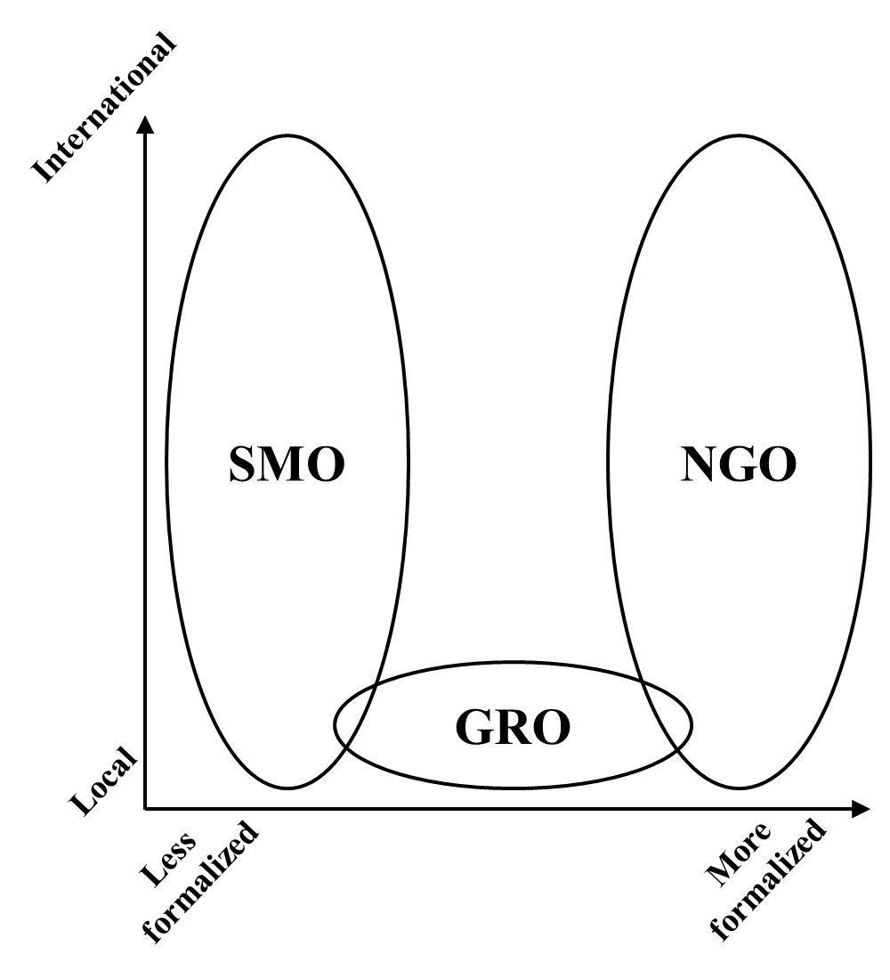

Figure 2: Framework of GRO Legitimacy over an Issue Life Cycle

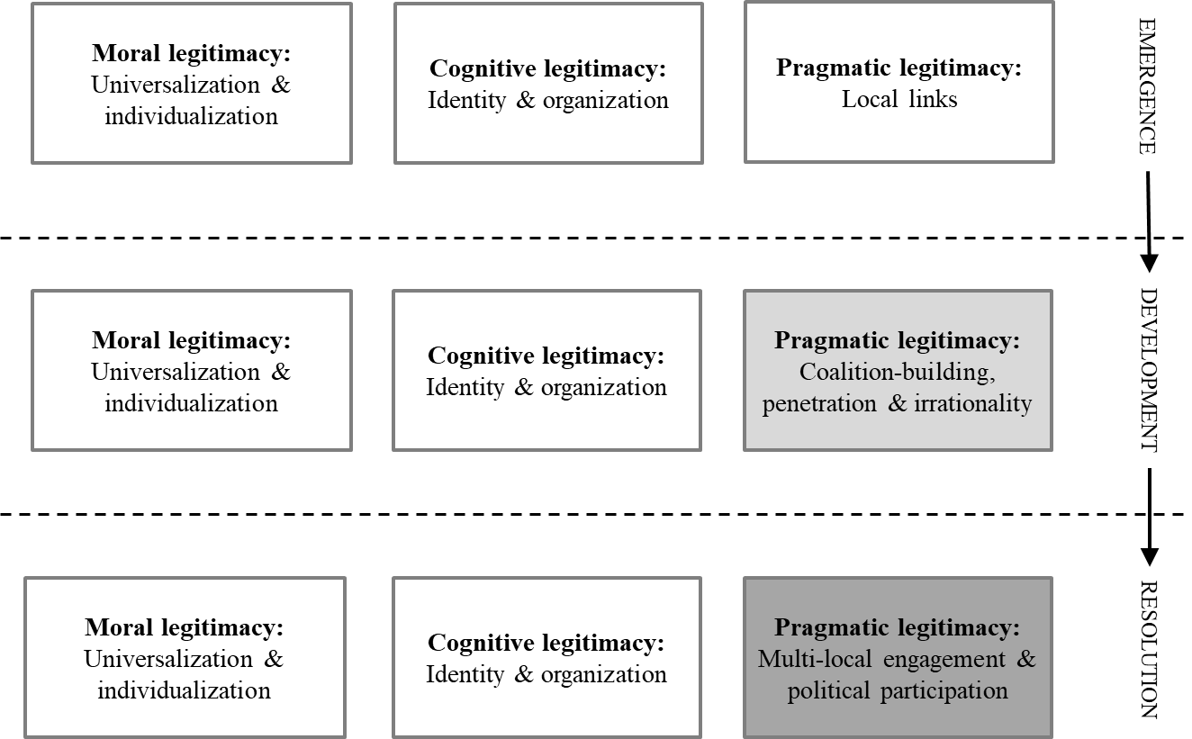

Figure 3: Legitimacy Strategies of ACT UP over an Issue Life Cycle

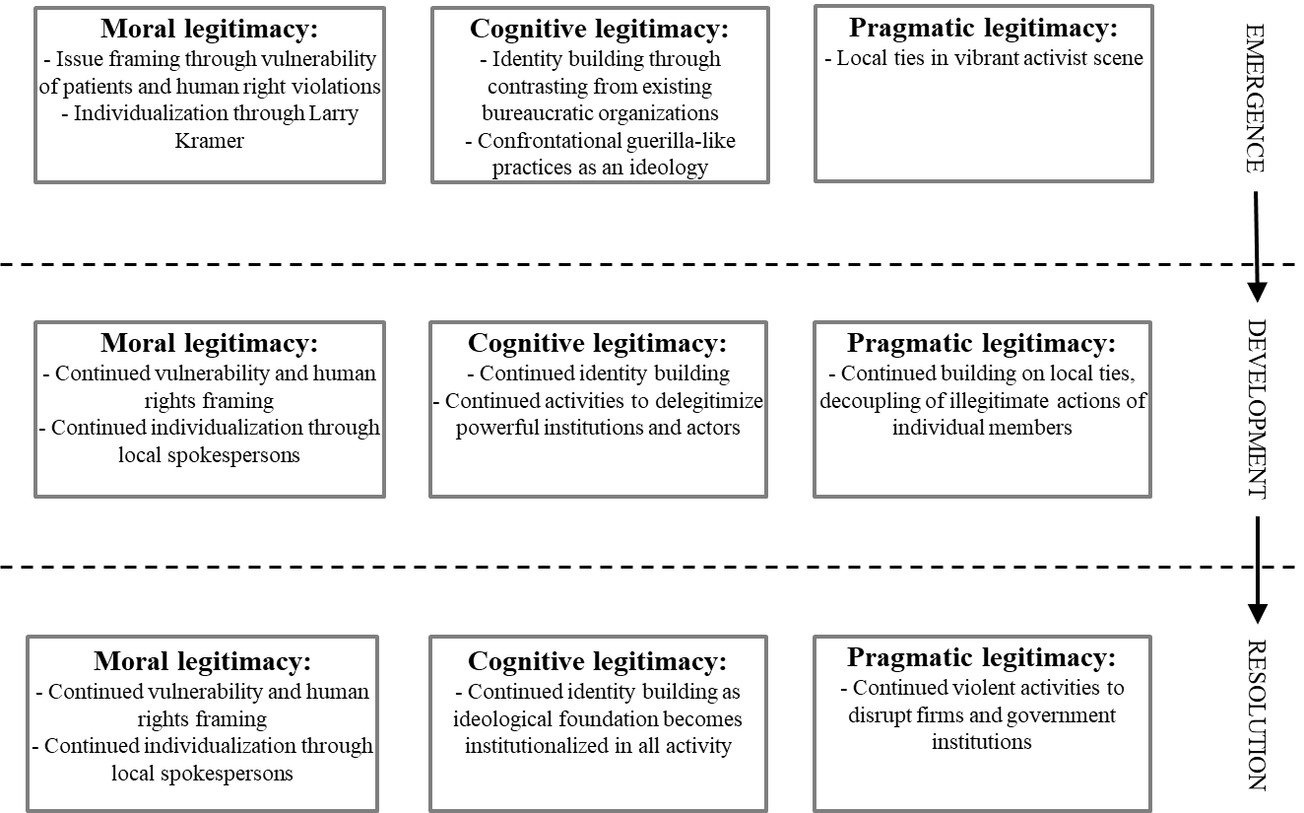

Figure 4: Legitimacy Strategies of TAC over an Issue Life Cycle

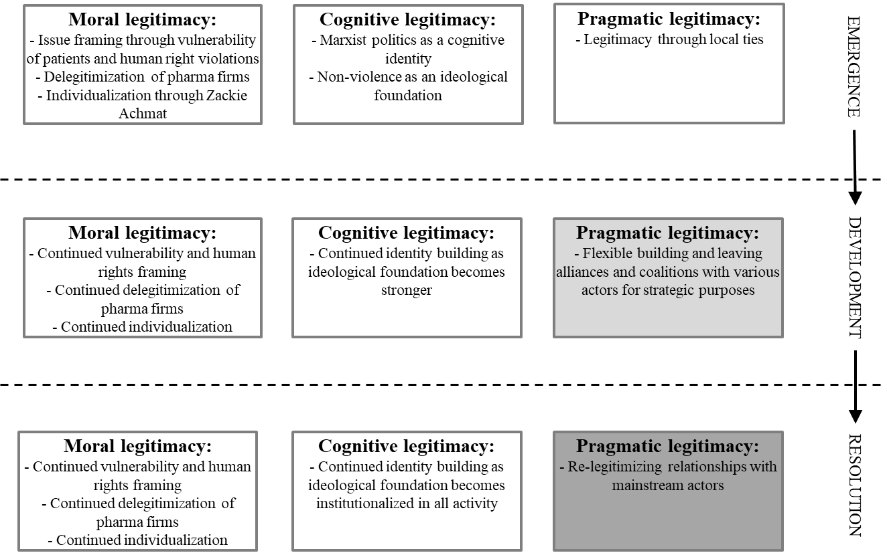

Acknowledgements
We thank the editor, Frank de Bakker, as well as four anonymous reviewers, for their guidance in improving this article. We also thank Santi Furnani and Daniel Waeger for their helpful comments on earlier version of this article.

Funding Acknowledgement
We gratefully acknowledge the support of the Finnish Academy (grant number: 259482).

Author Biographies
Rashedur Chowdhury is an Associate Professor at Southampton Business School, University of Southampton, and a Batten Fellow at Darden School of Business, University of Virginia (UVA). Prior to teaching in Southampton, he was an Assistant Professor at Michael Smurfit Business School, University College Dublin. He earned his Ph.D. at Judge Business School, University of Cambridge, and his thesis “Reconceptualizing the Dynamics of the Relationship between Marginalized Stakeholders and Multinational Firms,” received the Society for Business Ethics Best Dissertation Award in 2014. He has been invited as a Visiting Scholar by INSEAD Business School; UVA; Faculty of Business and Economics, HEC Lausanne, Switzerland; Department of Anthropology and Sociology, University of the Western Cape; School of Government, Peking University; School of Social Sciences, University of California, Irvine; and Haas School of Business, University of California, Berkeley. His most recent projects examine the Rana Plaza collapse and Phulbari movement in Bangladesh.

Arno Kourula is an Associate Professor (tenured) of Strategy at the University of Amsterdam Business School, Netherlands, and a Docent at Aalto University, Finland. Arno’s primary research interest is corporate sustainability through cross-sector interactions. He has published widely in academic journals in the fields of management, international business, business ethics, political science, and environmental studies.

Marjo Siltaoja is a Senior Researcher of corporate environmental management at the Jyväskylä University School of Business and Economics (JSBE) and a Docent of responsible business at the University of Tampere. Marjo’s research interest are in moral struggles related to corporate responsibility and pro-environmental business. She has previously published in academic journals in the field of management, environmental studies, organizations, sociology, and business ethics.

