AAV2/8 anti-angiogenic gene therapy using single chain antibodies inhibits murine choroidal neovascularization
Chris P Hughes¹, Neil MJ O’Flynn¹, Maureen Gatherer¹, Michelle E McClements², Jennifer A Scott¹, Robert E Maclaren², Srini Goverdhan¹, Martin J Glennie³, and Andrew J Lotery¹.
¹Clinical Neurosciences, Faculty of Medicine, University of Southampton, Southampton, United Kingdom.
²Oxford Eye Hospital and Nuffield Laboratory of Ophthalmology, Nuffield Department of Clinical Neurosciences, University Of Oxford, Oxford, United Kingdom.
³Cancer Sciences, Faculty of Medicine, University of Southampton, Southampton, United Kingdom.
Correspondence should be addressed to AL (A.J.Lotery@soton.ac.uk).
Address:
Clinical and Experimental Sciences, University of Southampton, South Lab and Path Block, MP 806, Level D, Southampton General Hospital, Tremona Road, Southampton SO16 6YD, United Kingdom
Phone:
+44 (0)23 8120 5049
Fax:
+44 (0) 2381 20 6085
Short title: Anti-angiogenic gene therapy for murine CNV

Abstract
While anti-angiogenic therapies for wet age-related macular degeneration (AMD) are effective for many patients, they require multiple injections, are expensive and prone to complications. Gene therapy could be an elegant solution for this problem by providing a long-term source of anti-angiogenic proteins after a single administration.
Another potential issue with current therapeutic proteins containing a fragment crystallizable (Fc) domain (such as whole antibodies like bevacizumab) is the induction of an unwanted immune response. In wet AMD a low level of inflammation is already present, so to avoid exacerbation of disease by the therapeutic protein, we propose single-chain fragment variable antibodies (scFv, which lack the Fc domain) as a safer alternative.
To investigate the feasibility of this, anti-vascular endothelial growth factor (VEGF) blocking antibodies in two formats were produced and tested in vitro and in vivo. The scFv transgene was then cloned into an adeno-associated virus (AAV) vector.
A therapeutic effect in a mouse model of choroidal neovascularization (CNV) was demonstrated with antibodies in both scFv and immunoglobulin G1 (IgG1) formats (p<0.04). Importantly, the scFv anti-VEGF antibody expressed from an AAV vector also had a significant beneficial effect (p=0.02), providing valuable preclinical data for future translation to the clinic.

Key Words: AAV gene therapy for AMD, anti- VEGF scFv antibodies, angiogenesis,

Introduction
AMD affects nearly 50 million individuals globally¹, costing $2 billion per year. With an ageing population, this is predicted to increase to $20 billion over the next decade, thus putting increasing, possibly unsustainable, financial demand on health care systems². Disease is characterized by excessive angiogenesis, causing irreversible loss of central vision¹. Therefore, treatments have targeted inhibition of this pathway. Current therapeutics for wet AMD have short half-lives, which necessitates monthly or bimonthly injections into the eye in perpetuity. This is expensive, painful and prone to adverse-effects. Repeated injections can result in retinal detachment, endophthalmitis, cataract, and possibly irreversible geographic atrophy (GA) in the long term³. Gene therapy can revolutionize AMD treatment by drastically reducing administration frequencies. Several phase I clinical trials of gene therapy for wet AMD have been reported, including AAV2 carrying sFLT01 (soluble VEGF receptor) by Rakoczy et al (2015)^{4,5} (ClinicalTrials.gov Identifier: NCT01678872).
In this study we have utilized AAV, which has been shown to be safe in a number of clinical trials to date, and compared to lentiviruses has a significantly lower insertional mutagenesis risk⁶. The absence of a cell-derived envelope makes AAV less immunogenic than many other viral vectors (such as adenovirus), and has also demonstrated long-term expression in retinal cells⁷. Indeed, many forms of therapeutics have been delivered by AAV for use in AMD models, ranging from anti-VEGF antibodies⁸, anti-VEGF shRNA⁹, sFlt-1¹⁰, to soluble membrane attack complex inhibitory protein (sCD59)¹¹. AAV has also been tested in several landmark ocular gene therapy clinical trials, including a phase I/II clinical trial for choroideremia where the vector was successfully delivered to the macula¹². To date, all trials published with AAV-mediated gene therapy for eye diseases have used the AAV2 serotype. However, quicker and higher transgene expression levels may occur with AAV2/8 vectors after subretinal injection¹³. We reasoned that the greatest expression of anti-angiogenic agents would equate to best efficacy, therefore we chose the AAV8 serotype for this study. After subretinal injection, AAV2/8 transduces mainly retinal pigmented epithelium (RPE) cells and some photoreceptors¹³.
We have recently shown that Fcγ receptor upregulation produces immune-complex mediated inflammation in AMD¹⁴. This may have implications for therapy with agents which have Fc segments. Therapeutic agents such as scFv antibodies that do not exacerbate disease by activating Fc receptors and complement would be preferable. scFv consist of only V_{H} and V_{L} domains separated by a flexible linker (see Fig. 1a), and represent the minimum portion of an antibody required for antigen binding¹⁵. We believe the development of scFv antibodies is important, as they are smaller (cDNA ~1kb) than whole antibodies (~2.5kb) or Fab fragments, and so better suited to expression from AAV vectors with limited transgene capacity (<5kb). Indeed, it is theoretically possible to fit more than one scFv into the same AAV vector, which opens up possibilities for combination therapies. Smaller scFv antibodies may also have improved diffusion in vivo compared to larger standard antibodies¹⁶ thus acting on a greater area of retina. An anti-VEGF designed ankyrin repeat protein (DARPin) has been successfully used in AMD models¹⁷, and is now being evaluated in clinical trials¹⁸. In addition, an alternative class of antibodies, the camelid-derived nanobodies are in several trials (e.g. anti-IL-6R for autoimmune diseases¹⁹). However, we are unaware of any reports of anti-angiogenic antibodies in the scFv format being developed for AMD. Therefore, this is both a novel and highly relevant option to developing a safer, longer lasting and convenient therapy for AMD. Furthermore, the combination of anti-VEGF scFv with an AAV2/8 vector may translate to an improved gene therapy for wet AMD. The purpose of this study was to provide pre-clinical data for an AAV2/8 vector encoding a previously described G6-31 anti-VEGF antibody²⁰ in scFv format for possible translation as a novel therapy for AMD.

RESULTS
Production and in vitro testing of recombinant anti-VEGF antibodies:
The anti-VEGF antibodies used in this study were based on the G6-31 antibody described by Liang et al, 2006²⁰. We incorporated the binding sites of G6-31 into both a standard (IgG1) and scFv format, and evaluated these antibodies for effectiveness in treating a laser induced CNV mouse model. The IgG1 antibody protein was produced by transfecting 293F cells with a plasmid containing both the heavy and light chains that later associate to form the mature IgG1 (see Fig 1a for illustration of antibodies used in this study). The scFv (variable heavy and variable light chains only) was encoded in a single plasmid and produced in a similar way. Both proteins gave high yields (>10mg/liter medium).
After purification, sodium dodecyl sulfate polyacrylamide gel electrophoresis (SDS-PAGE) analysis demonstrated the expected molecular weight (160kDa for IgG1, and 32kDa for scFv) and high purity of both of the antibody formats (Fig. 1b and c). Importantly, both antibodies were able to bind both human and mouse VEGF in enzyme-linked immunosorbent assay (ELISA) (Fig. 1d and e). The blocking activity of both antibody formats was also confirmed in a bioassay (Fig. 1f). This assay used varying amounts of antibody to block the human VEGF-dependent growth of human dermal microvascular endothelial cells (HDMEC). A dose-dependent inhibition of cell growth in all anti-VEGF treated cells was seen, but not with an irrelevant control antibody. Surprisingly, our IgG antibody had an inferior activity compared to our positive control antibody (bevacizumab), despite the affinity of bevacizumab being lower. This may be explained by the bevacizumab being taken from a clinical treatment vial, which may well be more pure and active than our preparations. Half-maximal inhibition of 10ng/ml human VEGF occurred with approximately 10ng/ml IgG and 40ng/ml scFv anti-VEGF, while around 2ng/ml was required for bevacizumab. Thus, the IgG is more active than the scFv, which reflects the higher affinity of the whole antibody format.
In vivo testing of recombinant anti-VEGF antibodies:
Antibody preparations were tested for endotoxin before injecting into mice. All samples were endotoxin negative (<10 EU units/ml/mg, data not shown). Forty µg anti-VEGF IgG1 protein was injected intravitreally both 3 days before and 3 days after laser induction of CNV (n=5 eyes). Two weeks after laser injury, the therapeutic effect on CNV was investigated by fundus fluorescein angiography (FFA) and immunohistology (IH, staining eye cups for blood vessels). This experimental timeline is shown in Fig. 2a.
Fig. 2b and d show typical images from this experiment. In general, an excellent correlation was seen between FFA and immunohistology (IH) with lesions showing similar locations and intensity. In addition, four CNV spots were always observed in the untreated eyes, indicating the reliability of laser-induced lesions. Indeed, fundus photographs showed four marks in all lasered eyes, and so were used to confirm the presence of injury even in treated eyes without detectable lesions (Fig. 2c). Moreover, on quantification of these signals (as illustrated with circles in Figs 2b and d) using Image J²¹, a significant (p = 0.03) decrease in CNV fluorescence (77%) was seen using FFA methods in IgG antibody treated eyes (mean fluorescence units (FU) = 640,000 ± SD 400,000), compared to PBS-injected controls (2,700,000 FU ± 2,600,000; Fig. 2e). An equally significant (p = 0.03) decrease (73%) was observed in antibody injected eyes (32 FU ± 18) compared to control eyes (120 FU ± 90) as determined by IH (Fig. 2g)
The anti-VEGF scFv was tested in the same way, using the same dose (n=6 eyes). A significant (p = 0.004) decrease in fluorescein signal (85%) was detected in antibody treated eyes (160,000 FU ± 150,000; Fig. 2f) versus PBS treated eyes (1,200,000 FU ± 660,000). Similarly, a significant (p = 0.04) reduction in collagen IV staining (61%), was noted in anti-VEGF scFv administered eyes (84,000 FU ± 120,000) relative to PBS controls (220,000 FU ± 130,000; Fig. 2h). Thus the two antibody formats showed similar efficacies. The quantification data for individual animals treated with recombinant antibody is tabulated in Table S1.
Production and in vitro testing of AAV2/8 anti-VEGF scFv antibodies:
The AAV2/8 vector (illustrated in Fig. 3a) was designed for maximal transgene expression, with a strong CAG (cytomegalovirus early enhancer element, chicken beta -actin promoter, rabbit beta-globin gene) promoter²², and a WPRE (woodchuck hepatitis virus post-transcriptional regulatory element) sequence²³ to enhance expression. As well as the anti-VEGF scFv, another scFv (termed Bcl-1, of unknown specificity) was also cloned into a separate vector as a negative control. Purified AAV2/8 scFv was verified by confirming the presence of the three main AAV proteins (VP1, VP2, VP3) using SDS-PAGE (data not shown). The virus was titred by qPCR, and HEK293T cells were infected (at an MOI of 100,000:1) to test expression of antibody. The supernatant of infected HEK293T cells was analyzed, and expression of both antibodies by Western Blot was detected (data not shown). Importantly, this supernatant was found to contain VEGF binding activity by ELISA (Fig. 3b), indicating that the anti-VEGF scFv had been correctly expressed, secreted, and was functional. Moreover, the negative control antibody did not bind VEGF in this ELISA (Fig. 3b).
In vivo testing of AAV2/8 anti-VEGF scFv antibodies:
In order to test expression from the AAV2/8 vectors in vivo, each mouse was injected with 8x10⁸ genome copies (gc) of AAV2/8 anti-VEGF scFv in one eye, and equal amounts of AAV2/8 control scFv in the other eye. These were given sub-retinally to maximize expression, as expression of AAV2/8 vectors is around 10-fold higher than intravitreal route¹³. Four months after injection, eyes were analyzed for antibody expression by Western blot (n=3) and ELISA (n=2). Anti-VEGF scFv could be detected in ELISA (Fig. 3c). The quantity of antibody was then estimated at approximately 1000µg/ml by extrapolating the signal obtained relative to that from a known concentration of anti-VEGF scFv protein (Fig 3c). Some anti-VEGF was also detected in one of the control AAV treated eyes, although at much lower levels. Similarly, anti-VEGF was detected in the serum of one of the two mice at very low levels (20-fold less than the injected eye). Importantly, supernatant from AAV control scFv (Bcl) infected cells did not bind VEGF in ELISA (Fig. 3b). Western blot showed the expected molecular weight bands (32kDa) in anti-VEGF scFv and control scFv eyes (Fig. 3d). In contrast to the ELISA (which cannot detect the control scFv), Western blot resulted in bands of similar intensities in AAV anti-VEGF and AAV control scFv. This was to be expected, as the Western blot detects both anti-VEGF and control scFv (via their His-tags), and equal amounts of each virus were injected into both eyes.
Once the presence of anti-VEGF had been shown in AAV-injected eyes, the exact localization of transduced cells was next investigated using IHC. Sections of AAV anti-VEGF and PBS-injected control eyes (posterior poles only) were stained with DAPI (blue) so that the various tissues could be visualized. Typical confocal images (Fig. 3e) showed green staining when slides were incubated with an anti-His-tag (which is incorporated into the anti-VEGF) antibody and a fluorescently labelled secondary antibody. Importantly, there was no green signal in AAV anti-VEGF control sections with the secondary antibody alone, or in PBS-injected eyes incubated with both detecting antibodies. This indicates a specific signal that corresponds to the anti-VEGF protein. Of note, the region of the eye stained was mainly the RPE. This in agreement with previous studies where sub-retinal injection of AAV2/8 vectors resulted in transduction largely of RPE cells, with some photoreceptors¹³.
When laser was used to induce CNV three weeks after AAV2/8 scFv injection (see Fig. 4a for an illustration of AAV treatment timelines and Fig. 4b for typical FFA images), a significant (p = 0.02) 83% decrease was seen in FFA CNV signal (n=7 eyes) in AAV anti-VEGF eyes (480,000 FU ± 1,000,000) compared to control AAV (2,800,000 FU ± 2,600,000; Fig. 4c). Moreover, when re-challenged with a repeat CNV laser induction in the same mice after a further two months, the anti-angiogenic effect (81% decrease in FFA signals) was as significant (720,000 FU ± 750,000 for AAV anti-VEGF scFv versus 3,800,000 FU ± 2,800,000 for control AAV; Fig. 4d). A significant (p = 0.03, n=5 eyes) decrease (67%) in CNV was also noted in AAV anti-VEGF eyes as determined by IH (2,400,000 FU ± 1,300,000 for AAV anti-VEGF scFv versus 7,200,000 FU ± 4,400,000 for control AAV) at the two-month time point (Fig. 4e). The quantification data for individual animals treated with AAV scFv is tabulated in Table S2. Together, these data indicate a long-term effect in these mice.
To demonstrate a lack of toxicity of injected AAV anti-VEGF, ERG responses were obtained (n= 4 anti-VEGF study eyes, n=3 PBS control eyes). No significant reduction in B wave amplitudes was revealed in the study and control eyes (0.11 mV vs 0.10 mV, P=0.34). The mean A wave amplitude was reduced in study eyes marginally (-0.03 mV vs -0.01 mV, P=0.06). The latency/implicit times were unaffected and similar for both A waves and B waves in the study and control eyes (figure 5a). To assess toxicity of the PF68 used as a surfactant in the previous AAV anti-VEGF efficacy experiment, PBS with or without PF68 was injected into eyes. PBS+ (with PF68; n=3 eyes) and PBS (without PF68; n=3 eyes) showed no significant differences in the B or A wave amplitudes and latency/implicit times (Fig. 5b).
Discussion
This study describes the use of a novel anti-VEGF antibody format designed to develop gene therapy of wet AMD. This antibody was based on the G6-31 generated by Liang et al (2006)²⁰ and was chosen as it was shown to bind both human and mouse forms of VEGF with high affinity. This binding was greater than that of bevacizumab²⁰ (K_{d} to hVEGF of 0.2nM for G6-31 IgG and 2.2nM for bevacizumab). These are highly desirable features of a potential therapeutic agent which can be tested in mouse models, and progress rapidly to clinical trials without modification.
Moreover, this antibody in an IgG format had previously been shown to suppress CNV in mice after being given intraperitoneally²⁴. However, this administration route has disadvantages if these methods were translated to treating AMD patients. These include a potential induction of an immune response by the IgG antibody and side effects of systemic VEGF suppression. Therefore, delivery into the immune-privileged eye appears more appropriate. In order to minimize the chances of the antibody causing deleterious inflammation in the eye, this antibody was produced in the mouse IgG1 format (as this isotype is the least able to activate complement or bind activating Fc receptors on antigen binding).
In order to validate the efficacy of the anti-VEGF we first used purified proteins of the mIgG1 and scFv formats. These proteins were then shown to bind both human and mouse forms of VEGF in ELISA. While we have not tested the affinities of our antibodies, we expect the affinity of our IgG1 antibodies to be similar to the IgG reported by Liang et al (2006)²⁰ i.e. 0.2nM for hVEGF, and 0.3nM for mVEGF. While scFv were not studied by Liang et al (2006)²⁰, we can assume they will be similar to the affinities of the Fab they used i.e. 0.9nM for hVEGF, and 0.6nM for mVEGF. The affinity is higher for IgG than Fab and scFv because the two binding sites in IgG create an extra avidity effect compared to the one binding site in Fab and scFv.
These antibodies were then shown to block VEGF activity in vitro and limit CNV in vivo after injection into the eye. Interestingly, a remarkably similar amount of inhibition of CNV was found with equal doses of the two different formats. This is very encouraging for potential clinical development of the scFv. It is tempting to directly compare the IgG and scFv versions in our experiments, but caution must be taken in interpretation of the data. A simple comparison of both in vitro and in vivo results even using equal amounts of protein of both antibodies is complicated by the different molecular weight of the antibodies – we estimate that approximately five times the number of scFv molecules (and 2.5 times the antibody binding sites) are present per gram. Other factors to be taken into account are the advantage of possible enhanced diffusion to the outer retina of the smaller scFv format being balanced by disadvantages such as decreased affinity and potentially shorter half-life of scFv compared to IgG antibodies.
The anti-VEGF scFv was incorporated into an AAV2/8 vector. The scFv was chosen over the IgG1 for incorporation in the vector due to the lack of Fc region and small size. Indeed, the limited capacity for this vector (1.5kb) meant that it was not possible to insert the full antibody (2.5kb), without compromising expression levels by removing the WPRE, or substituting the promoter for a potentially weaker one. An amelioration of CNV was seen in mice injected with this vector. Importantly, we observed that despite the fact that the bleb formed during sub-retinal injection only covered around one third of the retinal area, even CNV lesions distal to the injection site were also suppressed. It appears that the AAV2/8 and/or antibodies are able to diffuse to the site of disease. This is important for translation to human patients. By using a secreted antibody it may not be necessary to transduce every target cell in the eye to generate a therapeutic effect. Thus, this approach is more feasible than an intracellular gene replacement (e.g. Stargardt disease), where the aim is to transduce all target cells.
A similar CNV suppression was demonstrated in AAV and recombinant antibody-treated mice. Using an estimated volume of a mouse eye to be approximately 19mm³, we attempted to quantify the amount of anti-VEGF scFv protein in AAV2/8-treated eyes. 1000µg/ml was detected in eyes injected with AAV2/8 anti-VEGF scFv, while we estimate that 80µg anti-VEGF scFv protein injected during the antibody treatment experiments would correspond to around 4000µg/ml antibody in the eye. Therefore, despite the fact that there was less scFv in the virus treated mice, it seemed to be equally effective. This may be explained by this initial peak concentration quickly decreasing due to decay of protein injected, while with AAV anti-VEGF scFv the levels will remain constant, as any degraded protein is continuously replenished. Another factor may be the distance to CNV from the RPE/photoreceptor cells expressing the antibody is less than the vitreous location of antibody injections.
One cause for concern in our study was the detection of anti-VEGF scFv both in the serum and in control AAV injected eyes, as systemic inhibition of angiogenesis could lead to unwanted side-effects. While the blood-retina barrier is normally responsible for keeping the eye an isolated organ, in CNV this becomes leaky; potentially explaining the presence of antibody in serum and control AAV treated eyes. However, these levels were very low compared to those in the AAV-anti-VEGF treated eye. Furthermore, the subretinal injection in mice was given through the choroid, which would compromise the outer blood retina barrier and allow egress of AAV particles into the choroidal vasculature. This would not occur to the same extent in humans because the subretinal injection would be given transvitreally, which can be done without penetrating the choroidal vasculature¹². A range of doses would inform us of the optimum dose i.e. the minimum dose needed for efficacy without being able to detect antibody in the serum. Interestingly, systemic suppression of VEGF has been found in clinical trials using intravitreal ranibizumab and bevacizumab²⁵, and these drugs are still considered safe for clinical use. Indeed, bevacizumab is also safely given systemically to cancer patients suggesting that systemic inhibition of angiogenesis may not be a major issue. Efforts to minimize any potential side effects should be made, however. While the half-life of these antibodies has to our knowledge not been studied, in general the IgG format of an antibody has a longer half-life than its scFv counterpart. This is due in part to the IgG being above the renal threshold (and thus remaining in the blood), and the scFv being below (thus leaving the blood). In addition, IgG antibodies are actively recycled into the blood via their Fc domains by the Fc receptor FcRn. However, scFvs do not possess an Fc domain, so will not be subject to this system, and hence will have lower retention in the blood than and IgG. While a shorter half could potentially adversely affect the efficacy of scFvs, this may be more than made up for by increased safety due to lower systemic levels (as well as enhanced diffusion). This could be explored further in phase I/II clinical trials.
We used the laser-induced CNV mouse model, as it has similarities to human wet AMD, is highly reproducible, and is extremely well characterized in a number of anti-VEGF studies to date. One limitation of our study is that it focusses on prevention, as opposed to treatment of established disease, which would be more clinically relevant to AMD. Future work could include treating established disease, but this is complicated by finding a treatment window, as in the laser model CNV is short-lived and self-limiting²⁶ and AAV2/8 takes at least 2 weeks¹³ to express transgene. Thus in trials, it may be necessary to give an initial injection of antibodies until therapeutic levels of protein are expressed via AAV2/8.
The AAV2 sFlt01 gene therapy in wet AMD Phase I trial by Rakoczy et al (2015)⁴ has demonstrated that VEGF blockade delivered by gene therapy is safe. However, while these are promising results, this is only a small group of patients (8) and a short time point (1yr). Our data suggest that AAV2/8 may provide an alternate vector choice. Indeed, this vector may transduce more cells and express higher than the AAV2 serotype. Another advantage of elevated expression is that fewer viral particles will be needed for efficacy; thus there will be a reduced chance of vector-mediated toxicity.
As our aim is to produce safer transgenes, it was important investigate AAV vector toxicity. The ERG showed no significant difference was observed in virus-injected responses compared to PBS controls. This suggests the virus has no effect on visual function, and is in agreement with previous reports²⁷, where injection of 6.8x10⁹gc ( 10-fold higher than our dose) of AAV8 GFP did not alter ERG readings.
One exciting possibility for our future studies will be investigating combination therapies. Alternatives to antibody therapies may include vasoinhibin²⁸, IL-27²⁹, complement inhibitors such as sCD59³⁰ and complement factor H (CFH)³¹, all of which have been efficacious in animal models of wet AMD. The use of these therapies in the protein format as described in these reports still requires regular administration, however. This problem can be overcome similarly by incorporating them (either alone, or in combination) into a gene therapy vector for a continuous source of protein after a single administration. We therefore believe anti-angiogenic gene therapy is worth pursuing as a way to successfully treat this extremely prevalent and blinding condition.
Materials & Methods:
All materials were obtained from Sigma-Aldrich (Poole, UK) unless otherwise indicated.
Animals: All animal procedures were performed in accordance with the ARVO Statement for the Use of Animals in Ophthalmic and Vision Research and under the authority of a UK Home Office License (Home Office Project Licence No. 30/2843). Female C57BL/6 mice were bred in-house (at the University of Southampton). Mice of the same age (range 3-4 months old) were used for each experiment. All animal studies have been approved by the local Institutional Review Board.
Cells and tissue culture: Human dermal microvascular endothelial cells (HDMEC; Promocell, Heidelberg, Germany) were grown in complete MV Endothelial Cell Media (Promocell). HEK293T cells (ATCC) were grown in DMEM + 10% fetal calf serum (FCS) + 100 units/ml penicillin + 100 µg/ml streptomycin. Humidified incubators at 37ºC, 5% CO₂ were used for culturing 293T and HDMEC. 293F cells (Invitrogen, Inchinnan, UK) were grown in 293 Freestyle medium (Invitrogen) in Erlenmeyer flasks in shaking (130rpm) humidified incubators at 37ºC, 8% CO₂.
Antibody cloning and production: The G6-31 anti-VEGF (Liang et al 2006)²⁰ was used as a basis for both our antibodies. The variable heavy (V_{H}) domain of the anti-VEGF antibody was cloned into a plasmid (pEE14.1)³² containing the mouse IgG1 heavy chain constant domains. Into the same vector (at a separate location), the variable light (V_{L}) domain of the anti-VEGF antibody was cloned adjacent to the mouse IgG1 light chain constant domains. Thus, when transfected into cells this vector produces heavy and light chains separately, which then associate to form the mature antibody. The scFv format anti-VEGF was cloned by inserting the V_{H} and V_{L} domains of G6-31 separated by a 15 amino acid glycine/serine-rich flexible linker into the pcDNA4 HisMax plasmid (Invitrogen). This linker allows the association of the V_{H} and V_{L} domains to form a scFv capable of antigen binding. This plasmid contains a six histidine amino acid run at the N-terminus of the scFv (His-tag), used as a detection agent and for protein purification purposes. In addition, we cloned a CD33 (kindly provided by Claude Chan, University of Southampton) signal peptide upstream of the scFv to allow secretion of the protein.
The above plasmids were used to make recombinant IgG1 or scFv proteins by spinning down 5x10⁸ 293F cells, and resuspending in 25ml of medium containing 500µg plasmid and 1.5mg of linear polyethylenimine (PEI; Park Scientific, Maidenhead, UK). This mix was returned to culture for 3 hours, before adding 475ml medium and valproic acid to a final concentration of 3.75mM. The transfection was cultured for 7 days, and supernatant was harvested by spinning the cells at 2,400xg for 1 hour.
Antibody purification: Anti-VEGF IgG1 was purified by affinity chromatography by virtue of the ability of the antibody to bind protein A. Running buffer (40mM Tris-HCl, 2mM ethylenediaminetetraacetic acid (EDTA), 200mM NaCl) was passed down a column (at 2ml/min) containing protein A agarose beads (GE Healthcare, Little Chalfont, UK), before passing the 0.2µm filtered supernatant through. The column was washed with 30ml running buffer, before eluting with 20ml elution buffer (100mM glycine, 1mM EDTA, 44mM HCl, pH3). To neutralize the pH of the eluate, 10ml 5x running buffer was added after elution.
Anti-VEGF scFv was also purified by affinity chromatography. As His-tagged proteins bind Ni-conjugated beads, we exploited this for purification of scFv protein. Supernatants were supplemented with 300mM NaCl and 10mM imidazole, and the pH was adjusted to pH8 before 0.2µm filtering to sterilize. To this 3ml Ni-NTA agarose (Qiagen, Manchester, UK) and 1ml Protease Inhibitor Cocktail Set III, EDTA-Free (Roche, Welwyn, UK) was added, and left rotating overnight at 4ºC. Then, the supernatant (plus Ni-agarose) was passed down an Econo-Column chromatography column (Biorad, Hemel Hempstead, UK), where the agarose collected at the bottom, while allowing fluid to pass through (under gravity). The Ni-agarose was then washed with 2x8ml wash buffer (300mM NaCl, 50mM NaH₂PO₄, 20mM imidazole, pH8), and protein was eluted with 8ml elution buffer (300mM NaCl, 50mM NaH₂PO₄ , 250mM imidazole, pH8). Purified antibodies were dialyzed by inserting into Slide-A-Lyzer G2 3k MWCO dialysis cassettes (Invitrogen), and placing in an excess of phosphate buffered saline (PBS) with constant stirring overnight at 4ºC. To concentrate antibodies, Amicon Ultra-15 3k MWCO Centrifugal Filter Units (Millipore, Livingstone, UK) were used according to manufacturer’s instructions.
Endotoxin testing of antibodies: An EndosafePTS machine with an Ameobocyte Lysate cartridge (both Charles River, Tranent, UK) was used according to manufacturer’s instructions to test the antibodies for endotoxin before use in vivo. Samples <10 EU units/ml/mg were deemed endotoxin free.
ELISA (enzyme linked immunosorbent assay): Anti-VEGF binding ability of antibodies was analyzed by ELISA. A 96 well ELISA plate (Fisher, Loughborough, UK) was coated by incubating at 4°C overnight with 1 μg/mL human or mouse VEGF (Abcam, Cambridge, UK) in PBS. The plate was then blocked by incubating at 37°C for 1.5 hours in 2% Marvel/PBS. Samples for anti-VEGF testing were prepared in blocking buffer and placed into wells in duplicate and incubating at 37°C for 1.5 hours. Anti-VEGF IgG1 was detected using rabbit-anti-mouse conjugated to horse-radish peroxidase (HRP) diluted 1:2000 in blocking buffer, and incubating at room temperature (RT) for 1 hour. Anti-VEGF scFv was detected with mouse-anti-His tag HRP (Invitrogen) diluted 1:5000 in blocking buffer, and incubating at RT for 1 hour. After each step above, the plate was washed three times with PBS/0.05% Tween 20. The HRP substrate was made by dissolving an OPD tablet in 100mL of 4.8g/L citric acid + 7.1g/L Na₂ HPO₄ + 0.012% H₂O₂. After adding HRP substrate and allowing color to form at RT in the dark, the reaction was stopped with 2.5M H₂SO₄ and read on a plate reader (Dynatech MR4000, Dynatech Labs, Texas, USA) at 490nm.
For antibody quantification in homogenized eyes by ELISA, an average diameter of adult C57BL/6 eyes of 3.3mm³³ was used was used to calculate the volume (19mm³), equivalent to 19µl.
SDS-PAGE: Samples were prepared by adding loading buffer (Biorad) to samples (2:1), and heating at 95°C for 5 minutes. If denaturation was required, loading buffer + 5% β-mercaptoethanol was used. 10µl samples including Novex Sharp Pre-stained Protein Standard were loaded onto Bis-Tris 10% ready-made gels (both Invitrogen). The gel was run in an XCell SureLock Mini-Cell (Invitrogen) at 200 V for 1 hour in MOPS buffer (50 mM 3-(N-morpholino)propanesulfonic acid, 50 mM Tris Base, 0.1% SDS, 1 mM EDTA, pH 7.7). Gels were stained with EZBlue according to manufacturer’s instructions to visualize bands. Images of gels were taken with a Hewlett Packard (Newcastle, UK) scanner.
Western Blotting: Samples were first run on an SDS-PAGE gel as above. Then, the gel was transferred onto nitrocellulose (0.45µM, Biorad) by removing from its case and placing in a sandwich of gel and nitrocellulose surrounded by filter papers in transfer buffer (Tris base (0.025M), glycine 0.192M), 1% SDS, pH8.6, 20% methanol). The sandwich was then run in an XCell II™ Blot Module (Invitrogen) at 100V for 1hr. After transfer, the nitrocellulose is blocked by placing in TBS (50mM Tris, 150mM NaCl, pH 7.6) + 3% bovine serum albumin (BSA) at 4^{O}C, overnight, with shaking.
Following blocking, the anti-His HRP detection antibody was added at RT for 2hrs, at a dilution of 1:5000 in blocking buffer. This was then washed off with 3x5 minute washes with TBS+0.1% Tween20, before finally placing in TBS. Signals were then developed for imaging by adding ECL reagent (Clarity Western ECL reagent, Biorad) Images were captured using a Gel Doc (Biorad).
Bioassay: 0.5x10⁴ HDMEC cells in complete medium were added to each well of a 96-well tissue culture plate (Fisher). The next day, medium was replaced with basal medium + 1% FCS. 1 day later, 10ng/ml human VEGF in basal medium + 1% FCS was added, with or without antibodies. Antibody concentration ranged from 625ng/ml to 0.2ng/ml, with 1:4 dilutions across the plate. The following antibodies were added in triplicate: anti-VEGF IgG1, anti-VEGF scFv, bevacizumab (positive control, Genentech, California, USA), anti-PDGFRβ IgG1 (negative control). 2 days later, the number of live cells was quantified by adding the cell proliferation reagent WST-1 (Roche) for 4 hours, and reading on a plate reader at 450 nm.
Laser-induced CNV: Mice were anesthetised by intraperitoneal injection (IP) of 6mg/ml ketamine plus 0.05mg/ml Dexdormitor at a volume of 0.1ml of per 10g mouse. Pupils were dilated by addition of G.tropicamide 1% eye drops followed by G.phenylephirine 2.5% eye drops. Eyes were coated with Viscotears to keep moist. A layer of Viscotears was used for coverslip adherence on the eye. Using a 532nm retinal laser (frequency doubled ND-YAG laser, Zeiss, Welwyn, UK) set at 120mwatt, for 100ms and spot size of 100µm, four laser spots per eye (one per quadrant) were applied. Mice were recovered by injecting 0.3ml of 0.5mg/ml Antisedan (all materials in this section: Centaur Services, Castle Cary, UK).
Treatment with anti-VEGF antibody: Mice were anesthetized and pupils dilated using same methods as above. With the aid of an operating microscope (Zeiss), 2µl of 20mg/ml antibody (in PBS) was injected intravitreally with a 5µl Hamilton syringe (Esslabs, Hadleigh, UK) fitted with a 34G needle (Esslabs). For each mouse, anti-VEGF scFv or anti-VEGF IgG1 (n=6 or n=5, respectively) was injected into one eye, and an equal volume of PBS in the other (control) eye.
Fundus fluorescence angiography (FFA): 10 – 14 days after laser administration, mice were anesthetized and pupils dilated as above. The mouse was placed on the heated platform of a Micron III camera (Phoenix Labs, Pleasanton, USA). The retina was focused with the camera lens objective against the eye. 0.3ml 2% fluorescein (Centaur Services) was injected IP. The excitation and filter wheel was set to position 2. Early (30 seconds) and late (3 minutes) FFA images were captured for each eye using Streampix v5 software (Phoenix Labs).
Collagen IV immunohistology (IH): Mice were culled by cervical dislocation, and eyes for flat mounts were removed with forceps, and fixed in 4% paraformaldehyde (PFA) for 30 minutes, before storing in PBS. Eyes were dissected so that only RPE/choroid remained. To enable the eyecup to be spread flat, four radial cuts in the sclera/choroid/RPE were made. Eyecups were washed four times in PBS, before blocking with 15% normal goat serum IH buffer (PBS + 0.2% Tween + 0.5% BSA with shaking on an orbital shaker at 100 rpm overnight at 4ºC. Samples were then Incubated with a 1:500 dilution of rabbit anti collagen IV (Abcam) in IH buffer for 2 days shaking at 4ºC. Samples were washed four times in PBS, before incubating with a 1:200 dilution of goat anti rabbit alexafluor594 (Invitrogen) in IHC buffer for 1 days at 4ºC. Samples were washed three times in PBS and mounted on a Superfrost Plus slide (Fisher) in 0.25ml pre-warmed mowiol/citifluor (16% Mowiol (Harlow Chemicals, Batley, UK) in 30% glycerol in PBS plus 0.1% citifluor (VWR, Lutterworth, UK), and sealed with a coverslip. Slides were incubated overnight at 4ºC in the dark to dry. Images were taken using a Zeiss Axioskop fluorescent microscope.
Quantification and statistics: Quantification of size and intensity of lesions of both FFA and IH were done using Image J (version 1.47)²¹ as described in Wigg et al, 2015³⁴. Briefly, a region of interest (ROI) was drawn around the CNV lesion, and the signal intensity and area was measured. The area was multiplied by the signal intensity. A second ROI of the same area was drawn around an area without lesions, and measured. This background measurement was subtracted from the lesion signal to give corrected values. The corrected signals for each eye were then summed, and then logged into a spreadsheet (GraphPad Prism). n numbers thus refers to numbers of eyes used in each treatment group. An equal number of treated and control eyes were used. A box and whiskers graph was generated, with minimum and maximum values in each group illustrated by the whiskers and the band in the box representing the median. A Mann Whitney test (two-tailed) was used to determine a statistically significant difference in the two groups. Thus, a p value <0.05 was classed as statistically significant.
AAV2/8 scFv cloning: The anti-VEGF scFv or negative control scFv (Bcl-1) were cloned into the pAAV CAG WPRE vector (Vector Biolabs, Malvern, USA) between the CAG promoter and the WPRE region. The CD33 signal peptide was also included. XL10-Gold bacteria (Agilent, Cheadle, UK) were used for AAV vector cloning to maintain the integrity of the ITRs throughout the cloning process, which was confirmed by XmaI digestion (both ITRs contain XmaI sites).
AAV2/8 scFv vector production: For co-transfecting HEK293Ts with pAAV CAG scFv WPRE and pDP8.ape (Plasmid Factory, Bielefeld, Germany) in a 10-layer HyperFlask, a total of 500μg DNA was added to 1.125mg branched PEI. After growing for 72 hours in DMEM + 2% heat-inactivated serum, the transfected cells were harvested by centrifuging for 10 minutes at 1,200xg, 20ºC. The cell pellet was resuspended with 15ml of lysis buffer (1M tris(hydroxymethyl)aminomethane, 150mM NaCl, containing one protease inhibitor pellet (Roche). The cells were then lysed by three freeze-thaw cycles: samples were placed in a -80ºC freezer for one hour, and then the sample was placed in a 37ºC water bath for 15 minutes to thaw. Benzonase (Millipore) was added to the lysate to give a final concentration of 50U/ml. this was incubated at 37ºC for 45 minutes. The lysate was centrifuged at 3,700xg for 20 minutes at RT. To isolate the AAV particles, an iodixanol gradient was used. The iodixanol gradients were made by layering the different percentages into a tube as follows: 7.2ml of a 15% preparation was pipetted into the ultracentrifuge tube (OptiSeal 32.4ml tubes; Beckman Coulter, Wycombe, UK). Then 4.8ml of a 25% preparation was layered below the 15% fraction. The process was repeated to add 4ml of a 40% preparation beneath the 25% fraction, and finally 4ml of the 60% preparation was added beneath the 40% fraction. The lysate was added drop by drop to the top of the iodixanol gradient, and centrifuged at 357,653xg for 1 hour and 30 minutes at 20ºC. A 5ml syringe attached to an 18G needle was used to pierce the ultracentrifuge tube with the needle at the interface between the 60% and 40% phases. As much of the 40% phase as possible was collected without collecting debris from the 25% phase.
To concentrate the isolated AAV vectors, 5ml PBS was added to an Amicon Ultra 100K filter (Millipore), and centrifuged at 3,000xg for 15 minutes, 20ºC. 5ml PBS was added to the collected iodixanol fraction (2-3mls) and the total volume was added to the filter and centrifuged at 3,000xg, 20ºC until the volume reduced to 500μl. 15ml PBS was added to the filter and centrifuged at 3,000xg, 20ºC until the volume again reduced to 500μl. This step was repeated twice more. On the third and final PBS wash, the volume was reduced to 250μl. 50μl aliquots of this purified AAV were stored at -80ºC.
Confirmation of AAV2/8 scFv and titering: To ensure that AAV was present in the purified sample, 10μl of the purified virus was run on an SDS-PAGE gel and bands visualized as in ‘SDS-PAGE’ section above to show whether three bands corresponding to the three main AAV proteins (VP1-3) were present. The titer of the virus was determined by qPCR, with a forward primer complementary to the CAG promoter and a reverse primer complementary to the WPRE region. A standard curve was generated with varying concentrations of the plasmid DNA that was used to make the virus. The sample titer was determined by extrapolating the signal obtained from the standard curve, and was expressed in genome copies (gc).
In vitro testing of AAV2/8 scFv: To test the ability of the AAV2/8 scFv to successfully transduce cells, HEK293T were placed in a 6-well plate (Fisher) at a density of 5x10⁵ cells per well. After 1 day the cells were rinsed in serum free media before adding 1ml serum free media containing virus and 200nM doxorubicin. This was incubated for one hour. Then 1ml media with 20% FCS and doxorubicin was added and incubated at 37ºC, 5% CO₂ for 2 days. Supernatant from these cells was analyzed for presence of antibody by ELISA and western blotting. A multiplicity of infection (MOI) of 100,000 was used.
In vivo testing of AAV2/8 scFv: AAV administration was performed as in ‘Treatment with antibody’ section above, except that the injection was sub-retinal. A dose of 2µl 4x10⁸gc/µl (i.e. total 8x10⁸gc) AAV2/8 anti-VEGF scFv was injected into one eye (n=7), and an equal dose of AAV2/8 Control scFv in the other eye. To avoid virus particle adherence to the needles, surfactant was added (0.001% pluronic F68). At 3 and 8 weeks post-injection, laser was applied, and FFA and IH were performed as above.
Homogenization of eyes: Injected eyes were removed to 100µL PBS + 1% Protease Inhibitor Cocktail Set III (Roche) and snap frozen whole in liquid N₂. Eyes were then thawed on ice and manually homogenized using a ground glass mortar and pestle tissue homogenizer (Mini Glass Homogeniser 3ml with Handle, Camlab, Cambridge, UK). The homogenate was centrifuged at 16,000xg, 35 minutes, 4°C to pellet the insoluble material, and the supernatant was stored at -80°C.
Obtaining serum: Mice were placed under terminal anesthesia with CO₂ then blood was removed by inserting a 25G needle attached to a 1ml syringe into the heart (cardiac puncture). The blood was transferred to a 1.5ml eppendorf tube, and allowed to clot at 4°C overnight. The samples were then spun at 2,000xg for 20 minutes, 4°C, and the supernatant (serum) removed, and stored at -80°C.
Toxicity Experiments: In order to assess any toxicity of the subretinal injections, ERG measurements (visual function tests) were taken using the Micron ERG system (Phoenix Labs) 4 weeks after administration of 2μl of 4x10⁸/µl AAV2/8 anti-VEGF scFv (without PF68) i.e. the same dose as used for therapy experiments (n=4). Additionally, ERG was performed on mice with 2μl of PBS+0.001% pluronic F68 (n=3)) and 2μl of PBS without surfactant (n=3) injected subretinally.
Electroretinography (ERG): All mice were dark adapted for 3 hours before ERG measurements (figure 5) were obtained for study and control eyes. Scotopic b-wave amplitude, which reflects bipolar cell activity, was measured from the trough of the a-wave to the peak of the b-wave. The photoreceptor-mediated a-wave was measured from the baseline to the trough of the a-wave. Differences between study and control eyes were compared with the nonparametric Mann Whitney 2-tailed tests. ERG data are expressed as the mean ± 95% CI. A P value less than 0.05 was considered statistically significant.
Immunohistochemistry (IHC): The presence anti-VEGF scFv in AAV-injected eyes was also confirmed by IHC. Eyes from the toxicity experiment above were fixed as for IH. Eyes were then processed through a rising sucrose gradient, 30 minutes for each concentration: 5%, 10%, 12.5%, 15%, before being left in 20% sucrose overnight. The anterior pole of the eye was dissected away, leaving the retina, choroid and sclera intact. These posterior poles were embedded in OCT matrix (Agar Scientific, Stansted, UK) and frozen. Sections were cut on a cryostat at -22⁰C, 16µm thick, onto SuperfrostPlus slides (Fisher).
For staining sections, the tissue slices were surrounded using an ImmEdge Pen (Fisher) before drying for 20 minutes at 37⁰C. 200μl blocking serum (5% goat serum in PBS with 0.3% Triton) was added, and slides incubated for 30 minutes at RT. Blocking serum was then replaced with 200µl Anti-His G (Invitrogen; 1:100 in blocking serum), and incubated overnight at 4ºC. After washing twice with PBS (5 minutes), 200µl goat anti-mouse Alexafluor 555 (Fisher; 1:200 in PBS-Triton) was added, and incubated in the dark at RT for 1hour. The slides were washed twice with PBS and once with distilled water (5 minutes), before applying DAPI stain (5μg/ml) for 6 minutes. Subsequently, slides were washed twice with distilled water, before drying and mounting coverslips with mowiol (Harlow Chemicals) and sealing with nail varnish.
Stained slides were imaged on a Leica DMi8 Confocal Microscope with an HC PL APO CS2 x20/0.75 IMM oil immersive objective with a 600Hz scan speed, using Leica Application Suite X (2.0.1.14392). DAPI (blue) was detected using a UV 405nm Diode laser. The emission spectrum detected was 410nm – 566nm with a gain of 612.2 and an offset of -1.33. Alexafluor 555 (green) was detected using a DPSS 561 laser. The emission spectrum detected was 566nm – 746nm with a gain of 450.4 and an offset of -0.61.They were exposed sequentially between lines to prevent crosstalk between dyes.

Acknowledgments
This work was supported via funding from MRC grant MR/K007629/1 (REM) and by the Gift of Sight charity. Gift of Sight is managed by the University of Southampton ‘Exempt Charity’ (Inland Revenue reference number X19140). Michelle McClements is funded by an MRC DPFS grant awarded to REM (MR/K007629/1) to develop AAV8 retinal gene therapy and the vector facilities are funded by the Oxford University Hospitals NHS Foundation Trust NIHR Biomedical Research Centre. We would like to thank Claude Chan for providing help and advice with producing the antibodies, and Savannah Lynn for working on the graphs (both University of Southampton) .
References
1. van Lookeren Campagne, M, LeCouter, J, Yaspan, BL, and Ye, W (2014). Mechanisms of age-related macular degeneration and therapeutic opportunities. The Journal of pathology 232: 151-164.
2. Hutton, D, Newman-Casey, PA, Tavag, M, Zacks, D, and Stein, J (2014). Switching to less expensive blindness drug could save medicare part B $18 billion over a ten-year period. Health affairs 33: 931-939.
3. Chakravarthy, U, Harding, SP, Rogers, CA, Downes, S, Lotery, AJ, Dakin, HA, et al. (2015). A randomised controlled trial to assess the clinical effectiveness and cost-effectiveness of alternative treatments to Inhibit VEGF in Age-related choroidal Neovascularisation (IVAN). Health technology assessment 19: 1-298.
4. Rakoczy, EP, Lai, CM, Magno, AL, Wikstrom, ME, French, MA, Pierce, CM, et al. (2015). Gene therapy with recombinant adeno-associated vectors for neovascular age-related macular degeneration: 1 year follow-up of a phase 1 randomised clinical trial. Lancet.
5. Campochiaro, PA, Nguyen, QD, Shah, SM, Klein, ML, Holz, E, Frank, RN, et al. (2006). Adenoviral vector-delivered pigment epithelium-derived factor for neovascular age-related macular degeneration: results of a phase I clinical trial. Human gene therapy 17: 167-176.
6. Cesana, D, Ranzani, M, Volpin, M, Bartholomae, C, Duros, C, Artus, A, et al. (2014). Uncovering and dissecting the genotoxicity of self-inactivating lentiviral vectors in vivo. Molecular therapy : the journal of the American Society of Gene Therapy 22: 774-785.
7. Stieger, K, Le Meur, G, Lasne, F, Weber, M, Deschamps, JY, Nivard, D, et al. (2006). Long-term doxycycline-regulated transgene expression in the retina of nonhuman primates following subretinal injection of recombinant AAV vectors. Molecular therapy : the journal of the American Society of Gene Therapy 13: 967-975.
8. Mao, Y, Kiss, S, Boyer, JL, Hackett, NR, Qiu, J, Carbone, A, et al. (2011). Persistent suppression of ocular neovascularization with intravitreal administration of AAVrh.10 coding for bevacizumab. Human gene therapy 22: 1525-1535.
9. Askou, AL, Pournaras, JA, Pihlmann, M, Svalgaard, JD, Arsenijevic, Y, Kostic, C, et al. (2012). Reduction of choroidal neovascularization in mice by adeno-associated virus-delivered anti-vascular endothelial growth factor short hairpin RNA. The journal of gene medicine 14: 632-641.
10. Lai, CM, Shen, WY, Brankov, M, Lai, YK, Barnett, NL, Lee, SY, et al. (2005). Long-term evaluation of AAV-mediated sFlt-1 gene therapy for ocular neovascularization in mice and monkeys. Molecular therapy : the journal of the American Society of Gene Therapy 12: 659-668.
11. Cashman, SM, Ramo, K, and Kumar-Singh, R (2011). A non membrane-targeted human soluble CD59 attenuates choroidal neovascularization in a model of age related macular degeneration. PloS one 6: e19078.
12. MacLaren, RE, Groppe, M, Barnard, AR, Cottriall, CL, Tolmachova, T, Seymour, L, et al. (2014). Retinal gene therapy in patients with choroideremia: initial findings from a phase 1/2 clinical trial. Lancet 383: 1129-1137.
13. Lebherz, C, Maguire, A, Tang, W, Bennett, J, and Wilson, JM (2008). Novel AAV serotypes for improved ocular gene transfer. The journal of gene medicine 10: 375-382.
14. Murinello, S, Mullins, RF, Lotery, AJ, Perry, VH, and Teeling, JL (2014). Fcgamma receptor upregulation is associated with immune complex inflammation in the mouse retina and early age-related macular degeneration. Investigative ophthalmology & visual science 55: 247-258.
15. Tiller, KE, and Tessier, PM (2015). Advances in Antibody Design. Annual review of biomedical engineering 17: 191-216.
16. Mordenti, J, Thomsen, K, Licko, V, Berleau, L, Kahn, JW, Cuthbertson, RA, et al. (1999). Intraocular pharmacokinetics and safety of a humanized monoclonal antibody in rabbits after intravitreal administration of a solution or a PLGA microsphere formulation. Toxicological sciences : an official journal of the Society of Toxicology 52: 101-106.
17. Stahl, A, Stumpp, MT, Schlegel, A, Ekawardhani, S, Lehrling, C, Martin, G, et al. (2013). Highly potent VEGF-A-antagonistic DARPins as anti-angiogenic agents for topical and intravitreal applications. Angiogenesis 16: 101-111.
18. Souied, EH, Devin, F, Mauget-Faysse, M, Kolar, P, Wolf-Schnurrbusch, U, Framme, C, et al. (2014). Treatment of exudative age-related macular degeneration with a designed ankyrin repeat protein that binds vascular endothelial growth factor: a phase I/II study. American journal of ophthalmology 158: 724-732 e722.
19. Kovaleva, M, Ferguson, L, Steven, J, Porter, A, and Barelle, C (2014). Shark variable new antigen receptor biologics - a novel technology platform for therapeutic drug development. Expert opinion on biological therapy 14: 1527-1539.
20. Liang, WC, Wu, X, Peale, FV, Lee, CV, Meng, YG, Gutierrez, J, et al. (2006). Cross-species vascular endothelial growth factor (VEGF)-blocking antibodies completely inhibit the growth of human tumor xenografts and measure the contribution of stromal VEGF. The Journal of biological chemistry 281: 951-961.
21. Schneider, CA, Rasband, WS, and Eliceiri, KW (2012). NIH Image to ImageJ: 25 years of image analysis. Nature methods 9: 671-675.
22. Miyazaki, J, Takaki, S, Araki, K, Tashiro, F, Tominaga, A, Takatsu, K, et al. (1989). Expression vector system based on the chicken beta-actin promoter directs efficient production of interleukin-5. Gene 79: 269-277.
23. Donello, JE, Beeche, AA, Smith, GJ, 3rd, Lucero, GR, and Hope, TJ (1996). The hepatitis B virus posttranscriptional regulatory element is composed of two subelements. Journal of virology 70: 4345-4351.
24. Campa, C, Kasman, I, Ye, W, Lee, WP, Fuh, G, and Ferrara, N (2008). Effects of an anti-VEGF-A monoclonal antibody on laser-induced choroidal neovascularization in mice: optimizing methods to quantify vascular changes. Investigative ophthalmology & visual science 49: 1178-1183.
25. Chakravarthy, U, Harding, SP, Rogers, CA, Downes, SM, Lotery, AJ, Culliford, LA, et al. (2013). Alternative treatments to inhibit VEGF in age-related choroidal neovascularisation: 2-year findings of the IVAN randomised controlled trial. Lancet 382: 1258-1267.
26. Tobe, T, Ortega, S, Luna, JD, Ozaki, H, Okamoto, N, Derevjanik, NL, et al. (1998). Targeted disruption of the FGF2 gene does not prevent choroidal neovascularization in a murine model. The American journal of pathology 153: 1641-1646.
27. Allocca, M, Mussolino, C, Garcia-Hoyos, M, Sanges, D, Iodice, C, Petrillo, M, et al. (2007). Novel adeno-associated virus serotypes efficiently transduce murine photoreceptors. Journal of virology 81: 11372-11380.
28. Wakusawa, R, Abe, T, Sato, H, Sonoda, H, Sato, M, Mitsuda, Y, et al. (2011). Suppression of choroidal neovascularization by vasohibin-1, a vascular endothelium-derived angiogenic inhibitor. Investigative ophthalmology & visual science 52: 3272-3280.
29. Hasegawa, E, Oshima, Y, Takeda, A, Saeki, K, Yoshida, H, Sonoda, KH, et al. (2012). IL-27 inhibits pathophysiological intraocular neovascularization due to laser burn. Journal of leukocyte biology 91: 267-273.
30. Bora, NS, Kaliappan, S, Jha, P, Xu, Q, Sivasankar, B, Harris, CL, et al. (2007). CD59, a complement regulatory protein, controls choroidal neovascularization in a mouse model of wet-type age-related macular degeneration. Journal of immunology 178: 1783-1790.
31. Kim, SJ, Kim, J, Lee, J, Cho, SY, Kang, HJ, Kim, KY, et al. (2013). Intravitreal human complement factor H in a rat model of laser-induced choroidal neovascularisation. The British journal of ophthalmology 97: 367-370.
32. Harfst, E, Johnstone, AP, Gout, I, Taylor, AH, Waterfield, MD, and Nussey, SS (1992). The use of the amplifiable high-expression vector pEE14 to study the interactions of autoantibodies with recombinant human thyrotrophin receptor. Molecular and cellular endocrinology 83: 117-123.
33. Remtulla, S, and Hallett, PE (1985). A schematic eye for the mouse, and comparisons with the rat. Vision research 25: 21-31.
34. Wigg, JP, Zhang, H, and Yang, D (2015). A Quantitative and Standardized Method for the Evaluation of Choroidal Neovascularization Using MICRON III Fluorescein Angiograms in Rats. PloS one 10: e0128418.

Figures
Fig. 1
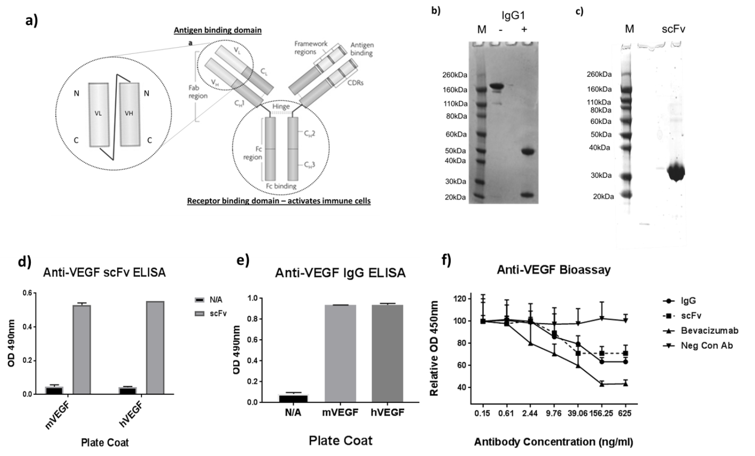

Fig. 2

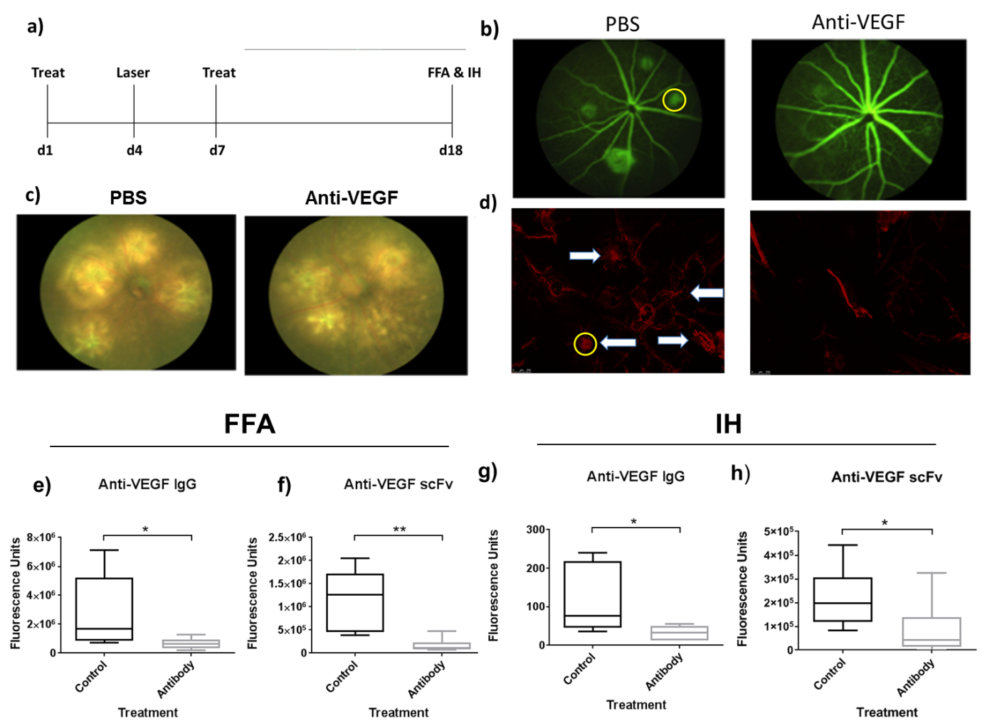

Fig 3
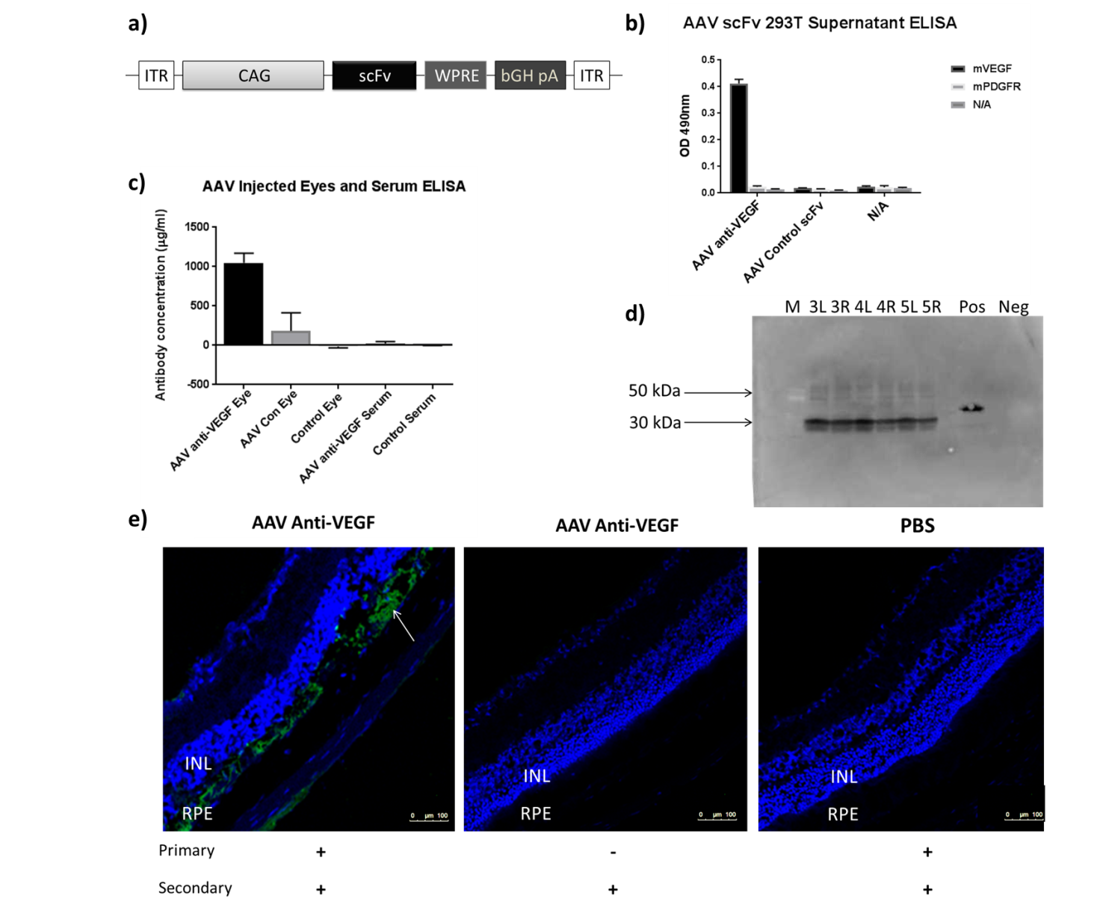

Fig. 4
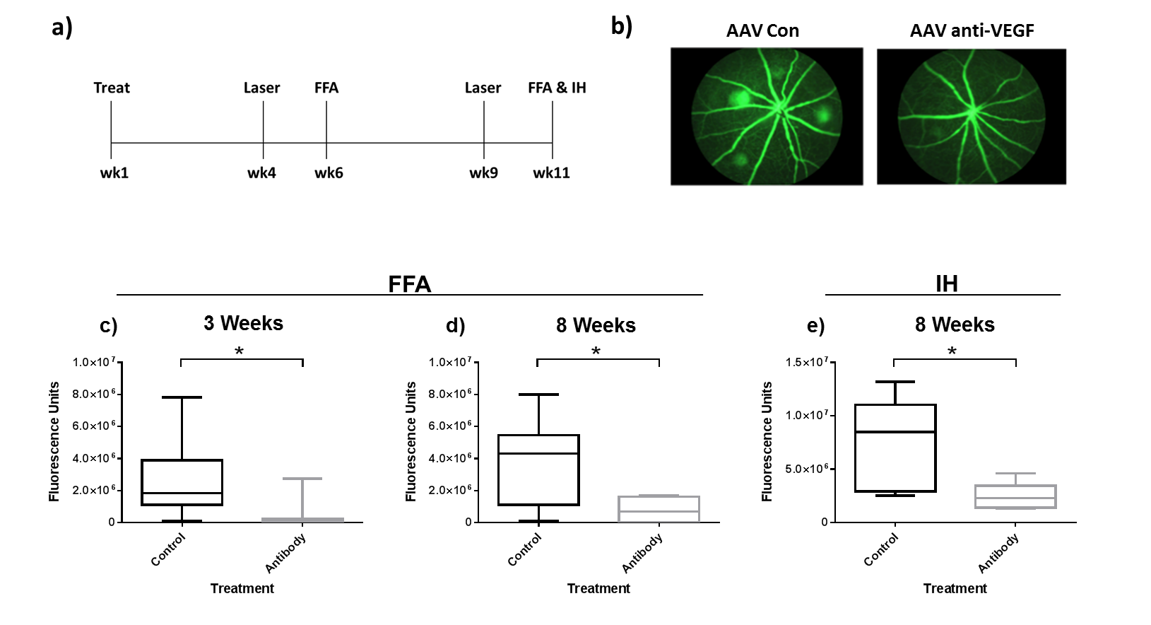

Fig. 5

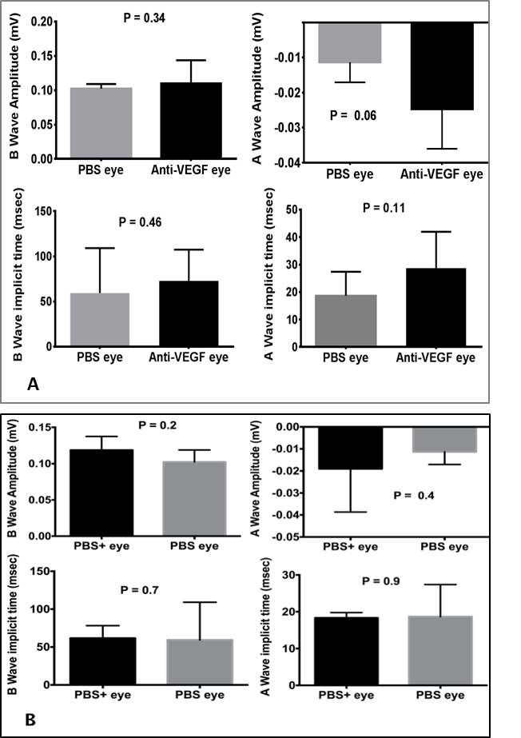

Table S1
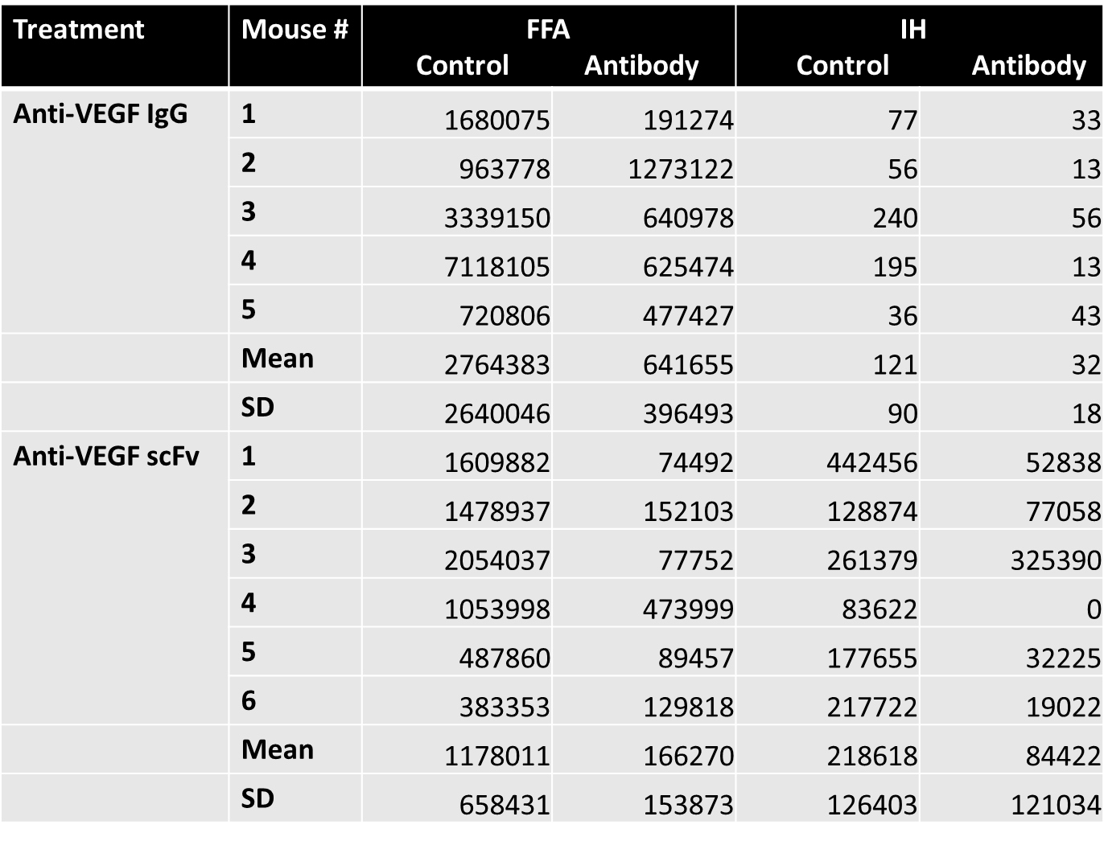

Table S2
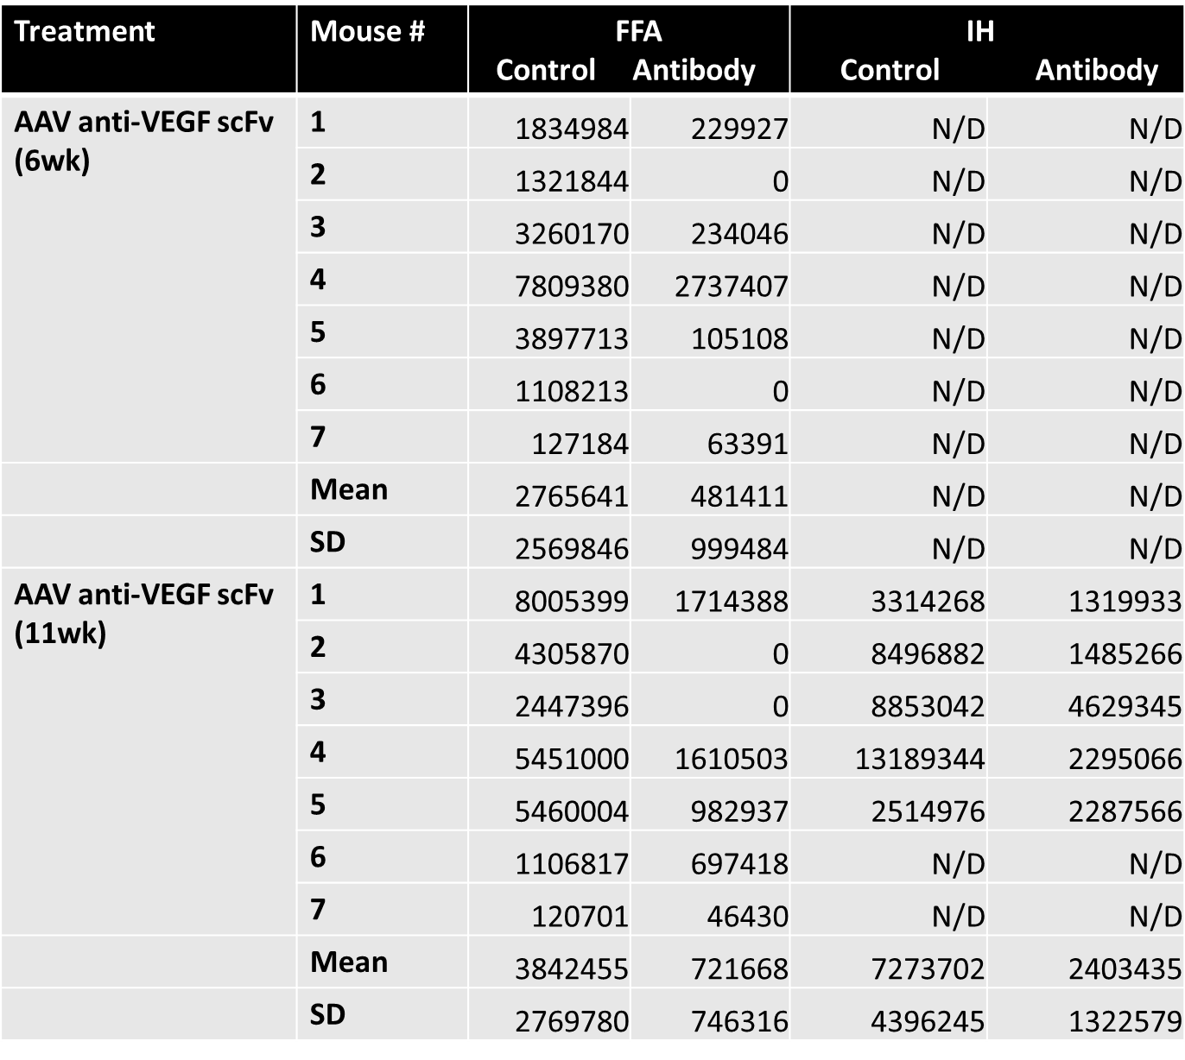

Figure Legends
Figure 1: In vitro characterization of recombinant anti-VEGF antibodies. a) Schematic of the antibodies produced. To the left, a representation of the scFv format, and to the right, the full IgG format. Adapted from Hansel et al (2010)³⁶.b) SDS-PAGE analysis of the anti-VEGF IgG1 format. The expected single 160kDa band of the IgG1 antibody was observed in the absence of mercaptoethanol (-), while in the presence of mercaptoethanol (+), dissociation into the heavy (55kDa) and light chains (25kDa) was seen. M refers to protein marker. c) SDS-PAGE analysis of the anti-VEGF scFv format. The anti-VEGF scFv migrated at around 30kDa (predicted MW = 32kDa). Antigen specificity of anti-VEGF antibodies: d) and e). Binding of anti-VEGF antibodies to human or murine VEGF-coated ELISA plates was detected by anti-His for scFv (d) or anti-mouse HRP for IgG1 (e). Both formats of anti-VEGF and specifically bound both mouse and human VEGF. N/A refers to a control where no sample was added to the plate. N/C refers to a control where no VEGF was added to the plate. Bars represent the mean of samples that were added in duplicate, and error bars represent the standard deviation. f) Biological activity of anti-VEGF antibodies (bioassay). VEGF-dependent growth of HDMEC (endothelial cells) was blocked by adding increasing amounts of anti-VEGF antibody to the cells. The IgG and scFv forms of anti-VEGF as well as the positive control anti-VEGF (bevacizumab) were able to block growth in a dose-dependent fashion, indicating activity. The negative control (Neg Con Ab, an anti-PDGFR-β IgG1) was not active. Data points represent the mean of samples that were added in triplicate, and error bars represent the standard deviation. Values are presented as per cent relative to the first data point (0.2ng/ml antibody).

Figure 2. In vivo activity of recombinant anti-VEGF antibodies. a) Representation of timeline of antibody treatment experiments. “Treat” refers to antibody injection, “laser” = CNV induction. “d” = days, and times of FFA and culling mice for IH indicated. b), c), and d) Representative images of the CNV treatment experiment. 14 days after laser administration a decrease in neovascularization was seen with antibody injection compared to PBS, both as determined by FFA (b), and by collagen IV staining by IH (d), white arrows indicate lesions. Yellow circles on PBS—treated images illustrate a typical region of interest used to quantify fluorescence signal. c) shows fundus photograph images showing laser marks. e) and g) In vivo activity of IgG1 anti-VEGF. Mice were treated with 40μg antibody, both 3 days before and 3 days after laser induction of CNV. 14 days after laser administration, CNV lesions were measured by FFA (e), and IH (g). Signals were quantified using Image J. A significantly lower fluorescence signal was observed with IgG1 anti-VEGF treatment than with PBS using both methods (using Mann Whitney test, n=5 eyes). f) and h) In vivo activity of scFv anti-VEGF. Mice were treated with the same dose of scFv antibody, and CNV lesions were quantified after FFA (f), or IH (h). A significantly lower fluorescence signal was observed with scFv anti-VEGF treatment than with PBS using both methods (using Mann Whitney test, n = 6 eyes). * denotes p <0.05, and ** p <0.005.

Figure 3. Characterization of AAV anti-VEGF. a) Schematic representation of AAV scFv vector. ITR = inverted terminal repeats of AAV2. CAG = synthetic ubiquitous promoter comprising the cytomegalovirus (CMV) early enhancer element, chicken beta actin promoter including intron 1 fragments followed by intron 2/exon 3 fragments of the rabbit beta-globin gene (with splice features). scFv = single chain antibody. WPRE = woodchuck post-transcriptional response element. bGH pA = bovine growth hormone polyadenylation signal. b) Antigen specificity of anti-VEGF antibodies secreted by AAV scFv infected cells. 293T cells were infected by AAVs carrying scFv antibodies to VEGF or an irrelevant control antibody, and the supernatants assayed for activity by ELISA (as in Fig. 1d). The plates coated with either mVEGF or mPDGFR as a negative control. N/A refers to a no sample negative control. Anti-VEGF specifically bound to VEGF, while no signal was detected with the control antibody. Bars represent the mean of samples that were added in duplicate, and error bars represent the standard deviation. c) Expression of antibodies from AAV in vivo. Two mice were injected into their left eyes with AAV anti-VEGF scFv (AAV anti-VEGF Eye), and right eyes with AAV control antibody (AAV Con Eye). 4 months later, eyes and serum were harvested from injected mice. Serum (AAV anti-VEGF Serum) and homogenized eye samples were then analyzed for antibody expression by ELISA (as in Fig.1d). The concentration of anti-VEGF antibody of each sample was then determined by the signal given relative to that by a known concentration of anti-VEGF scFv protein. As negative controls, eyes (Control Eye) and serum (Control Serum) from an uninjected animal were used. d) Demonstrating presence of anti-VEGF in mouse eyes by Western blot. Mice number 3-5 (n=3) were injected with AAV anti-VEGF (left eyes, L) or with AAV control antibody (Bcl, right eyes, R). Anti-His tag antibody used to detect anti-VEGF antibody. Pos is recombinant protein anti-VEGF scFv. Neg is uninjected eye. Bands at expected size confirm antibody expression in all homogenised eyes except the uninected. Slightly larger size of bands in Pos compared to eyes can be explained by differences in glycosylation of the antibody.
e) Localization of antibodies from AAV in vivo. Expression of anti-VEGF was also confirmed by IHC. Sections of AAV anti-VEGF and PBS control-injected eyes were stained with DAPI (blue) to visualize cell nuclei. Anti-VEGF was detected via its His-tag, using a mouse anti-His primary antibody, followed by an anti-mouse Alexafluor 555 secondary antibody. Representative images taken with a confocal microscope are shown. Labels above indicate the material injected into the eye, and the detection antibodies used are shown below. Green staining (white arrow) corresponds to anti-VEGF, and is mostly localized at the retinal pigmented epithelium (RPE). Also labelled for reference adjacent to the RPE is the inner nuclear layer (INL).

Figure 4. In vivo activity of AAV anti-VEGF. a) Representation of timeline of AAV treatment experiments. “Treat” refers to AAV injection, “laser” = CNV induction. “wk” = weeks, and times of FFA or culling mice for IH indicated. b) Representative images of the CNV treatment experiment. an FFA picture is shown. c) and d) In vivo activity of AAV anti-VEGF scFv (by FFA). Effects on CNV were measured by FFA. Laser was applied at 3 weeks (c) and 8 weeks (d) post-AAV sub-retinal injection (in the same eyes). FFA was performed 2 weeks after laser administration. A significantly lower (p = 0.02) CNV fluorescence signal was observed with AAV anti-VEGF than with AAV control scFv (n=7 eyes) at both time-points. e) In vivo activity of AAV anti-VEGF scFv (by IH). Effects on CNV were measured by IH. Laser was applied at 8 weeks post-injection, and IH was performed 2 weeks later. A significantly lower (p= 0.03) fluorescence signal was observed with anti-VEGF than with AAV control scFv (n=5 eyes). Thus, efficacy seen using both FFA and IH is long-lasting. * refers to p values <0.05.

Fig 5 ERG analysis of injected eyes. A. ERG mean amplitudes and implicit times recorded in AAV anti-VEGF injected study eyes (n=4 mice) and PBS control eyes (n=3 mice). B. ERG mean amplitudes and implicit times recorded in PBS+PF68 surfactant and PBS alone injected eyes (n=3 mice). P values shown (using Mann Whitney 2-tailed test) are all >0.05, indicating that no statistically significant differences in signals were observed between any treatment and controls.

Table S1. Raw data showing quantification values of each mouse treated with recombinant protein antibodies. Both FFA and IH data are included. All values are in fluorescence units. Mean and standard deviation (SD) of each group are also shown. Control treatment refers to PBS injection (intravitreal).

Table S2. Raw data showing quantification values of each mouse treated with AAV anti-VEGF scFv. Both FFA and IH data are included. All values are in fluorescence units. Mean and standard deviation (SD) of each group are also shown. Control treatment refers to AAV control scFv injection (sub-retinal). N/D refers to experiment not done.

