Broadband multicolor upconversion from Yb³⁺-Mn²⁺ codoped fluorosilicate glasses and transparent glass ceramics
Xin Wang,¹ Yushi Chu,¹ ZhiYong yang^{2,7}, Ke Tian,¹ Wenhao Li,¹ Shunbin Wang,¹ Shijie Jia,³ Gerald Farrell⁴, Gilberto Brambilla⁵and Pengfei Wang^{1,6,*}
¹Key Laboratory of In-fiber Integrated Optics of Ministry of Education, College of Science, Harbin Engineering University, Harbin 150001, China
²Jiangsu Key Laboratory of Advanced Laser Materials and Devices, School of Physics and Electronic Engineering, Jiangsu Normal University, Xuzhou, Jiangsu 221116, China
³State Key Laboratory on Integrated Optoelectronics, College of Electronic Science and Engineering, Jilin University, Changchun 130012, China
⁴Photonics Research Centre, Dublin Institute of Technology, Kevin Street, Dublin 8, D08 NF82 Ireland
⁵Optoelectronics Research Centre, University of Southampton, Southampton SO17 1BJ, United Kingdom
⁶Key Laboratory of Optoelectronic Devices and Systems of Ministry of Education and Guangdong Province, College of Optoelectronic Engineering, Shenzhen University, Shenzhen, 518060, China
⁷e-mail:yangzhiyong@jsnu.edu.cn
*Corresponding author: pengfei.wang@dit.ie
Received XX Month XXXX; revised XX Month, XXXX; accepted XX Month XXXX; posted XX Month XXXX (Doc. ID XXXXX); published XX Month XXXX

In contrast to well-known upconversion (UC) emission from Yb³⁺-Mn²⁺ co-doped crystal, a room-temperature intense broadband UC phenomenon was first observed both in Yb³⁺-Mn²⁺ co-doped fluorosilicate glasses and transparent glass ceramics under 980 nm pumping. The obtained photoluminescence (PL) ranged from yellow to white to blue. We attributed this effect to the cooperative UC of Yb³⁺ and to the formation of Yb³⁺-Mn²⁺ pairs. After heat treatment, KZnF₃ nanocrystals appeared in the glass matrix, as identified by X-ray diffraction (XRD) and transmission electron microscopy (TEM), and the emission intensity increased 45 times. We believe that Yb³⁺-Mn²⁺ co-doped glasses or glass ceramics show great potential as a material for multi-color displays.
OCIS codes: (140.3460) Lasers, (190.7110) upconversion; (300.6550) Spectroscopy, visible; (160.4670) Optical materials; (160.6990) Transition-metal-doped materials; (160.5690) Rare-earth-doped materials.

Upconversion (UC) refers to a nonlinear mechanism in which the sequential absorption of two or more photons leads to the emission of light at a shorter wavelength than the excitation wavelength [1-3]. Although this concept was first considered to be only a theoretical possibility [4], UC was later demonstrated in a number of materials, and shows potential for many applications such as biodetection [5], bioimaging [6], solar cells [7], 3D display technologies [8], and lasers [9, 10].
Most investigations of upconversion materials has focused on rare earth ions doped crystals [11-15], typically with Yb³⁺ as the sensitizer ion, which absorbs infrared radiation and non-radiatively transfers its excitation to activator ions such as Er³⁺, Tm³⁺ or Ho³⁺. Yet, the narrow emission band and the relatively unchanged emission wavelength limit their applications. Compared to rare earth ions, transition metal ions are closely associated with their surrounding chemical environment, resulting in a broadband emission and changeable emission peaks, desirable features for broadband tunable lasers.
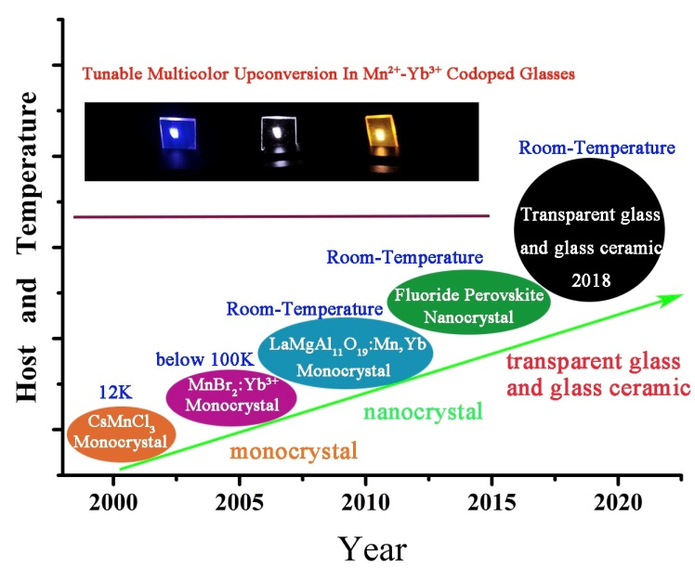
Fig. 1. Progress in upconversion of Mn²⁺ doped materials, digital photo: obtained glasses doped with different concentration of Yb³⁺.
Mn²⁺ is one of the transition metal ions that plays an important role in inorganic phosphors. The first example of upconversion between transition metal and rare earth ions was reported by R. Valiente et al. in 2000 [16]. Recently, Mn²⁺ doped and Yb³⁺-Mn²⁺ codoped materials have received increased attention because of the broadband tunable emission associated to the forbidden d-d transition ⁴T₁(⁴G)→⁶A₁(⁶S) [17,18]. Fig. 1 shows the progress of UC from Mn²⁺ doped materials, highlighting some breakthrough contributions. In 2001, R Valiente et al. firstly demonstrated Mn²⁺ UC in CsMnCl₃ and RbMnCl₃ monocrystal at the temperature T~12K [19]. In 2009, Martin-Rodriguez et al. broke through the temperature limit, obtaining broadband UC in LaMgAl₁₁O₁₉: Mn²⁺, Yb³⁺ monocrystal [20] at room-temperature. In 2016 Enhai Song et al. showed that single crystal is not necessary, by using a Yb³⁺-Mn²⁺ codoped fluoride perovskites ABF₃ nanocrystals [21]. As distinct from the traditional Yb³⁺ sensitizer, Yb³⁺-Mn²⁺ pairs absorb 980 nm pump energy and obtain visible (VIS) broadband emission at room-temperature by achieving energy transfer (ET) directly from the energy level ²F_{5/2} [22]. Compared to crystal materials, glasses or glass ceramics have better light transmission, easier processing and thus lower preparation costs. Yet, there is little reported in the literature about Mn²⁺-Yb³⁺ co-doped glasses or transparent glass ceramics.
In this letter, we prepared both glasses and transparent glass ceramics containing Yb³⁺-Mn²⁺ codoped KZnF₃ nanocrystals. Under λ~980 nm laser excitation, intense broadband UC emission from Mn²⁺ and Yb³⁺ was observed at room-temperature. When the Yb³⁺ content was changed, a multi-color emission from blue to white to yellow was observed, as shown in the inset of Fig. 1.
Glass samples of 22.5KF-(54.7-x)SiO₂-22.5ZnF₂-xYbF₃-0.3MnO (x= 0, 0.1, 0.3, 0.6, 0.8 in mol%) were prepared by a conventional melt-quenching method. 40 g of pure KF (99.9%), SiO₂ (99.9%), ZnF₂ (99.9%), YbF₃ (99.99%) and MnO (99.99%) powders were mixed in an agate mortar for at least 15 mins, stored in a platinum crucible and then put in an electric furnace at 1500 ºC for 30 mins. The melt was cast onto a brass plate and pressed into a flake, annealed at 420 ºC for 3 h to eliminate the inset press and to obtain the precursor glass (PG). The PGs were heated at 540 ºC for 5 h, 10 h, 20 h to obtain the glass ceramics (GC) containing KZnF₃ nanocrystals [23, 24]. To confirm the crystallization phase, X-ray diffraction (XRD) patterns were recorded by a D8 advance X-ray diffractometer (Bruker, Faellanden, Switzerland) with Cu-K_{α} irradiation. Nanocrystals morphology and size distribution were measured by transmission electron microscopy (TEM) and high-resolution transmission electron microscopy (HRTEM) (Tecnai G2, FEI, USA). The transmission and PL spectra of the obtained samples were recorded with a UV/VIS/NIR spectrophotometer (Lambda-900, PerkinElmer, USA) and a fluorescence spectrometer (FLS920, Edinburgh Instruments, UK), respectively.
Fig. 2 (a) shows the XRD patterns of the 0.3 Yb³⁺-0.3 Mn²⁺ codoped PG and GC samples with different heating treatment times. The broadband peak is attributed to the amorphous phase in the samples. The sharp peaks in the XRD patterns are distinguishable and both show features which match perfectly with the Joint Committee on Powder Diffraction Standards (JCPDS) Card of KZnF₃ (No: 06-0439) crystal phase. The main crystal peaks at 2θ = 20.901º, 31.167º, 44.657º, 50.271º, 64.998º, 73.84º correspond to the crystal planes (100), (110), (200), (210), (220), (310), respectively. With increased heating treatment time, the diffraction peaks were more distinguishable. Fig. 2 (b) demonstrates the transmission spectra of 0.3Yb³⁺-0.3Mn²⁺ codoped PG and GC treated at T~540 ºC for 20 h. The digital photo in the inset shows that the GC sample gets a little darker after thermal treatment, resulting in a transmittance attenuation of about 10% in the VIS wavelength region due
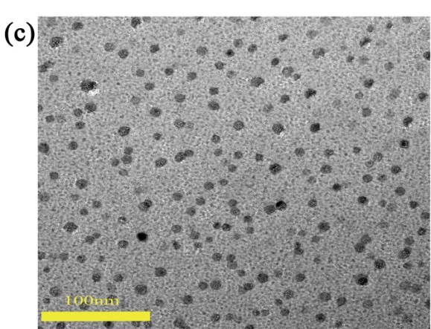

Fig. 2. (a) XRD patterns of 0.3Yb³⁺-0.3Mn²⁺ PG sample, 0.3Yb3+-0.3Mn²⁺ GC samples of different heating treatment and KZnF₃; (b) Transmission spectra of the PG and the GC (treated at T~540 ºC for -20 h) GC samples, inset: digital photo of PG and GC samples with 2 mm thickness; (c) TEM image of the GC sample; (d) HRTEM image of the same GC sample.
to scattering. Fig. 2 (c) and (d) show the TEM and HTEM patterns of the same GC samples. KZnF₃ nanocrystals are distributed uniformly in the glass phase and their sizes are in the range of 5 ~ 20 nm. This ultra-fine particle size allows these materials to be polished as they are in the glass state and then crystallized without any significant degradation of the surface quality. Fig. 2 (d) shows a series of lattice fringes of the KZnF₃ crystal. The d-spacing of these crystal facets was measured to be 0.407 nm, which correspond to the crystal plane (100) of KZnF₃.
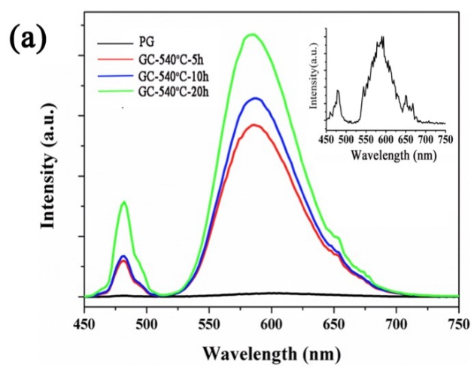
Fig. 3. (a) PL spectra of 0.3Yb³⁺-0.3Mn²⁺ doped PG and GC in the VIS wavelength region excited by 980 nm light, the inset is the PL spectrum of PG sample; (b) Schematic energy level diagram of the UC process.
Fig. 3 (a) shows the PL spectra of the 0.3Yb³⁺-0.3Mn²⁺ codoped PG and GC samples under the excitation of 980 nm LD. The emissions at 'λ~480 nm and 'λ~585 nm are attributed to the typical Yb³⁺-Yb³⁺ cooperative UC luminescence [25] and to the Yb³⁺-Mn²⁺ pairs UC processes [21] shown in Fig. 3 (b). The emission at 'λ~585 nm was observed in the PG sample, shown in the inset of Fig. 3 (a), which has not been reported previously. The intense emission was attributed to the structure of our samples. Phase separation in fluorosilicate glasses has already been confirmed by molecular dynamics (MD) simulations [26] and experiments [23]. In the fluoride-rich region, phonon energy and distance of ions are smaller than in the oxygen-rich region, thus it is possible to achieve ET between Yb³⁺-Mn²⁺ pairs. However, relatively high non-radiative probability still exists in the oxygen-rich region, as it is also in the glass form, resulting in weak luminescence. In the GC samples, KZnF₃ nanocrystals provide a strong crystal field environment for both Mn²⁺ and Yb³⁺, thus the non-radiative probability is much lower compared to the PG, producing the enhanced emission. The intensity of the Mn²⁺ broadband emission of GC is 45 times higher than that of the PG. With increasing the treatment time, the size of KZnF₃ becomes bigger and the crystal field becomes stronger, resulting in the enhanced emission. The mechanism of broadband emission was shown in Fig. 3 (b). When the distance between Yb³⁺ and Mn²⁺ was small enough, the Yb³⁺-Mn²⁺ pair is formed, leading to the establishment of a series of new energy levels. The energy levels |²F_{7/2}, ⁶A₁(⁶S)> , |²F_{5/2}, ⁶A₁(⁶S)> , |²F_{7/2}, ⁴T₁(⁴G)> were the ground state, intermediate hybrid excited state and emitting state, respectively. Under the excitation of the λ~980 nm laser, the ground state absorption (GSA) produced excitation of the Yb³⁺-Mn²⁺ pairs into the |²F_{5/2}, ⁶A₁(⁶S)> state. Meanwhile, the excited state absorption (ESA) occurred, populating the emitting state |²F_{5/2}, ⁶A₁(⁶S)>, which then emits a photon in the visible.
Fig. 4. (a) emission spectra of 0.3Yb³⁺-0.3Mn²⁺ codoped PG samples upon different pump power; (b) double-logarithmic plots of the pump-power dependent on UC emission of Mn²⁺ and Yb³⁺; (c) emission spectra of 0.3Mn²⁺-xYb³⁺ (x=0.1, 0.3, 0.6, 0.8) codoped PG samples(d) CIE chromaticity coordinates of different content of Yb³⁺. All excitation:980 nm LD.
To obtain more detailed information about the UC emission of Mn²⁺, the pump power-dependent UC emissions were investigated, as shown in Fig. 4 (a). The luminescence intensities both increase with increasing pump powers. The relationship between the UC intensity (I_{UC}) and the pumped power (I_{pump}) can be fitted as: I_{uc} ∞ (I_{pump})^{n}, where n represents the absorbed photon numbers per VIS or near-infrared (NIR) photon emitted, and the values can be obtained from the slope of the fitted line of the plot of log I_{UC} versus log (I_{pump})^{n}, as shown in Fig. 4 (b) [27, 28]. Therefore, the higher is the pump power density of the laser, the higher is the emission intensity achieved. The linear fits slopes of log (I_{UC}) - log (P_{pump}) for the λ~480 nm and λ~580 nm are 1.6173 and 1.6419, respectively, involving a two-photon process in the UC emission. Fig. 4 (c) shows the normalized PL spectra of xYb³⁺-0.3Mn²⁺ codoped PG samples (x=0.1, 0.3, 0.6, 0.8). Fig. 4 (d) gives the CIE chromaticity coordinates based on their UC emission spectra, shown in Fig. 4 (c). The UC emission color can be tuned from blue to white to yellow with decreasing the content of Yb³⁺.
In summary, a series of Yb³⁺-Mn²⁺ codoped glasses and transparent glass ceramics containing KZnF₃ nanocrystals were fabricated. Under 980 nm LD pumping, two room-temperature UC emission centered at around λ~480 nm and λ~585 nm were observed, with the emission intensities increasing when the KZnF₃ nanocrystals appeared in glass matrix. These emissions can be interpreted by two photon UC mechanism based on the coupled Yb³⁺-Yb³⁺ and Yb³⁺-Mn²⁺ pairs. The relative intensity of the two emission peaks can be adjusted by changing the concentration of Yb³⁺ ions to achieve a tunable multicolor emission. This kind of material shows promise for applications in various fields, such as tunable lasers, lighting, displays, imaging, and biosensors.
Funding Key Program for International S&T Cooperation Projects of China (2016YFE0126500); National Natural Science Foundation of China (NSFC) (61575050); Key Program for Natural Science Foundation of Heilongjiang Province of China (ZD2016012); Open Fund of the State Key Laboratory on Integrated Optoelectronics (IOSKL2016KF03); the 111 project (B13015) at the Harbin Engineering University; the Recruitment Program for Young Professionals (The Young Thousand Talents Plan); Fundamental Research Funds of the Central University and the Harbin Engineering University.
REFERENCES
1. F. Auzel, Cheminform 104, 139 (2004).
2. M. Haase and H. Schäfer, Angew. Chem. Int. Ed. 50, 5808 (2011).
3. B. Zhou, B. Shi, D. Jin, and X. Liu, Nat. Nanotechnol. 10, 924 (2015).
4. N. Bloembergen, Phys. Rev. Lett. 2, 84 (1959).
5. Z. C, Y. Y, Z. S, W. Y, and L. Z, Angew. Chem. Int. Ed. 50, 6851 (2011).
6. M. Nyk, R. Kumar, T. Y. Ohulchanskyy, E. J. Bergey, and P. N. Prasad, Nano Lett. 8, 3834 (2008).
7. W. Zou, C. Visser, J. A. Maduro, M. S. Pshenichnikov, and J. C. Hummelen, Nat. Photonics 6, 560 (2012).
8. F. Wang, Y. Han, C. S. Lim, Y. Lu, J. Wang, J. Xu, H. Chen, C. Zhang, M. Hong, and X. Liu,nature 463, 1061 (2010).
9. Z. Luo, Q. Ruan, M. Zhong, Y. Cheng, R. Yang, B. Xu, H. Xu, and Z. Cai, Opt. Lett. 41, 2258 (2016).
10. Y. Ma, Y. Li, J. Feng, and K. Zhang, Opt. Express 26, 12106 (2018).
11. Y. Liu, Q. Yang, G. Ren, C. Xu, and Y. Zhang, J. Alloys Compd. 467, 351 (2009).
12. J. Jin, Y.-J. Gu, C. W.-Y. Man, J. Cheng, Z. Xu, Y. Zhang, H. Wang, V. H.-Y. Lee, S. H. Cheng, and W.-T. Wong, ACS Nano 5, 7838 (2011).
13. W. Yin, L. Zhao, L. Zhou, Z. Gu, X. Liu, G. Tian, S. Jin, L. Yan, W. Ren, and G. Xing, Chem. Eur. J. Journal 18, 9239 (2012).
14. J. Sun, J. Xian, and H. Du, J. Phys. Chem. Solids 72, 207 (2011).
15. G. Chen, T. Y. Ohulchanskyy, R. Kumar, H. Ågren, and P. N. Prasad,ACS Nano 4, 3163 (2010).
16. R. Valiente, O. Wenger, and H. U. Güdel, Chem. Phys. Lets. 320, 639-644 (2000).
17. P. Gerner, O. S. Wenger, R. Valiente, and H. U. Güdel, Inorg. Chem. 40, 4534 (2001).
18. R. Martín-Rodríguez, R. Valiente, F. Rodríguez, F. Piccinelli, A. Speghini, and M. Bettinelli, Phys. Rev. B 82, 075117 (2010)
19. C. Reinhard, P. Gerner, R. Valiente, O. Wenger, and H. U. Güdel, J. Lumin. 94, 331 (2001).
20. R. Martín-Rodríguez, R. Valiente, and M. Bettinelli, Appl. Phys. Lett. 95, 091913 (2009).
21. E. Song, Z. Chen, M. Wu, S. Ding, S. Ye, S. Zhou, and Q. Zhang, Adv. Opt. Mater. 4, 798 (2016).
22. Y. Chu, J. Ren, J. Zhang, G. Peng, J. Yang, P. Wang, and L. Yuan, Sci. Rep. 6, 33865 (2016).
23. C. Lin, C. Bocker, and C. Rüssel, Nano Lett. 15, 6764 (2015).
24. C. Lin, L. Li, S. Dai, C. Liu, Z. Zhao, C. Bocker, and C. Rüssel, J. Phys. Chem. C 120, 4556 (2016).
25. P. Goldner, B. Schaudel, and M. Prassas,. Phys. Rev. B 65, 054103 (2002).
26. J. Zhao, R. Ma, X. Chen, B. Kang, X. Qiao, J. Du, X. Fan, U. Ross, C. Roiland, and A. Lotnyk, J. Phys. Chem. C 120, 17726-17732 (2016).
27. M. Pollnau, D. R. Gamelin, S. Lüthi, H. Güdel, and M. Hehlen, Phys. Rev. B 61,3337 (2000).
28. X. Wu, J. Denis, G. Özen, P. Goldner, and F. Pellé, Appl. Phys. B: Photophys. Laser Chem. 56, 269-273 (1993).
Full citation listings
1. F. Auzel, "Upconversion and anti-Stokes processes with f and d ions in solids," Cheminform 104, 139 (2004).
2. M. Haase and H. Schäfer, "Upconverting nanoparticles," Angewandte Chemie International Edition 50, 5808-5829 (2011).
3. B. Zhou, B. Shi, D. Jin, and X. Liu, "Controlling upconversion nanocrystals for emerging applications," Nature Nanotechnology 10, 924 (2015).
4. N. Bloembergen, "Solid State Infrared Quantum Counters," Physical Review Letters 2, 84-85 (1959).
5. Z. C, Y. Y, Z. S, W. Y, and L. Z, "Biosensing platform based on fluorescence resonance energy transfer from upconverting nanocrystals to graphene oxide," Angewandte Chemie International Edition 50, 6851-6854 (2011).
6. M. Nyk, R. Kumar, T. Y. Ohulchanskyy, E. J. Bergey, and P. N. Prasad, "High contrast in vitro and in vivo photoluminescence bioimaging using near infrared to near infrared up-conversion in Tm³⁺ and Yb³⁺ doped fluoride nanophosphors," Nano Letters 8, 3834 (2008).
7. W. Zou, C. Visser, J. A. Maduro, M. S. Pshenichnikov, and J. C. Hummelen, "Broadband dye-sensitized upconversion of near-infrared light," Nature Photonics 6, 560-564 (2012).
8. F. Wang, Y. Han, C. S. Lim, Y. Lu, J. Wang, J. Xu, H. Chen, C. Zhang, M. Hong, and X. Liu, "Simultaneous phase and size control of upconversion nanocrystals through lanthanide doping," nature 463, 1061 (2010).
9. Z. Luo, Q. Ruan, M. Zhong, Y. Cheng, R. Yang, B. Xu, H. Xu, and Z. Cai, "Compact self-Q-switched green upconversion Er: ZBLAN all-fiber laser operating at 543.4 nm," Optics letters 41, 2258-2261 (2016).
10. Y. Ma, Y. Li, J. Feng, and K. Zhang, "Influence of energy-transfer upconversion and excited-state absorption on a high power Nd: YVO 4 laser at 1.34 μm," Optics express 26, 12106-12120 (2018).
11. Y. Liu, Q. Yang, G. Ren, C. Xu, and Y. Zhang, "Relationship between microstructure and the achieving of the single-band red upconversion fluorescence of Er³⁺/Yb³⁺ codoped crystallites," Journal of Alloys and Compounds 467, 351-356 (2009).
12. J. Jin, Y.-J. Gu, C. W.-Y. Man, J. Cheng, Z. Xu, Y. Zhang, H. Wang, V. H.-Y. Lee, S. H. Cheng, and W.-T. Wong, "Polymer-coated NaYF4: Yb³⁺, Er³⁺ upconversion nanoparticles for charge-dependent cellular imaging," ACS nano 5, 7838-7847 (2011).
13. W. Yin, L. Zhao, L. Zhou, Z. Gu, X. Liu, G. Tian, S. Jin, L. Yan, W. Ren, and G. Xing, "Enhanced red emission from GdF₃: Yb³⁺, Er³⁺ upconversion nanocrystals by Li⁺ doping and their application for bioimaging," Chemistry-A European Journal 18, 9239-9245 (2012).
14. J. Sun, J. Xian, and H. Du, "Hydrothermal synthesis of BaYF₅: Yb³⁺/Er³⁺ upconversion luminescence submicrospheres by a surfactant-free aqueous solution route," Journal of Physics and Chemistry of Solids 72, 207-213 (2011).
15. G. Chen, T. Y. Ohulchanskyy, R. Kumar, H. Ågren, and P. N. Prasad, "Ultrasmall monodisperse NaYF₄: Yb³⁺/Tm³⁺ nanocrystals with enhanced near-infrared to near-infrared upconversion photoluminescence," ACS nano 4, 3163-3168 (2010).
16. R. Valiente, O. Wenger, and H. U. Güdel, "New photon upconversion processes in Yb³⁺ doped CsMnCl₃ and RbMnCl₃," Chemical Physics Letters 320, 639-644 (2000).
17. P. Gerner, O. S. Wenger, R. Valiente, and H. U. Güdel, "Green and red light emission by upconversion from the near-IR in Yb³⁺ doped CsMnBr₃," Inorganic chemistry 40, 4534-4542 (2001).
18. R. Martín-Rodríguez, R. Valiente, F. Rodríguez, F. Piccinelli, A. Speghini, and M. Bettinelli, "Temperature dependence and temporal dynamics of Mn²⁺ upconversion luminescence sensitized by Yb³⁺ in codoped LaMgAl₁₁O₁₉," Physical Review B 82, 075117 (2010).
19. C. Reinhard, P. Gerner, R. Valiente, O. Wenger, and H. U. Güdel, "Upconversion phenomena in the Yb³⁺ doped transition metal compounds Rb₂MnCl₄ and CsMnBr₃," Journal of luminescence 94, 331-335 (2001).
20. R. Martín-Rodríguez, R. Valiente, and M. Bettinelli, "Room-temperature green upconversion luminescence in LaMgAl₁₁O₁₉: Mn²⁺, Yb³⁺ upon infrared excitation," Applied Physics Letters 95, 091913 (2009).
21. E. Song, Z. Chen, M. Wu, S. Ding, S. Ye, S. Zhou, and Q. Zhang, "Room‐Temperature Wavelength‐Tunable Single‐Band Upconversion Luminescence from Yb³⁺/Mn²⁺ Codoped Fluoride Perovskites ABF₃," Advanced Optical Materials 4, 798-806 (2016).
22. Y. Chu, J. Ren, J. Zhang, G. Peng, J. Yang, P. Wang, and L. Yuan, "Ce³⁺/Yb³⁺/Er³⁺ triply doped bismuth borosilicate glass: a potential fiber material for broadband near-infrared fiber amplifiers," Scientific reports 6, 33865 (2016).
23. C. Lin, C. Bocker, and C. Rüssel, "Nanocrystallization in oxyfluoride glasses controlled by amorphous phase separation," Nano letters 15, 6764-6769 (2015).
24. C. Lin, L. Li, S. Dai, C. Liu, Z. Zhao, C. Bocker, and C. Rüssel, "Oxyfluoride glass-ceramics for transition metal ion based photonics: broadband Near-IR luminescence of nickel ion dopant and nanocrystallization mechanism," The Journal of Physical Chemistry C 120, 4556-4563 (2016).
25. P. Goldner, B. Schaudel, and M. Prassas, "Dependence of cooperative luminescence intensity on Yb³⁺ spatial distribution in crystals and glasses," Physical Review B 65, 054103 (2002).
26. J. Zhao, R. Ma, X. Chen, B. Kang, X. Qiao, J. Du, X. Fan, U. Ross, C. Roiland, and A. Lotnyk, "From phase separation to nanocrystallization in fluorosilicate glasses: structural design of highly luminescent glass-ceramics," The Journal of Physical Chemistry C 120, 17726-17732 (2016).
27. M. Pollnau, D. R. Gamelin, S. Lüthi, H. Güdel, and M. Hehlen, "Power dependence of upconversion luminescence in lanthanide and transition-metal-ion systems," Physical Review B 61, 3337 (2000).
28. X. Wu, J. Denis, G. Özen, P. Goldner, and F. Pellé, "The UV, blue and green up-conversion luminescence of PbF 2+ GeO 2: Er 2 O 3 pumped with 650 nm," Applied Physics B 56, 269-273 (1993).

