Published in Cultural Geographies DOI: 10.117/1474474018811663

Walking a lonely path: Gender, landscape and ‘new nature writing’.

In the wake of best-selling works by Roger Deakin, Kathleen Jamie, Richard Mabey, Helen McDonald, and Robert McFarlane, ‘new nature writing’ is now an established trope, with Oakley et al (2018) attesting that the shelves of the average bookshop now groan under the weight of books about the British countryside. This noted, the term ‘new nature writing’ appears a somewhat awkward label given that most of this literature seeks to disrupt any neat binary between nature / culture. Indeed, much of the work that has been placed in the genre of ‘new nature writing’ focuses on the intimate relationship between landscape, place and people, and is alert to the ways that individual biographies entwine with the landscapes and ecosystems that surround them. These writers tell a story that is both personal and political, using the biographical as a tool for environmental critique. In doing so, much of this ‘new nature writing’ narrates the author’s anxieties about environmental destruction and irreversible habitat loss. Cowley hence defines these ‘new nature’ writers as ‘a new generation...[who] share a sense that we are devouring our world, that there is simply no longer any natural landscape or ecosystem that is unchanged by humans’. As Matless notes, it is no coincidence that the genre of ‘new nature writing’ has emerged at a time of pronounced anxiety about local and planetary futures, albeit Moran argues that this new body of work builds on traditions of conservation writing which go back to at least the early 1970s. Blending elements of autobiography, travelogue, natural history, and popular science in its attempt explore the forgotten, and often threatened, landscapes of Britain, the writing that falls under the label of ‘new nature writing’ can then be read as inherently political, combining arts and environmentalism, politics and aesthetics.

Though written with due deference to traditional modes of writing about the natural world, and with an eye to documenting the rich ecologies of landscape, it is notable that a number of key works in this tradition of new nature writing eschew description of ‘pristine’ or ‘unspoilt’ nature to focus on more prosaic and everyday landscapes: the edgelands between urban and rural, deindustrialised sites, liminal spaces, places of abandonment. Here, nature is not depicted as a pristine idyll, but instead, as always on the edge of destruction. In revealing the diverse forms of life emerging in such ‘wastelands’, such books often focus on ‘recombinant ecologies’ – ‘the biological communities assembled through the dense comings and goings of (urban) life, rather than the discrete and undisturbed relations between particular species and habitats that are the staple of conservation biology’. As Oakley et al document, such books contribute to a growing awareness of the importance of ‘everyday’ landscapes as a component of what makes life livable for humans and non-humans alike. This surge of writing on edgelands and wastelands challenges the way that people understand and appreciate the landscape, dislocating established and ‘official’ visions of the countryside which blithely value the rugged beauty of rural uplands, mountains and rivers. As Lilley argues, the ‘senses of place, nature, and humanity familiar to the cultural and ecological landscapes of Britain have become less certain’, leading to an increasing interest in the more precarious and complicated landscapes of the margin. There is then an popular appetite for (re)visiting these overlooked landscapes, and capturing their fragile and shifting ecologies in photography, film, and art, recognizing that they are ‘in fact vibrant, resilient and enthralling environments teeming with life, renewal and re-birth’. As such, these ‘unintentional’ landscapes are beginning to be appreciated as both restorative and captivating. For as Gandy contends, an ‘unintentional landscape is not a primal landscape in the sense of ‘wild nature’ serving as an object of aesthetic contemplation, it is not an idealised landscape that conforms to some pre-existing conception of the innate relations between nature and culture, and it is not a designed landscape allied to particular social or political goals…It is a landscape in spite of itself; a focus of intrigue or pleasure that has emerged irrespective of its anomalous or redundant characteristics’.

The autobiographical genre of new nature writing explores the relation between landscape, selfhood and ethics, a blending of autobiography and ecocriticism. In this paper we focus upon one text that could be seen as a typical entry in the emerging genre of ‘new nature writing’ focused on edgelands: Carol Donaldson’s On the Marshes, which was published in 2017. In this book, Donaldson, a single woman in her 40s, narrates her relationship with the liminal landscape of the north Kent marshlands. Donaldson blends together observations from an 80-mile solo walk around this part of the coast and her past memories of living and working in this landscape (initially living as part of a loose collective of wardens in a caravan on an RSPB reserve before moving into a bungalow on the fringes of the Medway towns following a traumatic breakup with her fiancée and moving jobs). In this paper, we focus on how gendered embodiment shapes Donaldson’s work as she narrates a tale of passing through the predominantly masculinised landscape of the marshland. Of particular interest here is the way in which the narrative of a woman walking in nature alone challenges the conventional masculinist trope of the male wanderer who boldly strides into the wilderness. How then might gender alter this narrative of freedom, solitude and closeness to nature? What difference does difference make?

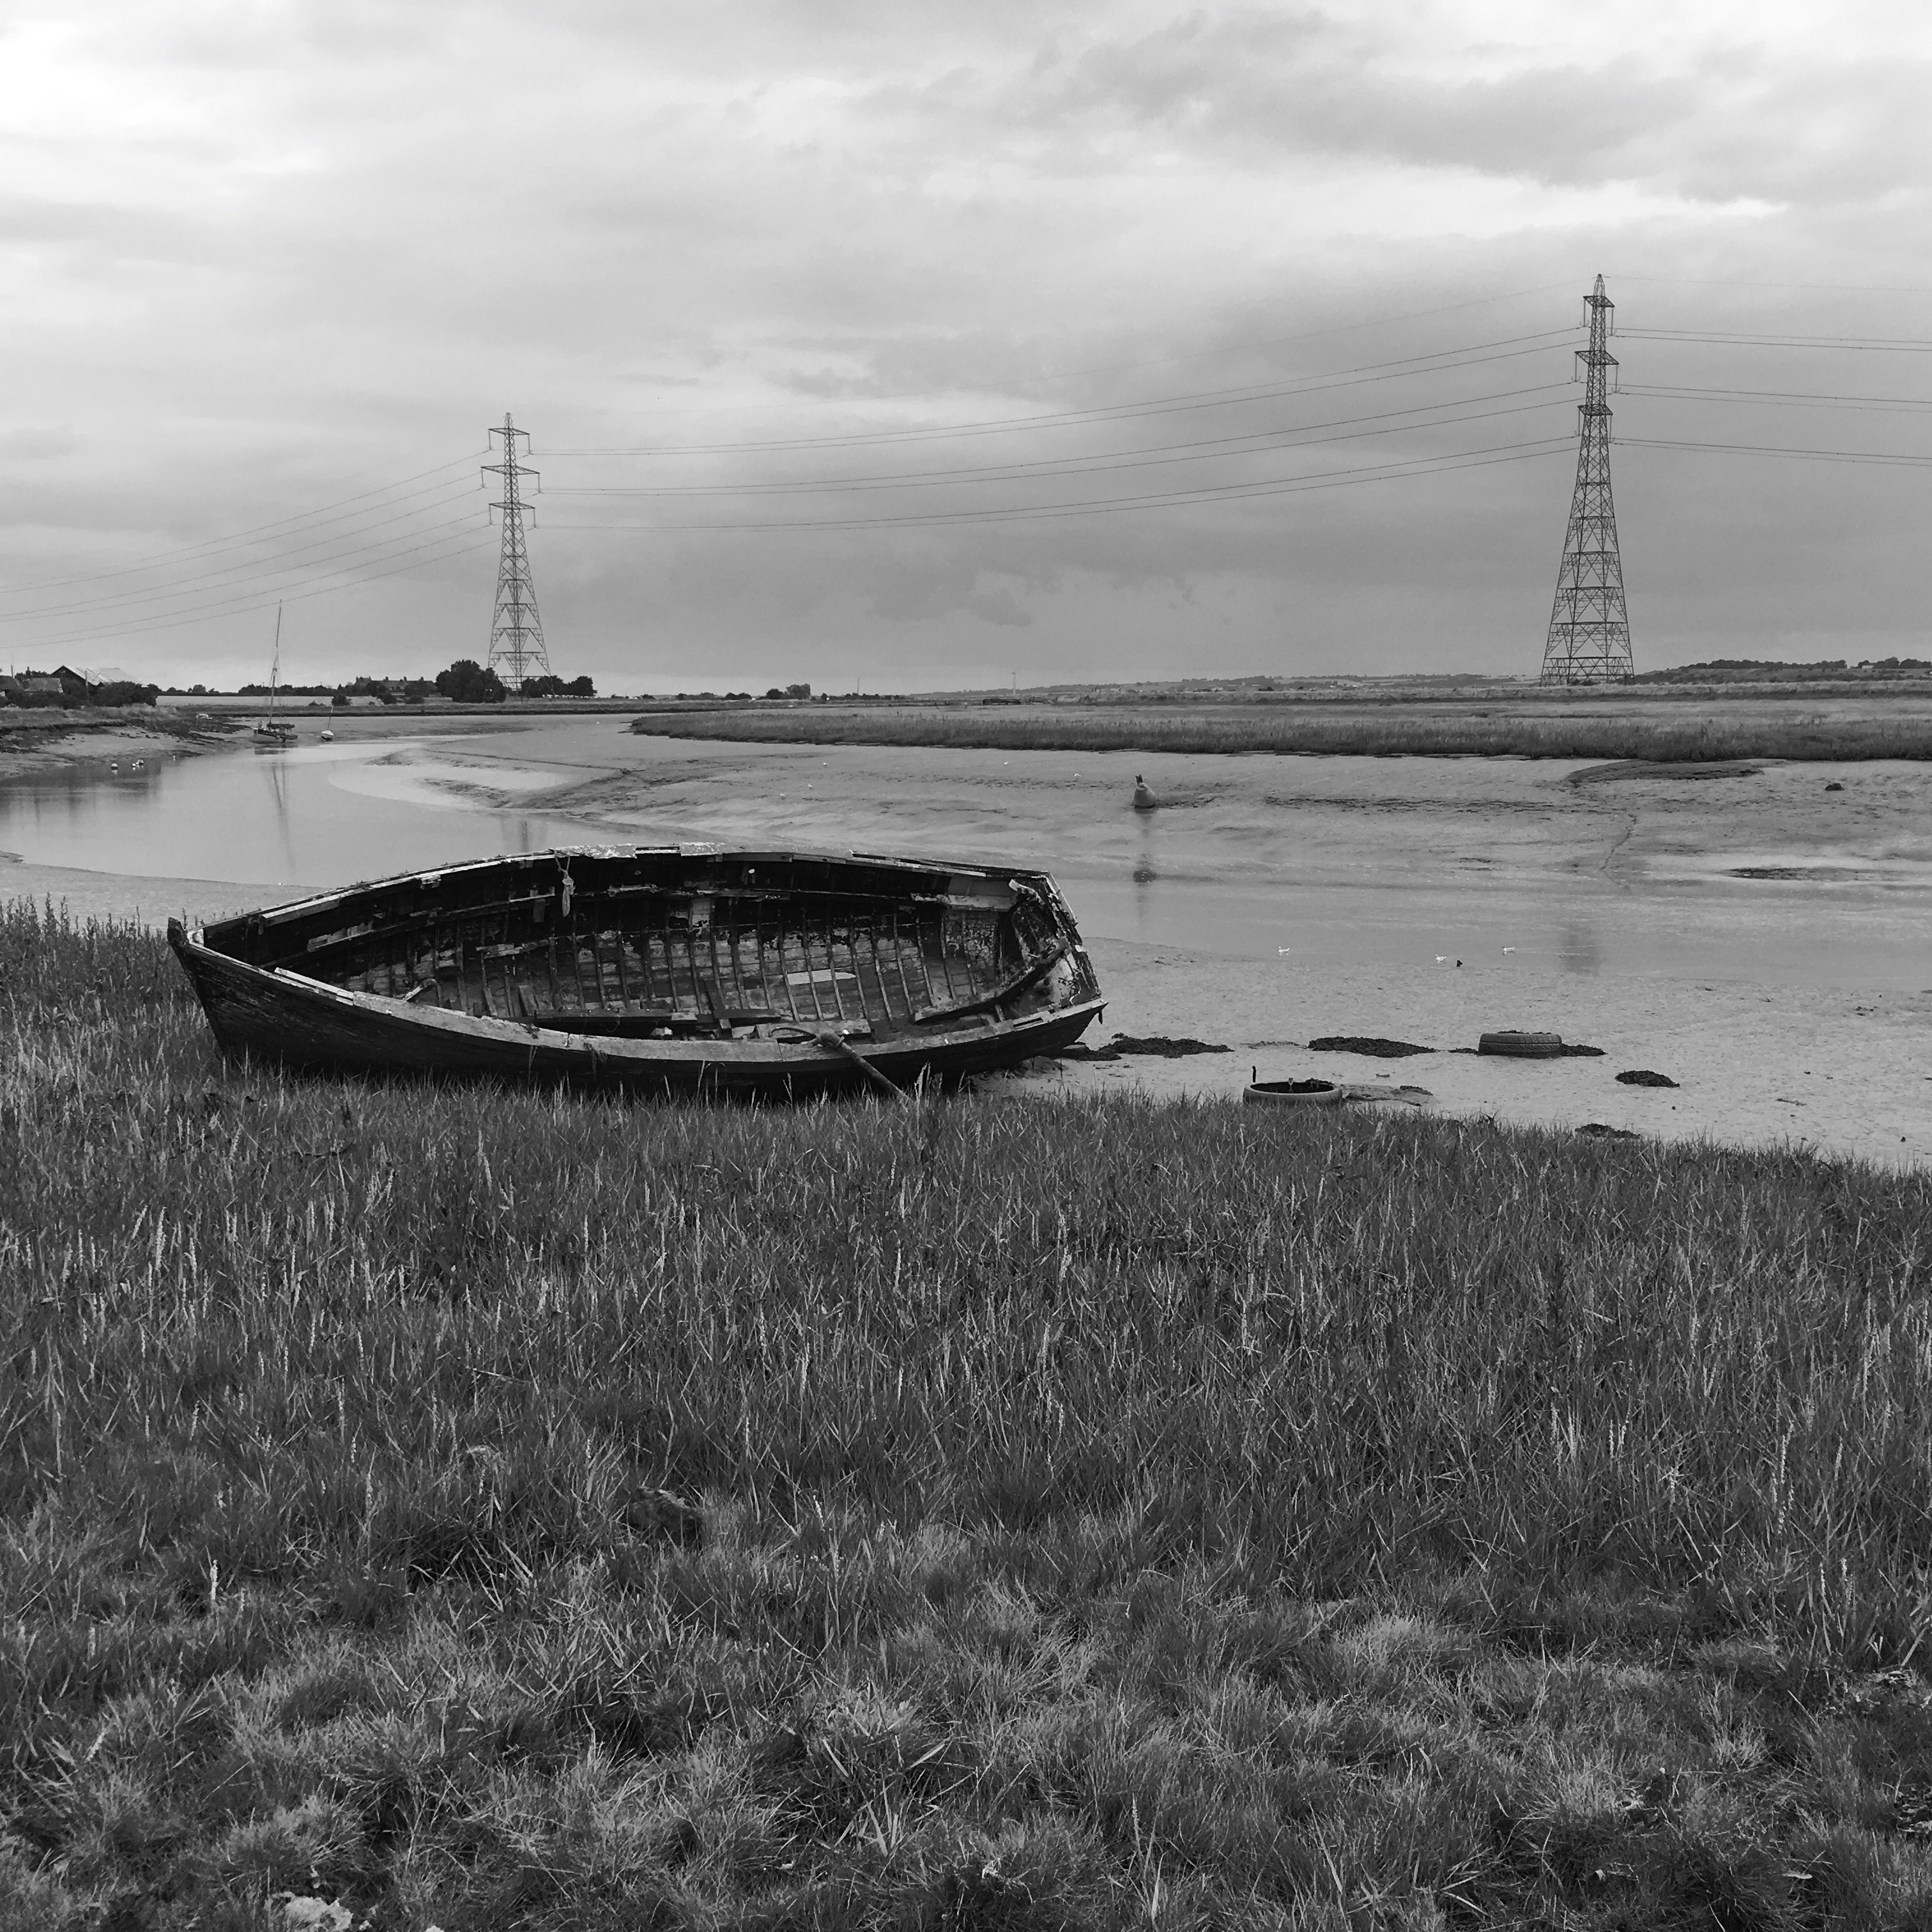

Pools of brackish water wriggled with wind waves, the samphire was burnt crimson amid the faded heads of sea lavender. It was hard going, fighting my way through snagging grass along the rutted track. I began to feel like I was in Wuthering Heights, walking a lonely path into the wind across the desolate wastes.

At first glance, On the Marshes, appears thoroughly rooted in both the stylistic and political traditions of contemporary writing on edgelands, being attentive to the cultural and ecological relations that make up this unintentional landscape. It documents the natural and human life of the north Kent marshes, a thrown-together collection of low-lying plotlands, muddy creeks, fly-tipped marinas, caravan parks, pylons, abandoned military defences, prisons, derelict cement works, locks, and sheep-grazing lands abutting the tidal estuaries of the Thames, Medway and Swale. Inundated by the great flood of 1953, this landscape remains fragile and contingent, and, like many edgelands, remains ‘the target of developers, preying on the frailty of liminality’. Notably, this landscape is routinely threatened by new incursions as the demand for new housing, warehousing and leisure space escalates in this part of the South East of England: while the threat of the Thames Estuary airport and a third Thames crossing appear to have been deflected for now, a 890-acre solar farm has been proposed for the Graveney Marshes and 5000 homes are still mooted for construction at the former barracks on the Hoo Peninsula (a Site of Special Scientific Interest thought to be the UK’s best for nightingales).

On the Marshes is a loosely autobiographical account of the author’s work as a RSPB warden, and later as an environmental consultant. The way the book combines ecocriticism with autobiography is typical of the ‘new nature writing’, and Donaldson openly acknowledges her indebtedness to some of the canonical texts in this genre:

Like many people with a love of nature writing I have read a lot of the current literature and was influenced by Roger Deakin’s Waterlog, which I saw as an ideal mixture of landscape description, personal anecdote and background information but I never consciously looked to fit in or out of the current trends in nature writing. I write about the things that enthuse me. With On the Marshes I felt a personal draw to rediscover a landscape that had been the backdrop to a turbulent time in my life and explore why I was drawn to an unconventional lifestyle.

Although it is rich with descriptions of local flora and fauna (especially lapwings, nightingales, oystercatchers, egrets, and herons), it is notable that much more attention is devoted by Donaldson to the inhabitants of the marshes, especially those who she describes as having ‘fallen off the rails of life’ in one way or another. These consist of caravan and chalet dwellers, people living on boats, plotlanders and itinerants, most of whom lack security of tenure and live in a precarious relationship both with local landowners and the land itself. But despite this endemic precarity, Donaldson documents the rich generosity of those she encounters on her walks, and notes the kindness and neighbourliness that characterizes life on the marshes, a life of ‘part-time, occasional work, fleeting relationships, late-night drinking sessions, shared roll ups’.

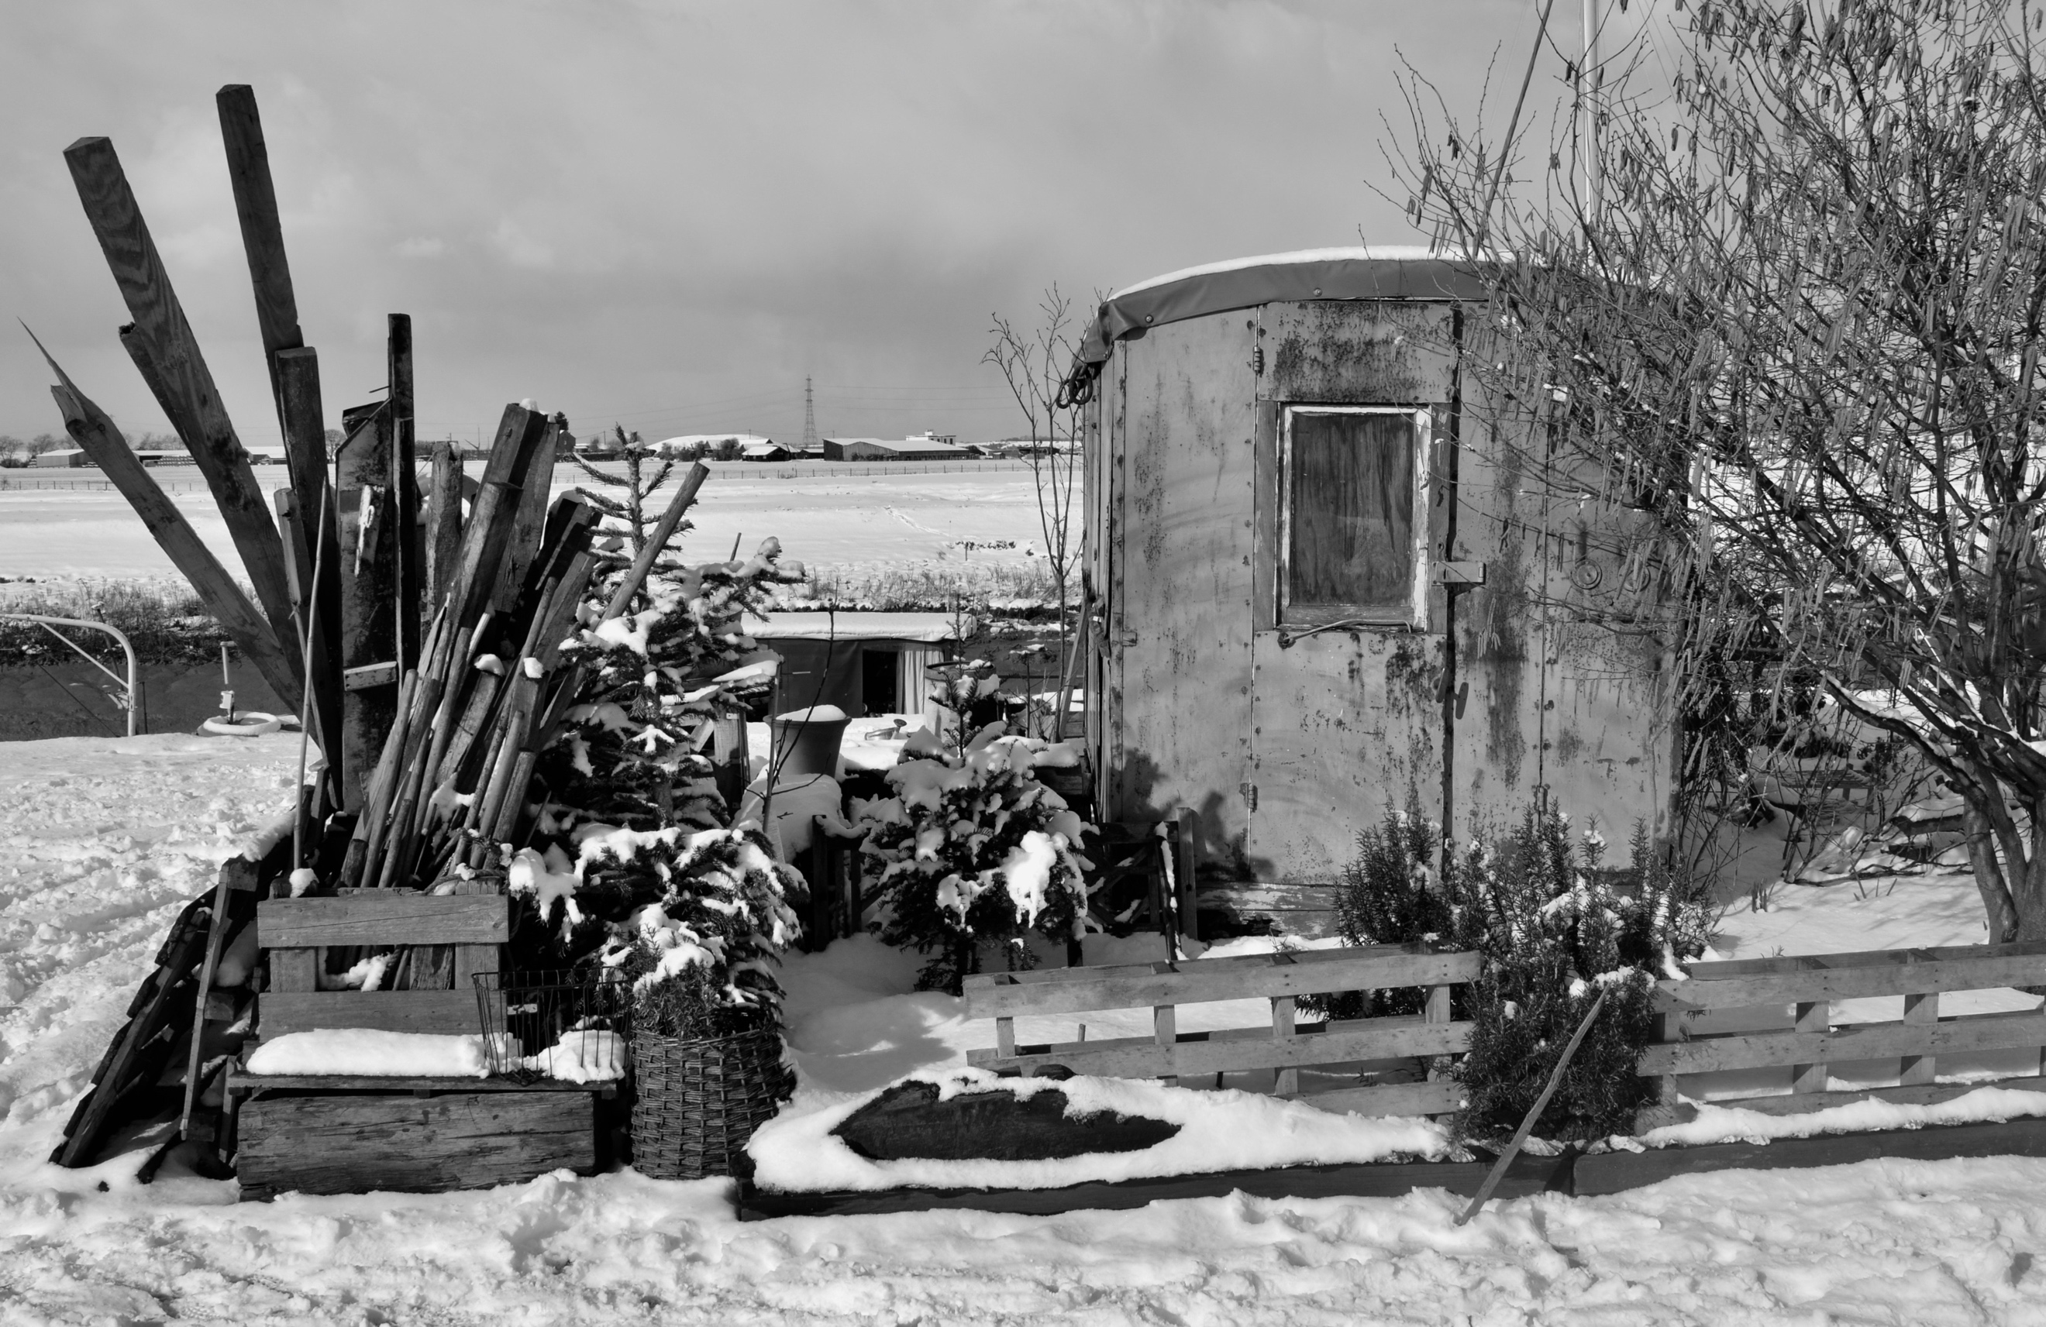
Many of the people I met on my trip, living in barges and chalets, houseboats or caravans, did so as they saw it as the best of the options available to them. They had chosen well.
As both littoral and liminal landscapes, marshlands have been imagined as culturally problematic, neither solid land nor flowing water, a shifting permeable ‘half-land’ of both presence and absence. Donaldson recognises this ambivalence, and presents the marsh as something of a ‘refuge’ from modern life, a place where people have turned their back on a settled, mortgaged existence and embraced insecurity. Her own life takes a somewhat different turn: when she finds out her fiancée is cheating on her, she flees from her life in a caravan on the marshes to embrace a more settled life, but constantly questions which life is best, something she regards as pressing given the ongoing threats to this landscape:
This is the marshes, a world of old industry which nature has reclaimed…it has been touched by man before and sucked his plans into the wetlands … but the future? Grand schemes for road bridges and airports are not so easy to absorb. The future is a place that fills me with fear, and I know that everything we see might be changed, altered and lost; and even though I will lay down in front of a digger to prevent it, it still might not be enough.

In arguing that marshes of the Thames Estuary ‘are not just blank spaces to dump unsightly developments and industry but wonderfully rich sanctuaries for people and wildlife’, Donaldson emphasises the value that this landscape has at the precise time that it appears most threatened:

The real issues are inflated housing prices, lack of affordable accommodation in London, second homes and the growing division between rich and poor. All these bigger issues are played out in Kent as people move out of the Capital and buy second homes. While this conflict is rapidly degrading parts of the Kent countryside it also appears to push individuals into unconventional living arrangements and, sometimes, once they have stepped off the treadmill of conventional house ownership they find a much more rewarding if precarious life on the other side.

This marginal place becomes a haven for those who are marginalized. Donaldson observes the majority of those who have made their home on the marsh are men who have experienced sudden unemployment, relationship breakdown or mental health issues, and have gravitated towards the marshes both for financial and therapeutic reasons. Donaldson repeatedly emphasizes the latter, and suggests that despite its bleak openness, there is an almost spiritual element to people’s connection to this landscape, which is associated with continual cycles of transformation, resilience and rebirth, constantly accompanied by echoes of life from times gone by: ‘rotting barges, derelict cranes, unmodernised barns, small ruined marshland houses’.

In his essay on the lives of Norman Angell and Tom Driberg on the Blackwater estuary, Essex, Stuart Oliver notes that the marsh can serve as a richly symbolic landscape in narratives of masculinity, a space contested between land and sea that connotes both freedom and solitude:

It was a place of queerness where odd things happened. As half-land it presented itself now as solid order, now as flowing change − and provided an ambiguous landscape in which struggle and identity were lived out in sometimes-desperate attempts at making meaningful lives. The results were places that had provisional meaningfulness: the work of life geographies that were only stable in being compromised by a never-stable landscape of incessant incursions. Those marshlands were, though, where intimate relationships were made − and where entanglements were negotiated according to the contingencies of circumstance.

This relationship between biography and (male) identity is repeatedly alluded to by Donaldson as she recounts the stories of men she encounters: part-time lecturer, hovercrafter and scrap metal dealer Peter who wrote his dissertation on the birdsong of the marsh; Andre, the Cobham Woods hermit who sat in his caravan surrounded by his model trains; Jason, a student at London Polytechnic who couldn’t afford rent in the capital in the 1980s so moved into a caravan, and stayed there for the next two decades as a woodcarver because he wanted to connect to an older way of life. But, as she notes, it is never quite clear if these men have chosen this life of isolation and simplicity to ‘hide from themselves’, or they simply couldn’t think what else to do.

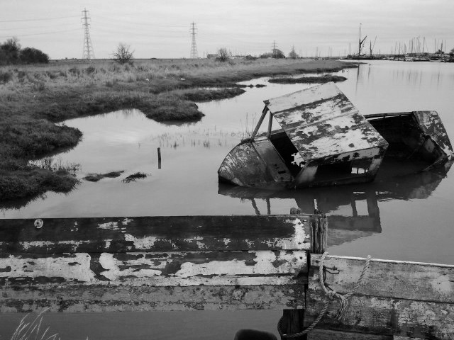

The marshes are not an obvious beauty: it is a rough-edged love, full of derelict industry, broken barges, wide bays of mud; icy with blue light and shrill with redshanks’ calls in the winter, fields and scrub bubbling over with nightingales in the spring.

In certain ways then, these edgelands are places in which a woman’s presence is still somewhat out of place, with these liminal marshlands predominantly occupied by men. The gendering of the landscape is emphasized in another section of the book where Donaldson is considering a move into a houseboat at a marina, with one of the male boaters leaning across to her, placing his hand on her knee and telling her she would do ‘very well’ at the marina. Donaldson also relates that many people who she met on her walk commended her for her confidence, noting that she was brave for ‘walking in the countryside alone’, for sleeping overnight in her car in the shadow of the Sheppey Bridge crossing, and for visiting the homes, chalets and caravans of people she didn’t know:

Women who have read the book have commented that I was brave for doing the journey alone where as a man wouldn’t have thought twice about it. Personally I never really felt in any kind of danger. The fears about being out in the countryside alone were in my head rather than any real threat. Likewise, I think I sometimes imagined others judging me rather than they were and I think the judgement was sometimes curiosity at a women in her 40’s walking across the marshes alone instead of looking after children. I think I was doing something that didn’t quite fit the expected image and this provoked curiosity from women as well as men. I’m sure many people envied my comparative freedom.

In making such claims, Donaldson implicitly embraces what Hille Koskela has termed ‘bold walking’, rejecting the idea that women’s fear is normal and boldness is risky. She also challenges the Western myth of mobility which implies men gain status by rejecting rootedness and ‘family values’, but which condemns women for the same. Her book hence narrates an example what Heddon and Turner refer to as ‘heroic walking’ – walking that takes place on a long-durational and geographical scale and claims an equal right for women to traverse ‘wild’ and open spaces.
Walking might be a way of escaping such gendered constraints, but such constraints are of course never entirely absent. In some ways, this provides an explanation for why the new British nature writing is so gendered, being dominated by stories of male self-discovery and exploration. As Kathleen Jamie notes in her review of Robert Macfarlane’s The Wild Places, there are simply too many journeys of discovery written by white, middle-class men:
When a bright, healthy and highly educated young man jumps on the sleeper train and heads this way [Scotland], with the declared intention of seeking ‘wild places’, my first reaction is to groan. It brings out in me a horrible mix of class, gender and ethnic tension. What’s that coming over the hill? A white, middle-class Englishman! A Lone Enraptured Male! From Cambridge! Here to boldly go, ‘discovering’, then quelling our harsh and lovely and sometimes difficult land with his civilised lyrical words. When he compounds this by declaring that ‘to reach a wild place was, for me, to step outside human history,’ I’m not just groaning but banging my head on the table.
On the Marshes is, in contrast, about an Essex-born single woman in her 40s walking around the Kent coast sleeping in the houseboats of friends, in a church, under canvas, or in the back of her Nissan Micra. While her walk is still a therapeutic one – a reflection on where she has come from and where she might be going – it engages with a very different set of gendered and classed assumptions, particularly those about domesticised femininities and the vulnerabilities of women in the ‘wild’. Donaldson’s walk hence embodies a different form of freedom and solitude than that sought by men on the marsh, representing her rejection of a (familial) suburban life and her desire to be (in her words) closer to nature:

Beyond the hamlet I discovered a beautiful stretch of coast line. A wild beach full of oystercatchers and brent geese vanished into the dune grass and marshes beyond. I hid in the shadow of a pillbox with a fantastic mural of a hen harrier painted on the side and looked out to the sea. Curlews flew low across the bay, joining the growing army of birds feeding on the wet mud exposed by the receding tide. Inside, the blockhouse was a mess. I walked in warily, fearing a dead body or the waste of too many live ones. It was a two-room hut with a little tower with skylights. The slit windows showed views of the bay on every side... This was what I wanted: an isolated hut on an undamaged shore, a place with just me and the wildlife... In the last few years, friendship had been the thing that had sustained me but, still, I felt the need to withdraw occasionally, to be on my own. It was part of who I was, and more and more I felt that being who I was, was not something I had to apologise for.

Donaldson narrates a story of a life on the outside, on the margins, of a desire for solitude in a liminal landscape, and hence reveals the complex intertwining of her life history and life geography. This trope of solitude and self-discovery in many ways mirrors that of the conventional lonely male wanderer, but her embodied difference alters this narrative of freedom and solitude. After all, the story of the male wanderer, or male explorer, offers us little new: masculinity has long been associated with unbridled movement, freedom, escape. But what does it mean for a woman to tell such a tale? Does an individualized narrative of freedom potentially become a political narrative of escape, a way in which we might envision life differently? Hence, rather than seeing isolation and solitude as apolitical, we could instead read this desire for withdrawal into the landscape as a potentially collective act: an escape from gendered conventions and obligations, from the domestic, from the familial. Such tales of female solitude may thus embolden us to realise that walking a lonely path is nothing to apologise for.

Acknowledgments

Thanks to Carol Donaldson for permission to publish her responses to our questions. The photos are by Phil Hubbard, taken on the north Kent marshes at Oare, Faversham and Graveney.

K. Oakley, J. Ward and I. Christie,2 ‘Engaging the imagination, new nature writing, collective politics and the environmental crisis’, Environmental Politics, forthcoming.
For such reasons, Wylie favours the term ‘landscape writing’ over the ‘new nature writing’: see J Wylie, ‘Vanishing points: an essay on landscape, memory and belonging’, Irish Geography 50(1) (2017) 3-18.
See J. Moran, ‘A Cultural History of the New Nature Writing’, Literature & History 23(1) (2014) 49-63; M. Pryor, ‘Eco-Autobiography: Writing Self through Place’ a/b: Auto/Biography Studies 32(2) (2017): 391-393.
See J. Smith, The New Nature Writing: Rethinking the Literature of Place (London, Bloomsbury Publishing, 2017). There are clear parallels here between the new nature writing and the more established traditions of psychogeographically-inflected urban writing in which nostalgia is deployed to sometimes radical ends – see A. Bonnett, ‘The dilemmas of radical nostalgia in British psychogeography’, Theory, Culture and Society, 26(1) (2009) 45-70.
J. Cowley, ‘Introduction,’ The New Nature Writing, Spec. issue of Granta: The Magazine of New Writing 102 (2008), 7-13.
D. Matless, ‘Nature Voices’, Journal of Historical Geography 35 (2009), 178-188.
J. Moran, op cit; see also J. Cowley, ed., The New Nature Writing, spec. issue of Granta: The Magazine of New Writing 102 (2008)
On edgelands, see especially P. Farley and M. Symons Roberts, Edgelands (London, Jonathan Cape, 2012). Notable examples of recent works that have an interest in such quotidian landscapes include R. Cowen, Common Ground (London, Hutchinson, 2015); G. Rees, Marshland: dreams and nightmares on the edge of London (London, Influx, 2013); E. Woolfson, Field Notes from a Hidden City (London, Granta, 2015), J. Grindrod, Outskirts (London, Sceptre, 2018) and M. Harrison’s novel Clay (London, Bloomsbury, 2013).
S. Whatmore and S. Hinchliffe, ‘Living cities: making space for nature’, Soundings 12 (2003), page 16.
K. Oakley et al, op cit.
P. Farley and M. Symons Roberts, op cit.
H. Lilley, ‘New British Nature Writing’, Oxford Handbooks Online (2017) http://www.oxfordhandbooks.com/view/10.1093/oxfordhb/9780199935338.001.0001/oxfordhb-9780199935338-e-155?print=pdf.
F. Houghton and S. Houghton, ‘Therapeutic micro-environments in the Edgelands: A thematic analysis of Richard Mabey's The Unofficial Countryside’, Social Science & Medicine, 133 (2015) 280-286.
M. Gandy, ‘Unintentional landscapes’, Landscape Research, 41 (2016), 433-440.
C. Donaldson, On the Marshes (Dorchester, Little Toller, 2017), p.199.
M. Pizzini, ‘Comments on “The littoral and the liminal: Challenges to the management of the coastal and marine commons”’, MAST 7 (2009) p. 8.
On new nature writing as genre, see especially
Interview with C. Donaldson conducted by authors via email, Jan 2018.
Donaldson, On the Marshes, p.199.
Donaldson, On the Marshes, p. 150.
C. Donaldson, ‘Walk the North Kent marshes - while the solitude lasts’, The Guardian 21 December (2017) https://www.theguardian.com/travel/2017/dec/21/walking-north-kent-marshes-hoo-peninsula-charles-dickens.
Interview with C. Donaldson conducted by the authors, Jan 2018.
S. Oliver, ‘Life in an in-between landscape: Norman Angell, Tom Driberg and the Blackwater marshlands’, cultural geographies, 21 (2014) pp. 189-206.
Donaldson, ‘Walk the North Kent marshes - while the solitude lasts’, np.
Interview with C. Donaldson conducted by authors via email, Jan 2018.
H. Koskela, ‘Bold Walk and Breakings: Women's spatial confidence versus fear of violence’, Gender, Place and Culture: A Journal of Feminist Geography, 4 (2005), pp. 301-320.
See especially T. Cresswell, ‘Mobility as resistance: a geographical reading of Kerouac's' On the road'’, Transactions of the Institute of British Geographers, 8 (1993) pp. 249-262.
D. Heddon and C. Turner, ‘Walking women: shifting the tales and scales of mobility’, Contemporary Theatre Review, 22 (2012), pp. 224-236.
See R. Pohl, ‘Book review of The New Nature Writing by Jos Smith’ (2017), http://blogs.lse.ac.uk/lsereviewofbooks/2017/11/09/book-review-the-new-nature-writing-rethinking-the-literature-of-place-by-jos-smith/
K. Jamie, ‘A lone enraptured male’, London Review of Books 30 (2008) pp. 25-27.
Donaldson, On the Marshes, p. 202.
C. Mott and S.M. Roberts, ‘Not everyone has (the) balls: Urban exploration and the persistence of masculinist geography’, Antipode, 46 (2014), pp. 229-245.

