Predict or Prophesy? Issues and Trade-Offs in Modelling Long-Term Transport Infrastructure Demand and Capacity

Abstract

Effective planning and investment for transport infrastructure systems is seen as key for economic development in both advanced and developing economies. However, planning for such strategic transport investments is fraught with difficulties, due to their high costs and public profile, long asset life, and uncertainty over future transport demand patterns and technologies. Given that only a finite quantity of funding is available for transport investment, it is important that this funding is spent in the right places and on the right schemes in order to ensure that the best return is obtained from limited public resources. There is therefore a need for a model which is capable of assessing network demand and performance in a wide range of possible futures, in order that robust decisions can be taken with regard to which schemes are given the go ahead. This paper discusses a range of issues associated with the development of a strategic national transport model for Great Britain as part of a wider interdependent infrastructure systems modelling framework (NISMOD). It considers the compromises which have to be made in order to develop a model which can examine a wide range of potential futures in a reasonable timescale, outlines how such futures can be captured in the model, and finally assesses the continued role of planners and policy-makers in determining both how the model is applied and how the future of transport systems might play out in reality. While the paper is based on a case study example from Great Britain, most of the general issues discussed are of relevance to transport and infrastructure policy making in almost any national or international context.

Keywords:

Strategic modelling; long-term planning; policy making; uncertainty; scenarios
1) Introduction and Background

The construction of new transport infrastructure arguably enjoys a higher profile today than at any time in the last 50 years, as a result of the key role it has played in economic recovery programmes in many countries following the 2008-9 financial crisis. In the UK there has been extensive (and emotive) public debate around large scale schemes such as the Crossrail and High Speed 2 rail projects and the expansion of airport capacity in South-East England. These schemes form part of a government policy drive to commit significant quantities of capital expenditure to transport projects. While there is a pressing need to modernise the UK’s transport infrastructure to deal with the challenges posed by congestion and carbon emissions, a central motivation in this policy has been to generate economic growth (Department for Transport, 2013a). This situation is not unique to the UK, with similar spending plans having been introduced in other countries. For example, transport infrastructure investment forms a key part of the EU growth strategy, which states that transport infrastructure is essential in order to guarantee the operation of the single market, and must promote competitiveness and sustainable growth (European Commission, 2011). Similarly, in the USA the Transportation Investment Generating Economic Recovery (TIGER) program has funded a number of relatively small-scale transport schemes, alongside significant funding for intercity rail projects under the 2009 American Recovery and Reinvestment Act (albeit with few tangible results to date), with capital investment used as a means of economic stimulus.

The scale of the investment currently taking place, along with the complexities and interdependencies inherent in large-scale infrastructure projects (Zhang & Peeta, 2011) and their often controversial nature, has seen a return to national (and in some cases supranational) planning of infrastructure in many countries. This contrasts with the ‘liberalising’ tendencies of recent decades, where planning had either been extensively devolved or left in the hands of the private sector (and therefore the market) (Marshall, 2014). The UK is no exception to this, with the government having produced near-annual National Infrastructure Plans since 2010 (NIPs, since 2016 National Infrastructure Delivery Plans or NIDPs) which provide an integrated strategy for investment in key economic infrastructure sectors (Infrastructure and Projects Authority, 2016a). These are accompanied by National Infrastructure Pipeline documents (Infrastructure and Projects Authority, 2016b) which give a more detailed description of planned UK infrastructure projects. The 2013 NIP stated that “the government recognises that meeting the UK’s infrastructure ambitions requires a long term sustainable plan, which means taking a cross-cutting and strategic approach”. While questions have been raised over whether the planned investment in the NIP does in fact form an overarching and coherent strategy, or whether it is simply a list of supported projects supplied by the relevant infrastructure ministries (Marshall, 2014), it is undeniable that the very existence of such a coordinated plan marks a shift in approach compared to what had gone before.

However, while the intention to take a long-term approach to infrastructure planning is admirable, in practice there will inevitably be problems encountered in putting together plans of this kind which are coherent, consistent, and sustainable. Planning for strategic investment in infrastructure networks is fraught with difficulty, because the high cost of large-scale infrastructure assets coupled with their long lifetimes and high public profile mean that planning errors can have expensive and embarrassing consequences. The situation is further complicated by the large number of actors involved in the planning process, with the complex interactions between planners, regulators, policy-makers and the profit motive of the largely privatised transport operators meaning that producing a coherent investment strategy can be a considerable challenge. Even with current investment levels, cost constraints mean that in most countries only a relatively small number of transport projects will be taken forward to construction. This, together with transport’s economic importance, makes it extremely important that the available funding is spent on the schemes which will deliver the best possible return (whether financial or social) on limited public resources. High levels of uncertainty over future transport demand patterns, technological developments and exogenous conditions mean that identifying the projects which should be given priority is no easy task, and this means that there is an urgent need for accurate modelling of future demand and capacity to inform infrastructure planning. This modelling must though be capable of assessing a wide range of future conditions and policy interventions, with results presented in a way which acknowledges and explains the assumptions and limitations behind their generation.

The remainder of this paper examines a number of policy-related issues which arose during the development of a modelling and decision support tool for national infrastructure planning in the UK, with particular reference to the transport sector. Section 2 summarises this tool, the Infrastructure Transitions Research Consortium’s (ITRC) National Infrastructure Systems Model (NISMOD). Section 3 examines some lessons from previous attempts at long term planning for transport infrastructure. The trade-offs between simplicity and complexity inherent in developing any national modelling tool are discussed in Section 4, with Section 5 then outlining the scenario-based approach used to examine possible transport futures. Issues arising from an initial modelling exercise using the NISMOD tool are considered in Section 6 along with the limitations of the exploratory approach taken here, with the paper then concluding with some proposed ways forward for this type of analysis. While the paper focuses on the situation in the UK, many of the issues considered and lessons learned are relevant to transport infrastructure planning and policy-making in any developed country.

2) The ITRC and NISMOD

As part of the shift towards national planning of infrastructure, the ITRC was established to help governments, utility providers, designers, investors and insurers by developing new ways to evaluate the performance and impact of long-term plans and policy for infrastructure service provision in an uncertain future. It is made up of seven universities along with a range of partners in government and industry including consultants, contractors, utility companies, NGOs and research organisations. Its aim is to deliver research, models and decision support tools for the analysis and long term planning of a robust national infrastructure system, focusing particularly on the UK context, with the ambition of providing a basis for cross-sectoral and long-term decision-making for infrastructure planning, design and operation. In support of this aim, ITRC researchers have developed a National Infrastructure System Model family (NISMOD) for Great Britain, providing a system-of-systems methodological framework capable of assessing sectoral interdependencies, future risk and resilience, and total system performance (Tran et al., 2014). The NISMOD family contains models of long term infrastructure performance, risks and vulnerability, and regional development, alongside a national database of infrastructure network demand and performance. The long-term performance model is made up of capacity and demand models for five key infrastructure sectors: energy (Chaudry et al., 2014), transport (Blainey et al., 2012), water supply, waste water and solid waste (Hall et al., 2016). These are supported by outputs from multi-sectoral regional economic models and national household-based micro-simulations of demographic change, covering a range of possible futures. The five infrastructure sector models have been integrated into a web-based infrastructure modelling framework which allows them to be run interdependently, explicitly accounting for linkages between sectors. While a number of stand-alone long term models of transport (for example Stephenson & Zheng, 2013; Van der Hoorn & Van Wee, 2013) and other infrastructure sectors have been developed in the past, as far as the authors are aware NISMOD is the first long-term integrated interdependent infrastructure systems model.

3) Long-Term Transport Infrastructure Planning – Lessons From The Past

While there has been a recent growth of interest in long term infrastructure planning, this is clearly not the first time such planning has been attempted, and it can be instructive to consider the lessons which can be learned from previous from past attempts to model the future demand for transport infrastructure. Two case studies in particular are considered here, as the implications of these examples are highly relevant to current infrastructure planning.

The first concerns the British policy of ‘predict and provide’ for road construction which was in place for much of the period from the 1960s to the early 1990s (Owens, 1995). This was based on the belief that constructing more road capacity would lead to a reduction in congestion levels by increasing the amount of road space available per vehicle. Transport planners assumed that growth in road traffic was driven entirely by economic growth, and therefore that an otherwise fixed trip matrix could be used when estimating the impact on traffic of opening a new road. This meant that it should be possible to work out how much additional road capacity would be needed in the future based on current traffic levels, and then to build new infrastructure to meet this demand. Unfortunately, though, these planners either did not fully understand the relationship between travel time and travel volume or were ignored by policy makers when they tried to communicate this relationship as it was not compatible with their ideological position. This linkage meant that as more roads were built and it became easier and quicker to drive from one place to another additional ‘induced’ traffic was generated which had not been included in the fixed trip matrix. Large scale road construction did not therefore lead to a long-term reduction in congestion, as additional traffic appeared to fill up the new roads, and this eventually led to a policy shift away from ‘predict and provide’ towards a more nuanced approach based on demand management.

Oversimplification of modelling therefore clearly has its dangers, but a second case study demonstrates that overcomplicated modelling can also cause problems, with the potential for it to lead to ‘paralysis by analysis’ (Lenz & Lyles, 1985). The cost-benefit analysis (CBA) approach used to justify the British major road programme as part of ‘predict and provide’ reached its zenith (or nadir) when it was applied by the Roskill Commission to evaluate the proposed options for a third London airport in the late 1960s. In order to capture all possible costs and benefits attempts were made to place a monetary valuation on everything from travel time savings to medieval churches. However, these efforts at monetisation were heavily criticised, with one author describing CBA as ‘nonsense on stilts’ (Self, 1970), and the recommendations of the commission were subsequently overturned on environmental ground in favour of another site. This project was itself later cancelled following an economic downturn, and the debate over London airport capacity continues to this day, generating an ever-growing library of reports and documentation, but relatively little actual infrastructure.

It is clearly not easy to strike a balance between either constructing transport infrastructure without considering the potential implications, or expending so much effort on considering possible implications that nothing is ever built, but it is also obvious that some compromise position in between the two extremes has to be found. It is clearly sensible to undertake some modelling of infrastructure usage before approving or rejecting construction, and government guidelines and commitments can help to set the boundaries for this. For example, the UK government’s transport appraisal guidance (WebTAG) recommends a 60 year project life for major infrastructure projects (Department for Transport, 2014), meaning that even for projects where construction is expected to start imminently it will be necessary to forecast transport demand until at least 2078. Similarly, carbon reduction targets through to 2050 should require that any additional transport infrastructure is compatible with the demand and technology trajectories required to achieve these. Until recently Department for Transport guidance for rail schemes stated that because it is difficult to predict far into the future with any certainty, appraisal should assume that demand will remain constant beyond 20 years from the appraisal year. However, this appears to be a ‘second-best’ solution to the problem of uncertainty, and guidance has now been revised to allow continued growth in line with population (Department for Transport, 2017a).

It is true that there have been well-publicised problems with generating accurate forecasts of transport even in the short-term (see, for example, the literature surrounding ‘Peak Car’ (Goodwin, 2013)), making it difficult to place a high degree of trust in any longer-term forecasts. Similarly, it could be argued that the high level of uncertainty regarding future variations in many factors which impact on transport demand (as well as over the future development of transport technologies) means that in fact it would be more sensible to prioritise short-term requirements and therefore apply very high discount rates to ‘uncertain’ costs and benefits which occur further in the future. However, the ‘game-changing’ nature of some longer term impacts (notably carbon emissions), the lengthy payback periods of the loans required to construct transport infrastructure assets, and the long lifetimes of the assets themselves mean that some attempt at long-term modelling is essential in order to make informed decision-making possible. The challenge in developing the NISMOD Transport Model was therefore to arrive at an acceptable compromise between simplicity and complexity and between uncertainty and longevity, by producing a model which could explore the likely future range of transport demand outcomes and thereby inform decisions relating to the construction of new transport infrastructure.

4) NISMOD Transport Model: Rationale and Trade-Offs

4.1 Rationale

When developing a model of any kind it is good practice to first consider the rationale and requirements for the model. The overall objective for the NISMOD transport model was to develop a reduced complexity but geographically explicit national-scale model of the British transport system, which would be compatible with the similar models being developed of other infrastructure sectors. This model should be capable of quickly assessing the impacts of a number of different strategic national policies and technological developments under a wide range of potential future conditions. Within this overall objective there were a number of more specific requirements which can be summarised as follows. The model was required to provide spatially disaggregated forecasts of multimodal transport demand and capacity covering the whole of Great Britain. Because ITRC research is primarily concerned with infrastructure utilisation rather than travel behaviour, the model was targeted at identifying infrastructure ‘pinch points’ (for example areas where trunk road capacity is likely to become constrained in future), with the details of the trips being made via these pinch points being less of a concern. The model needed to identify how quickly capacity constraints were likely to occur, and therefore temporal disaggregation of the results was required on a yearly basis. The long lifetime of the assets being modelled meant that forecasts were required for the period from 2011 to 2100, while because of uncertainty over future conditions, the model had to be capable of producing forecasts for a wide range of possible futures. This mean that model run times must be short (with the model completing a full run in minutes rather than days), a requirement that had significant implications for model complexity. The model was also required to explicitly take account of relevant changes in other infrastructure sectors, such as energy prices, and therefore had to be able to run in parallel with the other sector models and generate outputs which could feed back into these other models. Finally, it was intended that model outputs would be made publically available through a web service, and therefore the model needed to be based on open source data wherever possible.

This was obviously not the first project which had required a long-term model of the British transport network to be developed, and a number of modelling tools already existed such as the Long Distance Model (URS/Scott Wilson, 2011), the National Transport Model (NTM) (Department for Transport, 2009) and the National Trip End Model (WSP Group, 2011). These and other models were assessed to identify whether they were capable of meeting the requirements of the ITRC project, but while some models met some of the criteria none of the models were capable of fulfilling all of them. For example, the NISMOD transport model was originally intended to be a meta-model based on the NTM (see de Jong et al, 2004, for similar applications at the European level). However, it transpired that firstly there were insufficient existing data runs to develop such a meta-model and secondly that each additional run would take days to compile, meaning that insufficient results could be generated within the project timescale. A bespoke model was therefore developed with the aim of meeting the requirements set out above.

4.2 Model Development and Trade-Offs

While the model requirements determined the broad modelling framework, a number of trade-offs still had to be made during model development. The first of these concerned the level of spatial detail which should be included in the model. In theory, in order to accurately assess transport infrastructure constraints the model should include every road and rail link in Great Britain, along with all airports and seaports. While detailed data is readily available for some aspects of the transport system, such as the Department for Transport’s Annual Average Daily Flow (AADF) data on traffic levels on the major road network, this does not provide exact flows on every link or details of the origins, destinations, or purposes of trips. It might still have been theoretically possible to adopt a highly detailed micro-scale approach (see for example Rilett, 2001 and Perez et al., 2014), but there were several considerations which meant that this approach was not appropriate here. The complexity of such models means that they invariably have very long run times even when applied at a city or regional level, and the time required to run such models at a national level would make it impossible to produce forecasts within a reasonable timeframe for the wide range of future conditions being considered by ITRC. A second issue was that modelling at such a detailed level requires a great deal of data, not just for the base year but for the whole forecasting period. For example, in order to forecast changes in demand for road transport on a particular link, predictions of future levels of population and economic activity would be required at a higher level of spatial disaggregation than was provided by the forecasts generated elsewhere in the NISMOD system. While it would be possible to assume that economic and demographic change occurs at the same level at all places within the larger zones where data were available, this then reduces the value of modelling travel at a more detailed level. There were also aspects of the transport system where data on the characteristics and capacity of the infrastructure were not available even for the base year, for example with regard to port capacity. In such cases dummy values were included in the model, to allow the missing data to be easily incorporated if they should become available at a later date, but this problem became more acute as the level of spatial detail was increased. A further linked issue is compatibility with the models of other infrastructure sectors. Because there is arguably a more distinct infrastructure hierarchy for the energy and water sectors, with supply concentrated on quite a small number of key links, these models were able to represent the core infrastructure system using a relatively ‘sparse’ spatial network. Energy and water network managers also have much more control over flows along their networks, meaning that there is much less potential for unplanned flow ‘diversions’. In order to ensure reasonable run times and to give compatibility with other models, a macro-scale modelling approach was therefore adopted, with traffic and network capacity on all major links connecting two adjacent local authorities aggregated to give total intermodal demand and capacity figures for three road types (motorways, dual carriageways and single carriageways). Alongside this, total traffic levels were modelled within each zone to give a measure of overall transport demand.

This aggregation gave relatively simple national road and rail networks, and the next question to consider was whether to model traffic on an optimisation basis across the network as a whole, with traffic flows on adjacent links influencing each other and the potential for rerouting across the network, or whether to simulate changing demand on each link in isolation. The optimisation method appears to be the more realistic option at first sight. However, because this macro-scale model makes use of a highly aggregated network, rerouting based on this network would not necessarily be realistic given the aggregation of links between zones. Rerouting also requires flows to be defined across multiple links, and therefore needs to make use of an origin-destination matrix, and no such matrix covering the whole of Great Britain was available for this study. While it might have been possible to impute an OD matrix based on the AADF data, this would have introduced a further level of uncertainty into model results, and given that an optimisation approach would also significantly increase model run times it was instead decided to simulate traffic separately on each link. The model therefore uses a set of elasticities to adjust demand on each flow based on changes in a range of explanatory variables. Similarly, the lack of an OD matrix means that competition between modes on particular links is not explicitly modelled, as the fastest road and rail routes between two points might pass through different combinations of links and zones. However, the model does implicitly capture the impacts of changes in the relative costs of the different modes via the cost elasticities incorporated in the model. The absence of an OD matrix does not prevent consideration of changing trip generation and attraction levels, as population and employment elasticities allow the transport impacts of changes in these variables to be captured for particular links and zones. While the model cannot easily deal with the impact of significant changes in choice sets, it should still give a good representation of the impact of incremental changes in demand and capacity.

It was also necessary to decide the extent to which changes in factors internal (or at least specific to) the transport market and in individual travel behaviour should be determined endogenously (i.e. within the model) or exogenously (i.e. prior to the model being run). For example, a model could have been developed to forecast the fuel mix of the road vehicle fleet based on a range of economic and technological factors, such as the relative price of different fuels and the purchase price of electric vehicles. However, this would both add complexity to the model and increase uncertainty, by requiring the model to predict values for variables which are not easy to forecast, such as changes in the battery costs of electric vehicles or the roll-out of refuelling networks for hydrogen fuel cells. It was therefore decided to determine these factors exogenously based on the best available evidence from existing models, and then specify a range of values for different model runs allowing the uncertainty in this evidence to be taken into account. This scenario-based approach is discussed further in Section 5.

The model which was developed based on these trade-offs forecasts demand and capacity utilisation for road and rail transport within and between 144 local-authority based zones covering the whole of Great Britain, which are overlaid with 28 airport and 47 seaport nodes. The forecasts are produced by six simulation sub-models based on changes in a range of endogenous and exogenous factors. The set of factors modelled varies between sub-models (see Figure 1), but key factors include population, GVA, energy prices, speed, journey time, and cost. The model combines the variables in a multiplicative functional form, and adjusts base level demand in response to changes in the explanatory variables using a set of elasticities, with feedback between traffic levels, speed and capacity utilisation in three of the sub-models and cross-elasticities of rail demand with respect to road costs. The elasticity values were set based on an extensive review of the literature to identify the best available evidence (Blainey et al., 2012), as the absence of time-series data for many of the model variables made it impossible to estimate bespoke elasticities for the model. However, the flexible specification of the model allows the values and (in some respects) the functional form of these elasticities to be easily altered, and to vary between model years, if this is required for a particular scenario. When run as part of the broader NISMOD system, the linked energy supply model provides the transport model with energy price inputs in each model year, with the transport model then in turn generating transport energy requirements as an input for the energy demand model. The energy models also have coupled interactions with models of water, waste water and waste, meaning that the NISMOD system has demonstrated the feasibility of linking together strategic models of different infrastructure sectors and using them as a single entity to assess infrastructure policy options (Hall et al., 2016; 2017).

The transport model produces outputs in yearly time steps for the period from 2011 to 2100, with key outputs including demand (traffic/passenger numbers) and indexed capacity utilisation both at an aggregate (nationwide level) and for individual zones, interzonal links and nodes (for the air and sea models). Estimates of fuel consumption and carbon emissions at an aggregate level are also produced. A high degree of customisation is possible, with for example users able to specify if and when particular policies should be applied, and when and where infrastructure should be constructed. The model itself is described in detail elsewhere (Preston & Blainey, 2016; Blainey et al., 2012), but Figure 1 provides a summary of the model structure, demonstrating that it is (perhaps inevitably given its scope) a highly complex construct. It also shows that the model requires input data on a number of transport-related variables, and the process by which these values are determined is discussed in Section 5.

Figure 1: Structure of the Transport CDAM
Source: Preston & Blainey (2016)

5) The Scenario-Based Approach

The high level of uncertainty which is inherent in predictions of any human-related factor several decades into the future meant that it would clearly be unrealistic to aim to produce a single set of forecasts of transport demand and capacity utilisation. A range of different possible futures was therefore considered for factors both internal and external to the transport system using scenario analysis, which is a widely-used tool for assessing uncertain future developments in complex systems (Hickford et al., 2014). Scenarios can be generated based on three types of future, the probable, the possible and the preferable, with corresponding scenario studies being divided into predictive, explorative and normative categories (Borjeson et al., 2006). In the past most long-term transport modelling has tended to follow a predictive path, aiming to produce forecasts of the most probable future (perhaps with an upper, central and lower trends considered for comparison). However, research using NISMOD has so far taken an explorative approach to scenario analysis, considering a wide range of possible future situations and developments (Hickford et al., 2014). These futures are made up of two components, external ‘scenarios’ covering factors beyond the control of those planning the transport infrastructure system, and internal ‘strategies’ incorporating various policy options which planners can influence to at least some extent. While there have been other studies in the past which have taken a similar approach, such as the ‘Foresight’ (Curry et al., 2006) and ‘SULTAN’ (Hill et al., 2010) projects, the research using NISMOD is unusual in being based on a spatially-detailed quantitative model.

The external scenarios are made up of four exogenous components, which are demographic change, economic change, global fossil-fuel costs, and climate change, although the latter does not have any direct influence on the transport model. Forecasts of change in these components are produced elsewhere in the NISMOD framework, with eight population scenarios and three fossil fuel price scenarios considered in the initial phase of analysis, which together generate 72 possible economic scenarios (Tran et al., 2014). Seven endogenous strategies were developed alongside these external scenarios, depicting a range of futures for factors such as technological development, road vehicle fuel mix and infrastructure construction (Blainey et al., 2013), with developments in these factors translated into differing values for model input variables such as cost, capacity and speed. As noted above, the range of values for these factors were determined on the basis of the best available evidence, with the strategies aiming to cover a broad range of future conditions. Their content can be summarised as follows:

TR0 ‘Decline and Decay’: A ‘do minimum’ strategy with little innovation or investment.
TR1 ‘Predict and Provide’: Demand forecasting drives extensive construction of new infrastructure.
TR2 ‘Cost and Constrain’: Congestion pricing is used to manage demand across all modes.
TR3 ‘Adapting the Fleet’: Rapid technological development leads to reduced energy consumption.
TR4 ‘Promo-Pricing’: A highly-differentiated pricing structure ensures all travellers pay the full social and environmental costs of their journeys.
TR5 ‘Connected Grid’: ICT developments increase the efficiency of transport system operations.
TR6 ‘Smarter Choices’: Behavioural measures are successful in encouraging more sustainable travel choices.

Any of these strategies can be combined with any of the external scenarios, giving 504 possible sets of future conditions which can be represented in the model. Further variants can be easily modelled by customising individual inputs via the model user interface, and this option was used in the work undertaken with the National Infrastructure Commission (see below). Strategies were produced using a similar process for the other infrastructure sectors included in the NISMOD framework. These can be combined with the transport strategies to generate plausible cross-sectoral strategy combinations which can then be used to generate predicted outputs from the interdependent modelling system, with an example given by Figure 2. This shows predicted total road traffic in Great Britain for the period 2011-2050 with each of the seven transport strategies and low forecasts of population and economic growth. Growth in traffic is predicted by 2050 with all strategies, but the timing and volume of this growth varies widely. Strategy TR1 which includes high levels of road construction, facilitating shorter journey times and latent traffic release, leads to a 38% growth in traffic by 2050 compared to 2010, while strategy TR6 which assumes that nationwide ‘smarter choices’ approaches are successfully implemented (leading to a shift away from car use for some trips) only gives a 3% growth in traffic.

Figure 2: Aggregated GB Road Traffic Under Low Growth Scenario With Strategies TR0-TR6
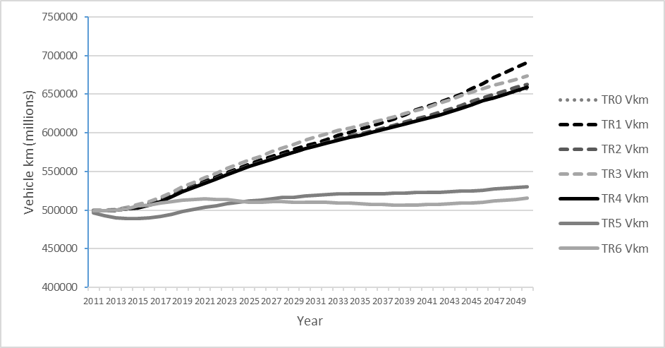

The combined modelling and scenario-based approach provides a tool which is capable of exploring future transport infrastructure requirements and indicating where and when infrastructure capacity is likely to become constrained given under a particular set of future conditions. It can also provide a high level overview of the impacts on transport of different trends in population and economic growth, along with the likely implications of certain policy approaches for issues such as energy demand and carbon emissions. The model user interface and the flexible nature of strategy definition make it easy to carry out sensitivity testing of model results (or ‘what-if’ analysis) by testing the impact on model results of changing future assumptions regarding a particular model variable (or several variables in combination). While the model is relatively simple compared to other strategic long-term transport models, the results it produces at a national level are broadly comparable with those generated by these more complex models, as illustrated by Figure 3 which shows the range of traffic forecasts for England generated by the DfT’s National Transport Model (Department for Transport, 2012) and by NISMOD with the baseline strategy. Furthermore, its relative simplicity and associated short run-times mean that it can be used together with models of other infrastructure systems as part of an interdependent modelling framework to assess how transport systems relate to (and are affected by) investments and policies in other sectors. Indeed, NISMOD was used by the UK National Infrastructure Commission (NIC), alongside models developed by the DfT and other government departments, to provide the forecasting which underpins its interim National Infrastructure Assessment for both transport and other infrastructure sectors (National Infrastructure Commission, 2017; Hall et al, 2017). This implementation of the model by NIC was an iterative process, with frequent interactions between NIC staff and university researchers to clarify how particular interventions and policies could be represented in the model and to explore why the model produced the results it did for different future scenarios. An enhanced version of the NISMOD framework (including the transport model) is currently being used to analyse proposed developments along the ‘East-West Corridor’ between Oxford and Cambridge in central England.

Figure 3: Comparison of NISMOD and NTM Road Traffic Forecasts for England 2011-2035

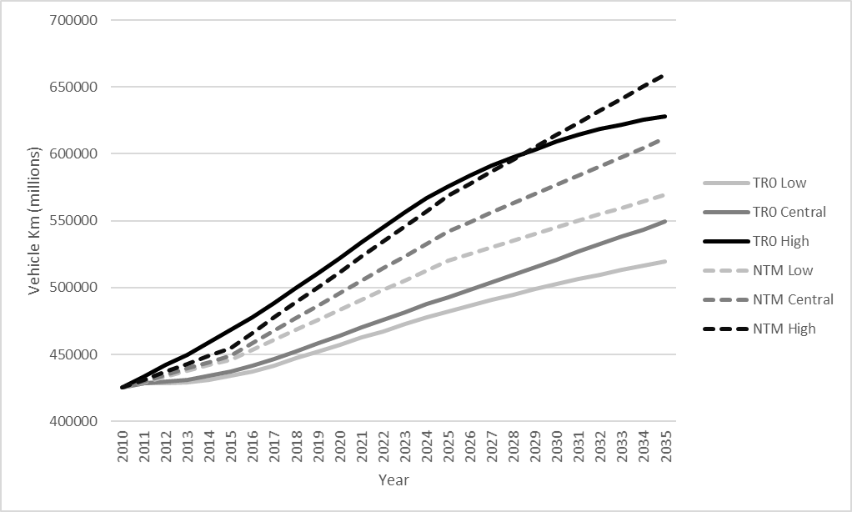

6) Limitations, the Unmodellable, and the Role of Decision Makers

While the modelling methodology outlined in Sections 4-5 fulfils the requirements of the project for which it was developed, by providing a tool for exploring future transport infrastructure requirements and indicating where and when infrastructure capacity is likely to become constrained under a particular set of future conditions, there are still a number of issues to consider when using tools of this kind to inform transport infrastructure planning and policy.

While the current set of scenarios and strategies covers a very large number of possible futures, there are (perhaps inevitably) still some gaps. For example, the economic forecasts all assume that aggregate GDP will continue to grow in the future (albeit at varying rates), whereas in reality recent history suggests that the potential for future recessions and sustained economic downturns should also be considered (this limitation is far from being unique to this particular study). It is also noticeable in Figure 2 that all the strategy-scenario combinations (as well as the NTM outputs) produce very smooth trends of change, something which is a common feature of most forecasts of this type. Figure 4 shows low, central and high forecasts of future road traffic growth from NISMOD for the period from 2011 to 2035 together with observed changes in traffic levels for the previous 25 year period (Department for Transport, 2017b). This shows that the smooth growth trends of the forecasts are not reflected in the observed reality where there is a much greater level of year on year fluctuation. While it might be argued that the smooth trends give a ‘best-fit’ approximation of this kind of fluctuation, it is possible that if these short-term fluctuations were sufficiently large scale they could in fact alter the slope or even the direction of a previously smooth trend.

Figure 4: Comparison Of Observed Trends In Road Traffic 1985-2010 With NISMOD Forecasts Of Road Traffic 2011-2035
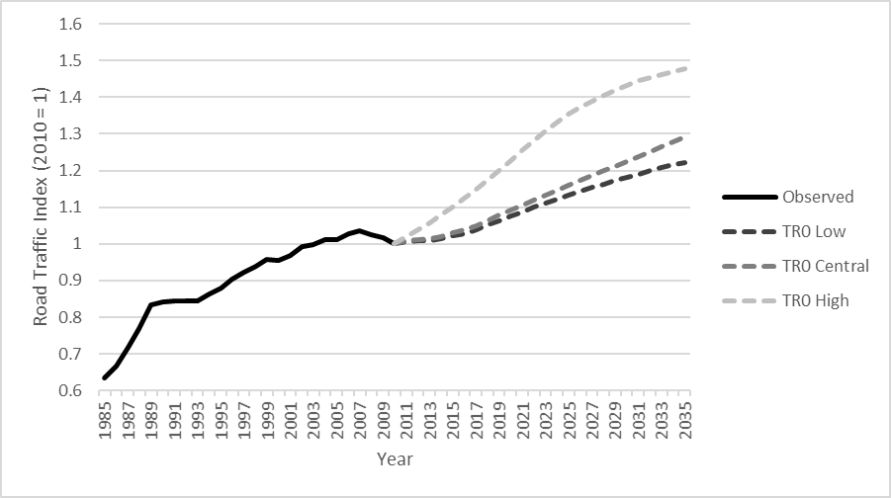

Furthermore, while the NISMOD model permits the exploration of a wide range of transport futures for the UK, it is important to recognise that the likelihood of any one of these futures being achieved, to a large extent depends on the consistency of the infrastructure planning approaches which are adopted in the future. In order for a long term vision of Britain’s national infrastructure to be transformed into reality, it will be necessary to sustain over a long period of time a societal (or at least governmental) consensus as to what this infrastructure should look like, in a return to the ‘high Keynesian’ model of centralised state planning (Marshall, 2014) which was favoured in the mid-20th century. While in some respects recent approaches to transport infrastructure planning in the UK seem to closely correspond to this model, for example with respect to HS2, other areas such as rail electrification have seen repeated policy ‘U-turns’. Recent profound shifts in the political landscape mean that future ‘U-turns’ are perhaps more likely than might have been the case even two years ago. A continued shift in policy emphasis towards ‘liberalisation’ and further privatisation of the infrastructure market could significantly affect the infrastructure planning landscape, and might even mean that integrated models of this nature became irrelevant to policy-makers. Given the obvious negative consequences for society of an end to integrated planning, it is therefore very important that the benefits of the interdependent approach are clearly articulated. Equally, it would perhaps be sensible for the impacts of ‘discontinuous’ policies to be modelled along with more coherent long-term strategies in order to give a more realistic view of the potential range of future conditions.

The results of the 2016 referendum on Britain leaving the European Union served as a reminder that predicting the future political landscape is arguably at least as difficult as predicting the future demand for infrastructure systems. Furthermore, continued uncertainty over what ‘Brexit’ will eventually involve makes it difficult to assess the impacts of this political change on the UK’s infrastructure systems using models such as NISMOD. However, while it is clearly beyond the scope of integrated infrastructure systems models such as NISMOD to predict step-changes in the political situation, it would nonetheless seem prudent to explore the likely (or potential) transport impacts of some plausible future political events, such as a vote for Scottish independence. While the timing of such events is clearly uncertain, some assessment of the likely impacts (such as a reduction in cross-border trade and an increase in costs) could still be undertaken in order to generate a set of inputs for the modelling system.

As well as political upheavals, history shows that transport systems can also be subject to similar upheavals, for example the rapid decline in international maritime passenger transport with the emergence of mass-market aviation in the 1950s. Because the NISMOD model simulates future demand based on existing transport systems and established relationships with key explanatory variables, this means that it cannot easily predict the impact of some such ‘revolutionary’ changes in transport provision. The model does provide a facility to alter trip rates over time to account for (for example) the impact of further developments in virtual mobility making travel unnecessary for certain types of trip, and strategy variables can also be altered to account for radical changes in vehicle technology. However, it would not be capable of predicting the impact of widespread take-up of a transport technology which exploited an additional dimension (like air travel) or required a dedicated infrastructure system, like some forms of personal rapid transit or the ‘hyperloop’. While transport experts may hold differing opinions on the likelihood of such new systems emerging, the inability of strategic modelling tools to deal effectively with some types of radical technological change is a clear limitation of such approaches.

When developing any model of this kind it is necessary to set both spatial and temporal bounds on the coverage of the model, as no model can capture every potentially relevant linkage with the system of interest. In the case of NISMOD the model is focused on the needs of the UK, and treats Great Britain as a spatially distinct unit. While Brexit is perhaps likely to make Britain more spatially distinct in some respects, it is nonetheless still clear that in a globalised world the infrastructure systems of national entities do not operate in isolation. The relational turn in economic geography suggests that ideally we should consider space and therefore transport in a more fragmented, unbounded, and discontinuous way (Boggs & Rantisi, 2003; Massey, 2007). In practice it is difficult to see what alternative there is to imposing more or less arbitrary bounds on model coverage, whatever theoretical disadvantages there might be to doing so. However, it is clearly sensible to at least implicitly consider wider linkages in these bounded models, for example through the impact of international migration on population levels, the effect of global economic shocks on GVA and transport costs, and the impact of international regulations on vehicle emissions levels and fuel efficiency.

It was noted in section 5 that studies which attempt to model infrastructure futures can be divided into predictive, exploratory and normative approaches. The research described here has so far taken an exploratory approach, but the policy implications of such an approach are not necessarily straightforward. There is often an understandable desire amongst policy makers to adopt the strategy which will generate the best possible future, whether that is for the long term or (more cynically) for the period up to when they will next be held accountable by an electorate. However, given the high level of uncertainty over future conditions, it could be argued that policy-makers should focus more on adopting the strategy choices which the model shows to be most robust, in other words those which allow transport infrastructure systems to continue to operate at an acceptable level under the widest possible range of future conditions. It is possible (and indeed likely) that the most ‘robust’ strategy will lead to a sub-optimal situation in the majority of potential futures, and that other strategies which carry a small risk of significant failure would in most circumstances deliver a better outcome for society, but the high stakes associated with failure may still mean that a risk-averse approach is preferable.

The other key disadvantage of both exploratory and predictive approaches is that by emphasising high levels of uncertainty (with exploratory approaches) or by concealing the possibility of alternative futures (with predictive approaches) they downplay the influence which planners and policy-makers can have on the shape of the future which will actually materialise. In fact, while a range of futures is undoubtedly possible, perhaps the biggest single determinant of which future becomes reality is the decisions taken by those in positions of power, be they world leaders or local transport planners. It may therefore be preferable to adopt a normative or ‘target-led’ approach to infrastructure systems modelling, where the starting point is for planners and politicians to identify what kind of future they wish to achieve (Borjeson et al., 2006) with the model then used to identify the set of potential pathways that could lead to this desired future. These pathways might either involve cost-effectively preserving and adapting the current situation, or alternatively adopting more investment-intensive transformational strategies. In either case, this approach would involve internalising in the planning process as much of the uncertainty over future conditions as is possible. While some aspects of the future will inevitably remain outside the planners’ control, there is evidence to show that when short-term targets are enforced through legislation then pathways will be chosen which maximise the chance of them being achieved (as has been seen with EU vehicle emissions targets, for example). There is clearly still a key role for modelling in this normative process, in terms of identifying whether a particular approach is compatible with the targets which have been set. However, demand models of the kind described here should not be expected to identify what these targets should be, and do not present policy makers with an excuse to abdicate responsibility. More advanced versions of such models which incorporated (for example) a welfare assessment could potentially help in the process of determining appropriate targets, but the final decision would inevitably still involve policy makers making a judgment with the aim (ideally) of maximising societal wellbeing.

7) Conclusions and Future Work

The long term modelling of interdependent infrastructure systems has seen significant advances in recent years, with models such as NISMOD now capable of informing strategic decision making by government bodies. This has been exemplified by the UK National Infrastructure Commission’s use of NISMOD to assess the UK’s infrastructure requirements for the period up to 2050 (National Infrastructure Commission, 2017). This paper has demonstrated the principles behind the transport component of one such modelling system, showing that while compromises are inevitable in such modelling these need not prevent useful outputs being produced. The work undertaken using NISMOD has shown that relatively simple models can produce outputs which at the aggregate level are comparable with those from more complex models such as the NTM, while also explicitly accounting for interactions with other infrastructure sectors and enabling a wide variety of possible futures to be rapidly compared. However, this paper also argues that, while useful, models on their own can only take us so far, and are certainly not capable of independently determining the pathway to a better transport future. Indeed, arguably the existence of such models increases rather than undermines the importance of the role played by planners and policy-makers, by highlighting the sheer range of transport futures which could potentially be achieved. In order for strategic models to make a practical difference to the effectiveness and efficiency of transport systems, they need to be underpinned by clear and consistent strategic thinking and decision making, with a coherent end goal to aim for. Otherwise there is a danger that the legacy of such models in several decades time will merely be to remind humanity of what might have been.

Acknowledgments and Data Access

The research described in this paper was supported by the UK EPSRC (Engineering and Physical Sciences Research Council) under grants EP/I01344X/1 and EP/N017064/1. The data supporting the results presented in this paper are available from the University of Southampton repository at https://doi.org/10.5258/SOTON/D0567.

References
Blainey SP, Preston JM & McLeod F (2012) A Long Term Capacity and Demand Assessment Model for the UK Transport System, European Transport Conference, Glasgow, 8-10 October 2012.
Blainey SP, Hickford AJ & Preston JM (2013) Planning Transport Networks For An Uncertain Future: A UK Case Study, European Transport Conference, Frankfurt am Main, 30 September-2 October 2013
Boggs JS & Rantisi NM (2003) The ‘Relational Turn’ in Economic Geography, Journal of Economic Geography 3:109-116
Borjeson L, Hojer M, Dreborg K, Ekvall T & Finnveden G (2006) Scenario Types and Techniques: Towards a User’s Guide, Futures 38:723-739
Chaudry M, Jenkins N, Qadrdan M & Wu J (2014) Combined Gas and Electricity Network Expansion Planning. Applied Energy, 113, pp.1171-87.
Curry A, Hodgson T, Kelnar R & Wilson A (2006) Foresight Intelligent Infrastructure Futures: The Scenarios - Towards 2055, London: Office of Science and Technology.
de Jong G, Gunn H & Ben Akiva M (2004) A Meta-model for Passenger and Freight Transport in Europe, Transport Policy, 11(4):329-344
Department for Transport (2009) National Transport Model: High Level Overview, London: DfT.
Department for Transport (2012) Road Transport Forecasts 2011: Results From The Department For Transport's National Transport Model, London: DfT.
Department for Transport (2014) TAG Unit A1.1: Cost Benefit Analysis, London: DfT.
Department for Transport (2017a) Forthcoming Change to WebTAG: Updated Guidance on Long-Term Demand Forecasting, London: DfT.
Department for Transport (2017b) Road Traffic Statistics Table TRA0101, London: DfT.
European Commission (2011) A Growth Package for Integrated European Infrastructures, COM(2011) 676, Brussels: European Commission.
Goodwin P (2013) ‘Peak Car’ – Where Did The Idea Come From? Where Is It Going?, Universities’ Transport Study Group Conference, January 2013, Oxford.
Hall JW, Tran M, Hickford AJ & Nicholls RJ (2016) The Future of National Infrastructure: A System of Systems Approach, Cambridge: Cambridge University Press.
Hall JW, Thacker S, Ives M, Cao Y, Chaudry M, Blainey S P & Oughton E (2017) ‘Strategic analysis of the future of national infrastructure’, Proceedings of the Institution of Civil Engineers: Civil Engineering 170(1):39-47
Hickford AJ, Nicholls RJ, Otto A, Hall JW, Blainey SP, Tran M & Baruah P (2014) Creating An Ensemble Of Future Strategies For National Infrastructure Provision, Futures, In Review.
Hill N, Morris M & Skinner I (2010) EU Transport GHG: Routes to 2050? SULTAN: Development of an Illustrative Scenarios Tool for Assessing Potential Impacts of Measures on EU Transport GHG, London: AEA.
Infrastructure and Projects Authority (2016a) National Infrastructure Delivery Plan 2016-2021, London: HM Treasury
Infrastructure and Projects Authority (2016b) National Infrastructure and Construction Pipeline Analysis, London: HM Treasury
Lenz RT & Lyles MA (1985) Paralysis by Analysis: Is Your Planning System Becoming Too Rational, Long Range Planning 18(4):64-72
Marshall T (2014) Infrastructure Futures And Spatial Planning: Lessons From France, The Netherlands, Spain And The UK, Progress in Planning 89-1-38
Massey D (2007) World City, Cambridge: Polity
National Infrastructure Commission (2017) Congestion, Capacity, Carbon: Priorities for National Infrastructure, London: National Infrastructure Commission
Owens S (1995) From ‘Predict and Provide’ to ‘Predict and Prevent’: Pricing and Planning in Transport Policy, Transport Policy, 2(1):43-49
Perez P, Huynh N, Cao VL, Wickramasuriya R & Berryman M (2014) TransMob: An Agent Based Simulation of Transport Demand and Residential Mobility in South East Sydney, Social Simulation Conference, Barcelona 1-5 Sep 2014
Preston JM & Blainey SP (2016) ‘Transport Systems Assessment’, in Hall JW, Nicholls R, Tran M & Hickford AJ (eds) The Future of National Infrastructure: A System-of-Systems Approach, ch. 5, Cambridge University Press
Rilett LR (2001) Transportation Planning and TRANSIMS Microsimulation Model: Preparing for the Transition, Transportation Research Record 1777:84-92
Self, P. (1970) Nonsense on Stilts: Cost-Benefit Analysis and the Roskill Commission. The Political Quarterly, 41(3):249-260
Stephenson, J. & Zheng, L. (2013) National Long-Term Land Transport Demand Model, NZ Transport Agency, Wellington.
Tran M et al. (2014) National Infrastructure Assessment: Analysis of Options for Infrastructure Provision in Great Britain, Interim Results. Environmental Change Institute, University of Oxford.
URS/Scott Wilson, 2011. Modelling Longer Distance Demand for Travel Phase 3: Final Report - Volume 1 Main Report. Basingstoke: URS/Scott Wilson.
Van der Hoorn, T. & van Wee, B. (2013) ‘Transportation Models And Their Applications’ in Van Wee, B., Annema, J.A. & Banister, D. (eds) The Transport System And Transport Policy: An Introduction, Edward Elgar, Cheltenham.
WSP Group, 2011. NTEM Planning Data Version 6.2: Guidance Note. London: DfT.
Zhang, P. & Peeta, S. (2011) ‘A Generalized Modeling Framework To Analyze Interdependencies Among Infrastructure Systems’, Transportation Research Part B, Vol. 45, pp.553-79.

