**Summary of the 2018 Placenta Imaging Workshop held at the University College London Centre for Medical Image Computing.**

Paddy Slator1, Rosalind Aughwane2, Georgina Cade2, Daniel Taylor2, Anna L David3, 4, Rohan Lewis5, Eric Jauniaux3, Adrien Desjardins2, Laurent Salomon6, Anne-Elodie Millischer6, Vassilis Tsatsaris6, Mary Rutherford7, Edward Johnstone8, Andrew Melbourne2,7, participants of the workshop*.

1Centre for Medical Image Computing and Department of Computer Science, University College London, UK.

2Dept. of Medical Physics and Biomedical Engineering, University College London, UK.

3Institute for Women’s Health, University College London, UK.

4NIHR University College London Hospitals Biomedical Research Centre, London, UK.

5University of Southampton, UK.

6Paris Descartes University, France.

7King’s College London, UK.

8University of Manchester, UK.

*Full list provided at the end of the article.

**Keywords:** Pregnancy, Placenta, Modelling, Multi-scale, Multi-modal, Collaboration

**Abstract:** The Centre for Medical Image Computing (CMIC) at University College London (UCL) hosted a two-day workshop on placenta imaging on April 12th and 13th 2018. The workshop consisted of 10 invited talks, 3 contributed talks, a poster session, a public interaction session and a panel discussion about the future direction of placental imaging. With approximately 50 placental researchers in attendance, the workshop was a platform for engineers, clinicians and medical experts in the field to network and exchange ideas. Attendees had the chance to explore over 20 posters with subjects ranging from the movement of blood within the placenta to the efficient segmentation of fetal MRI using deep learning tools. UCL public engagement specialists also presented a poster, encouraging attendees to learn more about how to engage patients and the public with their research, creating spaces for mutual learning and dialogue.

**1. Organisation**

*Organisers:* Paddy Slator, Rosalind Aughwane, Andrew Melbourne

*Speakers:* Anna David, Rohan Lewis, Eric Jauniaux, Adrien Desjardins, Laurent Salomon, Anne-Elodie Millischer, Vassilis Tsatsaris, Daniel Taylor, Romina Plitman Mayo, Gareth Nye, Simon Shah, Andrew Melbourne, Mary Rutherford, Ed Johnstone

*­*

**2. Proceedings**

**Anna David** opened the workshop on the first day by arguing *why we should image the placenta with MR* (Figure 1). The placenta’s complexity as a dual circulatory system with an integral barrier between the mother and fetus(es) make it the most difficult organ to access in vivo. Great strides have been made in understanding the brain using magnetic resonance imaging. Now this technique is being applied to increase our understanding of placental structure and function. From a purely curious perspective the placenta is a fascinating organ that functions as a respiratory, renal, hepatic, endocrine, and vascular system for the developing fetus. The origins of the great obstetric syndromes of preterm birth, fetal growth restriction and pre-eclampsia probably come down to abnormal placental development and function. These conditions affect up to a third of all pregnancies and are a leading cause of neonatal and maternal morbidity and death globally. MR imaging of the placenta may shed light on the pathology of these complications as well as allow the response to novel treatments to be evaluated.

**­­Rohan Lewis** presented his group’s work on *multiscale 3D imaging of the placenta*. These techniques allow identification of novel structures at the tissue, cellular and subcellular level, which are inaccessible using traditional 2D imaging techniques. Furthermore, the 3D approach demonstrates the spatial relationships between different features which allows relation of structure to function. The ability to see features and cellular spatial interrelationships that could not previously be visualised is leading to a new biological understanding of the placenta and may lead to novel biomarkers and therapeutic approaches.

**Eric Jauniaux** presented on *the etiopathology of ultrasound signs in the diagnosis of placenta accreta* and abnormally invasive placental disorders. Current findings continue to support the concept of a biologically defective decidua rather than a primarily abnormally invasive trophoblast. Prior caesarean section surgery increases the risk of placenta praevia and both adherent and invasive placenta accreta, suggesting that the endometrial/decidual defect following the iatrogenic creation of a uterine myometrium scar has an adverse effect on early implantation. Preferential attachment of the blastocyst to scar tissue facilitates abnormally deep invasion of trophoblastic cells and interactions with the radial and arcuate arteries. Subsequent high velocity maternal arterial inflow into the placenta creates large lacunae, destroying the normal cotyledonary arrangement of the villi.

**Adrien Desjardins** spoke on *photoacoustic and ultrasound imaging of the placenta*. Ultrasound imaging can be valuable to visualise the placenta for diagnostic and therapeutic procedures. However, current-generation ultrasound probes based on electronic components have several prominent limitations. For instance, they are unable to detect tissue colour directly, and it can be challenging to miniaturise them to the sub-millimetre scale for integration into minimally invasive devices. Optical methods for transmitting and receiving ultrasound are emerging as alternatives to their electrical counterparts. They offer several distinguishing advantages, including the potential to generate and detect broadband ultrasound required for high resolution imaging. The talk focused on recent work on photoacoustic imaging of the placenta, where ultrasound is generated in tissue using pulsed light, and fibre-optic generation of reception of ultrasound from within medical devices for interventional imaging and medical device tracking. Adrien finally highlighted recent work on placental phantoms with tuneable optical, ultrasonic, and mechanical properties.

*Functional MRI of the placenta* was the subject of **Laurent Salomon’s** talk. Abnormal placentation is responsible for most failures in pregnancy. Functional MRI (fMRI) of the placenta has not yet been largely validated in a clinical setting, and most data are derived from animal studies. FMRI could be used to further explore placental functions that are related to vascularization, oxygenation, and metabolism in human pregnancies by the use of various enhancement processes: dynamic contrast-enhanced MRI, arterial spin labeling MRI, blood oxygen level-dependent and oxygen-enhanced as well as diffusion-weighted imaging and intravoxel incoherent motion MRI are various techniques that have been successfully applied to the functional imaging of the placenta. The ability of each fMRI technique to make a timely diagnosis of abnormal placentation that would allow for appropriate planning of follow-up examinations and optimal scheduling of delivery needs to be further investigated. Research programs will benefit from the use of well-defined sequences, standardized imaging protocols, and robust computational methods.

**Anne-Elodie Millischer** presented work using *MRI with Gadolinium for the Diagnosis of Abnormally Invasive Placenta*. Ultrasound is the primary imaging modality for the diagnosis of placenta accreta, but it is not sufficiently accurate. MRI morphologic criteria have recently emerged as a useful tool in this setting, but their analysis is too subjective. Gadolinium enhancement may improve the accuracy to diagnose abnormal invasive placenta (AIP). In our experience, the use of dynamic contrast gadolinium enhancement (DCE) MRI emerges as a reliable procedure to diagnose AIP for both junior and senior radiologists. Particularly, the use of a specific pattern of enhancement, by allowing the extraction of tissular enhancement parameters, enables a predictable distinction between placenta accreta and normal placenta.

**Daniel Taylor** presented on public engagement as a route to improving the quality and dissemination of research outcomes. There is increasing evidence to support this link, with a corresponding increase in funders’ expectations of detailed plans as part of applications. However, there remain a number of perceived barriers across fields.

These issues were discussed further at the poster session, where feedback demonstrated a clear appetite for public communication and involvement in this area. This is particularly timely given the clear link to patient impact and evidence of benefits, such as “lead(ing) to new research questions”. There was also a clear perceived need to “reimagine the public image of the placenta”. Despite this, many felt unsure of where to start, including which groups to target, methods of reaching them and how to access support. This correlates to national feedback in the Factors Affecting Public Engagement UK survey [1].

Given the growing field there is increasingly institutional and local support available, with many universities, hospitals and biomedical research centres featuring teams to assist with developing activity. This is matched with national support such as the NCCPE [2], INVOLVE [3] and AHSNs [4], which are good starting points.

**Vassilis Tsatsaris** presented work undertaken in collaboration with **Edouard Lecarpentier** and **Olivier Morel** on *assessment of the utero-placental vascularization by ultrasound* approaches. The quality of utero-placental vasculature is essential for a proper fetal development and a successful pregnancy. Inadequate remodeling of the spiral arteries resulting in decreased maternal blood to the placenta has been implicated in the pathophysiology of preeclampsia and IUGR. However, the in vivo assessment of placental vascularization with non-invasive methods is complicated by the small size of placental terminal vessel, its complex architecture, and the very low blood velocities. Maternal utero-placental hemodynamics is currently assessed mainly by means of uterine artery pulsed Doppler, but this imaging modality has limited predictive value for preeclampsia and IUGR. Another approach consists in quantifying the vascularization directly in the placenta or the placental bed using a combined method of three-dimensional (3D) imaging and power Doppler ultrasonograph. First clinical studies suggest that the 3D power Doppler indices of the uteroplacental circulation could be helpful to improve the prediction of preeclampsia and IUGR. However, 3D power Doppler angiography of the placenta remains limited to large vessels and does not discriminate the fetal circulation from the maternal circulation. New technologies are emerging such as ultrafast scanners based on holographic imaging using unfocused ultrasonic waves. Recent studies suggest that ultrafast acquisition offers the possibility to analyze the flow with a high spatio-temporal resolution and may allow to discriminate maternal and fetal circulation.

The second day of the workshop began with **Andrew Melbourne** presenting for **Rosalind Aughwane** on *MicroCT for imaging the human placenta*. Little is known about the three-dimensional structure of the fetoplacental vascular tree, due to the small size of vessels and complexity of branching structure. Micro-CT can capture this data in 3D volumes and opens a new window into our understanding of the vascular structure both in normal pregnancy and in major obstetric disorders including fetal growth restriction, pre-eclampsia and complicated twin pregnancies. MicroCT shows that there is substantial heterogeneity in vascular density within normal placentas, however some trends in the structure of the vascular tree appear to be conserved. The technique applied to the placenta allows the three-dimensional chorionic and deep branching vessel structure to be visualised and quantified, and can transform our understanding and appreciation of this much understudied but vital organ.

**Mary Rutherford** gave an outline of the NIH-funded *Placenta Imaging Project*: the aim of this project is to develop an integrated MR approach to assess placental structure and function, and utilise it to characterise inadequate placentation. She then went on to discuss the links between placenta dysfunction and neonatal encephalopathy and perinatal brain injury.

**Ed Johnstone** spoke about *paying attention to the placenta to improve antenatal care*: during pregnancy monitoring attention is understandably focused on the fetus and the mother. However, the placenta sits at the interface between the two and examining it is essential if we are to gain a full picture of pregnancy health and well-being. Traditionally, antenatal placental assessment has primarily been confined to determining placental location, but more recently attention has focused on trying to gauge and measure placental function and health in vivo, particularly in pregnancies at risk of poor outcomes. The presentation discussed how his group are using imaging technologies to influence antenatal care and improve outcomes, how studies using ultrasound, magnetic resonance imaging and microCT will continue to expand the importance of examining the placenta in clinical care, and where he perceived the next important advances need to occur.

**3. Panel Discussion**

The final session of the workshop was a panel-led discussion on the future direction of placenta imaging research.

The discussion was led by Anna David, Mary Rutherford and Ed Johnstone, with many contributions from the audience. Figure 2 shows a mind map highlighting important outcomes collected on a white board during the discussion. Several key themes emerged throughout our panel discussion:

**Collaboration** – through coordinated research effort between Centres we can maximise the sharing of methods and data between research groups. A coordinated effort to make standardised imaging data available would help researchers share ideas and avoid replication. Funding would be needed to support this initiative. A central agreed registry of data is one possible solution; Ed Johnstone offered to investigate if the Tommy’s MRC biobank was prepared to host a national or international dataset of placental MRI. The placentome.org webpage, which is particularly relevant for modelling work, may represent the first step towards this.

**Outreach** – more is needed to communicate the importance of the placenta, and better understanding of its importance for future maternal and fetal health. Increasing public education and understanding will help boost recruitment, and hopefully lead to more *ex utero* placentas available for study *ex utero* after birth. Families will be more likely to donate placentas if they understand the importance of the organ and the potential benefits of placental examination and research to future pregnancies.

More **Research** into placental pathology is needed to understand the broad spectrum of placental conditions and fetal compensation in response to poor placentation. Pre-pregnancy imaging and correlation with subsequent placentation is likely to be a key research area, but is yet to be studied in detail. Very early imaging of pregnancy is also likely to become more important, with aims of establishing the timing of future intervention, and helping provide early prediction of outcome.

**Imaging** is vital for improving our understanding of placental physiology and efficiency. Current techniques are beginning to help us understand flow matching, and what constitutes a functional placenta. Many **new techniques** are emerging with much potential for advancing our understanding of the placenta: these include perfusion imaging, computational modelling of the placenta, placenta MR spectroscopy, and arterial spin labelled MRI. But these techniques currently have limitations due to difficulties with reproducibility, and more is needed regarding future protocol development. Automatic placental image analysis tools such as automated segmentation will be critical to future large-scale studies. Future projects will need to explore the value of these new imaging techniques and standardise measurements across hardware, software, and populations. Work on correlative imaging between modalities and between scales is an important area for future work. Mappings between different imaging modalities will be useful, since some imaging techniques have clear advantages in terms of cost, comfort or safety.

**Motion** remains an unsolved problem especially in MRI, complicated by the presence of mechanical vibration and reports of uterine contractions.

**Maternal position** remains a point of interest for MRI scans; there are valid, evidence-based concerns about compression of the vena cava during supine scanning. Ongoing efforts aim to evaluate if a supine position may offer greater consistency across scans, without compromising patient safety and comfort compared to left- or right- lateral positions.

In particular, **standardising inclusion criteria and data collection** for women with pathological pregnancies is vital to allow comparison of placental imaging findings between studies. Attention must be paid by researchers to ensure that characteristics such as maternal blood pressure and the timing of anti-hypertensive treatment is documented in relation to scans, as these factors may affect the results.

**More imaging** is needed, both in vivo and ex vivo. Longitudinal imaging is desirable. For large scale studies, long term follow-up is essential with precise definition of outcome at all stages. Focus is needed on the most important outcomes for each pathology. Birth weight is a useful proxy outcome, but the real goal should be to monitor the long-term health of children, ideally until school age. There are imminent core outcome sets for fetal growth restriction as part of an ongoing study and similar sets will need to be defined for other placental pathologies.

The discussion ended with some thoughts for the future and our hope to meet again next year.

**4. Summary**

This workshop at UCL showcased many aspects of research into the placenta across multiple scales and multiple imaging modalities. What is clear is that the future holds much promise for this much under-studied organ and future collaborations and sharing of data between groups will surely be extremely productive. We hope that the recent drive to publish the proceedings of placental workshops (e.g. [5]) will stimulate broader collaboration and deeper discussion of the common issues surroundings our shared research interests.

**Acknowledgements** The workshop was supported by EPSRC and CMIC platform grant (NS/A000027/1). We would also like to acknowledge the Wellcome Trust (grants 210182/Z/18/Z, 101957/Z/13/Z), the National Institute for Health Research (NIHR), and the US National Institutes of Health (grant 1U01HD087202-01).

**References**

[1] <https://wellcome.ac.uk/news/what-are-barriers-uk-researchers-engaging-public>

[2] National Coordinating Centre for Public Engagement (<https://www.publicengagement.ac.uk>)

[3] INVOLVE – NIHR funded body supporting active public involvement in NHS, public health, and social care research (<http://www.invo.org.uk>)

[4] Academic Health Science Networks (<https://www.england.nhs.uk/ourwork/part-rel/ahsn/>)

[5] Acharya G, Aplin J, Brownbill P, Bulmer J, Burton G, Chamley L, Chernyavsky I, Clark A, Collins S, Cottrell E2, Dilworth M, Elad D, Filoche M, Hannan N, Heazell AEP, Jensen O, Johnstone ED, Leach L, Lewis R, Morgan T, Myers J, Nye G, Oyen M, Salafia C, Schneider H, O'Tierney-Ginn P. IFPA meeting 2017 workshop report: Clinical placentology, 3D structure-based modeling of placental function, placental bed, and treating placental dysfunction. Placenta. 2018 Apr;64 Suppl 1:S4-S8. doi: 10.1016/j.placenta.2017.12.011. Epub 2017 Dec 15.

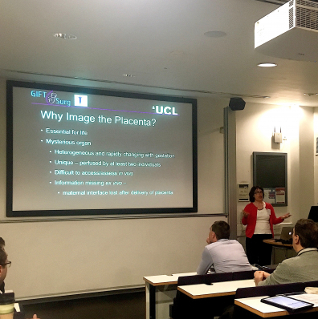

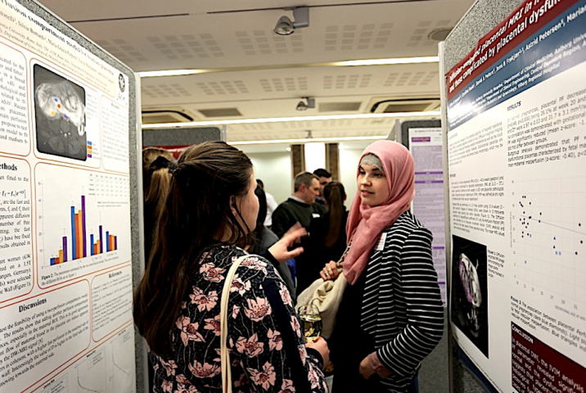

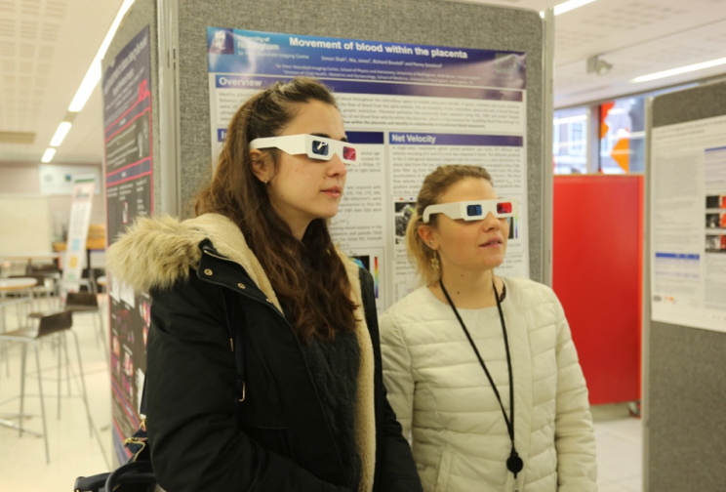

**Figure 1: Photo montage from the 2018 Placenta Imaging Workshop**



**Figure 2: Mind map arising from panel discussion on the future direction of placenta imaging research.**

**Full List of Workshop Participants**

David Atkinson, Rosalind Aughwane, Rupanjali Baranikumar, Charline Bertholdt, Elisenda Bonet-Carne, Paul Brownbill, Paul Brownbill, Muriel Bruchhage, Richard Caulfield, Igor Chernyavsky , Andrew Chew, Anna David, Adrien Desjardins, Enrico De Vita, Tom Doel, Alexander Erlich, , Dimitra Flouri, Michele Guerreri, Matina Hakim, Ditte Hansen, Makinah Haq, Parvez Haris, Sara Hillman, Alison Ho, Jana Hutter, Laurence Jackson, Eric Jauniaux, Edward Johnstone, Esra Kipergil, Silvia Labianco, Rohan Lewis, Christina Malamateniou, Efthymios Maneas, Andrew Melbourne, Anne-Elodie Millischer, Enrique Monton, David Morris, Julie Nihouarn, Gareth Nye, Helen O'Neill, Mette Østergaard Thunbo, Marco Palombo, Rachel Peasley, Kelly Pegoretti Baruteau, Romina Plitman Mayo, Saskia Port, Mary Rutherford, Laurent Salomon, Simon Shah, Paddy Slator, Natalia Soe, Anne Soerensen, Magdalena Sokolska, Carla Svigilsky, Teresa Tropea, Vassilis Tsatsaris, Guotai Wang, Bilal Yassine