Controls on Creek Margin Stability by the Root Systems of Saltmarsh Vegetation, Beaulieu Estuary, Southern England

Yining Chen^{1, 2}*, Charlotte Thompson^{1,3}, Michael Collins¹
- School of Ocean and Earth Sciences, University of Southampton, Southampton, UK
- Second Institute of Oceanography, SOA, Hangzhou, China
- Channel Coastal Observatory, National Oceanography Centre, Southampton, UK

[Abstract]
The retreat of cliffs (lateral expansion) within tidal creeks results in a net loss of saltmarshes, but this retreat process can be retarded by root systems. In order to understand the interaction between root presence and bank sediment, quantitative measurements of two saltmarsh species root systems (Atriplex portulacoides and Juncus maritima) were carried out in a saltmarsh in Southern England, and their relationships with bank stability were examined. Computed Tomography (CT) Scanning techniques were used to investigate three dimensional root architecture. The data obtained, e.g. root volume, diameter and distribution patterns of roots, were examined alongside more traditional root density measurements. The volumetric percentage, ratio between horizontal (lateral) and vertical roots (H/V ratio), and root diameter distribution are discussed in relation to their influence on bank sediment erosion threshold and shear strength. The results suggest that Atriplex portulacoides is more effective than Juncus maritimus, in stabilising banks. This is because root systems which provide a high resistance to flow-induced erosion are better than those which provide a high resistance to gravity-induced erosion in stabilising cliff banks. This conclusion is relevant to future saltmarsh protection and re-establishment.

Keywords: Saltmarsh; Root systems; 3D structure; Sediments; Cliff stability

1． Introduction
Coastal saltmarshes are not only highly-valued ecosystems, but also a buffer zone between the land and sea, protecting the land from wave and current induced erosion. However, saltmarshes are very sensitive to rises in sea-level. Many saltmarshes in Southern England have been reported to be experiencing serious erosion; and in some area, are likely to disappear completely (Kirby, 1986; Harmsworth and Long, 1986; Long and Tooley, 1995; and Cope et al., 2008; Foster et al., 2013). One of the mechanisms of saltmarsh erosion in these areas is enlargement of the tidal creeks, a process closely associated with the stabilisation effects of vegetation on the sediments, which can act to retard the net loss of saltmarshes (Gabet, 1998; Fagherazzi and Furbish, 2001; D'Alpaos, et al., 2006). A number of previous papers have studied the influence of vegetation on saltmarsh bank stability in high energy environments (e.g., van Eerdt, 1985a; Spencer et al., 2014; Shama et al., 2016; Bouma et al., 2016). Saltmarshes, together with tidal creeks, spread also into sheltered estuaries, where the prevailing hydrodynamic conditions are relatively low (Tubbs, 1999; Friedrichs and Perry, 2001). Bank failure takes place both in high-energy and low-energy saltmarshes under erosion, despite of prevailing hydrodynamic conditions, because the basic mechanisms are similar (Tal and Paola, 2010; Kearney and Fagherazzi, 2016). In general terms, the presence of vegetation increases the resistance of bank sediments to erosion and consequently decreases the rate of bank face retreat and the frequency of bank failure (e.g. Van Eerdt, 1985a; De Baets et al., 2007; Danjon et al., 2007; Chen et al., 2012; Zhao et al., 2017; Gong et al., 2018; Best et al., 2018), thereby stabilising tidal creek size.

Although plants have a long history of being used to stabilise banks, it is unclear which type of root systems are effective in reducing the retreat of saltmarsh banks. In Southern England, due to relative sea level rise, saltmarshes are experiencing a great recession and as a result, cliffs on vegetated banks characterise the saltmarsh geomorphology and the retreat of tidal creek cliffs is a major concern for local saltmarsh management (Dyer, 1980; Harmsworth and Long, 1986; Cope et al., 2008). In particular, the relative sea level rise also causes the squeeze of intertidal flats and further development of tidal creek systems into upper marshes to a large extent (Goudie, 2013). These creek banks create favourable habitats for middle or high marsh plants that improve bank stability (Kim et al. 2010).

Therefore, it is important to select the appropriate type of plants to stabilise the saltmarshes, particularly, middle to high marsh species under a background of sea level rise. A typical saltmarsh transect can be described by vegetation zonation in England: pioneer species such as Spartina anglica, middle marsh species such as Atriplex portulacoides, and upper marsh species such as Juncus maritimus (Boorman, 2003). Since 1920s, ‘dieback’ of Spartina anglica has been reported widely along the coasts of southern England (Lobeck, 1995) and Spartina was subsequently replaced by middle or high marsh species. Atriplex portulacoides is widespread on salt marshes around the coasts of Europe, North Africa and South-West Asia. This species is frequently dominant lower to middle marshes, particularly, along tidal creeks (Chapman, 1950; Boorman, 2003). Juncus maritimus occurs widely in British and North European saltmarshes and may be the dominant species over a large area of saltmarshes, particularly, middle to upper marshes (Adam, 1990; Boorman, 2003; Foster et al., 2013). Under such circumstance, Atriplex portulacoide and Juncus maritimus are considered as important species to study saltmarsh cliff stabilization in southern England.

Bank stability is mainly determined by erosion threshold and shear strength of bank sediments (Thorne and Levin, 1979; Micheli and Kirchner, 2002). The role of vegetation in reducing the magnitude of channel change appears to be by increasing the strength of the bank material through the presence of its root systems. Plant roots tend to bind the bank materials together and add extra cohesion to the sediment, thus increasing shear strength (Greenway, 1987; Coppin and Richards, 1990; Darby and Turner, 2008). The extent to which vegetation acts as reinforcement depends upon a number of root properties. For example, root strength depends upon the species, size, density, age and lateral roots (Rutherfurd, et al., 2002; Tian et al., 2014). It has also been noted that the contact area between roots and sediments is important in reducing the erodibility of sediments (De Baets et al., 2007). Belowground biomass and root system structure are the key parameters for model prediction (Friedrichs and Perry, 2001; D'Alpaos et al., 2006; Reubens et al., 2007). The belowground biomass of saltmarshes has been published extensively (e.g., Groenendijk and Vink-lievaart, 1987; Bouma et al., 2001; Neves et al., 2007; Darby and Turner, 2008), but the data describing root system architecture are limited.

The conventional method for root system architecture research is based upon the collection of cores or samples (Danjon and Reubens, 2008). Subsequently, the sediment and roots are manually separated and the root density (root mass, per soil volume) is measured (e.g., Van Eerdt, 1985a; Connor and Chmura, 2000; Bouma et al., 2001). This traditional method is both laborious and imprecise. The roots of Atriplex portulacoides and Juncus maritimus are both fibrous and fragile. Meanwhile, the sediments in saltmarshes often consist of highly cohesive clay. It is therefore difficult to separate the roots from soils without damage to the roots. To address these limitations, computed Tomography Scanners (CT Scanners) were used in this study, to obtain three-dimensional (3D) architecture data of the root systems without disturbing the original architecture of the root systems (Tracy et al., 2010; Mooney et al., 2012; Redelstein et al., 2018).

Based on the consideration above, the aims of this paper are (1) to provide detailed quantification of the root systems of two saltmarsh species (Atriplex portulacoides and Juncus maritimus) which are common in the Southern England; (2) to use this data to examine the relationships between the architecture of root systems and bank sediment stability; and (3) to highlight practical applications of this knowledge. The bank sediment stability is quantified herein using two parameters: erosion threshold (resistance to flow) and shear strength (resistance to gravity), which have been published in an earlier paper (Chen et al., 2012). The discussion of the efficiency of root systems in stabilising cliffs will be discussed using a simple model, and the specific example of the Beaulieu Estuary will be used to demonstrate the difference between two root systems.

2． Methods
Exbury Marsh is located in the middle reach of the Beaulieu Estuary (Figure 1). It receives only limited fresh water input and salinity here is 32-34 on average (Houghton, 1986). Exbury Marsh has a very narrow pioneer fringe of Salicornia europea at the seaward edge and grades into an Atriplex portulacoides (Sea Purslane) and Spartina anglica community within the Lower and Middle Marshes, with Spartina anglica making up less than 10% of the vegetation. A Juncus maritimus (Sea Rush) community occurs in the High Marshes (Figure 1). The sediments are relatively uniform mud (8-16 µm) with no significant vertical change throughout the saltmarsh deposits (Chen et al., 2012). This saltmarsh has a sloped gravel base beneath the mud, which lies 60-90 cm below the platform. Cliffs are present along both the Atriplex portulacoides and Juncus maritimus banks. A tidal creek across the boundary between middle and upper marsh was selected for this study (Figure 1), with Atriplex portulacoides and Juncus maritimus on each side of the banks. This selection allows a direct comparison between two banks under same physical settings (Chen et al., 2012).
Figure 1. Location map of the Beaulieu River Estuary and Exbury Marsh, with a schematic transect of the saltmarsh shown. The samples (2 box cores and 6 half-cores) were collected from the tidal creek banks covered by Juncus maritimus and Atriplex portulacoides, allowing a direct comparison between the two banks. The replicate cores were located 1-2 m away from the bank edges, covering an area of 20-40 m² (see Chen et al. (2012) for full details).

Due to the limited access to the micro-CT Scanner, this study carefully selected the top 40 cm of bank sediments for root system architecture analysis. The top 40 cm of bank sediments has been revealed to play fundamental importance in bank stability (Chen et al., 2012). A plastic box corer was used to collect two cores, both 10 cm in diameter (as required by CT Scanner) and 40 cm long, from the Atriplex portulacoides Bank and the Juncus maritimus Bank in Spring 2006. The complete cores were collected 1-2 m away from the bank edges and then sliced into 10 cm long subsamples for root architecture measurement (including the shape, size, orientation and branching patterns of the roots) and subsequent density measurement.

A Russian Corer was also used to collect three replicate 10 cm diameter, 60 cm long half-cores from the same banks in two seasons (Spring and Autumn) for supporting measurements, such as root density, erosion threshold and shear strength (full details of erosion threshold and shear strength measurements and data analyses can be found in Chen et al., 2012). The half cores were located close to the box cores. Erosion threshold and shear strength measurements were undertaken prior to root density measurements using the same cores. For fine (diameter < 2mm, Redelstein et al., 2018) root systems, root density can be defined as the ratio of dry roots to dry sediments (Connor and Chumra, 2000). Thus, the core samples were dried at 80°C to a constant mass, then weighed, to obtain the dry sediment weight. Subsequently, the sediments in the samples were washed though a 0.5 mm sieve, on which the roots were retained. The roots were dried at 80°C, to obtain their dry weight.

A Benchtop CT 160Xi (X-Tek Systems Limited, Hertfordshire, UK), equipped with a Hamamatsu C7943 X-ray flat panel sensor, was used in this study, to obtain topographic data on the root systems. This analysis was undertaken at the School of Civil Engineering, University of Southampton, and the detailed method has been described previously (Sinnett-Jones, 2007; Dinley et al., 2010). The CT Scanner system includes a Benchtop CT, an X-ray source, a manipulator and a flat panel. Specimens of 10 cm in height and 10cm in diameter were mounted on a 4-axis computer-controlled precision manipulator. X-rays were detected by a CMOS flat panel, fitted with a 1200 x 1200 pixel 12 bit sensor (Sinnett-Jones, 2007). In this study, the resolution is of ~80 μm for all axes. The principal of the CT Scanner is to utilise X-rays to penetrate the object to generate a series of 2D slices (or cross-sections) from a number of different angles to achieve the optimal contrast based on density difference. For the acquisition of high-resolution digital radiographs, the specimen was rotated through 360°, with the optimal number of increments being dependent upon the required resolution (Sinnett-Jones, 2007).

The raw data obtained initially was reconstructed using a standard Cone Beam Back Projection algorithm (Feldkamp algorithm), utilising the Inspect-X CT Client (X-Tek Systems Limited, Hertfordshire, UK) software package (Sinnett-Jones, 2007). The commercial software package ‘VGStudio Max 1.2’ (Volume Graphics GmbH, Heidelberg, Germany) was used, to separate the root systems from the sediments based on density gradients, and volumetric percentage data were generated by the software directly. The root number, including vertical and horizontal roots, were determined by visual identification and manual counting. Vertical roots are those with angles of 90±30º towards the bank top, whilst horizontal roots have a range of ±30º parallel to the bank top. Roots with other inclinations were regarded as half vertical root and half horizontal root. The H/V ratio was then calculated using the total number of horizontal roots divided by the number of vertical ones. The root diameter was determined by a measurer provided by the software.

The geomorphological development of banks is controlled by the resistance of bank sediments to flow-induced erosion, i.e. the erosion threshold (Fagherazzi and Furbish, 2001; D’Alpaos et al., 2006; De Baets et al., 2007). At the same time, bank failure is also an important process for the geometric evolution of channel banks, when gravity overcomes the holding strength (Thorne and Tovey, 1981; Van Eerdt, 1985b; Rutherfurd et al., 2002; Danjon et al., 2007). Measurements on the bank sediments, including vane shear strength and erosion threshold, were carried out on the cores. The erosion threshold was measured using a Cohesive Strength Metre (CSM, Mark IV) and the shear strength was tested using a Pocket Vane Shear Tester (Full details of both instruments can be found in Chen et al., 2012).

A SPSS software package was used for (1) difference examination for seasonal root density data and root diameter data of two species: if data obey normal distribution, ANOVA (Analysis of Variance) test is adopted, otherwise Kolmgorov-Smirnov (K-S) test is adopted; and (2) linear and non-linear regression analyses for estimating the relationships among variables, including root system properties (root density, root diameter, volumetric percentage, H/D ratio) and sediment properties (erosion threshold and shear strength). Null-hypothesis test was adopted and P-value was used to determine the significant level for all tests.
3． Results

3.1．Root density
In any study of bank stability associated with roots, the distribution of the root biomass throughout the vertical profile is important (Fitter, 1987). The root density data of Atriplex portulacoides do not obey normal distribution whilst Juncus maritimus data show normality. Both ANOVA and K-S tests were used to reveal minimal seasonal differences (P-value>0.05, where P is measure of significance in ANOVA and K-S tests between two seasons) and thus the data were averaged for subsequent interpretation. The mean root density data (Figure 2) illustrate generally a decreasing trend with depth (linear regression analyses between root density and depth give P<0.05 for both species). At the top of the banks, the densities of Juncus maritimus and Atriplex portulacoides roots reach 0.1 and 0.12 g g⁻¹ (gram of dry root mass per gram of dry sediment mass), respectively, i.e. roots occupy more than 10%, by weight of sediments. Below 30cm in depth, the root density decreases to 0.02 and 0.04 g g⁻¹ for Atriplex portulacoides and Juncus maritimus, respectively, i.e. only 20% to 33% of the density found at the top. Below 60 cm in the profiles, although the roots can penetrate the complete sediment (mud) deposit on the saltmarsh, their density is low, reduced to ~0.001 g g⁻¹, which is negligible when compared with the root density within the upper part of the bank. The root density derived by CT analysis are found to be within the error of those measured directly from half-cores (Fig. 2).
Figure 2. Root density data averaged over two seasons: (a) Atriplex portulacoides; and (b) Juncus maritima. Triangle points represent root density data determined by for CT analysis.

3.2．Root system architecture
Root system architecture is the spatial arrangement of the root system components (geometry), its structure and topology (Smit et al., 2013), including the shape, size, orientation and branching patterns of the roots. In general, root density, diameter of roots, root length density and root area ratio are the key parameters needed to understand the stabilising ability of the roots (Van Eerdt, 1985a; Li et al., 1991; De Baets et al., 2007; Danjon et al., 2008). In fact, root length density and root area ratio describe the contact between roots and soil. Using the data obtained using CT, the contact between the roots and soil can be described using the volumetric percentage of roots in the sediments and the H/V ratio (the ratio of the number of horizontal roots to that of vertical roots). In an earlier publication, the maximum depth up to which root stabilisation plays important role in comparison with consolidation has been revealed to be 30-40 cm (Chen et al., 2012), therefore, the root system architecture interpretation also focuses on top 40 cm.

The 3D images of the Atriplex portulacoides root system (Figures 3a, b, c and d) show a reduction in root density with depth below the marsh surface. The roots are most abundant within the upper 20 cm (Figures 3a and b), and become less abundant between 30 and 40 cm (Figures 3c and d). The tomography allows the whole of the root system to be seen, showing the interlaced nature and formation of a dense ‘net’ within the sediments. The system is composed of roots of various sizes within the upper part of the core, but with relatively coarser roots in the lower part. Horizontal roots are more dominant near the surface, whilst the vertical roots become more dominant with depth, in particular, at a depth of 30-40 cm. The image from 20-30 cm depth shows a few isolated sections of roots, which may be an artefact resulting from the data filters used during raw data processing.
Figure 3. The 3D images obtained of the root systems: (a) 0-10 cm of Atriplex portulacoides; (b) 10-20 cm of Atriplex portulacoides; (c) 20-30 cm of Atriplex portulacoides; (d) 30-40 cm of Atriplex portulacoides; (e) 0-10cm of Juncus maritima; (f) 10-20 cm of Juncus maritima; (g) 20-30 cm of Juncus maritima; and (h) 30-40 cm of Juncus maritima.

The 3D images of the Juncus maritimus samples (Figures 3e, f, g and h) show overall similarities to these of Atriplex portulacoides. In general, the abundance of the roots decreases with depth. The cause of the increase in root density for the 30-40 cm specimen is unclear, and not consistent with the varying trend over 0-30 cm. This inconsistency may be the result of intruding roots of neighbouring plants, which is also observed by root density data (Figure 2). The Juncus maritimus root system is also interlaced; however, not as densely as the Atriplex portulacoides. Compared with the Atriplex portulacoides root system, the Juncus maritimus root system consists of more horizontal roots, which are most abundant within the upper part of the system.

The diameter of roots can be measured with the assistance of tools provided by the software ‘VGStudio Max 1.2’. These data (Figure 4a) indicate that the diameters of the Atriplex portulacoides roots vary within a range (0.12-2.49 mm, mean=0.99 mm), over a depth of 0-40 cm. The mean diameters of Juncus maritimus roots also vary within a range (0.31-2.44 mm, mean=1.05), over the same depth. In the lower parts of both root systems (30-40 cm), thinner roots disappear, possibly because only coarser roots can penetrate the compacted sediments at the lower part of the bank (Figure 3). Comparisons between the two root systems reveals that the mean diameter of Juncus maritimus roots is only slightly greater than that of Atriplex portulacoides. Root diameter data comparison (Figure 5) also further shows no significant difference between those two species, as revealed by K-S test (P>0.05).
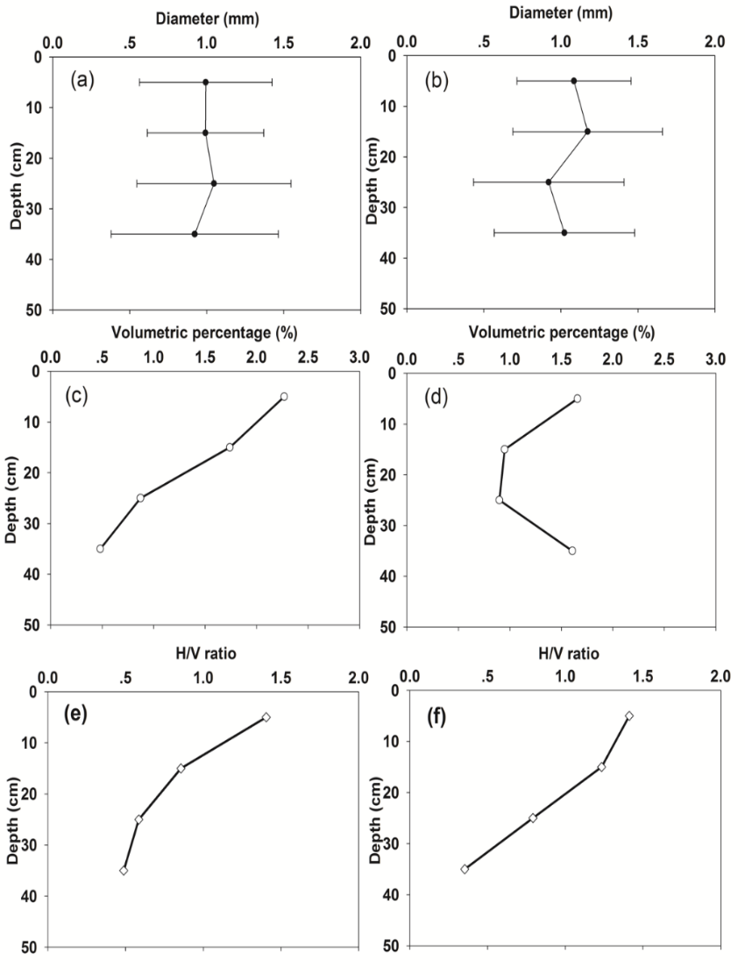
Figure 4. Root system architecture: (a) mean root diameter with standard deviation, Atriplex portulacoides; (b) mean root diameter with standard deviation, Juncus maritima; (c) volumetric percentage of Atriplex portulacoides roots; (d) volumetric percentage of Juncus maritima roots; (e) H/V ratio of Atriplex portulacoides roots; and (f) H/V ratio of Juncus maritima roots.

The volumetric percentage of the root systems within the sediments was also calculated using ‘VGStudio Max 1.2’. The data are shown in Figures 4c and d. The volumetric percentage of Atriplex portulacoides roots (Figure 4c) decreases with depth, from 2.3% at the top to 0.5% at a depth of 40cm. This pattern is consistent with the root density measured using dry mass, representing a Type 2 root system (see Discussion below). The volumetric percentage of Juncus maritimus roots (Figure 4d) shows a similar trend to that of Atriplex portulacoides between 0-30 cm, decreasing from 1.66% to 0.9%. However, there is an increase at 30-40 cm, almost returning surface levels.
Figure 5. Root size distribution comparison between Atriplex portulacoides and Juncus maritimus. The shadow marks roots classified as 1 mm in diameter.

In order to further test the reliability of the results obtained by CT Scanner, the volumetric percentage data were examined against the root density data obtained from the cores (Figure 6). A regression analysis shows a significant linear relationship between the two parameters (P=0.01; R²=0.66, Null-hypothesis). The volumetric percentage data obtained by CT Scanners therefore appears to be consistent with root density data obtained from cores and is considered to be reliable for further interpretation.
Figure 6. The results of regression analyses: the relationship between root density and volumetric percentage; the P value of 0.01 indicates a significant relationship between these two variables.

Data on the ratio of the number of horizontal (H) to vertical roots (V) were obtained using the 3D images from the CT Scanner. The ratio of horizontal root number to vertical root number (H/V ratio) is important, because it represents the relative strength (influence) of the roots, in two directions (horizontal and vertical). Root systems retain the bank sediments using an interlaced architecture. Therefore, if the roots are present only in one direction, the strength of the root ‘net’ will be decreased. On the other hand, for a cliff in a bank profile, the horizontal roots are the main suppliers of tensile strength, as related to the bank stability.

The H/V ratio of the vertical profiles are shown in Figures 4e and f. The H/V ratio of both of the root systems decreases with depth. This suggests a decrease of horizontal strength down the vertical profile as the vertical roots begin to dominate. The root system of Atriplex portulacoides has an H/V ratio of approx. 1.4 at the top, decreasing to 0.5 at the bottom; that of Juncus maritimus decreases more rapidly, from approximately 1.5 at the top, to 0.4 at the bottom. The mean H/V ratio of Juncus maritimus roots (0.95) is higher than that of Atriplex portulacoides roots (0.83). As such, Juncus maritimus root systems contribute relatively more strength to the bank in the horizontal direction, than that of Atriplex portulacoides. This is consistent with the fact that the Juncus maritimus (27% additional shear strength) Bank has greater shear strength than the Atriplex portulacoides (23% additional shear strength) Bank (Chen et al., 2012).

4．Discussion

4.1. The relationship between bank sediment stability and root system properties
The belowground biomass of Atriplex portulacoides and Juncus maritimus has been published by other researchers (Hussey and Long; 1982; Mucha et al., 2008). For comparison, Hussey and Long (1982) have provided the belowground biomass of a community dominated by Puccinellia maritime and Atriplex portulacoides, using core data, at Colne Point, Essex. The total belowground biomass, including live and dead roots and rhizomes, was 4245 g m⁻² (integrated from the surface to 15cm in depth). The conversion between the g g⁻¹ and g m⁻² can be undertaken using a wet sediment bulk density (1500 kg m⁻³ in this study, based upon density measurement), combined with depth data. Following conversion, the root density observed in the present study is equivalent to 4 784 g m-2, similar to the value provided by Hussey and Long (1982). Mucha et al. (2008) reported the estimated belowground biomass of Juncus maritimus to be 2000 kg m⁻³, similar to the 2050 kg m⁻³ value found in this study. Those correspondence suggests that the data appear to be internally consistent, when similar methods of measurements are used.

Elsewhere, Gallagher and Plumley (1979) grouped below-ground biomass profiles into three categories: Type 1, showing an even distribution with depth; Type 2, having most macro-organic matter concentrated near the surface: and Type 3, demonstrating a relatively low concentration near the surface, with the highest amount being somewhat below the surface, then with a decease with depth. For both Atriplex portulacoides and Juncus maritimus root systems, the most abundant roots are present at 0-10 cm, whilst the density decreases with depth; this indicates that these species are both Type 2 root systems, which have a considerable stabilising influence on sediments within the upper part of the bank. Conversely, their influence on the lower part of the bank is relatively weak, in particular, the root density decreases to a low level below a depth of 30 cm, although the Juncus maritimus root density decreases more slowly than that of the Atriplex portulacoides. Such a pattern for the distribution of root density is important in the formation of cantilevers, as the upper part of bank is significantly influenced by the root system, whilst the lower part is not (Chen et al., 2012).

The most important ways that vegetation affects bank stability are by increasing the resistance to flow erosion and increasing the strength of the bank material which retards mass movement (e.g., Li et al., 1991; Michaeli and Kirchner, 2002; Danjon et al., 2008; Chen et al., 2011; Francalanci et al., 2013; Zhao et al., 2017). It has been noted in previous studies that root density is important in increasing bank sediment stability, therefore, root density data are examined against shear strength and erosion threshold data.

The regression analysis reveals a significant power-law relationship (Null-hypothesis, P=0.048, R-squared=0.34) between root density and shear strength (Figure 7a, shear strength data source from Chen et al., 2012). The low R-squared value results from the fine roots holding sediments together and increase their tensile strength. Bank shear strength consists of both tensile strength and compressive strength (Michaeli and Kirchner, 2002). The tensile strength is mainly provided by the roots. However, the overall shear strength of the bank sediment can also be affected by many other factors, e.g., water content, which are not included in the model.

No significant linear or non-linear relationship has been found between the erosion threshold data (reported in Chen et al., 2012) and the root density data (P>0.1, Figure 7b). This pattern implies that the root systems do not directly influence erosion threshold, or that the relationship cannot be shown using the data collected in this study. However, the root systems of Atriplex portulacoides and Juncus maritimus have both been reported to increase the erosion threshold down creek banks (Chen, 2012). The absence of the link between the erosion threshold and root density may be because of a difference in the scales of measurement - the erosion threshold is measured at the scale of sediment particles (~μm), an order of magnitude smaller than the scale of roots (~ mm).
Figure 7. Relationships between root density and sediment properties using half-cores: (a) the relationship between averaged shear strength and root density at each depth; the P value of 0.048 shows that there is a good relationship between these two variables; and (b) the relationship between erosion threshold and root density, showing no significant relationship between these two variables. Data on erosion threshold and shear strength are sourced from Chen et al. (2012)

The organic matter content of the sediment may be more important than the root density, in increasing the erosion threshold. The organic matter content (mass percentage) of the bank sediments is high within the studied saltmarsh, with a maximum of approx. 10-15% (Chen et al., 2012). It has been suggested by other studies (e.g., Waldron and Dakessian, 1981) that the root systems mainly increase the cohesion of the bank sediments, and organic matter also plays a critical role in cohesion. Organic matter increases the cohesion of the sediment through the binding of mineral particles by organic polymers or through the physical enmeshment of particles by very fine roots (or even fungi) (Chenu et al., 2000). Very fine roots (at a scale of particle size, not visible on CT images, or captured by sieving/washing procedures), together with organic matter, can bind soil into stable aggregates (Bronick and Lal, 2005). The root systems have been studied under an optical photomicroscope. The roots are observed to have very fine hairs (see Figure 8). These hairs, with a diameter of ~10¹ μm, together with additional organic matter from root systems, can bind the sediment particles increasing the cohesion of the sediments. Thus, the root systems can increase the erosion threshold through an indirect means, not detectable by the methods described herein.

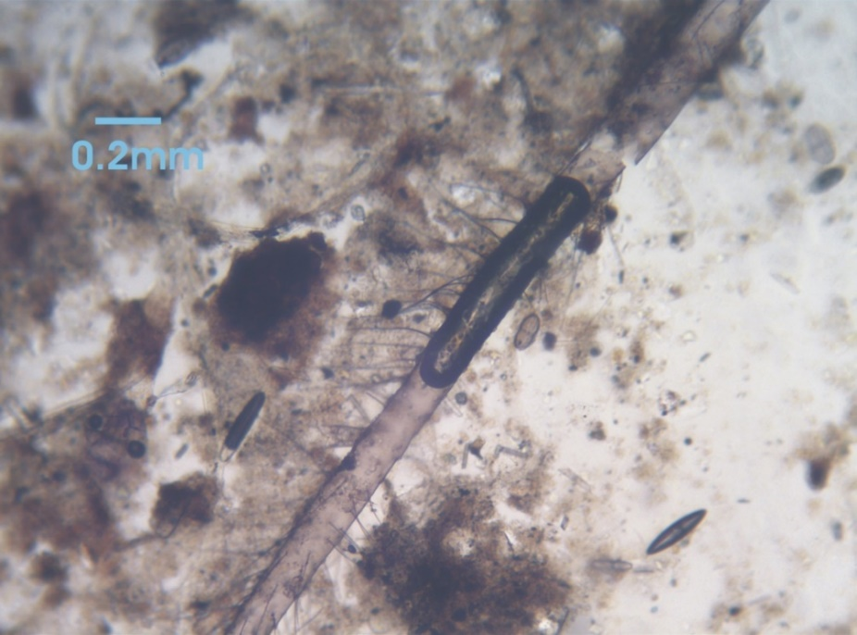
Figure 8. The photograph of root hairs under optical photomicroscope, with scale.

Previously, Heede (1980) has observed that the ability of vegetation to stabilise a bank is dependent upon factors such as plant vigour, density and rooting depth. Similarly, Mallik and Rasid (1993) have noted the importance of the vegetation forms (e.g. herbaceous, woody shrub, tree). More recently, root architecture has been related to bank sediment stability (e.g., De Baets et al., 2007; Danjon et al., 2008; Darby and Turner, 2008). Nonetheless, it is still unclear which parameter(s) are the most important, in terms of increasing the shear strength. Within the present study, attempts have been made to indicate the most important parameter(s) causing an increase in shear strength.

Several of the parameters presented herein have the potential to influence the shear strength (root density, root volumetric percentage, mean diameter of roots, and the H/V ratio). The root density has already been shown to be correlated with shear strength using the data from the half-cores (Figure 6a). Thus, root density, as a proxy for bank sediment shear strength, is examined using linear regression model against other parameters derived from CT analysis.

Linear regression results are listed in Table 1. For all samples in our experiments, it is found that volumetric percentage provides the best linear predictor for shear strength (R²=0.66, P = 0.014), while the H/V ratio is also an important predictor (R²=0.63, P = 0.019). There is no apparent relationship between root diameter and shear strength (R²=0.12, P = 0.411), even though the tensile strength has been considered related to root diameter in the past (Danjon et al., 2008).

Table 1: The results of the linear regression analyses between root density and the other root parameters.
Root density vs others | Volumetric percentage | H/V ratio | Root diameter
R-squared | 0.66 | 0.63 | 0.12
P-value | 0.014 | 0.019 | 0.411

Li et al. (1991) found that soil erosion resistance mainly depends on the distribution of roots and on the number of fibrous roots less than 1 mm in diameter. However, De Baets et al. (2007) observed that the shear strength provided by roots has a positive relationship with root diameter, with coarse roots being more important than fine ones. The size distributions of the two root systems (Fig. 5) show that the Atriplex portulacoides has more smaller roots with diameter less than 1 mm (52.5%), whilst Juncus maritimus has a greater proportion of coarser roots (> 1 mm, 51.2%, Fig. 5). This is consistent with in situ measurements which showed that the Atriplex portulacoides Bank had a greater erosion threshold than the Juncus maritimus Bank, whilst the Juncus maritimus Bank had a greater shear strength than the Atriplex portulacoides Bank (Chen et al., 2012).

4.2. Bank stability comparison between Atriplex portulacoides and Juncus maritime Banks
The root systems of Atriplex portulacoides and Juncus maritimus can increase both erosion threshold (indirectly) and shear strength. Measurements of bank sediment properties revealed that the root system of Atriplex portulacoides can increase erosion threshold by approx. 6 Pa and shear strength by 4 kPa; the root system of Juncus maritimus can increase erosion threshold by approximately 4 Pa and shear strength by 7 kPa (Chen et al., 2012). Therefore, Atriplex portulacoides banks have a higher resistance to flow-induced erosion, whilst Juncus maritimus banks have a higher resistance to gravity-induced mass movement (bank failure). This difference results in different bank shapes as well as different rates of retreat. For the practical purpose of engineering, it is important to identify which type of root system is “better” at stabilising banks. For cantilever banks, both hydraulic-induced erosion and mass failure due to gravity should be taken into account for bank stability analysis. Based upon the geometry of the cliffs in Exbury Marsh, the rate of cliff bank retreat can be estimated as follows (adapted from Gabet (1998), Figure 9):
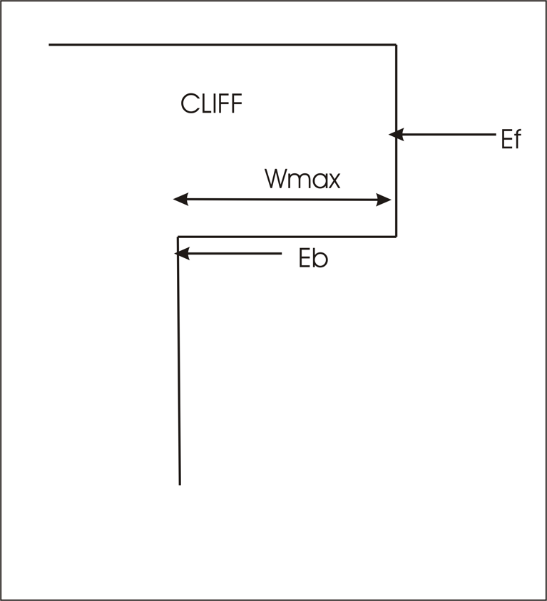
Figure 9. The stability analysis on bank retreat rate of a cantilever. Wmax is the maximum width of a cliff, Eb is the erosion rate below the cliff, and Ef is the erosion rate over the cliff surface.

Before bank failure occurs:
When bank failure occurs:
$$W_{max}={T×(E}_{b}-E_{f})$$
Here, is the time-averaged bank retreat rate; is the erosion rate over the cliff surface; is the erosion rate below the cliff base; is the maximum width of the cliff before bank failure; and is the period between the development of new cliff and its maximum development (Gabet, 1998). In order to simplify the problem, the time of removal of sediments after bank failure is assumed to be < and the removal takes place at the same rate as the subsequent new cliff develops (this is consistent with in situ observations in Exbury Marsh). In this model, the erosion rates, and , are controlled by erosion threshold, whilst the maximum width of the cliff, , depends on shear strength (van Eerdt, 1985a,b).

Over a long-term scale, the average bank retreat rate, , equals , when the time, , approaches +∞. Thus, the bank retreat rate is controlled only by the erosion rate at the cliff base, and not the maximum width of the cliff or the frequency of bank failures. Based upon the analysis above, it can be inferred that, over the long-term, a bank with high resistance to flow-induced erosion (high erosion threshold) will have a slower retreat rate than one with high resistance to mass failure (shear strength). A root system which can increase the erosion threshold of the bank sediments would be more effective at stabilising the bank than those which can increase more shear strength.

As discussed before, Atriplex portulacoides has greater percentages than Juncus maritimus of these fine roots associated with erosion threshold, and vice versa for coarse roots relevant to shear strength. As such, Atriplex portulacoides, which has a high resistance to flow-induced erosion, should be better than Juncus maritimus, which has a high resistance to mass failure, at stabilising the banks in Exbury Marsh. This is confirmed by considering that the erosion rates at the cliff bases are approx. 1.1 cm a⁻¹ and 1.6 cm a⁻¹, at the Atriplex portulacoides Bank and the Juncus maritimus Bank, respectively (Chen et al., 2011).

Moreover, bank retreat is also affected by the hydraulic forces working on bank surface, besides the bank erosion threshold increased by roots. Relative sea level rise has been recognized as an important factor associated with saltmarsh erosion and bank retreat (Möller et al., 2014; Bendoni et al., 2016). It has been argued whether or not vegetation roots are able to reduce bank retreat (Gabet, 1998; Bendoni et al., 2016). This is because the bank failure is the combined action of soil stabilised by roots and the impact of hydraulic breaking at the bank toe, although slump blocks can protect the bank toe from erosion (Gabet, 1998; Bendoni et al., 2016). With a fluctuating water level, the cantilever base can be modified over a long-term, even within low-energy environments (Chen et al., 2011). The relative sea level rise rate has been validated to be greater than the saltmarsh surface accretion rate in the Solent (Cundy and Croudace, 1996; Haigh et al., 2008). Under this circumstance, the hydraulic force will act on the upper part of bank surface than nowadays, where more roots are present. Thus, the erosion rate , same as the bank retreat rate over a long term, will be decreased by the increased erosion threshold by dense roots, and subsequently reduce the lateral retreat of tidal creeks. More importantly, due the lack of hinterland, the saltmarsh will be further squeezed by the relative sea level rise, Juncus maritimus might disappear and Atriplex portulacoides is expected to be the main species stabilising saltmarshes.

5. Conclusions
Two saltmarsh root systems (Atriplex portulacoides and Juncus maritimus) were studied in Exbury Marsh, using a CT Scanner. Both the architecture of undisturbed root systems and belowground biomass of root systems collected by coring are presented, and relsted to the properties of bank sediments. The main findings include:

- CT Scanning provides 3D visual images for root system architecture. Based on those data, volumetric percentage, H/V ratio and root diameter data for Atriplex portulacoides and Juncus maritimus could be exacted. A significant relationship between measured root density and CT derived volumetric percentage support the appropriateness of this method.
- Both root density and root system architecture were found to be important in increasing bank sediment stability. The shear strength of the root systems is directly influenced by root density, together with volumetric percentage and H/V ratio of the root systems. However, there are no clear relationships between the root density and the erosion threshold of the bank sediments.
- An analysis of cantilever (cliff) bank retreat processes revealed that Atriplex portulacoides appears to be better than Juncus maritimus, at stabilising creek banks. In general, root systems with high resistance to flow-induced erosion, (associated with very fine roots), are more effective than root systems with high resistance to gravity-induced erosion. Atriplex portulacoides and Juncus maritimus showed different distributions of fine roots and coarse roots (differentiated at 1 mm diameter), resulting in differential abilities to influence bank stability.
Acknowledgements – We would like to thank Dr. Ian Sinclair and Dr. Ian Croudace of University of Southampton, for their very kind help with CT Scanning measurements. Dr. Ian West for his valuable advices on this paper. Our thanks extend to Dr. Hao Zuo, Dr. Urs Neumeier, Dr. Erwan Grarel, Dr. Theocharis Plomaritis, for their support in fieldwork. The fieldwork was supported by a Dorothy Hodgkin Postgraduate Award (Grant Number: EP/P500753/1) and the preparation of the manuscript was funded by a NSFC Project (Grant no. 41776096).

References:
Adam, P., 1990. Saltmarsh Ecology. Cambridge University Press, 461pp.

Bendoni, M., Mel, R., Solari, L., Lanzoni, S., Francalanci, S., Oumeraci, H., 2016. Insights into lateral marsh retreat mechanism through localized field measurements. Water Resources Research, 52(2), 1446-1464. DOI:10.1002/2015WR017966

Best, U.S.N., Van der Wegen, M., Dijkstra, J., Willemsen, P.W.J.M., Borsje, B.W., Roelvink, D.J.A., 2016. Do salt marshes survive sea level rise? Modelling wave action, morphodynamics and vegetation dynamics. Environmental Modelling and Software, 19:152-166. DOI: 10.1016/j.envsoft.2018.08.004

Boorman, L., 2003. Saltmarsh review: An overview of coastal saltmarshes, their dynamic and sensitivity characteristics for conservation and management. JNCC Report No. 334, Peterborough, 114pp.

Bouma, T.J., Nielsen, K.F., Van Hal, J., and Koutstaal, B.P. 2001. Root system topology and diameter distribution of species from habitats differing in inundation frequency. Funct. Ecol. 15(3): 360-369. DOI: 10.1046/j.1365-2435.2001.00523.x.

Bouma, T.J., Van Belzen, J., Balke, T., Van Dalen, J., Klaassen, P., Hartog, A. M., et al., 2016. Short-term mudflat dynamics drive long-term cyclic salt marsh dynamics. Limnology and Oceanography, 61(6), 2261-2275. DOI: 10.1002/lno.10374

Bronick, C.J., and Lal, R. 2005. Soil structure and management: a review. Geoderma, 124: 3-22. DOI: 10.1016/j.geoderma.2004.03.005.

Chapman VJ. 1950. Biological flora of the British Isles: Atriplex portulacoides (L.) Aell. Journal of Ecology 38: 214–222.

Chen, Y., Collins, M.B., and Thompson, C.E.L. 2011. Creek enlargement in a low-energy degrading saltmarsh in southern England. Earth Surf. Proc. Land. 36(6): 767-778. DOI: 10.1002/esp.2104.

Chen, Y., Thompson, C.E.L., and Collins, M.B. 2012. Saltmarsh creek bank stability: Biostabilisation and consolidation with depth. Cont. Shelf Res. 35: 64-74. DOI: 10.1016/j.csr.2011.12.009.

Chenu, C., Bissonnais, Y.L., and Arrouays, D. 2000. Organic matter influence on clay wettability and soil aggregate stability. Soil Sci. Soc. Am. J. 64(4): 1479-1486. DOI: 10.2136/sssaj2000.6441479x.

Connor, R.A.O., and Chmura, G.L. 2000. Dynamics of above- and belowground organic matter in a high latitude macrotidal saltmarsh. Mar. Ecol. Prog. Ser. 204: 101-110. DOI: 10.3354/meps204101.

Cope, S., Bradbury, A., and Gorcznska, M. 2008. Solent dynamic coast project: main report 398, Channel Coast Observatory, New Forest District Council.

Coppin, N.J. and Richards, I.G., 1990. Use of vegetation in civil engineering, construction industry research and information. Butterworths, London. pp.292.

Cundy, A.B., Croudace, I.W., 1996. Sediment accretion and recent sea-level rise in the Solent, southern England: Inferences from radiometric and geochemical studies. Estuarine, Coastal and Shelf Science, 43, 449-467.

D'Alpaos, A., Lanzoni, S., Mudd, S.M., Fagherazzi, S., 2006. Modeling the influence of hydroperiod and vegetation on the cross-sectional formation of tidal channels. Estuarine Coastal and Shelf Science, 69(3-4), 311-324. DOI:10.1016/j.ecss.2006.05.002.

Danjon, F., Barker, D.H., Drexhage, M., and Stokes, A. 2007. Using Three-dimensional Plant Root Architecture in Models of Shallow-slope Stability. Ann. Bot. 101(8): 1281-1293. DOI: 10.1093/aob/mcm199.

Danjon, F., and Reubens, B. 2008. Assessing and analyzing 3D architecture of woody root systems, a review of methods and applications in tree and soil stability, resource acquisition and allocation. Plant Soil, 303(1-2): 1-34. DOI: 10.1007/s11104-007-9470-7.

Darby, F.A., and Turner, R.E. 2008. Below- and Aboveground Biomass of Spartina alterniflora: Response to Nutrient Addition in a Louisiana Salt Marsh. Estuaries and Coasts 31(2): 326-334. DOI: 10.1007/s12237-008-9037-8.

De Baets, S., Poesen, J., Knapen, A., and Galindo, P. 2007. Impact of root architecture on the erosion-reducing potential of roots during concentrated flow. Earth Surf. Proc. Land. 32(9): 1323-1345. DOI: 10.1002/esp.1470.

De Baets, S., Poesen, J., Reubens, B., Wemans, K., De Baerdemaeker, J., and Muys, B. 2008. Root tensile strength and root distribution of typical Mediterranean plant species and their contribution to soil shear strength. Plant Soil, 305(1-2): 207-226. DOI: 10.1007/s11104-008-9553-0.

Dinley, J., Hawkins, L.E., Paterson, G.L.J., Ball, A.D., Sinclair, I., Sinnettjones, P.E., and Lanham, S. 2010. Micro-computed X-ray tomography: a new non-destructive method of assessing sectional, fly-through and 3D imaging of a soft-bodied marine worm. J. Microsc. 238(2): 123-133. DOI: 10.1111/j.1365-2818.2009.03335.x.

Dyer, K.R., 1980. Sedimentation and Sediment Transport. In: The Solent Eestuarine System: An Assessment of Present Knowledge, NERC, Publication Series C, 22: 20-24.

Fagherazzi, S., and Furbish, D.J. 2001. On the shape and widening of salt marsh creeks. J. Geophys. Res. 106(C1): 991-1003. DOI: 10.1029/1999JC000115.

Fitter, A.H., 1987. An architectural approach to comparative ecology of plant root systems. New Phytologist, 106 (suppl.), 61–77.

Foster, N.M., Hudson, M.D., Bray, S., Nicholls, R.J., 2013. Intertidal mudflat and saltmarsh conservation and sustainable use in the UK: a review. Journal of Environmental Management, 126(14), 96-104.
Francalanci, S., Bendoni, M., Rinaldi, M., and Solari, L. 2013. Ecomorphodynamic evolution of salt marshes: Experimental observations of bank retreat processes. Geomorphology, 195: 53-65. DOI: 10.1016/j.geomorph.2013.04.026.

Friedrichs, C.T., Perry, J.E., 2001. Tidal salt marsh morphodynamics. Journal of Coastal Research, Special Issue 27: 7-37.

Gabet, E.J. 1998. Lateral Migration and Bank Erosion in a Saltmarsh Tidal Channel in San Francisco Bay, California. Estuaries, 21(7): 745-753. DOI: 10.2307/1353278.

Gallagher, J.L., and Plumley, F.G. 1979. Underground biomass profiles and productivity in Atlantic coastal marshes. Am. J. Bot. 66(2): 156-161. DOI: 10.2307/2442518.

Gong, Z., Zhao, K., Zhang, C., Dai, W., Coco, G., and Zhou, Z. 2018. The role of bank collapse on tidal creek ontogeny: A novel process-based model for bank retreat. Geomorphology, 311: 13-26. DOI: 10.1016/j.geomorph.2018.03.016.

Goudie, A., 2013. Characterising the distribution and morphology of creeks and pans on salt marshes in england and wales using google earth. Estuarine Coastal & Shelf Science, 129(5), 112-123.

Greenway, D.R., 1987. Vegetation and slope stability. In: Anderson, M.G. and Richards, K.S. (Eds.), Slope Stability, Wiley, Chichester, US, pp. 187-230.

Groenendijk, A.M., and Vinklievaart, M.A. 1987. Primary production and biomass on a Dutch salt marsh: emphasis on the below-ground component. Plant Ecol. 70(1): 21-27. DOI: 10.1007/BF00040754.

Haigh, I., Nicholls, R.J., Wells, N.C.. 2009. Twentieth-century changes in extreme still sea levels in the English Channel. Coastal Engineering -international Conference.

Harmsworth, G.C., and Long, S.P. 1986. An assessment of saltmarsh erosion in Essex, England, with reference to the Dengie Peninsula. Biol. Conserv. 35(4): 377-387. DOI: 10.1016/0006-3207(86)90095-9.

Heede, B.H. 1980. Stream dynamics: an overview for land managers. Gen. Tech. Rep. RM-72 Fort Collins, CO: US Department of Agriculture, Forest Service, Rocky Mountain Forest and Range Experiment Station. 26 p. 72.

Houghton, S.D. 1986. Coccolith assemblages in Recent marine and estuarine sediments from the continental shelf of northwest Europe. University of Southampton. Ph.D. Thesis. Geology Department, The University of Southampton. pp. 465.

Hussey, A., and Long, S. 1982. Seasonal changes in weight of above-and below-ground vegetation and dead plant material in a salt marsh at Colne Point, Essex. J. Ecol. 70(3): 757-771. DOI: 10.2307/2260103

Kearney, W.S., Fagherazzi, S., 2016. Salt marsh vegetation promotes efficient tidal channel networks. Nature Communications, 7, 12287. DOI: 10.1038/ncomms12287

Kim, D., Cairns, D.M., Bartholdy, J., 2010. Environmental controls on multiscale spatial pattern of salt marsh vegetation. Physical Geography 31:58–78.

Kirby, R. 1986. Suspended fine cohesive sediment in the Severn estuary and Inner Bristol channel. Rept. ESTU-STP-4042, Department of Atomic Energy, Harwell, UK.

Li ,Y., Zhu, X., and Tian, J. 1991. Effectiveness of plant roots to increase the anti-scourability of soil on the Loess Plateau. Chin. Sci. Bull. 24: 2077–2082.

Lobeck, R.T.G., 1995. A Study Into Ccoastal Change Between the Beaulieu River and Calshot Spit Over the Past 125 Years. Department of Oceanography, University of Southampton, MSc Dissertation, 45pp and 3 Appendices.

Long, A., and Tooley, M. 1995. Holocene sea-level and crustal movements in Hampshire and Southeast England, United Kingdom. J. Coast. Res. 17: 299-310.

Mallik, A.U., and Rasid, H. 1993. Root-shoot characteristics of riparian plants in a flood control channel: implications for bank stabilization. Ecol. Eng. 2(2): 149-158. DOI:10.1016/0925-8574(93)90036-F

Micheli, E.R., and Kirchner, J.W. 2002. Effects of wet meadow riparian vegetation on streambank erosion; 2, Measurements of vegetated bank strength and consequences for failure mechanics. Earth Surf. Proc. Land. 27(7): 687-697. DOI: 10.1002/esp.340.

Möller, I., Kudella, M., Rupprecht, F., Spencer, T., Paul, M., van Wesenbeeck, B., Wolters, G., Jensen, K., Bouma, T.J., Miranda-Lange, M., Schimmels, S., 2014. Wave attenuation over coastal salt marshes under storm surge conditions. Nat. Geosci. 7, 727–73.

Mooney, S.J., Pridmore, T.P., Helliwell, J.R., and Bennett, M.J. 2012. Developing X-ray Computed Tomography to non-invasively image 3-D root systems architecture in soil. Plant Soil, 352(1-2): 1-22. DOI: 10.1007/s11104-011-1039-9.

Mucha, A.P., Almeida, C.M.R., Bordalo, A.A., and Vasconcelos, M.T.S.D. 2008. Salt marsh plants (Juncus maritimus and Scirpus maritimus) as sources of strong complexing ligands. Estuar. Coastal. Shelf. Sci. 77(1): 104-112. DOI: 10.1016/j.ecss.2007.09.011.

Neves, J., Ferreira, L., Simões, M., and Gazarini, L. 2007. Primary production and nutrient content in two salt marsh species, Atriplex portulacoides L. andLimoniastrum monopetalum L., in Southern Portugal. Estuaries and Coasts, 30(3): 459-468.

Redelstein, R., Dinter, T., Hertel, D., and Leuschner, C. 2018. Effects of Inundation, Nutrient Availability and Plant Species Diversity on Fine Root Mass and Morphology Across a Saltmarsh Flooding Gradient. Frontiers in Plant Science, 9:98. DOI: 10.3389/fpls.2018.00098.

Reubens, B., Poesen, J., Danjon, F., Geudens, G., and Muys, B. 2007. The role of fine and coarse roots in shallow slope stability and soil erosion control with a focus on root system architecture: a review. Trees-structure and Function, 21(4): 385-402. DOI: 10.1007/s00468-007-0132-4.

Rutherfurd, I., Abernethy, B., Prosser, I., 2002. Stream Erosion. In: Riparian Land Management Technical Guidelines, Land and Water Resources, Research and Development Corporation, 61-78.

Sharma, S., Goff, J, Moody, R.M., McDonald, A., Byron, D., Heck, K.L., Jr., et al. (2016) Effects of Shoreline Dynamics on Saltmarsh Vegetation. PLoS ONE 11(7): e0159814. DOI:10.1371/journal. pone.0159814

Sinnett-Jones, P. 2007. Micromechanical aspects of fatigue failure in conventional and carbon nanotube-reinforced acrylic bone cement. Ph.D. thesis, School of Engineering Sciences, The University of Southampton. pp. 239.

Smit, A.L., Bengough, A.G., Engels, C., van Noordwijk, M., Pellerin, S., and van de Geijn, S.C. 2013. Root methods: a handbook. Springer Science & Business Media. pp. 587.

Spencer, T., Möller, I., Rupprecht, F., Bouma, T.J., Van Wesenbeeck, B.K., Kudella, M., et al., 2016. Salt marsh surface survives true-to-scale simulated storm surges. Earth Surface Processes and Landforms, 41(4), 543-552.

Tal, M., Paola, C., 2010. Effects of vegetation on channel morphodynamics: results and insights from laboratory experiments. Earth Surface Processes and Landforms, 35(9), 1014-1028.

Thorne, C.R., and Tovey, N.K. 1981. Stability of composite river banks. Earth. Surf. Proc. Land. 6(5): 469-484. DOI: 10.1002/esp.3290060507.

Tian, H., De Smet, I., and Ding, Z. 2014. Shaping a root system: regulating lateral versus primary root growth. Trends Plant Sci. 19(7): 426-431. DOI: 10.1016/j.tplants.2014.01.007.

Tracy, S.R., Roberts, J.A., Black, C.R., Mcneill, A., Davidson, R., and Mooney, S.J. 2010. The X-factor: visualizing undisturbed root architecture in soils using X-ray computed tomography. J. Exp. Bot. 61(2): 311-313. DOI: 10.1093/jxb/erp386.

Tubbs, C.R., 1999. The Ecology, Conservation and History of the Solent. Chichester: Packard Publishing Ltd, 204pp.

Van Eerdt, M.M. 1985a. The influence of vegetation on erosion and accretion in salt marshes of the Oosterschelde, The Netherlands. In Ecology of coastal vegetation. Springer. pp. 367-373.

Van Eerdt, M.M. 1985b. Salt marsh cliff stability in the oosterschelde. Earth. Surf. Proc. Land. 10(2): 95-106. DOI: 10.1002/esp.3290100203.

Waldron LJ, Dakessian S. 1981. Soil reinforcement by roots: calculation of increased soil shear resistance from root properties. Soil Science, 132, 427– 435. DOI:10.1097/00010694-198112000-00007.

Zhao, Y., Yu, Q., Wang, D., Wang, Y., Wang, Y., and Gao, S. 2017. Rapid formation of marsh-edge cliffs, Jiangsu coast, China. Mar. Geol. 385: 260-273. DOI: 10.1016/j.margeo.2017.02.001.

