Retention in care trajectories of HIV-positive individuals participating in a universal test and treat programme in rural South Africa (ANRS 12249 TasP trial)
Andréa Gosset^{1,2}, Camelia Protopopescu¹, Joseph Larmarange^{3,4}, Joanna Orne-Gliemann^{5,6}, Nuala McGrath^{7,3,8}, Deenan Pillay^{3,9}, François Dabis^{5,6}, Collins Iwuji^{10,3,8}, Sylvie Boyer¹
¹ Aix Marseille Univ, INSERM, IRD, SESSTIM, Sciences Economiques & Sociales de la Santé & Traitement de l’Information Médicale, Marseille, France
² ORS PACA, Observatoire régional de la santé Provence-Alpes-Côte d’Azur, Marseille, France
³ Africa Health Research Institute, KwaZulu-Natal, South Africa
⁴ Ceped, Institut de Recherche pour le Développement, Université Paris Descartes, Inserm, Paris, France
⁵ Univ. Bordeaux, Inserm, Bordeaux Population Health Research Center, UMR 1219, F-33000 Bordeaux, France
⁶ Inserm, ISPED, Bordeaux Population Health Research Center, UMR 1219, F-33000 Bordeaux, France
⁷ Faculty of Medicine and Faculty of Human, Social and Mathematical Sciences, University of Southampton, United Kingdom
⁸ Research Department of Infection and Population Health, University College London, United Kingdom
⁹ University College London, Division of Infection and Immunity, London, United Kingdom
¹⁰ Department of Global Health & Infection, Brighton and Sussex Medical School, Falmer, Brighton, United Kingdom
Abstract word count: 250; Manuscript word count: 3930
ABSTRACT
Objective: To study retention in care (RIC) trajectories and associated factors in patients eligible for antiretroviral treatment (ART) in a universal test-and-treat setting (TasP trial, South Africa, 2012-2016).
Design: A cluster-randomized trial whereby individuals identified HIV-positive after home-based testing were invited to initiate ART immediately (intervention) or following national guidelines (control).
Methods: Exiting care was defined as ≥3 months late for a clinic appointment, transferring elsewhere, or death. Group-Based Trajectory Modelling was performed to estimate RIC trajectories over 18 months and associated factors in 777 ART-eligible patients.
Results: Four RIC trajectory groups were identified: i) group 1 “remained” in care (reference, n=554, 71.3%), ii) group 2 exited care then “returned” after (median [interquartile range]) 4 [3-9] months (n=40, 5.2%), iii) group 3 “exited care rapidly” (after 4 [4-6] months, n=98, 12.6%), iv) group 4 “exited care later” (after 11 [9-13] months, n=85, 10.9%). Group 2 patients were less likely to have initiated ART within 1 month and more likely to be male, young (<29 years), without a regular partner and to have a CD4 count >350 cells/mm³. Group 3 patients were more likely to be women without social support, newly diagnosed, young, and less likely to have initiated ART within 1 month. Group 4 patients were more likely to be newly diagnosed and aged ≤39 years.
Conclusions: High CD4 counts at care initiation were not associated with a higher risk of exiting care. Prompt ART initiation and special support for young and newly diagnosed HIV-patients are needed to maximize RIC.

Keywords: universal test and treat, HIV, South Africa, retention in care, trajectories
INTRODUCTION
South Africa has the highest number of people living with HIV (PLWHIV) in the world, estimated at 7 million in 2015 (1). Forty-nine percent receive antiretroviral therapy (ART), making it the largest treatment programme worldwide (2). Despite a reduction in HIV-related morbidity and mortality and a consequent increase in life expectancy (3), HIV incidence remains unacceptably high (4).
In 2016, South Africa adopted the WHO’s recommendation to implement a universal test-and-treat (UTT) strategy for HIV (4). The success of this strategy depends on sustained retention in care (RIC) (5,6). Modelling estimated that in order to achieve an HIV incidence rate below 0.1% per year by 2050, rates of ART coverage and RIC need to reach 95% (5).
A meta-analysis in 2015 estimated that RIC among adults who initiated ART in South Africa was 77% at 12 months and 75% at 24 months (7). In 2017, the South African government set the objective of reaching a retention rate of 90% at 12 months after ART initiation among PLWHIV by 2018/19, increasing to 95% by 2021/22 (4).
In order to achieve this ambitious target, a greater understanding of the barriers to RIC in UTT settings, where PLWHIV start treatment early, is needed. To date, literature in low- and middle-income countries has mainly focused on non-RIC among pre-ART patients (8–10) or patients who start ART with low CD4 counts (≤350 cells/mm³) and/or at AIDS stage (11–13). Evidence suggests a lower RIC rate among pre-ART patients with high CD4 counts (9,10,14), but it is still unknown whether high CD4 counts (>350 cells/mm³) at ART initiation will improve or deteriorate RIC. In the only study conducted to date in a UTT setting - the SEARCH trial in Uganda and Kenya - the authors found high RIC among patients with high CD4 counts (350-500 cells/mm³, and >500 cells/mm³) (15). However, concerns remain that patients with high CD4 counts may be more reluctant to engage in treatment (16). Moreover, one limitation of previous RIC studies is the assumption that patients follow a single care trajectory while, in reality, patients can cycle in and out of care, and so multiple trajectories are possible (17,18).
In this study, we aimed to study RIC trajectories and associated factors in ART-eligible patients enrolled in the UTT TASP trial ANRS 12249 implemented in rural South Africa.

METHODS
Study setting and design
ANRS-12249 TasP (Treatment as Prevention) trial was a cluster-randomized trial conducted between 2012-2016 in the Hlabisa sub-district, KwaZulu-Natal, in South-Africa. The area is mainly rural with scattered homesteads. It is also among the most exposed to HIV in the country (19) with an estimated 30% HIV prevalence in adults (15-49 years) (20). The main objective of the trial was to investigate whether HIV testing of all adult populations followed by immediate ART initiation for all those testing positive (irrespective of immunological status or clinical stage) would reduce HIV incidence in this area.
The trial protocol is described elsewhere (21,22). Briefly, it was implemented in 22 (11 intervention and 11 control) geographic clusters, each with an average population of 1000 residents ≥16 years. In all clusters, home-based counselling and HIV testing (HBCT) were offered every six months to all eligible household members, i.e. residents ≥16 years. Individuals testing HIV-positive were then referred to their cluster trial clinic. These clinics which were set up specifically for the trial, were located <5 km from their homes. The clinics in the intervention clusters immediately offered ART to all PLWHIV regardless of CD4 count or clinical stage. Instead, PLWHIV in the control clinics initiated ART according the eligibility criteria defined by national guidelines: CD4 count ≤350 cells/mm³, WHO stage 3/4, and/or pregnancy (23). In January 2015, these criteria were extended to include CD4 count ≤500 cells/mm³, hepatitis B positivity and HIV-negative partners in serodiscordant relationships (24). In all the trial clinics, patients who initiated ART had monthly clinical follow-up visits, while pre-ART patients had a quarterly clinical follow-up. All patients, whether pre-ART or ART-treated, who were more than three months late for an appointment in their clinic, were contacted by phone or during home-based visits. HIV care was also available in government clinics located in the trial area which also provided care to non-HIV patients (25). Upon request, participants could transfer out from trial care to one of these clinics, in or outside the trial area.
The Biomedical Research Ethics Committee (BREC) of KwaZulu-Natal University (BFC 104/11) and the South African Medicines Control Council approved the trial. All participants provided written informed consent.
Outcome
The study outcome was a time-varying binary variable “retention in trial care” (RIC) status, describing whether a patient remained or not in trial care during the 18-month study period. A patient was considered to have exited trial care if s/he was >3 months late for his/her last appointment at the clinic, if s/he transferred out or if s/he died. RIC status in the trial clinics was assessed for each patient every month from 4 to 18 months after his/her baseline visit (RIC status was therefore not defined during the first four months of follow-up). A patient lost to follow-up (LTFU) at a given month could re-enter trial care if s/he revisited a trial clinic later.
Study population and study period
The study population included HIV-positive individuals eligible to initiate ART (as per the trial protocol) at their first visit in one of the trial’s clinics (baseline visit), who had their baseline visit ≥18 months before the end of the trial (30th June 2016), and who did not die in the first 4 months of follow-up. The study period covered from 4 to 18 months after the baseline visit of each patient.
Covariates
Information on covariates used in the analysis was obtained from (i) face-to-face questionnaires administered during home-based visits and at baseline visit in clinics, and (ii) clinical report forms completed by caregivers at baseline and during follow-up.
Covariate information collected during home-based visits included gender, age, education, having children, occupation, household wealth, and geographical accessibility to the trial’s clinics. Covariates collected at the baseline clinic visit included CD4 count, having a regular partner, social support, psychological distress (Patient Health Questionnaire-4 scale (26)), time between referral and baseline visit, and being newly diagnosed at referral (i.e., reporting - during HBHT - no previous HIV-positive diagnosis and not being registered as a HIV patient in local government clinics). We also distinguished patients who initiated ART within one month after baseline from those who did not. Finally, we classified the 22 clusters into a binary variable: (i) clusters with low number of patients (13-155) followed in the trial’s clinics (HIV prevalence in those clusters was 17.5%-35.4%), (ii) clusters with high number of patients (212-422) followed in the trial’s clinics (HIV prevalence: 32.3-39.4%).
Statistical analysis
Group-Based Trajectory Modelling (GBTM) was performed to estimate RIC trajectories during the study period using the outcome variable “retention in trial care”. GBTM is a semi-parametric mixture modelling procedure for longitudinal data (27), which identifies trajectory groups over time. It classifies individuals into groups with similar evolution for the outcome variable, and identifies factors associated with these groups.
The optimal number of trajectory groups was evaluated using the Bayesian Information Criterion (BIC), by selecting the number of groups that best represented the heterogeneity between the trajectories.
The probabilities of group membership were estimated using a multinomial logistic model. Patients were assigned to the group for which they had the highest estimated probability of membership. Each identified group had a specific trajectory that illustrated the probabilities of having exited care at a given month from 4 to 18 months after baseline. We assumed that the probability of exiting care followed a binary logit distribution.
Factors associated with trajectory group membership were tested for in the analysis as fixed covariates measured at the baseline visit and at one month after baseline for the ART initiation covariate. The model parameters were estimated using the maximum likelihood method.
Covariates were considered eligible for the GBTM multivariable model if their association with group membership indicated a p-value <0.20 in GBTM univariable analyses. A forward stepwise procedure was used to select the covariates in the final multivariable model with a p-value ≤0.05.
All analyses were performed using Stata/SE 12.1 for Windows software (28).
Sensitivity analysis
Sensitivity analysis were conducted to assess the robustness of the results when considering the following: i) a longer follow-up period (i.e. from 4 to 24 months after baseline), ii) alternative hypotheses for transfers-out. Specifically, we considered transfers-out as missing data from the time the patients transferred out (accordingly, exiting trial care only included deaths and LTFU). Second, we assessed an optimistic but realistic scenario where transfers-out were considered to be “retained in care”.

RESULTS
Cohort profile
Of the 7647 PLWHIV who were referred to the trial clinics over the trial period, 3019 (39.5%) actually visited a trial clinic at least once. Among these, 1412 (46.8%) were already on ART at the baseline visit, 428 (14.2%) were not eligible for ART, and 16 (0.5%) had missing data for either ART status or CD4 cell count. Of the remaining 1163 (38.5%) individuals - all eligible to initiate ART at baseline - we retained those who had their first visit ≥18 months before the end of the trial (788 patients), and excluded those who died during the first four months of follow-up (10 patients) since retention was not defined during this period, as well as one patient whose recorded date of death was inconsistent. Our study population therefore comprised 777 ART-eligible patients (Supplementary Figure 1).
Approximately two-thirds (70.7%) of our study population were women (Table 1). The median age [interquartile range (IQR)] at baseline was 35 [27.5; 46.6] years, and 76.2% had a regular partner. Most patients (88.5%) were already diagnosed HIV-positive at referral. Two-thirds (66.3%) entered HIV care at one of the trial’s clinics within one month after referral and 40% resided <1 km from their clinic. Over a quarter (26.3%) of patients had a CD4 count >500 cells/mm³ at baseline and 54% initiated ART within one month.
Retention in care and retention trajectories
The overall RIC rate was 77.5% at 12 months (M12) and 72.8% at M18 (Figure 1a). Among patients exiting trial care, LTFU was the main cause of attrition (76.6% and 73.4% at M12 and M18, respectively), while death accounted for 6.9% and 8.1%, respectively, and transfers-out for 16.6% and 18.5%. The median [IQR] follow-up duration before exiting care for the first time was 7 [4; 11] months.
RIC rates at M18 were similar in both arms (70.8% - control versus 73.8% - intervention, p=0.37), and between the three different CD4 count categories (71.9%, 77.8% and 69.6% for CD4 counts ≤350 cells/mm³, 350-500 cells/mm³, and >500 cells/mm³, respectively; p=0.22). In addition, focusing only on the 704 (90.6%) patients who initiated ART over the study period, the RIC rate at M18 reached 80.0% (79.4% - control versus 80.3% - intervention, p=0.79).
Four different trajectories were identified (Figure 2). Group 1 patients (71.3% of the study population) “remained in care” throughout the study period. At M18, fewer than 1% of them had died or transferred out (Figure 1b). Group 2 patients (5.2%) exited care and then returned later, after a median time [IQR] of 4 [3-9] months (hereafter the “returned” group). At M18, no deaths had occurred in this group and only one patient (2.5%) had transferred out. Group 3 patients (12.6%) “rapidly exited” care after a median time [IQR] of 4 [4-6] months of follow-up. In this group, all patients had exited trial care at M18 (8.2% had died and 21.4% had transferred out). Finally, Group 4 patients (10.9%) “exited care later” after a median time [IQR] of 11 [9-13] months of follow-up. At M18, 9.4% of them had died while 12.9% had transferred out.
ART initiation by trajectory group
While all study patients were ART-eligible at baseline, overall 90.6% initiated ART during the study period. Furthermore, ART initiation differed widely across the four trajectory groups (Table 2). In Groups 1 and 4, a large majority of patients initiated ART during the study period (99.6% and 87.1%, respectively), mainly during the first month after baseline. In Group 2, a large majority (85.0%) also initiated ART during the study period but after a longer delay (median [IQR] time after baseline: 343 [208-449] days). Conversely, in Group 3, only 44.9% initiated ART during the study period but within a short delay after baseline (median [IQR] time: 27.5 [15.5-49.5] days).
Factors associated with trajectory groups
Table 3 presents the results of the univariable and multivariable analyses.
In the multivariable model, the patients of Group 2 compared with those in Group 1 (reference group) were more likely to be young (adjusted odds ratio (aOR) [95% confidence interval (CI)]=3.3 [1.4;8.2] for 16-29 years old versus ≥40 years old), without regular partner (2.8 [1.1;6.8]), men receiving social support (3.4 [1.4;8.3] versus women receiving social support), and to have high CD4 counts (7.7 [2.6;23.1] and 5.1 [1.7;15.4] for CD4 counts between 350-500 cells/mm³ and >500 cells/mm³, respectively, versus CD4 counts ≤350 cells/mm³).
The patients in Group 3, compared with those in Group 1, were significantly younger (3.9 [2.1;7.2] for patients aged 16-29 years old versus ≥40 years old), were more likely to be women without social support (2.2 [1.1,4.2] versus women with social support), and newly diagnosed (4.2 [2.2;8.2]).
By contrast, the patients in Group 2 and those in Group 3, compared with those in Group 1, were less likely to have initiated ART within 1 month after baseline (0.03 [0.0;0.2] and 0.2 [0.1;0.3], respectively).
Finally, the patients in Group 4, compared with those in Group 1, were more likely to be young (4.6 [2.3;9.3] for 16-29 years old and 2.7 [1.3;5.7] for 30-39 years old versus ≥40 years old), and newly diagnosed (5.3 [2.7;10.1]).
Sensitivity analyses
When estimating the trajectory groups over a 24-month period (n=536), the retention rate decreased to 69.2% at M24 and was similar in both arms (63.9% - control versus 71.4% - intervention, p=0.09), and between the three CD4 counts categories at baseline (69.8%, 74.7% and 65.6% for CD4 counts ≤350 cells/mm³, between 350-500 cells/mm³, and >500 cells/mm³, respectively; p=0.311). A similar pattern including four trajectory groups was identified, but an additional group of patients (Group 5) who exited care after a median [IQR] time of 17 [15-20] months emerged (Supplementary Figure 2). Group 5 included 41 (7.6%) patients who were all in Group 4 of the main analysis (over the 18-month period). The only factor associated with Group 5 was being a woman without social support (aOR [95% CI]=2.6 [1.1;6.3] versus a woman reporting social support), while associated factors for the four other groups were the same as those identified in the main analysis.
When considering transfers-out as missing data, the retention rate at M12 and M18, respectively, increased to 80.5% and 76.7%. We found the same associated factors for each group as in the main analysis, except for social support, which was no longer significant (Supplementary Table 1). Similar results were found when considering transfers-out as “remaining in care”: the RIC rate at M12 and M18, respectively, increased to 81.2% and 77.9%, and the same associated factors were identified (Supplementary Table 2).

DISCUSSION
This study investigated retention in care among HIV-positive patients in Kwazulu-Natal in South Africa, who were eligible for ART in a UTT setting where HIV prevalence ranged from 17% in very rural areas to 39% in communities close to the zone’s national highway (29). Retention at 18 months was 72.8% overall and 80.6% if we only consider patients who initiated ART during the study period. Furthermore, using an original approach - group-based trajectory modelling - we identified care trajectories and their respective associated factors in this population, which is central for tailoring and prioritizing interventions. We showed that patterns of engagement with care are not uniform. Although three quarters of the study patients remained in care during the whole study period, three trajectories for exiting care emerged. Two corresponded to patients who left care and did not return during the study period (12.6% exited care after a very short follow-up duration, while 10.9% left after a longer duration). The third trajectory (5.2%) represented patients who exited care relatively rapidly but then returned. Our findings also suggest that initiating care in a UTT setting is not associated with lower retention, but that patients with high CD4 counts are more likely to exit care and then return. In addition, prompt ART initiation (within one month after first visit in a trial clinic) was associated with a lower risk of exiting care rapidly and of exiting then returning. The main factors associated with care exit trajectories (either rapidly or later) included male gender, young age and being newly diagnosed.
Retention rates found in our study are slightly higher than those estimated for the same period among patients initiating ART in South Africa’s national ART programme (80.6% versus 71%). Although relatively high, these retention rates are still well below 95%, the estimated rate needed to ensure the eradication of the HIV epidemic (5) and the target set by the 2017-2022 South African National Strategic Plan (4). In addition, we found no significant difference in retention rates between the trial’s arms, or the CD4 count categories (≤350; 350-500; >500 cells/mm³) at baseline. This was confirmed in multivariable analysis where patients with high CD4 counts (350-500 cells/mm³ and >500 cells/mm³) were not at higher risk of exiting care (either rapidly or later) than those with CD4 counts ≤350 cells/mm³. These findings suggest that initiating ART early in UTT settings is not associated with lower retention, probably because immediate ART initiation limits the duration of the pre-ART period, when the risk of exiting care is the highest (30). However, we showed that patients with high CD4 counts had a higher risk of exiting care and returning afterwards. In addition, ART initiation within 1 month after the first visit to a trial clinic was significantly associated with a lower risk of exiting care rapidly (whether subsequently returning or not), suggesting that in a UTT setting, rapid ART initiation fosters retention. Interestingly, in the “returned” group, despite relatively high ART uptake over 18 months (85%), almost 95% of the patients had not initiated ART within 1 month, but did so within approximately one year. Delayed ART initiation in those with high CD4 count may be due to patients being hesitant to initiate ART rapidly (31), but also due to care providers prioritising patients with lower CD4 counts in clinics with high patient loads (32).
As found in other settings (33,34), retaining young patients in care is a challenge. Indeed, young age (<30) was a common risk factor for the three trajectories of care exit. It has been shown that this population had more competing life activities preventing them from attending clinical appointments on a regular basis (17,31,35). The trial setting was also characterised by a high migration level, which may have contributed to lower engagement in care by younger individuals who are more mobile (36,37).
Furthermore, our findings highlight the importance of providing support to newly diagnosed HIV-positive individuals and of closely accompanying them on the HIV care continuum. Indeed, in the TasP trial, these people were less likely to be linked to care (38) and had a higher risk of exiting care. This not only suggests that a long delay is required to first accept the disease, and to decide whether or not to attend a clinic, but also that newly diagnosed persons who attend a clinic may not be ready to engage steadfastly in care. Although such difficulties are not specific to the UTT strategy (39,40), they may be more frequent in this setting as this strategy does not rely on a voluntary testing initiative, and therefore people may be less psychologically prepared to receive a positive diagnosis.
In this rural area of Kwazulu-Natal in South Africa, where HIV prevalence has reached extremely high levels, interventions are urgently needed to accelerate access to ART and to optimize retention in care, with the goal of achieving viral suppression in PLWHIV and reducing new infection incidence in the community. Prompt and early ART initiation proposed in a UTT setting may be an effective means to reach this objective. In the TasP trial, most of PLWHIV who initiated ART within one month had only one visit in a trial clinic before ART initiation. However, a non-negligible proportion of our study population (7.2%) never returned after their first visit, and a significant proportion of those who exited care during the study period (30.6%) attended clinics only once. Considering the importance of the first visit for future retention, a great deal of attention should be paid to patients during this visit, in order to adequately prepare them for ART initiation. Special attention is needed for the youngest, those newly diagnosed, and those with high CD4 counts who may be more hesitant to engage steadfastly in care and may require additional visits before initiating ART. Home-based ART initiation is another potential intervention which may encourage rapid ART initiation if patients are adequately prepared (41).
Our study has limitations. First, we focused on RIC only in the trial’s clinics because we lacked information about the retention status of patients who transferred out to public or private facilities. The latter were assumed to have exited care, which may have led to an underestimation of the retention rate. However, sensitivity analyses showed that our results are robust when considering alternative hypotheses for transfers-out. Second, although a tracking team contacted patients LTFU either by phone or during home-based visits, a certain number of silent transfers may have occurred, contributing to an underestimation of the retention rate. This limitation has often been mentioned in other studies (42,43). Third, although the TasP trial has been implemented at the population level with HIV status ascertained for 83% of adults living in the trial area (29), only 39.5% (3019/7647) of HIV-positive individuals referred for HIV care during HBHT actually attended a trial clinic. However, a significant proportion (42.7%) of the 7647 participants were already in the care of government clinics. Most of the latter (approximately 95%) were already ART-treated and thus not eligible for our study. In addition, according to a previous study on linkage to care in the trial, the majority (i.e. approximately 72%) of HIV-positive individuals not in care at referral were not linked to care at 3 months (either in TasP or in government clinics), while those linked to care attended the trial’s clinics and not the government clinics (44). This suggests that selection bias is possible but should be limited as the large majority (i.e. 86%) of our target population (HIV-positive individuals who initiated care i.e., who were not already being treated) were included in the trial’s clinics.

Despite these limitations, this study brings great added value to current knowledge about RIC in the context of UTT strategies in Sub-Saharan Africa. Our approach to analysing retention in care is innovative and promising, as it does not consider retention as a simple binary variable at a given point of time, rather a dynamic phenomenon where patients can cycle in and out of care, with multiple possible trajectories. It highlights the different trajectories of disengagement from care, and suggests that initiating care in a UTT setting is not associated with lower retention.
Our findings may also inform policy makers’ decision on the strategies to improve RIC which is crucial for maximizing the impact of ART on the reduction of incidence. This includes ensuring prompt ART initiation, and targeting young, newly diagnosed patients and those with high CD4 counts, in particular during initial follow-up visits.

Contributors
CI, JO-G, DP, and FD designed and implemented the TasP trial. SB, CP, JL, AG and NMG contributed to the conception and design of the study. AG performed the statistical analysis with the support and supervision of SB and CP. AG searched the literature, and co-wrote the first draft of the manuscript with SB and CP. All authors contributed to the interpretation and presentation of the findings, revised the article critically for important intellectual content, and approved the final version of the manuscript for submission.
ANRS 12249 TasP Study Group
South Africa Till Barnighausen, Kobus Herbst, Collins Iwuji, Thembisa Makowa, Kevi Naidu, Nonhlanhla Okesola, Tulio de Oliveira, Deenan Pillay, Tamsen Rochat, Frank Tanser, Johannes Viljoen, Thembelihle Zuma (Africa Health Research Institute [previously Africa Centre for Population Health, University of KwaZulu-Natal], KwaZulu-Natal, Durban). Frank Tanser, Nuala McGrath (School of Nursing and Public Health, University of KwaZulu-Natal, KwaZulu-Natal, Durban). Tulio de Oliveira (Nelson R Mandela School of Medicine, College of Health Sciences, University of KwaZulu-Natal, KwaZulu-Natal, Durban). France Eric Balestre, Francois Dabis, Sophie Karcher, Joanna Orne-Gliemann, Melanie Plazy, Melanie Prague, Rodolphe Thiebaut, Thierry Tiendrebeogo (ISPED, Centre INSERM U1219 Bordeaux Population Health, Universite de Bordeaux, Bordeaux). Sylvie Boyer, Hermann Donfouet, Andrea Gosset, Laura March, Camelia Protopopescu, Bruno Spire (INSERM, UMR912 SESSTIM, Universite Aix Marseille, Marseille). Joseph Larmarange, Maxime Inghels, Hassimiou Diallo (Centre Population et Developpement UMR 196, Universite Paris Descartes, Institut de Recherche pour le Developpement, Paris). Vincent Calvez, Anne Derache, Anne-Genevieve Marcelin (AP-HP, Virology, Hopital Pitie-Salpetriere, INSERM-Sorbonne Universites, UPMC Univ Paris 06, UMR-S 1136, Paris). Rosemary Dray-Spira, France Lert, Kamal El Farouki (INSERM U1018, CESP, Epidemiology of Occupational and Social Determinants of Health, Villejuif). Marie-Laure Chaix (EA 3620, Universite Paris-Descartes, Laboratoire de Virologie, Hopital Necker-Enfants Malades, AP-HP, Paris). Brigitte Bazin, Claire Rekacewicz (sponsor representatives; ANRS, Paris). UK Collins Iwuji, John Imrie (Department of Infection and Population Health, University College London, London). Deenan Pillay (Division of Infection and Immunity, University College London, London). Nuala McGrath (Department of Epidemiology and Public Health, University College London, London). Richard Lessells (Department of Clinical Research, London School of Hygiene & Tropical Medicine, London). Collins Iwuji (Department of Global Health and Infection, Brighton and Sussex Medical School, University of Sussex, Brighton). Nuala McGrath (Academic Unit of Primary Care and Population Sciences, and Department of Social Statistics and Demography, University of Southampton, Southampton). Colin Newell (Academic Unit of Human Development and Health, University of Southampton, Southampton). Marie-Louise Newell, (Academic Unit of Human Development and Health, and Global Health Research Institute, University of Southampton, Southampton). Switzerland Alexandra Calmy (Service des Maladies Infectieuses, HIV Unit, Hôpitaux Universitaires de Geneve, Geneva). USA Kenneth Freedberg (Massachusetts General Hospital, Harvard Medical School, Harvard University, Boston, MA). Till Barnighausen (Department of Global Health and Population, Harvard School of Public Health, Harvard University, Boston, MA). Netherlands Jan Hontelez (Department of Public Health, Erasmus MC, Erasmus University Medical Center Rotterdam, Rotterdam). Germany Till Barnighausen, Jan Hontelez (Institute of Public Health, Faculty of Medicine, Heidelberg University, Heidelberg).
Declaration of interests
CI has received honoraria for consulting services from Gilead Sciences. All other authors declare no competing interests.
Acknowledgements
The French National Agency for AIDS and Viral Hepatitis Research (ANRS; grant number, 2011-375) sponsored and co-founded the trial. The Deutsche Gesellschaft fur Internationale Zusammenarbeit (GIZ; grant number, 81151938), and the Bill & Melinda Gates Foundation through the 3ie Initiative co-founded the trial. Merck and Gilead Sciences supported the trial by providing Atripla. The Africa Health Research Institute receives core funding from the Wellcome Trust, which provides the platform for the population-based and clinic-based research at the centre. We thank Brigitte Bazin and Claire Rekacevicz at the ANRS for supporting this study, as well as Jean-Francois Delfraissy (director of ANRS). We thank the study volunteers for allowing us into their homes and participating in this trial, as well as the Provincial and National Departments of Health for their support of this study. Our thanks also to Jaco Dreyer for managing the TasP data, and to Jude Sweeney for the English revision and editing of the manuscript.
Funding
ANRS, GiZ, and 3ie co-funded the TasP trial.

Figure 1: Retention in care status of ART-eligible patients at first clinic visit from 4 to 18 months of clinical follow-up, overall (Figure 1a) and according to trajectory group (Figure 1b) (ANRS 12249 TasP trial, n=777)
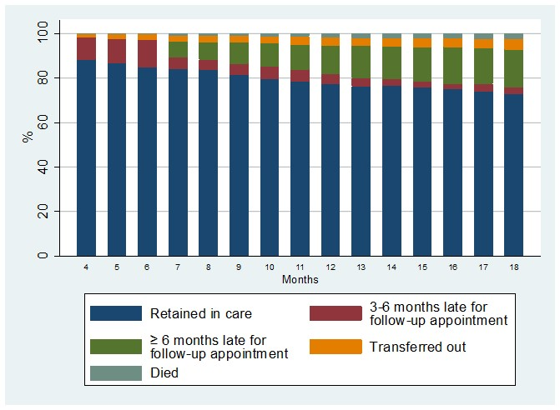
Figure 2: Care trajectories in trial clinics over 18 months of clinical follow-up among patients eligible for ART initiation at the first visit (ANRS 12249 TasP trial, n=777)
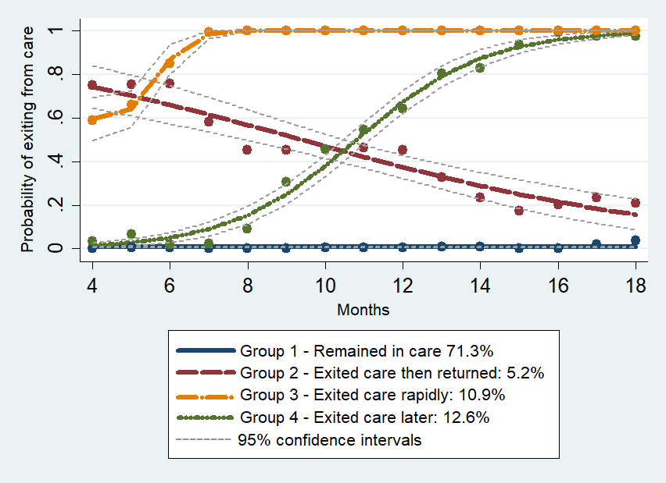

Table 1: Descriptive statistics of the study population at first visit according to trajectory groups (ANRS 12249 TasP trial, n=777)
 |  | Trajectory groups
 | Total at first visit  n=777 | Group 1: remained in care n=554 (71.3%) | Group 2: exited care then returned  n=40 (5.2%) | Group 3: exited care rapidly  n=98 (12.6%) | Group 4: exited care later  n=85 (10.9%)
Socio-demographic characteristics, n (%)
Gender
Male | 228 (29.3) | 144 (26.0) | 18 (45.0) | 31 (31.6) | 35 (41.2)
Female | 549 (70.7) | 410 (74.0) | 22 (55.0) | 67 (68.4) | 50 (58.8)
Age, median [IQR] years | 35.0  [27.5-46.6] | 36.8  [28.5-49.1] | 30.1  [26.9-45.7] | 29.8  [24.9-41.7] | 30.2  [25.7-37.9]
Age (years)
16-29 | 278 (35.8) | 165 (29.8) | 19 (47.5) | 52 (53.1) | 42 (49.4)
30-39 | 210 (27.0) | 158 (28.6) | 7 (17.5) | 19 (19.4) | 26 (30.6)
≥40 | 288 (37.1) | 230 (41.6) | 14 (35.0) | 27 (27.6) | 17 (20.0)
Missing | 1 (0.1)
Educational level
Primary or less | 340 (43.8) | 256 (46.3) | 19 (47.5) | 37 (37.8) | 28 (33.7)
Some secondary | 281 (36.2) | 194 (35.1) | 14 (35.0) | 42 (42.9) | 31 (37.4)
Completed secondary | 153 (19.7) | 103 (18.6) | 7 (17.5) | 19 (19.4) | 24 (28.9)
Missing | 3 (0.4)
Had a regular partner
Yes | 592 (76.2) | 424 (77.5) | 28 (70.0) | 70 (76.1) | 70 (83.3)
No | 171 (22.0) | 123 (22.5) | 12 (30.0) | 22 (23.9) | 14 (16.7)
Missing | 14 (1.8)
Partner HIV status
Partner HIV+ | 236 (30.4) | 179 (36.3) | 13 (33.3) | 19 (23.2) | 25 (32.5)
Partner HIV- | 71 (9.1) | 53 (10.8) | 2 (5.1) | 7 (8.5) | 9 (11.7)
Do not know | 213 (27.4) | 138 (28.0) | 12 (30.8) | 34 (41.5) | 29 (37.7)
No partner | 171 (22.0) | 123 (25.0) | 12 (30.8) | 22 (26.8) | 14 (18.2)
Missing | 86 (11.1)
Had children
Yes | 675 (86.9) | 493 (91.1) | 33 (82.5) | 78 (81.3) | 71 (86.6)
No | 84 (10.8) | 48 (8.9) | 7 (17.5) | 18 (18.7) | 11 (13.4)
Missing | 18 (2.3)
Economic characteristics, n (%)
Household wealth index§
Low | 317 (40.8) | 225 (40.8) | 16 (41.0) | 44 (44.9) | 32 (38.1)
Middle | 308 (39.6) | 218 (39.6) | 19 (48.7) | 37 (37.8) | 34 (40.5)
High | 147 (18.9) | 108 (19.6) | 4 (10.3) | 17 (17.4) | 18 (21.4)
Missing | 5 (0.6)
Occupational status
Employed | 111 (14.3) | 90 (16.5) | 3 (7.7) | 8 (8.3) | 10 (12.1)
Seeking employment | 221 (28.4) | 149 (27.3) | 12 (30.8) | 30 (30.9) | 30 (36.1)
Other, inactive | 433 (55.7) | 307 (56.2) | 24 (61.5) | 59 (60.8) | 43 (51.8)
Missing | 12 (1.5)
Psychosocial variables, n (%)
Social support
Yes | 582 (74.9) | 423 (78.3) | 29 (72.5) | 61 (67.0) | 69 (82.1)
No | 173 (22.3) | 117 (21.7) | 11 (27.5) | 30 (33.0) | 15 (17.9)
Missing | 22 (2.8)
Gender & Social support
Female & social support | 423 (54.4) | 320 (59.3) | 15 (37.5) | 44 (48.4) | 44 (52.4)
Female & no social support | 116 (14.9) | 82 (15.2) | 7 (17.5) | 21 (23.1) | 6 (7.1)
Male & social support | 159 (20.5) | 103 (19.1) | 14 (35.0) | 17 (18.7) | 25 (29.8)
Male & no social support | 57 (7.3) | 35 (6.5) | 4 (10.0) | 9 (9.9) | 9 (10.7)
Missing | 22 (2.8)
PHQ-4 depression score
Not depressed | 557 (71.7) | 398 (73.2) | 33 (84.6) | 67 (72.8) | 59 (70.2)
Depressed | 202 (26.0) | 146 (26.8) | 6 (15.4) | 25 (27.2) | 25 (29.8)
Missing | 18 (2.3)
Clinical variables, n (%)
On ART at M1
No | 357 (46.0) | 210 (37.9) | 38 (95.0) | 73 (74.5) | 36 (42.4)
Yes | 420 (54.0) | 344 (62.1) | 2 (5.0) | 25 (25.5) | 49 (57.6)
Time between referral and first visit
Less than 1M | 515 (66.3) | 368 (66.6) | 18 (45.0) | 72 (74.2) | 57 (67.9)
1-3M | 86 (11.1) | 64 (11.6) | 7 (17.5) | 9 (9.3) | 6 (7.1)
More than 3M | 173 (22.3) | 121 (21.9) | 15 (37.5) | 16 (16.5) | 21 (25.0)
Missing | 3 (0.4)
Newly diagnosed at referral
No | 686 (88.3) | 518 (93.5) | 37 (92.5) | 72 (74.2) | 59 (70.2)
Yes | 89 (11.5) | 36 (6.5) | 3 (7.5) | 25 (25.8) | 25 (29.8)
Missing | 2 (0.3)
CD4 at first visit
CD4≤350 | 405 (52.1) | 298 (55.1) | 5 (12.8) | 51 (52.0) | 51 (60.7)
CD4 between ]350-500] | 153 (19.7) | 106 (19.6) | 17 (43.6) | 17 (17.4) | 13 (15.5)
CD4>500 | 204 (26.3) | 137 (25.3) | 17 (43.6) | 30 (30.6) | 20 (23.8)
Missing | 15 (1.9)
Trial arm
Control | 257 (33.1) | 182 (32.9) | 13 (32.5) | 36 (36.7) | 26 (30.6)
Intervention | 520 (66.9) | 372 (67.2) | 27 (67.5) | 62 (63.3) | 59 (69.4)
Geographic accessibility and clusters, n (%)
Distance to nearest trial clinic
≤1 km | 311 (40.0) | 224 (40.6) | 17 (43.6) | 38 (38.8) | 32 (38.1)
>1 km | 462 (59.5) | 328 (59.4) | 22 (56.4) | 60 (61.2) | 52 (61.9)
Missing | 4 (0.5)
Clusters
Clusters with low number of patients and HIV prevalence | 349 (44.9) | 263 (47.5) | 8 (20.0) | 40 (40.8) | 38 (44.7)
Clusters with high number of patients and HIV prevalence | 428 (55.1) | 291 (52.5) | 32 (80.0) | 58 (59.2) | 47 (55.3)
IQR: interquartile range
§ Household wealth assets were defined in three categories using a principal component analysis on sources of energy, amenities and access to drinking water and toilet facilities (45).

Table 2: Patients who initiated ART among the study population according to trajectory groups (ANRS 12249 TasP trial, n=777)
 | n (%) of ART initiation within 1 month of baseline in TasP clinics | n (%) of ART initiation during the study period | Median [IQR] days between baseline and ART initiation
All | 420 (54.1) | 704 (90.6) | 25 [16-49]
Group 1: remained in care | 344 (62.1) | 552 (99.6) | 23 [15-42]
Group 2: exited care then returned | 2 (5.0) | 34 (85.0) | 343.5 [208-449]
Group 3: exited care rapidly | 25 (25.5) | 44 (44.9) | 27.5 [15.5-49.5]
Group 4: exited care later | 49 (57.7) | 74 (87.1) | 24 [16-41]
IQR: interquartile range

Table 3: Factors associated with trajectory groups (reference= Group 1: remained in care), univariable and multivariable analyses (ANRS 12249 TasP trial)
 |  | Univariable analyses  OR [95% CI] |  |  |  | Multivariable analysis  aOR [95% CI]
Covariates |  | Group 2: exited care then returned | Group 3: exited care rapidly | Group 4: exited care later |  | Group 2: exited care then returned | Group 3: exited care rapidly | Group 4: exited care later
Gender
Male |  | 1 | 1 | 1 |  | - | - | -
Female |  | 2.3* [1.1,4.4] | 1.3 [0.8,2.1] | 2.0** [1.2,3.2] |  | - | - | -
Age (years)
≥40 |  | 1 | 1 | 1 |  | 1 | 1 | 1
30-39 |  | 0.8 [0.3,1.9] | 1.0 [0.5,1.9] | 2.2* [1.2,4.4] |  | 1.0 [0.3,2.8] | 1.2 [0.6,2.4] | 2.7** [1.3,5.7]
16-29 |  | 1.9 [0.9,4.0] | 2.7*** [1.6,4.5] | 3.5*** [1.9,6.5] |  | 3.3** [1.4,8.2] | 3.9*** [2.1,7.2] | 4.6*** [2.3,9.3]
Educational level
Primary or less |  | 1 | 1 | 1 |  | - | - | -
Some secondary |  | 1.0 [0.5,2.2] | 1.5 [0.9,2.4] | 1.4 [0.8,2.5] |  | - | - | -
Completed secondary |  | 1.0 [0.4,2.4] | 1.3 [0.7,2.3] | 2.1* [1.1,3.8] |  | - | - | -
Partner HIV status
Partner HIV+ |  | 1 | 1 | 1 |  | - | - | -
Partner HIV- |  | 0.5 [0.1,2.4] | 1.2 [0.5,3.1] | 1.2 [0.5,2.8] |  | - | - | -
Do not know |  | 1.2 [0.5,2.7] | 2.3** [1.3,4.3] | 1.5 [0.8,2.7] |  | - | - | -
No partner |  | 1.4 [0.6,3.3] | 1.7 [0.9,3.3] | 0.8 [0.4,1.7] |  | - | - | -
Having a regular partner
Yes |  | 1 | 1 | 1 |  | 1 | 1 | 1
No |  | 1.6 [0.8,3.3] | 1.1 [0.7,1.8] | 0.7 [0.4,1.3] |  | 2.8* [1.1,6.8] | 1.5 [0.8,2.8] | 1.2 [0.6,2.4]
Had children
Yes |  | 1 | 1 | 1 |  | - | - | -
No |  | 2.0 [0.8,5.0] | 2.4** [1.3,4.3] | 1.6 [0.8,3.3] |  | - | - | -
Social support
Yes |  | 1 | 1 | 1 |  | - | - | -
No |  | 1.3 [0.6,2.9] | 1.8* [1.1,2.9] | 0.8 [0.4,1.4] |  | - | - | -
Gender & Social support
Female & social support |  | 1 | 1 | 1 |  | 1 | 1 | 1
Female & no social support |  | 1.8 [0.7,4.6] | 1.9* [1.0,3.3] | 0.5 [0.2,1.3] |  | 2.1 [0.7,6.3] | 2.2* [1.1,4.2] | 0.6 [0.2,1.5]
Male & social support |  | 2.8* [1.3,6.1] | 1.2 [0.7,2.2] | 1.8* [1.0,3.0] |  | 3.4** [1.4,8.3] | 1.4 [0.7,2.7] | 1.7 [0.9,3.1]
Male & no social support |  | 2.4 [0.7,7.8] | 1.9 [0.8,4.2] | 1.8 [0.8,4.1] |  | 3.0 [0.8,11.3] | 1.6 [0.6,4.0] | 1.6 [0.6,4.0]
Time between referral and first visit
Less than 1M |  | 1 | 1 | 1 |  | - | - | -
1-3M |  | 2.6 [1.0,7.1] | 0.7 [0.3,1.5] | 0.6 [0.2,1.4] |  | - | - | -
More than 3M |  | 3.1** [1.4,7.0] | 0.7 [0.4,1.2] | 1.1 [0.6,1.9] |  | - | - | -
Newly diagnosed at referral
No |  | 1 | 1 | 1 |  | 1 | 1 | 1
Yes |  | 1.2 [0.3,4.1] | 5.1*** [2.9,9.0] | 6.0*** [3.3,10.8] |  | 0.9 [0.2,3.6] | 4.2*** [2.2,8.2] | 5.3*** [2.7,10.1]
CD4 at first visit
CD4≤350 |  | 1 | 1 | 1 |  | 1 | 1 | 1
CD4 between ]350-500] |  | 9.5*** [3.4,26.6] | 0.9 [0.5,1.7] | 0.7 [0.4,1.4] |  | 7.7*** [2.6,23.1] | 0.7 [0.4,1.4] | 0.7 [0.3,1.4]
CD4>500 |  | 7.4*** [2.6,20.7] | 1.3 [0.8,2.1] | 0.9 [0.5,1.5] |  | 5.1** [1.7,15.4] | 0.8 [0.4,1.4] | 0.8 [0.4,1.5]
On ART at M1
No |  | 1 | 1 | 1 |  | 1 | 1 | 1
Yes |  | 0.02*** [0.0,0.1] | 0.2*** [0.1,0.3] | 0.8 [0.5,1.3] |  | 0.03*** [0.0,0.2] | 0.2*** [0.1,0.3] | 0.8 [0.5,1.3]
Clusters
Clusters with low number of patients and HIV prevalence |  | 1 | 1 | 1 |  | - | - | -
Clusters with high number of patients and HIV prevalence |  | 4.0** [1.6,9.7] | 1.1 [0.7,1.7] | 1.3 [0.8,2.0] |  | - | - | -
* p < 0.05, ** p < 0.01, *** p < 0.001; OR: odds ratio; aOR: adjusted odds ratio, CI: confidence interval

Supplemental Digital Content
Supplemental Figure 1: Flow-chart of the study population (ANRS 12249 TasP trial)
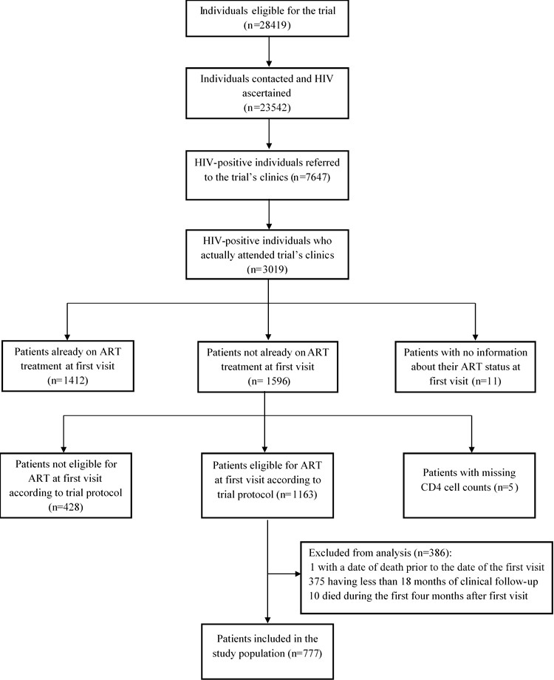

Supplemental Figure 2: Care trajectories in trial clinics over 24 months of clinical follow-up among patients eligible for ART initiation at the first visit (ANRS 12249 TasP trial, n=536)
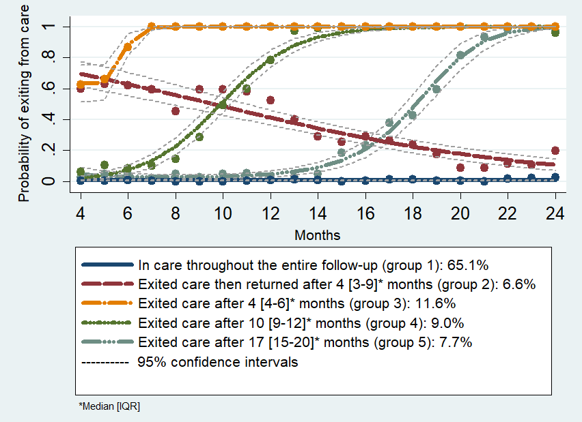
Supplemental Table 1: Sensitivity analysis of factors associated with trajectory groups (reference= Group 1 “Remained in care”) when patients who transferred out were considered as missing, multivariable analysis (ANRS 12249 TasP trial, n=725)
 | Groups
Covariates– aOR [95% CI] | Group 2: exited care then returned | Group 3: exited care rapidly | Group 4: exited care later
Gender & Social support
Female & social support | 1 | 1 | 1
Female & no social support | 1.5 [0.5,4.4] | 1.9 [0.8,4.1] | 0.6 [0.2,1.6]
Male & social support | 3.3** [1.4,7.9] | 1.8 [0.9,3.7] | 1.8 [0.9,3.4]
Male & no social support | 2.3 [0.5,9.9] | 1.9 [0.7,5.0] | 1.9 [0.7,4.7]
Age (years)
≥40 | 1 | 1 | 1
30-39 | 1.0 [0.4,3.0] | 1.0 [0.4,2.3] | 2.9** [1.3,6.4]
16-29 | 3.1* [1.3,7.7] | 3.6*** [1.8,7.2] | 4.5*** [2.1,9.6]
Having a regular partner
Yes | 1 | 1 | 1
No | 3.3* [1.3,8.1] | 1.5 [0.7,3.0] | 1.1 [0.5,2.4]
Newly diagnosed at referral
No | 1 | 1 | 1
Yes | 1.1 [0.3,4.4] | 5.5*** [2.7,11.1] | 6.0*** [3.1,11.7]
CD4 at first visit
CD4≤350 | 1 | 1 | 1
CD4 between ]350-500] | 12.1*** [3.3,45.0] | 0.5 [0.2,1.2] | 0.5 [0.2,1.1]
CD4>500 | 9.8*** [2.7,36.1] | 0.8 [0.4,1.6] | 0.9 [0.5,1.6]
On ART at M1
No | 1 | 1 | 1
Yes | 0.05*** [0.0,0.2] | 0.1*** [0.1,0.2] | 0.7 [0.4,1.2]
* p < 0.05, ** p < 0.01, *** p < 0.001; aOR: adjusted odds ratio

Supplemental Table 2: Sensitivity analysis of factors associated with trajectory groups (reference= Group 1: remained in care) when patients who transferred out were considered as retained in care, multivariable analysis (ANRS 12249 TasP trial, n=735)
 | Groups
Covariates– aOR [95% CI] | Group 2: exited care then returned | Group 3: exited care rapidly | Group 4: exited care later
Gender & Social support
Female & social support | 1.0 | 1.0 | 1.0
Female & no social support | 1.4 [0.5,4.1] | 1.7 [0.8,3.8] | 0.5 [0.2,1.4]
Male & social support | 3.2** [1.4,7.5] | 1.9 [0.9,3.8] | 1.8 [0.9,3.4]
Male & no social support | 2.8 [0.8,10.5] | 1.8 [0.7,4.9] | 1.6 [0.6,4.2]
Age (years)
≥40 | 1.0 | 1.0 | 1.0
30-39 | 0.9 [0.3,2.4] | 1.0 [0.4,2.3] | 3.2** [1.4,7.2]
16-29 | 2.5* [1.1,5.9] | 3.5*** [1.8,7.0] | 4.8*** [2.2,10.3]
Having a regular partner
Yes | 1.0 | 1.0 | 1.0
No | 3.1* [1.3,7.3] | 1.5 [0.7,3.1] | 1.2 [0.6,2.5]
Newly diagnosed at referral
No | 1.0 | 1.0 | 1.0
Yes | 1.1 [0.3,4.3] | 5.3*** [2.6,10.6] | 6.2*** [3.2,12.1]
CD4 at first visit
CD4≤350 | 1.0 | 1.0 | 1.0
CD4 between ]350-500] | 11.3*** [3.1,41.9] | 0.5 [0.2,1.1] | 0.5 [0.2,1.1]
CD4>500 | 11.1*** [3.1,40.2] | 0.8 [0.4,1.6] | 0.8 [0.4,1.5]
On ART at M1
No | 1.0 | 1.0 | 1.0
Yes | 0.1*** [0.0,0.2] | 0.1*** [0.1,0.2] | 0.7 [0.4,1.3]
* p < 0.05, ** p < 0.01, *** p < 0.001; aOR: adjusted odds ratio
REFERENCES
1. UNAIDS. South Africa: Country Situation. 2015;
2. Joint United Nations Programme on HIV/AIDS (UNAIDS). Global AIDS update. 2016; Available from: http://www.unaids.org/sites/default/files/media_asset/global-AIDS-update-2016_en.pdf
3. April MD, Wood R, Berkowitz BK, Paltiel AD, Anglaret X, Losina E, et al. The survival benefits of antiretroviral therapy in South Africa. J Infect Dis. 2014 Feb 15;209(4):491–9.
4. South African National AIDS Council. National Strategic Plan for HIV, TB and STIs 2017 - 2022 [Internet]. SANAC, Pretoria; 2017. Available from: http://sanac.org.za/wp-content/uploads/2017/05/NSP_FullDocument_FINAL.pdf
5. Eaton JW, Johnson LF, Salomon JA, Bärnighausen T, Bendavid E, Bershteyn A, et al. HIV treatment as prevention: systematic comparison of mathematical models of the potential impact of antiretroviral therapy on HIV incidence in South Africa. PLoS Med. 2012;9(7):e1001245.
6. Cornell M, Grimsrud A, Fairall L, Fox MP, van Cutsem G, Giddy J, et al. Temporal changes in programme outcomes among adult patients initiating antiretroviral therapy across South Africa, 2002-2007. AIDS Lond Engl. 2010 Sep 10;24(14):2263–70.
7. Fox MP, Rosen S. Retention of Adult Patients on Antiretroviral Therapy in Low- and Middle-Income Countries: Systematic Review and Meta-analysis 2008-2013. J Acquir Immune Defic Syndr 1999. 2015 May 1;69(1):98–108.
8. Evangeli M, Newell M-L, McGrath N. Factors associated with pre-ART loss-to-follow up in adults in rural KwaZulu-Natal, South Africa: a prospective cohort study. BMC Public Health. 2016 Apr 27;16:358.
9. da Silva M, Blevins M, Wester CW, Manjolo J, José E, Gonzalez LC, et al. Patient loss to follow-up before antiretroviral therapy initiation in rural Mozambique. AIDS Behav. 2015 Apr;19(4):666–78.
10. Lessells RJ, Mutevedzi PC, Cooke GS, Newell M-L. Retention in HIV care for individuals not yet eligible for antiretroviral therapy: rural KwaZulu-Natal, South Africa. J Acquir Immune Defic Syndr 1999. 2011 Mar 1;56(3):e79-86.
11. Evangeli M, Newell M-L, Richter L, McGrath N. The association between self-reported stigma and loss-to-follow up in treatment eligible HIV positive adults in rural Kwazulu-Natal, South Africa. PloS One. 2014;9(2):e88235.
12. Janssen S, Wieten RW, Stolp S, Cremers AL, Rossatanga EG, Klipstein-Grobusch K, et al. Factors Associated with Retention to Care in an HIV Clinic in Gabon, Central Africa. PLoS ONE [Internet]. 2015 Oct 16 [cited 2017 Jul 1];10(10). Available from: http://www.ncbi.nlm.nih.gov/pmc/articles/PMC4608719/
13. Mberi MN, Kuonza LR, Dube NM, Nattey C, Manda S, Summers R. Determinants of loss to follow-up in patients on antiretroviral treatment, South Africa, 2004-2012: a cohort study. BMC Health Serv Res. 2015 Jul 4;15:259.
14. Kelly JD, Schlough GW, Conteh S, Barrie MB, Kargbo B, Giordano TP. The Majority of the Pre-Antiretroviral Population Who Were Lost to Follow-Up Stopped Their Care in Freetown, Sierra Leone: A 12-Month Prospective Cohort Study Starting with HIV Diagnosis. PloS One. 2016;11(2):e0149584.
15. Brown LB, Havlir DV, Ayieko J, Mwangwa F, Owaraganise A, Kwarisiima D, et al. High levels of retention in care with streamlined care and universal test and treat in East Africa. AIDS Lond Engl. 2016 Nov 28;30(18):2855–64.
16. Sabapathy K, Mubekapi-Musadaidzwa C, Mulubwa C, Schaap A, Hoddinott G, Stangl A, et al. Predictors of timely linkage-to-ART within universal test and treat in the HPTN 071 (PopART) trial in Zambia and South Africa: findings from a nested case-control study. J Int AIDS Soc. 2017 Dec;20(4).
17. Ware NC, Wyatt MA, Geng EH, Kaaya SF, Agbaji OO, Muyindike WR, et al. Toward an understanding of disengagement from HIV treatment and care in sub-Saharan Africa: a qualitative study. PLoS Med. 2013;10(1):e1001369; discussion e1001369.
18. Camlin CS, Neilands TB, Odeny TA, Lyamuya R, Nakiwogga-Muwanga A, Diero L, et al. Patient-reported factors associated with reengagement among HIV-infected patients disengaged from care in East Africa. AIDS Lond Engl. 2016 Jan 28;30(3):495–502.
19. Johnson LF, Dorrington RE, Moolla H. HIV epidemic drivers in South Africa: A model-based evaluation of factors accounting for inter-provincial differences in HIV prevalence and incidence trends. South Afr J HIV Med. 2017;18(1):695.
20. Iwuji CC, Orne-Gliemann J, Larmarange J, Okesola N, Tanser F, Thiebaut R, et al. Uptake of Home-Based HIV Testing, Linkage to Care, and Community Attitudes about ART in Rural KwaZulu-Natal, South Africa: Descriptive Results from the First Phase of the ANRS 12249 TasP Cluster-Randomised Trial. PLoS Med. 2016 Aug;13(8):e1002107.
21. Iwuji CC, Orne-Gliemann J, Tanser F, Boyer S, Lessells RJ, Lert F, et al. Evaluation of the impact of immediate versus WHO recommendations-guided antiretroviral therapy initiation on HIV incidence: the ANRS 12249 TasP (Treatment as Prevention) trial in Hlabisa sub-district, KwaZulu-Natal, South Africa: study protocol for a cluster randomised controlled trial. Trials. 2013;14:230.
22. Orne-Gliemann J, Larmarange J, Boyer S, Iwuji C, McGrath N, Bärnighausen T, et al. Addressing social issues in a universal HIV test and treat intervention trial (ANRS 12249 TasP) in South Africa: methods for appraisal. BMC Public Health. 2015;15:209.
23. National Department of Health, Republic of South Africa. The South African antiretroviral treatment guidelines. 2013;
24. National Department of Health, Republic of South Africa. National Consolidated Guidelines for the prevention of mother-to-child transmission of HIV (PMTCT) and the management of HIV in Children, adolescents and adults [Internet]. 2015. Available from: http://www.sahivsoc.org/Files/ART%20Guidelines%2015052015.pdf
25. Houlihan CF, Bland RM, Mutevedzi PC, Lessells RJ, Ndirangu J, Thulare H, et al. Cohort Profile: Hlabisa HIV Treatment and Care Programme. Int J Epidemiol. 2011 Apr;40(2):318–26.
26. Kroenke K, Spitzer RL, Williams JBW, Löwe B. An ultra-brief screening scale for anxiety and depression: the PHQ-4. Psychosomatics. 2009 Dec;50(6):613–21.
27. Nagin D. Group-based modeling of development. Cambridge, Mass: Harvard University Press; 2005. 201 p.
28. StataCorp. Stata Statistical Software: Release 12. College Station, TX: StataCorp LP; 2011.
29. Iwuji CC, Orne-Gliemann J, Larmarange J, Balestre E, Thiebaut R, Tanser F, et al. Universal test and treat and the HIV epidemic in rural South Africa: a phase 4, open-label, community cluster randomised trial. Lancet HIV. 2018 Mar;5(3):e116–25.
30. Rosen S, Fox MP. Retention in HIV Care between Testing and Treatment in Sub-Saharan Africa: A Systematic Review. PLoS Med [Internet]. 2011 Jul 19 [cited 2018 Nov 14];8(7). Available from: https://www.ncbi.nlm.nih.gov/pmc/articles/PMC3139665/
31. Geng EH, Odeny TA, Lyamuya R, Nakiwogga-Muwanga A, Diero L, Bwana M, et al. Retention in Care and Patient-Reported Reasons for Undocumented Transfer or Stopping Care Among HIV-Infected Patients on Antiretroviral Therapy in Eastern Africa: Application of a Sampling-Based Approach. Clin Infect Dis Off Publ Infect Dis Soc Am. 2016 Apr 1;62(7):935–44.
32. Boyer S, Iwuji C, Gosset A, Protopopescu C, Okesola N, Plazy M, et al. Factors associated with antiretroviral treatment initiation amongst HIV-positive individuals linked to care within a universal test and treat programme: early findings of the ANRS 12249 TasP trial in rural South Africa. AIDS Care. 2016;28 Suppl 3:39–51.
33. Arnesen R, Moll AP, Shenoi SV. Predictors of loss to follow-up among patients on ART at a rural hospital in KwaZulu-Natal, South Africa. PloS One. 2017;12(5):e0177168.
34. Vinikoor MJ, Joseph J, Mwale J, Marx MA, Goma FM, Mulenga LB, et al. Age at antiretroviral therapy initiation predicts immune recovery, death, and loss to follow-up among HIV-infected adults in urban Zambia. AIDS Res Hum Retroviruses. 2014 Oct;30(10):949–55.
35. Magazi B, Stadler J, Delany-Moretlwe S, Montgomery E, Mathebula F, Hartmann M, et al. Influences on visit retention in clinical trials: insights from qualitative research during the VOICE trial in Johannesburg, South Africa. BMC Womens Health. 2014 Jul 28;14:88.
36. Muhwava W, Hosegood V, Nyirenda M, Herbst K, Newell M-L. Levels and determinants of migration in rural KwaZulu-Natal, South Africa. Afr Popul Stud. 2013 Oct 15;24(3).
37. Camlin CS, Snow RC, Hosegood V. Gendered Patterns of Migration in Rural South Africa. Popul Space Place. 2014 Aug 1;20(6):528–51.
38. Plazy M, Diallo A, Hlabisa T, Okesola N, Iwuji C, Herbst K, et al. Implementation and effectiveness of a linkage to HIV care intervention in rural South Africa. 9th IAS conference on HIV science, Paris, France. 2017 Jul 23;
39. Naik R, Zembe W, Adigun F, Jackson E, Tabana H, Jackson D, et al. What Influences Linkage to Care After Home-Based HIV Counseling and Testing? AIDS Behav. 2017 Jun 22;
40. Naik R, Doherty T, Jackson D, Tabana H, Swanevelder S, Thea DM, et al. Linkage to care following a home-based HIV counselling and testing intervention in rural South Africa. J Int AIDS Soc. 2015;18:19843.
41. Kredo T, Ford N, Adeniyi FB, Garner P. Decentralising HIV treatment in lower- and middle-income countries. Cochrane Database Syst Rev. 2013 Jun 27;(6):CD009987.
42. Wilkinson LS, Skordis-Worrall J, Ajose O, Ford N. Self-transfer and mortality amongst adults lost to follow-up in ART programmes in low- and middle-income countries: systematic review and meta-analysis. Trop Med Int Health TM IH. 2015 Mar;20(3):365–79.
43. Geng EH, Glidden DV, Bwana MB, Musinguzi N, Emenyonu N, Muyindike W, et al. Retention in care and connection to care among HIV-infected patients on antiretroviral therapy in Africa: estimation via a sampling-based approach. PloS One. 2011;6(7):e21797.
44. Plazy M, Farouki KE, Iwuji C, Okesola N, Orne-Gliemann J, Larmarange J, et al. Access to HIV care in the context of universal test and treat: challenges within the ANRS 12249 TasP cluster-randomized trial in rural South Africa. J Int AIDS Soc [Internet]. 2016 Jun 1 [cited 2018 May 17];19(1). Available from: https://www.ncbi.nlm.nih.gov/pmc/articles/PMC4891946/
45. Morris SS, Carletto C, Hoddinott J, Christiaensen LJM. Validity of rapid estimates of household wealth and income for health surveys in rural Africa. J Epidemiol Community Health. 2000 May 1;54(5):381–7.

