Title: Methylococcaceae are the dominant active aerobic methanotrophs in a Chinese tidal marsh
Authors: Yongcui Deng^{1,2,3,4}, Qian Gui¹, Marc Dumont⁵, Cheng Han¹, Huan Deng¹, Juanli Yun⁶, Wenhui Zhong^{1,3,4*}
Author affiliations:
¹ School of Geography Science, Nanjing Normal University, Nanjing, China
² Key Laboratory of Virtual Geographic Environment, Ministry of Education, Nanjing, China
³ Jiangsu Center for Collaborative Innovation in Geographical Information Resource Development and Application, Nanjing, China
⁴ Jiangsu Provincial Key Laboratory of Materials Cycling and Pollution Control, Nanjing, China
⁵ Biological Sciences, University of Southampton, Southampton, UK.
⁶ Institute of Microbiology, Chinese Academy of Sciences, Beijing, China

Email: zhongwenhui@njnu.edu.cn

Abstract
Although coastal marshes are net carbon sinks, they are net methane sources. Aerobic methanotrophs in coastal marsh soils are important methane consumers, but their activity and populations are poorly characterized. DNA stable-isotope probing followed by sequencing were used to determine how active methanotrophic populations differed in the main habitats of a Chinese coastal marsh. These habitats included mudflat, native plant-dominated, and alien plant-dominated, habitats. Methylococcaceae was the most active methanotroph family across four habitats. Abundant methylotroph sequences, including methanotrophs and non-methane-oxidizing methylotrophs (Methylotenera and Methylophaga), constituted 50%–70% of the 16S rRNA genes detected in the labeled native plant-dominated and mudflat soils. Methylotrophs were less abundant (~20%) in labeled alien plant-dominated soils, suggesting less methane assimilation into the target community or a different extent of carbon cross-feeding. Canonical correspondence analysis indicated a significant correlation between the active bacterial communities and soil properties (salinity, organic carbon, total nitrogen, pH, and available phosphorus). Importantly, these results highlight how changing vegetation or soil features in coastal marshes may change their resident active methanotrophic populations, which will further influence methane cycling.
Keywords
methanotrophs; Methylococcaceae; DNA-SIP; Spartina alterniflora; tidal marsh; methane.
Introduction
Methane (CH₄) is a potent greenhouse gas with a global warming potential 84-fold that of carbon dioxide (CO₂) over a 20-year period (IPCC 2014). Natural wetlands are critical CH₄ emission sources contributing 23% of the total global CH₄ emissions (Conrad 2009). Compared with freshwater wetlands, coastal salt marshes represent a small source of CH₄ emissions (Poffenbarger et al. 2011; Livesley and Andrusiak 2012) but they are highly efficient carbon sinks. It is estimated that vegetated coastal habitats, such as marshes and mangroves, may hold up to 70% of all carbon stored in ocean sediments (Mudd et al. 2009; Nellemann et al. 2010); however, most coastal marshes are now threatened by climate change and invasions by alien plants (Ayres et al. 2004; Kirwan et al. 2010).
CH₄ emissions are balanced by production and consumption carried out by methanogens and methanotrophs, respectively. Aerobic methanotrophs are responsible for most of the biological CH₄ oxidation (Murrell 2010). Phylogenetically, type I methanotrophs are in the families Methylococcaceae and Methylothermaceae of the Gammaproteobacteria, and also in the family Crenotrichaceae (Hirayama et al. 2014; Knief, 2015). Type II methanotrophs in Alphaproteobacteria are divided into type IIa and type IIb methanotrophs, which are affiliated to the families Methylocystaceae and Beijerinckiaceae, respectively (Dumont et al., 2014). In addition to methanotrophs, both Methylocystaceae and Beijerinckiaceae include non-methanotrophic species (Dunfield et al., 2010). Methanotrophs in the family Methylacidiphilaceae of Verrucomicrobia are referred to as type III methanotrophs (Dunfield et al. 2007; Pol et al. 2007; Knief, 2015). Performing the first step of CH₄ oxidation is methane monooxygenase (MMO), a key enzyme of methanotrophs that has particulate (pMMO) and soluble methane monooxygenase (sMMO) forms (Hanson and Hanson 1996). The pmoA gene encoding a subunit of the pMMO is commonly used as a marker to study aerobic methanotrophs (Dumont and Murrell 2005). To the best of our knowledge, however, only a few studies have investigated the activity and community composition of aerobic methanotrophs in coastal marsh ecosystems. Type II methanotrophs of Methylocystis are reportedly dominant in a brackish marsh located on a sub-estuary of Chesapeake Bay, USA (Lee et al. 2017); yet it remains unclear whether this is also the common pattern for other coastal marsh ecosystems, let alone for the functionally active methanotrophic populations in these ecosystems.
The Yancheng tidal marsh (in Jiangsu Province, China) is characterized by an intertidal mudflat and dominated by herbaceous vegetation. Two native species, Suaeda salsa and Phragmites australis, and one alien, Spartina alterniflora, currently dominate this marsh ecosystem. S. alterniflora, native to the Atlantic coast of North and South America (Bertness 1985; Adam 1990), was first introduced to China in 1979 for the sediment stabilization of its intertidal marshes (Qin and Zhong 1992). Since then, this species has spread rapidly and is now mainly distributed in the Jiangsu, Shanghai, Zhejiang, and Fujian Provinces of China (Zuo et al. 2012), where its range has increased to 2661.74 hm² from 1996 to 2010 (Wang and Liu 2014). In the process, S. alterniflora has gradually replaced the habitats of S. salsa and P. australis in the tidal marshes of Jiangsu Province (Zhang et al. 2004). Compared with the native plants, S. alterniflora has a higher plant productivity, which results in rapid accumulation of soil organic carbon (SOC) (Zhang et al. 2010). This provides an additional substrate for methanogens to produce CH₄ that could alter the CH₄ emissions of tidal marshes. CH₄ cycle-related research in these vegetated habitats of the Yancheng tidal marsh is largely limited to measuring CH₄ fluxes (Zhang et al. 2010; Xu et al. 2014; Yuan et al. 2014; Xiang et al. 2015), CH₄ production potential, and to methanogenic community structure analyses (Yuan et al. 2015). The CH₄ oxidation potential and active methanotrophic populations after the S. alterniflora invasion in this tidal marsh have not yet been characterized. To this end, we employed DNA stable-isotope probing (DNA-SIP) in this study to identify the active consumers of CH₄ in the soils of the four main habitats of the Yancheng tidal marsh.

Materials and methods

Soil sample collection and analyses
Soil samples were collected in the Yancheng National Wetland Reserve of Jiangsu Province, China (33°36’N, 120°36’E). Currently, there are four main habitat types in the Yancheng tidal marsh from the coast to terrestrial land (Zuo et al. 2012); (1) the bare tidal mudflat (MF), with no vegetation in this habitat; (2) habitat with the invasive species S. alterniflora (SA); (3) habitat with S. salsa (SS) as the dominant vegetation; and (4) habitat with P. australis (PA) as the dominant vegetation. Along the Yancheng coastal vegetation profile, three soil cores from each habitat and thus 12 samples were collected (8 cm in diameter, 0–5 cm in depth) in June 2015. Soil samples were kept at 4°C using ice bags during transportation. Upon arrival in the laboratory, the main roots in soils were removed and samples were further divided into two subsamples. The subsample used for soil property analysis was air-dried and passed through a 2-mm sieve, while that used for isotope labeling was stored at 4°C until SIP incubation was initiated within one week.
Soil organic carbon (SOC) and total nitrogen (TN) were determined by dichromate oxidation (Bremner and Jenkinson 1960) and Kjeldahl digestion (Bremner 1960), respectively. Soil available phosphorus (AP) was extracted by sodium bicarbonate and measured using the molybdenum antimony anti-colorimetry method. Soil salinity was determined by measurement of the electrical conductivity of a soil-water sample. Soil pH was measured with a water/soil ratio of 2.5 (v/v).

DNA extraction and quantitative PCR (qPCR)
Total genomic DNA of 0.5 g soil sample was extracted using a FastDNA SPIN Kit for Soil (MP Biomedicals). Primer pairs A189f (5’-GGNGACTGGGACTTCTGG) and mb661r (5’-CCGGMGCAACGTCYTTACC) (Costello and Lidstrom 1999) were used to quantify the abundance of methanotroph pmoA genes (Kolb et al. 2003). Quantitative PCR was conducted in 25-μl reaction mixtures containing 12.5 μl of SYBR premix Ex TaqTM (Takara Co), 0.5 μl of 20 μM of each primer and 1 μl of template DNA. The cycling steps were as follows: 94°C for 6 min, followed by 40 cycles of 94°C for 25 s, 65.5°C for 20 s, and 72°C for 45 s, and then melting curve analysis from 75°C to 94.8°C, increment 0.2 °C for 6 s and data collection. The reaction was conducted on a CFX96 Optical Real-Time Detection System (BioRad). Ten-fold serial dilutions of plasmid DNA from 10² to 10⁸ copy numbers μl⁻¹ were used to perform standard curves. Samples were quantified in triplicate. The amplification efficiencies were between 91.8% and 94.5%.

¹³CH₄ labeling and gradient separation
Ten grams of fresh soils from each sample were incubated in 125-ml serum vials capped with butyl stoppers. A total of 10 ml of air in the headspace of each vial was removed using a syringe, after which 10 ml >99.9% labeled ¹³CH₄ or natural abundance CH₄ (referred to here as ¹²CH₄) was injected into the headspace. Soils were then incubated on a shaker (100 rpm) in the dark at 25°C. CH₄ concentration in the headspace was measured daily using a gas chromatograph (Agilent 7890B GC). Once the CH₄ concentration in the headspace started to increase, the incubation was stopped. In total, soil samples were labeled for 6 days.
Soil DNA was extracted immediately after incubation using a FastDNA SPIN Kit for Soil (MP Biomedicals), after which SIP gradient fractionation was performed as previously described (Neufeld et al, 2007; Deng et al. 2016). Briefly, 2 µg of purified DNA was centrifuged in CsCl gradients with an average density of 1.725 g ml⁻¹. The CsCl gradients were prepared by mixing 4.9 ml of a 1.85 g ml⁻¹ CsCl stock solution with 1 ml of gradient buffer (GB, 100 mM Tris-HCl, pH 8.0; 100 mM KCl; 1 mM EDTA). The CsCl density gradients were added into 6-ml polyallomer ultracentrifuge tubes and then centrifuged at 190,000 × g for 44 h at 20°C in a Hitachi Preparative Centrifuge CP80WX (Hitachi Ultras). The gradient solution was subsequently fractionated from bottom to top into 11 DNA fractions by displacing with sterile water using an NE-1000 single syringe pump (New Era Pump Systems, Inc.). Each fraction contained about 0.5 ml of solution. The buoyant density of each collected fraction was determined using an AR200 digital hand-held refractometer (Reichert), after which DNA was precipitated from CsCl gradient fractions with polyethylene glycol and dissolved in 30 µl of elution buffer.

Quantitative PCR, terminal restriction length polymorphism (T-RFLP), and clone analysis of gradient fractions
The A189f-mb661r primers were used to quantify the pmoA gene copies in DNA of labeled soils and in DNA of different gradient fractions (Kolb et al. 2003) using the same qPCR conditions as described above.

T-RFLP of the bacterial 16S rRNA genes was performed from the heavy and light DNA fractions using the primers 27F (5’-AGAGTTTGATCMTGGCTCAG)-FAM and 907r (5’-CCGTCAATTCMTTTRAGTTT) (Lueders et al. 2006). PCR was conducted in a total volume of 50-μl with an initial DNA denaturation step (94°C, 3 min), followed by 32 cycles of denaturation (94°C, 30 s), annealing (52°C, 45 s), and elongation (72°C, 1 min), and then final extension at 72°C for 10 min using an Eppendorf PCR instrument. The PCR products were purified using the GenElute PCR Clean-up Kit (Sigma). Next, approximately 100 ng of purified product was digested with the restriction endonuclease MspI (TaKaRa Co) for 1 h at 37°C. Reactions were stopped by incubating at 65°C for 15 min, after which the digested products were sent to Sangon Biotech Company (Shanghai, China) for terminal restriction fragments (T-RFs) separation.

To determine which active species the T-RF peaks represented, the same primers (27F and 907r) and PCR program described above for T-RFLP were used to construct the 16S rRNA gene clone libraries of the heavy fractions (ca. 1.74 g ml⁻¹). The PCR products were then purified using a GenElute PCR Clean-up Kit (Sigma), after which the purified products were ligated into the pEASY-T1 vector (TaKaRa Co) and transformed into Escherichia coli TOP 10 competent cells according to the manufacturer’s instructions. On average, 36 clones (32–40) were collected in each sample and were classified into various cOTUs (Figure S3, we named cOTUs in order to distinguish them from OTUs obtained by Miseq sequencing). All clone sequences obtained were deposited in GenBank under accession numbers MF950917–MF951051.
MiSeq sequencing and sequence analysis
To further confirm the bacterial community that had been labeled by CH₄ oxidation, barcoded PCR amplification of the 16S rRNA gene from the DNA of the heavy fractions was conducted using the bacterial primers 515F (5’-GTGCCAGCMGCCGCGGTAA) and 907R (5’-CCGTCAATTCMTTTRAGTTT) (Angenent et al. 2005). The library was sequenced on an Illumina MiSeq system using standard procedures of a 2×300 cycle combination mode at Meiji Biotechnology Company (Shanghai, China).
Paired-end reads were first merged by USEARCH using the default settings (Edgar 2010). All reads were then subjected to quality control and chimera and singleton filtering based on the recommendations of the UPARSE pipeline (Edgar 2013). On average, 15,912 (7580–29282) high quality reads per sample were generated by amplicon sequencing. Species level OTU representatives for 16S rRNA genes were obtained using cluster_otus at 97% sequence identity in USEARCH. Taxonomic identities of represented OTUs were assigned using the Ribosomal Database Project Classifier against the SILVA 123 SSU Ref database (Quast et al. 2013) at a confidence level of 95% within Mothur (Schloss et al. 2009). Sequence datasets are available in the NCBI Sequence Read Archive under study accession number SRP6023620–23.
Statistical analysis
One-way analysis of variance and Tukey’s HSD (Honestly Significant Difference) were conducted to test for significant differences in estimated CH₄ consumption rate and soil properties between the four habitats. Canonical Correspondence Analysis (CCA, Anderson and Willis 2003) was conducted to investigate the effects of soil properties on the community composition of active bacteria involved in oxidizing CH₄. At first, CCA analysis was conducted for each soil property, including soil salinity, pH, SOC, TN and AP. An ANOVA-like permutation test function (anova.cca) was run to detect the significance of each soil property contributing to bacterial communities in the labeled DNA. The variables of bacterial community composition only contained OTUs with the relative abundance higher than 0.1%. CCA statistical analyses were performed using the vegan package in R (Oksanen et al. 2016). For all analyses, a P value of <0.05 was considered to be significant.

Results
Soil characteristics and methanotroph abundance
In the Yancheng tidal marsh, the S. alterniflora-dominated soil had significantly higher soil organic carbon (SOC), total nitrogen (TN), available phosphorus content (AP), and salinity than did the soils of the other three habitats (Table 1). No significant differences of TN and AP were detected among these three marsh soil habitats (i.e., mudflat, P. australis-dominated, and S. salsa-dominated). However, the average SOC in the mudflat soil was 1.90 g kg⁻¹ and significantly lower than that of the other habitats. By contrast, the mudflat’s salinity was significantly higher than that of the P. australis- and S. salsa-dominated soils. The pH values of S. alterniflora-dominated soil were close to neutral and the lowest among these habitats. However, the methanotroph abundance of the sampled soils, as quantified by qPCR, was 10⁶ pmoA gene copies g^{–1} fresh soil, with no significant differences detected among the four habitats (Table 1).
The DNA-SIP experiments were performed to detect the active aerobic methanotrophs in each habitat sample. After 5 days of incubation, a significantly higher CH₄ consumption rate was detected in the mudflat soil (2.67±0.1 μmol g wet weight⁻¹ day⁻¹, Figure 1), with ~7.5% CH₄ in the vial headspace decreasing to ~5%. Significantly lower estimated consumption rates were detected in the P. australis- (2.18±0.2 μmol g wet weight⁻¹ day⁻¹) and S. alterniflora- (2.03±0.29 μmol g wet weight⁻¹ day⁻¹) dominated soils. The lowest rates were detected in S. salsa-dominated soil (1.6±0.22 μmol g wet weight⁻¹ day⁻¹).
DNA was extracted from the soils on the 6th day of incubation. The copy numbers of methanotrophs in soils of the four habitats all increased from 10⁶ pmoA gene copies g^{–1} fresh soil in the original soils to 10⁷ after the incubation with ¹³CH₄ or ¹²CH₄ (Figure S1). Results of the qPCR targeting the pmoA genes in DNA of different density gradients are expressed as relative abundances. The ‘heavy’ pmoA gene peaks were detected in the heavy fractions (density > 1.73 g ml^{–1}, Figure 2) of ¹³CH₄-incubated soils. Moreover, those soils incubated with ¹²CH₄ only formed pmoA gene peaks in the light fractions (density < 1.73 g ml⁻¹). These clear separations were detected in all four soils, indicating that their methanotroph pmoA genes were labeled by ¹³C, irrespective of any differences in their CH₄ oxidation rates.
Analysis of T-RFLP and the clone libraries of 16S rRNA genes constructed from heavy DNAs
After high-speed centrifugation and gradient separation, the concentration of DNA obtained was too low to amplify the pmoA genes. Hence, the 16S rRNA genes were used for the T-RFLP analysis of each fraction to characterize the bacteria involved in CH₄ consumption. In addition, 16S rRNA gene clone libraries were constructed from the heavy fractions (density > 1.74 g ml⁻¹), by using the same primers of T-RFLP to characterize the phylogenetic information of the obtained T-RF peaks. The T-RFs with lengths of 436 bp, 456 bp, and 489–491 bp were dominant in the heavy fractions of the ¹³CH₄-labeled mudflat soil and not so dominant in the light fractions of the ¹²CH₄-incubated soils (Figure S2). Phylogenetic analyses of the clone sequences from the heavy fractions showed that the T-RFs of 456 bp detected in the mudflat soil represented Methylomonas and Methylomarinum species (Figure S3). There were six cOTUs which had T-RFs of 489–491 bp in the mudflat soil: cOTU_2 (with a relative abundance of 15.6%) in the genus Methylotenera; cOTU_20 and cOTU_47 in the marine methylotrophic groups; and cOTU_7, cOTU_10, and cOTU_16 in the order Methylococcales (Figure S3). Those T-RFs with a length of 483 bp, and belonging to cOTU_1 in the order Methylococcales, were predominant in the S. salsa- and P. australis-dominated soils (Figures S2 and S3), in which representative cOTUs of Methylohalobius (7.5%, cOTU_6) and Methylocystis (2.9%, cOTU_46) were also detected respectively. By contrast, no corresponding cOTUs were identified for the T-RF peaks in the heavy fractions of the S. alterniflora-dominated soil (Figures S2 and S3). In this habitat, the most abundant cOTU was cOTU_10, which belonged to the order Methylococcales and had a relative abundance of 5.4% (Figure S3).
MiSeq sequencing of the ¹³C-enriched 16S rRNA gene targeting the bacteria actively involved in CH₄ consumption
For the analyses of the composition of total bacterial community, only the most abundant OTUs were included— i.e. those with a mean relative abundance >1% in all habitats or >3% in one habitat (not shown, Figure 3A). Methanotrophs are a subgroup of methylotrophs, and not all methylotrophs are methantrophs. Besides CH₄, methylotrophs can grow on other one-carbon compounds such as methanol (CH₃OH). Except for the S. alterniflora-dominated soil, the methylotroph 16S rRNA sequences comprised ~50%–70% of the heavy fraction in the other three marsh soil habitats. The abundant methylotrophic community from the labeled DNAs obtained via MiSeq sequencing was consistent with that obtained from the clone sequencing (Figures 4A and S1).
The majority of heavy sequences detected in the mudflat soil habitat were methanotroph 16S rRNA sequences and clustered to OTU_2 (Figure 3A). It had a relative abundance of 24.2% and belongs to the family Methylococcaceae, as does OTU_1011, which was classified as Methylomonas and accounted for 6.3% of the heavy sequences occurring in the mudflat soil. The methylotroph OTUs—namely the OTUs of Methylotenera (OTU_4), Marine_Methylotrophic_Group_1 (OTU_5), and Methylophaga (OTU_7)—were more abundant in mudflat than other marsh soil habitats. The majority of the heavy sequences detected in the P. australis- and S. salsa-dominated soils were also methanotroph sequences and both belonged to family Methylococcaceae (Figure 3A); however, unlike OTU_2 in the mudflat soil, they clustered to another OTU, named OTU_1. OTU_1 accounted for 62.1% and 44.6% of the labeled sequences in the P. australis- and S. salsa-dominated soils, respectively (Figure 3A). Meanwhile, 5.3% of the Methylohalobius sequences (OTU_9) were detected in the S. salsa-dominated soil. The proportion of methylotroph sequences detected in S. alterniflora-dominated soil was much lower than that detected in the other soil habitats (Figure 3A). OTU_1 and OTU_2 were also detected in S. alterniflora-dominated soil, but they accounted for just ~1.7% of the heavy fraction, while in this habitat relatively higher proportions of Methylomicrobium (3.5%, OTU_8) and Methylomonas (3.9%, OTU_1011) were detected.
Most of the abundant OTUs represented the methylotrophic community involved in CH₄ oxidization (Figure 3A). Correspondingly, most of the 16S rRNA gene sequences in the heavy fraction belonged to the Proteobacteria at the phylum level, especially Gammaproteobacteria (Figure 3B). The proportion of non-Proteobacteria sequences was greater in the S. alterniflora-dominated soil than in the other marsh soil habitats, including bacteria belonging to the phyla Acidobacteria, Chloroflexi, and Gemmatimonadetes (Figure 3B).
Correlations between the soil properties and the active bacterial community
The CCA and the ANOVA-like permutation test (anova.cca) for each soil property (soil salinity, pH, SOC, TN, and AP) aimed to detect the correlation between soil properties and the active bacterial community matrix. All the tested soil properties significantly accounted for the variation found in the sampled bacterial communities (P < 0.05). Among them, however, salinity was the most important explanatory variable: it independently accounted for 29.2% of variation in the active bacterial community composition. The CCA were further conducted with all soil properties and compositions of the active bacterial community included. The CCA model with all the five soil properties considered represented 79.6% of the total variation in the bacterial communities, of which CCA1 accounted for 40.2% and CCA2 for 27.6%. As Figure 4 shows, the samples from the mudflat (MF) and S. alterniflora (SA) habitats clustered separately; while those of the more similar P. australis (PA) and S. salsa (SS) habitats clustered together, yet remained distinct from the samples of either MF or SA.

Discussion
Spartina alterniflora invasion is known to stimulate CH₄ emission and production potential in the Yancheng tidal marsh (Zhang et al. 2010; Yuan et al. 2014, 2015). CH₄ emission is a balance between production and oxidation, which are performed by distinct groups of microorganisms. In the present study, the estimated CH₄ oxidation rate of the S. alterniflora soil was higher than that of S. salsa soil and not significantly lower than P. australis soil (Figure 1). This indicates that, compared with native plant-dominated soil, the greater CH₄ emission of S. alterniflora soil was driven by the increased CH₄ production and not decreased CH₄ oxidation. It is also reasonable that the increased methanogenesis in this soil will have enriched methanotrophs and stimulated CH₄ oxidation capacity.
The active community composition in the S. alterniflora soil differed from the other soils and showed a much lower proportion of 16S rRNA sequences from known methanotrophs among the total labeled bacteria. S. alterniflora and P. australis soils consumed the same amount of ¹³CH₄, and pmoA gene copy numbers increased similarly in all soils. Therefore, it is difficult to explain why the relative abundance of labeled methanotrophs was particularly low in the S. alterniflora soil. One possible explanation is that the labeled Acidobacteria, Chloroflexi and Gemmatimonadetes in this soil are novel methanotrophs, but this seems unlikely. A more plausible explanation is that greater cross-feeding of ¹³C from methanotrophs to heterotrophs occurred in the S. alterniflora soil. Cross-feeding is poorly understood, but widely observed for in SIP experiments targeting methanotrophs (Beck et al., 2013). A recent study showed that Methylotenera mobilis, a non-methanotrophic methylotroph, could induce excess methanol production in Methylobacter tundripaludum thus facilitating cross-feeding (Krause et al., 2017). It is plausible that the microbial community in the S. alterniflora soil has more extensive cross-feeding partnerships that the other soils, leading to wider labeling of the non-methanotroph populations with the ¹³CH₄.
Most of the methylotroph OTUs from the 16S rRNA gene sequencing were unclassified at the genus level at a 95%-similarity level. Rather, they could be only identified to family or order and lacked close affiliations with the cultivated methylotrophic species. Moreover, these OTUs were abundant in the heavy fractions after the ¹³CH₄ incubation, indicating that they played important roles in CH₄ consumption. A dominance of Methylococcaceae OTUs was detected in the SIP-labeled soils in the Yancheng tidal marsh. This family is composed entirely of type I methanotrophs (Bowman et al. 1993; Knief 2015). Hence, it can be concluded that the active and abundant bacteria that consumed CH₄ were unclassified type I methanotrophs.
In both the P. australis and S. salsa soils, OTU_1 belonged to an unclassified genus in the family Methylococcaceae that was dominant in the ¹³C-enriched fractions after the 6-day incubation. The representative sequences of OTU_1 had a 99.5% identity with the uncultured bacterial sequences obtained from mangrove sediment of Sundarban, India (Ghosh et al. 2010). In another red mangrove soil, unclassified Methylococcaceae were also detected as abundant methanotrophs by ¹³CH₄ DNA-SIP via 16S rRNA MiSeq sequencing (Shiau et al. 2018). These findings indicate that these two typical coastal soil ecosystems, salt marshes and mangroves, likely share similar methanotrophic populations. Furthermore, OTU_1 was 96.9% similar to Methylomicrobium sp. XLMV4 (alternative name: Methylobacter sp. XLMV4) that was isolated from oil sands tailings ponds (Saidi-Mehrabad 2014). Because they are closely related, OTU_1 species likely share physiological characteristics with other Methylomicrobium species, which include well-known halotolerant and halophilic methanotrophs (Knief 2015) that are abundant in saline lake sediments (Deng et al. 2017). Soils in the Yancheng tidal marsh had salinity of 5.0‰–23.7‰, which could provide a suitable salinity for halophilic Methylomicrobium species.
OTU_2 was dominant in mudflat soil and also belonged to the family Methylococcaceae. It had a 98% identity with Methylomarinum sp. SSMP-1, which was isolated from a hydrothermal seep field at the northern terminus of the Eastern Pacific Rise (Fradet et al. 2016). The genus Methylomarinum is the cultivated representative of deep-sea cluster 2 (Knief 2015) while the deep-sea clusters 1 to 5 belong to uncultivated type I methanotrophs that have mostly been detected in marine ecosystems by targeting the pmoA gene as a functional marker (Tavormina et al. 2010; Lüke and Frenzel 2011; Knief 2015). Similar environmental conditions occur in the Yancheng marsh soils with its marine sediments, since the Yancheng marsh is continually flushed with seawater by the tide. Thus, we may infer that the different unclassified OTUs in the family Methylococcaceae obtained from the Yancheng marsh may correspond to the different “deep-sea” methanotroph clusters. However, only OTU_2 was related to deep-sea cluster 2, and no other pieces of conclusive evidence were found to prove this inference for the other unclassified OTUs. Nonetheless, further investigations are now necessary to reveal the ecophysiological activity and phylogenetic classification of these unclassified methanotrophic populations.
Type II methanotroph Methylocystis species are reportedly abundant and active CH₄ consumers in many peatlands of England, China, and North and South America (Chen et al. 2008; Gupta et al. 2012; Kip et al. 2012; Deng et al. 2013, 2016). However, in the Yancheng tidal marsh, we only found one such OTU belonging to Methylocystis, which accounts for 2.9% of the total labeled bacteria in the P. australis soil. The activity of Methylocystis species may be completely inhibited by 1% NaCl (Han et al, 2017). Therefore, even if Methylocystis was abundant in the in-situ soils, they may primarily occur as metabolically inactive spores, doing little to oxidize CH₄. Another possibility is that adding high levels of CH₄ into the headspace stimulated the growth of type I, rather than type II, methanotrophs during the SIP experiment we conducted.
We also found that the non-CH₄-utilizing methylotrophic species Methylotenera and Methylophaga were active when labeled with ¹³CH₄ in soils of the Yancheng tidal marsh. Methylotrophs are a group of bacteria that can grow on a number of different C1 compounds (Lidstrom 2006). Methylotenera species in the family Methylophilaceae are reportedly highly active in freshwater habitats when incubated with ¹³CH₄ or ¹³CH₃OH (Chistoserdova 2011, 2015). Methylophaga species are moderately halophilic methylotrophs in the family Piscirickettsiaceae (Doronina et al. 1997), which also have been detected as active bacteria by the ¹³CH₃OH SIP method in coastal marine environments (Neufeld et al. 2007). Therefore, in soils of the Yancheng tidal marsh, Methylotenera and Methylophaga may have used the CH₃OH produced by methanotrophs and been detected by the ¹³CH₄ SIP experiment.
That the samples formed three major groups, as suggested by the CCA, is indicative of the different active bacterial communities found among the habitats due to distinguishable soil properties. When compared with the mudflat and S. alterniflora habitats, the samples from P. australis and S. salsa had similar soil properties, especially with respect to soil organic carbon and salinity, and clustered together in the CCA plot. It has been reported that S. alterniflora has a competitive advantage over native species in high salinity conditions. As a consequence, this has changed the vegetation pattern by pushing the native communities to the low salinity zones (Tang et al. 2014). Soil salinity was also the primary factor influencing the bacterial community composition in the labeled soils, which was consistent with other bacterial community analyses of sediment in the Florida Coastal Everglades (Ikenaga et al. 2010) and Gironde estuary (France) (Prieur et al. 1987). These results emphasize the important role that salinity plays in shaping the community composition of active bacteria involved in CH₄ oxidation.
Conclusion
In this study, we successfully used ¹³CH₄ DNA-SIP approach and identified the microorganisms involved in CH₄ oxidation in four soil habitats of the Yancheng tidal marsh. Compared with native vegetation and mudflat habitats, a lower relative abundance of active methanotrophs was detected in the S. alterniflora-dominated habitat, which suggested different ways of carbon cross-feeding. Our results show that in these four marsh habitats different unclassified type I methanotrophs in the family Methylococcaceae were the major active aerobic methanotrophs, thus suggesting an important role for Methylococcaceae in the dynamics of CH₄ oxidation in coastal marshes.

Funding
This work was supported by the Natural Science Foundation of Jiangsu Province, China [grant number BK20140923], the National Natural Science Foundation of China [grant number 41401075], and the Priority Academic Program Development of Jiangsu Higher Education Institutions.
Conflict of interest: The authors declare that they have no conflict of interest.
References
Adam P (1990) Saltmarsh Ecology. Cambridge University Press, New York.
Anderson MJ, Willis TJ (2003) Canonical analysis of principal coordinates: a useful method of constrained ordination for ecology. Ecology 84:511–525
Angenent LT, Kelley ST, Amand AS, Pace NR, Hernandez MT (2005) Molecular identification of potential pathogens in water and air of a hospital therapy pool. Proc Natl Acad Sci USA 102:4860-4865
Ayres DR, Smith DL, Zaremba K, Klohr S, Strong DR (2004) Spread of exotic cordgrasses and hybrids (Spartina sp.) in the tidal marshes of San Francisco Bay, California, USA. Biol Invasions 6:221-231
Beck DAC, Kalyuzhnaya MG, Malfatti S, Tringe SG, Glavina Del Rio T, Ivanova N, Lidstrom ME, Chistoserdova L. 2013. A metagenomic insight into freshwater methane-utilizing communities and evidence for cooperation between the Methylococcaceae and the Methylophilaceae. PeerJ. 2013;1:e23
Bertness MD (1985) Fiddler crab regulation of Spartina alterniflora production on a New England salt marsh. Ecology 66: 1042-1055
Bowman JP, Sly LI, Nichols PD, Hayward AC (1993) Revised taxonomy of the methanotrophs: description of Methylobacter gen. nov., emendation of Methylococcus, validation of Methylosinus and Methylocystis species, and a proposal that the family Methylococcaceae includes only the Group I methanotrophs. Int J Syst Bacteriol 43:735–753
Bremner JM, Jenkinson DS (1960) Determination of organic carbon in soil. Eur J Soil Sci 11:394-402
Bremner JM (1960) Determination of nitrogen in soil by the Kjeldahl method. J Agric Sci 55:11-33
Chen Y, Dumont MG, McNamara NP, Chamberlain PM, Bodrossy L, Stralis-Pavese N, Murrell JC (2008) Diversity of the active methanotrophic community in acidic peatlands as assessed by mRNA and SIP-PLFA analyses. Environ Microbiol 10:446-459
Chistoserdova L (2011) Methylotrophy in a lake: from metagenomics to single-organism physiology. Appl Environ Microbiol 77:4705-4711
Chistoserdova L (2015) Methylotrophs in natural habitats: current insights through metagenomics. Appl Microbiol Biotechnol 99:5763-5779
Conrad R (2009) The global methane cycle: recent advances in understanding the microbial processes involved. Environ Microbiol Rep 1:285-292.
Costello AM, Lidstrom ME (1999) Molecular characterization of functional and phylogenetic genes from natural populations of methanotrophs in lake sediments. Appl Environ Microbiol 65:5066-5074
Deng Y, Cui X, Lüke C, Dumont M (2013) Aerobic methanotroph diversity in Riganqiao peatlands on the Qinghai‐Tibetan Plateau. Environ Microbiol Rep 5:566-574
Deng Y, Cui X, Dumont M (2016) Identification of active aerobic methanotrophs in plateau wetlands using DNA stable isotope probing. FEMS Microbiol Lett 363:fnw168
Deng Y, Liu Y, Dumont M, Conrad R (2017) Salinity affects the composition of the aerobic methanotroph community in alkaline lake sediments from the Tibetan Plateau. Microb Ecol 73:101-110
Doronina NV, Krauzova VI, Trotsenko YA (1997) Methylophaga limanica sp. nov.: a new species of moderately halophilic, aerobic, methylotrophic bacteria. Microbiology 66:434-439
Dumont MG, Lüke C, Deng Y, Frenzel P (2014) Classification of pmoA amplicon pyrosequences using BLAST and the lowest common ancestor method in MEGAN. Front Microbiol 5:34
Dumont MG, Murrell JC (2005) Community-level analysis: Key genes of aerobic methane oxidation. Environ Microbiol, Methods in Enzymology, ed Leadbetter JR), Vol 397, pp 413-427
Dunfield PF, Yuryev A, Senin P, Smirnova AV, Stott MB, Hou S, Ly B, Saw JH, Zhou Z, Ren Y, Wang J, Mountain BW, Crowe MA, Weatherby TM, Bodelier PLE, Liesack W, Feng L, Wang L, Alam M (2007) Methane oxidation by an extremely acidophilic bacterium of the phylum Verrucomicrobia. Nature 450:879-U818
Dunfield PF, Belova SE, Vorob'ev, AV, Cornish SL, Dedysh SN (2010) Methylocapsa aurea sp. nov., a facultative methanotroph possessing a particulate methane monooxygenase, and emended description of the genus Methylocapsa. Int J Syst Evol Microbiol 60:2659-2664
Edgar RC (2010) Search and clustering orders of magnitude faster than BLAST. Bioinformatics 26:2460-2461
Edgar RC (2013) UPARSE: highly accurate OTU sequences from microbial amplicon reads. Nat Methods 10:996-998
Fradet DT, Tavormina PL, Orphan VJ (2016) Members of the methanotrophic genus Methylomarinum inhabit inland mud pots. PeerJ 4:e2116
Ghosh A, Dey N, Bera A, Tiwari A, Sathyaniranjan KB, Chakrabarti K, Chattopadhyay D (2010) Culture independent molecular analysis of bacterial communities in the mangrove sediment of Sundarban, India. Saline Systems 6:1
Gupta V, Smemo KA, Yavitt JB, Basiliko N (2012) Active methanotrophs in two contrasting North American peatland ecosystems revealed using DNA-SIP. Microb Ecol 63:438-445
Han DF, Link H, Liesack W (2017) Response of Methylocystis sp Strain SC2 to salt stress: physiology, global transcriptome, and amino acid profiles. Appl Environ Microbiol 83:14
Hanson RS, Hanson TE (1996) Methanotrophic bacteria. Microbiol Rev 60:439
Hirayama H, Abe M, Miyazaki M, Nunoura T, Furushima Y, Yamamoto H, Takai K (2014) Methylomarinovum caldicuralii gen. nov., sp. nov., a moderately thermophilic methanotroph isolated from a shallow submarine hydrothermal system, and proposal of the family Methylothermaceae fam. nov. Int J Syst Evol Microbiol 64:989-999
Ikenaga M, Guevara R, Dean AL, Pisani C, Boyer JN (2010) Changes in community structure of sediment bacteria along the Florida Coastal Everglades marsh-mangrove-seagrass salinity gradient. Microb Ecol 59:284-295
IPCC (2014) In: Core Writing Team, Pachauri RK, Meyer LA (eds) Climate Change 2014: Synthesis report. Contribution of working groups I, II and III to the fifth assessment report of the intergovernmental panel on climate change. IPCC, Geneva, pp. 151
Kip N, Fritz C, Langelaan ES, Pan Y, Bodrossy L, Pancotto V, Jetten MSM, Smolders AJP, den Camp HJMO (2012) Methanotrophic activity and diversity in different Sphagnum magellanicum dominated habitats in the southernmost peat bogs of Patagonia. Biogeosciences 9:47-55
Kirwan ML, Guntenspergen GR, D'Alpaos A, Morris JT, Mudd SM, Temmerman S (2010) Limits on the adaptability of coastal marshes to rising sea level. Geophys Res Lett 37: L23401
Knief C (2015) Diversity and habitat preferences of cultivated and uncultivated aerobic methanotrophic bacteria evaluated based on pmoA as molecular marker. Front Microbiol 6:1346
Kolb S, Knief C, Stubner S, Conrad R (2003) Quantitative detection of methanotrophs in soil by novel pmoA-targeted real-time PCR assays. Appl Environ Microb 69:2423-2429
Krause SMB, Johnson T, Samadhi Karunaratne Y, Fu Y, Beck DAC, Chistoserdova L, Lidstrom ME (2017). Lanthanide-dependent cross-feeding of methane-derived carbon is linked by microbial community interactions. Proc Natl Acad Sci USA 114:358–363
Lee SH, Megonigal PJ, Kang H (2017) How do elevated CO₂ and nitrogen addition affect functional microbial community involved in greenhouse gas flux in salt marsh system. Microb Ecol 74:670-680
Lidstrom ME (2006) Aerobic methylotrophic prokaryotes. The Prokaryotes, (Springer), pp 618-634
Livesley SJ, Andrusiak SM (2012) Temperate mangrove and salt marsh sediments are a small methane and nitrous oxide source but important carbon store. Estuar Coast Shelf Sci 97:19-27
Lueders T, Wagner B, Claus P, Friedrich MW (2004) Stable isotope probing of rRNA and DNA reveals a dynamic methylotroph community and trophic interactions with fungi and protozoa in oxic rice field soil. Environ Microbiol 6:60-72
Lüke C, Frenzel P (2011) Potential of pmoA amplicon pyrosequencing for methanotroph diversity studies. Appl Environ Microbiol 77:6305-6309
Mudd SM, Howell SM, Morris JT (2009) Impact of dynamic feedbacks between sedimentation, sea-level rise, and biomass production on near-surface marsh stratigraphy and carbon accumulation. Estuar Coast Shelf S 82:377-389.
Murrell JC (2010) The aerobic methane oxidizing bacteria (methanotrophs). Handbook of hydrocarbon and lipid microbiology, (Springer), pp 1953-1966
Nellemann, Christian; Corcoran, Emily; Duarte, Carlos M.; De Young, Cassandra; Fonseca, Luciano E.; and Grimsdith, Gabriel, "Blue Carbon: The role of healthy oceans in binding carbon" (2010). Center for Coastal and Ocean Mapping 132
Neufeld JD, Schäfer H, Cox MJ, Boden R, McDonald IR, Murrell JC (2007) Stable-isotope probing implicates Methylophaga spp and novel Gammaproteobacteria in marine methanol and methylamine metabolism. ISME J 1:480-491
Neufeld JD, Vohra J, Dumont MG, Lueders T, Manefield M, Friedrich MW, Murrell JC (2007) DNA stable-isotope probing. Nat Protocols 2:860-866
Oksanen J, Blanchet FG, Kindt R, Legendre P, O'Hara RG, Simpson GL, Solymos P, Stevens MHH, Wagner H (2016) Vegan: community ecology package. R Package Version 2.2-0.
Poffenbarger HJ, Needelman BA, Megonigal JP (2011) Salinity influence on methane emissions from tidal marshes. Wetlands 31:831-842.
Pol A, Heijmans K, Harhangi HR, Tedesco D, Jetten MSM, den Camp HJMO (2007) Methanotrophy below pH1 by a new Verrucomicrobia species. Nature 450:874-879
Prieur D, Troussellier M, Romana A, Chamrouxd S, Meveld G, Baleuxb B (1987) Evolution of bacterial communities in the Gironde estuary (France) according to a salinity gradient. Estuarine Coastal Shelf Sci 24:95-108
Qin P, Zhong CX (1992) Applied studies on Spartina. Ocean Press 26:s160-s169
Quast C, Pruesse E, Yilmaz P, Gerken J, Schweer T, Yarza P, Peplies J, Glöckner FO (2013) The SILVA ribosomal RNA gene database project: improved data processing and web-based tools. Nucleic Acids Res 41:D590-596
Saidi-Mehrabad A (2014) Characterization of aerobic methane oxidizing bacteria in oil sands tailings ponds. MSc thesis, University of Calgary.
Schloss PD, Westcott SL, Ryabin T, Hall JR, Hartmann M, Hollister EB, Lesniewski RA, Oakley BB, Parks DH, Robinson CJ (2009) Introducing mothur: open-source, platform-independent, community-supported software for describing and comparing microbial communities. Appl Environ Microb 75:7537-7541
Shiau YJ, Cai Y, Lin YT, Jia Z, Chiu CY (2018) Community structure of active aerobic methanotrophs in red mangrove (Kandelia obovata) soils under different frequency of tides. Microb Ecol 75:761-770
Tang L, Gao Y, Li B, Wang Q, Wang CH, Zhao B (2014) Spartina alterniflora with high tolerance to salt stress changes vegetation pattern by outcompeting native species. Ecosphere 5:1-18
Tavormina PL, Ussler W, Joye SB, Harrison BK, Orphan VJ (2010) Distributions of putative aerobic methanotrophs in diverse pelagic marine environments. ISME J 4:700-710
Wang C, Liu H (2014) The impact of Spartina alterniflora expansion on vegetation landscapes in the Yancheng tidal flat wetland. Resources Sci 36:2413-2422
Xiang J, Liu D, Ding W, Yuan J, Lin Y (2015) Invasion chronosequence of Spartina alterniflora on methane emission and organic carbon sequestration in a coastal salt marsh. Atmos Environ 112:72-80
Xu X, Zou X, Cao L, Zhamangulova N, Zhao Y, Tang D, Liu D (2014) Seasonal and spatial dynamics of greenhouse gas emissions under various vegetation covers in a coastal saline wetland in southeast China. Ecol Eng 73:469-477
Yuan J, Ding W, Liu D, Xiang J, Lin Y (2014) Methane production potential and methanogenic archaea community dynamics along the Spartina alterniflora invasion chronosequence in a coastal salt marsh. Appl Microbiol Biotechnol 98:1817-1829
Yuan J, Ding W, Liu D, Kang H, Freeman C, Xiang J, Lin Y (2015) Exotic Spartina alterniflora invasion alters ecosystem–atmosphere exchange of CH₄ and N₂O and carbon sequestration in a coastal salt marsh in China. Glob Change Biol 21:1567-1580
Zhang Y, Ding W, Cai Z, Valerie P, Han F (2010) Response of methane emission to invasion of Spartina alterniflora and exogenous N deposition in the coastal salt marsh. Atmos Environ 44:4588-4594
Zhang Y, Ding W, Luo J, Donnison A (2010) Changes in soil organic carbon dynamics in an Eastern Chinese coastal wetland following invasion by a C₄ plant Spartina alterniflora. Soil Biol and Biochem 42:1712-1720
Zhang RS, Shen YM, Lu LY, Yan SG, Wang YH, Li JL, Zhang ZL (2004) Formation of Spartina alterniflora salt marshes on the coast of Jiangsu Province, China. Ecol Eng 23:95-105
Zuo P, Zhao S, Liu Ca, Wang C, Liang Y (2012) Distribution of Spartina spp. along China's coast. Ecol Eng 40:160-166
Figure legends
Figure 1. CH₄ concentrations in vials for the Yancheng soils SIP labeling. Soils from four marsh habitats (MF: mudflat, PA: Phragmites australis-, SS: Suaeda salsa-, and SA: Spartina alterniflora-dominated) were incubated with ¹³CH₄ or ¹²C-CH₄. Error bars represent standard deviations (n = 6).
Figure 2. Distributions of the methanotroph pmoA genes, as determined by qPCR of the DNA recovered from CsCl gradient fractions, after 6 days of incubation with ¹³CH₄ or ¹²CH₄. The y-axis indicates the relative abundance at each gradient fraction, with the total quantity detected in a gradient equal to 1. The four panels correspond to the pmoA distribution from incubations of the four types of soils (MF: mudflat, PA: Phragmites australis-, SS: Suaeda salsa-, and SA: Spartina alterniflora-dominated). Densities between 1.73 and 1.8 g ml^{–1} corresponded to heavy fractions (labeled DNA), and those between 1.66 and 1.73 g ml^{–1} corresponded to light fractions (unlabeled DNA).
Figure 3. Relative abundance of the major 16S rRNA gene-derived clusters that were retrieved from the heavy fractions (density = ~1.74 g ml^{–1}). (A) MiSeq sequencing of the OTU levels, (B) MiSeq sequencing of the phylum levels. Error bars represent standard deviations (n = 3).
Figure 4. Canonical correspondence analysis (CCA) ordination diagram of the active bacterial communities associated with the soil variables, based on an Illumina MiSeq sequencing of the 12 samples (colored circles) from the four studied habitats (MF: mudflat, PA: Phragmites australis-, SS: Suaeda salsa-, and SA: Spartina alterniflora-dominated). Blue arrows represent the five soil variables considered: soil organic carbon (SOC), total nitrogen (TN), soil available phosphorus (AP), soil salinity, and pH value. The relative abundance of the OTUs was used for the bacterial community composition. OTUs are shown as red ‘+’ symbols.

Figure S1. Changes in the copy number of pmoA genes in soils of four marsh habitats (MF: mudflat, PA: Phragmites australis-, SS: Suaeda salsa-, and SA: Spartina alterniflora-dominated) incubated with ¹³CH₄ or ¹²CH₄ for 6 days. Error bars represent standard deviations (n = 3).
Figure S2. Bacterial 16S rRNA gene T-RFLP analysis of the DNA recovered from the CsCl gradient fractions. The three panels on the upper left of the figure, MF-1, MF-2, and MF-3 represent three replications of the heavy fractions of ¹³CH₄-labeled mudflat (MF) soils, while panels in their left represent three replications of the light fractions of the ¹²CH₄-incubated MF soil. The same principles were applied to Phragmites australis- (PA), Suaeda salsa- (SS), and Spartina alterniflora- (SA) dominated soils. The numbers accompanying the arrows point to each T-RF peak indicates the respective T-RF length (bp). The associated CsCl buoyant density is listed at the center-top of each panel.

Figure S3. Relative abundance of the major 16S rRNA gene-derived clusters in the Sanger sequencing datasets that were retrieved from the heavy fractions of the labeled soils (density = ~1.74 g ml^{–1}).

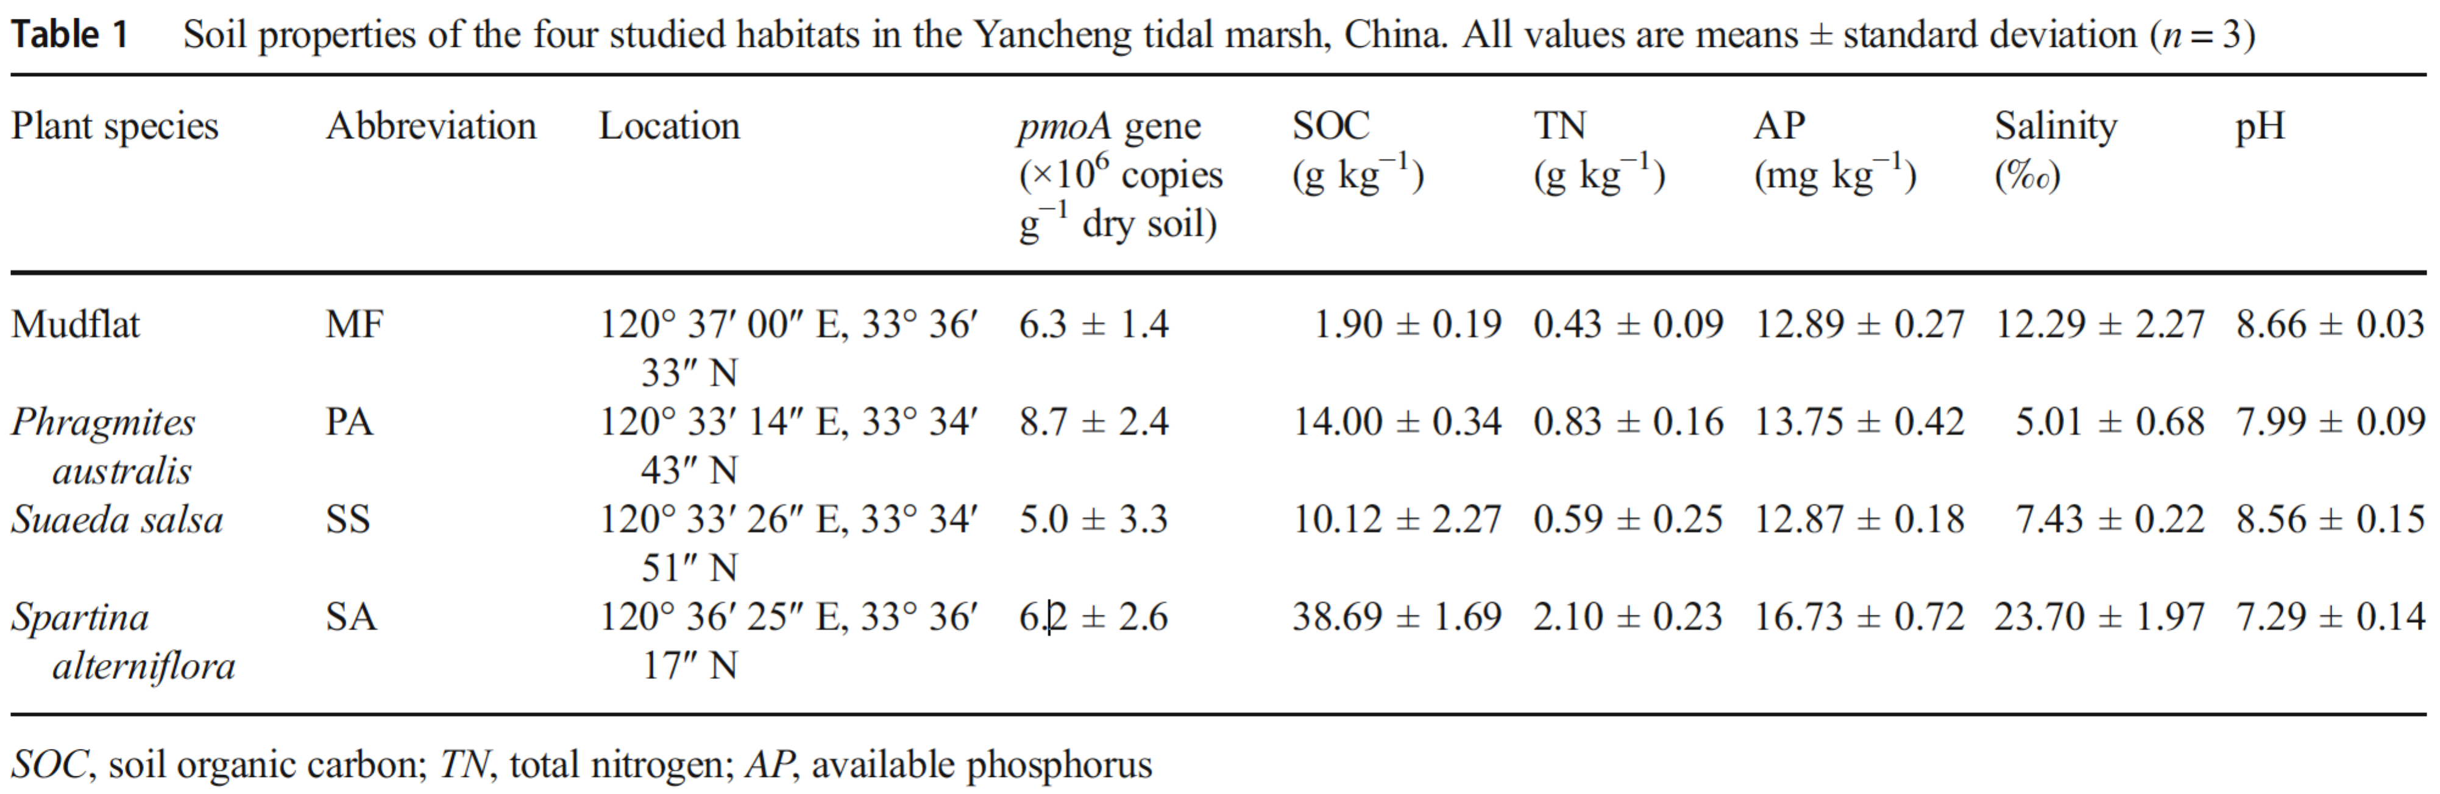

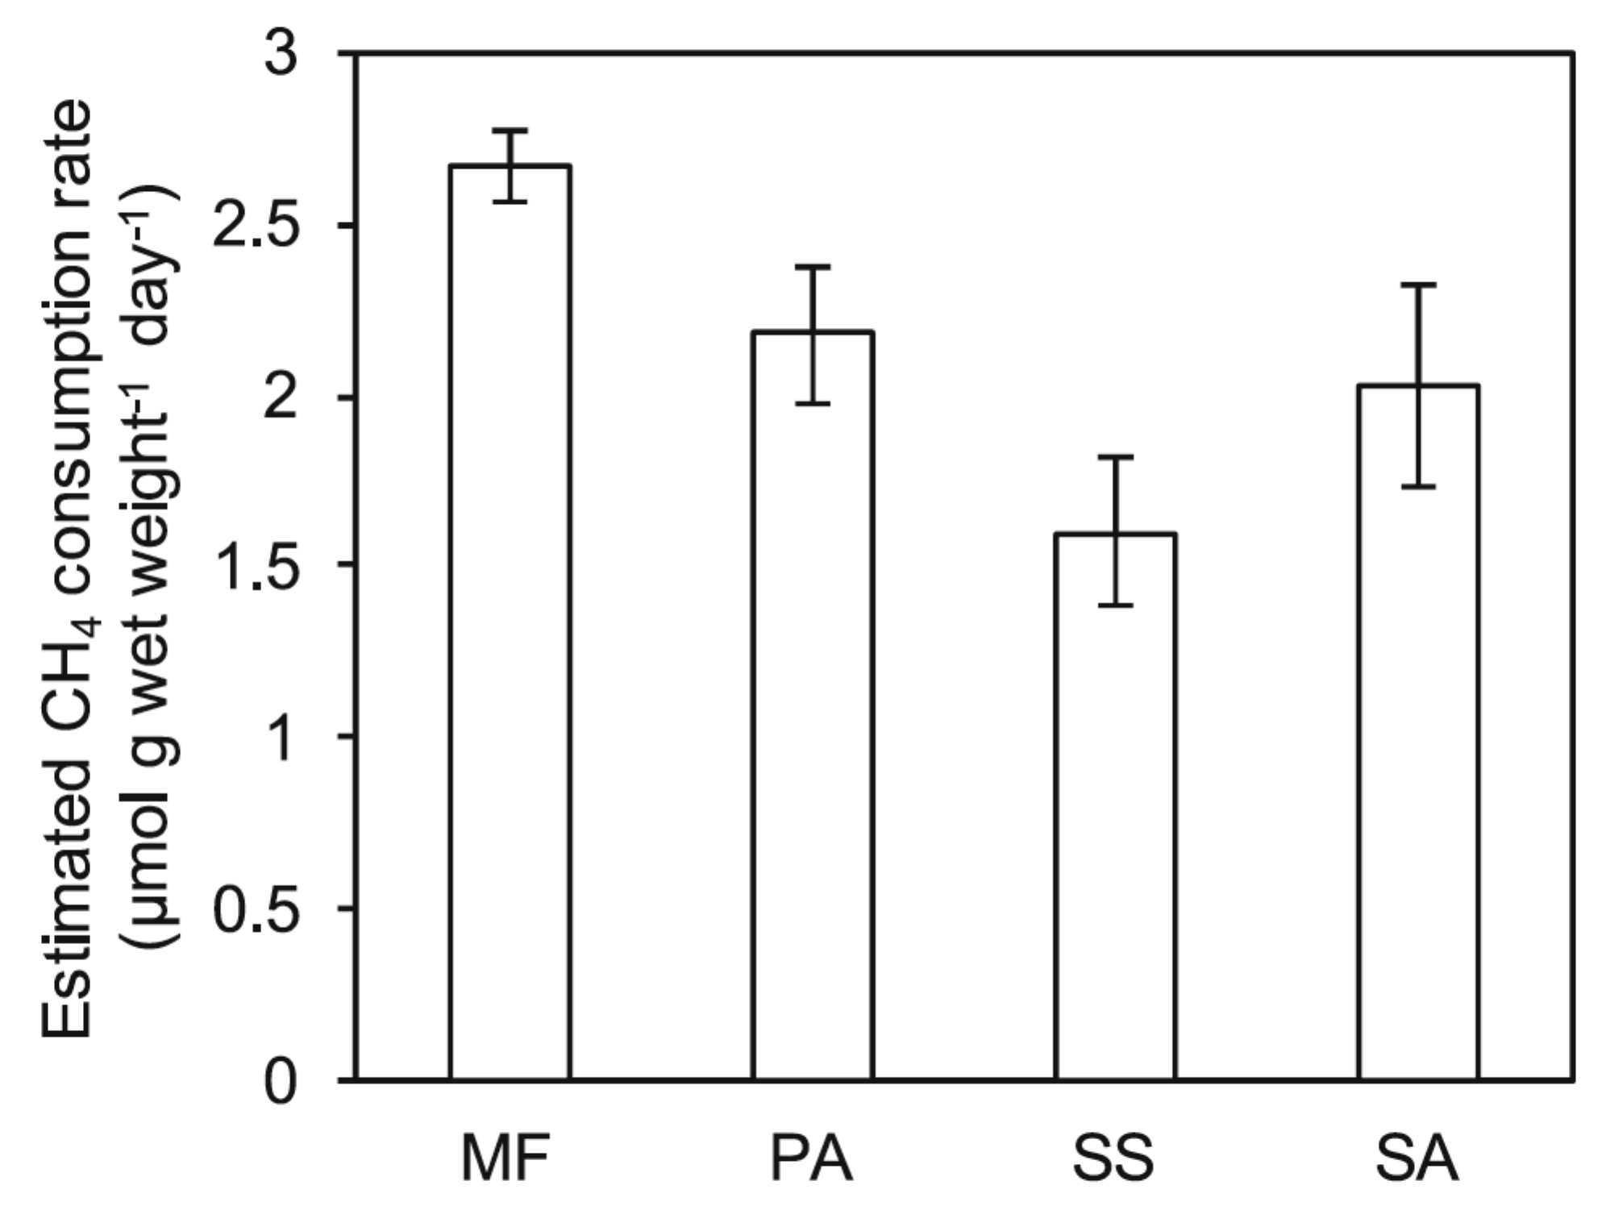

Figure 1

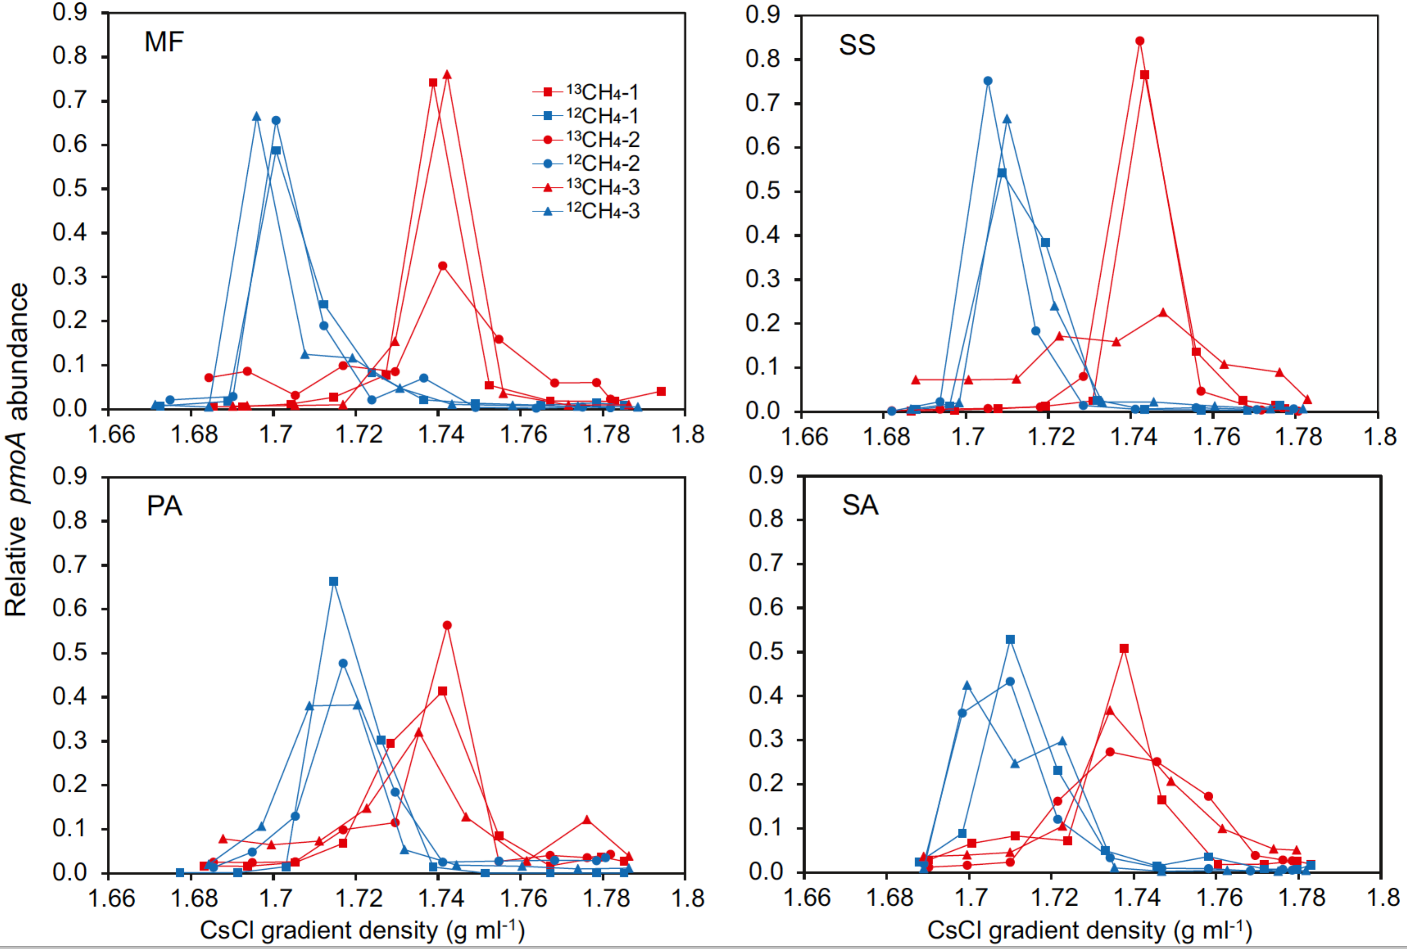

Figure 2

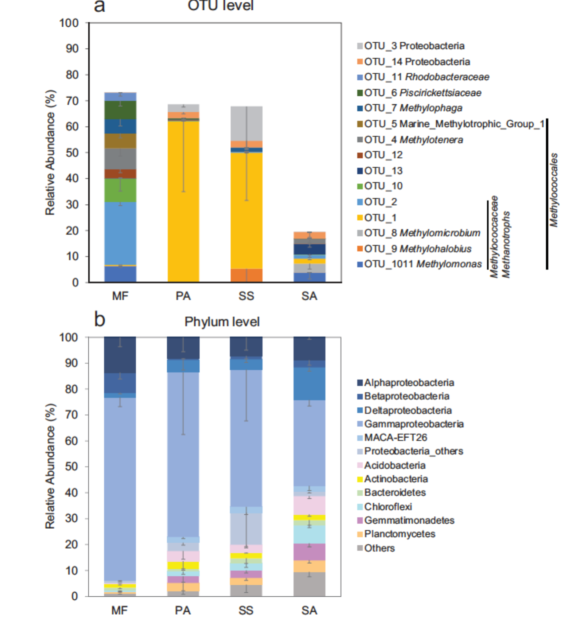

Figure 3

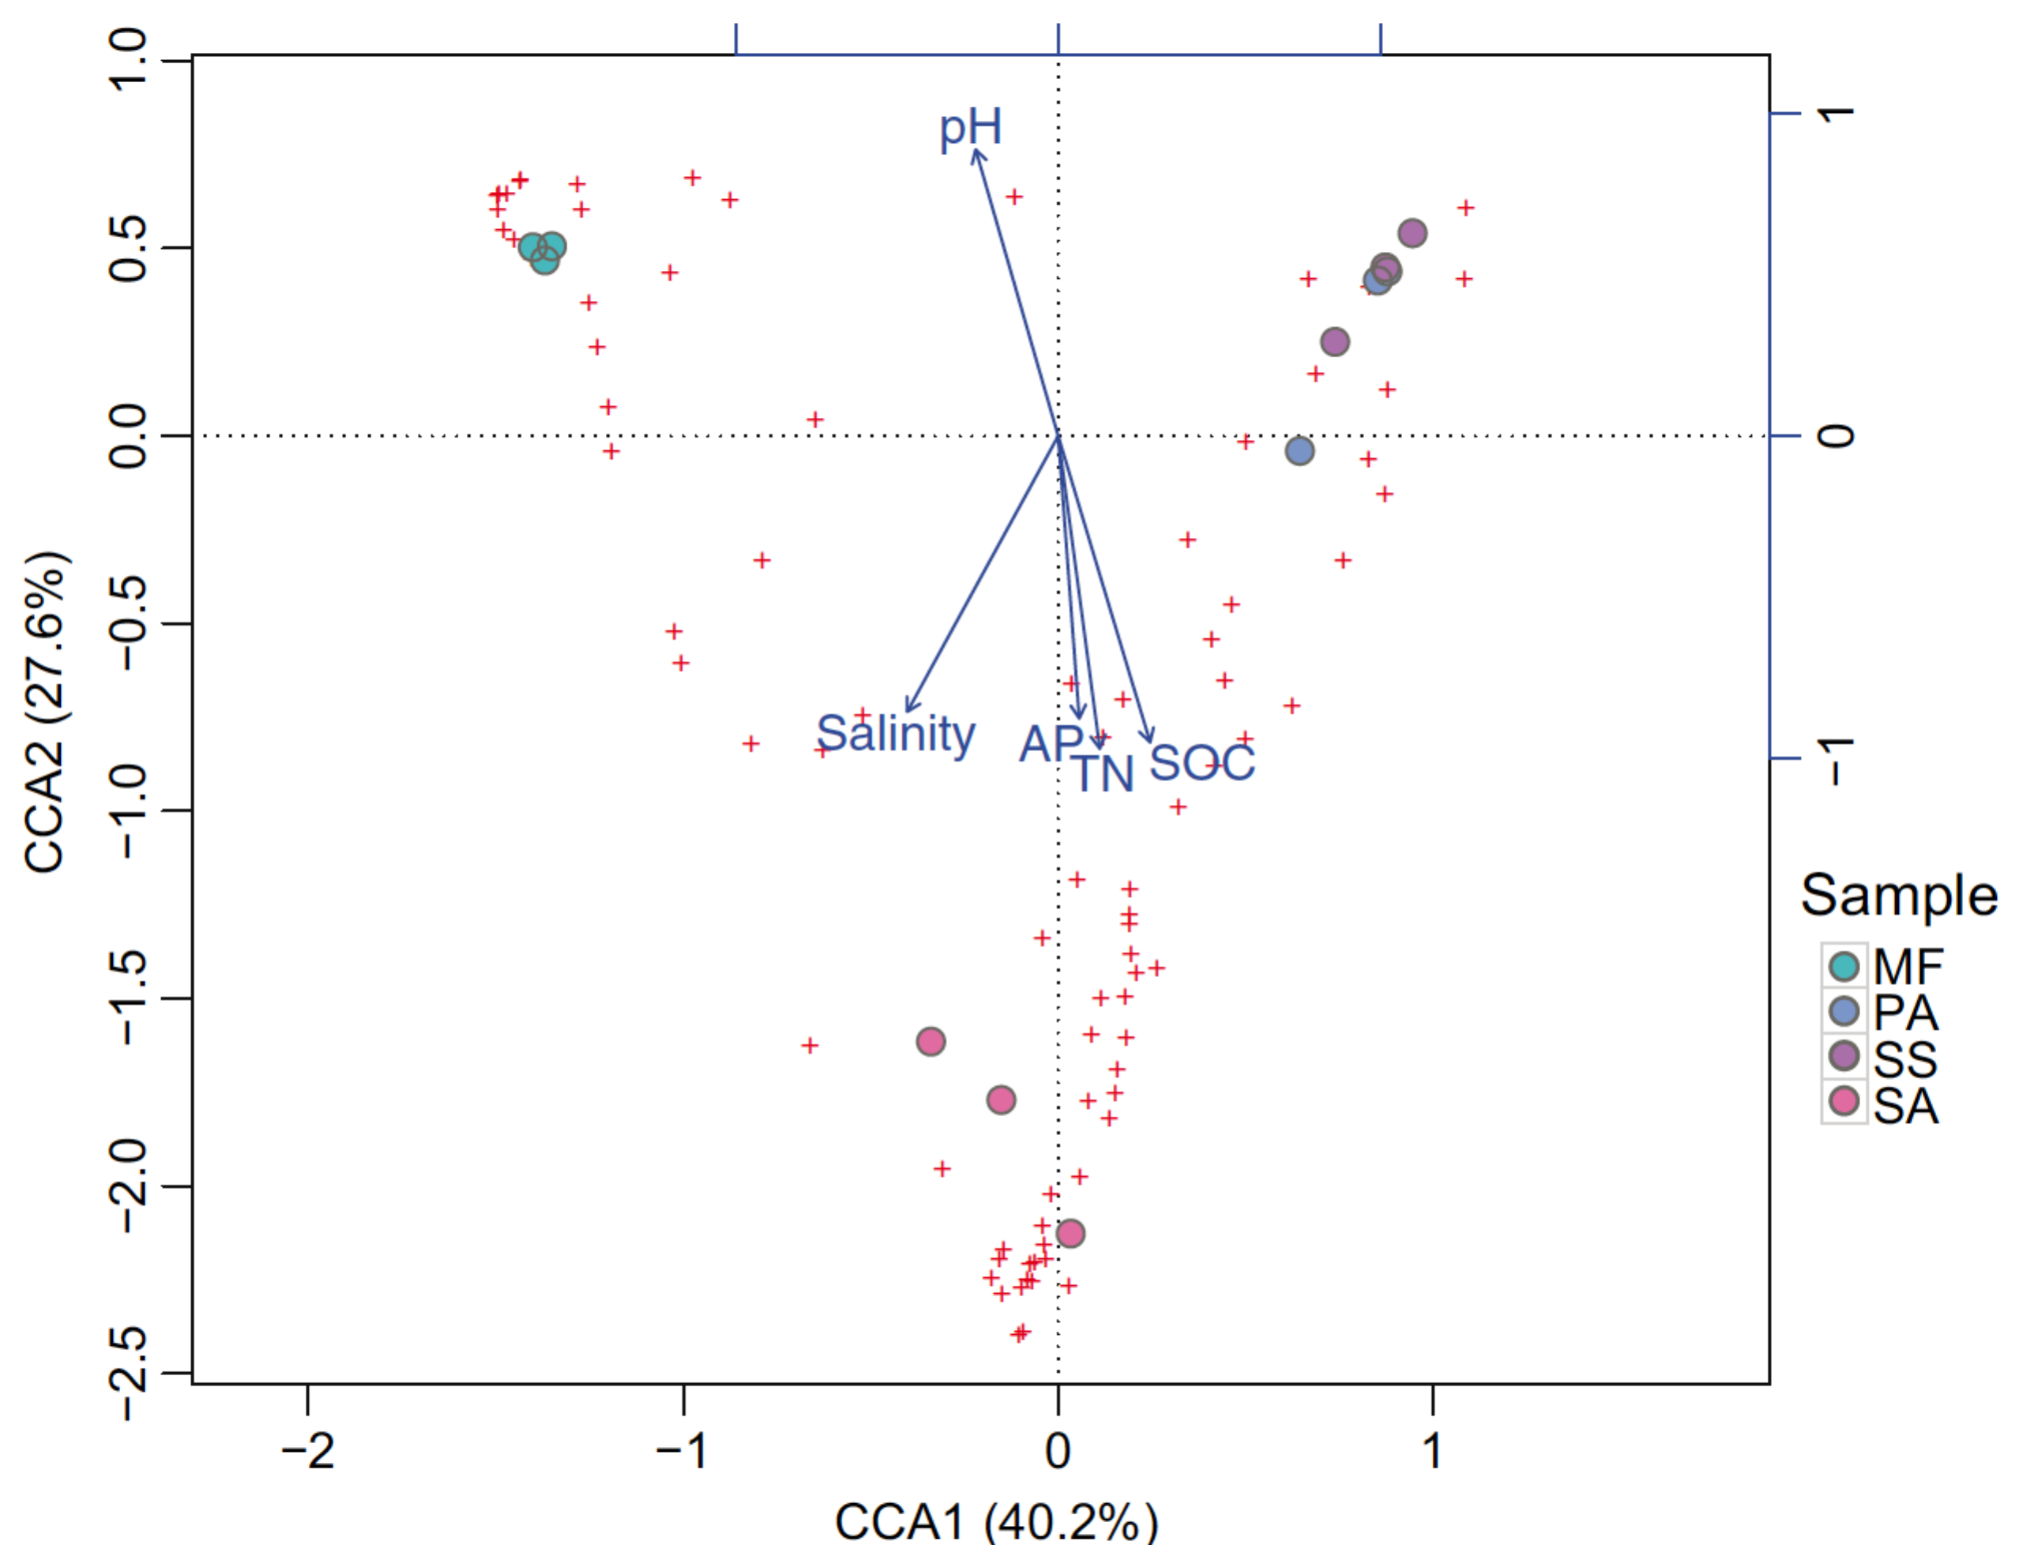
Figure 4

