ABSTRACT
The Royal Navy uses Hawk jets to simulate sea-skimming missile attacks against vessels as part of their training regulations. To best achieve these goals, pilots of the Hawk are required to fly at approximately 50 feet above sea level to accurately mimic the flight path of a missile. Despite this need the Hawk is not equipped with a radar altimeter and instead relies upon pilot skill to ensure the safe completion of the operation. Incidents whereby the Hawk jets have struck the water are however recorded, risking pilot safety. This paper explores the Hawk missile simulation task using a Systems Theoretic Accident Model and Process (STAMP) and its corresponding hazard analysis Systems-Theoretic Process Analysis (STPA) methodology to map the key stakeholders within this operation. In doing so, the method explores areas of potential risk in the system and recommends how overall systemic safety of the operation can be improved.

Key Words: STAMP-STPA; Systemic Safety; Royal Navy; Systems Thinking

During the Falklands War, 2nd April – 14th June 1982, the Royal Navy Type 42 destroyer, HMS Sheffield, was operating as part of a picket force ahead of the larger Royal Navy task force. On the 4th of May, 1982, an Exocet anti-ship missile, launched by an Argentine Navy Super Étendard fighter-bomber, struck the destroyer. The threat was not identified as a sea-skimming missile until crew aboard HMS Sheffield saw smoke rising from the missiles exhaust approximately five seconds before impact. Due to the lack of threat identification, HMS Sheffield failed to take any defensive or evasive manoeuvres to avoid the missile, and did not deploy any countermeasures, such as launching chaff or preparing defensive fire. Although evidence suggests that the missile did not detonate, heat from the missile ignited HMS Sheffield’s fuel reserve and fire engulfed the ship. This extensive fire, combined with the initial impact of the missile, resulted in the death of 20 Royal Navy seamen and the eventual foundering of the vessel, the first Royal Navy vessel sunk since the Second World War (Board of Inquiry, 1982).
Following the sinking of HMS Sheffield, the Royal Navy instigated significant procedural changes for dealing with missile attacks, including the required manoeuvres that vessels should take and immediate defensive actions that should be followed. Significantly, a need was identified to focus on crew training to enable the crew to rapidly respond to the threat of a fast approaching sea-skimming missile. Crew training needs included both detection of the incoming threat and required countermeasures to attempt to avoid the impact of the missile. To facilitate this training, during live sea training operations, the Royal Navy utilises low flying Hawk T1/1A jets to mimic the flight path of a sea-skimming missile in order to realistically train ship radar operators and gunners (Royal Navy, 2012). This training operation is conducted by the Royal Navy, and its subsidiary force, the Fleet Air Arm, without direct involvement of the Royal Air Force (RAF). The Hawk T1/1A, used in this training operation, originally known as the Hawker Siddeley, first entered service with the RAF in 1976. The Hawk T1/1A is a tandem-seat transonic ground-attack and training aircraft, with a max speed of 625mph at sea level. Traditionally flown by a forward pilot and rear seated trainer, the Hawk can also be flown and operated by a single pilot. As an older aircraft, the Hawk T1/1A does not possess a Head Up Display (HUD) and is reliant on primarily analogue gauges. The Hawk T1/1A jets used within missile training simulations have been made famous for its use by the RAF acrobatic team, the Red Arrows. Newer models of the Hawk have been developed by BAE Systems, including the Advanced Hawk, which is equipped with improved safety systems, including an integrated HUD. Advanced Hawks are not available however to the Fleet Air Arm who maintain the use of previously retired RAF T1/1A Hawks for missile simulation training.
In order to best mimic the approach of a sea-skimming missile the Hawk must be flown at very low altitudes, ideally less than 50 feet above sea level. Due to cost implications and original design specifications, the Hawk T1/1A is not fitted with a Radar Altimeter (Rad-Alt), which provides accurate measurement of the altitude of the aircraft above the sea. Indeed, to refit a single Hawk T1/1A with Rad-Alt would cost approximately £1 million, making such a refit financially unviable, particularly as the aircraft is being phased out of service. This makes flying the Hawk T1/1A at low altitude extremely difficult, and requires a high level of expertise to perform safely. This training operation therefore has significant safety implications. The pilot must rely upon visual cues to gauge altitude, whilst flying as low and as fast as possible to mimic the flight path of a missile. To illustrate the risk associated with this operation, in 2000, one Hawk T1/1A suffered a sea strike incident, whereby the jet struck the surface of the sea during a training operation (Stanton & Harvey, 2017). Although there was no resulting loss of life, the aircraft involved suffered considerable damage to its underside. To mitigate the immanent Risk to Life (RtL), the Fleet Air Arm increased the minimum altitude for the Hawk during such operations. This risk mitigation however began to erode the realism of the training operations, as the aircraft would inevitably be detected earlier than would be the case of an incoming missile in an active combat zone, allowing radar and gunnery officers and crew greater time to respond to the encroaching threat.
Despite access to fast jet and fixed-wing aircraft, the primary focus of the Fleet Air Arm has traditionally been rotary-wing and Harrier jet operations. The Fleet Air Arm has therefore historically lacked pilots skilled in fast jet operations, a prerequisite for Hawk training simulations. To reduce the risk to Hawk pilots, Royal Navy vessels and attendant crew, retired RAF pilots, independently contracted by the Fleet Air Arm, were used to fly the Hawk jets used for missile simulation training operations. The commissioned pilots had extensive experience in military fast jets, including low altitude flight, gained from their previous service within the RAF. This experience acted to provide a level of mitigation against the pilots’ RtL for the Hawk missile simulation task. Following an overhaul to British defense strategy (Strategic Defense and Security Review, October 2010), the British Government (2010) decided to retire the aging Harrier jet from active service. Due to this decisions, trainee Fleet Air Arm pilots were diverted from Harrier training into Hawk training, leading to a high number of, albeit relatively inexperienced, pilots, becoming available to the Fleet Air Arm for training operations. Due the junior pilots’ lack of experience, reassessment of the risks associated with the Hawk missile simulation task was deemed necessary. This reassessment was required to consider both the immediate risk to the pilots operating the Hawk jets but also the long-term safety of the ships crew, who require training for live combat regions in the future.
In addition to direct changes within the Fleet Air Arm, Hawk missile simulation exercises were significantly impacted by safety related cultural changes within the British Military. In 2006, RAF Nimrod XV230 suffered catastrophic mid-air explosion that resulted in the total loss of the aircraft and the deaths of all 14 personnel on-board during a standard refueling procedure. This accident was the greatest loss of life in a single incident in military aviation since the Falklands War, 1982. Following this event, the British Government requested a comprehensive review into the airworthiness and safe operation of the Nimrod aircraft and military operation more generally. This report was delivered by Haddon-Cave (2009) who concluded that safe military training operations were undermined by a safety culture that held assumptions of safety due to previous safe operations. The report suggested that a shift in organizational culture towards business and financial targets ‘at the expense of functional values such as safety and airworthiness’ (p. 355) also negatively impacted the safe completion of operations (Haddon-Cave 2009). As a consequence, Haddon-Cave (2009) recommended the establishment of an independent Military Aviation Authority (MAA) to properly assess RtL and shape future safety culture within all British military aviation arms, including the RAF and Fleet Air Arm. Following the Haddon-Cave (2009) report a culture change was seen within British military aviation resulting in a decision to assign individual accountability for RtL assessments to ‘Duty Holders’ (DH), where previously responsibility for risk had been held at the organization level. The newly established MAA produced guidelines for the assessment of RtL, in the form of the Defense Aviation Hazard Risk Matrix (MAA, 2011), which supports the classification of single risks according to their estimated severity (catastrophic, critical, major, minor) and likelihood (frequent, occasional, remote, improbable). The resulting risk level determines at which level of DH the risk is held.
The goal of safety management within the UK military is to reduce risk to a level which is As Low As Reasonably Practicable (ALARP): this is reached when ‘the cost of further reduction is grossly disproportionate to the benefits of risk reduction’ (Ministry of Defence, 2007). In order to reduce the associated RtL of the Hawk missile simulation training exercise to a level that was ALARP, a decision was taken by the Royal Navy, with Subject Matter Expert (SME) advice, to increase the minimum height above sea level that the Hawks were allowed to safely operate. Taken with previous altitude increases, this decision further degraded. By flying at an increased altitude, the Hawk can no longer accurately simulate sea-skimming missile attacks on surface ships thereby denigrating Royal Navy surface fleet and ships crew training against very low-level targets.
In addition to organisational changes, safety and risk assessment within British military aviation underwent a series of cultural changes following the Haddon-Cave (2009) report. Traditionally, the Royal Navy and Fleet Air Arm relied upon quantitative risk assessment techniques including Technique for Human Error Rate Prediction (THERP; Swain, 1964; Swain & Guttmann, 1983; Boring, 2012) and Systematic Human Error Reduction and Prediction Approach (SHERPA; Embrey, 1986). These techniques quantitatively model the probability of humans within the system making an error, reminiscent of Fault Tree Analysis (FTA; Barlow, 1973). Within the developing safety culture changes however, the British Military holds the growing acceptance that such methods can be seen as reductionist and can fail to actively attribute the risks associated with the interactions of different subsystems. This acceptance matches a wider trend in safety research within academic research towards system-based approaches (Walker, Salmon, Bedinger, & Stanton, 2017; Salmon et al., 2017). To this end, the military has sought to increase the use of systemic approaches to safety to augment previously completed assessments. Of the developed systemic approaches within the larger academic literature, Systems Theoretic Accident Model and Process (STAMP) approach (Leveson, 2004) and its corresponding hazard analysis Systems-Theoretic Process Analysis (STPA) has become the most prolific and widely cited (Underwood & Waterson, 2012). STAMP-STPA has been used to explore system safety across a variety of domains including road transport (Salmon, Read, & Stevens, 2016), rail accidents (Underwood, & Waterson, 2014) and potential aviation accidents (Allison, Revell, Sears & Stanton, 2017).
Despite its clear domain agnostic utility, STAMP-STPA has been less used within the military domain (Pereira, Lee & Howard, 2006), especially in relationship to training paradigms. Indeed, development of the systemic approach to address safety within military systems of systems has been a significant challenge to date. Within STAMP-STPA, systems can be viewed as “interrelated components that are kept in a state of dynamic equilibrium by feedback loops of information and control.” (p. 250, Leveson, 2004). STAMP-STPA can be seen as advantageous over the linear fault and error methods such as THERP (Swain, 1964; Swain & Guttmann, 1983; Boring, 2012) and FTA (Barlow, 1973) previously used within the military domain in that it seeks to improve the safety of the system as a system as a whole, rather than attribute blame on individual personnel for an accident. To achieve this, STAMP-STPA considers the role of individuals, organizations and technology within the same analysis. This allows safety to be considered as a dynamic, as apposed to linear, process, characterised by feedforward and feedback, from both human, technological and organizational agents. The identification of the non-linear, interactive, coupling between different stakeholders and the constraints imposed by the different stakeholders, makes STAMP-STPA ideal for understanding complex systems (Leveson, 2004) and systems of systems (Salmon et al., 2012; Harvey & Stanton, 2014; Allison et al., 2017). STAMP-STPA analysis therefore provides a model of potential accidents, which Leveson (2011) describes as an ideal basis for investigation, analysis, prevention and risk assessment
This paper aims to assess the risk to life that surrounds the Hawk missile simulation scenario and identify the primary stakeholders within the system of systems. To achieve these aims, a STAMP-STPA analysis of the Hawk missile simulation scenario was undertaken. As discussed, previous risk assessment strategies used by the Royal Navy have been viewed as reductionist and have historically failed to ensure safe operations. By offering a systemic approach to safety, it is argued that STAMP-STPA can provide novel safety insights, not offered by methods previously used within the military. STAMP-STPA methodology has seen limited application within the military domain, this work therefore offers a novel use of this approach.

METHOD
SME INVOLVEMENT
Understanding of the Hawk RtL case study was gained through and initial workshop and subsequent interviews with SMEs. An initial workshop was conducted with nine independent SMEs. Eight SMEs were military and industrial stakeholders who had a job role focused in developing military safety culture following the Haddon-Cave (2009) report. The final SME participant was an independent industry Human Factors professional. During this workshop, the Hawk RtL scenario was explored and key stakeholders were identified.
To achieve a greater understanding, analysts were provided with detailed overview of the Hawk RtL scenario in a subsequent interview with an SME from Air Command, a senior Wing Commander. This resulted in a detailed account of the missile simulation task, which was further supplemented by information available within official documentation including Military Aviation Authority guidelines (MAA regulatory publications, 2016), and Flag Officer Sea Training (FOST) guidance (International Defence Training Royal Navy, n.d.). Two analysts completed a second, in-depth interview with the same Air Command SME for greater insight and clarification. During the second interview, the ten characteristics of a system of systems (Harvey & Stanton, 2014) were used to structure the discussion and elicit detailed information about Hawk operations for missile simulation training.
Upon completion of the analysis, findings were presented to an independent team of SMEs who had considerable experience working in the defence sector and with previous safety experience for review, comment and feedback.

CONSTRUCTION OF THE MODEL
Systems Theoretic Accident Model and Process (STAMP)
The cornerstone of the STAMP methodology is the identification of the stakeholders at all levels within the system, and the constraints that they impose on other stakeholders (Leveson, 2004). The control structure represents the highest level of abstraction within the system of systems (Harvey & Stanton, 2014). By organising the layers of constraints that link these stakeholders, it is possible to develop a hierarchical control structure that maps the systems under investigation (Stanton et al., 2013). The initial step of the STAMP analysis therefore involves the construction of a high-level hierarchical control structure. The control structure maps the system of systems under investigation and identifies all the stakeholders that contribute to the system.
These stakeholders are linked by control actions, typically represented by labelled arrows. Control actions constitute the main source of feedback and interaction between the different stakeholders. Some control actions are continuously performed during the scenario under investigation whilst others denote intermittent actions, for example an action performed after an event has occurred.
Systems-Theoretic Process Analysis (STPA)
Systems-Theoretic Process Analysis (STPA, Leveson, 2004, 2011) is used to make predictions about the future safety of systems; based on control theory and the use of consistent guide sentences. STAMP-STPA views systems as interrelated components linked by loops, which control the flow of information within the system and, therefore, maintain a state of dynamic equilibrium (Leveson, 2011). A key concept in STAMP-STPA is that of constraints: accidents occur not due to the occurrence of an event; rather accidents are the result of a lack of appropriate constraints applied at points within the control structure (i.e. feed-forward and feedback loops). Representing interactions within a system as a hierarchy of control loops allows these constraints to be identified. STPA maps these control loops and identifies potential Unsafe Control Actions (UCAs) through the use of a standardised off-nominal taxonomy. The off-nominal taxonomy is driven by the use of four guide sentences:
1) Action required but not provided;
2) Unsafe action provided;
3) Incorrect timing / order;
4) Stopped too soon / applied too long.
These guide sentences are set as part of the standardised STPA methodology (Leveson, 2004) and are applied to each of the control actions that were identified in the initial stage. The guide sentences are designed to allow analysts to identify all potential UCAs within the system and elicit all the possible failings in order to create the complete failure taxonomy. When applying these guide sentences, each may generate multiple UCAs, equally when exploring some systems not all are applicable in all cases.
For the final stage of the analysis, the causes for the UCAs can be explored by constructing feedback loops for identified UCAs. This enables the researchers to examine how multiple UCAs can interact as well as explore the causal factors behind the UCAs. Once this stage is complete it is possible to begin to develop safety constraints for each of the potential UCAs. These are constraints that should be imposed on the system to prevent the UCAs from occurring, reducing the likelihood of an accident (Leveson, 2004). In this regard, the addition of novel safety constraints allows the analysts to progress the STAMP-STPA methodology to allow for the development of potential mitigation strategies.
As discussed, STAMP-STPA follows an established step-by-step process to construct a control structure, identify potential UCAs and identify interactions and causal factors. Before this can be completed however, the primary hazards of the scenario under investigation must be identified. The STAMP model defines a hazard as “A system state or set of conditions that, together with a particular set of worst-case environmental conditions, will lead to an accident (loss)” (p14, Thomas, et al., 2013). As an example, an accident could be the exposure of people to toxic chemicals and the related hazard would be the release of toxic chemicals into the atmosphere (Thomas et al., 2013). Prior to the start of the analysis, the research team were required to define the potential hazards that could lead to an accident. In the Hawk RtL case study, a potential accident was defined as any event leading to death or injury, with the potential hazards being defined as:
- Hawk strikes the sea
- Hawk strikes the Frigate
- Inadequate training of Frigate crew for future missile attack
The initial risks relating to the Hawk are primarily concerned with the Hawk flying at low altitude. Should the Hawk strikes the sea, as occurred within the incident in 2000, the aircraft is likely to suffer considerable damage, risking the pilot’s safety and the airworthiness of the aircraft. Should the aircraft strike the frigate, the Hawk itself is likely to suffer catastrophic damage, providing substantial risk to the pilot’s safety. The Frigate is also likely to suffer significant damage, risking the lives of crew and potentially seaworthiness of the vessel. Should the Hawk fail to fly at low altitude, the Hawk will appear on the frigate’s radar earlier than an incoming missile would. This would result in the incomplete training of the frigates crew, potentially endangering the lives of the crew in future live fire conflict zones. The current analysis developed the control structure and Control Actions associated with the Hawk missile simulation task in order to avoid these potentially fatal consequences.

RESULTS AND DISCUSSION

Following STAMP-STPA procedure, the mapped control structure for Hawk missile simulation task is shown in Figure 1. The developed control structure takes a hierarchical form, with the addition of the ‘Sea’ component operating in parallel, linking to the pilot and frigate crew. Seven stakeholders were identified, Military Aviation Authority, who operates as regulator, Duty Holder, Pilot, Hawk Jet, Frigate, Crew and the Sea. Each of the seven stakeholders are linked by unique Control Actions, mapping the stakeholder relationships.

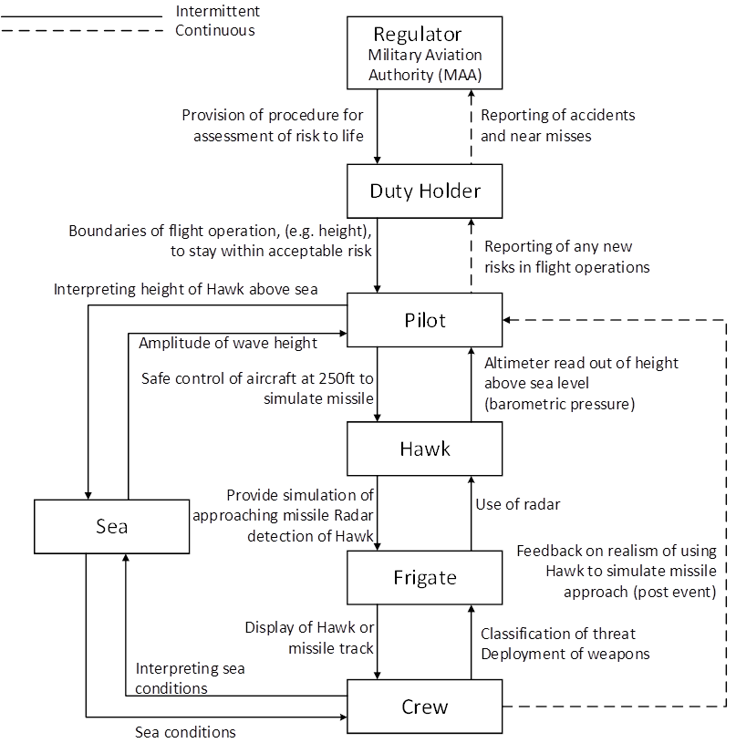
Figure 1 Control structure for the Hawk Risk to Life (RtL) case study
Working through the control structure presented in Figure 1, the Regulator, the Military Aviation Authority (MAA), provides the Duty Holder with assessment procedures for the Hawk RtL scenario. The MAA acts as the single regulatory authority responsible for regulating all aspects of air safety across British defense. The MAA has full oversight of all defence aviation activity, including the operation of the Hawk RtL scenario. A key directive of the MAA is to maintain appropriate standards of air safety (ALARP) within defense operations. The duty holder’s prime role is to take responsibility for implementing effective Aviation Safety Management Systems and ensuring that their air operations are at all times conducted at a level of safety that is at least ALARP, as laid out in MAA Regulatory Article 1022. In practical terms, the key role of the duty holder is to provide pilots with the boundaries of flight operations to stay within what is judged acceptable risk. The pilot is responsible for the safe control of the aircraft within these boundaries. The pilot is required to use readings provided by the on-board sensors to accurately simulate a potential missile attack and provide an accurate radar image to the frigate. The radar sensors of the frigate detect an object that is approaching the vessel rapidly. The crew of the frigate is required to classify an event like this as threat that requires preparation of its defense weapons. The frigate’s radar continues to track the objects progress towards the vessel. During this time, the frigates crew executes all required defense operations. Once the exercise is complete, the pilot is required to report to the duty holder any new risks that have been identified within the missile simulation exercise. The Duty Holder has a responsibility to report to the Regulator any accidents or near misses. Operating in parallel to the primary control structure is the sea, which is a key stakeholder with the operation. The sea is not static during the simulation exercise but rather subject to different weather conditions. The pilot must frequently interpret the height of the Hawk above the sea to ensure safe operations. The sea also provides key conditional variable for the crew of the frigate to interpret. Sea conditions can impact the potential countermeasures available to avoid the simulated missile strike, whether the frigate is required to “destroy” the simulated missile, using on board defensive weapons or undertake maneuvers to avoid the strike.
Based on the control structure presented within Figure 1, each of the control actions were considered in turn to compile a failure taxonomy using the standardised STAMP-STPA method as discussed previously. In total, 88 UCAs were identified for the Hawk RtL case study. Examples of generated UCAs using each of the guide sentences are provided in Table 1.
Table 1 Example analysis of two control actions against STPA guide sentences
Control action | From | To | Guide sentence | Unsafe control action
Provision of procedures for assessment of RtL | Regulator | Duty Holder | Action required but not provided | Fail to provide procedures for RtL assessment
 |  |  | Unsafe action provided | Provide wrong procedures for RtL assessment
 |  |  | Incorrect order / timing | Provide RtL procedures too late
 |  |  | Stopped too soon / applied too long | RtL process overly complex and bureaucratic
 |  |  |  | RtL process too vague
Safe control of aircraft at 250 feet, to simulate missile | Pilot | Hawk | Action required but not provided | Failure to maintain safe control of the aircraft below 250 feet
 |  |  | Action required but not provided | Failure to maintain safe control of the aircraft above 250 feet
 |  |  | Stopped too soon / applied too long | Move out of safe altitude too early
 |  |  | Stopped too soon / applied too long | Move out of safe altitude too late

*RtL Risk to Life
Safety constraints were defined for each of the identified UCAs. The safety constraints for the example UCAs presented in Table 1 are presented in Table 2. Safety constraints were however generated for all 88 identified UCAs, and are presented within the appendix.

Table 2 Example analysis of safety constraints assigned to UCAs
Unsafe Control Action | Safety Constraint
Fail to provide procedures for RtL assessment | Must provide procedures for RtL assessment
Provide wrong procedures for RtL assessment | Must provide correct procedures for RtL assessment
Provide RtL procedures too late | Must provide procedures for RtL assessment in sufficient time
RtL process overly complex and bureaucratic | RtL process should not be overly complex and bureaucratic
RtL process too vague | RtL process should not be too vague
Failure to maintain safe control of the aircraft below 250 feet | Must maintain safe control of aircraft
Failure to maintain safe control of the aircraft above 250 feet | Must maintain safe control of aircraft
Move out of safe altitude too early | Hawk must stay at correct altitude for appropriate duration
Move out of safe altitude too late | Hawk must stay at correct altitude for appropriate duration
*RtL Risk to Life
Example mapping of UCAs is illustrated for two of the UCAs described in Table 2 above: “fail to provide procedures for RtL” (Figure 2) and “failure to maintain safe control of the aircraft below 250 feet” (Figure 3). Figure 2 shows that for the UCA of “fail to provide procedures for RtL”, the regulator may fail to define procedures for RtL assessment due to an incorrect, incomplete or inconsistent process model relating to current regulations, previous incidents/ accidents, risk assessment procedures or the definition of risk likelihood or severity. This in turn can result in a failure to document procedures, and/ or a failure to provide the documentation to required parties. Further risks are identified in that the regulator, the MAA, is required to ensure that duty holders receive all appropriate documentation. Duty holders are required to use this documentation and establish suitable procedures for RtL assessments, and to ensure that RtL assessments are carried out. Mirroring the relationship between regulator and duty holder, the duty holder also has responsibility to feedback RtL assessments back to the regulator. Within this example, no mechanical failure endangers the safety of either the pilot of the Hawk or the crew of the Frigate. Such a relationship would be traditionally not be considered by the safety approaches used within the British military. This relationship, highlighted by the STAMP-STPA analysis is however crucial for ensuring the safety of the overall training operation.
With the risk of “failure to maintain safe control of the aircraft below 250 feet” (Figure 3) the pilot may fail to understand or input the correct control actions to the Hawk due to an incorrect, incomplete or inconsistent process model relating to the required control inputs, feedback from the aircraft or safety regulations for flying below 250 feet. Alternatively, there could be a failure of aircraft controls, whereby the aircraft does not respond to the control inputs of the pilot. This lack of control response suggests a failure of aircraft components, and would result in the Hawks behaviour becoming unsafe. Further component failure could result in feedback not being received by the pilot, leading to, or reinforcing, the pilots misunderstanding of required control inputs. Although the failures identified within this example are not unique to the STAMP-STPA approach, this example does demonstrate the utility of the method. In addition to identifying potential areas of unsafe operations within stakeholder relationships, STAMP-STPA is also able to identify the risks and consequence of component failure.

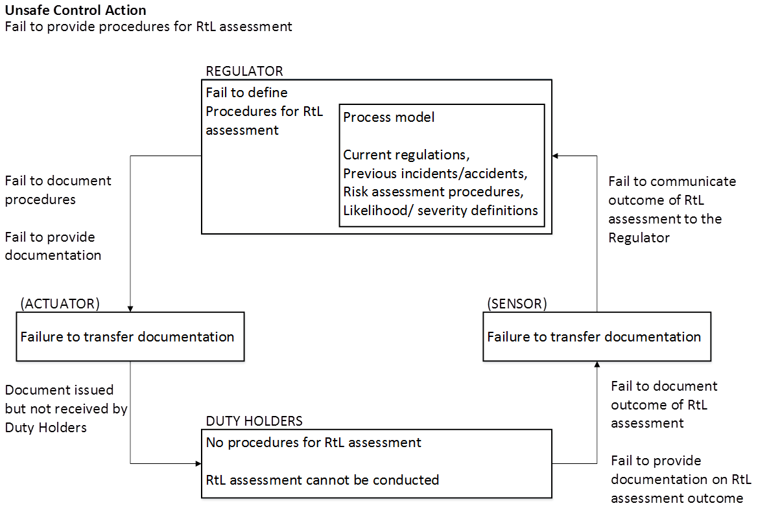

Figure 2. Causal factors identified for the UCA ‘fail to provide procedures for RtL assessment’, between the regulator and duty holder.

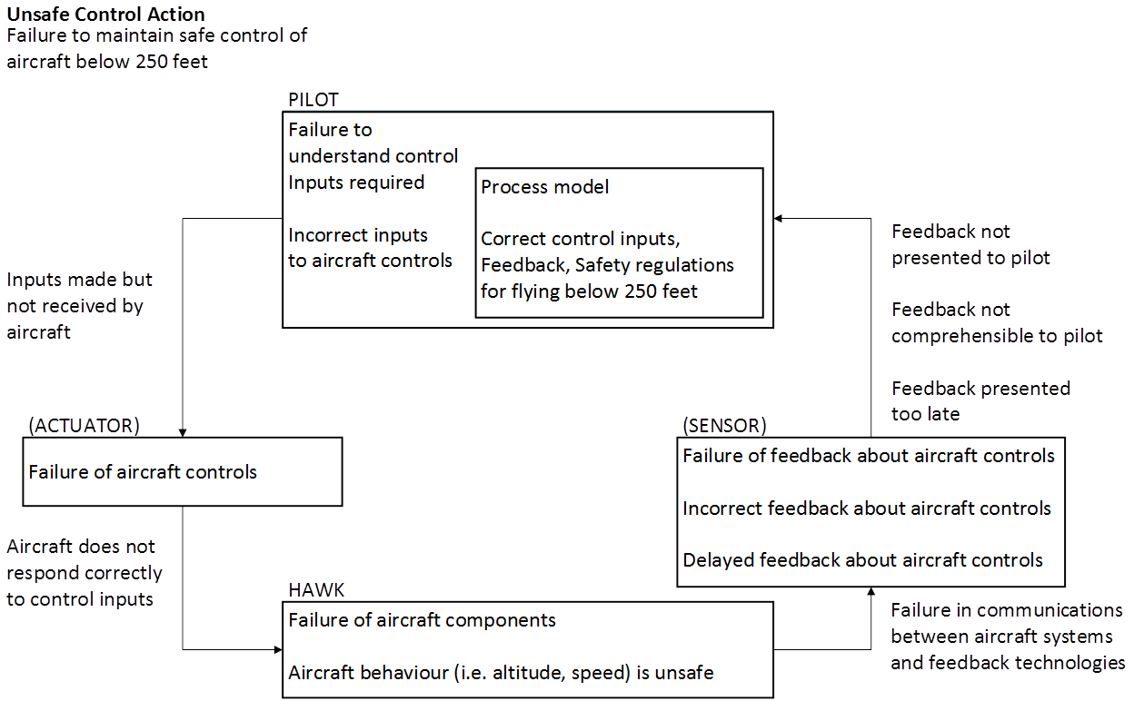

Figure 3. Causal factors identified for the UCA ‘failure to maintain safe control of aircraft below 250 feet’, between the pilot and hawk

Each of the 88 UCAs identified within this work lead to the generation of a corresponding safety constraint designed to minimise the likelihood of each UCA occurring. Each safety constraint is presented within the appendix. Generated safety constraints fell into three main categories: 1) ensuring proper adherence to established procedures; 2) ensuring operations are adequately followed; and 3) ensuring sufficient training and experience is both possessed and generated by individuals operating within the system. By adequately employing the generated safety constraints the likelihood of an incident or an accident occurring can be reduced (Leveson, 2004). Each of these categories, and how the application of exemplar safety constraints can be used to improve the safety of the system, will be discussed in turn.
Interviews with SMEs and official documentation revealed that extensive procedures are in place governing the Hawk missile simulation scenario, including predetermined minimum altitudes for the Hawk to operate. The present analysis highlighted that operational requirements must be followed to maintain a valuable and safe exercise, Within this scenario, the clearest example of this action is the pilot must ensure the “Safe control of the aircraft at approximately 250 feet to simulate missile”. To achieve this goal it is essential that the pilot maintains safe control of the Hawk and must stay at a maximum 250 feet for the duration of the exercise. By flying higher than this altitude, the aircraft would appear on radar considerably sooner than would be the case of a sea-skimming missile, defeating the purpose of the exercise. Flying significantly lower than this level however risks the safety of the pilot and risks a repeat of the sea strike incident of 2000 (Stanton & Harvey, 2017), as discussed previously. Priority at all times must be given to the pilots’ safety however, in order to ensure that the aircraft is under control.
The Hawk missile simulation task is associated with considerable risks. Immediate risk is placed upon the pilot, due to the need to fly low and fast over the sea, with no accurate reading of altitude available. The pilot is reliant on visual cues of wave height and information provided by the Hawk’s barometric pressure altimeter, which can be inaccurate at very low altitude. To achieve these goals, the pilot must regularly interpret their height above the sea, allowing for sufficient time to respond to changes in wave amplitude and dynamics. Ensuring that Hawk pilots possess sufficient experience in fast, low altitude, operations is therefore essential in maintaining safety. As noted previously, retired RAF pilots are no longer commissioned to this training exercise but instead rather more junior Fleet Air Arm pilots are utilised. Appropriate procedures are essential in ensuring that the selected pilots possess the required experience to be able to complete these goals.
Secondary risk is placed upon the Frigate and its attending crew. Frigate and crew are at direct risk of potential impact with the Hawk, should the pilot collide with the ships superstructure, by flying too low. Equally the Frigate and crew are also at risk of not receiving sufficient training should the Hawk approach too high. The Hawk missile simulation task provides essential training for crew to be able to accurate classify and take suitable action against such potential incoming threats. By ensuring that crew training is adequate, future safety, including potentially within a live combat region, is improved. It is therefore essential that the Hawk missile simulation task generates sufficient experience and training for the crew of the frigate. The use and value of simulation training has seen across work domains and is now standard practice within aviation, medicine and the military (Salas, Wilson, Burke, & Priest, 2005). Ensuring the simulation is representative of the real event is however paramount, reinforcing the Hawks requirement to fly as low and fast as possible to accurately mimic the flight profile of a sea-skimming missile.
The use of STAMP-STPA (Leveson, 2004; 2011) has provided a novel approach to examine where risk could emerge in the highly controlled Hawk missile simulation task. The use of a systemic approach to safety has allowed the researchers to consider a significantly wider array of risks, especially those relating to human-system interactions, than those previously identified using methods previously utilised by the Fleet Air Arm, including FTA (Barlow, 1973) and THERP (Swain, 1964 Swain & Guttmann, 1983; Boring, 2012). The use of the STAMP-STPA approach is however highly time consuming and reliant on the knowledge of both the SMEs available and the research team undertaking the analysis. Work is therefore needed within the safety community to provide support for systemic safety analysis, including STAMP-STPA to improve the availability of these tools. Dedicated software tools supporting such analysis are currently lacking and would be beneficial to increase the efficiency and level of fidelity of the analysis.
The STAMP-STPA framework (Leveson, 2004; 2011) has been deployed within this study to explore the Hawk missile simulation task from a highly abstract perspective, using declassified information. Future detailed work is needed to explore the individual stakeholders that operate within all levels of the system in order to ensure that each stakeholder is operating as safely as they can. The analysis can also be extended to explore the potential safety implication of alternative military training operations, for example joint service operations, to examine whether the insights gained from the current investigation can be applied more universally. Finally, it would be beneficial to directly compare the insights gained from STAMP-STPA to alternative systemic safety methods such as Functional Resonance Analysis Method (FRAM; Hollnagel, 2012), Accimaps (Rasmussen, 1997), and Event Analysis of Systemic Teamwork (EAST) (Stanton, Baber, & Harris, 2008; Stanton, Salmon & Walker, 2018). This is especially apt when considering that EAST Broken Links approach has previously been used to empirically explore the same training scenario (Stanton & Harvey, 2017). Whilst Underwood and Waterson (2014) suggests that STAMP-STPA method, as applied within the current paper, offers the most comprehensive approach to exploring systemic safety, the use of alternative methods could provide additional benefit. Underwood and Waterson (2014) undertook an extensive comparison between STAMP-STPA and Accimaps and found that despite considerable differences between the two approaches, both offered unique insights when examining a rail accident. It would therefore be prudent to utilise alternative metrics to examine the relative benefits and limitation of different approaches.

CONCLUSIONS
The current work has applied the STAMP-STPA method (Leveson, 2004) to examine Royal Navy Hawk missile simulation training. An evolving safety culture within the British Military as well as previous incidents within this specific training exercise have highlighted the need for modern approaches to safety within this task.
A control structure, mapping all key stakeholders within the Hawk missile simulation exercise was generated using STAMP. This was furthered to elicit 88 potential UCAs by applying STPA. Finally, initial safety constraints have been provided for each identified UCA in order to reduce the likelihood of each UCA arising and to improve overall systemic safety. The developed safety constraints focused on ensuring adherence to require procedures, ensuring required operations are completed safely, and ensuring adequate training for all agents within the system. It is argued that the STAMP-STPA approach offered qualitatively different insights that would be offered using traditional safety tools currently used within the military domain. The use of a systemic approach has highlighted the importance of pre-existing stakeholder relationships and the interactions between these different organisations and individuals, factors that had not been previously considered within this military training exercise. It is concluded therefore that the STAMP-STPA approach is not only valid within the military domain, but can offer unique insights, essential in improving overall systemic safety.

GLOSASARY OF TERMS
ALARP As Low As Reasonably Practicable
DH Duty Holder
EAST Event Analysis of Systemic Teamwork
FOST Flag Officer Sea Training
FRAM Functional Resonance Analysis Method
FTA Fault Tree Analysis
HUD Head Up Display
MAA Military Aviation Authority
Rad-Alt Radar Altimeter
RAF Royal Air Force
RtL Risk to Life
SHERPA Systematic Human Error Reduction and Prediction Approach
SME Subject Matter Expert
STAMP Systems Theoretic Accident Model and Process
STPA Systems Theoretic Process Analysis
THERP Technique for Human Error Rate Prediction
UCA(s) Unsafe Control Action(s)

ACKNOWLEDGEMENTS
The authors would like to thank Wing Commander Neil Bing (Bingo) of Air Cap So1 Lightning, RAF High Wycombe, for his account of the Hawk Risk-to-Life case study and his very valuable insights into the challenges faced by this complex Sociotechnical System.
This work was part-funded by the Defense Human Capability Science and Technology Centre (DHCSTC) grant reference TIN 2.002.

REFERENCES
Allison, C. K., Revell, K. M., Sears, R., & Stanton, N. A. (2017). Systems Theoretic Accident Model and Process (STAMP) safety modelling applied to an aircraft rapid decompression event. Safety Science, 98, 159-166.
Arnzen, H. E. (1964). Failure Mode and Effect Analysis. A powerful engineering tool for component and system optimization.
Barlow, R. E. (1973). Fault Tree Analysis. John Wiley & Sons, Inc.
Board of Inquiry (1982) Loss of HMS Sheffield. Retrieved August 1st 2017, from http://www.admiraltytrilogy.com/read/BOI_Rpt_HMS_Sheffield_May82.pdf
Boring, R. L. (2012). Fifty years of THERP and human reliability analysis (No. INL/CON-12-25623). Idaho National Laboratory (INL).
Carlock, P. G., & Fenton, R. E. (2001). System of Systems (SoS) enterprise systems engineering for information‐intensive organizations. Systems Engineering, 4(4), 242-261.
Embrey, D. E. (1986). SHERPA: A systematic human error reduction and prediction approach. In Proceedings of the international topical meeting on advances in human factors in nuclear power systems. Knoxville, TN, USA.
H M Government (2010). Securing Britain in an age of uncertainty: the strategic defence and security review. London: The Stationery Office.
Haddon-Cave, C. (2009). The Nimrod review. An independent review into broader issues surrounding the loss of the RAF Nimrod MR2 aircraft XV230 in Afghanistan in 2006. London: The Stationery Office, UK.
Hadian, S., & Madani, K. (2015). A system of systems approach to energy sustainability assessment: Are all renewables really green? Ecological Indicators, 52, 194-206.
Harris, D., & Stanton, N. A. (2010). Aviation as a system of systems: Preface to the special issue of human factors in aviation. Ergonomics, 53 (2), 145 – 148.
Harvey, C., & Stanton, N. A. (2014). Safety in System-of-Systems: Ten Key Challenges. Safety Science, 70, 358-366.

Hollnagel, E. (2012). FRAM, the functional resonance analysis method: modeling complex socio-technical systems. Ashgate Publishing. Ashgate, Farnham, UK
International Defence Training, Royal Navy (n.d.) Flag Officer Sea Training. Retrieved August 5th 2017, from http://webarchive.nationalarchives.gov.uk/20121109043853/http://www.mod.uk/NR/rdonlyres/F1316923-78C0-45C4-819B-512919DA153B/0/flagofficerseatraining.pdf
Leveson, N. (2004). A new accident model for engineering safer systems. Safety science, 42(4), 237-270.
Leveson, N. (2011). Engineering a Safer World: Systems Thinking Applied to Safety. Cambridge, MA, USA: MIT Press.
Leveson, N. G., Daouk, M., Dulac, N., & Marais, K. (2003). Applying STAMP in accident analysis. Second Workshop on the Investigation and Reporting of Accidents, Williamsburg, September 2003.
MAA regulatory publications. (2016). Retrieved October 23, 2017, from https://www.gov.uk/government/collections/maa-regulatory-publications
Maier, M. W. (1998). Architecting principles for systems‐of‐systems. Systems Engineering, 1(4), 267-284.
Ministry Of Defence (2007). Defence Standard 00-56, Issue 4, Parts 1 & 2. London: MOD.
Pereira, S.J., Lee, G. & Howard, J., (2006). A system-theoretic hazard analysis methodology for a non- advocate safety assessment of the ballistic missile defense system. Missile Defense Agency Washington DC.
Rasmussen, J. (1997). Risk management in a dynamic society: a modelling problem. Safety Science, 27(2), 183-213.

Royal Navy. (2012). Fleet Requirements Air Direction Unit (FRADU) [Online]. Royal Navy. Accessed January 11, 2013. http:// www.royalnavy.mod.uk/sitecore/content/home/the-fleet/ air-stations/rnas-culdrose/fleet-requirements-air-direction- unit-fradu
Salas, E., Wilson, K. A., Burke, C. S., & Priest, H. A. (2005). Using simulation-based training to improve patient safety: what does it take?. The Joint Commission Journal on Quality and Patient Safety, 31(7), 363-371.
Salmon, P. M., Cornelissen, M., & Trotter, M. J. (2012). Systems-based accident analysis methods: A comparison of Accimap, HFACS, and STAMP. Safety Science, 50(4), 1158-1170.
Salmon, P. M., Read, G. J., & Stevens, N. J. (2016). Who is in control of road safety? A STAMP control structure analysis of the road transport system in Queensland, Australia. Accident Analysis & Prevention, 96, 140-151.
Salmon, P. M., Walker, G. H., M. Read, G. J., Goode, N., & Stanton, N. A. (2017). Fitting methods to paradigms: are ergonomics methods fit for systems thinking?. Ergonomics, 60(2), 194-205.
Stanton N. A., Salmon P. M. and Walker G. H. (2018) Systems Thinking in Practice: Applications of the Event Analysis of Systemic Teamwork Method. CRC Press: Boca Raton, FL, USA.
Stanton, N. A., & Harvey, C. (2017). Beyond human error taxonomies in assessment of risk in sociotechnical systems: a new paradigm with the EAST ‘broken-links’ approach. Ergonomics, 60(2), 221-233.
Stanton, N. A., Baber, C. and Harris, D. (2008) Modelling Command and Control: Event Analysis of Systemic Teamwork. Ashgate: Aldershot.
Stanton, N. A., Rafferty, L. A., & Blane, A. (2012). Human Factors Analysis of Accidents in System of Systems. Journal of Battlefield Technology, 15(2), 23- 30.
Stanton, N. A., Salmon, P. M., Rafferty L. A., Walker, G. H., Baber, C., & Jenkins, D. P. (2013). Human Factors Methods: A Practical Guide for Engineering and Design. 2nd ed. Aldershot: Ashgate, UK.
Stanton, N. A., Salmon, P. M., Walker, G. H., Baber, C., & Jenkins, D. P. (2005). Human Factors Methods: A Practical Guide for Engineering and Design. 1st ed. Aldershot: Ashgate, UK.

Swain, A. D. (1964). THERP (No. SC-R-64-1338). Sandia Corp., Albuquerque, New Mexico, USA.
Swain, A. D., and H. E. Guttmann. (1983). A Handbook of Human Reliability Analysis with Emphasis on Nuclear Power Plant Applications, NUREG CR-1278. Washington, DC: USNRC.
Thomas, J., Antoine, B., Fleming, C., Spencer, M., Hommes, Q., Ishimatsu, T., Helferich, J. (2013) STAMP experienced users tutorial., MIT. Retrived from http://psas.scripts.mit.edu/home/get_pdf.php?name=1-3-Advanced-Experienced-STPA-Guided-Exercise.pdf
Underwood, P., & Waterson, P. (2012). A critical review of the STAMP, FRAM and Accimap systemic accident analysis models. Advances in Human Aspects of Road and Rail Transportation. CRC Press, Boca Raton, FL, USA, 385-394.
Underwood, P., & Waterson, P. (2014). Systems thinking, the Swiss Cheese Model and accident analysis: a comparative systemic analysis of the Grayrigg train derailment using the ATSB, AcciMap and STAMP models. Accident Analysis & Prevention, 68, 75-94.
Walker, G. H., Salmon, P. M., Bedinger, M., & Stanton, N. A. (2017). Quantum ergonomics: shifting the paradigm of the systems agenda. Ergonomics, 60(2), 157-166.
Young, K. L., & Salmon, P. M. (2015). Sharing the responsibility for driver distraction across road transport systems: a systems approach to the management of distracted driving. Accident Analysis & Prevention, 74, 350-359.

APPENDIX

STPA safety constraints assigned to all control actions identified in the Hawk Risk to life case study

Control action | From | To | Guide sentence | Unsafe control action | Safety constraint
Provision of procedures for assessment of risk to life (RtL) | Regulator | Duty Holder | Action or feedback required but not provided | Fail to provide procedures for Risk to life assessment | Must provide procedures for Risk to life assessment
 |  |  | Unsafe action or feedback provided | Provide wrong procedures for Risk to life assessment | Must provide correct procedures for Risk to life assessment
 |  |  | Incorrect timing or order | Provide Risk to life procedures too late | Must provide procedures for Risk to life assessment in sufficient time
 |  |  | Stopped too soon / Applied too long | Risk to life process overly complex and bureaucratic | Risk to life process should not be overly complex and bureaucratic
 |  |  | Stopped too soon / Applied too long | Risk to life process too vague | Risk to life process should not be too vague
Reporting of accidents and near misses | Duty Holder | Regulator | Action or feedback required but not provided | Fail to report accident or near miss | Must report all accidents or near misses
 |  |  | Unsafe action or feedback provided | Wrong cause for accident or near miss reported | Right cause for accident or near miss must be reported
 |  |  | Unsafe action or feedback provided | Wrong consequence for accident or near miss reported | Right consequence for accident or near miss must be reported
 |  |  | Incorrect timing or order | Accident or near miss reported too late (to be acted upon) | Must report accident or near miss in sufficient time to be acted upon
 |  |  | Stopped too soon / Applied too long | Incomplete report of accident or near miss | Must ensure complete report of accident or near miss
 |  |  | Stopped too soon / Applied too long | Too much detail in reporting so salient points are masked | Must avoid over-reporting of detail
Report performance against risk boundaries | Duty Holder | Regulator | Action or feedback required but not provided | Fail to report performance against risk boundaries | Must report performance against risk boundaries
 |  |  | Unsafe action or feedback provided | Report performance against risk boundaries incorrectly | Must report performance against risk boundaries correctly
 |  |  | Incorrect timing or order | Report performance against risk boundaries too late | Report performance against risk boundaries with sufficient time to act
 |  |  | Stopped too soon / Applied too long | Fail to report performance sufficiently against all risk boundaries | Report performance sufficiently against all risk boundaries
Identify hazards within Risk to life assessment process | Duty Holder | Pilot | Action or feedback required but not provided | Fail to define the hazards for flight operations to stay within acceptable risk | Hazards for flight operations must be defined
 |  |  | Unsafe action or feedback provided | Setting incorrect hazards for flight operations to stay within acceptable risk | Right hazards for flight operations must be set
 |  |  | Incorrect timing or order | Defining the hazards too late for the pilot to act | Must define hazards in sufficient time for pilot to act
 |  |  | Incorrect timing or order | Fail to define all of the appropriate hazards for safe flight operations | Hazards must be set when sufficient information is available
 |  |  | Stopped too soon / Applied too long | Hazards defined too early based on insufficient information | Hazards for flight operations must be defined
 |  |  | Stopped too soon / Applied too long | Too many hazards defined, making the Risk to life advice overly complex | Hazards for flight operations must be defined to an appropriate level of detail too avoid complexity
Assign severity and criticality levels of risks | Duty Holder | Pilot | Action or feedback required but not provided | Fail to assign severity and criticality levels for risks | Must assign severity and criticality levels for risks
 |  |  | Unsafe action or feedback provided | Wrong criticality or severity assigned to risk | Right criticality or severity must be assigned to risk
 |  |  | Incorrect timing or order | Assign severity and criticality levels for risks too late | Must assign severity and criticality levels for risks with sufficient time
 |  |  | Incorrect timing or order | Assign severity and criticality levels for risks too early, without complete information | Must assign severity and criticality levels for risks when all information about reported risks is known
 |  |  | Stopped too soon / Applied too long | Fail to complete assignment of severity and criticality to risks | Must complete assignment of severity and criticality to risks
Reporting of any new risks in flight operations | Pilot | Duty Holder | Action or feedback required but not provided | Failure to report any new risks to flight operations | Must report any new risks
 |  |  | Unsafe action or feedback provided | Wrong risks reported | Right risks must be reported
 |  |  | Incorrect timing or order | Risks reported too late (to be acted upon) | Risks must be reported in sufficient time to be acted upon
 |  |  | Stopped too soon / Applied too long | Not reporting all the risks (only reporting partial information) | All risks must be reported
 |  |  | Stopped too soon / Applied too long | Over-reporting of risks, resulting in trivial risks reported | Trivial risks must not be reported
Safe control of aircraft at 250 feet to simulate missile | Pilot | Hawk | Action or feedback required but not provided | Failure to maintain safe control or the aircraft (flying below 250 feet) | Must maintain safe control of aircraft
 |  |  | Action or feedback required but not provided | Failure to maintain safe control or the aircraft (flying above 250 feet) | Must maintain safe control of aircraft
 |  |  | Stopped too soon / Applied too long | Move out of safe altitude too early (not held 250 feet for the time necessary for Frigate to track as simulated missile) | Hawk must stay at 250ft for appropriate duration
 |  |  | Stopped too soon / Applied too long | Move out of safe altitude too late | Hawk must stay at 250ft for appropriate duration
Altimeter readout of altitude (barometric pressure) | Hawk | Pilot | Action or feedback required but not provided | Altimeter fails to provide height above sea level | Provide accurate reference to altitude above sea level
 |  |  | Unsafe action or feedback provided | Error in altimeter reading | Accurate height reference must be provided
 |  |  | Incorrect timing or order | Pilot reads altimeter too late | Pilot must read altimeter in sufficient time to respond
Interpreting altitude of Hawk | Pilot | Sea | Action or feedback required but not provided | Pilot fails to look at sea | Pilot must look at sea
 |  |  | Action or feedback required but not provided | Pilot cannot see sea (poor visibility) | Provide visual representation of sea under poor conditions
 |  |  | Action or feedback required but not provided | Pilot fails to interpret height of Hawk above sea | Pilot must correctly interpret the height of the Hawk above sea
 |  |  | Unsafe action or feedback provided | Pilot interprets wrong height of Hawk above sea | Pilot must interpret height above sea accurately
 |  |  | Incorrect timing or order | Pilot interprets height above sea too late | Pilot must interpret height above sea in sufficient time to respond
 |  |  | Stopped too soon / Applied too long | Pilot fails to monitor height above sea for adequate amount of time to see changes | Pilot must monitor height for adequate amount of time to see changes
 |  |  | Stopped too soon / Applied too long | Pilot takes too long to interpret height of Hawk above sea | Pilot must not take too long to interpret height of Hawk above sea
Amplitude of wave height | Sea | Pilot | Action or feedback required but not provided | No wave amplitude (flat sea) | N/A
 |  |  | Unsafe action or feedback provided | Amplitude of waves insufficient to judge height accurately | N/A
Provide simulation of approaching missile | Hawk | Frigate | Action or feedback required but not provided | Simulation of missile not provided | Provide simulation of missile
 |  |  | Unsafe action or feedback provided | Not an accurate representation of a missile approach (e.g., see aircraft take-off from base) | Must provide accurate representation of missile approach
 |  |  | Incorrect timing or order | Simulated missile approach too fast or too slow | Hawk must approach at appropriate speed to simulate missile accurately
 |  |  | Stopped too soon / Applied too long | Simulated approach abandoned too early | Pilot must not abandon approach too early
 |  |  | Stopped too soon / Applied too long | Simulated approach carries on too late | Pilot must not continue approach too late
Radar detection of Hawk | Hawk | Frigate | Action or feedback required but not provided | Fail to detect Hawk | Ensure success of detection by radar
 |  |  | Unsafe action or feedback provided | Inaccurate identification of Hawk | Must accurately identify Hawk
 |  |  | Incorrect timing or order | Detect Hawk too late | Hawk must be detected as early as possible
Use of radar | Frigate | Hawk | Action or feedback required but not provided | Fail to use radar | Radar must be used by crew
 |  |  | Unsafe action or feedback provided | Fail to use appropriate radar | Must use appropriate radar
 |  |  | Incorrect timing or order | Switch radar on too early | Radar must be switched on at appropriate time
 |  |  | Stopped too soon / Applied too long | Switch radar off to early | Radar must not be switched off too early
 |  |  | Stopped too soon / Applied too long | Switch radar off too late | Radar must not be switched off too late
Feedback on realism of using Hawk to simulate a missile approach (post-event) | Crew | Pilot | Action or feedback required but not provided | Fail to provide feedback on realism of simulation | Provide feedback on realism of simulation
 |  |  | Unsafe action or feedback provided | Provide incorrect feedback on simulation | Must provide correct feedback on simulation
 |  |  | Incorrect timing or order | Provide feedback on simulation too late | Must provide feedback on simulation in sufficient time to be acted upon
 |  |  | Stopped too soon / Applied too long | Provide insufficient feedback on simulation | Must provide sufficient feedback on simulation
 |  |  | Stopped too soon / Applied too long | Over-reporting of feedback, resulting in trivial feedback reported, and essential feedback being lost | Must report essential and not trivial feedback
Transmission of information about Hawk or missile track | Frigate | Crew | Action or feedback required but not provided | Fail to display Hawk or missile track | Frigate must be capable of displaying Hawk or missile track
 |  |  | Unsafe action or feedback provided | Inaccurate display of Hawk or missile track | Must display accurate display of hawk or missile track
 |  |  | Incorrect timing or order | Display of Hawk or missile track too late to act upon | Missile track must be displayed in sufficient time to be acted upon
 |  |  | Stopped too soon / Applied too long | Transmission stopped too soon | Must not stop transmission to soon
 |  |  | Stopped too soon / Applied too long | Transmission applied too long | Must not apply transmission too long
Classification of threat | Crew | Frigate | Action or feedback required but not provided | Fail to classify threat | Crew must classify threat
 |  |  | Unsafe action or feedback provided | Misclassification of threat | Must provide accurate classification of threat
 |  |  | Incorrect timing or order | Classification of threat too early based on insufficient information | Classification of threat must be done in sufficient time to be acted upon
 |  |  | Incorrect timing or order | Classification of threat too late | Classification of threat must be done in sufficient time to be acted upon
 |  |  | Stopped too soon / Applied too long | Classification stopped to soon leading to inaccuracies due to incomplete information | Must not stop classification too soon
 |  |  | Stopped too soon / Applied too long | Too much time spent in classification, delays response | Must not spend too much time in classification
Deployment of weapons | Crew | Frigate | Action or feedback required but not provided | Fail to deploy weapons | Weapons must be deployed by crew
 |  |  | Unsafe action or feedback provided | Deployment of wrong weapons | Must deploy correct weapons
 |  |  | Incorrect timing or order | Deployment of weapons too early | Weapons must be deployed at the correct time
 |  |  | Incorrect timing or order | Deployment of weapons too late | Weapons must be deployed at the correct time
 |  |  | Stopped too soon / Applied too long | Stop deployment of weapons before target destroyed | Deployment of weapons must continue until target is destroyed
 |  |  | Stopped too soon / Applied too long | Deployment of weapons at a redundant target, waste of weapons | Deployment of weapons must not continue after target is destroyed
Interpreting sea conditions | Crew | Sea | Action or feedback required but not provided | Crew fails to look at sea | Crew must look at sea
 |  |  | Action or feedback required but not provided | Crew cannot see sea (poor visibility) | Provide visual representation of sea under poor conditions
 |  |  | Incorrect timing or order | Crew interprets sea conditions too late | Crew must interpret height above sea in sufficient time to respond
 |  |  | Stopped too soon / Applied too long | Crew fails to monitor sea conditions for an adequate amount of time to see changes | Crew must monitor sea conditions for adequate amount of time to see changes
 |  |  | Stopped too soon / Applied too long | Crew takes too long to interpret sea conditions | Crew must not take too long to interpret sea conditions
Sea conditions | Sea | Crew | Unsafe action or feedback provided | Sea conditions present a danger to safe control of the Frigate | Crew should not operate the Frigate in dangerous sea conditions

