                - © H. Almujibah, J. Preston
                - University of Southampton, Transportation Research Group
                - (Southampton, United Kingdom)

THE TOTAL SOCIAL COSTS OF CONSTRUCTING AND OPERATING A MAGLEV LINE USING A CASE STUDY
OF THE RIYADH-DAMMAM CORRIDOR, SAUDI ARABIA

Background: Introducing Magnetic Levitation (Maglev) technology in a developing country is a big challenge that needs huge investments in infrastructure, operations and maintenance. Background information about the development of Maglev worldwide to date is included.
Aim: Determine a methodology to estimate the full cost of travel and provide insights into the working model developed to include the calculations of the total social costs of building a new Maglev line for the Riyadh-Dammam corridor in Saudi Arabia and understand in what circumstances it is a suitable technology to use.
Methods: The Spreadsheet Total Cost Model (STCM) is used to determine the calculations of operator costs, user costs, and environmental costs. However, the operator costs are related to infrastructure construction and maintenance costs, and costs associated with the acquisition, operation and maintenance of Maglev rolling stock. The user costs are dependent on the journey time, including access/egress time, waiting time, and in-vehicle time. The value of time is considered in order to get the user costs calculated. The external costs include air pollution, noise pollution, accident, and climate change per passenger-km.
Results: The travel demand has to be forecasted in order to determine the total social costs, using the elasticity approach between the the proposed HSR and Maglev lines in terms of their number of trips and the generalised journey times. In addition, the generalised journey time is based on the in-vehicle time and service interval penalty. The Maglev system is operated at the capacity limit and the change in service is therefore forecasted to increase the Maglev demand by 24.6 % (3.25 million passengers). In terms of the total infrastructure costs, the infrastructure construction and maintenance costs are included and computed to be about € 835.4 million per year, using the capital recovery factor (0.06) based on 35 years of operation and a 5 % social discount rate. The acquiring, operating, and maintaining train’s unit cost is included in the calculation of rolling stock to achieve results of € 22.4 million, € 22.5 million, and € 40.9 million, respectively. In terms of the user costs, the access/egress time is computed as of 33 minutes, using the car, while the in-vehicle travel time and waiting time are resulted of 61.8 minutes and 7.8 minutes, respectively. The external environmental costs are based on accidents, and climate changes of € 8.87 million per year and € 8.13 million per year, respectively. However, the total social costs of Maglev line are computed as € 1.18 billion for 16.45 million passengers per year. This gives an average social cost of € 71.9 per passenger. The comparable figures for High-Speed Rail (HSR) are € 1.10 billion for 13.21 million passengers per year, giving an average social cost of € 83 per passenger.
Conclusion: In conclusion, the Riyadh-Dammam Maglev system introduces a new intercity system into Saudi Arabia and brings new competition in the intercity transit market as a part of the future transport developments in the country. The average social cost for HSR is around 16 % higher than Maglev- but that is more proven technology.

Keywords: Magnetic Levitation, High-Speed Rail, Operator Cost, User Cost, External Cost

INTRODUCTION

Maglev is defined as a system in which the vehicle runs levitated by using electromagnetic forces between coils on the ground and superconducting magnets on board the vehicle [1]. The Maglev technology is also a form of transportation that uses electromagnetic force to suspend the guides and propels vehicles. The term of Maglev refers to both of vehicles and the railway system, while the meaning of levitation refers to a technology that uses Maglev to push vehicles with magnets instead of wheels [2, 3]. The Maglev can also be defined as an innovative technology, using magnetic field to make a gap between the guideway and vehicle. The vehicles of Maglev have no wheels, transmission and axles, and use non-contact magnetic levitation, guidance and propulsion systems. Moreover, these vehicles move along magnetic fields, which are established between the vehicle and its guideway [4].
In this case, the vehicle levitation will be kept at a constant distance of 10 mm from its guideway by an electronic control system. Maglev trains move more smoothly and quietly with less friction than wheeled mass transit systems whilst there is only a small percentage needed for the power of levitation of the overall energy consumption and most of the energy consumed goes to overcome air resistance [2]. The Maglev works after the electromagnets that are located on the underside of the train pull it up to the ferromagnetic stators (current) on the track and levitate the train, while the magnets on the side keep the train from moving from side to side. In order to keep the train one cm from the track, the computer changes the amount of current [3]. In term of transferring of energy to the vehicle, contactless transfer (e.g. linear generator, inductive power transfer, transformer action, and gas turbine generator) is considered for high-speed Maglev whilst the catenary is the chosen technology for low speed Maglev with a DC voltage of 1500 VDC. In this case, the linear generator is used at high-speed Maglev that created by flux harmonics induced in the wires which are inserted in each motor pole [5].

OVERVIEW OF MAGNETIC LEVITATION

  - Main Principles of Maglev Trains
Maglev train floats on a magnetic field and it is propelled by Linear Induction Motor (LIM) or Linear Synchronous Motor (LSM) [3]. With Maglev technology, the magnets are used to levitate a vehicle a short distance away from a guideway and create both lift and thrust. However, there are three different principles of Maglev as shown in Fig. 1 that are necessary to be considered, including levitation, propulsion, lateral guidance. These three principles are magnetic forces used in most current design [2]. The levitation of the train is mainly dependent on the train’s speed, as its coils are connected under the guideway through facing each other and constituting a loop.

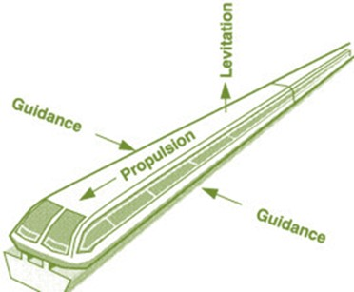

Fig. 1. The basic principles of magnetic levitation [6]

In this case, there are two main types of Maglev trains based on the technique used for levitation technologies. First, the electromagnetic suspension (EMS) as shown in Fig. 2 is based on using the magnetic attraction force between electromagnets and guideway [7]. However, the magnets of the vehicles wrap around the iron guide ways and get it lifted by the attractive upward forces. Furthermore, the resulting attractive electromagnetic forces are usually independent of the speed, as there could be lift forces at a zero speed at the end of the vehicle. In this case, the EMS requires a small gap of magnetic air of ≤ 25 mm [5]. The speed usually becomes higher and maintaining control is difficult because of the small air gaps used in the EMS. There are two types of levitation technologies in EMS that either the levitation and guideway can be integrated as in the Japanese HSST system, and the Korean UTM system, or separated such as the German Transrapid system. In terms of the rating of electric power supply, the separated type is larger than the integrated one, as it is difficult in integrated types to control guidance and levitation simultaneously because of the increasing interference for high-speed operation between levitation and guidance that is caused by speed increases [7]. On the other hand, the number of electromagnets and controllers is reduced for low-speed operation and low cost, while the difference of reluctance automatically generates the guiding force. In the integrated type, the rating of electric power supply is smaller than that in the separated type [7]. The EMS technology is defined as classical and that includes the German Transrapid system, the Chinese CMS system, the Japanese HSST system, and the Korean UTM system [5, 8]. In the EMS system, a magnetic circuit is excited by a current-carrying coil, consisting of a ferromagnetic rail fixed to the track and an iron core in the vehicle [9].

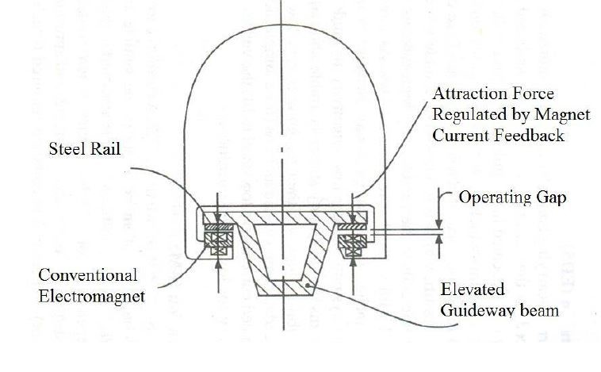

Fig. 1. Electromagnetic Suspensions [9]

Second, there is the electrodynamic suspension (EDS) that has been developed by Japanese engineers as shown in Fig. 3 and used the same polarity of magnets to levitate the trains by repulsive force from the induced currents located in the conductive guide ways and keep the two objective apart [5, 7]. Moreover, the repulsive forces are originally due to the temporal variation of a magnetic field in a conductor that are exerted by both rail and train [3, 5]. Moreover, the repulsive force is in the track is either created by conducting strips in the track or an induced magnetic field in wires [3]. However, the EDS technology is very reliable for the load variation and so stable magnetically, which needs enough speed to obtain induced currents for levitation [7]. In the EDS technology, the magnetic air gap is considered to be large (≤ 80 mm) and there is no repulsive damping forces at zero speed. The actual technology same as the Japan JR-Maglev (MLX) is based on superconductivity in order to match large air gap, as the system requires bogie at low speed (≤ 100 km/h) [5]. Into the vehicle of the EDS system, a current carrying coil is built and the flux produced by the current flowing in the on-board coil induces currents either in conducting aluminium sheet or in passive coils located in the guideway [9].

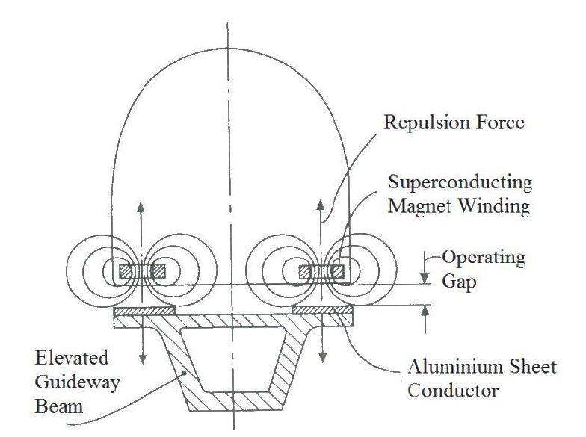
Fig. 2. Electrodynamic Suspensions [9]

The main difference between EMS and EDS Maglev trains is that the EMS uses standard electromagnets and when a power supply is present, the coils only conduct electricity. On the other hand, the EDS Maglev train uses super-cooled coils as a kind of superconducting electromagnets to conduct electricity even after the power supply has been turned off [10]. However, this system can increase the speed of the train, but it is not strong enough to move the train vehicle from a stationary position all the way around the track. In order to control the air gap between the track and the train, the EDS system compared with the EMS system enables a larger suspension gap of up to 10 mm and it is inherently stable during the operation. On the other hand, the EMS system requires constant control to levitate at a standstill, as it is an inherently unstable system [8]. In this case, some of the characteristics of EMS and EDS systems are presented in Table 1.

Table 1. Characteristics of EMS and EDS systems [9]
Characteristic | EMS | EDS
Type of Mode | Attraction Mode | Repulsive Mode
Magnets | Iron cored electromagnets | Superconducting coils
Guideway | 10-15 mm | 100-150 mm
Guideway components | Laminated strips | Aluminium strips
Stability | Inherently unstable | Dynamically stable
Feedback control | Necessary to maintain dynamic stability | Necessary
Compatible  drive system | Linear Induction Motor | Linear Synchronous Motor
Example | Transrapid | MLX

However, the majority of the Maglev trains are electromagnetic suspension type whilst the guideway for most of them are elevated, U-shaped, and double track, with spans and track gauges of 24.8 m and 2.8 respectively as shown in Table 2.

Table 2. Guideway structures and suspension systems [4]
Maglev systems | Shanghai, China | HSST, Japan | Transrapid, Germany | JR, Japan | Korea
Suspension | EMS | EMS | EMS | EDS | EMS
Section | I-shaped | U-shaped | U-shaped | U-shaped | U-shaped
Guideway | Elevated | Elevated | Elevated (at grade) | Elevated (at grade) | Elevated
Track gauge | 2.8 m | 1.7 m | 2.8 m | 2.8 m | 2.8
Span length (elevated) | 24.8 m | 30 m | 24.8 | – | 25–30 m
Guideway structure | Double track | Double track | Double track | Double track | Double track

The propulsion system involves two main types. First, linear induction motor (LIM), which use the propulsion systems to analyse its properties of force and power consumption, and travel through deep underground tunnels. The LIM has many advantages over other systems of conventional propulsion such as the ability to climb steep gradients, and excellent acceleration and deceleration. In this case, the control equipment of LIM is installed under the deep underground GTX (Great Train Express) bogie whilst its reaction plate is installed on the rail [11]. Second, the propulsion by a Linear Synchronous Motor (LSM) has the magnetic source within itself whilst its motion is in synchrony with a traveling magnetic field that is produced by either switched currents or AC. However, the levitation-propulsion modules of the LSM are located on each side of the vehicle whilst one of this system’s disadvantages, it requires data of the on-board magnets for the exact position to guarantee that the vehicle is matched with the traveling magnetic wave in the guideway produced by the stator winding [12]. In the superconducting Maglev system, the north and south poles of magnetic field is produced by passing current through the propulsion coils located on the ground to propel the vehicle forward by the attractive force of opposite poles. In addition, the repulsive force can also act for the same poles between the superconducting magnets built into the vehicles and the ground coils [13]. The active part of the motor for the low speed Maglev is located inside the vehicle, while it is placed on the infrastructure for the high-speed Maglevs such as Trasrapid and JR-Maglev [5].
The lateral guidance system controls the train’s ability to stay on the track and use the system of electromagnets that is located in the undercarriage of the Maglev train to stabilize its movement from the left and right sides of the train track [14]. In this case, the concrete or steel beams supporting by concrete substructure have been used in building the guideway of Maglev line, which can be determine in three ways. First, it can be elevated to avoid conflicts with existing infrastructure of other transport modes and ground surface activities. Second, in tunnels in order to direct the guideway under densely populated areas. Finally, at-grade where safety can be maintained and land is available [15]. In the EDS system, the principle of null-flux coils provides the guidance, which is mainly achieved by cross coupling the conducting coil mounted on the guideway and it is also used as the framework of linear synchronous motor for propulsion (9). On the other hand, the guidance in the EMS mode is provided by the magnetic guidance forces that are generated by the interaction of separate sets of electromagnets carried by vehicles and ferromagnetic rails on the sides of the guideway structure [9]. The vehicles can be kept in the centre of the guideway at all times by exerting a repulsive force and attractive force on both of the nearer and further sides respectively, especially when the vehicle moves off centre to either side [13].

  - Magnetic Levitation in Various Countries
Magnetic Levitated systems are seen on the worldwide market that is mainly depending on the mechanical air gap between the track and the train, and speed of the transportation systems [5]. In this case, the super-speed Maglev systems are limited to two Maglev types such as the German and Chinese Transrapid systems, and the Japan MLX system. However, the Maglev vehicles structure is closer to airplane structure than HSR, even if compared to the latest development of Japanese railway and French AGV. None of the Maglev trains has a double deck approach for passengers, which might be considered in the future as a handicap in relation with station length and capacity [5].

- China
- Shanghai Maglev Line
In 1999, many Chinese experts believed that would be a great achievement for China to construct a High-Speed Maglev system in Shanghai, as there was no operational Maglev lines worldwide at that time and that would mean the country would be the first in developing and constructing Maglev line [16]. However, the Shanghai Maglev Transportation Development Company (SMTDC) was founded in August 2000 to accomplish the construction and operation of the project, using the German Transrapid for its guideway. The construction of the Shanghai Maglev line started in March 2001, while the demonstration and operation of its opening was in December 2002 to become the first Maglev system in operation. In addition, the commercial operation of the Shanghai Maglev line began in 2004 and it showed to people how possible high speed can be reached with Maglev trains. The length of Shanghai Maglev line is 30 kilometers with trains running every ten minutes from the Pudong International Airport (PIA) to the Lujiazui Financial District for operations hours between 6:45 a.m. and 9:40 p.m. [16]. Moreover, this system has three sets of five-section TR-08 trains with an average capacity of 100 passenger per section, as the double track route starts from the station located in the Longyang Road and ends at the station of PIA. As a result, the total cost of the Shanghai Maglev project was €1.3 billion in 2004 prices, as the Transrapid system was the most appropriate Maglev system for China based on the its large population and vast land [16].

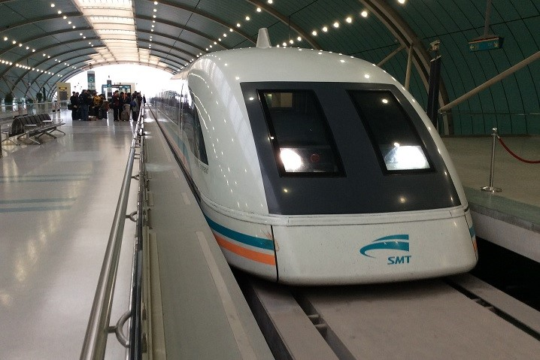

Fig. 3. The Shanghai Maglev Train [17]

The Shanghai Maglev system contains four main parts, including the vehicle, the guideway, operation control, and power supply. The vehicles of this system are electromagnetic for elevation and population, and include on-board batteries, levitation control system, and an emergency braking system [16]. Along the path, the guideway directs the trains and spreads the load onto the ground from the train. For the entire Maglev system, the operation control system is needed to operate it whilst the Linear Synchronous Motor is used. However, the LSM is a highly efficient motor and it requires an active guideway, which significantly increasing the system costs [18]. On the other hand, the power supply for the Shanghai Maglev system includes the substations, switch stations, other power supply equipment, and trackside feeder cables [16].
- Changsha Maglev Line
China operated the Changsha Maglev system on May 2016 that runs from Changsha’s south railway station to the local airport for a length of 18.55 km and a maximum speed of 100 km/h. In addition, the travel time for the Changsha Maglev line is about 19 min 30 sec, and it might reduce the amount of traffic in the areas along the line [16]. The Changsha Maglev system uses the electromagnetic suspension (EMS) and Linear Induction Motor (LIM) propulsion system, as the Maglev train has three vehicles, including one middle car and two head cars that can run in both directions. In addition, each vehicle consists of 10 electromagnetic modules and 20 suspension points [19]. This line uses Chinese Maglev technology and has only one intermediate station at Langlizhen, consisting a fleet of three-car trains and each 48m-long train has an average capacity up to 363 passengers [20].

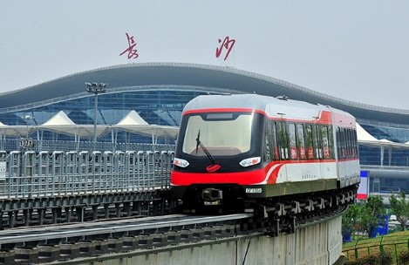

Fig. 4. The Changsha Maglev Line [21]

The total cost of the Changsha Maglev project is between € 18.4 million and € 30.7 million, with an average of € 2.5 of a one-way ticket in 2015 prices [22].

- South Korea
The Korea Institute of Machinery and Materials (KIMM) was given funding in 1989 to start a research and development project for a low-to-medium Maglev system, using EMS system and LIM propulsion. The KIMM and Hyundai Rotem developed this system, as they enhanced their UTM-02 model to attain the nominal air gap of 8 mm. However, the Incheon Airport Maglev line (IAM) had been using as a test project since 2007, while this type of system allows the Maglev to work without noise and vibration, and the need for the wheels [16]. The length of the IAM line is 6.1 km and includes of six stations, with a design speed up to 110 km/h and a maximum speed of 80 km/h. Moreover, the line contains four Maglev trains and each train consists of two carriages to carry up to 230 passengers and the operation hours between 9:00 a.m. and 6:00 p.m. with 15 min intervals. The total cost of the project was about € 280 million, while the construction cost was € 28.8 million per kilometre in 2006 prices. South Korea started passenger operations in early 2016 on the IAM line, making the country as the second nation worldwide to launch urban Maglev technology [16].

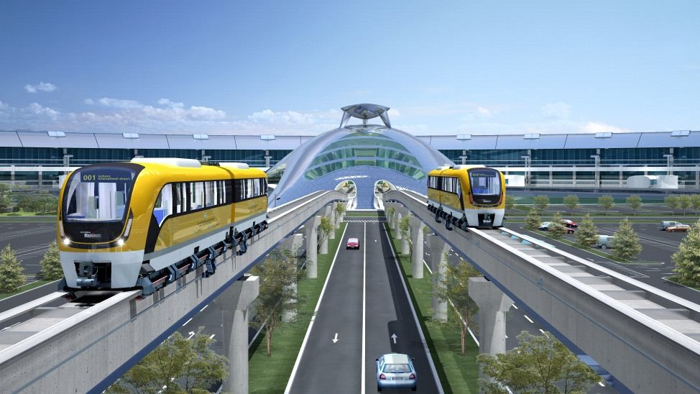

Fig. 5. The Incheon International Airport Maglev [23]

Now, South Korea has the ability to sell their Maglev technology, as different countries worldwide have expressed their interest in adopt this technology such as Russia, Malaysia, the United States, and Indonesia [16].

- Japan
- MLX-JR-Maglev
The JR-Maglev is a Maglev system developed by the Japan Railway Technical Research Institute, while the JR-Maglev MLX01 is one of the latest design of Maglev trains in Japan. In the Yamanashi prefecture, Japan has built a demonstration line as part of the planned new Chuo Maglev Shinkansen line (CMS). The proposed CMS line is connecting Tokyo and Osaka via Nagoya, as the president of JR Central, Masayuki Matsumoto disclosed in 2007 that the service of commercial Maglev would aim to begin in the year 2025 between Tokyo and Nagoya [24].

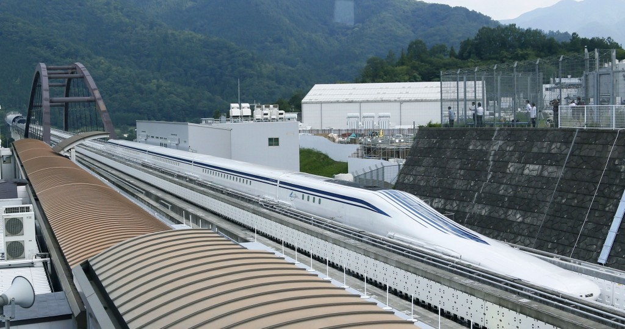

Fig. 6. Japanese MLX Maglev Train [25]

In 2003, a three-car train of MLX01 achieved a maximum speed of 581 km/h, which was faster than any wheeled trains and compared to the TGV speed record of 574.8 km/h set in 2007, which the Japanese Maglev technically able to reach higher speeds. The Japanese Maglev trains mainly use the modern superconducting magnets to allow for the repulsive type of EDS and a larger air gap [24]. In this case, the Maglev system is expected to run through nine prefectures when the total line goes into operation, and the prefectures include jointly governments group of Tokyo and Osaka to promote the construction of the line. One of the reasons why the Japanese use the EDS system is the wider air gap, especially the magnets of a Transrapid system in the EMS air gap of only one cm could touch the stator in the case of an earthquake. However, the Japanese system has an air gap of about 10 cm and is self-stable and using a Linear Synchronous Motor (LSM) system for the driving system. In terms of the guideway, the construction costs has estimated of € 30 to € 70 million per kilometer in 2003 prices as shown in Table 3 [24, 26].

Table 3. The projected Chuo Maglev Shinkansen Line [26]
Construction Line | Chuo Shinkansen
Section | Tokyo - Osaka
Total Length | 438 kilometres
Length of open Section | 126 kilometres
System | Superconducting Maglev system
Maximum Operation Speed | 505 km/h
Travel Time | 67 minutes
Construction Cost (including vehicles) | 30 to 70 million euros
Traffic Demand (in 2045) (billion passenger-km) | 41.6

- Linimo Maglev Line
The Japanese Linimo Maglev line was constructed to comply with the World Expos 2005 and run from the Higashiyama Subway line at Fujigaoka to the World Exposition’s satellite grounds at Yakusa. The Aichi Rapid Transit Company (ARTC) operates the Linimo Maglev system, while its vehicles levitate at 8 mm above the guideway and be able to reach a top speed of 100 km/h. Moreover, the length of the Linimo Maglev line is 8.9 km and has nine stations, which transported about 31,000 daily passengers during the World Exposition. After the ending of the Exposition’s event, the number of daily passengers dropped to 12,000 passengers, as the Linimo serves the local community from 5:50 a.m. to 12:05 a.m. every day [16]. This Type of High-Speed Surface Transport (HHST) runs with closely stations on an elevated guideway, as it has 15 min of the end-to-end trip time, and 6 minutes and 10 minutes of headways during the peak and off peak period respectively [27]. The Linimo Maglev is the first HSST Maglev commercial train in Japan and the second worldwide that is propelled by LIM and used the attractive force of normal conductive magnetics for its levitation. In addition, the vehicle is provided by the guidance and levitation system for the primary suspension, while the air springs and lateral mechanical linkages are used for the secondary suspension [28]. The construction of the Linimo Maglev project costs approximately €471 million and about €311 million for train in 2009 prices, as the line has a minimum operating radius of 75 meters and a maximum gradient of 6 % [29].

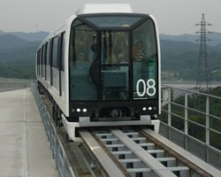

Fig. 7. The Linimo Maglev Train [30]

- United Kingdom
The Birmingham International Maglev shuttle was the first commercial maglev train that opened in 1984, connecting the airport terminal of Birmingham International Airport with the nearby the railway station for a total length of 600 meters [31]. It ran at speed of 25 mph, using LIM for its propulsion and levitated by electromagnets [32].

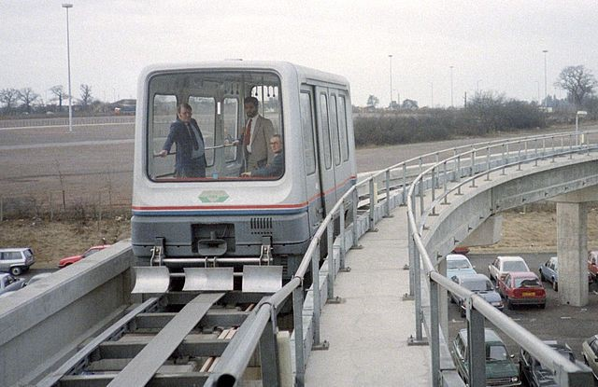

Fig. 8. The Birmingham International Maglev shuttle [33]

This system flew at the impressive attitude of 15 mm along its 600 m track and worked for 11 years before it was closed in 1995 due to design and maintenance problems. One of the problems was arisen to a contractor who decided individually that the Maglev vehicle needed to be stronger, which required an extra layer of glass fiber and would make the cost of replacing and maintaining too high. In this case, the electromagnets could not lift the train off the track with the additional weight and that led to build an entirely new vehicle [32].

  - Advantages and disadvantages of Maglev
Speed is one of the advantages of Maglev as it is a floating train and travels extremely fast so that it can reach speeds up to 500 km/h (or 300 mph). Moreover, it has more wide potential for further development, as it overcomes the main obstacles for increasing the speed of HSR, including the existence of mechanical contacts between rail and wheels as well as in the power supply system [34]. In this case, Maglev could match gate-to-gate air travel time on routes of less than 1000 kilometers, as it can accelerate and decelerate up to 1.5 m per second, and reach 300 km/h in around 5 km compared with 30 km for a HSR [35].

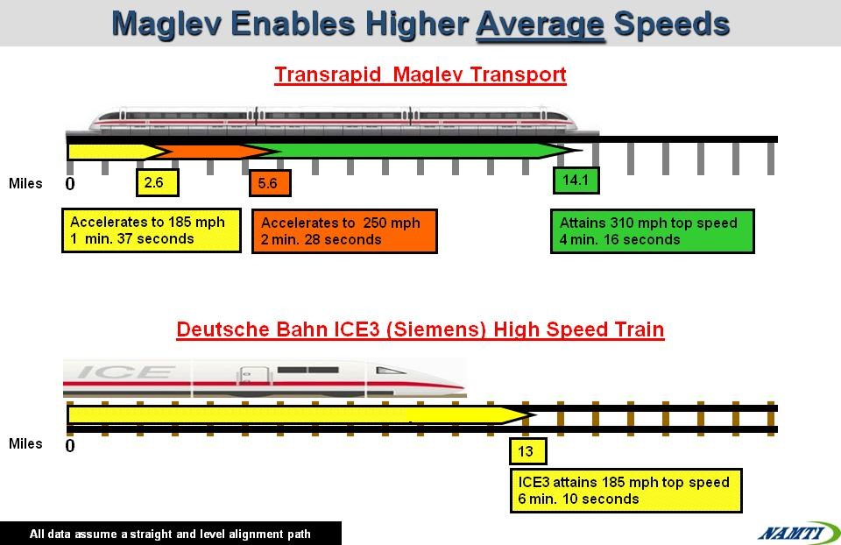

Fig. 9. Maglev Enables Higher Average Speed [36]

It is also less noisy because there are no wheels running along which makes it quieter than normal trains, and it uses 30 % less energy than normal trains. Moreover, Maglev and its track would require very little maintenance and it is recognized as the primary advantage because the train never touches the track and the wear and tear of parts is minimal. In theory, this means the Maglev trains and track would need no maintenance at all, or the cost is very little for maintaining the rail, since checkups and frequent repairs are not required [37, 38]. Moreover, a Maglev can reach to 300 km/h in only 5 km after stations and going uphill and greater gradients will be applicable [37]. The energy consumption of Maglev transport can use the renewable sources such as wind and solar power. It is also weather independent and can carry enormous traffic loads of both goods and people with less cost than the present modes of auto, rail, bus, and air. Moreover, the train and track operating costs are the long-term advantages of a Maglev train as they are much lower along with less wear and tear costs associated with the moving parts of a conventional train [39]. Since, there is no contact with the tracks of Maglev trains, they will never be delayed and they are operational during any weather conditions, compared to HSR that can get stuck in severe snowfall [38]. As a result, the developers of Maglev claim that their system can reach higher speeds with lower energy consumption, attract more passenger, lower life cycle costs, and produce less vibration and noise than other transport modes, including HSR [40].
On the other hand, there are several disadvantages of Maglev trains. First, the Maglev guide paths are more costly than conventional steel railways, as the Maglev guideways are not matched with the infrastructure of existing rail and a new set of tracks is needed to build for the Maglev system from scratch. Second, the unsuitability with existing infrastructure. For example, the Maglev trains would not be able to achieve whatever the high-speed trains can do of going for a fast run on the high-speed line and come off it for the rest of the journey. In this case, it is very difficult to construct Maglev lines commercially workable unless there are two very large destinations being connected, as the high-speed rail can serve other nearby cities beside the two main cities by running on normal railways that branch off the HSR line. Another disadvantage of Maglev train’s design is the weight of the large electromagnets in many EDS and EMS designers. From technical view, Maglev has enormous switching difficulties, in order to direct a vehicle from one track to another perfectly. In terms of energy consumption, larger train cars of Maglev are difficult to levitate and that require more energy and making the system less efficient [37].

BACKGROUND OF THE CASE STUDY

The Kingdom of Saudi Arabia (KSA) is located in the continent of Asia as shown in Fig. 11, in the Middle East region, with an estimated size of 2.21 million square kilometres, of which about 95 % is dominated by desert. KSA shares its borders with Kuwait, Jordan, and Iraq to the north, Oman and Yemen to the south, United Arab Emirates, Qatar, Bahrain, and the Persian Gulf to the east, and the Red Sea to the west [41]. The discovery of oil changed the kingdom from a pre-industrial country to a modern industrial country and has made it as one of the rich developing countries and its wealth comes from the oil revenue. In Saudi Arabia, the demographic surveys are one of the most important sources of data, which is necessary for development planning in the social and economic fields, at the national and domestic levels. The population of Saudi Arabia increased by 16.54 % (4.5 million people) from 27.2 million people in 2010 to 31.7 million people in 2016, with an average annual increase of 2.52 % [42].

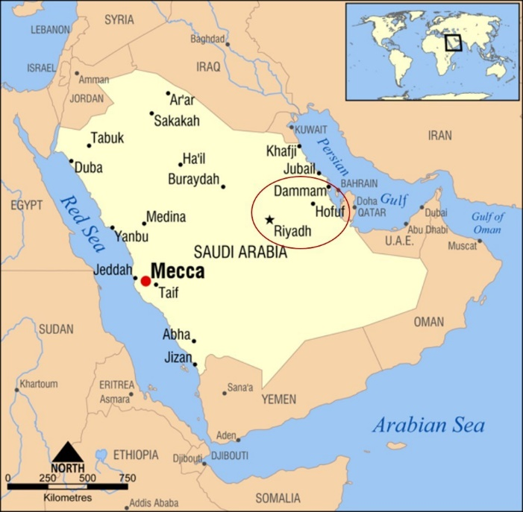

Fig. 10. Map of Saudi Arabia [43]
Saudi Arabia is among the 25 largest economies in the world in terms of GDP (billions of $) in 2016 that can be described as modest compared with the United Kingdom in its experience in the railway industry [44]. The conventional train for the Riyadh-Dammam corridor was opened for public service in 1981 and managed by the Saudi Railway Organization (SRO). It traverses the desert dunes via Al Hofuf and Abqaiq, covering 449 km with a journey time of 4 hours and 30 minutes
The track gauge is 1,600mm and the line is equipped with the European Train Control System (ETCS) Level 1, the first implementation of this technology in the Arab world. The SRO increased the frequency between Riyadh and Dammam starting from September 2018, to 82 trips per week, 88 trips between Dammam and Hofuf, and 68 between Riyadh and Hofuf; a total of 238 trips per week compared to 35 trips in each direction per week [45]. Saudi Arabia has an ambition of making a bigger railway network, as there are railway projects coming into life in the eastern and western regions of the country. The upcoming projects include the Harmain High Speed Rail (partly operating) connecting Mecca and Medina via Jeddah and Rabigh; North-South Rail (partly operating) linking Riyadh with Qurayyat via Majmah, Qassim, Hail, and Al-Jouf; and the Landbridge rail (planned) between Riyadh and Jeddah, and Dammam with Jubail [46].
This case study of Riyadh-Dammam line, Saudi Arabia has modal comparisons of total travel time, total travel costs (fares), and service frequency. The conventional rail service took about 4 hours and 15 minutes, travelling via two intermediate stations, Abqaiq and Hofuf as shown in Fig. 12 within a distance of 454 km and different travel fares for different classes. On the other hand, the approximately 412 km corridor is travelled also by plane in only one hour, with extra time required for check-in, boarding, and baggage collection.

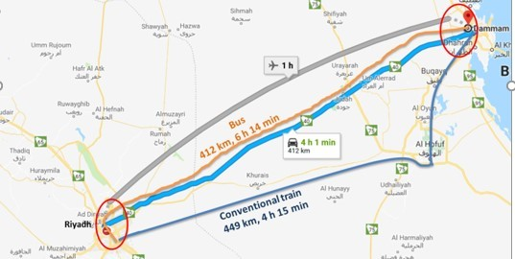

Fig. 11. Riyadh-Dammam corridor, using different transport modes

METHODOLOGY

- Spreadsheet Cost Model
The methodology of this paper is to provide an estimate of the total social costs of a new Maglev line worldwide and apply it in the case study of Saudi Arabia for the Riyadh and Dammam corridor, using a Spreadsheet Cost Model that is based on Microsoft Excel. However, the estimated total social costs are based on the total annual volume of passengers assumed and included three main categories. First, the operating costs that include infrastructure construction and maintenance costs, and the acquisition, operation and maintenance of rolling stock. With regard to the acquisition, the price of the Maglev trains is determined by their technical specifications, including the capacity and the unit cost of acquiring trains. On the other hand, costs of labour, energy consumed to run the trains, and the number of trains operated on a specific line are determined with respect to the operating costs. In the case of maintaining rolling stock, the costs are related to the fleet size, labour, materials and spare part, train usage (related to the total distance covered by each train every year). Second, user costs that are mainly dependant on door-to-door travel costs, including access, waiting, in-vehicle and egress time, and excluding money costs. Finally, external social costs include air pollution, accidents, noise and climate change.
The operator cost is mainly based on the infrastructure construction cost of Maglev line that can be calculated into two parts. First, the infrastructure construction cost is mainly dependent on the proportion of the construction costs spent on planning and the length of the Maglev line, as multiplying it by the capital recovery factor is necessary. In this model, the capital recovery factor is used to convert from present cost to an annual cost as shown in equation 1 [47].

 | $$A=P[\frac{i{(1+i)}^{n}}{{(1+i)}^{n}-1}]$$ | (1)

However, the capital recovery factor is used in the infrastructure construction cost to convert it to the annual cost as shown in equation 2.

Infrastructure construction cost (${IC}_{C}$) =$L [c_{c}\left(1+ρ\right)]x[\frac{i{(1+i)}^{n}}{{(1+i)}^{n}-1}$] | (2)
where:
${\text{IC}}_{\text{C}}$ = The infrastructure construction costs of Maglev line (€/kilometre).
$\text{L}$ = The length of a given Maglev line (kilometres)
${\text{c}}_{\text{c }}$= The unit construction cost of a given Maglev line (€/kilometre)
$\text{ρ}$ = The proportion of the construction costs spent on planning (percentage)
$P$ = The present value of costs of the Maglev line (€)
$A$ = The annual value costs (€/year)

Second, the infrastructure maintenance cost is already in an annual unit and it can be calculated as shown in equation 3.

 | Infrastructure maintenance cost (${IM}_{c}$) = $L x c_{m}$ | (3)
where:
${\text{IM}}_{\text{c}}$ = The infrastructure maintenance costs of Maglev line (€/year).
$c_{m}$ = The unit cost of regular maintenance of a given Maglev line (€/kilometre)

The rolling stock costs are considered for the different three categories: acquisition, operation and maintenance of the trains needed to run the services of the corridor. The acquisition cost of rolling stock is determined by main factors related to its technical specification, including the capacity (number of seats), the delivery and payment conditions, the contractual relationship between the rail operator and the manufacturer, in terms of price. In this case, some of the rail operators have their rolling stock designed internally, while other preferred contracting out. However, the capacity of Maglev is represented by the maximum number of trains needed during a specified period of time, which can be handled on the particular line, and the size of Maglev rolling stock operating (seats). The forecasting travel demand is needed in order to estimate the total social costs of proposed Maglev line worldwide. However, the regression model has been applied on determining the travel demand for the proposed HSR line between Riyadh and Dammam, two large cities in Saudi Arabia within a length of 412 kilometres. In this case, the travel demand of Maglev line can be forecasted by using the elasticity approach between the proposed HSR and Maglev lines in terms of their number of trips and the generalised journey times as shown in equation 4.
 | $$Forecast change \left(F_{c}\right)= \frac{T_{M}}{T_{HSR}}={(\frac{{GJT}_{M}}{{GJT}_{HSR}})}^{E}$$ | (4)
where:
$T_{M}$ = The number of trips by Maglev (trains)
$T_{HSR}$ = The number of trips by HSR (trains)
${GJT}_{M}$ = The generalised journey time by Maglev system (minutes)
${GJT}_{HSR}$ = The generalised journey time by HSR system (minutes)
$E$ = The elasticity of generalised journey time

In this case, the generalised journey time is based on the in-vehicle time and service interval penalty that can be calculated as shown in equation 5 and 6:
 | $$GJT=IVT+Service Interval penalty$$ | (5)
 | $$GJT=\frac{Distance}{Speed}+\frac{60}{Service frequency }$$ | (6)

However, the frequency is mainly dependent on the total number of daily services per direction, which is obtained from the projected demand and the effective occupation capacity of train, which can be calculated by multiplying the train capacity by the average load factor per service frequency on the line during a time as shown in equation 7.
 | $$F_{t}=\frac{Q_{t}}{O_{d}{×Q}_{e}}$$ | (7)
where:
$F_{t}$ = The transport service frequency on the corridor during time (train/hour)
$t$ = The t-th year starting from the beginning of the period of (n) years of operation of a given Maglev line (year)
$Q_{t}$ = The projections of the (one-way) daily demand (passenger)
$O_{d}$ = Operating daily hours (hour)
$Q_{e}$ = The effective occupation (seats)

In addition, the effective occupation is calculated as shown in equation 8.
 | $$Q_{e}=l×c$$ | (8)
where:
$l$ = Load factor (percentage)
$c$ = Train capacity (seats)

The number of passenger per day and direction in year can also be calculated as shown in equation 9.
 | $$Q_{t}= \frac{{ID}_{a} }{N×days/year}$$ | (9)
where:
$Q_{t}$ = The projections of the (one-way) daily demand (passenger)
${ID}_{a}$ = Initial annual demand (passengers/year)
$N$ = Number of direction

The number of train per day-direction (train) can be determined as shown in equation 10.
 | $$NS=\frac{Q_{t} }{Q_{e}}$$ | (10)

In this case, the number of trains per day is needed in order to calculate the service frequency per hour as shown in equation 11.
 | $$F_{t}=\frac{Q_{t}}{O_{d}{×Q}_{e}}$$ | (11)
The total number of trains needed for the Maglev corridor can be calculated as shown in equation 12, which is mainly related to the number of passengers and frequency.
 | $${RS}_{t}=(1.5)×τ\frac{Q_{t}}{O_{d}{×Q}_{e}}$$ | (12)
where:
${RS}_{t}$ = The number of trains acquired in the t-th year of the observed period (train)
$τ$ = The operation cycle time of the Maglev train (hour/train)
$v$ = Average commercial speed (kilometres/hour)
The operation cycle time of the Maglev train is necessary to be determined using 40 seconds for both start and end journey in order to calculate the number of acquired trains as shown in equation 13.

 | $$τ=2×(L/v)+(20+20)/60min$$ | (13)
In order to purchase new rolling stock, the process of contracting, designing, building, delivering and testing them usually takes several years, especially if the demand projections are known in advance. However, the cost of Maglev rolling stock usually depends on the number of seats, as it is better to choose a train with large capacity seats in order to reduce the maintenance cost as well as the number of departures. In this case, acquisition cost can be calculated by multiplying the number of trains every year by their average capacity and the unit cost per seat, as shown in equation 14.

 | ${RSC}_{A}=[{RS}_{t}×c_{A}×\overline{q}]×[\frac{i{(1+i)}^{n}}{{(1+i)}^{n}-1}$] | (14)
where:
${RSC}_{A}$ = The acquisition costs of rolling stock (€/year)
$c_{A}$ = The unit cost of acquiring a rolling stock (€/seat)
$\overline{q}$ = The average seat capacity of a train (seat)

The operating costs of rolling stock mainly depend on the expected traffic level, as labour cost on board the train, energy cost, and sales and administration costs are included. In the equation 15, a number of trains per day and operation hours is considered in the operating cost of rolling stock to meet ridership, while the value 2 representing the number of directions.

 | $${RSC}_{O}={2×c}_{O}×F_{t}×\overline{q}×L$$ | (15)
where:
${RSC}_{O}$ = The operating costs of rolling stock (€/year)
$c_{O}$ = Average unit cost of operating a rolling stock (€/seat-km)
The maintenance costs of the Maglev rolling stock are related to the number of trains, their utilization during a given period and the average unit maintenance cost and can be calculated as shown in equation 16.

 | $${RSC}_{M}=c_{M}×u_{t}×\overline{q}×{RS}_{t}$$ | (16)
where:
${RSC}_{M}$ = The maintenance cost of rolling stock (€/year)
$u_{t}$ = The average utilization of a train in the t-th year of the observed period (km/seat)
$C_{M}$ = The unit cost of maintaining rolling stock (€/seat-km)
The user cost is mainly based on time related to the journey is taken into account in order to calculate the total social cost. In transportation studies, the user travel time is broken into several components including walking (access/egress) time, waiting time, and in-vehicle time. In Fig. 13, the access time is the total time spent to reach a Maglev station (A) from the origin point, while the egress time is the total time spent from Maglev station (B) to the destination point. On the other hand, the line-haul represents the in-vehicle time and the waiting time spent in station.

Fig. 12. The structure of the total journey time

The access time as normally the time taken from one’s door (e.g. home, work, etc.) to the first transportation infrastructure used in the city (A). It is the time spent by the traveller in getting to a metro, bus station, rail station, airport terminal, etc. For travelling by Maglev, the access time could mean the time spent on a bus, metro, or in the car (e.g. private or taxi) [48].
On the other hand, the egress time is defined as the time taken from the first transportation infrastructure used in the city (B) to the final destination. In this case, the main difference between access and egress time is mostly for travel to/from Maglev station and the egress time was found as 32% higher than access time, which may due to greater familiarity at one’s origin with the transportation options rather than at the destination for a long distance trip. Access/egress times can also include other access options beside car such as any transit service (e.g. bus, metro, etc.) and by walking. In some studies, the coefficient for walking time has valued as almost twice that of in-vehicle travel time [48].
In this case, the access/egress travel time per passenger is mainly dependent on the average access/egress distance and average travel speed that can be calculated as shown in equation 17.

 | $$T_{AE}=\frac{D_{AE}}{V_{AE}}$$ | (17)
where:
$T_{AE}$ = The average access/egress time per passenger (hour)
$D_{AE}$ = The average access/egress distance to/from the Maglev station (kilometre)
$V_{AE}$ = Average travel speed (kilometre/hour)
The total access/egress time needs to be on an annual basis and can be calculated by multiplying the average access/egress time per passenger by the total number of passenger per year. In this case, the average access/egress time has to be multiplied by a factor of 2 in order to account for both the access/egress to and from the Maglev station as shown in equation 18.

 | $${TT}_{AE}={2 x Q}_{t} x T_{AE}$$ | (18)
where:
${TT}_{AE}$= The total annual passenger access/egress time (hours)
$Q_{t}$= Passenger demand in the time period t per direction (passenger / year)
The waiting time is determined as one of the most important factors of the total user cost for all public transport modes, as it starts counting when a passenger arrives at the rail station when the passenger boards the train. However, the waiting time is a very critical element for judging the service of the passenger, as the passenger of railway usually faces different types of waiting due to different reasons. For example, the waiting time might be longer if trains running behind schedule and most trains meet with some delay during rush hours. The value of time is almost expressed relative to the driving time in the case of waiting for trains, which it means passengers rate one minute of waiting as equivalent to 2.5 minutes of driving [49]. The average waiting time can be estimated as a fraction of the headway, while the average of headway is calculated by dividing the length of the operating day by the service frequency (50). As a result, the passenger waiting time can be calculated by taking the half of the headway as shown in equation 19.
 | $$T_{WT}=\frac{1}{2}×Headway$$ | (19)
where:
$T_{WT}$ = The average waiting time per passenger (hour)
$F_{t}$ = The transport service frequency on the corridor during time (train/hour)
In order to obtain the total user cost of the Maglev passengers on an annual basis, the total annual waiting time is calculated by using the annual demand, as shown in equation 20.

 | $${TT}_{WT}=Q×T_{WT}$$ | (20)
where:
${TT}_{WT}$ = The total annual passenger waiting time (hours)
$Q$= Passenger demand in the time period t (passenger / year)
The in-vehicle time for Maglev is mainly dependent on the average length of the journey, the average operating speed$(v)$. As there are no intermediate stops along the Maglev, the dwell time is excluded in this section, and the average in-vehicle time can be simply calculated by dividing the average journey length by the average speed as shown in equation 21.

 | $$T_{IV}=\frac{L}{v}$$ | (21)
where:
$T_{IV}$ = The average in-vehicle time per passenger (hour)
$L$= The average length of a given Maglev line (kilometres)
$v$ = The average operating speed (km/h)
The annual HSR passenger’s in-vehicle time can be calculated by using the average passenger journey length, the average operating speed of Maglev, and the annual passenger demand as shown in equation 22.

 | $${TT}_{IV}=Q_{t}×T_{IV}$$ | (22)
where:
${TT}_{IV}$ = The total annual passenger in-vehicle time (hours)
$Q_{t}$= Passenger demand in the time period t per direction (passenger / year)
The Value of Time (VOT) is important for management and evaluation of transport investment decisions and considered as one of the key inputs related to travel demand models. It also is defined as the price that travellers as willing to pay in order to acquire an additional unit of time, while the value of time savings is the willingness to pay for time between two different transportation alternatives [51]. The VOT is also counted as one of the most important outcomes that can be extracted from the experiment of stated preference, which concerning for the willingness to pay, in order to save time. The value of time for personal journeys varies usually by circumstances, which ranges between 20 % and 90 % of the gross wage rate within an average of around 50 % and generally much higher for business travel. In this case, the value of walking time (access/egress) and waiting time is 1.6 to 2.0 times the in-vehicle time [52].
The values of time for private trips were estimated of €10/h, €12/h and €6.5/h for rail, car and coach respectively, based on Stated Choice data using for the Swedish national forecasting model in price level 2008 [53]. For business journeys, the value of time is dependent on the cost saving, which considers the benefit of time saving in terms of cost savings to the employer (54). However, the value of time savings may be more valuable on longer distance trips, as it is noted and recommended in the Netherlands and Sweden. On the other hand, lower value of time can be applied to time savings on shorter distance trips, as the value of time for employee in time savings requires an appropriate valuation of leisure time (54). Small, Verhoef (52) defined the value of time as a fraction of the wage rate. For example, the value of time is equal to 1.33 of the wage rate per hour for work trips and business in terms of cost to employer whilst it values of one-third for shorter commuting (less than one hour round trips) and two-third for longer trips that is applied (52, 55). In this case, the average hourly wage rate is calculated as shown in equation 23.

 | $$AWR=\frac{average monthly wage rate}{average working hour per month}$$ | (23)
The total user cost in the previous sections are mainly related to generalised time, including walking time, waiting time and in-vehicle time, while it is converted to generalised cost by multiplying by the value of time, as shown in equation 24.

 | $$TUC=\left[{(w}_{AE}×{TT}_{AE})+{(w}_{wt}×{TT}_{WT})+{TT}_{IV}\right]×VOT$$ | (24)
where:
$TUC$ = The annual total user costs (€/year)
$W_{AE}$ = The factor to represent the weighting perception of access/egress time vs. in-vehicle time (number)
$W_{wt}$ = The factor to represent the weighting perception of waiting time vs. in-vehicle time (number)
$VOT$ = Value of in-vehicle time for Maglev (€/hour)

The external environmental cost is defined as the costs generated by transport users but paid by surroundings, the environment, people, and the society as a whole, including air pollution, noise, accidents and climate change (56). The external costs associated with society and the transport user cannot be considered without policy intervention, as they usually refer to the difference between internal costs and social costs. In this case, the internal costs directly accepted by the transport user, such as energy cost of the vehicle, transport fares and taxes, wear and tear, and own time costs [57]. However, the external costs of transport modes strongly depend on parameters such as location, peak/off-peak time, and vehicle characteristics [57]. Moreover, the cost calculation of external environment uses the vehicle-kilometre and the unit environmental cost used in previous environmental cost studies, which can measure the external costs due to the operating performance of the transport technology [58]. As a result, the external environmental costs can be calculated by multiplying the sum of unit costs of air pollution, noise pollution, accident, and climate change by the total passengers per kilometres as shown in equation 25.

$$\text{Total External Costs }\left(\text{TEC}\right)\text{=}\left({\text{UAP}}_{\text{c}}\text{+}{\text{UNP}}_{\text{c}}\text{+}{\text{UA}}_{\text{c}}\text{+}{\text{UCC}}_{\text{c}}\right)\text{ x PKM}$$ | (25)
where:
${UAP}_{c}$= Unit air pollution costs per passenger-kilometre (€/pkm)
${UNP}_{c}$= Unit noise pollution costs per passenger-kilometre (€/pkm)
${UA}_{c}$= Unit accident costs per passenger-kilometre (€/pkm)
${UCC}_{c}$= Unit climate change costs per passenger-kilometre (€/pkm)
PKM= Total Passenger per kilometres

The unit cost for the external costs per vehicle – kilometre needs to be identified by using the Purchasing Power Parity (PPP) rate, which is defined as an economic theory that is constructed to consider the values of currency rates and the PPP of different countries.

- Results
In order to forecast the initial annual demand for the first year of operating the Maglev system for the proposed line, the generalised journey time for both Maglev and HSR need to be determined with using the elasticity of – 0.9 for non-London ticket holders over 20 miles [59]. The Transrapid Maglev system is chosen, as its technical stability and reliability have shown at both of the Shanghai, China and in Emsland Test Track Line, Germany. However, the service frequency of HSR was based on an initial demand of 18,089 per day and calculated as of 3.21 trains an hour, which could be rounded to 4 trains per hour to give a headway of 18.7 minutes. This would result in an equivalent time penalty of around 16.2 minutes, using the interpolation based on Table 4.

Table 4. Service Interval Penalties (in minutes) [Source: (59)]
Service Interval | Equivalent Time Penalty
5 | 5
10 | 10
15 | 14
20 | 17
30 | 21
0 | 23
60 | 27

In order to introduce operational flexibility and in light of the above, it is assumed that four trains an hour are operated and this gives an equivalent time penalty of 14 minutes as shown in Table 5. It is also used to determine the generalised journey time of Maglev system for an operating speed of 400 km/h, as there is no interchange related to the Riyadh-Dammam proposed corridor of a length of 412 km.

Table 5. Forecasting Service Frequency Changes
Category | HSR |  | Maglev
 | Service | GJT Units | Service | GJT Units
In-vehicle travel Time | 83 min | 83 min | 62 min | 62 min
Service frequency | 4 per hour | 14 | 4 per hour | 14
Interchange | 0 | 0 | 0 | 0
Total GJT |  | 97 min |  | 76 min

As a result of the elasticity based on generalised journey time, the forecast change in demand is shown in equation 26.

 | $$F_{c}={[\frac{76}{97}]}^{-.09}=1.246=\frac{4}{3.21}=1.246$$ | (26)

This means that Maglev would be operated at the capacity limit and the change in service is therefore forecast to increase the Maglev demand by 24.6 % (3.25 million passengers) and resulted of 16 453 694 passengers. With increasing the number of travel demand of Maglev line, the number of daily service is reached to 69 trains per day-direction compared to 58 trains for HSR, as the service frequency increased from 3.21 for HSR to 3.81 trains per hour for Maglev system and rounded up to be 4 trains per hour for both as shown in Table 5 previously. The construction cost of Shanghai Maglev line is about €30 million per kilometre. However, the Transrapid Maglev high-speed train commonly consists a passenger capacity of 438 seats per train, using a standard seating layout. On the other hand, the annual unit cost of maintaining the proposed Maglev line is €12 300 per track-km, as one of the reasons of this lower cost is no frictions. In terms of purchasing, operating, and maintaining the Maglev trainset, the average unit costs are € 49 233/seat, €9.74/seat-km, and € 0.011/seat-km respectively as shown in Table 6.

Table 6. Estimated Costs in 2009 year’s prices [Source: (60-64)]
Category | Cost Value | Unit
The unit construction cost of a given Maglev line | 30 000 000 | €/km
The unit cost of regular maintenance of a given Maglev line | 12 300 | €/year
The unit cost of acquiring a Transrapid | 49 233 | €/seat
Average unit cost of operating a Maglev trainset | 9.74 | €/seat-km
Average unit cost of maintaining a Maglev trainset | 0.011 | €/seat-km

With the unit costs of infrastructure, construction and maintenance shown previously in Table 6 and using the capital recovery factor (0.06) based on 35 years of operation and a 5 % social discount rate, the total infrastructure costs (including maintenance) is computed to be about € 835.4 million per year. The number of acquired Maglev trains is about 17 trains, as it is mainly based on the operation cycle time, value of risk of failing (1.5) and the service frequency of four trains per hour. In addition, the acquiring, operating, and maintaining train’s unit cost is included in the calculation of rolling stock to achieve results of € 22.4 million, € 22.5 million, and € 40.9 million respectively. In terms of the user costs, the access/egress time, waiting time, and in-vehicle time are mainly based on the value of time related to business and commuting trips. In this case, the distances and travel speed to/from Maglev stations based on speed limit in cities are calculated within average of 24.9 km and 45 km/h respectively in order to obtain the access/egress time of 33 minutes, using the car. Moreover, the in-vehicle travel time is based on the length of 412 km and 400 km/h and resulted of 61.8 minutes whilst the waiting time is based on half of headway and resulted of 7.8 minutes. In terms of external environmental costs, it is assumed that there is no air pollution or noise pollution caused by the Maglev train. In addition, the same external costs of HSR will be used for Maglev system in terms of unit accident that is resulted of € 1.31/1 000 passenger-kilometres due to similar number of incidents, as the total passenger-kilometre is 6.77 billion. In this case, the average accident cost of Maglev line is € 8.87 million per year. Maglev also uses more energy per kilometre than HSR and hence will have a greater climate change impact of € 8.13 million per year, compared to HSR of € 4.38 million per year.

CONCLUSION

In the conclusion, there is a number of key findings have resulted and shown as follows:
- The Riyadh-Dammam Maglev technology system introduces a new intercity system into Saudi Arabia and brings new competition in the intercity transit market as a part of the future transport developments in the country.
- The forecast demand of the proposed Maglev system for Riyadh-Dammam corridor is increased by 24.6 % and resulted of 16.45 million passengers in the first year of operation compared to the HSR forecast demand of 13.21 million passengers.
- The total operator cost resulted from constructing and maintaining of infrastructure, and the acquiring, operating and maintaining of the rolling stocks is € 921.24 million per year, which is higher than HSR of € 867.78 million per year.
- The total user cost resulted from access/egress times, waiting time, and in-vehicle time is € 245.50 million per year, which is higher than HSR of € 216.77 million per year.
- The total external environmental cost of Maglev only resulted from accident, and climate change is € 17 million per year whilst the air and noise pollution are excluded in this paper due to insufficient data. In this case, the total external costs of accident and climate change for Maglev is higher than HSR that is resulted of € 11.5 million per year.
- The total social costs of Maglev line is €1.18 billion based on forecasting demand of 16.45 million passengers, given an average social cost of €71.9 per passenger.
- On the other hand, the total social costs of HSR line is € 1.10 billion based on forecasting demand of 13.21 million passengers, given an average social cost of € 83 per passenger.
- In other words, the average social costs for HSR is around 16 % higher than Maglev- but that is more proven technology.

References

1. Pandey N, Kumar M, Tiwari P. Analysis of Magnetic Levitation and Maglev Trains. 2016.
2. Yadav M, Mehta N, Gupta A, Chaudhary A, Mahindru D. Review of magnetic levitation (maglev): A technology to propel vehicles with magnets. Global Journal of Research In Engineering. 2013.
3. Chopade SS. Magnetically Levitated Trains (Maglev). 2017.
4. Yaghoubi H, Barazi N, Reza M. Maglev. Infrastructure Design, Signalling and Security in Railway: InTech; 2012. doi: 10.5772/35339
5. Cassat A, Bourquin V. MAGLEV – Worldwide Status and Technical Review. 2011.
6. Shaik A. Magnetic Train 2018. Available from: http://www.physics-and-radio-electronics.com/blog/magnetictrain-maglevtrain/. Accessed Desember 02, 2018.
7. Lee H-W, Kim K-C, Lee J. Review of maglev train technologies. IEEE transactions on magnetics. 2006;42(7):1917-25. doi: 10.1109/tmag.2006.875842
8. Zhou D, Hansen CH, Li J, Chang W. Review of coupled vibration problems in EMS maglev vehicles. International Journal of Acoustics and Vibration. 2010;15(1):10. doi: 10.20855/ijav.2010.15.1255
9. Sharma RC, Dhingra M, Pathak RK, Kumar M. Magnetically levitated vehicles: suspension, propulsion and guidance. International Journal of Engineering Research & Technology. 2014;3(11):5-8.
10. Naufal DAM. Maglev Suspension Systems 2008. Available from: http://emt18.blogspot.co.uk/2008/10/maglev-suspension-systems.html. Accessed Desember 02, 2018.
11. Park C-B, Lee H-W, Lee J. Performance analysis of the linear induction motor for the deep-underground high-speed GTX. Journal of Electrical Engineering and Technology. 2012;7(2):200-6. doi: 10.5370/jeet.2012.7.2.200
12. Mustapha B, Bababe A. Propulsion of Magnetic Levitation Train. 2017.
13. Central Japan Railway Company. Superconducting Maglev (SCMaglev). 2017.
14. Train BPOM. Propulsion System. 2011.
15. American Magline Group U. Technology Comparison: High Speed Ground Transportation Transrapid Superspeed Maglev and Bombardier JetTrain. 2002.
16. Dona S, Singh A. The Workings of Maglev: A New Way to Travel. 2017.
17. Edwin F. A Train as Fast as an Aeroplane – Maglev Train 2015. Available from: http://kinooze.com/a-train-as-fast-as-an-aeroplane-maglev-train/. Accessed Desember 02, 2018.
18. Anisimow V, Wilson J, Womck W, Kaye RJ, et al. Urban Maglev Technology Development Program: Colorado Maglev Project: part 1: executive summary of final report. 2004.
19. Jingfang D, Zhiqiang L, Xin Y, editors. Numerical analysis of eddy current effect of EMS system for medium-low speed maglev train. 2017 2nd International Conference on Robotics and Automation Engineering (ICRAE); (Conference proceedings) 2017: IEEE. doi:10.1109/icrae.2017.8291399
20. Barrow K. Changsha airport maglev line opens 2016. Available from: http://www.railjournal.com/index.php/asia/changsha-airport-maglev-line-opens.html. Accessed Desember 02, 2018.
21. Railway Pro. CRRC delivers new maglev trains for Changsha 2017. Available from: https://www.railwaypro.com/wp/crrc-delivers-new-maglev-trains-changsha/. Accessed Desember 02, 2018.
22. Xinhua. China's first home-grown maglev in operation 2016. Available from: http://www.chinadaily.com.cn/china/2016-05/06/content_25117948.htm. Accessed Desember 02, 2018.
23. Shin B, Kim W, Park D, Beak J, Kang H. Progress of urban Maglev program in Korea [C]. The 9th World Congress Railway Research, Lille, France; 2011.
24. Maglev Board. Chuo Maglev Shinkansen 2018. Available from: https://www.maglevboard.net/en/facts/systems-overview/chuo-maglev-shinkansen. Accessed Desember 02, 2018.
25. Erfurth S. High-Speed Trains. 2016.
26. Sawada K. Outlook of the superconducting Maglev. Proceedings of the IEEE. 2009;97(11):1881-5. doi: 10.1109/jproc.2009.2030246
27. Latino F, Yokobri T. Urban Magnetic Levitation (MAGLEV) Transit - Japanese HSST System 2009. Available from: https://faculty.washington.edu/jbs/itrans/hsstpage.htm. Accessed Desember 02, 2018.
28. Yasuda Y, Fujino M, Tanaka M, Ishimoto S. The first HSST maglev commercial train in Japan. Proceedings of the 18th international conference on magnetically levitated systems and linear drives (MAGLEV 2004); 2004: Citeseer.
29. Glenn C. LINIMO, the Maglev Train 2011. Available from: https://en.japantravel.com/aichi/linimo-the-mag-lev-train/385. Accessed Desember 02, 2018.
30. Gizmo Highway. Japan's Maglev Train 2011. Available from: http://www.gizmohighway.com/transport/japan_maglev_train.htm. Accessed Desember 02, 2018.
31. Bansal K. Trains at the Speed of Bullets? ; 2014.
32. BBC News. The magnetic attraction of trains 1999. Available from: http://news.bbc.co.uk/1/hi/sci/tech/488394.stm. Accessed Desember 02, 2018.
33. The Beauty of Transport. Taking Wing (Elmdon Air Terminal, Birmingham, UK) 2017. Available from: https://thebeautyoftransport.com/2017/10/25/taking-wing-elmdon-air-terminal-birmingham-uk/. Accessed Desember 02, 2018.
34. Luguang Y. Progress of high-speed Maglev in China. IEEE Transactions on applied superconductivity. 2002;12(1):944-7. doi: 10.1109/tasc.2002.1018555
35. Holmer P. China is throttling up a 430-km/h magnetically levitated train to link Shanghai and its airport. 2003.
36. Namti. Maglev enables higher average speed 2011. Available from: https://web.archive.org/web/20120724152619/http://namti.org/wp-content/uploads/2010/11/HSR-Maglev-Compare-Acceleration.jpg. Accessed Desember 02, 2018.
37. Chopade SS, Sharma PK. High Speed trains. 2013.
38. Tang A, Wong S, Mishra H, Van K. Maglev Trains A Look into Economic Concessions By: Binyam Abeye. 2012.
39. Chadha A, Ballani A, Bhavnani A, Vishnani B, Jain A, Malkani A. Maglev Trains for the humanities Section. 2009.
40. Vuchic VR, Casello JM. An evaluation of maglev technology and its comparison with high speed rail. Transportation Quarterly. 2002;56(2):33.
41. Ministry of Municipal and Rural Affairs SA. The National Report for the Third UN Conference on Housing and Sustainable Urban Development (HABITAT III) for the Kingdom of Saudi Arabia 2016.
42. General Authority for Statistics SA. Demography Survey 2016.
43. Einstein N. Locator map of Mecca, in western Saudi Arabia 2007. Available from: https://commons.wikimedia.org/wiki/File:Mecca,_Saudi_Arabia_locator_map.png. Accessed Desember 02, 2018.
44. International Monetary Fund SA. GDP (Nominal) Ranking 2016 2016. Available from: http://statisticstimes.com/economy/projected-world-gdp-ranking.php. Accessed Desember 02, 2018.
45. Alsugair S. SRO orders 238 passenger trips per week. 2016.
46. Aldagheiri M. The expected role of railways in the economic development of Saudi Arabia. Urban Transport XVI. 2010;111:157-67. doi: 10.2495/ut100151
47. Rogers M, Duffy A. Engineering project appraisal: John Wiley & Sons; 2012.
48. Allard RF, Moura F. Analysis of Accessibility Distributions for Inter-city Travel by Public Transport. 2013.
49. Vansteenwegen P, Van Oudheusden D. Decreasing the Passenger Waiting Time for an Intercity Rail Network. Transportation Research Part B: Methodological. 2007;41(4):478-92. doi: 10.1016/j.trb.2006.06.006
50. Gleave SD. HSIPR Best Practices: Ridership and Revenue Forecasting. Office of Inspector General, US Department of Transportation; 2011.
51. Athira I, Muneera C, Krishnamurthy K, Anjaneyulu M. Estimation of Value of Travel Time for Work Trips. Transportation Research Procedia. 2016;17:116-23. doi: 10.1016/j.trpro.2016.11.067
52. Small KA. The Economics of Urban Transportation; 2007. doi: 10.4324/9780203642306
53. Borjesson M. Forecasting demand for high speed rail. Transportation Research Part A: Policy and Practice. 2014;70:81-92. doi: 10.1016/j.tra.2014.10.010
54. Batley R, Mackie P, Wardman M. Review of the value of time assumptions for business travellers on HS2. DfT, London. 2013.
55. Gwilliam KM. The value of time in economic evaluation of transport projects: lessons from recent research. World Bank (Washington DC). 1997.
56. Maout EL, Kato H. Life Cycle Cost-Estimation Model for Building, Operating, and Maintaining High-Speed Rail Systems. Asian Transport Studies. 2016;4(1):245-60.
57. Maibach M, Schreyer C, Sutter D, Van Essen H, et al. Handbook on estimation of external costs in the transport sector. CE Delft. 2008.
58. Li X. A Comparative Assessment for Innovative Public Transport Technologies: University of Southampton; 2015.
59. Rail Delivery Group. Passenger Demand Forecasting Handbook. 2011.
60. Retzmann M, Eiler K, Klühspies J, Wiegand D. The Moscow–Warsaw–Berlin Project: A High-Speed Maglev for long distance transport. 2011.
61. Ziemke D. Comparison of high-speed rail systems for the United States: Georgia Institute of Technology; 2010.
62. Boardman JH. Costs and Benefits of Magnetic Levitation. 2005.
63. Nuworsoo C. Preliminaries to a Feasibility Analysis of the Maglev Proposal of The Southern California Association of Governments for the Region. City and Regional Planning. 2009:51.
64. Nassar FE. Operational and cost models for high-speed rail and maglev systems. Transportation Research Part A. 1996;30(1):70. doi: 10.1016/0965-8564(96)81143-8

Convert rate used in this paper 1€=1.22$
The operating cost is mainly based on the Shanghai Maglev train with a capacity of 444 seats

