Mapping Bacterial Biofilms on Recovered Orthopaedic Implants by a Novel Agar Candle Dip Method

James P. Moley BS^{a, *}, Mary S. McGrath^{a, *}, Jeffrey F. Granger MD^{b}, Anne C. Sullivan MD^{b}, Paul Stoodley PhD^{a,b,c}, Devendra H. Dusane PhDª
ª Department of Microbial Infection and Immunity, The Ohio State University, Columbus, Ohio 43210, e-mails: james.moley@osumc.edu, mcgrath.160@osu.edu, devendra.dusane@osumc.edu

^{b} Department of Orthopaedics; The Ohio State University, Columbus, Ohio 43210, e-mails: jeffrey.granger@osumc.edu, anne.sullivan@osumc.edu

^{c} National Centre for Advanced Tribology, Engineering and the Environment, University of Southampton, Southampton, UK. e-mail: Paul.Stoodley@osumc.edu

Short title: Biofilm Mapping on Orthopaedic Implants

Conflict of Interest Statement: One or more of the authors (PS) has received funding from, or consults for Biocomposites Ltd., Zimmer-Biomet and Smith and Nephew. DHD consults for Biocomposites Ltd.

*Equal contribution

Summary
While the detrimental effects of periprosthetic joint infections (PJIs) are well-known, the process of biofilm formation on orthopaedic hardware is unclear. Previous work has shown that encasement of explant hardware in agar can aid in identifying biofilms. This study tested the utility of agar “candle dip” method in detecting and mapping the location of biofilm on infected orthopedic components. Explant components from fifteen patients were rinsed, briefly submerged in agar to create a surface coating, and incubated. Larger components were coated by pipetting agar over them. After incubation, colony outgrowth on the component surface was documented (candle dip status). Data was compared with clinical laboratory results (clinical culture status) and PJI diagnosis using Musculoskeletal Infection Society criteria (MSIS status). All six patients classified as MSIS and clinical culture positive were also positive with candle dip technique. Of the nine-candle dip negative cases, four were positive and five were negative for both MSIS and clinical culture status. Candle dip may be negative in few cases due to the residual antibiotic eluting from the spacers, limiting growth of bacterial biofilms on the components. The candle dip method shows promise for biofilm mapping but requires additional testing to evaluate clinical diagnostic potential.

Key words: biofilm, implant, mapping, bacteria, orthopaedic

Paul Stoodley, PhD, 716 Biomedical Research Tower, 460 West 12th Avenue, Columbus, OH 43210, USA. E-mail: Paul.Stoodley@osumc.edu

Introduction
Despite the devastating complications and economic burden of treatment for periprosthetic joint infection (PJI), relatively little work has effectively mapped bacterial biofilm formation on individual components (1-2). Well-documented work has shown the predominance of Gram-positive bacteria in such infections (such as Staphylococcus aureus and S. epidermidis) (3). There is increasing evidence showing the formation of biofilms and is a mechanism of chronic infection and tolerance to antibiotic therapy (4-5). It has been shown that components as small as sutures can harbor biofilm formation and growth in PJI. While surgical methods, such as sonication (6), can help diagnose biofilm, there is a significant gap in understanding the spatial arrangement of where biofilms might form on specific components and whether certain materials or component features are more favorable for biofilm formation (7).
In order to address this gap, Swearingen et al. used a novel agar encasement culturing method (AECM) in which whole components were submerged in molten agar; after incubation the location of biofilm was determined by outgrowth from the surfaces of components (7-8). In addition to allow mapping, this method has number of advantages such as (i) it does not require disruption of the biofilm which may influence the culturability and growth from within the agar rather than on top of the agar, and (ii) it allows the growth of oxygen-sensitive species (7). However, in the AECM method, there were difficulties in visualizing colony outgrowth through the nutrient agar because of the opacity of the agar which in some cases was made worse by increased turbidity due to bacterial growth throughout the agar, presumably seeded by bacteria washed off the component and into the agar during the flooding process. The current study was developed to overcome these limitations and to increase the sample size. In the proposed candle dip (CD) method, orthopaedic components were coated with a thin layer of agar followed by incubation upto seven days to visualize bacterial growth. In addition, we assessed the potential for diagnostic sensitivity by comparing our candle dip results with those from clinical microbiology and the diagnosis of PJI using the MSIS criteria (9).

Methods

Sample Collection
Forty-three explanted orthopaedic materials were collected from fifteen implant removal surgical cases at The Ohio State University, Wexner Medical Center, Department of Orthopaedics, with no inclusion or exclusion criteria to maximize the number and variety of components studied. Component materials included: metal (M), ultra-high molecular weight polyethylene (UHMWPE), polymethylmethacrylate (PMMA), and ceramic (CE) (Table 2). Many of our patients were in some way joint arthroplasty patients; however, removal of potentially infected components in the clinical setting also required removal of non-arthroplasty permanent materials, such as braided sutures or fracture fixation plates retained from prior surgical interventions in the region of interest in case of arthroplasty. We tested these materials to better understand the relationship between implanted materials and microbial growth. In some cases, these materials were all that was available to us. We also included materials that were explanted from patients with debridement of suspected infection and not necessarily associated with joint arthroplasty in order to validate our method on different materials. We also included several non-infected controls in the study. The patient demographic information is listed in Table 1. Of the 15 patients, five were male (33.3%) and 10 were female (66.7%). The median age was 60 years old and the median BMI was 34. Three patients were identified as current smokers at the time of surgery (20%), five reported no smoking history (33.3%) and seven reported past but no current smoking history (46.7%).

Explant Rinsing, Candle Dip, and Incubation
Following explantation, all components were transported and processed within an hour from the operating room (OR) to the biofilm laboratory at OSU in a sterile container, placed in another secondary biohazard container. The samples were processed according to the schematic shown in Figure 1. First, to remove the non-adherent planktonic bacteria or tissue and blood associated with the components, these components were transferred to a sterile vacuum filtration unit (Corning, Inc., USA). The components were rinsed twice with sterile phosphate buffered saline (PBS; Dulbecco’s, Gibco, USA) by a single operator. PBS was used variably according to component size to rinse in the 500 mL vacuum filtration units. The chamber size is approximately 20 cm (height) and 12 cm (diameter). Following rinses with PBS, the components smaller than the container were completely submerged for three seconds in cooled (approximately 45°C, but still molten) 1.5% Brain Heart Infusion Agar (BHI; Sigma Aldrich, USA) before being removed from agar and placed in a new sterile container (Corning, Inc., USA) such that a thin layer of agar remained on the component surfaces (Fig. 2). Thin layers of agar of approximately 1 cm were poured over the surfaces of filtration unit and the unit was incubated at 37°C. The components which were larger than the chamber, such as the stemmed hip femoral components were placed in a separate sterile container and molten agar was gently poured over the entire surface twice, using a 50 mL sterile pipette (Corning, Inc., USA). All components were incubated till seven days in an incubator set at 37°C with 5% CO₂ and the components were examined for development of colonies on the surfaces. The components were incubated till seven-days based on our previous observations that showed the time is sufficient to foster biofilm growth (7, 10). The components were visually monitored daily for colony outgrowth, and fresh agar was gently poured over any components where it appeared that the agar had begun to dry out. A replenishment coat was typically needed after the first 24 hours, and additional replenishment coats were applied at every 24-hour intervals thereafter.

Post-Incubation Culture Status and Anatomical Mapping from the Candle Dip Method
During the seven-day incubation period, all components were examined for bacterial growth. The presence of visible colonies growing on the surface of agar coated components were used to determine the presence and location of biofilms, and for comparing the candle dip status with MSIS and clinical culture status. If colonies were present, their positions on the component were noted to determine the possible patterns of biofilm formation. Pictures of the components prior to incubation were compared with post-incubation in order to differentiate bacterial growth from host materials deposited on the implants. If infection with S. aureus was suspected based on the pre-operative clinical culture status, a colony was selected, picked using sterile toothpick and plated onto the Mannitol Salt Agar (MSA, Sigma Aldrich, USA). This medium is a selective for the growth of S. aureus which shows yellow color colonies (10). In the same way, analysis was done for the colonies growing on the surface of the filtration units.

MSIS criteria for PJI diagnosis
Retrospectively, the patient charts were used to determine a diagnosis of PJI based on the Musculoskeletal Infection Society (MSIS) criteria, which is based on either the two cultures with phenotypically identical organisms or a sinus tract communicating with the joint. PJI is also diagnosed if three of the following five conditions are present: 1) elevated C-reactive protein (CRP) and erythrocyte sedimentation rate (ESR), 2) elevated synovial fluid white blood cell (WBC) count or positive change on leukocyte esterase test strip, 3) elevated synovial fluid polymorphonuclear neutrophil (PMN) percentage, 4) positive histological analysis of periprosthetic tissue, or 5) a single positive culture (9).
The clinical microbiology culture findings were reported as culture negative or positive and, when identified, the genera and species were also reported.

Statistical Measures
Statistical analyses of sensitivity and specificity were calculated to compare the candle dip method with both the MSIS status and the clinical culture status. Sensitivity, or the true positive rate quantifies the ability of a method to successfully identify cases with infection. Specificity, or the true negative rate quantifies the ability of a method to identify cases with no infection.

Results
To evaluate the effectiveness of the candle dip method in detecting bacterial growth, MSIS status, clinical culture status, and candle dip status along with previous antibiotic treatment with surgery type and components were considered (Table 2). In six cases, patients were found to be MSIS positive, clinical culture positive, and candle dip positive, as shown in Table 2. In five cases, patients were found to be MSIS negative, clinical culture negative, and candle dip negative. Four patients were classified as MSIS positive, clinical culture status positive, but candle dip negative.
Components from the patients (e.g. case 12) which showed signs of bacterial growth through the candle dip method were examined for possible areas colonized by biofilms. All the three femoral heads exhibited the presence of biofilms (Fig. 2), while the articular surfaces were mostly devoid of outgrowth. There was a noted outgrowth of biofilms formed along the rim skirt. For other component types with signs of bacterial growth, there were no localization trends, as biofilm diffusely covered the surfaces of these components. Most bacterial outgrowth from the various components was noted after 24 hours, with minimal change observed over the next six days. The candle dip method is therefore beneficial in rapid growth and identification of biofilms and localization at early stages. Of all the isolates that were tested for S. aureus, 16 total components from 4 different patients were positive for this organism; this was determined through fermentation of mannitol indicative of infection with Staphylococcus species using mannitol salt agar.
Comparing candle dip status with MSIS status, candle dip status showed no false positives, 4 false negatives, 6 true positives, and 5 true negatives (Table 2). The sensitivity of the candle dip status criteria, or the percentage of patients who were diagnosed with PJI using MSIS criteria and showed positive candle dip culture status was 60%. The specificity, or the percentage of patients who were candle dip negative out of the cases deemed MSIS status negative was 100%. Comparing the candle dip status and the clinical culture status, the candle dip method showed no false positives, 4 false negatives, 6 true positives, and 5 true negatives (Table 2). The percentage of patients who received a positive clinical culture status and positive candle dip culture status (sensitivity) was 60% and the percentage of patients who received a negative clinical culture status and a negative candle dip culture status (specificity) was 100%.

Discussion and Conclusions
The detection and analysis of PJI formation is a significant task that carries transformative potential for the treatment of affected individuals. The candle dip method shows potential for detection and mapping of bacterial growth and biofilms formed on different orthopaedic components. The technique has shown utility, but it requires further testing with larger number of patient samples and method development, to evaluate whether it will be useful for clinical diagnostic purposes. In some of the revision arthroplasty cases, while not technically revision of a prior TKA, cannot be called a “primary TKA,” as the patients had a previous surgical procedure involving non-absorbable foreign materials in the same region. This foreign material represents a possible route of contamination of the tissue spaces involved in the “index” or “primary” total knee arthroplasty. This is especially relevant, as our method showed positive bacterial growth from these explanted materials including permanent suture material, which is sometimes missed or not thought of as a foreign body.
The candle dip method showed a sensitivity of 60% when compared to both the MSIS and clinical culture status. 100% specificity was demonstrated when comparing the candle dip status to both MSIS and clinical culture status. However, components from 4 cases were negative for growth despite being positive by MSIS criteria and clinical culture status. There might be multiple reasons, e.g. in case 6 (Fig. 3) an antibiotic loaded PMMA spacer may have been eluting antibiotics locally but not achieving high concentrations enough to kill bacteria in the aspirate. Previously we have observed that antibiotic loaded PMMA spacers and beads were still eluting antibiotics even after 117 and 210 days at concentrations that could protect the immediate vicinity of the surface yet failed to clear the infection (7). Another reason might be that the agar did not adhere well to some of the component materials or bacterial outgrowth was more difficult to visualize on the PE and PMMA components due to the similar color of the materials and agar.
In the cases which were positive by the candle dip method, it was noted that all components showed the presence of biofilm. This observation is consistent with our previous work (7) where we found that all components taken from the same site were positive for bacteria by PCR, regardless of materials or component types. While outgrowth from a surface after an extensive rinse suggests that the bacteria were firmly attached, the spread of bacteria and dislodged biofilm during explantation surgery and collection cannot be ruled out. The risk of contamination also exists at several stages throughout the process such as agar preparation, component submersion, and agar replenishments since the technique requires more handling than conventional swab plating, although to the best of our ability we used appropriate controls such as using biosafety cabinet, sterile containers for transportation of patient components, checking the sterility of the growth medium.
However, we did find evidence that the method might reveal locations which might be more prone to harboring biofilms. For example, cases 12 and 13 showed preferential biofilm formation around the femoral head non-articulating “rim skirt” surface and surface features and a similar pattern was seen in a biofilm grown in vitro and a previous explant case (10), suggesting factors such as surface roughness (11) or the non-abating nature of the rim skirt played a role in the harboring of bacteria. Such information may provide insight into the development of orthopaedic components with surface modifications to reduce bacterial attachment and biofilm formation.
The technique is beneficial however it does have a number of limitations: 1) as previously mentioned it requires relatively extensive handling, 2) only one type of agar and incubation environment (i.e. aerobic or anaerobic) can be used for each component, limiting the choice to a general or selective media, 3) agar dripping down the component sometimes resulted in a distorted distribution and may have caused the spread of bacteria, 4) the agar appeared to be less adherent to PE and PMMA components, and bacterial growth was more difficult to see on these components due to their color and texture, 5) the agar dried out over time, which could limit the detection of slow growing bacteria and 6) extensive growth within the media, presumably due to remaining planktonic cells or dislodged biofilm made it difficult to tell if there was outgrowth from specific locations on the surface. Many of these issues could be addressed by completely immersing the components as we have previously done (10) although for large components this requires large containers and volumes of agar such that opacity becomes an issue.
Despite these issues the mapping potential of the candle dip method also is unique among diagnostic tests for PJI. Mapping in the context of debridement, antibiotics and implant retention (DAIR) could be useful as it may show the specific location of biofilms and guide the debridement process. In future studies using candle dip method, we will analyze whether certain areas of implant materials show biofilm growth. These areas could then be suggested as a target for biofilm growth and can be focused for treatment during an operative debridement procedure. The ability to visualize bacterial growth on specific components also conveys the potential for industrial intervention and modification of surface properties or materials to reduce the attachment and formation of biofilms on these components ultimately reducing the PJIs. Other areas of future consideration include additional bacterial analysis of the components before and after incubation. This could include PCR testing, microbial genome sequencing and other methods to determine the virulence of various organisms and its relation to biofilm formation on orthopaedic components as mentioned in our previous study (7).

Acknowledgements
This work was supported by The Ohio State University College of Medicine and The Ohio State University Department of Microbial Infection and Immunity. We thank M.M. Manring, PhD (Dept. Orthopaedics, OSU) for proofing the manuscript. JPM and MSM contributed equally to this work. We acknowledge NIH R01 GM124436-01 (PS) for contributing to funding for this project.

References
1. Zmistowski B, Karam JA, Durinka JB, Casper DS, Parvizi J. Periprosthetic joint infection increases the risk of one-year mortality. J Bone Joint Surg Am 2013;95(24):2177-84.
2. Kurtz SM, Lau E, Watson H, Schmier JK, Parvizi J. Economic burden of periprosthetic joint infection in the United States. The Journal of arthroplasty 2012;27(8):61-65. e1.
3. Lima ALL, Oliveira PR, Carvalho VC, Saconi ES, Cabrita HB, Rodrigues MB. Periprosthetic joint infections. Interdisciplinary perspectives on infectious diseases 2013;2013.
4. McConoughey SJ, Howlin R, Granger JF, Manring MM, Calhoun JH, Shirtliff M, Kathju S, Stoodley P. Biofilms in periprosthetic orthopedic infections. Future Microbiol 2014;9(8):987-1007.
5. Tzeng A, Tzeng TH, Vasdev S, Korth K, Healey T, Parvizi J, Saleh KJ. Treating periprosthetic joint infections as biofilms: key diagnosis and management strategies. Diagn Microbiol Infect Dis 2015;81(3):192-200.
6. Erivan R, Villatte G, Eymond G, Mulliez A, Descamps S, Boisgard S. Usefulness of sonication for diagnosing infection in explanted orthopaedic implants. Orthop Traumatol Surg Res 2018;104(4):433-438.
7. Swearingen MC, DiBartola AC, Dusane D, Granger J, Stoodley P. 16S rRNA analysis provides evidence of biofilms on all components of three infected periprosthetic knees including permanent braided suture. Pathog Dis 2016;74(7).
8. Stoodley P, Conti SF, DeMeo PJ, Nistico L, Melton-Kreft R, Johnson S, Darabi A, Ehrlich GD, Costerton JW, Kathju S. Characterization of a mixed MRSA/MRSE biofilm in an explanted total ankle arthroplasty. FEMS Immunology & Medical Microbiology 2011;62(1):66-74.
9. Parvizi J, Gehrke T, Infection ICGoPJ. Definition of periprosthetic joint infection. J Arthroplasty 2014;29(7):1331.
10. Dibartola, AC., et al. "Biofilms in orthopedic infections: a review of laboratory methods." APMIS 2017;125(4): 418-428.
11. Knecht CS, Moley JP, McGrath MS, Granger JF, Stoodley P, Dusane DH. Antibiotic loaded calcium sulfate bead and pulse lavage eradicates biofilms on metal implant materials in vitro. J Orthop Res 2018;9999:1-6.

Tables and Figures and Legends
Table 1. Patient demographic information for 15 observed orthopaedic surgery cases at The Ohio State University Wexner Medical Center (OSUMC).

Demographics | Values
Number of Cases | 15
Male sex, No. (%) | 5 (33%)
Female sex, No. (%) | 10 (67%)
Age (years)
Low | 41
High | 80
Median | 60
BMI (kg/m²)
Low | 22.2
High | 56.8
Median | 34
Smoking Status, No. (%)
Yes | 3 (20%)
No | 5 (33.3%)
Former | 7 (46.7%)

Table 2. Type of surgery, previous antibiotic treatment, component identification and material type, MSIS status, clinical culture status, and candle dip status for 15 observed patients. Component materials are identified with the following abbreviations: M (metallic), CE (ceramic), PE (polyethylene), and polymethylmethacrylate (PMMA).

Case Number | Surgery | Previous Antibiotic Treatment | Components | MSIS Status | Clinical Culture Status | Candle Dip Status
1 | DAIR with poly exchange and removal of old fixation hardware | None | 1 two-hole screw plate (M), 2 knee component screws (M), 1 poly component (PE) | Positive | Positive (MSSA) | Positive  (S. aureus)
2 | DAIR with poly exchange | None | 1 poly component (PE), 1 knee component screws (M) | Positive | Positive (MRSE) | Negative
3 | Removal of infected total knee and placement of rod spacer | Vancomycin ×10 days | 1 poly component (PE) | Positive | Positive (MSSA) | Positive  (S. aureus)
4 | Removal of infected total knee and placement of antibiotic spacer | Ciprofloxacin × 2 months | 1 tibial component (M), 1 femoral component (M) | Negative | Negative | Negative
5 | Removal of infected total knee and placement of antibiotic spacer | Vancomycin × 10 days | 1 tibial component (M) | Positive | Positive (MRSE) | Negative
6 | Removal of antibiotic spacer, placement of new antibiotic spacer | Spacer eluting antibiotic × 3 months | 3 pieces of a tibial component (PMMA), 1 tibial component stem (PMMA), 1 femoral component stem (PMMA) | Positive | Positive (MSSA) | Negative
7 | Removal of femoral nail | None | 2 screws (M) | Negative | Negative | Negative
8 | Removal of total knee and placement of antibiotic spacer | Vancomycin × 10 days | 1 femoral component (M), 1 rotating poly component (PE), 1 knee femoral component stem (M), 1 knee tibial component (M), 4 pieces of braided permanent suture material | Positive | Positive (GBS) | Negative
9 | Removal of hardware associated with prior arthroplasty | None | 2 cables and clips (M) | Negative | Negative | Negative
10 | Aseptic poly exchange | None | 1 tibial component (PE) | Negative | Negative | Negative
11 | DAIR with poly exchange | None | 1 tibial component (PE) | Positive | Positive (MSSA) | Positive  (S. aureus)
12 | Removal of infected total hip and absorbable antibiotic beads placement | Vancomycin  × 10 days | 1 femoral component (CE), 1 hook, 1 acetabular cup (M), 2 femoral component screws (M), 2 pieces of braided permanent suture material | Positive | Positive (MRSA) | Positive  (S. aureus)
13 | DAIR with femoral head exchange | Ertapenem  × 2 days | 1 femoral component (M), 3 pieces of braided permanent suture material | Positive | Positive (MSSA) | Positive  (S. aureus)
14 | Removal of infected hip arthroplasty | Ertapenem  × 5 days | 1 femoral head component (CE) | Positive | Positive (MSSA) | Positive  (S. aureus)
15 | Removal of infected hip arthroplasty | Bactrim  × 9 months | 1 femoral component (M) | Negative | Negative | Negative

Figure legends
Figure 1. Schematic of candle dip method showing step-by-step procedure after obtaining explant materials from patients.

Figure 2. Components from various cases showing signs of colony outgrowth into the agar coating or in the surrounding pool of agar around the component in “before and after agar incubation” pictures (left and right respectively). Some images have been adjusted for contrast and brightness to more clearly show colony growth. Case 1 shows a polyethylene tibial component (left) and a 2-hole screw plate (right). Note the outgrowth from the surface of the tibial component (white arrow). Outgrowth from the screw plate was only seen on one side of the plate. Case 3 shows a bolt from a total knee (left) and a tibial stem with associated PMMA cement (right). Case 11 shows a polyethylene tibial component with colonies growing from the articulating surface (shown more clearly in inset). Case 12 shows a metal acetabular cup, a polyethylene liner and a femoral head (left to right). All components showed colony outgrowth from the surfaces as well as in the pooled agar (white arrows). The gold color of the colonies indicates S. aureus. The red/brown color (red arrows) are patches of blood which diffused into the agar causing a smeared color during the incubation. Case 13 shows a femoral head showing growth in one of the circular holes (shown more clearly in the insets).

Figure 3. Components showing no signs of colony outgrowth on the agar coating or in the surrounding pool of agar around the component. Case 6 shows PMMA spacer components before and after agar incubation left and right respectively. Case 7 shows a titanium fracture nail (left) and an interlocking screw (right) before and after agar incubation top and bottom respectively.
Figure 1.
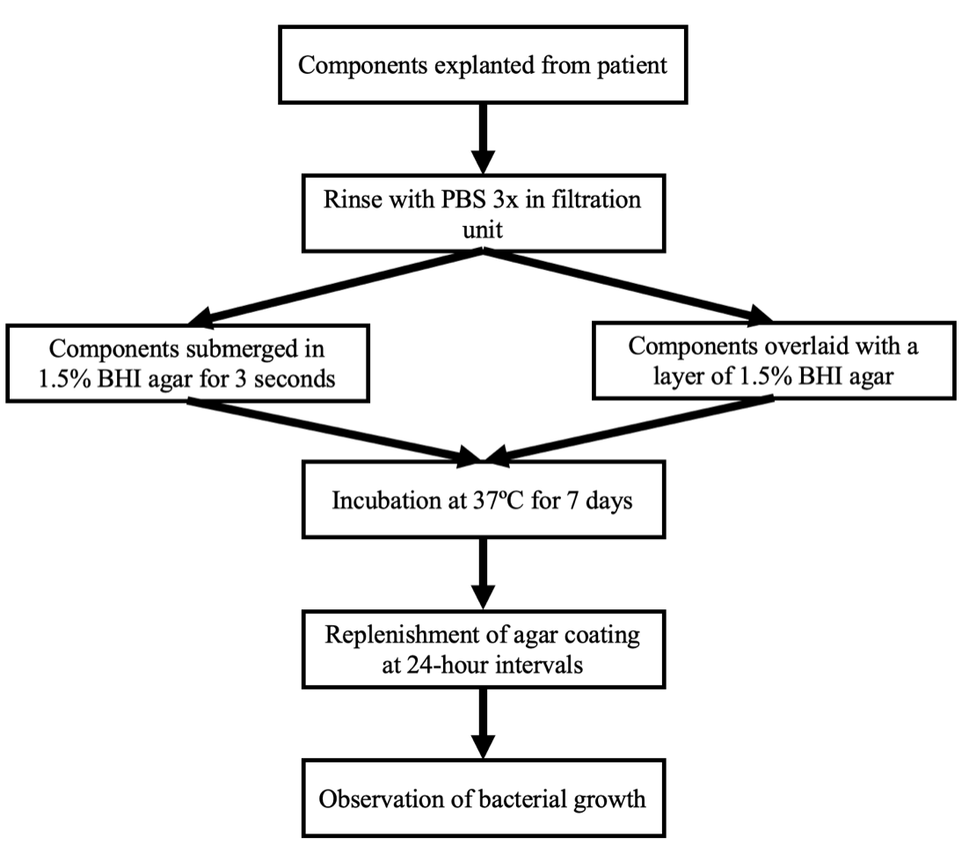

Figure 2.

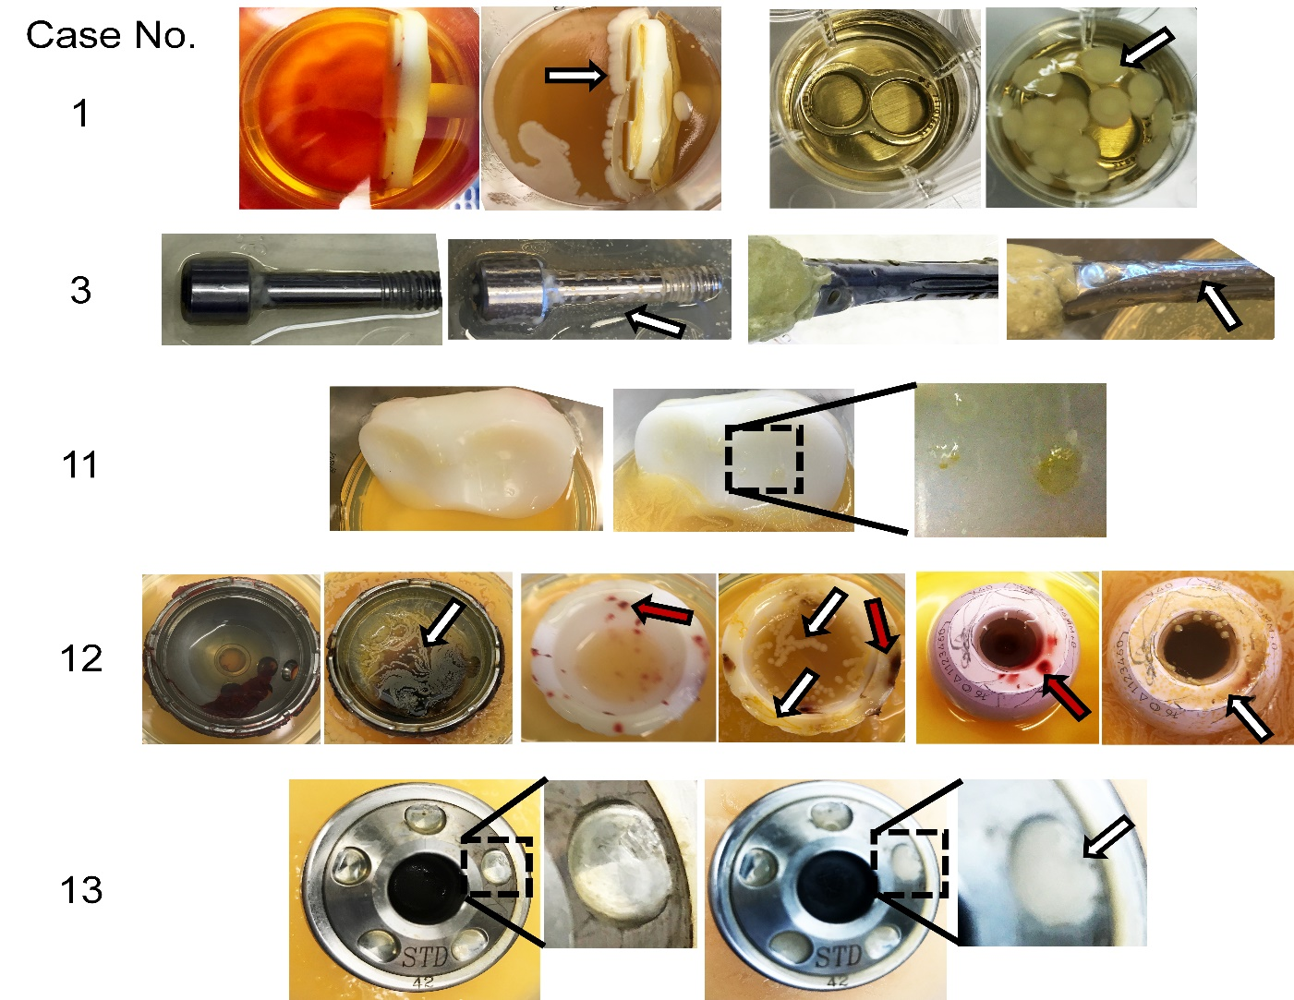

Figure 3.

