A computational literature review of the field of System Dynamics from 1974 to 2017

Martin Kunc^{a*}, Michael J. Mortenson^{b} and Richard Vidgen^{c1}

^{a*} Warwick Business School, University of Warwick, United Kingdom
Office 0.208, WBS Building, Coventry, CV4 7AL.
Email: martin.kunc@wbs.ac.uk / Phone: +44 2476528203

^{b} Warwick Manufacturing Group, University of Warwick, United Kingdom
^{c} University of New South Wales Business School, Australia

¹ Authors in alphabetical order
* Corresponding Author

Abstract
System Dynamics celebrated its 60th anniversary in 2017. While there have been numerous special issues in diverse journals, that bring together work by System Dynamic scholars who share similar research interests, there have not been systematic reviews of the scholarly activity across the broad field. This paper presents a computational literature review of the field until 2017. A computational literature review automates the analysis of research articles with analysis of content (topic modelling of abstracts) to identify emergent themes in the literature. We performed a broad review of the field by initially searching using the term “System Dynamics” with more than 8000 articles. However, the results obtained were not satisfactory so we decided to restrict our sample to less than 800 articles from recognised journals and proceedings. After evaluation of the results obtained from topic modelling, we decided to use 51 topics covering most of the articles in our sample. A list of 51 topics provides enough granularity to identify relevant patterns of activity within the community of System Dynamics scholars. From the list of 51 topics, we present a commentary on key insights from each of them.

KEYWORDS: System Dynamics; Computational Literature Review; Healthcare; Supply Chain; Methodology

Introduction
System Dynamics (SD) celebrated its 60th anniversary in 2017 so it is an adequate opportunity to review the achievements of the field through systematic reviews of the literature and/or special issues, such as the one in the Journal of Simulation. In terms of systematic reviews, there have been articles evaluating applications of simulation in different fields where SD appeared as one of the top three simulation methods, e.g. healthcare (Brailsford et al, 2009) and manufacturing (Jahangirian et al, 2010). SD scholars have generated a number of special issues highlighting the range of applications in the field, e.g. special issues in System Dynamics Review in 1997, 1998, 1999, 2001, 2002a,b, 2004, 2005, 2007, 2008 and 2010; Journal of the Operational Research Society, 1999; and European Journal of Operational Research, 1992. While there is a commendable effort by the System Dynamics Society to keep a list of publications where SD is employed, it is a daunting task when scientific production grows at 8-9% per year, so output doubles every nine years (Bornmann and Mutz, 2015). Interestingly, there have not been broad reviews of the literature trying to uncover trends and themes in the SD field. This paper provides the first computational review of the literature in the SD field until 2017.
A computational literature review (CLR) provides an automated analysis of a set of research outputs in three areas (Mortenson and Vidgen, 2016). Firstly, CLR can measure the impact in terms of citation count for research articles, h-index for authors and journal citation impact metric for journals. Secondly, CLR can structure the scholar community using co-authorship network. Thirdly, CLR identifies themes through underlying (latent) topics that are discovered performing topic modelling. In this paper, we focused on the third area, theme analysis using topic modelling so researchers, especially from other simulation methods, can have a broad overview of the trends and themes in the SD field.
The structure of the paper consists on a brief discussion of reviews of SD field through special issues, a review of the concept of CLR followed by the design of the CLR performed for the SD field and the results obtained.

Reviews of the System Dynamics field
SD researchers have preferred the use of special issues to present the state-of-the-art on the use of SD in specific areas of application. The spectrum of special issues (table included in appendix) since 1992 shows the diversity of interests of the broad community and the breadth of the field in terms of themes and areas of application. Unfortunately, there have not been special issues in recent years to account for the development of the field. Interestingly, there have been more literature reviews of the SD field from scholars outside the SD community in recent years than special issues from SD scholars. For example, Brailsford et al (2009) evaluated the use of SD in healthcare, Jahangirian et al (2010) discussed the use of simulation in manufacturing where SD is a prominent method, and Tako and Robinson (2012) identified the use of SD in logistics and supply chain. Finally, Brailsford, Churilov and Dangerfield (2014) in an edited book reviewed the increasing use of SD with other modelling methods, such as discrete event simulation. This situation demonstrates the wide appeal of SD in different areas of application and to researchers from outside the traditional SD community.
After the review of special issues, we concluded there are additional areas that may not have been covered previously. Therefore, it is important to perform a systematic study of the SD literature to provide an overview of the field. Recently researchers have developed systematic algorithms to perform computer literature review (CLR) using clustering methods (Park et al, 2012). CLR aims to reduce the judgmental biases in literature reviews by selecting, filtering and analysing large volume of research articles using clustering algorithms (Mortenson and Vidgen, 2016).

Defining Computer Literature Review
Systematic literature reviews offer obvious value to the research community, particularly with respect to ‘repeatability’ and ‘objectivity’, which are elements considered key to scientific methodology but are typically absent in most [non-systematic] literature reviews. As White and Schmidt (2005) note, “before reviews became systematic, the writer was free to pick and choose the papers that supported his or her viewpoint […] clearly a biased approach.” Whilst systematic reviews are preferable (from a scientific perspective), they are not easy to perform nor completely free from problems. A true systematic review should include all relevant work from across a range of academic publications. Sourcing and reading all such articles is obviously highly time-consuming. Then, the literature review may be incomplete and bias can be introduced regarding the articles included in the search phase. Additional subjectivity may also be introduced with respect to the articles that are excluded from the initial dataset.
CLR belongs to the area of systematic literature review since it follows a set of reproducible steps; and, therefore, is an algorithm rather than a heuristic (Mortenson and Vidgen, 2016). CLR seeks to maintain the benefits of a systematic review, whilst countering some of the issues mentioned previously. Moreover, attempts to provide support for reviews through automation have been implemented previously in literature related with this review, for instance Larsen et al. (2008) evaluated the Information System field and Jahangirian et al. (2011) analysed the Simulation field. The CLR is appropriate for this task because it includes a wide range of metrics to analyse academic research and is based upon latent Dirichlet allocation (Blei et al., 2003), which has “become the ‘de facto’ standard for topic modelling” (Mortenson and Vidgen, 2016).
Topic modelling is performed when a predefined number of topics, which are groupings of words based on their co-occurrences representing specific subject matters, are populated algorithmically (Mortenson and Vidgen, 2016). The approach is in the same family of algorithms as principal component analysis (PCA) because it finds components (called topics) which can explain variance in the data, though specifically designed for the use of text data (Mortenson and Vidgen, 2016). The two key elements of this design are non-linearity, as the distribution of words in documents is rarely “normal”, and an ability to deal with polysemy (whereby words can have multiple meanings – i.e. have membership of multiple components/topics). With respect to polysemy, the latent Dirichlet allocation algorithm (Blei et al., 2003) has advantages over approaches such as latent semantic indexing (Deerwester et al., 1990). In latent semantic indexing, words are given in a single position in its projected, low-dimensional space, analogous to each word only having one ‘meaning’, something rarely true of words in a modern language.

The Computer Literature Review process
Article selection. The source of data for CLR was the Scopus database from 1974 to 2017. Scopus asserts that it is “the largest abstract and citation database of peer-reviewed literature: scientific journals, books and conference proceedings.” (www.elsevier.com/solutions/scopus). Scopus is recognized as a high quality source of data for systematic reviews. Scopus permits the download of citation and abstract data in csv (comma separated variable) format. Scopus provide with breadth of coverage, quality of data, and ease of extraction.
The initial search in Scopus used the term “System Dynamics” in title, abstract and keywords generated more than 8000 documents from more than 5000 journals/conference proceedings. The data set is then cleaned to remove any articles with missing authors, missing abstracts, and duplicate records. However, the initial results were disappointing in terms of the themes and trends observed in the topics since many concepts and articles were not recognised as SD practice by the author with SD knowledge. Then, we decided to focalise on the articles from journals and conference proceedings (in Scopus) recognised for publishing SD. This resulted in 772 usable articles. The data shows increasing number of articles published per year, as figure 1 and a least squares regression line shows, with important oscillations due to special issues.
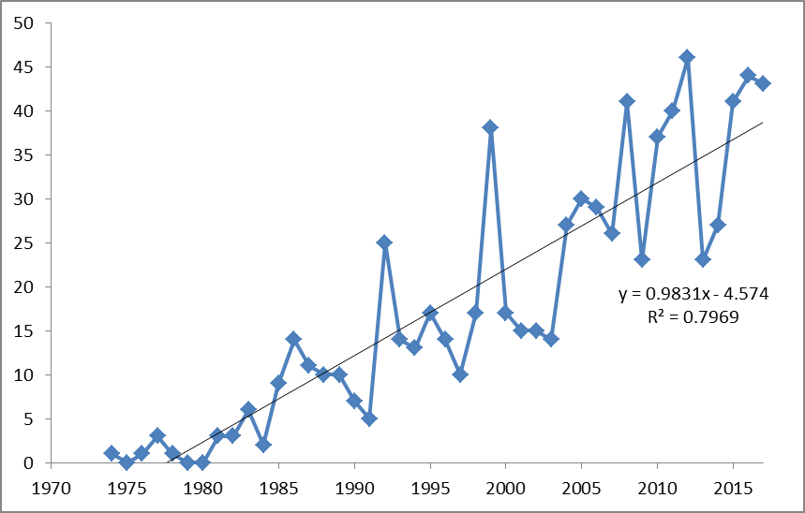
Figure 1. Publications per year in the dataset employed for CLR – 772 articles ranging from 1974 to 2017
Having looked at the publications by year the next stage in the CLR was to analyse the publication venues (journals and conferences) in which the publications appear. The CLR used the citation data to calculate a local h-index for each of the publication venues. A publication venue with an h-index of 20 has 20 articles that are cited at least 20 times by other articles. Table 1 presents the publication venues in our dataset in order of their h-index, together with the number of articles, the number of citations, and the average citations per article. Unsurprisingly, System Dynamics Review clearly dominates the publication venues, both with regards to quantity (347 articles and 8515 citations) and impact (an h-index of 46). At the other end of the table there are journals with few articles and little impact: for example the Journal of Simulation has 11 relevant articles and these have only managed to achieve an average of 2.6 citations per article (however, this journal started in 2010).

Source title | Articles | Cites | Start year | End year | Cites per paper | h-index
System Dynamics Review | 347 | 8515 | 1985 | 2017 | 24.5 | 46
European Journal of Operational Research | 112 | 3584 | 1978 | 2017 | 32.0 | 36
Journal of the Operational Research Society | 109 | 2596 | 1981 | 2017 | 23.8 | 28
Proceedings - Winter Simulation Conference | 99 | 811 | 1976 | 2017 | 8.2 | 17
Systems Research and Behavioral Science | 72 | 614 | 2006 | 2017 | 8.6 | 13
Systemic Practice and Action Research | 15 | 173 | 2004 | 2017 | 11.5 | 8
Behavioral Science* | 7 | 108 | 1974 | 1988 | 15.4 | 4
Journal of Simulation | 11 | 29 | 2010 | 2017 | 2.6 | 4
*Predecessor of Systems Research and Behavioral Science
Table 1. Analysis of publication venues

Topic modelling. A key part of the CLR process was the identification of the topics discussed in each abstract within the literature. In this research, the latent Dirichlet allocation (LDA) algorithm was modified to allow for the use of covariates (Mortenson and Vidgen, 2016; Mortenson, Powell and Vidgen, forthcoming). The modified algorithm, introduced in Roberts et al. (2013) and inspired by the correlated topic model (Blei and Lafferty, 2007), was fitted to a logistic-normal distribution as opposed to the Dirichlet distribution with two key consequences. Firstly, the topics were correlate (impossible in a Dirichlet distribution). Secondly, covariates were introduced into the model fit. In this case, the year of publication was included in the modelling so it could have influence on the prevalence of topics across the corpus. In other words, the model recognised that the popularity of topics would change over time and the year of a journal issue would influence the topics included.
Selecting the number of topics, K, is a somewhat contentious issue, much as it is for related methods such as principal components analysis (PCA) or K-means clustering. As K is unknowable a priori in almost all situations, previous researchers have tended to opt for a value based on convenience (e.g., 30, 50, 100 are popular choices) or through building multiple models with different values of K and selecting K based on visual inspection of results. A procedure called cross-validation based on a perplexity-based method is widely used in topic modelling (Nikita, 2016). Perplexity is a measure of the appropriateness of a probabilistic method to predict a sample where a low perplexity indicates the distribution is adequate at predicting the sample (Griffiths and Steyvers, 2004). As Griffiths and Steyvers (2004, 5228) explains “A scientific paper can deal with multiple topics, and the words that appear in that paper reflect the particular set of topics it addresses. In statistical natural language processing, one common way of modeling the contributions of different topics to a document is to treat each topic as a probability distribution over words, viewing a document as a probabilistic mixture of these topics”. For example, if there are K topics, the probability of the i^{th} word in a given document is a conditional probability of the word belong to a topic given the probability of choosing a word from topics j in the current document. The first conditional probability indicates which words are important to a topic and the second probability is the prevalence of those topics within a document.
To fix a value of K, we used the R package ldatuning (Nikita, 2016) and ran the algorithm for values of K from 10 to 200 in increments of 10 (Figure 2 where the y-axis indicates the level of perplexity and x-axis the number of topics). Figure 2 suggests that a value of K in the range 30 to 80 would be appropriate. Two of the metrics, Arun2010 (Arun et al, 2010) and CaoJuan2009 (Cao et al, 2009), have to be minimized (top graph in figure 2) and the point where they intersect indicates the appropriate number of topics. Two metrics, Griffiths2004 (Griffiths and Steyvers, 2004) and Deveaud2014 (Deveaud, SanJuan, and Bellot, 2014) have to be maximized (bottom graph in figure 2).

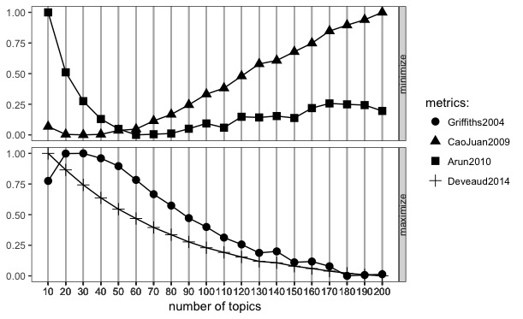
Figure 2. Finding K – 10 to 200 in increments of 10

We ran the analysis again for this range but with increments of 1 (Figure 3) and applied the same R package as in figure 2. The metrics indicated that 51 topics is appropriate. To confirm this value, the SD domain expert reviewed the outcome of the topic model for 51 topics and decided that it was an appropriate set of topics.
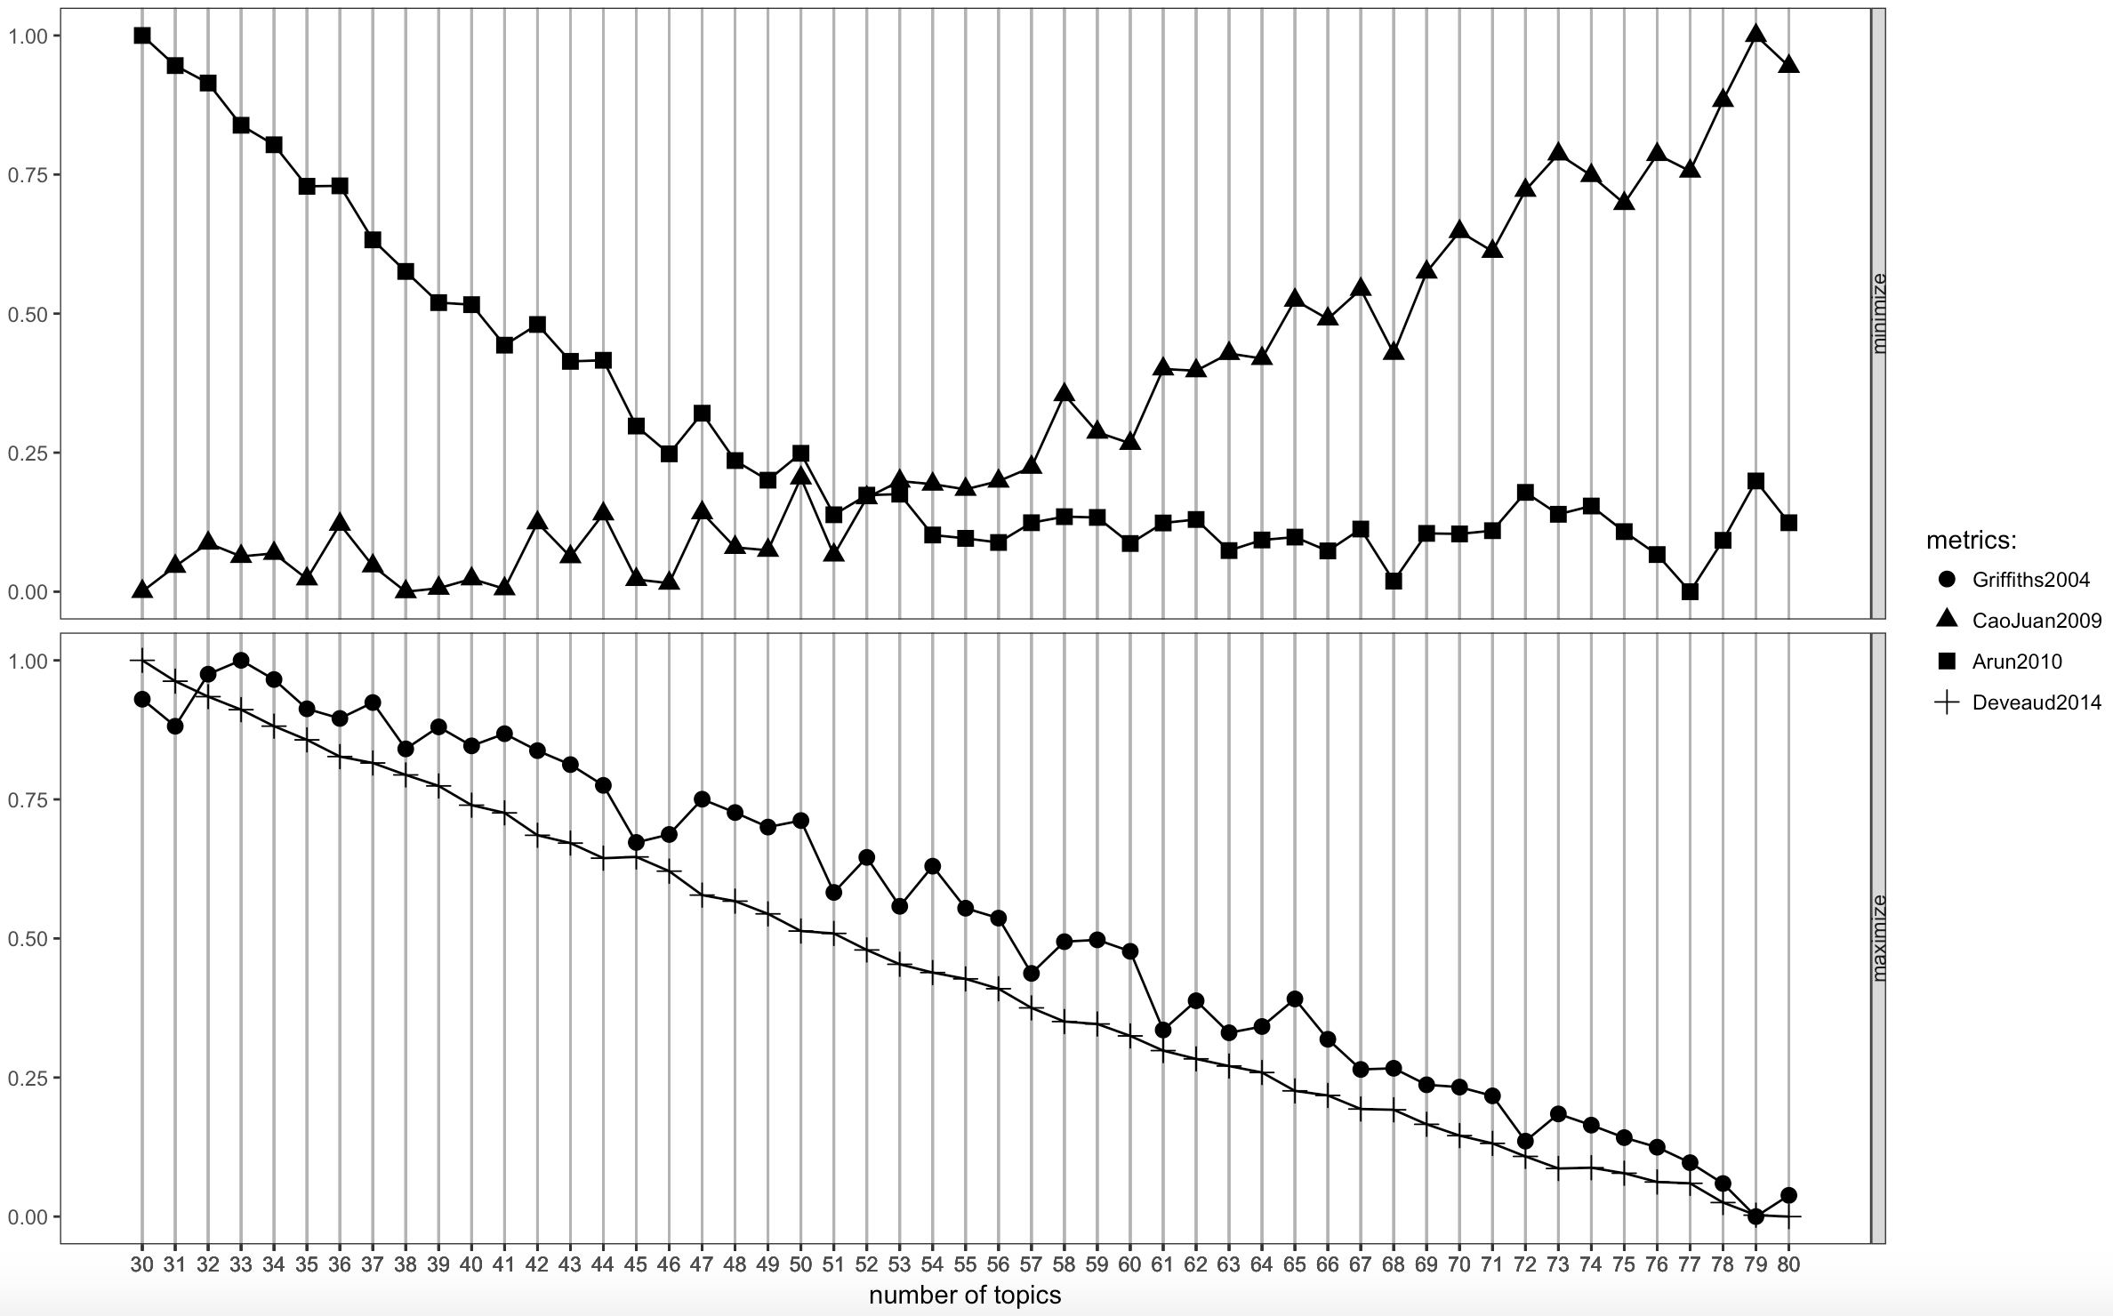
Figure 3. Finding K – 30 to 80 in increments of 1

Then, we created the word clouds corresponding to each topic. The word clouds show the most likely words in the topics (based on highest probability of occurring). The words are sized in scale with likelihood (the larger the font, the more likely the word) and grouped by colours into categories (black, blue, red and green – representing a descending order of likelihood). One of the limitations of this method is the word cloud can contain words that seem to be generic or having little connection with a topic or articles existing in a topic. However, this result can’t be avoided as it comes from the process of modelling topics from articles that contain heterogeneous information (Blei, 2012). See figure 4 for an example of a word cloud. All word clouds and their corresponding words are included in the supplementary material. Then, a set of papers for each topic were generated by using the posterior probabilities that a paper loads on a given topic - these are the papers with the highest loadings for a specific topic. Each topic has allocated 12 papers that do not repeat across topics. See supplementary material for the full list of papers in each topic. We used this information to define the theme of a topic and validate the usefulness of number of topics (k). However, the papers loaded on a given topic sometimes were not clearly associated with a theme but we tried to minimise undefined topics as much as possible through reviewing different k.
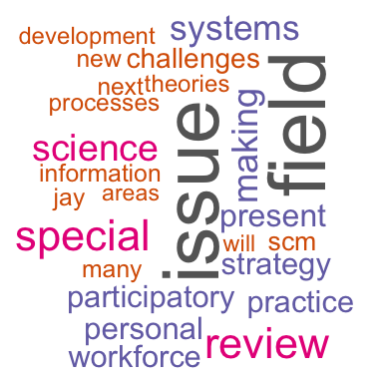
Figure 4. Example of a word cloud

Results from topic modelling – An exploration of themes emerging from the SD literature
The list of the 51 topics identified by CLR was evaluated together with the critical words, word clouds and papers assigned to each topic. The supplementary material has the word cloud and critical words. The supplementary material has the papers for each topic. Table 3 presents a qualitative analysis of the 51 topics in terms of insights emerging from the papers that have the highest proportion of content associated with them (the topic loading). In other words, the insights are based upon an analysis of the papers associate with each topic. The numbers in the second column correspond to the paper in each topic which are numbered as X.Y where X=Topic and Y=Order inside the topic. Please, refer to the supplementary material for the information about the paper.
Topic Number | Insights from the topic
1 – SD history | Reflects on the developments of the SD field occurring at its 50th anniversary. For example, paper (1.3) discusses the contribution to a behavioural and dynamic theory of strategy. Papers (1.1) and (1.4) are personal views of the founder of SD, Jay Forrester. While papers (1.5) and (1.12) are reflections from two recognised scholars in the field.
2 – Health complexity | The topic comprises three areas. Firstly, a focus on healthcare as a complex system with models addressing issues such as workforce management in healthcare (papers 2.1, 2.3, 2.11). Secondly, three papers (2.9, 2.10 and 2.12) offer a perspective on common areas between SD and other soft Operational Research methods. Thirdly, methodological issues are discussed: loop polarity and loop dominance (paper 2.8) and a competence development framework for system dynamicists (paper 2.4).
3 – Macro issues | The main focus of this topic is macro-level issues, such as trade (paper 3.1), nation building (paper 3.4), transportation (paper 3.5) and security (papers 3.6 and 3.9). These issues are addressed using generic system archetypes.
4 – Contributions to Economics | The area covered in this topic is the contributions of SD to economics: Forrester’s perspective on economics (paper 4.12), globalization (papers 4.6, 4.8 and 4.10), and market dynamics with a behavioural economics perspective (papers 4.1, 4.2, 4.3 and 4.7).
5 – Public Policy making | The main theme is public policy making in two areas. Firstly, policy making in the energy industry addresses issues such as efficiency (papers 5.4, 5.12), transportation (papers 5.3, 5.7) and new technologies (papers 5.2, 5.9, and 5.10). A second area in policy making is healthcare with applications in prescriptions, workforce and drug usage (papers 5.5, 5.6, and 5.8). In this topic, policy models use well-established structures such as population ageing chains.
6 – Management flight simulators | Two themes are distributed uniformly in this topic. Firstly, the focus is on the use of SD in management flight simulators in order to evaluate the learning process of users and changes in their cognitive abilities (papers 6.1, 6.3, 6.5, 6.6, 6.8, 6.9 and 6.12). Then, there are examples of policy analysis at government level also using management flight simulators in papers (6.2, 6.4, 6.7 and 6.11) for food and transportation.
7 - Health improvement | The main theme is supporting health emergency and healthcare improvement programmes (papers 7.2, 7.5, 7.7, 7.9 and 7.10). In addition, two articles reflect on the emergent role of SD as a dynamic and behavioural theory of strategy (papers 7.3 and 7.6). Unfortunately, there are some papers that cannot be classified adequately.
8 – Technology adoption | Two areas are important in this topic. Firstly, the development and adoption of technologies modelled at macro-level considering two processes: user adoption and capacity expansion (papers 8.2, 8.4, 8.6, 8.7, 8.8 and 8.10). Secondly, the use of SD for issues related with security (papers 8.1, 8.3, 8.5 and 8.9).
9 –Learning | Organisational learning processes is a strong area of research in SD with numerous papers (9.3, 9.4, 9.6, 9.9, 9.10 and 9.12) employing both qualitative and quantitative models. The other theme is: how users and modellers learn at individual level (papers 9.5, 9.7, 9.8 and 9.11) and group level (paper 9.2).
10 – Social systems | This topic reflects the interest in the SD field to integrate SD with other disciplines, e.g. sociology, and modelling the social dimensions of systems. Lane is the most prolific author in this topic with 3 papers (paper 10.1, 10.2 and 10.3).
11 – Validation | This theme addresses validation in SD in terms of processes, tests and paradigms (papers 11.1, 11.2, 11.4, 11.5 and 11.6), as well as the role of users/clients (papers 11.8, 11.11 and 11.12).
12 – Bass diffusion model | This topic demonstrates the strength of SD in modelling market dynamics through the use of a standard structure based on the Bass diffusion model (papers 12.1, 12.2, 12.3, 12.4, 12.5, 12.6, 12.9 and 12.12). The findings in this topic can be associated with themes discussed in topics 5 and 8.
13 – Waste and recycling | This topic is strongly defined by modelling waste and recycling processes, as well as closed loop supply chains (papers 13.2, 13.6, 13.7, 13.8, 13.9, 13.10, 13.11 and 13.12)
14 – Participatory modelling | There are two contributions in this topic. Firstly, participating modelling is a key approach to model building in SD (papers 14.1, 14.2, 14.3, 14.6, 14.11 and 14.12). Secondly, changes in mental models as a measure of the effectiveness of participatory modelling is also discussed in this topic (papers 14.8. 14.9 and 14.10).
15 – Security | This topic reflects on a long standing area of interest in SD: warfare/security/defence. However, the papers are not recent. The papers in this topic should be considered together with the papers in topic 8.
16 – Education | This topic contains papers before 2000 and it shows a traditional focus of SD researchers on education (papers 16.3, 16.6 and 16.11) and ecological modelling (papers 4 and 5). Simultaneously, there are a large number of papers examining methodological aspects of SD modelling (papers 16.1, 16.2, 16.7, 16.8, 16.9, 16.10 and 16.12).
17 – Model behaviour: feedback analysis and optimisation | There are three main themes. Firstly, the analysis of feedback loops has received substantial attention in the SD field with different approaches to study feedback loops dominance over time (papers 17.1, 17.4, 17.7, 17.9 and 17.11). These papers need to be complemented with papers in topic 2. Secondly, the use of optimisation to find out best policies in models (papers 17.5, 17.6, 17.10 and 17.12) complements the traditional interactive approach to policy making depicted in topics 1, 3, 5 and 6. Thirdly, papers (17.2, 17.3 and 17.8) show research related with the process of evaluating structural components of SD models such as graphical functions and causal relationships.
18 – Participatory modelling | Another recurrent theme is presented in this topic: participatory modelling. See also topic 14. In this case, there are papers from a well-known set of researchers (papers 18.1, 18.3, 18.7, 18.8, 18.9 and 18.10). Paper 18.6 could have been part of topic 17 as well. Finally, three papers (18.5, 18.11 and 18.12) examine the emergence of participatory modelling in SD.
19 – Tourism and sustainability | This topic has two main areas. Firstly, modelling related with tourism and sustainability (water use), which are intrinsically related, is observed in papers (19.1, 19.5, 19.8, 19.9, 19.10 and 19.11). Secondly, the use of SD during strategic development processes is addressed in papers (19.2, 19.3, 19.4 and 19.12).
20 – Modelling methodology | This topic is strongly connected with SD modelling methodologies. Papers (20.1, 20.2, 20.4, 20.5, 20.7, 20.8, 20.9 and 20.11) address issues related with parameter estimation and calibration. These papers can be associated with papers in topic 17. The remaining papers are examples of calibration and parameter estimation in specific applications.
21 – SD/DES | There is one strongly defined theme in this topic: the integration of SD with Discrete Event Simulation. A lot of activity has been occurring in this area recently with researchers, mostly from discrete event simulation, performing analysis of how both methods are used for addressing similar issues (papers 21.1, 21.2, 21.3 and 21.12) and how they can be taught together (papers 21.4 and 21.8). Finally, a set of papers (21.5, 21.6, 21.7, 21.9, 21.10 and 21.11) looks for approaches to mix both simulation methods.
22 – Group model building | The main theme is applications of group model building so the papers in this topic can be associated with papers in topics 14 and 18. One of the important contributions from the papers here is the ‘scripts’ for doing group model building (papers 22.3, 22.5, 22.6, 22.7 and 22.11) with their corresponding applications (papers 22.2, 22.4 and 22.9).
23 – Market Dynamics | This is a strong area of modelling for the SD community: market dynamics and the role of information in decisions such as price and capacity (papers 23.1, 23.2, 23.3, 23.4, 23.5, 23.6, 23.9 and 23.12). There are examples of case studies and experiments related with this area of research (papers 23.1, 23.8 and 23.12).
24 – Parameter estimation | This is an interesting topic for SD modelling. The papers offer examples and recommendations on using statistics to test model accuracy (papers 24.1, 24.2, 24.3, 24.7 and 24.12) and calculating model parameters, in the tradition of other simulation methods (papers 24.6, 24.8, 24.9, 24.10, 24.11). This topic can be associated with topics 17 and 20 to have a broad overview of papers examining methodological issues in SD.
25 – Systems thinking | This topic is completely devoted to systems thinking and the contribution of SD to systems thinking. Papers (25.1, 25.3, 25.4, 25.7 and 25.12) offer diverse accounts of the integration of systems thinking and SD. Papers (25.2 and 25.6) look at the issues facing teachers on introducing systems thinking in schools. Papers (25.8, 25.9 and 25.10) address the issues of aggregation in systems.
26 – Health policy making | This topic presents extensive evidence of SD contributions to policy making in healthcare. This is one of the key areas of applications for SD due to the existence of established structures to represent populations and/or chronic disease progression. This topic complements topics 2 and 7 to have a broad overview of the contributions of SD to healthcare.
27 – Psychological aspects of behaviour | The main theme covered is psychological aspects of behaviour (papers 27.1, 27.2, 27.3, 27.4, 27.5, 27.6, 27.8 and 27.10). One interesting insights is the diversity of applications of this research area. There are three papers (27.7, 27.11 and 27.12) offering methods to evaluate behaviour in SD models through technical solutions.
28 – Supply chain management | This topic presents SD contributions to Supply Chain Management. The main contributions of SD to this field are offering explanations for oscillations in supply chains, also known as the bullwhip effect, in papers (28.2, 28.3, 28.5, 28.8, 28.10 and 28.12) and approaches to predict and control variability (papers 28.1, 28.4, 28.6, 28.7, 28.9 and 28.11).
29 - SD methodology applied to Economic topics | Two themes: integration of SD with economics (papers 29.1, 29.6, 29.7, 29.9, 29.10) as a research method; and measuring effectiveness in group model building (papers 29.2, 29.3, 29.4 and 29.11). The last theme complements areas of research in topics 14, 18 and 22; while the first theme can be associated with topics 3 and 4.
30 – Manufacturing planning | Two critical aspects of manufacturing are discussed here. Firstly, capacity planning from job-shop to networks of suppliers demonstrates the versatility of SD to address issues at different level of analysis (papers 30.1, 30.2, 30.3 and 30.5). Secondly, ordering process, e.g. retail orders, is another strong area of research using mostly experiments in laboratories (papers 30.4, 30.6 and 30.7).
31 – SD and control systems | Basically, there are articles describing the use of SD to design control systems in business (papers 31.1, 31.2 and 31.8) and operations (papers 31.5 and 31.10). There are another set of articles also addressing control issues but at the national level (papers 31.4, 31.6 and 31.12).
32 – Archetypes | This topic presents evidence of the use of repeated structures in SD called archetypes in diverse contexts (papers 32.1, 32.2, 32.4, 32.7, 32.9, 32.11 and 32.12) as well as specifically in healthcare (papers 32.5, 32.6 and 32.10).
33 – Health services | This is an additional topic depicting papers in the area of healthcare. In this case, there are examples of policy making in different service areas such as treatments, patient pathways and workforce. This topic complements topics 2, 7 and 26.
34 – SD/Fuzzy methods | The main theme is the representation of behaviour in SD models using fuzzy methods (papers 34.6, 34.9 and 34.10). There is other set of papers offering methods to analyse the behaviour generated by SD models through different methods (papers 34.1, 34.2, 34.3, 34.4, 34.5, 34.7 and 34.11). This second theme is associated with topics 17, 20 and 24.
35 – Not defined | This is not a clearly defined topic but there seems to be a connecting theme in the area of information in papers (35.1, 35.4, 35.6, 35.8, 35.9, 35.11 and 35.12).
36 – Population aging | This topic is associated with one of the most used structures in SD: population aging, which is a set of stocks representing transitions processes in groups. There are applications in health (papers 36.1, 36.2. 36.6, 36.8, 36.11) and ecology (papers 36.7 and 36.10). There are also three papers discussing methodological issues associated with this structure, such as number of states and bootstrapping, in papers (36.3, 36.4, 36.5 and 36.9). These three papers can be associated with the methodological theme discussed in topics 17, 20 and 24.
37 – SD/ABM | This topic discusses experiences with the integration of SD and Agent Based Models in terms of tools (paper 37.11), methodology (papers 37.4, 37.5, 37.8, 37.10), teaching (papers 37.1, 37.2 and 37.3) and applications (papers 37.7 and 37.10).
38 – Learning and misperceptions of feedback | The main theme is evaluating, measuring and discussing how is learning under dynamic complexity, which is affected by misperceptions of feedback. This is a traditional field of research in SD performed using mostly experimental research. All papers are associated with the theme.
39 - Misperceptions of stocks and flows | This topic can be considered together with the previous topic but it addresses another area of research in SD: the understanding of stocks and flows dynamics. In this case, the research is performed with healthcare professionals given the importance of accumulation processes in medicine. All papers are connected with the theme.
40 – Energy Markets | This topic can be associated with topics 5 in terms of energy and topics 4 and 12 in terms of market dynamics due to the extensive set of papers discussing oil industry dynamics. All papers define the theme.
41 – SD/Hybrid models | This topic is associated with an emerging area in simulation: hybrid models. Hybrid models are combination of two or more modelling methods. Papers (41.1, 41.3, 41.4, 41.5, 41.6, 41.7, and 41.8) discuss approaches and case studies. This topic should be considered together with topics 21 and 37.
42 – Parameter estimation | This topic presents papers from a cluster of UK-based researchers engaged in parameter estimation with applications in optimisation applied to SD modelling, SD in defence and organisational issues.
43 – Project management | The main theme is the contribution of SD to project management during the late 1990s in areas such as construction (paper 43.2) and engineering (papers 43.6 and 43.10) as well as the behaviour of clients (papers 43.4, 43.5, 43.7 and 43.8).
44 – Not defined | This topic has not defined themes.
45 – Causal loop developments | The main theme is related with automatizing the development of qualitative SD models, e.g. causal loop diagrams, using text data (papers 45.3, 45.4, 45.5, 45.6, 45.8 and 45.10) together with issues on the process of group model building (papers 45.1, 45.2, 45.7, 45.11 and 45.12).
46 – Archetypes | This topic is related with topic 32 since the main theme is the use of repeated structures in SD called archetypes. In this topic, the papers evaluate the robustness and usability from a theoretical perspective (papers 46.1, 46.3, 46.4, 46.9, 46.11 and 46.12) and empirically (papers 46.2, 46.5, 46.6 and 46.10).
47 – Strategic decision making | The main theme is supporting strategic decision making using models (papers 47.2, 47.7 and 47.9), facilitated interventions (papers 47.1, 47.3, 47.4, 47.6 and 47.8) and experiments (papers 47.5, 47.10).
48 – Research on behavioural decision making | This topic presents research on behavioural aspects of decision making in areas such as production, supply chain and forecasting using experiments (papers 48.5 and 48.11).
49 – Security | The main theme is related with policing and security (papers 49.1, 49.2 and 49.10). There is another theme associated with policy making in diverse contexts (papers 49.3, 49.4, 49.5, 49.6, 49.7, 49.8, 49.9 and 49.12). The second theme is more related with the topics defining policy making at national level.
50 – Health epidemics | This topic complements other topics related with healthcare (topics 2, 7, 26 and 33). In this case, the papers offer examples of modelling epidemics and chronic diseases.
51 – Project management | This topic presents contributions to project management in recent years. The main areas of research are related with cost management. All papers contribute to the theme.
Table 3. Insights from 51 topics
Finally, another function of the CLR is to evaluate the interactions between topics and covariates. Therefore, we can identify and compare the prevalence of topics over time. The next figures present some examples but all the graphs are in the appendix. Some topics shows a clear upward trend in topic popularity as shown in figure 5. Others follow a downward trend, exemplified in figure 6, and some topics does not have a clear pattern, demonstrated in figure 7.
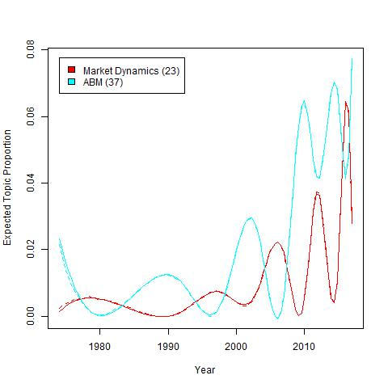
Figure 5. Topics with a positive trend over time
Figure 5 features topic 23, focused on market dynamics, and topic 37, the interface between SD and agent based modelling (ABM). In respect to the former, although there is some natural variation, there is an upward trend beginning around 2009/2010 with the processes of boom and bust observed in markets. Topic 37 starts growing in the mid-2000s since ABM, as a field, saw notable growth (e.g. Macal and North, 2014).
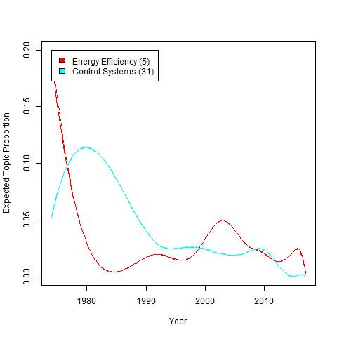
Figure 6. Topics with a declining trend over time
At the other end of the scale, topics 5 (public policy making) and 31 (design control systems) show a declining trend over time in our sample of papers (figure 6). However, topic 5 only captures a limited view of the SD in its application in energy since a larger, and increasing, number of papers are published in specialist journals, e.g. Energy Policy, instead of generalist journals like in our sample. Additionally, there are other energy related topics, such as 4, 12 and 40, which are increasing over time and cover other aspects of the energy industry. Topic 31 reflects the declining interest in the area of control design as a driver of SD modelling.
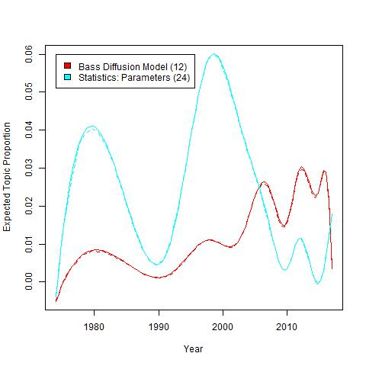
Figure 7. Topics with no clear long term trend
Finally, we consider topics that have no clear long term trend, two of which are shown in figure 7. Topic 12, related to studies using the Bass diffusion model, and topic 24, the use of statistics in the validation of SD models, are good examples. In both cases, research interest seems to come in waves (mostly determined by special issues or group of collaborators publishing a stream of papers), with topic 24 showing two very clear peaks in 1980 and 2000. Topic 12 has an upward trend but it is not constant and oscillates from year to year. Moreover, it shows a step decline in 2017.

Discussion
The contribution of the CLR to the field of SD can be considered in three areas. Firstly, there is clear evidence the field of SD has areas of research related to its soft (qualitative) and hard (quantitative) nature (Kunc, 2017). There are multiple areas of research on soft aspects such as facilitated modelling and group model building (topics 14, 18 and 22, 29, 45), problem structuring methods (topics 2, 25 and 32) and extraction of causal relationships from text data (topic 45). Important developments in evaluating quantitative models also appeared in the literature such as feedback loop dominance analysis (topic 17), validation (topic 12) and optimisation (topic 34). There are also works focusing on model building such as non-linear functions, parameter estimation using statistics (topic 24) and calibration (topic 20). The number of topics reflect clear research areas in SD in the methodological aspects of soft and hard modelling that other modellers can use in the future.
Secondly, there is a strong tradition in research in behavioural aspects. For example, a key area of research is decision making in multiple contexts: strategy, supply chain and education. The use of simulators, or management flight simulators, to explore the impact of interventions on mental models (topics 6 and 27) and understand how mental models affect the performance under dynamic complexity (topics 38 and 39) is well established in the field. In the area of biases, the SD field has contributed with extensive research on misperceptions of feedback through experiments in lab (topics 38 and 48). Finally, there is a strong area of research in organisational learning (topic 9).
Thirdly, SD has become a strong contributor in different areas of application built over the use of stable SD model structures for problems in these areas. For example, SD has a long tradition in healthcare (topics 2, 7, 26, 33 and 50), specifically in national policies, epidemics and service design; energy policy and markets (topics 4, 5, 12 and 40); and supply chain management and manufacturing (topics 13, 28 and 31). It is clear there are areas of application where the use of stocks and flows is widely accepted as it fits well with the set of research questions and problem situations, e.g. aggregate, macro-level and strategic. However, there are increasing use of SD with other modelling methods to provide multi-level solutions to problems, e.g. topics (21, 37 and 41), which demonstrates the versatility of SD as a contributor to the simulation field.

Conclusion
The study involved a computer literature review of the SD field until 2017. Computational Literature Review provides unbiased categorisation of topics and their trends over time in the field. The review of more than 770 papers from significant journals in the field provided 51 topics uncovering diverse aspects of SD research: qualitative modelling, quantitative modelling, contributions to behavioural aspects, multiple areas of application and an increasing integration with other modelling methods. The topics also offer a list of relevant articles associated with each topic that can facilitate the understanding of an area of research for new comers to the field or existing SD researchers without knowledge of further research opportunities.
While we believe the study provides very useful insights, there are a number of limitations. Firstly, the selection of journals does not cover journals associated with areas of application, e.g. Energy Policy published a large number of papers, and specific areas of research, e.g. operations management, so we missed the richness in those areas. We experimented with larger set of papers and journals but the results were not convincing so we had to make a decision to focus on those journals strongly associated with research on SD or in the broad Operational Research field. This speaks to a more general problem with CLR and topic models in general. Whilst the software/models are designed to deal with polysemy, the data employed is drawn from academic databases where a search query has to be used to extract the relevant articles. For certain topics, “system dynamics” is one of them, the search term leads to ambiguities because it means different things in different fields, e.g. engineering or computer science. Ultimately there is a trade-off between an exclusive policy, where the journals are limited to ensure relevance to the research topic in question, and an inclusive policy that means a far larger dataset that it will also introduce ‘noise’, and fewer potentially valid results. Moreover, an inclusive policy may not capture articles where “System Dynamics” is applied but its name is not used in either abstract or keyword. We decided to take a more conservative approach. Secondly, the word clouds contain words that may not be clearly associated with specific topics but it is very difficult to distil specific language from general papers. Potentially, the application of CLR to highly specific areas can provide better word clouds but the low number of papers will affect the precision of the algorithm. Thirdly, the insights are generic and do not delve into detail of each paper. Unfortunately, it will be a very long paper to address each topic in detail. However, the map of the field presented in this paper is an initial starting point for more in-depth research on each of the topics, as well as providing a greater understanding of the developments of SD over 40 years. The papers in each topic may not be clear contributors to the topic but this is a general limitation that only numerous refinements, in our case it was more than four iterations, can overcome. While a topic without trend may not be interesting, graphs in the appendix present raw data from evaluating the sample of papers so it may show either important changes in the mood of the SD community or lack of sustained effort regarding research in this area. Consequently, it may be a useful piece of information for future research.

References
Arun, R., V. Suresh, C. E. Veni Madhavan, and M. N. Narasimha Murthy. 2010. On Finding the Natural Number of Topics with Latent Dirichlet Allocation: Some Observations. In Advances in Knowledge Discovery and Data Mining, Mohammed J. Zaki, Jeffrey Xu Yu, Balaraman Ravindran and Vikram Pudi (eds.). Springer Berlin Heidelberg, 391–402. http://doi.org/10.1007/978-3-642-13657-3_43
Blei, D. M. 2012. Probabilistic topic models. Communications of the ACM, 55(4), 77-84.
Blei, D. M., Ng, A. Y., and Jordan, M. I., 2003. Latent Dirichlet allocation. The Journal of Machine Learning Research, 3, pp.993–1022.
Blei, D.M. and Lafferty, J.D., 2007. A correlated topic model of science. The Annals of Applied Statistics, pp.17-35.
Brailsford, S., Churilov, L. and Dangerfield, B. eds. 2014, Discrete-Event Simulation and System Dynamics for Management Decision Making. John Wiley & Sons.
Brailsford, S.C., Harper, P.R., Patel, B. and Pitt, M., 2009. An analysis of the academic literature on simulation and modelling in health care. Journal of simulation, 3(3), pp.130-140.
Cao, J., Xia, T., Li, J., Zhang, Y., & Tang, S. 2009. A density-based method for adaptive LDA model selection. Neurocomputing, 72(7-9), 1775-1781.
Deveaud, R., SanJuan, E. and P. Bellot 2014. Accurate and effective latent concept modeling for ad hoc information retrieval. Document numérique 17, 1: 61–84. http://doi.org/10.3166/dn.17.1.61-84
Griffiths, T. L., & Steyvers, M. 2004. Finding scientific topics. Proceedings of the National academy of Sciences, 101(suppl 1), 5228-5235.
Jahangirian, M., Eldabi, T., Naseer, A., Stergioulas, L.K. and Young, T., 2010. Simulation in manufacturing and business: A review. European Journal of Operational Research, 203(1), pp.1-13.
Jahangirian, M., Eldabi, T., Garg, L., Jun, G. T., Naseer, A., Patel, B., et al., 2011. A rapid review method for extremely large corpora of literature: Applications to the domains of modelling, simulation, and management. International Journal of Information Management, 31(3), pp.234–243.
Kunc, M. 2017. System Dynamics: Hard and Soft Operational Research, Palgrave: London.
Larsen, K. R., Monarchi, D. E., Hovorka, D. S., and Bailey, C. N., 2008. Analyzing unstructured text data: using latent categorization to identify intellectual communities in information systems. Decision Support Systems, 45(4), pp.884–896.
Macal, C. and North, M., 2014, December. Introductory tutorial: Agent-based modeling and simulation. In Proceedings of the 2014 Winter Simulation Conference (pp. 6-20). IEEE Press.
Mortenson, M., Powell, P., and Vidgen, R., (forthcoming). An analysis of The Financial Times 50 (FT50) Journal list.
Mortenson, M.J. and Vidgen, R., 2016. A computational literature review of the technology acceptance model. International Journal of Information Management, 36(6), pp.1248-1259.
Nikita, M., 2016. ldatuning. https://cran.r-project.org/web/packages/ldatuning/ldatuning.pdf
Park, D.H., Kim, H.K., Choi, I.Y. and Kim, J.K., 2012. A literature review and classification of recommender systems research. Expert Systems with Applications, 39(11), pp.10059-10072.
Roberts, M.E., Stewart, B.M., Tingley, D. and Airoldi, E.M., 2013. The structural topic model and applied social science. In Advances in Neural Information Processing Systems Workshop on Topic Models: Computation, Application, and Evaluation.
Tako, A.A. and Robinson, S., 2012. The application of discrete event simulation and system dynamics in the logistics and supply chain context. Decision support systems,52(4), pp.802-815.
White, A. and Schmidt, K., 2005. Systematic literature reviews. Complementary therapies in medicine, 13(1), pp.54-60.

APPENDIX

Table A. List of Special Issues devoted to the methodology and applications of SD

Journal | Issue | Topic
European Journal of Operational Research | Volume 59, Issue 1, Pages 1-230, May 1992 | “Modelling for learning” presents a set of articles focused on the use of SD to support learning processes.
System Dynamics Review | Volume 13, Issue 2, Pages 103-201, Summer 1997 | “Group model building” shows the developments in the process of model building with clients, users and stakeholders interactively.
System Dynamics Review | Volume 14, Issue 2-3, Pages 105-255, Summer - Autumn (Fall) 1998 | “Sustainable development” is an account of the important use of SD to facilitate the evaluation of policies aimed at generating sustainable development in broader terms.
System Dynamics Review | Volume 15, Issue 3, Pages 197-344, Autumn (Fall) 1999 | “Health and Health Care Dynamics” displays papers in one of the most vibrant themes in the SD field: health care interventions and policy making.
Journal of the Operational Research Society | Volume 50, Issue 4, Pages 291-449, April 1999 | “System Dynamics for Policy, Strategy and Management Education” is an account of the activity of SD in the area of strategy and management education mostly based in the work of UK researchers.
System Dynamics Review | Volume 17, Issue 3, Pages 173-291, Autumn (Fall) 2001 | “Consulting and Practice” presents works in one of the most active areas of SD: consulting. It reflects the challenges and accomplishments by consultants in the use of SD with clients.
System Dynamics Review | Volume 18, Issue 2, Pages 101-310, Summer 2002 | “The Global Citizen: Celebrating the Life of Dana Meadows” presents papers related to the work of Dana Meadows in different areas but mostly in sustainability which were driven by her book based on The Limits to Growth project.
System Dynamics Review | Volume 18, Issue 3, Pages 311-429, Autumn (Fall) 2002 | “Systems Thinking and System Dynamics in Small-Medium Enterprises” shows papers discussing applications and the challenges on using SD with small companies.
System Dynamics Review | Volume 20, Issue 2, Pages 89-198, Summer 2004 | “Environmental and Resource Systems” explores the use of SD in the area of sustainability in terms of the dynamics of resources, e.g. water.
System Dynamics Review | Volume 21, Issue 3, Pages 173-269, Autumn (Fall) 2005 | “The Dynamics of Supply Chains and Networks” presents articles in one of most extensive areas of experimental research using SD: supply chain dynamics and, more especially, the bullwhip effect.
System Dynamics Review | Volume 23, Issue 2-3, Pages 89-370, Summer - Autumn (Fall) 2007 | “Exploring the Next Great Frontier: System Dynamics at 50” presents review papers of the different areas where SD has been applied: project management, corporate strategy, limits to growth, operational gaming, bullwhip effect/Beer Distribution Game, education and health economy, together with personal memoirs.
System Dynamics Review | Volume 24, Issue 3, Pages 247-405, Autumn (Fall) 2008 | “Information Systems Research with System Dynamics” shows papers that reflect the use of SD to support research on design, development and impact of information systems.
System Dynamics Review | Volume 26, Issue 3, Pages 193-290, July/September 2010 | “System Dynamics and Transportation” deals with the use of SD in the area of highway maintenance, new powertrain diffusion, fleet maintenance and land use.

Special issues of the System Dynamics Review have been discontinued from 2012 as a result of editorial policy*.

* We appreciate this comment from an anonymous reviewer.

Figures for topics Trends – The y-axis represents the probabilistic distribution of the topic over time as explained in the methodology.
