**Strategic Workforce Planning in Healthcare: A multi-methodology approach**

Graham Willis

Robust Futures Ltd

gjwillis@icloud.com

Siôn Cave

Decision Analysis Service Ltd

Grove House, Lutyens Close, Chineham Court, Basingstoke, Hampshire, RG24 8AG, UK

SionCave@DAS-Ltd.co.uk

Martin Kunc*

Warwick Business School, University of Warwick

Coventry, CV4 7AL

martin.kunc@wbs.ac.uk

* Corresponding author

European Journal of Operational Research

Available online 16 November 2017

In Press, Accepted Manuscript

**Abstract:**

This paper presents a description of the development and use of a framework for strategic workforce planning for healthcare at the national level. The framework is called the Robust Workforce Planning Framework, and was developed by the Centre for Workforce Intelligence. The Centre for Workforce Intelligence was a national organisation that delivered workforce planning advice, and was active from July 2010 until March 2016. The Centre was a key contributor to the planning of future workforce requirements for healthcare in England and was primarily commissioned by the English Department of Health, Health Education England and Public Health England, supporting them in national and local strategic workforce planning. The framework involved the use of multiple methodologies, including the development of strategic workforce models based on System Dynamics, and the framework evolved through practise. This paper describes contributions to three areas in the field: healthcare workforce planning models using System Dynamics, the use of System Dynamics to support strategic planning with the integration of multiple methodologies, and facilitated modelling through building and using System Dynamics models in workshops.

**Keywords**: System Dynamics; OR in Government; Practice of OR; OR in Healthcare; Human Resources strategic planning

# **Introduction**

The use of Operational Research (OR) in healthcare has grown considerably over the years (Brailsford and Vissers, 2011). However, Brailsford and Vissers (2011) also suggest that the application of OR in health is largely unreported in academic papers as its primary emphasis is on implementation rather than contribution to literature. This paper presents a unique opportunity to learn more about the practice of OR in health as it reports how an OR multi-methodology framework was developed, over five years of continuous practice. The framework arose from the analytical requirements necessary to support strategic workforce planning for the English health and social care system.

Effective workforce planning is commonly described as ensuring that ‘the right people with the right competences are in the right jobs at the right time’ (Taylor, 2005). Workforce planning presents a challenge in healthcare due to the number and mix of professions, the skills needed by the different professions and the wide range of healthcare services offered. The risks of not planning the healthcare workforce correctly are significant: lives can be put at risk, morbidity may increase, jobs may not be available for highly trained staff, and large amounts of taxpayers’ money potentially misallocated. Strategic workforce planning involves managing three key problems: systemic delays, combinatorial complexity, and dynamic complexity (Kunc, 2008; Brailsford and De Silva, 2015; Vanderby et al 2014).

Firstly, there are different development delays between workforces associated with workforce training (Brailsford and De Silva, 2015; Vanderby et al, 2014). For example, it can take approximately 15 years to train a hospital doctor if their time at medical school is included, as opposed to 3 to 4 years for a nurse. In the period it takes to train staff, the needs of the population may change drastically, and advances in technology may replace some of the workforce or require different skills. Furthermore, delays exist on the demand side of the system. For example, the impact of population behaviour (such as smoking and other behaviours that can have a detrimental impact on health, or preventative public health interventions) can take time before an adverse or beneficial impact is observed.

Secondly combinatorial and dynamic complexity must be managed. Combinatorial complexity arises from the many care paths and branches existing in medical training and the different models of care delivery. For example, different models of healthcare delivery result in diverse configurations of service delivery, and thus the resulting requirements of the workforce. While combinatorial complexity can be tackled by static approaches in workforce planning such as mathematical programming (De Bruecker et al, 2015), the healthcare workforces are also dynamically complex. Dynamic complexity originates from the movements in the workforce (Kunc, 2008; Größler and Zock, 2010; Vanderby et al 2014). For example, attrition rates, diverse training schemes and movement between training paths make it difficult to forecast workforce supply. Demand is also dynamically complex due to aging and feedback processes between availability of treatments and patient behaviour (Kunc, 2015).

Thus, workforce planning for healthcare systems requires an approach to understand and manage system delays, and combinatorial and dynamic complexity, in order to minimize operational and funding risks. An OR methodology that can manage these three issues is System Dynamics (SD), which has a long history of applications in health contexts (Vanderby et al, 2014; Brailsford and De Silva, 2015). SD is a simulation method employed for understanding system behaviour at strategic level (Sterman, 2000; Gary et al, 2008; Kunc and Morecroft, 2007). SD modelling helps managers to design strategies, evaluate how strategies will perform over time, investigate when policies can go wrong, and determine what interventions are needed to improve performance over time (Gary et al, 2008; Kunc and Morecroft, 2007). Although SD has a long history of applications in health contexts (Viana et al, 2014), most of the applications are at unit- and hospital-operations rather than at a national-level (De Bruecker et al, 2015).

This paper is an account of more than five years’ experience in developing, evolving and using a strategic workforce planning methodology (based on SD and other methodologies) for various stakeholders in the healthcare system in England. The National Health Service in England employs approximately 1.2 million staff, including 150,000 doctors, 40,000 general practitioners (GPs) and more than 300,000 nurses (NHS, 2016). The study covers the work performed by the Centre for Workforce Intelligence (CfWI), and it is a reflection of the lessons learned during this period (<http://webarchive.nationalarchives.gov.uk/20161007101116/http://www.cfwi.org.uk/>). The Centre was a multidisciplinary institution created in 2010 to support the Department of Health (DH) in policy making with respect to the health and social care workforce in England. The Centre was active from July 2010 until March 2016 when its functions were transferred into the Department of Health and Health Education England. OR practitioners in the Department of Health have been using SD for a long time (Royston et al, 1999; Lane and Husemann, 2008) so the approach was not unfamiliar.

The work carried out by the CfWI involved more than fifteen modelling and simulation projects providing strategic analysis on a range of healthcare workforces, and more than 30 workshops employing diverse methodologies with stakeholders to provide specific workforce insights. All the projects were carried out using a strategic workforce planning methodology, which integrated a number of different methods alongside qualitative and quantitative SD modelling, developed by the CfWI over five years.

Our contributions in this paper are in different areas. First, the paper contributes to workforce modelling literature with the description of national workforce modelling carried out to support national policy. Second, the paper adds to the literature on facilitated modelling and simulation in health through a description of the process followed to integrate the views of multiple stakeholders about the future of the workforce at national level. It describes an integration of different methodologies to formulate policies, adding to the limited existing research into frameworks for the use of SD with other soft and hard OR tools (Howick and Ackermann, 2011). Third, since the healthcare strategic workforce modelling initiative lasted many years, it provided the opportunity to experiment with and integrate different methodologies, as well as learning about their effectiveness during the project lifecycle, from a practice-based perspective. Therefore, the case provides an opportunity to learn from practice on the integration of multiple methodologies in the area of healthcare, which is a growing field (Viana et al, 2014; Howick and Ackermann, 2011), at strategic and national levels.

The paper is structured as follows. First, there is an exploration of the existing literature related to: healthcare workforce planning, SD facilitated modelling and the use of SD with other methodologies. Next, an account of the development of the workforce planning framework, and the different methodologies integrated and evaluated during this time. Finally, examples of applications and the core structure of some of the SD models are presented, concluding with a discussion of the lessons for healthcare workforce planning, SD modelling and facilitated modelling.

# **Literature review**

The literature review explores SD developments in the areas related with the work performed by CfWI: workforce planning, healthcare strategic planning, the use of SD in facilitated modelling, and its combination with other OR methodologies. Additionally, two other literature streams employed in the framework are reviewed: horizon scanning and facilitated modelling.

## SD and workforce planning

Workforce planning methods can be divided into three groups: judgmental, mathematical and a mix of both (Kunc, 2008). Mathematical workforce planning methods are in the realm of OR. De Bruecker et al (2015) reviewed the state of the art in the area of workforce planning and identified an unbalanced situation in the field. From their review, De Bruecker et al (2015) concluded research focuses on the development of mathematical OR models, which are usually simplifications of complex workforce situations, without considering how the results were implemented. Simultaneously, they also found that papers based on case studies provided descriptive explanations of complex workforce models without the support of mathematical OR models. Finally, most of the OR mathematical models were applied on operational or tactical levels, e.g. staff scheduling, and few on strategic level, e.g. strategic workforce planning (De Bruecker et al, 2015). In conclusion, there is a need for studies that not only capture the existing complexity in workforce management but also explain the development and use of OR models to design policies for managing the workforce.

There are few reported applications of SD on workforce planning, and they mostly apply SD in isolation from other OR methods. For example, Größler and Zock (2010) employed an ageing chain SD model to understand the recruiting and training process for a large German service provider in the field of logistics. Another example is Kunc (2008) who provided an in-depth study on the impact of hiring, training and promotion in professional services. Kunc (2008) suggested the desired relative mix of skills in an organisation (e.g. optimal organisational structure) was primarily determined by the requirements in terms of volume and complexity of the work demanded, but the real shape of the organisation depended on the rate at which people progressed from one stage in their career to the next. Consequently, organisations will almost certainly diverged from the optimal configuration in the medium to long term (due to the differences between market demands, organisational structure and professional development) so the main objective of strategic workforce modelling was to determine policies to reshape organisations or manage human resources strategically (Kunc, 2008). The non-desired consequences of unbalanced organisations were increasing workloads for staff, reduction in the quality of service provided, increasing backlogs and staff attrition (Kunc, 2008). Thus, SD modelling focuses on the complexity dynamics due to delays and diverse career paths that can affect the performance of professional services.

The findings from Kunc (2008)’s research can be easily extended to the issues facing service organisations in healthcare. There are few specific applications of SD on workforce planning in healthcare. Brailsford and De Silva (2015) developed a SD model to inform government policy with respect to the number of dentists at national level in Sri Lanka. The model represented supply and demand for dental care services. The supply-side reflected the dynamics of the dental workforce including career progression from recruitment and training at university to retirement. The demand-side model calculated future demand for dental care using potential future economic development. Among the challenges they found were long delays in training coupled with technological and demographic changes. Vanderby et al (2014) evaluated healthcare workforce at national level by developing a SD model simulating the cardiac surgeons workforce to help to inform future resource planning in Canada. The key goals of this model were to demonstrate the effects that doctors’ workload decisions and student enrolment decisions would have on the system in the future. The model was used to communicate to different stakeholders how their behaviours could generate future excess or shortage in the system. To summarise, SD models in healthcare workforce planning portray potential gaps between supply and demand in healthcare considering the long delays in the development of the workforce. Additionally, SD models are used to test ‘what-if’ situations given the different uncertainties affecting the health system.

## SD and healthcare strategic planning

There is an established practice on using SD at strategic level (Gary et al, 2008; Torres, Kunc and O’Brien, 2017) and, more specifically, supporting strategic planning in the healthcare system. For example, Maliapen and Dangerfield (2010) examined the development of clinical pathways in a hospital in Australia based on empirical clinical data of patient episodes. The SD model highlighted scenarios that helped hospital administrators to redistribute caseloads in order to improve the patient turnaround and hospital throughput. Smits (2010) developed a SD model to support healthcare managers considering business process redesign, implementation of standardised therapies, stepped care, and policy changes to solve supply chain management issues on the treatment processes in mental health care. A full spectrum of the process of strategic planning in healthcare can be observed in a recent work by Kunc and Kazakov (2013) with the national health institute of an Eastern European country. The authors performed an analysis of the dynamics of patients with cardiac chronic disease and its impacts on the costs of the whole healthcare system (e.g. hospitals, patients, government) using SD. The project involved initially an assessment of the key feedback processes, using SD qualitative modelling, that uncovered the processes which had higher impact in the performance of the health system. This analysis defined the scope for a SD quantitative model. The SD quantitative model focused on the paths that chronic cardiac patients follow in terms of medication behaviour: diagnosis, initial prescription, treatment switching behaviour, and treatment persistence. Finally, Cave et al (2016) describe a set of case studies where SD has been applied and has made a demonstrable and significant impact to the healthcare system in England. These case studies include workforce planning, along with population access to care and public health policies. ~~To synthesise, SD is a widely employed tool to support strategic planning in different contexts including healthcare due to its~~

## SD and facilitated modelling using multi-methodology

The field of OR has traditionally worked on two modes of engagement with clients: expert or facilitated modelling (Franco and Montibeller, 2010). In expert modelling mode the OR consultant discusses the problem situation with the stakeholders, then builds a model and provides advice/solutions using the model (Franco and Montibeller, 2010). In facilitated modelling the OR consultant works together with the stakeholders to structure the problem, build the model and define the solutions. This mode of engagement is ideal for healthcare systems because the system is underpinned by distributed decision making structures and multiple stakeholders with conflicting interests and perspectives that need to be considered (Tako and Kotiadis, 2015).

The SD field is one of the OR methods that has used the facilitated modelling mode for many years (Kunc, 2017). A SD modelling project involves grafting a soft approach (causal loop diagrams, model conceptualisation) onto the quantitative modelling (equation formulation, model testing and policy design) as a process of reducing social complexity (Pollack, 2009). There is a long tradition of developing qualitative and quantitative SD models together with stakeholders (facilitated modelling), and this method is known as Group Model Building (GMB). GMB is a method to engage stakeholders actively in the process of facilitated qualitative and quantitative modelling in order to achieve a shared understanding of the problems in the system and their solutions (Rouwette and Vennix, 2006; Vennix, 1999). There are many examples of GMB in qualitative and quantitative modelling (Scott, Cavana and Cameron, 2016), with an example of its use in healthcare is the evaluation of cataract treatment in the Netherlands (van Nistelrooij et al, 2013). Another example of facilitated modelling with stakeholders is the training of policymakers in systems thinking to incorporate the methods in their discussion of policies. For example, the Georgia Health Policy Centre, located at Georgia State University, developed, over three years, a training program for legislators who were taught how to approach policy issues considering system dynamics in order to explore high-leverage interventions (Minyard et al, 2014). Lane and Husemann (2008) used stocks and flow diagrams to discuss acute patient flows with NHS staff in order to identify potential interventions to improve the flows through the system. The project involved the definition of a conceptual framework which was employed by more than 50 NHS staff to structure the discussion of issues affecting acute patient flows. To conclude, SD has been used extensively in healthcare using a facilitated mode at diverse levels and different types of interventions.

Another approach for developing SD models in healthcare is to use SD with other methodologies, but it is not widely employed by the SD community (Howick and Ackermann, 2011). For example, Coyle and Alexander (1997) combined Soft System Methodology and SD to model drug trade at national level. Santos, Belton and Howick (2008) mixed SD with Multi-Criteria Decision Analysis to enhance the process of performance measurement and management in a radiotherapy department of a major UK cancer treatment centre. The methods were combined in a sequential fashion. In some cases, scholars have combined methods to present more detailed results in healthcare settings. For example, Viana et al (2014) presented a hybrid model mixing discrete event and SD modelling approaches. On the one hand, the discrete event model helped stakeholders to understand the dynamics of the operations, especially the impact of reduced resources leading to delays and poor service, in a clinic treating patients. On the other hand, the SD model provided a medium to long-term view of the level of infection on patients after different levels of intervention and clinic performance. SD modelling has been increasingly mixed with other OR methodologies to achieve better results for the users of models. Morgan, Belton and Howick (2016) also combined discrete event simulation and SD in healthcare. Mixing simulation methods has been growing in recent years. In Morgan et al (2016), the authors found that mixing models occurred iteratively, as building each model provided insights for the development of the other model. Moreover, mixing models offered answers to different levels of detail. Brailsford, Desai and Viana (2010) suggest combining SD with discrete event simulation in healthcare to represent and solve healthcare problems. SD is a flexible simulation method amenable to combine with other OR methodologies but the research on how to combine SD needs further development.

## Horizon scanning and Scenarios

Horizon scanning appeared as a future-oriented analysis method in the public policy domain in the 2000s (Amanatidou et al, 2012). The UK has performed national horizon scanning activities for many years to support future-oriented policy making (Van Rij, 2010). Douw and Vondeling (2006) found extensive evidence of the use of horizon scanning in healthcare around the world, including the Department of Health in England, to detect future trends in drugs, medical devices and clinical procedures.

The horizon scanning process informs policy makers about future opportunities and threats. Horizon scanning is a systematic examination of the future problems and developments including those marginal to current planning, for example a search process for weak or early signals (Amanatidou et al, 2012). Horizon scanning can be used in exploratory (bottom-up or hypothesis generating) or issue-centred (top-down or hypothesis testing) modes (Amanatidou et al, 2012). Horizon scanning can be performed using participatory methods, e.g. surveys, workshops, Twitter, and non-participatory methods, e.g. focused expert-review and text-mining (Amanatidou et al, 2012). Horizon scanning can not only alert policy makers about future problems but also become a creative tool to face those problems. However, horizon scanning does not provide a holistic view of how the future will look like, which is the realm of scenarios.

Scenarios are narratives about the future to help explore the different ways it might unfold and to consider its impact on the strategy (Kunc and O’Brien, 2017). Schoemaker (1993) suggests scenarios are “focused descriptions of fundamentally different futures presented in coherent script-like or narrative fashion” (page 195). He added that “The focus is not on single-line forecasting or on fully estimating probability distributions, but rather *on bounding* and better understanding future uncertainties… People seem to relate best to concrete, causally coherent narratives… Also, the scenario method caters to people's preference for certainty, by primarily specifying uncertainty across rather than within scenarios” (ibid, page 196). Thus, the use of scenarios is useful to bound initial divergent ideas generated from horizon scanning processes.

To summarise, the literature review shows SD has been applied to model the workforce in healthcare at a strategic level. However, SD has been employed as a standalone OR tool without the use of additional tools that can enhance stakeholders’ participation and reduce uncertainty through scanning future problems and developing scenarios with stakeholders. This is one of the main contributions of this paper to the literature. Additionally, SD papers only described its use in one engagement with a client. This paper presents multiple engagements using a similar SD modelling framework over a long period of time. This is a unique opportunity to understand the evolution of a modelling framework obtained through continuous engagement and replication.

# **CfWI’s strategic workforce modelling framework**

Before the section starts, it is important to highlight that this is not a traditional academic research project but a practice-based project. Academic research projects start with a conceptual framework that is going to be applied into one or multiple real situations. Practice-based projects start with a problem to solve, for example modelling the long-term size of the healthcare workforce in England under future uncertainties. A set of practitioners with different capabilities, such as modellers, scenario experts, healthcare experts, are then assembled to solve the problem. Consequently, the driver of practice-based projects is not a conceptual framework but the critical reflection of the use of OR tools to solve problems while satisfying key stakeholders.

The CfWI was created to provide analysis and advice on strategic health and social care workforce issues. It was within this context that the CfWI developed, and incrementally improved upon, a workforce planning framework. This framework, referred to as the Robust Workforce Planning (RWP) Framework was applied to numerous workforce studies (see section 4). In contrast to OR methods traditionally used to inform workforce planning, the framework focuses on the uncertainty arising from future factors which determine the demand for health services and the complexity of factors influencing workforce supply. A key reason for applying this approach in particular is the long term horizon of planning for developing healthcare workforce and the strategic nature of the workforce in the healthcare system (Kunc, 2015).

The RWP framework consists of four key stages:

1. Horizon scanning: defines the future issues affecting the healthcare workforce
2. Scenario generation: identifies how the future issues will occur in a structured way.
3. Workforce modelling: generates a dynamic picture of the workforce across the scenarios and the impact of future issues
4. Policy analysis: defines robust policies for the workforce to face the scenarios

The stages were carried out in an overlapping sequence with iterations between them within a particular project, and were bound by a focal question established in consultation with relevant stakeholders prior to the *Horizon Scanning* stage. The focal question included the timeframe of interest, and was a concise definition of the project requirement. Following initial agreement on the focal question with the commissioners of the project, the application of the framework began by using horizon scanning to identify weak signals and the uncertain factors that would impact both the workforce and the healthcare needs associated with the workforce under consideration. The focal question itself was subject to continuous review throughout the project to ensure that it remained valid and relevant. Since models were used for long-term workforce planning many of the factors affecting the workforce were future-oriented and uncertain. This is a fundamental difference with traditional facilitated modelling in healthcare (Tako and Kotiadis, 2015) where the project solves a current problem, e.g. arrivals at Accident and Emergency.

Then, the process continued discussing how health or social care might evolve in the future. By analysing the key issues and uncertainties, a set of plausible and highly challenging scenarios were created using diverse methods, e.g. TEEPSE framework (technology, economy, environment, politics, society and ethics) was employed in generating factors to include a broad range of factors, causal maps to elicit relationships between variables, cross-impact balance method (Weimer-Jehle, 2006) was used to confirm the consistency of workshop scenarios, and intuitive logics approach (Wright and Cairns, 2011). Each scenario represented a future that could happen and would present a challenge to policymaking if it did. Scenarios methods took the role of a problem structuring method since they structured the set of issues identified in the previous stage into a defined set of coherent and plausible futures. This stage is known as *Scenario Generation*.

Then, workforce demand and supply was simulated generally using SD for each scenario to understand how workforce numbers or skills might change over time under the diverse scenarios. This stage is known as *Workforce Modelling*.

Prospective policies were tested against the scenarios and robust decisions, in terms of stakeholders goals, made about workforce requirements across a range of futures. This stage is *Policy Analysis*.

Finally, following each project the CfWI reflected on the performance of the framework itself in terms of use of OR tools, processes and user involvement. This “double loop learning” led to continuous improvements to the framework. The learning and improvements were published in a number of reports available in the public domain through the national archive website (http://webarchive.nationalarchives.gov.uk/20161007101116/http://www.cfwi.org.uk/).

A major feature of the framework was the high degree of stakeholder involvement, which was critical in order to arrive at a shared view of future challenges and in agreeing political decisions. Stakeholders were involved from the start in agreeing the scope and timeframe as well as in all subsequent stages to provide sense-checking to the workforce model. This process is similar to other OR engagement in facilitated mode (Franco and Montibeller, 2010; Tako and Kotiadis, 2015). A schematic presentation of the framework is presented in figure 1 where the process followed can be understood as a linear progression from uncertain and unstructured complexity (a set of issues, forces and events about the future of the workforce in the mind of the stakeholders: the horizon scanning stage) to structured complexity (a detailed model with all assumptions discussed and documented: the scenario generation and workforce modelling stages) (CfWI, 2014a). The process involved divergent-convergent-divergent phases (Franco and Montibeller, 2010). Firstly, the horizon scanning offered an opportunity to identify divergent views about issues affecting the future of the workforce. Secondly, the scenario generation structured those divergent views into a systematic perspective of the future and then outlining how the future would play out through emerging stories (scenarios). After identifying critical variables from the scenarios, the SD workforce model helped to explore quantitatively the impact of scenarios on the workforce and facilitated additional what-ifs analysis within scenarios methods to create diverse robust policies.

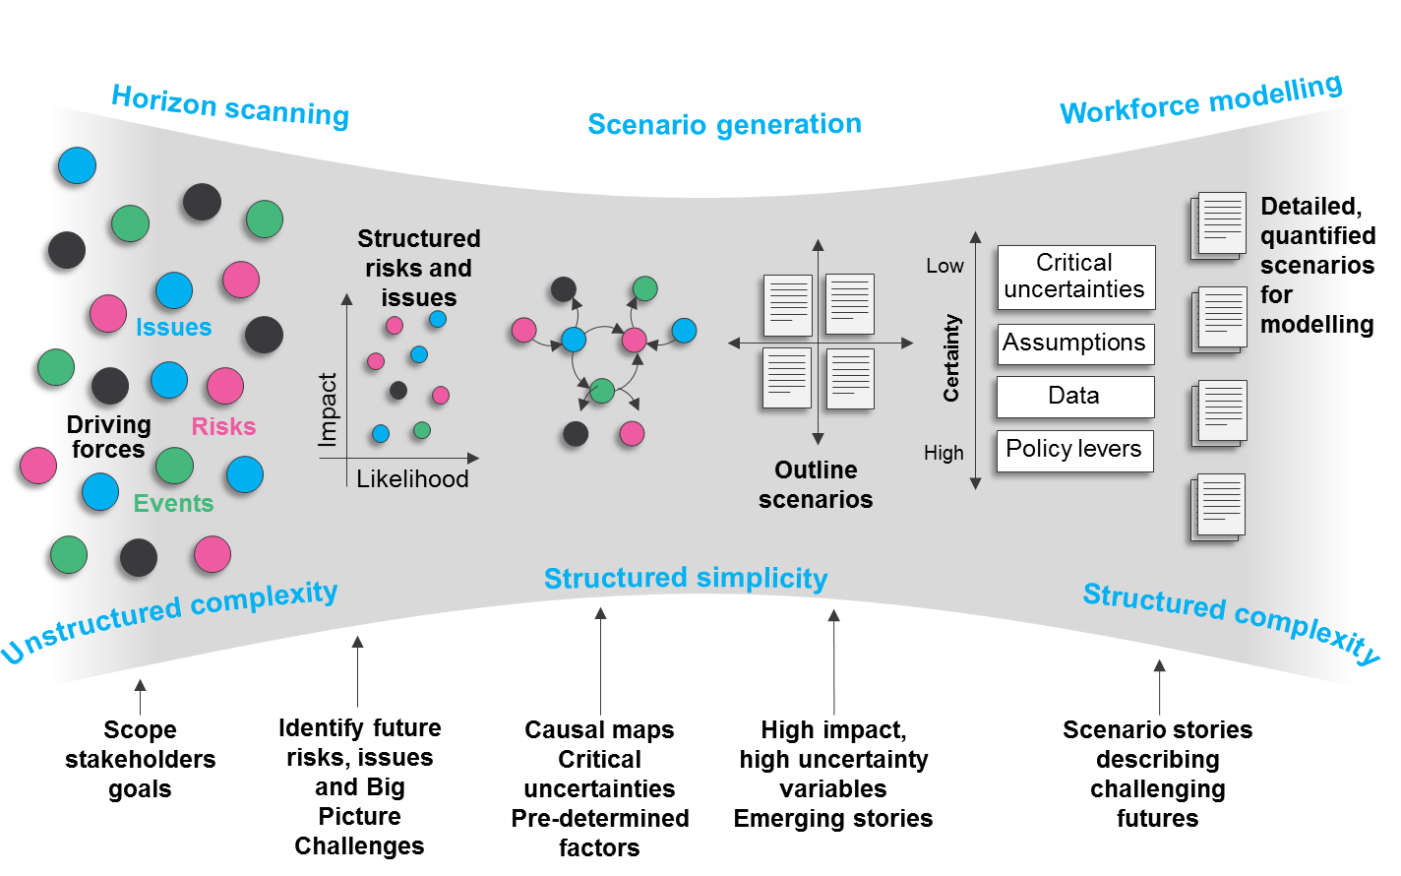

**Figure 1. Robust Workforce Planning Framework Process (CfWI, 2014a: 8)**

The stages of the framework are described in more detail below.

## Horizon Scanning

The future for a particular workforce is affected by driving forces, issues, risks, wild cards, and events which need to be structured (CfWI, 2014b). Given the extensive use for public policy within the UK government, horizon scanning was applied at the beginning of the workforce modelling process. Within the framework, horizon scanning was used to undertake a systematic exploration of threats and opportunities that could influence the workforce requirements over the period under investigation.

Horizon scanning was conducted either across all health and social care or focused on a particular area of interest such as technology, training or specific events (CfWI, 2014b). In this step, CfWI captured short stories, sometimes called micro-narratives, describing future situations that they believed would have a positive or negative impact on the supply and/or demand of the workforce. Sometimes the information captured included sets of historic trends and/or events that described the current situation and the future trends and/or events impacting the workforce. Each idea was categorised using the TEEPSE (technological, economic, ethical, political, social and environmental categories) framework to achieve comprehensiveness on the coverage of external factors (CfWI, 2014d). Typically the set of factors were more than 100 but they were refined to 20 or 30 after being evaluated in terms of uncertainty and size of impact on the workforce. The evaluation occurred during the workshop and after the workshop in some circumstances. This stage was mostly divergent and unstructured.

Horizon scanning was performed through stakeholder interviews (CfWI, 2014c), online surveys and stakeholder workshops using principles of GMB. A selection of the methods typically depended on the level of unstructured complexity: highly unstructured issues were dealt through face to face interactions rather than online surveys. The number of participants in each workshop was between 15 and 25 people to have enough representation from stakeholders, and the workshops followed Chatham House Rules in terms of privacy of the discussion (Chatham House, 2014). The factors for the next stage in the framework were selected considering the number of times a factor was mentioned during interviews/workshops, as a measure of importance on the stakeholders’ attention (Amanatidou et al, 2012).

Then, factors were linked to each other in cause-and-effect relationships described in terms of impacts on the workforce. Those factors which had large influences in the workforce and were highly uncertain were considered during the scenario generation step (CfWI, 2014c; O’Brien, Meadows and Murtland, 2007)

## Scenario Generation

In a departure from traditional methods for evaluating health care demand and supply, which are mostly based on forecasting the economy, population and the use of health services (Kunc, 2015), the framework employed scenarios to support workforce planning. One of the main reasons for using scenarios was the need to structure the issues discovered through the horizon scanning stage. Another reason was some aspects of the future of the workforce could be relatively easy to understand and model based on historical data, such as demographics, service utilisation and participation rates (Kunc, 2015); however, it was recognised that extrapolating trends did not always work. Additionally, some aspects were difficult to capture using only past data, for example the impact of technology, workforce reform policies and changes in models of care. Therefore, strategic workforce planning at the national level needs to take these uncertainties into account, as planning timescales extend over many years, even decades for medical professions.

There were two major parts in the scenario generation stage: workshops to develop the scenarios followed by an elicitation process about the future value of parameters for the workforce model under each scenario using principles of GMB when it was required (CfWI, 2014b). During the evolution of the workforce framework, CfWI explored a range of methods for quantifying the values of critical and uncertain parameters, which are discussed below.

The approach taken to generate scenarios evolved over the years, but was mostly one-day facilitated workshops (CfWI, 2014b). The scenario generation was initially based on Wright and Cairns (2011)’s method for scenario generation but was subsequently adapted to suit the particular requirements of the CfWI (CfWI, 2014c). Participants were drawn from a wide range of stakeholders and interested parties, not just experts on the workforce under investigation. The workshops started with a review of the key issues and driving forces identified in the horizon scanning stage. First, forces identified in the horizon scanning stage were used as the starting point for a workshop to collect a large set of factors and forces that have an impact on the focal question (issue). Workshop participants first ranked the factors by importance to the focal question, for example the most significant effect or the ability to tip the future in one direction or another. The top ten most important factors were then further refined. Participants were asked to form groups and brainstorm two extreme or opposite resolutions for each factor. Each group presented back their analysis, after which all participants were asked to vote on the impact on the focal question and the uncertainty of outcome. Two factors of the highest impact and highest uncertainty were selected as the scenario dimensions.

Later on, scenario generation process changed from Wright and Cairns (2011) from a single 2 x 2 matrix looking at two dimensions to a nested matrix approach (Weeks, Malone and Welling, 2011) where a 2 x 2 matrix was nested in each quadrant to support four dimensions and up to 16 scenarios. Three factors of highest impact and highest uncertainty were selected as scenario dimensions, along with the economy (due to its impact on government funding) to make four. This change was originated by the need to establish more diverse scenarios. Workshop participants worked in groups to ascertain which combinations of projections for the four dimensions were consistent, and therefore relevant for development into scenarios. The participants then worked in groups to develop the scenario narratives, describing the timeline of cause and events and activities leading to the end state, and bringing in the wider set of factors and the likely responses by stakeholders. The final output of this method is a set of qualitative scenarios for the workforce (CfWI, 2014c).

The next step required the generation of numerical data for the workforce model for each of the scenarios. Initially, CfWI employed the Delphi method (CfWI, 2012a, b, c), which is based on a structured process for collecting and extracting knowledge from a group of experts by a series of questionnaires (Adler and Ziglio, 1996). The method was employed to quantify the key workforce uncertainties arising from the scenarios. The participants received the scenarios developed previously before being asked to make quantitative judgements and share the reasoning that underpinned their estimates. A refinement process over several rounds led to an agreement on the values of the uncertainties and parameters for the workforce model. Delphi was supported by web-based software (CfWI, 2012a, b, c). While the process was successful in some projects, CfWI revaluated the method given the challenges observed (CfWI, 2015a, b):

* The workforce models were highly segmented, e.g. by gender and professional so the number of parameters could be great
* Time for the Delphi process was too long for the amount of time available for each project
* Experts became disengaged over the multiple rounds affecting the quality of the consensus
* No possibility of open debate to share ideas and evaluate experts’ understanding of process, questions and concepts during online questionnaires
* Loss of richness from experts’ views
* Pooling can hide significant differences
* Difficult to evaluate uncertainty around elicited values since it only considers the distribution of medians

Over time the CfWI looked for other approaches to elicit uncertain parameters, e.g. Cooke’s method (EFSA, 2014: 5470) and SHELF (O’Hagan and Oakley, 2014). At the end of 2014, CfWI adopted Sheffield Elicitation Framework (SHELF) (O’Hagan and Oakley, 2014). SHELF is designed to elicit the knowledge of a group of experts in a face-to-face workshop capturing the probability distribution of the parameter (O’Hagan and Oakley, 2014). SHELF has a good track record within the public policy in the EU and other countries (see EFSA, 2014). This method requires a facilitator to guide experts in obtaining a probability distribution organized in quartiles (upper and lower bounds of a parameter, median and upper and lower quartiles (CfWI, 2015a, b). One of the benefits of the approach was to push experts to consider the uncertainty in their estimates and reduce over-confidence (CfWI, 2015a, b).

The process of quantification using SHELF was as follows. First, the CfWI asked a small group of experts (typically five to eight) to consider what they ‘expected’ the future to be. This was called the reference scenario. In this future it was assumed that existing policies and underlying trends continued without surprises, e.g. only changes the experts believed were reasonably to happen. The reference scenario was not a forecast or prediction. The reference scenario was developed by an expert group for the sole purpose of quantifying the scenarios used for stress testing. Surprising changes or shocks to the health and care system were provided by the scenarios.

Once experts had quantified their reference scenario, they were asked to read each scenario narrative and consider how the parameters might change from the reference scenario. Quantifying each scenario against a reference scenario reduces the risk of bias, as the experts are not being asked to make direct comparisons between scenarios. Bryson et al (2016) suggest that reviewing multiple scenarios increases confidence on the estimation of parameters and reduces framing bias. Additionally, the reflection on extreme scenarios help to counter the availability heuristic, which implies overestimating events that are easily remembered (Bryson et al, 2016).

## Workforce modelling

SD was utilised to develop the models that projected future demand for, and supply of, the workforce under consideration. The models developed by the CfWI to project demand and supply required several inputs: baseline data about workforce components; assumptions where key data was not available or of poor quality; parameters that policymakers could use to adjust demand and supply; and intrinsically uncertain parameters quantified during the scenario generation stage. CfWI produced a formal document (CfWI, 2014f) explaining the practices for building models. The 76-pages document covers the four steps in the process for building models: scoping, construction, documentation and testing (see figure 2 for a sequence of the process) together with the project roles (lead model developer, lead data analyst, lead tester and project sponsor). The document contains check lists to ensure all practices were applied in the project. GMB principles were used to review the model structured as well as during the validation of model outputs. The modelling of supply and demand are explained in more detail in the next paragraphs.



**Figure 2. SD modelling process (CfWI, 2014f: 4)**

**Workforce Supply.** The combinatorial complexity of a workforce supply model can be large because the workforce supply needs to be segmented by age and gender to allow changes in attrition or part-time working, as well as observing differentiated effects of future events. For example, retirement rates might vary by both age and gender, and furthermore government policy might change the state pension age in England over time so there would be important effects on the gender distribution in the healthcare workforce.

The CfWI used SD to represent the workforce under study using stocks and flows that described career progression through the diverse training and pipeline stages associated with the profession (CfWI, 2014e, f). This is a typical structure used in SD modelling to account for human resources dynamics (Sterman, 2000; Kunc, 2008). The workforce models were large, for example the model developed to represent the supply of the English medical workforce from medical school through to the workforce comprised 997 distinct variables, of which a large proportion were heavily segmented, for example by workforce age and gender (CfWI, 2014e, f). The implications of large models were related to input data and testing. For example, it was necessary to define a data dictionary for all data, and tests were performed by a different modeller than the developer of the simulation, and all errors were documented and verified (similarly to a software development programme) before signing off the model (CfWI, 2014f).

Figure 3 provides an illustration of one of the high level stock and flow diagrams used in the CfWI models, in this case for the medical workforce (CfWI, 2014e). The movement of doctors across the different stages of their career is reflected by the flows connecting the stocks (boxes in the figure). Stocks represent the number of doctors in each stage of the career and training (see table 1). The stock and flow diagram forms the basis of the system dynamics model of the medical training and career pathway system, which is similar to other professional services models (Kunc, 2008).

The actual pathways in the quantitative model were in fact much more complicated than shown in Figure 3, as they included additional flows associated with each stage. These included attrition rates, exits out of the system, inflows from overseas, workforce re-joiners, and trainees re-sitting examinations. Furthermore, the workforce levels were also subdivided into more detailed career progression pathways that considered, for example, the acquisition of medical qualifications. Each stock and flow in the supply model was segmented by age (from 16 to 80 years) and gender. This enabled age and gender dependent influences to be analysed such as attrition and participation rates. All these specifications for the model were agreed with relevant stakeholders and validated. Finally, the models contained training allocation algorithms and capacity constraints at each stage of the training pipeline. They enabled the preference between types of training to be included (for example a female gender preference for GP Training) and changes in future demography for new doctors.

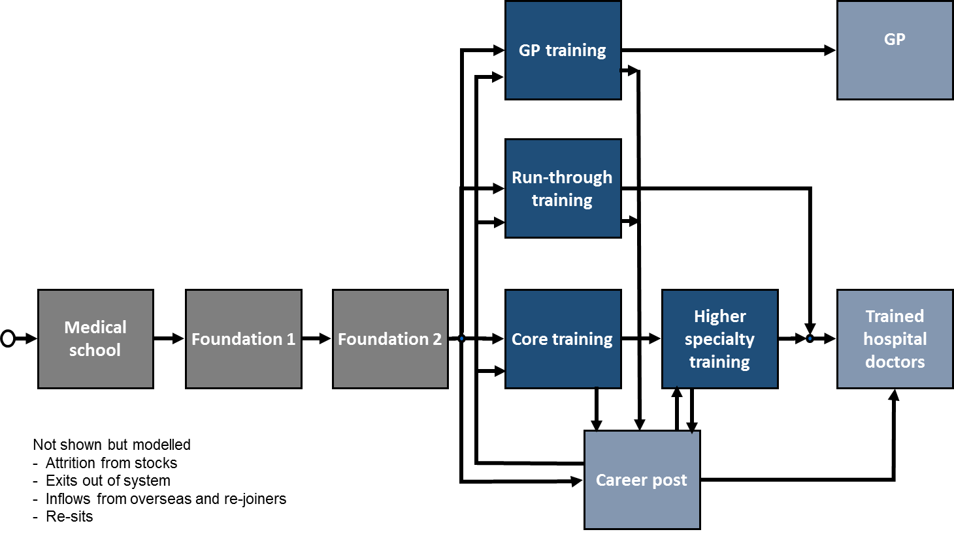

**Figure 3. Stock and flow diagram of medical training (CfWI, 2014a:19). Definitions for each of the stocks are provided in CfWI, 2014c: 14**

**Workforce Demand.** The CfWI models calculated the future demand for a workforce based on the current demand for service, future population projections, changes in levels of population need, changes in workforce productivity (for example through technological advances) and changes in service delivery. The last three changes were obtained from the scenarios. The demand was segmented by gender, age and primary and secondary care requirements. The demand calculation was broadly based on a framework from the Canadian research programme on health human resources (Birch et al, 2007; Tomblin-Murphy et al., 2012). The current demand for service was based on the current supply and the percentage of the current need that was met. The population projections originated from the UK Office for National Statistics by age and gender, and were applied with a demand scalar to determine the current need by age and gender. Variables, such as the demand scalar, were adjusted to calibrate the model. Finally, parameters that determined potential changes in levels of need and changes in productivity were applied. These parameters were determined through the Delphi or SHELF process and were scenario specific (CfWI, 2014c, d, e).

Sensitivity analysis was performed to determine which input variables (e.g. data and assumptions) across the supply and demand models had the greatest effect on the outputs from the model if the data or assumption were changed by a certain amount. The analysis identified the variables which required further investigation due to its impact on performance and uncertainty in the range of value. The sensitivity analysis was undertaken by running the model and individually changing each model input data variable and for percentage profiles (defined with experts) shifting and redistributing the data between the specific ranges (CfWI, 2014e; Moxnes, 2005). No experimental design was employed. CfWI did not consider the use of deep uncertainty analysis (Kwakkel and Pruyt, 2013) because the value of uncertain variables was obtained through the elicitation processes performed after the scenarios. Monte Carlo simulation was used to develop “Fan Charts” for the model outputs in order to make the range of potential values in the projections more explicit. Fan charts are charts which show a central projection (e.g. the median, mode, or mean) of a variable delimited by a set of probability bounds reflected through shading effects (Dowd, Blake and Cairns, 2010).

The structure of the models was widely discussed, and sense-checking performed with stakeholders in workshops and reports throughout the model development process. Figures 3 and 4 are examples of the visual displays shown to the stakeholders to validate the model. Figure 4 shows the graphs of the value of the stocks over time that helped stakeholders to make sense of the workforce dynamics. During the demonstrations of the SD model, stakeholders obtained insights into the structure of the model which were used to define what-if policies.

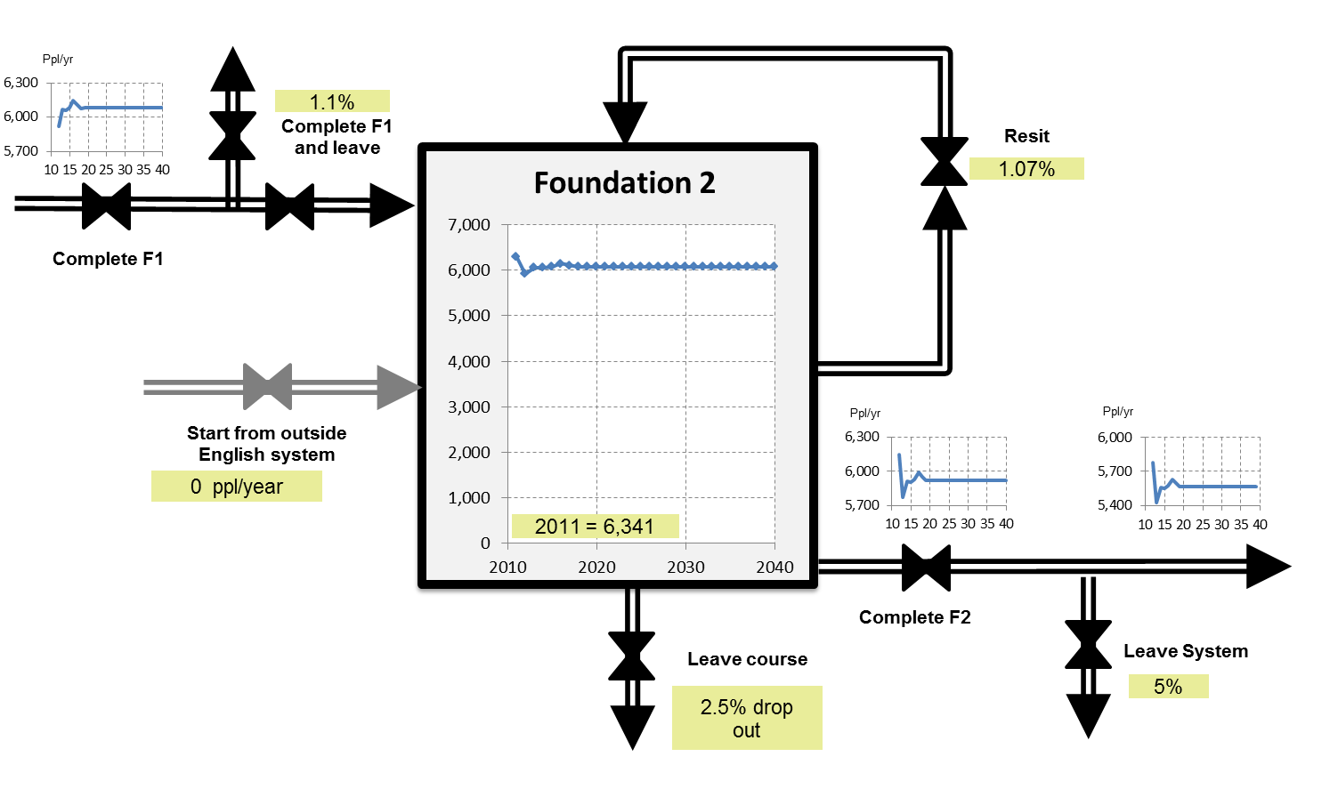

**Figure 4. Graphical representation of stock and flows behaviour for sense-checking**

## Policy analysis

The process of policy analysis involved a number of steps. Once the scenarios had been quantified, future scenarios were simulated using the changes to the parameters elicited during the scenario stage. This outcome provided the policy maker with a broad spectrum of the future of the workforce if no new policies were implemented.

Next, the model was run for the policies suggested by stakeholders against each of the scenarios. Policies originated from workshops using principles of GMB, ‘what-if’ exercises, and proposals for healthcare reforms or new legislation (CfWI, 2014b). Policies could involve changing a single parameter or a combination of parameters. The experience showed that typical parameters included skill mix (the ratio of different staff types used to deliver a service), retirement age in the workforce, training preferences and training duration (CfWI, 2014e, f).

Irrespective of their source, a fundamental part of the policy analysis process was to analyse prospective policies systematically. Policy design critically depended on knowing where the most effective interventions could be made in the system. This required an analysis of the system which the policy was intended to influence. Each policy was tested against a range of potential futures. Some policies led to favourable outcomes across all futures but others had less clear outcomes. Therefore, Measures of Effectiveness (MOEs) (Davis and Dreyer, 2009) were employed, which were underpinned by the following principles, to evaluate the impact of the policies (CfWI, 2014e):

1. A set of clear objectives, e.g. matching supply to demand or minimising costs, that were high-level measurable outcomes and weighted in importance.

2. Measures should reflect the full range of stakeholder perspectives, i.e. from decision maker through to recipient of change.

3. All MOEs were subject to uncertainty which had to be reflected in the results presented to stakeholders, e.g. using fan charts.

4. Results could not be presented simultaneously. Selective aggregation was one approach used to circumvent problems of overloading.

5. All chosen policy options were presented in the same way reflecting the true variance in outcomes and uncertainty across interventions.

6. High level outputs allowed drilling down to reveal detail at a higher resolution through the use of an interactive presentation tool.

7. Policy effects under plausible future scenarios were represented in the analysis.

As stated previously, the RWP was refined over the five years it was implemented at the CfWI. Table 1 presents a summary of the evolution of the four stages of the framework. CfWI had numerous meetings to discuss progress, emerging results and adapting the initial ideas to refine the initial practices comprising the strategic workforce planning framework.

|  |  |
| --- | --- |
| Stage | Methodological evolution |
| Horizon scanning | Initially, horizon scanning was obtained through interviews to inform the issues (focal questions) to be addressed in the scenario stage.  Later on, system thinking methods, e.g. causal loops, were employed to have a more structured approach to understand the past, present and future of the workforce.  Additional developments:   1. A consistent set of terms originated from many horizon scanning exercises and were compiled into a “visual dictionary”. 2. A collection of fragmented narratives (ideas) about the future were stored in an online repository for access to participants to enhance creativity. More than 300 narratives were collected. 3. Definition of thematic categories to analyse results from activities. The categories are related to technology, economy, environment, politics, society and ethics. 4. Use of causal loop diagrams to explore cause-and-effect relationships. |
| Scenario generation | Scenario methods were updated over time based on comments from stakeholders.   * Initially, the intuitive logics approach was used to create 2 by 2 matrix considering two dimensions of uncertainty. The scenarios were created in a single workshop and the four scenarios were quantified for the SD model. * Workshops remained as part of scenario generation but the emphasis moved to the production of broad set of potential scenarios (up to 16) that were reduced to 5-6 after removing inconsistent scenarios.   Additional developments:   1. Scripts for the development of scenarios based on the scripts defined for group model building activities (Hovmand et al, 2012). 2. Elicitation of the future values of parameters for the SD model using SHELF (O’Hagan, 2012). |
| Workforce modelling | A formal approach was developed over time comprised of four steps: model scoping, model construction, model documentation and model testing.   * Model scoping comprised the articulation of the purpose of the model; a clear identification of the workforce in terms of segments and paths; model outputs; necessary data; and risks involved in not achieving the objectives in the required time. * Model construction involved stock and flow diagrams; variable naming; generating clear linkages and feedback loops; checking units; reducing complexity in the equations; treatment the model construction like a software project in terms of maintaining configuration control (versions) and associated data architecture components together with creating traceable versions. * Model documentation comprised internal model documentation, model assumptions, data dictionary and user guide. * Model testing contained the following tests: model documentation (is the model aligned with its documentation?); model structure (is the structure aligned with stakeholders goals? is the structure understandable by stakeholders?); model formulation (are dimensions correct? are equations clear? are parameters aligned with the data? are parameters associated with real variables? are functions clear and equations offering realistic outputs? are stochastic inputs correct?); model behaviour (robustness of the model with respect to time steps, impact of lookup functions, extending time horizon impacts on performance); and model data (is data clearly linked with real data? are units consistent between real and model data? is input data plausible? are the results from sensitivity analysis correct?). |
| Policy analysis | This stage involved the process of determining which workforce planning decisions were most robust by assessing and prioritising the different options.  Policies can be originated from ‘what-if’ exercises, published proposals/legislation or specific decisions about existing issues.  Additional developments:   * Defining clear scenarios for policy makers through the quantification of reference scenarios and divergent futures as the basis for policies. * Implementation of measures of effectiveness to evaluate the impact of policies. |

**Table 1. The evolution of methods employed in the RWP**

# **Application of the CfWI’s Strategic Workforce Modelling Framework**

The framework was used to apply strategic advice for a large number of healthcare workforces in England. These include:

1. Medical and dental student intake in 2012 (section 4.1) – (CfWI, 2012, a, b, c) and DH (2012).
2. Pharmacy workforce in 2013 (section 4.2) – (CfWI, 2013a).
3. Dental workforce in 2013 – (CfWI, 2013b).
4. Psychiatrist workforce in 2014 – (CfWI, 2014g, h).
5. General Practitioner review in 2013/2014 – (CfWI, 2014i).
6. Speech and language therapy workforce in 2014 – (CfWI, 2014j).
7. Trauma and Orthopaedic workforce in 2014 – (CfWI, 2014k).
8. Dental care professionals workforce in 2014 – (CfWI, 2014l).
9. Obstetrician and Gynaecologist workforce in 2014 – (CfWI, 2015c)
10. Anaesthetic and intensive care workforce in 2014 – (CfWI, 2015d)
11. Acute medical care workforce in 2013/2015- (CfWI, 2015e)
12. General surgery – (CfWI, 2016a)
13. Public health specialist workforce – (CfWI, 2016b)

Figure 5 presents an approximate timeline for the projects. All the reports listed above are available from the National Archive, <http://webarchive.nationalarchives.gov.uk/20161007101116/http://www.cfwi.org.uk/>, but three of these projects are described in more detail in the following sections.

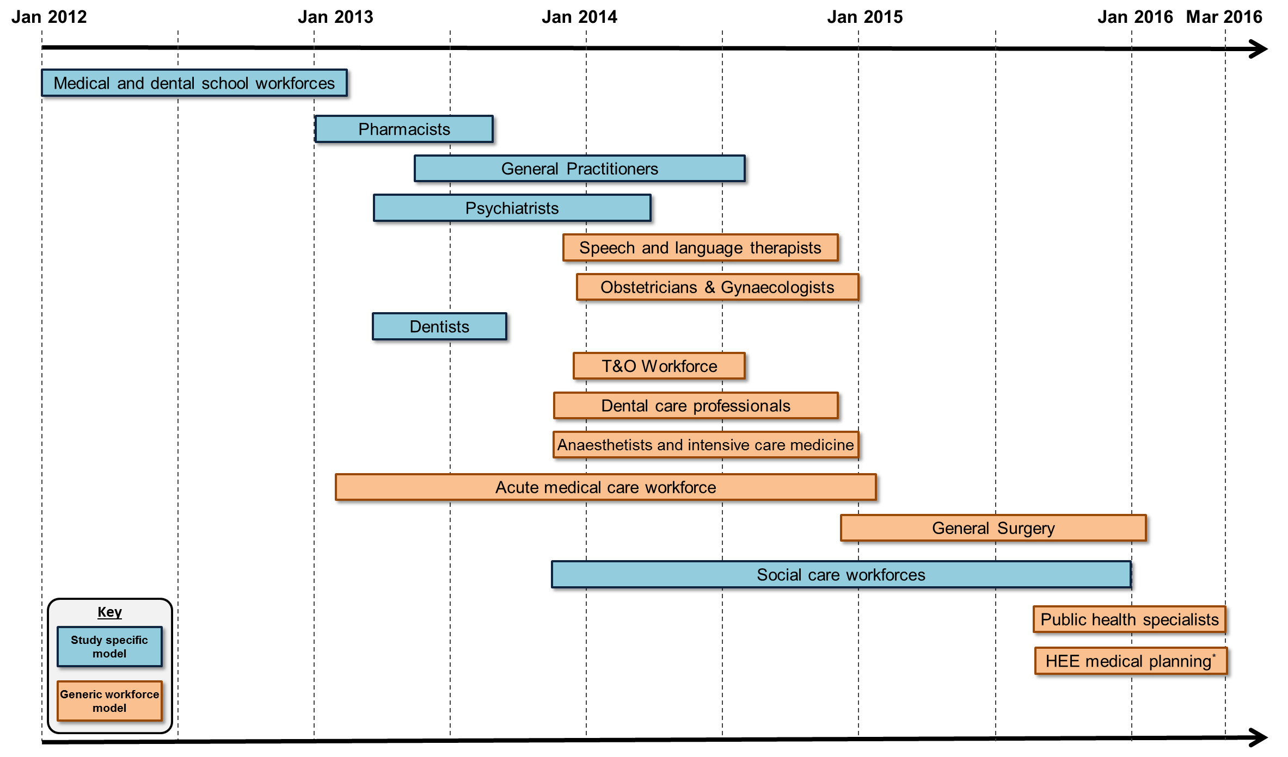

**Figure 5. Timeline for the application of the RWP and SD at the CfWI for workforce studies (adapted from Cave, Willis and Woodward (2016))**

## Medical and dental student intakes

The objective of the Department of Health’s (2012) Review of Medical and Dental Student Intakes in England was to analyse the provision of an adequate supply of trained doctors and dentists, and support investment decisions on medical and dental school training and the numbers of medical and dental students needed from overseas, up to the year 2040.

This was the first major application of the CfWI’s SD modelling approach and the use of scenarios methods. The Delphi method was used to quantify uncertain variables. The model for medical students considered four scenarios, which comprised two levels of morbidity and financial resources availability, as well as a base line case. It showed an oversupply of hospital doctors but the number of GP doctors was below the demands

The policy recommendations were:

* 2% reduction in medical school intakes, to be introduced with the 2013 intake – and this level should be adhered to until further decisions to change due to the potential unbalance between supply of doctors and demands.
* Further review of medical school intakes in 2014 (for 2015 intakes) – followed by a 3 year rolling programme of further reviews.

The model for dental students was used to run four scenarios considering a future focus on either patients or dentists and two levels of resources availability. The results showed an undersupply of dentists. However, the policy recommendation was no change in the dental school intakes due to the high degree of uncertainty in demand.

## Pharmacists

The objective of the strategic review of the future pharmacist workforce: Informing pharmacist student intakes project (CfWI, 2013a) was to consider how short-term decisions may have a significant impact on the long-term availability of pharmacists in the workforce. The focus was to support the Professional Board’s wider review of pharmacy training. In the longer term, the future pharmacist workforce review had to provide the evidence base for the pharmacist workforce of the future, looking ahead to 2040.

In all four developed scenarios, supply was forecast to exceed demand, regardless of the pharmacist’s role in healthcare. There would be a surplus supply of pharmacists in the future between 11,000 and 19,000. A broad view of the stocks and flows in the model representing the movement of the workforce from university until they are working in pharmacies is presented below.

The scenarios developed considered both broader and narrower role of pharmacists in healthcare and the impact of internet on the supply of medicines. The range of outputs from the Delphi method to quantify uncertain variables was used to generate FAN charts to illustrate the range of uncertainty. However, it should be noted that this is the uncertainty across the median values elicited, and not the overall uncertainty. The conclusion after testing the full range of variables was that no significant overlap would occur until late in the time horizon.

The recommendation was a periodic review of supply and demand, with a continued drive to improve data around the pharmacy workforce. A review of this plan at least every five years with yearly monitoring was recommended to ensure the impact of any intervention could be tracked. To improve the reliability of future modelling it was advised to take a new census since the model used data from the most recent census which was in 2008.

## Horizon 2035

The Horizon 2035 project (CfWI, 2015f) was an initiative to look at future workforce skills and competences across the whole of the health, social care and public health system. As such it departs from the more usual demand and supply modelling approach for an individual workforce. In this project six scenarios were generated using the extended scenario generation approach (CfWI 2014d), and the SHELF methodology was used to quantify uncertain variables. A completely new SD model was developed, together with a framework for representing skills and competences, and a new measure of workforce skill – a skill hour which is an hour spent applying a skill, presented as a total for a given year. The uncertainty is represented as a FAN chart with confidence bounds.

The results of the Horizon 2035 project were used to inform senior policy makers, and highlighted and quantified some of the critical pressures that are faced by the health and social care system, and need to be addressed by policy-makers.

# **Discussion**

We present the discussion of the main lessons from the work of the CfWI with respect to four areas: OR in healthcare through the development of SD models of healthcare workforce planning, the use of SD to support strategic planning with the integration of multiple methodologies, facilitated modelling in healthcare and the practice of OR.

One of the key components of any healthcare system is staff, such as doctors and nurses, associated with the provision of healthcare. OR has generated mathematical models that address combinatorial complexity in scheduling healthcare resources in the short term, e.g. assigning surgeons to the availability of operating theatres. However, less work has been done on addressing dynamic complexity in healthcare workforce over long timeframes. Strategic workforce planning has to take into account the fact that we cannot accurately forecast the long-term future, especially if it involves the behaviour of people and multiple exogenous factors not controlled by the administrators of healthcare systems such as technology developments and economic crisis. Some workforce plans and policies may work better for specific futures than others. Therefore, strategic workforce planning needs to consider frameworks using multi-methodologies that consider long term dynamic complexity, such as SD, rather than mathematical models that optimise scheduling. While this paper is not the first paper showing the use of SD on workforce planning at strategic level, we believe we have presented an account of long term sustained engagement (more than five years and more than 10 different studies) with healthcare stakeholders on the use of SD to address strategic decisions related to the workforce at national level. The sustained evidence of the papers mentioned previously and this paper provides strong grounds for a wide adoption of SD as an OR method to support workforce planning in healthcare, especially at strategic level. Different to previous papers, this study shows an evolution on the use of more than one methodology to support SD on the development of strategic workforce planning models.

A few scholars, for example Howick and Ackermann (2011), Coyle and Alexander (1997) and Santos, Belton and Howick (2008), have addressed the importance of complementing and enriching SD models with the use of other hard and soft OR methods. This paper complements previous work with a multi-methodology framework to support long-term planning. For example, horizon scanning helps to identify the scope of SD model when the reference mode for the system is located in a distant future. Additionally, scenario techniques can be useful to define consistent stories that support the future paths obtained from the simulation of SD models. Elicitation techniques for estimating the future values of parameters, such as Delphi and SHELF, can offer robust procedures for developing inputs for SD models when they are uncertain. Another aspect is a method to find robust policies that can work well across a range of challenging futures. A policy that is robust across all scenarios is not necessarily the optimal solution for each individual scenario (Davis and Dreyer, 2009). The multi-methodology framework for strategic workforce planning described in this paper has four stages, where diverse methodologies are grafted and embedded with SD. illustrated in figure 6,

* **Horizon scanning** activities aimed at identifying the uncertain driving forces by combining the outcomes of facilitated workshops, interviews and on-line surveys. This activity focuses the attention of the stakeholders on the future issues facing the workforce, rather than on their current mental models about the current problems of the workforce. This activity is mostly unstructured.
* **Scenario generation** to produce plausible and challenging futures based on well-recognised scenario methods and follow up with approaches to quantify the value of the uncertain variables for the SD model. This activity helps to move from simply attending to issues, to understanding holistically how the future will evolve given the issues discovered in horizon scanning. It structures the uncertainty into a set of interconnected variables and their corresponding values.
* **Workforce modelling** to project workforce supply and its balance with respect to demand across the futures defined in the scenarios using established SD model structures adapted to the requirements of the stakeholders.
* **Policy analysis** to identify the most robust policies across these uncertain futures employing the SD models as well as additional techniques to evaluate the new performances observed.

An illustration of the method is shown in figure 6. The framework is applied essentially in a linear process, with some overlaps between stages as figure 2 shows, combining different methodologies (the oval shapes in each stage).

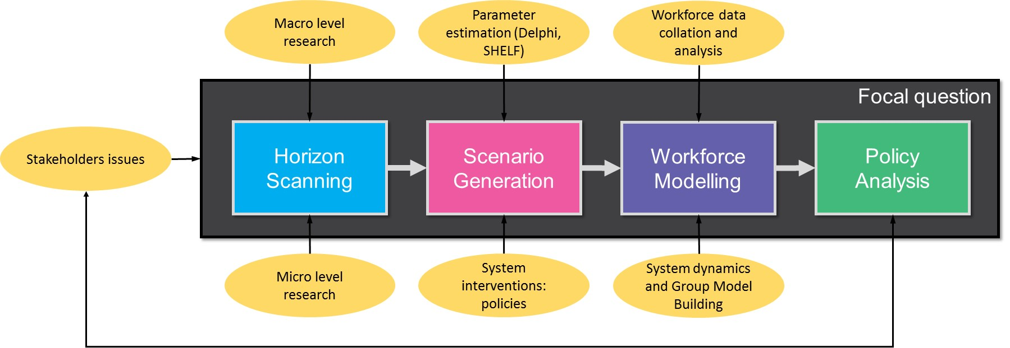

**Figure 6. A strategic workforce planning framework.**

In terms of facilitated modelling, the work performed by the CfWI provided a unique opportunity to design, rehearse, test and improve this workforce planning framework over time from a practice-based perspective. The choice of methodologies for facilitating involvement was strongly influenced by the desire for a high degree of stakeholder involvement, which was critical in arriving at a shared view of future challenges and in agreeing political decisions, together with feedback from participants. Stakeholders were involved from the start in confirming the scope and time frame. The stakeholder groups were also involved in the development of the model structures via Group Model Building and validation of the model behaviour using the special designed graphical representation of the Stock and Flow diagrams (see figure 4). However, facilitated modelling in strategic level projects at national level differs from traditional facilitated OR projects in a number of dimensions. Firstly, the issues are usually located in the future. Therefore, techniques, such as scenarios, that structure the future of systems have to be employed in contrast with more operational techniques. Secondly, the participants are not always directly responsible for implementing the policies since they can be experts in a certain issue and participate in a workshop for providing their perspective. Thirdly, participants are not from the same organization (and/or location) so it creates special challenges on obtaining their collaboration.

In terms of the practice of OR, this study shows important differences between a practice-based and an academic-based project. Practitioners face uncertainty about the suitability and effectiveness of certain tools and need to make professional judgments about the tools to be used. Some of the judgments are based on personal preferences, and skills but there are also institutional pressures affecting the choice of OR methodologies. The continuous use of a multi-methodology framework leads to refinements over time towards a specific framework, and the adoption of new tools, techniques and practices. Some of the refinements originate from client’s feedback or internal evaluation of the project team. Cave, Willis and Woodward (2016) describe how the capability of the staff at the CfWI was developed through training and mentoring. Academic-based projects may start with a clear idea of the tools to be employed given their extensive knowledge of relevant literature and issues/benefits for a tool. This study offers a glimpse of practice-based projects but further research has to be considered in diverse areas: learning processes, behaviour aspects of the development, use and impact of the model (Kunc, Malpass and White, 2016).

# **Conclusions**

The paper contributes to different areas: healthcare workforce planning through the use of SD, and facilitated modelling through the description of a long term practice in modelling healthcare workforces in England using a multi-methodology framework. The experience at the CfWI was a unique opportunity to observe a dedicated team of modellers and analysts supported with a number of specialists in diverse methods such as scenarios, Delphi and SHELF, and strongly engaged with relevant stakeholders performing more than fifteen workforce studies over a period of five years. During this period CfWI developed and refined a framework to carry out strategic workforce planning. This was an example of “double-loop learning” (Argyris, 2000).

Rather than attempt to predict the exact future in a workforce model, the developed framework recognises the intrinsic uncertainty and complexity of factors influencing workforce demand and supply. The framework starts by asking stakeholders to think about the key question or issue of concern about a workforce. Then the next step is to consider how the healthcare workforce may look like in the future. By analysing the key issues and uncertainties the framework can be used to generate a set of plausible and highly challenging scenarios. Each scenario represents a future that could happen. Workforce demand and supply is then simulated for each scenario to understand how workforce numbers or skills change over time. Prospective policies can be tested against these scenarios to see which one is the most effective. Decisions made about workforce requirements need to work well across a range of futures in order to be robust against uncertainty. The strategic workforce planning framework is suitable for evaluating workforce size under uncertainty at professional and national levels.

The realm of practice is subject to important constraints that limit the analytical choices, such as institutional pressures, time and cost limitations, and preferences from clients. The selection of tools and methods in practice is usually influenced by many factors: personal choice, usual practice of the modeller and/or institutional pressures. Thus, selection is not subject to a predefined design but it may result from double loop learning processes and/or organizational changes. In a practice-based world, the future of a framework may be unpredictable since a new team may decide to change tools and methodologies. Thus, more publications of practice-based solutions are necessary to externalise lessons.

**Acknowledgements**

The authors would like to acknowledge the contributions of Andrew Woodward, Matt Edwards, John Fellows, Tom Lyscom, Shyam Lamba, Cristina Sanchez, Joe Fernandez, Alison Harbord, Andrew Woodward, Hannah Darvill, David Lannen, Daniele Gioè and Jack Lawrence from the Centre for Workforce Intelligence. The authors would also like to thank the Department of Health for its support with the work described in this paper, and in particular Cris Scotter.

# **References**

Adler, M. and Ziglio, E., 1996. *Gazing into the oracle: The Delphi method and its application to social policy and public health*. Jessica Kingsley Publishers.

Amanatidou, E., Butter, M., Carabias, V., Könnölä, T., Leis, M., Saritas, O., Schaper-Rinkel, P. and van Rij, V., 2012. On concepts and methods in horizon scanning: Lessons from initiating policy dialogues on emerging issues. *Science and Public Policy*, 39(2): 208-221.

Argyris, C., 2000. Double‐Loop Learning. *Wiley Encyclopedia of Management*. John Wiley & Sons

Birch, S., Kephart, G., Tomblin-Murphy, G., O’Brien-Pallas, L., Alder, R. and MacKenzie, A. 2007. Human resource planning and the production of health: a needs-based analytical framework. *Canadian Public Policy*, 33: S1-S16.

Brailsford, S.C. and De Silva, M.D., 2015. How many dentists does Sri Lanka need? Modelling to inform policy decisions. *Journal of the Operational Research Society*. 66: 1566-1577

Brailsford, S.C., Desai, S.M., and Viana, I. 2010. Towards the holy grail: combining system dynamics and discrete event simulation in healthcare. In *Proceedings of the Winter Simulation Conference,* Baltimore, USA

Brailsford, S.C. and Vissers, J., 2011. OR in healthcare: A European perspective. *European Journal of Operational Research*, 212(2): 223-234.

Bryson, S., Grime, M., Murthy, A. and Wright, G., 2016. *Behavioral Issues in the Practical Application of Scenario Thinking: Cognitive Biases, Effective Group Facilitation and Overcoming Business-as-Usual Thinking*. In Kunc, M., Malpass, J. and White, L. (eds) Behavioral Operational Research, 195-212. Palgrave Macmillan UK.

Cave, S., McKelvie, D., Lacey, P., Willis, G., Wolstenholme, E and Todd, D 2016. Making an impact with System Dynamics in the health and social care system, *Making an Impact With System Dynamics Case Study 001. UK Chapter of the International System Dynamics Society*

Cave, S. Willis, G. and Woodward, A 2016. A retrospective of System Dynamics based workforce modelling at the Centre for Workforce Intelligence. *The 34th International Conference of the System Dynamics Society*, Delft, The Netherlands

CfWI 2012a. Horizon scanning report: Medical – informing medical and dental student intakes. [online] London: Centre for Workforce Intelligence. Available at http://www.cfwi.org.uk/publications/horizon-scanning-report-medical [Accessed November 2016].

CfWI 2012b . Horizon scanning report: Dental – informing medical and dental student intakes. [online] London: Centre for Workforce Intelligence. Available at http://www.cfwi.org.uk/publications/horizon-scanning-report-dental [Accessed November 2016].

CfWI 2012c . A strategic review of the future healthcare workforce – informing medical and dental student intakes. [online] London: Centre for Workforce Intelligence. Available at: http://www.cfwi.org.uk/workforce-planning-news-and-review/publications/a-strategic-review-of-the-future-healthcare-workforce-informing-medical-and-dental-student-intakes-1 [Accessed November 2016].

CfWI. 2013a A strategic review of the future pharmacist workforce: Informing pharmacist student intakes. [online] London: Centre for Workforce Intelligence. Available at http://www.cfwi.org.uk/publications/a-strategic-review-of-the-future-pharmacist-workforce [Accessed 19 June 2015]

CfWI. 2013b A strategic review of the future dentistry workforce: Informing dental student intakes. [online] London: Centre for Workforce Intelligence. Available at http://www.cfwi.org.uk/our-work/publications/a-strategic-review-of-the-future-dentistry-workforce-informing-dental-student-intakes [Accessed 19 June 2015]

CfWI 2014a . Robust workforce planning framework An introduction. CfWI technical paper series. No.0001. [online] London: Centre for Workforce Intelligence. Available at www.cfwi.org.uk/publications/in-depth-review-of-the-acute-medical-care-workforce/ [Accessed 22nd March 2016]

CfWI 2014b . Robust workforce planning Experiences and best practice. CfWI technical paper series. No.0002 [online] London: Centre for Workforce Intelligence. Available at www.cfwi.org.uk/publications/in-depth-review-of-the-acute-medical-care-workforce/ [Accessed 22nd March 2016]

CfWI 2014c .Horizon scanning Analysis of key forces and factors. CfWI technical paper series No. 0006. [online] London: Centre for Workforce Intelligence. Available at www.cfwi.org.uk/publications/in-depth-review-of-the-acute-medical-care-workforce/ [Accessed 22nd March 2016]

CfWI 2014d. Scenario generation: Enhancing scenario generation and quantification. CfWI technical paper series. No. 0007 [online] London: Centre for Workforce Intelligence. Available at http://www.cfwi.org.uk/publications/scenario-generation-enhancing-scenario-generation-and-quantification-3 [Accessed 22nd March 2016]

CfWI 2014e . Robust workforce planning: Medical model technical description. CfWI technical paper series. No.0003. [online] London: Centre for Workforce Intelligence. Available at www.cfwi.org.uk/publications/in-depth-review-of-the-acute-medical-care-workforce/ [Accessed 22nd March 2016]

CfWI 2014f Developing Robust System Dynamics Based Workforce Models: A Best Practice Approach. CfWI technical paper series No. 0008. [online] London: Centre for Workforce Intelligence. Available at www.cfwi.org.uk/publications/in-depth-review-of-the-acute-medical-care-workforce/ [Accessed 22nd March 2016]

CfWI. 2014g In-depth review of the psychiatrist workforce: Technical report. [online] London: Centre for Workforce Intelligence. Available at http://www.cfwi.org.uk/publications/in-depth-review-of-the-psychiatrist-workforce-technical-report [Accessed 22nd March 2016]

CfWI. 2014h In-depth review of the psychiatrist workforce: Main report. [online] London: Centre for Workforce Intelligence. Available at http://www.cfwi.org.uk/publications/in-depth-review-of-the-psychiatrist-workforce [Accessed 22nd March 2016]

CfWI. 2014i In-depth review of the general practitioner workforce: Final report. [online] London: Centre for Workforce Intelligence. Available at http://www.cfwi.org.uk/publications/in-depth-review-of-the-gp-workforce [Accessed 22nd March 2016]

CfWI. 2014j Securing the future workforce supply: Speech and language therapy stocktake. [online] London: Centre for Workforce Intelligence. Available at http://www.cfwi.org.uk/publications/securing-the-future-workforce-supply-speech-and-language-therapy-stocktake [Accessed 22nd March 2016]

CfWI. 2014k Securing the future workforce supply: Trauma and orthopaedic surgery stocktake. [online] London: Centre for Workforce Intelligence. Available at http://www.cfwi.org.uk/publications/securing-the-future-workforce-supply-trauma-and-orthopaedic-surgery-stocktake [Accessed 22nd March 2016]

CfWI. 2014l Securing the future workforce supply: Dental care professionals stocktake. [online] London: Centre for Workforce Intelligence. Available at http://www.cfwi.org.uk/publications/dental-care-professionals-stocktake [Accessed 22nd March 2016]

CfWI 2015a Elicitation methods: Applying elicitation methods to robust workforce planning. CfWI technical paper series No. 0011. [online] London: Centre for Workforce Intelligence. Available at www.cfwi.org.uk/publications/in-depth-review-of-the-acute-medical-care-workforce/ [Accessed 22nd March 2016]

CfWI 2015b Elicitation methods: updated approaches to elicitation. CfWI technical paper series No. 0014. [online] London: Centre for Workforce Intelligence. Available at www.cfwi.org.uk/publications/in-depth-review-of-the-acute-medical-care-workforce/ [Accessed 22nd March 2016]

CfWI. 2015c Securing the future workforce supply: Obstetrics and gynaecology stocktake. [online] London: Centre for Workforce Intelligence. Available at http://www.cfwi.org.uk/publications/obstetrics-and-gynaecology-stocktake [Accessed 22nd March 2016]

CfWI. 2015d In-depth review of the anaesthetics and intensive care medicine workforce*.* [online] London: Centre for Workforce Intelligence. Available at http://www.cfwi.org.uk/publications/obstetrics-and-gynaecology-stocktake [Accessed 22nd March 2016]

CfWI. 2015e In-depth review of the acute medical care workforce: Final report. [online] London: Centre for Workforce Intelligence. Available at www.cfwi.org.uk/publications/in-depth-review-of-the-acute-medical-care-workforce/ [Accessed 22nd March 2016]

CfWI. 2015f Horizon 2035 Future demand for skills: Initial results. Available at https://www.gov.uk/government/publications/horizon-2035-future-demand-for-skills-initial-results [Accessed 1st August 2017]

CfWI. 2016a Securing the future workforce supply: General surgery stocktake. [online] London: Centre for Workforce Intelligence. Available at http://www.cfwi.org.uk/publications/securing-the-future-workforce-supply-general-surgery-stocktake [Accessed 22nd March 2016]

CfWI. 2016b Public health specialist stocktake: Final report. [online] London: Centre for Workforce Intelligence. Available at http://www.cfwi.org.uk/publications/cfwi-publishes-stocktake-review-of-the-public-health-specialist-workforce-in-england [Accessed 22nd March 2016]

Chatham House 2014 *Chatham House Rule*. [online] www.chathamhouse.org/about-us/chathamhouserule [Accessed November 2016].

Coyle, R. G. and Alexander, M. D. W., 1997. Two approaches to qualitative modelling of a nation’s drugs trade. *System Dynamics Review* 13 (3): 205–222.

Davis, P.K. and Dreyer, P., 2009. RAND's Portfolio Analysis Tool (PAT): Theory, Methods, and Reference Manual. *Rand National Defence Research Institute, Santa Monica California*.

De Bruecker, P., Van den Bergh, J., Beliën, J., and Demeulemeester, E. 2015. Workforce planning incorporating skills: State of the art. *European Journal of Operational Research*, 243(1): 1-16.

Department of Health, DH 2012 *Review of Medical and Dental Student Intakes in England*. https://www.gov.uk/government/uploads/system/uploads/attachment_data/file/213236/medical-and-dental-school-intakes.pdf [Accessed 4th December 2015]

Dowd, K., Blake, D., and Cairns, A. J. 2010. Facing up to uncertain life expectancy: The longevity fan charts. *Demography*, 47(1): 67-78.

Douw, K. and Vondeling, H., 2006. Selection of new health technologies for assessment aimed at informing decision making: A survey among horizon scanning systems. *International Journal of Technology Assessment in Health Care*, 22: 177-183.

EFSA (European Food Safety Authority) 2014. Guidance on Expert Knowledge Elicitation in Food and Feed Safety Risk Assessment. *EFSA Journal* 12 (6): 3734. [online]. Available: http://www.efsa.europa.eu/sites/default/files/consultation/130813.pdf [Accessed September 2015].

Franco, L.A. and Montibeller, G., 2010. Facilitated modelling in operational research. European Journal of Operational Research, 205: 489-500.

Gary, M. S., Kunc, M., Morecroft, J. D., and Rockart, S. F. 2008. System dynamics and strategy. *System Dynamics Review*, 24(4), 407-429.

Größler A. and Zock A. 2010. Supporting long-term workforce planning with a dynamic aging chain model: a case study from the service industry. *Human Resource Management* 49(5): 829–848.

Hovmand, P.S., Andersen, D.F., Rouwette, E., Richardson, G.P., Rux, K. and Calhoun, A., 2012. Group model‐building ‘scripts’ as a collaborative planning tool. *Systems Research and Behavioral Science*,*29*(2), 179-193.

Howick, S. and Ackermann, F., 2011. Mixing OR methods in practice: Past, present and future directions. *European Journal of Operational Research*, 215(3): 503-511.

Howick, S., Ackermann, F. and Andersen, D., 2006. Linking event thinking with structural thinking: Methods to improve client value in projects. *System Dynamics Review* 22: 113–140.

Kunc, M. 2008. Achieving a balanced organizational structure in professional services firms: Some lessons from a modeling project. *System Dynamics Review*, 24: 119–143.

Kunc, M 2015. *Modelling supply, demand and need: A literature review*. [online] The Centre for Workforce Intelligence. CfWI technical paper series no. 0013. http://www.cfwi.org.uk/publications/technical-paper-modelling-supply-demand-and-need-a-literature-review [Accessed November 2016]

Kunc, M 2017 (ed.). *System Dynamics - Soft and Hard Operational Research* , Series: OR Essentials, Palgrave-Macmillan

Kunc, M. and Kazakov, R., 2013. Competitive dynamics in pharmaceutical markets: A case study in the chronic cardiac disease market. *Journal of the Operational Research Society*, 64: 1790-1799.

Kunc, M., Malpass, J. and White, L. eds., 2016. *Behavioral Operational Research: Theory, Methodology and Practice*. Springer.

Kunc, M and J. Morecroft. 2007. System Dynamics Modelling for Strategic Development. In Dyson, R and O'Brien, F. (eds.) *Supporting Strategy: Frameworks, Methods and Models*, Wiley & Sons.

Kunc, M. and O'Brien, F.A., 2017. Exploring the development of a methodology for scenario use: Combining scenario and resource mapping approaches. *Technological Forecasting and Social Change. https://doi.org/10.1016/j.techfore.2017.03.018*.

Kwakkel, J.H. and Pruyt, E., 2013. Exploratory Modeling and Analysis, an approach for model-based foresight under deep uncertainty. *Technological Forecasting and Social Change*, 80: 419-431.

Lane, D.C. and Husemann, E., 2008. System dynamics mapping of acute patient flows. *Journal of the Operational Research Society,* 59: 213-224.

Maliapen M. and Dangerfield BC. 2010. A system dynamics-based simulation study for managing clinical governance and pathways in a hospital. *Journal of the Operational Research Society* 61: 255–264.

Minyard, K.J., Ferencik, R., Phillips, A. and Soderquist, C., 2014. Using systems thinking in state health policymaking: an educational initiative. *Health Systems*, 3: 117-123.

Morgan, J.S., Belton, V. and Howick, A. 2016. Lessons from mixing OR methods in practice: using DES and SD to explore a radiotherapy treatment planning process. *Health Systems,* 5: 166-177

Moxnes, E., 2005. Policy sensitivity analysis: simple versus complex fishery models. *System Dynamics Review*, 21(2): 123-145.

NHS 2016. National Health Institute – The NHS in England. <http://www.nhs.uk/NHSEngland/thenhs/about/Pages/overview.aspx>, [accessed September 2016].

O’Brien, F., Meadows, M. and Murtland, M., 2007. Creating and using scenarios—Exploring alternative possible futures and their impact on strategic decisions. In O’Brien, F. and Dyson, R (eds) *Supporting Strategy: Frameworks, Methods and Models*. John Wiley & Sons Ltd: Chichester, pp.211-247.

O’Hagan, T., and Oakley, J. (2014). *SHELF 2.0*. [online]. Downloadable: http://www.tonyohagan.co.uk/shelf/SHELFv2_0.zip [Accessed September 2015].

Pollack, J., 2009. Multimethodology in series and parallel: strategic planning using hard and soft OR. *Journal of the Operational Research Society*, 60: 156-167.

Rouwette E. and Vennix JAM. 2006. System dynamics and organizational interventions. *Systems Research and Behavioral Studies* 23: 451–466.

Royston, G., Dost, A., Townshend, J. and Turner, H., 1999. Using system dynamics to help develop and implement policies and programmes in health care in England. *System Dynamics Review*, 15: 293-313.

Santos, S., Belton, V., Howick, S., 2008. Enhanced performance measurement using OR: A case study. *Journal of the Operational Research Society* 59: 762–775.

Schoemaker, P.J.H 1993. Multiple Scenario Development: Its Conceptual and Behavioral Foundation. *Strategic Management Journal*, 14: 193-213

Scott, R. J., Cavana, R. Y., & Cameron, D. (2015). Recent evidence on the effectiveness of group model building. *European Journal of Operational Research*, 249(3), 908-918.

Smits M. 2010. Impact of policy and process design on the performance of intake and treatment processes in mental health care: a system dynamics case study. *Journal of the Operational Research Society* 61: 1437–1445.

Sterman, J. 2000 *Business Dynamics: Systems Thinking and Modeling for a Complex World*. Boston, MA: Irwin McGraw Hill.

Tako, A. A., and Kotiadis, K. 2015. PartiSim: A multi-methodology framework to support facilitated simulation modelling in healthcare. *European Journal of Operational Research*, 244(2), 555-564.

Taylor, S. (2005). *People Resourcing*. London: Chartered Institute of Personnel and Development.

Tomblin Murphy, G., Birch, S., MacKenzie, A., Alder, R., Lethbridge, L. and Little, L. 2012. Eliminating the shortage of registered nurses in Canada: An exercise in applied needs-based planning. *Health Policy*, 105 (2):192-202.

Torres, J.P., Kunc, M. and O'Brien, F., 2017. Supporting strategy using system dynamics. *European Journal of Operational Research*, 260: 1081-1094.

van Nistelrooij, L.P.J., Rouwette, E.A.J.A., Vennix, J.A.M. and Verstijnen, I., 2013. The eye of the beholder: exploring the dynamics of regional differences in cataract treatment. *31st International Conference of the System Dynamics Society*, St Gallen, Switzerland

Van Rij, V. 2010 Joint horizon scanning: identifying common strategic choices and questions for knowledge, *Science and Public Policy*, 37: 7–18.

Vanderby, S.A., Carter, M.W., Latham, T. and Feindel, F. 2014. Modelling the future of the Canadian cardiac surgery workforce using system dynamics. *Journal of the Operational Research Society* 65, 1325–1335

Vennix, J.A., 1999. Group model‐building: tackling messy problems. System Dynamics Review, 15(4); 379-401.

Viana, J., Brailsford, S.C., Harindra, V. and Harper, P.R., 2014. Combining discrete-event simulation and system dynamics in a healthcare setting: A composite model for Chlamydia infection. *European Journal of Operational Research*, 237: 196-206.

Weeks, D., Malone, P. and Welling, L., 2011. Climate change scenario planning: a tool for managing parks into uncertain futures. *Park Science*, 28(1): 26-33.

Weimer-Jehle, W. (2006). Cross-impact balances: A system-theoretical approach to cross-impact analysis. *Technological Forecasting and Social Change*, 73 (4), 334-361.

Wright, G. and Cairns, G. 2011. *Scenario Thinking: Practical Approaches to the Future*. London: Palgrave.