Supporting Strategy using System Dynamics

Juan Pablo Torres₁  jtorresc@unegocios.cl  Tel: +56 2 2978 3366  Fax: +56 2 2222 0639 | Martin Kunc₂  Martin.Kunc@wbs.ac.uk  Tel: +44 (0)24 7652 8203  Fax: +44 (0)24 765 24539 | Frances O’Brien₂  Frances.O-Brien@wbs.ac.uk  Tel: +44 (0) 2476 522095  Fax: +44 (0)24 765 24539

₁ Department of Business, School of Economics and Business, Universidad de Chile
257 Diagonal Paraguay, Santiago, Chile

₂ Warwick Business School, University of Warwick
The University of Warwick, CV4 7AL, Coventry, United Kingdom

Send correspondence to Dr. Torres, Department of Business, School of Economics and Business, Universidad de Chile, Diagonal Paraguay 257, Chile, Phone: +56-2-2978-3366, Email: jtorresc@unegocios.cl.

Supporting Strategy using System Dynamics

Abstract
This paper presents a protocol for supporting strategy development via system dynamics (SD) modeling in consultation with Chief Executive Officers (CEOs) of small organizations; it also reports on the effectiveness of this protocol one year after an initial study was conducted. The protocol was applied in five small organizations; it involves the development of a SD model that is used to generate scenarios of alternative strategic situations an organization may face. We found that when the CEOs identified more feedback loops and causal relationships among key resources through their modeling analyses, they increased their capacities to generate new strategic ideas through more developed mental models. However, those CEOs who were not able to generate alternative strategic ideas to overcome the challenges of scenarios presented during the simulation sessions found it difficult to make strategic decisions when the scenarios occurred one year after our intervention. This finding suggests that SD modeling can affect firm performance when the facilitation process helps CEOs reflect on potential strategic actions that can be taken in the future. When CEOs cannot change their strategic plans by imagining what should be done in a challenging scenario, they are not able to address challenging situations when they arise.

Keywords
Strategic Planning, Decision Processes, System Dynamics Modeling

- Introduction
A central debate concerning strategy processes is related to how managers can effectively manage their organizations and strategies in dynamic environments (Kaplan, 2008; Kunc & Morecroft, 2010; Gary & Wood, 2011; Rahmandad & Repenning, 2016). Evidence indicates that many organizations operate within increasingly dynamic environments where destabilizing forces of technical innovation, globalized competition, and entrepreneurial action operate with greater frequency (Eisenhardt, Furr & Bingham, 2010). As a result, managers frequently face the challenge of having to effectively organize and strategize within such environments. System dynamics modeling, as a modeling methodology for developing strategies within dynamic environments, serves as a suitable vehicle for addressing this challenge (Kunc & Morecroft, 2007; Gary et al. 2008; Kunc & Morecroft, 2010; Kunc, 2012). In fact, one of the earliest arguments for the use of system dynamics (SD) for supporting strategic processes was developed by Dierickx & Cool (1989), who argued that firm resources behave similar to “stock” variables because they take time to accumulate. SD research has focused almost exclusively on processes governing the accumulation of resources and capabilities, implicitly assuming that managers can identify a particular combination of strategic resources and capabilities (Rahmandad & Repenning, 2016). Research on the use of SD to support strategy development has also acknowledged that many managerial challenges are associated with a manager’s ability to understand and manage reinforcing feedback loops driven by asset stock accumulation through learning by doing, scale economies, network effects, information contagions, and complementary assets (Sterman et al., 2007). Feedback loops are often linked by nonlinear couplings that often spur counterintuitive behavior (Rahmandad, Repenning & Sterman, 2009).

Several scholars have highlighted a number of benefits of using SD modeling for supporting strategic decision-making. For example, SD researchers have long been interested in connecting diversity in decision-making to performance differences among firms over time (Gary et al., 2008). SD modeling can also be used to help people understand how strategies will perform over time, how things may go wrong and interventions that could be applied to mitigate such situations (Kunc & Morecroft, 2007). For example, SD modeling can be used to create a set of distinct strategies to challenge the collective intuition of a management team (Probert, 1982). Furthermore, SD modeling can be used as an effective graphic display method for illustrating the policy structure of an organization (Morecroft, 1984). In addition, SD modeling can be used to explain why some managers adopt strategies that are associated with competitive success (Gary & Wood, 2011; Langley & Morecroft, 2004). Although SD scholars support the use of modeling and simulations as a means of helping managers test and evaluate strategic options (Sterman et al., 2007; Senge & Sterman, 1992), there is a lack of research on SD protocol use by managers as a way of formulating and implementing strategies. There are also few studies on processes that test the post-intervention effectiveness of such projects. This paper therefore makes two contributions in addressing these gaps in knowledge. First, the paper presents a protocol for supporting strategy development via SD modeling that was developed in collaboration with the CEOs of a set of small organizations. Second, we illustrate the effectiveness of this protocol one year after our initial study. Our results can guide SD scholars and Operational Research practitioners who are interested in supporting strategic development processes and in measuring the effects of their interventions in particular.

The remainder of this paper is organized as follows. First, we discuss the theoretical basis of this research. We then introduce the protocol and the case study research from which it was developed; we also present our reflections on our study results made one year after our study was completed. Finally, we discuss some significant findings of our study and present our conclusions.
- Literature Review
  - The role of operational research in supporting strategy development
Dyson (2000) identifies three streams of Operational Research (OR) within the strategy research field. He first describes the ‘Strategic OR’ stream wherein traditional OR techniques such as optimization, simulation and queuing approaches are used to address operational issues and typically within the private sector, which by virtue of its size and complexity is deemed of strategic importance. The second field involves ‘policy analysis within the public sector.’ The volume of issues involved, uncertainties inherent of multiple factors and the variety of stakeholder interests to consider are issues addressed within this stream; approaches used to address such problems include both soft and hard OR approaches. Dyson identifies the final stream as ‘strategic development support,’ wherein a variety of frameworks, methods and models or tools can be used to support various activities that together form a strategic process (Dyson, 2004). One of the key tenets of this final research stream is the need for strategy rehearsal (thinking through strategic ideas, options and their consequences) prior to enactment or implementation with the use of certain tools (Dyson et al., 2007).

Over the years, a wide variety of tools drawn from different disciplines have been developed to support managers undertaking various activities of a strategy process. The term ‘tool’ is defined by Stenfors et al. (2007) as a generic term covering quantitative or qualitative frameworks, methods, modeling approaches, techniques, etc. used in their original or modified forms or combined with other tools to suit the user’s needs. Bain & Co periodically conducts a survey of the use of such tools by executives, reporting the most popular tools in use (Rigby & Bilodeau, 2007). This longitudinal research serves as an indication of the variety of tools available for supporting strategies. Surveys have also been conducted with a focus on different tool users such as MBA alumni and OR practitioners (O’Brien, 2011).
Scholars have typically classified tools used to support strategy development based on their origins. O’Brien (2011) identifies three categories of tools: strategy and management, OR, and Soft OR, where simulation, or more specifically SD, is one of the most widely used tools. While most of the surveys typically focus on management tools (Rigby & Bilodeau, 2007), Stenfors et al. (2007) focus on management and ‘hard’ OR tools and less on Soft OR tools. All OR tools (hard or soft) are similar in that they are based on the formation of models on aspects of certain situations, but they differ in terms of processes used to generate models of reality (Mingers, 2003).
  - The use of SD as a tool for supporting strategy development
For SD scholars of strategy, the term “model” denotes an endogenous theory of business dynamics, a simulation microworld, and not merely a spreadsheet or econometric testing model (Graham et al., 1992). The use of SD modeling in the strategy research field can be divided into three categories: (1) Models for testing strategy theories, (2) Models for teaching strategic thinking and capacity development, and (3) Models for supporting strategy development within organizations.
Under the first category, SD Scholars test theories by modeling an endogenous structure that is responsible for strategy dynamics as illustrated by Gary (2005), who built a system dynamics model for analyzing the implementation of a diversification strategy. Gary's findings show that in the absence of policies that manage shared resources, a diversification strategy can negatively affect firm performance - an unintended consequence not identified in the extant strategy literature. Kampmann & Sterman (2014) provide an additional example of research in this category that explores whether different price mechanisms improve firm market performance. The authors found that dynamic complexity degrades a manager’s decision performance substantially relative to its optimal potential under different pricing mechanisms. This result rejects the hypothesis of rationality at the individual level in strategic decision making but supports the view of behavioral decision rules consistent with bounded rationality (Sterman, 1989). Articles discussing other issues of strategy under this framework have been written by Kunc & Morecroft (2010), Langley & Morecroft (2004), Pierson & Sterman (2013), Gary, Wood, & Pillinger (2012), and Repenning (2002).
Under the second category, SD scholars have focused on analyzing ways to teach strategy and strategic thinking via SD modeling (Morecroft, 1992). In a recent article, Sterman (2014) presented the benefits of using simulations in an open course at MIT, the purpose of which was to explore consequences of different strategies by simulating them so that students, executives and policy makers could learn about the complexities of business dynamics. Kunc (2012) also presented an analysis of the development of student strategic systems thinking skills while studying SD through a course introducing uses of tools that support strategic development. However, he reported that a large group of students did not follow SD practices adequately and thus performed poorly in their strategies. A similar finding was reported by Booth-Sweeney & Sterman (2007) who found that most students (85 percent) struggle to describe feedback processes when feedback is given.
Finally, researchers focused on the third category have analyzed ways in which SD modeling can help managers facilitate strategy formulation and an understanding of the consequences of strategies adopted by industries and firms, e.g., the UK steel industry (Dangerfield & Roberts, 2000); through public services, e.g., European health care services (Taylor & Dangerfield, 2005); and by firms, e.g., startup firms and large organizations (Morecroft, Lane & Viita, 1991; Probert, 1982; Repenning & Sterman, 2002; Senge et al., 2007). Within this third category, one particular body of knowledge considers the use of scenarios to test and explore effects of strategies. For example, scenarios can involve testing the robustness of diverse strategies within a dynamic but endogenous environment, e.g., external variables affecting firms are included in models and are modeled as feedback processes. For instance, in Kunc & Morecroft (2007), prices are generated endogenously based on the interplay between rivals in an industry.
Scenarios can also involve simulating the external environment and observing the performance path of a system under ‘business as usual’ conditions. In such cases, a system does not determine external environment dynamics, but rather the external environment defines system performance. One use of SD in this manner is presented by Carlisle, Johansen & Kunc (2016), who use traditional scenario methodologies to identify exogenous variables, to create scenarios and to develop an SD model that evaluates the robustness of existing strategies under given scenarios. Geum, Lee & Park (2014) also use SD modeling to support scenario planning by creating hypothetical scenarios linking the external environment to internal business strategies. Furthermore, Langley & Morecroft (2004) asked participants to make strategic decisions under a number of industry scenarios in a simulation study. One scenario was called “Quota busting in a Green World.” Under this scenario, public concerns about environmental damage (e.g., global warming, air pollution, and road building) galvanize political and business leaders to act to curb the use of fossil fuels. Powell (2014) suggests that the robustness of strategies applied across scenarios in SD modeling activities not only concerns the fit to historical data measurements and expectations, but the variation in assumptions on outcomes depicted in the scenarios, which are used to support strategic hypothesizing, assessments of candidate policies, and risk appraisal (Powell, 2014).
The body of research on the use of SD modeling to support strategy development shows that its strength lies in its use to facilitate understanding of a feedback system's view of a business in which managers can analyze the robustness of current strategies under extreme scenarios and to reveal the potential effects of strategic ideas prior to their implementation. This view presented by Gary et al. (2008) highlights the relevance of SD modeling as a means of improving the mental models of managers. Gary & Wood (2012) suggest that mental models are simplified knowledge structures or cognitive representations on how an environment works. By developing models and simulations of specific strategy issues in organizations, managers can understand the problems facing existing or future strategies (Kunc, 2012). In fact, SD models compress time and space, making it possible for managers to experiment and to identify future consequences of their decisions in distant parts of their organizations (Kunc & Morecroft, 2009).
2.3 SD modeling and strategy development in small organizations
Although Forrester (1961) in an early report argued that SD would be most helpful to small firms, evidence from the literature on the use of SD modeling to support strategic decisions has been slow to emerge; we include a few examples here. Ahlstrom et al.'s (2007) book attempted to explain cause-and-effect relationships between small business growth policies and their sustainability. However, the book focused on corporate planning contexts and thus on developing long-term planning documents that set goals and objectives rather than on supporting managers in their strategic decision-making efforts directly. Morecroft et al. (1991) were one of the first to apply SD modeling to support strategy development within a small firm; they authors described means of modeling the growth strategy of a biotechnology start-up firm. This study interestingly showed that managers recognize that they have learned about business processes only after SD modeling development, which was found to challenge team views on policy options and their consequences. Senge & Sterman (1992) reported on the experiences of a medium-sized insurance company in improving its quality and total cost performance. In this study, managers clarified their assumptions and shared views on business dynamics affecting their firm. Later, Cavaleri & Sterman (1997) presented a follow-up evaluation of a well-known systems thinking intervention designed to improve the quality and performance of a U.S.-based insurance firm. They found that the intervention succeeded at changing the mental models and behaviors of key managers but that performance measures had not improved after the SD intervention. More recently, Bianchi (2002) reported that modelers cannot apply common approaches that are typically successful in larger firms when introducing SD modeling into a small organization’s planning activities. Rather, it was found that modelers must create interactive learning environments to foster learning on business plans.
- Supporting strategy development using SD in small organizations: A protocol and its application in five case studies
The organizational settings for this research were five export companies, each of which wanted to rehearse their internationalization strategies within specific industrial sectors: wine, fruit, and fish. The five companies agreed to participate in the study and to evaluate the utility of system dynamics use to plan out strategies one year later; LR, IW, AF, CT, and FT denote the five firms.

3.1 The organizations and participants
The first case study considers LR wine, a company with 60 years of operation in the wine industry. Its upper management team includes four shareholders, a general manager (CEO) and one sales manager. The current CEO (Participant 1) and wine maker has occupied this role since 2007. He is an agronomist engineer with an MBA. He is 40 years old with 12 years of experience in wine making and exporting. He previously worked for a French wine company.

The second case study examines the IW wine company. This Chilean wine firm specializes in premium wines. The owner, wine maker, and CEO (Participant 2) leads the company. She is one of the most prominent wine makers in Chile and is an agronomist engineer with an MBA. She is 48 years old and has 20 years of experience in wine making and five years of experience in wine exporting.

The third case study concerns the CT fruit company. This firm specializes in producing and exporting dried plums. The firm was created four years ago. Participant 3 is the owner and CEO of the company. He is an agronomist engineer with 10 years of experience in export fruit production and cultivation. He is 36 years old and CT is his first exporting firm.

The fourth case study examines the AF fruit company. This Chilean firm exports several varieties of fruit, including apples, apricots, oranges, plums, pears, and table grapes. Participant 4, the CEO of AF, shares the company’s ownership with his father and his two brothers-in-law. Aged 47, he is an agricultural technician with 22 years of experience in orchard fruit production, cultivation, and export.

The fifth case study examines the FT fish company, a Chilean export company that was first created 12 years age as a cargo agency for fresh fish exports. The company collects fish from its own fish processing plants and from industrial fisheries and fishermen and then sends its products by aircraft to the Spanish market. Participant 5 is the CEO and owner of FT. Aged 52, he is a technician with 25 years of experience in fish exporting.

3.2 Protocol for supporting strategic development processes in small organizations
Forrester (1994) suggested that traditional SD modeling involves the following 6 steps:
(1) Describe the system,
(2) Convert the system description into level and rate equations,
(3) Simulate the model,
(4) Design alternative policies and structures,
(5) Educate and debate, and
(6) Implement changes in policies and structures.
Although this is performed using a step-by-step process, system description and conversion into level and rate equations is not straightforward, as systems are typically created as part of a manager’s (or owner’s) mental model of a system (Forrester, 1994); this is particularly true when systems concern business strategies (Morecroft, 1984; Gary et al., 2008). In contrast to large companies, small organizations typically only employ one or two professionals responsible for developing business strategies. As business strategies are abstract, their cognitive representation may not always be complete, capturing only certain aspects of a given firm. Studies (Morecroft, Lane & Vita, 1991; Kunc & Morecroft, 2009) have demonstrated that the use of facilitation techniques can help managers identify underlying system structures responsible for generating future business dynamics as strategies play out over time (e.g., key variables and delay and feedback effects). This is not a trivial task, as even students who have received traditional system dynamics modeling training can exhibit limited understanding of feedback effects (e.g., students assume linear rather than causal thinking) and a lack of consideration of temporal dimensions (Booth-Sweeney & Sterman, 2007) when analyzing strategic issues (Kunc, 2012).
The protocol presented in this paper addresses the issues described above. We propose a four-step protocol where steps 1 and 2 focus on describing key variables identified by managers as relevant for explaining organization performance (step 1 of traditional SD modeling according to Forrester, 1994). Step 3 focuses on defining the structure of business strategies by converting system descriptions into level and rate equations. Finally, step 4 involves simulating the model, designing alternative policies and educating managers through strategy rehearsal modules that consider effects of uncertainty as depicted in a set of scenarios. We now describe each step of the protocol in more detail. Figure 1 provides a summary overview of the protocol in the form of a process diagram; it specifies facilitator and participant roles and describes interactions between them.

<<INSERT FIGURE 1 HERE>>
Step 1: Conceptualizing the internationalization strategy process. The first step of the protocol involves describing the strategy process by selecting a strategic issue or topic to focus on and by then exploring the CEO’s understanding of it. In the present study, we focused on each organization’s internationalization strategy process. Once an issue/topic was determined, a series of questions were designed to help each participant articulate his or her understanding of the issue/topic. Questions were designed to gather information on the internationalization strategy process (e.g., how do they actually export?) and then on resources that could be identified throughout the process. Tape and video recordings were made in the meetings, which lasted between 90 and 180 min. As a practical illustration, we opened with a general question: how has your company developed its internationalization strategy process? CEO responses were coded in terms of resources, variables and feedback loops identified. CEOs with a postgraduate degree (LR and IW) found the exercise of describing internationalization strategy processes through the identification of resources and drivers to be an interesting experience.

Note-taking was found to be especially critical in this step as a means of supporting the CEO learning process; notes were shared with each CEO so that he/she could reflect on them and draw conclusions from his/her descriptions of internationalization strategy processes. The notes also allowed the facilitator to guide discussions towards gathering relevant information that could support subsequent improvements to internationalization strategy processes. To illustrate how this step worked in practice, the following extract shows how one CEO answered the question listed above. Here and elsewhere in the paper where we include quotes, resources are shown in bold, and their effects on the development of other resources are shown in italics:

‘We try to focus on the needs of our customers (what they want) [...] by promoting our products in international markets [...] this implies, for example, a variety of grapes and bottle sizes and styles.’ (Participant 1 – LR)

The protocol used in step 1 focused on exploring answers given to the first question by posing related questions such as, how do you promote your products in international markets? Although several of the themes that emerged from answers given were somewhat diversionary (e.g., the history of the organization; the reason for producing wine; and currency exchange problems), we guided the conversations by asking participants to identify causal relationships between variables related to internationalization strategy processes. Finally, we concluded the session by creating a list of elements identified by the CEOs as relevant in describing internationalization processes and as useful for SD model creation.

Step 2: Building a representation of business as a system. Once each CEO described his or her internationalization strategy process, we explored the factors or drivers that underpin these processes and identified underlying feedback structures that support them. We initiated step 2 by asking the CEOs to describe the feedback structures of business processes based on a causal loop diagram. Causal loop diagrams, which focus on feedback structures, serve as a framework from which to think about internationalization processes, thus linking a series of concepts that help to build mental representations of businesses as systems (Kunc & Morecroft, 2009). Causal loop diagrams are also used to identify positive and negative feedback processes that underpin the dynamics of a system (Morecroft, 2007). This approach allowed the CEOs to articulate their views on relevant information that supports their strategic decisions. Open-ended questions were posed to solicit explanations of business drivers (e.g., how do you use the Internet to contact customers in international markets?).
The following quote from participant 2 (IW) describes the causal diagram generated in step 2 (with resources shown in bold):

“Most international customers contact me through my website [...] (also) Naked-wines, an online specialist retailer in the UK, uses my website to order wine bottles [...] Additionally, international retailers use email or just call […] e-business activities allow me to contact specialist wine retailers […] (specialist) wine retailers not only give me orders but also recommend tasting characteristics, this information (on tasting characteristics) has expanded my understanding (experience) of ways to improve wine quality levels based on new niche markets.”

Although the paragraph above covers only one aspect of the customer relationship formation process, the CEO easily explained the entire reinforcing feedback loop related to learning from customers. For example, she explained that when she engages with customers through wine tasting activities, such activities reveal new information on customer needs, expanding the CEO’s understanding, creating networks that facilitate contact with specialist wine retailers, and in turn leading to more wine tasting activities. After the CEOs drew the entire causal loop diagram, we asked them to identify the positive and negative polarity of each link between two connected variables. Each CEO found this drawing exercise to improve their understanding of their international strategies, and especially when they identified an unexpected new variable mediating a link that could not at first be classified as either positive or negative. Finally, when a CEO identified new SD elements, we included them in the list of SD elements developed in step 1.

Step 3: Convert descriptions of business strategies into level and rate equations. We asked each CEO to identify resources (stocks) in the causal loop diagram. Here, our role was to formalize a stock-and-flow model that captured the structure of their thinking on: (1) key resources as asset stock accumulations, (2) the nature of existing relationships between resources and potential drivers for those resources (flow variables), (3) polarities of causal relationships, and (4) potential feedback structures and delay effects. The CEOs found it difficult to identify strategic resources, factors and time delay effects as relevant to their internationalization strategies. Hence, to facilitate elicitation, we asked them to describe how they accumulate resources (stock variables in the stock-and-flow diagrams) and then how such resources have changed throughout strategy implementation (Kunc & Morecroft, 2009). We illustrate one CEO’s (LR) comments made during this stage (with resources shown in bold):

‘We have developed several marketing activities for looking for customers (customer portfolios) who are able to pay higher prices for our wines [...] However, this task is not easy because it takes a long time [...] Thankfully, the Internet (e-business systems) serves as a platform for making this search process faster and cheaper [...] but you have to train people to acquire new skills (e-business capabilities) and to buy necessary systems (e-business systems) for contacting customers and making agreements (e-business) [...] (however) you must always pay attention to what (activities) your rivals are developing to reach customers.’

This quotation refers to two resources: customer portfolios and e-business systems. In system dynamics terms, the first sentence of the quote refers to a positive (or reinforcing) loop: as the organization engages in more marketing activity to gain customers who are able to pay higher prices for wine, resulting sales growth causes the company to increase its prices, which in turn encourages the firm to expand its marketing activities more. International marketing activities are also reinforced through the use of e-business capabilities. The CEO has also identified a negative (or balancing) loop: increasing demand for wine places more pressure on rivals to increase their wine prices, which in turn decreases the number of wine consumers in the near future. The five CEOs agreed that the stock-and-flow diagram represented the internationalization strategies that they apply. However, once we started to model the relationships described above, the CEOs found it very difficult to conceptualize the equations. To overcome these difficulties, we introduced each CEO to the notion that a strategic resource, which is a key component of a business strategy, can be considered an asset stock. We then formalized the equation with the CEO in the following way: a strategic resource (stock) ($R_{t}$) is the initial value of the resource ($R_{0}$) plus the integral of investment in this resource over time ($r_{i}(t)$).

 | $$R_{i}(t)= R_{i}(0)+ \int_{0}^{t}{r_{i}(t)} dt$$ | $$(1)$$
The current rate of accumulation $r_{i}(t)$ of resource $i$ at time $t$ is a function of the current level of all existing resources affecting it ($R_{1}\left(t\right), R_{2}\left(t\right), …, R_{n}(t)$), including exogenous factors denoted generically as$E(t)$. While it is unusual to use equations when collaborating with CEOs, we were keen to explain the equations to them based on their academic background. We used the bathtub analogy to explain to the CEOs that the integral of investment is simply the net flow of new and depleted resources over time (Booth-Sweeney & Sterman, 2000).

 | $$r_{i}\left(t\right)=f(R_{1}\left(t\right), R_{2}\left(t\right), …, R_{n}\left(t\right), E(t))$$ | $$(2)$$

Only Participant 1 (LR) was familiar with the analytical notation of a stock. While we initially asked the CEO to define relationships using fixed rates, the fit between the model and real data was found to be poor. We thus instead collected historical data to quantify the effects of interconnected variables on resource accumulation over time. The five SD models were also validated with the CEOs in terms of structure, behavior, extreme conditions and dimensions (Morecroft, 2007; Taylor & Dangerfield, 2005). The SD model structure, equation and behavior validation results are available from the authors upon request.

Step 4: Selecting strategic initiatives for rehearsing with a set of scenarios. This step involved three tasks. We first ran a base case scenario (business as usual) as an extrapolation of past behavior. We then invited the CEOs to identify future possible developments in the external environment that could affect their internationalization strategies; these were simulated in one potential scenario. Finally, we invited the CEOs to test their strategic ideas to overcome challenges emerging from scenarios using the SD model.

The scenario analysis focused on exploring how CEOs respond to external uncertainties captured by a set of scenarios by identifying strategic means of improving strategy processes. After we ran a base case (business as usual) scenario, the five CEOs were asked to identify one external event that would affect their internationalization strategies. This external event, which we refer to as a “scenario,” described future possible developments in the external environment. Hence, after the CEOs suggested an initiative, we selected an external variable (exogenous) from the stock-and-flow model that could trigger changes in the simulation. Finally, we asked the CEOs to identify 3 strategic ideas, which were modeled using relevant internal variables of the SD model.

Figures 2, 3, 4, 5 and 6 show five charts of the simulations analyzed by the five CEOs (LR, IW, CT, AF, and FT). Each chart includes a base case scenario, which we label “current,” and the simulation of scenario variables, which we label “Sim.” Sim variables illustrate variations of the assumptions in terms of outcomes captured by the scenarios. We also illustrate one strategic initiative identified by each CEO (LR and IW cases). We refer to the strategic initiatives as “S_Initiative 1.”

<<INSERT FIGURE 2 HERE>>
LR’s CEO focused on analyzing the impact of changing customer responses to country attractiveness. The simulation for the LR case shows that free trade agreements have a short-term impact on new customers (new specialist retailers) because free trade agreements increase wine exports quickly by reducing transaction costs. Hence, when wine firms do not reduce wine quality in the short term, they can offer wines that are more attractive to new specialist retailers (wine customers: sim) – lower prices for the same quality. In premium wine segments, specialist retailers can persuade wine firms to host more tasting events, wine exhibitions, and cellar tours. This reinforcing process can incentivize specialist retailers to recommend wines to other potential customers even more. However, if the country where this business is based suddenly reduces the number of free trade agreements held, the number of specialist retailers interested in premium wine segments of this country would decrease slightly. Figure 2 (Wine customers: S_initiative 1; LR) shows one strategic initiative that was tested by LR’s CEO. This strategic initiative focuses on expanding relational marketing activities through the development of a new brand. Line 4 (Wine customers: S_initiative 1; LR) shows that a new brand has a long-term impact on wine customers. However, its long-term effect is more significant than that described in the previous scenario (Wine Customers:sim).

<<INSERT FIGURE 3 HERE>>
IW’s CEO analyzed the effect of new wine retailer demand through two sales channels: e-commerce and tasting exhibitions. The base case (Figure 3) shows a faster initial increase in wine customers (wine customers: current), but after four years the trajectory of wine customers begins to plateau. Additionally, Figure 3 shows that IW’s exports (Exports: sim) are very sensitive to even minor changes in the dynamics of new retailers (New retailers: sim). IW competes within the premium wine segment, and therefore specialist retailers are key stakeholders in its business model. The strategic initiative suggested by IW’s CEO focuses on expanding traditional and relational marketing activities in current markets through the company’s participation in wine competitions, affording the firm a chance to win awards. Although Figure 3 shows that wine tournaments have a short-term impact on exports (Exports: S_Initiative 1; IW), in reality, CEOs can only access a limited number of markets, and this limits a firm’s capacity to increase exports. In fact, exports (Exports: S_Initiative 1; IW) show better short-term performance than those of the base case (Exports: Current), but after four years, their trajectory begins to drop, reflecting poorer performance than that of the base case.

<<INSERT FIGURE 4 HERE>>

In the fruit industry, CT’s scenario analyzed the impact of external agriculturist activities on plum collection and harvesting. Figure 4 illustrates the scenario describing a situation in which collection from external agriculturists (Plum collection from agriculturist: sim) decreased dramatically due to financial constraints (Financial resources: sim). The simulation highlighted how CT would become highly vulnerable if some external agriculturists were to stop sending CT their fruits for export. Such financial constraints can result when international customers fail to pay on time (within 3 months). Although the CEO was presented with a complex scenario and base case, he could not identify any ways to overcome the stated payment problems.

<<INSERT FIGURE 5 HERE>>

AF’s scenario focused on effects of increasing the number of certifications required to export into new markets. Figure 5 describes the number of food, technical and sanitary certifications facilitates entry into new markets (International markets: sim) and therefore allows AF to increase its exports (Exports: sim). Although the scenario (Exports:sim) and base case (Exports: Current) show a slight increase in exports, this behavior is driven by the assumption that AF’s CEO is able to fulfill all requirements needed to obtain international certifications. When we asked the CEO what would happen if he were to experience difficulty with acquiring certification, he could not identify any ways to address this scenario.

<<INSERT FIGURE 6 HERE>>

Finally, Figure 6 shows the FT’s scenario analyzed the effect of conflicts among fishing workers resulting from depleting fish stocks. Although FT’s overall catch capacity is linked to the number of industrial ships and artisan fishermen in operation, both industrial ships and artisan fishermen compete for austral hake fish in a delimited region. The simulation showed that fish stock depletion (Austral Hake Fish: sim) would affect the catch sizes of all ships, whether they be industrial ships (Industrial Catch: sim) or ships operated by artisan fishermen (Fisherman Catch: sim). Industrial ships are more technologically advanced and able to catch fish than artisan fishermen, and therefore FT’s scenario illustrated that when industrial ships increase the sizes of their fish catches, this should reduce the volume of fish stocks available, which should in turn reduce the catch volumes of artisan fishermen. The scenario illustrated the effects of intensifying rivalries between fishermen and industrial ships on overall fish depletion patterns. Capturing this conflict within a scenario proved critical to the CEO’s understanding of his business because while industrial ships and fishermen are external actors, they do still export through FT.

Table 1 shows (for each CEO) a summary of each scenario used, variables changed in the model, and new strategic ideas (s) developed in response to each given scenario. Only two CEOs (LR and IW) were able to identify ways of overcoming challenges emerging from the scenarios developed in Step 4.

<<INSERT TABLE 1 HERE>>

Although the two CEOs were able to formulate some strategies as thought experiments, they did not fully understand the unexpected consequences of implementing their suggested initiatives. For example, LR’s CEO suggested 3 strategic ways address the given scenario (e.g., expanding the relational marketing activities of specialist wine retailers to unexplored markets through (1) training experience; (2) new brands; and (3) customer service development). He expected the development of a new brand to have short-term effects on exports (Figure 2, strategic initiative 1, graph LR). In contrast, IW’s CEO recommended expanding traditional and relational marketing activities in current markets by: (1) including bottle registration number on bottle labels and (2) participation in wine tournaments. However, when we analyzed the effect of increasing participation in wine tournaments (Figure 2, strategic initiative 1, graph IW), the results show a short-term effect whereby exports increase rapidly followed by a plateau and subsequent decrease caused by the limited number of tournaments that the CEO is able to participate in. IW’s CEO did not expect that the limited number of tournaments that she could participate in would affect her strategy. It should be noted that the CEOs typically identified strategies based on their past experiences or replicated initiatives applied elsewhere in the industry.

3.3 Reflections on rehearsing strategies under uncertain scenarios.
In summary, in following the specified protocol, we helped the CEOs identify elements needed to build an SD model that could be used to support strategy development. Through our facilitation, all of the CEOs were able to identify numerous resources, flow variables, auxiliary variable causal relationships, feedback structures and delayed effects over the four steps of the protocol. Table 2 shows that those CEOs (LR and IW) presenting higher levels of academic achievement identified more SD elements than those CEOs with less formal education (CT and AF). Surprisingly, the CEO who most improved his description of his strategy process over steps 3 and 4 was the CEO with a long tenure with his organization (FT). Although recognition of strategic ideas was triggered intentionally in step 4 based on thought experiments, some of the CEOs described a series of initiatives (experiments) that they would like to apply in the short term (e.g., wine tourism development, label creation, bottle numbering, and customer services).

Feedback recognition through the use of causal loop and stock-and-flow diagrams also encouraged the CEOs to reflect on resources, causal relationships, loops and delay effects embedded in their strategy processes. Table 2 shows that LR and IW’s CEOs described three and two resources, ten and twelve auxiliary variables, eighteen and nineteen causal relationships, and two and one feedback loop(s) and delayed effect(s), respectively. In contrast, those CEOs (CT and AF) presenting lower levels of academic achievement found it difficult to describe strategic processes through the resource identification exercise. Interestingly, although FT’s CEO did not have an MBA similar to LR and IW’s CEOs, he did manage to describe the largest set of resources, variables and loops in step 3, potentially due to his long tenure as CEO of this company.
<<INSERT TABLE 2 HERE>>
3.4 Evaluating protocols in use one year later

3.4.1 Effects on firm performance
One year after the initial study was conducted (2012), we revisited the five companies to discuss the results of strategic initiatives applied over the previous year. In our meetings, participants 1 (LR), 2 (IW), 3 (CT), and 5 (FT) analyzed the scenario that had been closest to their situation. Previously, we noted that only Participants 1 (LR) and 2 (IW) had followed strategic initiatives developed in response to scenarios explored in step 4 of the protocol. In contrast, Participants 3 (CT) and 5 (FT) had not developed any initiatives for overcoming issues raised by the scenarios explored in step 4; over the previous year, their export sales had in fact decreased. We now review the performance of each of the five participating firms.

Performance in LR: Activities aligned with strategic initiatives developed and discussed in step 4 were implemented. The CEO suggested that the increase in the number of customers was triggered by marketing activities and by changes made to bottle labels. The firm experienced a slight increase in its number of customers from 16 to 18, representing an increase of 12.5 percent. The firm also witnessed a 25 percent increase in its average price for a bottle of wine.

Performance in IW: One identified way to increase the number of wine retailers involved participation in more tasting exhibitions. Tasting exhibitions hosting sophisticated wine customers (e.g., wine judges) had allowed the CEO to gain an understanding of his customers’ preferences, e.g., wine price expectations. IW increased its average price for a bottle of wine by 33 percent.

Performance in CT: This firm witnessed a reduction its collection of plums because 30 percent of its international brokers had not paid on time, and in turn CT did not receive produce from several agriculturists. In fact, CT lost the harvest season and was only able to collect fruit from external agriculturists (external suppliers). This situation had been captured in one of the scenarios presented. Although the company’s CEO had classified this case as his worst-case scenario at the simulation stage, he did not discuss or apply any ways to mitigate non-payment risks.

Performance in AF: AF’s CEO resigned from the family business three months after the workshops were held and started a new company to export fruit to one of the new markets evaluated in step 2 of the protocol. This situation was unexpected according to our model. We were unable to obtain data on this firm one year later because the new CEO would not participate in an interview. Interestingly, the previous CEO said that exploring new initiatives had led him to start the new company.

Performance in FT: From the workshops, we found that it would not have been possible to reverse (hake) fish decline and that the fish quota system was bound to collapse after 2014, marking the end of the simulated period. Unfortunately, this scenario did occur, and fish stock declines affected many Chilean fish companies and others involved in this industrial activity (fishermen, fish store owners, and their families). One year later, the company’s CEO had restructured the entire organization. Although the CEO suggested he had been planning to reduce the number of plants in operation (in Step 2), he had actually sold all of the company’s fish processing plants and industrial ships and had outsourced most of the fish catch to industrial firms to reduce his company’s structural costs (unexpected scenario consequences).
- Discussion
We open this section by reviewing our study’s contributions to SD modeling; in particular, we evaluate the impact of modeling interventions on firm performance and on the CEOs’ mental models. Next, we consider the impacts of our study on decision-making processes and subsequent performance. We then discuss lessons learned in terms of facilitated model elicitation. We then present our protocol’s contributions to strategic planning within a context of external environmental uncertainty. We conclude our discussion with this study’s implications in terms of scenario-based learning.

4.1 Contributions to SD modeling.
We first contribute to the measurement of the effectiveness of certain protocols in terms of the comprehensiveness of CEOs’ strategic decisions. Figure 7 shows SD elements related to businesses strategies identified by the five CEOs in the four phases of the protocol. We use a continuous line to delineate those cases presenting higher levels of performance after one year (LR and IW) and a dotted line to denote those cases presenting lower levels of performance (CT and FT) and the AF case with undefined performance.

--Insert Figure 7 here—

Figure 7 includes four graphs. Each graph tracks how each CEO’s conceptualization process evolved over the four phases of the protocol. We present one graph for each of the four classic dimensions used in the SD literature: causal relationships, feedback loops, resources and delayed effects. CEOs exhibiting higher levels of performance across these four dimensions (LR and IW) learned consistently about the dynamics of their businesses throughout the process while CEOs presenting lower levels of performance did not appear to learn new principles until step 4.

Our analysis of casual relationships provides insight into how the CEOs developed views on their business strategies over time. Table 2 shows that during steps 1 and 2, 17 and 29 casual relationships were identified by all five CEOs, respectively; in contrast, 76 and 59 causal relationships were identified by all five CEOS during steps 3 and 4, respectively. This suggests that the use of SD modeling allowed the CEOs to recognize the causal structure that caused changes in their firms’ resources. However, the CEOs from firms presenting lower levels of performance identified causal relationships during simulation sessions but not during model development sessions. Several of these new causal relationships were identified by lesser-performing CEOs in step 4 when they were asked to explain why the simulation results did not match the historical data. This critical exercise allowed the CEOs to realize their mistakes in reflecting on the causal structure of their business strategies and helped them identify new causal relationships.

Feedback loops identified by the CEOs were highly related to how each CEO had developed his or her strategic resources while applying his or her business strategies. The SD model development process allowed the CEOs to identify feedback loop structures involved in internationalization strategy processes. However, only those CEOs presenting higher levels of performance one year later (LR and IW) recognized all loops during the model development session (step 3). The formal SD model development and simulation rehearsal modules improved the number of feedback loops identified by all five CEOs, increasing from 13 loops identified in steps 1 and 2 to 21 loops identified in steps 3 and 4. See Table 2.

The CEOs’ identification of more resources, causal relationships and feedback loops shows that after the stock-and-flow model development and simulation sessions were delivered, the CEOs managed to present their business strategies in a more detailed manner. In fact, the simulation sessions were fundamental to spurring discussion on current business strategies and on their consequences given uncertainties captured using the scenarios. When the CEOs observed the base-case simulations mapped onto real data, they became more interested in discussing their own queries on the strategy process. Nonetheless, only those CEOs exhibiting higher levels of performance one year later (LR and IW) were able to identify ways to address the scenarios explored in step 4.

Our second contribution concerns how SD modeling can be used to facilitate business strategy understanding and rehearsal in cases where there are uncertainties regarding future external environments. Although several SD applications have explored strategy issues (Gary et al., 2012; Kunc & Morecroft, 2010; Sterman et al., 2007), strategies have not previously been modeled and simulated in consultation with company CEOs who are ultimately responsible for implementing strategies. In fact, few studies in the SD literature have demonstrated the efficacy of SD interventions in enhancing strategic initiatives through the use of simulations and have explored consequent impacts on firm performance. Table 3 compares our results with other SD interventions reported (Cavaleri & Sterman, 1997; Morecroft et al., 1991; Repenning & Sterman, 2002; Senge et al., 2007; Senge & Sterman, 1992). We considered various aspects (e.g., industry, place, firm type, strategic decision-making and business performance improvements) as well as process aspects such as elicitation methods, data sources and post-intervention evaluations. A variety of interventions, primarily used in developed countries, clearly facilitate similar improvements to decision-making processes. This paper makes an important contribution to SD modeling research, as we make explicit and model CEOs’ business strategies and simulate business strategies in consideration of uncertainties perceived by CEOs in the form of future scenarios. We tracked the results of our modeling efforts one year later to observe whether initiatives developed within the exercise were in fact implemented and whether any of the scenarios had come to pass.

<<INSERT TABLE 3 HERE>>

4.2 Exploring the impact of SD modeling on subsequent performance.
The participants in the six research projects listed in Table 3 stated that SD modeling helped them enhance their understanding of the links between decisions and future performance. While firms must address uncontrollable events regardless of their current situation, they must also identify long-term solutions that will affect the success of their long-term strategies (Gary, 2005). Although all previous related studies report that SD modeling serves as a robust tool for managers to analyze the unintended consequences of certain decisions (Sterman et al., 2007), our results additionally suggest that when managers identify more resources, causal relationships, and feedback loops in strategy analysis, they improve their capacities to initiate strategic initiatives within a context of challenging scenarios. In fact, the use of preliminary graphs and interviews facilitated the identification of feedback affecting the internationalization strategy process. This result aligns with experimental results reported by Kunc (2012), who found a relationship between the ability to explain feedback loops and the analysis of impacts of strategic decisions on firm performance. The result observed also complements Bianchi’s (2002) suggestion that SME performance is associated with decision makers’ capacities to learn through the planning process, e.g., questioning both mental models and how businesses are likely to behave in the future as a result of strategic decisions.

4.3 Lessons for facilitated model elicitation
Model elicitation has proven to be a difficult aspect of SD modeling for two reasons. First, participants find it difficult to fully understand the effects of stock-and-flow diagrams based on feedback loops of real situations (Sterman, 1989). Second, managers of SMEs typically have linear, static and biased perspectives (Bianchi, 2002). Only three studies discussed in Table 3 actually described elicitation protocols. In most SD projects, it is the experts who sketch out delay and feedback effects in consultation with management teams either on a whiteboard or directly onto a computer (Morecroft et al., 1991). Nonetheless, when models are developed by participant managers with the assistance of facilitators, managers can identify feedback effects on their own. Conclusions emerging from such discussions can then be used to discuss the potential implications of decision-making feedback (Kampmann & Sterman, 2014). Thus, interactive modeling has been shown to be useful as a means of avoiding the development of linear and static perspectives in SD modeling with SMEs; we have incorporated these principles into our protocol.

4.4 Contributions of our protocol to strategic planning within contexts of external environmental uncertainty.
In most previous studies, evaluations of SD interventions have not been reported. Our study shows that SD modeling can impact firm performance when facilitation processes allow CEOs to rehearse potential strategic actions against future scenarios. When CEOs cannot modify their strategic plans by imagining what to do when facing a challenging scenario while testing their ideas out using an SD model, our results suggest they will struggle to overcome any problems should such scenarios occur. The proliferation of potentially poor and damaging analyses reduces a CEO’s ability to create strategic initiatives in response to changes in the external environment. Strategic development processes, as an organizational capability, can only be effective when strategy implementation is supported by testing out strategies under uncertainty conditions beforehand (Kunc & Bhandari, 2011).

4.5 Implications for learning from scenarios
By learning through virtual performance, strategists can enhance their analyses of ways to implement a series of initiatives designed to improve performance (Dyson, et al., 2007). In step 1 of our protocol, the CEOs stated that they had run their small businesses based on past business experiences and that most strategic decisions have thus been made based on judgments emerging from mental models of their organizations and industries through trial and error. This suggests that strategies employed in small organizations tend to emerge from contingency rather than from a planning process aligned with a vision or mission, an approach Dyson et al. (2004) refer to as deliberate or planned. The use of models based on scenarios to support the development of deliberate strategies proved challenging in this context, wherein most strategies were emergent and depended on how each CEO viewed his or her business environment.

In the present study, SD modeling enabled the CEOs to test and refine their strategic decisions through simulation exercises. SD modeling helped the CEOs theorize on the potential impacts of scenarios that emerged from their mental models and real business decisions. It was through this form of learning that the CEOs reflected on how resources are perceived and employed to improve internationalization strategies (Kunc & Morecroft, 2010). However, three CEOs failed to take advantage of knowledge generated through the simulations, as they did not execute any strategic initiatives that would address such challenges in the future. While we did not explore the reasons for this in detail, this may be related to fears about the future or to a lack of belief in positive outcomes.

4.6 Study limitations
First, we only conducted five case studies of small and medium-sized enterprises. We do not account for how the proposed protocol could be applied to rehearse strategies in large firms, where modeling in teams of upper managers should raise a different set of issues (Vennix, 1999). Second, although the CEOs interviewed formulated the stock and flow diagram consistent with the aims of SD modeling, scenarios and related strategic initiatives were created based on the CEOs’ assumptions about their strategic processes and not on the use of expert knowledge on the business activities of the examined companies. Consequently, upper management team assumptions were not tested in terms of their suitability for a given industry. Third, only Participant 1 (LR) was familiar with the analytical notation of stock and flow diagrams. As the other four participants (IW, CT, AF, and FT) were not familiar with SD analytical notation, we did not have a balanced sample for comparing the effects of possessing more knowledge on analytical notation. Finally, the suggested protocol for supporting strategies was based on only two scenarios (the base case plus one other) and on some strategic initiatives for addressing them. We therefore could not explore whether a larger number of scenarios would have affected the strategy rehearsal results.
- Conclusion
This paper proposes a protocol based on an elicitation process that helps CEOs of small companies identify consequences of their internationalization strategies. Five CEOs enhanced their understanding of resource recognition processes, causal relationships, feedback, and delayed effects shaping their business strategies. Reflections drawn from the set of scenario-based simulations helped two of the five CEOs improve their performance one year later, as they chose to analyze their strategic initiatives prior to implementation – a valuable finding related to strategy rehearsal employed as a part of strategic development.

We see great opportunities to support strategic thinking in simple and insightful ways through the use of SD modeling in direct collaboration with those responsible for developing strategies in small organizations. Simulation rehearsal proved fundamental to facilitating discussion on current strategies and on their likely outcomes and to the exploration of future strategies. Our study suggests that there are ample opportunities to use tools such as SD models to support strategy rehearsal within small organizations. Future studies may explore how such tools could be applied to support strategy development in small organizations.

References

Ahlstrom, R., Bianchi, C., Bivona, E., Dyner, I., Galan, L., Strocchia, M., & Winch, G. 2007. Managing Small Business Growth.Scandbook: Sweden.
Bianchi, C. 2002. Introducing SD modelling into planning and control systems to management SMEs' growth: a learning-oriented perspective. System Dynamics Review, 18(3): 315-338.
Booth Sweeney L. & Sterman J. 2000. Bathtub dynamics: initial results of a systemsthinking inventory. System Dynamics Review 16(4): 249–286.
Booth Sweeney, L. & Sterman, J. D. 2007. Thinking about systems: student and teacher conceptions of natural and social systems. System Dynamics Review (Wiley), 23(2/3): 285-311.
Carlisle, S., Johansen, A., & Kunc, M. 2016 Strategic foresight for (coastal) urban tourism market complexity: The case of Bournemouth. Tourism Management 54: 81-95
Cavaleri, S., & Sterman, J. D. 1997. Towards evaluation of systems thinking interventions: A case study. System Dynamics Review, 13(2): 171-186.
Dangerfield, B. C., & Roberts, C. A. 2000. A strategic evaluation of capacity retirements in the steel industry. Journal of the Operational Research Society, 51(1): 53-60.
Dierickx, I., & Cool, K. 1989. Asset Stock Accumulation and Sustainability of Competitive Advantage. Management Science, 35(12): 1504-1511.
Dyson, R. 2000. Strategy, performance and operational research. Journal of the Operational Research Society, 51(1): 5-11.
Dyson, R. 2004. Strategic development and SWOT analysis at the University of Warwick. European Journal of Operational Research, 152(3):631-640.
Dyson, R., Bryant, J., Morecroft, J.W. & O’Brien, F. 2007. The strategic development process, in O’Brien and Dyson eds., Supporting Strategy: Frameworks, methods, and models. Wiley: Chichester.
Eisenhardt, K., Furr, N., & Bingham, C. 2010. Microfoundations of Performance: Balancing Efficiency and Flexibility in Dynamic Environments. Organization Science, 21(6): 1263-1273.
Forrester, J. W. 1961. Industrial Dynamics. MIT Press: Cambridge, MA.
Forrester, J. W. 1994. System dynamics, systems thinking, and soft OR. System Dynamics Review, 10(2-3): 245-256.
Gary, M. S. 2005. Implementation strategy and performance outcomes in related diversification. Strategic Management Journal, 26(7): 643-664.
Gary, M. S., Kunc, M., Morecroft, J. D. W., & Rockart, S. F. 2008. System dynamics and strategy. System Dynamics Review, 24(4): 407-429.
Gary, M. S., & Wood, R. E. 2011. Mental models, decision rules, and performance heterogeneity. Strategic Management Journal, 32(6): 569-594.
Gary, M. S., Wood, R. E., & Pillinger, T. 2012. Enhancing mental models, analogical transfer, and performance in strategic decision making. Strategic Management Journal, 33(11): 1229-1246.
Geum, Y., Lee, S., Park, Y. (2014) Combining technology roadmap and system dynamics simulation to support scenario-planning: A case of car-sharing service. Computers and Industrial Engineering 71: 37-49.
Graham, A. K., Morecroft, J. D. W., Senge, P. M., & Sterman, J. D. 1992. Model-supported case-studies for management education. European Journal of Operational Research, 59(1): 151-166.
Kaplan, S. 2008. Framing contests: Strategy making under uncertaintly. Organizational Science, 19(5): 729-752.
Kampmann, C. E., & Sterman, J. 2014. Do markets mitigate misperceptions of feedback? System Dynamics Review, 30: 123-160.
Kunc, M. 2012. Teaching strategic thinking using system dynamics: lessons from a strategic development course. System Dynamics Review, 28(1): 28-45.
Kunc, M., & Bhandari, R. 2011. Strategic development processes during economic and financial crisis. Management Decision, 49(8): 1343-1353.
Kunc, M., & Morecroft, J. D. W. 2007. Competitive dynamics and gaming simulation: lessons from a fishing industry simulator. Journal of the Operational Research Society, 58(9): 1146-1155.
Kunc, M. H., & Morecroft, J. D. W. 2009. Resource-based strategies and problem structuring: using resource maps to manage resource systems. Journal of the Operational Research Society, 60(2): 191-199.
Kunc, M. H., & Morecroft, J. D. W. 2010. Managerial decision making and firm performance under a resource-based paradigm. Strategic Management Journal, 31(11): 1164-1182.
Langley, P. A., & Morecroft, J. D. W. 2004. Performance and learning in a simulation of oil industry dynamics. European Journal of Operational Research, 155(3): 715-732.
Mingers, J. 2003. A classification of the philosophical assumptions fo management science methods. Journal of the Operational Research Society, 54(6): 559-570.
Morecroft, J. D., Lane, D. C., & Viita, P. S. 1991. Modeling growth strategy in a biotechnology startup firm. System Dynamics Review, 7(2): 93-116.
Morecroft, J. D. W. 1984. Strategy support models. Strategic Management Journal, 5(3): 215-229.
Morecroft, J. D. W. 2007. Strategic modelling and business dynamics: A feedback approach. Wiley: Chichester.
O'Brien, F. 2011. Supporting strategy : a survey of UK OR/MS practitioners, Journal of the Operational Research Society, 62(5): 900-920.
Pierson, K., & Sterman, J. 2013. Cyclical dynamics of airline industry earnings. System Dynamics Review, 29(3): 129-156.
Powell, J.H. (2014) System/scenario duality-a supporting equivalence. Journal of the Operational Research Society 65(9): 1344-1360
Probert, D. E. 1982. System Dynamics Modelling within the British Telecommunications Business. Dynamica, 8: 69-81.
Rahmandad, H., & Repenning, N. 2016. Capability Erosion Dynamics. Strategic Management Journal, 37: 649-672.
Rahmandad, H., Repenning, N., & Sterman, J.D. 2009. Effects of feedback delay on learning. System Dynamics Review, 25: 309-338.
Repenning, N. P. 2002. A simulation-based approach to understanding the dynamics of innovation implementation. Organization Science, 13(2): 109-127.
Repenning, N. P., & Sterman, J. D. 2002. Capability traps and self-confirming attribution errors in the dynamics of process improvement. Administrative Science Quarterly, 47(2): 265-295.
Rigby, D. & Bilodeau, B. 2007. Bain's global 2007 management tools and trends survey. Strategy Leadership, 35: 9-16.
Senge, P. M., Lichtenstein, B. B., Kaeufer, K., Bradbury, H., & Carroll, J. 2007. Collaborating for systemic change. Mit Sloan Management Review, 48(2): 44-53.
Senge, P. M., & Sterman, J. D. 1992. Systems thinking and organizational learning - acting locally and thinking globally in the organization of the future. European Journal of Operational Research, 59(1): 137-150.
Stenfors, S., Tanner, L., Seppala, T. & Haapalinna, I. 2007. Executive views concerning decision support tools. European Journal of Operational Research, 181(2): 929-938
Sterman, J. 2014. Interactive web-based simulations for strategy and sustainability: The MIT Sloan LearningEdge management flight simulators, Part II. System Dynamics Review, 30(3): 206-231.
Sterman, J. D. 2001. System Dynamics Modeling: Tools for learning in a complex world. California Management Review, 43(4): 8-25.
Sterman, J. D. 1989. Modeling managerial behavior - misperceptions of feedback in a dynamic decision-making experiment. Management Science, 35(3): 321-339.
Sterman, J. D., Henderson, R., Beinhocker, E. D., & Newman, L. I. 2007. Getting big too fast: Strategic dynamics with increasing returns and bounded rationality. Management Science, 53(4): 683-696.
Taylor, K., & Dangerfield, B. 2005. Modelling the feedback effects of reconfiguring health services. Journal of the Operational Research Society, 56(6):659-675.
Vennix, JAM, 1999. Group model-building: tackling messy problems. System dynamics review 15(4): 379-401

Figure 1 Swim lane flow chart of the protocol

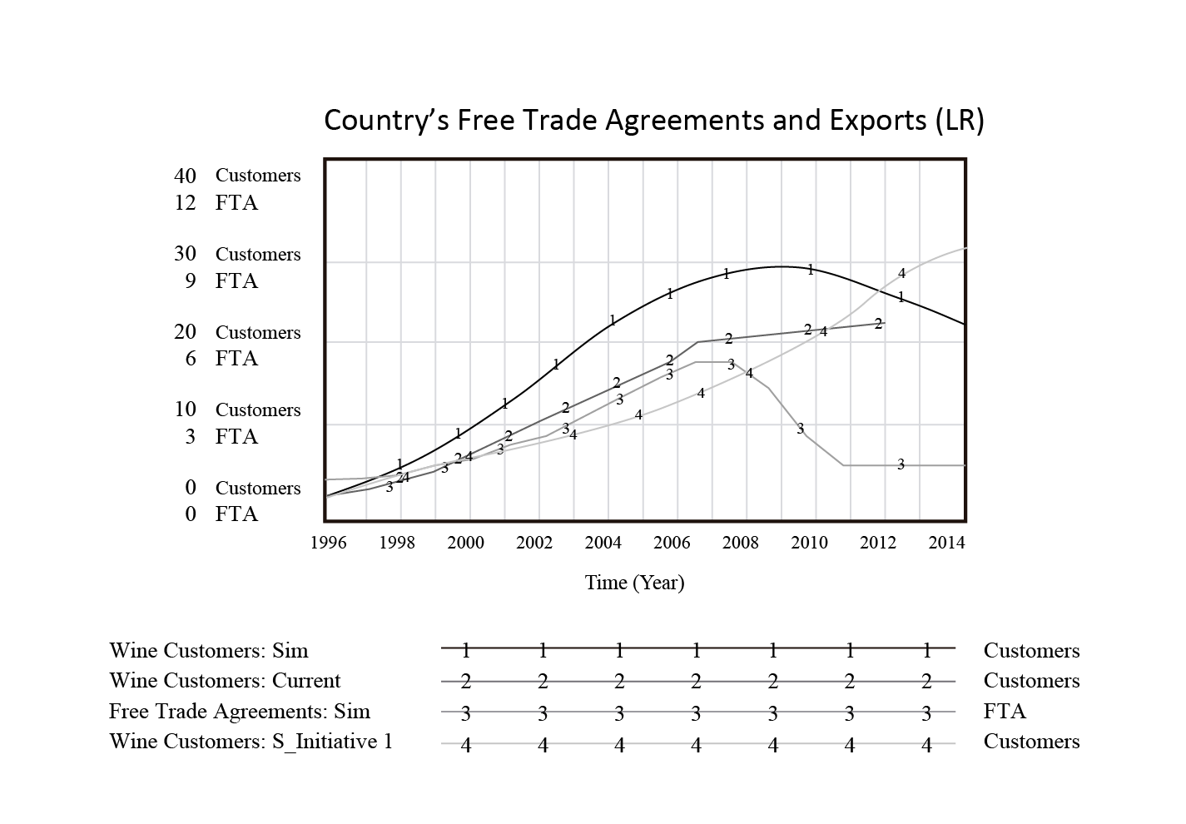

Figure 2. Trajectories for the performance of the internationalization strategies: base case (line named current) and scenario (line named Sim) analyzed by the LR’s CEO

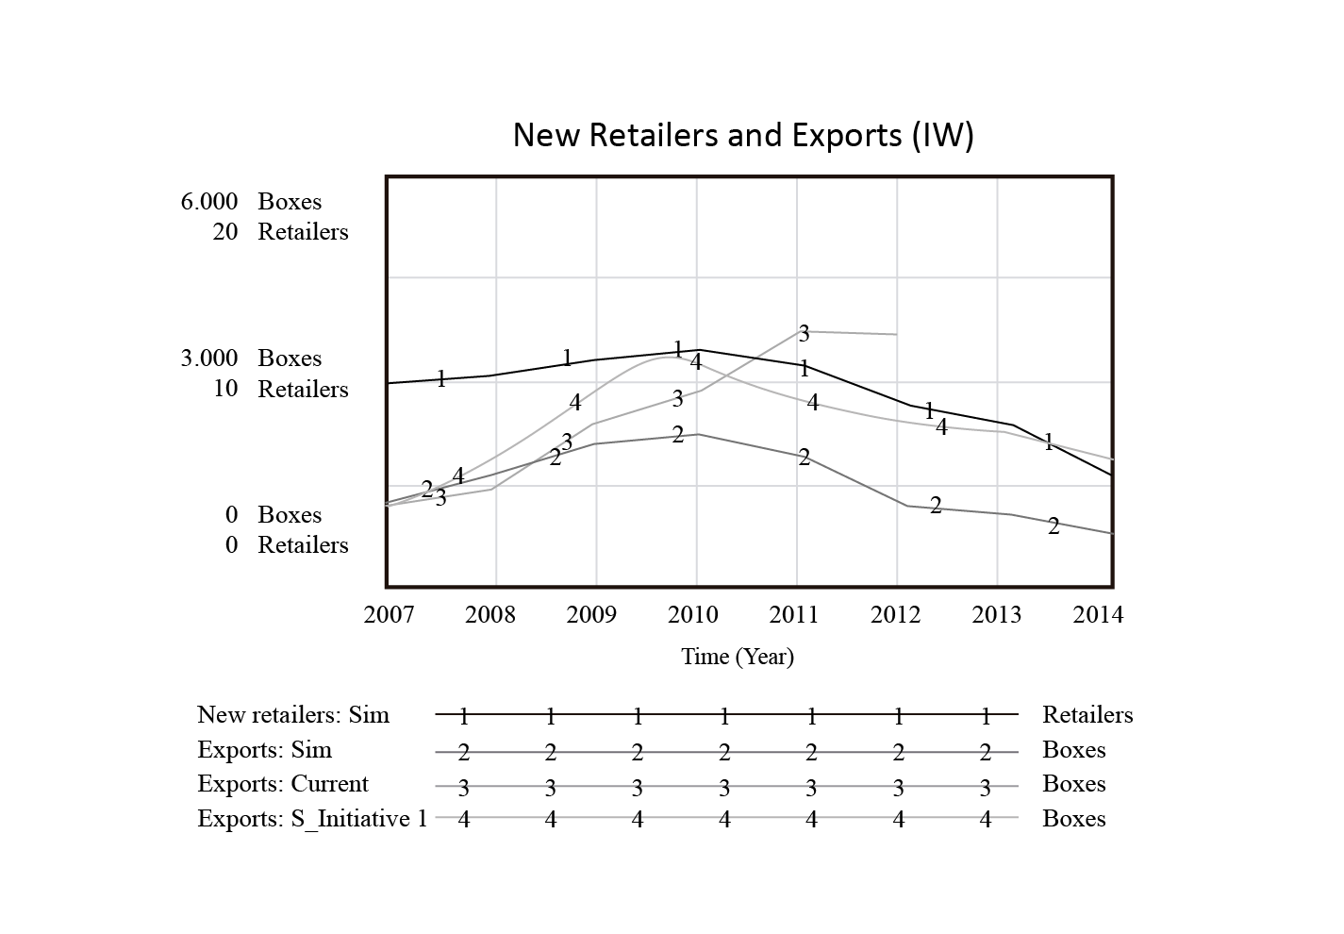
Figure 3. Trajectories for the performance of the internationalization strategies: base case (line named current) and scenario (line named Sim) analyzed by the IW’s CEO

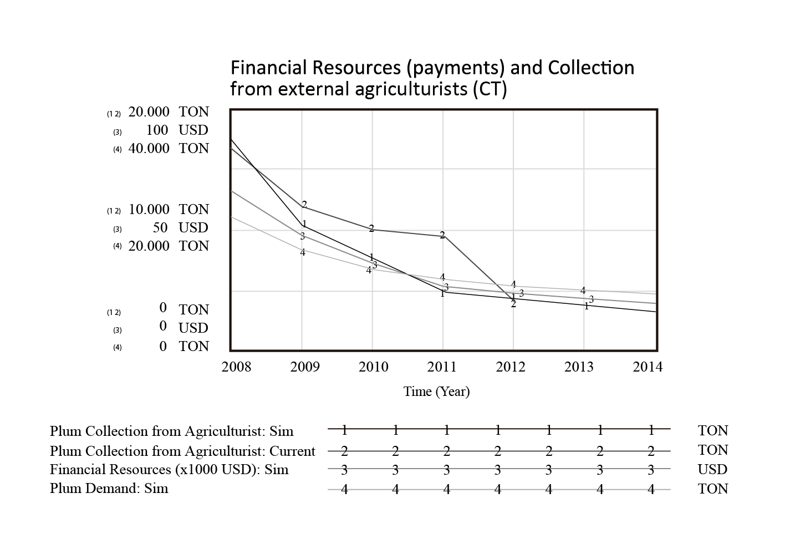
Figure 4. Trajectories for the performance of the internationalization strategies: base case (line named current) and scenario (line named Sim) analyzed by the CT’s CEO

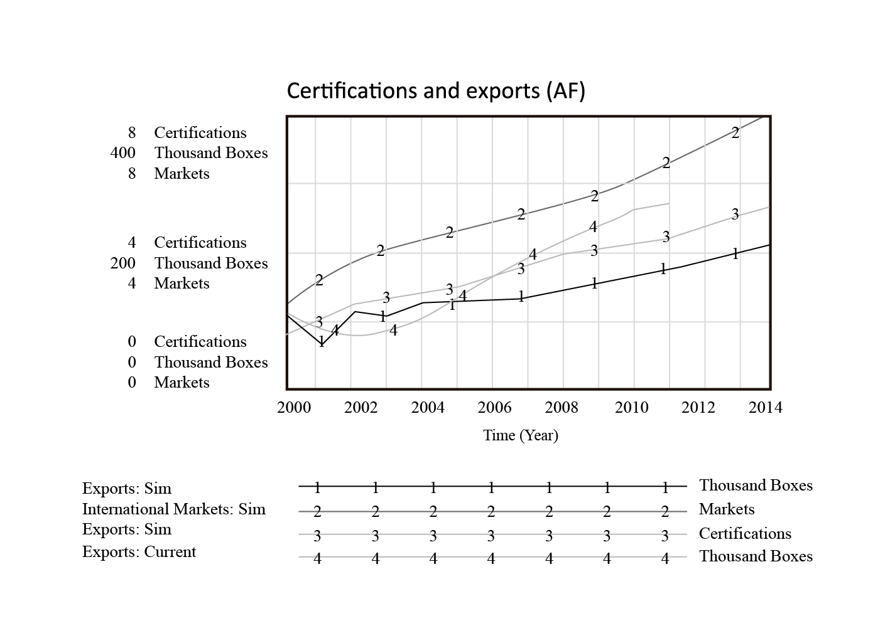
Figure 5. Trajectories for the performance of the internationalization strategies: base case (line named current) and scenario (line named Sim) analyzed by the AF’s CEO

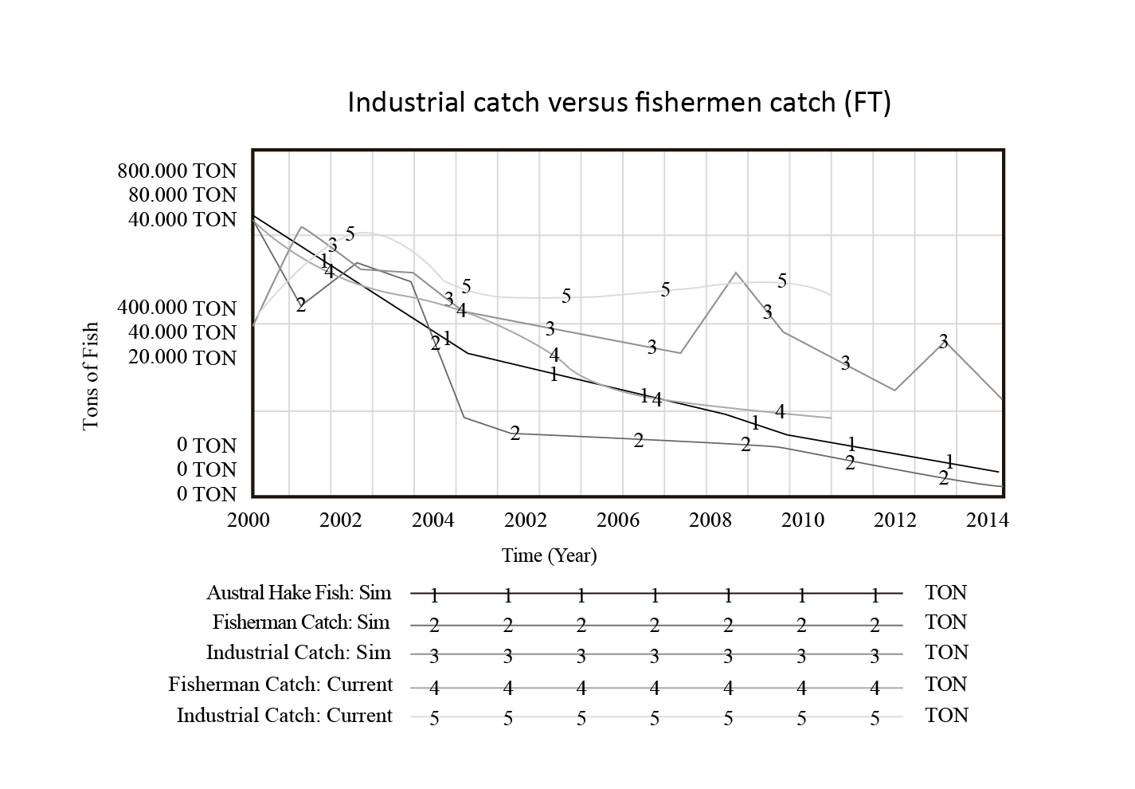
Figure 6. Trajectories for the performance of the internationalization strategies: base case (line named current) and scenario (line named Sim) analyzed by the FT’s CEO

Figure 7. Performance of the protocol based on CEO’s answers in each step of the protocol. We show the outcome of the process one year later by adding (+) if it was a positive results and (-) if it was a negative outcome

Table 1. Summary of scenarios and strategies
Firm | Scenario | DESCRIPTION | Exogenous variable | Strategic initiatives to overcome scenario | Endogenous variable changed
 |  |  | employed
LR | National Free Trade Agreements | The effect of increasing Chile's FTA on exports | Country's Trade Agreements | Increasing relational marketing activities on specialist wine retailers in unexplored markets through (1) training experience; (2) new brand; (3) developing customer services | International Marketing Activities  Training programs  Max number of loyal customers
IW | Wine Specialists overseas | The effect of decreasing the number of retailers on new customers | Rate of retailers per taste exhibition / Rate of retailers per e-business activities | Increasing traditional and relational marketing activities in current markets through: (1) including the register of every bottle in the label; (2) participation in wine tournaments | Rate of customers per retailers / Rate of customers per taste exhibition
 |  |  |  |  | Wine quality
 |  |  |  |  | Awards
CT | Unexpected Delinquent clients | The effect of unexpected delay payments (50%) on the plum collection and harvest | Payments from External customers | No strategic initiative | No strategic initiative
AF | Customer's requirements | The effect of increasing the number of certification due to new customer's requirements | Customer's certification requirements | No strategic initiative | No strategic initiative
FT | Limit of fish growth | The effect of fish stock depletion on the fish catch capacity (industrial and fishermen) | Time to adjust Industrial fleet and fishermen's ships | No strategic initiative | No strategic initiative

Table 3 Comparison of results with other SD interventions
Characteristic |  |  | Morecroft et al. (1991) |  | Senge & Sterman (1992) |  | Cavaleri & Sterman (1997) |  | Repenning & Sterman (2002) |  | Senge et al. (2007)
Country |  |  | United Kingdom |  | United States |  | United States |  | United States |  | United States
Industry |  |  | Biotechnology |  | Insurance |  | Insurance |  | Electronic manufacturing |  | Oil, motorcycle, technology, and clothing
Firms |  |  | 1 SME |  | 1 SME |  | 1 Firm (not reported size) |  | 1 Large firm |  | 5 Large firms
Improvement in decision-making |  |  | Participants suggested that they learnt about the business process |  | Participants could not articulate a significant new insight, but they clarified assumptions and shared experience |  | Participants suggested that they experienced a shift in their mental models |  | Participants enhanced their understanding of linkages between errors and performance |  | Participants recognized the need for collaboration across multinational companies
Reflection on strategic actions |  |  | Insights from SD model led to increased priority for two internal projects |  | Participants compared simulated results to their expectations |  | Not performed |  | Participants described the trade-off between doing their real work and the improvement work required by the initiative |  | Three of reflections were discussed: Conceptual, relational, and task-oriented work
Business Performance |  |  | Not reported |  | Not reported |  | Intervention did not produce measurable improvements in business performance |  | Not reported |  | Not reported
Model elicitation |  |  | Model developed by adviser |  | Model developed by participants and facilitator |  | Not reported |  | Not reported |  | Not reported
Data sources |  |  | Workshops, and interviews |  | Workshops, and interviews |  | Workshops, archival data, and questionnaire |  | Interviews |  | Workshops
Evaluation period |  |  | Last meeting |  | Not reported |  | 6 years after intervention |  | Not reported |  | Not reported

