Exploring Temporality in Socio-Ecological Resilience through Experiences of the 2015/16 El Niño across the Tropics

Stephen Whitfield^{1*}, Emilie Beauchamp^{2,3}, Doreen S. Boyd⁴, David Burslem⁵, Anja Byg⁶, Francis Colledge⁷, Mark Cutler⁸, Mengitsu Didena⁹, Andrew Dougill¹, Giles Foody⁴, Jasmin A. Godbold^{10,11}, Mirjam Hazenbosch³, Mark Hirons¹², Chinwe Ifejika Speranza²⁰, Eleanor Jew¹, Carmen Lacambra^{13,18}, David Mkwambisi¹⁹, Awdenegest Moges⁹, Alexandra Morel^{12,14}, Rebecca Morris^{3,15}, Paula Novo¹⁶, Mario Enrique Rueda Hernández²¹, Harriet Smith¹, Martin Solan¹⁰, Thomas Spencer¹³, Ann Thornton¹⁰, Julia Touza¹⁷, Piran C. L. White¹⁷
* corresponding author: s.whitfield@leeds.ac.uk
1. Sustainability Research Institute, University of Leeds, Leeds, LS2 9JT, United Kingdom
2. International Institute for Environment and Development (IIED), London WC1X 8NH , United Kingdom
3. Department of Zoology, University of Oxford, OX1 3PS, United Kingdom
4. School of Geography, University of Nottingham, Nottingham, NG7 2RD, United Kingdom
5. Institute of Biological & Environmental Sciences, University of Aberdeen, Aberdeen, AB24 3UU, United Kingdom
6. Social, Economic and Geographical Sciences Group, The James Hutton Institute, Craigiebuckler, Aberdeen, AB15 8QH, United Kingdom
7. Met Office, Fitzroy Road, Exeter, EX1 3PB, United Kingdom.
8. Department of Geography, University of Dundee, Dundee, DD1 4HN, United Kingdom
9. Institute of Environment , Hawassa University, Ethiopia.
10. Ocean and Earth Science, University of Southampton, National Oceanography Centre, Southampton, European Way, Southampton, SO14 3ZH, United Kingdom.
11. Biological Sciences, University of Southampton, Highfield Campus, Southampton, SO17 1BJ, United Kingdom.
12. Environmental Change Institute, School of Geography and the Environment, University of Oxford, Oxford, OX1 3QY, United Kingdom
13. Department of Geography, University of Cambridge, Cambridge CB2 3EN, United Kingdom
14. Institute of Zoology, Zoological Society of London, Regent’s Park, NW1 4RY, United Kingdom.
15. Biological Sciences, Life Sciences Building 85, University of Southampton, Highfield Campus, Southampton, SO17 1BJ, United Kingdom.
16. Land Economy, Environment and Society Group, Scotland’s Rural College (SRUC), Kings Buildings, West Mains Road, Edinburgh, EH9 3JG, United Kingdom.
17. Environment Department, University of York, Heslington, York, YO10 5NG, United Kingdom
18. Grupo Laera, Avenida Carrera 9 N 113-52 office 1901, Bogotá, Colombia
19. Malawi University of Science and Technology, Limbe, Malawi
20. Geographisches Institut, Universität Bern, Bern, Switzerland
21. Instituto de Investigaciones Marinas y Costeras (INVEMAR), Sede Principal: Calle 25 No. 2-55, Playa Salguero, Santa Marta, Colombia

Abstract
In a context of both long-term climatic changes and short-term climatic shocks, temporal dynamics profoundly influence ecosystems and societies. In low income contexts in the Tropics, where both exposure and vulnerability to climatic fluctuations is high, the frequency, duration, and trends in these fluctuations are important determinants of socio-ecological resilience. In this paper, the dynamics of six diverse socio-ecological systems (SES) across the Tropics – ranging from agricultural and horticultural systems in Africa and Oceania to managed forests in South East Asia and coastal systems in South America – are examined in relation to the 2015-16 El Niño, and the longer context of climatic variability in which this short-term ‘event’ occurred. In each case, details of the socio-ecological characteristics of the systems and the climate phenomena experienced during the El Niño event are described and reflections on the observed impacts of, and responses to it are presented. Drawing on these cases, we argue that SES resilience (or lack of) is, in part, a product of both long-term historical trends, as well as short terms shocks within this history. Political and economic lock-ins and dependencies, and the memory and social learning that originates from past experience, all contribute to contemporary system resilience. We propose that the experiences of climate shocks can provide a window of insight into future ecosystem responses and, when combined with historical perspectives and learning from multiple contexts and cases, can be an important foundation for efforts to build appropriate long-term resilience strategies to mediate changing and uncertain climates.
Key words: Climate change, variability, temporal dynamics, resistance, perturbations, societies, ecosystems
Funding: This work was supported by the UK Natural Environment Research Council and the UK Government Department for International Development [grant numbers NE/P004806/1; NE/P004091/1; NE/P00394X/1; NE/P004210/1; NE/P004830/1; NE/P003974/1]

1. Introduction
The consequences of climate-driven and climate-related change are most negatively experienced by those in low income economies in the Tropics (IPCC, 2014). This is in part caused by baseline trends in which the world’s hottest places are becoming hotter and extreme weather events, such as droughts and tropical cyclones, are being exacerbated (Donat et al., 2016, Latif et al., 2015). However, the impacts of these changes depend critically on how climatic variables interact with the resilience of socio-ecological systems (SES). While climatic processes take place at global scales, resilience to these processes is contextual. Where societal reliance on a small suite of local natural resources is high (e.g. for food production and provision) and where ecological systems are degraded or low in diversity, the implications for system resilience to extreme weather events are clear. However, such conditions are not generalizable across the diverse geographies of low income economies in the Tropics (Adger, 2000), and as we set out the case for in this paper, they cannot be considered in the absence of temporal context either. It is, of course, difficult to extract short-term system dynamics from longer-term processes of social and environmental change, although analytical approaches are beginning to emerge (Vincenzi et al., 2018). Extreme short-term weather events, and inter-decadal variability, occur against a backdrop of longer-term changes in climates (Easterling et al., 2000), to which systems display complex responses (Schurman et al., 2018, von Buttlar et al., 2018) and are differently adapted and resilient. In response to both climatic and non-climatic drivers, historical land management and use of natural resources, governance regimes, and social and cultural interactions might contribute to the building of social cohesion and ecological health (i.e. the building of resilience) (Berkes and Folke, 2002, Olsson et al., 2004). Conversely, they may create lock-ins to unsustainable extractions of resources and low agro-ecological diversity (i.e. the erosion of resilience) (Adger et al., 2011, Stringer et al., 2016). Furthermore, it is possible to imagine a situation in which resilience building and erosion are occurring simultaneously and at different scales and rates.
Against this backdrop, extreme weather events, such as drought can be caused by fluctuations in the El Niño Southern Oscillation (ENSO). These are events to which systems may be more or less resilient, but such events may in themselves affect system resilience in the long-term. For example, extreme weather events may undermine system resilience by causing long-term damage to ecological health and infrastructure or causing displacement of populations (Adger et al., 2005, Badjeck et al., 2010, Bakar and Jin, 2018). Short-term (<1 year) events may also play an important role in the longer-term (>20 years) building and maintenance of system resilience, such as by helping to maintain biological diversity, enhance community solidarity, or present opportunities for learning about adaptation (Osbahr et al., 2008, Grant et al., 2017).
Understanding these complex temporal dynamics is important in informing adaptation actions and interventions, particularly if longer-term trends (e.g. climate change) change the frequency, severity, and probability of short-term shocks. Yet the cross-temporal dynamics of system behaviour and adaptation are understudied (for example in the absence of considerations of the temporality of adaptation within IPCC and IPBES assessment reports), potentially contributing to over simplistic assumptions about the state and trajectory of resilience in different contexts.
In this paper, we use the 2015-16 El Niño event as a window through which to examine the resilience dynamics of six diverse SES across the global Tropics, ranging from agricultural and horticultural systems to managed forest and coastal systems, studied under the “Understanding the Impacts of the Current El Niño” programme of the United Kingdom Natural Environment Research Council (NERC). Combining insights from these projects with climatological characterisations of this ENSO and climate model-derived information about the changing nature of climate events, such as those experienced during the 2015/16 ENSO, will help us to understand the interactions between short-term weather events and longer-term resilience of these SES. More specifically, we set out with the objectives of:
- Exploring the role of long-term trajectories in system characteristics, such as health, heterogeneity, learning and autonomy, in conferring resilience to short-term extreme weather events
- Assessing the effects of these short-term events on longer-term socio-ecological resilience
Although there is not scope in this paper to revisit an already extensive and rich literature that discusses and refines the language of resilience theory (Walker et al., 2004, Cote and Nightingale, 2012, Dixon and Stringer, 2015), such consideration of terminology is important. For the sake of clarity in our own use of terms, we consider ENSO cycles as a climatic process that manifests in short-term and localised weather events, such a high or low seasonal rainfall. We use the term ‘short-term’ to consistently refer to phenomena that are annual or sub-annual in duration. These are distinct from ‘long-term’ processes that are multi-decadal or greater (i.e. >20 years) in duration. An extreme weather event, one in which there is a significant enough anomaly in (annual/sub-annual) weather conditions (e.g. rainfall, temperature) to alter socio-ecological system function, is considered to be one form of system shock, often interacting with other economic, socio-political and environmental shocks.
The paper begins with an overview of SES resilience literature, focussing on the way that temporal dynamics have been theorised within this expansive and divergent body of writing. Next, we give an overview of the six systems and the characteristics of the El Niño event in each location, before drawing out key findings in relation to each objective. We conclude by drawing out the contributions of this work to both the theorization of socio-ecological resilience and general lessons for broad efforts towards ‘building’ climate change resilience.

2. Material and Methods
The paper is the outcome of a workshop held in October 2017, which brought together research teams from projects funded under the NERC “Understanding the Impacts of the current El Niño” programme to identify common themes across our work. The six case studies (Figure 1), described below cover a broad geographic scope and varied socio-ecological interactions, inclusive of agricultural and horticultural systems, managed forest systems, and coastal systems. The methods and approaches applied in each research case study cross disciplines and represent a variety of longitudinal, situational and retrospective data collection focused on examining and contextualising impacts of and responses to the 2015/16 El Niño. The methods and results of the individual studies are detailed in existing and forthcoming publications (Morel, in preparation, Jew et al., under review, Byg et al., 2017, Steward et al., 2018, Hirons et al., 2018a).

[Figure 1: Six case study tropical socio-ecological systems described and discussed in this paper]

For each case study country, we undertook a climatological analysis of the El Niño event, using the Multi-Source Weighted-Ensemble Precipitation (MSWEP) Version 2.0 global dataset for precipitation and using the Watch Forcing ERA-Interim (WFDEI) global dataset for temperature. MSWEP covers the period 1979-2016, and is available at 3-hourly temporal resolution and at 0.1° spatial resolution (Beck et al., 2017). WFDEI covers the period 1979-2012, and is available at 3-hourly temporal resolution and at 0.5° spatial resolution (Weedon et al., 2011). For both temperature (seasonal average) and precipitation (seasonal total accumulation), the long-term climatology was averaged for the main wet and dry seasons for 1981-2010. To produce the differences in temperature and rainfall for the 2015/2016 El Niño year event, the change in temperature (i.e. 2015 season minus climatology (1981-2010)), and the percentage of normal rainfall from 1981 to 2010 (i.e. dividing 2015 season actual rainfall, divided by normal precipitation and multiplying by 100) were calculated. This climatological description of the ENSO event is combined below with a narrative description of the experiences and recorded impacts of the El Niño in each context. Through the lens of this single short-term event, across a variety of locations and contexts, we draw out some key points about the temporal nature of socio-ecological resilience.

3. Theory: Socio-Ecological Resilience and Temporality
Across a large and growing body of SES research, in which the idea of resilience has been much theorised and empirically examined, there are popular ideas about what resilience is and the characteristics of a resilient system. Socio-ecological resilience is broadly understood as the capacity of a system, to absorb, respond, adapt to and continue to function in the face of disturbance (Folke et al., 2010). However it is a concept more amenable to contestation than measurement. This is the case not only because what it means to function or recover is a value judgement, and because systemic behaviours and responses are shock-specific, but also because the dynamics of SES are often socially and politically mediated. In conceptualising SES, Fisher et al. (2013) highlight the importance of understanding them as dynamic and continuously changing, and guard against the notion of stable or climax states, to be recovered to following shocks. As such, adaptations - changes that are deliberately made in anticipation of, or in response to, shocks – may be characteristic of resilient systems. However, it is also possible that systems may be resilient in highly undesirable, degraded or inequitable states (Béné et al., 2014).

Those important caveats withstanding, and in spite of diverse terminology, there is general consensus across a broad literature on the characteristics of resilient systems (Fiksel, 2003, Cinner et al., 2009, Bennett et al., 2005, Dixon and Stringer, 2015). These include: good ecological health; heterogeneity in ecological composition and social livelihoods (diversity of properties, activities and pathways and flexibility to nimbly move between these (Carpenter et al., 2001, Folke et al., 2010)); resource use efficiency (Kahiluoto and Kaseva, 2016); the existence of opportunities, resources and information for learning and the acquisition of skills and knowledge by society (Berkes, 2009, Olsson et al., 2004); effective institutions (Adger et al., 2003); and social cohesion and the capacity and autonomy for democratic self-organisation (Lebel et al., 2006). However, it may be inaccurate to assume that a resilient system is simply one that is well endowed with these attributes without paying attention to the dynamic structures, agencies, and power that affect the abilities of individuals and groups to access resources and information, and that can underpin inequalities and injustices within systems. The structures, agency and power within systems is something that socio-ecological concepts of resilience are sometimes criticised for overlooking (Smith and Stirling, 2010, Cote and Nightingale, 2012), and themselves have important temporal dimensions.

There are important temporalities to systemic characteristics. Ecological health, heterogeneity, learning and autonomy within systems can both accumulate and erode over time. As many of these have inherent thresholds, and because they can be affected by multiple uneven and unsynchronised processes, socio-ecosystem responses to change can be non-linear and/or non-additive. Whilst this temporality is recognised in SES literature, it is rarely the focus of empirical analysis, perhaps because of the difficulties of longitudinal studies/data availability, or because of the more tangible urgency of addressing short-term shocks, such as extreme weather events. However, such shocks can offer an important window through which to ask questions about what creates and constrains long-term socio-ecological resilience, and may offer contemporary insight into longer-term future climatic challenges (Pinho et al., 2015). Here we set out some of the key conceptualisations of temporality in SES that frame our analysis of resilience in the context of the 2015/16 El Niño event.

3.1 The erosion and accumulation of resilience
Folke et al. (2002) argue that the processes through which SES resilience accumulates are slow. This is seen, for example, in the long-term accumulation of soil health that is documented in indigenous soil enrichment practices in West Africa (Solomon et al., 2016); in the inter-generational building of local ecological knowledge of flood adaptation and management of farmer-fishers in the Amazon delta (Vogt et al., 2016); the rich species diversity that accumulates in ancient sacred forest groves of Yoruba in Nigeria (Warren and Pinkston, 1998); and the long post-colonial transition towards establishing autonomy and community based natural resource management in southern Africa (Muboko and Murindagomo, 2014). Socio-ecological heterogeneity, in the form of mosaic landscapes, diverse species compositions and diverse livelihood strategies can be the product of long-term diversifications, in- and out-migrations and interactions across systems. Whilst political change can be rapid and dynamic, establishing effective systems of autonomous governance (that are recognised and legalised), and altering embedded power dynamics, is often slow {Lebel, 2006 #483}.
Processes of erosion of these characteristics can occur over a range of timescales. In systems where shocks are not frequently experienced, and even in some cases where they are, the value of resilience building system features may be undervalued and gradually polluted, degraded or unsustainably extracted. Slow external processes of change, such as climate change, can contribute to a gradual undermining of ecological health, for example as observed in the loss of coral reef species (Hoegh-Guldberg et al., 2007). Learning and local knowledge can also be lost over time, as Reyes-García et al. (2013) observe in the case of knowledge of wild foods and medicine amongst the Tsimane in Bolivia, and growing and perpetuating inequalities and social marginalisation can gradually undermine good governance (Blaikie, 2006). However, unlike the accumulation of resilience, its degradation may also be rapid. External events such as fires or landslides can destroy ecological health instantaneously, as observed by Allen et al. (1999) in New Zealand montane forests; and the autonomy or governance of a system can be rapidly altered through political regime change or conflict, as seen in the displacement of Kenyan pastoralists in the violent conflict that followed the 2017 national elections.
These slow and fast processes of change interact in complex ways. Climatic events in themselves often represent a combination of processes at different temporal scales: short-terms spikes within longer-term trajectories or cycles of change. In contexts of trade-off between short-term adaptation and longer-term resilience, extreme weather events can raise questions not only about how resilient a system is, but about what it is resilient to and when it is most susceptible to forcing.

3.2 Short-term shocks and long-term trajectories in socio-ecological-climatic systems
As SES scholars have strongly argued, resilience must be considered within contexts of constant change; a recognition that systems are inherently changeable and uncertain and that the experience of, and response to shocks is essential to this dynamic (Gunderson, 2001). This challenges the notion of extreme weather events as shocks that are external to, and impacting on a system, as if the system exists separately from its climate, and denies the multidirectional relationship by which human activity, land use and ecosystems affect climate (Cote and Nightingale, 2012). The tendency to decouple SES and climatic changes and shocks leads us to overlook an important aspect of the temporal complexity of these systems.
That weather is a manifestation of multiple complex processes within the climate system, and that it is only extreme when it leads to impacts on systems (associated crop losses, health risks etc.), makes the idea of an extreme weather event, as something that is external to the SES and temporally bounded, problematic. Moreover, whether or not a weather event is defined as ‘extreme’ depends on discipline specific norms, but generally reflects some judgement about the intensity and frequency of an occurrence relative to baseline conditions (McPhillips et al., 2018). Climate varies naturally on nearly all temporal and spatial scales. Quantifying precisely the nature of this variability is challenging and characterised by considerable uncertainty (Thornton et al., 2014, Kirtman et al., 2013). Across a range of spatial and temporal scales, the combination of events, short-term variability, and long-term change in climates is an inherent part of SES dynamics. The temporal boundaries that we put on a baseline will significantly impact the relative ‘extremeness’ of an event, or even whether an event is an event at all (i.e. something that is identifiable and temporally bounded as opposed to a process of unspecific duration). Although the impacts of and responses to extreme events may be understood in isolation, it is important to recognise that, under climate change, particularly in the Tropics, extremes are occurring with greater frequency and intensity (Cai et al., 2014, Yeh et al., 2009). As such, longer term climate trends are changing the baseline against which an ‘extreme’ might be defined.
The context of adaptive response in this case is one of both long-term systemic change, in which processes of climate change are implicated, and of inter-annual extremes, that are changing in intensity and frequency. The two are not easily disentangled, and whilst we distinguish between extreme events and climatic trends, and correspondingly between longer-term adaptations and short-term coping mechanisms, we recognise that this represents an oversimplification of the continual and dynamic interactions between climatic and socio-ecological processes. For example, a short-term extreme event may represent a trigger for longer-term adaptive responses. Therefore, the premise of the analysis presented here is that the interplay of socio-ecological and climatic processes of change at different scales can provide insight into the resilience (and the constraints on resilience) of systems in which societies, climates and ecosystems are inherently interlinked.

4. Results: The Stories of Six Socio-Ecological Systems

4.1 Mangrove-lagoon systems on the Colombian Caribbean coast
La Ciénaga Grande de Santa Marta (CGSM) is Colombia’s largest coastal mangrove-lagoon system, covering an area of 800km². It is connected to the Caribbean Sea and fed in part by the Magdalena, Colombia’s largest river. CGSM is a designated Wetland of International Importance and a UNESCO Biosphere Reserve. Approximately 25,000 people live within or around the lagoon; most livelihoods are dependent on small-scale fisheries (Blanco et al., 2007) and the majority (58-73%) of households are considered poor (National Administrative Department of Statistics, 2012). The CGSM system is under threat from a wide range of slow-onset stressors such as increased nutrient and sediment loads (due to deforestation and land use change in the main watersheds, infrastructural developments, and alteration of natural drainage), salt intrusion and climate variability (IDEAM, 2015). These longer-term trends are overlain by short-term impacts from environmental shocks, including droughts and floods linked to ENSO events (Blanco et al., 2007). Armed conflicts have also undermined social resilience, particularly in the 1960s and 1990s (Torres-Guevara and Schlüter, 2016). The interaction between the different environmental stressors, occurring within a dynamic socio-political context of post-conflict readjustment, affects the prospects for building longer-term socio-ecological resilience in the area.

A study conducted by the Universities of York, Southampton and Cambridge, Grupo Laera, and the Colombian Institute for Marine and Coastal Research (INVEMAR) of the current and historical ecological status of the mangrove and its ecosystem services revealed evidence of the effects of long-term and short-term stressors on the ecosystem and the communities that depend on it for their livelihoods.

The clearest signs of acute stress are mass fish kill events, most dramatic in the mid-1990s (Mancera et al., 1994, Epstein et al., 1995), but still happening as recently as 2016, in conjunction with the 2015-16 El Niño event. For the Colombian Caribbean coast, El Niño brings warmer and drier than average conditions during the late rainy season (McSweeney et al., 2010a). Parts of the Colombian Caribbean coast experienced rainfall at <25% of normal levels between April-October 2015, and >150% above normal levels during April-October 2016. The discharge of the Magdalena River has been shown to be linked with ENSO and associated inland rainfall patterns (Restrepo and Kjerfve, 2000), and this has important implications for the salinity of lagoon water (inversely related to freshwater inflows) (Blanco and Viloria, 2006) and consequently for variations in the distribution of salt-water intolerant fish species such as tilapia (Blanco et al., 2007).

Variations in total fish, mollusc and crustacean catch (Figures 2a and 2b) reflect a combination of changes in the conditions in the lagoon including impacts of El Niño-La Niña events contributing to changes in salinity, changes in the management of the system, changes in the market, and changes in fishing practices. (Rueda et al., 2011, Rueda and Defeo, 2003, Blanco et al., 2007), As an illustration of these interacting processes, in 1996, one of the main channels feeding the CGSM, Caño Clarín, was dredged, and other channels (Aguas Negras, Renegado, Torno and Almendros) were re-opened by dredging between 1997 and 1998. This action resulted in the restoration of a hydrological regime that re-connected the estuarine system to the Magdalena River. However, an immediate consequence was an increase in sediment loads and consequent high sedimentation rates along the channels and finally in the main water bodies (The Pajarales Ciénaga and the Ciénaga Grande de Santa Marta). This sediment covered the natural oyster (Crassostrea rhizophorae) beds, and contributed significantly to the collapse in what was the main mollusc fishery prior to 1996. The occurrence of La Niña between 1998 and 2000 also contributed to this effect, with higher rainfall flooding the system with freshwater.
This variability takes place against longer-term environmental changes such as increasing salinity, pollution and sedimentation of the system (Cardona and Botero, 1998, Gónima et al., 1996). The oyster stock has shown some signs of recovery in 2007, 2010 and 2013, but fishing pressure and unsuitable habitat conditions have not allowed its full recovery. Similarly, fish catches have shown a consistent decline since 2006. Furthermore, the overall patterns of fish, mollusc and crustacean catches mask significant changes in species composition within these ecological groups. But the fact that the system can continue to deliver consistent fishery benefits, and functioning markets, in the face of the combined effects of environmental change and anthropogenic pressures demonstrates an apparent resilience of the socio-ecological system.

However, ecological changes have also been associated with a persistent decline or loss of income-generating capacity for local residents, higher competition for natural resources, and at certain times, scarcity of food and drinking water, flooding, concern over the sanitary quality of the food, and restricted transport mobility. Responses to these pressures include temporary migration and job-relocation, a greater reliance on dried rather than fresh fish, and elevation of agricultural fields and houses. The biophysical and socio-economic changes in the system are therefore the consequence of multiple stressors brought about by the interplay between short- to mid-term events such as ENSO cycles, longer-term anthropogenic changes in the environment, and changes in social and economic conditions, which interact in complex ways.

[Figure 2: Temporal patterns of: (a) total annual catch and average monthly catch combining fish, crustaceans and molluscs (tonnes) and (b) annual catch of fish, crustaceans and molluscs separately (tonnes). Source: INVEMAR (2018), reproduced with permission. Note: asterisks above the years 2002-2003, 2009-2010 and 2015-2016 indicate ‘moderate’, ‘moderate’ and ‘very strong’ El Niño events respectively (for definitions: http://ggweather.com/enso/oni.htm). Total fish catch decreased under these events in 2009-2010 (-12%) and 2015-2016 (-10%) but increased in 2002-2003 (+28%). There were ‘weak’ El Niño events in 1994-1995, 2004-2005 and 2006-2007; across these years total fish catch decreased by 10%, 4% and 30% respectively.

4.2 Mixed farming systems in Halaba, Southern Ethiopia
In the Halaba district, located within the Southern Nations, Nationalities and Peoples region of Ethiopia, land use is dominated by small-scale rain-fed maize agriculture and some cash cropping, such as teff and pepper. Average land holdings are less than one hectare, and for those who can afford it, livestock is limited to a few heads of cattle. The current agricultural dominated landscape is the result of historic processes including political and demographic changes. Until 1974, under the Imperial Regime feudal large-scale landowners owned most land, which they leased to largely pastoral, tenant farmers. Historically low population densities resulted in high coverage of woody vegetation. With the overthrow of the Imperial Regime, the advent of the Derg military regime resulted in extensive land reforms. All land officially became the property of the state, but small-scale farmers were given long-term use rights over individual land holdings. These use rights entitled them to temporal land transfers and inheritance. A combined political push for higher crop production and population growth led to a shift from predominantly pastoral to mixed systems, where crops eventually came to dominate. This resulted in extensive deforestation to meet increasing demand for agricultural land alongside population growth, and ultimately increased soil erosion and degradation.
Since the mid-1970s, efforts to address soil degradation have been institutionalised nationally (Haregeweyn et al., 2015). In the Halaba district, agricultural extension services have promoted soil and water conservation practices in agricultural systems as well as setting aside and reforesting degraded areas. These measures have slowly reversed the trends of soil degradation, however gains are unevenly distributed, both spatially and socially (Byg et al., 2017). Typically, wealthier farmers with access to more resources have been more successful in implementing these measures. Implementation barriers include lack of livestock or capital to buy fertiliser, or the amount of space taken up by physical soil conservation structures (i.e. stone bunds, which take up a large share of small plots). Furthermore, decreasing land availability and plot size threatens the sustainability of the current farming system and gains in soil restoration. Others have also found that the continued lack of legal land ownership may dis-incentivise farmers from investing in long-term conservation measures (Tarfasa et al., 2018).
A study conducted by Hawassa University, the University of Aberdeen and the James Hutton Institute revealed the relationship between land management practice and resilience to the extreme weather experienced in the region as a consequence of the El Niño event. Data shows that for the long rains in 2015, Ethiopia experienced below normal rainfall (50 to 100%), and that following a prolonged period of drought in 2015, the early wet season of 2016 brought floods (Figure 3a-d).

The 2015 drought resulted in a serious impact on crop productivity and water availability and quality. Farmers used a range of coping mechanisms to mitigate drought impacts. For example, they relied on water sources (rivers), often unimproved and unsafe; correspondingly the time taken to collect water increased due to scarcity, with a larger impact on women and children who are typically responsible for fetching water. Some also sold livestock (at low prices) to purchase food. Furthermore, due to feed shortages there were reports of livestock deaths. Others relied on wage work or petty trading, however there were reported barriers to both of these. Wage work was seen as unreliable and available only to those in good physical health, as it mainly consisted of physical labour such as construction work. Petty trading was only available to wealthier households, with adequate resources. Women also had to engage in other non-farm activities and, for some, this meant breaking cultural traditions. Loss of livestock through death or sale as well as sale of other assets, resulted not only in the immediate loss of income and food sources but also lowered households’ resilience against future shocks, as it meant that savings were eroded and the ability to maintain soil fertility and productivity through farming inputs (such as manure and animals for ploughing) was reduced. This also resulted in a number of indirect effects as farmers could not recover the costs of fertilisers and other agricultural expenditures, which left some of them indebted. This was further exacerbated by flood events following the drought (see below) which reduced soil fertility in some places by washing away top soil or depositing sand on agricultural fields. Taken together, the El Niño thus had longer term impacts on the people’s ability to respond to future droughts and floods (by eroding their assets) as well as reducing the productivity of their agricultural system. Noticeable impacts of the drought were relatively spatially uniform. However, in comparison the subsequent flood impacts were highly localised. Experiences of acute damage to property and crops and long-term impacts on soil fertility, due to erosion and/or deposition of sandy material, are not only a consequence of the El Niño event, but of the history of occupation and conversion of marginal lands, and of inequities in capacities and access to resources for implementing improved soil management and diversification.

[ Figure 3 Percentage of normal (1981-2010) seasonal total rainfall in Ethiopia for (a) February-March-April-May (FMAM) (wet) season 2015 (top left panel), (b) June-July-August-September (JJAS) (wet) season 2015 (top right panel), (c) October-November-December-January (ONDJ) (dry) season 2015/16 (bottom left panel – grey hatching marks areas of increases of >200% in very dry areas), and (d) FMAM (wet) season 2016 (bottom right panel). Data from the WFDEI dataset (Beck et al., 2017) (Source: Met Office).]

4.3 Conservation agriculture in central and southern Malawi
In central and southern Malawi, over 80 per cent of the population is engaged in small-scale food production, primarily of rain-fed maize agriculture (World Bank DataBank, 2018). Across the region, systems of maize production range from conventional mono-cultural and tillage-based systems, to ‘conservation agriculture’ (CA) practice, in which minimum tillage is combined with inter-cropping of (or rotations with) legumes and the maintenance of permanent organic soil cover. In recent years, CA practices have been promoted in the region by a range of non-governmental organisations and state agricultural extension services, in part on the premise that through soil conservation and improving water retention, production systems become more resilient to climatic extremes. Exposure to climate extremes (particularly drought) are high in central and southern Malawi, and the impacts of both droughts and floods are largely experienced as impacts on agricultural production and food availability.
A study conducted by the University of Leeds and the Lilongwe University of Agriculture and Natural Resources, evaluated the performance of CA in comparison with conventional agriculture during the 2015/16 El Niño -affected growing seasons. The inter-annual variability of the main rainfall season (November-to-April) in Malawi is strongly influenced by Indian Ocean sea-surface temperatures, and ENSO is the most documented cause for this variability (McSweeney et al., 2010b). As well as 2015/16, significant ENSO-driven droughts have occurred in Malawi in 1982/83, 1991/92, and 1997/98. However, the influences of ENSO on the climate of Malawi can be difficult to ascertain as it sits between two regions of opposing climatic response to El Niño (McSweeney et al., 2010b). During the maize growing season (November-to-April) in 2015/2016, central and southern regions of Malawi experienced below to near normal rainfall (50 to 100%), and temperatures were above average during 2015 and 2016 (0.2 to 1.0°C higher than the baseline period) (Figure 4 a-c). The inter-seasonal distribution of rainfall had particularly severe impacts on crop production. In the southern District of Machinga, farmers reported planting seeds following a day of rainfall in November. This was the second single-day rainfall event of the early growing season, and was followed by a three-week dryspell. Planted seeds failed to germinate and many farmers were subsequently unable to access replacement seeds to replant when sustained rains eventually came in December. In the adjacent Balaka District, the seasonal rainfall distribution was such that the majority of rain fell at a late point in the season (April). Farmers who had planted maize in planting basins reported a reduced crop yield owing to waterlogging and plant damage. These climate-related challenges interacted in complex ways with the socio-ecological characteristics of both conventional farming and CA farming households. Although there was evidence of CA systems producing higher yields than conventional systems on average, the altered distribution of labour burdens associated with CA (i.e. earlier land preparation, increased weeding), both across time, and across gendered household roles, meant that CA was not universally more effective (e.g. higher yielding) than conventional systems across all households. Variables relating to health and access to land and resources (including extension service information) affected whether or not farmers were able to make the required adjustments to the early season failed rains in Machinga, and whether or not crop losses were experienced in Balaka.
Health and resource access characteristics of households have historical dimension to them. Where loss of labour impacts productivity, the potential that a household experiences spiralling deprivation is real. Following a poor harvest in 2014/15, there were food shortages in the El Niño affected season, which were themselves identified as a significant source of labour loss. The case reveals the systemic nature of farm production constraints, highlighting important positive feedback loops between dependence on input subsidies, lost labour days, low productivity and food shortage. In this way, low crop yields in one season can negatively affect livelihoods, and the abilities of farmers to maintain soil conservation practices, in the longer term. In the adoption of CA systems, there is an important lead-time (of up to 5 years) in building soil health as well as innovating and adopting more efficient labour practices (Corbeels et al., 2014, Thierfelder et al., 2015, Hobbs et al., 2008). As such, the history of practice and learning around CA practices can represent an important determinant of the resilience of the system. However, in many cases, rather than consistent long-term investment in building the capacities and learning around CA, intervention has been characterised by short- and inconsistent projects and temporary incentives (Andersson and D'Souza, 2014, Dougill et al., 2017). Such intervention can undermine local knowledge and learning, as well as some of the resilience building gains associated with long-term investments in building soil health through CA practices, for example (Thierfelder et al., 2013a, Thierfelder et al., 2013b) .

[Figure 4 Percentage of normal (1981-2010) seasonal total rainfall in Malawi for (a) MJJASO (dry) season 2015 (left panel), (b) NDJFMA (wet) season 2015/16 (middle panel) and (c) MJJASO (dry) season 2016 (right panel - grey hatching marks areas of increases of >200% in very dry areas). Data from the WFDEI dataset (Beck et al., 2017) (Source: Met Office).]

4.4 Managed and Natural Forests in Borneo, Malaysia
In Borneo, perturbations associated with climatic change takes place in an environment where other anthropogenic impacts, such as timber extraction and forest clearance for palm oil and agriculture, are pervasive (Gaveau et al., 2016, Brinck et al., 2017, Ashton et al., 2014). Responses to these changes can be expected to be highly variable dependent on the frequency and intensity of these multiple disturbances (Qie et al., 2017).

A study conducted by the Universities of Dundee, Nottingham and Aberdeen, in conjunction with researchers from the South East Asian Rainforest Research Programme aimed to understand how and why forests with different degrees of management and degradation respond differently to El Niño. The study used the longitudinal collection of vegetation health indicator data (e.g. canopy structure, liana/tree compositions, etc.) and remotely sensed image analysis.

El Niño influences the Bornean monsoons and generally brings warmer and drier conditions to the region. During the dry season (May-to-October) in 2015, the region generally experienced below normal rainfall (25 to 50%) in the southern Archipelago, and below to near normal to the north and east (50 to 100%). During the dry season in 2016 the region experienced ‘wetter’ than normal rainfall (125 to 175%). During the wet season (November-to-April), the region predominately experienced normal to above normal (100 to 150%) rainfall with more than normal in mountainous regions (175 to 200%). Temperatures were typically above average throughout the 2015 and 2016 El Niño period (0.4 to 1.2°C higher than the baseline period). Visual interpretation of WorldView-3 images with a spatial resolution of 0.31 m (panchromatic waveband) and 1.24 m (multispectral bands) before and after the El Niño event indicated very little evidence of widespread short-term tree mortality in either logged forests or undisturbed forests, although some new canopy gaps and standing dead trees were found (Figure 5). The field plot data also revealed some mortality over the ENSO period but this was a very small proportion of the total number of trees surveyed.

[Figure 5– WorldView-3 imagery (1.2m resolution, true colour display) from December 2015 (left) and August 2016 (right) showing post-ENSO tree mortality at Danum Valley, Borneo.]

We expect that the addition of subsequent images over the next five years should clarify the longer-term trend in mortality at the landscape scale. Analyses of tree mortality across Borneo as a result of the 1997-98 ENSO drought demonstrated that the responses (i.e., mortality) were lagged and it took large-scale data synthesis from multiple plots to detect it against background variability (Qie et al., 2017). The unique biogeography and evolutionary history of Southeast Asian tropical forests may influence their temporal dynamics in response to El Niño and longer-term climatic changes. For example, lowland forests in aseasonal environments across the region display a phenomenon known as general flowering or mast fruiting (Ashton et al., 1988). This is characterised by community-level synchronisation of reproduction during irregular supra-annual events that take place at intervals of 2-10 years, and a general absence of reproduction or plant recruitment between these events (Appanah, 1993, Maycock et al., 2005). Long-term records demonstrate an association between general flowering events and periods of low temperature or drought (Azmy et al., 2016), which are often associated with ENSO events (Ashton et al., 1988, Cannon et al., 2007, Curran et al., 1999). The positive association of general flowering with ENSO years suggests that changes in the frequency or intensity of ENSO events across Southeast Asia may disrupt the induction of flowering and subsequent fruit production. Disturbance associated with logging and expansion of plantations exacerbates the disruption to tree reproduction from changing ENSO patterns, leading to subsequent regeneration failures of certain tree species (Curran et al., 1999). In cases where sufficient disturbance coincides with sufficiently extreme weather events, we would expect to see impacts on the longer term ecological health of these systems, although such affects are were not observed in the case of the 2015/16 El Niño. Post-logging management strategies, such as enrichment planting, should be investigated over ecologically-relevant timescales to determine their efficacy in mitigating diversity loss from single and multiple ENSO events.

4.5 Food Gardens and Forest Resource Use on Mount Wilhelm, Papua New Guinea
Papua New Guinea (PNG) contains the third largest area of tropical forest worldwide. In PNG, 85% of the population depends on small-scale subsistence agriculture (Shearman et al., 2009). With 97% of all land in PNG being held by tribes, clans and land groups and its ownership being dictated by local customs and traditional values under customary law (Anderson, 2010), one of the key drivers of land use change is the increase in subsistence farming due to population growth (Shearman et al., 2009), currently at 2.1% annually (World Bank Group 2016). On the slopes of Mount Wilhelm, PNG’s highest mountain located in the Central Range, households typically cultivate small (0.1 ha) temporary garden plots in the forest to grow a variety of food crops, including staples such as sweet potato, banana, and taro. Cash crop production of betel nut and cacao in the lowlands, and coffee in the highlands, also occurs in forest margins.
A study conducted by the University of Southampton, University of Oxford and the New Guinea Binatang Research Center examined the dynamic social and ecological effects of El Niño across an altitudinal transect on the northern side of Mount Wilhelm. The study focused on six villages located approximately 500m in elevation apart, ranging from 200m to 2700m above sea level. Mount Wilhelm is part of a highland range that divides northern and southern PNG. Over large island countries such as PNG, El Niño effects vary across different regions and altitudes, with the southern regions experiencing more severe decreases in rainfall than northern (UN-ESCAP 2014). The Australian Bureau of Meteorology and CSIRO (2011) also found that during El Niño events, the region of Kavieng, in the north of PNG, tends to have wet seasons that are wetter than normal, and tend to have warmer days. No clear influence of ENSO during the dry season was identified in Kavieng. During the dry season (May-to-October) in 2015 below normal rainfall (25 to 75%) was experienced across PNG. In the 2015/2016 wet season, near to above normal rainfall (100 to 125%) was experienced to the north of the highlands, and near to below normal rainfall (75 to 100%) to the south (Figure 6a,b). In May 2016, the El Niño dissipated as near average to below average sea surface temperatures expanded across the eastern equatorial Pacific Ocean (ENSO, 2016, IOM, 2015). Climatological effects of El Niño in the Mount Wilhelm region varied with elevation. Extreme high temperatures were recorded at lower elevations (200m and 700m), coinciding with bush fires and severe drought; but at mid-elevation (1200m and 2200m), reductions in dry season rainfall and increases in temperature were less severe, due to the mediation of cloud effects, and intermittent frosts occurred at particularly high elevations.
[Figure 6 Seasonal rainfall totals in Papua New Guinea for (a) the MJJASO (dry) season (left panel), (b) the NDJFMA (wet) season (right panel) averaged over the 1981 – 2010 period. Data from the MSWEP dataset (Beck et al., 2017) (Source: Met Office).]

The El Niño event impacted crops both directly through drought and frost, and indirectly, through changes in ecosystem services and disservices, including pest pressure and predation of pests. The impacts also varied with elevation due to changing conditions along the elevational gradient. For example, bird species richness and abundance increased at higher elevations (1700m and 2200m), but was reduced at lower elevations (200-1200m) (Sam et al., unp.), with potential impacts on pest predation, as many of these bird species attack crop pests.
Without access to climate information, and with little support from external interventions in the studied villages, the coping strategies adopted during El Niño were largely responsive: planting closer to water sources, in shaded areas, and closer to forests (a strategy which is thought to decrease pest pressure). Awareness of pre-emptive coping strategies existed, such as planting resistant crop varieties or those that can be stored, and employing soil management practices (e.g. mulching), but few more sophisticated strategies were adopted due to limited resource access. Village and clan-level safety nets (in terms of food and resource sharing, and small amounts of borrowing) were also an important short-term coping mechanism, along with buying food externally at markets, possible because under the drier El Nino conditions roads that are often otherwise washed out remained accessible. Post-El Niño, when a return to more favourable agricultural conditions was recorded, few of these coping strategies were maintained as regular agricultural or social practices (Beauchamp et al., in prep), and there is little evidence of the El Nino having a social legacy that might influence resilience, positively or negatively, into the future.

4.6 Cocoa Farming Landscapes in Central Region, Ghana
Ghana is the second largest exporter of cocoa in Africa, with more than half of its cocoa beans produced on smallholder farms of 2 hectares or less (Anim-Kwapong and Frimpong, 2005). The Central Region is one of the older cocoa growing regions of Ghana, with its forest-agricultural landscape characterised as a “land-sparing” configuration, with few patches of remnant trees outside of designated forest areas. Kakum National Park is a particularly well-protected forest area in Ghana’s Central Region, where cocoa farms directly abut the edge of the protected area. There is littlecanopy cover above cocoa farms, and what remains is relatively homogeneous in composition. After over fifty years of cultivation, pre-El Niño cocoa yield monitoring showed a strong signal of soil nutrient mining and pollination limitation (Morel et al., submitted).
A study conducted by the University of Oxford and the Nature Conservation Research Centre, Ghana, monitored the interaction between ecological drivers of cocoa production and household measures of well-being before, during and after the 2015/16 El Niño event on 36 farms. The impacts of the 2015/16 El Niño in this region resulted in a complicated pattern of rainfall across the bi-modal wet season (April-June and September-November). The re-starting of the rains in September were delayed, and were followed by a higher than normal rainfall the following April, when the strong ENSO conditions had subsided (Figure 7 a,b). During the ENSO, the Harmattan period (the dry period from late November to March) had drier than average conditions, which, when combined with elevated temperatures drove heightened vapour pressure deficits and low soil water availability.

[Figure 7 Graphs of (a) monthly precipitation and (b) monthly day-time temperature maximum for 2015-2017, recorded at the study sites in Ghana at different distances form the forest edge (100m, 500m, 1000m and 5000m). “0” refers to measures within the forest. Red shaded region indicates time period over which the El Nino Southern Occilation (ENSO) Index was “very strong” (>2.0) and orange region indicates a “strong” ENSO Index (>1.5-2.0). Harmattan refers to the annual dry season characterised by hazy conditions due to deposition of Saharan dust.]

Monitored farms exhibited elevated mortality (up to 30 percent) of productive cocoa trees seven months after the ENSO conditions had subsided, correlating with maximum temperature anomalies 10-15°C above average. The long-term impact of heightened cocoa tree mortality on a farmer’s resilience will depend on their ability to acquire additional planting material followed by the requisite 3-5 years for a cocoa tree to begin producing pods. Anomalies in cocoa yields varied by farm and across communities, with some areas seeing an increase in heavy crop harvests (as defined by the Ghana Cocoa Board). For farmers who experienced a decline in yields, the corresponding reduction in income inhibited their ability to send their children to school and undermined their food security (see: Hirons et al., 2018b) which may in turn contribute to lower levels of resilience, both in the immediate aftermath and in the longer term. Fungal attacks (e.g. black pod) on cocoa pods during the El Niño period were lower; however, insect attacks (e.g. capsids) showed a more complicated pattern. During interviews and focus groups, farmers noted the similarities between the drought/extended dry season in 2015 and that of 1983, another year with a significant El Niño event. However, they noted that, unlike 1983, the 2015 event did not result in devastating fires (Ampadu-Agyei, 1988). The experiences of farmers who continue to farm today, coupled with messages distributed through radio and print media, points towards societal learning and reduced risks. As well as increased awareness of the risks of using fire during drought periods, farmers noted that the 1983 fires contributed to a diversification of crop portfolios. For example burnt cocoa was replaced with oil palm, which yields more regularly and so smooths income, and is now widely cultivated alongside cocoa. In response to the 2015 drought, a shifting of cultivation of food crops to wetland areas was documented. It is not clear yet what impact the 2015 drought will have on farmers’ strategic decisions regarding crop portfolios and practices in the longer-term. Although most cocoa plots remained intact, which may limit dramatic crop switching decisions, community members highlighted concerns regarding the long-term hydrological impact of farming on wetlands and the potentially mal-adaptiveness of this short-term response to the shock leading to longer-term decreases in resilience (Hirons et al., 2018a).

[Table 1: Summary of the effects of long-term trends and short-terms shocks on the resilience of the six case study systems]

5. Discussion
The experiences of the 2015-16 El Niño across SES presented here (and summarised in Table 1) differently contribute to the broad argument that system resilience (or lack of) is a product of long-term and historical trends. The erosion of fisheries and coastal system health and ecosystem services over interdecadal periods in Colombia has restricted livelihood options and the substitutability of provisioning services that are important lifelines in times of crisis. Whereas, in Ethiopia and Malawi there is evidence of decadal and sub-decadal timescales of the accumulation of soil health through improved management practices, contributing to increasing the productive window of agricultural systems, and in Ghana there is a legacy of learning from historical events (such as the 1983 fires) about how to mitigate climatic risk within cocoa plantations.
Historical human interventions in ecological systems, and the power and politics that shapes this, can create uneven vulnerability within systems. A focus on the long-term nature of systems helps to ensure that these inequities are not overlooked, and that resilience is not depoliticised. The example of mixed farming systems in Halaba district (Ethiopia) illustrates the cumulative effect of two short-term extreme weather events with uneven spatial and temporal consequences. The differentiation is, in part, reflective of a historical and political legacy of both poor soil conservation and stability, but also of access to and capacities for implementing improved soil management strategies, access to labour and land, and the ownership of livestock. Similarly, in Colombia, socio-economic adjustments to changing environmental conditions are made against a backdrop of historical conflict and mistrust in official institutions that can further constrain livelihood options.
One way in which vulnerability might be created is through historical lock-ins to particular systems that limit autonomy, flexibility, heterogeneity or learning. Responses to short-term shocks that are permanent or structural, but without sufficient long-term foresight may have negative long-term legacies and ultimately be maladaptive (Adger et al., 2011). In the case of Ghana, where some farmers were forced to shift cultivation of food crops to wetlands in times of drought, or in Ethiopia where rural households drew down on their limited assets at points of financial difficulty, such potentially detrimental coping strategies are borne of necessity. However, the more active management decisions around logging, timber extraction and post-logging management (e.g. enrichment planting), in Borneo, for example, may have more scope within them for the integration of understandings of how such disturbance impacts the resilience and recovery of forest stands to short-term extreme weather events. Moreover, the agency of those within vulnerable SESs should not be overlooked, remaining within vulnerable livelihoods or situations, in many cases may be in part an active choice, underpinned by individual, familial, cultural, or even economic rationalities.
There is an important role for memory and learning, both in making sure that short-terms shocks (climate-related or otherwise) have a positive legacy and that long-term trends (in society and in ecology) are recognised. Ecologically, the role played by species that recolonise disturbed sites, either from internal remnants or cross system migrations, is recognised. Similarly, social memory persists in the passing down of knowledge, cultures and value systems between generations, and lessons learnt from past experiences of system change or disturbance (Adger et al., 2005). The historical frequency of change and exposure to system shocks are important temporal properties of resilience, because of the role they play in the evolution of diversity and in keeping adaptive knowledge alive across generations (Dixon and Stringer, 2015, Berkes and Folke, 2002). This links to the idea that disturbance maintains systems (Holling et al., 2002), reducing the chance that key resilience-properties of a system will be recognised and not be eroded over time, for example through practices such as pollution or unsustainable extraction. Particularly where the system is subject to long-term trajectories of change, the potential for ‘shifting baseline syndrome’ (Pauly, 1995) – by which successive generations regard the conditions that they grew up with as the ‘normal’ state to which any changes or trends are compared – to result in historical lessons and resilient characteristics to become undervalued is significant. There are also cases, such as in PNG, however, where this learning from past El Niño events does not appear to be associated with permanent change, either because of the temporary nature of the systems themselves or because of a combination of active choice and constrained options.
The interaction between long and short-term processes of change are important, and some of this interaction happens in the politically and scientifically-challenging ‘medium-term’. In modelling climate systems, there is growing confidence in the broad direction of long-term climatic trends, and short-term events can be forecast with relative accuracy. Yet, questions about the medium-term, such as whether the next decade will be El Niño-rich, are associated with a noisy signal and significant uncertainty (Meehl et al., 2014, Meehl et al., 2009, Eade et al., 2014) . The challenge of the medium-term is reflected too in politics and the noted inertia around making commitments that are beyond election cycles (3-5 years), but not so distant as to become abstract and without accountability (25-50 years) (Adger et al., 2011, Van Vuuren and Riahi, 2011, Ostrom, 2010). Furthermore, this scientific uncertainty can be a convenient and sometimes justifiable reason for non-committal politics. However, in addressing this inertia, reflections on the experience of recent history and the window of insight that short-terms events, such as El Niño offer into future, otherwise abstract, climates may be important. Particularly where such events bring to the fore examples of the negative consequences of longer term maladaptive practices or demonstrate the benefits of medium- to long-term investments in resilience building, they may provide evidence in support of calls on governments and institutions to act: to invest in improved ecological health, to address historical social inequities, to facilitate social learning and access to (climate) information, to open up opportunities of livelihood diversification, and to provide social safety nets. The sharing of lessons and experiences across contexts – of where such action has succeeded, and of where its absence has compounded the impacts of extreme weather events – as we have attempted with this synthesis, is particularly valuable in this regard.

References
ADGER, W. N. 2000. Social and ecological resilience: are they related? Progress in human geography, 24, 347-364.
ADGER, W. N., BROWN, K., NELSON, D. R., BERKES, F., EAKIN, H., FOLKE, C., GALVIN, K., GUNDERSON, L., GOULDEN, M. & O'BRIEN, K. 2011. Resilience implications of policy responses to climate change. Wiley Interdisciplinary Reviews: Climate Change, 2, 757-766.
ADGER, W. N., HUGHES, T. P., FOLKE, C., CARPENTER, S. R. & ROCKSTRÖM, J. 2005. Social-ecological resilience to coastal disasters. Science, 309, 1036-1039.
ADGER, W. N., HUQ, S., BROWN, K., CONWAY, D. & HULME, M. 2003. Adaptation to climate change in the developing world. Progress in development studies, 3, 179-195.
ALLEN, R. B., BELLINGHAM, P. J. & WISER, S. K. 1999. Immediate damage by an earthquake to a temperate montane forest. Ecology, 80, 708-714.
AMPADU-AGYEI, O. 1988. Bushfires and management policies in Ghana. Environmentalist, 8, 221-228.
ANDERSON, T. 2010. Land registration, land markets and livelihoods in Papua New Guinea. Customary Land, 11, 11-19.
ANDERSSON, J. A. & D'SOUZA, S. 2014. From adoption claims to understanding farmers and contexts: A literature review of Conservation Agriculture (CA) adoption among smallholder farmers in southern Africa. Agriculture, Ecosystems & Environment, 187, 116-132.
ANIM-KWAPONG, G. & FRIMPONG, E. 2005. Vulnerability of agriculture to climate change-impact of climate change on cocoa production. Accra, Ghana.
APPANAH, S. 1993. Mass flowering of dipterocarp forests in the aseasonal tropics. Journal of Biosciences, 18, 457-474.
ASHTON, P. S., GIVNISH, T. & APPANAH, S. 1988. Staggered flowering in the Dipterocarpaceae: new insights into floral induction and the evolution of mast fruiting in the aseasonal tropics. The American Naturalist, 132, 44-66.
ASHTON, P. S., REINMAR, R. & KASSIM, A. R. 2014. On the forests of tropical Asia: lest the memory fade, Kew Publishing.
AUSTRALIAN BUREAU OF METEOROLOGY & CSIRO 2011. Climate Change in the Pacific: Scientific Assessment and New Research. Volume 1: Regional Overview.
AZMY, M. M., HASHIM, M., NUMATA, S., HOSAKA, T., NOOR, N. S. M. & FLETCHER, C. 2016. Satellite-based characterization of climatic conditions before large-scale general flowering events in Peninsular Malaysia. Scientific reports, 6, 32329.
BADJECK, M.-C., ALLISON, E. H., HALLS, A. S. & DULVY, N. K. 2010. Impacts of climate variability and change on fishery-based livelihoods. Marine policy, 34, 375-383.
BAKAR, K. S. & JIN, H. 2018. Spatio-temporal quantitative links between climatic extremes and population flows: a case study in the Murray-Darling Basin, Australia. Climatic Change, 148, 139-153.
BECK, H. E., VAN DIJK, A. I., LEVIZZANI, V., SCHELLEKENS, J., MIRALLES, D. G., MARTENS, B. & DE ROO, A. 2017. MSWEP: 3-hourly 0.25 global gridded precipitation (1979-2015) by merging gauge, satellite, and reanalysis data. Hydrology and Earth System Sciences, 21, 589.
BÉNÉ, C., NEWSHAM, A., DAVIES, M., ULRICHS, M. & GODFREY‐WOOD, R. 2014. Resilience, poverty and development. Journal of International Development, 26, 598-623.
BENNETT, E., CUMMING, G. & PETERSON, G. 2005. A systems model approach to determining resilience surrogates for case studies. Ecosystems, 8, 945-957.
BERKES, F. 2009. Evolution of co-management: role of knowledge generation, bridging organizations and social learning. Journal of Environmental Management, 90, 1692-1702.
BERKES, F. & FOLKE, C. 2002. Back to the future: Ecosystem dynamics and local knowledge In: GUNDERSON, L. H. & HOLLING, C. S. (eds.) Panarchy: Understanding Transformations in Human and Natural Systems. Washington DC: Island Press.
BLAIKIE, P. 2006. Is Small Really Beautiful? Community-based Natural Resource Management in Malawi and Botswana. World Development, 34, 1942-1957.
BLANCO, J. & VILORIA, E. 2006. ENSO and salinity changes in the Ciénaga Grande de Santa Marta coastal lagoon system, Colombian Caribbean. Estuarine, Coastal and Shelf Science, 66, 157-167.
BLANCO, J. A., BARANDICA, J. C. N. & VILORIA, E. A. 2007. ENSO and the rise and fall of a tilapia fishery in northern Colombia. Fisheries Research, 88, 100-108.
BRINCK, K., FISCHER, R., GROENEVELD, J., LEHMANN, S., DE PAULA, M. D., PÜTZ, S., SEXTON, J. O., SONG, D. & HUTH, A. 2017. High resolution analysis of tropical forest fragmentation and its impact on the global carbon cycle. Nature Communications, 8, 14855.
BYG, A., NOVO, P., DINATO, M., MOGES, A., TEFERA, T., BALANA, B., WOLDEAMANUEL, T. & BLACK, H. 2017. Trees, soils, and warthogs–Distribution of services and disservices from reforestation areas in southern Ethiopia. Forest Policy and Economics, 84, 112-119.
CAI, W., BORLACE, S., LENGAIGNE, M., VAN RENSCH, P., COLLINS, M., VECCHI, G., TIMMERMANN, A., SANTOSO, A., MCPHADEN, M. J. & WU, L. 2014. Increasing frequency of extreme El Niño events due to greenhouse warming. Nature climate change, 4, 111.
CANNON, C. H., CURRAN, L. M., MARSHALL, A. J. & LEIGHTON, M. 2007. Long‐term reproductive behaviour of woody plants across seven Bornean forest types in the Gunung Palung National Park (Indonesia): suprannual synchrony, temporal productivity and fruiting diversity. Ecology Letters, 10, 956-969.
CARDONA, P. & BOTERO, L. 1998. Soil characteristics and vegetation structure in a heavily deteriorated mangrove forest in the Caribbean coast of Colombia. Biotropica, 30, 24-34.
CARPENTER, S., WALKER, B., ANDERIES, J. M. & ABEL, N. 2001. From metaphor to measurement: resilience of what to what? Ecosystems, 4, 765-781.
CINNER, J., FUENTES, M. & RANDRIAMAHAZO, H. 2009. Exploring social resilience in Madagascar’s marine protected areas. Ecology and society, 14.
CORBEELS, M., DE GRAAFF, J., NDAH, T. H., PENOT, E., BAUDRON, F., NAUDIN, K., ANDRIEU, N., CHIRAT, G., SCHULER, J. & NYAGUMBO, I. 2014. Understanding the impact and adoption of conservation agriculture in Africa: A multi-scale analysis. Agriculture, Ecosystems & Environment, 187, 155-170.
COTE, M. & NIGHTINGALE, A. J. 2012. Resilience thinking meets social theory Situating social change in socio-ecological systems (SES) research. Progress in Human Geography, 36, 475-489.
CURRAN, L. M., CANIAGO, I., PAOLI, G., ASTIANTI, D., KUSNETI, M., LEIGHTON, M., NIRARITA, C. & HAERUMAN, H. 1999. Impact of El Nino and logging on canopy tree recruitment in Borneo. Science, 286, 2184-2188.
DIXON, J. L. & STRINGER, L. C. 2015. Towards a theoretical grounding of climate resilience assessments for smallholder farming systems in Sub-Saharan Africa. Resources, 4, 128-154.
DONAT, M. G., LOWRY, A. L., ALEXANDER, L. V., O’GORMAN, P. A. & MAHER, N. 2016. More extreme precipitation in the world’s dry and wet regions. Nature Climate Change, 6, 508.
DOUGILL, A. J., WHITFIELD, S., STRINGER, L. C., VINCENT, K., WOOD, B. T., CHINSEU, E. L., STEWARD, P. & MKWAMBISI, D. D. 2017. Mainstreaming Conservation Agriculture in Malawi: knowledge gaps and institutional barriers. Journal of environmental management, 195, 25-34.
EADE, R., SMITH, D., SCAIFE, A., WALLACE, E., DUNSTONE, N., HERMANSON, L. & ROBINSON, N. 2014. Do seasonal‐to‐decadal climate predictions underestimate the predictability of the real world? Geophysical research letters, 41, 5620-5628.
EASTERLING, D. R., EVANS, J., GROISMAN, P. Y., KARL, T. R., KUNKEL, K. E. & AMBENJE, P. 2000. Observed variability and trends in extreme climate events: a brief review. Bulletin of the American Meteorological Society, 81, 417-425.
ENSO. 2016. El Niño/Southern Oscillation (ENSO) diagnostic discussion: June 2016. United States Climate Prediction Center.
EPSTEIN, P., PENA, O. & RACEDO, J. 1995. Climate and disease in Colombia. The Lancet, 346, 1243-1244.
FIKSEL, J. 2003. Designing resilient, sustainable systems. Environmental science & technology, 37, 5330-5339.
FISHER, J. A., PATENAUDE, G., MEIR, P., NIGHTINGALE, A. J., ROUNSEVELL, M. D., WILLIAMS, M. & WOODHOUSE, I. H. 2013. Strengthening conceptual foundations: analysing frameworks for ecosystem services and poverty alleviation research. Global Environmental Change, 23, 1098-1111.
FOLKE, C., CARPENTER, S., ELMQVIST, T., GUNDERSON, L., HOLLING, C. S. & WALKER, B. 2002. Resilience and sustainable development: building adaptive capacity in a world of transformations. AMBIO: A journal of the human environment, 31, 437-440.
FOLKE, C., CARPENTER, S. R., WALKER, B., SCHEFFER, M., CHAPIN, T. & ROCKSTRÖM, J. 2010. Resilience thinking: integrating resilience, adaptability and transformability. Ecology and Society, 15, 20.
GAVEAU, D. L., SHEIL, D., SALIM, M. A., ARJASAKUSUMA, S., ANCRENAZ, M., PACHECO, P. & MEIJAARD, E. 2016. Rapid conversions and avoided deforestation: examining four decades of industrial plantation expansion in Borneo. Scientific reports, 6, 32017.
GIANNINI, A., BIASUTTI, M., HELD, I. M. & SOBEL, A. H. 2008. A global perspective on African climate. Climatic Change, 90, 359-383.
GÓNIMA, L., MANCERA, J. & BOTERO, L. 1996. Análisis e interpretación de imagenes de satélite para estudios de vegetación, suelos y aguas en la Ciénaga Grande de Santa Marta. Informe Final.
GRANT, P. R., GRANT, B. R., HUEY, R. B., JOHNSON, M. T., KNOLL, A. H. & SCHMITT, J. 2017. Evolution caused by extreme events. Phil. Trans. R. Soc. B, 372, 20160146.
GUNDERSON, L. H. 2001. Panarchy: understanding transformations in human and natural systems, Island press.
HAREGEWEYN, N., TSUNEKAWA, A., NYSSEN, J., POESEN, J., TSUBO, M., TSEGAYE MESHESHA, D., SCHÜTT, B., ADGO, E. & TEGEGNE, F. 2015. Soil erosion and conservation in Ethiopia: a review. Progress in Physical Geography, 39, 750-774.
HIRONS, M., BOYD, E., MCDERMOTT, C., ASARE, R., MOREL, A., MASON, J., MALHI, Y. & NORRIS, K. 2018a. Understanding climate resilience in Ghanaian cocoa communities–Advancing a biocultural perspective. Journal of Rural Studies, 63, 120-129.
HIRONS, M., ROBINSON, E., MCDERMOTT, C., MOREL, A., ASARE, R., BOYD, E., GONFA, T., GOLE, T., MALHI, Y. & MASON, J. 2018b. Understanding Poverty in Cash-crop Agro-forestry Systems: Evidence from Ghana and Ethiopia. Ecological Economics, 154, 31-41.
HOBBS, P. R., SAYRE, K. & GUPTA, R. 2008. The role of conservation agriculture in sustainable agriculture. Philosophical Transactions of the Royal Society B: Biological Sciences, 363, 543-555.
HOEGH-GULDBERG, O., MUMBY, P. J., HOOTEN, A. J., STENECK, R. S., GREENFIELD, P., GOMEZ, E., HARVELL, C. D., SALE, P. F., EDWARDS, A. J., CALDEIRA, K., KNOWLTON, N., EAKIN, C. M., IGLESIAS-PRIETO, R., MUTHIGA, N., BRADBURY, R. H., DUBI, A. & HATZIOLOS, M. E. 2007. Coral Reefs Under Rapid Climate Change and Ocean Acidification. Science, 318, 1737-1742.
HOLLING, C. S., GUNDERSON, L. H. & PETERSON, G. D. 2002. Sustainability and panarchies. Panarchy: understanding transformations in human and natural systems. Island Press, Washington, DC, USA, 63-102.
IOM. 2015. El Nino Affects a Million People in PNG Highlands. http://reliefweb.int/report/papua-new-guinea/el-nino-affects-million-people-png-highlands. Published 04/09/2015 [Online]. [Accessed Accessed 25/05/2017].
IPCC 2014. Summary for policymakers. In: Climate Change 2014: Impacts,Adaptation, and Vulnerability. Part A: Global and Sectoral Aspects. In: FIELD, C. B., V.R. BARROS, D.J. DOKKEN, K.J. MACH, M.D. MASTRANDREA, T.E. BILIR, M. CHATTERJEE, K.L. EBI, Y.O. ESTRADA, R.C. GENOVA, B. GIRMA, E.S. KISSEL, A.N. LEVY, S. MACCRACKEN, P.R. MASTRANDREA & L.L.WHITE (eds.) Contribution of Working Group II to the Fifth Assessment Report of the Intergovernmental Panel on Climate Change. Cambridge: Cambridge University Press.
JEW, E. K. K., WHITFIELD, S., DOUGILL, A. & MKWAMBISI, D. D. under review. Agricultural innovation and constrained farming systems: Examining technology, structures, and agency in Conservation Agriculture in Malawi. Land Use Policy.
KAHILUOTO, H. & KASEVA, J. 2016. No evidence of trade-Off between farm efficiency and resilience: Dependence of resource-use efficiency on land-Use diversity. PloS one, 11, e0162736.
KIRTMAN, B., POWER, S., ADEDOYIN, A., BOER, G., BOJARIU, R., CAMILLONI, I., DOBLAS-REYES, F., FIORE, A., KIMOTO, M. & MEEHL, G. 2013. Near-term climate change: projections and predictability. In: STOCKER, T. F., QIN, D., PLATTNER, G.-K., TIGNOR, M., ALLEN, S. K., BOSCHUNG, J., NAUELS, A., XIA, Y., BEX, V. & MIDGLEY, P. M. (eds.) Climate Change 2013: The Physical Science Basis. Contribution of Working Group I to the Fifth Assessment Report of the Intergovernmental Panel on Climate Change. Cambridge: Cambridge University Press.
LATIF, M., SEMENOV, V. A. & PARK, W. 2015. Super El Niños in response to global warming in a climate model. Climatic Change, 132, 489-500.
LEBEL, L., ANDERIES, J. M., CAMPBELL, B., FOLKE, C., HATFIELD-DODDS, S., HUGHES, T. P. & WILSON, J. 2006. Governance and the capacity to manage resilience in regional social-ecological systems. Ecology and Society, 11, 19.
MANCERA, P., ERNESTO, J., VIDAL, V. & ALFONSO, L. 1994. Florecimiento de microalgas relacionado con mortandad masiva de peces en el complejo lagunar Ciénaga Grande de Santa Marta, Caribe colombiano. Boletín de Investigaciones Marinas y Costeras-INVEMAR, 23, 103-117.
MAYCOCK, C. R., THEWLIS, R. N., GHAZOUL, J., NILUS, R. & BURSLEM, D. 2005. Reproduction of dipterocarps during low intensity masting events in a Bornean rain forest. Journal of Vegetation Science, 16, 635-646.
MCPHILLIPS, L. E., CHANG, H., CHESTER, M. V., DEPIETRI, Y., FRIEDMAN, E., GRIMM, N. B., KOMINOSKI, J. S., MCPHEARSON, T., MÉNDEZ‐LÁZARO, P. & ROSI, E. J. 2018. Defining Extreme Events: A Cross‐Disciplinary Review. Earth's Future, 6, 441-455.
MCSWEENEY, C., NEW, M. & LIZCANO, G. 2010a. UNDP Climate Change Country Profiles: Colombia.
MCSWEENEY, C., NEW, M., LIZCANO, G. & LU, X. 2010b. The UNDP Climate Change Country Profiles: Improving the accessibility of observed and projected climate information for studies of climate change in developing countries. Bulletin of the American Meteorological Society, 91, 157-166.
MEEHL, G. A., GODDARD, L., BOER, G., BURGMAN, R., BRANSTATOR, G., CASSOU, C., CORTI, S., DANABASOGLU, G., DOBLAS-REYES, F. & HAWKINS, E. 2014. Decadal climate prediction: an update from the trenches. Bulletin of the American Meteorological Society, 95, 243-267.
MEEHL, G. A., GODDARD, L., MURPHY, J., STOUFFER, R. J., BOER, G., DANABASOGLU, G., DIXON, K., GIORGETTA, M. A., GREENE, A. M. & HAWKINS, E. 2009. Decadal prediction: can it be skillful? Bulletin of the American Meteorological Society, 90, 1467-1485.
MOREL, A. C. in preparation. Socio-ecological response and resilience to climate shocks: The case of coffee and cocoa agroforestry landscapes in Africa. .
MOREL, A. C., HIRONS, M., SASU, M. A., QUAYE, M., ASARE, R. A., MASON, J., ADU-BREDU, S., BOYD, E., MCDERMOTT, C. L., ROBINSON, E. J. Z., STRASER, R., MALHI, Y. & NORRIS, K. submitted. The Ecological Limits of Poverty Alleviation in an African Forest-Agriculture Landscape.
MUBOKO, N. & MURINDAGOMO, F. 2014. Wildlife control, access and utilisation: Lessons from legislation, policy evolution and implementation in Zimbabwe. Journal for nature conservation, 22, 206-211.
OLSSON, P., FOLKE, C. & BERKES, F. 2004. Adaptive Comanagement for Building Resilience in Social–Ecological Systems. Environmental Management, 34, 75-90.
OSBAHR, H., TWYMAN, C., ADGER, W. N. & THOMAS, D. S. 2008. Effective livelihood adaptation to climate change disturbance: scale dimensions of practice in Mozambique. Geoforum, 39, 1951-1964.
OSTROM, E. 2010. Polycentric systems for coping with collective action and global environmental change. Global Environmental Change, 20, 550-557.
PAULY, D. 1995. Anecdotes and the shifting baseline syndrome of fisheries. Trends in ecology & evolution, 10, 430.
PINHO, P. F., MARENGO, J. A. & SMITH, M. S. 2015. Complex socio-ecological dynamics driven by extreme events in the Amazon. Regional Environmental Change, 15, 643-655.
QIE, L., LEWIS, S. L., SULLIVAN, M. J., LOPEZ-GONZALEZ, G., PICKAVANCE, G. C., SUNDERLAND, T., ASHTON, P., HUBAU, W., SALIM, K. A. & AIBA, S.-I. 2017. Long-term carbon sink in Borneo’s forests halted by drought and vulnerable to edge effects. Nature communications, 8, 1966.
RESTREPO, J. & KJERFVE, B. 2000. Magdalena river: interannual variability (1975–1995) and revised water discharge and sediment load estimates. Journal of hydrology, 235, 137-149.
REYES-GARCÍA, V., GUÈZE, M., LUZ, A. C., PANEQUE-GÁLVEZ, J., MACÍA, M. J., ORTA-MARTÍNEZ, M., PINO, J. & RUBIO-CAMPILLO, X. 2013. Evidence of traditional knowledge loss among a contemporary indigenous society. Evolution and Human Behavior, 34, 249-257.
RUEDA, M., BLANCO, J., NARVÁEZ, J., VILORIA, E. & BELTRÁN, C. 2011. Coastal fisheries of Colombia. Coastal fisheries of Latin America and the Caribbean, 117.
RUEDA, M. & DEFEO, O. 2003. Spatial structure of fish assemblages in a tropical estuarine lagoon: combining multivariate and geostatistical techniques. Journal of Experimental Marine Biology and Ecology, 296, 93-112.
SCHURMAN, J. S., TROTSIUK, V., BAČE, R., ČADA, V., FRAVER, S., JANDA, P., KULAKOWSKI, D., LABUSOVA, J., MIKOLÁŠ, M. & NAGEL, T. A. 2018. Large‐scale disturbance legacies and the climate sensitivity of primary Picea abies forests. Global change biology.
SHEARMAN, P. L., ASH, J., MACKEY, B., BRYAN, J. E. & LOKES, B. 2009. Forest conversion and degradation in Papua New Guinea 1972–2002. Biotropica, 41, 379-390.
SMITH, A. & STIRLING, A. 2010. The politics of social-ecological resilience and sustainable socio-technical transitions. Ecology and Society, 15.
SOLOMON, D., LEHMANN, J., FRASER, J. A., LEACH, M., AMANOR, K., FRAUSIN, V., KRISTIANSEN, S. M., MILLIMOUNO, D. & FAIRHEAD, J. 2016. Indigenous African soil enrichment as a climate‐smart sustainable agriculture alternative. Frontiers in Ecology and the Environment, 14, 71-76.
STEWARD, P. R., DOUGILL, A. J., THIERFELDER, C., PITTELKOW, C. M., STRINGER, L. C., KUDZALA, M. & SHACKELFORD, G. E. 2018. The adaptive capacity of maize-based conservation agriculture systems to climate stress in tropical and subtropical environments: A meta-regression of yields. Agriculture, Ecosystems & Environment, 251, 194-202.
STRINGER, L., QUINN, C., BERMAN, R. & DIXON, J. 2016. Livelihood Adaptation and Climate Variability in Africa. The Palgrave Handbook of International Development. Springer.
TARFASA, S., BALANA, B. B., TEFERA, T., WOLDEAMANUEL, T., MOGES, A., DINATO, M. & BLACK, H. 2018. Modeling Smallholder Farmers' Preferences for Soil Management Measures: A Case Study From South Ethiopia. Ecological Economics, 145, 410-419.
THIERFELDER, C., CHISUI, J. L., GAMA, M., CHEESMAN, S., JERE, Z. D., BUNDERSON, W. T., EASH, N. S. & RUSINAMHODZI, L. 2013a. Maize-based conservation agriculture systems in Malawi: long-term trends in productivity. Field Crops Research, 142, 47-57.
THIERFELDER, C., MWILA, M. & RUSINAMHODZI, L. 2013b. Conservation agriculture in eastern and southern provinces of Zambia: Long-term effects on soil quality and maize productivity. Soil and tillage research, 126, 246-258.
THIERFELDER, C., RUSINAMHODZI, L., NGWIRA, A. R., MUPANGWA, W., NYAGUMBO, I., KASSIE, G. T. & CAIRNS, J. E. 2015. Conservation agriculture in Southern Africa: Advances in knowledge. Renewable Agriculture and Food Systems, 30, 328-348.
THORNTON, P. K., ERICKSEN, P. J., HERRERO, M. & CHALLINOR, A. J. 2014. Climate variability and vulnerability to climate change: a review. Global change biology, 20, 3313-3328.
TORRES-GUEVARA, L. E. & SCHLÜTER, A. 2016. External validity of artefactual field experiments: A study on cooperation, impatience and sustainability in an artisanal fishery in Colombia. Ecological economics, 128, 187-201.
UMMENHOFER, C. C. & MEEHL, G. A. 2017. Extreme weather and climate events with ecological relevance: a review. Phil. Trans. R. Soc. B, 372, 20160135.
VAN VUUREN, D. P. & RIAHI, K. 2011. The relationship between short-term emissions and long-term concentration targets. Climatic Change, 104, 793-801.
VINCENZI, S., JESENŠEK, D. & CRIVELLI, A. J. 2018. A framework for estimating the determinants of spatial and temporal variation in vital rates and inferring the occurrence of unobserved extreme events. Royal Society open science, 5, 171087.
VOGT, N., PINEDO-VASQUEZ, M., BRONDÍZIO, E. S., RABELO, F. G., FERNANDES, K., ALMEIDA, O., RIVEIRO, S., DEADMAN, P. J. & DOU, Y. 2016. Local ecological knowledge and incremental adaptation to changing flood patterns in the Amazon delta. Sustainability Science, 11, 611-623.
VON BUTTLAR, J., ZSCHEISCHLER, J., RAMMIG, A., SIPPEL, S., REICHSTEIN, M., KNOHL, A., JUNG, M., MENZER, O., ARAIN, M. A. & BUCHMANN, N. 2018. Impacts of droughts and extreme-temperature events on gross primary production and ecosystem respiration: a systematic assessment across ecosystems and climate zones. Biogeosciences, 15, 1293-1318.
WALKER, B., HOLLING, C. S., CARPENTER, S. R. & KINZIG, A. 2004. Resilience, adaptability and transformability in social–ecological systems. Ecology and society, 9.
WARREN, D. M. & PINKSTON, J. 1998. Indigenous African resource management of a tropical rainforest ecosystem: a case study of the Yoruba of Ara, Nigeria. Linking social and ecological systems: management practices and social mechanisms for building resilience, 158-189.
WEEDON, G., GOMES, S., VITERBO, P., SHUTTLEWORTH, W., BLYTH, E., ÖSTERLE, H., ADAM, J., BELLOUIN, N., BOUCHER, O. & BEST, M. 2011. Creation of the WATCH forcing data and its use to assess global and regional reference crop evaporation over land during the twentieth century. Journal of Hydrometeorology, 12, 823-848.
YEH, S.-W., KUG, J.-S., DEWITTE, B., KWON, M.-H., KIRTMAN, B. P. & JIN, F.-F. 2009. El Niño in a changing climate. Nature, 461, 511.

Figure 1: Six case study tropical socio-ecological systems described and discussed in this paper
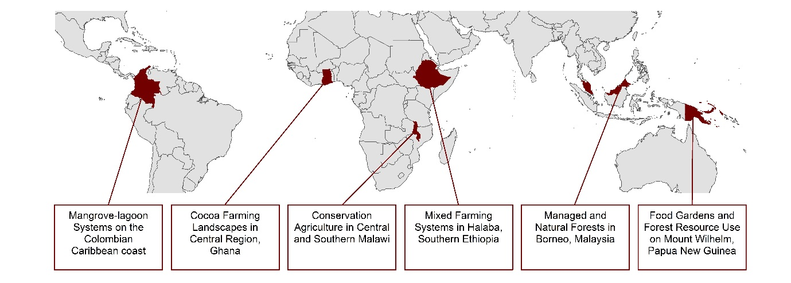

Figure 2: Temporal patterns of: (a) total annual catch and average monthly catch combining fish, crustaceans and molluscs (tonnes) and (b) annual catch of fish, crustaceans and molluscs separately (tonnes). Source: INVEMAR (2018), reproduced with permission. Note: asterisks above the years 2002-2003, 2009-2010 and 2015-2016 indicate ‘moderate’, ‘moderate’ and ‘very strong’ El Niño events respectively (for definitions: http://ggweather.com/enso/oni.htm). Total fish catch decreased under these events in 2009-2010 (-12%) and 2015-2016 (-10%) but increased in 2002-2003 (+28%). There were ‘weak’ El Niño events in 1994-1995, 2004-2005 and 2006-2007; across these years total fish catch decreased by 10%, 4% and 30% respectively.

Figure 3 Percentage of normal (1981-2010) seasonal total rainfall in Ethiopia for (a) February-March-April-May (FMAM) (wet) season 2015 (top left panel), (b) June-July-August-September (JJAS) (wet) season 2015 (top right panel), (c) October-November-December-January (ONDJ) (dry) season 2015/16 (bottom left panel – grey hatching marks areas of increases of >200% in very dry areas), and (d) FMAM (wet) season 2016 (bottom right panel). Data from the WFDEI dataset (Beck et al., 2017) (Source: Met Office).
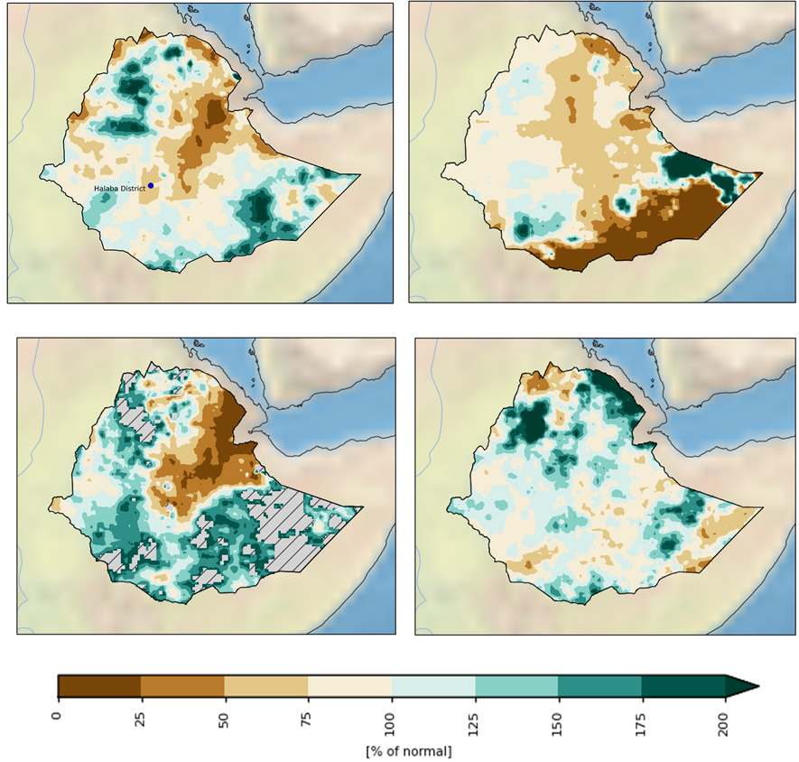
(d)
(c)
(b)
(a)

Figure 4 Percentage of normal (1981-2010) seasonal total rainfall in Malawi for (a) MJJASO (dry) season 2015 (left panel), (b) NDJFMA (wet) season 2015/16 (middle panel) and (c) MJJASO (dry) season 2016 (right panel - grey hatching marks areas of increases of >200% in very dry areas). Data from the WFDEI dataset (Beck et al., 2017) (Source: Met Office).
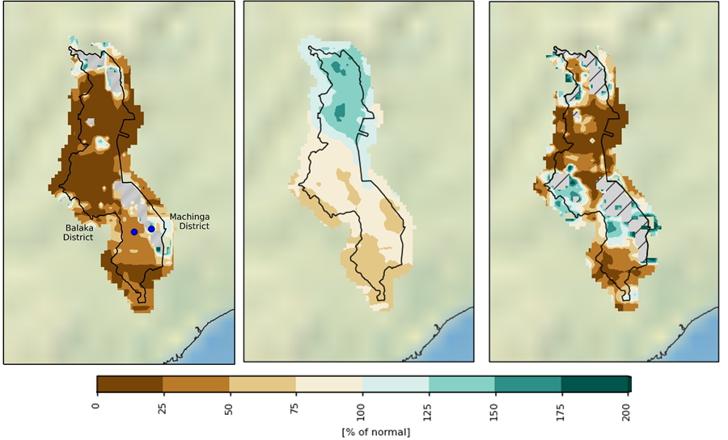
(c)
(b)
(a)

Figure 5– WorldView-3 imagery (1.2m resolution, true colour display) from December 2015 (left) and August 2016 (right) showing post-ENSO tree mortality at Danum Valley, Borneo
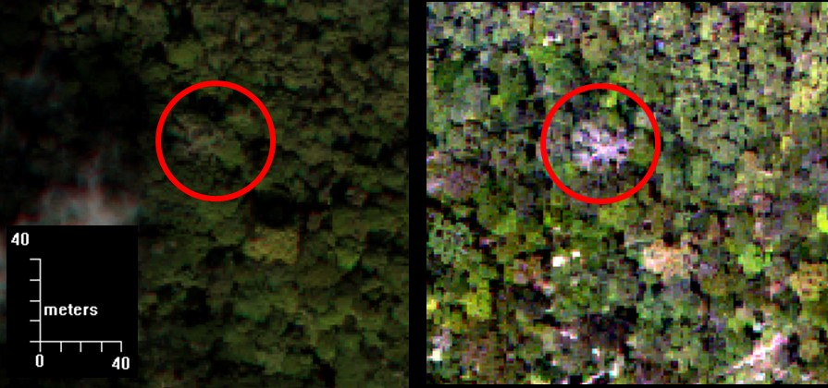

Figure 6 Seasonal rainfall totals in Papua New Guinea for (a) the MJJASO (dry) season (left panel), (b) the NDJFMA (wet) season (right panel) averaged over the 1981 – 2010 period. Data from the MSWEP dataset (Beck et al., 2017) (Source: Met Office).
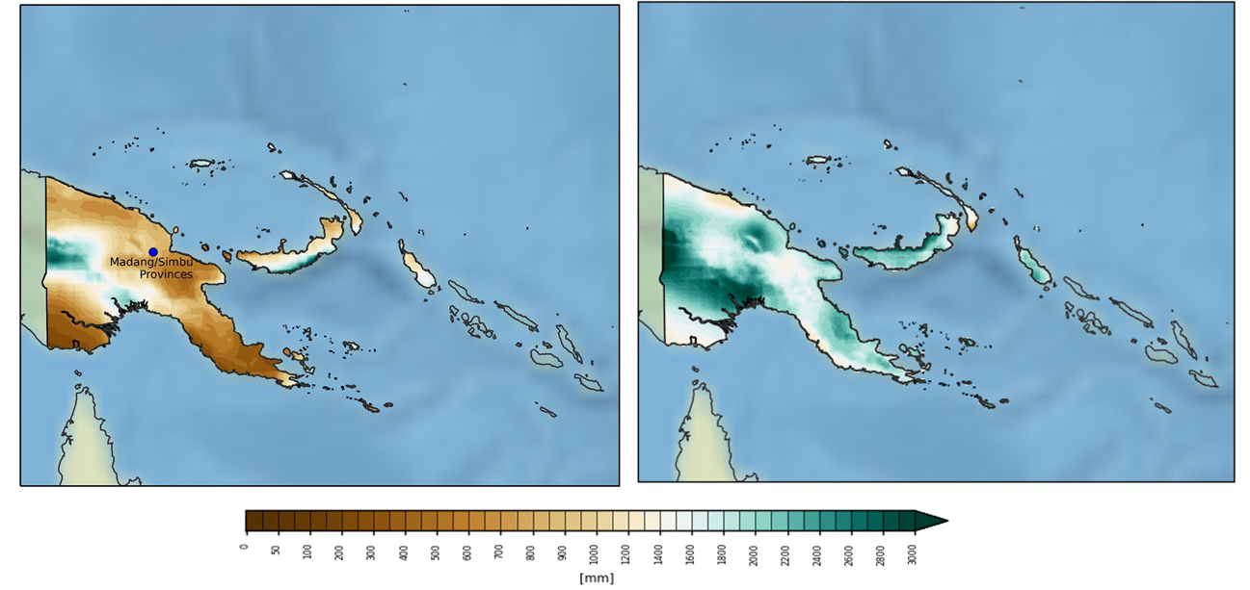
(b)
(a)

Figure 7 Graphs of (a) monthly precipitation and (b) monthly day-time temperature maximum for 2015-2017, recorded at the study sites in Ghana at different distances form the forest edge (100m, 500m, 1000m and 5000m). “0” refers to measures within the forest. Red shaded region indicates time period over which the El Nino Southern Occilation (ENSO) Index was “very strong” (>2.0) and orange region indicates a “strong” ENSO Index (>1.5-2.0). Harmattan refers to the annual dry season characterised by hazy conditions due to deposition of Saharan dust.

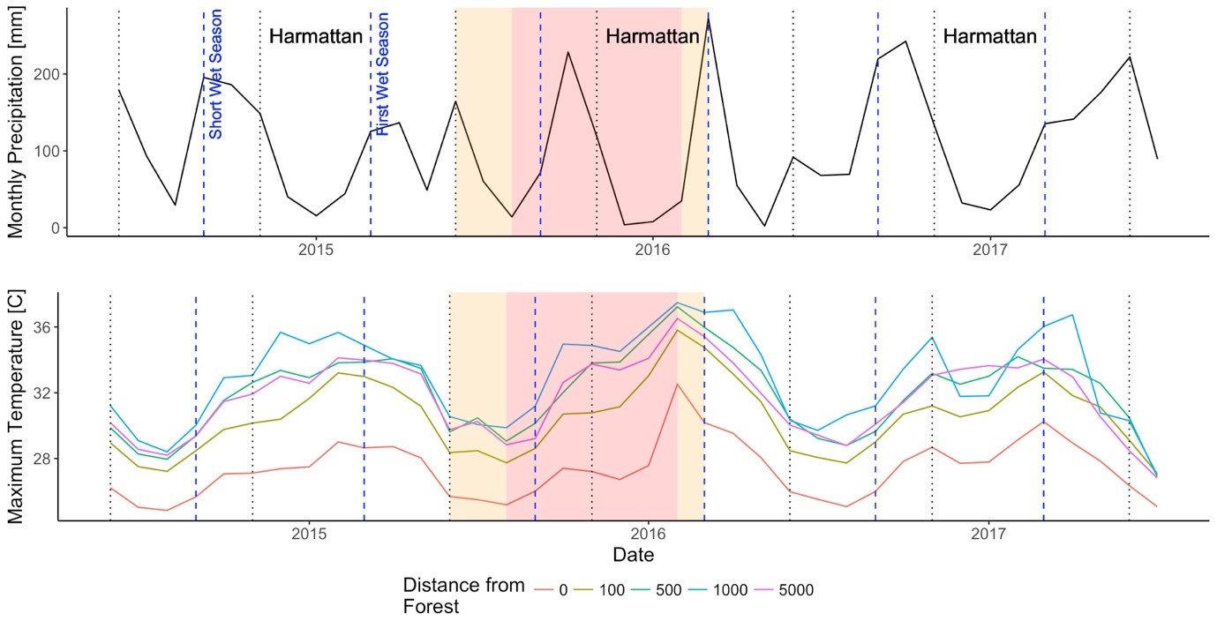
(b)
(a)

Table 1: Summary of the effects of long-term trends and short-terms shocks on the resilience of the six case study systems

 |  | Contribution to Resilience…
Case Study | Characterised By | of Long-term Trends | of Short-term Shocks
Mangrove-lagoon systems on the Colombian Caribbean coast | Significant livelihood dependence on small mangrove-lagoon fisheries that are affected by fluctuating salinity. | - Declines (but significant variability) in ecological health (fish stocks)  +/- Diversification of employment/income sources | +/- reduced fish stocks are a driver of alternative/diversified income sources and markets
Mixed farming systems in Halaba, Southern Ethiopia | Small-scale rain-fed maize in land previously degraded by deforestation but now subject to soil and water conservation practices. | + reforestation and soil conservation practices  + diversification of production systems | - Loss of livestock and household assets with implications for continuation of soil conservation practices
Conservation agriculture in central and southern Malawi | Small-scale rain-fed maize agriculture, including both ‘conventional’ and ‘conservation agriculture’ practices | +conservation agriculture implementation to improve soil health  +/- changing labour burdens associated with conservation agriculture practices | - Poor conservation agriculture performance during short trial periods can create negative perceptions and undermine the value of long-term investment in soil health
Managed and Natural Forests in Borneo, Malaysia | Tropical forests with mixed timber extraction and forest clearance for palm oil and agriculture | - Clearing/cutting of forest stands decreases ecological health and heterogeneity | - Disruption of tree reproduction which can lead to subsequent regeneration failures of certain tree species
Food Gardens and Forest Resource Use on Mount Wilhelm, Papua New Guinea | Small food garden plots with high plant diversity, within forest margins | + Diverse production practices and food sources  + Existence of village and clan-level safety nets | - Few coping strategies were maintained as regular agricultural or social practices
Cocoa Farming Landscapes in Central Region, Ghana | Small cocoa farms on the outskirts of protected forest reserve. | - Soil nutrient mining  +Diversification of production practices | - Shift to wetland farming with negative impacts on hydrological systems  + Learning from events about effective fire mitigation  -Higher mortality of cocoa trees

