Accuracy of Nature of Call screening tool in identifying patients requiring treatment for Out of Hospital Cardiac Arrest

Corresponding author:
Jonathan David Green
South Western Ambulance Service NHS Foundation Trust
Research, Audit and Quality Improvement Department
Unit 1, Abbey Court
Eagle Way
Exeter
EX2 7HY
UK
Corresponding author e-mail: Jonathan.green@swast.nhs.uk
Corresponding author telephone: 01392 453946 / 07814 223948

Co-authors:
Dr Sean Ewings
Senior Medical Statistician
Southampton Statistical Sciences Research Institute
University of Southampton
UK

Richard Wortham
Senior Business Intelligence Developer
Research and Audit Department
South Western Ambulance Service NHS Foundation Trust
Exeter
UK

Dr Bronagh Walsh
Associate Professor
Faculty of Health Sciences
University of Southampton
UK

Key words: cardiac arrest, triage, emergency ambulance systems, chain of survival and prehospital care, despatch

Word count: Abstract –300 Main paper – 2531 (not including title page, abstract, table, figures or appendices)

Abstract
Background A new pre-triage screening tool, Nature of Call (NoC), has been introduced into the telephone triage system of UK ambulance services which employ NHS Pathways (NHSP). Its function is to provide rapid recognition of patients who may need immediate ambulance dispatch for Out-of-Hospital Cardiac Arrest (OHCA) and withholding dispatch for other calls whilst further triage is undertaken. In this study, we evaluated the accuracy of NoC and NHSP in identifying patients with potentially treatable or imminent OHCA.

Methods This retrospective, observational study reviewed consecutive calls to a UK ambulance service between October 2016 and February 2017 in which NOC, and then NHSP were applied sequentially. Only those calls for which a corresponding electronic Patient Clinical Record (ePCR) was available were included. Sensitivity and specificity of NOC and NHSP for recognition of an OHCA were determined by comparing allocated priority dispositions with an OHCA Treatment Registry (OHCATR).

Results Of 96,423 calls received, 71,373 were reviewed. For 590 (0.8%) of these calls, the patients received treatment for OHCA. NOC identified 458 OHCATR patients; NHSP identified 467; together they identified 496. NoC captured 29 patients not identified by NHSP; NHSP captured 38 patients not identified by NOC. For NOC sensitivity was 77.6% (95% CI 74.1 to 80.8) and specificity 86.9% (95% CI 86.6 to 87.1). NHSP sensitivity was 79.2% (95% CI 75.7 to 82.2) and specificity 93.4% (93.2 to 93.6). NoC and NHSP combined had a sensitivity of 84.1% (95% CI 80.9 to 86.8) and specificity of 85.3% (95% CI 85.1 to 85.6).

Conclusions NoC and NHSP call categorisation each achieved similar sensitivity for the identification of OHCATR, identifying most of the same patients, but each captured unique patients. Using both methods sequentially improved accuracy. The 16% of OHCATR patients not identified by either method present a challenge to ambulance dispatch systems.

Introduction
Key messages
What is already known on this subject?
- There is evidence that current ambulance telephone triage identifies between 76% and 83% of OHCAs.
- NoC is an OHCA screening tool, applied prior to full NHSP triage, which aims to speed up ambulance dispatch for this group. If this benefit is to be realised, NoC must be accurate.
What this study adds?
- In identifying patients on an OHCA treatment registry, the sensitivity of NoC, by itself, is similar to NHSP but allows earlier dispatch of ambulances.
- Accuracy is enhanced when NHSP and NoC are used together.
- NoC and NHSP identify many of the same patients, but each also identifies a unique group.

Emergency ambulance services in the UK have seen year-on-year growth in the numbers of calls received.¹ This is placing increasing pressure on the traditional operating model, whereby most calls trigger the immediate dispatch of ambulance resources. A recent review of ambulance dispatch, the Ambulance Response Programme (ARP),² has led to the introduction of a national policy of only dispatching ambulance resources after telephone triage has concluded (‘dispatch on disposition’); specifically, when either a category associated with a priority disposition is allocated or 240 seconds have passed without reaching a priority disposition. The aim of this policy is to increase the efficiency and appropriateness of ambulance care delivery, by taking a more considered approach to the management of lower acuity patients.
It is essential that there is minimal delay in attending higher acuity patients who require an immediate response, particularly those who are having, or are in imminent danger of having, an out-of-hospital cardiac arrest (OHCA). Although this ultimately is a small group of patients (only 0.6% of emergency calls are triaged as OHCA and only 8% of these are later confirmed as true OHCA),³ for this group of patients small increases in the time taken to provide interventions may reduce the chances of survival or increase the risk of sustaining life-changing neurological deficit.⁴ A rapid and accurate telephone triage system is therefore vital for identifying those patients in immediate need of treatment.
Two telephone triage systems are currently in use by UK ambulance services: NHS Pathways (NHSP) and the Medical Priority Dispatch System (MPDS) (Medical Priority Consultants, Salt Lake City, Utah, USA).The most recent and relevant study of the accuracy of NHSP, regarding the identification of OHCA, estimated sensitivity of 75.9% (95% confidence interval [CI] 74.3 to 77.3) and specificity of 98.6% (95% CI 98.6 to 98.7).⁵ Due to the perceived impact of NHSP on speed of triage, the NHS England ARP has implemented a rapid screening tool at the beginning of NHSP known as Nature of Call (NoC). NoC is primarily a patient safety strategy, intended to support the move to ‘dispatch on disposition’. It aims to do this by hastening the identification of the most urgent cases, so that they are not disadvantaged by the additional time required to complete full triage before dispatch. The ability of this system to accomplish these goals has not yet been evaluated.
The aim of this study was to estimate the diagnostic accuracy of NoC in differentiating those who may require treatment for OHCA from all other calls. NoC was evaluated in isolation (in recognition of its role in delaying the dispatch of some ambulances), in comparison with NHSP for the same cohort, and also in combination with NHSP (reflecting their sequential application and interrelated functionality).

Methods
Design
A retrospective, observational study was used to assess the diagnostic accuracy of NoC, NHSP and the combination of NoC and NHSP for patients having or at risk of imminent cardiac arrest, between 26 October 2016 and 17 February 2017.

Setting
South Western Ambulance Service NHS Foundation Trust (SWASFT) is one of 10 NHS ambulance trusts providing emergency medical care for England. It serves one fifth of England. Emergency calls to SWASFT are received by two clinical hubs (North and East/West). At the time of data collection, the hubs employed different triage systems. This study was conducted at the East/West hub, which largely receives calls originating from Cornwall, Devon, Somerset and Dorset, and used NHSP triage. The North hub used the MPDS triage system, which does not use the NoC screening tool. Calls to the North hub were not included.

Intervention
Calls received by the East/West hub first undergo NoC screening. Call takers place each patient into a category from a pre-determined list, based on the answers to questions regarding the patient’s level of consciousness, the quality of their breathing and the nature of their presenting problem and a response category is assigned (Figure 1). After the call has been screened using NOC, more information is taken using NHSP (NHSP version 10.0.08) and another response category is assigned.

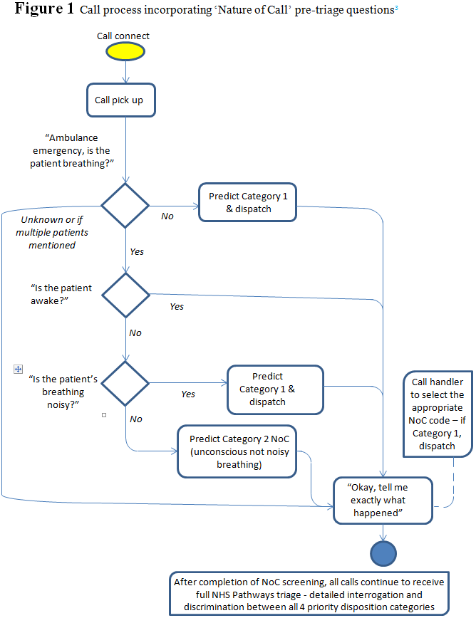

For both NoC and NHSP, each category is associated with a priority/resource disposition reflecting Department of Health determined levels of acuity/priority (Table 1).

Table 1 Emergency call priority/dispatch dispositions³

NHS England priority/ dispatch disposition | Description
Category 1 | Time critical life-threatening event needing immediate intervention and/or resuscitation e.g. cardiac or respiratory arrest; airway obstruction; ineffective breathing; unconscious with abnormal or noisy breathing; hanging.  Mortality rates high; a difference of one minute in response time is likely to affect outcome and there is evidence to support the fastest response.
Category 2 | Potentially serious conditions (ABCD problem) that may require rapid assessment, urgent on-scene intervention and/or urgent transport.  Mortality rates are lower; a difference of an extra 15 minutes response time is likely to affect outcome and there is evidence to support early dispatch.
Category 3 | Urgent problem (not immediately life-threatening) that needs treatment to relieve suffering (e.g. pain control) and transport or assessment and management at scene with referral where needed within a clinically appropriate timeframe. Mortality rates are very low or zero; a difference of one hour or more might affect outcome and there is evidence to support alternative pathways of care.
Category 4 | Problems that are not urgent but need assessment (face to face or telephone) and possibly transport within a clinically appropriate timeframe.

Only calls allocated to NoC categories associated with the Category 1 disposition receive immediate ambulance dispatch; all others await NHSP triage (or 240 seconds without triage), before a decision to dispatch an ambulance is made. NoC serves as a single purpose screen to identify OHCA/ imminent OHCA and speed-up dispatch to this group. NHSP provides detailed systematic interrogation and differentiation between all four priority categories.

Participants
Inclusion criteria: Calls were included if they received both NoC and NHSP categorisation, and a corresponding electronic Patient Clinical Record (ePCR) was available. The ePCR is the documentation created by ambulance clinicians detailing each patient episode. Calls from healthcare professionals were excluded because, although they are screened for acuity, their NoC category is routinely recorded as ‘Category 4’ (table 1).

Data collection
Data relating to calls are recorded on internal computer servers using MIS Emergency Systems’ Alert C3 computer-aided dispatch software. Consecutive calls which met the inclusion criteria during the period between 26 October 2016 (when revised call category definitions were introduced (see appendix 1) and 15 February 2017 were retrospectively reviewed to determine their categorization by each of the two systems. Patient demographics and other data regarding the patient or call characteristics were not analysed.

Reference standard
In order to confirm whether or not a call was appropriately categorised by either NOC or NHSP, we used the OHCA Treatment Registry (OHCATR), maintained by SWASFT, which records clinical and demographic data for those patients who receive a resuscitative attempt from the ambulance service.⁶ Presence in this registry was considered a proxy measure for patients who were in immediate or imminent need of treatment for OHCA at the time of the call. The selection of the OHCATR as the reference standard differs from most similar studies, which evaluate the identification of OHCA whether treated or not. The advantage of the OHCATR is that it excludes the high proportion of calls for patients who suffer OHCA, but who do not receive a resuscitative attempt (63%).⁷ In these cases resuscitation is considered futile, typically because OHCA is unwitnessed, or ‘do not resuscitate’ orders are present.

Data Analysis
Sample size was chosen by estimating sensitivity with a suitable degree of precision. Assuming a planning value for sensitivity of 76% (based on previous studies of NHSP), and a desired width of 20% for the 95% CI, a total of 71 cases on the OHCATR were required (calculated using nQuery). Assuming a prevalence of OHCA in emergency calls of 0.3%, and aiming for a 95% probability of observing the desired 71 cases, we required almost 29,000 calls.⁸
NoC and NHSP call categories and OHCATR records were linked by the incident number allocated to each call during the call taking process. Sensitivity and specificity were determined using the following definitions: true positive (patients allocated the Category 1 disposition by NoC, NHSP or both and on the OHCATR); true negative (patients not allocated to Category 1 and not on the OHCATR); false positive (patients allocated to Category 1 and not on the OHCATR); and false negative (patients not allocated to Category 1 and on the OHCATR). Analysis was conducted in Stata v14.0.

Results
In the four-month period between 26 October 2016 and 15 February 2017, 71,363 calls were received by the East/West hub for which there was an associated ePCR. Among these calls, 590 (0.8%) patients were recorded on the OHCATR and 70,773 (99.2%) were not. Sensitivity and specificity are presented for NoC alone, NHSP (post-NoC), and NoC and NHSP combined (Figure 2).

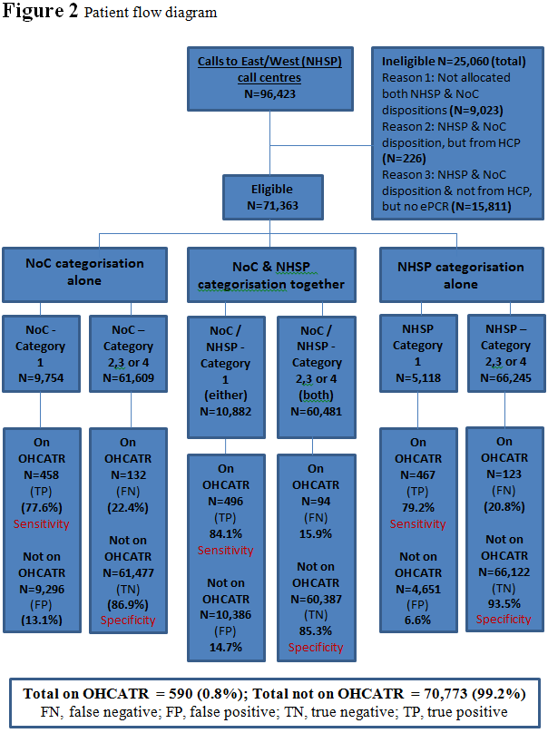

Nature of Call
A total of 9,754 eligible calls (13.7%) were allocated to Category 1 by NoC (figure 2). Of these, 458 (4.7%) were on the OHCATR. Of those patients who were not allocated to Category 1 by NoC (61,477), 132 (0.2%) were on the OHCATR.

The sensitivity of NoC (probability of being allocated to Category 1 by NoC, if on the OHCATR) is estimated to be 77.6% (95% CI: 74.0 to 80.9); the specificity (probability of being allocated to Categories 2, 3 or 4 by NoC, if not on OHCATR) is estimated to be 86.9% (95% CI: 86.6 to 87.1).

NHS Pathways
A total of 5,118 eligible calls (7.2%) were allocated to Category 1 by NHSP (figure 2). Of these, 467 (9.1%) were on the OHCATR. Of those patients who were not allocated to Category 1 by NHSP (66,245), 123 (0.2%) were on the OHCATR.

Sensitivity (probability of being allocated to Category 1 by NHSP, if on the OHCATR)=79.2% (95% CI 75.7 to 82.2). Specificity (probability of being allocated to Categories 2, 3 or 4 by NHSP, if not on OHCATR) was estimated to be 93.4% (95% CI 93.2 to 93.6).

NoC and NHSP combined
A total of 10,882 eligible calls (15.2%) were allocated to Category 1 by NoC or NHSP (Figure 2). Of these, 496 (4.6%) were on the OHCATR. Of those patients who were not allocated to Category 1 by NoC or NHSP (60,481), 94 (0.2%) were on the OHCATR.

Sensitivity (probability of being allocated to Category 1 by NoC or NHSP, if on the OHCATR)=84.1% (95% CI 80.9 to 86.8). Specificity (probability of being allocated to Categories 2, 3 or 4 by NoC or NHSP, if not on OHCATR)=85.3% (95% CI 85.1 to 85.6).

Of the 590 patients identified on the OHCATR, 94 (15.9%) were not allocated to Category 1 by either NoC or NHSP. Of the 496 patients who appear on the OHCATR and were allocated a Category 1 disposition by NoC or NHSP, 429 (86.5%) were identified by both systems, 38 (7.7%) by NHSP alone and 29 (5.8%) by NoC alone.

Discussion
This study provides evidence that the sensitivity of the Nature of Call (NoC) screening tool and of the NHS Pathways (NHSP) triage system, in identifying patients who require treatment for OHCA, are similar. Therefore, even though NoC requires only a short interaction with callers, it can save time compared to prior standard care while still identifying approximately 80% of those on the OHCATR. These measures of sensitivity for both NoC and NHSP are similar to that of NHSP for OHCA recognition, as reported in a previous study by Deakin et al which reported a sensitivity of 75.9%.⁵ Although the performance of NoC, in identifying those requiring treatment for OHCA is similar to that of NHSP triage, 22.4% of OHCATR patients are not allocated Category 1 prioritisation by NoC. For these patients ambulance dispatch would have been delayed as NHS Pathways triage proceeded.
NoC also achieved a high level of specificity (86.9%); nearly 9/10 of patients who do not receive treatment for OCHA are appropriately allocated lower priority dispositions, meaning that resources can be prioritised to those most in need. NOC specificity was slightly lower than NHSP in this study, and also lower than that determined by Deakin et al (98.6%).
Although the application of NoC does not result in the appropriate categorisation of all OHCATR patients, it does not operate in a vacuum. Subsequent NHSP triage provides a more accurate safety net. This study evaluated the combined performance of NoC and NHSP as they are used in practice. Combined sensitivity is a relatively high 84.1% (whilst maintaining 85.3% specificity). Therefore, although recognition by NoC should facilitate very rapid dispatch, subsequent recognition by NHSP may identify additional OHCATR patients (a further 6.4%). It is however important to recognise that 4.9% of those on the OHCATR were only identified by NoC. Therefore, NoC informed dispatch to Category 1 calls should not automatically be revised to reflect NHSP triage. This performance compares well with OHCA identification by the other triage system widely used in the UK (MPDS): sensitivity 76.7%, specificity 99.2%.⁹
As call triage and ambulance dispatch are interconnected, the results of this study are relevant to changes to ambulance dispatch, introduced by the Ambulance Response Programme (ARP). In the past, the impact of any failure of triage systems to identify the highest priority patients was mitigated by a policy of rapid ambulance dispatch to almost all calls. The ARP is intended to enable more selective dispatch, based on call triage. This approach increases reliance on triage accuracy. Our data suggest NoC is fulfilling its intended patient safety function reasonably well, both as an OHCA sieve and in identifying OHCA in conjunction with subsequent NHSP triage. This is an appropriate response to the problem, as it does not in itself prohibit (and may facilitate) rapid ambulance dispatch to the highest acuity calls compared to NHSP alone or MPDS triage. However, because no triage system is perfect, the ARP’s introduction of ‘dispatch on disposition’, including efforts to avoid dispatch altogether for some low acuity calls, will expose a small group of OHCA patients to the risk of having an ambulance delayed which may have been routinely dispatched under the previous dispatch system.

Limitations

The impact of prehospital treatment, either in preventing or treating OHCA may be expected to be influenced by speed of response. A rapid response will make the aversion of OHCA more likely and a delayed response will increase the likelihood that commencing resuscitation will be considered futile. Neither of these groups are recorded on the OHCATR. We suspect that each scenario is rare, but cases are difficult to identify. A future study may benefit from an analysis of dispatch to OHCA patients, such as times to dispatch and numbers of ambulances dispatched to Category 1 calls, before and after NoC was introduced. Retrospective, observational accuracy studies are limited in their ability to compare causative links between telephone triage/ ambulance dispatch systems and clinical outcomes. There is therefore a pressing need for prospective trials in this field.

Conclusions
Our data suggest that, compared to NHSP alone, triage by NoC and NHSP together offers improved accuracy for identifying OHCA calls, while providing rapid dispatch for most of these patients. However, sufficient safety-netting must be built into dispatch systems to ensure that failure to rapidly respond to high-acuity patients is ‘acceptably’ rare.

Footnotes

Ethics: The University of Southampton granted ethics approval for this study on 1 March 2017.

Funding: There is no funding to report.

Competing interests: There are no competing interests for any author.

Contributorship: JG conducted and submitted the study. All authors drafted or revised this manuscript and approved the final version.

Acknowledgement: We would like to acknowledge Sue Tuckett, recent Clinical Lead for SWASFT, for her advice regarding NoC (and her role in its creation).

References
1. | NHS Digital. National statistics: Ambulance Services, England 2014 to 2015. NHS Digital 2015. https://www.gov.uk/government/statistics/ ambulance-services-england-2014-to-2015 (accessed 01 May 2017)
2. | NHS England. Ambulance response programme. NHS England 2016. https://www.england.nhs.uk/ourwork/qual-clin-lead/arp/ (accessed 01 May 2017)
3. | Turner J, Jacques R, Crum A et al. Ambulance response programme: evaluation of phase 1 and phase 2. University of Sheffield 2017. https://www.sheffield.ac.uk/polopoly_fs/1.715849!/file/ARPReport_Final.pdf (accessed 10 July 2018)
4. | Pons PT, Haukoos JS, Bludworth W et al. Paramedic response time: does it affect patient survival? Academic Emergency Medicine 2005;12(7)594-600
5. | Deakin CD, England S and Diffey D. Ambulance telephone triage using ‘NHS Pathways’ to identify adult cardiac arrest. Heart 2017;103:761-765
6. | Perkins GD and Brace-McDonnell SJ. The UK Out-of-Hospital Cardiac Arrest Outcome (OHCAO) project. British Medical Journal 2015;5:10
7. | NHS England. Ambulance quality indicators data 2018-19: clinical outcomes (April-July). NHS England. https://www.england.nhs.uk/statistics/statistical-work-areas/ambulance-quality-indicators/ambulance-quality-indicators-data-2018-19/ (accessed 17 December 2018)
8. | Schatzkin A, Connor RJ, Taylor PR et al. Comparing new and old screening tests when a reference procedure cannot be performed on all screenees. American Journal of Epidemiology 1987;125:672–8
9. | Flynn J, Archer F and Morgans A. Sensitivity and specificity of the Medical Priority Dispatch System in detecting cardiac arrest emergency calls in Melbourne. Prehospital and Disaster Medicine 2006;21(2):72-76

