External validation of two models
to predict delirium in critically ill adults

Annelies Wassenaar¹, RN, CCRN, MSc; Lisette Schoonhoven^{2,3}, PhD, FEANS; John W. Devlin^{4,5}, PharmD; Frank M.P. van Haren^{6,7, 8}, MD, PhD; Arjen J.C. Slooter⁹, MD, PhD; Philippe G. Jorens¹⁰, MD, PhD; Mathieu van der Jagt¹¹, MD, PhD; Koen S. Simons¹², MD; Ingrid Egerod¹³, RN, PhD; Lisa D. Burry^{14,15}, PharmD; Albertus Beishuizen¹⁶, MD, PhD; Joaquim Matos¹⁷, RN, BSc; A. Rogier T. Donders¹⁸, PhD; Peter Pickkers^{1,19}, MD, PhD; Mark van den Boogaard¹, RN, CCRN, PhD

- Department of Intensive Care Medicine, Radboud Institute for Health Sciences, Radboud university medical center, Nijmegen, the Netherlands
- Faculty of Health Sciences and National Institute for Health Research Collaboration for Leadership in Applied Health Research and Care (Wessex), University of Southampton, Southampton, UK
- Scientific Institute for Quality of Healthcare, Radboud Institute for Health Sciences, Radboud university medical center, the Netherlands
- School of Pharmacy, Northeastern University, Boston, USA
- Division of Pulmonary, Critical Care and Sleep Medicine, Tufts Medical Center, Boston, USA
- Intensive Care Unit, The Canberra Hospital, Canberra, Australia
- Faculty of Health, University of Canberra, Canberra Australia
- College of Health and Medicine, Australian National University, Canberra, Australia
- Department of Intensive Care Medicine and Brain Center Rudolf Magnus, University Medical Centre Utrecht, Utrecht, the Netherlands
- Department of Critical Care Medicine, Antwerp University Hospital, University of Antwerp, Edegem (Antwerp), Belgium
- Department of Intensive Care, Erasmus Medical Center, Rotterdam, the Netherlands
- Department of Intensive Care Medicine, Jeroen Bosch Ziekenhuis, ’s-Hertogenbosch, the Netherlands
- Intensive Care Unit, Rigshospitalet, University of Copenhagen, Copenhagen, Denmark
- Leslie Dan Faculty of Pharmacy, University of Toronto, Toronto, Canada
- Mount Sinai Hospital, Sinai Health System, Toronto, Canada
- Department of Intensive Care, Medisch Spectrum Twente, Enschede, the Netherlands
- Department of Intensive Care Medicine, Hospital Espírito Santo, Evora, Portugal
- Department for Health Evidence, Radboud Institute for Health Sciences, Radboud university medical center, Nijmegen, the Netherlands
- Radboud Center for Infectious Diseases, Radboud Institute for Molecular Life Sciences, Radboud university medical center, Nijmegen, the Netherlands

* Corresponding author:
Mark van den Boogaard
Department of Intensive Care Medicine
Radboud Institute for Health Sciences
Radboud university medical center
P.O. Box 9101
6500 HB Nijmegen
The Netherlands
Tel: +31(0)24366 5009
Fax: +31(0)24799 9119
Email: Mark.vandenBoogaard@radboudumc.nl

Conflict of Interest and Sources of Funding
The authors declare that they have no conflict of interest related to this study.
There was no funding for this study.

Institutions where the work was performed
Radboud university medical center, Tufts Medical Center, The Canberra Hospital, Antwerp University Hospital, Erasmus Medical Center, Jeroen Bosch Ziekenhuis, Rigshospitalet, Mount Sinai Hospital, Medisch Spectrum Twente, Hospital Espírito Santo, University Medical Centre Utrecht

Reprints
No reprints will be ordered.

Authors’ contribution
Study concept and design: AW, LS, RD, PP, MvdB.
Acquisition of data: AW, JD, FvH, AS, PJ, MvdJ, KS, IE, LB, AB, JM.
Statistical analysis: AW, RD, MvdB.
Analysis and interpretation of data: AW, LS, RD, PP, MvdB.
Drafting of the manuscript: AW.
Critical revision of the manuscript for important intellectual content: LS, JD, FvH, AS, PJ, MvdJ, KS, IE, LB, AB, JM, RD, PP, MvdB.
Study supervision: PP, MvdB, LS.
All authors read and approved the final manuscript.

ABSTRACT
Objectives: To externally validate two delirium prediction models (the E-PRE-DELIRIC and recalibrated PRE-DELIRIC) and compare the performance of each model using both Confusion Assessment Method-ICU (CAM-ICU) and Intensive Care Delirium Screening Checklist (ICDSC)delirium assessment scores.

Design: Prospective, multinational cohort study.

Setting: Eleven ICUs from seven countries in 3 continents.

Patients: Consecutive, delirium-free adults admitted to the ICU for ≥ 6 hours in whom delirium could be reliably assessed.

Interventions: None.

Measurements and Main Results: The predictors included in each model were collected (E-PRE-DELIRIC: at the time of ICU admission; PRE-DELIRIC: within 24 hours of ICU admission). Delirium was assessed using the CAM-ICU or ICDSC. Discrimination and calibration of both models was assessed for the total cohort and also for patients evaluated with each delirium assessment tool. Discrimination was determined using the area under the receiver operating characteristic curve (AUROC). The predictive performance using the CAM-ICU or ICDSC was compared and the performance of the total cohort was compared with the original results for each model. Calibration was assessed graphically. A total of 2,178 patients were included. Delirium incidence was 21.4%. The AUROC of the E-PRE-DELIRIC model was 0.68 (95%CI 0.66-0.71) versus prior reported AUROC of 0.75 (95%CI 0.71-0.79). The AUROC of the recalibrated PRE-DELIRIC model was 0.74 (95%CI 0.71-0.76) versus prior AUROC of 0.77 (95%CI 0.74-0.79). Both models were well calibrated. Use of CAM-ICU or the ICDSC did not significantly affect the AUROC for either the E-PRE-DELIRIC [Z-score of -0.91 (p>0.1] or PRE-DELIRIC [Z-score of 1.50 (p>0.1)] model.

Conclusions: Using a large, heterogeneous, multinational cohort of critically ill adults, evaluated with either the CAM-ICU or ICDSC, we show that the E-PRE-DELIRIC and PRE-DELIRIC models both statistically perform at a moderately-to-good level. These results allow for generalization to ICUs around the world.

Key Words:
Adult; Clinical Prediction; Critical Illness; Delirium; Intensive Care Unit; Validation Study

Manuscript: 2456 words
Abstract: 291 words
INTRODUCTION
Clinical prediction models are increasingly being developed and used to predict the occurrence of clinical events and outcomes both during and after the Intensive Care Unit (ICU) stay.(1, 2) Delirium is common in the ICU, sometimes preventable, and is poorly predicted by ICU clinicians,(3, 4) warranting the use of a delirium prediction model in the ICU. Current guidelines recommend that all ICU patients be routinely screened for delirium with using either the Confusion Assessment Method for the ICU (CAM-ICU) [pooled sensitivity 80.0%, specificity 95.9%] or the Intensive Care Delirium Screening Checklist (ICDSC)[pooled sensitivity 74.0%,specificity 81.9%].(5, 6) Use of a prediction model in daily practice can help rationalize the delivery of ICU delirium prevention strategies, some of which are time consuming to deliver, have risks or are expensive, to those patients at the highest risk for developing delirium.(7, 8). Furthermore, stratification of patients, based on risk for delirium, can positively influence an efficient use of both the care for ICU patients and research resources. Two ICU delirium prediction models, the PRE-DELIRIC and the E-PRE-DELIRIC, each developed and or recalibrated in large, multinational cohorts, are currently available to clinicians and researchers to predict a patient’s risk for developing delirium over the course of their ICU stay. (4, 9, 10) The recalibrated PRE-DELIRIC model incorporates 10 predictors (age, urea, admission category, urgent admission, coma, infection, morphine use, sedative use, APACHE-II score, and metabolic acidosis) available within the first 24 hours after ICU admission.(9) The E-PRE-DELIRIC model was developed to enable earlier use of delirium-prevention strategies, and includes nine predictors (age, urea, admission category, urgent admission, history of alcohol abuse or cognitive impairment, mean arterial blood pressure, use of corticosteroids, and respiratory failure) available at the time of ICU admission.(10) Both the PRE-DELIRIC and E-PRE-DELIRIC models were developed based on the use of only the CAM-ICU for delirium assessment.
Before any ICU prediction model can be used outside the developmental setting, it is essential to confirm its predictive performance in a new cohort of patients, independent from the dataset used during development and initial validation, and who are likely to have different risk factors for delirium. In addition, the generalizability of the models should be determined across different types of ICUs and ICUs from different countries where ICU clinical practices may vary.(11) Since for both available ICU delirium prediction models external validity has not been tested previously in mixed ICU patients, the primary aim of our study was to externally validate both the PRE-DELIRIC and E-PRE-DELIRIC models in a multinational cohort of patients from different ICUs. Importantly, it is unknown what the performance of both ICU delirium prediction models is using the ICDSC for delirium assessment. Therefore, the secondary aim of our study was to compare the performance of each prediction model when either the CAM-ICU or ICDSC was used to assess delirium.
METHODS
This multinational prospective cohort study was conducted as part of the The DElirium prediCtIon in the intenSIve care unit: comparisON of two delirium prediction models (DECISION) study in eleven ICUs from Australia, Belgium, Canada, Denmark, Portugal, the Netherlands, and the United States. Between September 2015 and June 2016, adult ICU patients were consecutively enrolled and evaluated for up to three months (or until 300 patients were enrolled at a particular hospital). Patients with delirium at ICU admission, a barrier to reliable delirium assessment (e.g. sustained coma based on the level of sedation, inability to understand the predominant language spoken in the ICU, severe cognitive dysfunction, receptive aphasia, or serious auditory or visual disorders) or a subjective assessment of an expected ICU stay <6 hours, were excluded.(4, 9, 10) The Medical research ethics committee (MREC) Arnhem-Nijmegen region, The Netherlands (no. 2015-1782) and the local MRECs/IRBs of the participating ICUs approved the study and waived the need for informed consent.
Data for the E-PRE-DELIRIC model were collected immediately after ICU admission,(10) and data for the PRE-DELIRIC model was collected within 24 hours of ICU admission.(4, 9) [Supplemental Digital Content 1 and 2 contain each model’s predictors, corresponding definitions and regression coefficients.] Each patient was screened for delirium by a trained nurse at least once every 12 hours for up to 14 days after ICU admission. Level of sedation was assessed using the Richmond Agitation-Sedation Scale (RASS)(12) or Riker Sedation-Agitation Scale (SAS)(13) prior to delirium assessment. No standard assessment of coma was used, the definition of coma was based on the level of sedation which was assessed with the RASS or Riker-SAS, preferably when patients were maximally awake and off medication for sedation (e.g. after a spontaneous awakening trial). [See supplemental Digital Content 2 for the definition of coma.] To exclude potential bias, the nurses were not informed about this study. Delirium was defined as at least one positive delirium assessment using either the CAM-ICU(14) or the ICDSC(15) and/or when a patient received anti-psychotic medication for delirium treatment. The reliability of nursing delirium assessments were checked once monthly at each site against a member of the research team, in a similar fashion that was used during original development of each prediction model.(9, 10) More detailed information regarding the reliability screening is reported elsewhere.(16)
For each prediction model at least 200 events, i.e. positive delirium assessments were needed. With an anticipated delirium incidence of 20% we sought to enroll (400/0.20) = 2000 patients. Complete-case analysis was performed. No imputation techniques were used to handle missing data. To minimize missing values, we provided clear definitions and instruction manuals for data collection.(4, 9, 10) [Supplemental Digital Content 1 and 2 contain an important note on how to handle missing data on the predictors.] The original models with their predictors and assigned linear predictor weights were applied.(9, 10) [Supplemental Digital Content 1 and 2.] The predictor and delirium outcome values were subsequently used to quantify the predictive performance of each model. Discriminative power and calibration were assessed for the total cohort, a cohort of the ICUs using the CAM-ICU and a cohort of ICUs using the ICDSC for delirium assessment. Discriminative power was assessed using the area under the receiver operating characteristic curve (AUROC). Calibration was assessed graphically,(11) by fitting a flexible Loess curve.(17) For this we used the package ‘CalibrationCurves’ in R statistics. The predictive performance of each model using either the CAM-ICU or ICDSC for delirium assessment was compared using the Hanley & McNeil method.(18) Differences from the development data in setting, outcome and predictors were identified. We used the Transparent Reporting of a multivariable prediction model for Individual Prognosis Or Diagnosis (TRIPOD) for data reporting.(19)
RESULTS
Of 2,802 patients screened, 2,178 were included. Among the 624 patients excluded, a barrier to reliable delirium assessment (46.3%) and delirium present at the time of ICU admission (25.9%) were the most frequent reasons for exclusion. A total of 14 patients (2.2%) were excluded because of missing model data. No patients were excluded due to missing delirium assessment data. (Figure 1.) Patients’ mean (standard deviation (SD)) age was 62.1 (15.2) years and admission APACHE-II score was 17.4 (7.1). A total of 467 (21.4%) patients developed delirium. The median [IQR] onset of delirium was 3 [2-4] days. Patient characteristics are presented in Table 1; patient characteristics by each study ICU is presented in Supplemental Digital Content 3. Delirium assessment reliability was overall of strong quality. ICUs that did not meet all predefined criteria for reliability, did not significantly affect the performance of both prediction models. Thus data from all ICUs were included in the primary analysis. More detailed information regarding the reliability results is reported elsewhere.(16)

Model performance for the total cohort
The AUROC of the E-PRE-DELIRIC model was 0.68 (95% CI, 0.66-0.71) [versus the previously reported AUROC of 0.75 (95%CI 0.71-0.79](6) and the AUROC of the recalibrated PRE-DELIRIC model was 0.74 (95% CI, 0.71-0.76) [versus the previously reported AUROC of 0.77 (95% CI, 0.74-0.79](5) (Figure 2). Both models showed good calibration until the last decile, the group of patients with a predicted probability for delirium ≥ 0.60. From this point both models, but the E-PRE-DELIRIC most pronounced, show overestimation of the patients’ risk for delirium. (Figure 3 and 4).

Model performance CAM-ICU cohort
Using the CAM-ICU for delirium assessment, the AUROC of the E-PRE-DELIRIC model was 0.67 (95% CI, 0.64-0.71). The AUROC of the recalibrated PRE-DELIRIC model was 0.75 (95% CI, 0.72-0.78) (Supplemental digital content 4). Both models showed a good calibration until the last decile, the group of patients with a predicted probability for delirium ≥ 0.60. From this point both models, but the E-PRE-DELIRIC most pronounced, show overestimation of the patients’ risk for delirium. (Supplemental digital content 5 and 6).

Model performance ICDSC cohort
Using the ICDSC for delirium assessment, the AUROC of the E-PRE-DELIRIC model was 0.70 (95% CI, 0.66-0.74). The AUROC of the recalibrated PRE-DELIRIC model was 0.71 (95% CI, 0.67-0.75) (Supplemental digital content 7). Both models showed a good calibration until the last decile, the group of patients with a predicted probability for delirium ≥ 0.50 (E-PRE-DELIRIC) and ≥ 0.60 (PRE-DELIRIC). From this point both models show overestimation of the patients’ risk for delirium. (Supplemental digital content 8 and 9).

The AUROC using the CAM-ICU or the ICDSC did not significantly differ for either E-PRE-DELIRIC [Z-score of -0.91 (p>0.1] or PRE-DELIRIC [Z-score of 1.50 (p>0.1)] model.
DISCUSSION
Given that most prediction models demonstrate an optimistic performance in their development sample, the use of a prediction model in daily clinical practice should be preceded by external validation.(11, 20) In our large multinational study we externally validated two different ICU delirium prediction models (the E-PRE-DELIRIC and PRE-DELIRIC models) and showed that each have a moderate-to-good statistical performance when evaluated in a new and independent sample of ICU patients. Consistent with the results from other primary external validation studies,(20) the discrimination of both models was lower in the present study than in the original studies.(4, 9, 10) However, despite this somewhat lower predictive value, the PRE-DELIRIC model still more accurately predicts delirium than clinicians not using a prediction model as was previously determined in another cohort.(4) We have no reasons to assume that care-providers have improved their ability to predict delirium. Importantly, the predictive performance of each model was not dependent on whether the CAM-ICU or ICDSC was used for delirium assessment.
The lower statistical performance observed in the total cohort is not surprising and may have occurred for several reasons. First, a difference in case-mix between the development and external validation sample may have affected the models’ discriminative performance. The difference in case-mix is indicated by a difference in delirium incidence, which was lower in the current study compared to the development samples, as well as by the distribution of the predictor values. For example, history of cognitive impairment and alcohol abuse and respiratory failure, predictors of the E-PRE-DELIRIC model, had a lower incidence in the current cohort. Second, different predictor effects might have influenced the models’ performance in the current study due to overfitting of the regression coefficients of their formula in the development sample. This effect is likely less prevalent with the PRE-DELIRIC model due to the fact that it was previously recalibrated using an external sample.(9) Also, changes over time may have influenced the models’ performance; since data collection in 2008-2009 for de PRE-DELIRIC and 2011-2012 for the E-PRE-DELIRIC models, daily clinical practice in the ICU has changed. For example, the ABCDEF-bundle, an ICU quality bundle known to reduce delirium, was not in use in 2008 but is widely used by 2012.(21) As a result of this change in practice, in the current study sedative exposure was less and the frequency of medication associated coma and morphine administration was lower. However, despite differences in patient case-mix, different predictor effects and delirium-related management paradigms, both delirium prediction models demonstrated an acceptable calibration in the current study with plots being comparable to those in the original studies. In the groups of patients with a high predicted probability for delirium, who were screened for delirium using the CAM-ICU, both prediction models, the E-PRE-DELIRIC model most pronounced, showed some overestimation of the patients’ risk for delirium similar to the earlier PRE-DELIRIC recalibration study.(9) Interestingly, the overestimation was less pronounced for the E-PRE-DELIRIC model in the group of patients screened for delirium using the ICDSC. A reason for the overestimation might be the delirium incidence and low number of patients with a high predicted probability for delirium in this study.(17) However, overestimation in this group of patients is no problem in the light of delirium prevention, since these patients are already is at high risk for delirium and therefore will receive preventive measures anyway. Importantly, in view of understanding the effect of delirium prevention or treatment on the delirium incidence in high-risk patients, one should take the overestimation in this group of patients into account when drawing conclusions.
An important strength of our study is its multinational design and the fact that patients were evaluated with one of two different recommended delirium screening tools. The majority of the participating ICUs in this study, nine out of eleven, were different from those of the recalibration study of PRE-DELIRIC and six out of eleven ICUs were different compared to those of the development study of E-PRE-DELIRIC. This resulted in an independent dataset and improves the generalizability. To prevent bias due to an overrepresentation of one of the participating ICUs in the dataset, each ICU included patients for three consecutive months with a maximum of 300 patients per ICU. Naturally, also limitations of the current study are present. One might argue that adjusting the ICU delirium prediction models to a specific center to account for differences in ICUs may improve both models’ performance. However, this would obviously limit the generalizability. Therefore, we prefer a general prediction model that can be widely used rather than an ICU specific model. Although a large and heterogeneous sample of ICUs was used in the study, when generalizing the results to another setting, it should be taken into account that 21% of patients received a corticosteroid, which can be considered rather high. This may influence the models’ performance in other populations receiving less corticosteroids. Lastly, one may not be able to extrapolate both delirium prediction models to their ICU in case of using an alternative tool for delirium assessment, however, the two assessment tools used in this study are clearly the most validated and widely used tools.

In conclusion, this study shows that both available ICU delirium prediction models have moderate-to-good statistical performance in a new and independent sample of ICU patients, using either the CAM-ICU or the ICDSC for delirium assessment, which allows for generalization to ICUs around the world. Future research should focus on the improvement of ICU delirium prediction and on understanding how clinicians and researchers should use both delirium prediction models in daily clinical ICU practice.

Acknowledgements
The authors would like to thank all involved research nurses and the intensive care teams of each of the participating sites for their help in collecting the patient data.

REFERENCES
1. Mikacenic C, Price BL, Harju-Baker S, et al: A Two Biomarker Model Predicts Mortality in the Critically Ill with Sepsis. Am J Respir Crit Care Med. 2017.
2. Heyland DK, Stelfox HT, Garland A, et al: Predicting Performance Status 1 Year After Critical Illness in Patients 80 Years or Older: Development of a Multivariable Clinical Prediction Model. Crit Care Med. 2016;44(9):1718-26.
3. Salluh JI, Wang H, Schneider EB, et al: Outcome of delirium in critically ill patients: systematic review and meta-analysis. BMJ. 2015;350:h2538.
4. van den Boogaard M, Pickkers P, Slooter AJ, et al: Development and validation of PRE-DELIRIC (PREdiction of DELIRium in ICu patients) delirium prediction model for intensive care patients: observational multicentre study. BMJ. 2012;344:e420.
5. Barr J, Fraser GL, Puntillo K, et al: Clinical practice guidelines for the management of pain, agitation, and delirium in adult patients in the intensive care unit. Crit Care Med. 2013;41(1):263-306.
6. Gusmao-Flores D, Salluh JI, Chalhub RA, et al:The Confusion Assessment Method for the Intensive Care Unit (CAM-ICU) and Intensive Care Delirium Screening Checklist (ICDSC) for the diagnosis of delirium: a systematic review and meta-analysis of clinical studies. Crit Care. 2012;16(4):R115.
7. Djaiani G, Silverton N, Fedorko L, et al: Dexmedetomidine versus Propofol Sedation Reduces Delirium after Cardiac Surgery: A Randomized Controlled Trial. Anesthesiology. 2016;124(2):362-8.
8. Schweickert WD, Pohlman MC, Pohlman AS, et al: Early physical and occupational therapy in mechanically ventilated, critically ill patients: a randomised controlled trial. Lancet. 2009;373(9678):1874-82.
9. van den Boogaard M, Schoonhoven L, Maseda E, et al: Recalibration of the delirium prediction model for ICU patients (PRE-DELIRIC): a multinational observational study. Intensive Care Med. 2014;40(3):361-9.
10. Wassenaar A, van den Boogaard M, van Achterberg T, et al: Multinational development and validation of an early prediction model for delirium in ICU patients. Intensive Care Med. 2015;41(6):1048-56.
11. Moons KG, Kengne AP, Grobbee DE, et al: Risk prediction models: II. External validation, model updating, and impact assessment. Heart. 2012;98(9):691-8.
12. Sessler CN, Gosnell MS, Grap MJ, et al: The Richmond Agitation-Sedation Scale: validity and reliability in adult intensive care unit patients. Am J Respir Crit Care Med. 2002;166(10):1338-44.
13. Riker RR, Picard JT, Fraser GL. Prospective evaluation of the Sedation-Agitation Scale for adult critically ill patients. Crit Care Med. 1999;27(7):1325-9.
14. Ely EW, Inouye SK, Bernard GR, et al: Delirium in mechanically ventilated patients: validity and reliability of the confusion assessment method for the intensive care unit (CAM-ICU). JAMA. 2001;286(21):2703-10.
15. Bergeron N, Dubois MJ, Dumont M, et al: Intensive Care Delirium Screening Checklist: evaluation of a new screening tool. Intensive Care Med. 2001;27(5):859-64.
16. Wassenaar A, Schoonhoven L, Devlin JW, et al: Delirium prediction in the intensive care unit: comparison of two delirium prediction models. Under review. Crit Care. 2018.
17. Austin PC, Steyerberg EW: Graphical assessment of internal and external calibration of logistic regression models by using loess smoothers. Stat Med. 2014;33(3):517-35.
18. Hanley JA, McNeil BJ: A method of comparing the areas under receiver operating characteristic curves derived from the same cases. Radiology. 1983;148(3):839-43.
19. Localio AR, Stack CB: TRIPOD: a new reporting baseline for developing and interpreting prediction models. Ann Intern Med. 2015;162(1):73-4.
20. Siontis GC, Tzoulaki I, Castaldi PJ, et al: External validation of new risk prediction models is infrequent and reveals worse prognostic discrimination. J Clin Epidemiol. 2015;68(1):25-34.
21. Morandi A, Piva S, Ely EW, et al: Worldwide Survey of the "Assessing Pain, Both Spontaneous Awakening and Breathing Trials, Choice of Drugs, Delirium Monitoring/Management, Early Exercise/Mobility, and Family Empowerment" (ABCDEF) Bundle. Crit Care Med. 2017.
Figure 1: Study flowchart
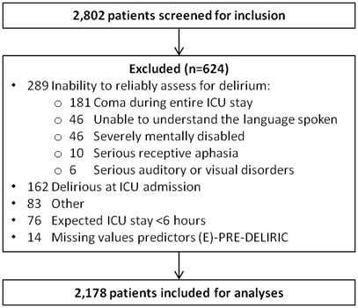
Figure 2: AUROC of E-PRE-DELIRIC and PRE-DELIRIC
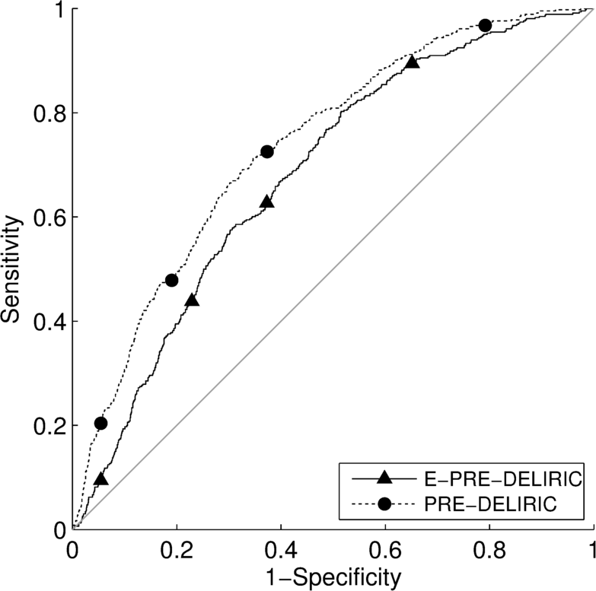
Figure 3: Calibration plot of E-PRE-DELIRIC
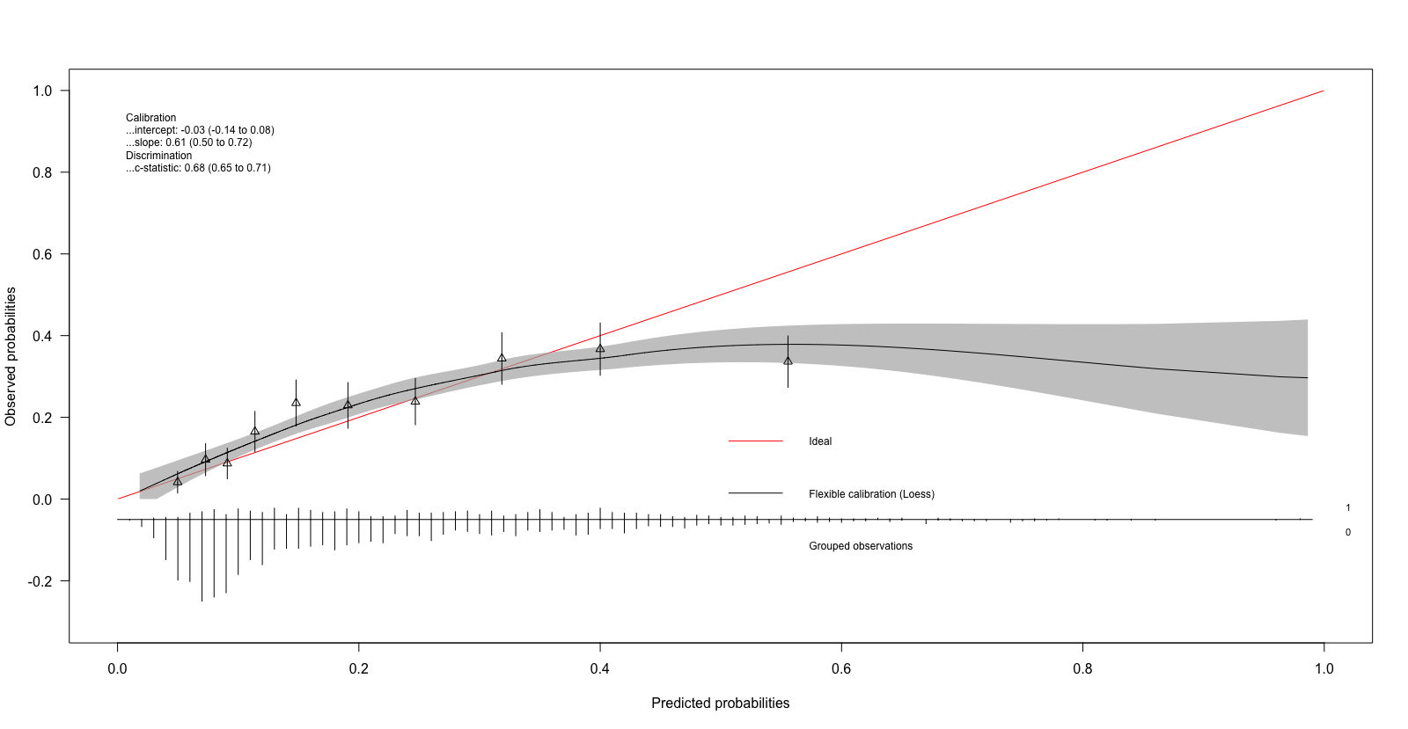
Grouped observations for delirium in total cohort, 1= positive for delirium, 0= negative for delirium
Figure 4: Calibration plot of PRE-DELIRIC
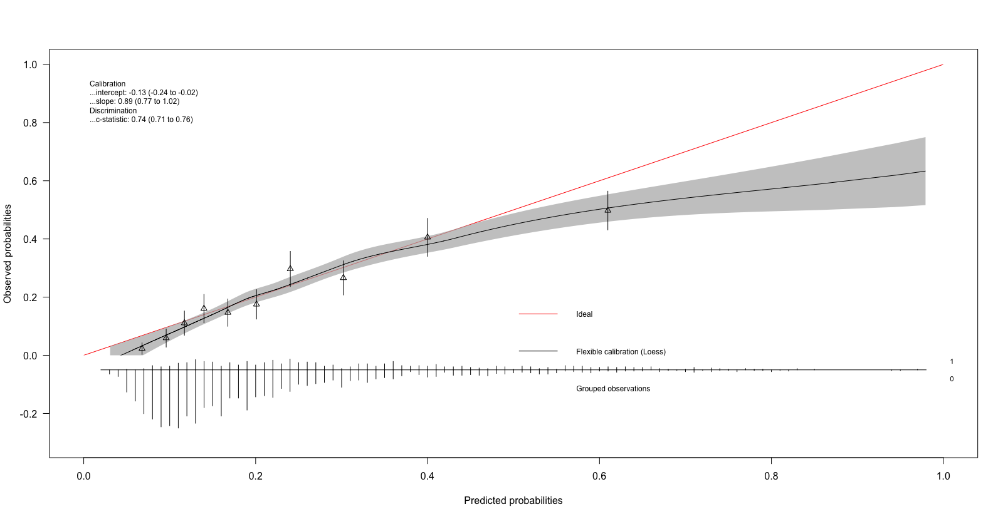
Grouped observations for delirium in total cohort, 1= positive for delirium, 0= negative for delirium
Table 1 Patient characteristics of both the present and original studies according to TRIPOD criteria
Variable | External  validation  cohort  (N=2178) | Recalibration  PRE-DELIRIC  cohort (5)  (N=1824) | Original  E-PRE-DELIRIC  cohort (6)  (N=2914)
Male, N (%) | 1324 (60.8) | N.A. | 1716 (58.9)
Age in years, Mean (SD) | 62.1 (15.2) | 60 (17) | 61.3 (16.1)
History of cognitive impairment¹, N (%) | 53 (2.4) | N.A. | 437 (15.0)
History of alcohol abuse², N (%) | 146 (6.7) | N.A. | 524 (18.0)
Admission category, N (%)  Surgery  Medical  Trauma  Neurology/neurosurgery | 1079 (49.5)  856 (39.3)  86 (3.9)  157 (7.2) | 869 (48)  654 (36)  99 (5)  202 (11) | 1495 (51.3)  1021 (35.0)  134 (4.6)  264 (9.1)
Urgent admission³, N (%) | 1345 (61.8) | 1147 (63) | 1733 (59.5)
Mean arterial blood pressure in mmHg, Mean (SD) | 80 (18.5) | N.A. | 82.4 (18.8)
Use of corticosteroids⁴, N (%) | 453 (20.8) | N.A. | 465 (16.0)
Respiratory failure⁵, N (%) | 796 (36.5) | N.A. | 1270 (43.6)
Urea at ICU admission (mmol/L)  Median (Q1-Q3, min/max) | 7.9  (5-13, 1/277) | N.A. | 7.5  (5-12, 0/95)
APACHE-II score, Mean (SD) | 17.4 (7.1) | 19 (9) | N.A.
No coma⁶, N (%)  Coma:  - With use of medication, N (%)  - Other (i.e. intra cerebral bleeding, post-resuscitation), N (%)  - Combination (1+2), N (%) | 1792 (82.2)  237 (10.9)  21 (1.0)  128 (5.9) | 1405 (77)  295 (16)  21 (1)  103 (6) | N.A.
Infection⁷, N (%) | 681 (31.3) | 516 (35) | N.A.
Metabolic acidosis⁸, N (%) | 782 (35.9) | 525 (29) | N.A.
No morphine use⁹, N (%)  Cumulative use of morphine:  - 0.01-7.1mg/day  - 7.2-18.6mg/day  - 18.7mg or more/day | 1571 (72.2)  210 (9.6)  274 (12.6)  122 (5.6) | 1333 (77)  77 (6)  115 (8)  135 (9) | N.A.
Sedative use¹⁰, N (%) | 882 (40.5) | 774 (42) | N.A.
Urea (mmol/L), Mean (SD)  Median (Q1-Q3, min/max) | 8.0  (56-14, 0.6/287) | 11.2 (8.2) | N.A.
Delirium, N (%) | 467 (21.4) | 410 (22.5) | 689 (23.6)
LOS-ICU in days,  Median (Q1-Q3, min/max) | 3.0  (2-6, 1/96) | N.A. | 2.0  1-5, 1/133)

Supplemental Digital Content 1: Collected delirium predictors immediately after ICU admission (E-PRE-DELIRIC)*
Predictor | Explanation | Category | Regression coefficient
Age (years) | In years at time of admission | C | 0.025
History of cognitive impairment | Known medical history of dementia, mild cognitive impairment or delirium (normal value = no history of cognitive impairment) | D | 0.878
History of alcohol abuse | Known medical history of alcohol abuse  (normal value = no history of alcohol abuse) | D | 0.505
Admission category | - Surgical  - Medical  - Trauma  - Neurology/neurosurgical | Cat | 0  0.370  1.219  0.504
Urgent admission | Unplanned intensive care admission  (normal value = no urgent admission) | D | 0.612
Mean arterial blood pressure (MAP in mmHg) | At the time of ICU admission | C | -0.006
Use of corticosteroids | Oral/iv, the corticosteroids should be used until time of ICU admission (normal value = no use of corticosteroids) | D | 0.283
Respiratory failure | Non-elective mechanical ventilation or non-invasive ventilation is necessary or expected <24hr after ICU admission  (normal value = no respiratory failure) | D | 0.982
Urea (mmol/L) | Urea value in the blood at time of ICU admission or max 12 hours before ICU admission  (normal value at admission = 8 mmol/l) | C | 0.018
Intercept |  |  | -3.907

C= continuous
D= dichotomous
Cat.= categorical

*IMPORTANT NOTE: When no data is available about the predictors for the E-PRE-DELIRIC model (after asking the patient, the patient’s family or general practitioner, or by assessment of the patient’s medical record), there is no reason to assume the value is abnormal and therefore the predictor can be filled out as normal/absence of disease. [see italic font in the table]. Age, admission category and MAP = no normal value available (these values are always available, therefore no missing values are expected).
Supplemental Digital Content 2: Collected delirium predictors within 24 hours after ICU admission (PRE-DELIRIC)*

Predictor | Explanation | Category | Regression  coefficient
Age (years) | In years at time of admission | C | 0.0183
APACHE-II score  (per point) | Calculated 24 hours after ICU admission  (no normal value available (when APACHE-II is missing this patient will be excluded from analyses)) | C | 0.0272
Coma | No coma: RASS -4/-5 maximum 8 hours  RASS -4/-5 for longer than 8 hours:  OR  No coma: Riker SAS 1/2 maximum 8 hours  Riker SAS 1/2 for longer than 8 hours:  - With use of medication  - Other (i.e. intra cerebral bleeding, post-resuscitation)  - Combination (1+2)  (normal value = no coma) | Cat | 0  0  0.2578  1.0721  1.3361
Admission category | - Surgical  - Medical  - Trauma  - Neurology/neurosurgical | Cat | 0  0.1446  0.5316  0.6516
Infection | Proven or strong suspicion of infection for which antibiotics were started  (normal value = no infection) | D | 0.4965
Metabolic acidosis | pH <7.35 with bicarbonate <24mmol/L  (normal value = no metabolic acidosis) | D | 0.1378
Morphine use | No morphine: no use of any morphine  Cumulative use of any form of morphine:  - 0.01-7.1mg/day  - 7.2-18.6mg/day  - 18.7mg or more/day  NOTE: This only concerns morphine, no other opiates. (Do not use any converting formulas to calculate the morphine dose of other opiates).  (normal value = no use of morphine) | Cat | 0  0.1926  0.0625  0.2414
Sedative use | Any iv use of propofol, midazolam, lorazepam or combination  (normal value = no use of sedatives) | D | 0.6581
Urgent admission | Unplanned intensive care admission | D | 0.1891
Urea (mmol/L) | Highest urea value in the blood the first 24 hours after ICU admission or max 12 hours before ICU admission  (normal value the first 24 hours after ICU admission or max 12 hours before ICU admission = 8 mmol/l) | C | 0.0141
Intercept |  |  | -4.0369

C= continuous
D= dichotomous
Cat.= categorical

*IMPORTANT NOTE: When no data is available about the predictors for the PRE-DELIRIC model (after asking the patient, the patient’s family or general practitioner, or by assessment of the patient’s medical record), there is no reason to assume the value is abnormal and therefore the predictor can be filled out as normal/absence of disease. [see italic font in the table].
Age and admission category = no normal value available (these values are always available, therefore no missing values are expected).
Supplemental digital content 3: Patient characteristics by each study ICU
Variable | External  validation  cohort  (N=2178) | University Medical Centre Utrecht  (N=292) | Jeroen Bosch Ziekenhuis  (N=146) | Antwerp University Hospital  (N=288) | The Canberra Hospital  (N=299) | Medisch Spectrum Twente  (N=64) | Hospital Espírito Santo  (N=48) | Erasmus Medical Center  (N=222) | Tufts Medical Center  (N=274) | Radboud university medical center  (N=298) | Rigs  hospitalet  (N=139) | Mt Sinai Hospital/U of Toronto  (N=108)
Male, N (%) | 1324 (60.8) | 193 (66.1) | 78 (53.4) | 171 (59.4) | 172 (57.5) | 44 (68.8) | 43 (89.6) | 141 (63.5) | 169 (61.7) | 189 (63.4) | 92 (66.2) | 43 (39.8)
Age in years, Mean (SD) | 62.1 (15.2) | 62.8 (14.2) | 63.0 (15.2) | 62.6 (14.6) | 63.6 (16.5) | 61.5 (12.4) | 69.4 (13.0) | 56.1 (15.7) | 63.1 (15.2) | 63.1 (14.0) | 62.2 (14.6) | 57.4 (17.5)
History of cognitive impairment, N (%) | 53 (2.4) | 8 (2.7) | 6 (4.1) | 5 (1.7) | 8 (2.7) | 5 (7.8) | 5 (10.4) | 5 (2.3) | 3 (1.1) | 4 (1.3) | 4 (2.9) | 0
History of alcohol abuse, N (%) | 146 (6.7) | 19 (6.5) | 9 (6.2) | 8 (2.8) | 26 (8.7) | 6 (9.4) | 7 (14.6) | 27 (12.2) | 18 (6.6) | 15 (5.0) | 7 (5.0) | 4 (3.7)
Admission category, N (%)  Surgery  Medical  Trauma  Neurology/neurosurgery | 1079 (49.5)  856 (39.3)  86 (3.9)  157 (7.2) | 191 (65.4)  58 (19.9)  10 (3.4)  33 (11.3) | 41 (28.1)  100 (68.5)  3 (2.0)  2 (1.4) | 159 (55.2)  112 (38.9)  17 (5.9)  - | 129 (43.1)  134 (44.8)  19 (6.4)  17(5.7) | 17 (26.6)  42 (65.6)  2 (3.1)  3 (4.7) | 12 (25.0)  33 (68.8)  2 (4.1)  1 (2.1) | 89 (40.1)  66 (29.7)  14 (6.3)  53 (23.9) | 101 (36.9)  164 (59.8)  1 (0.4)  8 (2.9) | 208 (69.8)  56 (18.8)  11 (3.7)  23 (7.7) | 72 (51.8)  43 (30.9)  7 (5.0)  17 (12.2) | 60 (55.6)  48 (44.4)  -  -
Urgent admission, N (%) | 1345 (61.8) | 108 (37.0) | 126 (86.3) | 173 (60.1) | 216 (72.2) | 57 (89.1) | 48 (100) | 112 (50.5) | 241 (88.0) | 104 (34.9) | 88 (63.3) | 72 (66.7)
Mean arterial blood pressure, Mean (SD) | 80.1 (18.5) | 82.0 (18.6) | 84.5 (23.0) | 71.0 (13.2) | 79.1 (15.7) | 78.7 (17.6) | 73.9 (18.8) | 84.1 (17.8) | 83.6 (17.8) | 82.4 (19.1) | 73.5 (17.2) | 85.6 (22.4)
Use of corticosteroids, N (%) | 453 (20.8) | 63 (21.6) | 27 (18.5) | 36 (12.5) | 35 (11.7) | 18 (28.1) | 22 (45.8) | 48 (21.6) | 27 (9.9) | 147 (49.3) | 10 (7.2) | 20 (18.5)
Respiratory failure, N (%) | 796 (36.5) | 84 (28.8) | 83 (56.8) | 81 (28.1) | 113 (37.8) | 46 (71.9) | 43 (89.6) | 55 (24.8) | 98 (35.8) | 60 (20.1) | 114 (82.0) | 19 (17.6)
Urea at ICU admission (mmol/L),  Median (Q1-Q3, min/max) | 8 (5-13, 1/277) | 8 (6-8, 1/70) | 7 (5-12, 1/60) | 13 (10-20, 1/114) | 6 (5-10, 1/67) | 7 (5-10, 1/34) | 23 (13-38, 5/104) | 6 (5-9, 2/46) | 7 (5-12, 1/54) | 6 (5-7, 1/40) | 47 (29-62, 1-253) | 6 (4-9, 1/277)
APACHE-II score, Mean (SD) | 17.4 (7.1) | 17.3 (6.0) | 19.2 (7.7) | 17.2 (6.9) | 16.2 (6.7) | 18.7 (6.0) | 24.3 (8.0) | 18.6 (6.6) | 15.0 (6.2) | 16.1 (5.5) | 23.9 (7.7) | 14.8 (8.7)
No coma, N (%)  Coma:  - With use of medication, N (%)  - Other (i.e. intra cerebral bleeding, post-resuscitation), N (%)  - Combination (1+2), N (%) | 1792 (82.2)  237 (10.9)  21 (1.0)  128 (5.9) | 241 (82.5)  42 (14.4)  2 (0.7)  7 (2.4) | 121 (82.9)  18 (12.3)  0  7 (4.8) | 210 (72.9)  0  0  78 (27.1) | 268 (89.6)  21 (7.0)  0  10 (3.3) | 28 (43.8)  36 (56.3)  0  0 | 26 (54.2)  11 (22.9)  5 (10.4)  6 (12.5) | 184 (82.9)  30 (13.5)  3 (1.3)  5 (2.3) | 241 (88.0)  30 (10.9)  1 (0.4)  2 (0.7) | 274 (91.9)  13 (4.4)  3 (1.0)  8 (2.7) | 96 (69.1)  31 (22.3)  7 (5.0)  5 (3.6) | 103 (95.4)  5 (4.6)  0  0
Infection, N (%) | 681 (31.3) | 56 (19.2) | 49 (33.6) | 63 (21.9) | 112 (37.5) | 33 (51.6) | 38 (79.2) | 71 (32.0) | 121 (44.2) | 90 (30.2) | 11 (7.9) | 37 (34.3)
Metabolic acidosis, N (%) | 782 (35.9) | 80 (27.4) | 50 (34.2) | 71 (24.7) | 132 (44.1) | 20 (31.3) | 20 (41.7) | 101 (45.5) | 81 (29.6) | 146 (49.0) | 55 (39.6) | 26 (24.1)
No morphine use, N (%)  Cumulative use of morphine:  - 0.01-7.1mg/day  - 7.2-18.6mg/day  - 18.7mg or more/day | 1571 (72.2)  210 (9.6)  274 (12.6)  122 (5.6) | 83 (28.4)  73 (25.0)  82 (28.1)  54 (18.5) | 145 (99.3)  0  0  1 (0.7) | 201 (69.8)  16 (5.6)  42 (14.6)  29 (10.1) | 284 (95.0)  4 (1.3)  2 (0.7)  9 (3.0) | 58 (90.6)  2 (3.1)  3 (4.7)  1 (1.6) | 48 (100)  0  0  0 | 174 (78.4)  20 (9.0)  22 (9.9)  6 (2.7) | 234 (85.4)  21 (7.7)  12 (4.4)  7 (2.6) | 137 (46.0)  61 (20.5)  90 (30.2)  10 (3.4) | 110 (79.1)  7 (5.0)  17 (12.2)  5 (3.6) | 97 (89.8)  6 (5.6)  4 (3.7)  1 (0.9)
Sedative use, N (%) | 882 (40.5) | 152 (52.1) | 60 (41.1) | 70 (24.3) | 96 (32.1) | 55 (85.9) | 32 (66.7) | 137 (61.7) |  | 91 (30.5) | 52 (37.4) | 31 (28.7)
Urea (mmol/L),  Median (Q1-Q3, min/max) | 8 (6-14, 1/287) | 8 (6-8, 1/56) | 9 (6-13, 1/61) | 15 (11-23,  3/120) | 7 (5-11, 1/57) | 8 (5-12, 1/34) | 22 (12-31, 6/92) | 7 (5-12, 2/46) | 8 (5-12, 1/54) | 7 (5-9, 1/40) | 46 (31-61, 1-287) | 6 (4-10, 1/277)
Delirium, N (%) | 467 (21.4) | 58 (19.9) | 36 (24.7) | 64 (22.2) | 37 (12.4) | 24 (37.5) | 5 (10.4) | 59 (26.6) | 66 (24.1) | 71 (23.8) | 32 (23.0) | 14 (13.0)
LOS-ICU in days,  Median (Q1-Q3, min/max) | 3 (2-6, 1/96) | 2 (2-4, 1/45) | 3 (2-6, 1/36) | 3 (2-6, 1/85) | 3 (2-5, 1/96) | 7 (3-17,  1/81) | 6 (3-12,  2/19) | 3 (2-7, 1/57) | 3 (2-6, 1/14) | 2 (2-3, 1/71) | 4 (2-8, 2/38) | 3 (2-5, 1/49)
Delirium assessment:  Tool  Number of assessments/day  Implementation | NA | CAM-ICU  2/day  2010 | CAM-ICU  3/day  2009 | ICDSC  3/day  2015-2016 | CAM-ICU  3/day  2012 | CAM-ICU  3/day  2013 | CAM-ICU  2/day  2015 | ICDSC  3/day  2012-2014 | ICDSC  2/day  2005 | CAM-ICU  3/day  2008 | CAM-ICU  2-3/day  2012-2015 | ICDSC  2/day  2010
Number of beds  Yearly admission rate | NA | 30  2000  Mixed ICU | 16 beds  850  Mixed ICU | 45 beds  2800  Mixed ICU | 31 beds  2000  Mixed ICU | 18  900  Mixed ICU | 5-6 beds  200  Medical ICU | 30 beds  1200-1300  Mixed ICU | 30 beds  3300  Mixed ICU | 34 beds  2500  Mixed ICU | 40 beds  2600  Mixed ICU | 16 beds  800-850  Mixed ICU
Type of hospital | NA | Academic medical center | Teaching hospital | Academic medical center | Teaching hospital | Teaching hospital | Urban hospital | Academic medical center | Academic medical center | Academic medical center | Academic medical center | Academic  medical center
ICU staffed by intensivist | NA | Yes | Yes | Yes | Yes | Yes | Yes | Yes | Yes | Yes | Yes | Yes

Supplemental Digital Content 4: AUROC of E-PRE-DELIRIC and PRE-DELIRIC using CAM-ICU
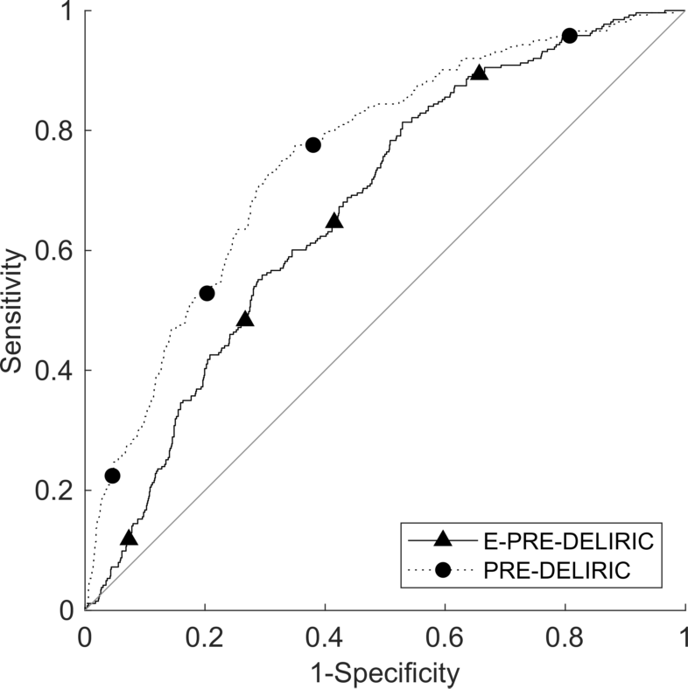
Supplemental Digital Content 5: Calibration plot of E-PRE-DELIRIC using CAM-ICU
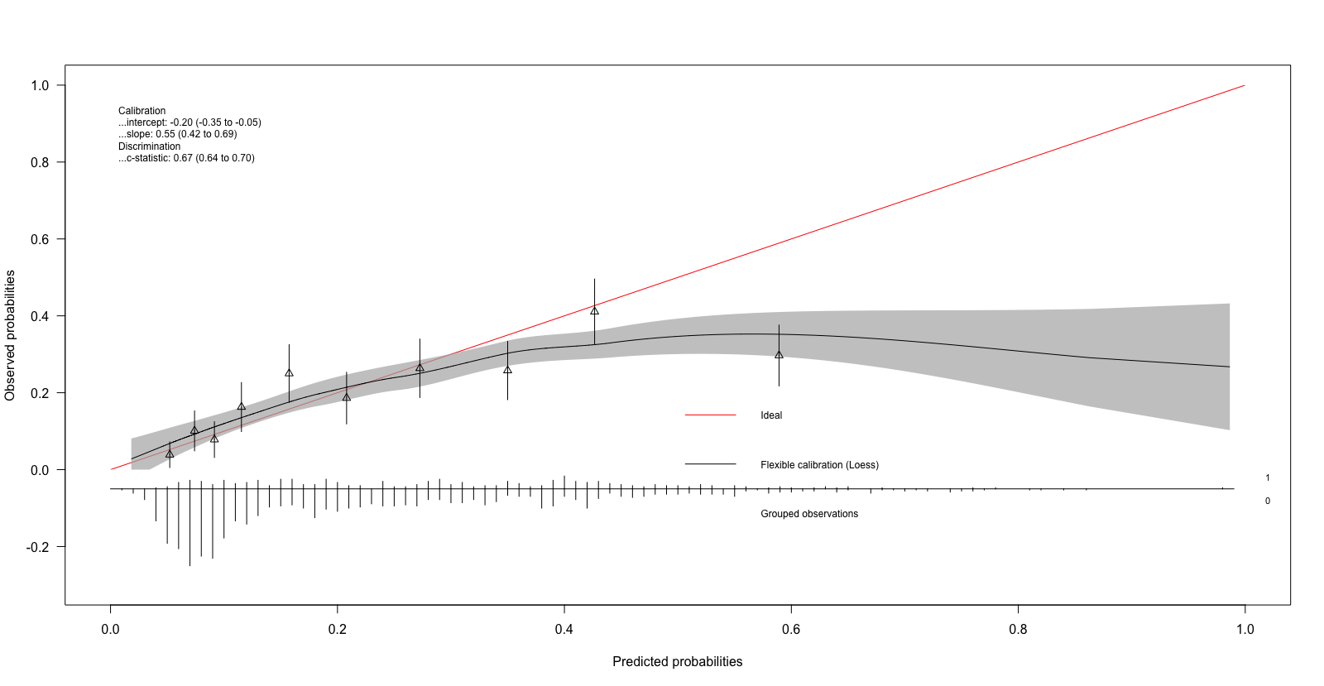
Grouped observations for delirium in total cohort, 1= positive for delirium, 0= negative for delirium
Supplemental Digital Content 6: Calibration plot of PRE-DELIRIC using CAM-ICU
Grouped observations for delirium in total cohort, 1= positive for delirium, 0= negative for delirium
Supplemental Digital Content 7: AUROC of E-PRE-DELIRIC and PRE-DELIRIC using ICDSC

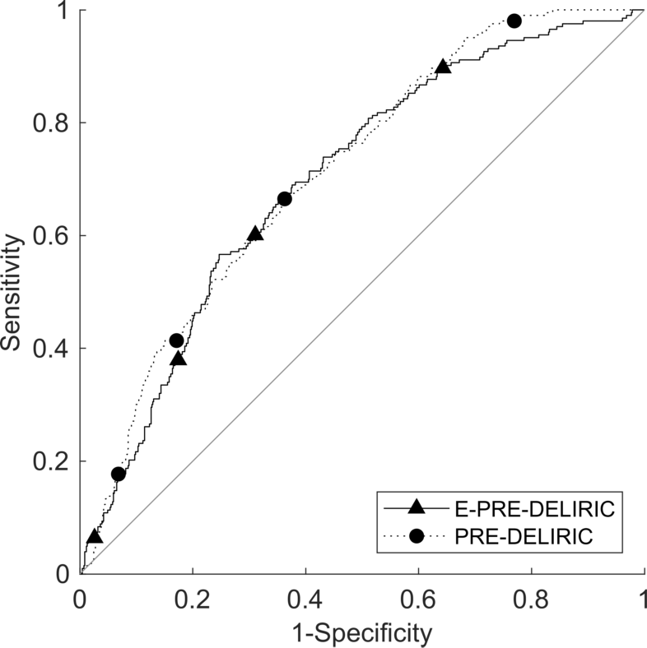
Supplemental Digital Content 8: Calibration plot of E-PRE-DELIRIC using ICDSC
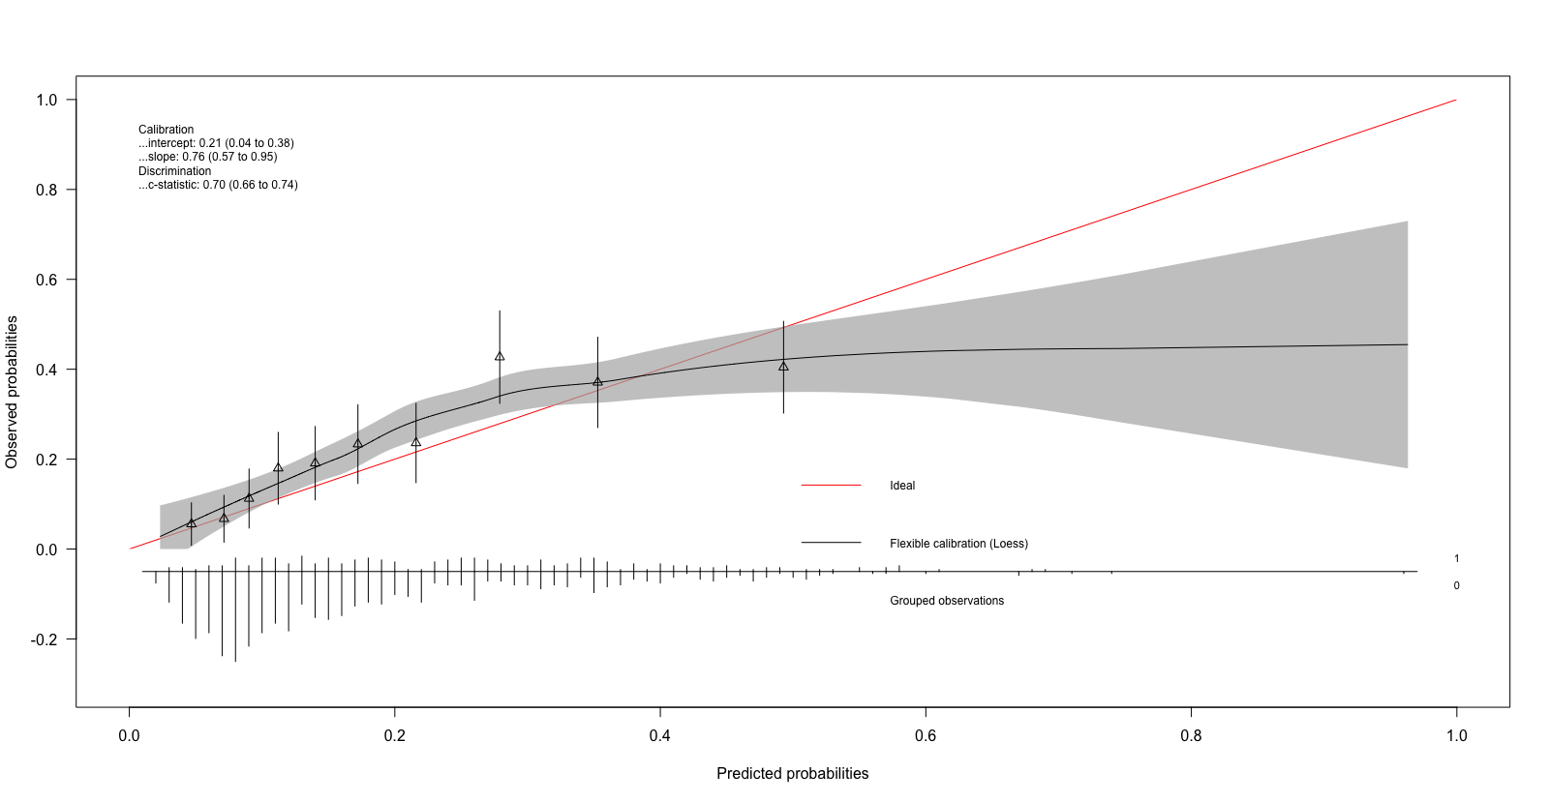
Grouped observations for delirium in total cohort, 1= positive for delirium, 0= negative for delirium

Supplemental Digital Content 9: Calibration plot of PRE-DELIRIC using ICDSC
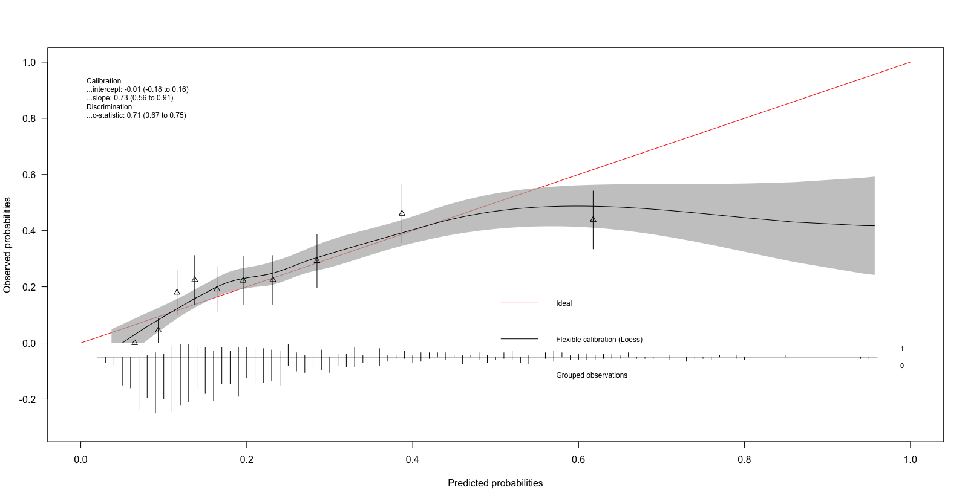Grouped observations for delirium in total cohort, 1= positive for delirium, 0= negative for delirium

