An analytical framework for spatially targeted management of natural capital
Rebecca Spake¹, Chloe Bellamy², Laura J. Graham¹, Kevin Watts³, Tom Wilson⁴, Lisa R. Norton⁵, Claire M. Wood⁵, Reto Schmucki⁶, James M. Bullock⁶ and Felix Eigenbrod¹.

¹ Geography and Environment, University of Southampton, Southampton SO17 1BJ, U.K.
² Forest Research, Centre for Ecosystems, Society and Biosecurity, Northern Research Station, Roslin, Midlothian, EH25 9SY, U.K.
³ Forest Research, Centre for Ecosystems, Society and Biosecurity, Farnham, Surrey, GU10 4LS, U.K
⁴ Forest Research, Silvan House, 231, Corstorphine Road, Edinburgh, EH12 7AT, U.K.
⁵ Centre for Ecology and Hydrology, Lancaster Environment Centre, Library Avenue, Bailrigg, Lancaster LA1 4AP, U.K.
⁶ NERC Centre for Ecology and Hydrology, Maclean Building, Benson Lane, Crowmarsh Gifford, Wallingford, Oxfordshire OX10 8BB, U.K.
Correspondence address: Rebecca Spake, Geography and Environment, University of Southampton, Southampton SO17 1BJ, U.K. R.Spake@soton.ac.uk.

An analytical framework for spatially targeted management of natural capital
A major sustainability challenge is determining where to target management to enhance natural capital and the ecosystem services it provides. Achieving this understanding is difficult, given that the effects of most actions vary according to wider environmental conditions; and this context dependency is typically poorly understood. Here, we describe an analytical framework that helps meet this challenge by identifying both ‘why’ and ‘where’ management actions are most effective for enhancing natural capital across large geographic areas. We illustrate the framework’s generality by applying it to two examples for Britain: pond water quality and invasion of forests by rhododendron.
Natural capital must be managed in a way that meets growing human demands for ecosystem services (ES), without comprising biodiversity and future ES provision¹. Here, we define natural capital as the elements of nature that directly and indirectly produce benefits to people, including ecosystems, species, water, land, minerals, the air and oceans, as well as ecological processes and functions². While humans cannot manage the biophysical and geological template of a region, we can manage natural capital locally, and to some extent alter its composition and configuration within landscapes to enhance the provision of ES such as food, fibre, clean water, aesthetic value, hazard protection and recreation³. However, despite much progress in recent decades, a clear understanding of how to manage natural capital sustainably has yet to be achieved. Much research has resulted in the impracticable conclusion that the effects of a given driver or management intervention on natural capital are ‘context-dependent’, meaning that effects vary according to location and scale of study. Context dependency results from the synergistic and antagonistic interactions among multiple environmental drivers across multiple spatial scales⁴; so-called ‘cross-scale interactions’⁵. Not understanding context dependency is problematic as it limits transferability: our ability to borrow ecological knowledge or management policies from one location and effectively apply them to another with a similar environmental context. It can lead to wasted resources if standardised interventions are ineffectively prescribed across a range of contexts or, worse still, may lead to unexpected or even perverse outcomes⁶.
Studies that value and map ES have proliferated in last decade⁷, usually with the stated aim of guiding spatial planning and management⁸. However, maps of ES themselves tell us only about the state of the natural capital that underpins their provision, rather than how it responds to management³. Instead, managing natural capital and ES sustainably requires an understanding of how changes in key predictors (‘drivers’) acting at local and landscape scales affect natural capital. In other words, sustainable management of natural capital to enhance the desired ES does not require us to characterise the context dependent distributions of ES values, but rather why the responses of manageable aspects of natural capital³ (hereafter ‘ecosystem responses’) to key drivers are context dependent. The importance of focusing on ES responses to manageable aspects of natural capital is already recognised^{3,9}, however how to operationalize such an approach across large spatial extents remains a challenge. Here, we outline a generally applicable analytical framework that achieves this through the creation of ‘effect maps’ that quantify how the effects of key drivers of ecosystem responses vary across broad geographic extents. In doing so, our framework enables one to understand how ecological drivers at multiple spatial scales combine and interact to produce context dependency. This understanding means that these effect maps identify where natural capital and ES respond to particular drivers so that management can be efficiently targeted to appropriate contexts¹⁰.

Understanding context dependency
Studies that relate broad-extent field measurements to spatial variation in environmental drivers are advocated for identifying cross-scale interactions among drivers operating at regional, landscape and local scales¹¹ and their effects on ecosystem responses^{12,13}. Such studies are becoming increasingly possible given the rising availability of high-resolution spatial data that often combines remote sensing, monitoring and census data over large extents, permitting better characterisation of landscape and regional drivers¹³. Drawing strong and practicable inference from such macro-scale empirical studies remains a challenge, however, because such studies are by necessity observational. Unlike designed experiments, observational studies comprise data wherein the identity, crossing, replication and interspersion of driving variables are largely outside the control of the observer¹⁴.
Recent macro-scale ecological studies have met this challenge by incorporating existing regional classifications into hierarchical modelling frameworks, modelling region as a random, latent variable, allowing for different intercepts and slopes of local drivers within different regions^{e.g.11,15,16}. Despite the utility of this flexible approach¹⁷, such studies only account for, rather than understand context dependency, by determining what are considered overall relationships ‘in the face of spatial heterogeneity’¹⁷. However, variations in ecosystem responses across contexts can occur due to true interactions, and so understanding how context dependency arises is paramount. If ‘region’ is characterised as a random variable, it provides no predictive power. Whereas if we model as fixed and truly understand and characterise the context dependency, inference can be extended across regions within the geographic extent of the study, with a known environmental contexts (results should not be extrapolated to other areas, with unknown environmental contexts). For example, the efficacy of riparian buffers at removing stream pollutants might vary regionally through an interaction with rainfall¹⁸. In this case, knowing that rainfall is important, rather than some unknown aspect of regional spatial heterogeneity, is clearly critical in deciding where to place riparian buffers to improve water quality. Such a mechanistic understanding of true interactions between local, landscape and regional contexts remains a critical knowledge gap¹², limiting our ability to manage landscapes sustainably.

An eight-step analytical framework
The framework we outline here allows for a mechanistic understanding of context dependency to identify where natural capital can be managed either locally or at the landscape scale to enhance the provision of ES. A core premise of our framework is that regional effects should be modelled as fixed, rather than random, effects in a generalised linear (mixed) modelling framework¹⁹. This allows us to detect and understand the cross-scale interactions that lead to context dependency, rather than merely controlling for them. Doing so has important implications for the inferences that can be drawn (see Discussion). We demonstrate the generality of our framework by application to two different aspects of natural capital: woodland susceptibility to invasion by a non-native shrub, rhododendron (Rhododendron ponticum), and pond water quality. Invasive species control is a common goal in sustainable resource management, given their often negative impacts on the capacity of ecosystems to support biodiversity and deliver ES^{20,21}. Limiting the spread of rhododendron is a conservation and economic priority in Britain as it affects the quality of natural capital (forests); it inhibits the regeneration of native woodlands, reduces biodiversity and increases the cost of forestry operations²². Good pond water quality is also an important indicator of natural capital quality, as it affects the amenity values of ponds and their contribution to freshwater biodiversity. Ponds generally support greater macroinvertebrate and macrophyte diversity and numbers of rare species compared to other freshwater ecosystems²³.
Our framework has eight steps (Figure 1). For each step, we first outline its rationale before applying it to our two case studies. Further details of each step, including justifications, data sources and model outputs can be found in Appendix S1 (woodland invasion) and S2 (water quality).

Select ecosystem responses
We define ‘ecosystem responses’ as measurable indicators of natural capital that can be managed to directly or indirectly produce benefits to people². The selection of ecosystem responses will be somewhat constrained by the information collected over large areas. As far as possible, ecosystem responses selected should i) be directly linked to measurable natural capital targets that ii) have explicit social value, and iii) are of direct relevance to management⁹. Measurements should be taken at the scale at which uniform local-level management actions occur, such as within forest stands or patches of land cover²⁴.
For the rhododendron case study, our chosen ecosystem response is the susceptibility to invasion by rhododendron. The cost of limiting its spread by local eradication increases with growth stage; untrained volunteers can remove young seedlings by hand, while older bushes require costly mechanical and chemical treatment²² and also produce seeds that allow spread. Identifying the factors that render a woodland susceptible to invasion is therefore critical to inform spatial targeting of management and monitoring to allow for removal before they set seed. We used 12,473 ‘section-level’ records of occurrence (presence/absence) from the UK Forestry Commission’s National Forest Inventory (NFI; 2010 – 2015; Appendix S1.1). The NFI monitors over 15,000 1-ha woodland ‘squares’ widely distributed across Great Britain, spanning gradients of regional, landscape and local drivers. Squares are subdivided into ‘sections’ of at least 0.05-ha that are relatively homogenous in terms of habitat and attributes including silvicultural system and vertical structure. Sections therefore represent local management units and a relevant scale for measuring this ecosystem response.
For pond water quality, we selected measures of soluble reactive phosphorous concentrations (SRP) in ponds surveyed in the UK Countryside Survey 2007 (CS2007; http://www.countrysidesurvey.org.uk ). CS2007 comprises 591, 1×1-km ‘sample squares’ distributed across Britain in a stratified, random design which maximised sampling across the country’s ‘major environmental gradients’, based on a classification of all 1-km squares in Britain according to their topographic, climatic and geological attributes²⁵. From the 591 sample squares, 259 contained a pond that was surveyed for physical, chemical and biotic attributes²⁶. SRP is influenced by land cover and anthropogenic activities within catchments, and is an indicator of eutrophication¹⁵.
The data used in this study are available from Forest Research and the Centre for Ecology and Hydrology but restrictions apply to the availability of these data, which were used under license for the current study, and so are not publicly available.

Identify drivers and hierarchies
Drivers of ecosystem responses are typically distinguished into a three-tiered interconnected hierarchy of regional, landscape and local-levels^{27,28}. Hierarchy theory posits that higher-level drivers constrain or moderate the effects of lower-level drivers, that can interact in turn to influence higher-level outcomes²⁹. We acknowledge that driver hierarchies are ultimately a human construct directed by the objectives of a study³⁰ and that levels in the hierarchies cannot always simply be discretised, but argue that hierarchies provide a framework for testing hypothesises and understanding how relationships change with scale and context, and how higher levels function as a context for lower levels³¹.
Regional-level drivers of ecosystem responses exhibit spatial variation at broader extents than landscape- and local-level drivers¹¹³²; examples are precipitation, temperature and nitrogen deposition³³. At the landscape-level, three types of driver are realised to affect an ecosystem response: landscape composition, configuration and quality². The spatial extent of a landscape-level driver depends on the phenomenon in question: landscape-level drivers of stream water quality are typically determined at the catchment extent³⁴, whilst landscape-level drivers of bird abundance are typically defined within a species’ ecological neighbourhood³⁵. Local-level drivers vary at small scales within landscapes, affected, for example, by local management practices. In addition to defining the hierarchies of drivers, it is also useful to distinguish which drivers are amenable to management³.
We identified putative regional drivers of rhododendron occurrence as soil pH, soil moisture and elevation based on existing literature³⁶ ^{37,38}. Potential landscape-level drivers relate to the amount and connectivity of natural land covers that may act as propagule sources. Local drivers are those affected by management and include e.g. dominant canopy species, stocking density of trees and woodland origin (e.g. whether naturally regenerated or planted; Appendix S1.2).
Regional drivers of pond water quality include: i) precipitation, with its potential to exacerbate agricultural run-off; ii) atmospheric nitrate deposition which can affect phosphorous uptake by pond biota due to its influence on N:P ratios, iii) temperature, with its effects on pond biota and water levels and iv) soil type, which can affect surface and ground water movements^{39–41}. Landscape-level drivers include the composition and configuration of land covers that act as sources and sinks of pollutants, in addition to buffer vegetation, and local drivers comprise the presence of an inflow and pond size (Appendix S2.1).

Generate hypotheses
Once all potential regional, landscape and local drivers and their hierarchies have been identified, it is possible to generate specific hypotheses about how these will affect a given ecosystem response, including cross-scale interactions. For, rhododendron, we hypothesized a cross-scale interaction between the regional favourability, according to pH, moisture and elevation, and some stand-level and landscape-level variables known to affect rhododendron occurrence (tree stocking density, distance to propagule sources, see Table 1). In unfavourable regions, the importance of propagule sources might be greater in facilitating successful establishment. In addition, we hypothesised that other local and landscape-level variables have a consistent effect on rhododendron establishment across broad extents. For pond water quality, our hypothesized cross-scale interaction was that the negative effect of intensive land cover would be strongest in areas of high slope and high precipitation, where these variables might exacerbate pollution^{39,40}. Moreover, the effectiveness of buffer vegetation was hypothesised to vary with these factors, with their ability to buffer against run-off potentially overwhelmed in high precipitation regions, suggesting a three-way interaction between buffer, precipitation gradient and landscape-level cover of intensive land uses.

Define regional contexts
To understand regional differences in the effects of local- and landscape-level drivers, regional contexts must be appropriately defined. Delineating regional contexts has a long history in a range of disciplines from hydrology⁴² to economic planning⁴³. Multivariate approaches have been widely applied to define regional contexts. Cluster analysis (e.g. k-means, self-organizing maps) identifies regions by aggregating a large number of geographical units into a smaller number of regions by optimising some objective function⁴⁴. Principal components analysis (PCA) has been used to set regional context by delineating continuous gradients⁴⁵. A plethora of regionalisations now exist based on various combinations of social and ecological variables, and are becoming increasingly incorporated in macroscale studies to identify cross-scale interactions^{44,46,47}. However, existing regionalisations have been derived from specific variables, for specific purposes, and are therefore unsuitable for research questions outside of those for which they were developed⁴⁴. Moreover, different combinations of variables will result in different regionalisations. We therefore concur with Cheruvelil et al.^{15,44} that it is important to generate regional contexts with driver variables related to the process of interest and that multiple regionalisations generated from various combinations of these variables should be considered. If discrete correlation structures are present amongst the regional drivers, cluster analysis is most appropriate and different algorithms and clusters should be considered as candidates⁴⁸ (in the statistical models). We note that regionalisations should be defined using the driver variables only, and not the response variable of interest.
We used three regional gradients related to rhododendron establishment across Great Britain: two gradients related to moisture and elevation, and a soil pH gradient. We calculated the first two gradients using a PCA of elevation and soil moisture deficit (MD). The first component, the ‘moisture and elevation gradient’ from hereon, explained 90% of the variation and represented increasing elevation and decreasing MD. The second component accounted for 10% of the variation and identified a gradient of increasing elevation and MD, with both variables moving in a direction that is not conducive to rhododendron occurrence. The second gradient was retained as it is meaningful as a favourability gradient for rhododendron occurrence (Appendix S1.3).
We found two PCA axes were sufficient to characterize the structure of the regional pond driver data, as they cumulatively explained 79% of the variation in precipitation, slope, temperature, soil type and atmospheric nitrogen deposition. The first axis represented a ‘precipitation gradient’ that correlated positively with precipitation and slope, and negatively with temperature. The second axis, the ‘soil gradient’, represented increasing cover of light soils, and decreasing wet nitrate deposition (Appendix S2.2).

Measure landscape-level drivers
Landscape structure comprises the relative abundance and diversity of land cover types (composition) and the spatial character, arrangement, or location of land cover type (configuration)⁴⁹. Understanding how landscape structure affects natural capital is critical as it is amenable to management. Landscape structure must be quantified at an extent appropriate to the phenomenon in question to maximise the probability of detecting a relationship if one exists⁵⁰. For example, for biodiversity, circular buffers might be used, while for landscape aesthetic values, viewsheds may be appropriate⁵¹. If unknown a priori, a ‘multi-scale’ analysis can be applied, wherein landscape structure is quantified in multiple buffers surrounding a focal point⁵².
We had no a priori knowledge of the appropriate landscape extent relevant to rhododendron occurrence, so we characterised landscape structure in circular buffers of size 250, 500, 750, 1000 and 2000-m with a thematic resolution that distinguished woodland, semi-natural and urban land covers (Appendix S1.4). We hypothesised that woodland and urban areas provide source propagules for rhododendron establishment. Several studies have found that occurrence of invasive species declines from edge to interior of forest patches⁵³, so the distance of survey square section to a forest edge was calculated. As another propagule source, measures of distance to historic gardens, where rhododendron has often been planted as an ornamental, were calculated.
Previous studies of pond water quality have characterised landscape structure within buffer zones in addition to the pond’s entire catchment⁵⁴. The cover of trees, scrub or woodland, ‘buffer vegetation’ from hereon, within 5 and 100-m of each pond was measured by visual assessment by Countryside Survey surveyors. In the absence of an existing pond catchment GIS layer, we characterised landscape structure within 250, 500, 750, and 1000-m buffers surrounding each pond. For these extents, we used Land Cover Map 2007 (LCM2007⁵⁵) and distinguished between land covers putatively acting as pollution sources (intensive agricultural land of either arable or improved grassland), or that tend towards acting as sinks (woodland and wetlands). In addition to the amount of source and sink land covers, we calculated edge density, as we hypothesised a positive edge effect of source covers and a negative effect of sink covers (e.g. forest or wetland), by facilitating nutrient absorption and retention⁵⁶.

Assess data limitations
Once the regional gradients have been delineated,and landscape structure characterised, it is necessary to assess the data and establish whether it is feasible to model the hypothesised cross-scale interactions. It is important to be aware that plausible theoretical predictions might be constrained by the limitations (replication and representation) of available data. For the cross-scale interactions hypothesized (Table 1), we established that replication and representation were sufficient to test for interactions between regional gradients and the local landscape variables. For the analysis of rhododendron, however, while it was possible to test for an interaction between the regional gradient with aspect and landscape-level woodland cover, insufficient representation precluded the testing of an interaction between regional favourability and tree stocking density. High multi-collinearity between landscape composition and configuration metrics meant that only woodland cover was modelled at multiple scales. Woodland size was omitted from the analysis due to high correlation with woodland cover (Appendix S1.5).

Specify appropriate statistical models
The previous steps will likely generate multiple regional gradients and landscape metrics quantified at multiple extents, all of which are plausibly linked to the hypotheses that have been generated. To identify the appropriate regional gradients and extents for each of the landscape-level drivers, we recommend creating a global model, containing all potentially important drivers and their interactions (identified in Step 3), for each possible combination of extents of each landscape metrics. Such models must not simultaneously consider the same landscape-level driver calculated at multiple extents as they essentially measure the same thing and are highly correlated. Important drivers, including landscape metrics at their appropriate extents and regional gradients, can be identified by selecting the best model(s) using information theoretic approaches such as by ranking models according to Akaike’s Information Criterion⁵⁷ (AIC). We favour this approach over the usual practice of fitting multiple univariate models for each extent of each landscape driver^{e.g.46,52}, because univariate models necessarily omit important variables and interactions, increasing residual variance and leading to a bias in the statistical inference⁵⁸. We suggest that model selection, rather than model averaging, is likely to be more useful, because models differing only in the extent of landscape variables are likely to have very similar support, and such models cannot be averaged as they are technically different variables measuring a similar quantity⁵⁹. We created global models for both rhododendron and pond water quality containing meaningful combinations of regional, landscape and local drivers (that translate to the hypotheses), for all appropriate extents for each landscape driver, and from these generated a full set of nested models to be compared with AIC using R package MuMIn⁶⁰. Although in our illustration of the framework we focus specifically on GLM(M)s, it should be noted that any modelling framework where the effects of interactions can be estimated, such as structural equation modelling⁶¹ or boosted regression trees⁶² could be used.

Produce effect maps and draw inferences
Reporting on how changes in drivers affect ecosystem responses is necessary to provide practicable guidance for management actions and landscape design⁹. Interactions between multiple drivers operating at local, landscape and regional scales (cross-scale interactions) can lead to context dependency in these marginal effects. In this step, we describe how reporting and mapping of the regional variation in marginal effects (i.e. estimated regression coefficients, or slopes⁹) can identify where management resources should be targeted, or where natural capital can be managed to enhance an ecosystem response. Indeed humans can intervene in some contexts to manage natural capital and enhance ES but have little influence in others^{63,64}. For local and landscape-level drivers that interact with regional gradients, it is possible to map the direction and strength of their effect across the range of the regional gradient, within their ‘zone of significance’, i.e. within the range within which an effect was detected (i.e. the Johnson-Neyman interval⁶⁵). Mapping this regional variation in the effect of drivers provides an ‘effect map’ that highlights areas where management interventions targeting these drivers are most likely to be successful. These maps can also inform policy, the prioritisation of areas for grants and subsidies to support ecosystem management, and spatial targeting of monitoring schemes. Of course, for some drivers no cross-scale interactions may occur – for these, effect maps are unnecessary.
We identified cross-scale interactions wherein the susceptibility to rhododendron invasion (within 500-m of a woodland site) depended on woodland cover only in regions with unfavourable, alkaline soils (details in Appendix S1.6). Figure 2a displays a marginal effect plot (top) and effect map (centre) displaying this context dependent effect of landscape-level woodland cover across Britain. In areas with alkaline soils, woodland sites should be prioritised or monitored to detect early establishment of seedlings and promote their removal before significant and costly growth occurs. By contrast, in regions with acidic soils the degree of woodland cover in the landscape cannot be used to prioritise woodlands for monitoring for rhododendron. Woodland susceptibility to rhododendron invasion responded consistently to several local variables across the regional gradients, wherein occurrence increased with stand vertical structural complexity and stand age, and varied according to forest type, with the highest probability of establishment in mixed species stands. Consistent landscape-level drivers included a negative effect of distance to historic gardens, and a positive effect of road density within 250-m. Occurrence probability exhibited a negative quadratic relationship with the regional moisture and elevation gradient and a positive quadratic relationship with the favourability gradient showing that moist, low elevation sites tend to have higher establishment probabilities. As such, woodlands that should be prioritized for monitoring of rhododendron are old sites of conservation concern with complex vertical structure, located on alkaline soils and near roads, with high levels of forest cover within 500-m.
For pond water quality, we identified a cross-scale interaction wherein a regional soil gradient characterised by increasing soil sandiness and decreasing atmospheric nitrate deposition moderated the effect of the surrounding intensive land cover on pond SRP (details in Appendix S2.3). The main effects were important as demonstrated by the decreasing intercept of the intensive land cover relationship with the increasing gradient of soil sandiness: in areas with heavier soils, landscapes with low coverage of intensive land use still had elevated pond SRP concentrations. The slope was higher in sandier regions, likely because SRP is more susceptible to leaching in sandy soils⁶⁶, and because low nitrate deposition here means that these ponds could be nitrogen-limited, and so unlikely to use up excess phosphorus. For pond water quality, the increase of intensive land cover within 250-m of a pond had the highest effect on pond water quality in northern Britain (Figure 2b), suggesting that agricultural intensification (and expansion) in these regions would be the most detrimental to water quality. By contrast, precipitation had a consistently positive relationship, and inflow presence a consistently negative relationship, with SRP.

Discussion
Land resources are finite, and a mechanistic understanding of the drivers of natural capital and the ES it provides is vital in the face of global environmental change and increasing human use of natural resources. We urgently need to identify both why and where management actions should be allocated to enhance and allow sustainable use of ES¹⁰. In our framework we achieve the why through formalising context-dependency of ecosystem responses to key drivers at local, landscape and regional scales. We achieve the where using effect maps of regional variation in the effect of local and landscape-level drivers that represent key characteristics of natural capital at local and landscape scales (the final step of our framework; Fig. 3), providing practicable spatially-targeted management recommendations. Our framework also imposes an explicit consideration of scale in two ways. Firstly, the application of hierarchy theory²⁹ (second step) distils ecosystem complexity and compels the researcher to make alternative a priori hypotheses (third step) and so set up alternative hierarchies and interactions. Secondly, the comparison of multiple models containing drivers characterised at a range of ecologically meaningful landscape extents⁵² (fifth step), in addition to multiple regional gradients or contexts (fourth step), allows for the identification of the ‘scales of effect’ (the extents at which effects are strongest; different extents may be observed for each driver), and the changing importance of drivers across regional contexts. Knowledge of the scales of effect of landscape-level drivers has the potential to advance sustainability science substantially regarding both modelling and management^{13,67}. In terms of modelling, including drivers at their appropriate scale of effect reduces residual spatial autocorrelation in statistical models⁶⁸. Moreover, accounting for the scale of effect will likely transform ES modelling: a study using process models to map ES in Scotland obtained very different values of landscape aesthetic value after incorporating landscape structure metrics at the scale of effect, corresponding to the viewshed⁶⁷. Identifying the scales of effect of drivers is also important for management, as it means that the correct landscape extent can be identified for managing natural capital at a particular location. Our framework therefore provides a way to operationalize the ‘multi-scale’ approach that is increasingly advocated for ecosystem modelling and management⁶⁹, and helps provide clarity and consistency by what is meant by this³⁵.

Caveats and the need for cautious inference
Unlike designed experiments, observational studies comprise data wherein the identity, crossing, replication and interspersion of driving variables are outside the control of the observer¹⁴, and trade-offs and compromises will inevitably produce a less-than-optimal study design⁴⁹. For example, landscape composition and configuration metrics are correlated in real landscapes, including those in our study. As these phenomena are confounded in nature and therefore hard to separate empirically, existing studies (including ours) of ecosystem response–landscape structure relationships have focused on landscape composition rather than configuration, due to much evidence of composition having a greater effect than configuration on natural capital and ecosystem services. Theoretical studies suggest that landscape composition in general exerts a stronger influence, with landscape configuration effects most apparent at intermediate levels of land cover types⁷⁰. Qiu & Turner (2015)⁵⁶ demonstrated this empirically, showing that where agricultural or urban cover dominate watersheds (>60% cover), landscape composition has a greater effect on hydrological services and configuration matters less. At high coverage, croplands coalesce into larger patches, reducing edge effects and nutrient retention by other land covers such as forest. It is critical to determine when configuration is important¹³ for natural capital, and is likely to be possible in the future, given that monitoring programmes are increasingly incorporating regional and landscape-level considerations in their sampling strategies^{71,72}.
We stress that inferences made from applying our framework, which specifies the regional context as a fixed effect, must not extrapolate beyond the sampled range of the drivers. That is, inference cannot be extended to other areas with regional contexts which are outside of the range of the data (i.e. study extent) used to build the regional gradients and the statistical models, which could comprise new correlation structures^{14,73}. For example, in studies of plant diversity along a productivity gradient in Britain a quadratic relationship was found at the national level⁷⁴, and a negative linear relationship was found at the catchment level⁷⁵. Whilst these results appear contradictory, they are entirely consistent: the smaller extent of the catchment-level study captured only a subset of the range of the national productivity gradient, falling in the right-hand side of the quadratic curve observed at the national scale. Therefore, the effect maps created in the final step must not map the effects of drivers beyond their sampled ranges. In our case study of rhododendron establishment, we note that the NFI limits sampling to woodland plots only, so we cannot make inferences about the effects of drivers on rhododendron establishment in other focal ecosystems, such as heathland. As for regional gradients, we do not extend our inference beyond the range of the regional drivers sampled by the NFI or Countryside Survey (the effect maps in Figure 2 contains missing raster cells corresponding to values beyond the sampled range, and missing data).
A key strength of our framework is that it enables us to understand – not just control for – interactions. Mechanistically understanding the hypothesised interactions between drivers at multiple scales (cross-scale interactions) requires that there is not only sufficient sampling across the gradient of the local and landscape-level drivers of interest (the focal drivers)⁷⁶, but also that the full range of these drivers are represented across the regional gradient in question (the moderating driver)³³ . If a focal driver is not well represented across the range of a moderator, it is more difficult to distinguish whether an apparent interaction is due to a true interaction, or because of between-region differences in the range of the focal driver. This is particularly important if the shape of the relationship, whether linear, asymptotic or quadratic, changes with the moderator driver among different regional contexts¹⁴. Without strong inference, one could make misleading conclusions about the changing importance of a driver. For discrete regions and drivers, representation can be ensured by checking the data have a cross-factored structure⁷⁷. For continuous regions and drivers, or a mixture of continuous and discrete variables, this can be done by checking that regression assumptions are met and by visually assessing scatterplots and histograms.

Towards multifunctional landscapes
A question at the frontier of sustainability science and landscape ecology is concerned with whether certain landscape patterns at multiple scales result in synergies or trade-offs among multiple ES^{13,63,64}. For example, do agri-environment schemes, which aim to balance conservation and agriculture, lead to enhanced yield through pest control, in addition to improving water quality and maintaining biodiversity? The most common way to infer trade-offs and synergies between ES has been from spatial overlays of ES indicators, that have been harmonised to a common grain, using bivariate or multivariate analyses to identify ES bundles⁷⁸. Only weak inference can be drawn from such simplistic correlational analyses, as direct causal relationships between ES and social-ecological variables are not assessed⁴⁸.
Our framework, with its focus on the effects of drivers of natural capital and ES, rather than ES valuation per se, is well suited to gaining true understanding of the reasons for trade-offs and synergies among multiple ES. If two or more ecosystem responses share a common driver (e.g. the amount of woodland cover in the landscape), the effect maps of the different ecosystem responses of this common driver can be overlaid. These combined effect maps can then be used to identify both why current trade-offs exist, and the locational-specific effects of a given management action on multiple ES sharing the same common driver. Such an understanding is critical to truly sustainable natural capital management, and enables us to quantify the degree to which multifunctionality is achievable in our landscapes.

References
1. Seppelt, R., Lautenbach, S. & Volk, M. Identifying trade-offs between ecosystem services, land use, and biodiversity: A plea for combining scenario analysis and optimization on different spatial scales. Curr. Opin. Environ. Sustain. 5, 458–463 (2013).
2. Mace, G. M., Hails, R. S., Cryle, P., Harlow, J. & Clarke, S. J. Towards a risk register for natural capital. J. Appl. Ecol. 52, 641–653 (2015).
3. Maseyk, F. J. F., Mackay, A. D., Possingham, H. P., Dominati, E. J. & Buckley, Y. M. Managing Natural Capital Stocks for the Provision of Ecosystem Services. Conserv. Lett. 10, 211–220 (2017).
4. Darling, E. S. & Côté, I. M. Quantifying the evidence for ecological synergies. Ecol. Lett. 11, 1278–1286 (2008).
5. Levin, S. A. The Problem of Pattern and Scale in Ecology, Ecology 73, 1943–1967 (1992).
6. Peters, D. P. C., Bestelmeyer, B. T. & Turner, M. G. Cross-scale interactions and changing pattern-process relationships: Consequences for system dynamics. Ecosystems 10, 790–796 (2007).
7. Boerema, A., Rebelo, A. J., Bodi, M. B., Esler, K. J. & Meire, P. Are ecosystem services adequately quantified? J. Appl. Ecol. 54, 358–370 (2017).
8. Maes, J. et al. Mapping ecosystem services for policy support and decision making in the European Union. Ecosyst. Serv. 1, 31–39 (2012).
9. Wong, C. P., Jiang, B., Kinzig, A. P., Lee, K. N. & Ouyang, Z. Linking ecosystem characteristics to final ecosystem services for public policy. Ecol. Lett. 18, 108–118 (2015).
10. Rieb, J. T. et al. When, Where, and How Nature Matters for Ecosystem Services: Challenges for the Next Generation of Ecosystem Service Models. Bioscience 67, 820–833 (2017).
11. Soranno, P. A. et al. Cross-scale interactions: Quantifying multi-scaled cause-effect relationships in macrosystems. Front. Ecol. Environ. 12, 65–73 (2014).
12. Oliver, T. H. & Morecroft, M. D. Interactions between climate change and land use change on biodiversity: attribution problems, risks, and opportunities. WIREs Clim Chang. n/a (2014). doi:10.1002/wcc.271
13. Jones, K. B. et al. Informing landscape planning and design for sustaining ecosystem services from existing spatial patterns and knowledge. Landsc. Ecol. 28, 1175–1192 (2013).
14. Smart, S. M. et al. Clarity or confusion? - Problems in attributing large-scale ecological changes to anthropogenic drivers. Ecol. Indic. 20, 51–56 (2012).
15. Cheruvelil, K. S., Soranno, P. A., Webster, K. E. & Bremigan, M. T. Multi-scaled drivers of ecosystem state: Quantifying the importance of the regional spatial scale. Ecol. Appl. 23, 1603–1618 (2013).
16. Iannone, B. V. et al. Region-specific patterns and drivers of macroscale forest plant invasions. Divers. Distrib. 21, 1181–1192 (2015).
17. Dixon Hamil, K. A., Iannone, B. V., Huang, W. K., Fei, S. & Zhang, H. Cross-scale contradictions in ecological relationships. Landsc. Ecol. 31, 7–18 (2016).
18. Dorioz, J. M., Wang, D., Poulenard, J. & Trévisan, D. The effect of grass buffer strips on phosphorus dynamics-A critical review and synthesis as a basis for application in agricultural landscapes in France. Agric. Ecosyst. Environ. 117, 4–21 (2006).
19. Bolker, B. M. et al. Generalized linear mixed models: a practical guide for ecology and evolution. Trends in Ecology and Evolution, 127–135. (2008).
20. Larson, D. L. et al. A framework for sustainable invasive species management: Environmental, social, and economic objectives. J. Environ. Manage. 92, 14–22 (2011).
21. Pyšek, P. et al. A global assessment of invasive plant impacts on resident species, communities and ecosystems: The interaction of impact measures, invading species’ traits and environment. Glob. Chang. Biol. 18, 1725–1737 (2012).
22. Edwards, C. Forestry Commission Practice Guide: Managing and controlling invasive rhododendron. (2006).
23. Céréghino, R., Biggs, J., Oertli, B. & Declerck, S. The ecology of European ponds: Defining the characteristics of a neglected freshwater habitat. Hydrobiologia 597, 1–6 (2008).
24. Manning, P. et al. Redefining ecosystem multifunctionality. Nat. Ecol. Evol. 2, 427–436 (2018).
25. Carey, P. D. et al. Countryside Survey Methodology. Countrys. Surv. UK results from 2007 (2009).
26. Williams, P. et al. Countryside Survey: Ponds Report from 2007. Technical Report No. 7/07. Pond Conserv. NERC/Centre Ecol. Hydrol. 77pp. (CEH Project Number: C03259). (2010).
27. Heffernan, J. B. et al. Macrosystems ecology: Understanding ecological patterns and processes at continental scales. Front. Ecol. Environ. 12, 5–14 (2014).
28. Wu, J. & David, J. L. A spatially explicit hierarchical approach to modeling complex ecological systems: Theory and applications. Ecol. Modell. 153, 7–26 (2002).
29. Allen, T. F. . & Starr, T. . Hierarchy: perspectives for ecological complexity. (University of Chicago Press, 1982).
30. Jensen, M. E., Bourgeron, P., Everett, R. & Goodman, I. Ecosystem Management : A Landscape Ecology Perspective. 32, (1996).
31. Wu, J. in Linking Ecology and Ethics for a Changing World: Values, Philosophy, and Action (ed. R. Rozzi, S.T.A. Pickett, C. Palmer, J.J. Armesto, and J. B. C.) 281–302 (Springer, 2013).
32. Allen, T. F. H. in Ecosystem ecology – a derivative of encyclopedia of ecology (ed. Jorgensen, S. E.) 114–120 (Elsevier, 2009).
33. Peters, D. P. C. et al. Living in an increasingly connected world: A framework for continental-scale environmental science. Front. Ecol. Environ. 6, 229–237 (2008).
34. Allan, J. D. & Johnson, L. B. Catchment-scale analysis of aquatic ecosystems. Freshw. Biol. 37, 107–111 (1997).
35. Holland, J. D. & Yang, S. Multi-scale Studies and the Ecological Neighborhood. Curr. Landsc. Ecol. Reports 1, 135–145 (2016).
36. Stephenson, C. M., MacKenzie, M. L., Edwards, C. & Travis, J. M. J. Modelling establishment probabilities of an exotic plant, Rhododendron ponticum, invading a heterogeneous, woodland landscape using logistic regression with spatial autocorrelation. Ecol. Modell. 193, 747–758 (2006).
37. Cross, J. R. Biological flora of the British Isles: Rhododendron ponticum. J. Ecol. 63, 345–364 (1975).
38. Purse, B. V., Graeser, P., Searle, K., Edwards, C. & Harris, C. Challenges in predicting invasive reservoir hosts of emerging pathogens: Mapping Rhododendron ponticum as a foliar host for Phytophthora ramorum and Phytophthora kernoviae in the UK. Biol. Invasions 15, 529–545 (2013).
39. Jones, K. B. et al. The consequences of landscape change on ecological resources: An assessment of the United States mid-Atlantic region, 1973-1993. Ecosyst. Heal. 7, 229–242 (2001).
40. Jones, K. B. et al. Multiscale relationships between landscape characteristics and nitrogen concentrations in streams. Scaling Uncertain. Anal. Ecol. Methods Appl. 205–224 (2006). doi:10.1007/1-4020-4663-4_11
41. Bergström, A. K. & Jansson, M. Atmospheric nitrogen deposition has caused nitrogen enrichment and eutrophication of lakes in the northern hemisphere. Glob. Chang. Biol. 12, 635–643 (2006).
42. Mosley, M. Delimitation of New Zealand hydrological regions. J. HydroIogy 49, 173–192 (1981).
43. Spence, N. A. A Multifactor Uniform Regionalization of British Counties on the Basis of Employment Data for 1961. Reg. Stud. 2, 87–104 (1968).
44. Cheruvelil, K. S. et al. Creating multithemed ecological regions for macroscale ecology: Testing a flexible, repeatable, and accessible clustering method. Ecol. Evol. 7, 3046–3058 (2017).
45. White, D. Climate regionalization and rotation of principal components, Int. J. Climatology. 11, 1–25 (1991).
46. Soranno, P. A., Cheruvelil, K. S., Wagner, T., Webster, K. E. & Bremigan, M. T. Effects of land use on lake nutrients: The importance of scale, hydrologic connectivity, and region. PLoS One 10, 1–22 (2015).
47. Iannone, B. V. et al. Evidence of biotic resistance to invasions in forests of the Eastern USA. Landsc. Ecol. 31, 85–99 (2016).
48. Spake, R. et al. Unpacking ecosystem service bundles: Towards predictive mapping of synergies and trade-offs between ecosystem services. Glob. Environ. Chang. 47, 37–50 (2017).
49. Fahrig, L. et al. Functional landscape heterogeneity and animal biodiversity in agricultural landscapes. Ecol. Lett. 14, 101–112 (2011).
50. Miguet, P., Jackson, H. B., Jackson, N. D., Martin, A. E. & Fahrig, L. What determines the spatial extent of landscape effects on species? Landsc. Ecol. 31, 1177–1194 (2016).
51. Dramstad, W. E., Tveit, M. S., Fjellstad, W. J. & Fry, G. L. A. Relationships between visual landscape preferences and map-based indicators of landscape structure. Landsc. Urban Plan. 78, 465–474 (2006).
52. Holland, J. D., Bert, D. G. & Fahrig, L. Determining the Spatial Scale of Species’ Response to Habitat. Bioscience 54, 227 (2004).
53. Vilà, M. & Ibáñez, I. Plant invasions in the landscape. Landsc. Ecol. 26, 461–472 (2011).
54. Novikmec, M. et al. Ponds and their catchments: size relationships and influence of land use across multiple spatial scales. Hydrobiologia 155–166 (2015). doi:10.1007/s10750-015-2514-8
55. Morton, R. D. et al. Land Cover Map 2007 (25m raster, GB) v1.2. (2014).
56. Qiu, J. & Turner, M. G. Importance of landscape heterogeneity in sustaining hydrologic ecosystem services in an agricultural watershed. Ecosphere 6, 1–19 (2015).
57. Burnham, K. P. & Anderson, D. R. Model Selection and Multimodel Inference: A Practical Information-Theoretic Approach (2nd ed). Ecological Modelling 172, (2002).
58. Bradter, U., Kunin, W. E., Altringham, J. D., Thom, T. J. & Benton, T. G. Identifying appropriate spatial scales of predictors in species distribution models with the random forest algorithm. Methods Ecol. Evol. 4, 167–174 (2013).
59. Freckleton, R. P. Dealing with collinearity in behavioural and ecological data: Model averaging and the problems of measurement error. Behav. Ecol. Sociobiol. 65, 91–101 (2011).
60. Bartoń, K. MuMIn: model selection and model averaging based on information criteria (AICc and alike) R package version. (2018).
61. Lefcheck, J. S. Piecewise SEM: Piecewise structural equation modelling in R for ecology, evolution, and systematics. Methods Ecol. Evol. 2–7 (2015). doi:10.1111/2041-210X.12512
62. Elith, J., Leathwick, J. R. & Hastie, T. A working guide to boosted regression trees. J. Anim. Ecol. 77, 802–813 (2008).
63. Turner, M. G. & Gardner, R. H. Landscape Ecology in Theory and Practice. Pattern and Process. (Springer-Verlag New York, 2015).
64. Turner, M. G., Donato, D. C. & Romme, W. H. Consequences of spatial heterogeneity for ecosystem services in changing forest landscapes: Priorities for future research. Landsc. Ecol. 28, 1081–1097 (2013).
65. Johnson, P. O. & Neyman, J. Tests of certain linear hypotheses and their application to some educational problems. Stat. Res. Mem. 1, 57–93 (1936).
66. Mcdowell, R. W., Sharpley, A. N., Condron, L. M., Haygarth, P. M. & Brookes, P. C. Processes controlling soil phosphorus release to runoff and implications for agricultural management. Nutr. Cycl. Agroecosystems 59, 269–284 (2001).
67. Verhagen, W. et al. Effects of landscape configuration on mapping ecosystem service capacity: a review of evidence and a case study in Scotland. Landsc. Ecol. 31, 1457–1479 (2016).
68. De Knegt, H. J. et al. Spatial autocorrelation and the scaling of species – environment relationships. Ecology 91, 2455–2465 (2010).
69. Scholes, R. J., Reyers, B., Biggs, R., Spierenburg, M. J. & Duriappah, A. Multi-scale and cross-scale assessments of social-ecological systems and their ecosystem services. Curr. Opin. Environ. Sustain. 5, 16–25 (2013).
70. Gergel, S. E. Spatial and non-spatial factors: When do they affect landscape indicators of watershed loading? Landsc. Ecol. 20, 177–189 (2005).
71. Watts, K. et al. Using historical woodland creation to construct a long-term, large-scale natural experiment: The WrEN project. Ecol. Evol. 6, 3012–3025 (2016).
72. Gillespie, M. A. K. et al. A method for the objective selection of landscape-scale study regions and sites at the national level. Methods Ecol. Evol. 8, 1468–1476 (2017).
73. Steel, A., Kennedy, M. C., Cunningham, P. G. & Stanovick, J. S. Applied statistics in ecology : common pitfalls and simple solutions. Ecosphere 4, 1–13 (2013).
74. Maskell, L. C. et al. Exploring the ecological constraints to multiple ecosystem service delivery and biodiversity. J. Appl. Ecol. 50, 561–571 (2013).
75. Emmett, B. A. et al. Spatial patterns and environmental constraints on ecosystem services at a catchment scale. Sci. Total Environ. 572, 1586–1600 (2016).
76. Eigenbrod, F., Hecnar, S. J. & Fahrig, L. Sub-optimal study design has major impacts on landscape-scale inference. Biol. Conserv. 144, 298–305 (2011).
77. Zuur, A. F., Ieno, E. N. & Elphick, C. S. A protocol for data exploration to avoid common statistical problems. Methods Ecol. Evol. 1, 3–14 (2010).
78. Raudsepp-Hearne, C., Peterson, G. D. & Bennett, E. M. Ecosystem service bundles for analyzing tradeoffs in diverse landscapes. Proc. Natl. Acad. Sci. U. S. A. 107, 5242–7 (2010).
79. Cross, J. R. The Establishment of Rhododendron Ponticum in the Killarney Oakwoods. J. Ecol. 69, 807–824 (1981).

Correspondence should be addressed to R. Spake.

Acknowledgements
We thank J. Catford and B. Ditchburn for advice on variables to consider for invasive species modelling. Thanks also to J. Lefcheck and J. Forster for invaluable discussions on statistical approaches. This research was funded by the ERC Starting Grant “SCALEFORES” [grant no. 680176] awarded to FE.

Author contributions
FE, JMB and KW conceived the project ‘SCALEFORES’. RSp (Rebecca Spake), CB, LG, JMB, KW, RSch (Reto Schmucki), LN and FE designed the analytical framework and case study designs. RSp, CB, CW and RSch carried out all statistical and GIS analyses. TW, CW, and CB collated and supplied data. RS, CB and FE wrote the manuscript. All authors discussed the results and contributed to the manuscript.

Competing interests
The authors declare no competing financial interests.

Tables
Table 1. Hypothesised cross-scale interactions in the drivers of rhododendron establishment and their specifications in a statistical model
Hypothesised relationship | Specification in statistical model | Hierarchical levels
Woodland susceptibility to invasion by rhododendron
The importance of potential propagule sources to rhododendron establishment will depend on regional favourability. In regions that are broadly unfavourable to rhododendron establishment, repeated colonisation events from propagule sources will be necessary for successful establishment. | Woodland cover * favourability gradient  Distance to historic park garden * regional favourability gradient | landscape * region
An effect of distance to woodland edge could depend on whether the surrounding land use is arable, due to any edge effect mediated by herbicides or fertiliser ⁵³. | Distance to woodland edge * arable cover within 250-m of woodland edge. | local * landscape
Bryophytes provide safe sites for rhododendron establishment⁷⁹. Stand density, as a proxy for light reaching the forest floor and water availability (and so bryophyte abundance), will limit rhododendron establishment – and more strongly – in unfavourable regions. Similarly, the importance of local aspect may vary with the favourability gradient. | Stocking density * favourability#  Aspect * favourability | local * region
Pond soluble reactive phosphorous concentration
The positive effect of landscape-level intensive land cover (arable and pasture) on pond soluble reactive phosphorous concentrations will be stronger in areas with soils that are more susceptible to leaching, i.e. sandy soils | Intensive agriculture cover * soil gradient | landscape * region
# Indicates relationships that were not possible to test, given insufficient representation of drivers across the regional gradient

Figure legends
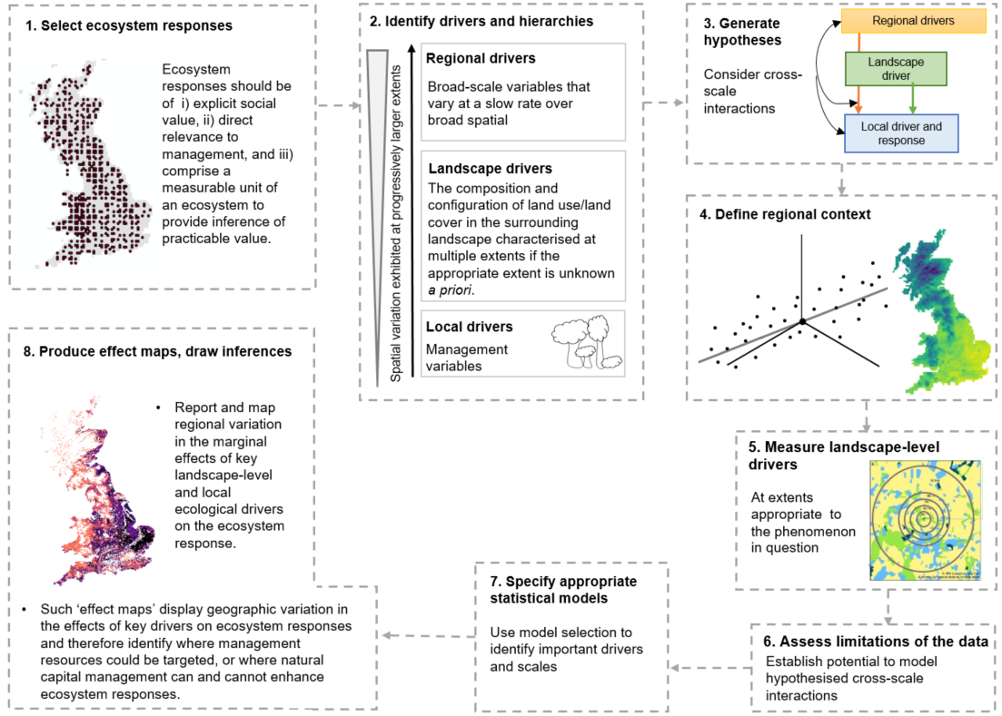
Figure 1. Outline for our analytical framework, which enables the production of effect maps that show how and where to manage natural capital sustainably.

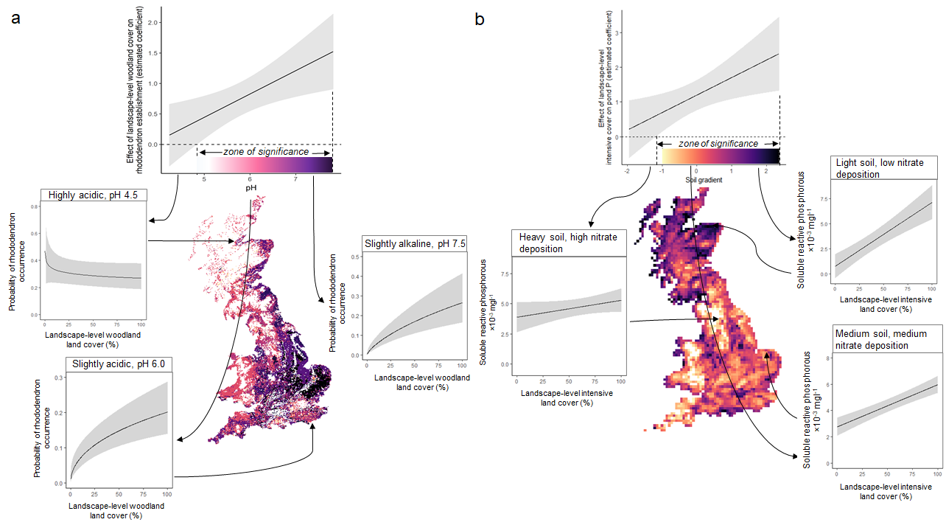
Figure 2. Cross-scale interactions of the effects of landscape-level drivers on ecosystem responses; a) the effect of landscape-level woodland cover (within 500-m of a woodland site) on woodland susceptibility to invasion depends on soil pH, and b) the effect of landscape-level intensive land cover (within 250-m of a pond) depends on a soil gradient. Relationships were graphed using coefficients from the minimum adequate models with conditional variables held at their mean except for the bottom three graphs that used values of actual samples sites. Shown are marginal effect plots (top) and effect map (centre) showing the effect (estimated coefficient) of landscape-level drivers, conditional on the value of regional gradients, and estimated ecosystem response values in relation landscape level drivers within three regional contexts (bottom three graphs). Grey shading represent 95% confidence intervals.

Supporting information
Contents
Appendix S1. Further methodological details for modelling woodland susceptibility to rhododendron invasion 22
Appendix S1.1 Rationale for modelling rhododendron occurrence and the NFI 22
Rationale 22
National Forest Inventory 22
Appendix S1.2 Details of the drivers selected for the analysis of rhododendron occurrence 23
Appendix S1.3 Defining regional contexts 24
Appendix S1.4 Characterising landscape structure 24
Appendix S1.5 Details of data exploration and processing 25
Appendix S1.6 Details of model selection to identify important drivers and scales 26
Appendix S2. Further methodological details for modelling pond water quality 30
Appendix S2.1 Details of the drivers selected for the analysis of soluble reactive phosphorus concentrations (SRP) in ponds 30
Appendix S2.2 Defining regional contexts 31
Appendix S2.3 Details of model selection to identify important drivers and scales 32
Supplementary Information References 35

Appendix S1. Further methodological details for modelling woodland susceptibility to rhododendron invasion

Appendix S1.1 Rationale for modelling rhododendron occurrence, the dataset and selected drivers

Rationale
Rhododendron is an evergreen shrub that has become a well-established pest of conservation and economic concern in Britain since its introduction as an ornamental in 1763. It inhibits the regeneration of native woodlands, reduces woodland biodiversity and increases the cost of forestry operations if pre-treatment is required. Eradication expenses depend on the site accessibility and clearance method and can cost as much as £10,000 ha⁻¹ (Dehnen-Schmutzet al. 2004). Several studies have investigated its establishment requirements, but at small geographic extents thus far (e.g. Thomson et al. 1993; Stephenson et al. 2006). Understanding variation in the effects of factors that facilitate rhododendron invasion at broad extents, such as across Britain, could allow for the spatial targeting of grant aid and monitoring for early removal and management.

National Forest Inventory
We used the first cycle of the Forestry Commission’s National Forest Inventory (NFI; 2010 – 2015) to model rhododendron invasion. This rolling field survey scheme incorporates over 15,000 1ha woodland ‘squares’ across Great Britain, from which data describing the site’s biophysical attributes and human activities are collected using a standardised protocol (https://www.forestry.gov.uk/fr/beeh-a3gf9u#fieldsurvey). These sites were selected using a stratified-random sampling technique. Each 1-ha square is subdivided into sections, areas of woodland within a survey square that are relatively homogenous in terms of management and land use attributes including silvicultural system, age, height, and are at least 0.05ha in extent (S1.1).

Appendix S1.2 Details of the drivers selected for the analysis of rhododendron occurrence
Table S1.1. Drivers selected for the analysis of rhododendron occurrence
 | Relationship to rhododendron occurrence probability |  | Variable type | Source, original resolution and processing details
Region-level
Soil moisture deficit | Negative to negative quadratic – rhododendron requires damp soils and is intolerant to drought and water-logging³⁷. |  | Continuous | Ecological Site Classification (ESC), originally available at 250-m https://www.forestresearch.gov.uk/tools-and-resources/forest-planning-and-management-services/ecological-site-classification-decision-support-system-esc-dss/
Elevation | Negative - suitability decreases with increasing elevation³⁸. |  | Continuous | OS Terrain 50, available at 50-m resolution https://www.ordnancesurvey.co.uk/xml/products/OSTerrain50Grid.xml
Soil pH | Negative - rhododendron is found in a range of acidic soil conditions, from pH 3 to 6.4, but growth is generally inhibited below pH 5³⁷. |  | Continuous | Countryside Survey’s Model estimates of topsoil pH and bulk density at 1-km resolution https://catalogue.ceh.ac.uk/documents/gemini/waf/
Landscape-level
Road density | Positive – roads represent potential corridors along which invasive species may spread as a direct result of as well as indirectly through modification of the environment in a way that is favourable to establishment. |  | Continuous | OS OpenRoads https://www.ordnancesurvey.co.uk/business-and-government/products/os-open-roads.html
Distance to woodland edge | Positive or negative – increasing distance to an edge tends towards damper conditions that favour germination, however, it likely also results in a further distance from propagule sources |  | Continuous | Derived using 2016 Forestry Commission National Forest Inventory (NFI) Map (vector) for Great Britain (http://data-forestry.opendata.arcgis.com/datasets/national-forest-inventory-woodland-gb). Measured using ArcGIS (www.esri.com, v10.2.2), using section centroids.
Distance to historic park or garden | Negative – will decline with increasing distance from this propagule source. |  | Continuous | (Historic England; The Welsh Historic Environment Service (Cadw), Historic Environment Scotland). Measured using ArcGIS (www.esri.com, v10.2.2), using section centroids
Woodland amount and configuration metrics | Positive - woodland cover serves a potential source of propagules for establishment. |  | Continuous | 25-m resolution land cover raster for Britain, LCM2007⁵³. Landscape metrics were calculated using the ClassStat function provide by the R package SDMTools (VanDerWal et al. 2014). https://digimap.edina.ac.uk/webhelp/environment/data_information/lcm2007.htm
Local-level
Interpreted forest type (IFT) | Rhododendron is typically associated with mixed, rather than monoculture forest stands. |  | Categorical | NFI field survey. Sites classified as IFT category ‘Young trees’ (n=) were removed due to ambiguity.
Stocking density | Negative – a high stocking density of trees, limits both the amount of light reaching the forest floor and water availability, therefore limiting rhododendron establishment. |  | Continuous | NFI field survey
Stand vertical complexity | Positive – seedling establishment is typically associated with bryophytes, which are more abundant under more complex canopies. Rhododendron also associated with deep leaf litter, a correlate of stand vertical complexity³⁷. |  | Ordinal (1-5) | NFI field survey (level 5 was merged with level 4 due to very low sample size)
Stand age | . Canopy closure, and therefore the amount of light reaching the forest floor, varies with stand age, so rhododendron establishment may vary with stand age. Quadratic, linear or log relationships are plausible. |  |  | NFI field survey
Signs of herbivory | Positive – Disturbances caused by grazing creates ‘safe sites’ for seedling establishment⁷⁶. |  | Binary | NFI field survey
Aspect | Rhododendron has been shown to favour northerly aspects³⁶. |  | Categorical (NSEW) | Derived using ArcGIS (www.esri.com, v10.2.2), using section centroids
Woodland patch size | Positive or negative – increasing distance to an edge tends towards damper conditions that favour germination, however, it likely also results in a further distance from propagule sources. |  | Continuous | NFI map data

Appendix S1.3 Defining regional contexts
Regional drivers of rhododendron establishment (identified in Step 2) were harmonised to a common resolution of 1-km and subjected to Spearman’s correlation analysis within the variable ranges sampled by the NFI, following standardisation to z-scores. Principal component analysis (PCA) was applied to moisture deficit (MD) and elevation as these were highly correlated across Britain as a whole (Spearman’s rho = 0.80 within the range sampled by NFI squares). PCA identified two gradients.

Appendix S1.4 Characterising landscape structure
We used a 25-m resolution land cover raster for Britain, LCM2007 (Morton et al. 2014). Landscape metrics were calculated using the ClassStat function provide by the R package SDMTools (VanDerWal et al. 2014). Distance measures were carried out in ArcGIS (www.esri.com, v10.2.2), using section centroids. R code to calculate landscape metrics within multiple buffers for multiple sites can be found in Appendix S4.
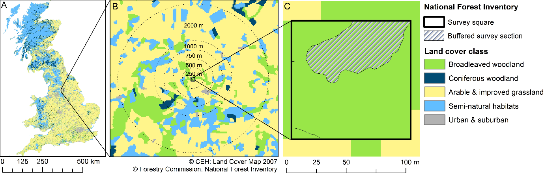
Figure S1.1 Landscape structure metrics hypothesised to influence the probability of rhododendron establishment were quantified within multiple buffers surrounding each NFI section.

Appendix S1.5 Details of data exploration and processing
Woodland patch size (“wood.size”) was omitted from the global model due to high collinearity with landscape-level woodland cover (“wood.cov”):
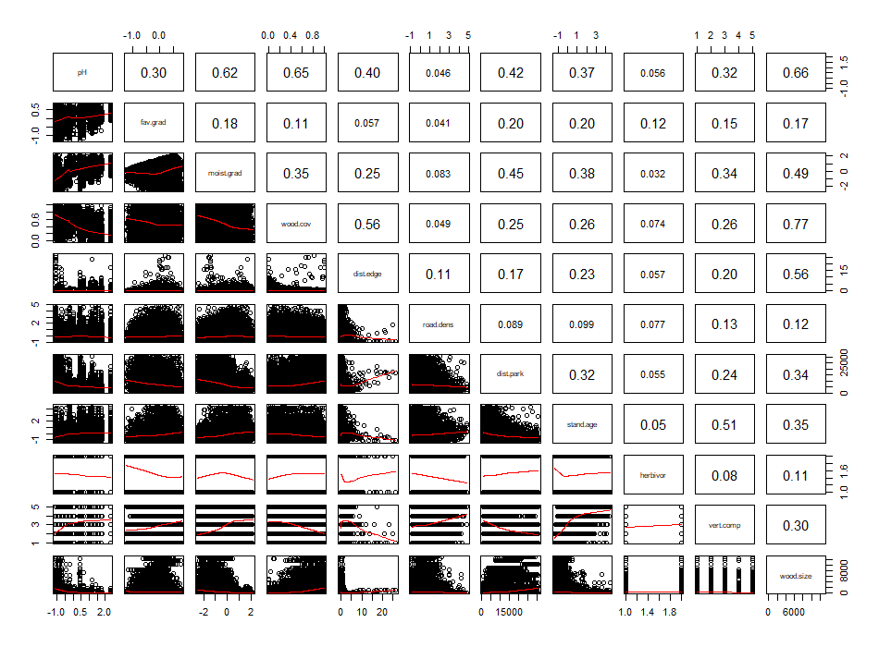
Fig. S1.2. Spearman’s rank correlation coefficients of variables considered in the analysis of rhododendron occurrence

Appendix S1.6 Details of model selection to identify important drivers and scales
To quantify how susceptibility to invasion varied with regional, landscape, local-level drivers and their interactions as hypothesised in Step 5 (Table 1), we fitted generalised linear models against a binomial distribution with a clog-log link function to the rhododendron occurrence data. Sections area varied, so section area was fitted as an offset, thus controlling for effects of section area on the probability of rhododendron occurrence. To account for the spatial non-independence of sections within squares, a single section was randomly selected from each NFI square, leaving a total of 12,473 sections. This subsampling approach was used instead of a mixed-effects modelling framework (with NFI squares identified as random effects), due to insufficient computational power and also because handling random effects in the IT environment is troublesome, particularly when averaging models⁸². All possible combinations of meaningful terms were included in models constructed by maximum likelihood methods with R package MuMIn (Barton, 2013), to allow model comparisons based on AIC with small-sample correction (AICc; Burnham and Anderson, 2004). We included quadratic relationships with regional gradients and log relationships with landscape and local-level metrics. The ΔAIC value between the best and second best model was 1.7.

Table S1.2. Parameter estimates of the minimum adequate model explaining variation in the probability of rhododendron establishment at a woodland site. Explanatory variables were centred and scaled prior to analysis to improve interpretability of regression coefficients (Schielzeth, 2010).
Explanatory variable |  | Hierarchy level | Parameter est. | Standard error | P
intercept |  | NA | -0.17 | 0.43 | <0.001
log10(woodland cover) |  | lands | 0.61 | 0.15 | <0.001
pH |  | rgn | -0.08 | 0.08 | 0.003
poly(favourability gradient,2)1 |  | rgn | -15.26 | 6.52 | <0.001
poly(favourability gradient,2)2 |  | rgn | 9.99 | 3.82 | <0.001
log10(woodland cover):favourability gradient |  | rgn: lands | 0.61 | 0.26 | <0.001
log10(woodland cover): pH |  | rgn: lands | 0.40 | 0.15 | 0.001
road density |  | lands | 0.24 | 0.03 | <0.001
distance to historic garden |  | lands | -0.82 | 0.11 | <0.001
vertical structure |  | loc | 1.35 | 0.14 | <0.001
IFT | coniferous |  | 0.05 | 0.11 | 0.042
 | broadleaved mixed | loc | 0.34 | 0.17 | <0.001
 | coniferous mixed |  | 0.36 | 0.11 | <0.001
stand age |  | loc | 0.19 | 0.37 | <0.001

Table S1.3. Relative importance values for explanatory variables contained within considerably supported models (∆AIC ≤10) explaining rhododendron occurrence. All models compared here included landscape-level variables calculated at a 500-m-extent, except road density, which was calculated within a 250-m buffer. Weights calculated by summing up the Akaike weights of models that included the term in question (Burnham and Anderson, 2004).
Term | Importance value
log10(woodland cover): | 1.00
ph | 1.00
stand age | 1.00
vertical structure | 1.00
moisture and elevation gradient | 1.00
road density | 1.00
distance to historic garden | 1.00
IFT | 0.96
log10(woodland cover): ph | 0.96
favourability gradient | 0.91
distance to woodland edge | 0.76
log10(woodland cover):favourability gradient | 0.74
log(stocking density) | 0.71
signs of herbivory | 0.27
woodland origin | 0.14

Table S1.4. Generalised variance inflation factors (GVIF) for variables contained within the minimum adequate model, calculated following Fox & Monette (1992). All GVIF values are below 2, suggesting collinearity is not an issue.
Variable | Df | GVIF
Stand age | 1 | 1.166
IFT | 3 | 1.083
Vertical structure | 4 | 1.032
Road density | 1 | 1.018
distance to historic garden | 1 | 1.110
Favourability gradient | 2 | 1.659
log10(woodland cover) | 1 | 1.374
Moisture and elevation gradient | 2 | 1.158
PH98 | 1 | 1.910
log10(woodland cover):favourability gradient | 2 | 1.712

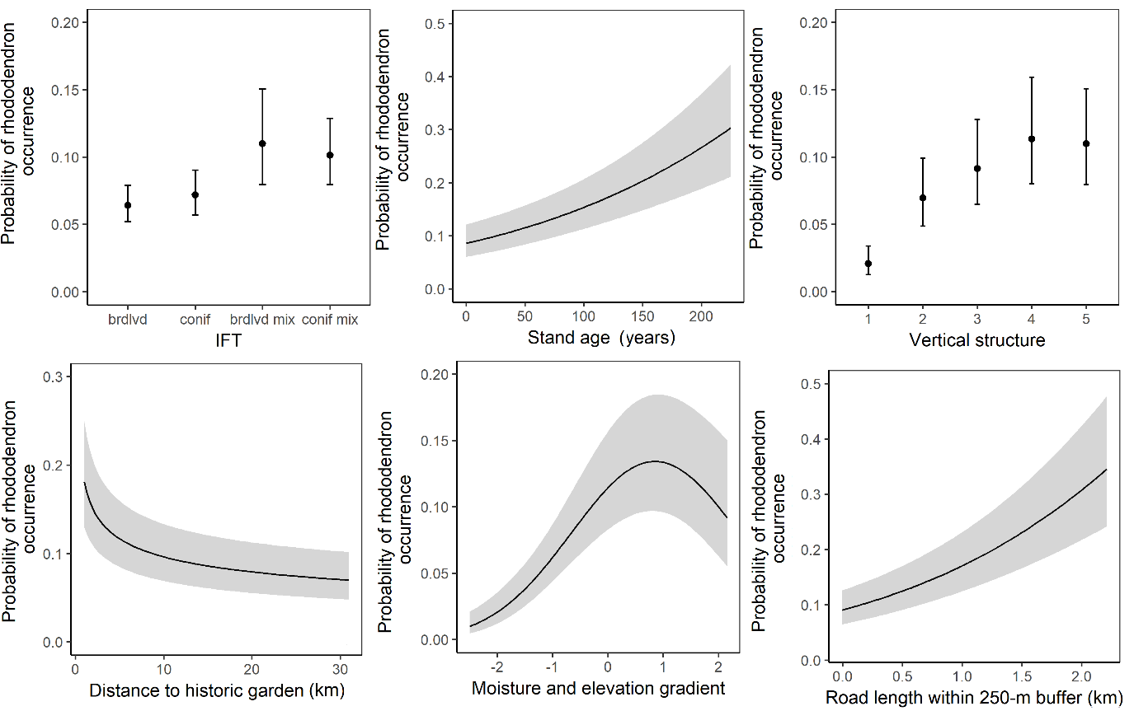
Figure S1.3. Conditional plots of variation in the probability of rhododendron occurrence in woodland sites in relation to local and landscape-level drivers. Results were graphed using coefficients from the minimum adequate model. Error bars represent 95% confidence intervals.

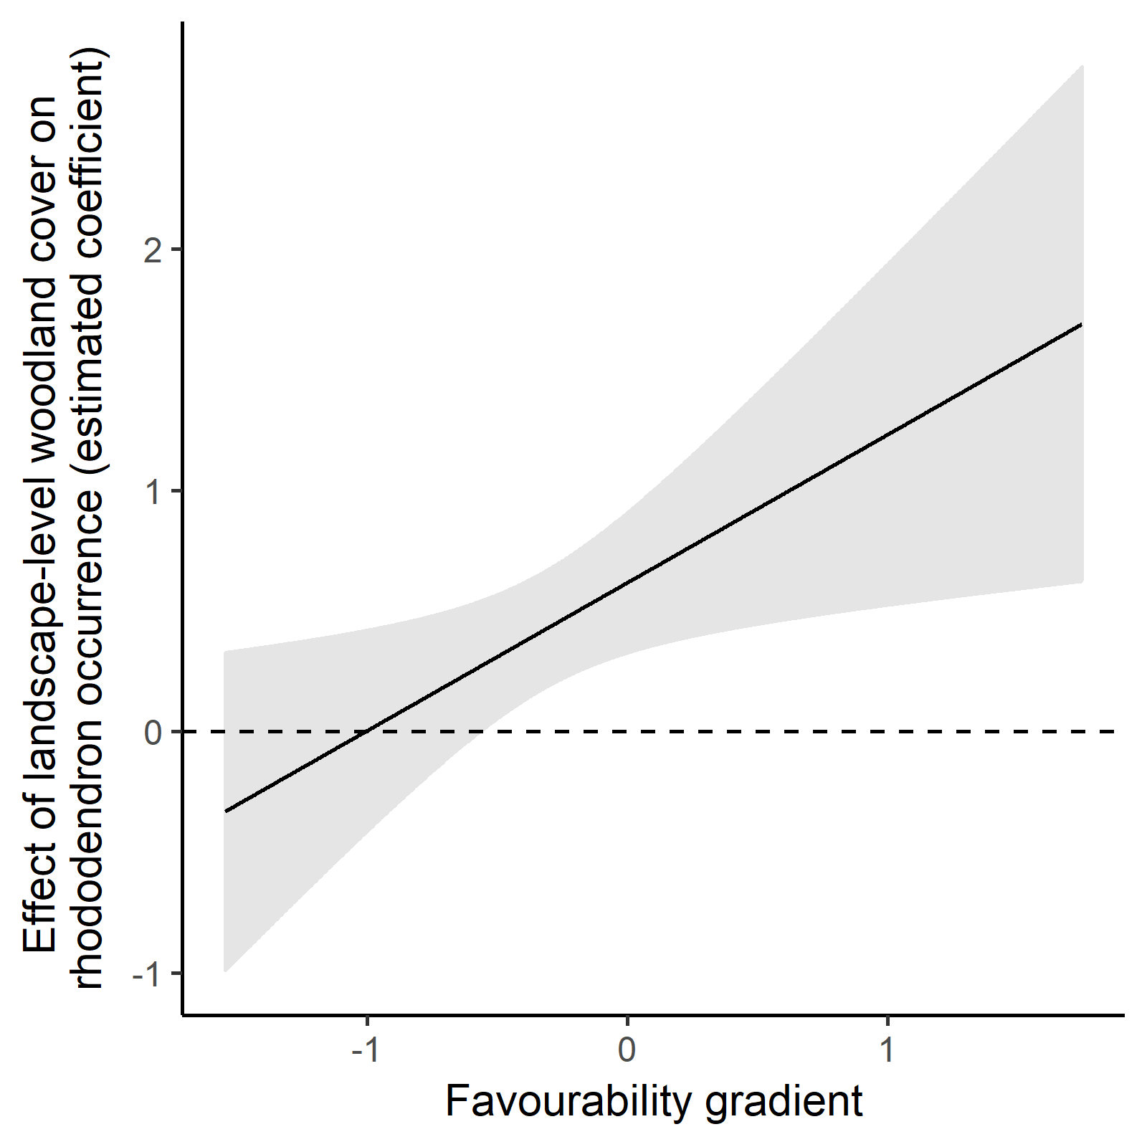
Figure S1.4. Cross-scale interactions of the effects of landscape-level woodland cover (within 500-m of a woodland site) on woodland susceptibility to invasion depends on the favurability gradient. Relationship graphed using coefficients from the minimum adequate model with conditional variables held at their mean.

Appendix S2. Further methodological details for modelling pond water quality

Appendix S2.1 Details of the drivers selected for the analysis of soluble reactive phosphorus concentrations (SRP) in ponds
Table S2.1. Drivers selected for the analysis of pond water quality
Driver | Relationships with SRP | Variable type | Source, original resolution and processing details
Region-level
Precipitation | Can increase runoff and carry agricultural runoff to ponds in agricultural areas. Could also serve to ‘flush out’ ponds, which are generally shallow in the UK. | Continuous | UK Met office  Average of monthly values across 2006-2007 / mm https://www.metoffice.gov.uk/climate/uk/data/ukcp09/datasets
Temperature | Many nutrient cycling processes, such as microbially mediated reactions, are affected by temperature. | Continuous | UK Met office  Average of monthly values across 2006-2007 / °C https://www.metoffice.gov.uk/climate/uk/data/ukcp09/datasets
Slope | High slopes can exacerbate agricultural runoff. | Continuous | OS Terrain 50, available at 50-m resolution https://www.ordnancesurvey.co.uk/xml/products/OSTerrain50Grid.xml
Soil | SRP is more susceptible to leaching in light sandy soils, and so is more likely to flow into ponds that are surrounded by intensive agriculture. | Continuous | Soil Parent Material Model (PMM) gives a soil classification at a resolution at 1-km. Proportion of 10-km square covered by soils classified as ‘light’ by the Soil Parent Material Model (PMM) https://www.bgs.ac.uk/products/onshore/soilPMM.html
Atmospheric nitrate deposition | Atmospheric deposition can be a significant source of nitrogen, which can affect N:P, ratios and so the concentration of SRP. | Continuous | Deposition maps for the UK are available at a resolution of 5km from UK Pollution Deposition. 2006-2007 average values were used for wet nitrates. Available online http://www.pollutantdeposition.ceh.ac.uk/
Landscape-level
Source cover landscape metrics | Intensive land covers including arable and improved grasslands are sources of P. | Continuous | LCM2007. Calculated in buffers of varying extents surrounding ponds. https://digimap.edina.ac.uk/webhelp/environment/data_information/lcm2007.htm
Sink cover landscape metrics | Can reduce agricultural runoff by interception. | Continuous | LCM2007 https://digimap.edina.ac.uk/webhelp/environment/data_information/lcm2007.htm
Slope (topographic position index) | Ponds with low (negative) TPI values were predicted to be more susceptible to agricultural runoff, if surrounded by intensive land uses. | Continuous | OS Terrain 50, available at 50-m resolution https://www.ordnancesurvey.co.uk/xml/products/OSTerrain50Grid.xml  A pond’s TPI equals the elevation of the pond minus the mean elevation of the surrounding area - this value can be calculated at multiple extents of the surrounding area.  SRP exhibited a Laplace distribution in relation to TPI, peaking at 0 TPI, so values were converted to absolute values for modelling, and the variable was referred to as ‘slope’.
Local-level
Inflow | Inflows directly link ponds to stream drainage systems and so are inlets of stream-borne pollutants. | Binary | CS; Presence/absence of wet or dry inflow into pond
Area | Larger area corresponds to larger perimeter for intercepting pollutants in ground water or surface runoff | Continuous | CS measured in m²
Buffer | Will intercept runoff and therefore reduce SRP concentrations | Continuous | CS; % land within 100-m zone occupied by sink land covers (woodland or scrubby vegetation).

Appendix S2.2 Defining regional contexts
Regional drivers of pond water quality (identified in Step 2) were harmonised to a common resolution of 10-km and subjected to PCA following standardisation to z-scores.

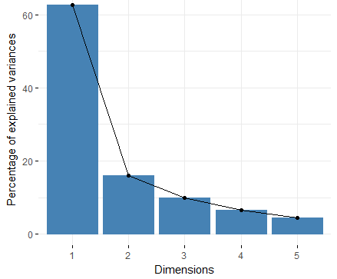
Figure S2.1. Percentage of variance explained by each axis obtained by the PCA of regional variables across the UK.

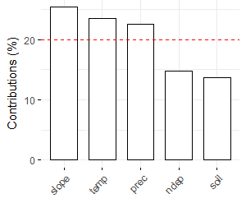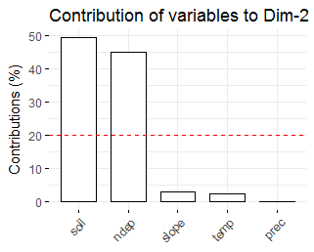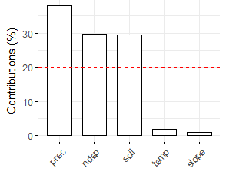
Figure S2.2. Variable contributions to three regional gradients identified by PCA. The red dashed indicates the expected average contribution if the contributions of the variables were uniform; variables with a contribution larger than this value are considered the most important.

Table S2.2. Variable correlation coefficients with the three principle components representing regional gradients across the UK. Variance values indicate the percentage of the total variance in regional heterogeneity accounted for by each principle component.
 | Axis1 | Axis2 | Axis3
prec | 0.84 | 0.02 | 0.44
temp | -0.86 | -0.14 | -0.10
soil | 0.56 | 0.63 | -0.38
slope | 0.89 | -0.16 | 0.07
ndep | 0.68 | -0.60 | -0.39
Variance / % | 62.74 | 16.13 | 10.01

Appendix S2.3 Details of model selection to identify important drivers and scales
To investigate drivers of pond water quality, we fitted generalised linear models against a negative binomial distribution with a log link function to soluble reactive phosphorous concentrations after conversion to integer values (multiplication by 1000). The model section procedure followed that for rhododendron establishment (see main text).
The minimum adequate model explaining variation in pond water quality contained intensive land cover within 250-m of the ponds and its interaction with the soil gradient (Axis 2), a main effect of the precipitation gradient (Axis 1) and the presence of inflows (Tables S2.4-S2.7).
Table S2.3. Parameter estimates of the minimum adequate model that explained pond soluble reactive phosphorous concentration. Explanatory variables were centred and scaled prior to analysis to improve interpretability of regression coefficients (Schielzeth, 2010).
Explanatory variable | Hierarchy level | Parameter estimate | Standard error | P | Importance value*
Intercept | NA | 5.10 | 0.23 | <0.001 | NA
Intensive cover | Landscape | 1.35 | 0.187 | <0.001 | 1.00
Soil gradient (Axis 2) | Regional | -0.14 | 0.17 | 0.488 | 1.00
Inflow | Local | -0.67 | 0.33 | 0.040 | 0.70
Soil gradient: Intensive cover | Regional: landscape | 0.54 | 0.19 | 0.003 | 1.00

Table 2.4. Relative importance values for explanatory variables contained within considerably supported models (∆AIC ≤10) explaining pond soluble reactive phosphorous concentrations. All models compared here included landscape-level variables calculated at a 250-m-extent. Weights calculated by summing up the Akaike weights of models that included the term in question (Burnham and Anderson, 2004).
Term | Importance value
intensive cover | 1.00
soil gradient | 0.95
soil gradient: intensive cover | 0.84
inflow | 0.70
slope | 0.50
precipitation gradient | 0.47
buffer | 0.34
inflow: intensive cover | 0.19
precipitation gradient: intensive cover | 0.13
buffer: intensive cover | 0.09

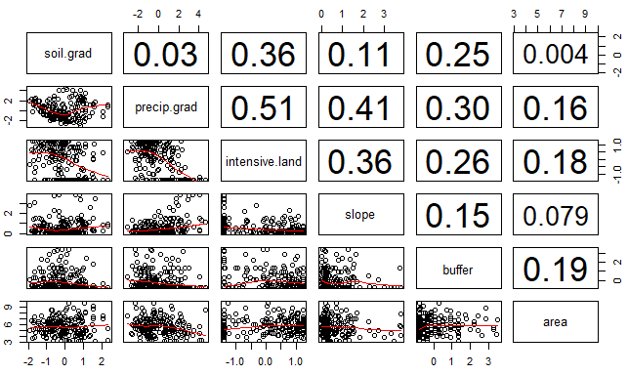
Fig. S2.3. Spearman’s rank correlation coefficients of variables considered in the analysis of pond water quality.

Table S2.4. Generalised variance inflation factors (GVIF) for variables contained within the minimum adequate model, calculated following Fox & Monette (1992). All GVIF values are below 2, suggesting collinearity is not an issue.
Variable | Df | GVIF
Soil gradient | 1 | 1.18
Intensive cover | 1 | 1.17
soil gradient: intensive cover | 2 | 1.03
inflow | 1 | 1.02

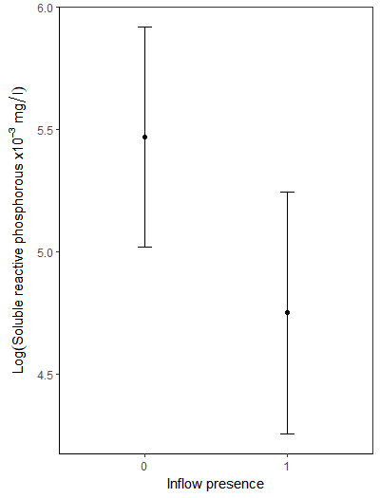
Figure S2.4 Conditional plot of variation in pond soluble reactive phosphorus concentration in relation to inflow presence. Results were graphed using coefficients from the minimum adequate model. Error bars represent 95% confidence intervals.

Supplementary Information References
Bartoń, K. MuMIn: model selection and model averaging based on information criteria (AICc and alike) R package version. (2018).
Burnham, K. P. & Anderson, D. R. Model Selection and Multimodel Inference: A Practical Information-Theoretic Approach (2nd ed). Ecological Modelling 172, (2002).
Dehnen-Schmutz, K., Perrings, C. & Williamson, M. Controlling Rhododendron ponticum in British Isles: An economic analysis. J. Environ. Manage. 70, 323–332 (2004).
Forestry Commission (2017). National Forest Inventory field survey data, first cycle. https://www.forestresearch.gov.uk/tools-and-resources/national-forest-inventory/
Fox, J. and Monette, G. Generalized collinearity diagnostics. JASA, 87, 178--183. (1992).
Morton, R. D. et al. Land Cover Map 2007 (25m raster, GB) v1.2. (2014).
Thomson, A. G., Radford, G. L., Norris, D. A. & Good, J. E. G. Factors affecting the distribution and spread of Rhododendron in North Wales. J. Environ. Manage. 39, 199–212 (1993).
VanDerWal, J., Falconi, L., Januchowski, S., Shoo, L., & Storlie, C. SDMTools: Species distribution modelling tools: Tools for processing data associated with species distribution modelling exercises. R package version 1.1‐221. (2014).

