Democratisation of AAC Symbol Choices using Technology
E.A. DRAFFAN^{a,}, Mike WALD ª , Nadine ZEINOUN^{b} and David BANES^{c}
ª WAIS, ECS, University of Southampton, UK
^{b} Mada Assistive Technology Center, Qatar
^{c} David Banes Access and Inclusion Services, UK
Abstract. The use of an online voting system has been developed to enable democratic choices of newly designed symbols to support speech, language and literacy skills in a localisation situation. The system works for those using and supporting Augmentative and Alternative Communication (AAC) symbols on electronic systems by the provision of simplified scales of acceptance and adapted grids. The methodology and results highlighted the importance of user participation at the outset and concrete examples of symbol adaptations that were found necessary to ensure higher levels of user satisfaction. Design changes included appropriate local dress codes, linguistic nuances, social settings, the built environment and religious sensitivities.
Keywords. AAC, symbols, communication, voting, user participation, technology

Introduction
Choosing a suitable symbol set and then individual symbols for those who need pictograms or images as a form of Augmentative and Alternative Communication (AAC) can be difficult and at times frustrating [1]. The core vocabulary lists used to support the choices may not be readily available in some languages and it has even been said that some professionals may not necessarily be the best people to make the selections [2]. Where there are cultural and very different social settings involving bilingualism, the complexities of successful symbol choices increase and the importance of AAC users’ involvement along with their families and carers is essential [3].
However, there has been very little research in the area of choosing symbol sets suitable for those working in the Middle East and many professionals have felt they lacked support, knowledge and training in this area [4]. A recent project involving the development of a symbol dictionary for those living in a bilingual situation in the Gulf State of Qatar provided further insights into these issues, as the two main symbol sets in use had been developed in USA and Europe. The team made the decision to involve AAC users, their families and carers alongside professionals at the outset of the project. The idea of enabling participation in symbol choices was part of a wider remit, which also involved the building of a list of frequently used words and phrases in Arabic specific to speech, language and literacy skill development.
Despite limited communication competency levels [5] a group of young individuals using symbol systems, some with considerable speech and language difficulties joined professionals and families in the design of new symbols that better suited their cultural, social, environmental and religious settings rather than those offered by the westernised symbol sets. Technology provided the key to allowing independent voting to take place and at times very definite reactions as to why a symbol was or was not acceptable were noted when AAC users indicated their choices.
The aim of the voting sessions was to establish whether, not only the design of the symbols for individual words or phrases was acceptable, but also to learn which symbols did not have to be changed from the ones already in use, as no one wanted a completely new symbol set.

Method
Democratisation has been defined as “the action of making something accessible to everyone”[6] and in the methodology designed to enable those using AAC devices equal access to a symbol voting system, several issues had to be addressed. These included ensuring there was support from families, carers and the professionals involved, with well-defined ethical considerations. There were no stipulations as to who should join in the participation for the design of the new symbols, other than an interest in the subject. Organisations supporting those with speech, language and literacy skill difficulties were contacted and teachers and therapists then contacted their clients’ families to ask if they would like to support the project. There were no incentives offered, other than immediate use of any symbols developed for the word lists they supplied in their language of choice – in this case Arabic and English. Those willing to participate could choose the amount of time they wished to spend on the project and could leave at any time.
Distance, travel, time and costs were concerns for all involved, so an online symbol management system was developed and trialled with 10 therapists and teachers plus two AAC users who had considerable mobility, dexterity, speech and language disabilities. The Arabic / English symbol management system had a database that was used for uploading lexical concepts with metadata and symbols with categories, which fed into an accessible web based front-end. This could be adapted to work on a Sensory Software Grid 2 system [7] with a bespoke grid using the newly designed symbols and their labels. The initial trial resulted in several changes to the voting system design, until it appeared more like a flash card. This could be used with large submit /previous/next buttons and a Likert scale that was set at 1-5 acceptance levels where 5 was completely acceptable. There was a chance to add comments in a free text field, which was placed after the 1-5 Likert scale for four criteria:

- Feelings about the symbol as a whole
- Represents the word or phrase
- Colour contrast
- Cultural sensitivity. (See Figure 1)

There was an alternative of a 1-3 scale or a simpler ‘thumbs up’ and ‘thumbs down’ symbol version for the Grid 2 systems.

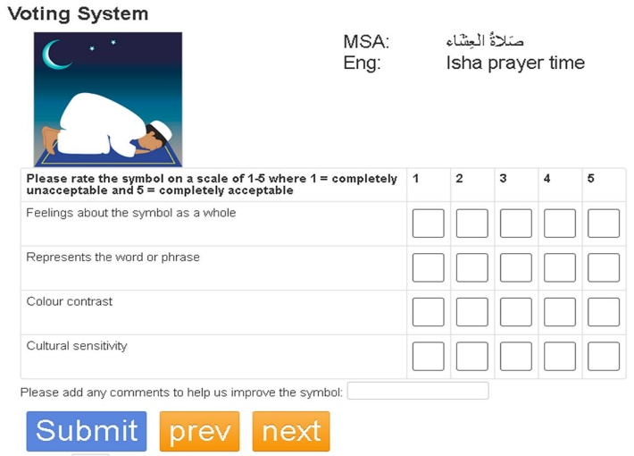
Figure 1. Symbol Voting System

Face to face voting sessions were organised to enable training times and early discussions. The participants became known as the AAC Forum and were kept up to date with the project via a blog and an email list. At the beginning of the project, there were four young adult AAC users, their parents and carers along with 55 therapists, teachers and professionals who worked with symbol users. By the end of the project a further 11 specials needs students joined in the process along with their teachers from one college.
Batches of symbols were presented with up to 65 at a time for those using the 1-5 Likert scale down to 10 or 20 at a time for the AAC users or those students with special needs. Results were gathered automatically via the online system and presented in Excel spreadsheets or scores were added later from paper-based collections. Any symbol voted 3.5 or above was seen as being acceptable, unless a comment triggered the need for further changes.
Alongside the participatory methodology, the ISO 9241-210:2010 human centred design framework provided a useful standard, stating amongst other requirements:

• “Project planning shall allocate time and resources for the human-centred activities. This shall include time for iteration and the incorporation of user feedback, and for evaluating whether the design solution satisfies the user requirements.
• Relevant user and stakeholder groups shall be identified and their relationship with the proposed development described in terms of key goals and constraints.
• There are four linked human-centred design activities that shall take place during the design of any interactive system
a) Understand and specify the context of use;
b) Specify the user requirements;
c) Produce design solutions;
d) Evaluate.”[8]

An iterative process was successfully built up as the project progressed with the graphic designer adapting rejected symbols and creating new symbols based on the comments received and voting results. Over time, a set of principles for symbol design began to appear and where there were small differences, voting was not required. Early indications were that this system could be useful for others designing symbols where localisation changes were necessary.

Results
There were usually two voting sessions for each batch of symbols with 127 individuals voting over the two years, providing 3,451 comments for 504 newly developed symbols of the 626 symbols available by November 2016. The proportion of participants who voted on each batch of symbols increased over time with 46% of participants voting on all the batches and only 8% from the first batch not taking part in all the voting sessions. At all times there was a choice of online voting as well as face to face sessions held in local centres. Family, carers and therapists or teachers supported those using AAC systems enabled users to select their choices independently.
The results were collated in Excel spreadsheets, comments were analysed and as mentioned, feedback to the graphic designer was immediate. The iterative process continued and resources began to build up to the extent that it was important to reflect on the type of resources that would be provided to the public at a remarkably early stage in the project.
There was a distinct improvement in cultural acceptance of symbols over time (see Figure 2). However, it was interesting to note that as the word lists began to have more abstract or complex words and phrases, there were dips in the acceptance levels for the word or phrase being accurately represented by the symbol.

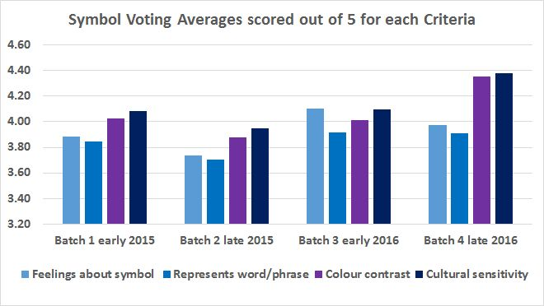
Figure 2 Data collected from the four batches of symbols voted on during voting sessions.
The differences in results between batch 2 and 3 were attributed to a number of factors. In the third session (one of the sessions for batch 2), having analysed the earlier voting results, voters were encouraged to provide more detailed comments about the suitability of the symbols. This may have caused voters to be increasingly critical in their feedback. Furthermore, it was found that as the voting sessions became more widely appreciated, those taking part openly commented when in face to face voting sessions, perhaps realising that their input was making a difference. It was also found that face to face sessions resulted in invaluable discussions between participants, but took up more time and involved as a considerable amount of forward planning and organisation.

As the majority of comments were based around the cultural differences in clothing and body imagery, a separate survey was undertaken to clarify the situation. There was a debate about local attire versus the wider community and the acceptance of symbols using stick characters. The results showed 68% of those voting wanted to see general discrete clothing and when asked about stick figures 86% preferred coloured symbols with people. The team decided that it was best to create symbols with general discrete clothing as well as Islamic attire and no stick characters to serve the needs of all those voting and other communities. This decision was supported by comments such as "Some wear normal clothes and some wear abaya and this is the reality", "I prefer one to wear the abaya, one to wear a normal hijab and one without a hijab". "I don't like stick figures".

The voting results were collated and preferences began to appear, so that a set of symbol design principles could be shared with the participants. There was general agreement that many of the changes necessary had been accomplished and could be published as an open resource on the symbol dictionary blog in an illustrated format that is presented in text below:

Dress
- Qatari families: Abaya and Shela (all hair covered)
- Qatari males: Thobe and Ghutra
- General Arab dress code: Hijab and modest clothing
Linguistics
- Flip symbols to follow Arabic sentence orientation
- Male and female version for each symbol
- Differentiate dual and plural symbols
Social and Demographics
- Darker physical features for characters
- Facial hair for adult male characters
- Limit mixing and show of affection with opposite sex
Environment
- Use local currency
- Less greenery in the environment
- No stick figures
Religion
- Consider religious sensitivities
- Include religious holidays, customs, local landmarks and food

Finally, it was also possible to reveal that once high levels of agreement and acceptance had been collected, the symbols could be uploaded to the Tawasol symbols website and shown to a wider audience with downloads occurring on average at least once a week over a period of six months before dissemination practices were in place. But ultimately the success of the project should be defined by the number of individuals who were using the symbols to communicate and engage with content. By the end of the project the symbols were being made available to over 240 people, including Arabic speakers with autism, cerebral palsy, speech impairments, hearing loss and dyslexia.

Mohammed’s brother seen in a video called “Share and Believe, A Symbolic Journey” where he is praying with Mohammed using the Tawasol symbols commented: “I am so happy because Mohammed is able to pray with me using the prayer symbols on his Eye Gaze system. Knowing that he is excused from praying, but I am happy to see him trying to pray.”

Discussion
“Communication across cultures reveals that nonsymbolic as well as symbolic forms of communication are culturally dependent”[10] and that “participants’ cultural/linguistic experiences may be significant elements to consider when selecting graphic symbols and when teaching consumers to represent meaning through them.” [10] But the localisation of symbols, as a general concept, is rather different when compared to developing symbols for an individual. Personal preferences always need to be taken into account, but it is felt that by developing a user-friendly voting system some decisions regarding cultural, social, environmental and religious suitability can be made with the support of interested parties.

The use of social media and continued support from the AAC Forum has not only increased dissemination of the symbols, but has also encouraged further discussions about the localisation process used in this project. In particular, acceptance of a number of symbols that can be used in religious settings and how these have been received by other Islamic communities.

Making use of the localisation symbol design principles developed in the manner suggested, may also provide guidance for others working with symbols in other cultures and social settings and environments across the world. The symbol dictionary project has now made over 800 freely available symbols and these can be adapted to suit personal preferences, along with other downloadable resources all developed under a creative commons licence. They have already been used in several AAC apps and refugee settings, having reached over 50 countries.

It is felt that a democratic model of participation with a community of AAC symbol users and supporters has been established, although there remains further research to be carried out into ways of making the graphic design process easier, now that it might be possible to investigate crowdsourcing methods of symbol acceptance.

Conclusion
Despite three years of symbol development for localization purposes, it is felt that there is still a need to increase knowledge around participatory research combined with the use of interactive technologies to enhance and speed outcomes that provide practical results for AAC users. There is also a requirement to encourage further questioning of the content of core and fringe vocabularies where bilingual environments can bring together very different linguistic situations affecting AAC users and those with speech, language and literacy skill difficulties. These vocabularies are fundamental to the design of the most useful symbols and how they are presented on symbol charts and digital systems.
The Tawasol symbol research has also highlighted the demand for further research into systems that allow for the easy localisation of AAC symbols by external designers that can then be incorporated into other symbols sets to allow for personalisation and ensure mapping between those symbols already available. This would allow for collaboration and offer users access to online communication between each other whatever symbol set is in use as well as successful symbol to text translation.
Finally, localisation as well as personalisation of symbol based communication systems is essential in bilingual situations. This should be led by users with their families, carers, teachers and other professionals because impersonal language translation options inevitably fail to recognise the obvious and subtle differences between the wide range of social, linguistic, environment and religious nuances experienced by all AAC users in their own surroundings.

Acknowledgements
This research was made possible by the NPRP award [NPRP 6 - 1046 - 2 - 427] from the Qatar National Research Fund (a member of The Qatar Foundation) and thanks must go to all those participants in Doha who have contributed to the work of the Arabic Symbol Dictionary team. Grateful thanks are also expressed to the ARASAAC team for allowing their symbols to be used with participants. The statements made herein are solely the responsibility of the authors.

References
- Beukelman, D., McGinnis, J., & Morrow, D. (1991). Vocabulary selection in augmentative and alternative communication. Augmentative and Alternative Communication, 7(3), 171-185.
- Balandin, S., & Iacono, T. (1998). A few well-chosen words. Augmentative and Alternative Communication, 14(3), 147-161.
- Subihi, A. S. (2013). Saudi Special Education Student Teachers' Knowledge of Augmentative and Alternative Communication (AAC). International Journal of Special Education, 28(3), 93-103.
- Rossi, C., & Balandin, S. (2005). Bilingualism, culture and AAC. Acquiring Knowledge in Speech, Language and Hearing, 7(1), 27-29.
- Light, J. (1989). Toward a definition of communicative competence for individuals using augmentative and alternative communication systems. Augmentative and Alternative Communication, 5(2), 137-144.
- Oxford University Press (OUP) (2017) Democratisation second definition Oxford Living Dictionaries Retrieved 23rd February, 2017 from https://en.oxforddictionaries.com/definition/democratization
- Sensory Software (2015) SmartBox Grid 2 Retrieved 23rd February, 2017 from https://thinksmartbox.com/product/the-grid-2/
- Bevan, N. (2009). International standards for usability should be more widely used. Journal of Usability Studies, 4(3), 106-113.
- Huer, M. B. (1997). Culturally inclusive assessments for children using augmentative and alternative communication (AAC). Journal of Children’s Communication Development, 19 (1), 23–34.
- Huer, M. B. (2000). Examining perceptions of graphic symbols across cultures: Preliminary study of the impact of culture/ethnicity. Augmentative and Alternative Communication, 16: 180-185.

Corresponding Author. E.A. Draffan, WAIS, ECS, University of Southampton, Southampton, UK; E-mail: ead@ecs.soton.ac.uk
YouTube https://youtu.be/68TbCVNQ3Z8

