PROF. GEORGE V. PAPATHEODORIDIS (Orcid ID : 0000-0002-3518-4060) PROF. S KHAKOO (Orcid ID : 0000-0002-4057-9091)
Accepted
Article

Article type : Original Paper

Immunological biomarkers as indicators for outcome after discontinuation of nucleos(t)ide analogue therapy in patients with HBeAg negative chronic hepatitis B

Running title: Biomarkers for cessation of NAs in CHB

Hariklia Kranidioti1, 2 , Spilios Manolakopoulos2,3, George Kontos2, Michael S. Breen1, Anastasia Kourikou2, Melanie Deutsch2, Maria Ester Quesada-Del-Bosque1, Rocio T. Martinez-Nunez1, Mohammed M. Naiyer1, Christopher H. Woelk1, Tilman Sanchez-Elsner1, Emilia Hadziyannis3, George Papatheodoridis3, Salim I. Khakoo1

1Department of Clinical and Experimental Sciences, Faculty of Medicine, University of Southampton, United Kingdom

22nd Academic Department of Internal Medicine, Hippokration General Hospital of Athens, Greece

3Academic Department of Gastroenterology, Laiko General Hospital of Athens, Greece

This article has been accepted for publication and undergone full peer review but has not been through the copyediting, typesetting, pagination and proofreading process, which may lead to differences between this version and the Version of Record. Please cite this article as doi: 10.1111/jvh.13068

Correspondence:
Accepted
Article

Salim Khakoo

Mailpoint 811, Level E, South Academic Block, Southampton General Hospital Tremona Road, Southampton, SO16 6YD
E-mail: s.i.khakoo@soton.ac.uk, Tel: (0)23 8120 4004/5099

Acknowledgments:

This work was supported by European Association for the Study of the Liver (EASL Physician Scientist Fellowship) and Bristol-Myers Squibb. We would like to acknowledge the contribution of Dr Borislav Dmitrov to this work.

Conflict of interest:

HK: Research support from Bristol-Myers Squibb. SM: Research grants, lectures and advisory boards for Gilead, Abbvie, Novartis, GlaxoSmithKline, Janssen, Merck Sharp & Dohme, and Bristol-Myers Squibb. MD: Advisory board for Gilead, lecturer for Gilead and BMS. EH: Research grant from Gilead. GP: advisor/lecturer for Abbvie, Boehringer Ingelheim, Bristol-Myers Squibb, Gilead, GlaxoSmithKline, Janssen, Merck Sharp & Dohme, Novartis, Roche; research grants from Abbvie, Bristol- Myers Squibb, Gilead, Janssen, Roche, Data Safety Management Board for Gilead. SIK: Advisory board for Bristol-Myers Squibb, research grants from Bristol-Myers Squibb and Gilead. GK, BD, MSB, AK, MEQDB, RTMN, MMN, CHW, TSE, EH: No conflict

Author contributions:
Accepted
Article

Conception and Design: H.K., S.M., S.I.K., Data collection: H.K., S.M, G.K., A.K., M.D., G.P.;

Experimental design: S.I.K., S.M., H.K., T.S.E., M.E.Q.B., R.T.M.N., M.M.N., C.H.W., E.H.;

Experimentation: H.K.; Data Analysis: H.K., M.S.B., B.D.; Manuscript writing: H.K., S.M., S.I.K.

ABSTRACT

The optimal duration of treatment with nucleos(t)ide analogues (NAs) for patients with HBeAg-negative Chronic Hepatitis B (CHB) is unknown. The aim of this study was to identify an immune signature associated with off-treatment remission to NA therapy. We performed microarray analysis of PBMCs from six patients with chronic hepatitis B who stopped NA therapy (3 with off-treatment remission, 3 with relapse) and 5 patients with chronic HBV infection (previously termed “inactive carriers”) served as controls. Results were validated using qRT-PCR on a second group of 21 individuals (17 patients who stopped treatment and 4 controls). PBMCs from 38 patients on long-term NA treatment were analysed for potential to stop treatment.

Microarray analysis indicated that patients with off-treatment remission segregated as a distinct out-group. Twenty-one genes were selected for subsequent validation. Ten of these were expressed at significantly lower levels in the patients with off-treatment remission compared to the patients with relapse and predicted remission with AUC of 0.78-0.92. IFNγ, IL-8, FASLG and CCL4 were the most significant by logistic regression. Twelve (31.6%) of 38 patients on long-term NA therapy had expression levels of all these four genes below cut- off values, and hence were candidates for stopping treatment. Our data suggest that patients with HBeAg-negative CHB who remain in off-treatment remission 3 years after NA

cessation have a distinct immune signature and that PBMC RNA levels of IFNγ, IL-8, FASLG and CCL4 may serve as potential biomarkers for stopping NA therapy.
Accepted
Article

Keywords: Chronic hepatitis B; Nucleos(t)ide Analogues; treatment discontinuation

INTRODUCTION

Chronic infection with hepatitis B virus (HBV) remains a serious public health problem worldwide with a high morbidity and mortality rate 1. Patients with active viral replication and necro-inflammation who remain untreated are at particular risk for cirrhosis and hepatocellular carcinoma (HCC) 2, 3. The infection can be controlled either with a limited course of interferon-α or long term nucleos(t)ide analogue (NA) therapy 4, 5. Potent first line nucleos(t)ide analogues (NAs) have been widely used and found to be associated with virological response, biochemical remission, reversion in liver fibrosis and significant reduction in morbidity and mortality 5-8. However, long-term administration of NAs has raised several safety and economic issues, making the question of treatment discontinuation an emerging issue especially in patients with HBeAg negative chronic hepatitis B (CHB).
Several small studies have shown that a proportion of patients remained in remission after NA discontinuation 9-13. Therefore, the Asian Pacific Association 14 and more recently European guidelines 5 recommended that NAs could be discontinued in selected, non- cirrhotic HBeAg negative patients who have achieved virological suppression for at least 3 years and are under close monitoring 5. However, as 55% to 70% of patients relapse within 24 months after NA discontinuation, and since no acceptable end point marker exists to safely predict long term off treatment remission, NA discontinuation in HBeAg negative patients still remains a debatable issue 9-13.

Control of HBV infection involves the host immune response to control viral replication, whilst HBV has evolved mechanisms to evade both innate and adaptive immune responses in order to establish persistent infection 15. Long-term therapy with NAs seems to facilitate the restoration of the host immune system following reduction of serum HBV DNA 16.
Accepted
Article
Biochemical rebound in patients after NA discontinuation, followed by HBsAg clearance in some of them, might be explained by the restoration of immune system functions at the time of NA discontinuation. Patients who can control virological rebound and remain in remission or develop off-treatment HBsAg clearance may have different immunological characteristics compared to individuals in different stages of HBV infection. In this study we investigated whether peripheral blood mononuclear cell (PBMC) RNA levels are associated with off- therapy remission acting therefore as potential immune-related biomarkers to identify individuals with HBeAg-negative CHB on NA therapy who can benefit from stopping treatment.

PATIENTS AND METHODS

Patients

In July 2013 we initiated a prospective multicentre study examining the potential of NA discontinuation in patients with HBeAg-negative CHB who were receiving NA therapy for at least five years and had no evidence of cirrhosis before NA initiation. The current study represents a group of patients with long-term (3 years) of follow-up after treatment discontinuation that were recruited from the outpatient clinic of the 2nd Academic Department of Internal Medicine at “Hippocration” General Hospital of Athens, Greece.

Twenty-three adult patients under maintenance therapy stopped NA treatment. The main inclusion criteria for participation in the discontinuation study were as follows: documented HBeAg negative chronic hepatitis B before NA therapy initiation, absence of cirrhosis defined by liver stiffness <10 kPa assessed by transient elastography (Echosens) or Ishak

score <4 at liver biopsy; treatment with NA or a combination of NAs for at least 5 years and undetectable serum HBV DNA for at least 4 years. Patients were excluded if they had: co- infection with hepatitis D virus (HDV), hepatitis C virus (HCV) or human immunodeficiency virus (HIV); any additional cause for liver injury; history of liver decompensation, malignancy including hepatocellular carcinoma (HCC) or history of liver transplantation. The study was approved by an independent ethics committee of the Hippocration General Hospital and was conducted according with the principles of the Declaration of Helsinski. All patients signed an informed consent before screening for their participation.
Accepted
Article

Nine untreated patients with HBeAg-negative chronic HBV infection (previously termed “inactive carriers”) served as controls for the present study. All of them were HBsAg positive, HBeAg negative / anti-HBe positive with ALT values <40 IU/l on at least 4 occasions for the last 12 months, serum HBV DNA levels <2,000 IU/mL and liver stiffness < 7 kPa at transient elastography.
A second matched population of thirty-eight non-cirrhotic HBeAg-negative CHB patients under maintenance therapy without stopping NAs were recruited to assess the potential for using cut-off values of identified genes to stop treatment.

Study Design - Definitions

The study was divided into two parts. Firstly, an investigative study to identify determinants associated with off-treatment remission and secondly a cross-sectional analysis of patients on long-term treatment (Figure 1). This second part was conducted to investigate if determinants identified in the first part of the study could be used to subdivide patients on NA therapy into two discrete populations, one of which could be targeted for cessation of therapy.

PBMC samples for gene expression analysis were collected at the end of treatment (EOT) and at 6th months after NA discontinuation for three of the patients. All patients were followed-up for at least 36 months after stopping treatment. According to the protocol all patients had monthly visits during the first 3 months and every 2 to 3 months thereafter. Clinical examination and liver function tests were performed at each visit. Serum HBV DNA levels were measured every 3 months for the first year and 6 monthly thereafter. Serum HBsAg quantification was performed at the EOT and every 6 months. The upper limit of normal (ULN) for ALT and AST was 40 IU/L and serum HBV DNA levels were assessed by a polymerase chain reaction assay with sensitivity of 13 IU/mL.
Accepted
Article

In the present study the definition of remission was based on the combination of biochemical and virological profile; remission was defined as ALT < 40IU/l and serum HBV DNA levels < 20,000 IU/mL or ALT > 40IU/l in only one-measurement and serum HBV DNA levels < 20,000 IU/mL for at least 36 months after treatment cessation.

Methods

Isolation of PBMCs and mRNA purification

Blood samples were collected from 23 patients who stopped NA treatment at the End Of Treatment (EOT) and 3 of the patients with off-treatment remission at 6th months post- therapy cessation. Blood samples were also collected from 38 patients on long-term NA therapy and from 9 controls. PBMCs were isolated from 10-20 mls blood using Ficoll Histopaque 1077-1 (SIGMA, St Louis, MO, USA) density centrifugation. Cell pellets were lysed with TRIzol (Invitrogen, Life Technologies, Grand Island, NY, USA) and kept at -80 °C until mRNA extraction. mRNA was extracted and purified using the RNeasy Mini kit (QIAGEN, CA, USA). A NanoDrop 1000 Spectrophotometer (Thermo Scientific, Wilmington, Delaware) was used to determine the quality and quantity of the mRNA.

Agilent Whole Human Genome Oligo Microarrays
Accepted
Article

Agilent Whole Human Genome Oligo Microarrays (Miltenyi Biotec, GmbH) were used to analyse PBMCs: taken at the EOT from 3 patients with off-treatment relapse; from 3 patients with off-treatment remission taken at the EOT and at 6th months post-treatment; and from 5 controls. Microarray image files were processed using Agilent Feature Extraction software (FES, Agilent Technologies, Inc). For determination of differential gene expression FES derived output data files were further analysed using the Rosetta Resolver® Gene expression data analysis system (Rosetta Inpharmatics LLC). The signal intensities were normalized by dividing the intensity values by their median. The significance threshold was a nominal p-value p<0.05. Principal component analysis (PCA) was performed using the rgl package in R 17. Results were also displayed as a Heat map using MultiExperiment Viewer
18. To assess the relationship between the genes, Kyoto Encyclopaedia of Genes (KEGG)
and Genomes pathway analysis (DAVID v6.7) 19 software were applied.

Reverse transcription - qRT-PCR

mRNA samples of 10 patients with off-treatment relapse (at the EOT), from 7 patients with off-treatment remission (at the EOT), from 4 controls and from 38 patients on NA therapy were used for qRT-PCR. cDNA was reverse transcribed using Applied Biosystems High Capacity cDNA Kit (USA). qPCR was performed using Taqman® Low Density Array System (Life Technologies, USA). The TaqMan array was designed for custom configuration with 21 pre-dispensed primer assays for the target genes and 3 for the endogenous controls (Housekeeping genes: GAPDH, B2-microglobulin and B-actin). Relative levels of gene expression were calculated using ΔCt (threshold cycle) method. The GAPDH housekeeping gene was used to normalize the RNA amounts. Results are expressed relative to GAPDH using the equation: Relative quantity (Fold change): 2-ΔCt, where ΔCt = Ct target gene – Ct GAPDH

Statistical Analysis
Accepted
Article

Data was analysed using GraphPad Prism 6.0 (GraphPad Software, Inc., San Diego, CA) and SPSS (version 22; SPSS Inc, Chicago, IL). Patient characteristics were compared using Mann-Whitney test for continuous variables and chi-square or Fisher’s exact tests for categorical variables. The Mann-Whitney test was used to compare gene expression levels between the clinical groups and Wilcoxon matched-pairs signed rank test to compare gene expression levels between different time points of the same individuals. Receiver Operating Characteristic (ROC) curves for the accuracy of prediction of off-treatment remission or relapse were derived and thresholds of gene expression levels were calculated [with areas under the ROC curves (AUCROC) and their 95% confidence intervals (CI)]. Gene expression levels were log-transformed to achieve normality and to be included in the univariable logistic regression analysis. Multivariable logistic regression analysis was applied to the predictors, which were significant at the univariable analysis. Correlations were analysed using the Spearman’s rank test (rho). The level of p<0.05 was considered to be statistically significant.

RESULTS

Population characteristics and outcome

The main characteristics of the patients are shown in Table 1. For the individuals that stopped NA therapy, the mean age was 59±9 years and 15 of the 23 patients were males. The median duration of NA treatment was 8 (5-14) years and the median off-treatment follow-up period 4.6 (3.2-5.2) years. Off-treatment remission was observed in 10 of the 23 patients (43%); Seven out of ten patients with remission achieved non-detectable serum HBV DNA levels at 30 (±20) months after treatment discontinuation. Two patients had ALT
>40 Ul/mL in only one measurement during the follow-up.

According to the study design, six of the 23 patients and 5 of the controls were used to perform whole genome gene expression analysis (“development cohort”). Three out of six patients relapsed after a mean of 2.6 (±0.6) months and three had off-treatment remission with median serum HBV DNA levels 172 (0-9300) IU/ml, 2000 (0-4000) IU/ml, 2470 (0-4410) IU/ml at 12, 24 and 36 months respectively. Seventeen of the 23 patients and four of the controls were studied as a “validation cohort” performing the qRT-PCR gene expression analysis. Ten of these had off-treatment relapse after a mean of 5.2±4 months and seven had remission with median serum HBV DNA levels 3084 (0-9200) IU/ml, 170 (0-6650) IU/ml, 63 (0-10907) IU/ml at 12, 24 and 36 months respectively. HBV DNA levels of the patients with off-treatment remission during the follow-up period are shown in Supplementary Table
Accepted
Article
1. No significant difference in baseline characteristics was observed between the development and validation groups (Table 1).

Patients with off-treatment remission have a distinct gene expression profile

Micro array analysis was performed in “the development sub-cohort”: three patients with off- treatment relapse at the end of treatment (EOT); three patients with off-treatment remission at the EOT and six months following cessation of therapy; and five controls. This demonstrated that there were 1649 differentially expressed genes (p<0.05 after Bonferoni correction) between patients with off-treatment remission and relapse, 2231 differentially expressed genes between patients with off-treatment remission and controls, and 730 differentially expressed genes between patients with off-treatment remission at the EOT and at 6 months post-treatment. One hundred and sixty differentially expressed genes had a greater than two-fold increase and 201 a greater than two-fold decrease between patients with off-treatment remission and relapse. Unsupervised hierarchical clustering analysis of the oligo-microarray data suggested that the three patients with off-treatment remission at the EOT clustered as a distinct group compared to the other groups (relapsers, controls and

patients with remission at 6 months after treatment cessation) (Figure 2A), which was also illustrated by the principal component analysis (PCA) (Figure 2B).
Accepted
Article

The heat map, which was created using only the differentially expressed genes between patients with remission at the EOT and relapse, again demonstrated that the group with remission clustered as an out-group to the others (Figure 2C). The cytokine-cytokine receptor interaction pathway was the most significantly different in the off-treatment remission group compared to the other groups [p=3.14 x10-4, false discovery rate (FDR) 0.002] as determined by Kyoto Encyclopedia of Genes (KEGG) and Genomes pathway analysis (DAVID v6.7).

Comparison of expression levels for the target genes between patients with off- treatment remission and relapse.

We selected 21 differentially expressed key genes based on the fold change difference between the patients with off-treatment remission and relapse, their participation in the cytokine-cytokine receptor interaction pathway and their potential immunological relevance for controlling HBV infection. All had p values of less than 0.05 after Bonferoni correction. The levels of expression for these 21 target genes were determined by qRT-PCR on the “validation sub-cohort”. The results indicated that 10 of the 21 genes were expressed at significantly lower levels in the patients with off-treatment remission as compared to the patients with relapse (Figure 3). Specifically, patients with remission had lower expression of CCL20 (14 fold decrease (fd), p=0.03), CCL4 (5.9 fd, p=0.02), CXCL2 (18 fd, p=0.02), CXCL3 (17.6 fd, p=0.01), IFNγ (5.3 fd, p=0.01), IL-8 (5.7 fd, p=0.01), IL-1A (61 fd, p=0.03),
IL-1B (8.6 fd, p=0.05), FASLG (2 fd, p=0.01) and TNFRSF9 (2.9 fd, p=0.05) (Supplementary Table 2). Additionally, ROC curve analysis of the 10 target genes showed that expression levels of the genes was a potentially useful marker for discriminating patients who will have off-treatment remission with AUROCs of 0.78-0.92 (95% CI: 0.56-1.00, p <0.05) (Figure 4).

The best performing genes were CCL4 (AUROC: 0.929), IFNγ and IL-8 (AUROC: 0.871), CXCL3 and FASLG (AUROC: 0.857).
Accepted
Article

Predictive model of the off-treatment remission or relapse

Univariable logistic regression analysis of the expression of the 10 target genes indicated that low expression of the target genes was associated with off-treatment remission after NA therapy cessation (Table 2). Specifically, we observed significant association for FASLG (p=0.030), IFNγ (p=0.032), IL-8 (p=0.048) after log-transformation and a trend for the CCL4 (p=0.053). Multivariate logistic regression analysis revealed that none of the four genes associated with off-treatment remission on univariate analysis remained independently significant; a trend towards association with off-treatment remission was observed for IFNγ (p=0.073).

Expression levels of the target genes and HBsAg clearance

Four of the twenty-three patients (17.4%) who stopped NA therapy achieved HBsAg loss after a mean of 30 (±23) months. These patients had a mean age 71±4 years, ALT levels 20±3 IU/mL and liver stiffness 5.4±1 kPa. The duration of NA treatment was 6±0.5 years, 3 were treated with TDF and one with ETV. The duration of follow-up for them was 54±12 months and at EOT all patients had HBsAg <1000 IU/mL with two having levels <100 IU/mL. These four patients had significantly lower expression levels of FASLG (p=0.04), IL-8 (p=0.02), CCL4 (p=0.008) and a trend for IFNγ (p=0.06), compared to those who did not achieve seroclearance during follow-up.

Stratifying patients on NA treatment using levels of immune response genes
Accepted
Article

Expression of CCL4, IFNγ, IL-8 and FASLG, the four genes that were significantly associated with off treatment remission in the logistic regression analysis, was determined by qRT-PCR in the 38 patients on long-term NA therapy to determine if a discrete sub-group of individuals could be identified with a similar immune signature to the sustained responders. These individuals could then be potential candidates for stopping treatment. We used ROC curve analyses of the validation sub-cohort to derive the cut-off values in gene expression levels, which discriminate patients into two sub-groups. Patients with gene expression levels lower than the cut-off values will have potential off treatment remission and higher potential relapse. We applied these cut-off values on the gene expression levels of the 38 on treatment patients. Patients with CCL4 expression levels lower than 0.098, IFNγ expression levels lower than 0.0057, IL-8 expression levels lower than 0.12 or FASLG expression levels lower than 0.0038 could be potential sustained responders with a sensitivity of prediction 71.4-85.7% and specificity 80-90% (Figure 5A). Twelve (31.6%) of the 38 patients had expression levels lower than the cut-off values for all four genes and therefore could be considered for stopping treatment (Figure 5B).

DISCUSSION

NAs are widely used by the majority of the physicians in the treatment of patients with CHB and they have been proved very effective and safe 4, 5. Long term maintenance therapy with NAs is associated with sustained viral suppression and an improvement in histology and overall outcomes 6-8. However, it does not affect serum HBsAg levels and HBsAg loss rarely is achieved particularly in HBeAg negative patients 20, 21. Recently, a number of small studies have shown that NA therapy can be stopped in patients with HBeAg negative CHB who have long-term viral suppression and the evaluation of NA treatment withdrawal has shown higher HBsAg loss rates than in studies with long-term NA. This has resulted in inclusion of

possible treatment withdrawal as an option in recent European guidelines for the treatment of HBV infection, based on the duration of HBV DNA negativity 5. The host immune response plays a crucial role in HBV clearance and is expected to participate in the maintenance of an off-treatment remission 22-24. This is the first study investigating PBMC RNA levels as an accessible indicator of immune activity in patients with HBeAg negative CHB who stopped long term NA therapy. Our results have shown that low gene expression of CCL4, IFNγ, IL-8 and FASLG is associated with off treatment remission.
Accepted
Article

Our study was based on prospectively collected data from a clinical multicenter cohort of HBeAg negative non-cirrhotic patients. We used two different cohorts. In the development cohort we analyzed PBMCs using the whole genome microarray methodology. We found that patients with off-treatment remission had a distinct immunological pattern, which was confirmed when we performed qRT-PCR in the validation cohort. Ten out of 21 genes were significantly down regulated in the patients with off-treatment remission as compared to the patients who relapsed during the follow up. These genes belong to the cytokine-cytokine receptor interaction pathway, are pleiotropic and secreted by both adaptive and innate immune cells. Using robust statistical analysis with the areas under the curve (AUC) and logistic regression we found that four genes (IFNγ, IL-8, FASLG and CCL4) could serve as predictive factors for off-treatment remission with AUC: 0.78-0.92 (95% confidence interval (CI) 0.56 to 1, p <0.05). None of these factors are independently associated with off- treatment remission, which is not surprising as the immune system is complex with multiple interactions and individual immune components do not function in isolation. The same four genes, which predict off-treatment remission, are down regulated in the patients with successful seroclearance during the follow-up supporting again the immunological potency for sustained HBV suppression after NA discontinuation.

We hypothesized that gene expression patterns within the PBMC would indicate if there was a beneficial immune status that was predictive of remission. Overall this appear to show that lower levels of markers associated with immune cell activation were found in the patients

with off-treatment remission, suggesting that their immune system had been “turned down”. Patients with off-treatment remission had a distinct immunological pattern at the EOT compared to 6 months post-treatment probably due to a subsequent increase in viral load with an associated immune response. One hypothesis is that the turning down of the immune system may subsequently result in “re-priming” of the immune system if the virus rebounds, and resulting in better subsequent viral control, as observed by Höner zu Siederdissen et al, who correlated rebound in HBV DNA with subsequent HBsAg loss 25. Further longitudinal studies would help to ascertain if these individuals relapse in the long run and if this is associated with an up-regulation of these immune markers. IFNγ is a well- known effector cytokine, an immune marker, which can “turn on” the cellular antiviral mechanism by inducing the expression of several antiviral proteins modulating both innate and adaptive immune responses 26, 27. FasL and IL-8 have both been previously associated
Accepted
Article
with active CHB. In particular, the HBx protein can transactivate the FasL 28, 29 and the IL-8
promoters 30, thereby up regulating the expression of these genes. Also, HBV-specific T cells can produce IL-8 during active CHB, and flares of liver inflammation (either spontaneous or induced by anti-viral withdrawal) have been shown to be preceded by a parallel increase of IL-8 production and serum HBV DNA levels 31-34. Specific inhibition of IL- 8 increased the potency of IFNα against HBV in vitro and the addition of recombinant human IL-8 almost totally rescued HBV replication during IFN challenge, strongly suggesting that IL- 8 expression induced by HBV can impair the ability of endogenous IFNα to inhibit early stages of viral replication, thus favoring viral persistence 35. Inhibition of IL-8 activity could be instrumental to the suppression of viral activity and to the improvement of IFNα antiviral action.
Previous work from Rivino et al 36 and Rinker et al 37 have analysed T cell responses following cessation of NA therapy. Both studies used in vitro stimulation of T cells with HBV peptides in order to specifically amplify low frequency T cell responses, with contrasting results. In the study of Rivino et al, expression of PD-1 was associated with beneficial

responses as defined by an absence of a flare in ALT, whereas Rinker et al described an absence of PD-1 on T cells as being beneficial in terms of HBsAg loss. These data are consistent with discrete mechanisms operating in these two different scenarios. For prolonged viral suppression, the presence of PD-1 positive T cells, which may represent T cell memory populations with improved survival characteristics 38, appears important. Whereas following a virological relapse T cell priming may be required, in which case PD-1 negative T cells may be more important. Our data studies patients with a response pattern similar to the work of Rivino, in which memory responses may be present and so lower levels of T cell help are required to maintain immune response, and control of viral replication. Thus the immune response appears to be turned down. Furthermore, low frequency T cell responses, which require antigen specific stimulation in vitro in order to become detectable, are unlikely to be identified using our unbiased approach.
Accepted
Article

The percentage of our patients with off-treatment remission and HBsAg loss is in accordance with the results of other clinical studies 9, 10, 13, 39-41. Although several studies tried to explore the factors that may predict the post-cessation outcome, none revealed a strong or reliable indicator 10, 13, 25, 39, 42, 43. The significance of serum HBsAg levels at the time of discontinuation as an indicator of remission has been debatable with contradictory results among the studies 13, 41, 44-48 while novel HBV markers, such as core-related antigen (HBcrAg) 49, 50 and HBV RNA 51, 52 need to be assessed in larger cohorts prospectively. The data regarding the course of patients before losing HBsAg after NA discontinuation are conflicting 11. Interstingly, Höner zu Siederdissen et al 25 reported that patients with HBsAg loss had significant increases in serum HBV DNA after treatment discontinuation. These authors also reported the presence of antigen-specific PD-1 negative T cells correlating with this 37. As noted above this population appears to be immunologically distinct from individuals who have prolonged viral suppression. However given the conflicting results in this area, we consider that an approach which predicts prolonged viral suppression would currently be more clinically applicable, than one which relies on a later association with

HBsAg loss. Further studies in this area will be important both in identifiying additional markers, but also in determining which short term outcomes are best predictive of long term benefit.
Accepted
Article

The study has some limitations. Applying immunological predictive factors in clinical practice is more cumbersome than serological analysis, however given current technological advances and the advent of personalized medicine, costs are likely to fall. Additionally, further investigation is needed to define the thresholds of gene expression levels giving the highest AUC, which may predict the off-treatment remission. The small number of patients who stopped NA treatment is another drawback but the risk of post-treatment relapse and the need for close follow-up after treatment cessation made the identification of these patients challenging. Thirdly, we included non-cirrhotics, Caucasians with HBV genotype D infection patients and therefore our results may not be generalizable to all patients. Finally, it might be argued that off-treatment remission is a dynamic condition and remission or relapse rates may change during the follow up with the percentages of relapse varying considerably among studies 10. However, we should emphasize that we have prospectively collected data, we used strict criteria for remission and all patients have been followed for 36 months, which strengthen our data.

In conclusion, our results demonstrated that the HBeAg-negative CHB patients on effective long-term therapy with NAs who stopped NA treatment and had off-treatment remission seem to share a distinct immune profile from those patients with an off-treatment relapse. Expression levels of the CCL4, IL-8, IFNγ and FASLG genes could be used as potential biomarkers of off-treatment remission and could stratify those patients on NA treatment for consideration of treatment cessation. Our data showed for first time the predictive significance of immunological biomarkers in patients with HBeAg-negative CHB who stopped NAs and underlined the need for further research with a higher number of patients confirming our results.

REFERENCES
Accepted
Article

- Trepo C, Chan HL, Lok A. Hepatitis B virus infection. Lancet. 2014;384(9959):2053- 63.

- Chan SL, Wong VW, Qin S, et al. Infection and Cancer: The Case of Hepatitis B. J Clin Oncol. 2016;34(1):83-90.

- El-Serag HB. Epidemiology of viral hepatitis and hepatocellular carcinoma. Gastroenterology. 2012;142(6):1264-73 e1.

- Terrault NA, Bzowej NH, Chang KM, et al. AASLD guidelines for treatment of chronic hepatitis B. Hepatology. 2016;63(1):261-83.

- European Association for the Study of the Liver. Electronic address eee, European Association for the Study of the L. EASL 2017 Clinical Practice Guidelines on the management of hepatitis B virus infection. J Hepatol. 2017;67(2):370-98.

- Manolakopoulos S, Karatapanis S, Elefsiniotis J, et al. Clinical course of lamivudine monotherapy in patients with decompensated cirrhosis due to HBeAg negative chronic HBV infection. Am J Gastroenterol. 2004;99(1):57-63.

- Liaw YF, Sung JJ, Chow WC, et al. Lamivudine for patients with chronic hepatitis B and advanced liver disease. N Engl J Med. 2004;351(15):1521-31.

- Marcellin P, Gane E, Buti M, et al. Regression of cirrhosis during treatment with tenofovir disoproxil fumarate for chronic hepatitis B: a 5-year open-label follow-up study. Lancet. 2013;381(9865):468-75.

- Kranidioti H, Manolakopoulos S, Khakoo SI. Outcome after discontinuation of nucleot(s)ide analogues in chronic hepatitis B: relapse rate and associated factors. Ann Gastroenterol. 2015;28(2):173-81.

- Papatheodoridis G, Vlachogiannakos I, Cholongitas E, et al. Discontinuation of oral antivirals in chronic hepatitis B: A systematic review. Hepatology. 2016;63(5):1481-92.
Accepted
Article

- Papatheodoridis GV, Manolakopoulos S, Su TH, et al. Significance of definitions of relapse after discontinuation of oral antivirals in HBeAg-negative chronic hepatitis B. Hepatology. 2018;68(2):415-24.

- van Bommel F, Berg T. Stopping long-term treatment with nucleos(t)ide analogues is a favourable option for selected patients with HBeAg-negative chronic hepatitis B. Liver Int. 2018;38 Suppl 1:90-6.

- Berg T, Simon KG, Mauss S, et al. Long-term response after stopping tenofovir disoproxil fumarate in non-cirrhotic HBeAg-negative patients - FINITE study. J Hepatol. 2017;67(5):918-24.

- Sarin SK, Kumar M, Lau GK, et al. Asian-Pacific clinical practice guidelines on the management of hepatitis B: a 2015 update. Hepatol Int. 2016;10(1):1-98.

- Bertoletti A, Ferrari C. Innate and adaptive immune responses in chronic hepatitis B virus infections: towards restoration of immune control of viral infection. Gut. 2012;61(12):1754-64.

- Boni C, Laccabue D, Lampertico P, et al. Restored function of HBV-specific T cells after long-term effective therapy with nucleos(t)ide analogues. Gastroenterology. 2012;143(4):963-73 e9.

- Langfelder P, Horvath S. WGCNA: an R package for weighted correlation network analysis. BMC Bioinformatics. 2008;9:559.

- Saeed AI, Sharov V, White J, et al. TM4: a free, open-source system for microarray data management and analysis. Biotechniques. 2003;34(2):374-8.

- Huang DW, Sherman BT, Tan Q, et al. The DAVID Gene Functional Classification Tool: a novel biological module-centric algorithm to functionally analyze large gene lists. Genome Biol. 2007;8(9):R183.
Accepted
Article

- Buti M, Tsai N, Petersen J, et al. Seven-year efficacy and safety of treatment with tenofovir disoproxil fumarate for chronic hepatitis B virus infection. Dig Dis Sci. 2015;60(5):1457-64.

- Striki A, Manolakopoulos S, Deutsch M, et al. Hepatitis B s antigen kinetics during treatment with nucleos(t)ides analogues in patients with hepatitis B e antigen-negative chronic hepatitis B. Liver Int. 2017;37(11):1642-50.

- Ferrari C. HBV and the immune response. Liver Int. 2015;35 Suppl 1:121-8.

- Maini MK, Schurich A. The molecular basis of the failed immune response in chronic HBV: therapeutic implications. J Hepatol. 2010;52(4):616-9.

- Yuan T, Jiang Y, Li M, et al. Chronic hepatitis B surface antigen seroclearance- related immune factors. Hepatol Res. 2017;47(1):49-59.

- Honer Zu Siederdissen C, Rinker F, Maasoumy B, et al. Viral and Host Responses After Stopping Long-term Nucleos(t)ide Analogue Therapy in HBeAg-Negative Chronic Hepatitis B. J Infect Dis. 2016;214(10):1492-7.

- Lin FC, Young HA. Interferons: Success in anti-viral immunotherapy. Cytokine Growth Factor Rev. 2014;25(4):369-76.

- Schroder K, Hertzog PJ, Ravasi T, et al. Interferon-gamma: an overview of signals, mechanisms and functions. J Leukoc Biol. 2004;75(2):163-89.

- Kim SY, Kim JK, Kim HJ, et al. Hepatitis B virus X protein sensitizes UV-induced apoptosis by transcriptional transactivation of Fas ligand gene expression. IUBMB Life. 2005;57(9):651-8.

- Zhang SJ, Chen HY, Chen ZX, et al. Possible mechanism for hepatitis B virus X gene to induce apoptosis of hepatocytes. World J Gastroenterol. 2005;11(28):4351-6.
Accepted
Article

- Mahe Y, Mukaida N, Kuno K, et al. Hepatitis B virus X protein transactivates human interleukin-8 gene through acting on nuclear factor kB and CCAAT/enhancer-binding protein-like cis-elements. J Biol Chem. 1991;266(21):13759-63.

- Gehring AJ, Koh S, Chia A, et al. Licensing virus-specific T cells to secrete the neutrophil attracting chemokine CXCL-8 during hepatitis B virus infection. PLoS One. 2011;6(8):e23330.

- Dunn C, Brunetto M, Reynolds G, et al. Cytokines induced during chronic hepatitis B virus infection promote a pathway for NK cell-mediated liver damage. J Exp Med. 2007;204(3):667-80.

- Zimmermann HW, Seidler S, Gassler N, et al. Interleukin-8 is activated in patients with chronic liver diseases and associated with hepatic macrophage accumulation in human liver fibrosis. PLoS One. 2011;6(6):e21381.

- Tan AT, Koh S, Goh W, et al. A longitudinal analysis of innate and adaptive immune profile during hepatic flares in chronic hepatitis B. J Hepatol. 2010;52(3):330-9.

- Pollicino T, Bellinghieri L, Restuccia A, et al. Hepatitis B virus (HBV) induces the expression of interleukin-8 that in turn reduces HBV sensitivity to interferon-alpha. Virology. 2013;444(1-2):317-28.

- Rivino L, Le Bert N, Gill US, et al. Hepatitis B virus-specific T cells associate with viral control upon nucleos(t)ide-analogue therapy discontinuation. J Clin Invest. 2018;128(2):668-81.

- Rinker F, Zimmer CL, Siederdissen CHZ, et al. Hepatitis B virus-specific T cell responses after stopping nucleos(t)ide analogue therapy in HBeAg negative chronic hepatitis B. J Hepatol. 2018;69(3);584-593.
Accepted
Article

- Odorizzi PM, Pauken KE, Paley MA, et al. Genetic absence of PD-1 promotes accumulation of terminally differentiated exhausted CD8+ T cells. J Exp Med. 2015;212(7):1125-37.

- Liu F, Wang L, Li XY, et al. Poor durability of lamivudine effectiveness despite stringent cessation criteria: a prospective clinical study in hepatitis B e antigen-negative chronic hepatitis B patients. J Gastroenterol Hepatol. 2011;26(3):456-60.

- He D, Guo S, Chen W, et al. Long-term outcomes after nucleos(t)ide analogues discontinuation in chronic hepatitis B patients with HBeAg-negative. BMC Infect Dis. 2013;13:458.

- Papatheodoridis GV, Rigopoulou EI, Papatheodoridi M, et al. DARING-B: discontinuation of effective entecavir or tenofovir disoproxil fumarate long-term therapy before HBsAg loss in non-cirrhotic HBeAg-negative chronic hepatitis B. Antivir Ther. 2018.doi: 10.385/3256. [Epub ahead of print]

- Hadziyannis SJ, Sevastianos V, Rapti I, et al. Sustained responses and loss of HBsAg in HBeAg-negative patients with chronic hepatitis B who stop long-term treatment with adefovir. Gastroenterology. 2012;143(3):629-36 e1.

- Sohn HR, Min BY, Song JC, et al. Off-treatment virologic relapse and outcomes of re-treatment in chronic hepatitis B patients who achieved complete viral suppression with oral nucleos(t)ide analogs. BMC Infect Dis. 2014;14:439.

- Chan HL, Wong GL, Chim AM, et al. Prediction of off-treatment response to lamivudine by serum hepatitis B surface antigen quantification in hepatitis B e antigen- negative patients. Antivir Ther. 2011;16(8):1249-57.

- Liang Y, Jiang J, Su M, et al. Predictors of relapse in chronic hepatitis B after discontinuation of anti-viral therapy. Aliment Pharmacol Ther. 2011;34(3):344-52.
Accepted
Article

- Lee HA, Seo YS, Park SW, et al. Hepatitis B surface antigen titer is a good indicator of durable viral response after entecavir off-treatment for chronic hepatitis B. Clin Mol Hepatol. 2016;22(3):382-9.

- Jeng WJ, Sheen IS, Chen YC, et al. Off-therapy durability of response to entecavir therapy in hepatitis B e antigen-negative chronic hepatitis B patients. Hepatology. 2013;58(6):1888-96.

- Seto WK, Hui AJ, Wong VW, et al. Treatment cessation of entecavir in Asian patients with hepatitis B e antigen negative chronic hepatitis B: a multicentre prospective study. Gut. 2015;64(4):667-72.

- Matsumoto A, Yatsuhashi H, Nagaoka S, et al. Factors associated with the effect of interferon-alpha sequential therapy in order to discontinue nucleoside/nucleotide analog treatment in patients with chronic hepatitis B. Hepatol Res. 2015;45(12):1195-202.

- Matsumoto A, Tanaka E, Minami M, et al. Low serum level of hepatitis B core-related antigen indicates unlikely reactivation of hepatitis after cessation of lamivudine therapy. Hepatol Res. 2007;37(8):661-6.

- Wang J, Shen T, Huang X, et al. Serum hepatitis B virus RNA is encapsidated pregenome RNA that may be associated with persistence of viral infection and rebound. J Hepatol. 2016;65(4):700-10.

- Yu Y, Wang J, Li G, et al. Nucleos(t)ide analogue interruption: Alternative approach to intrahepatic set point for spontaneous control of HBV replication? J Hepatol. 2018;68(3):609-10.

TABLES
Accepted
Article

Table 1: Baseline characteristics of the chronic hepatitis B (CHB) patients and inactive carriers (controls). No significant differences were observed between the patients or controls

Baseline characteristics | Development cohort (N=11) |  | Validation cohort (N=21) |  | Cross- sectional cohort
 | CHB Patients | Inactive carriers (Controls) | CHB Patients | Inactive carriers (Controls) | CHB Patients
Number (N) | 6 | 5 | 17 | 4 | 38
Gender (M/F) | 3/3 | 2/2 | 12/5 | 2/3 | 26/12
Age (years)† | 57±8.4 | 44±19 | 59.8±11 | 37.5±10.4 | 53.9±12
ALT (IU/ml)† | 23.2±5.6 | 23±3.4 | 22.4±6.2 | 21±5.4 | 22±7.6
HBV DNA  (IU/ml)† | Undetectable | 864±1019 | Undetectable | 1091±425 | Undetectable
HBsAg (log10 IU/ml)† | 3.4±3.4 | N/A | 3±3.1 | N/A | N/A
Duration of NA treatment (years)‡ | 8 (6-14) | 0 | 8 (5-13) | 0 | 8 (5-13)
Duration of follow-up  (months)‡ | 65 (61-68) | - | 61 (38-68) | - | -

(†Mean ± SD, ‡Median (range), NA: Nucleos(t)ide Analogue, N/A: Not available)

Table 2: Univariable logistic regression analysis of the expression of the 10 target genes with the off-treatment remission and relapse.
Accepted
Article

Variables | B | S.E | P value | Odds  Ratio | 95% CI of OR
 |  |  |  |  | Lower | Upper
 |  |  |  |  | Lower | Upper
CCL20 | 0.653 | 0.344 | 0.057 | 1.922 | 0.980 | 3.769
CCL4* | 3.317 | 1.911 | 0.053 | 27.568 | 0.652 | 1165.958
CXCL2 | 0.954 | 0.535 | 0.074 | 2.596 | 0.910 | 7.401
CXCL3 | 1.257 | 0.663 | 0.058 | 3.514 | 0.958 | 12.894
FASLG* | 3.394 | 1.568 | 0.030 | 29.783 | 1.379 | 643.079
IFNγ* | 1.242 | 0.580 | 0.032 | 3.463 | 1.112 | 10.788
IL-1A | 0.618 | 0.332 | 0.063 | 1.855 | 0.968 | 3.555
IL-1B | 0.858 | 0.484 | 0.076 | 2.358 | 0.914 | 6.083
IL-8* | 1.090 | 0.550 | 0.048 | 2.973 | 1.012 | 8.737
TNFSF9 | 1.188 | 0.625 | 0.057 | 3.280 | 0.963 | 11.166
*P ≤ 0.05

Accepted
Article

FIGURE LEGENDS

Figure 1: Flow-chart diagram illustrating study design

Patients: Non-cirrhotic HBeAg-negative Chronic Hepatitis B (CHB) patients on long-term treatment with Nucleos(t)ides analogues (NAs); Sub-cohorts: Patients who stopped NA therapy (Development and Validation cohort) and had at least 36 months of follow-up (n=23); Patients on NAs without cessation of therapy (Cross-sectional cohort, n=38); Controls (C): Nine untreated patients with HBeAg-negative chronic HBV infection (previously termed “inactive carriers”); Off-treatment remission was defined as ALT < 40IU/l and serum HBV DNA levels < 20,000 IU/mL or ALT > 40IU/l in only one-measurement and serum HBV DNA levels < 20,000 IU/mL for at least 36 months after treatment cessation

Figure 2:

(2A) Hierarchical clustering analysis for all the genes from the microarray analsyis showing that patients with off-treatment remission (REM-EOT) cluster as an out-group; (2B) Principal component analysis for all the genes. (2C) Heat Map representing the microarrays comparing the differentially expressed genes between patients with off-treatment remission and relapse at the end of treatment (EOT). Genes which are relatively up-regulated are coloured red and those down–regulated are coloured green. REL-EOT (N=3): patients with off-treatment relapse (End Of Treatment), REM-EOT (N=3): patients with off-treatment remission (End Of Treatment), REM-6 months (N=3): patients with off-treatment remission (6th months off-treatment for the same patients as REM-EOT), Control (N=5): untreated inactive carriers

Figure 3: Relative mRNA expression of the 10 target genes, which are significantly differentially expressed between the patients with off-treatment remission (REM-EOT, n=7), relapse off-treatment (REL-EOT, n=10) and untreated carriers with inactive disease (n=4).

mRNA was quantified by qRT-PCR, expression levels normalised to glyceraldehyde phosphate dehydrogenase (GAPDH) and the result expressed as fold expression. Shown are the mean ± SD expression levels. *p <0.05, **p ≤0.01
Accepted
Article

Figure 4: Receiver Operator Characteristic (ROC) for prediction of off-treatment relapse using the expression levels of the 10 significantly differentially expressed genes. The Areas Under the ROC Curve (AUC) are shown.

Figure 5: (5A) CCL4, IFNγ, IL-8 and FASLG expression levels of the patients on treatment (n=38). The cut-off values as determined by the ROC analyses were sued to divide the population into two subgroups, one with potential off-treatment remission (potential REM) and one with potential off-treatment relapse (potential REL). Bars represent mean ± SD. **** p-value < 0.0001. (5B) The percentage of patients on treatment with one, two, three or four genes below the cut off values.

Accepted
Article
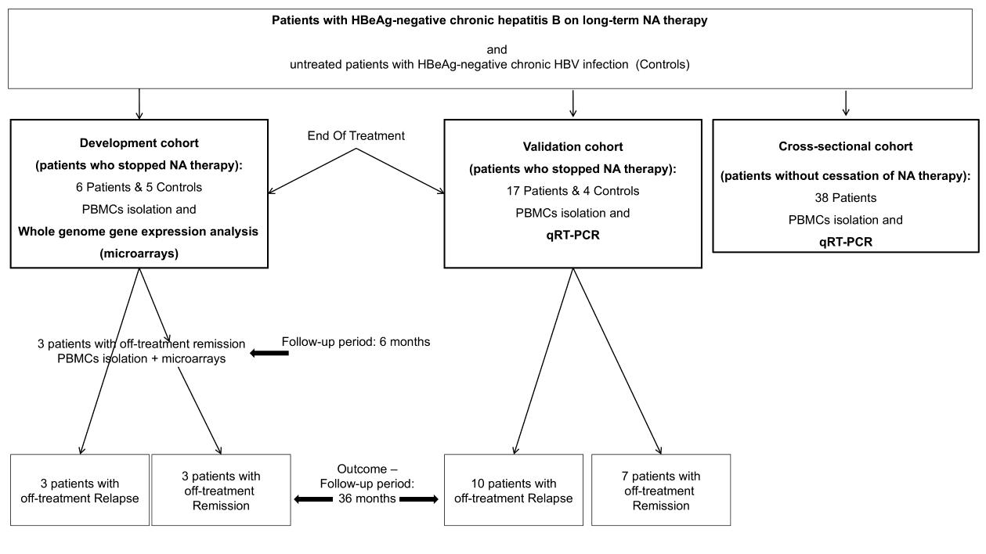

Accepted
Article
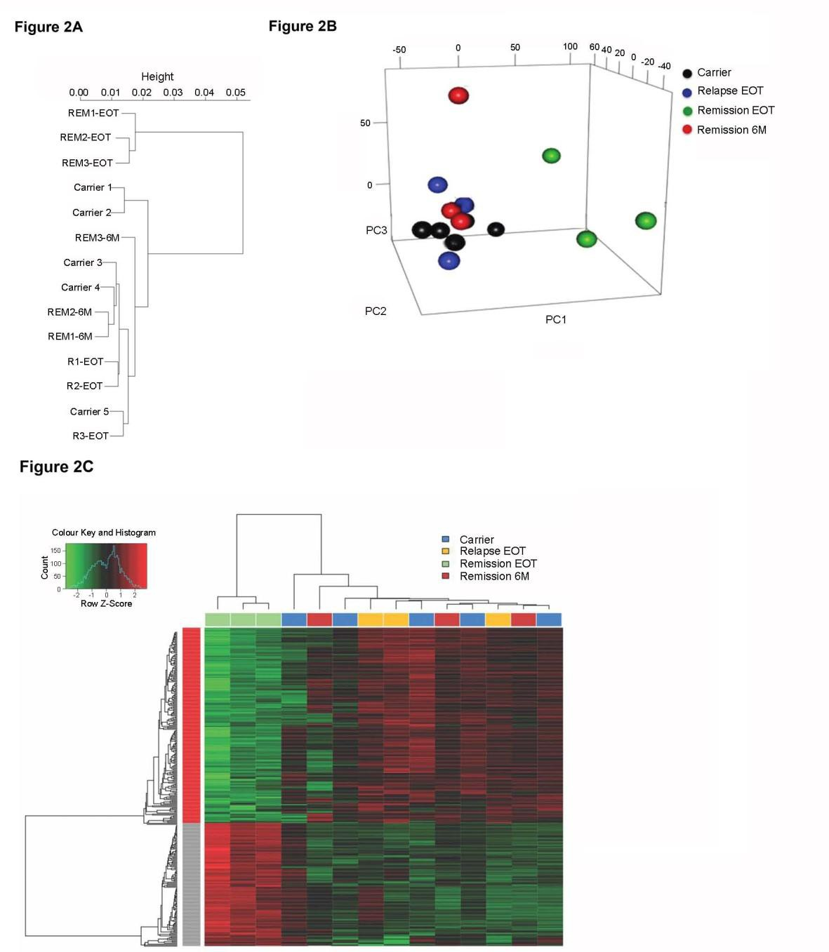

Accepted
Article
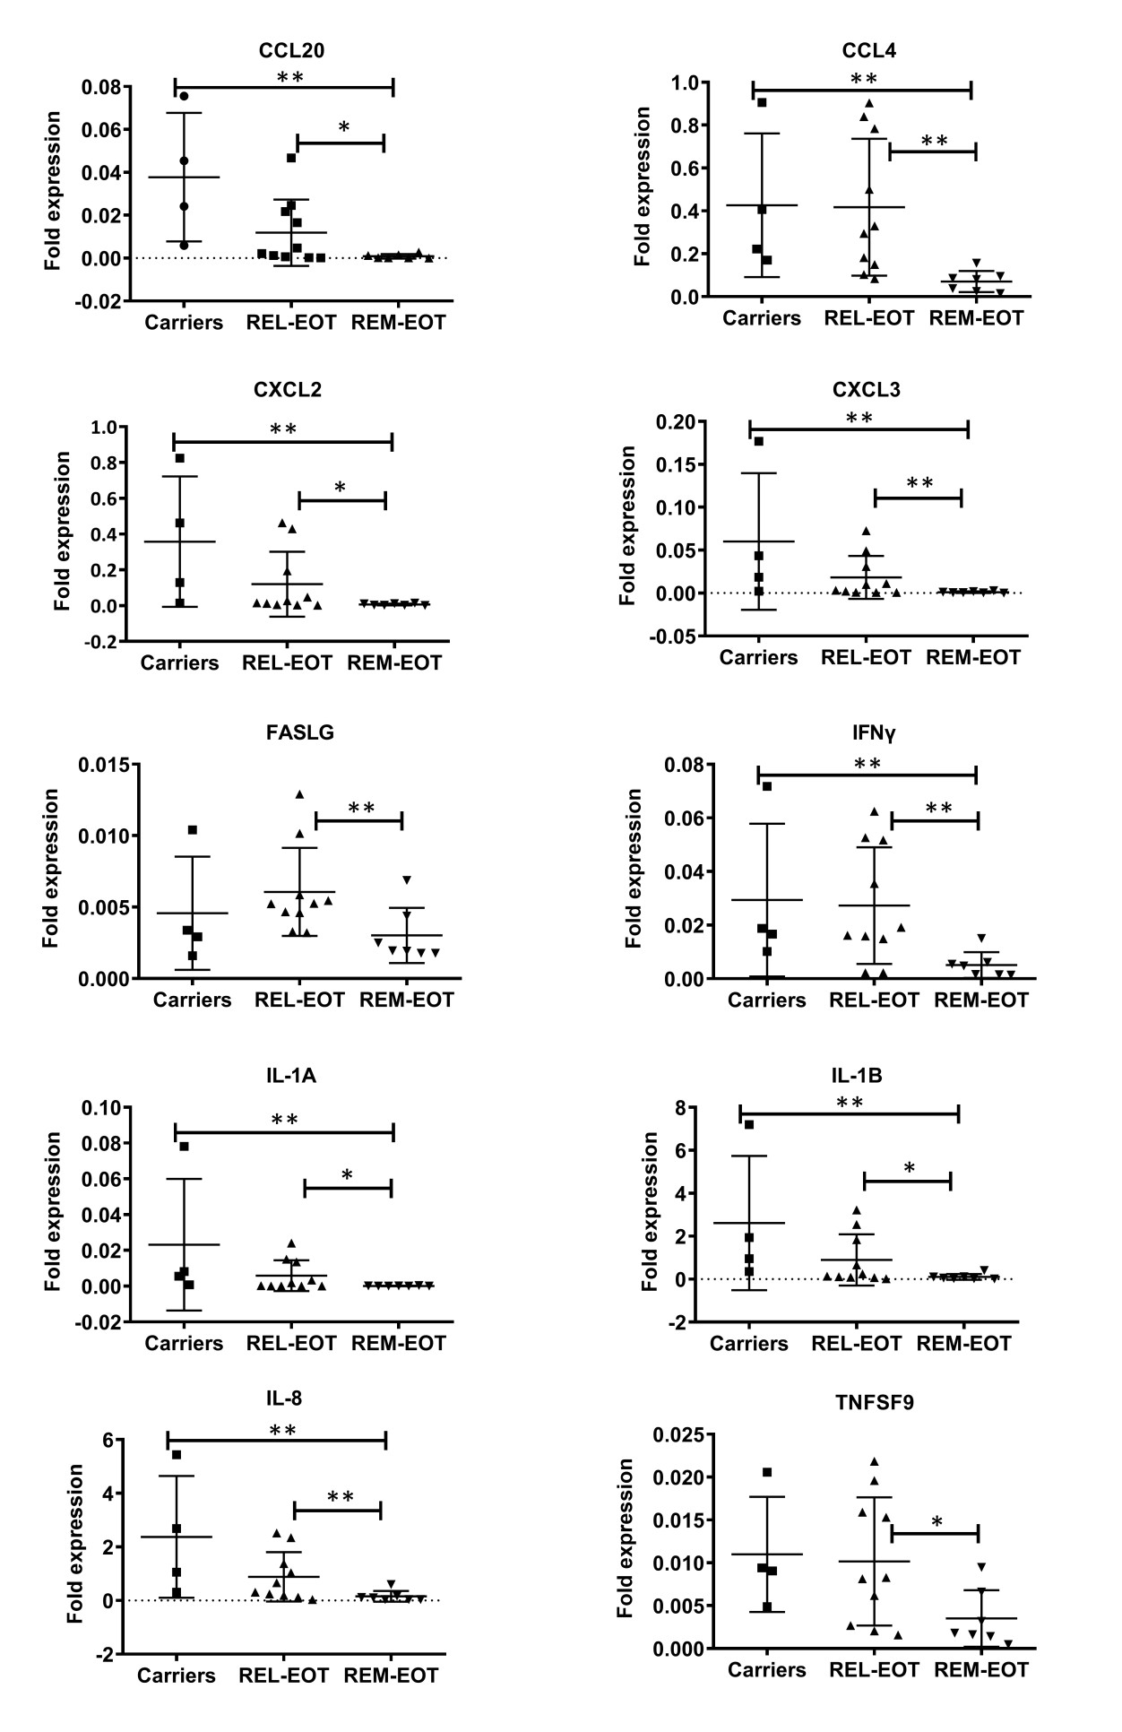

Accepted
Article
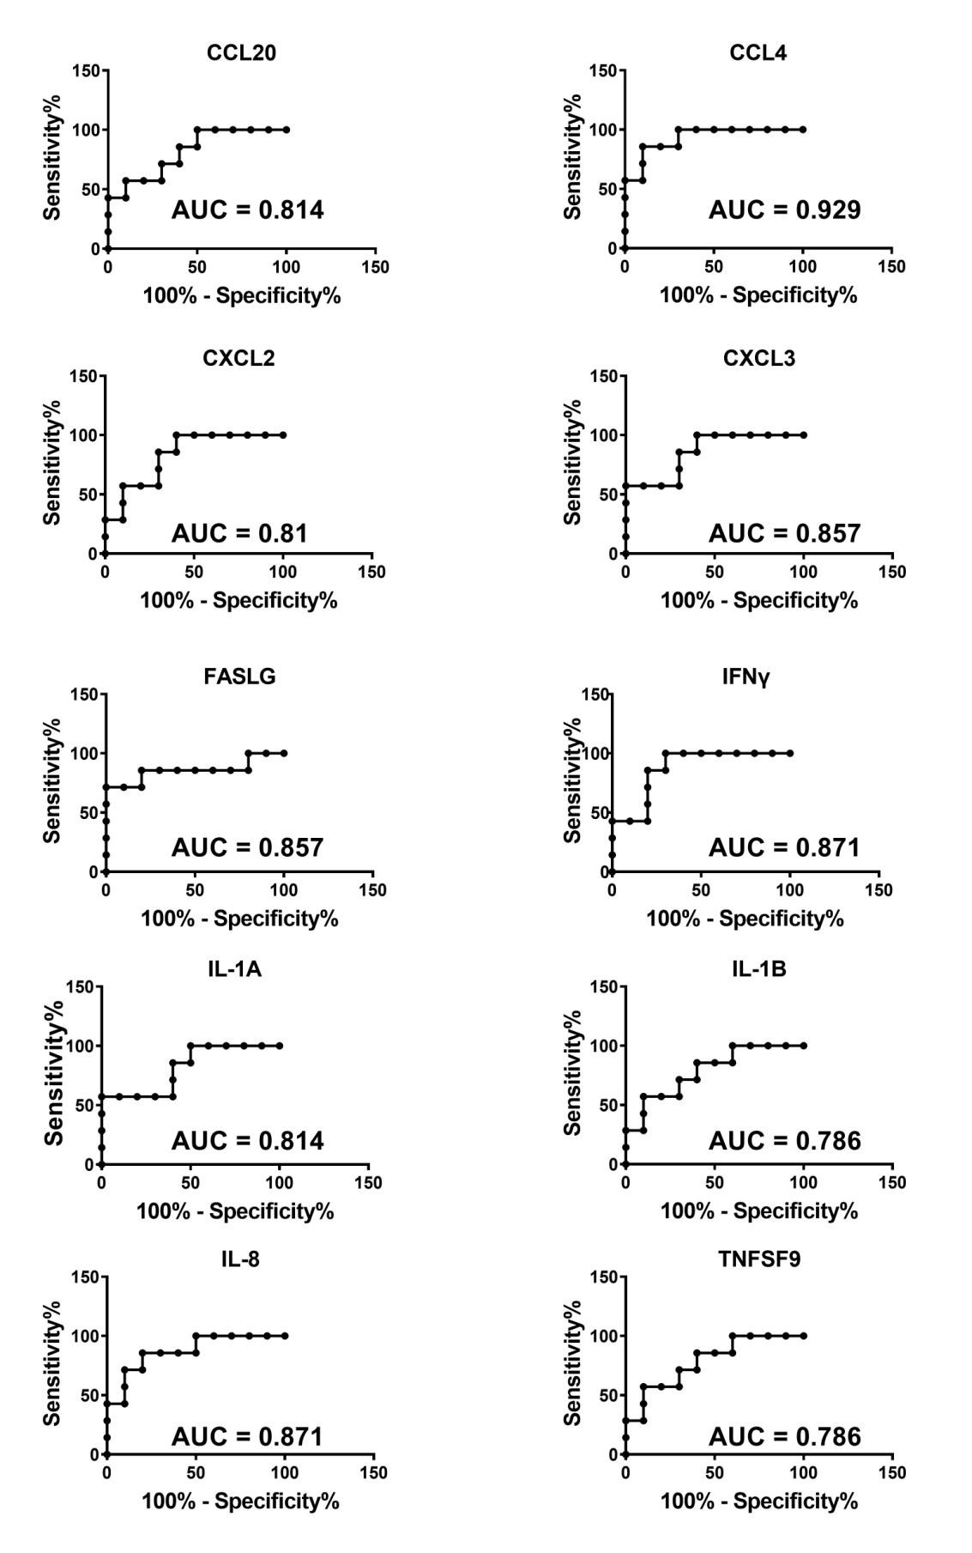

Accepted
Article
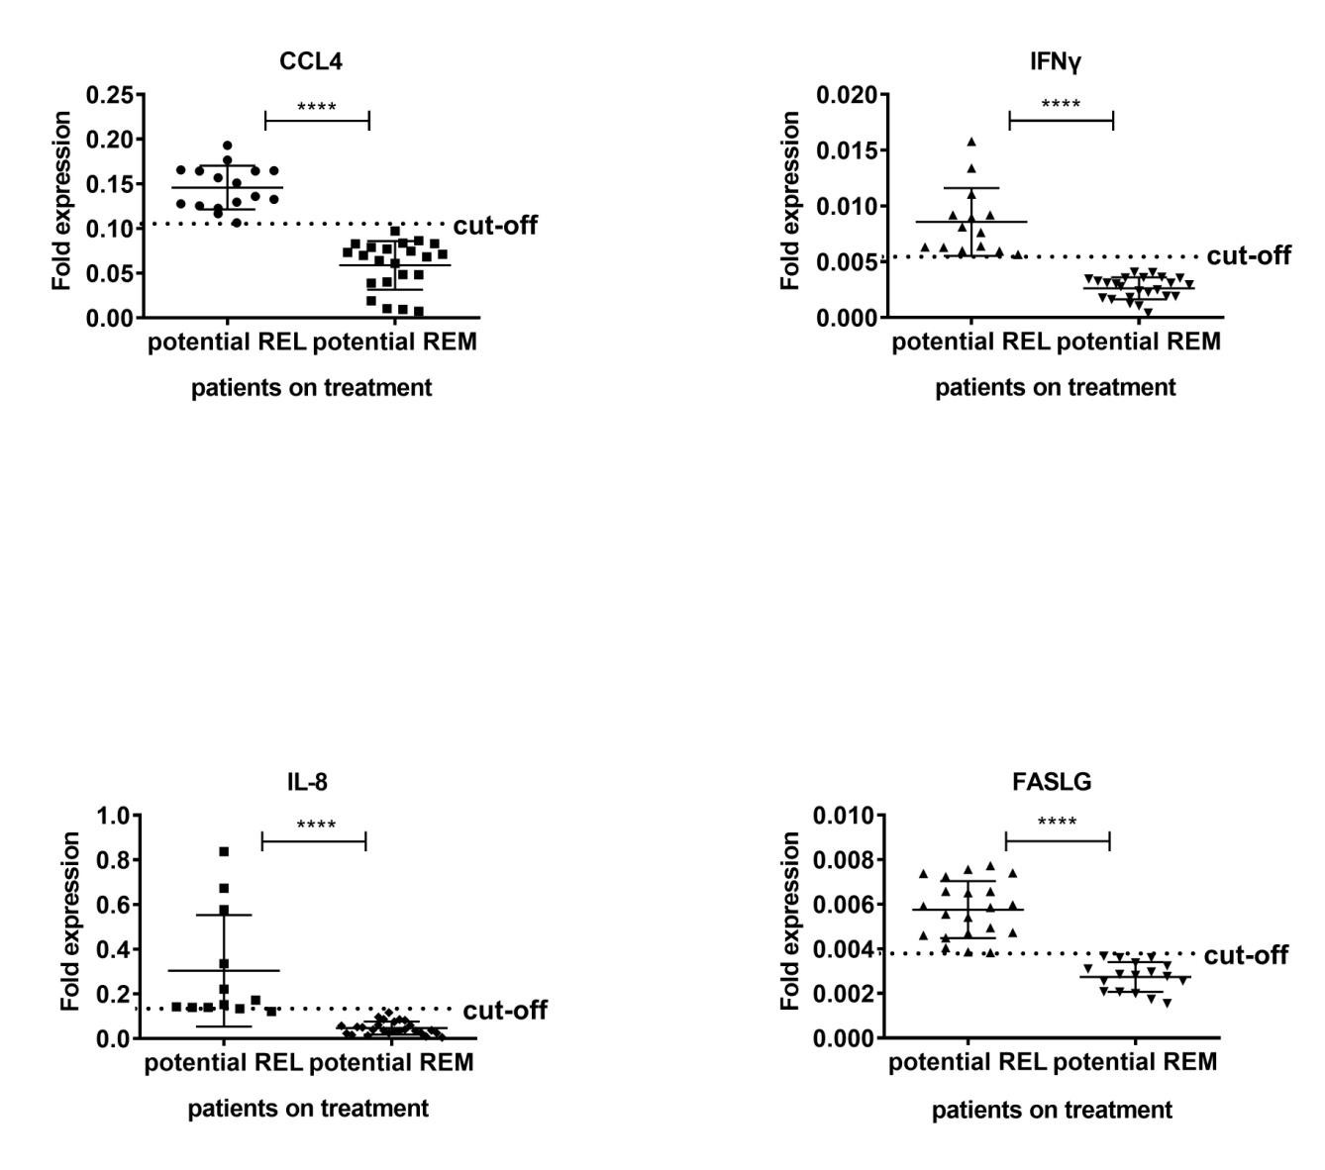

Accepted
Article
