Pages: 23
Figures: 12
Tables: 2
References: 20

Fore-and-aft and dual-axis vibration of the seated human body: Nonlinearity, cross-axis coupling, and associations between resonances in the transmissibility and apparent mass
Guangtai Zheng, Yi Qiu* and Michael J Griffin

Human Factors Research Unit
Institute of Sound and Vibration Research
University of Southampton
Southampton SO17 1BJ
United Kingdom

*, address of corresponding author:

Dr Yi Qiu
Human Factors Research Unit
Institute of Sound and Vibration Research
University of Southampton
Southampton SO17 1BJ
England

Telephone: +44 (0)23 8059 9594

e-mail: yq@isvr.soton.ac.uk

Abstract:
This study examined how the apparent mass and transmissibility of the human body depend on the magnitude of fore-and-aft vibration excitation and the presence of vertical vibration. Fore-and-aft and vertical acceleration at five locations along the spine, and pitch acceleration at the pelvis, were measured in 12 seated male subjects during fore-and-aft random vibration excitation (0.25 to 20 Hz) at three vibration magnitudes (0.25, 0.5 and 1.0 ms⁻² r.m.s.). With the greatest magnitude of fore-and-aft excitation, vertical vibration was added at 0.25, 0.5, or 1.0 ms⁻² r.m.s. Forces in the fore-and-aft and vertical directions on the seat surface were measured to calculate apparent masses. Transmissibilities and apparent masses during fore-and-aft excitation showed a principal resonance around 1 Hz and a secondary resonance around 2 to 3 Hz. Increasing the magnitude of fore-and-aft excitation, or adding vertical excitation, decreased the magnitudes of the resonances. At the primary resonance frequency, the dominant mode induced by fore-and-aft excitation involved bending of the lumbar spine and the lower thoracic spine with shear deformation of tissues at the ischial tuberosities. The relative contributions to this mode from each body segment (especially the pelvis and the lower thoracic spine) varied with vibration magnitude. The nonlinearities in the apparent mass and transmissibility during dual-axis excitation indicate coupling between the principal mode of the seated human body excited by fore-and-aft excitation and the cross-axis influence of vertical excitation.

Relevance to industry
Understanding movements of the body during exposure to whole-body vibration can assist the optimisation of seating dynamics and help to control the effects of the vibration on human comfort, performance, and health. This study suggests cross-axis nonlinearity in biodynamic responses to vibration should be considered when optimising vibration environments.

Key words: biodynamics; nonlinearity; dual-axis excitation.

Highlights
> Motions of the lumbar spine and pelvis contribute to the first body resonance. > The fore-and-aft resonance depends on fore-and-aft and vertical vibration magnitude.

1. Introduction
The principal resonance of the seated human body excited by fore-and-aft vibration is at a much lower frequency than the 5-Hz principal resonance associated with vertical excitation. In eight males sitting without a backrest during fore-and-aft random vibration, a first resonance in the apparent mass around 0.7 Hz and a less-pronounced second resonance between 1.5 and 3 Hz have been reported [1]. In 12 males exposed to fore-and-aft random vibration over the range 0.25 to 20 Hz, three resonances (around 1 Hz, between 1 and 3 Hz, and between 3 and 5 Hz) have been seen in the fore-and-aft apparent mass measured on a seat without backrest [2]. The fore-aft mechanical impedance of the seated human body during fore-aft excitation has been reported to have peaks between 2 and 5 Hz [3]. With sinusoidal excitation, the fore-and-aft apparent mass has been reported to be greatest around 2.5 Hz [4].
With single-axis vertical excitation, the principal resonance in the driving point apparent mass has been related to movements of the pelvis, the spine, and the viscera [5-7]. Resonances in the apparent mass and in the transmissibility to the spine and the pelvis in both the fore-and-aft and the vertical directions, and pitch transmissibility to the pelvis, shift to lower frequencies as the magnitude of vertical excitation increases and as the magnitude of additional fore-and-aft excitation increases [9]. However, there are no published studies of the motion of either the pelvis or the upper-body during fore-and-aft excitation, and the modes associated with resonances in the fore-and-aft apparent mass are unknown.
During fore-and-aft excitation, both the fore-and-aft apparent mass and the vertical cross-axis apparent mass (i.e., the ratio of vertical force to fore-and-aft acceleration) depend on the vibration magnitude. It has been reported that the resonance frequency of the second mode of the fore-and-aft apparent mass (in the range 1.5 to 3 Hz) decreases as the magnitude of fore-and-aft vibration excitation increases [1]. It is also reported that with increasing magnitude of fore-and-aft vibration, the fore-and-aft apparent mass increases at a resonance around 2 or 3 Hz but decreases at a resonance around 5 or 6 Hz [10]. At frequencies greater than 6 Hz, both the fore-and-aft apparent mass and the vertical cross-axis apparent mass reduce progressively as the magnitude of the fore-and-aft vibration increases from 0.125 to 1.25 ms⁻² r.m.s. [2]. Other studies have also reported that the frequencies of the principal resonance in the fore-and-aft apparent mass around 2 Hz and in the vertical cross-axis apparent mass around 4 to 8 Hz decrease with increasing magnitude of fore-and-aft excitation [11].
A few studies have investigated the apparent mass of the human body with dual-axis excitation and found that the apparent mass is similar to that with single-axis excitation [9, 10, 11, and 12]. Nonetheless, additional excitation in an orthogonal direction tends to reduce the modulus of the primary peak in the fore-and-aft apparent mass [10, 11, and 12]. The fore-and-aft transmissibility of the human body exposed to dual-axis vibration has not previously been investigated systematically. How the vibration modes of the upper body contribute to the resonances seen in the fore-and-aft apparent mass during dual-axis excitation is unknown.
This study was designed to examine the influence of the magnitude of fore-and-aft vibration and the addition of vertical excitation on the resonances evident in both the apparent mass and the transmissibility of the human body sitting without a backrest. This study investigated how biodynamic responses of the seated human body to fore-and-aft excitation depend on the magnitude of fore-and-aft excitation and the addition of vertical excitation. In this paper, the term ‘nonlinearity’ is used to refer to changes in the apparent mass of the body or the transmissibility of the body as the magnitude of either the fore-and-aft excitation or the magnitude of the vertical excitation varies. The study was conducted in parallel with an equivalent study of how the response to vertical excitation depends on the magnitude of vertical excitation and the addition of fore-and-aft excitation [9]. It was hoped to advance understanding of the association between the fore-and-aft apparent mass and the fore-and-aft transmission of vibration to the pelvis and to the spine during dual-axis excitation. It was hypothesised that the transmission of fore-and-aft vibration to the pelvis and the upper-body would change if the magnitude of fore-and-aft excitation increased or vertical excitation was introduced. It was also hypothesized that the fore-and-aft apparent mass of the body during dual-axis excitation is related to movements of the lumbar spine and shear motion of the ischial tuberosities.

2. Experiment method

2.1 Apparatus
Subjects sat on a rigid seat mounted on the ISVR 6-axis motion simulator capable of ±1 m vertical displacement, ±0.5 m fore-and-aft and lateral displacement, ±20 degrees of roll and pitch, and ±10 degrees of yaw. A force plate capable of measuring forces in the fore-and-aft and vertical directions simultaneously was secured to the supporting surface of the seat. The force plate (Kistler 9281 B) consisted of four tri-axial quartz transducers at the four corners of a rectangular aluminium plate. Signals from the four force transducers orientated to be sensitive to fore-and-aft force were summed and amplified by a charge amplifier (Kistler 5001). Signals from the four force transducers orientated to be sensitive to vertical force were summed and amplified by a similar charge amplifier. A tri-axial HVLab SIT-pad with three Entran EGCSDO-10 piezo-resistive accelerometers was used to measure the fore-and-aft acceleration on the seat surface at the centre of the force platform.

2.2 Subjects and stimuli
Twelve male subjects with median age 26.5 years (range 23 to 36 years), weight 68.5 kg (range 60.4 to 80 kg), and stature 1.74 m (range 1.65 to 1.82 m), participated in the study that was approved by the Human Experimentation Safety and Ethics Committee of the Institute of Sound and Vibration Research at the University of Southampton. During the experiment, subjects sat with their upper body in a comfortable upright position and looked straight ahead. Subjects were asked to keep their posture as consistent as possible, and their posture was observed by the experimenter. Their feet were supported by a footrest that moved with the simulator platform. The footrest was adjusted for each subject if necessary so as to produce similar thigh contact with the seat (i.e., the thighs were approximately horizontal and the lower legs were approximately vertical).
Subjects were exposed to random vibration with approximately flat constant-bandwidth acceleration spectra (0.2 to 20 Hz) in six combinations of four magnitudes of fore-and-aft vibration (0, 0.25, 0.5, or 1.0 ms⁻² r.m.s.) and four magnitudes of vertical vibration (0, 0.25, 0.5, or 1.0 ms⁻² r.m.s., Table 1). All stimuli were of 60-s duration, with motions in the fore-and-aft and vertical directions uncorrelated with each other.
Table 1 Vertical (z-axis) and fore-and-aft (x-axis) excitations experienced by subjects.
x-axis excitation
(ms⁻² r.m.s.)
 |  | 0 | 0.25 | 0.5 | 1.0
z-axis excitation (ms⁻² r.m.s.) | 0 |  | a_{x} | a_{x} | a_{x}
z-axis excitation (ms⁻² r.m.s.) | 0.25 | - | - | - | a_{x} + a_{z}
z-axis excitation (ms⁻² r.m.s.) | 0.5 | - | - | - | a_{x} + a_{z}
z-axis excitation (ms⁻² r.m.s.) | 1.0 | - | - | - | a_{x} + a_{z}

2.3 Motion measurement locations on the body
Acceleration was measured in the fore-and-aft and vertical directions on the body surface over the first, fifth, and twelfth thoracic vertebrae, the third lumbar vertebra, and the pelvis (at the iliac crest). The pitch motion of the pelvis was also estimated from the difference between two vertical accelerations mounted at 25-mm separation on a single block located at the iliac crest.
The vibration at each measurement point on the body surface was measured with two miniature piezoresistive accelerometers (Entran EGAX or Entran EGA) attached orthogonally to T-shaped balsa wood blocks. The weight of each block was about 1 g and similar to that of each miniature accelerometer. The frequency of the first free-free mode of the block was identified to be greater than 10 Hz. The block was attached to the body surface with double-side adhesive tape with a contact area similar to that of a vertebral body (i.e., 30 mm × 40 mm).
The experimental set-up and the mounting of the accelerometer block are shown in Figure 1.

d
Force plate (Kistler 9281 B)
a_{zs,} F_{zs}
a_{xs,} F_{xs}
a_{z}
a_{x}
Spine accelerometer blocks
T1
Iliac crest
L3
T12
T5
Pelvis accelerometers block
Six-axis vibrator
Trial-axial SIT-pad
Figure 1 Experiment set-up and the body transmissibility measurement locations.

2.4. Data analysis
Forces and accelerations were acquired with a sampling rate of 512 samples per second via anti-aliasing filters at 50 Hz. Mass cancellation was performed in the time domain to remove the influence of the mass of the top plate (i.e., the product of the mass of the force plate and the acceleration time history was subtracted from the measured force time history). Signal processing was conducted with a frequency resolution of 0.25 Hz.
Assuming that a_{x} and a_{z} represent the fore-and-aft and vertical accelerations and f_{x} and f_{z}, the fore-and-aft and vertical forces, the fore-and-aft apparent mass and the vertical cross-axis apparent mass and the corresponding coherency were calculated with the HVLab Matlab Toolbox function using the cross-spectral density method (CSD):
. (1)
where,
, is the auto spectrum of a_{x},
and are the auto spectra of f_{x} and f_{z},
, is the cross-spectrum of a_{x} and f_{x}, and
, is the cross-spectrum of a_{x} and f_{z}.
The fore-and-aft transmissibility, T_{xx,} and the vertical cross-axis transmissibility, T_{xz}, were calculated from a_{tx} and a_{tz} representing the fore-and-aft and vertical acceleration measured on the body surface:
. (2)
where,
and are the auto spectra of a_{tz} and a_{tx},
, is the cross-spectrum of a_{x} and a_{tx},
, is the cross-spectrum of a_{x} and a_{tz}.
The pitch motion of the pelvis was defined as ratio of the difference in the two vertical vibrations to the distance between the two transducers [9]:
(3)
The pitch transmissibility of the pelvis was calculated as
(4)
where,
, is the cross-spectrum of a_{x} and,
, is the auto spectrum of.

Equations (1-4) were used to calculate the transfer functions with both single-axis and dual-axis excitation, because they are appropriate when the two inputs are independent [13].
The effect of inclination of the body surface was reduced using the angle between the body surface and the vertical axis [9]:
a_{tx} =cos Ψ - sin Ψ, a_{tz} =cos Ψ + sin Ψ. (5)

where a_{tz} is the time history of the vertical acceleration and a_{tx} is the fore-and-aft acceleration;
and are the measured accelerations along the body surface and normal to the body surface respectively; Ψ is the angle between the body surface and the vertical direction.
The motion of the spine, T_{s}(f), was estimated from the transmissibility between the seat base and the body surface and a data correction function that takes into account the effect of the tissue and the skin between the bone and the accelerometer [9]. The local tissues where the responses were measured were assumed to respond linearly.

3 Results

3.1 Apparent mass
3.1.1 Inter-subject variability
With both single-axis excitation and dual-axis excitation, the fore-and-aft apparent mass showed a first peak around 1 Hz. A second peak around 2 to 4 Hz can be observed for all 12 subjects (row (I) in Figure 2). All subjects except subjects 1 and 2 exhibited a third resonance in the frequency range 5 to 7 Hz. The vertical cross-axis apparent mass had a first peak in the frequency range 0.5 to 1.25 Hz (row (II) in Figure 2), with a broad second peak apparent from 2 to 6 Hz in most subjects.

3.1.2 Nonlinearity in the apparent mass
The frequency of the first peak in the fore-and-aft apparent mass around 1 Hz was not changed significantly with a change in the magnitude of the single-axis fore-and-aft excitation or the addition of vertical excitation (p>0.05; Friedman). Nonlinearity was therefore examined by studying changes in the apparent mass at the resonance frequency.
Figure 2 Individual apparent masses of 12 subjects: (I), the fore-and-aft apparent mass; (II), the vertical cross-axis apparent mass. (a), a_{x}=0.25 ms⁻² r.m.s.; (b), a_{x}=0.5 ms⁻² r.m.s.; (c), a_{x}=1.0 ms⁻² r.m.s.; (d), a_{x}=1.0 ms⁻² r.m.s., a_{z}=0.25 ms⁻² r.m.s.; (e), a_{x}=1.0 ms⁻² r.m.s., a_{z}=0.5 ms⁻² r.m.s.; (f), a_{x}=1.0 ms⁻² r.m.s., a_{z}=1.0 ms⁻² r.m.s.

(a)
(b)
(c)
(d)
(e)
(f)
(I)
(II)

Nonlinearity in the modulus of the fore-and-aft apparent mass was examined at the first resonance around 1 Hz, the second peak around 2.75 Hz, and the third peak around 5.25 Hz. Increasing the magnitude of single-axis fore-and-aft excitation reduced the fore-and-aft apparent mass at the first resonance (Friedman, p=0.006; Figure 3). The fore-and-aft apparent mass also decreased as the additional vertical vibration increased in magnitude from 0.25 to 1.0 ms⁻² r.m.s. when the fore-and-aft excitation was 1.0 ms⁻² r.m.s. (Friedman, p=0.023; Figure 4). At 5.25 Hz, the fore-and-aft apparent mass was reduced with increasing magnitude of single-axis fore-and-aft excitation (Friedman, p<0.001; Figure 3) and with the addition of vertical excitation from 0.25 to 1.0 ms⁻² r.m.s. during fore-and-aft excitation at 1.0 ms⁻² r.m.s. (Friedman, p=0.005; Figure 4).
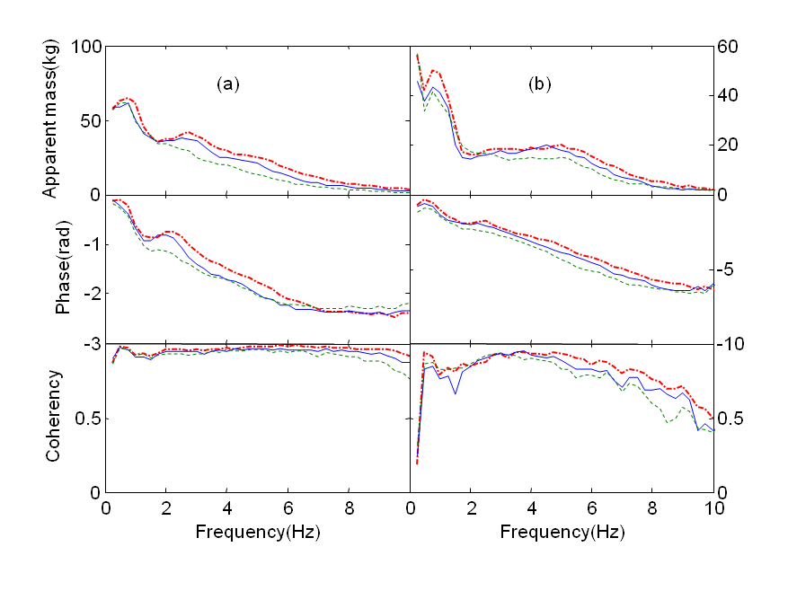
Figure 3 Effect of the magnitude of the single-axis fore-and-aft excitation on: (a) fore-and-aft apparent mass; (b) vertical cross-axis apparent mass. —.—, a_{x}=0.25 ms⁻² r.m.s.; ——, a_{x}=0.5 ms⁻² r.m.s.; - - -, a_{x}=1.0 ms⁻² r.m.s. (medians of 12 subjects).
Nonlinearity in the modulus of the vertical cross-axis apparent mass was also examined at 1.0 Hz, 2.75 Hz, and 5.25 Hz. The vertical cross-axis apparent mass at 1.0 Hz reduced with increasing magnitude of single-axis fore-and-aft excitation (Friedman, p=0.001; Figure 3). A similar change was observed as the magnitude of the additional vertical vibration increased from 0.25 to 1.0 ms⁻² r.m.s. while maintaining the fore-and-aft vibration magnitude at 1.0 ms⁻² r.m.s. (Friedman, p=0.039; Figure 4). At 2.75 Hz, there was no significant reduction in the vertical cross-axis apparent mass with either increasing magnitude of the fore-and-aft excitation or the additional vertical excitation. At 5.25 Hz, the vertical cross-axis apparent mass was reduced with increasing magnitude of fore-and-aft excitation (Friedman, p=0.009; Figure 3) and with increasing magnitude of the additional vertical excitation from 0.25 to 1.0 ms⁻² r.m.s. (Friedman, p<0.001; Figure 4).

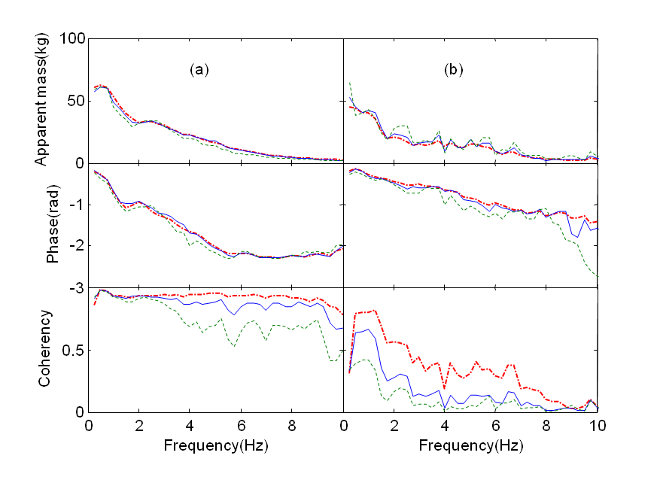Figure 4 Effect of the magnitude of the additional vertical excitation on: (a) fore-and-aft apparent mass; (b) vertical cross-axis apparent mass. —.—, a_{z}=0.25 ms⁻² r.m.s., a_{x}=1.0 ms⁻² r.m.s.; ——, a_{z}=0.5 ms⁻² r.m.s., a_{x}=1.0 ms⁻² r.m.s.; - - -, a_{z}=1.0 ms⁻² r.m.s., a_{x}=1.0 ms⁻² r.m.s. (medians of 12 subjects).

3.2 Transmissibility
3.2.1 Fore-and-aft transmissibility
There was large inter-subject variability in the fore-and-aft inline transmissibility to the spine and the pelvis (Figure 5a and 5c). The transmissibility from fore-and-aft seat motion to fore-and-aft motion at T1 showed a first peak over the frequency range 0.5 to 1.25 Hz in all subjects. Second and third peaks were present around 2.25 and 4.5 Hz but were smaller and observed in only 8 of the 12 subjects. The transmission of fore-and-aft vibration to T5 and T12 was similar to T1. The transmissibility to L3 showed a first peak in the frequency range 0.5 to 1.75 Hz and a second peak around 2.5 Hz. A third peak around 7.5 Hz was observed in subject 12. There was greater inter-subject variability in transmissibility to the pelvis than to other locations. The primary peak occurred in the range 0.5 to 1.75 Hz for seven subjects, with other subjects exhibiting higher primary resonance frequencies (2 Hz for subject 7; 2.25 Hz for subject 12; 3 Hz for subject 9; 3.25 Hz for subject 11; 4.25 Hz for subject 10).
3.2.2 Vertical cross-axis transmissibility
The cross-axis transmissibilities from fore-and-aft seat motion to vertical motion at each measurement location showed a first resonance in the range 2.25 to 5.25 Hz, with marked inter-subject variability (Figures 5b and 5d). The vertical cross-axis transmissibility to T1 had a resonance in the range 3.25 to 5.25 Hz for all subjects except subject 1. The vertical cross-axis transmissibility to T5 had a primary resonance in the range 2.25 to 5.5 Hz, for all except subjects 1, 2, and 8. The vertical cross-axis transmissibility to T12 showed a primary resonance in the range 2.25 to 5 Hz for all except subject 2. The resonance in the vertical cross-axis transmissibility to L3 varied from 1.0 to 2.25 Hz, much lower than the vertical cross-axis transmissibility to other measurement locations but similar to the resonance in the fore-and-aft transmissibility to L3. The resonance frequencies in the vertical cross-axis transmissibility to the pelvis ranged from 3.25 to 5.25 Hz in nine of the 12 subjects, but with no evidence of a resonance in subjects 1, 7, or 9 over the frequency range 0.5 to 10 Hz.
Figure 5 Individual transmissibility from fore-and-aft seat motion to upper body motion of 12 subjects: (a), fore-and-aft transmissibility with single-axis fore-and-aft vibration (a_{x}=1.0 ms⁻² r.m.s.); (b), vertical cross-axis transmissibility with single-axis fore-and-aft vibration (a_{x}=1.0 ms⁻² r.m.s.); (c), fore-and-aft transmissibility with dual-axis vibration (a_{x}=1.0 ms⁻² r.m.s, a_{z}=1.0 ms⁻² r.m.s.); (d), vertical cross-axis transmissibility with dual-axis vibration (a_{x}=1.0 ms⁻² r.m.s., a_{z} =1.0 ms⁻² r.m.s.).
Single-axis
T1 (a)
T5
T12
L3
Pelvis
(b)
(c)
Dual-axis
(d)

3.2.3 Pitch transmissibility to the pelvis
The transmissibility from fore-and-aft seat motion to pitch motion of the pelvis exhibited large inter-subject variability with both single-axis fore-and-aft excitation and with dual-axis excitation (Figure 6). The primary resonance frequency in the pitch transmissibility ranged from 1 to 8.75 Hz with single-axis excitation and from 2.25 to 9.75 Hz with dual-axis excitation. Similar to the fore-and-aft transmissibility to each measurement location, multiple peaks were observed with all subjects over the frequency range 0.5 to 10 Hz.

(a)
(b)

Figure 6 Individual transmissibility from fore-and-aft seat motion to pitch of the pelvis of 12 subjects: (a) pitch transmissibility with single-axis vibration (a_{x}=1.0 ms⁻² r.m.s.); (b) pitch transmissibility with dual-axis vibration (a_{x}=1.0 ms⁻² r.m.s., a_{z} =1.0 ms⁻² r.m.s.).
3.2.4 Nonlinearity in the fore-and-aft transmissibility
The first resonance frequency of the fore-and-aft transmissibility to any of the measurement locations was not changed significantly with increasing magnitude of single-axis fore-and-aft excitation (Friedman, p>0.05 for all locations) or the addition of vertical excitation from 0.25 to 1.0 ms⁻² r.m.s. (Friedman, p>0.05 for all locations). Nonlinearity was therefore examined by studying changes in the transmissibility at the resonance frequency.
The influence of the magnitude of fore-and-aft excitation and the addition of vertical excitation on the fore-and-aft transmissibility at the first resonance around 1 Hz, the second peak around 2.75 Hz, and the third peak around 5.25 Hz was examined for each measurement location (Figures 7 and 8). The fore-and-aft transmissibility to the pelvis at the first resonance frequency reduced with increasing magnitude of the additional vertical excitation from 0.25 to 1.0 ms⁻² r.m.s. (Friedman, p=0.017). However, a significant reduction in the fore-and-aft transmissibility to the pelvis at 2.75 Hz and 5 Hz was only found with increasing magnitude of single-axis fore-and-aft vibration (Friedman, p=0.005 at 2.75 Hz; p=0.015 at 5.25 Hz). The fore-and-aft transmissibility to L3 and T12 at the first resonance frequency was reduced with increasing magnitude of fore-and-aft vibration excitation (Friedman, p=0.006 for L3; p=0.039 for T12). The reductions at 2.75 Hz and 5.25 Hz were observed with both increasing magnitude of single-axis fore-and-aft excitation (Friedman, p<0.001) and increasing magnitude of the additional vertical excitation from 0.25 to 1.0 ms⁻² r.m.s. (Friedman, p<0.001). A significant decrease in the fore-and-aft transmissibility to T5 was only observed at 5.25 Hz, but with both increasing magnitude of single-axis fore-and-aft vibration (p<0.001) and increasing magnitude of the additional vertical excitation from 0.25 to 1.0 ms⁻² r.m.s. (Friedman, p=0.01). With increasing magnitude of single-axis fore-and-aft excitation there was a significant decrease in the fore-and-aft transmissibility to T1 at the first resonance frequency (Friedman, p=0.009) and at 5.25 Hz (Friedman, p<0.001).
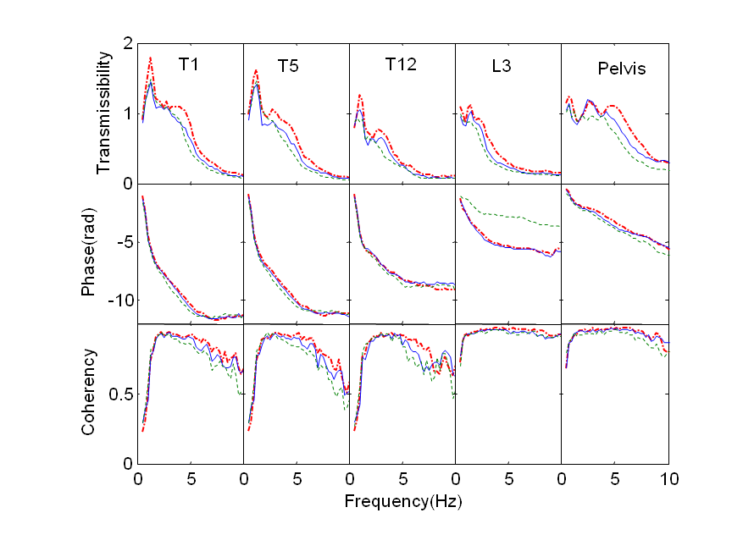Figure 7 Effect of the magnitude of fore-and-aft excitation on the fore-and-aft transmissibility to each measurement location: —.—, a_{x}=0.25 ms⁻² r.m.s.; ——, a_{x}=0.5 ms⁻² r.m.s.; - - -, a_{x}=1.0 ms⁻² r.m.s. (medians of 12 subjects).

3.2.5 Nonlinearity in the cross-axis transmissibility
With increasing magnitude of single-axis fore-and-aft excitation, there was a reduction in pitch transmissibility to the pelvis at 5.25 Hz (Friedman, p=0.017; Figure 9).

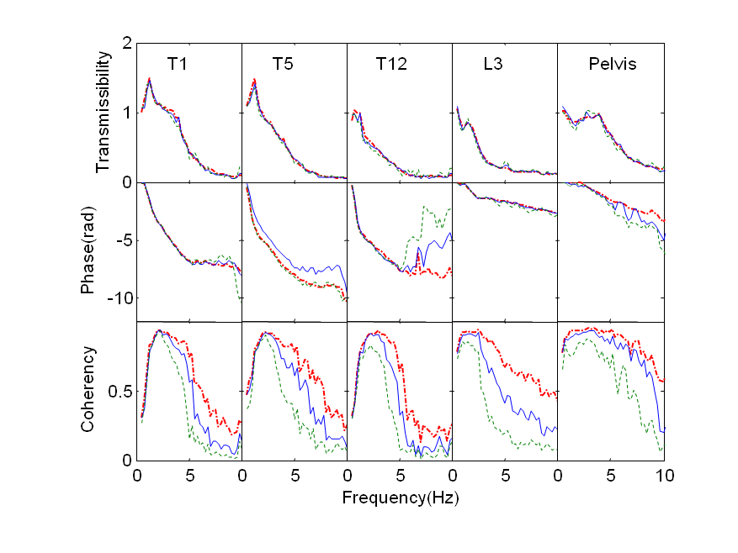Figure 8 Effect of the magnitude of the additional vertical excitation on the fore-and-aft transmissibility to each measurement location: —.—, a_{z}=0.25 ms⁻² r.m.s., a_{x}=1.0 ms⁻² r.m.s.; ——, a_{z}=0.5 ms⁻² r.m.s., a_{x}=1.0 ms⁻² r.m.s.; - - -, a_{z}=1.0 ms⁻² r.m.s., a_{x}=1.0 ms⁻² r.m.s. (medians of 12 subjects).

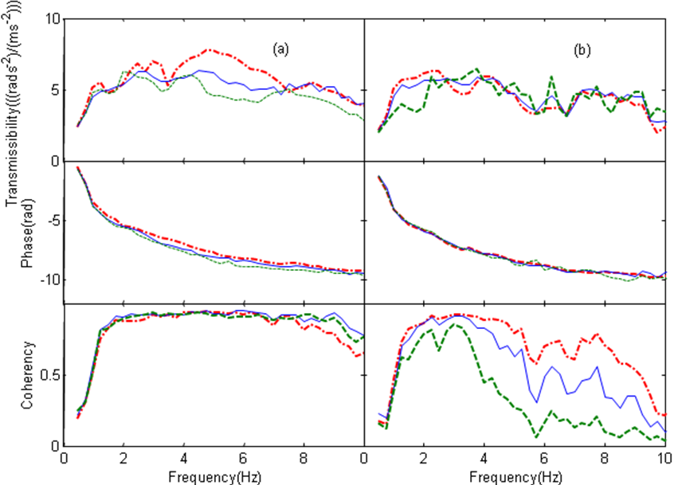
Figure 9 Median pitch transmissibility of the pelvis of 12 subjects exposed to: (a) single-axis vibration, —.—, a_{x}=0.25 ms⁻² r.m.s.; ——, a_{x}=0.5 ms⁻² r.m.s.; - - -, a_{x}=1.0 ms⁻² r.m.s.; (b) dual-axis vibration, —.—, a_{z}=0.25 ms⁻²r.m.s., a_{x}=1.0 ms⁻² r.m.s.; ——, a_{z}=0.5 ms⁻² r.m.s., a_{x}=1.0 ms⁻² r.m.s.; - - -, a_{z}=1.0 ms⁻² r.m.s., a_{x}=1.0 ms⁻² r.m.s. (medians of 12 subjects).
The nonlinearity in the vertical cross-axis transmissibility to each measurement location (Figures 10 and 11) around 1 Hz, 2.75 Hz and 5.25 Hz was also examined with changing magnitude of vibration excitation. The vertical cross-axis transmissibility to the pelvis at 2.75 Hz was reduced with increasing magnitude of vertical vibration from 0.25 to 1.0 ms⁻² r.m.s. when the fore-and-aft excitation magnitude was at 1.0 ms⁻² r.m.s. (Friedman, p=0.036). A significant reduction in transmissibility at 5.25 Hz was observed with increasing magnitude of single-axis fore-and-aft excitation (Friedman, p=0.013), and with increasing magnitude of additional vertical excitation from 0.25 to 1.0 ms⁻² r.m.s. (Friedman, p=0.028). The vertical cross-axis transmissibility to L3 around 1 Hz decreased with increasing magnitude of the additional vertical excitation from 0.25 to 1.0 ms⁻² r.m.s. (Friedman, p<0.001). The transmissibility at 2.75 Hz and at 5.25 Hz was also reduced with increasing magnitude of single-axis fore-and-aft excitation (Friedman, p<0.001 at 2.75 Hz; p=0.005 at 5.25 Hz). The vertical cross-axis transmissibility to T12 and T5 around 1 Hz decreased with increasing magnitude of the additional vertical excitation from 0.25 to 1.0 ms⁻² r.m.s. when the magnitude of the fore-and-aft excitation was constant at 1.0 ms⁻² r.m.s. The transmissibility at 5.25 Hz also decreased with increasing magnitude of single-axis fore-and-aft excitation (Friedman, p=0.04). The vertical cross-axis transmissibility to T1 only decreased at 5.25 Hz, and only with increasing magnitude of single-axis fore-and-aft vibration (Friedman, p=0.028).
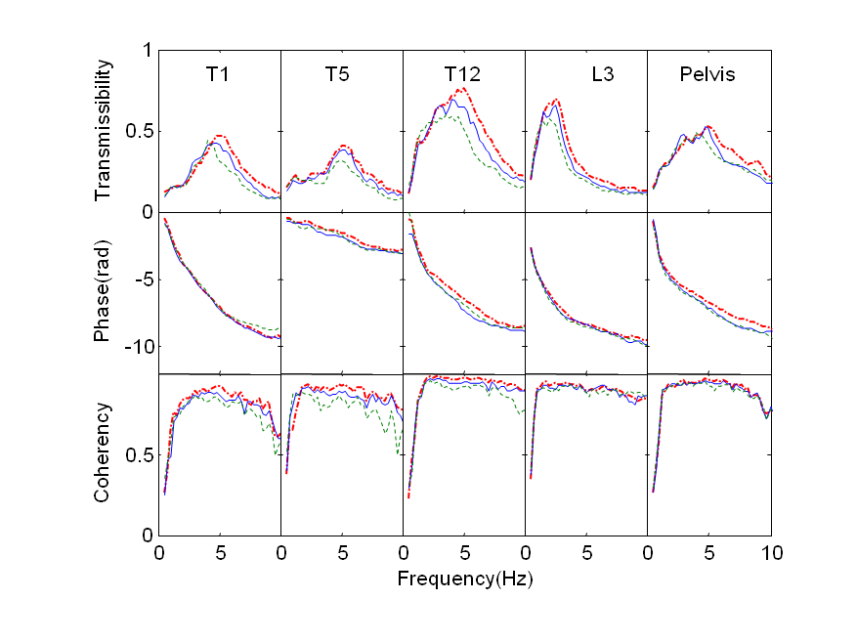Figure 10 Effect of the magnitude of the fore-and-aft excitation on the vertical cross-axis transmissibility to each measurement location: —.—, a_{x}=0.25 ms⁻² r.m.s.; ——, a_{x}=0.5 ms⁻² r.m.s.; - - -, a_{x}=1.0 ms⁻² r.m.s. (medians of 12 subjects).

4 Discussion

4.1 Apparent mass
The apparent mass measured in the present study exhibits similar characteristics to that published previously. The fore-and-aft apparent mass with single-axis fore-and-aft excitation showed the first peak in the vicinity of 1 Hz and a second mode between 2 and 4 Hz, consistent with previous findings [1, 2, and 10]. The first peak in the vertical cross-axis apparent mass in the present study occurred in the frequency range 0.5 to 1.25 Hz and there was second wide peak between 2 and 6 Hz with most subjects, similar to results reported in [2]. With dual-axis excitation, the fore-and-aft apparent mass and the vertical cross-axis apparent mass exhibited similar resonant behaviour to that found with single-axis excitation (Figure 4), as suggested previously [8, 10, and 14].

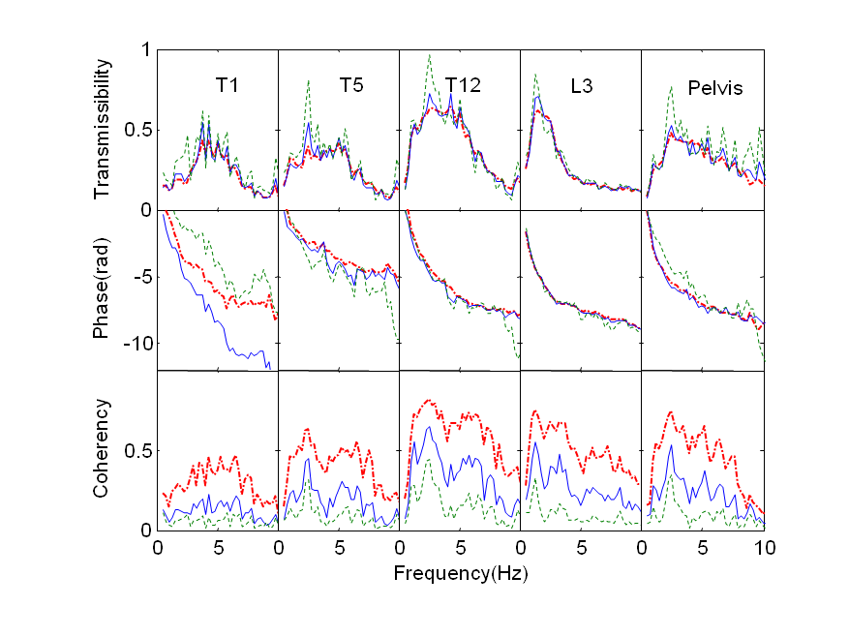Figure 11 Effect of the magnitude of additional vertical excitation on the vertical cross-axis transmissibility to each measurement location: —.—, a_{z}=0.25 ms⁻² r.m.s, a_{x}=1.0 ms⁻² r.m.s.; ——, a_{z}=0.5 ms⁻² r.m.s., a_{x}=1.0 ms⁻² r.m.s.; - - -,, a_{z}=1.0 ms⁻² r.m.s., a_{x}=1.0 ms⁻² r.m.s. (medians of 12 subjects).
Some previous studies have reported a decrease in the resonance frequency of the second mode in the fore-and-aft apparent mass between 2 to 3 Hz with increasing magnitude of excitation, but did not study the first mode around 1 Hz [8, 10]. In the present study, the first resonance frequency in the fore-and-aft apparent mass was not found to depend on the magnitude of fore-and-aft excitation (as observed in [1] and [2]) or the magnitude of the additional vertical excitation. This does not necessarily mean the first resonance is unaffected by vibration magnitude: the 0.25-Hz frequency resolution of the analysis limited the ability to detect small changes in the resonance frequency. With no measurable change in the resonance frequency, the variation in the apparent mass modulus was used to quantify any nonlinearity evident with changing vibration magnitude.
The moduli at the first resonances in the fore-and-aft inline apparent mass and the vertical cross-axis apparent mass reduced with increasing magnitude of fore-and-aft excitation, as found previously [1, 2, 11]. Similarly, with dual-axis excitation, the fore-and-aft inline apparent mass and the vertical cross-axis apparent mass decreased when the magnitude of vertical excitation increased from 0.25 to 1.0 ms⁻² r.m.s. while the fore-and-aft excitation was held constant at 1.0 ms⁻² r.m.s. This implies coupling between the response to vertical and fore-and-aft excitation.

4.2 Transmissibility
The effect of the magnitude of vibration on the first resonance in the fore-and-aft transmissibility of the body has not previously been reported. In the present study, similar to the apparent mass, the frequencies of the first resonances evident in the fore-and-aft transmissibilities to the pelvis and the spine were not significantly changed by changes in the magnitude of the fore-and-aft excitation. The absence of significant changes in the first resonance frequencies in the transmissibilities and the apparent masses implies that any changes are small relative to the frequency resolution employed in this study, but it does not exclude the possibility of real changes that may become apparent with further study using a finer frequency resolution.
The fore-and-aft transmissibility to the lumbar spine and to the pelvis at the first resonance decreased when the magnitude of additional vertical vibration increased from 0.25 to 1.0 ms⁻² r.m.s. while the magnitude of fore-and-aft excitation was held constant at 1.0 ms⁻² r.m.s. (Section 3.2.4). The reduction might be caused by increased damping of the pelvis tissues, but it could also be due to a change in stiffness with the associated change of resonance frequency not measurable with the 0.25-Hz frequency resolution. The addition of vertical excitation may also have moderated the transmission of fore-and-aft seat vibration to fore-and-aft motion of the upper body and the pelvis by encouraging a more erect posture of the upper body and the pelvis. It seems that different body segments are not equally sensitive to changes in the magnitude of fore-and-aft excitation or the addition of vertical vibration: with increasing magnitude of fore-and-aft vibration, and increasing magnitude of additional vertical vibration, the fore-and-aft transmissibilities to the pelvis, L3 and T12 were reduced at the first resonance but with no reduction in transmissibility to T5 or T1 (Section 3.2.4).

4.3 Relation between the apparent mass and the transmissibility
Motions of the pelvis and lumbar spine seem to contribute to the first resonance in the fore-and-aft apparent mass. In the fore-and-aft direction, the relative displacements between adjacent measurement locations were greatest between the pelvis and the seat (Figure 12). The first resonance frequency in the fore-and-aft transmissibility to the pelvis was correlated with the first resonance in the fore-and-aft apparent mass (Table 2). The second greatest fore-and-aft relative displacements occurred between the pelvis and L3, consistent with the first resonance in the fore-and-aft transmissibility to the pelvis being associated with the first resonance in the fore-and-aft apparent mass (Table 2).
Movements within the thoracic spine (i.e., T12, T5, and T1) do not seem to make a major contribution to the principal resonance seen in the driving point fore-and-aft apparent mass, although pitch motion of the thoracic spine contributes to the principal resonance in the vertical apparent mass [9]. The relative displacements between these locations along the thoracic spine were less than the relative motions at the pelvis and the lumbar spine (Figure 12). Furthermore, there was no significant correlations between the first resonance frequency in the fore-and-aft transmissibility to either T5 or T1 and the first resonance in the fore-and-aft apparent mass at the seat with any vibration excitation. There was a relation between the first resonance frequency in the fore-and-aft transmissibility to T12 and the first resonance in the fore-and-aft apparent mass, but only during dual-axis excitation (Table 2).
(a)
(b)

Figure 12 Example power spectral densities of (a), vertical relative displacement, and (b), fore-and-aft relative displacement between: —*—, pelvis and seat; —.—, L3 and pelvis; —Δ—, T12 and L3; —Ο—, T5 and T12; ——, T1 and T5 (Subject 11 with single-axis fore-and-aft vibration at a_{x}=1.0 ms⁻² r.m.s. Frequency resolution of the power spectrum density is 0.25 Hz
There was a high correlation between the first resonance frequency in the fore-and-aft transmissibility to the pelvis and the first resonance frequency in the fore-and-aft apparent mass. However, the pitch motion of the pelvis did not appear to contribute much to the first resonance in the fore-and-aft apparent mass: the first resonance frequency in the pitch transmissibility to the pelvis was not highly correlated with the resonance frequency in the fore-and-aft apparent mass (Table 2). This suggests that motion of the pelvis contributed to the resonance in the fore-and-aft apparent mass as a result of shear deformation of the tissues beneath the pelvis rather than pitch motion of the pelvis.
It seems logical to conclude that the combined movements of the lower thoracic spine, the lumbar spine, and the pelvis were the main contributors to the first resonance frequency in the fore-and-aft apparent mass. The motions of the middle and upper thoracic spine contributed relatively little. This contrasts with the conclusion that movements of the upper thoracic spine (e.g., regions between T1 and T5) are associated with the first resonance in the vertical apparent mass of the body during vertical excitation [6, 9].
Table 2 Correlation (Spearman test) between the first resonance frequency in the fore-and-aft apparent mass and the resonance frequency in the fore-and-aft transmissibility to the spine and the pelvis for all six vibration exposures.
a_{x}  (ms⁻²  r.m.s.) | a_{z}  (ms⁻²  r.m.s.) |  | Pelvis | L3 | T12 | T5 | T1 | Pelvis pitch
0.25 | 0 | Correlation coefficient | 0.35 | 0.804 | 0.356 | 0.324 | 0.059 | 0.384
0.25 | 0 | p value | 0.265 | 0.002 | 0.256 | 0.304 | 0.856 | 0.121
0.5 | 0 | Correlation coefficient | 0.359 | 0.633 | 0.562 | 0.005 | 0.021 | 0.408
0.5 | 0 | p value | 0.251 | 0.027 | 0.057 | 0.988 | 0.949 | 0.142
1.0 | 0 | Correlation coefficient | 0.895 | 0.689 | 0.267 | 0.203 | 0.213 | 0.505
1.0 | 0 | p value | <0.001 | 0.013 | 0.401 | 0.527 | 0.507 | 0.094
1.0 | 0.25 | Correlation coefficient | 0.065 | 0.185 | 0.06 | 0.083 | 0.282 | 0.416
1.0 | 0.25 | p value | 0.842 | 0.566 | 0.852 | 0.798 | 0.375 | 0.156
1.0 | 0.5 | Correlation coefficient | 0.525 | 0.646 | 0.755 | 0.455 | 0.182 | 0.107
1.0 | 0.5 | p value | 0.08 | 0.023 | 0.005 | 0.137 | 0.872 | 0.896
1.0 | 1.0 | Correlation coefficient | 0.421 | 0.684 | 0.708 | 0.311 | 0.207 | 0.302
1.0 | 1.0 | p value | 0.173 | 0.014 | 0.01 | 0.326 | 0.518 | 0.621

4.4 Indication of health and comfort
This study has found that the ‘nonlinearities’ in apparent mass and transmissibility caused by dual-axis vibration are small relative to the large inter-subject variability in the apparent mass and transmissibility of the human body. For the conditions investigated here, the nonlinearity is also small relative to the within-axis nonlinearities found previously with single-axis vertical vibration [15] and single-axis fore-and-aft vibration [1].
Studies of the discomfort caused by whole-body vibration show the rate at which vibration discomfort increases with increasing magnitude of vibration depends on the frequency of vibration [16-17] and the direction of vibration [16, 18]. These variations cause changes in the frequency-dependence of vibration discomfort as the magnitude of vibration increases. During vertical vibration [19] and during horizontal vibration [20], some of this ‘nonlinearity’ in vibration discomfort comes from biodynamic nonlinearity, but much of the nonlinearity appears to arise from the differing mechanisms mediating sensations of discomfort with different frequencies and directions of vibration. This has led to suggestions for differing frequency weightings with different magnitudes of vibration, but the nonlinearity found with dual axis vibration in the current study may not be sufficient to make a major contribution to such considerations.
Some research into the potential for whole-body vibration to cause injury assumes that injury or disease may be predicted using biodynamic models. In the absence of a large dual-axis nonlinearity, a principal contribution from the current research may be to advance understanding of how the body moves during excitation by fore-and-aft and vertical vibration. Such information is essential when developing biodynamic models capable of predicting internal forces within the body.

5. Conclusions
With increasing magnitude of fore-and-aft vibration, or the addition of vertical excitation, there are reductions in the principal peaks evident between 0.7 and 1.0 Hz in the fore-and-aft inline apparent mass, the vertical cross-axis apparent mass, and the transmissibility to the spine. The nonlinear behaviour of the fore-and-aft inline apparent mass and the transmissibility to the spine during dual-axis excitation indicates coupling between the principal mode excited by fore-and-aft vibration and the cross-axis influence of vertical excitation.
Whereas pitch motion of the thoracic spine can have a large influence on the principal resonance in the vertical apparent mass during vertical excitation, bending in the lower thoracic and lumbar spine, and shear deformation of tissue beneath the pelvis, seem to be involved in the primary resonance excited by fore-and-aft vibration when sitting without a backrest. The relative contributions from each body segment, especially the pelvis and the lower thoracic spine, depend on the vibration magnitude and the direction of vibration excitation.

References
[1] T.E. Fairley, M.J. Griffin, The apparent mass of the seated human body in the fore-and-aft and lateral directions, Journal of Sound and Vibration 139 (1990) 299-306.
[2] N. Nawayseh, M.J. Griffin, Non-linear dual-axis biodynamic response to fore-and-aft whole-body vibration, Journal of Sound and Vibration 282 (2005) 831–862.
[3] P. Holmlund, R. Lundström, Mechanical impedance of the human body in the horizontal direction. J. of Sound and Vibration, 215 (1998), 801-812.
[4] G.H.M.J. Subashi, N. Nawayseh, Y. Matsumoto, M.J. Griffin, Nonlinear subjective and dynamic responses of seated subjects exposed to horizontal whole-body vibration, Journal of Sound and Vibration 321 (2009) 416–434.
[5] J. Sandover, H. Dupuis, A reanalysis of spinal motion during vibration, Ergonomics 30 (1987) 975 - 985.
[6] S. Kitazaki, M.J. Griffin, A modal analysis of whole-body vertical vibration using a finite element model of the human body, Journal of Sound and Vibration 200 (1998) 83-103.
[7] Y. Matsumoto, M.J. Griffin, Movement of the upper-body of seated subjects exposed to vertical whole-body vibration at the principal resonance frequency, Journal of Sound and Vibration 215 (1998) 743–762.
[8] N.J. Mansfield, R. Lundström, The apparent mass of the human body exposed to non-orthogonal horizontal vibration, Journal of Biomechanics 32 (1999) 1269-1278.
[9] G. Zheng, Y. Qiu, M.J. Griffin, Vertical and dual-axis vibration of the seated human body: Nonlinearity, cross-axis coupling, and associations between resonances in transmissibility and apparent mass. Journal of Sound and Vibration, 331 (2012), 5880-5898.
[10] Y. Qiu, M.J. Griffin, Biodynamic responses of the seated human body to single-axis and dual-axis vibration, Industrial Health 48 (2010) 615-27.
[11] B. Hinz, R. Blüthner, G. Menzel, S. Rützel, H. Seidel, and H. P. Wölfel, Apparent mass of seated men–Determination with single- and multi-axis excitations at different magnitudes, Journal of Sound and Vibration 298 (2006) 788-809.
[12] S. Mandapuram, S, Rakheja, P, Marcotte, P. Boileau, Analyses of biodynamic responses of seated occupants to uncorrelated fore-aft and vertical whole-body vibration. J. of Sound and Vibration, 330(2011): 4964-4079.
[13] J.S. Bendat, A.G. Piersol, Random Data Analysis and Measurement Procedures, 2nd Edition, Wiley, New York, 1986.
[14] N.J. Mansfield, S. Maeda, Comparison of the apparent masses and cross-axis apparent masses of seated humans exposed to single and dual-axis whole-body vibration, Journal of Sound and Vibration 298 (2006) 841-853.
[15] T.E. Fairley, M.J. Griffin, The apparent mass of the seated human body: Vertical vibration. Journal of Biomechanics, 22 (2) (1989), 81-94.
[16] M. Morioka, M.J. Griffin, Magnitude-dependence of equivalent comfort contours for fore-and-aft, lateral and vertical whole-body vibration. Journal of Sound and Vibration, 298 (3) (2006), 755-772.
[17] Z. Zhou, M.J. Griffin, Response of the seated human body to whole-body vertical vibration: Discomfort caused by sinusoidal vibration. Ergonomics, 57 (5) (2014), 693-713.
[18] J.J. Arnold, M.J. Griffin, Equivalent comfort contours for fore-and-aft, lateral, and vertical whole-body vibration in the frequency range 1.0 to 10 Hz. Awaiting publication in Ergonomics. https://doi.org/10.1080/00140139.2018.1517900.
[19] Y. Matsumoto, M.J. Griffin, Nonlinear subjective and biodynamic responses to continuous and transient whole-body vibration in the vertical direction. Journal of Sound and Vibration, 287 (2005), 919-937.
[20] G.H.M.J. Subashi, N. Nawayseh, Y. Matsumoto, M.J. Griffin, Nonlinear subjective and dynamic responses of seated subjects exposed to horizontal whole-body vibration. Journal of Sound and Vibration, 321 (1-2) (2009), 416-434.

