Introduction
The performance demands placed on batteries are growing rapidly due to the increasing adoption of technologies such as off-grid storage for photovoltaic power stations, and electric vehicles. Currently, lithium-ion batteries and their derivatives have the highest voltage and power/energy density of any commercial battery, and are therefore the most common batteries used in applications that demand high performance. [1] However, there are downsides to lithium-ion batteries, such as their need for extra circuitry to prevent thermal runaway, their high fabrication cost, the electrolyte toxicity,[2,3] and the relative global scarcity of lithium compared to common metals such as sodium, iron and aluminium.
These concerns have led to research into alternative battery chemistries that only use abundant active materials, together with electrolytes that are better for the environment. For example, research on sodium-ion batteries has accelerated in the past decade, as has research on aqueous batteries. Aluminium is a desirable anode metal on which to base battery chemistry, because aluminium is more abundant in nature and has a higher volumetric energy density than lithium. [4] Recent examples of high energy-density aluminium batteries include aluminium-air. [5], [6] and aluminium-sulphur [7] chemistries. Aluminium-ion batteries may not achieve such high energy density as these two battery types, but suffer from fewer problems involving rechargeability (aluminium-air cannot be recharged at all, and the kinetic processes of Al-S are very slow [7]).
Recently, much progress has been made in the construction of aluminium-ion pouch cells by researchers in Stanford and Taipei. [8,9] Their device resembles a rechargeable version of the lithium-metal battery, with an intercalation cathode vs. a metal anode. Unlike lithium-ion batteries, it is not a full metal-ion battery where both the anode and cathode are intercalation materials. The anode of these cells is made from pure (99.999%) aluminium foil, and the cathode is made from graphite, which can intercalate AlCl₄⁻ anions produced in the AlCl₃/ethyl-methyl-imidazolium ionic-liquid electrolyte. The specific cathodic capacity of their cell constructed with a pyrolytic graphite cathode is 65 mAh.g⁻¹,[8] and for their cell constructed with a powdered natural graphite cathode is 110 mAh.g⁻¹.[9] At cell level, accounting for the mass of both electrodes and the electrolyte, the energy density of this natural graphite cell is 68.7 Wh.kg⁻¹. This is around half the energy density of lithium-ion batteries, so improvements are needed before the cells could become competitive. The longevity of the cell up to at least 2,000 cycles has been proved in a separate study by researchers in Berlin, [10] so the durability of a graphitic aluminium-ion battery is assured.
The reactions of the cell have been written as below,[8] with aluminium re-plating and stripping occurring at the anode during charging and discharging respectively, whilst at the same time intercalation and de-intercalation of tetrachloroaluminate occurs at the cathode:
4Al₂Cl₇⁻ + 3e⁻ ⇌ Al + 7AlCl₄⁻ (anode)
C_{n} + AlCl₄⁻ ⇌ C_{n}[AlCl₄] + e⁻ (cathode)
The charge storage capacity of the aluminium-ion battery is limited by the performance of the cathode material: aluminium metal has a gravimetric energy storage capacity of 2980 mAh.g⁻¹ for dissolution/re-plating, [10] whereas the energy storage capacity of graphitic material towards AlCl₄⁻ ions is an order of magnitude smaller. The greatest effort, therefore, should be focused on the cathode material in order to improve the performance of aluminium-ion batteries. As well as pyrolytic and natural graphite, a variety of different structural forms of graphitic carbon have been investigated as cathodes; recently Kish graphite flakes, a by-product of steel manufacturing, have been tested with promising results of up to 142 mAh.g⁻¹ discharge capacity and impressive power densities of up to 4363 W.kg⁻¹ [11] Also, a battery containing a graphene film cathode with a specific capacity of 120 mAh.g⁻¹ that can be cycled at a current density of 400 A.g⁻¹ has recently been reported: here what is called graphene is actually a film similar to pyrolytic graphite, but containing only a few graphite layers. [12] Graphene-type cathode materials for Aluminium-ion batteries have also been reported in reference [13], where graphite-aerogel millispheres were created using a wet-spinning technique. The capacity of this material towards aluminium is not greater than ordinary graphite; [9] however, the material many have some advantages in terms of its high elasticity for producing flexible cathodes for batteries.
From the literature, it seems that graphitic cathode materials are superior in terms of both the voltages and power densities that can be achieved. Of the other materials that have been used as cathodes, only MoO₂ has given a performance comparable to graphite (Table 1).[14] The capacity of V₂O₅, VO₂ and CuS compounds towards aluminium intercalation can be impressive, up to around 200 mAh.g⁻¹[15][16]-[17], but the main drawback of these materials is a much lower intercalation potential, such that the overall energy density would fall short of the graphite materials.

Table 1. Comparision of different cathode materials used against metallic aluminium to make a rechargeable aluminium-ion battery. Abreviations: EMIMCl = 1-ethyl-3-methylimidazolium chloride, BMIMCl =1-butyl-3-methylimidazolium chloride.

Cathode Material | Electrolyte | Average Cell Voltage / V | Capacity / mAh.g⁻¹ | Max. Power Density/ W.kg⁻¹ | Max. Energy Density/ Wh.kg⁻¹ (electrodes + electrolyte) | Ref.
Pyrolytic graphite | EMIMCl/AlCl₃ | 2.0 | 65 | 132 | - | [8]
Graphitic foam | EMIMCl/AlCl₃ | 2.0 | 70 | 3000 | 40 | [8]
Natural graphite powder | EMIMCl/AlCl₃ | 2.0 | 110 | 1320 | 68.7 | [9]
Graphene mesh | EMIMCl/AlCl₃ | 1.7-2.2 | 57 | 5700 | - | [18]
Graphene film | EMIMCl/AlCl₃ | 2.0 | 120 | 175000 | 66 | [12]
Graphene millispheres | EMIMCl/AlCl₃ | 1.8 | 85 | 9000 | - | [13]
Carbon paper | EMIMCl/AlCl₃ | 1.8 | 70 | 180 | - | [19]
Kish graphite powder | EMIMCl/AlCl₃ | 1.79 | 142 | 4363 | 65 | [11]
Graphite powder | Urea/AlCl₃ | 1.73 | 73 | 346 | 76 | [20]
MoO₂ | EMIMCl/AlCl₃ | 1.9 | 90 | 190 | - | [14]
CuS/C microspheres | EMIMCl/AlCl₃ | 1.0 | 90-200 | 20-150 | - | [17]
V₂O₅/C nanoparticles | Dipropylsulfone/ toluene/ AlCl₃ | 1.0 | 70-100 | <10 | - | [21]
V₂O₅ nanowires | EMIMCl/AlCl₃ | 0.6 | 305 | 75 | - | [15]
VO₂ nanorods | BMIMCl/AlCl₃ | 0.5 | 116 | 25 | - | [22]
V₂O₅ nanorods | BMIMCl/AlCl₃ | 0.6 | 239 | 27 | - | [16]
V₂O₅ nanowires | BMIMOTF/ Al(OTF)₃ | 0.3 | 80 | <10 | - | [23]
α-MoO₃ | EMIMCl/AlCl₃ | 0.7-1.3 | 100 | 4 | - | [24]
TiO₂ nanotube arrays | AlCl₃ aqueous | 0.95 | 75 | - | - | [25]
TiO₂ nanoleaves | Al(NO₃)₃ aqueous | 0.95 | 270 | 47.5 | - | [26]
V₂O₅ | AlCl₃ aqueous | 0.3 | 250 | 18 | - | [27]
Na₃V₂(PO)₃ | AlCl₃ aqueous  EMIMCl/AlCl₃ | 0.38  1.25 | 45  86 | 4  4 | - | [28]
MoO₃ | AlCl₃ aqueous | 0.6 | - | - | - | [29]
Cu₃[Fe(CN)₆]₂ | AlCl₃ aqueous | 1.5 | 15 | 300 | 15 | [30]

The most suitable electrolyte for aluminium-ion batteries is still an ongoing matter for debate; 1-ethyl-3-methylimidazolium chloride (EMIMCl) as an ionic liquid solvent for anhydrous AlCl₃ is the most popular solvent, as the reversible electroplating of AlCl₄⁻ is well-established and it is relatively simple to prepare an electrolyte with various ratios EMIMCl:AlCl₃ (1:1.3 – 1:1.5 is the usual range). However, recent research showed urea, CO(NH)₂, to be a feasible alternative electrolyte, although it was not tested to such high power densities as EMIMCl and the discharging voltage of the cell is slightly lower. [20] The main advantage of urea over EMIMCl would be its lower cost. Aqueous electrolytes have also been investigated (final 6 rows of Table 1), although it should be noted that these are not at a very advanced stage, with mostly half-cells investigated, apart from a full cell composed of copper hexacyanoferrate vs. titanium dioxide, [30] This cell has achieved a power density comparable with ionic liquid cells; however the potential window of operation and the power density generally suffer in aqueous electrolytes, although some promising half-cell capacities have been achieved with vanadium-containing materials. [27,28]
When it comes to designing a commercial cell, the mechanical properties of the electrodes are important in addition to the electrochemical properties. For example, to make a standard 18650 cylindrical cell, the cathode and anode must be flexible and easy to roll for insertion inside the cell, whereas for a larger parallel-plate cell flexibility is not as important as the ability to withstand high sealing pressure at the edges of the electrodes. In any case, it important that the cathode material is not as brittle as to cause cracks when the cell is sealed.
In this paper, various commercially available forms of carbon are compared for their suitability in aluminium-ion cells. The advantages of these forms of carbon are that they are mass-manufactured and relatively inexpensive. They are also thicker and have a much higher porosity than pyrolytic graphite (see Table 2), which could be beneficial if they are used as support materials loaded with active materials with large AlCl₄⁻ insertion capacity, e.g. AlMn₂O₄, MnO₂, MoO₂ or CuS [14], [17], [4] that are not electrically conductive and need the presence of a lightweight conductive scaffold.

2. Experimental
All experiments were conducted using a Swagelok cell made from a PEEK PFA-820-6 Swagelok Tube Fitting with a diameter of 12.7 mm (1/2 in). The anode current collector was a 12.7 mm aluminium rod (99.999% purity, Sigma Aldrich) and the cathode current collector was a 12.7 mm stainless steel rod (430 alloy, Sigma Aldrich). The separator was a Whatman glass microfiber sheet (grade GF/A) which has a thickness of 0.25 mm: multiple layers of this separator were stacked together to increase electrode separation. Experiments were initially run without a separator using the natural interior volume inside the as-received Swagelok fitting to separate the electrode to a spacing of 6 mm. This was done to ensure an excess of electrolyte and provide a simple cell setup. In subsequent experiments, the cell was bored through using a drill and the Whatmann glass microfiber sheet was used to separate the electrodes. Therefore, experiments using a 0.25-3 mm separation between the electrodes employed the glass microfiber separator, whereas those at 6 mm were performed in a flooded cell without a separator.
The electrolyte was a commercially obtained mixture of 1-ethyl-3-methylimidazolium chloride (EMIMCl) with AlCl₃ to a 1:1.5 mass ratio (Sigma Aldrich). The separator was soaked overnight so that it was saturated with the electrolyte. The anode was a 12.7 mm, 7.6 mg disk of 99.999% pure aluminium foil (0.025 mm thickness, Sigma Aldrich). The cathode was a 12.7 mm disk of one of the following materials: pyrolytic graphite foil (0.025 mm, Panasonic), carbon paper 5 wt.% PTFE added (0.19 mm, Sigracet), carbon paper with microporous carbon layer + 5 wt.% PTFE (0.23 mm, Sigracet), carbon cloth + 5 wt.% PTFE added (0.3 mm, Fuel Cell Ltd.), carbon cloth with microporous layer (0.5 mm, Fuel Cell carbon cloth with in-house added microporous layer composed of 80 wt. % Vulcan XC72 with 20 wt. % PTFE), or graphitised carbon felt (2 mm, Sigracell). The microporous layer (MPL) was added to the carbon cloth by spreading a mixture of 80 wt. % Vulcan XC72 carbon black with 20 % PTFE onto the carbon cloth, hot-pressing at 140 ºC, 10 MPa, and then treating for 10 minutes in a furnace at 380 ⁰C to remove the PTFE dispersing agent.
In the first instance the assembled Swagelok cells were charged and discharged at a current density of 50 mA.g⁻¹ using a potentiostat (Solartron, CellTest 1470E). All cell assembly was performed inside a nitrogen-filled glove box with concentrations of O₂ and H₂O below 0.5 ppm. SEM was performed using a JEOL 6500F instrument operating at an accelerating voltage of 15 kV, and the samples were washed in DMC solvent (which has been identified as the best solvent for washing away the ionic liquid without affecting the carbon structure according to reference [10]) prior to SEM and XRD analysis.

3. Results and Discussion
Before exploring their electrochemical properties, the carbon cathode materials were first analysed using SEM and XRD. The results (Figures 1 and 2), together with the known physical properties of these materials (Table 2) show that three of the materials, carbon paper, carbon cloth and carbon felt (all used as received) have a highly open, porous structure all the way through. Adding a microporous layer, which could be used to support other aluminium-intercalating materials, replaces the open surface with a dense microlayer (less than 200 μm thick) of carbon containing nano-sized pores (Figure 1). Pyrolytic graphite, on the other hand, is a thin foil with negligible porosity, so the penetration of ionic liquid into this material would be slower. Observation showed that any PTFE content did not hinder wetting of the porous carbon materials with the ionic liquid, they all absorbed the liquid within one minute of exposure.
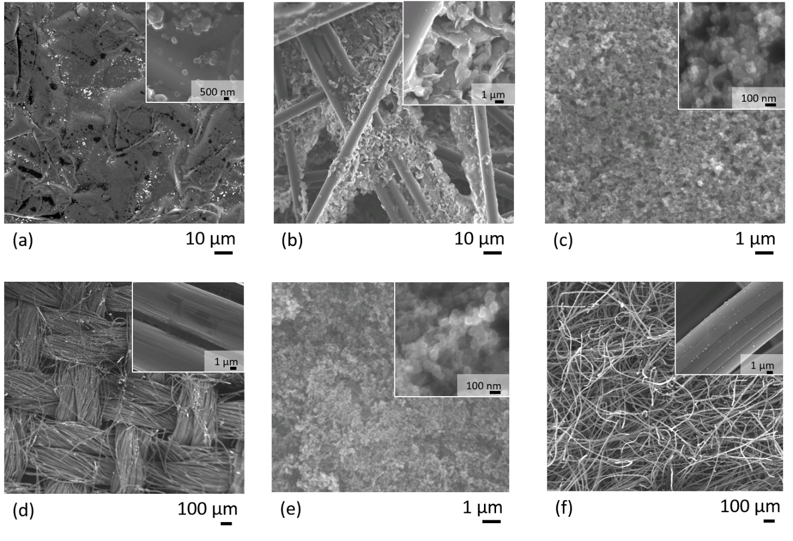
Figure 1. SEM characterisation of (a) pyrolytic graphite, (b) carbon paper, (c) carbon paper with microporous layer, (d) carbon cloth, (e) carbon cloth with microporous layer, and (f) carbon felt.

Table 2. Physical and electrochemical properties of carbon materials in aluminium-ion cells. All electrochemical properties were measured at a cycling current density of 50 mA.g⁻¹ (Figure 3). The Physical properties (thickness, density, porosity) were obtained from the manufacturers, Sigracet, Sigracell and Fuel Cell Ltd.

Material | Thickness / mm | ρ / g cm⁻³ | Porosity / % |  | Discharge capacity/ mA.g⁻¹_{cathode} |  | Energy Density/ Wh.kg⁻¹_{cathode} |  | Coulombic Efficiency / % |  | Energy Efficiency / %
Pyrolytic graphite | 0.025 | 2.1 |  | < 1 |  | 60 |  | 102 |  | 92 |  | 73
Carbon paper | 0.19 | 0.45 |  | 82 |  | 70 |  | 122 |  | 93 |  | 69
Carbon paper + MPL | 0.23 | 0.45 |  | 37 |  | 20 |  | 34 |  | 40 |  | 31
Carbon cloth | 0.3 | 0.35 |  | 80 |  | 37 |  | 64 |  | 61 |  | 47
Carbon cloth + MPL | 0.5 | 0.8 |  | 63 |  | 33 |  | 56 |  | 88 |  | 75
Carbon felt | 0.5 | 0.4 |  | 98 |  | 23 |  | 43 |  | 88 |  | 61

The carbon paper is highly graphitic in nature possessing a strong sharp (002) diffraction peak identical to pyrolytic graphite in the XRD analysis (Figure 2). The small, flaky particles apparent in the SEM image (Figure 1b) must therefore be micron-sized flakes of graphite with a thickness of a few graphene layers. These graphite flakes are bound to a framework of graphitic carbon fibres 7.5 μm thick. This hierarchical structure explains the high porosity of carbon paper (Table 2). On the other hand, carbon cloth and carbon felt both have simpler microscopic structures, they are composed of carbon fibres 10 (carbon felt) or 7.5 (carbon cloth) μm thick. A highly ordered graphiticity is not so apparent in these materials from the XRD pattern (Figure 2); the (002) peak is very broad suggesting that the graphitised carbon fibres contain only very small domains of ordered graphite. Line broadening analysis of the graphitic peaks carried out using the Halder-Wagner method [31] suggested an average crystallite domain size for carbon felt of 27 nm and 48 nm for the carbon cloth. The carbon paper and pyrolytic graphite, on the other hand had average domain sizes of 61 nm and 323 nm respectively. With the added microporous layer the values for carbon cloth and paper changed to 24 nm and 38 nm respectively, suggesting that the average grain size measurement is decreased by the very small (ca. 20 nm according to the TEM) carbon particles in the MPL.

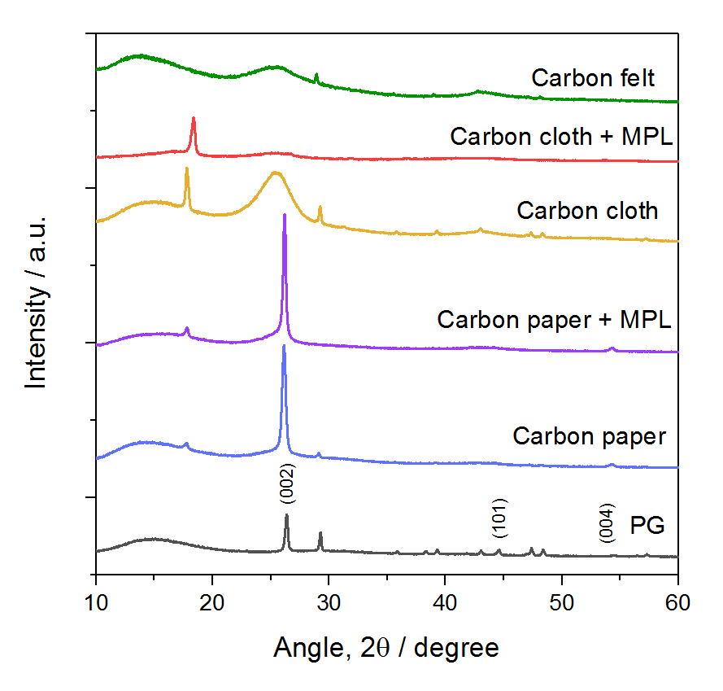
Figure 2. XRD characterisation of the different types of carbon. The peaks for pyrolytic graphite are labelled, and the peak at 17-18 º that appears in the other samples is the (100) peak from crystalline PTFE that is present as a binder.[32]

Although the pyrolytic graphite is not porous, the presence of graphite nanoparticles on the surface was confirmed by SEM. These particles, which may be nucleation particles remaining from the pyrolytic graphite synthesis process, do not completely cover the surface of the pyrolytic graphite, but they may provide an extra surface area and which could initially help to activate the graphite sheet towards aluminium intercalation.
All of the carbon materials were then tested as cathodes in a Swagelok cell using aluminium foil as the anode. The charge discharge cycles obtained (Figure 3) allowed determination of their cathodic properties in an aluminium-ion battery (Table 2). The material with the highest specific capacity was carbon paper with 70 mAh.g⁻¹, which equates to a specific energy density of 122 Wh.kg⁻¹, calculated in terms of the mass of the cathode by integrating the plot of capacity versus voltage in Figure 3a. The capacity here is close to that reported by Sun et. al. [19], however they reported this value at a discharging current density of 100 mA.g⁻¹; at the current density of 50 mA.g⁻¹ used in this publication they reported a value of 88.55 mA.g⁻¹. The average discharge voltage of the carbon paper cell is 1.9 V, slightly higher than previously reported. [19] Carbon paper has a discharge slope which is less marked by a clear end-point than the other materials, so it was deemed reasonable to discharge the cell down to 1.0 V to make sure the maximum capacity had been extracted. In future work, it may not be desirable to discharge the cell this fully as it could shorten the cell lifetime (though not in the timescale of the multiple cycles observed in Figure 4).

(a) 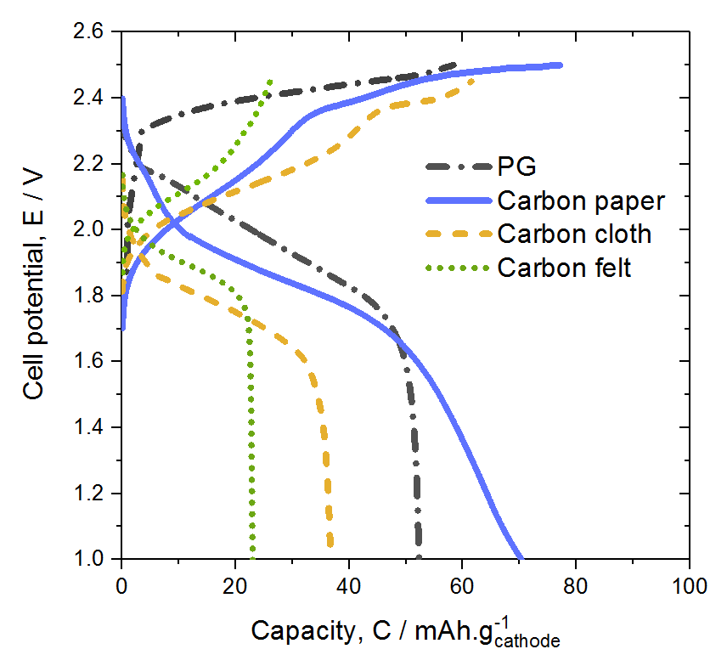 (b) 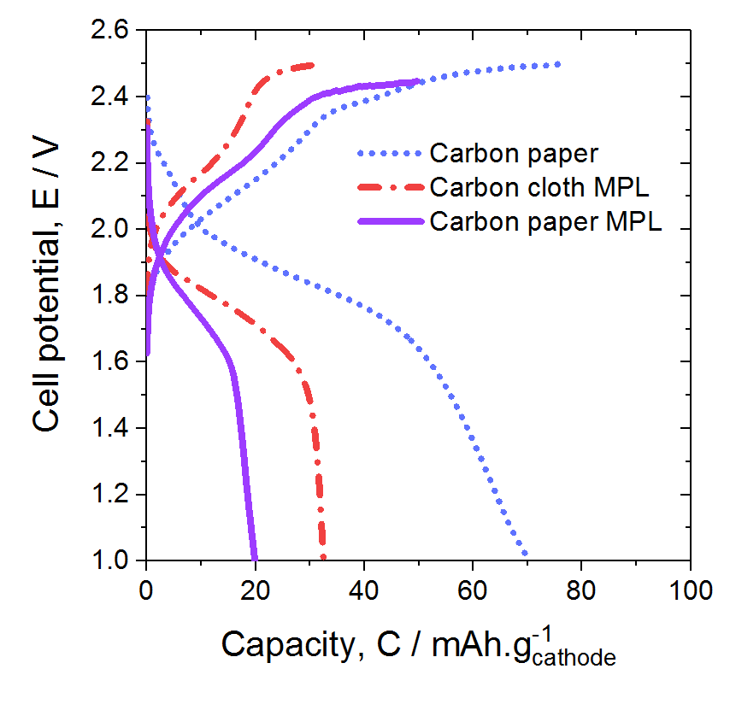
Figure 3. (a) Charge-discharge cycles of different carbon materials: pyrolytic graphite, carbon paper, carbon cloth and carbon felt. (b) charge-discharge cycles of carbon cloth and paper with added carbon microporous layers. The electrolyte was 1:1.5 EMIMCl:AlCl₃ in a Swagelok cell with no separator and electrode separation of 6 mm. The cycling current density was 50 mA.g⁻¹. The cycles were taken from after the cell capacity had begun to stabilise: for carbon paper and pyrolytic graphite cycle 11, for carbon paper + MPL cycle 14, and for the other materials cycle 30 (Figure 4).
All things considered, the performance of the carbon paper and pyrolytic graphite cells are very similar in terms of capacity, energy density, and efficiency (Table 2). Carbon cloth showed a discharge capacity of 37 mAh.g⁻¹, just over half that of carbon paper, and the other materials have capacities that are even lower (Figure 3). Adding a microporous layer to the carbon paper or cloth decreased its specific capacity, which makes sense as carbons blacks contain a mixture of graphitic and amorphous carbon [33] so are not expected to have much [AlCl₄]⁻ intercalation activity, hence the added weight of carbon black would decrease the cathode capacity per gram of material. However, adding the microporous layer to carbon cloth appeared to increase its coulombic and energy efficiency; the same cannot be said of the carbon paper, where the coulombic and energy efficiencies both decreased when a microporous layer is added.
An explanation of this may lie in the different nature of the two materials. Adding carbon black to the surface of carbon paper may clog the structure and physically block access of the ionic liquid to the internal structure of the paper shown in Figure 1b. This explains the large decrease in porosity between the carbon paper with and without the added microporous layer (MPL) evident in Table 2. The carbon cloth only contains graphitised fibres and no small flakes, so does not suffer this dramatic decrease in porosity. This explains why carbon cloth does not suffer such a strong decrease in performance as a cathode material when a carbon black MPL is added; however, is it not yet clear why adding the MPL should improve coulombic efficiency. Possibly, the microporous layer helps to hold the flexible carbon cloth together as it undergoes changes in shape due to intercalation during the charging process.
Figure 4 shows how the cathodes gradually activate and improve their performance over the first 30 cycles. Carbon paper and pyrolytic graphite quickly improve their capacity during the first 10 cycles, and after this point the capacity stabilises. The carbon cloth with and without an MPL, carbon paper with MPL and carbon felt, however, take some time to reach full capacity, improving mostly between cycle 10 and cycle 25.
(a)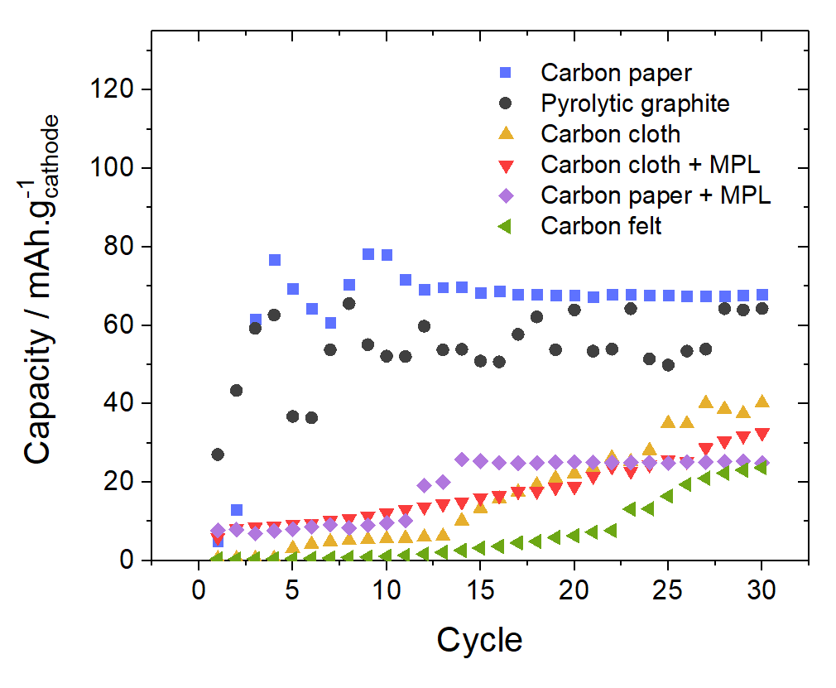(b)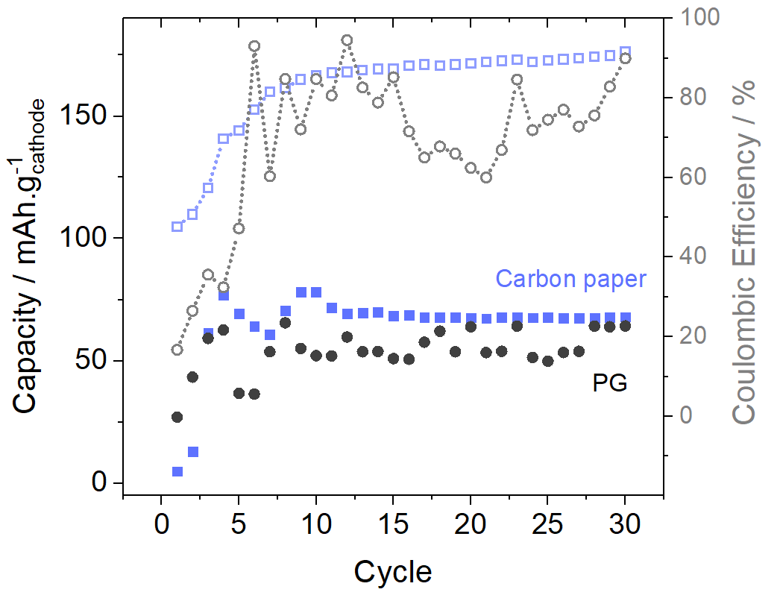
Figure 4. (a) Discharge capacity of carbon materials for the first 30 cycles in the Swagelok cell with no separator and 1:1.5 EMIMCl:AlCl₃ electrolyte, with (b) cycle capacities of pyrolytic graphite and carbon paper shown with their corresponding coulombic efficiencies. The cycling current density was 50 mA.g⁻¹.

Carbon paper gives the most reliable discharge capacity, with only small variation between cycles once the performance has stabilised (Figure 4). The same is true for carbon paper with an added microporous layer. Pyrolytic graphite shows more variation in discharge performance and coulombic efficiency (Figure 4b), with around 10 mAh.g⁻¹ difference between the best and worst-performance discharge cycles after cycle 10. This could be because as a continuous sheet material rather than flexible interwoven fibres like the other carbon materials, pyrolytic graphite is more susceptible to deformation on repeated intercalation and de-intercalation, especially as there is no separator inside the cell to inhibit expansion. Carbon cloth and felt show a slow and steady increase in capacity over time, and the trend in Figure 4 suggests that if the cells were left to cycle for longer, the capacity of these materials may slowly continue to increase by a small amount; however it is not likely they would reach the capacity of carbon paper or pyrolytic graphite.
After the capacity of the carbon materials was identified, further experiments were formed using the well-established pyrolytic graphite vs. Al system to ascertain the effect that cell charging voltage, and the separation of the electrodes (and also the volume of electrolyte in the cell) has on the cell performance. Figure 5 shows the effect that overcharging the cell has on the discharge capacity and cathodic energy density of the cell (above 2.5 V is considered overcharging because the electrolyte begins to degrade, evolving chlorine gas [8]). The cell eventually failed on the 10th cycle due to gas evolution, but interestingly Figure 5 suggests that if the graphite-Al system could be charged to 2.75 V, in another electrolyte that would not degrade, the capacity of the cell could be more than tripled.
According to previous studies of the interaction of the ionic liquid EMIMCl:AlCl₃ with graphite, the fully charged graphite at 2.45 V corresponds to stage 4 compound, i.e. the [AlCl₄]⁻ species are intercalated on average in every 4th layer of graphene.[10] Applying a higher charging cut-off voltage (and also longer charging time) to the graphite may allow more [AlCl₄]⁻ species to intercalate inside the graphene layers, increasing the discharge capacity of the cell. The maximum theoretical capacity of graphite for [AlCl₄]⁻ (assuming one species is intercalated per graphite C₆ unit) is 372 mAh.g⁻¹.[8] At a charging voltage of 2.75 V, the cathode reaches 230 mAh.g⁻¹ stored capacity, which is about 60 % of the theoretical maximum, so the cathode is approaching a scenario where species could be intercalated inside almost every graphite layer (the theoretical fully-charged compound would be [AlCl₄]⁻.C₆). The 2015 paper by Lin et al. [9] did not observe such a large increase in the capacity caused by overcharging the cell, but two factors are different between their results and those presented here: they only went as high as 2.6 V, and also their cell contained a porous glass fibre separator, which would have trapped chlorine bubbles from electrolyte degradation next to the electrodes and decreased their capacity. In the setup in Figure 5, there was no separator included and any bubbles evolved were free to leave the electrode surface into a larger volume of electrolyte.
(a)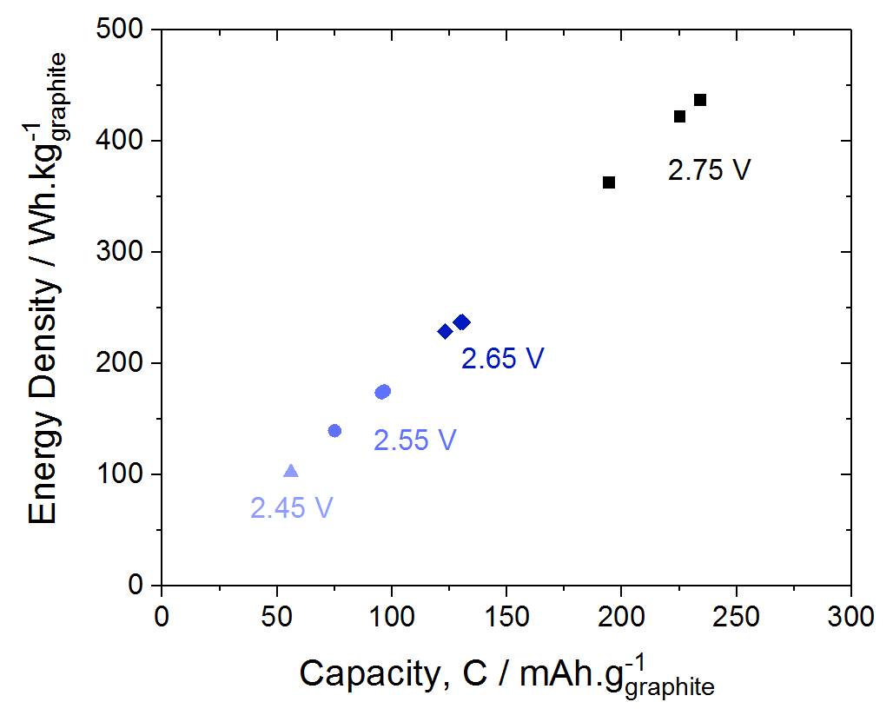(b)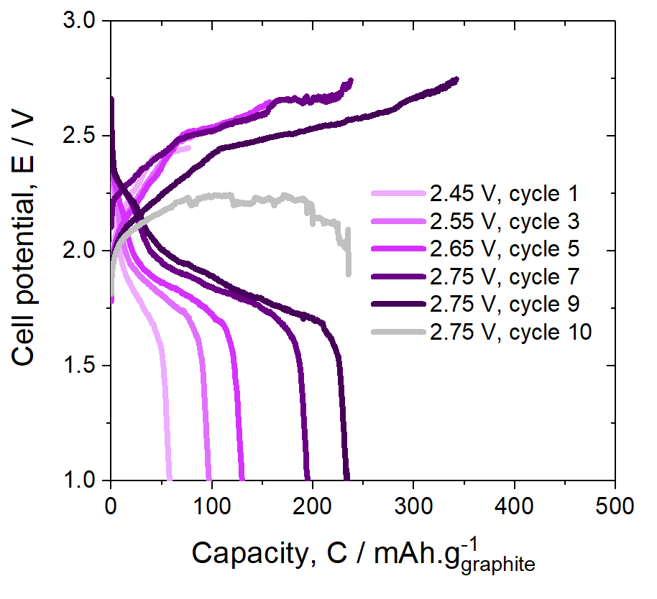
Figure 5. (a) Effect on cell capacity of overcharging the pyrolytic graphite cell using upper voltage limits up to 2.75 V over 9 cycles, for 3 cycles each at 2.55 V, 2.65 V and 2.75 V voltage cut-offs, and (b) charge-discharge profiles for selected data points. Data from Figure 2a for 2.45 V is also included. Aside from the eventual degradation of the electrolyte releasing chlorine gas, the capacity of the cell was shown to increase with increased charging voltage. Cell failure occurred on the 10th cycle. The cell had an inter-electrode separation of 6mm with no separator included.

Although the results of Figure 5 have implications for electrolyte development, for the rest of this study the cell was charged to 2.45 V each time to avoid the electrolyte degradation. The pyrolytic graphite versus aluminium cell was then studied with different separation between the electrodes by varying the number of 0.25 mm glass fibre separators used (Figure 6). This also had the effect of varying the volume, in microliters, of electrolyte available in the cell. It was found that the electrolyte volume and electrode separation have an effect on the capacity and energy density of the cell, with the optimum around 1.5 mm electrode separation with an electrolyte mass of 0.2 mg (or 150 μL). Differences in capacity are very small between 1-3 mm separation, but at smaller (0.25, 0.5 mm) and larger (6 mm) separations the capacity decreased. In the case of the large electrode separation, the average capacity was lower because the large volume of electrolyte has a greater electrical resistance. At smaller separations < 1 mm, the observed decline in capacity could be because of the decreased electrolyte volume. At a separation of 0.25 mm, the electrolyte volume contains 55 mg of AlCl₃ (in 95 mg of electrolyte). To intercalate up to 70 mAh.g⁻¹, the cathode requires 1.36 C of charge, which equates to 1.86 mg of AlCl₃. Therefore, even with such a small separation the amount of AlCl₃ contained in the electrolyte should be enough to fully charge the cathode.
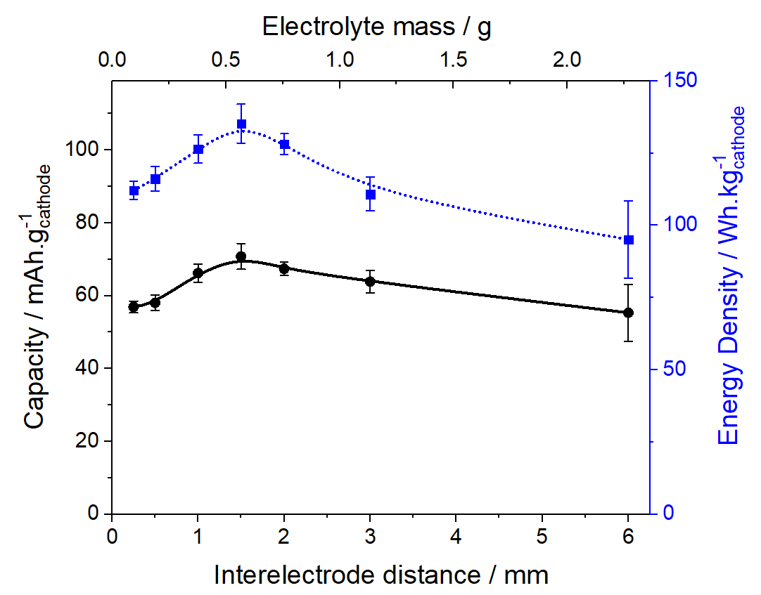
Figure 6. Performance of pyrolytic graphite cell with variable electrolyte volume and electrode separation, using layers of Whatman GF/A glass microfiber separator. Data points shown are the mean of data collected up to the 50th cycle, after the cell performance had stabilised at the 10th cycle (Figure 7). The standard deviation is shown by the error bars.

The decrease in capacity at 0.25 mm electrode separation, as well as the fact that the capacity was observed to fall away after only 15 cycles (Figure 7), suggests that eventual short circuiting may be a problem. When the cell was disassembled inside the glove box, it was evident that some black particles had been deposited in the separator, most likely electrodeposited aluminium (Figure 7b). At other separations > 0.25 mm, the cell continued to perform for at least 50 cycles (Figure 7). It seems that use of a single layer of separator is not enough to prevent eventual short circuit (Figure 7a) as the aluminium deposits at the anode grow in size (Figure 7b, 10a).
(a)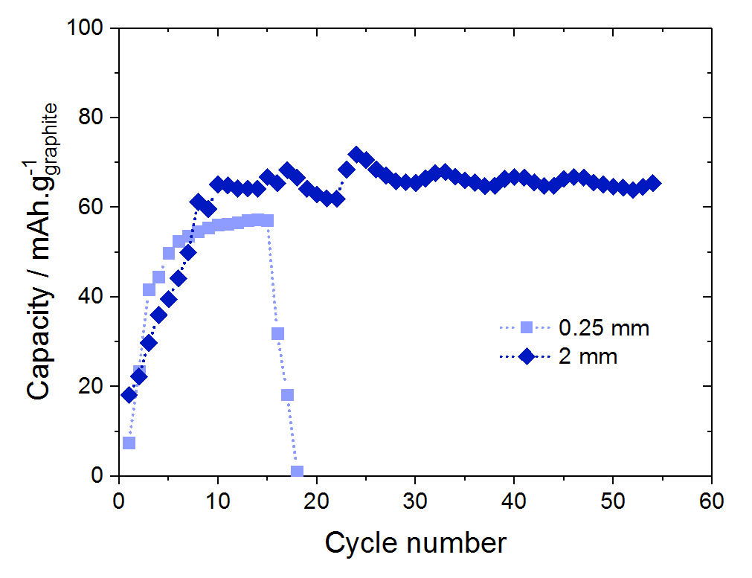(b)
Figure 7. (a) Performance of pyrolytic graphite cell with 0.25 and 2 mm separation over 54 cycles and (b) photograph of glass fibre separator on top of aluminium anode removed from 0.25 mm cell after cell failure at the 18th cycle.

For all subsequent experiments, it was decided to use a separation of 2 mm between the electrodes, with eight layers of 0.25 mm glass fibre separator. Figure 8a shows a comparison of the effect of increasing the C-rate of both charge and discharge on the discharge capacity of both pyrolytic graphite and carbon paper, which were identified as the best performing cathode materials. At a lower discharge rate of 0.5 C, the capacity of both materials was equal. However, with increasing C-rate, the capacity of pyrolytic falls dramatically compared with the carbon paper. At the 20 C charging rate, the carbon paper had a capacity of around 20 mAh.g⁻¹ and could be cycled within 3 minutes. The pyrolytic graphite, on the other hand, had lost all capacity by the time it was cycled at the 5C rate.
These results show that carbon paper has a much more robust structure that can withstand cycling at much higher current densities. This makes sense in light of the results of Lin et al. [8] who found a similar difference between the performance of pyrolytic graphite versus a more expanded graphitic foam structure at high current densities. No explicit explanation is given in their publication, but the higher surface area of foam structures should allow better utilisation of the carbon materials, hence a higher capacity. The pyrolytic graphite sheet most likely undergoes more strain upon repeated interaction/deintercalation at higher cycling rates: it is composed of a large sheet of graphite that must undergo swelling and deformation. [8] Carbon paper, on the other hand, is a porous structure containing micron-sized graphite particles, which can to some extent rearrange themselves within the structure as they intercalate and swell, so the structure will overall experience less strain, and may tolerate high C rates of charge and discharge better. Figure 8b shows that when a fresh piece of carbon paper is cycled at the high 10C rate (700 mAh.g⁻¹), the capacity will grow from 26 mAh.g⁻¹ the first cycle and develop until it stabilises at 40 mAh.g⁻¹, more than half the capacity achieved at a 14 times lower C-rate (Figure 4a).

(a)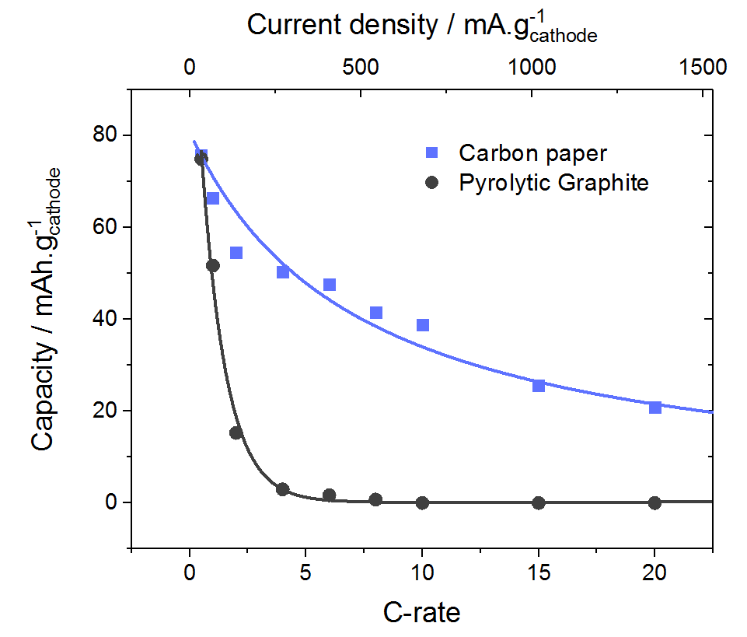(b) 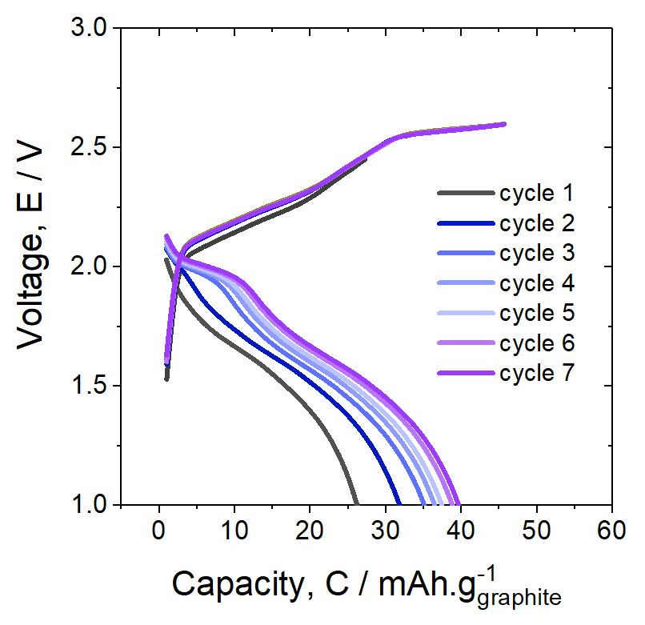
Figure 8. (a) Comparison of carbon paper and pyrolytic graphite cathode 2 mm electrode separation in Swagelok cell cycled at different current densities corresponding to C rates in the range 0.5 C - 20C rates. The data points were recorded sequentially starting with the lowest C rate. (b) repeated cycles at the 10C rate for carbon paper cathode.

After the cycling at variable C rates (Figure 8), and in the fully discharged state, the cathodes were subjected to SEM and XRD analysis (Figures 9 and 10). The XRD analysis showed that the crystallographic structure of carbon paper was virtually unchanged after cycling, even at higher current densities. The pyrolytic graphite had undergone some structural changes in line with those previously reported, [10] but these changes to the XRD pattern have been shown to occur mostly during the first cycles and give no indication of structural deterioration, rather, they show that some [AlCl₄]⁻ remains intercalated in the structure even after discharging. [10] Analysis of the d-spacing calculated from the (002) peak shows that the interlayer spacing of the carbon paper was 6.8 nm both before and after cycling, whereas for the pyrolytic graphite the interlayer spacing has split into two peaks at 7.1 and 6.6 nm. This is due to the formation of a stacked layer compound where only some of the layers are intercalated with [AlCl₄]⁻ species.
- 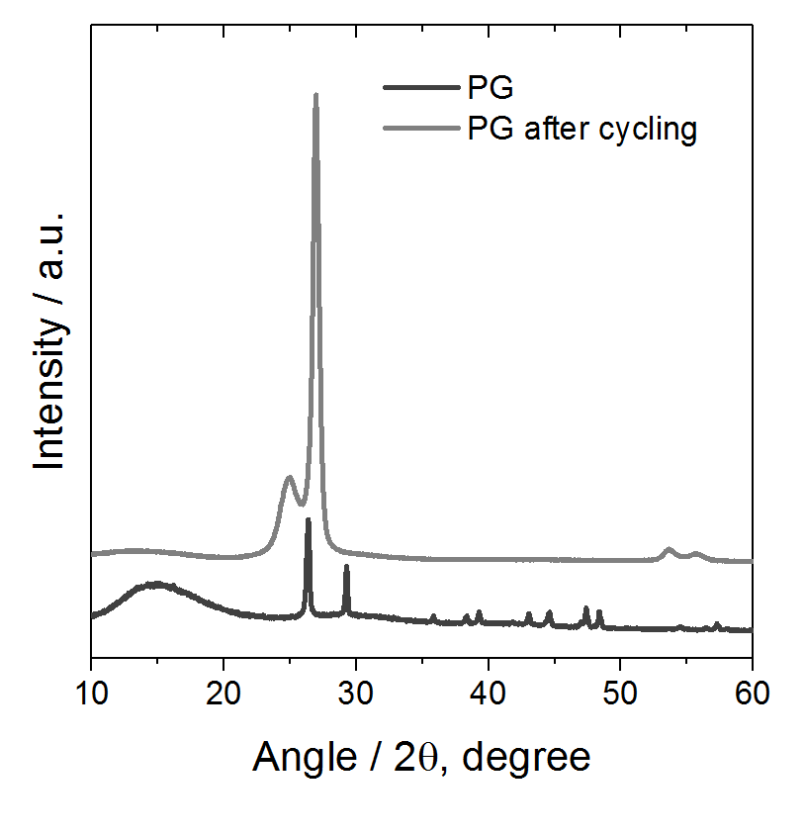 (b) 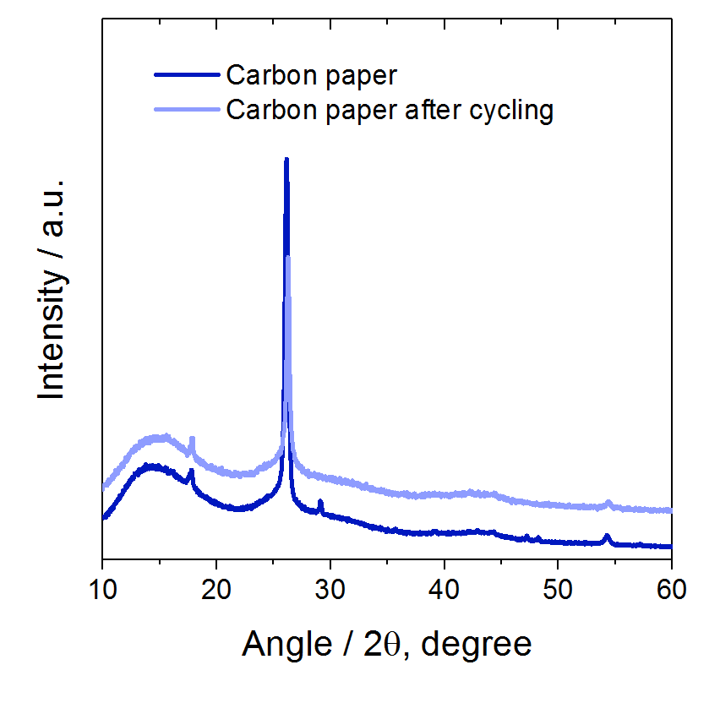
Figure 9. XRD analysis of (a) pyrolytic graphite cathode and (b) carbon paper after 30 cycles in Swagelok cell.
The peaks have obviously broadened (Figure 9a), and line broadening analysis of the largest (002) peak for both samples showed a decreases in the average crystallite domain size size of the pyrolytic graphite from 344 nm to 145 nm, a substantial decrease, most likely caused by the repeated intercalation and de-intercalation that the electrode has experienced causing exfoliation and fragmentation of particles. The carbon paper, on the other hand, with analysis of the strong (002) peak, had an average domain size of 246 nm which slightly increased to 309 nm after cycling. In the absence of any structural change in the XRD pattern, this size increase cannot be related to [AlCl₄]⁻ trapped within the structure. According to the SEM images Figure 1b and Figure 10b insets, the graphite particle size has not changed perceptibly.

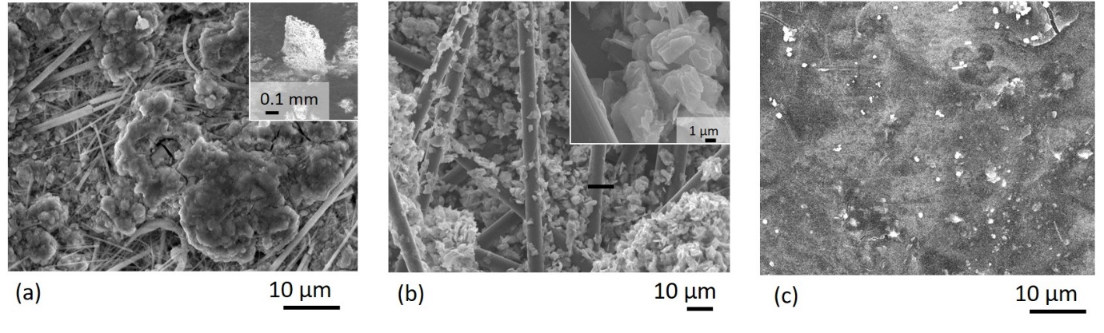
Figure 10. SEM analysis of (a) surface of Al anode, (b) carbon paper cathode and (c) pyrolytic graphite cathode after cycles at variable C-rate in Swagelok cell (Figure 7). All the electrodes were rinsed with 10 cm³ of dimethylcarbonate to wash away the ionic liquid prior to removal from a nitrogen atmosphere. The inset in (a) shows the sample tilted at 45 ⁰ with a dendrite visible.
The SEM images of the cycled carbon paper, pyrolytic graphite and aluminium foil show that the structure of each had been altered by the cycling. The aluminium foil (Figure 10a) had some glass fibres of the separator adhered to it even after careful washing with dimethylcarbonate. These fibres were held in place by some aluminium nodules that were projecting from the surface, by as much as 0.4 mm (inset Figure 10a). In Figure 11 these nodule-shaped dendrites are analysed by elemental mapping and are confirmed to be made from aluminium. It seems that the surface of the aluminium is no longer flat after cycling at higher C rates and small dendrites begin to form into the separator. This could explain why the cell with 0.25 mm in Figure 7 began to fail after 15 cycles, because dendrites have grown and can short-circuit the cell.
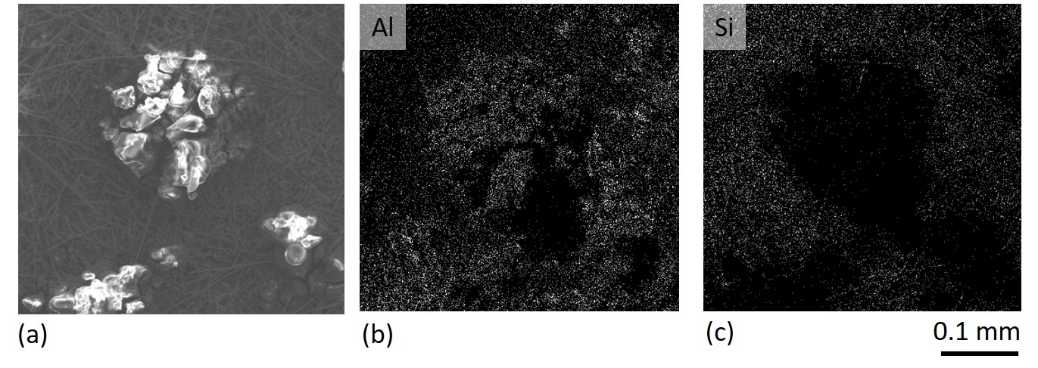
Figure 11. SEM analysis of a dendritic deposit on the surface of the Al anode, surrounded by glass microfibers that have adhered to the electrode. The elemental mapping in images (b) and (c) show that the dendrite area is rich in aluminium, and the microfiber area is rich is silicon.

The carbon paper (Figure 10b) showed some structural change, since some of the graphite flakes had collected together in agglomerates instead of being attached more evenly along the length of the carbon fibres as in the cathode before use (Figure 1). This suggests that the EMIMCl ionic liquid is affecting the properties of the PTFE binder in the carbon paper, causing the graphite particles to be less strongly adhered to the carbon fibres and more mobile. The pyrolytic graphite was more challenging to image because, despite the washing some ionic liquid still remained on the surface (Figure 10c). More cracks were visible on the surface of the pyrolytic graphite after cycling. Together with the XRD results in Figure 9, the conclusion can be reached that graphite particle size and structure of the carbon paper have not been affected by the repeated intercalation of [AlCl₄]⁻, but for the pyrolytic graphite the average crystallite size has decreased, and the graphite structure has been altered by irreversible intercalation of [AlCl₄]⁻.

4. Conclusions
The performance of four different graphitic materials, pyrolytic graphite, carbon paper, carbon cloth and carbon felt was compared to see which was the most promising cathode material for aluminium-ion batteries. The capacity of the materials towards aluminium intercalation is not directly related to their porosity, as pyrolytic graphite had superior performance to both carbon cloth and graphitized carbon felt. This is despite the fact that is has almost no porosity, so [AlCl₄]⁻ ions must diffuse through the structure to intercalate the bulk material rather than having direct access to most of the bulk via a larger surface area. The electrode capacity appears to be more directly related to whether the material contains a highly graphitised structure with larger graphite crystal domains within the structure. Thus, carbon paper and pyrolytic graphite, with their highly graphitic structure, had capacities close to 70 mAh.g⁻¹, whereas carbon cloth and carbon felt, with broad XRD peaks indicating only small graphite crystal domains, and the complete absence of some graphitic peaks, had lower capacities of 20-40 mAh.g⁻¹.
Other features of the carbon structure were important, for instance carbon paper had superior stability compared to pyrolytic graphite, particularly as the current density of cycling was increased up to the 20C rate. Upon more intensive cycling, the crystal structure of carbon paper was unchanged, although some of the flakes of graphite are displaced within the structure, the material is still intact. The presence of a dense network of carbon fibres, micron-sized graphite particles and PTFE binder within the structure, arranged with ample space for expansion and re-arrangement upon [AlCl₄]⁻ intercalation, helps to hold the electrode together and allows it to withstand more intensive cycling. With the pyrolytic graphite sheet, the structure does not perform well at C rates above 2C, and cracks are observed in the structure after cycling.
Finally, it was found that the optimum distance between electrodes in an aluminium-ion cell should ideally be 1-2 mm to maximise cell energy density and to avoid shorting caused by the growth of aluminium nodules into the glass-fibre separator. In ionic liquid, the cell could only be charged to 2.45 V for repeated cycling (> 30 cycles), because the electrolyte will decompose above this cell potential after 9 cycles. Experiments in a separator-less sealed cell showed that if the cell could be charged to potentials as positive as 2.75 V, the capacity could be tripled. It is therefore recommended that future work be undertaken to search for new electrolytes with a greater potential window.

5. Acknowledgements
The authors acknowledge funding from the EU commission under the Horizon 2020 grant agreement Nº 646286 “ALION: A low-cost aluminium-ion battery”. A. Holland acknowledges the funding from the EPSRC Centre for Doctoral Training in Energy Storage and its Applications.

References

[1] W.A. van Schalkwijk, B. Scrosati, Advances in lithium-ion batteries, Springer, 2002. https://books.google.co.uk/books?hl=en&lr=&id=LxwRBwAAQBAJ&oi=fnd&pg=PA2&dq=lithium-ion+batteries&ots=iQ55I1nfyx&sig=Y-NbkxZDB-WbVEWP3bQzPd5HR_U#v=onepage&q=lithium-ion batteries&f=false (accessed September 27, 2017).
[2] A. Hammami, N. Raymond, M. Armand, Lithium-ion batteries: Runaway risk of forming toxic compounds, Nature. 424 (2003) 635–636. doi:10.1038/424635b.
[3] J.-M. Tarascon, M. Armand, Issues and challenges facing rechargeable lithium batteries, Nature. 414 (2001) 359–367. doi:10.1038/35104644.
[4] G.A. Elia, K. Marquardt, K. Hoeppner, S. Fantini, R. Lin, E. Knipping, W. Peters, J.-F. Drillet, S. Passerini, R. Hahn, An Overview and Future Perspectives of Aluminum Batteries, Adv. Mater. 28 (2016) 7564–7579. doi:10.1002/adma.201601357.
[5] X. Liu, Yisi; Sun, Qian; Li, Wenzhang; Adair, K.R.; Li, Jie; Sun, A comprehensive review on recent progress in aluminum–air batteries, Green Energy Environ. 2 (2017) 246–277. doi:10.1016/J.GEE.2017.06.006.
[6] J.-Y. Hwang, S.-T. Myung, Y.-K. Sun, Sodium-ion batteries: present and future., Chem. Soc. Rev. 46 (2017) 3529–3614. doi:10.1039/c6cs00776g.
[7] H. Yang, L. Yin, J. Liang, Z. Sun, Y. Wang, H. Li, K. He, L. Ma, Z. Peng, S. Qiu, C. Sun, H.-M. Cheng, F. Li, An Aluminum-Sulfur Battery with a Fast Kinetic Response, Angew. Chemie Int. Ed. 57 (2018) 1898–1902. doi:10.1002/anie.201711328.
[8] M.-C. Lin, M. Gong, B. Lu, Y. Wu, D.-Y. Wang, M. Guan, M. Angell, C. Chen, J. Yang, B.-J. Hwang, H. Dai, An ultrafast rechargeable aluminium-ion battery, Nature. 520 (2015) 324–328. doi:10.1038/nature14340.
[9] D.-Y. Wang, C.-Y. Wei, M.-C. Lin, C.-J. Pan, H.-L. Chou, H.-A. Chen, M. Gong, Y. Wu, C. Yuan, M. Angell, Y.-J. Hsieh, Y.-H. Chen, C.-Y. Wen, C.-W. Chen, B.-J. Hwang, C.-C. Chen, H. Dai, Advanced rechargeable aluminium ion battery with a high-quality natural graphite cathode., Nat. Commun. 8 (2017) 14283. doi:10.1038/ncomms14283.
[10] G.A. Elia, I. Hasa, G. Greco, T. Diemant, K. Marquardt, K. Hoeppner, R.J. Behm, A. Hoell, S. Passerini, R. Hahn, Insights into the reversibility of aluminum graphite batteries, J. Mater. Chem. A. 5 (2017) 9682–9690. doi:10.1039/C7TA01018D.
[11] S. Wang, K. V. Kravchyk, F. Krumeich, M. V. Kovalenko, Kish Graphite Flakes as a Cathode Material for an Aluminum Chloride–Graphite Battery, ACS Appl. Mater. Interfaces. 9 (2017) 28478–28485. doi:10.1021/acsami.7b07499.
[12] H. Chen, H. Xu, S. Wang, T. Huang, J. Xi, S. Cai, F. Guo, Z. Xu, W. Gao, C. Gao, Ultrafast all-climate aluminum-graphene battery with quarter-million cycle life, Sci. Adv. 3 (2017) eaao7233. doi:10.1126/sciadv.aao7233.
[13] X. Zhao, W. Yao, W. Gao, H. Chen, C. Gao, Wet-Spun Superelastic Graphene Aerogel Millispheres with Group Effect, Adv. Mater. 29 (2017) 1701482. doi:10.1002/adma.201701482.
[14] J. Wei, W. Chen, D. Chen, K. Yang, Molybdenum Oxide as Cathode for High Voltage Rechargeable Aluminum Ion Battery, J. Electrochem. Soc. 164 (2017) A2304–A2309. doi:10.1149/2.0411712jes.
[15] N. Jayaprakash, S.K. Das, L.A. Archer, The rechargeable aluminum-ion battery, Chem. Commun. 47 (2011) 12610. doi:10.1039/c1cc15779e.
[16] H. Wang, Y. Bai, S. Chen, X. Luo, C. Wu, F. Wu, J. Lu, K. Amine, Binder-Free V ₂ O ₅ Cathode for Greener Rechargeable Aluminum Battery, ACS Appl. Mater. Interfaces. 7 (2015) 80–84. doi:10.1021/am508001h.
[17] S. Wang, S. Jiao, J. Wang, H.-S. Chen, D. Tian, H. Lei, D.-N. Fang, High-Performance Aluminum-Ion Battery with CuS@C Microsphere Composite Cathode, ACS Nano. 11 (2017) 469–477. doi:10.1021/acsnano.6b06446.
[18] G.Y. Yang, L. Chen, P. Jiang, Z.Y. Guo, W. Wang, Z.P. Liu, Fabrication of tunable 3D graphene mesh network with enhanced electrical and thermal properties for high-rate aluminum-ion battery application, RSC Adv. 6 (2016) 47655–47660. doi:10.1039/C6RA06467A.
[19] H. Sun, W. Wang, Z. Yu, Y. Yuan, S. Wang, S. Jiao, A new aluminium-ion battery with high voltage, high safety and low cost, Chem. Commun. 51 (2015) 11892–11895. doi:10.1039/C5CC00542F.
[20] M. Angell, C.-J. Pan, Y. Rong, C. Yuan, M.-C. Lin, B. Hwang, H. Dai, A High Efficiency Aluminum-Ion Battery Using an AlCl 3 -Urea Ionic Liquid Analogue Electrolyte, (n.d.). https://arxiv.org/ftp/arxiv/papers/1611/1611.09951.pdf (accessed September 27, 2017).
[21] M. Chiku, H. Takeda, S. Matsumura, E. Higuchi, H. Inoue, Amorphous Vanadium Oxide/Carbon Composite Positive Electrode for Rechargeable Aluminum Battery, ACS Appl. Mater. Interfaces. 7 (2015) 24385–24389. doi:10.1021/acsami.5b06420.
[22] W. Wang, B. Jiang, W. Xiong, H. Sun, Z. Lin, L. Hu, J. Tu, J. Hou, H. Zhu, S. Jiao, A new cathode material for super-valent battery based on aluminium ion intercalation and deintercalation., Sci. Rep. 3 (2013) 3383. doi:10.1038/srep03383.
[23] H. Wang, S. Gu, Y. Bai, S. Chen, F. Wu, C. Wu, High-Voltage and Noncorrosive Ionic Liquid Electrolyte Used in Rechargeable Aluminum Battery, ACS Appl. Mater. Interfaces. 8 (2016) 27444–27448. doi:10.1021/acsami.6b10579.
[24] F. Nacimiento, M. Cabello, R. Alcántara, C. Pérez-Vicente, P. Lavela, J.L. Tirado, Exploring an Aluminum Ion Battery Based on Molybdite as Working Electrode and Ionic Liquid as Electrolyte, J. Electrochem. Soc. 165 (2018) A2994–A2999. doi:10.1149/2.0391813jes.
[25] S. Liu, J.J. Hu, N.F. Yan, G.L. Pan, G.R. Li, X.P. Gao, Aluminum storage behavior of anatase TiO2 nanotube arrays in aqueous solution for aluminum ion batteries, Energy Environ. Sci. 5 (2012) 9743. doi:10.1039/c2ee22987k.
[26] Y.J. He, J.F. Peng, W. Chu, Y.Z. Li, D.G. Tong, Black mesoporous anatase TiO ₂ nanoleaves: a high capacity and high rate anode for aqueous Al-ion batteries, J. Mater. Chem. A. 2 (2014) 1721–1731. doi:10.1039/C3TA13906A.
[27] J.R. González, F. Nacimiento, M. Cabello, R. Alcántara, P. Lavela, J.L. Tirado, Reversible intercalation of aluminium into vanadium pentoxide xerogel for aqueous rechargeable batteries, RSC Adv. 6 (2016) 62157–62164. doi:10.1039/C6RA11030D.
[28] F. Nacimiento, M. Cabello, R. Alcántara, P. Lavela, J.L. Tirado, NASICON-type Na3V2(PO4)3 as a new positive electrode material for rechargeable aluminium battery, Electrochim. Acta. 260 (2018) 798–804. doi:10.1016/j.electacta.2017.12.040.
[29] E. Hatzikraniotis, I. Samaras, K.M. Paraskevopoulos, Al-intercalated in MoO3: optical characterisation, Ionics (Kiel). 2 (1996) 29–33. doi:10.1007/BF02375865.
[30] A. Holland, R.D. Mckerracher, A. Cruden, R.G.A. Wills, An aluminium battery operating with an aqueous electrolyte, J. Appl. Electrochem. 48 (2018). doi:10.1007/s10800-018-1154-x.
[31] N.C.W.C.N. Halder, Adv. X-Ray Anal. 9 (1966) 91-102.
[32] W. Kang, F. Li, Y. Zhao, C. Qiao, J. Ju, B. Cheng, Fabrication of porous Fe ₂ O ₃ /PTFE nanofiber membranes and their application as a catalyst for dye degradation, RSC Adv. 6 (2016) 32646–32652. doi:10.1039/C5RA27879A.
[33] T. Ungar, J. Gubicza, G. Ribarik, C. Pantea, T.W. Zerda, Microstructure of carbon blacks determined by X-ray diffraction profile analysis, Carbon N. Y. 40 (2002) 929–937. http://szft.elte.hu/~gubicza/publikaciok/carbon.pdf (accessed December 15, 2017).

