Figure Captions
Figure 1. Map of United Kingdom with rivers hosting Atlantic salmon shown in blue. The locations of the egg sources used in this study are labelled and displayed in heavy red.

Figure 2. Images of membrane structures used in analysis: (A) regular micropore arrangement on membrane internus at 2400x magnification; (B) membrane internus with micropore dimensions at 9000x magnification and lower quadrant where measurements of micropore diameter were taken is highlighted; (C) membrane internus at 9000x magnification; (D) membrane cross-section traversed by pore canals at 1700x magnification; (E) membrane cross-section with thickness dimensions; (F) image of the membrane externus where the adhesive film is present at 900x magnification. An area where the film is missing, revealing the membrane itself can be observed in the centre of the image.

Figure 3. Recorded features of eggs examined under electron microscope relevant to objectives 1 and 2. A: membrane thickness; B: membrane quotient; C: membrane porosity; D: oxygen permeability. Data on the left of the solid line refers to objective 1 and enables comparison of egg architecture among populations tested. Data on the right of the solid line refers to objective 2 and enables comparison of egg architecture among control eggs and those that died or survived when exposed to hypoxia. Dashed lines separate data for each mortality threshold. Error bars indicate standard deviation.

Figure 4. Range of intragravel velocities and oxygen concentrations necessary to support respiratory requirements at 5°C for Atlantic salmon eggs of the five populations investigated in the present study. Data calculated using the mass transfer model (equation 2) and compared with original data for membrane thickness and porosity used in that equation to predict embryonic oxygen requirements. Note that lines do not represent mortality thresholds, but the concentration at which sublethal reductions of post-hatch fitness could be expected.

Figures

Figure 1.
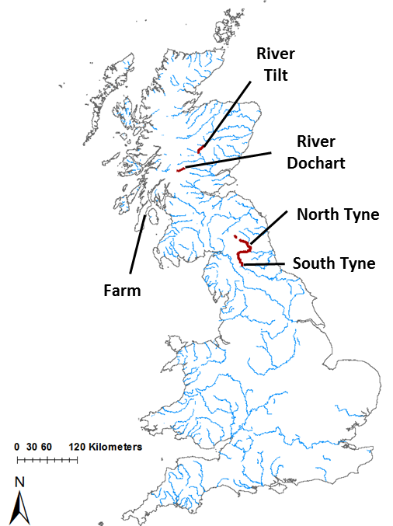

Figure 2.
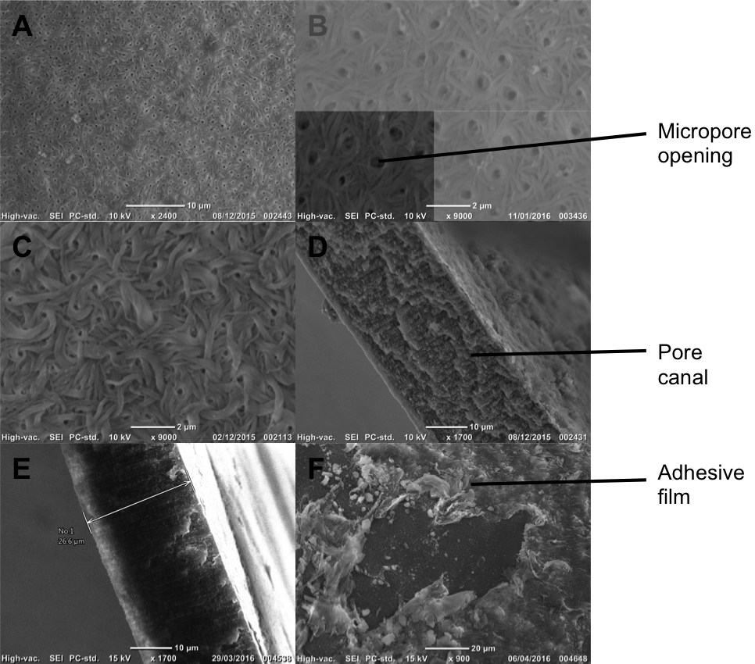

Figure 3.

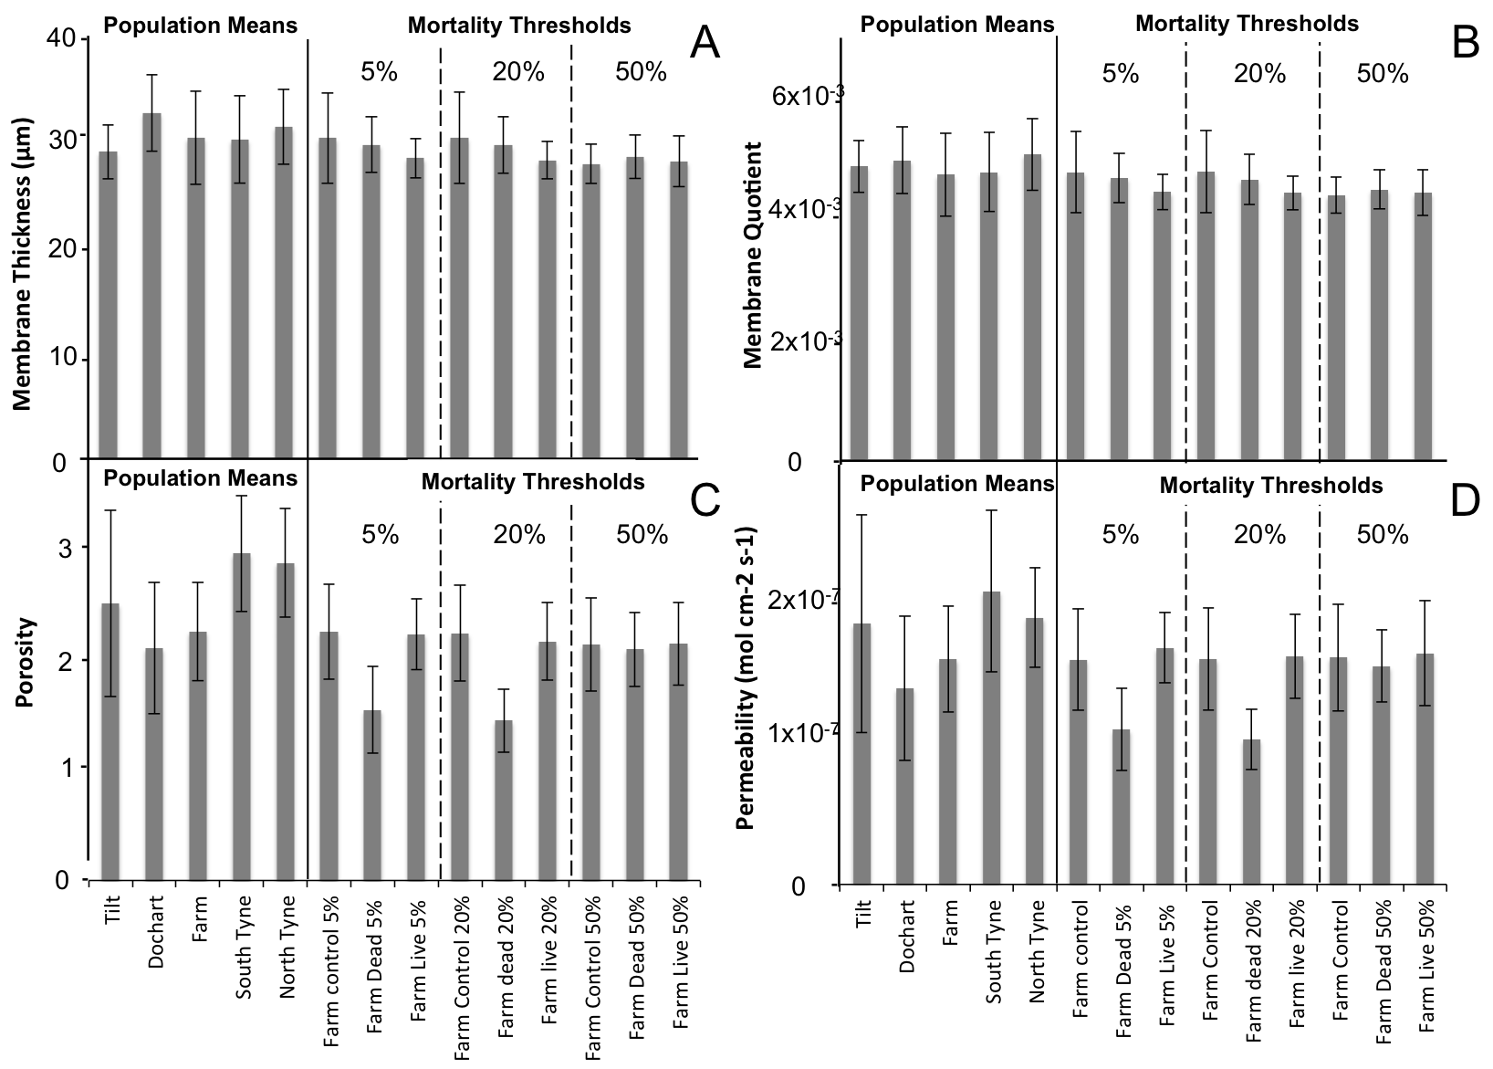

Figure 4.

