# Evaluating the carbon footprint of WEEE management in the UK

Christopher Clarkea, Ian D Williamsa, David A Turnerab

aCentre for Environmental Sciences, Faculty of Engineering and the Environment, University of Southampton, University Road, Southampton, Hampshire, SO17 1BJ, United Kingdom

bTechnology and Society Lab, Empa, Swiss Federal Laboratories for Materials Science and Technology, Lerchenfeldstrasse 5, CH-9014, St. Gallen, Switzerland

Corresponding author:

Ian D Williams

Tel: (+44) 2380 528 755

Email: i.d.williams@soton.ac.uk

Mailing address: Centre for Environmental Sciences, Faculty of Engineering and the Environment, University of Southampton, University Road, Southampton, Hampshire, SO17 1BJ, United Kingdom**Abstract**. The UK produces an estimated 2 Mt of waste electrical and electronic equipment (WEEE) annually and the management of this waste has become a foremost environmental issue in the UK. Whilst the collection, transportation and treatment of WEEE contributes to climate change due to its considerable energy and material requirements, the effective recovery and reuse or recycling of WEEE can contribute towards a net climate benefit. Here, we present a combined material flow analysis and carbon footprint approach (based on a bespoke calculator tool) for quantifying the flows of WEEE through a national waste management system and evaluating their potential climate impacts. We apply this approach to analyse the WEEE management system for the UK from 2010-2030 using prospective scenario analysis and assess the carbon footprint of their management pathways. Reuse was identified as the most favourable end-of-life management option in terms of potential climate impact, followed by recycling, with landfill identified as being the least favourable option. Overall, current end-of-life management practices for WEEE in the UK were found to result in a net positive (i.e. beneficial) climatic effect, although this saving was found to reduce when WEEE recycled as non-obligated WEEE was not included. Overall, we recommend that future national policies should focus on formalising indirect WEEE collection pathways to help increase overall collection rates and, thus, reuse and recycling activities.

***Keywords***. Waste electronic and electrical equipment, carbon footprint, material flow analysis, waste management

## 1. INTRODUCTION

The quantity of both household and industrial electrical and electronic equipment (EEE) has risen continuously over the past 20 years (Tanskanen, 2013). The electronics industry is the largest and fastest growing manufacturing industry globally. When combined with faster obsolescence, this growth has resulted in significant increases in waste electrical and electronic equipment (WEEE)[1] and used electrical and electronic equipment (UEEE)[2] (Kumar et al. 2017; Parajuly et al. 2017). Globally, an estimated 44.7 Mt of WEEE is produced annually (Baldé et al. 2017), and this figure is likely to rise in the future as product life cycles become shorter and the affordability of EEE becomes ever greater (Cucchiella et al. 2015; Thiébaud (-Müller) et al. 2017).

Due to the ever-increasing amounts of WEEE being generated annually, its management has become a prominent global issue (Ongondo et al. 2011). WEEE contains a variety of hazardous materials – such as cadmium, lead, mercury, polychlorinated biphenyls and brominated flame retardants (Widmer et al., 2005) – that pose a considerable risk to both humans and the environment if not adequately treated. However, WEEE also contains potentially valuable materials – such as (amongst others) ferrous and non-ferrous metals, glass, plastics and scarce and critical minerals (Buchert et al. 2012) – that, if recovered, represent a latent economic opportunity (Zhang & Xu, 2016). Furthermore, inefficient WEEE management contributes directly to climate change, due to emissions of greenhouse gases (e.g. due to energy consumption during transportation and treatment). This effect can be exacerbated by poor material recovery rates in many countries, which is due to poor recycling techniques, disposal into the residual waste stream and/or exportation of waste to developing countries for treatment and disposal (Tanskanen, 2013; Ikhlayel, 2018). Conversely, effective WEEE management can contribute towards a net reduction in greenhouse gas emissions (Foelster et al. 2016; Menikpura et al. 2014), with increased reuse and recycling of WEEE potentially resulting in a reduction in the need for virgin materials (Turner et al. 2015).

Recently, a number of studies have been published that have sought to analyse the potential climate impacts of WEEE management systems using life cycle assessment (LCA) – a well-established method for assessing the potential environmental and human health impacts of products and product systems – in either a full or partial form; so called “carbon footprint” assessment. Ibanescu et al. (2018) assessed the carbon footprints of WEEE management in five EU countries (Germany, Sweden, Italy, Romania and Bulgaria), with their results showing that the total national carbon footprints of each country were net negative (i.e. climatically beneficial), due to the significant contribution of recycling in terms of avoided emissions. Similar findings have been reported by numerous other researchers, for instance, by Menikpura et al. (2014) in their study of the potential climate benefits of WEEE recycling in Japan; Baxter et al. (2016) , who assessed the collection, distribution and processing system for WEEE in Norway; Ikhlayel (2017) in their study on small and large electronic device end-of-life management options in Jordan; and Song et al. (2016), who assessed and compared alternative cathode ray tube (CRT) screen treatment options in China.

Other studies have combined LCA with other environmental systems analysis techniques to gain a more comprehensive understanding of system performance. Combined material flow analysis (MFA) and LCA approaches have been used by Wäger et al. (2011), Biganzoli et al. (2015) and Turner et al. (2016) to assess the environmental performance of the WEEE management systems in Switzerland, the Lombardia Region of Italy, and Cardiff, UK, respectively. Elsewhere, an LCA-integrated multi-criteria analysis approach was presented by de Souza et al. (2016) in their study into the sustainability of WEEE management systems in Brazil, which considered social and economic performance as well as environmental.

Despite the growing concern for WEEE management in the UK and the wider proliferation of work carried out in this field globally, no previous research has been done to systematically evaluate the potential climate impacts of the WEEE management system in the UK. As demonstrated by studies elsewhere, such work could help to provide policy makers and waste managers in the UK with useful information to support WEEE decision making at the national and sub-national scale.

The UK is a major producer of WEEE, with an estimated 2 Mt of WEEE is generated and discarded annually; approximately 32 kg of WEEE per capita (HSE 2018). With this amount ever-increasing, WEEE management has become a foremost environmental issue over the past decade for UK policy makers and waste managers, and a prominent, rapidly growing WEEE recycling industry has emerged (Ongondo & Williams 2012). This has been driven to a large extent by regulatory compliance and the implementation of a regulatory framework that transposes two EU Directives. The WEEE Directive (2012/19/EU) – transposed in the UK by The Waste Electrical and Electronic Equipment Regulations 2013 (as amended) – sets targets for the collection of WEEE for all Member States and requires that all manufacturers of electronic products and importers establish collection schemes for their products and ensure that environmentally-sound treatment and disposal methods are used. For UK manufacturers, compliance is typically attained either through joining a Distributor Take-Back Scheme (DTS) or by offering free in-store take-back of WEEE. In either case, the distributer is financially obligated to collect and transport the WEEE. The Restriction of Hazardous Substances Directive (RoHS) (2002/95/EC) – transposed in the UK by The Restriction of the Use of Certain Hazardous Substances in Electrical and Electronic Regulations 2012 (as amended) – aims to limit the amount of certain toxic substances in newly produced EEE (including lead, cadmium, mercury, hexavalent chromium, polybrominated biphenyl and polybrominated diphenyl ether) by banning the placement of any EEE on EU markets if agreed levels are exceeded.

Here, we present a combined material flow analysis and carbon footprint approach for quantifying the flows of WEEE through a waste management system and evaluating their potential climate impacts. Using prospective scenario analysis, we apply this approach to a) assess the major flows of WEEE/UEEE within the UK waste management system from 2010-2030 and b) evaluate the potential climate impacts (carbon footprint) of different WEEE/UEEE management routes. The carbon footprint assessment is performed using a bespoke calculator tool and takes into account the potential GHG emissions from waste treatment and disposal, as well as those from the collection and transportation of WEEE to treatment facilities. To the best of these authors’ knowledge, this is the first paper to estimate the carbon footprint of WEEE management in the UK. The remainder of this paper comprises an outline of the methods used to complete the analysis and the presentation and interpretation of key results. Through hotspot analysis, we highlight areas of concern within the extant WEEE management system with regards to the potential climate impacts. Finally, based on the outcomes of our research we make recommendations on how future policies and management should be developed to improve the environmental performance of the system..

## 2. METHODS

Material flow analysis (MFA) was used quantify the flows of WEEE through the UK WEEE management network. MFA enables a systematic assessment of flows and stocks of materials into, within, and from a defined system (Brunner & Rechberger, 2005). The use of MFA to analyse waste systems has been widely acknowledged (Wager et al., 2011; Cifrian et al., 2012; Lau et al., 2013; Turner et al., 2016). MFA involves four basic steps: (1) determination of the system model including processes and materials, (2) measurement of material flows, (3) calculation of material flows, and (4) interpretation of results.

The carbon footprint methodology was used to evaluate the potential climate impacts of WEEE management in the UK. Carbon footprinting is a well-acknowledged and systematic method of quantifying GHG emissions and has been utilised in studies of WEEE management systems throughout the world (see previous section). Here, the carbon footprint is defined in accordance with Wright et al. (2011) as “a measure of the total amount of carbon dioxide (CO2) and methane (CH4) emissions of a defined population, system or activity, considering all relevant sources, sinks and storage within the spatial and temporal boundary of the population, system or activity of interest”.

### 2.1 System model

The basis for the MFA was the model developed by the Waste and Resources Action Programme (WRAP, 2011) for estimating the flows of WEEE/UEEE in the UK (Figure 1). Key input data to the model include annual UK WEEE/UEEE disposal figures, consumer/business disposal practices, the amounts of WEEE treated by different processing means, and the final destinations of treated WEEE (more details below). The model contains data for both household and non-household WEEE. The boundaries for this study were set as the UK for the years 2010 (baseline) through until 2030. It should be noted that the model developed by WRAP was based on a number of assumptions; an overview of these, which were independently validated by Valpak, is available in WRAP (2011).

### 2.2 Estimation of UEEE/WEEE arising in the UK

Estimates on the mass of WEEE/UEEE disposed of in the UK for the years 2010-2030 were taken from WRAP (2011). These estimates were based on Weibull distributions that predicted the time-to-failure of EEE products. Historical data was used to create representative lifespan distributions for the 10 categories of WEEE: C1, large household appliances; C2, small household appliances; C3, IT and telecommunications equipment; C4, consumer equipment and photovoltaic panels; C5, lighting equipment; C6, electrical and electronic tools (excluding large-scale stationary industrial tools); C7, toys, leisure and sports equipment; C8, medical devices (excluding implanted and infected products); C9, monitoring and control instruments; and C10, automatic dispensers (EC 2012). Data on the amount of EEE entering the UK market annually and estimated lifespans were taken from WRAP, 2011.

### 2.3 Disposal decision

The second stage of the model concerned the decisions of consumers/businesses regarding the disposal route that WEEE/UEEE enters (Figure 1). Data on the amount of WEEE collected at designated collection facilities (DCF; includes household waste recycling centres (HWRC), kerbside collections, and bulky waste collections) and received through producer compliance schemes (PCS; includes in-warranty returns and retail take-back) for the period 2010-2013 were obtained from published annual Environment Agency (EA) reports (EA, 2014). For the future scenarios (the years 2015, 2020, 2025 and 2030), WEEE collection were modelled using data from WRAP (2011). The amount of WEEE collected at DCFs was split between HWRC, kerbside collections, and bulky waste collections. The amount received through PCS and non-household collections was split between in-warranty return and retail take-back based on WRAP (2011). Estimates for WEEE flows into resale/reuse, asset management, and residual waste were taken from WRAP (2011). WEEE collected through indirect collections for a given year was estimated as the difference between the predicted mass of WEEE/UEEE arisings and the predicted mass of WEEE collected through other routes.

### 2.4 Processing stage

Seven major processing routes for WEEE were identified (Figure 1). For the years 2010-2013, the amount of WEEE received at authorised approved treatment facilities (AATF) for treatment, including household and non-household WEEE and non-obligated WEEE[3] received at approved treatment facilities (ATF), was determined based on published annual EA data (EA, 2014). The percentage of WEEE that is disposed of via other processing routes (e.g. incineration or dismantling) was estimated based on pathway split estimates from WRAP (2011). Estimated future flows of WEEE were taken from WRAP (2011) for all pathways.

WEEE is also present in the “light iron”[4] waste stream, a mixed stream of ferrous metal (WRAP, 2014). An estimate of WEEE present in the light iron waste stream was calculated by taking the non-obligated WEEE received for treatment at ATFs and subtracting the WEEE entering this stream from other routes. This gave the quantity of WEEE received from indirect collections that could be identified as WEEE. This was subtracted from the overall indirect collection disposal decision from the previous stage, giving an estimate of WEEE collected indirectly that is then processed as part of the light iron stream at ATFs (Eq. 1), as:

|  |  |
| --- | --- |
| $$W=IC-(NO-\sum{\left(IR∙0.08\right)+\left(RT ∙0.08\right)+(AM∙0.5))}$$ | (1) |

Where *W* is the mass of WEEE present in the light iron waste stream, *ID*, *IR*, *RT*, and *AM* are the masses of WEEE collected through indirect collections, in-warranty returns, retail take-back, and asset management schemes, respectively, and *NO* is the mass of non-obligated WEEE. Note that the coefficients in Eq. 1 were taken from WRAP (2011). It was assumed that all WEEE collected through indirect/informal collections would be treated via an ATF as non-obligated WEEE or as part of the light iron stream

### 2.5 Final Destinations

Five final destinations for collected WEEE were identified: reuse in the UK, recycling, export, incineration, and landfill. Pathway splits from the processing stage were taken from estimates made by WRAP (2011). This process was repeated for each year and the quantity of WEEE entering each final destination route was used to calculate the carbon footprint associated with each final destination. For the years of 2015–2030, scenarios were developed based on a model calibration method (see Section 2.6).

### 2.6 Calibration of model predictions

For the years 2015 onwards, a range of flows were calculated using the percentage difference between the original WRAP model and the research model for each disposal destination (Table 1). This was calculated for the years 2011-2013. The average percentage change between the two models for each disposal destination was used to create high, medium and low scenarios for the future flow predictions.

### 2.7 Processing stage

The collection and recycling rates for 2013 were calculated as a percentage of the average weight of EEE placed on the UK market in the three preceding years; this allowed direct comparison with EU targets. The 2015 rates were calculated using 2012 and 2013 data for EEE placed on the UK market (EA, 2014). More recent data were not available at the time of this study. The rates for 2020 could only be calculated as a percentage of the total WEEE disposed of in the UK due to there being no data available for the three preceding years. The collection and recycling rates were calculated including WEEE indirectly collected and subsequently recycled as non-obligated WEEE in the light iron stream.

### 2.8 Carbon footprint methodology

Carbon footprinting, a streamlined form of life cycle assessment, is recognised as a valid tool for assessing the environmental performance of waste management systems (Turner et al., 2011). To calculate the carbon footprint of WEEE management, a carbon footprint calculator tool was developed (see Supporting Information) using life cycle inventory data from a variety of secondary sources, particularly Turner et al. (2015) and Turner et al. (2016). The composition of WEEE used in the calculation was the average composition of categories 1 (large household appliances; based on Department for Environment Food & Rural Affairs [Defra], 2007), 2 (small household), 3 (IT and telecommunications equipment, 4 (consumer equipment), 6 (electrical tools) and 7 (toys, games and leisure) (all based on WRAP, 2012a).

The transport distance for WEEE when reused and from collection to disposal (inert landfill) was set as 25 km, based on data from the EA (2010). The distance from collection to treatment facilities and to subsequent reprocessing was set as 250 km for recycling (EA, 2010). The carbon footprint calculated both the net emissions and avoided burdens of the major disposal destinations allowing total emissions associated with each destination and the network as a whole to be calculated. The carbon footprint associated with exported WEEE/UEEE out of the UK for treatment/disposal was not included as it was considered out of the scope of this study, which is only concerned with WEEE/UEEE management in the UK. The carbon footprint associated with the incineration of WEEE was not calculated as only 1% of the total WEEE entered this disposal route, which was considered negligible.

## 3. RESULTS

### 3.1 Current flows of WEEE

Results presented in this section concern the material flows of WEEE/UEEE into, through and from the UK WEEE/UEEE management system for the period 2010-2015. The mass of WEEE/UEEE that enters the system via different routes (‘flows’) is presented in Figure 2. The largest flow of WEEE into the system is through the mixed (‘residual’) waste stream, although there the mass of WEEE entering the system through this route steadily declined between 2010 and 2013 (2.6%). Disposal through collection at a DCF was the second largest flow of WEEE into the formal system. WEEE collected via this route decreased by 1.7% between 2010 and 2013, although there was a slight increase between 2012 and 2013. Disposal of WEEE through a PCS (In-warranty return and retail take-back) increased by 15% over the time period, however there was a reduction between 2012 and 2013 from approximately 49 kt to 41 kt. The quantity of WEEE/UEEE being reused or resold directly from the consumers was steady, with an overall rise of 0.6%; however, there was a slight decline in 2013 from 2012 levels. Disposal of WEEE from businesses, primarily via asset management companies, reduced steadily over the time period by 3.5%. WEEE disposed via indirect collections was estimated to have risen by 5.5% with a slight fall in collections in 2011. The practice of hoarding WEEE/UEEE by consumers/businesses occurs throughout the UK and this reduces the amount of WEEE/UEEE available for collection through the formal waste system. Permanent hoarding of WEEE/UEEE dropped by 3.6%.

‘Processing of WEEE’ is the second stage in the WEEE management system. The mass of WEEE processed via the various alternative methods in the year 2013 is shown in Figure 3. The largest flows of WEEE are into AATF and ATFs, which saw overall increases of 1.6% and 5.1% between the period 2013-2015, respectively. WEEE entering landfill directly over this period decreases by 2.6% (note that this value does not include WEEE entering landfill through other processing facilities, such as MRFs or incinerators, as process rejects).

The mass of WEEE/UEEE collected the UK that is sent to each final destination (reuse, recycle, export, incineration and landfill) in the year 2013 is presented in Figure 4. The largest flow was recycling, which increased by 3.2% over the time period. This figure contained WEEE that is collected and recycled by the formal waste system that is recorded by the EA. It also contained an estimate of WEEE potentially recycled as part of the light iron stream. Approximately one third of WEEE is landfilled annually and this amount remains relatively constant, with only a slight increase of 0.1% over the time period, whilst reuse of WEEE/UEEE in the UK shows a slight decrease of 0.8%. Export and incineration were seen as negligible as they only made up approximately 1.0% of the total WEEE/UEEE disposed of in the UK annually. Furthermore, both of these routes saw a reduction of 1.9% and 2.6%, respectively.

### 3.2 Recycling and collection rates in the UK

The results show that the UK achieved a WEEE recycling rate of 50.2% (834,284 t) in 2013 and this was projected to remain relatively constant up to 2030 (rate of 51.5%). However, these estimates include the total WEEE from both formal and indirect collections. When only the amount of WEEE that can be included in formal recycling rates was included, the recycling rate decreased to 23.8% (395,498 t) for 2013. The collection rate in 2013 was approximately 33% and the collection rate for 2015 was estimated as 34.5%. The collection rate for 2020 was predicated to be approximately 29.7% of the total WEEE disposed in 2020. The collection rates were estimated to increase to 71.9% and 75.7% in 2013 and 2015, respectively, when WEEE indirectly collected is included.

### 3.3 Future Scenarios

We also estimated the flows of WEEE/UEEE into, through and from the defined system until 2030. Three scenarios (high, medium and low) were created for the final destinations of WEEE/UEEE in the system, representing predicted minimum, mean and maximum flows, respectively. These scenarios were then used to calculate the carbon footprint associated with the management of WEEE at each final destination.

WEEE disposal into the residual waste stream was estimated to be the dominant disposal route into the formal system, with an overall increase of 3.8% over the time period. Disposal of WEEE through DCFs was the second largest formal route, with an increase of 7.2%. However the quantity of WEEE was estimated to decline between 2015 and 2020 before increasing up to a maximum of approximately 401,000 t in 2030. Disposal through PCSs was found to rise by 11.1% between 2013 and 2030. However, WEEE entering this route was found to decrease between 2013 and 2015 before steadily rising through until 2030. Indirect collection of WEEE was the largest route overall and steadily increased over the time period, with an overall rise of 19.2%. Reuse/resale and asset management routes both increased steadily over the time period, showing an overall rise of 17.2% and 29.0%, respectively. Permanent hoarding of WEEE/UEEE were predicted to decrease between 2013 and 2030 by 10.2%, which follows the trend set by the current scenario.

The majority of WEEE/UEEE is anticipated to be processed via AATF/ATFs or will enter final disposal at landfills. The processing of WEEE at AATFs and ATFs increased by 6.4% and 19.7%, respectively, between 2010 and 2030. WEEE entering ATFs includes that entering through the light iron stream. The landfilling of WEEE was found to increase by 3.8% over the time period, although the quantity entering landfills was found to decline until 2020 before increasing again until 2030. Processing through MRFs and incinerators reduced until 2020, before increasing to an overall rate of 3.8% for both routes.

Recycling of WEEE/UEEE was predicted to be the dominant final destination in the UK in the future, with the proportion of WEEE/UEEE sent for recycling estimated to increase by 14% between 2015 and 2030 across all scenarios (Figures 5). The quantity of WEEE recycled in 2030 was predicted to be between approximately 881,069 t and 968,208 t. Landfill was anticipated as the second largest route for WEEE in the UK, where an overall increase of 10.7% is observed across all scenarios over the time period. The amount of WEEE going to landfill was predicted to fall between 2015 and 2020, it then increases until 2030 when it was predicted to be between 722,585 t and 794,844 t. Reuse in the UK was found to rise steadily from 2015 to 2030, with an overall increase of 10% across all scenarios. The quantity of WEEE/UEEE reused in the UK was found to reach a high in 2030 of between 144,707 t and 166,413 t. The routes of incineration and export were found to be minor compared to the other three destinations, with approximately 1% of total WEEE predicted to be disposed of via these destinations.

### 3.4 Carbon footprint of final disposal destinations

The carbon footprint methodology described in Section 2.8 was applied to the final disposal destination data (reuse, recycle and landfill) obtained by the MFA model (Table. 2). The carbon footprint of WEEE disposed of in landfill was estimated as 14,711 t CO2e in 2010 to 17,821 t CO2e in 2030 (high scenario). Over the time period, an increasing trend in emissions from landfilled WEEE is observed, with minor reductions between 2010-2011 and 2015-2020. The carbon footprint calculated for the recycling of WEEE showed a carbon saving of -682,582 t CO2e in 2010. This rose steadily to a maximum of -818,925 t CO2e (high scenario) in 2030. Between 2013 and 2015 there is a reduction in the carbon savings over all three scenarios. The reuse of WEEE/UEEE within the UK showed a carbon saving of between -149,533 t in 2010 and -191,150 t CO2e in 2030. The carbon emissions and savings associated with the major final disposal destinations show the largest savings when WEEE is either reused or recycled, with a saving of -1.14 t CO2e and -0.85 t CO2e found per tonne of WEEE/UEEE, respectively. Landfilling of one tonne of WEEE had a carbon footprint of 0.02 t CO2e.

## 4. DISCUSSION

### 4.1 Recycling in the UK

The recycling rates for WEEE were found to vary significantly depending on whether WEEE from the light iron waste stream is included in the calculations. The light iron estimate presented in this study is within the range reported by a WRAP (2014) study that estimates that between 381,000 and 597,000 t (95% confidence level) of large domestic appliances could be present within the UK light iron stream. When WEEE from light iron were excluded, which is in line with the approach taken to calculate the official UK WEEE recycling rate, the recycling rate was found to be insufficient for the UK to reach its EU target for 2015. When WEEE from light iron were included, the recycling rate was found almost double and far-exceeded the requirements of the EU target Thus, the inclusion of WEEE present in the light iron stream [in the official calculations of recycling rate] could enable the UK to meet its recycling targets.

## 4.2 Collection of WEEE in the UK

The WEEE Directive 2012/19/EU has set legally binding targets for all EU MS for the collection of WEEE. By 2016, 45% of the average weight of EEE placed on the UK market in the three preceding years must to be collected and by 2019 this rises to 65% or 85% of the total WEEE generated by each member state (EEA, 2013). This study presented a collection rate for 2013 of approximately 33%. The collection rate for 2015 is predicted to be 34.5%, meaning an increase of over 10% is needed to reach the 2016 target of 45%. By 2020, the collection rate is predicted to reduce to 29.7% of the total WEEE generated in that year, far below the required rate of 85% of WEEE generated in 2019. WEEE collected indirectly within the UK was assumed to be processed through ATFs. Thus, if this collection of WEEE can be formalised and quantified to meet EU collection criteria, it could be used as part of the official UK collection rate. If this was utilised it could increase collection rates to 71.9% and 75.7% for 2013 and 2015, respectively, thus achieving the 2016 EU target. The 2019 target would not be achieved as 66.6% of the total WEEE/UEEE arising in 2020 is predicted to be collected, although this would see a large improvement on collection rates and may exceed the collection target if compared to the average weight of EEE placed on the market for the three preceding years.

To achieve future targets, significant changes to collection schemes are needed to make them more efficient and economically viable. Kerbside collections can be utilised to collect WEEE/UEEE from households; these schemes have been trialled and implemented within several local authorities in the UK. Costs can be kept acceptably low and are partially recovered via selling WEEE to reprocessors and recycling evidence notes as part of the compliance schemes (Messenger, 2013). Finland has a WEEE drop-off centre network throughout the country. In rural locations these collections are mobile and collect typically once or twice a year. These permanent collection points are seen in many European countries, including Italy, Denmark and Sweden. However, the efficiency of the collection point network can be compromised by long transportation distances and low collection quantities from certain areas (Yla Mella, 2014). Take-back schemes for small WEEE such as mobile phones should look to place collection points near high traffic areas (libraries, shopping centres) and manufacturers should consider being more visibly involved in take-back schemes (Ongondo & Williams, 2011). In order to maximise collection efficiency, a collection rate of 3-6 months from households would be needed in the UK to maximise collections and user awareness of such schemes is essential (WRAP, 2009). Collection schemes should be carefully planned prior to commencement as collection and transportation costs are major factors in determining the success of any scheme. The number and placement of collection centres is key to their design (Gomes et al., 2011).

### 4.3 Reuse of WEEE in the UK

The amount of WEEE/UEEE reused in the UK was estimated here to be between 7-8% of the total WEEE generated annually. Reuse of WEEE/UEEE includes that reused formally from processing facilities and that informally reused through routes such as car boot sales and internet sales. Reuse is the preferred final destination set out by the waste hierarchy and is placed above to recycling (EEA, 2013). This figure is significantly lower than both recycling and landfilling, thus would need improving to achieve EU future targets for reuse and recycling (EEA, 2013).

Maximising reuse of WEEE/UEEE in the UK should be seen as a priority for future management practices as it is seen as the best option in both the WEEE directive 2012/19/EU and the waste hierarchy. Reuse allows the extension of usable product lifespans which results in the prevention of WEEE and the subsequent treatment and disposal (Cui & Roven, 2011). The Reuse of WEEE allows the potential to displace new products and virgin materials from the market; this is seen as one of the largest environmental benefits. Profitability of reuse schemes is seen as a primary driver for the collection of small WEEE, such as mobile phones (Geyer & Blass, 2010). Collection schemes should aim to promote the reuse of WEEE/UEEE. Collection and storage logistics can affect the reusability of items, for example WEEE/UEEE should be stored in dry areas in adequate containers and handled with care to reduce potential damage (Gamberini et al., 2009). This is particularly relevant at HWRC sites, bulky waste and kerbside collections. Collection from inside homes should be implemented where possible to increase reuse potential of items and HWRC operatives should actively segregate WEEE/UEEE for reuse (WRAP, 2010).

### 4.4 WEEE in the residual waste stream

The flows of WEEE into the UK residual waste stream ranged between 25 and 29% of the total WEEE disposed of annually. These figures compare well with studies by DEFRA (2013) and estimates for WEEE in municipal solid waste (MSW) by Parfitt and Bridgewater (2011). The flow of WEEE into this waste stream represents a significant loss of resources that could otherwise be recovered (Gregson et al., 2013).

The majority of WEEE found in residual waste is small household WEEE. Larger items are generally not placed in residual waste due to the limited size of household waste containers (Bigum et al., 2013). Kerbside collections can effectively divert small household WEEE from residual waste; however, reuse of items can be affected by collection means due to contamination and damage in transport (WRAP, 2009). Raising the awareness of collection schemes and the environmental implications of disposal into residual waste to consumers is key when looking to improve the recovery rates of WEEE (Yla-Mella et al., 2014). It should be noted that by improving collection, recycling and reuse rates of WEEE the amount entering the residual waste stream and landfill can be reduced and hence so could associated carbon emissions.

### 4.5 WEEE entering landfill

A primary aim of European waste policy is to reduce the amount of waste entering landfills throughout Europe (EEA, 2013). WEEE disposal into landfill is a major flow within the UK that needs to be reduced in the future as the generation of WEEE increases. It also represents the priority action of the waste hierarchy where landfilling should be seen as the least favourable disposal method (Gregson et al., 2013). Currently in the UK, landfill tax is used as an economic instrument to reduce the amount of waste placed in landfill; these taxes could be revised according to social costs and could be coupled with stricter waste management strategies and waste prevention mechanisms (Mazzanti et al., 2013).WEEE is generally composed of non-biodegradable material, thus the associated GHG emissions from landfill are from the loss of potential resources for reuse and recycling, resulting in the need to extract and process additional virgin materials (WRAP, 2012b). WRAP (2012b) found that a landfill ban on WEEE would not be cost effective in the UK due to current high collection/treatment costs, and state that this cost would have to fall by nearly 25% for the ban to be economically beneficial. An issue that has arisen from implementing landfill tax and bans is transboundary shipment of waste to countries where disposal is less costly, if these policy instruments are utilised effectively there would need to be tighter controls on waste shipments (Scharff et al., 2014).

### 4.6 Carbon footprint of the final disposal destinations

The carbon footprint results for reuse, recycling and landfilling of WEEE/UEEE in the UK network show an overall carbon saving. However this saving reduces if the quantity of WEEE recycled as part of the light iron stream is not included. Reuse is the favoured disposal destination in terms of reducing the GWP, this correlates well with the waste hierarchy. The carbon saving from the reuse of WEEE/UEEE is from the avoided virgin production of materials for new products. Landfilling is the worst contributor to carbon emissions and is the least favoured option within the waste hierarchy (Gregson et al., 2013). This correlates with Wäger et al. (2011) who showed landfilling is the worst case scenario within WEEE management.

The UK Climate Change Act 2008 establishes a target carbon emission reduction of at least 80 % of 1990 levels by 2050. To achieve this, four carbon budgets are set in law for each four year period from 2008-2027. By reducing the quantity of WEEE entering UK landfills annually, it could allow annual emission reductions of between 16,208 and 17,821 t CO2e by 2030.

## 5. CONCLUSIONS

Here, a combined MFA and carbon footprint approach was developed and applied to quantify the flows of WEEE/UEEE throughout the UK waste management system and to evaluate its potential climate impacts. This represents the first attempt to estimate the carbon footprint of WEEE management in the UK. We identified three major final treatment/disposal destinations for WEEE/UEEE: reuse, recycling and landfill. Based on our analysis, we predict that the UK will not meet its collection or reuse and recycling targets for 2019 as established by the WEEE directive 2012/19/EU. However, the MFA demonstrated that a significant amount of WEEE is collected indirectly and that the majority of this may enter formal treatment facilities as non-obligated WEEE or as part of the light iron stream. Our findings suggest that by formalising these indirect collection pathways, collections rates could be increased substantially, helping the UK meet future targets. Non-obligated WEEE included in the light iron stream could also be counted towards recycling targets. Reducing the quantity of WEEE that enters the residual waste stream should be a priority action for policy makers as this represents the disposal route for approximately one third of total annual WEEE arising in the UK. This represents a significant area for potential future improvement in the WEEE management system for the UK

Of the three WEEE/UEEE management options considered, we found that the best option in terms of potential climate impact is reuse, followed by recycling, while landfilling was found to be the least favourable option. Whilst waste prevention and minimisation should be the main aim of all WEEE management policies as this would reduce the overall burden on waste managers, our findings show that future policies in this area should focus on improving collection and recovery rates of WEEE and promoting reuse within the UK (or, if not, export abroad). Future work should focus on better quantifying flows of WEEE through informal routes in the UK, as well as on tracking the flows of WEEE that are exported for treatment abroad. Such research will help give policy and decisions makers in the UK a better understanding of the major WEEE flows through their system such that they can develop more effective policies and approaches for minimising the climatic impacts of WEEE treatment.

## REFERENCES

Baldé, C.P., Forti V., Gray, V., Kuehr, R., Stegmann,P. (2017). The Global E-waste Monitor – 2017, United Nations University (UNU), International Telecommunication Union (ITU) & International Solid Waste Association (ISWA): Bonn/Geneva/Vienna.

Baxter, J., Lyng, K.-A., Askham, C. & Hanssen, O. J. (2016). High-quality collection and disposal of WEEE: Environmental impacts and resultant issues. Waste Management, 57, 17-26.

Biganzoli, L., Falbo, A., Forte, F., Grosso, M. & Rigamonti, L. (2015). Mass balance and life cycle assessment of the waste electrical and electronic equipment management system implemented in Lombardia Region (Italy). Science of The Total Environment, 524-525: 361-375.

Bigum, M., Petersen, C., Christensen, T. H. & Scheutz, C. (2013). WEEE and portable batteries in residual household waste: quantification and characterisation of misplaced waste. Waste Management, 33: 2372-2380.

BIS (2014). Collection of waste electrical and electronic equipment from designated collection facilities. Department for Business, Innovation & Skills (BIS): London, UK.

Brunner, P. H. & Rechberger, H. (2004). Practical Handbook of Material Flow Analysis. Lewis Publishers: Boca Raton, FL, USA.

Buchert, M., Manhart, A., Bleher, D. & Pingel, D. (2012). Recycling critical raw materials from waste electronic equipment. Oeko-Institut e.V.: Freiburg, Germany.

Climate Change Act 2008, Chapter 27. HMSO: London, UK.

Cucchiella, F., D'Adamo, I., Lenny Koh, S.C. & Rosa, P. (2015). Recycling of WEEEs: an economic assessment of present and future e-waste streams. Renewable & Sustainable Energy Reviews, 51: 263-272.

Cui, J. & Roven, H. J. (2011). Electronic Waste IN: Letcher, T. M., Vallero, D. A. (eds). Waste: A handbook for Management. Elsevier: New York, NY. USA.

Defra (2007). Trial to establish waste electrical and electronic equipment (WEEE) protocols. Department for Environment Food & Rural Affairs: London, UK.

Defra (2013). National compositional estimates for local authority collected waste and recycling in England, 2010/2011. Department for Environment Food & Rural Affairs: London, UK.

EA (2010). Waste and Resources Assessment Tool for the Environment (WRATE) LCA model. Environment Agency: Rotherham, UK.

EA (2014). Waste electrical and electronic equipment in the UK (online). Environment Agency. Available from: https://www.gov.uk/government/statistics/waste-electrical-and-electronic-equipment-in-the-uk-2013 (Accessed 24.07.18).

EEA (2013). Towards a green economy in Europe. EEA Report, No 8. European Environment Agency: Copenhagen, Denmark.

European Commission (2012). Directive 2011/65/EU of the European Parliament and of the Council of 8 June 2011 on the restriction of the use of certain hazardous substances in electrical and electronic equipment. Official Journal of the European Communities, L 174: 88-110.

European Commission (2012). Directive 2012/19/EU of the European Parliament and of the Council of 4 July 2012 on waste electrical and electronic equipment (WEEE). Official Journal of the European Communities, L 197: 38-71.

Foelster A.-S., Andrew, S., Kroeger, L., Bohr, P., Dettmer, T., Boehme, S. &Herrmann, C. (2016). Electronics recycling as an energy efficiency measure – a Life Cycle Assessment (LCA) study on refrigerator recycling in Brazil.Journal of Cleaner Production, 129: 30-42,

Gamberini, R., Gebennini, E. & Rimini, B. (2009). An innovative container for WEEE collection and transport: Details and effects following the adoption. Waste Management, 29: 2846-2858.

Geyer, R. & Blass, V. D. (2010). The economics of cell phone reuse and recycling. International Journal Advanced Manufacturing Technology, 47: 515-525.

Gomes, M. I., Barbosa-Povoa, A. P. & Novais, A. Q. (2011). Modelling a recovery network for WEEE: A case study in Portugal. Waste Management, 31: 1645-1660.

Gregson, N., Crang, M., Laws, J., Fleetwood, T. & Holmes, H. (2013). Moving up the waste hierarchy: Car boot sales, reuse exchange and the challenges of consumer culture to waste prevention. Resources, Conservation and Recycling, 77: 97-107.

Health and Safety Executive (HSE) (2018). Waste Electrical and Electronic Equipment recycling (WEEE) (online). Available from: http://www.hse.gov.uk/waste/waste-electrical.htm (accessed 01/08/2018).

Ibanescu, D., Cailean, D., Teodosiu, C. & Fiore, S. (2018). Assessment of the waste electrical and electronic equipment management systems profile and sustainability in developed and developing European Union countries. Waste Management, 73, 39-53.

Ikhlayel, M. (2017). Environmental impacts and benefits of state-of-the-art technologies for E-waste management. Waste Management, 68, 458-474.

Ikhlayel, M. (2018). An integrated approach to establish e-waste management systems for developing countries. Journal of Cleaner Production, 170: 119-130.

Kumar, A., Holuszko, M. & Espinosa D.C.R. (2017). E-waste: an overview on generation, collection, legislation and recycling practices. Resources, Conservation & Recycling, 122: 32-42.

Lau, W. K., Chung, S. & Zhang,C. (2013). A material flow analysis on current electrical and electronic waste disposal from Hong Kong households. Waste Management, 33: 714-721.

Menikpura, S. N. M., Santo, A. & Hotta, Y. (2014). Assessing the climate co-benefits from Waste Electrical and Electronic Equipment (WEEE) recycling in Japan. Journal of Cleaner Production, 74: 183-190.

Messenger, B. (2013). WEEE collection & recycling success for BIFFA kerbside schemes. Waste Management World. Available from: http://www.waste-management-world.com/articles/2013/11/weee-collection-recycling-success-for-biffa-kerbside-scheme.html (Accessed 24.10.17).

Ongondo, F. O. & Williams, I. D. (2011). Mobile phone collection, reuse and recycling in the UK. Waste Management, 31: 1307-1315.

Ongondo, F. O. & Williams, I. D. (2012). A critical review of the UK household WEEE collection network. Waste and Resource Management, 165: 13-23.

Ongondo, F. O., Williams, I. D. & Cherrett, T. J. (2011). How are WEEE doing? A global review of the management of electrical and electronic wastes. Waste Management, 31: 714-730.

Parajuly, K., Habib, K. & Liu, G. (2017). Waste electrical and electronic equipment (WEEE) in Denmark: Flows, quantities and management. Resources, Conservation and Recycling, 123: 85-92.

Parfitt, J. P. & Bridgewater, E. (2011). Final Report to Defra: WR1002 Detailed compositional assessment for municipal residual waste and recycling streams in England. Bristol. UK: Resource Futures.

Scharff, H. (2014). Landfill reduction experience in The Netherlands. Waste Management, 34(11): 2218-2224.

Tanskanen, P. (2013). Management and recycling of electronic waste. Acta Materialia, 61: 1001-1011.

The Restriction of the Use of Certain Hazardous Substances in Electrical and Electronic Regulations 2012 (as amended), SI 2012 No. 3032. HMSO: London, UK.

The Waste Electrical and Electronic Equipment Regulations 2013, SI 2013 No. 3113. HMSO: London, UK.

Thiébaud (-Müller), E., Hilty, L. M., Schluep, M., Widmer, R. & Faulstich, M. (2017). Service Lifetime, Storage Time, and Disposal Pathways of Electronic Equipment: A Swiss Case Study. Journal of Industrial Ecology, 22 (1): 196-208.

Turner, D. A., Williams, I. & Kemp, S. (2015). Greenhouse gas emission factors for source-segregated materials recycling. Resources, Conservation & Recycling, 105: 186-197.

Turner, D. A., Williams, I. & Kemp, S. (2016). Combined material flow analysis and life cycle assessment as a support tool for solid waste management decision-making. Journal of Cleaner Production, 129: 234-248.

Wäger, P. A., Hishier, R. & Eugster, M. (2011). Environment impacts of the Swiss collection and recovery systems from Waste Electrical and Electronic Equipment (WEEE): A follow-up. Science of the Total Environment, 409: 1746-1756.

Widmer, R., Oswald-Krapf, H., Sinha-Khetriwal, D., Schnellmann, M. & Boni, H. (2005). Global perspectives on e-waste. Environmental Impact Assessment Review, 25: 436-458.

WRAP (2009). Compositional Analysis of Kerbside Collected Small WEEE. Final Technical Report, MDD009. Waste and Resources Action Programme: Banbury, UK.

WRAP (2010). WEEE good practice – Reuse and collection systems. Waste and Resources Action Programme: Banbury, UK.

WRAP (2011). Market flows of the WEEE material, Final Technical Report, MDD036. Waste and Resources Action Programme: Banbury, UK.

WRAP (2012a). Electrical product material composition. Final Report, IMT002. Waste and Resources Action Programme: Banbury, UK.

WRAP (2012b). Landfill Bans: Feasibility Research, Final Technical Report, EVA130. Waste and Resources Action Programme: Banbury, UK.

WRAP (2014). Evidence of large domestic appliances recovered in the UK light iron stream. Final Technical report, IMT002-020. Waste and Resources Action Programme: Banbury, UK.

Wright, L. A., Kemp, S. & Williams, I. (2011). ‘Carbon footprinting’: Towards a universally accepted definition. Carbon Management 2(1): 61–72.

Yla-Mella, J., Poikela, K., Lehtinen, U., Leiski, R. & Pongracz, E. (2014). Implementation of the Waste Electrical and Electronic Equipment Directive in Finland: Evaluation of the collection network and challenges of the effective WEEE management. Resources, Conservation and Recycling, 86: 38-46.

Zhang, L. & Xu, Z. (2016). A review of current progress of recycling technologies for metals from waste electrical and electronic equipment. Journal of Cleaner Production, 127: 19-36,

## TABLES

**Table 1**. Differences between the WRAP (2011) model and this study’s research model.

|  |  |  |  |
| --- | --- | --- | --- |
| Year | Recycling quantity WRAP (2011) (t) | Recycling Quantity Research Model (t) | Variation |
| 2011 | 884,483 | 809,967 | -9% |
| 2012 | 894,493 | 824,006 | -9% |
| 2013 | 902,170 | 834,284 | -8% |

**Table 2**. Carbon footprint associated with the final destination routes for WEEE/UEEE in the UK (t/CO2e).

|  |  |  |  |  |  |
| --- | --- | --- | --- | --- | --- |
| Year | Scenario | Reuse  (t CO2e) | Recycle  (t CO2e) | Landfill  (t CO2e) | Net total  (t CO2e) |
| 2010 | - | -149,533 | -682,582 | 14,711 | -667,871 |
| 2011 | - | -153,713 | -684,550 | 14,680 | -669,870 |
| 2012 | - | -153,220 | -696,372 | 14,739 | -681,632 |
| 2013 | - | -148,069 | -704,455 | 14,754 | -689,701 |
| 2015 | Low | -148,527 | -639,321 | 14,465 | -624,856 |
| Medium | -160,607 | -670,453 | 15,205 | -655,248 |
| High | -170,901 | -701,863 | 15,914 | -685,949 |
| 2020 | Low | -150,434 | -654,566 | 14,464 | -640,102 |
| Medium | -160,755 | -686,133 | 15,175 | -670,959 |
| High | -173,094 | -719,403 | 15,893 | -703,512 |
| 2025 | Low | -155,860 | -688,348 | 15,138 | -673,210 |
| Medium | -166,681 | -721481 | 15,924 | -705,557 |
| High | -179,619 | -756,400 | 16,676 | -739,724 |
| 2030 | Low | -165,601 | -744,044 | 16,209 | -740,498 |
| Medium | -177,236 | -781,317 | 17,011 | -764,306 |
| High | -191,150 | -818,925 | 17,821 | -801,105 |

## FIGURES

Figure captions

**Fig. 1.** UK WEEE network model.

a Includes HWRC, kerbside collections, and bulky waste collections.

b Includes WEEE/UEEE from in-warranty returns and retail take-back.

**Fig. 2**. Flows of WEEE/UEEE at the disposal decision stage.

**Fig 3**. Flows of WEEE/UEEE at the processing stage.

**Fig 4**. Flows of WEEE/UEEE at the final destination stage.

**Fig 5**. Future flows of WEEE/UEEE into the final destinations of the UK for the a) low, b) medium and c) high scenarios.

Figure 1



Figure 2

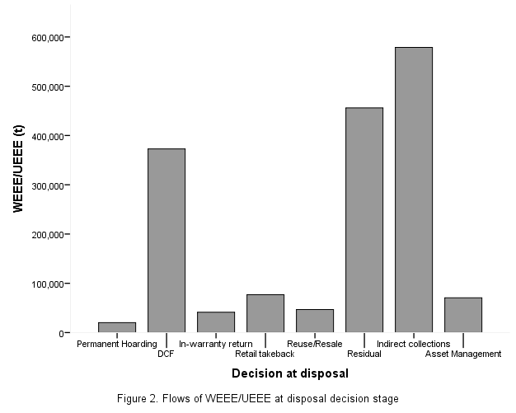

Figure 3

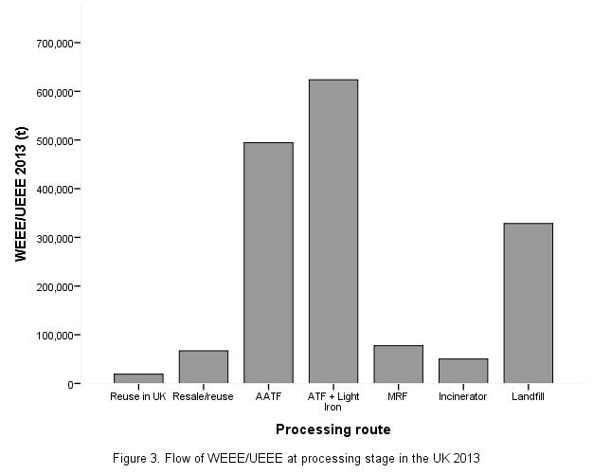

Figure 4

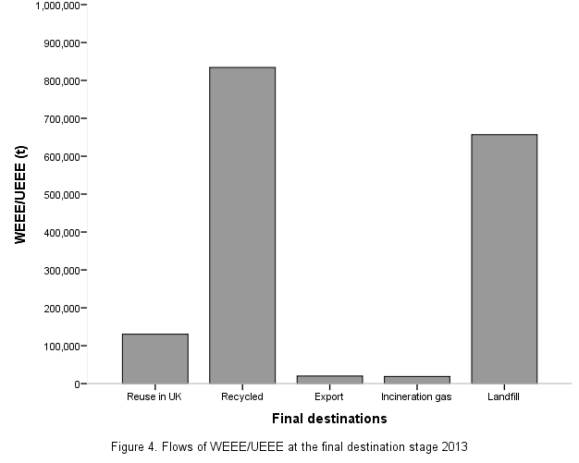

Figure 5

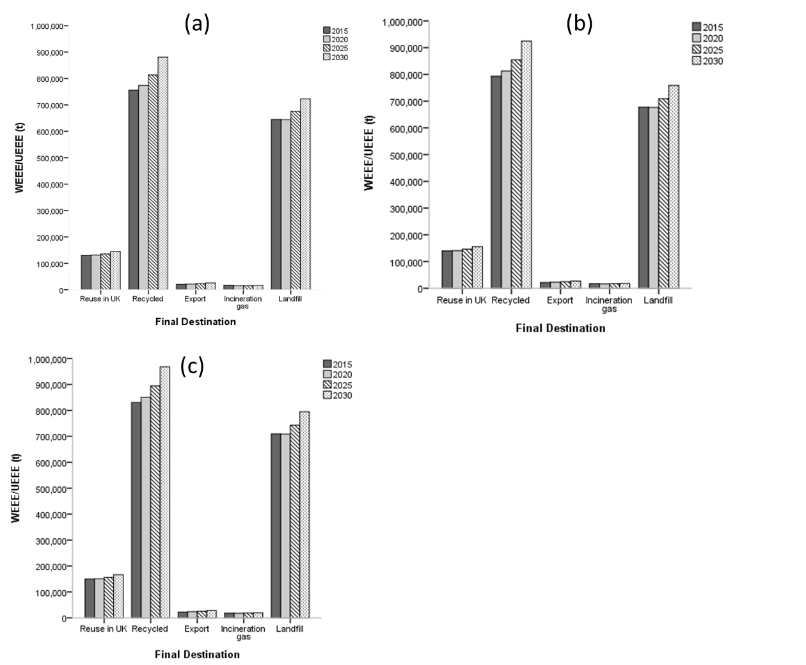

1. WEEE is defined in the EU WEEE Directive 2012/19/EU as any electrical or electronic equipment that is waste, including all components, sub-assemblies and consumables, which are part of the product at the time of discarding.
2. UEEE is defined as any electrical or electronic equipment that has reached the end of its first useful life but for which a disposal decision has not yet been made by the consumer (WRAP, 2011).
3. Non-obligated WEEE is any WEEE that is received by an AATF/ATF or Approved Exporter but not on behalf of a PCS (BIS, 2014).
4. Scrapped domestic appliances (or “white goods”) are the main source of light iron (e.g. washing machines and dryers, cookers, ovens, microwaves, etc.). Other sources of light iron include sheet metal, car shells and body panels, light iron shelving, scrap paint tins (empty), hot water heaters, etc.