Type of contribution: Regular papers
Date of preparation: January 16, 2019
Number of text pages: 36, number of tables: 1, number of figures: 6
Number of Supplementary tables: 20, Number of Supplementary figures: 10
Manuscript title: Distinct methanotrophic communities exist in habitats with different soil water contents
Author Names: Liyan Zhang ^{a,b}, Jonathan Adams^{c}, Marc G. Dumont^{d}, Yuntao Li^{a,b}, Yu shiª, Dan He^{e}, Jin-Sheng He^{f,g}, Haiyan Chu^{a,}*
Affiliation:
ª State Key Laboratory of Soil and Sustainable Agriculture, Institute of Soil Science, Chinese Academy of Sciences, 71 East Beijing Road, Nanjing 210008, China.
^{b} University of Chinese Academy of Sciences, Beijing 100049, China.
^{c} Department of Biological Sciences, Seoul National University, Seoul, Republic of Korea.
^{d} Biological Sciences, University of Southampton, Southampton, UK.
^{e} Center for Ecological and Environmental Sciences, South China Botanical Garden, Chinese Academy of Sciences, Guangzhou 510650, China.
^{f} Department of Ecology, College of Urban and Environmental Sciences, and Key Laboratory for Earth Surface Processes of the Ministry of Education, Peking University, Beijing 100871, China.
^{g} State Key Laboratory of Grassland Agro-Ecosystems, and College of Pastoral Agriculture Science and Technology, Lanzhou University, Lanzhou 730000, Gansu, China.
*Corresponding author: Haiyan Chu
Corresponding address: State Key Laboratory of Soil and Sustainable Agriculture, Institute of Soil Science, Chinese Academy of Sciences, 71 East Beijing Road, Nanjing 210008, China.
Tel.: +862586881356, Fax: +8602586881000, E-mail: hychu@issas.ac.cn
Abstract
Aerobic methane oxidizing bacteria play a key role in controlling global climate by reducing methane (CH₄) emissions in natural ecosystems. We studied the community assembly processes and co-occurrence interactions of soil methanotrophs in three habitats (an alpine meadow, a marsh meadow, and a marsh) from Qinghai-Tibetan Plateau. Methanotrophic communities and CH₄ oxidation potentials varied considerably between the habitats, and the diversity of methanotrophs was significantly lower in marsh meadow than in the other two soils (P < 0.001). Methanotrophic bacterial diversity was significantly correlated with soil dissolved organic carbon (DOC), pH, total carbon (TC), and total nitrogen (TN), while methanotrophic community structure was mostly correlated with soil C/N, TC, soil moisture, and TN. Stochasticity dominated methanotrophic community assembly, and increased from 67.6% in the alpine meadow and 68.0% in the marsh meadow to 98.2% in the marsh. The natural connectivity of co-occurrence network was greater in the alpine meadow than in the other two habitats, suggesting a more stable network in the alpine meadow. Methanotroph diversity contributed to the sub-network topological differences and keystone species were identified such as USCγ, Methylobacter, and RPC-1. The results suggest the existence of distinct community assembly processes and co-occurrence patterns of soil methanotrophs among different habitats, which may ultimately enhance the understanding of factors influencing CH₄ oxidation rates.
Key words: methane; methanotrophs; stochastic; deterministic; phylogenetic diversity; co-occurrence
1. Introduction
Wetlands contribute nearly one-third of the global methane emissions, releasing about 250 Tg of methane per year to the atmosphere (Mitsch et al, 2013), thus serving as a major carbon reservoir with potential to accelerate climate change (IPCC, 2013). Aerobic methane oxidizing bacteria (MOB) are ubiquitous in wetlands (Deng et al., 2013), forest soils (Kolb et al., 2005), and cold environments, such as tundra soils, permafrost sediments, and arctic soils (Trotsenko and Khmelenina, 2005; Liebner and Wagner, 2007; Martineau et al., 2010), and play a critical role in global climate control and element cycling (Hanson and Hanson, 1996; Bodelier and Laanbroek, 2004; Murrell, 2010; Reeburgh, 2014). They can oxidize one-carbon (C1) compounds, such as methane and methanol using the particulate (pMMO) and/or soluble (sMMO) methane monooxygenase enzymes (Hanson and Hanson, 1996), and are currently restricted to the phylum Proteobacteria. Methanotrophs can be divided into two groups. Type I methanotrophs are members of the Gammaproteobacteria, and primarily use the ribulose monophosphate cycle for carbon assimilation. Type II methanotrophs are Alphaproteobacteria, which use the serine cycle for carbon assimilation (Hanson and Hanson, 1996). The pMMO is present in all known methanotrophs except the genera Methylocella and Methyloferula (Vorobev et al., 2011), while these two genera seem to play a minor role in habitats on the Tibet Plateau. (Deng et al., 2013). The pmoA gene encodes the β-subunit of the pMMO, exist in most well-known methanotrophs and has become the excellent marker in identifying methanotrophs (McDonald et al., 2008; Knief, 2015). Previous molecular surveys have revealed dynamic changes in methanotrophic community structure, abundance, and activity. For example, combining real-time quantitative PCR (qPCR) and denaturing gradient gel electrophoresis (DGGE) analysis, Yun et al. (2010; 2012) observed that Methylobacter (type I methanotrophs) species outnumbered Methylocystis (type II methanotrophs) in the Zoige wetland (at the eastern edge of Tibetan Plateau) and their abundance and activity varied between different soil conditions. Cloning and sequencing analyses from Riganqiao peatlands (belong to Zoige wetland) revealed high type II methanotroph abundance in the area and their diversity distinct between hummocks and hollows (Deng et al., 2013). The two sites have different soil properties and somewhat different vegetation types. In general, the Riganqiao soil is more acidic and has both higher soil organic carbon and higher total nitrogen than the Zoige soil. In addition to pH, factors such as vegetation types, oxygen, nutrient availability, and soil moisture are also important for the selection of methanotroph species (Hanson and Hanson, 1996). In fact, Type I and type II MOB have been shown to display markedly different behaviour, which can be interpreted as ecologically different strategies. Type I methanotrophs (e.g., Methylobacter, Methylosarcina, Methylomonas) would be classified as competitors or ruderals. They can quickly become dominant in various environments. Sufficient nutrient availability seems to be a prerequisite for the proliferation of type I methanotrophs; however, type II methanotrophs are at an advantage in niches where resources are more limiting (Siljanen et al., 2010; Ho et al., 2012). Nevertheless, there has been limited study of methanotroph abundance and community structure across habitats differing in water content.
Soil microbial community structure is shaped by a combination of deterministic and stochastic processes (Chase and Myers, 2011). Deterministic processes are niche-based, including environmental filtering, biotic interactions, and interspecific trade-offs that enable species to co-exist within communities for long periods of time (Stegen et al., 2012). Stochastic processes essentially involve random processes such as reproduction, dispersal, colonization (Barber and Marquis, 2011), and ecological drift (Bell, 2001). Both deterministic and stochastic processes simultaneously govern the spatial distribution of microbial communities, and different processes are dominant in different cases (Caruso et al., 2011; Dumbrell et al., 2010; Peay and Bruns, 2014). Therefore, anthropogenic activities (e.g. global warming caused by greenhouse gases) may influence soil microbial assembly through the modulation of both deterministic and stochastic processes (Zhang et al., 2016). However, to the best of our knowledge, few data are available regarding MOB community assembly.
In natural ecosystems, microorganisms living together form complex networks through positive (e.g. mutualistic) and negative (e.g. competitive) interactions, as well as interactions with no impacts on fitness (Faust and Raes, 2012). Network analysis has been used to explore interactions among microorganisms in various habitats, including soils (Lupatini et al., 2014), lakes (Xue et al., 2018), and the human gut (Faust et al., 2012). The topological properties of the networks reflect the interactions between microorganisms that traditional methods could not have predicted. For example, taxa in the co-occurrence network with high closeness centralization and low betweenness centrality can be considered as keystone taxa (Berry and Widder, 2014). The scores (network topology properties) also change as environmental conditions shift (Wu et al., 2016). Owing to such merits, network analysis has become a powerful tool in the study of microbial ecology.
The Qinghai-Tibetan Plateau (QTP) is the Earth’s largest (2×10⁶ km²) and highest (average ~ 4500 m a. s. l.) plateau. It has been called the “third pole” of the Earth, and is a major CH₄ emission hotspot with annual emissions estimated to be 0.56-1.00 Tg (Ding and Cai, 2007). We collected soil samples from three habitats (alpine meadow, marsh meadow, and marsh) in a continuum water-content region. In this study, we hypothesized that the methanotrophic community assembly processes and co-occurrence network patterns would be distinct between the three habitats with different water contents. The objective of this study was to investigate the factors influencing soil methanotrophic community diversity, structure and community assembly processes on a local scale between habitat types.
2. Material and methods
2.1. Study site description
Three transects were set-up across an alpine meadow, a marsh meadow and a marsh in a single valley in the northeast (37°50'N~37°60'N, 101°32'E~101°35'E) of QTP (Fig S1A; Table S1). This area (~10 km² square sub-region) represents the world’s largest high-altitude (about 3200 m) and low-latitude permafrost area. Mean annual temperature (MAT) in the valley is about -2°C and mean annual precipitation (MAP) is about 500 mm. The area is dominated by meadow vegetation, but also contains alpine meadow, marsh meadow and marsh (Fig S1B). Soil type was mat-cryic cambisol in alpine meadow, mol-cryic cambisol in marsh meadow and organic cryic gleysol in marsh; soil texture was silty clay soil, loam clay soil, and loam clay soil, respectively. As our sampling site, we choose a continuum in geography containing the three vegetation types. The plant community is dominated by Kobresia humilis (C. A. Mey. ex Trautv.) Sergiev., K. pygmaca C. B. Clarke., and Ajania tenuifolia in the alpine meadow; Stipa capillata Linn., Scirpus pumilus Vahl., and Saussurea romuleifolia Franch in the marsh meadow; and Heleocharis dulcis (Burm. f.) Trin., Carex spp., and Crepis flexuosa (Ledeb.) C. B. Clarke in the marsh.
2.2. Sampling and soil physiochemical analysis
Samples were collected on August 26th, 2016. In total, 45 soil samples were collected from the three habitats and three transects. On each transect, 15 samples (5 from each habitat site) were collected from the top 0-10 cm of the soil. The samples were then transported to the laboratory in insulated boxes fitted with sterile ice bags. They were divided into three parts as follows: one part was stored at 4ºC for the measurement of soil physiochemical properties; one was air dried and sieved through a 2 mm mesh for the incubation experiment; and one was stored at -40°C for DNA extraction. Soil pH was determined using a pH meter (Thermo Orion-868, Waltham, MA, USA) after shaking a soil water (1:5 w/v) suspension. Soil moisture was determined gravimetrically. Total carbon (TC) and total nitrogen (TN) were measured using an elemental analyzer (Vario MAX, Elementar, Germany). Dissolved organic nitrogen (DON) and dissolved organic carbon (DOC) were determined from a mixture with a ratio of 10 g fresh soil to 100 mL 2M KCl (deionized water for DOC) by shaking for 1 h, after standing for 1 h and then filtered (Fisher G4 1.2 µm). Then the extracted was determined using a continuous flow analyzer (San++ System, Skalar, Holland).
2.3. CH₄ oxidation potential
Before incubation, the soil was pre-incubated at 60% water holding capacity (WHC) at 28°C in darkness for four days under ambient air conditions. Aliquots (5 g, wet weight) of the pre-incubated soil were then placed into 120 ml serum vials capped with butyl rubber stoppers and CH₄ was injected into the gas headspace of the vials to yield final mixing ratios of 2% (Siljanen et al., 2011). Triplicate flasks were prepared and a control serum vial without soil was used to confirm the absence of gas leaks. CH₄ concentrations were measured daily with a gas chromatograph (Agilent 7890, Santa Clara, CA, USA) equipped with a flame ionization detector using 1 ml gas samples from the bottle headspaces. The concentration of CH₄ began to decrease immediately at the beginning of incubation (Fig S2). Potential CH₄ oxidation rates were determined from the slope of the linear regression equation of CH₄ oxidation versus incubation time (Shrestha et al., 2012).
2.4. DNA extraction, pmoA gene quantification and 454 pyrosequencing
0.5 g fresh soil was used for total DNA extraction using a FastDNA® Spin kit (MO Bio, Carlsbad, CA, USA) according to the manufacturer’s instructions. The DNA was further purified using DNA Clean-Up kits (MO Bio, Carlsbad, CA, USA). Final DNA yield was determined using a Nanodrop 1000 spectrophotometer (Thermo Scientific, Wilmington, DE). The A189F/mb661r primer pair was used to amplify the pmoA gene (Knief, 2015). Soil samples were then sequenced on a Roche Genome Sequencer FLX System platform (454 Life Science, Branford, CT, USA). The absolute abundance of pmoA genes was determined using qPCR assays, which were performed in 20 μl volumes containing 10 μl Premix Ex Taq (RR420A, SYBR® Premix Ex Taq™, Takara Bio Inc, Japan), 0.2 μl of each primer, and 2 μl of DNA template. All reactions were performed in triplicate on a CFX96 Optical Real-Time Detection System (Bio-Rad, Laboratories Inc., Hercules, CA, USA). Cycling conditions were set as follows: 30 s at 95°C, followed by 39 cycles of denaturation at 95°C for 10 s, 55°C for 30 s, 72°C for 30 s, and 80°C for 5 s. The standard was obtained by a 10-fold dilution series of a pmoA gene clone from a stock concentration of 2.83×10⁹ copies. The amplification efficiency was between 94.8% and 98.1% with R² values of 0.999-1, no signals were detected in the negative controls.
2.5. Bioinformatic analysis
The raw sequences obtained from the present study were deposited into the NCBI Sequence Read Archive (SRA) with the accession number SRP127483.
A total of 274,405 sequences were obtained from 45 soil samples. QIIME 1.9.1 was used to analyze the sequencing data (Caporaso et al., 2010). Chimeric reads were identified and removed using USEARCH 6.1 (Edgar et al., 2011). Frameshifts were corrected using FrameBot (Wang et al., 2013) with the online version of the FunGene Pipeline (Fish et al., 2013). High-quality sequences were clustered into operational taxonomic units (OTUs) with UCLUST algorithm (Edgar, 2010) using the pick de novo mode at a 7% distance cutoff value (Degelmann et al., 2010). The pmoA gene annotation was performed in standalone BLAST 2.7.1+ according to a database with 6628 sequences (Dumont et al., 2014). Database sequences were aligned using MUSCLE software (Edgar, 2004). A phylogenetic tree was constructed using the FastTree software program (Price et al, 2010).
2.6. Statistical analysis
SPSS Statistics 23.0 (IBM Corporation, Armonk, NY, USA) was used to perform ANOVA analysis to evaluate differences in soil physiochemical properties, CH₄ oxidation potential, and gene copies among habitats. Non-metric multidimensional scaling (NMDS), Simper analysis, Mantel test, Partial Mantel test, and pairwise comparisons (ADONIS, ANOSIM and MRPP) were conducted with the vegan package in R3.4.1 (http://cran.stat.sfu.ca/). Weighted Unifrac and unweighted Unifrac distances were used to evaluate phylogenetic dissimilarity and were calculated with QIIME script (beta_diversity_through_plots.py) (Caporaso et al., 2010). Partial least squares path models (PLS-PM) were constructed with the function “inner plot” using the plspm package of R3.4.1 (Sanchez, 2013). In addition, we used multiple regressions on distance matrices (MRM) measuring the relative explained variances of soil physiochemical properties, CH₄ oxidation potential, and methanotroph diversity to explain the community structure. MRM analyses were conducted with the ecodist package of R3.4.1.
To determine the assembly processes driving the community composition within a sample, we calculated the Nearest Taxon Index (NTI) values of each sample and beta Nearest Taxon Index (βNTI) for paired samples. NTI values were calculated in R3.4.1 using the picante package (Webb et al., 2008), and βNTI values were calculated using the comdist functions in phylocom 4.2 (Webb et al., 2008). If the NTI values are positive and mean values are above 0 (P < 0.05), co-occurring species are more affected by phylogenetic clustering than by overdispersal; conversely, negative values and mean values below 0 (P > 0.95) indicate that co-occurring species are more affected by overdispersal (Webb, 2000). If βNTI values are > 2 or < -2, deterministic processes are critical in shaping community composition, while if βNTI values are between -2 and +2, stochastic processes play a key role (Stegen et al., 2012). To further quantify the stochastic differences, we estimated pairwise community turnover using the Raup-Crick metric extended to incorporate species’ relative abundances (RC_{bray}). Pairwise comparisons between communities that did not deviate from the null model distribution were evaluated as the contribution of dispersal limitation (|βNTI| < 2 and RC_{bray} > +0.95) and homogenizing dispersal (|βNTI| < 2 and RC_{bray} < -0.95); RC_{bray} values between -0.95 and +0.95 indicate that compositional turnover between a given pair of communities is ‘undominated’ (Stegen et al., 2013).
Network structures were calculated in R3.4.1 using the WGCNA package and visualized using the interactive platform Gephi 0.9.1 using directed network and the Fruchterman-Reingold layout (Bastian et al., 2009). We considered a valid co-occurrence event to have a Spearman’s correlation coefficient (p) > 0.6 (P < 0.01; Junker and Schreiber, 2008). We generated sub-networks for each soil sample from networks by preserving OTUs presented in each site using subgraph functions in igraph packages. The correlation between sub-network topological features and environmental factors were tested using ANOVA analysis. The Z_{i}-P_{i} thresholds were based on metabolic network methods (Guimerà and Amaral, 2005). Briefly, we sorted all species into four groups: peripherals (z_{i} ≤ 2.5; p_{i} ≤ 0.62), connectors (z_{i} ≤ 2.5; p_{i} > 0.62), module hubs (z_{i} > 2.5; p_{i} ≤ 0.62), and network hubs (z_{i} > 2.5; p_{i} > 0.62) (Olesen et al., 2007).
3. Results
3.1. Soil chemical properties and CH₄ oxidation activity
In all three transects, soil chemical properties were significantly different among the three habitats, and there were almost no differences when comparing the same habitat type among replicate transects (Table S2). As expected, soil moisture was significantly higher in marsh soil (265 ± 83%) than marsh meadow soil (211 ± 48%) and alpine meadow soil (48 ± 6%). Soil DOC, TC, and TN in the marsh meadow were all significantly higher (P < 0.001, ANOVA) than those in the alpine meadow and marsh. The soil C/N ratio and DON were higher in the marsh than in the alpine meadow and marsh meadow. Soil pH exhibited no variation across the three habitats. The potential CH₄ oxidation rate was significantly higher in marsh meadow soil (15.60 ± 4.04 μg g⁻¹ dry soil h⁻¹) than the alpine meadow (1.80 ± 0.50 μg g⁻¹ dry soil h⁻¹) and marsh soils (13.70 ± 0.26 μg g⁻¹ dry soil h⁻¹), with similar values among replicate transects when comparing a single habitat (Table S2). The pmoA gene copy numbers were significantly higher in the marsh (5.86 ± 3.51×10⁷ g⁻¹ dry soil) than those in the alpine meadow (1.58 ± 0.39 × 10⁷ g⁻¹ dry soil) and the marsh meadow (2.39 ± 1.02×10⁷ g⁻¹ dry soil). Methanotrophs typically contain two copies of the pmo operon in their genome, and therefore pmoA abundance can be used as proxy (at a ratio of 2:1) for cell abundance. Based on this calculation, the specific CH₄ oxidation potential in the marsh meadow was significantly higher (P < 0.05) than those in the other habitats; however, there was no significant difference between alpine meadow and marsh (Fig. S2).
3.2. Variations in methanotrophic community composition among alpine meadow, marsh meadow, and marsh
Soil methanotrophic community composition differed between the alpine meadow, marsh meadow, and marsh (Fig. 1) and there were almost no differences among three replicate transects when comparing the same habitat (Table S3). The methanotroph genera were divided into five groups according to their phylogenetic classification. Generally, type Ib, type IIa, and type Ia methanotrophs dominated the communities and overall amongst the samples they accounted for 69.5%, 69.8%, and 43.9% of the species, respectively (Table S4). The relative abundances of each lineage varied between the habitats. The USCγ (type Ib) were the dominant species in the alpine meadow and accounted for 66.3% of the methanotrophic community, but were rare in the marsh meadow (0.1%) and the marsh (0.02%). The relative abundance of Methylocystis (type IIa) was higher in the marsh meadow (69.7%) than in the alpine meadow (4.7%) and the marsh (18.0%). In the marsh, Methylobacter, FWs, and Methylocystis were dominant species (Fig. 1). RPC-1 (type Ib) were well represented in the marsh meadow (7.9%) and in the marsh (7.6%) compared with in the alpine meadow (0.4%). In contrast, Methylosarcina (Type Ia) had higher relative abundance in the alpine meadow (3.7%) than in the marsh meadow (1.2%) and the marsh (0.4%).
3.3. Environmental drivers of CH₄ oxidation potential, soil methanotroph diversity and community structure
CH₄ oxidation potential and pmoA gene copies were positively correlated with soil C/N in all soil samples (Table S11) and increased from the drier to the wetter soils (Fig. S3). Community diversity (Shannon index, Phylogenetic diversity, and OTU richness were lower in the marsh meadow than in the alpine meadow and the marsh (Fig. 2A, 2B and 2C) and there were almost no differences among transects (Table S5). NMDS demonstrated that soil methanotrophic community structure varied among habitats (Fig. 2D), which was further demonstrated by Simper analysis (Table S6). Community dissimilarity was significantly different between each compartment, which was further confirmed by ADONIS, ANOSIM, and MRPP analyses based on Bray-Curtis distances (Table S7; Table S8). “Within-site pairs” and “between-site pairs” of Bray-Curtis dissimilarity revealed that community dissimilarity was greater between habitats than between transects (Fig. S4; Fig. S5).
Compared with all other factors, soil DOC had the highest negative correlation with soil methanotroph diversity (Table S10). A Mantel test between community similarity and phylogenetic similarity with geographical distance, and environmental dissimilarity revealed that environmental variables played key roles in shaping community similarity and phylogenetic similarity overall, and that geographical distance significantly influenced soil methanotrophic community similarity in the alpine meadow and the marsh (Table S12). After eliminating the effect of geographic distance, partial Mantel test results revealed that environmental factors were significantly correlated with methanotroph community similarities (r = 0.356, P = 0.001) and phylogenetic similarities (Unweighted Unifrac: r = 0.447, P = 0.001; Weighted Unifrac: r =0.291, P = 0.001) across all soil samples. Environmental variables played a critical role in shaping the community similarity and phylogenetic similarity, particularly in the marsh meadow (Bray-Curtis: r = 0.357, P = 0.006; Weighted Unifrac: r = 0.251, P = 0.046) and the marsh (Unweighted Unifrac: r = 0.473, P = 0.014) but not in the alpine meadow. In addition, when we eliminated the effect of environmental distance, a high significant correlation between geographic distance and methanotrophic community dissimilarity (r = 0.266, P < 0.001) was detected across all soil samples, and independently in the alpine meadow (r = 0.231, P < 0.001) and the marsh (r = 0.218, P = 0.031) (Table 1). PLS-PM and MRM analyses were carried out to reveal the potential pathways influencing methanotrophic community structure with regard to three factors, including physicochemical properties, CH₄ oxidation potential, and soil methanotroph alpha diversity (Fig. 3A, 3B and 3C). After retaining the most significant variables, the PLS path modeling explained 89% of the community variation. The direct effect of soil parameters (path coefficient = 0.703) on methanotrophic community structure was greater than the direct effects of CH₄ oxidation potential (path coefficient = 0.366) and soil methanotroph alpha diversity (path coefficient = 0.0338) (Fig 3A). Among the environmental variables, soil C/N had the highest explained variance (0.54) (Fig. 3C), suggesting that soil C/N was a key driver explaining methanotrophic community structure (Fig. 5A; Table S9).
3.4. Quantifying influences of ecological processes in shaping methanotrophic community structure
In general, we observed that all the mean NTI values were above zero in habitats and transects (Fig. S6; Table S13), which indicated that methanotrophic communities were phylogenetically clustered. The values of βNTI metrics were between -2 and +2 either within or between community comparisons (Fig. S7A, 7B), which indicated that a stochastic process mainly governed methanotrophic community dynamics, and the relative contribution of stochasticity was lower in alpine meadow (67.6%) and marsh meadow (68.0%), compared to marsh (98.2%) (Fig. 4A; Fig. 4B; Table S14). The stochastic processes were different between the three habitats. Compositional turnover was undominated in alpine meadow (74.3%) and marsh (77.9%); there was a relatively high rate of dispersal limitation in the alpine meadow (25.7%) while no dispersal limitation was detected in marsh meadow and marsh; however, there was a high rate of homogenizing dispersal in marsh (22.1%) and marsh meadow (97.1%) and no homogenizing dispersal was detected in the alpine meadow (Fig. 4C). Moreover, the βNTI metric values in the alpine meadow and the marsh meadow were significantly lower in soils from the marsh (P < 0.001, ANOVA), these two habitats have a proportion of deterministic processes (32.4%, 32.0%, respectively). To assess the relative influence of environmental variables on βNTI, Mantel tests between the βNTI metric and the environmental factors were performed. Among the environmental variables, phylogenetic null deviation was mostly correlated to the changes in DOC (Table S15; Fig. S8; r = 0.140, P = 0.001). This could suggest that the filtering effect of soil DOC (e.g. increase or decrease in the soil DOC variation between sites) could be causing the disturbances in the phylogenetic structure pattern across sites, leading to the phylogenetic conservation of methanotrophic communities within sites.
3.5. Topological properties and keystone species in methanotroph communities co-occurring in alpine meadow, marsh meadow and marsh
In order to characterize and evaluate the co-occurrence interactions of the methanotrophic communities in each of the habitats, we constructed co-occurrence networks and calculated the topological properties of the networks and sub-networks (Table S17). Considering the number of correlations, we found that predominantly positive correlations in all habitats, which indicated that methanotrophs exhibited cooperative rather than competitive relationships (Oliveira et al., 2014). Alpine meadow had the highest node connectivity (i.e., average degree of 10.346) and the highest average path length (1.64) compared with marsh meadow and marsh (Table S16). The diameters of the networks displayed a similar trend, peaking in the alpine meadow (7 edges) and the least value was observed in the marsh (3 edges). Topological patterns of degree distribution showed that pmoA genes in all the three habitats exhibited a typical power-law distribution (Fig. S10), which indicated a scale-free network structure and not a random co-occurrence pattern. When comparing network stability among the three habitats, less fluctuation from natural connectivity patterns was observed in response to the proportions of removed nodes in the alpine meadow (Fig. 5B), which indicated a more stable network topology.
We further generated sub-networks for each soil sample by keeping OTUs associated with specific samples and all edges among them in the co-occurrence network in each habitat. A number of subnetwork-level topological features were calculated and separated into three clusters based on hierarchical cluster analyses on the dissimilarities (Fig. S9). Cluster 1 included node number, edge number, global clustering coefficient, and average clustering coefficient. Cluster 2 included edge density and degree centralization. Cluster 3 included clusters, eigenvector centralization, modularity, and betweenness centralization. After evaluating their correlations with the environmental variables, we observed that the edge numbers, similar to other topological features in the cluster, such as node number, global clustering coefficient, and average clustering coefficient, had a positive correlation with soil methanotroph alpha diversity, with a lower correlation coefficient in the marsh than in the other two habitats. Edge density and degree centralization in cluster 2 were negatively correlated with soil methanotroph alpha diversity in all the three habitats. Additionally, cluster number, eigenvector centralization, and modularity were positively correlated with soil alpha diversity. Betweenness centralization had a negative relationship with methanotroph alpha diversity in the marsh meadow and the marsh (Table S18).
The Zi-Pi relationships among OTUs revealed that most nodes were peripherals in all habitats, a few nodes were connectors in every habitat (Table S19), while there were no module hubs or network hubs. We identified the ‘connectors’ as the keystone species in the networks. Methylobacter (OTU 158) and USCγ (OTU 2013) were connectors in the alpine meadow. There were relatively more low abundance OTUs (Table S20) serving as connectors in the marsh meadow, e.g. OTU 3746, OTU 2909, OTU 962, OTU 6544, OTU 3608 (all assigned to USCγ), and OTU 3154 (assigned to RPC-1) than in the alpine meadow and the marsh meadow. OTU 6431 (assigned to Methylobacter) and OTU 3149 (Unclassified methanotrophs) were detected as connectors in the the marsh network (Fig. 6).
4. Discussion
4.1. Potential CH₄ oxidation rates and different groups of soil methanotrophs
Soil CH₄ oxidation potential is typically concentrated at the soil-water interface. Therefore, CH₄ oxidation potential was higher in the marsh meadow and the marsh (high water table areas) than in the alpine meadow (Fig. S2), which is consistent with the findings of a previous study (Rachwal et al., 2014). CH₄ oxidation potential was spatially positively correlated with C/N and soil moisture (Table S11), which is also consistent with the results of several studies (Roslev and King, 1994; Martineau et al., 2014). In the present study, soil moisture exhibited an increasing trend from the alpine meadow (48%), the marsh meadow (211%) to the marsh (265%), which was correlated with a significant increase in soil CH₄ oxidation activity. Soil structure and soil pore system influence water regimes and gas fluxes. A high water table makes conditions more anoxic. Consequently, the methanogenic activity was high, which facilitated aerobic methanotrophy near the oxic interface (Smith et al., 2003; Wagner, 2017).
This study demonstrated that the methanotrophic communities vary among the three habitats with distinct soil physiochemical properties optima. Some species in genus Methylocystis, a group of type II methanotrophs, have been reported to have a relatively high affinity for CH₄ (Baani and Liesack, 2008; Limbri et al., 2014). In the present study, a high abundance of Methylocystis was detected in the marsh meadow. High abundances of Methylocystis have also been reported in various boreal peatlands (Esson et al., 2016; Putkinen et al., 2018). Notably, a very high abundance (66.3%) of USCγ was detected in the alpine meadow. This taxon is more likely to be detected in upland soils that consume atmospheric CH₄ and have pH values > 6.0 (Knief et al., 2003). FWs, an uncultured phylogenetic cluster, was enriched in the marsh. This group, which has been found in plant harvest wetlands, is believed to play a key role in global CH₄ cycling (Zhu et al., 2007).
4.2. Environmental factors shape soil methanotrophic community similarity and phylogenetic similarity more than geographical distance on a small scale
Soil DOC, TC, and TN were all negatively correlated with methanotroph diversity and soil pH had a positive correlation with methanotroph diversity in all the soil samples. The result suggest that methanotrophs are specifically adapted to particular environments, and substrate availability has been suggested to select for type I and type II methanotrophs and limited their growth (Bodelier et al., 2000; Shiau et al., 2018). Soil C/N, TC, TN and soil moisture were the major drivers of distinct community structures, which is supported by findings of a previous study (Kumaresan et al., 2009). In addition, we observed that environmental factors play a critical role in shaping soil methanotrophic community structure and phylogenetic similarity, and geographical distance plays a relatively minor role in determining methanotrophic communities (Table 1; Table S12). This may be because the three habitats are located at a relatively small spatial scale. For comparison, sampling across larger distances should be considered in future studies.
4.3. Stochastic processes dominated in methanotrophic community assembly
Stochastic processes can greatly influence microbial community composition when environmental heterogeneity or species sorting is low (Woodcock et al., 2013; Bennke et al., 2016). In our results, the βNTI values were between -2 and +2, which indicated that stochastic processes were shaping methanotrophic community assembly (Fig. 4A; Fig. 4B), and was consistent with the findings of a study conducted in QTP that demonstrated that stochasticity may overwhelm deterministic processes at scales of less than 130 km (Shi et al., 2018). Nevertheless, there were some deterministic processes in the alpine meadow (with a relative contribution of 32.4%) and in the marsh meadow (with a relative contribution of 32.0%) compared with the marsh (Table S14). Although the proportion of stochasticity stayed consistent along the water gradients, the result may indicate that methanotroph community composition varied among habitats, which may select for specialist taxa (e.g. atmospheric CH₄ oxidation by USCγ). However, our research was constrained within the context of the QTP, and it is important to consider that the relative proportions of methanotrophs in the soil community will shift over space and time – for example with the seasons (Lüke et al., 2014; Smith et al., 2018). More research is required to elucidate the ecological niches of closely related taxa selected along environmental gradients or across space and time. It would be fascinating to know if such stochastic variation produces microscale spatial variation in methane oxidation potential.
4.4. Type I methanotrophs were more responsible for stability of co-occurrence network hubs
Methanotrophic networks exhibited power-law distribution patterns (scale-free networks) in all three habitats, superficially similar to the Internet backbone (Jeong et al., 2000) and metabolic reaction networks (Faloutsos et al., 1999). This means that the power-law distribution networks have many nodes with few links and a few highly connected nodes that are termed as hubs. Networks with these characteristics are considered to be robust towards random node removal but sensitive to the removal of hub nodes (Faust and Raes, 2012). Since the co-occurrence patterns are linked to the interactions of microorganisms in ecosystems, the factors driving the topological features of microbial networks could reflect their effects on microbial interactions (Ma et al., 2016). The environmental drivers of topological features varied among alpine meadow, marsh meadow and marsh networks. Generally, the alpha diversity of soil methanotrophs was more critical than soil physiochemical variables in influencing subnetwork structures, which could indicate that methanotroph diversity was directly correlated with methanotrophic interactions. We also observed that pH and soil C/N were significantly correlated with subnetwork topological properties in the alpine meadow and the marsh, respectively. The correlational relationships could provide some insights for understanding the importance of CH₄-oxidizing inter-species interactions in influencing element cycling, which could also be influenced by changes in the water tables. From Z_{i}-P_{i} space, we suggested that type I methanotrophs (e.g. Methylobacter, USCγ, RPC-1) were network connectors and likely to play a key role in community cooperation and have a pronounced impact on the stability of co-occurrence networks. Indeed, several studies indicate that type I methanotrophs are highly active in permafrost wetlands and their roles in low-affinity CH₄ oxidation were varied across soils (Liebner and Wagner, 2007; Yun et al., 2014; Christiansen et al., 2015).
In summary, methanotrophic activity, as observed from our samples tested in laboratory mesocosms, was highest in soils from the marsh and the marsh meadow, as is expected from an environment with higher CH₄ fluxes associated with anoxic conditions in water-saturated environments. Soil methanotrophic assemblages have different niches along a soil water content gradient, resulting in distinct community assemblages in the alpine meadow, the marsh meadow, and the marsh. Although there were different trends in methanotrophic community composition along soil water gradients, the community assembly of methanotrophs appeared to be dominated more by stochastic processes than by deterministic processes, and marshes had a large proportion of stochasticity (Homogenizing dispersal). For the network structure patterns, type I methanotrophs seems to be more responsible for the inter-species cooperation. Collectively, the results suggested that the soil methanotrophic community assemblage processes varied along water table gradients in QTP. Future research should focus on the effect of alternating dry and wet conditions on methanotrophic community to examine community responses and the resilience of CH₄ oxidation.
Acknowledgements
We thank Teng Yang, Yingying Ni, Kunkun Fan and Xu Liu for their help in statistical analysis and Junji Yuan for their help in CH₄ oxidation rate measurements. This study was funded by the National Program on Key Basic Research Project (2014CB954002), the Strategic Priority Research Program (XDB15010101) of Chinese Academy of Sciences, and the basic work of science and technology of Ministry of Science and Technology of China (2015FY110100). The authors declare no competing interests.
References
Baani, M., Liesack, W., 2008. Two isozymes of particulate methane monooxygenase with different methane oxidation kinetics are found in Methylocystis sp. strain SC2. Proceedings of the National Academy of Sciences 105, 10203-10208.
Barber N.A., Marquis R.J., 2011. Leaf quality, predators, and stochastic processes in the assembly of a diverse herbivore community. Ecology 92, 699-708.
Bastian, M., Heymann, S., Jacomy, M., 2009. Gephi: an open source software for exploring and manipulating networks. In International AAAI Conference on Weblogs and Social Media: San Jose, California.
Bell, G., 2001. Neutral macroecology. Science 293, 2413-2418.
Bennke, C.M., Krüger, K., Kappelmann, L., Huang, S., Gobet, A., Schüler, M., 2016. Polysaccharide utilisation loci of Bacteroidetes from two contrasting open ocean sites in the north Atlantic. Environmental Microbiology 18, 4456-4470.
Berry, D., Widder, S., 2014. Deciphering microbial interactions and detecting keystone species with co-occurrence networks. Frontiers in Microbiology 5, 1-14.
Bodelier, P.L.E., Roslev, P., Henckel, T., Frenzel, P., 2000. Stimulation by ammonium-based fertilizers of methane oxidation in soil around rice roots. Nature 403, 421-424.
Bodelier, P.L.E., Laanbroek, H.J., 2004. Nitrogen as a regulatory factor of methane oxidation in soils and sediments. FEMS Microbiology Ecology 47, 265-277.
Caporaso, J.G., Kuczynski, J., Stombaugh, J., Bittinger, K., Bushman, F.D., Costello, E.K., Fierer, N., Pena, A.G., Goodrich, J.K., Gordon, J.I., 2010. QIIME allows analysis of high-throughput community sequencing data. Nature Methods 7, 335-336.
Caruso, T., Chan, Y., Lacap, D.C., Lau, M.C.Y., McKay, C.P., Pointing, S.B., 2011. Stochastic and deterministic processes interact in the assembly of desert microbial communities on a global scale. The ISME Journal 5, 1406-1413.
Chase, J.M., Myers, J.A., 2011. Disentangling the importance of ecological niches from stochastic processes across scales. Philosophical Transactions of the Royal Society of London 366, 2351-2363.
Christiansen, J.R., Romero, A.J.B., Jørgensen, N.O.G., Glaring, M.A., Jørgensen, C.J., Berg, L.K., Louise, K., 2015. Methane fluxes and the functional groups of methanotrophs and methanogens in a young Arctic landscape on Disko Island, West Greenland. Biogeochemistry 122, 15-33.
Degelmann, D.M., Borken, W., Drake, H.L., Kolb, S., 2010. Different atmospheric methane-oxidizing communities in European beech and Norway spruce soils. Applied and Environmental Microbiology 76, 3228-3235.
Deng, Y., Cui, X., Lüke, C., Dumont, M.G., 2013. Aerobic methanotroph diversity in Riganqiao peatlands on the Qinghai-Tibetan Plateau. Environmental Microbiology Reports 5, 566-574.
Ding, W.X., Cai, Z.C., 2007. Methane emission from natural wetlands in China: summary of years 1995-2004 studies. Pedosphere 17, 475-486.
Dumbrell, A.J., Nelson, M., Helgason, T., Dytham, C., Fitter, A.H., 2010. Relative roles of niche and neutral processes in structuring a soil microbial community. The ISME Journal 4, 337-345.
Dumont, M.G., Lüke, C., Deng, Y., Frenzel, P., 2014. Classification of pmoA amplicon pyrosequences using blast and the lowest common ancestor method in MEGAN. Frontiers in Microbiology 5, 77-79.
Edgar, R.C., 2004. MUSCLE: multiple sequence alignment with high accuracy and high throughput. Nucleic Acids Research 32, 1792-1797.
Edgar, R.C., 2010. Search and clustering orders of magnitude faster than BLAST. Bioinformatics 26, 2460-2461.
Edgar, R.C., Haas, B.J., Clemente, J.C., Quince, C., Knight, R., 2011. UCHIME improves sensitivity and speed of chimera detection. Bioinformatics 27, 2194-2200.
Esson, K.C., Lin, X., Kumaresan, D., Chanton, J.P., Murrell, J.C., Kostka, J.E., 2016. Alpha- and gamma-proteobacterial methanotrophs codominate the active methane-oxidizing communities in an acidic boreal peat bog. Applied and Environmental Microbiology 82, 2363-2371.
Faloutsos, M., Faloutsos, P., Faloutsos, C., 1999. On power-law relationships of the internet topology. Computer Communication Review 29, 251-262.
Faust, K., Raes, J., 2012. Microbial interactions: from networks to models. Nature Reviews Microbiology 10, 538-550.
Faust, K., Sathirapongsasuti, J.F., Izard J., Segata, N, Gevers, D., Raes J., Huttenhower C., 2012. Microbial co-occurrence relationships in the human microbiome. PLoS Computational Biology 8, e1002606.
Fish, J.A., Chai, B., Wang, Q., Sun, Y., Titus, B.C., Tiedje, J.M., 2013. Fungene: the functional gene pipeline and repository. Frontiers in Microbiology 4, 291.
Guimerà, R., Amaral, L.A.N., 2005. Functional cartography of complex metabolic networks. Nature 433, 895-900.
Hanson, R.S., Hanson, T.E., 1996. Methanotrophic bacteria. Microbiological Reviews 60, 439-471.
Ho, A., Kerckhof, F.M., Luke, C., Reim, A., Krause, S., Boon, N., Bodelier P.L.E., 2013. Conceptualizing functional traits and ecological characteristics of methane-oxidizing bacteria as life strategies. Environmental Microbiology Reports 5, 335-345.
IPCC. 2013. Contribution of Working Group I to the Fifth Assessment Report of the Intergovernmental Panel on Climate Change. Cambridge University Press, 465-570.
Jeong H., Tombor, B., Albert, R., Oltavi, Z.N., Barabási, A.L., 2000. The large-scale organization of metabolic networks. Nature 407, 651-654.
Junker, B.H., Schreiber, F., 2008. Correlation Networks. In: Analysis of Biological Networks. Wiley-Interscience, New York, 310-313.
Knief, C., Lipski, A., Dunfield, P.F., 2003. Diversity and activity of methanotrophic bacteria in different upland soils. Applied and Environmental Microbiology 69, 6703-6714.
Knief, C., 2015. Diversity and habitat preferences of cultivated and uncultivated aerobic methanotrophic bacteria evaluated based on pmoA as molecular marker. Frontiers in Microbiology 6, 1-38.
Kolb, S., Knief, C., Dunfield, P.F., Conrad, R., 2005. Abundance and activity of uncultured methanotrophic bacteria involved in the consumption of atmospheric methane in two forest soils. Environmental Microbiology 7, 1150-1161.
Kumaresan, D., Abell, G.C., Bodrossy, L., Stralispavese, N., Murrell, J.C., 2009. Spatial and temporal diversity of methanotrophs in a landfill cover soil are differentially related to soil abiotic factors. Environmental Microbiology Reports 1, 398-407.
Liebner, S., Wagner, D., 2007. Abundance, distribution and potential activity of methane oxidizing bacteria in permafrost soils from the Lena Delta, Siberia. Environmental Microbiology 9, 107-117.
Limbri, H., Gunawan, C., Thomas, T., Smith, A., Scott, J., Rosche, B., 2014. Coal-packed methane biofilter for mitigation of green house gas emissions from coal mine ventilation air. Plos One 9, e94641.
Lüke, C., Frenzel, P., 2011. Potential of pmoA amplicon pyrosequencing for methanotroph diversity studies. Applied and Environmental Microbiology 77, 6305-6309.
Lüke, C., Peter, F., Adrian, H., Dian, F., Peter, S., Schneider, B., Schwark, L., Utami, R.S., 2014. Macroecology of methane-oxidizing bacteria: the β-diversity of pmoA genotypes in tropical and subtropical rice paddies. Environmental Microbiology, 16(1), 72-83.
Lupatini, M., Suleiman, A.K.A., Jacques, R.J.S., Antoniolli, Z.I., De, Siqueira, Ferreira, A., Kuramae, E.E., Roesch, L.F.W., 2014. Network topology reveals high connectance levels and few key microbial genera within soils. Frontiers in Environmental Science 2, 2-11.
Ma, B., Wang, H., Dsouza, M., Lou, J., He, Y., Dai, Z., Brookes, P.C., Xu, J., Gilbert, J.A., 2016. Geographic patterns of co-occurrence network topological features for soil microbiota at continental scale in eastern China. The ISME Journal 10, 1891-1901.
Martineau, C., Whyte, L.G., Greer, C.W., 2010. Stable isotope probing analysis of the diversity and activity of methanotrophic bacteria in soils from the Canadian high arctic. Applied and Environmental Microbiology 76, 5773-5783.
Martineau, C., Pan, Y., Bodrossy, L., Yergeau, E., Whyte, L.G., Greer, C.W., 2014. Atmospheric methane oxidizers are present and active in Canadian high Arctic soils. FEMS Microbiology Ecology 89, 257-269.
Mcdonald, I.R., Bodrossy, L., Chen, Y., Murrell, J.C., 2008. Molecular ecology techniques for the study of aerobic methanotrophs. Applied and Environmental Microbiology 74, 1305-1315.
Mitsch, W.J. , Bernal, B., Nahlik, A.M., Ülo Mander, Zhang, L., Anderson, C.J., Jørgensen S.E., Brix H., 2013. Wetlands, carbon, and climate change. Landscape Ecology, 28(4), 583-597.
Murrell, J.C., 2010. The Aerobic Methane Oxidizing Bacteria (Methanotrophs). Handbook of Hydrocarbon and Lipid Microbiology, Springer-Verlag Berlin Heidelberg, 1953-1966.
Olesen, J.M., Bascompte, J., Dupont, Y.L., Jordano, P., 2007. The modularity of pollination networks. Proceedings of National Academy of Sciences of the United States of America 104, 19891-19896.
Oliveira, N.M., Niehus, R., Foster, K.R., 2014. Evolutionary limits to cooperation in microbial communities. Proceedings of the National Academy of Sciences of the United States of America 111, 17941-17946.
Peay, K.G., Bruns, T.D., 2014. Spore dispersal of basidiomycete fungi at the landscape scale is driven by stochastic and deterministic processes and generates variability in plant-fungal interactions. New Phytologist 204, 180-191.
Price, M.N., Dehal, P.S., Arkin, A.P., 2010. FastTree 2-approximately maximum-likelihood trees for large alignments. PLoS One 5, e9490.
Putkinen, A., Tuittila, E.S., Siljanen, H.M.P., Bodrossy, L., Fritze, H., 2018. Recovery of methane turnover and the associated microbial communities in restored cutover peatlands is strongly linked with increasing sphagnum, abundance. Soil Biology and Biochemistry 116, 110-119.
Rachwal, M.F.G., Zanatta, J.A., Dieckow, J., Denega, G.L., Curcio, G.R., Bayer, C., 2014. Methane fluxes from waterlogged and drained Histosols of highland areas. Revista Brasileira De Ciência Do Solo 38, 486-494.
Reeburgh, W.S., 2014. Global Methane Biogeochemistry. Treatise on Geochemistry 4, 71-94.
Roslev, P., King, G.M., 1994. Survival and recovery of methanotrophic bacteria starved under oxic and anoxic conditions. Applied and Environmental Microbiology 60, 2602-2608.
Sanchez, G., 2013. PLS Path Modeling with R. Trowchez Editions. Berkeley.
Shrestha, P.M., Kammann, C., Lenhart, K., Dam, B., Liesack, W., 2012. Linking activity, composition and seasonal dynamics of atmospheric methane oxidizers in a meadow soil. The ISME Journal 6, 1115-1126.
Shi, Y., Li, Y., Xiang, X., Sun, R., Yang, T., He, D., Zhang, K., Ni Y., Zhu, Y-G., Adams, J., Chu, H., 2018. Spatial scale affects the relative role of stochasticity versus determinism in soil bacterial communities in wheat fields across the North China Plain. Microbiome 6, 27.
Shiau Y.J., Cai Y.F., Jia Z.J., Chen C.L., Chiu C.Y., 2018. Phylogenetically distinct methanotrophs modulate methane oxidation in rice paddies across Taiwan. Soil Biology and Biochemistry 124, 59-69.
Siljanen, H.M., Saari, A., Krause, S., Lensu, A., Abell, G.C., Bodrossy, L., Bodelier, P.L.E., Martikainen, P.J., 2011. Hydrology is reflected in the functioning and community composition of methanotrophs in the littoral wetland of a boreal lake. FEMS Microbiology Ecology 75, 430-445.
Smith G.J., Angle J.C., Solden L.M., Borton M.A., Morin T.H., Daly R.A., Johnston M.D., Stefanik K.C., Wolfe R., Gil B., Wrighton K.C., 2018. Members of the genus Methylobacter are inferred to account for the majority of aerobic methane oxidation in oxic soils from a freshwater wetland. mBio 9, e00815-18.
Smith, K.A., Ball, T., Conen, K.E.D., Massheder, J., Rey, A., 2003. Exchange of greenhouse gases between soil and atmosphere: interactions of soil physical factors and biological processes. European Journal of Soil Science 54, 779-791.
Stegen, J.C., Lin, X., Konopka, A.E., Fredrickson, J.K., 2012. Stochastic and deterministic assembly processes in subsurface microbial communities. The ISME Journal 6, 1653-1664.
Stegen, J.C., Lin, X., Fredrickson, J.K., Chen, X., Kennedy, D.W., Murray, C.J., Rockhold M.L., Konopka A., 2013. Quantifying community assembly processes and identifying features that impose them. The ISME Journal 7, 2069-2079.
Trotsenko, Y.A., Khmelenina, V.N., 2005. Aerobic methanotrophic bacteria of cold ecosystems. FEMS Microbiology Ecology 53, 15-26.
Vorobev A.V., Baani M., Doronina N.V., Brady A.L., Liesack W., Dunfield P.F., Dedysh, S.N., 2011. Methyloferula stellata gen. nov., sp. nov., an acidophilic, obligately methanotrophic bacterium that possesses only a soluble methane monooxygenase. International Journal of Systematic and Evolutionary Microbiology 61, 2456-2463.
Wagner, D., 2017. Effect of varying soil water potentials on methanogenesis in aerated marshland soils. Scientific Reports 7, 14706.
Wang, Q., Quensen, J.F.I., Fish, J.A., Lee, T.K., Sun, Y., Tiedje, J.M., Cole, J.R., 2013. Ecological patterns of nifH genes in four terrestrial climatic zones explored with targeted metagenomics using FrameBot, a new informatics tool. mBio 4, e00592-13.
Webb C.O., 2000. Exploring the phylogenetic structure of ecological communities: an example for rain forest trees. American Naturalist 156, 145-155.
Webb, C.O., Ackerly, D.D., Kembel, S.W., 2008. Phylocom: software for the analysis of phylogenetic community structure and trait evolution. Bioinformatics 24, 2098-2100.
Woodcock, S., Besemer, K., Battin, T.J., Curtis, T.P., Sloan, W.T., 2013. Modelling the effects of dispersal mechanisms and hydrodynamic regimes upon the structure of microbial communities within fluvial biofilms. Environmental Microbiology 15, 1216-1225.
Wu, L., Yang, Y., Chen, S., Zhao, M., Zhu, Z., Yang, S., Qu, Y., Ma, Q., He, Z., Zhou, J., He, Q., 2016. Long-term successional dynamics of microbial association networks in anaerobic digestion processes. Water Research 104, 1-10.
Xue, Y., Chen, H., Yang, J.R., Min, L., Huang, B., Yang, J., 2018. Distinct patterns and processes of abundant and rare eukaryotic plankton communities following a reservoir cyanobacterial bloom. The ISME Journal 12, 2263-2277.
Yun, J., Ma, A., Li, Y., Zhuang, G., Wang, Y., Zhang, H., 2010. Diversity of methanotrophs in Zoige wetland soils under both anaerobic and aerobic conditions. Journal of Environmental Sciences 22, 1232-1238.
Yun, J., Zhuang, G., Ma, A., Guo, H., Wang, Y., Zhang, H., 2012. Community structure, Abundance, and activity of methanotrophs in the Zoige Wetland of the Tibetan Plateau. Microbial Ecology 63, 835-843.
Yun, J., Ju, Y., Deng, Y., Zhang, H., 2014. Bacterial community structure in two permafrost wetlands on the Tibetan Plateau and Sanjiang Plain, China. Microbial Ecology 68, 360-369.
Zhang, X., Johnston, E.R., Liu, W., Li, L., Han, X., 2016. Environmental changes affect the assembly of soil bacterial community primarily by mediating stochastic processes. Global Change Biology 22, 198-207.
Zhu, N., An, P., Krishnakumar, B., Zhao, L., Sun, L., Mizuochi, M., Inamori, Y., 2007. Effect of plant harvest on methane emission from two constructed wetlands designed for the treatment of wastewater. Journal of Environmental Management 85, 936-943.
Table legends
Table 1 Partial Mantel tests were conducted to compare the relative effects of environment and spatial distance on soil methanotrophic community compositional similarity and phylogenetic similarity. Env.dist is the environmental heterogeneity matrix calculated with Euclidean and Geog.dist is the geographic distance matrix. Bold values indicate significant differences (***P < 0.001; **P < 0.01; *P < 0.05). Am: alpine meadow; Mm: marsh meadow; M: marsh.
Figure legends
Fig 1 The relative abundances of dominant soil methanotrophic genera in alpine meadow, marsh meadow, and marsh. Methanotroph taxonomy is based on Lüke and Frenzel (2011). The abbreviations of lineages: USC, upland soil cluster; FWs, freshwater sediment of Lake Wintergreen, Michigan, USA; RPC, rice paddy cluster; LW, sediment of Lake Washington, USA; JRC, Japanese rice cluster; TUSC, tropical upland soil cluster. Am: alpine meadow; Mm: marsh meadow; M: marsh.
Fig 2 Shannon index (A), OTU richness (B), and phylogenetic diversity (C) of soil methanotrophic communities in the three habitats. Values in the columns that do not share the same letter differ significantly (P < 0.05). Soil methanotrophic community structure in the three habitats as indicated by non-metric multidimensional scaling (NMDS) plots (D). Am: alpine meadow; Mm: marsh meadow; M: marsh.
Fig 3 Path analysis diagrams for soil methanotrophic community structure. The weights of the arrows indicate the strengths of the causal relationships, supplemented by a path coefficient, continuous and dashed arrows indicate positive and negative relationships, respectively (A); the amount of variability explained by the latent variable (B); and the relative explained variance of factors on soil methanotrophic community structure (MCS) in all sampling sites (C). AF: All factors; SM: Soil moisture; DOC: dissolved organic carbon; TC: total carbon content; TN: total nitrogen; C/N: carbon-to-nitrogen ratio; MOP: methane (CH₄) oxidation potential; SHA: Shannon index; OR: OTU richness; PD: PD whole tree; BC1: Bray Curtis PcoA1; UP1: Unweighted unifracPcoA1; WP1: Weighted unifracPcoA1.
Fig 4 Methanotrophic community assemblages tested by βNTI values (A). (−2 and +2 were the ecological processes threshold for deterministic and stochastic force). Values in the columns that do not share the same letter differ significantly (P < 0.05); the relative contribution of each processes (B); and the relative contribution of ecological processes to stochasticity in the three habitats (C). Am: alpine meadow; Mm: marsh meadow; M: marsh.
Fig 5 The co-occurrence network interactions of soil methanotrophic community at the genus level. The size of each node is proportional to the number of connections (i.e., degree). OTUs colored by genus (A); and network stability (B). Am: Alpine meadow; Mm: Marsh meadow; M: Marsh.
Fig 6 Z_{i}-P_{i} plots showing distribution of OTUs based on their topological roles in methanotrophic networks. Threshold values of Z_{i} and P_{i} for categorizing OTUs were 2.5 and 0.62, respectively. Am: Alpine meadow; Mm: Marsh meadow; M: Marsh.
Table 1
 | Composition similarity |  |  |  | Phylogenetic similarity
Habitat | Bray-Curtis |  |  | Unweighted Unifrac |  | Weighted Unifrac
Habitat | Effect of Env.dist | Effect of Geog.dist |  | Effect of Env.dist | Effect of Geog.dist | Effect of Env.dist | Effect of Geog.dist
Habitat | Controlling for Geog.dist | Controlling for Env.dist |  | Controlling for Geog.dist | Controlling for Env.dist | Controlling for Geog.dist | Controlling for Env.dist
Am | -0.029 | 0.231*** |  | -0.08 | 0.108 | -0.242 | 0.058
Mm | 0.357*** | 0.254 |  | 0.127 | 0.018 | 0.251* | 0.008
M | 0.047 | 0.218* |  | 0.473* | -0.008 | 0.148 | 0.046
All samples | 0.356*** | 0.266*** |  | 0.447*** | 0.171** | 0.291*** | 0.154**

Fig 1
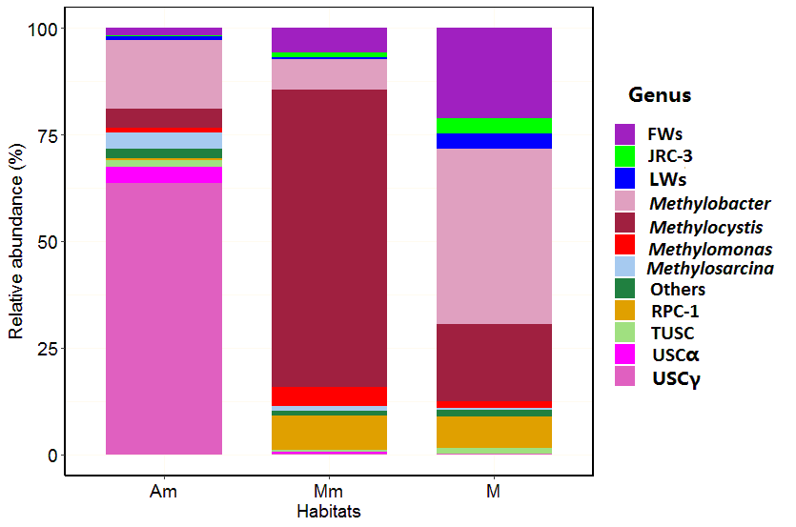

Fig 2

Fig 3
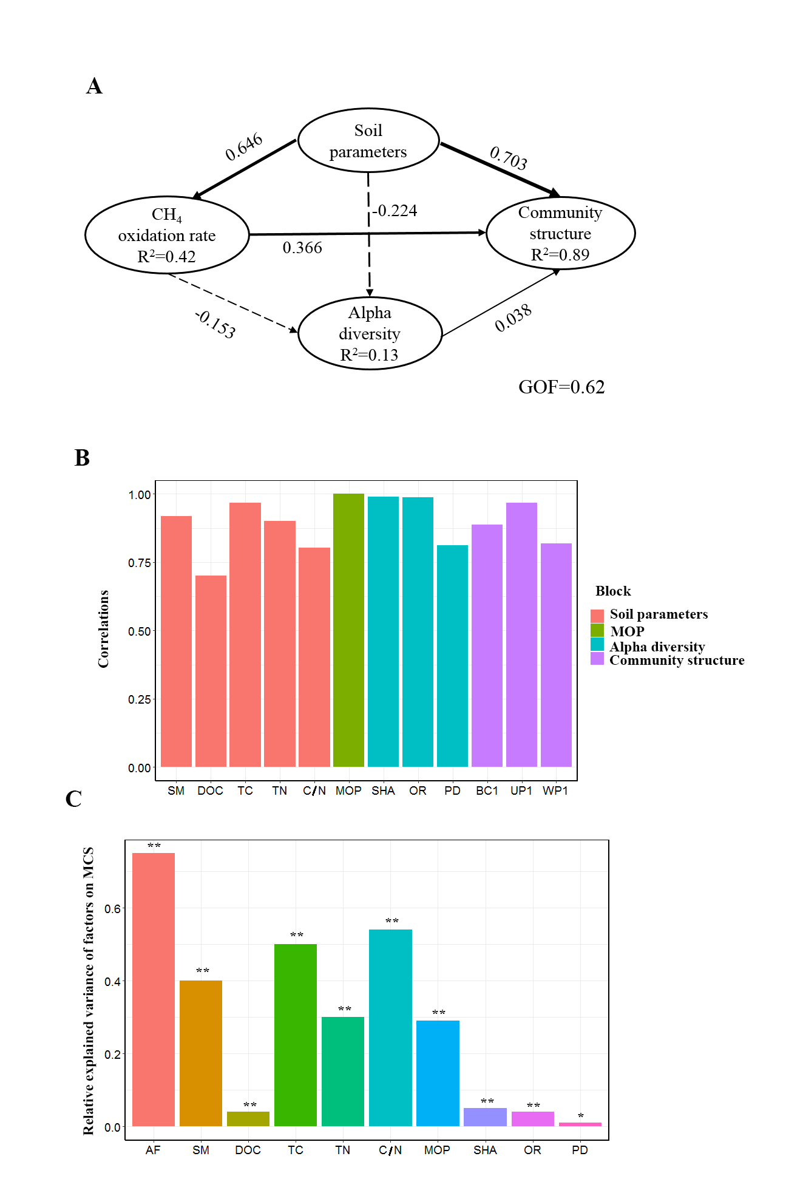
Fig 4
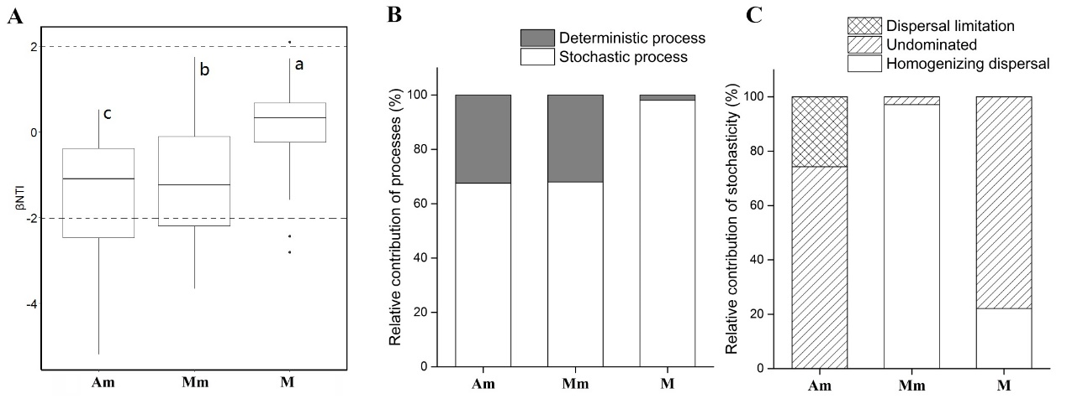
Fig 5
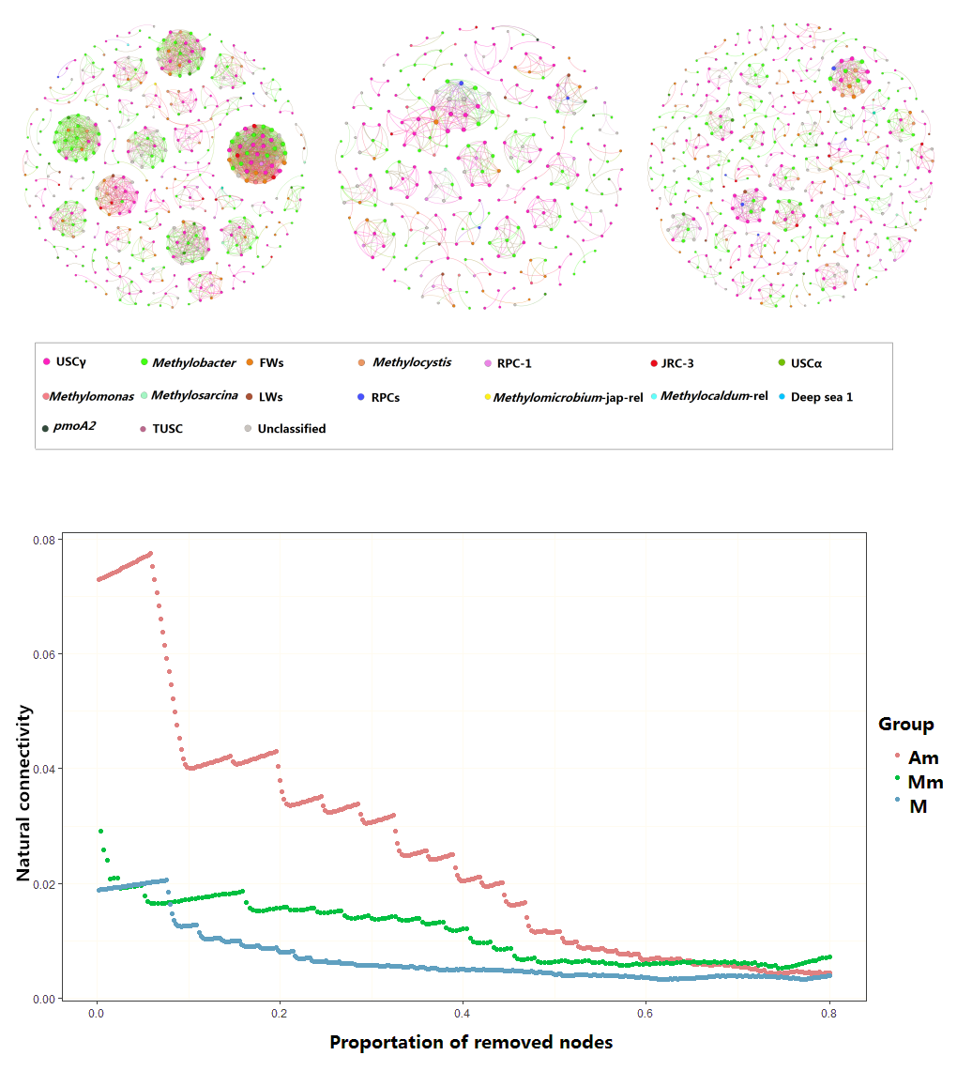

Fig 6
