Harnessing behavioural insights to encourage consumer engagement in the British energy market: Results from a field trial

Roger Tyers
University of Southampton

Martin Sweeney
Behavioural Insights Team

Beth Moon
Ofgem

Abstract
Many British energy customers pay more than they need to for their household energy, and a lack of engagement is now a recognised policy challenge. Around 60% of British energy customers are on a Standard Variable Tariff (SVT), a ‘default’ tariff which costs on average about £300 more per year than the cheapest market alternative. This paper presents results of a large-scale randomised controlled trial (RCT) which aimed to increase consumer engagement in the energy market. We tested the effect of sending a “Cheaper Market Offers Letter” (CMOL) to nearly 140,000 disengaged energy customers drawn from two energy suppliers. The CMOL was highly personalised, highlighting the amount a customer could save by switching and featuring details of the three cheapest tariffs on the market available to them. We measured the effect of the letters on switching (our primary outcome) and quality of switch (our secondary outcome, measured by estimated savings). After one month, we find that CMOLs significantly increase switching – from 1.0% to 3.4% in the most effective arm – and increase savings amongst those who switch by an estimated £50 per year. We conclude by discussing the results and implications for future research.

Introduction
Behavioural insights – the field of applied social psychology and behavioural economics often known by the shorthand of ‘nudge’ – are being applied to an ever-widening range of policy problems by policy-makers around the world (Lourenço et al, 2016b; Whitehead et al, 2014). Arguably, nowhere is this trend more pronounced than in the United Kingdom, where two recent developments can be seen. Firstly, the role of the pioneering Behavioural Insights Team (BIT) has evolved since it become a semi-private enterprise in 2014, so that beyond its original mandate to support UK policy-makers, it now increasingly pursues work in the third sector and for foreign governments as well. Secondly, government departments have increasingly brought behavioural insight (BI) expertise ‘in-house’, with governmental departments, public agencies and non-departmental bodies setting up their own BI teams or units (John, 2018; Lourenço, et al 2016a).

Ofgem – the Office for Gas and Electricity Markets – is no exception to this second development. Ofgem is the independent regulator of the energy industry in Great Britain, and its primary function is to protect the interests of energy consumers (Ofgem, 2018, 5). In 2014, Ofgem referred the energy market to the UK Competition and Markets Authority (CMA) to investigate – among other issues – low consumer engagement, and how that may contribute to weak competitive pressure in the market. The CMA’s subsequent report, published in 2016, argued that many energy customers were disengaged and were paying more than necessary for their energy. It recommended that Ofgem set up a programme of testing interventions to improve consumer engagement, using randomised controlled trials wherever appropriate (CMA, 2016, 54). In response, Ofgem set up a Behavioural Insights Unit to provide both practical support – in helping to design, run, and analyse randomised controlled trials (RCTs) – and theoretical expertise – in the application of behavioural insights to Ofgem’s specific policy challenges.

In 2017, Ofgem’s Behavioural Insights Unit worked with the Ofgem ‘Consumer Engagement’ policy team and the Behavioural Insights Team (BIT) to undertake Ofgem’s first large-scale RCT, which tested a letter-based intervention to encourage customers to switch to cheaper energy tariffs. Over a one month period, the ‘cheaper market offer letter’ (CMOL) increased tariff/supplier switching from a baseline of 1% in the control group to 3.4% in the most effective trial arm. Those who switched having received the letter saved considerably more money than those who switched in the control group. This paper describes the rationale, implementation and results from Ofgem’s first large-scale RCT, and the implications for future policy and research.

Context: Existing literature and rationale
This paper contributes to literature on the use of information provision to influence behaviour. While providing information to citizens has always been a central function of policy-making, identifying the best means of doing so has increasingly been systematised amid the rise of behavioural public policy and the use of randomised controlled trials (John, 2018). Understanding how to best provide information is especially important in contexts where changing the default, usually considered a ‘stronger’ intervention (Tyers, 2018), is not an available option. Previous trials have tested the effectiveness of providing information via different methods, to promote different outcomes. These include using posters to promote exercise (Slaunwhite et al., 2009); labelling products to encourage healthy eating (Mathios, 2000; Swartz et al., 2011) or energy-efficient purchases (Kallbekken et al., 2013; Newell & Siikamäki, 2014); and sending text messages, emails (Cadena & Schoar, 2011; Haynes et al., 2012) or letters (Bhargava & Manoli, 2015; Blumenthal et al., 2001; Fellner et al., 2011; Hasseldine et al., 2007) to increase tax compliance or reduce energy consumption (Allcott, 2011). A range of trials have tested the integration of social norms in providing information (see Cialdini, 2001; Johannessen & Glider, 2003; John et al., 2014), or tested whether certain messengers are more effective in changing behaviour (Cialdini, 2007; Durantini et al., 2016). Such trials have targeted relatively simple and/or ‘obvious’ behavioural outcomes – improving health, saving money, or complying with the law – whereas other contexts, particularly those concerning consumers’ purchases from private companies, may well be more complex.

Weil et al (2006) describe how policy-makers are increasingly mandating private firms to disclose information to consumers to reduce information asymmetry and facilitate better decision-making, with varying degrees of success. Meanwhile, the growth of the Internet has also facilitated online search and price comparison tools which have become increasingly popular with consumers (Bodur et al, 2016; CMA 2017). Yet the availability of such information does not always ensure consumers actually access or use it, and there may even be a risk of information ‘overload’ which works against consumers’ best interests (see Iyengar & Lepper, 2000; Lunn, 2013). It is also worth noting that UK Internet access and use remains far from universal, meaning some vulnerable groups lack access to information which might benefit them as consumers (Office for National Statistics, 2018a).

Some studies have attempted to provide information to consumers in a manner which is more accessible, and two are of particular relevance to this paper. Kling et al (2012) found that sending US Medicare patients a letter with personalised cost information on prescription drug insurance plans (which was already freely available online) led to significant increase in insurance plan switching, and also improved financial outcomes for those who switched. The UK Financial Conduct Authority similarly found that sending a letter to bank account holders with details of better products also increased switching (Adams et al, 2016). This paper adds to this body of literature, using the relatively novel method of using information available via online comparison tools, yet presenting it in an offline format via a letter. To the best knowledge of the authors, it is the first study to do so in the context of switching in the retail energy market.

Many energy customers in Great Britain are paying more than they need to for their energy. In a market of around 60 different energy suppliers, significant savings are available to those customers who actively shop around each year for attractively priced one- or two- year fixed tariffs, whilst customers who do nothing will end up on default Standard Variable Tariffs (SVTs). Around 60% of British energy customers are on SVTs. These tariffs have the benefit of flexibility – customers can switch away from them without exit fees – but are ‘variable’ in that prices can rise (or in theory, fall) at any time, and are almost always more expensive. The price differential between the average SVT and the cheapest available deal on the market has regularly been around £300 a year (Ofgem, 2017b, 6). The CMA has estimated that in total this adds up to £1.4 billion per year of customer detriment (CMA, 2016). While this figure has been disputed by suppliers and some scholars (see Littlechild, 2017), it remains clear that most customers do not take advantage of the significant potential savings available to them. Vulnerable low-income groups are more likely to be on SVTs, despite being less able to afford them (Ofgem, 2017c), a pattern which has been observed in other countries too (Hortaçsu et al, 2017). Behavioural science can help us identify both barriers to engagement – such as status quo bias, a tendency to follow defaults, and information deficits – and approaches to overcoming such barriers such as personalisation, the mobilisation of appropriate messengers, and the reduction of choice overload.

A traditional economics perspective might suggest that customers choose energy deals that maximise their utility or financial well-being. However, the evidence outlined above suggests that for many people this is not the case. Behavioural economics and social psychology highlight the power of defaults, inertia and status quo bias, to account for why customers do not always act in their best (financial) interests. In the context of energy markets, these behavioural biases may lead customers to stay on SVTs despite the existence of cheaper deals. We know that people often stay with a default option rather than making an active choice (Kahneman et al, 1991; Samuelson & Zeckhauser, 1988), and that default options can appear to be tacit endorsements or implied recommendations (Mckenzie et al, 2006). This is particularly true when default tariffs for energy in Britain are currently framed by suppliers as the neutral-sounding ‘standard’.

Other consumer services, such as insurance, often have strict fixed-term contracts. When these terms expire, consumers must make a choice about purchasing a new product, and there is sometimes a legal imperative to do so (e.g. for car insurance). For British energy customers on a fixed term tariff, suppliers are obliged to notify customers that their tariff is expiring and encourage them to consider their options. However, a customer’s energy supply will not be stopped should they do nothing: instead, customers simply roll-over onto their supplier’s SVT or other default tariff. In this sense, inertia, in the form of continuity of service, works against some energy customers’ longer-term financial interests.

For customers who have never been on a fixed tariff, the opportunities to encourage engagement are even more limited. As Waddams-Price describes it, “unlike the regular grocery shop, because there is a default supplier, there is a not a point in time in the day, the week, the month or even the year where, as a routine, people are required to pay attention to the task of choosing their energy supplier” (2013, 75). Consumers in energy, as in other markets where customers can easily become passive – such as banking (see FCA, 2015) – will therefore often maintain a default setting, even where there are benefits to switching.

Traditional economics might also assume that people have access to relevant information to enable them to make well-informed beneficial choices. However, unless customers actively engage in the energy market, is it easy for them to be unaware of the potential savings they can achieve by switching, and therefore ill-prepared to make a financially beneficial choice. Nearly half (49%) of customers who have not switched for four years assume they are on the best deal, and this may simply be because they have not seen information to the contrary (Williams et al 2017). One simple function of the CMOL was to fill in this ‘information deficit’ by simply making customers aware of their options.

Making the act of switching energy tariff seem important and salient is evidently a challenge, as the (non-financial) consequences of remaining on an SVT are very limited. Also, suppliers do not ‘visibly’ differ in their offers to customers – the gas and electricity supplied will be the same, only price, customer service and wholesale fuel blend will differ. Although domestic energy underpins many activities which are fundamental to modern lifestyles (cooking, washing, heating, home entertainment, etc.), the purchase of the energy itself is not a topic many people find remarkable (Williams et al, 2017). Studies show that personalising messages and interventions increases recipient attention and makes the message seem more relevant to them (Service et al., 2014). The letter intervention in this trial was therefore personalised: it referred to customers by name and tailored the featured “cheaper market offers” based on the customer’s household energy consumption over the previous year, their payment method (e.g. payment on receipt of a bill or direct debit), and the way they managed their account (e.g. online or with paper bills).

Customers can be overwhelmed by too much choice, both in the energy market (Williams et al 2017), as in other decisional contexts (Iyengar & Lepper, 2000). Price comparison websites can generate a multitude of offers for customers, with each offer differing along a number of dimensions (e.g. length of term, exit fees, account management, fuel blend, etc.) To counteract this, the letter we tested displayed only three cheaper offers and restricted the amount of additional information presented.. Reducing the choice of offers even further was considered, but it was decided, following pre-trial pilot testing, that providing three offers gave the customer an appropriate level of choice, particularly as the cheaper offers were often from less well-known brands.

Behavioural field trials have often shown that people respond more positively if a message is delivered by an appropriate messenger (Dolan et al, 2012). The challenge is usually identifying who is an appropriate messenger for a certain group of people or a certain preferred outcome behaviour. As this was Ofgem’s first trial of its kind, it was unclear if the more effective messenger would be Ofgem or the customer’s existing supplier. As the intervention involved a letter telling customers about cheaper options on the market, Ofgem – as an independent government regulator – might be considered the more appropriate messenger, rather than the incumbent supplier who has a vested interest in a customer not switching away. On the other hand, it is not clear how valuable or recognisable Ofgem’s brand is, nor is it clear whether customers understand the organisation's role as a regulator. The letter might be more effective if it came from a customer’s own supplier, with whom the customer already has a contractual relationship. To resolve this, the messenger was tested in this trial. Customers received either a letter branded from their supplier, a letter branded from Ofgem, or no letter at all (the control group). The content of the letters was otherwise identical.

In addition to applying these behavioural insights to our intervention, specific barriers to engagement observed in the energy sector were also addressed in the design of the letter. Previous consumer research has found that many people wrongly assume that their energy supply may be cut off if they switch, or that they consider switching to be a hassle (Williams et al., 2017). Our letter firstly emphasised that switching is “easy and safe” and that a customer’s supply “will not be cut off” during a switch. Secondly, the letter gave customers specific instructions on how to switch or conduct their own market search (see Intervention and Appendix 1).

Intervention
The intervention tested in this trial is a Cheaper Market Offers Letter, or ‘CMOL’ (see Appendix 1 for an example). The CMOL was a letter addressed to the named account holder that informed them how much they could save by switching to a new energy deal. It presented customers with three cheaper tariffs currently available to them and listed how much they would save under each tariff. The potential savings and featured tariffs presented in the letter were determined by a price comparison company commissioned by the trial supplier.

The information presented in each CMOL was highly personalised: savings estimates were generated and tariffs were selected using (a) customers’ household energy consumption over the previous year; (b) their payment method (i.e. direct debit or payment on receipt of bill); and (c) their method of account management (i.e. if they receive their bills and annual statements by email or letter). For each tariff, the contact phone number and website was given for the supplier. The letter informed customers that they could switch by calling the new supplier or going on their website. Alternatively, customers were told that they could use a price comparison website to conduct their own market search. To enable them to get an accurate quote on such a website, customers were provided with the details they would need – their annual gas and electricity consumption in kilowatt hours, and current tariff type – on the reverse of the letter.

The tariffs listed on the letters belonged to competitors. Tariffs from the suppliers participating in the trial were not featured on the letters, in order to prevent ‘gaming’ whereby the suppliers could introduce unusually cheap tariffs in order to retain or attract customers. Regardless of whether or not they received a CMOL, trial customers were still able to contact their existing supplier, enquire about cheaper tariffs, and (if they wished to) initiate an internal switch to a cheaper tariff.

Method
Ofgem collaborated with two energy suppliers to conduct this trial. These suppliers remain anonymous and are referred to as ‘Supplier A’ and ‘Supplier B’ in this paper.

In order to secure the suppliers’ co-operation, Ofgem used its licence powers - specifically standard licence condition 32A - for the first time. This licence condition was a product of the CMA’s energy market investigation, and enables Ofgem to compel energy suppliers to undertake randomised controlled trials to test interventions to improve consumer engagement (Ofgem, 2017a). It is highly unlikely that any suppliers would have participated without having to do so under this licence power, a power which is relatively unique among UK regulators.

Eligibility
Customers eligible for our trial were domestic (residential) dual fuel customers (i.e. they receive both gas and electricity from their supplier) who had been on an SVT for at least one year. Ofgem specified a range of additional eligibility criteria customers needed to meet to be eligible for our trial (see Appendix 3). For example, customers who usually receive communications from their supplier in braille or in Welsh (rather than English) were excluded to make the trial simpler to deliver and ensure that interventions were consistent. Our results might not be generalizable to certain customer categories who may have behaved differently to our eligible trial participants (e.g. customers who have an outstanding debt to their supplier).

Power calculations
Ofgem was particularly interested in whether the CMOLs were effective for customers who had been on SVTs for three or more years – this is a group the organisation considers to be particularly disengaged. Using historical data on switching rates provided by the suppliers, we conducted power calculations to calculate the sample size needed in order to detect increases of switching of 0.5 percentage points for each tenure group in each supplier (1-3 years on an SVT, 3+ years on an SVT). For the sake of fairness, we requested the same number of customers from each supplier – see Appendix 4 for more details on power calculations.

Sampling
While Suppliers A and B were compelled to participate in the trial, they were not compelled to share data on their entire customer base, due to commercial sensitivities. Therefore, we relied on suppliers to randomly sample eligible customers to participate in the trial. We provided suppliers with detailed instructions on how to sample customers, including the number of customers to sample as generated by our power calculations. We conducted checks to ensure that each supplier’s chosen sample was representative of their eligible population in terms of consumption, length of time on an SVT, and geographical distribution. (We cannot report these results at the supplier level due to commercial sensitivities).

Randomisation
Our trial’s unit of randomisation was the customer account, which proxies for a customer/household. Customers were randomly assigned to receive either no letter, a letter branded by Ofgem, or a letter branded by their existing supplier. Each supplier’s randomisation was stratified by tenure (1-3 years vs. 3+ years on an SVT).

Contamination of participants, while theoretically possible in our sample, is quite unlikely. The only way that a customer could be contaminated is if they are energy account-holders for multiple residential properties, both of which are sampled. This is an unlikely scenario: the vast majority of people have only one residence, and those with multiple residences would be unlikely to have multiple residences sampled.

We provided suppliers with guidance on how to conduct the randomisation and confirmed balance between trial arms using aggregated characteristics provided by the suppliers. (Once we received access to customer-level data, for the purposes of analysis, we checked and confirmed post-attrition balance – details of these checks are provided in the “Attrition and Balance checks” section below).

Data collection
Suppliers A and B provided us with relevant customer data for the purposes of our analysis. As part of their routine operations, suppliers collect data on whether their customers have requested to switch suppliers/tariffs – this allows us to measure switching within our sample. We also requested and received additional data on customer characteristics, which allows us to check balance between our trial arms, perform robustness checks, and conduct subgroup analysis.

While data from Suppliers A and B allowed us to observe whether a customer switches and calculate savings for customers that switch internally, the data did not allow us to track the new tariff details for customers that switch externally. Ofgem therefore used its regulatory powers to collect data from the 19 suppliers who gained the most customers, which allows us to observe new tariff details and estimate potential savings for 90% of external switches during our trial. (Collecting data for more than 90% would not have been a proportionate use of Ofgem and supplier resources).

Finally, following the trial, a research agency (DJS) conducted qualitative interviews with a small subset of trial customers, following a script and a stratified sampling strategy. Details of the sample can be found in Appendix 6.

Research questions
We designed the trial to be able to answer the following research questions:
1. Does a single standalone letter which sets out cheaper market offers increase switching rates among SVT customers?
2. Does the messenger (Ofgem or Supplier) have an impact on switching rates?
3. Does the letter increase savings from switching?
4. Which types of customer were more likely to switch in response to the CMOL?
5. How did customers react to the letter and the messenger?

Our primary outcome measure is whether a customer switched tariffs within 30 days. This includes switches that were in the process of being completed, and includes both external switches (i.e. switching suppliers) and internal switches (i.e. staying with their supplier but changing tariffs).

Timeline
The suppliers operated under similar but slightly different schedules, as outlined in Appendix 5. Suppliers drew their samples in late May 2017. Tariff offers were generated by a third party price comparison company in late May/early June 2017, and CMOLs were mailed by suppliers in mid-June/early July 2017.

Empirical Strategy
All analysis presented in this paper uses Ordinary Least Squares (OLS) regressions to measure the effects of the letters on outcomes. We conduct robustness checks on our binary outcome measures using logistic regression models, and find that our results and conclusions are robust to these alternative specifications.

To measure the effect of the letters on switching (our primary outcome), we use the following model:
$${Switched}_{i}= α+ β_{1} {Ofgem letter}_{i}+β_{2} {Supplier letter}_{i}+ φ_{i}Γ+ ε_{i}$$

where${Switched}_{i}$ is a binary variable that captures whether customer i requested a switch during the trial period;$α$ is the constant;${Ofgem letter}_{i}$ is a binary variable that captures whether the customer received the Ofgem treatment letter;${Supplier letter}_{i}$is a binary variable that captures whether the customer received the Supplier treatment letter; and $Γ$ is a vector of covariates composed of (1) whether the customer has been on the SVT for 3+ years (binary variable); (2) supplier (binary variable); and (3) potential savings (continuous variable, representing the best offer from the CMOL).

When we conduct subgroup analysis, our regression model takes the following form (using account management type as a subgroup example):
$${Switched}_{i}= α+ β_{1} {Ofgem letter x Offline}_{i}+β_{2} {Supplier letter x Offline}_{i}+$$
$$β_{3} {Control x Online}_{i}+β_{4} {Ofgem letter x Online}_{i}+β_{5} {Supplier letter x Online}_{i}+$$
$$φ_{i}Γ+ ε_{i}$$

With one notable exception, all analysis presented is intent-to-treat (ITT) and uses robust (Huber White) standard errors. Our analysis of the effect of the CMOLs on savings is restricted to customers that switch (see Quality of Switch section for more details).

Attrition and Balance checks
A total of 148,404 customers were originally selected to take part in our trial. About three to five weeks elapsed from the time customers were selected to the time that letters were mailed, and during this time, the status of some customers changed such that they no longer met the trial eligibility criteria (e.g. they had a smart meter installed, an issue that particularly affected Supplier B customers – see Annex 3 for a full list of eligibility criteria). In some cases, customers switched supplier, moved house, or died.

We exclude these types of customers from our analysis, which leaves us with a total sample size of 137,876. After excluding these customers, we checked balance across our trial arms for each supplier to verify that our trial groups are comparable across key observable characteristics. Table 1 presents the means for each trial arm and supplier, as well as the p-values from F-tests of joint equality. We would expect about 5% of comparisons to be statistically significant at p < 0.05 due to random chance, and find only one characteristic with a joint difference between arms that is statistically significant.
Table 1: Balance checks
 | Control (mean) | Ofgem (mean) | Supplier (mean) | p-value from F test
Energy tariff and consumption
Annual gas consumption (kwh) | 12,836.86 | 12,871.92 | 12,868.40 | 0.740
Annual electricity consumption (kwh) | 3,184.46 | 3,187.95 | 3,188.29 | 0.947
Length of time on a Gas SVT (months) | 53.940 | 54.037 | 53.949 | 0.913
Length of time on an electricity SVT (months) | 51.952 | 52.096 | 52.027 | 0.842
Gas standing charge (p/day) | 22.118 | 22.107 | 22.099 | 0.853
Gas unit rate (p/kwh) | 3.986 | 3.985 | 3.985 | 0.447
Electric standing charge (p/day) | 22.117 | 22.107 | 22.097 | 0.848
Electric unit rate (p/kwh) | 14.793 | 14.787 | 14.788 | 0.879
CMOL characteristics
Estimated annual energy spending (from CMOL, in £) | 1,130.54 | 1,132.31 | 1,132.30 | 0.819
First CMOL deal: saving listed on letter (£) | 248.19 | 248.99 | 249.12 | 0.491
Second CMOL deal: saving listed on letter (£) | 228.36 | 229.20 | 229.32 | 0.439
Third CMOL deal: saving listed on letter (£) | 214.12 | 214.91 | 215.11 | 0.422
First CMOL deal estimated annual energy spending (£) | 882.34 | 883.32 | 883.19 | 0.916
Second CMOL deal estimated annual energy spending (£) | 902.17 | 903.12 | 902.98 | 0.923
Third CMOL deal estimated annual energy spending (£) | 916.42 | 917.40 | 917.19 | 0.922
Received at least one offer from a Big 6 provider (1 = yes) | 0.321 | 0.322 | 0.322 | 0.996
Customer characteristics
Manages account online (1 = yes) | 0.448 | 0.447 | 0.450 | 0.521
Logged in to online account in the previous year (1 = yes; all customers) | 0.375 | 0.374 | 0.379 | 0.377
Pays by direct debit (1 = yes) | 0.744 | 0.748 | 0.748 | 0.244
Paperless billing (1 = yes) | 0.419 | 0.419 | 0.422 | 0.606
Submitted a gas meter reading in the previous year (1 = yes) | 0.634 | 0.638 | 0.640 | 0.177
Submitted an electric meter reading in the previous year (1 = yes) | 0.654 | 0.658 | 0.657 | 0.445
Ever had a fixed product with supplier (1 = yes) | 0.303 | 0.307 | 0.305 | 0.403
Number of SVT engagement letters received recently (1 = yes) | 0.484 | 0.485 | 0.487 | 0.761
Region
East Midlands | 0.073 | 0.073 | 0.073 | 0.977
Eastern | 0.118 | 0.121 | 0.118 | 0.289
London | 0.080 | 0.079 | 0.078 | 0.529
Manweb | 0.036 | 0.035 | 0.036 | 0.478
Midlands | 0.071 | 0.072 | 0.073 | 0.628
North Scotland | 0.034 | 0.033 | 0.033 | 0.692
North Western | 0.063 | 0.059 | 0.059 | 0.019
Northern | 0.040 | 0.042 | 0.042 | 0.456
SWEB | 0.049 | 0.048 | 0.049 | 0.859
South Eastern | 0.080 | 0.081 | 0.081 | 0.590
South Scotland | 0.074 | 0.074 | 0.074 | 0.876
South Wales | 0.063 | 0.064 | 0.064 | 0.609
Southern | 0.158 | 0.156 | 0.158 | 0.644
Yorkshire | 0.062 | 0.064 | 0.062 | 0.223
N | 45,984 | 45,954 | 45,938

Since this trial took place throughout the entirety of England, Scotland, and Wales, we consider the possibility of a violation of the Stable Unit Treatment Value Assumption (SUTVA) to be extremely low (Rubin, 1974). In other words, it is highly unlikely that trial participants would become aware of and/or influenced by another participant’s receipt of a CMOL (e.g. one trial participant who received a letter showing the letter to a neighbour who was also a trial participant).

Descriptive Statistics

Table 2 presents descriptive statistics for the sample of customers in the trial. We can see that potential savings for Supplier A customers were about £90 higher than for Supplier B customers, as Supplier A’s standard variable tariff was more expensive at the time of the trial.
Table 2: Descriptive statistics of trial sample
 | 1-3 years SVT customers | 3+ years SVT customers
Median tenure | 2 years, 3 months | 6 years, 3 months
Manage their account online | 51% | 38%
Have ever had a fixed tariff | 37.5% | 23.6%
Have paperless billing | 48.4% | 35.6%
Potential saving on CMOL (Supplier A) | Mean: £284  Range: £98 - £1,383 | Mean: £301  Range: £104 - £1,377
Potential saving on CMOL (Supplier B) | Mean: £202  Range £23 - £1,485 | Mean: £204  Range: £24 - £1,538

External validity
In order to gauge whether our sample of customers resembles the broader national energy market, Table 3 compares our sample’s characteristics to publicly available, national-level energy data. These comparisons must come with some caveats. While national data includes the types of customers that were excluded from our trial, it also includes those on fixed tariffs who would not be targeted by our intervention. Some measures also include Northern Ireland, which is not part of the British energy market regulated by Ofgem.

Notably, customers in our sample consume about 17% less electricity than the average UK household (though when households with electric heating are excluded, as they were from our trial, this figure is closer to 9%). Customers in our sample consume 3.7% less gas than the average British household.

Despite these consumption differences, annual energy spending of our customers is £20 (1.8%) greater than the national average. This comparison admittedly may not be an ideal one to make. First, recall that the national average figures include customers on fixed tariffs, who appear to consume more energy (but pay less on a per kWh basis due to their cheaper tariffs). Second, it is worth noting that the British energy market saw significant price increases in the latter half of 2017, which would increase the actual UK spending figures while leaving our sample’s estimated spending (estimated in mid-2017) unchanged.

A better comparison of energy spending would be between our sample and all British customers on SVTs. To our knowledge, nationally representative data on actual energy spending for SVT customers is not publicly available, but Ofgem’s 2017 State of the Market report estimated the average annual energy spending for customers with the 10 largest British suppliers in July-September 2017. These companies had a 90% market share for domestic energy at that time, and this period coincides well with our trial period. Across the 10 largest suppliers, the average estimated annual energy spending was £1,126, which is only £6 less than our sample’s annual spending. These figures suggest that our sample’s annual energy spending is in line with the national average.

Finally, the proportion of customers that pay by direct debit is only about 1 percentage point higher for our sample than the national average when pre-payment meters are excluded. In short, while there are some moderate differences between our customers and the average UK customers in terms of energy consumption, we believe that our sample is broadly representative of the UK market.
Table 3: Comparing trial sample to UK population
Characteristic | Our sample | UK population | Difference and notes
Annual energy spending (2017) | £1,132 (estimated) | £1,112 (actual)  £1,126 (estimated, SVT customers and 10 largest suppliers only) | Actual: 1.8% higher in our sample  Estimated: 0.5% higher in our sample  (Department for Business Energy and Industrial Strategy (BEIS), 2018; Ofgem, 2017c)
Gas consumption (2016) | 12,859 kWh | 13,351 kWh | 3.7% lower in our sample  (BEIS, 2017a)
Electricity consumption (2016) | 3,187 kWh | 3,830 kWh  (3,509 KWh for standard electricity) | 16.8% lower in our sample (9.2% lower for standard electricity)  (BEIS, 2017a)
Pay by direct debit | 74.5% | 64%  (73.6% when excluding pre-payment meters) | 10.5 percentage points higher in our sample.  (0.9 percentage points higher in our sample when excluding pre-payment meters)  (BEIS, 2017b)

Results

Switching Rates and the messenger

In response to our primary research question, we find that the CMOL significantly increased switching rates: customers who received a CMOL were three times more likely to switch tariffs than those who received no letter.

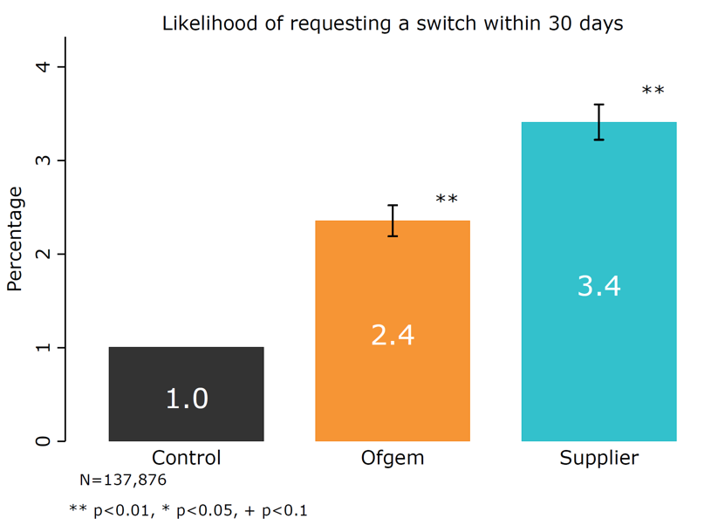
Figure 1: Switching rates over 30 days by trial arm
Table 4. Switched (primary analysis)

 | (1) | (2)
 | Switched within 30 days | Switched within 30 days
Ofgem | 0.014** | 0.014**
 | [0.001] | [0.001]
Supplier | 0.024** | 0.024**
 | [0.001] | [0.001]
On SVT for 3+ years |  | -0.008**
 |  | [0.001]
Supplier B customer |  | -0.007**
 |  | [0.001]
Potential savings (Best CMOL offer) |  | 0.000**
 |  | [0.000]
Constant | 0.010** | 0.004**
 | [0.000] | [0.001]
Control mean | 0.010 | 0.010
N | 137,876 | 137,876
Robust standard errors in parentheses. + p < 0.10, * p < 0.05, ** p < 0.01.

Regarding our second research question, whether the messenger (Ofgem or Supplier) has an impact on switching rates, Figure 1 demonstrates that the messenger clearly does matter. While the Ofgem-branded letter increased switching by 1.4 percentage points (p=1.491e-57), the Supplier-branded increased switching significantly more, by 2.4 percentage points (p=9.675e-22 compared to Ofgem).

In most cases, customers who switched chose a new supplier (i.e. switched externally) rather than a new tariff with their existing supplier (i.e. switched internally), as shown in Figure 2. We know from market conditions at the time that customers could save more money if they switched externally, and it appears that customers who received a CMOL were not only more likely to switch, but also more likely to switch externally. It is worth remembering that Suppliers A and B were not able to feature one of their own tariffs on the letter.
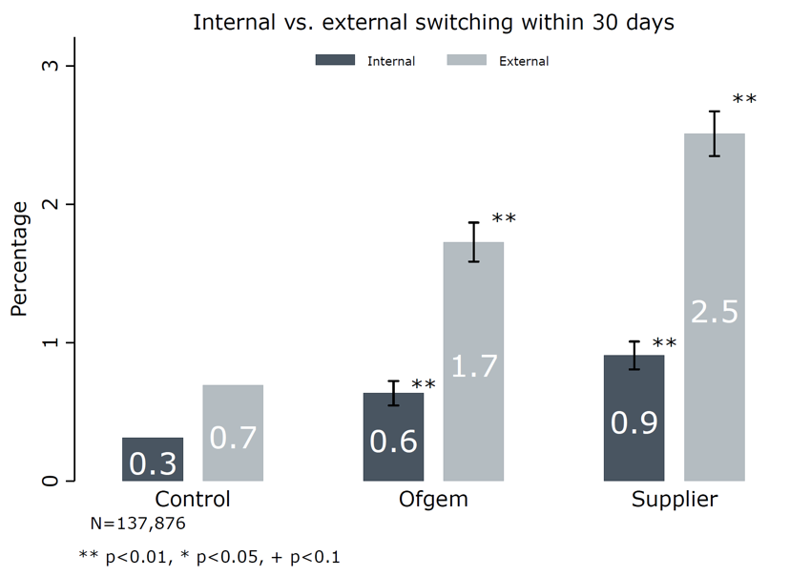
Figure 2: Internal/external switching over 30 days by trial arm
Table 5. Type of switch

 | (1) | (2) | (3) | (4)
 | Switched externally  (to new supplier) | Switched externally  (to new supplier) | Switched internally  (new tariff with same supplier) | Switched internally  (new tariff with same supplier)
Ofgem | 0.010** | 0.010** | 0.003** | 0.003**
 | [0.001] | [0.001] | [0.000] | [0.000]
Supplier | 0.018** | 0.018** | 0.006** | 0.006**
 | [0.001] | [0.001] | [0.001] | [0.001]
On SVT for 3+ years |  | -0.005** |  | -0.003**
 |  | [0.001] |  | [0.000]
Supplier B customer |  | -0.002* |  | -0.006**
 |  | [0.001] |  | [0.000]
Potential savings (Best CMOL offer) |  | 0.000** |  | 0.000**
 |  | [0.000] |  | [0.000]
Constant | 0.007** | 0.001 | 0.003** | 0.003**
 | [0.000] | [0.001] | [0.000] | [0.001]
Control mean | 0.007 | 0.007 | 0.003 | 0.003
N | 137,876 | 137,876 | 137,876 | 137,876
Robust standard errors in parentheses. + p < 0.10, * p < 0.05, ** p < 0.01.

Table 6 breaks down the effect of the letters by supplier and suggests that the letters were particularly effective for Supplier A. Qualitative interviews, as discussed below, indicated that the amount of potential savings was a key driver to switching. Our analysis confirms that savings is indeed important – controlling for potential savings attenuates the differences in switching between suppliers by 27%. But this result also speaks to the existence of other factors which significantly influence switching, e.g. unobservable customer characteristics such as brand loyalty.

Table 6. Switched, by supplier

 | (1) | (2)
 | Switched within 30 days | Switched within 30 days
Ofgem, Supplier A | 0.023** | 0.023**
 | [0.001] | [0.001]
Supplier, Supplier A | 0.036** | 0.036**
 | [0.001] | [0.001]
Control, Supplier B | 0.002* | 0.007**
 | [0.001] | [0.001]
Ofgem, Supplier B | 0.006** | 0.011**
 | [0.001] | [0.001]
Supplier, Supplier B | 0.014** | 0.019**
 | [0.001] | [0.001]
On SVT for 3+ years |  | -0.008**
 |  | [0.001]
Potential savings (Best CMOL offer) |  | 0.000**
 |  | [0.000]
Constant | 0.009** | -0.002⁺
 | [0.001] | [0.001]
Mean of omitted group | 0.009 | 0.009
N | 137,876 | 137,876
Robust standard errors in parentheses. + p < 0.10, * p < 0.05, ** p < 0.01.

Quality of Switch

When we measure the effect of CMOLs on savings from switching, we focus only on customers that switched during our trial period (Control N = 361, Ofgem N = 913, Supplier N = 1,335). This analysis therefore measures whether CMOLs are effective in helping customers that switch make better switches (as measured by savings). We recognise that conducting this analysis raises concerns about selection, as customers who switched after receiving a CMOL may be different from customers who switched in the Control group on a variety of measures. One important (and measurable) way in which these customers differ is in terms of potential savings – unsurprisingly, we can confirm that customers that switched after receiving a CMOL have significantly higher potential savings. We therefore control for potential savings in this analysis.

Table 7. Savings from a switch

 | (1)
 | Estimated annual savings (£)
Ofgem | 47.724**
 | [8.021]
Supplier | 51.555**
 | [7.730]
Potential savings (Best CMOL offer) | 0.974**
 | [0.024]
Constant | -86.981**
 | [8.761]
Adjusted R² | 0.601
Control mean | 163.51
N | 2,609
Robust standard errors in parentheses. + p < 0.10, * p < 0.05, ** p < 0.01.

Our analysis suggests that CMOLs increase savings from a switch by about £50 per year, a substantial and statistically significant amount (Ofgem arm: p=3.044e-09; Supplier arm: p=3.128e-11). One possible explanation for this difference in savings may be that the letter increased customers’ expectations about how much they could save. In other financial contexts, price ‘anchors’ have been shown to influence decisions (Adaval & Wyer, 2011) and the CMOL may have provided a numerical anchor which served as a reference point and influenced customers’ subsequent judgments.

Our results provide strong evidence that consumers opted to switch to suppliers featured on their letters. Of customers that switched externally, 43% of customers in the Ofgem arm and 48% of customers in the Supplier arm chose a tariff with the supplier that was listed on their CMOL. By contrast, only 10% of external switchers in the Control group switched a tariff with a supplier that would have appeared on their CMOL had they received one.

Figure 4 presents the ‘route to switch’ of customers who switched externally during our trial. (It does not include data on internal switches, as this data was not available). As a result of the CMOL, customers were more likely to switch via a supplier directly. Customers in the Control group, meanwhile, were more likely to switch via a price comparison website (PCW) or as a response to marketing. As discussed in the introduction, many customers are unaware of how much they can save by switching and may possibly switch sub-optimally if they do so as a result of outbound telesales or marketing campaigns.

Tariffs eligible for the CMOL were often with small suppliers, who would not have appeared on some PCWs unless customers looked at the ‘wide view’ of offers – the default view is usually restricted to suppliers with whom the PCW has a contractual relationship (i.e. the PCW receives a commission per switch). One possible explanation for the difference in ‘route to switch’ here is that customers who received a CMOL and were given a price anchor were more likely to look at this wide view to find deals comparable in price as the ones they had seen on the letter. Lacking this anchor, customers in the Control group may not have searched as widely and as a result may have accepted a tariff offering lower savings. This hypothesis would require further testing.
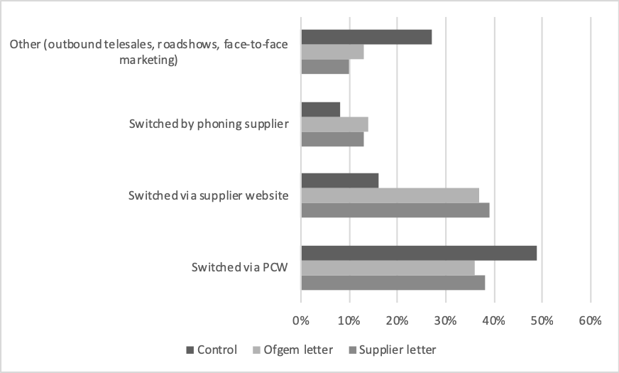
Figure 4: Method for external switch, by trial arm

Demographic differences in switching
Due to a lack of reliable data on age, income, or owner/renter status of customers, we are unable to see how these factors affect switching, or how the effectiveness of the letters varies by these characteristics. This is because energy suppliers do not hold – nor do they require as a business – such demographic data for their customers. However, other customers characteristics – e.g. length of time a customer has been with a supplier/on a certain tariff, meter readings, and account management method – are held by suppliers and were shared with us for analysis purposes. This data allows us to conduct subgroup analysis in order to identify which types of customer were more likely to respond to the CMOL.

First, we conducted subgroup analysis to see if the effects of the CMOL vary by how “engaged” customers are. Our hypothesis was that propensity to switch was correlated with shorter SVT tenure and more frequent provision of (manual) meter readings to their supplier. As shown in Figure 5, customers who have been on an SVT for 1-3 years are more likely to switch in general than those on an SVT for 3+ years (as the Control switching rates are higher in the first group). However, the relative effect of a CMOL (i.e. the proportional difference in switching between letter arms and the Control) was slightly stronger for 3+ year customers. In the 1-3 year group, the Ofgem letter doubled switching, and the Supplier letters tripled switching, whereas in the 3+ year group, the Ofgem letter tripled and the Supplier letters quadrupled switching. In short, CMOLs significantly increased switching in both tenure groups, including the less engaged group of customers who are considered to be harder to reach.
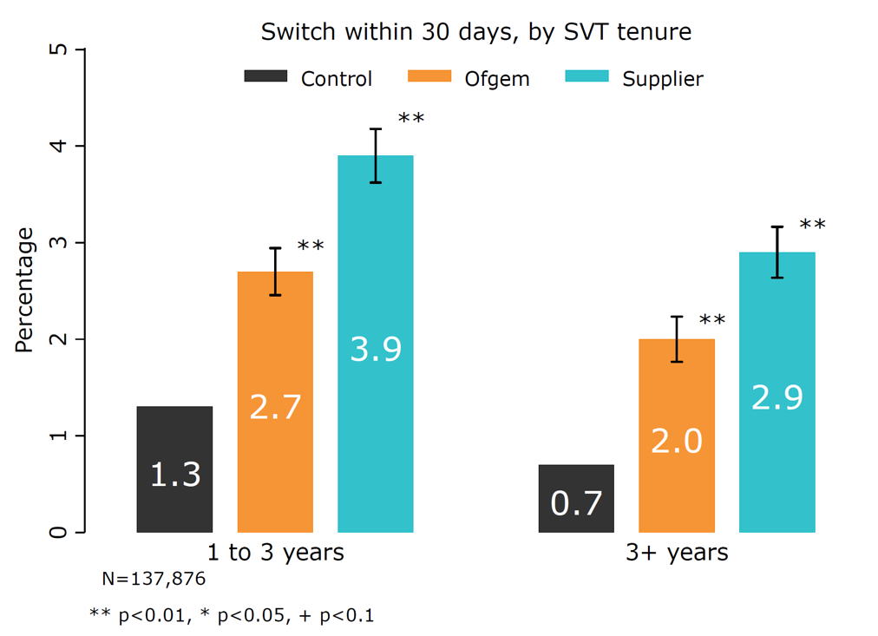
Figure 5: Switching by SVT tenure
Table 8. Switched, by tenure

 | (1) | (2) | (3)
 | Switched within 30 days | Switched within 30 days | Switched within 30 days
Ofgem, 1-3 years | 0.014** | 0.014** | 0.014**
 | [0.001] | [0.001] | [0.001]
Supplier, 1-3 years | 0.026** | 0.026** | 0.026**
 | [0.001] | [0.001] | [0.001]
Control, 3+ years | -0.006** | -0.006** | -0.006**
 | [0.001] | [0.001] | [0.001]
Ofgem, 3+ years | 0.007** | 0.007** | 0.007**
 | [0.001] | [0.001] | [0.001]
Supplier, 3+ years | 0.016** | 0.016** | 0.015**
 | [0.001] | [0.001] | [0.001]
Supplier B customer |  | -0.012** | -0.007**
 |  | [0.001] | [0.001]
Potential savings (Best CMOL offer) |  |  | 0.000**
 |  |  | [0.000]
Constant | 0.013** | 0.018** | 0.004**
 | [0.001] | [0.001] | [0.001]
Mean of omitted group | 0.013 | 0.013 | 0.013
N | 137,876 | 137,876 | 137,876
Robust standard errors in parentheses. + p < 0.10, * p < 0.05, ** p < 0.01.

We see a similar pattern when we break down the effects of switching by customer engagement, defined for our purposes as whether a customer submitted a meter reading in the year previous to the trial start date (see Figure 6). Judging from the Control group, customers that submitted readings (69% of our sample), perhaps unsurprisingly, are more engaged and are in general more likely to switch (see Table 9 Column 3). But CMOLs are effective for both types of customers: those that submit meter readings and those that don't. The relative differences suggest that CMOLs are actually more effective for less engaged customers.

Table 9. Switched, by meter reading

 | (1) | (2) | (3)
 | Switched within 30 days | Switched within 30 days | Switched within 30 days
Ofgem, No reading | 0.017** | 0.017** | 0.017**
 | [0.002] | [0.002] | [0.002]
Supplier, No reading | 0.024** | 0.024** | 0.024**
 | [0.002] | [0.002] | [0.002]
Control, At least one | 0.002⁺ | 0.010** | 0.011**
 | [0.001] | [0.001] | [0.001]
Ofgem, At least one | 0.014** | 0.022** | 0.023**
 | [0.001] | [0.001] | [0.001]
Supplier, At least one | 0.026** | 0.034** | 0.035**
 | [0.001] | [0.001] | [0.002]
On SVT for 3+ years |  | -0.007** | -0.008**
 |  | [0.001] | [0.001]
Supplier B customer |  | -0.016** | -0.012**
 |  | [0.001] | [0.001]
Potential savings (Best CMOL offer) |  |  | 0.000**
 |  |  | [0.000]
Constant | 0.009** | 0.014** | -0.002
 | [0.001] | [0.001] | [0.001]
Mean of omitted group | 0.009 | 0.009 | 0.009
N | 137,876 | 137,876 | 137,876
Robust standard errors in parentheses. + p < 0.10, * p < 0.05, ** p < 0.01.

In short, if we accept that not submitting meter readings and longer SVT tenure act as a proxy for disengagement in the energy market, our results suggest that the CMOL has a greater effect in relative terms for less engaged customers.

Regarding account management type, Figure 7 below shows that the effects of a CMOL were more pronounced among customers who managed their account online (44.5% of the total sample) than those who did not. One interpretation is that customers who manage their account online are perhaps more savvy Internet users, and may be more likely to shop around for deals on price comparison websites than those who manage their account offline. Unfortunately we are unable to conduct subgroup analysis by customer age, as we lack data on ages. However, there is some suggestive evidence that online account management may be correlated with age. Data from the Office of National Statistics on Internet usage in Great Britain shows that younger people are more likely to use online banking. Assuming customers typically manage their banking and energy accounts in the same way, our online versus offline account management findings may be confounded by age. In other words, our findings may be driven by differences in customer age rather than by account management preferences. This hypothesis would require further testing.
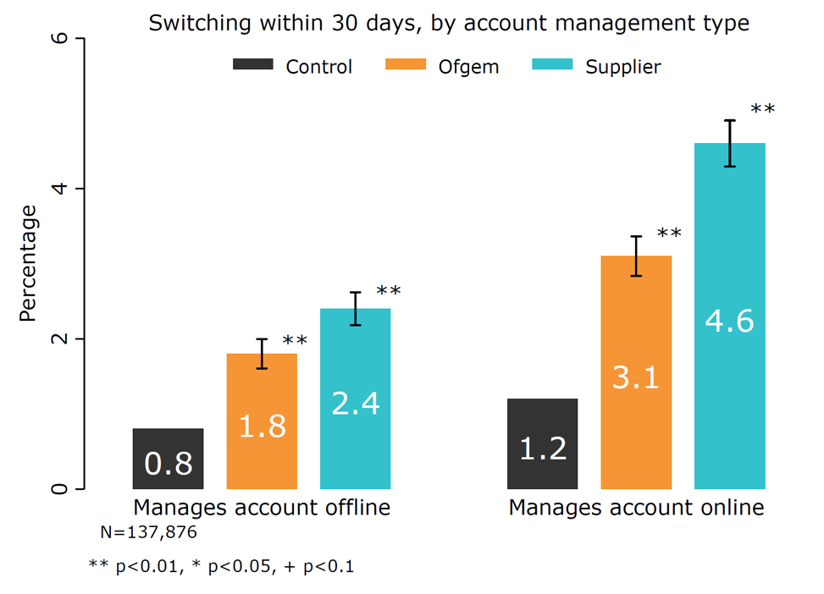
Figure 7: Switching by account management type
Table 10. Switched, by account management

 | (1) | (2) | (3)
 | Switched within 30 days | Switched within 30 days | Switched within 30 days
Ofgem, Offline | 0.009** | 0.009** | 0.009**
 | [0.001] | [0.001] | [0.001]
Supplier, Offline | 0.016** | 0.016** | 0.016**
 | [0.001] | [0.001] | [0.001]
Control, Online | 0.004** | 0.004** | 0.003**
 | [0.001] | [0.001] | [0.001]
Ofgem, Online | 0.023** | 0.022** | 0.022**
 | [0.001] | [0.001] | [0.001]
Supplier, Online | 0.038** | 0.038** | 0.037**
 | [0.002] | [0.002] | [0.002]
On SVT for 3+ years |  | -0.006** | -0.006**
 |  | [0.001] | [0.001]
Supplier B customer |  | -0.012** | -0.008**
 |  | [0.001] | [0.001]
Potential savings (Best CMOL offer) |  |  | 0.000**
 |  |  | [0.000]
Constant | 0.008** | 0.017** | 0.003*
 | [0.001] | [0.001] | [0.001]
Mean of omitted group | 0.008 | 0.008 | 0.008
N | 137,876 | 137,876 | 137,876
Robust standard errors in parentheses. + p < 0.10, * p < 0.05, ** p < 0.01.

Our final subgroup analysis breaks down effects of the letters by potential savings. We find that letters are effective for customers with both above and below median potential savings (median = £217.30), but (unsurprisingly) letters are more effective for those with larger potential savings.
Table 11. Switched, by potential savings (£)

 | (1) | (2)
 | Switched within 30 days | Switched within 30 days
Ofgem, Below median savings | 0.007** | 0.007**
 | [0.001] | [0.001]
Supplier, Below median savings | 0.014** | 0.014**
 | [0.001] | [0.001]
Control, Above median savings | 0.002* | -0.001
 | [0.001] | [0.001]
Ofgem, Above median savings | 0.022** | 0.019**
 | [0.001] | [0.001]
Supplier, Above median savings | 0.036** | 0.033**
 | [0.002] | [0.001]
On SVT for 3+ years |  | -0.008**
 |  | [0.001]
Supplier B customer |  | -0.009**
 |  | [0.001]
Constant | 0.009** | 0.018**
 | [0.001] | [0.001]
Mean of omitted group | 0.009 | 0.009
N | 137,876 | 137,876
Median savings | 217.30 | 217.30
Robust standard errors in parentheses. + p < 0.10, * p < 0.05, ** p < 0.01.

Qualitative reactions to the letter and messenger
The qualitative interviews gave us an opportunity to examine how customers reacted to the letter and the messenger. The data collected from 91 interviews with customers in the trial suggested that direct mail is becoming increasingly novel, as more communications are sent by email and other channels instead. Customers reported that they are likely to open letters, particularly those coming from their energy supplier. The letter being addressed to a specific person meant it was taken more seriously, and that the Ofgem ‘endorsement’ (which was on both variants of the CMOL) gave the letter credibility; even though many customers were not entirely aware of Ofgem’s role, many seemed to appreciate that Ofgem are a public body. It is likely that customers are less familiar with Ofgem than their own supplier (Ofgem, 2018b), and this may have been a reason why fewer customers acted on the Ofgem letter – they may have been less likely to even read the letter in the first place. On the other hand, these customers will have had a relationship with the trial suppliers for at least a year, and in some cases much longer.
“I am not sure of who they [Ofgem] are. I know they are something to do with energy and they are funded by the government.” – Supplier A customer; received Ofgem letter; switched externally
While customers seemed to understand the content of the letters - what they were being told (about savings they could make on the energy bills) and their options (to switch to a new tariff) - the context of the letter was not so obvious. Many already had an inkling that they were likely paying too much for their energy, and most reported the “you could save £x” message on the letter as being the most memorable and powerful statement.
“It was all a bit confusing at first as I did not understand why they sent it, but the letter itself was easy to understand.” – Supplier B customer; received supplier letter; switched internally
“It was clear the message was that there's cheaper tariffs, but without the contextual stuff behind it as just a one-off letter, I was a bit sceptical.” - Supplier B customer; received supplier letter; no action taken
Many customers seemed to appreciate that the letter was something ‘different’, and perhaps more powerful than receiving traditional marketing from rival companies. Others found it somewhat odd that their own supplier would write to them to inform them of a competitors’ deals.
“I think it was appropriate to come from [Supplier B] or Ofgem. If it came from a competitor, it would look like junk mail so it's better if it comes from your current supplier.” - Supplier B customer; received Supplier letter; switched externally
“I could not understand why [Supplier B] would send out a letter pointing out that I could get a cheaper tariff from somewhere else.” – Supplier B customer; received Supplier letter; switched internally
The vast proportion of suppliers listed on the letters were smaller suppliers, who invariably offer the cheaper tariffs on the market, yet enjoy much less brand recognition than the larger, more established suppliers. This may have led some customers to refrain from switching, or to seek a cheaper tariff with their existing supplier (i.e. to switch internally).
“I was not sure who they [suppliers listed on letters] were or how big they were, which is an issue. I haven't seen their vans with the company names around here, so will they be able to provide a good service? if I have a problem with the boiler or pipes will I wait a day for them to come out like [my supplier] or would it be a week? It was strange that [my existing supplier] didn't have their tariff on there.” – Supplier B customer; received Supplier letter; switched internally
Despite the letter aiming to reassure customers that switching is a low-risk and easy activity which can result in potentially high savings to customers, many interviewees still reported suspicion of the market and of switching to smaller suppliers, preferring to choose a supplier with a well-known brand or stay with their own supplier. Repeating some of the barriers to engagement described earlier in the introduction, other interviewees relayed a lack of urgency to switch, a lack of time to do so, and/or a preference for the familiar as reasons to do nothing.
“The only reason I haven't switched yet is down to a lack of time. I went on holiday soon after I got it and I only came back yesterday. So I haven't really had the time to look into the different suppliers.” – Supplier B customer; received Ofgem letter; no action taken
“For me, it's better with the devil you know; and unless you read the small print you find yourself in deeper waters.” – Supplier A customer; received Supplier letter; no action taken
“I generally like Supplier A since I have been with them I have not had any reason to be on the phone to them or, you know, they haven't caused me any problems. So if they aren't causing me a problem I am a happy bunny.” – Supplier A customer; received Supplier letter; no action taken

Conclusion
We find that a single, personalised letter with three cheaper market offers increased switching among default tariff customers. The overall effect of a CMOL was to increase switching from a baseline of 1% to an average of 2.9% for CMOL recipients across both the Ofgem and Supplier arms. We also found that the messenger is important. While the Supplier-branded CMOL increased switching from 1% to 3.4%, the Ofgem-branded letter increased switching from 1% to 2.4%. This could be because of greater recognition of the supplier brand, a greater likelihood of customers opening post from their supplier, or because of the novelty of a supplier giving details of rival supplier tariffs. Whatever the reason, one clear policy implication is that requiring incumbent suppliers of services or products to provide information on cheaper market alternatives may be more effective than a government institution providing such information.

There are notable switching differences between supplier. Even after controlling for potential savings, the rate of switching in the Supplier A arm was double the rate in the Supplier B arm. This difference may be explained by other customer or supplier characteristics (e.g. brand loyalty). Customers in each trial arm were also more likely to switch externally than internally, likely because external switches offered greater savings than internal switches.

Customers that switched after receiving a CMOL saved an average of around £50 a year compared to those who switched in the Control. This finding suggests that the CMOL may have given customers a higher potential savings ‘anchor’, making them more likely to seek higher savings than those who received no letter.

In relative terms, the impact of a CMOL was slightly greater for customers who had been on an SVT for 3+ years, compared to those on an SVT for 1-3 years. Likewise, CMOLs had a greater releative impact on customers who did not submit a meter reading in the previous twelve months, compared to those that did. If we accept these two variables as good proxies for disengagement in the energy market, our findings suggest that the CMOL has a greater effect in relative terms for less engaged customers, and that the effects are not confined only to the ‘low-hanging fruit’ of already more-engaged customers. This suggests that customers who have historically been disengaged from the energy market are still interested in saving money, but the decision to switch has been less salient for them as they have had no recent experience of it. The CMOL performs an especially beneficial function for disengaged customers in bringing an unfamiliar decision to their attention and countering their ‘availability heuristic’ (Tversky & Kahneman, 1974).

The qualitative interviews suggested that customers found the letter to be novel, and possibly more powerful than traditional marketing. Customers may have been more likely to act on the supplier letter because they generally open post from their supplier, whilst qualitative findings in this and in previous research (Ofgem, 2018a) suggest that brand recognition of Ofgem is likely less widespread, and therefore customers may have ignored an Ofgem-branded letter. Some customers clearly found the supplier letter slightly strange in that their own supplier was informing them of rival companies’ cheaper deals, whilst others found this approach refreshing. Moreover, the qualitative data identifies some of the outstanding barriers to switching - a perceived lack of urgency to switch, a lack of confidence in smaller suppliers, and a preference for the familiar and the status quo – to be pervasive and persistent.

Whilst our results are encouraging, the fact remains that the vast majority of customers did not switch after receiving this letter. This suggests the need for further research to see if the intervention could be improved. The qualitative research hints at what such improvements might be, and Ofgem plans to undertake further trials to test new iterations of a ‘Cheaper Market Offer Communication’ (Ofgem, 2017b).

Three additional variations could be considered. One variation is a reminder letter (or set of reminders) in order to overcome procrastination and a perceived lack of urgency. Similar trials in the banking sector found that reminder letters increased switching to better value savings products by as much as 9 percentage points (Adams et al 2016), and it would be interesting to see if a similar uplift could be achieved in the energy market.

A second variation is a CMOL which includes a cheaper ‘internal’ tariff offer. This may address the fact that some customers feel more comfortable remaining with their existing supplier. Thirdly, it may be fruitful to test sending a similar communication by email rather than by post (especially when a customer already receives their energy bills and annual statements by email). Because switching (or searching the energy market) is predominantly an online activity, receiving an email rather than a letter may mean customers find it easier and more ‘frictionless’ to be linked directly to supplier tariffs or PCWs, rather than reading a letter and then needing to find a computer, smartphone or other device to actually initiate a market search or a switch.

The selection of certain suppliers and exclusion criteria applied in this trial may have implications for external validity, as discussed earlier in this paper. It may therefore be useful to understand the effect of the intervention on categories of customers excluded from the CMOL trial, such as those customers with an outstanding debt or customers of different suppliers.

Separate strands of research may also be of interest. For example, it may be worth reducing choice even further by testing a simplified letter – perhaps only featuring one tariff instead of three. Other recent Ofgem trials suggest this may be a fruitful avenue (Ofgem, 2018a). It may also be of interest to see if nudging customers to engage is a ‘one-off’, or if engagement persists. For example, if a customer switched to a one-year fixed tariff for the first time in years as a result of receiving a CMOL, would they switch again after their one-year fixed tariff expires, or would they roll back onto a default tariff unless they were nudged again? Finally, if a customer switches and saves money, do they respond by increasing their energy consumption i.e. ‘spending’ their savings, akin to the so-called ‘rebound effect’ (see Hertwich, 2005), and if so what are the consequences for individual customer wellbeing and wider aggregate energy use? These empirical questions currently remain unresolved.

Other barriers to greater engagement exist on the supply-side. For example, customers might not trust small/new suppliers’ customer service standards, or they might think that switching may risk losing one’s energy supply or be a lengthy process. Addressing such barriers goes beyond demand-side behavioural interventions, and responsibility may lie with the wider energy industry, the regulator and government. Furthermore, other events may interact with the issue of energy market engagement in ways we are not yet sure of. In particular, the UK government’s new price cap on default energy tariffs will likely reduce – but will not eliminate – savings which are available to SVT customers (BEIS, 2018). This could potentially further dampen customer engagement and radically alter the market environment in which consumers find themselves over the coming years. In spite of such events, consumers are always likely to get a better deal if they engage in any market – including in the energy market. This trial shows that a single behaviourally-informed letter can, if delivered with the right content and sent by an appropriate messenger, drive such engagement and improve financial outcomes for consumers.

Acknowledgements
This research would not exist without the input and support from these (and other) individuals. In particular, we would like to thank Fiona Cochrane-Williams, Alex Tyler, Annabelle Bonus, Neil Barnes, Rishi Vashani, Francisco Moraiz, Moira Nicolson, and other colleagues at Ofgem; Pantelis Solomon, Elisabeth Costa, and Katy King at the Behavioural Insights Team; Alasdair Gleed and Liam Higgins at DJS for conducting the qualitative research; and the two trial suppliers for their participation and cooperation. We also thank two anonymous reviewers for their helpful comments. Any outstanding weaknesses with this paper remain the responsibility of the authors.

Roger Tyers is a research fellow in sociology at the University of Southampton, having previously worked at Ofgem as a Senior Behavioural Insights Practitioner during the period of this research. His current research interests are around behaviour change in public policy, particularly concerning energy, environment and transport policy.

Martin Sweeney is a Senior Research Advisor at the Behavioural Insights Team.

Beth Moon is the Head of Customer and Behavioural Insight at Ofgem.

References
Adams, P., Hunt, S., Palmer, C., & Zaliauskas, R. (2016). Attention, Search and Switching: Evidence on Mandated Disclosure from the Savings Market. London: FCA. Retrieved from https://www.fca.org.uk/publication/occasional-papers/occasional-paper-19.pdf
Adaval, R., & Wyer, R. S. (2011). Conscious and Nonconscious Comparisons with Price Anchors: Effects on Willingness to Pay for Related and Unrelated Products. Journal of Marketing Research, 48(2), 355–365. https://doi.org/10.1509/jmkr.48.2.355
Allcott, H. (2011). Social norms and energy conservation. Journal of Public Economics, 95(9-10), 1082-1095. https://doi.org/10.1016/j.jpubeco.2011.03.003
Bhargava, S., & Manoli, D. (2015). Psychological Frictions and the Incomplete Take-Up of Social Benefits: Evidence from an IRS Field Experiment. American Economic Review, 105(11), 3489–3529. Retrieved from https://dd42c9be-a-62cb3a1a-s-sites.googlegroups.com/site/sbhargav/Bhargava_IRSExperiment.pdf?attachauth=ANoY7cpNsMQ1WuOmB7vwpsYILzWBD6QA8MvvGvOsuLiRUk5_RcvLP_cSi9BQewrVxYWXc21jybLBph2LxvE2kwRgh7pwV7y-KW-bQEf_6Dt4U_hX9Wjs3WA0rKZxU1v7Vo9RsGvu88tH25SslDGF15
Blumenthal, M., Christian, C., & Slemrod, J. (2001). Compliance ? Evidence from a Controlled Experiment in Minnesota. National Tax Journal, 54(1), 125–138.
Bodur, H. O., Klein, N. M., & Arora, N. (2016). Online Price Search : Impact of Price Comparison Sites on Offline Price Evaluations. Journal of Retailing, 91(1), 125–139. https://doi.org/10.1016/j.jretai.2014.09.003
Cadena, X., & Schoar, A. (2011). Remembering to Pay? Reminders vs. Financial Incentives for Loan Payments (No. 17020). https://doi.org/10.3386/w17020
Cialdini, R. (2007). Influence. Influence: The psychology of persuasion. (Second edi). New York: Harper Business.
Cialdini, R. B. (2001). Influence: Science and practice (4th Edition). Boston: Allyn & Bacon.
Competition & Markets Authority. (2016). Energy market investigation: Summary of final report. https://doi.org/10.1002/9781118716571.ch6
Competition & Markets Authority. (2017). Digital comparison tools market study. London. Retrieved from https://assets.publishing.service.gov.uk/media/59c93546e5274a77468120d6/digital-comparison-tools-market-study-final-report.pdf
Department for Business Energy & Industrial Strategy. (2018). Victory for consumers as cap on energy tariffs to become law. Retrieved August 21, 2018, from https://www.gov.uk/government/news/victory-for-consumers-as-cap-on-energy-tariffs-to-become-law
Department for Business Energy and Industrial Strategy. (2017a). Domestic energy bills in 2016: The impact of variable consumption.
Department for Business Energy and Industrial Strategy. (2017b). Quarterly Energy Prices, September 2017. London. Retrieved from https://assets.publishing.service.gov.uk/government/uploads/system/uploads/attachment_data/file/647090/QEP_Q217.pdf
Department for Business Energy and Industrial Strategy. (2017c). Smart Meters: Quarterly Report to end June 2017. London. Retrieved from https://www.gov.uk/government/policies/helping-households-to-cut-their-energy-bills/supporting-pages/smart-meters
Department for Business Energy and Industrial Strategy. (2018). Domestic energy bills in 2017: The impact of variable consumption. London. Retrieved from https://www.gov.uk/ghttps://assets.publishing.service.gov.uk/government/uploads/system/uploads/attachment_data/file/695834/Domestic_energy_bills_in_2017_-_The_impact_of_variable_consumption.pdfmption.pdf
Durantini, M. R., Albarracín, D., Mitchell, A. L., Earl, A. N., Jeffrey, C., Durantini, M. R., … Gillette, J. C. (2016). Conceptualizing the Influence of Social Agents of Behavior Change: A Meta-Analysis of the Effectiveness of HIV-Prevention Interventionists for Different Groups. Psychol Bull., 132(2), 212–248. https://doi.org/10.1037/0033-2909.132.2.212.Conceptualizing
Fellner, G., Sausgruber, R., & Traxler, C. (2011). Testing Enforcement Strategies in the Field: Legal Threat, Moral Appeal and Social Information. Journal of the European Economic Association, 11(3), 634–660. https://doi.org/10.2139/ssrn.1468344
Financial Conduct Authority. (2015). Cash savings market study report. London. Retrieved from https://www.fca.org.uk/publication/market-studies/cash-savings-market-study-final-findings.pdf
Hasseldine, J., Hite, P., James, S., & Toumi, M. (2007). Persuasive communications: Tax compliance enforcement strategies for sole proprietors. Contemporary Accounting Research, 24(1), 171–194. https://doi.org/10.1506/P207-004L-4205-7NX0
Haynes, L., Service, O., Goldacre, B., & Torgerson, D. (2012). Test, learn, adapt: developing public policy with randomised controlled trials. Cabinet Office-Behavioural …. Retrieved from http://papers.ssrn.com/sol3/papers.cfm?abstract_id=2131581
Hertwich, E. G. (2005). Consumption and the An Industrial Ecology Perspective. Journal of Industrial Ecology, 9 (1-2)(1), 85–98.
Hortaçsu, A., Madanizadeh, S., & Puller, S. (2017). Power to choose? An analysis of consumer inertia in the residential electricity market. American Economic Journal: Economic Policy, 9(4), 192–226.
https://doi.org/10.1257/pol.20150235
Iyengar, S. S., & Lepper, M. R. (2000). When choice is demotivating: Can one desire too much of a good thing? Journal of Personality and Social Psychology, 79(6), 995–1006. https://doi.org/10.1037/0022-3514.79.6.995
Johannessen, K., & Glider, P. (2003). The University of Arizona’s Campus Health social norms media campaign. In H. W. Perkins (Ed.), The Social Norms Approach to Preventing School and College Age Substance Abuse: A Handbook for Educators, Counselors, and Clinicians.
John, P. (2018). How Far to Nudge: Assessing Behavioural Public Policy. London: Edward Elgar.
John, P., Sanders, M., & Wang, J. (2014). The use of descriptive norms in public administration: a panacea for improving citizen behaviours?
Kahneman, D., Knetsch, J. L., & Thaler, R. H. (1991). Anomalies: The Endowment Effect , Loss Aversion , and Status Quo Bias. Journal of Economic Perspectives, 5(1), 193–206.
Kallbekken, S., Sælen, H., & Hermansen, E. A. T. (2013). Bridging the Energy Efficiency Gap: A Field Experiment on Lifetime Energy Costs and Household Appliances. Journal of Consumer Policy, 36(1), 1–16. https://doi.org/10.1007/s10603-012-9211-z
Kling, J. R., Mullainathan, S., Shafir, E., Vermeulen, L. C., & Wrobel, M. V. (2012). Comparison friction: Experimental evidence from medicare drug plans. Quarterly Journal of Economics, 127(1), 199–235. https://doi.org/10.1093/qje/qjr055
Littlechild, S. (2017). The CMA’s analysis of the retail energy market : an examination using textbook economics. Cambridge Working Papers in Economics. Retrieved from https://www.eprg.group.cam.ac.uk/wp-content/uploads/2017/03/1703-Text_1.pdf
Lourenço, J. S., Ciriolo, E., Rafael Almeida, S., & Troussard, X. (2016a). Behavioural Insights Applied to Policy: United Kingdom country overview. https://doi.org/10.4324/9781315715315
Lourenço, J. S., Ciriolo, E., Rafael Almeida, S., & Troussard, X. (2016b). Behavioural Insights Applied to Policy. European Report 2016. https://doi.org/10.2760/903938
Lunn, P. (2013). Regulatory Policy and Behavioural Economics. http://www.oecd.org/officialdocuments/publicdisplaydocumentpdf/?cote=GOV/RPC(2013)15&docLanguage=En
Mathios, A. D. (2000). The Impact of Mandatory Disclosure Laws on Product Choices: An Analysis of the Salad Dressing Market. The Journal of Law and Economics, 43(2), 651–678. https://doi.org/10.1086/467468
Mckenzie, C. R. M., Liersch, M. J., & Finkelstein, S. R. (2006). Recommendations Implicit in Policy Defaults. Psychological Science, 17(5), 414–420. Retrieved from http://psy2.ucsd.edu/~mckenzie/McKenzieetal2006PsychSci.pdf
Newell, R. G., & Siikamäki, J. (2014). Nudging Energy Efficiency Behavior: The Role of Information Labels. Journal of the Association of Environmental and Resource Economists, 1(4), 555–598. Retrieved from https://www.journals.uchicago.edu/doi/full/10.1086/679281
Office for National Statistics. (2018a). Internet users, UK:2018. Retrieved from https://www.ons.gov.uk/businessindustryandtrade/itandinternetindustry/bulletins/internetusers/2018
Office for National Statistics. (2018b) Internet access - households and individuals. Retrieved from www.ons.gov.uk/peoplepopulationandcommunity/householdcharacteristics/homeinternetandsocialmediausage/datasets/internetaccesshouseholdsandindividualsreferencetables
Ofgem. (2017a). Implementation of Standard Licence Condition 32A: Power to direct suppliers to test consumer engagement measures – decision to make licence modification. Retrieved from https://www.ofgem.gov.uk/publications-and-updates/decision-selection-criteria-mandatory-supplier-testing-
Ofgem. (2017b). Our next steps to prompting greater consumer engagement. London. Retrieved from https://www.ofgem.gov.uk/system/files/docs/2017/11/cmoc_open_letter_0.pdf
Ofgem. (2017c). State of the Energy Market. London. Retrieved from https://www.ofgem.gov.uk/system/files/docs/2017/10/state_of_the_market_report_2017_web_1.pdf
Ofgem. (2018a). Active Choice Collective Switch Trial Final results. London. Retrieved from https://www.ofgem.gov.uk/system/files/docs/2018/11/cs_results_final_pdf_0.pdf
Ofgem. (2018b). Consumer First Panel : Wave Three. London. Retrieved from https://www.ofgem.gov.uk/system/files/docs/2018/02/wave_three_workshops_report_0.pdf
Ofgem. (2018c). Forward Work Programme 2018-19. London. Retrieved from https://www.ofgem.gov.uk/system/files/docs/2017/12/ofg_forward_work_programme_2018_brochure_web.pdf
Ofgem. (2018d). State of the Energy Market. London. Retrieved from https://www.ofgem.gov.uk/system/files/docs/2018/10/state_of_the_energy_market_report_2018.pdf
Ofgem. (2018e). Vulnerable Customers in the Energy Market. London. Retrieved from https://www.ofgem.gov.uk/system/files/docs/2018/11/vulnerability_report_2018.pdf
Rubin, D. B. (1974). Estimating causal effects of treatments in randomized and nonrandomized studies. Journal of Educational Psychology, 66(5), 688–701. https://doi.org/http://dx.doi.org/10.1037/h0037350
Samuelson, W., & Zeckhauser, R. (1988). Status quo bias in decision making. Journal of Risk and Uncertainty, 7–59. Retrieved from http://link.springer.com/article/10.1007/BF00055564
Service, O., Hallsworth, M., Halpern, D., Algate, F., Gallagher, R., Nguyen, S., … Kirkman, E. (2014). EAST Four simple ways to apply behavioural insights. Retrieved from http://www.behaviouralinsights.co.uk/sites/default/files/BIT Publication EAST_FA_WEB.pdf
Slaunwhite, J. M., Smith, S. M., Fleming, M. T., & Fabrigar, L. R. (2009). Using normative messages to increase healthy behaviours. International Journal of Workplace Health Management, 2(3), 231–244. https://doi.org/https://doi.org/10.1108/17538350910993421
Swartz, J. J., Braxton, D., & Viera, A. J. (2011). Calorie menu labeling on quick-service restaurant menus: An updated systematic review of the literature. International Journal of Behavioral Nutrition and Physical Activity, 8, 1–8. https://doi.org/10.1186/1479-5868-8-135
Tversky, A., & Kahneman, D. (1974). Judgement under Uncertainty: Heuristics and Biases. Science, 185(4157), 1124–1131.
Tyers, R. (2017) Cheaper Market Offers Letter Trial: Research Results. London: Ofgem. Retrieved from www.ofgem.gov.uk/system/files/docs/2017/11/cmol_report_0.pdf
Tyers, R. (2018). Nudging the Jetset to offset: Voluntary carbon offsetting for flying, and the limits of “nudging.” Journal of Sustainable Tourism, 0(0), 1–20. https://doi.org/10.1080/09669582.2018.1494737
Waddams-Price, C. (2013). Shedding Light on Consumer Behaviour in Energy Markets. In J. Mehta (Ed.), Behavioural Economics in Competition and Consumer Policy. Norwich: ESRC.
Weil, D., Fung, A., Graham, M., & Fagotto, E. (2006). The Effectiveness of Regulatory Disclosure Policies. Journal of Policy Analysis and Management, 25(1), 155–181. https://doi.org/10.1002/pam.20160
Whitehead, M., Jones, R., Howell, R., Lilley, R., & Pykett, J. (2014). Nudging all over the World.
Williams, B., Silk, A., & Waring, G. (2017). Consumer Engagement in the Energy Market 2017. London.

Appendices

1. Examples of letters – Front (redacted)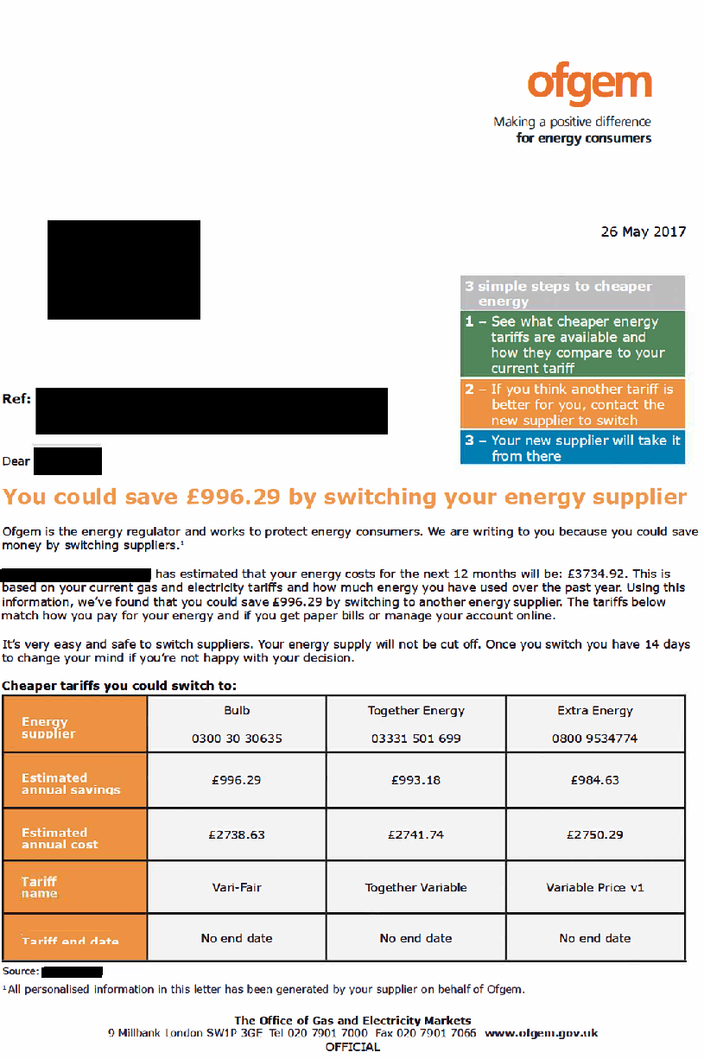

2. Example of letter – back (redacted)
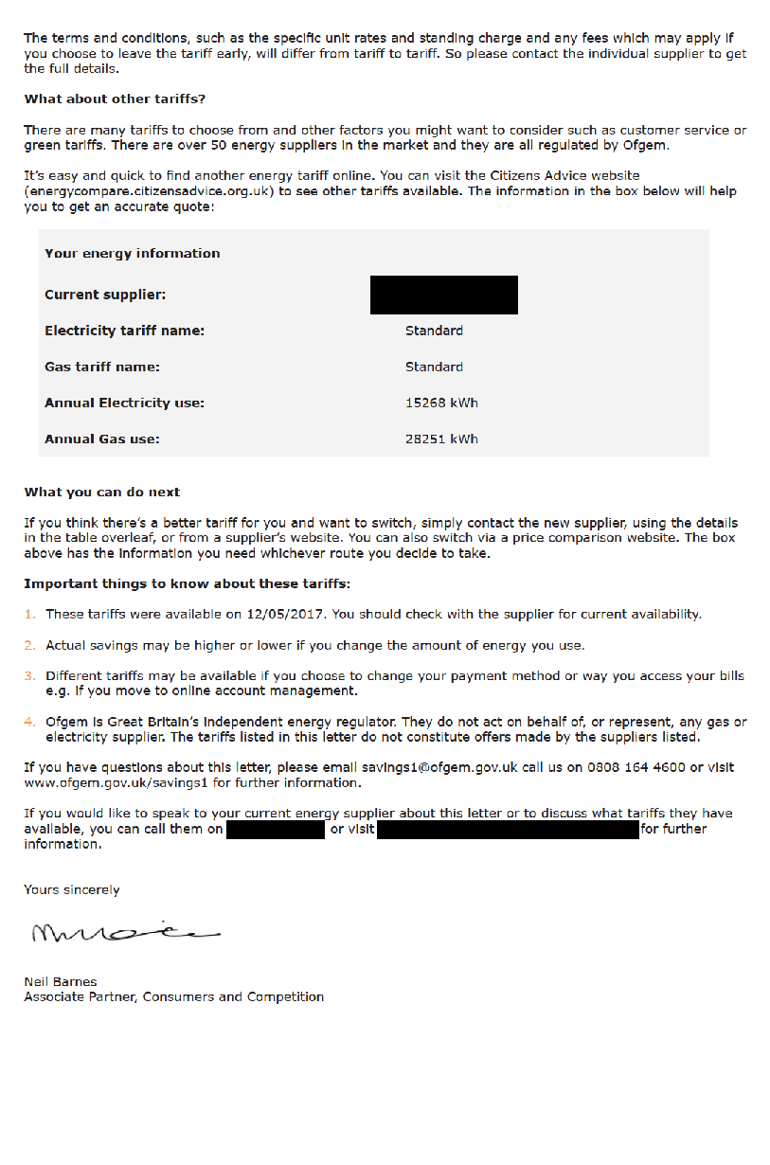

3. Exclusion criteria
This table presents the exclusions criteria for our trial, and rationale for using it. It also presents the approximate number of customers/individuals that meet each exclusion criteria using publicly available data.

(One important caveat is that customer figures presented include the roughly 40% of British energy customers on fixed tariffs. Cross-sectional data does not exist, so we cannot say how many SVT customers meet these criteria. Therefore, the volumes are likely over-estimates).

Criterion | Chosen parameter | Rationale | Number of customers/individuals excluded
Debt | Exclude Customers with Outstanding Charges, which would enable the Licensee to raise a request to prevent a Proposed Supplier Transfer in accordance with standard licence condition 14 of gas and electricity supply licences. | Customers may have wished to switch but would have been blocked from doing so (because they owed too much money to their current supplier), causing unnecessary distress for customers. | Up to 1 million customers (estimated)  (Ofgem, 2018e)
Warm Home Discount | Exclude customers in receipt of the Warm Home Discount (WHD). | Customers who switch away might potentially have lost their WHD. Within the space of one letter, we could not ensure consumers were aware of the considerations around the WHD. | 1.4 million individuals (estimated)  (Ofgem, 2017c)
Marketing consent / Section 11 | Exclude customers who have opted out of marketing. | The CMOL could potentially be interpreted as marketing. | Unknown
Bundled services (eg energy plus insurance or broadband) or affinity SVTs (ie those linked with vouchers or rewards) | Exclude customers with bundled services. | Bundled or affinity/ voucher preferences may have added a degree of complication to the letter (for example the savings message).  We would not be able to present like-for-like bundle or voucher deals on the CMOL. | Unknown
Non-standard meters (smart, restricted and other meters) | Exclude customers with non-standard metering. | This kept the tariff calculation simple, and we didn’t need to consider any issues of a consumer losing smart functionality depending on which smart meter they currently have. | Over 6 million smart meters, others (e.g. Economy 7, Economy 10) unknown  (BEIS, 2017c)
Prepayment meters | Exclude PPM customers. | PPM customers are not a priority focus for this project as the PPM price cap has come into play. | About 4 million customers (estimated)  (Ofgem, 2018d)
Unoccupied homes | Exclude customers with consumption of less than 25KwH of energy per year. | Households who consume very little energy may be largely unoccupied and therefore a letter was unlikely to be read. | Unknown
Non standard communications | Exclude customers who receive comms in Braille, audio bills etc. | Excluded to reduce complexity and enable greater standardisation of the letters that were being sent – enabling more valid comparisons between trial arms. | Unknown
Welsh language letters | Exclude customers who usually receive government communications in the Welsh language. | As this was only a trial and not an implemented policy intervention, usual rules on welsh language provision did not apply. | Unknown

4. Sample size and attrition
Our primary research question focusses on switching rates for all those customers on SVTs for one year or more. However, the trial was powered sufficiently to allow us to assess the impact by tenure length, in two groupings: those on an SVT for 1-3 years and those on an SVT for 3 or more years. Data provided by the supplier showed that switching rates vary between these groups – unsurprisingly, those customers who have been on an SVT for longer are less likely to switch. Therefore, the sample sizes for two lengths of tenure were calculated separately. The trials were powered to detect increases in the likelihood of switching of 0.5 percentage points or higher for both tenure groups. We performed two sets power calculations using the following specifications:

● beta = 0.8
● alpha = 0.05
● effect size = 0.5 percentage points
● baseline switching rate
1.836% for the 1-3 year group ; 1.48% for the 3+ year group (note: this data represents an average monthly switching rate from one of the suppliers in our trial for customers on the SVT)
Post-attrition, the target sample size for each supplier was: (40,497 + 33,705) X 0.95 ≈ 70,492

The tables below depicts the actual sample size for each trial.
The total sample size pre-attrition was 148,404, broken down as follows:
Tenure/Supplier | Control | Ofgem CMOL | Supplier CMOL
Supplier A / 1-3 years SVT | 13,499 | 13,499 | 13,499 | Total Supplier A sample  74,202
Supplier A / 3+ years SVT | 11,235 | 11,235 | 11,235
Supplier B /1-3 years SVT | 13,499 | 13,499 | 13,499 | Total Supplier B sample 74,202
Supplier B / 3+ years SVT | 11,235 | 11,235 | 11,235
Total | 49,468 | 49,468 | 49,468 | 148,404
Causes of attrition were a customer dying, moving house, switching, or having a change of meter, otherwise falling into the exclusion criteria in Annex 3 above (e.g. having a smart meter installed). When the letters were mailed out, post-attrition, the sample size was 137,876, broken down as were as follows:
Tenure/Supplier | Control | Ofgem CMOL | Supplier CMOL
Supplier A / 1-3 years SVT | 12,861 | 12,887 | 12,846 | Total Supplier A sample 71,164
Supplier A / 3+ years SVT | 10,885 | 10,861 | 10,824
Supplier B /1-3 years SVT | 11,933 | 11,991 | 12,028 | Total Supplier B sample  66,712
Supplier B / 3+ years SVT | 10,305 | 10,215 | 10,240
Total | 45,984 | 45,954 | 45,938 | 137,876

Despite the slightly smaller sample size in supplier B, the trial is still well-powered.

5. Switching window

Supplier A | Supplier B
- Sample drawn on 23rd May  - Cheaper market offers generated on May 29th (note that these offers were not guaranteed to be in place upon delivery of the letters)  - Letters mailed on:  - Ofgem arm: 12th June  - Supplier arm: 13th June  - We define the 30-day switching window as:  - Control arm: 13th June through 12th July (inclusive)  - Ofgem arm: 13th June through 12th July (inclusive)  - Supplier arm: 14th June through 13th July (inclusive) | - Sample drawn on 31st May  - Cheaper market offers generated on 13th June (note that these offers were not guaranteed to be in place upon delivery of the letters)  - All letters mailed on 5th July  - We define the 30-day switching window as 6th July through 4th August (inclusive)

6. Description of Qualitative Research sample (n=91)
 | Supplier A |  | Supplier B
 | Ofgem letter | Supplier A letter | Ofgem letter | Supplier B letter
1-3 years switched internally | 4 | 4 | 0 | 3
1-3 years switched externally | 2 | 6 | 10 | 9
1-3 years did nothing | 5 | 2 | 3 | 3
3+ years switched internally | 3 | 5 | 1 | 1
3+ years switched externally | 3 | 4 | 1 | 5
3+ did nothing | 4 | 3 | 2 | 8
Total | 21 | 24 | 17 | 29

7. Logistic Regressions and Robustness checks (online version only)

Table A4. Switched (logistic regressions)

 | Unadjusted coefficients |  | Odds ratios
 | (1) | (2) | (3) | (4)
 | Switched within 30 days | Switched within 30 days | Switched within 30 days | Switched within 30 days
Ofgem | 0.872** | 0.872** | 2.391** | 2.392**
 | [0.056] | [0.056] | [0.134] | [0.134]
Supplier | 1.252** | 1.254** | 3.497** | 3.503**
 | [0.053] | [0.054] | [0.187] | [0.188]
On SVT for 3+ years |  | -0.377** |  | 0.686**
 |  | [0.038] |  | [0.026]
Supplier B customer |  | -0.389** |  | 0.678**
 |  | [0.040] |  | [0.027]
Potential savings (Best CMOL offer) |  | 0.002** |  | 1.002**
 |  | [0.000] |  | [0.000]
Constant | -4.595** | -4.775**
 | [0.047] | [0.063]
Control mean | 0.010 | 0.010 | 0.010 | 0.010
N | 137,876 | 137,876 | 137,876 | 137,876
Robust standard errors in parentheses. + p < 0.10, * p < 0.05, ** p < 0.01.

Table A5. Type of switch (logistic regressions)

Panel A. Unadjusted coefficients
 | (1) | (2) | (3) | (4)
 | Switched externally  (to new supplier) | Switched externally  (to new supplier) | Switched internally  (new tariff with same supplier) | Switched internally  (new tariff with same supplier)
Ofgem | 0.929** | 0.929** | 0.718** | 0.716**
 | [0.067] | [0.067] | [0.102] | [0.102]
Supplier | 1.312** | 1.311** | 1.077** | 1.076**
 | [0.064] | [0.064] | [0.097] | [0.097]
On SVT for 3+ years |  | -0.291** |  | -0.597**
 |  | [0.043] |  | [0.073]
Supplier B customer |  | -0.144** |  | -1.158**
 |  | [0.045] |  | [0.088]
Potential savings (Best CMOL offer) |  | 0.002** |  | 0.002**
 |  | [0.000] |  | [0.000]
Constant | -4.970** | -5.246** | -5.770** | -5.704**
 | [0.056] | [0.074] | [0.084] | [0.111]
Control mean | 0.007 | 0.007 | 0.003 | 0.003
N | 137,876 | 137,876 | 137,876 | 137,876
Robust standard errors in parentheses. + p < 0.10, * p < 0.05, ** p < 0.01.

Panel B. Odds ratios
 | (1) | (2) | (3) | (4)
 | Switched externally  (to new supplier) | Switched externally  (to new supplier) | Switched internally  (new tariff with same supplier) | Switched internally  (new tariff with same supplier)
Ofgem | 2.533** | 2.531** | 2.050** | 2.046**
 | [0.169] | [0.169] | [0.210] | [0.210]
Supplier | 3.712** | 3.710** | 2.937** | 2.933**
 | [0.237] | [0.237] | [0.285] | [0.285]
On SVT for 3+ years |  | 0.747** |  | 0.550**
 |  | [0.032] |  | [0.040]
Supplier B customer |  | 0.866** |  | 0.314**
 |  | [0.039] |  | [0.028]
Potential savings (Best CMOL offer) |  | 1.002** |  | 1.002**
 |  | [0.000] |  | [0.000]
Control mean | 0.007 | 0.007 | 0.003 | 0.003
N | 137,876 | 137,876 | 137,876 | 137,876
Robust standard errors in parentheses. + p < 0.10, * p < 0.05, ** p < 0.01.

Table A6. Switched, by supplier (logistic regressions)

Panel A. Unadjusted coefficients
 | Supplier A |  | Supplier B
 | (1) | (2) | (3) | (4)
 | Switched within 30 days | Switched within 30 days | Switched within 30 days | Switched within 30 days
Ofgem | 1.282** | 1.281** | 0.307** | 0.308**
 | [0.078] | [0.078] | [0.084] | [0.085]
Supplier | 1.643** | 1.640** | 0.736** | 0.737**
 | [0.076] | [0.076] | [0.078] | [0.078]
On SVT for 3+ years |  | -0.207** |  | -0.708**
 |  | [0.046] |  | [0.067]
Potential savings (Best CMOL offer) |  | 0.002** |  | 0.002**
 |  | [0.000] |  | [0.000]
Constant | -4.705** | -5.198** | -4.489** | -4.580**
 | [0.069] | [0.086] | [0.064] | [0.085]
Control mean | 0.009 | 0.009 | 0.011 | 0.011
N | 71,164 | 71,164 | 66,712 | 66,712
Robust standard errors in parentheses. + p < 0.10, * p < 0.05, ** p < 0.01.

Panel B. Odds ratios

 | Supplier A |  | Supplier B
 | (1) | (2) | (3) | (4)
 | Switched within 30 days | Switched within 30 days | Switched within 30 days | Switched within 30 days
Ofgem | 3.603** | 3.599** | 1.360** | 1.360**
 | [0.282] | [0.282] | [0.115] | [0.115]
Supplier | 5.169** | 5.158** | 2.087** | 2.090**
 | [0.391] | [0.391] | [0.163] | [0.164]
On SVT for 3+ years |  | 0.813** |  | 0.492**
 |  | [0.037] |  | [0.033]
Potential savings (Best CMOL offer) |  | 1.002** |  | 1.002**
 |  | [0.000] |  | [0.000]
Control mean | 0.009 | 0.009 | 0.011 | 0.011
N | 71,164 | 71,164 | 66,712 | 66,712
Robust standard errors in parentheses. + p < 0.10, * p < 0.05, ** p < 0.01.

Table A6b. Switched, by supplier (pooled model, interactions)

 | (1) | (2)
 | Switched within 30 days | Switched within 30 days
Ofgem | 0.023** | 0.023**
 | [0.001] | [0.001]
Supplier | 0.036** | 0.036**
 | [0.001] | [0.001]
Supplier B customer | 0.002* | 0.007**
 | [0.001] | [0.001]
Ofgem x Supplier B customer | -0.019** | -0.019**
 | [0.002] | [0.002]
Supplier x Supplier B customer | -0.024** | -0.024**
 | [0.002] | [0.002]
On SVT for 3+ years |  | -0.008**
 |  | [0.001]
Potential savings (Best CMOL offer) |  | 0.000**
 |  | [0.000]
Constant | 0.009** | -0.002⁺
 | [0.001] | [0.001]
Control mean | 0.010 | 0.010
N | 137,876 | 137,876
Robust standard errors in parentheses. + p < 0.10, * p < 0.05, ** p < 0.01.

Table A7. Savings from a switch (additional covariates)

 | (1)
 | savings
Ofgem | 41.424**
 | [7.832]
Supplier | 45.308**
 | [7.609]
Potential savings (Best CMOL offer) | 0.929**
 | [0.026]
Supplier B customer | -34.110**
 | [6.191]
On SVT for 3+ years | 12.667**
 | [4.616]
Constant | -61.341**
 | [10.488]
Adjusted R² | 0.609
Control mean | 163.51
N | 2,609
Robust standard errors in parentheses. + p < 0.10, * p < 0.05, ** p < 0.01.

Table A8. Switched, by tenure (logistic regressions)

Panel A. Unadjusted coefficients
 | (1) | (2) | (3)
 | Switched within 30 days | Switched within 30 days | Switched within 30 days
Ofgem, 1-3 yrs | 0.752** | 0.753** | 0.755**
 | [0.069] | [0.069] | [0.069]
Supplier, 1-3 yrs | 1.146** | 1.150** | 1.146**
 | [0.066] | [0.066] | [0.066]
Control, 3+ yrs | -0.625** | -0.622** | -0.648**
 | [0.101] | [0.101] | [0.101]
Ofgem, 3+ yrs | 0.465** | 0.467** | 0.439**
 | [0.075] | [0.075] | [0.075]
Supplier, 3+ yrs | 0.824** | 0.827** | 0.805**
 | [0.070] | [0.070] | [0.070]
Supplier B customer |  | -0.567** | -0.389**
 |  | [0.038] | [0.040]
Potential savings (Best CMOL offer) |  |  | 0.002**
 |  |  | [0.000]
Constant | -4.353** | -4.119** | -4.681**
 | [0.057] | [0.056] | [0.068]
Mean of omitted group | 0.013 | 0.013 | 0.013
N | 137,876 | 137,876 | 137,876
Robust standard errors in parentheses. + p < 0.10, * p < 0.05, ** p < 0.01.

Panel B. Odds ratios

 | (1) | (2) | (3)
 | Switched within 30 days | Switched within 30 days | Switched within 30 days
Ofgem, 1-3 yrs | 2.121** | 2.124** | 2.127**
 | [0.146] | [0.147] | [0.147]
Supplier, 1-3 yrs | 3.147** | 3.157** | 3.146**
 | [0.206] | [0.207] | [0.207]
Control, 3+ yrs | 0.535** | 0.537** | 0.523**
 | [0.054] | [0.054] | [0.053]
Ofgem, 3+ yrs | 1.592** | 1.595** | 1.551**
 | [0.119] | [0.120] | [0.116]
Supplier, 3+ yrs | 2.278** | 2.287** | 2.236**
 | [0.160] | [0.161] | [0.157]
Supplier B customer |  | 0.567** | 0.678**
 |  | [0.022] | [0.027]
Potential savings (Best CMOL offer) |  |  | 1.002**
 |  |  | [0.000]
Mean of omitted group | 0.013 | 0.013 | 0.013
N | 137,876 | 137,876 | 137,876
Robust standard errors in parentheses. + p < 0.10, * p < 0.05, ** p < 0.01.

Table A9. Switched, by meter reading (logistic regressions)

Panel A. Unadjusted coefficients
 | (1) | (2) | (3)
 | Switched within 30 days | Switched within 30 days | Switched within 30 days
Ofgem, No reading | 1.076** | 1.079** | 1.084**
 | [0.104] | [0.104] | [0.104]
Supplier, No reading | 1.339** | 1.339** | 1.338**
 | [0.101] | [0.101] | [0.101]
Control, At least one | 0.176⁺ | 0.516** | 0.554**
 | [0.105] | [0.105] | [0.105]
Ofgem, At least one | 0.958** | 1.294** | 1.329**
 | [0.097] | [0.099] | [0.099]
Supplier, At least one | 1.393** | 1.736** | 1.773**
 | [0.094] | [0.097] | [0.097]
On SVT for 3+ years |  | -0.335** | -0.358**
 |  | [0.038] | [0.038]
Supplier B customer |  | -0.719** | -0.552**
 |  | [0.042] | [0.043]
Potential savings (Best CMOL offer) |  |  | 0.002**
 |  |  | [0.000]
Constant | -4.719** | -4.513** | -5.116**
 | [0.089] | [0.091] | [0.100]
Mean of omitted group | 0.009 | 0.009 | 0.009
N | 137,876 | 137,876 | 137,876
Robust standard errors in parentheses. + p < 0.10, * p < 0.05, ** p < 0.01.

Panel B. Odds ratios
 | (1) | (2) | (3)
 | Switched within 30 days | Switched within 30 days | Switched within 30 days
Ofgem, No reading | 2.933** | 2.943** | 2.957**
 | [0.305] | [0.306] | [0.308]
Supplier, No reading | 3.815** | 3.815** | 3.811**
 | [0.384] | [0.385] | [0.385]
Control, At least one | 1.193⁺ | 1.675** | 1.740**
 | [0.125] | [0.176] | [0.184]
Ofgem, At least one | 2.607** | 3.649** | 3.779**
 | [0.252] | [0.362] | [0.376]
Supplier, At least one | 4.026** | 5.672** | 5.888**
 | [0.379] | [0.549] | [0.572]
On SVT for 3+ years |  | 0.715** | 0.699**
 |  | [0.027] | [0.026]
Supplier B customer |  | 0.487** | 0.576**
 |  | [0.020] | [0.025]
Potential savings (Best CMOL offer) |  |  | 1.002**
 |  |  | [0.000]
Mean of omitted group | 0.009 | 0.009 | 0.009
N | 137,876 | 137,876 | 137,876
Robust standard errors in parentheses. + p < 0.10, * p < 0.05, ** p < 0.01.
Table A10. Switched, by account management (logistic regressions)

Panel A. Unadjusted coefficients
 | (1) | (2) | (3)
 | Switched within 30 days | Switched within 30 days | Switched within 30 days
Ofgem, Offline | 0.787** | 0.789** | 0.791**
 | [0.085] | [0.085] | [0.085]
Supplier, Offline | 1.116** | 1.118** | 1.118**
 | [0.081] | [0.081] | [0.082]
Control, Online | 0.437** | 0.409** | 0.388**
 | [0.094] | [0.095] | [0.095]
Ofgem, Online | 1.374** | 1.346** | 1.321**
 | [0.081] | [0.082] | [0.082]
Supplier, Online | 1.786** | 1.762** | 1.739**
 | [0.078] | [0.078] | [0.078]
On SVT for 3+ years |  | -0.281** | -0.307**
 |  | [0.038] | [0.038]
Supplier B customer |  | -0.576** | -0.411**
 |  | [0.038] | [0.040]
Potential savings (Best CMOL offer) |  |  | 0.002**
 |  |  | [0.000]
Constant | -4.814** | -4.443** | -4.963**
 | [0.070] | [0.073] | [0.082]
Mean of omitted group | 0.008 | 0.008 | 0.008
N | 137,876 | 137,876 | 137,876
Robust standard errors in parentheses. + p < 0.10, * p < 0.05, ** p < 0.01.

Panel B. Odds ratios
 | (1) | (2) | (3)
 | Switched within 30 days | Switched within 30 days | Switched within 30 days
Ofgem, Offline | 2.197** | 2.201** | 2.206**
 | [0.187] | [0.187] | [0.188]
Supplier, Offline | 3.052** | 3.059** | 3.058**
 | [0.248] | [0.249] | [0.249]
Control, Online | 1.548** | 1.506** | 1.474**
 | [0.146] | [0.143] | [0.140]
Ofgem, Online | 3.950** | 3.841** | 3.746**
 | [0.320] | [0.313] | [0.306]
Supplier, Online | 5.968** | 5.825** | 5.690**
 | [0.464] | [0.456] | [0.445]
On SVT for 3+ years |  | 0.755** | 0.735**
 |  | [0.029] | [0.028]
Supplier B customer |  | 0.562** | 0.663**
 |  | [0.021] | [0.026]
Potential savings (Best CMOL offer) |  |  | 1.002**
 |  |  | [0.000]
Control mean | 0.010 | 0.010 | 0.010
N | 137,876 | 137,876 | 137,876
Robust standard errors in parentheses. + p < 0.10, * p < 0.05, ** p < 0.01.

Table A11. Switched, by savings (logistic regressions)

Panel A. Unadjusted coefficients
 | (1) | (2)
 | Switched within 30 days | Switched within 30 days
Ofgem, Below median savings | 0.599** | 0.598**
 | [0.087] | [0.087]
Supplier, Below median savings | 0.961** | 0.964**
 | [0.082] | [0.082]
Control, Above median savings | 0.185* | 0.068
 | [0.094] | [0.095]
Ofgem, Above median savings | 1.238** | 1.124**
 | [0.079] | [0.079]
Supplier, Above median savings | 1.632** | 1.516**
 | [0.076] | [0.076]
On SVT for 3+ years |  | -0.371**
 |  | [0.038]
Supplier B customer |  | -0.422**
 |  | [0.039]
Constant | -4.691** | -4.295**
 | [0.069] | [0.072]
Mean of omitted group | 0.009 | 0.009
N | 137,876 | 137,876
Median savings | 217.30 | 217.30
Robust standard errors in parentheses. + p < 0.10, * p < 0.05, ** p < 0.01.

Panel B. Odds ratios
 | (1) | (2)
 | Switched within 30 days | Switched within 30 days
Ofgem, Below median savings | 1.820** | 1.819**
 | [0.158] | [0.158]
Supplier, Below median savings | 2.614** | 2.623**
 | [0.214] | [0.215]
Control, Above median savings | 1.203* | 1.071
 | [0.113] | [0.102]
Ofgem, Above median savings | 3.450** | 3.076**
 | [0.273] | [0.242]
Supplier, Above median savings | 5.113** | 4.554**
 | [0.390] | [0.346]
On SVT for 3+ years |  | 0.690**
 |  | [0.026]
Supplier B customer |  | 0.655**
 |  | [0.026]
Mean of omitted group | 0.009 | 0.009
N | 137,876 | 137,876
Robust standard errors in parentheses. + p < 0.10, * p < 0.05, ** p < 0.01.

w

Corresponding author address: Dr Roger Tyers, Economic, Social and Political Sciences, University of Southampton, Southampton SO17 1BJ, UK. R.Tyers@soton.ac.uk
Behavioural Insights Team, 4 Matthew Parker Street, London SW1H 9NP, UK.
Ofgem, 10 South Colonnade, Canary Wharf, London E14 4PU, UK. This trial was conceived, funded and conducted by Ofgem. The lead author was previously a member of staff of the Ofgem Behavioural Insights Unit; he managed the trial's implementation and summarised its findings in a report previously published by Ofgem, which this paper expands upon (Tyers 2017). The second author provided support on trial design and conducted the quantitative analysis. Both authors contributed to the writing and ideas presented in this paper. The third author worked on the initiation, planning and management of the trial, and provided comments on this paper. The views expressed in this paper are those of the authors and do not necessarily represent the views of, and should not be attributed to, Ofgem or the Gas and Electricity Markets Authority.
Northern Ireland has a separate regulatory regime, hence the use of ‘Great Britain’ throughout this paper, rather than United Kingdom
Throughout the paper, we (the authors) refer to "our" trial, intervention, sample, etc. This is not to claim sole credit for the work presented, but rather to enable easier reading. In reality, this trial was conceived and implemented by members of Ofgem's Behavioural Insights Unit and Ofgem's Consumer Engagement policy team (see acknowledgements).
Due to confidentiality agreements, we are unable to report exact market share or certain other commercially sensitive details in this paper.
The survey of British adults found that 93% of 25-34 year olds reported using internet banking in the past 3 months, compared to 35% of 65+ year olds. (ONS 2018b, table 10)

