Accepted Review for Trans. Institute of Materials Finishing 12 Nov. 2018
TIMF 1207R
Modern Developments in Electrodes for Electrochemical Technology and the Role of Surface Finishing
Frank C. Walsh
Electrochemical Engineering Laboratory, Department of Mechanical Engineering,
University of Southampton, Southampton SO17 1 BJ, UK.
f.c.walsh@soton.ac.uk

Abstract
Fundamental research into electrode materials has focussed on their active area and catalytic ability to drive reaction kinetics. Prerequisites for practical electrodes used in industrial processing and technology include moderate costs, good mechanical, thermal and chemical stability, effective electrocatalysis, a high electrical conductivity and the facility for scale-up, such that an electrochemical engineering approach is important. Following a consideration of important electrode properties, this concise review considers the fabrication, imaging, structure and the dressing of electrode surfaces with particles, coatings and films; nanostructured and hierarchical features are included. Trends in electrodes are noted, using examples from the author’s laboratory. Electrochemical surface finishing techniques make an important contribution to the toolbox of practical techniques capable of industrial development. Approaches to electrode fabrication and finishing are considered in application areas such as energy storage and conversion, environmental treatment and tribology.
Keywords: anodising; area; composites; electrodeposition; electrophoresis; electrospinning; P

Contents
1. Introduction
2. Design, imaging and fabrication
2.1 Traditional approaches
2.2 Modern imaging techniques
2.3 Fast prototyping and 3D printing
3. Surface modification
3.1 Benefits
3.2 Approaches
3.3 Nanostructured and hierarchical surfaces
4. Performance
4.1 Factors affecting electrode performance
4.2 Electrode reaction rates and current efficiency
4.3 Electrode area
5. Applications
5.1 Electrochemical energy storage and conversion
5.2 Environmental treatment
5.3 Engineering coatings and tribology
6. Summary
7. Opportunities for further research & development
(Approx. 9,750 words, 45 references, 20 reactions/equations, 12 figures).

List of symbols
A Geometrical electrode area cm²
A_{XS} Cross-sectional area of electrical conductor cm²
c Concentration of electroactive species mol cm⁻³
C Capacitance F
C_{s} Specific capacitance F g⁻¹
E Electrode potential V
E_{cell} Cell potential (voltage) V
$E_{e, cell}$ Equilibrium cell potential (voltage) V
F Faraday constant C mol⁻¹
G Electrical conductance S = ohm⁻¹
${∆G}_{cell}$ Gibbs free energy change for the cell reaction J mol⁻¹
I Current A
I_{L} Limiting current (due to mass transport control) A
j Current density A cm⁻²
j_{L} Limiting current density A cm⁻²
j_{o} Exchange current density A cm⁻²
k_{m} Mass transfer coefficient cm s⁻¹
l Length of conductor cm
n Amount of material mol
r Empirical constant in equation (13) Dimensionless
R Molar gas constant J K⁻¹ mol⁻¹
R_{e} Electrical resistance ohm
t Time s
T Temperature K
v Mean electrolyte velocity over the electrode surface cm s⁻¹
V Volume cm³
w Mass of active material g
Y_{ST} Space time yield of an electrochemical reactor mol cm⁻³ s⁻¹
z Electron stoichiometry Dimensionless
Z’; Z’’ Imaginary impedance; real impedance ohm
Greek
α Charge transfer coefficient Dimensionless
η Overpotential V
ν Kinematic viscosity of the electrolyte cm² s⁻¹
ρ_{e} Electrical resistivity ohm⁻¹ cm⁻¹
θ Current efficiency Dimensionless

Subscipts
A Anode
act Activation (or charge transfer) control
C Cathode
cell Cell
conc Concentration (diffusion or mass transfer) control
e Equilibrium
R Reactor

Abbreviations
AFM Atomic force microscopy
CAD/CAM Computer aided design and manufacture
µCT X-ray computed micro-tomography
BDD Boron doped diamond
ED Electron diffraction
EDS Energy dispersive X-ray spectroscopy
GO Graphene oxide
HRTEM High resolution transmission electron microscope
PAA Polyamic acid
PPyr Polypyrrole
SEM Scanning electron microscope
SWNT Single-walled (carbon) nanotubes
TEM Transmission electron microscope
TiNT Titanate nanotubes
XRD X-ray diffraction
1. Introduction
The electrochemical cell is shown, schematically in Figure 1, highlighting choices in cell type together with the geometry, structure and surface finish of electrodes. Commonly, the electronically conducting electrodes are metallic or carbon although other electronically conducting ceramic, polymeric and composite electrodes are increasingly important. The electrochemical cell is comprised of an anode and a cathode in contact with an electrolyte. The interfaces with the electrolyte at each electrode, at the junction of an electronic and ionic conductor, are the vital regions where electrode processes occur. The electrolyte is an ionic conductor and may be a) an aqueous solution or gel, b) a non-aqueous (e.g. an organic) solution, c) a molten salt or d) a solid state (polymeric or ceramic) ionic conductor. The cell may be undivided, with one electrolyte common to both electrodes, or divided by an ionically conductive material, typically a microporous polymer or ceramic or else an ion-exchange polymer.
2. The anode is the electrode at which oxidation of a reactant occurs at the electrode/electrolyte interface via electron loss; at the cathode, electron gain at the electrode/electrolyte interface leads to reduction. The net cell reaction is a corresponding redox process. The desired (or primary) electrode reactions often have competition from secondary ones, resulting in a charge capability below the theoretical one.
3. The overall cell has several important features. It is electrically neutral; electrical current flows bidirectionally, as cations and anions, in the electrolyte but unidirectionally as electrons, e⁻, in the external circuit. Reactions take place locally at the electrode/electrolyte interfaces, resulting in a potential difference, E_{cell}, in the outer circuit between the electrodes.
4. Regarding the direction of energy conversion, there are two distinctly different types of cell. The cell reaction can take place spontaneously at open-circuit (in a galvanic cell) but requires driving by an external electrical power supply (in an electrolytic cell).
5. An appropriate value of electrode potential can provide good control of reaction rate and efficiency; unsuitable or poorly distributed potential can result in poor efficiency or selectivity, due to side reactions, a lower reaction rate, an unsuitable product purity or unwanted morphological features (e.g., nodules, dendrites or pores) in the case of solid films. In this sense, the electrode potential, E may be considered as the ‘double-edged sword of electrochemistry’.
6. The rate determining step, which is often potential-dependent, is the slowest one and often measured in the laboratory but is part of a sequence in an overall reaction.
7. In some cells, e.g., secondary batteries, an electrode is anodic for part of a cycle, such as during charge, then cathodic for another period when the direction of current flow reverses, e.g., during discharge.
8. Microstructured and nanostructured electrode surfaces do not always behave as higher surface area versions of flat electrode surfaces.
9. In the case of bipolar electrodes, one side of the structure is anodic while the other is cathodic.
10. The electrode reactions can involve a wide range of reactant and product species and phases, including ions, uncharged solvent molecules, solids, liquids, gases and colloidal dispersions.

Fundamental research on electrode materials has tended to focus on their active area and catalytic ability to drive reaction kinetics [1, 2]. Practical electrodes used in industrial processing and technology [3-6] also demand moderate costs, good mechanical, thermal and chemical stability, effective electrocatalysis, a high electrical conductivity and ease of scale-up, such that an electrochemical engineering approach is important. Important aspects of electrode development and decisions include:
a) The type of material involved, possibilities being metals, conductive polymers, ceramics and diverse layers and composites,
b) Whether the structure is 2- or 3-dimensional, the former being commonly seen in planar or cylindrical electrodes while the latter embraces an increasingly diverse range of materials and internal structures, ranging from meshes through foams to more complex and hybrid systems.
c) If the electrode has a definite surface finish, texture or coating together with the porosity and microscale or nanoscale architecture of the surface, the techniques used to produce the electrode structure and which surface properties are sought (mechanical, chemical and electrochemical) for a particular application.

The diverse scale of electrodes is indicated in Figure 2, where electrode area and cell current together with ranges of subject areas are outlined across many fields of R & D and industrial processing, from single nanometre-sized particles to multiple square metre plates and meshes involving nA to MA. Laboratory electrodes might be <1 mm² to >10 cm² in size. Laboratory pilot plant electrodes may be 100 cm² to >500 cm² in area while industrial pilot plant may involve electrodes of 0.1 m² to >1 m². Large industrial installations can involve electrode areas from 10 m² to >>100 m².

It must also be borne in mind that the species involved in an electrode reaction have an incredibly wide range of chemistry (and scale); they might include:
a) Surface species (atomic or molecular),
b) Electrocatalysts (nanostructured),
c) Laboratory electrodes (<1 mm² to >10 cm²),
d) Laboratory pilot plant (100 cm² to >500 cm²),
e) Industrial pilot plant (0.1 m² to >1 m²) or
f) Full-scale industrial plant (10 m² to >>100 m²).
So, the scale ranges from individual atoms, ions and molecules, through monolayers via laboratory electrodes of several square centimetres projected area in size to full industrial scale which can be involve many square metres.

In Figure 3, an attempt is made to outline the general directions for the development of electrodes for electrochemical technology, involving design, structure, imaging, surface modification, simulation and performance. Following a consideration of important electrode properties, this concise review considers the fabrication, imaging, structure and surface decoration of electrodes are considered. Trends in electrodes are noted and illustrated by examples. Electrochemical surface finishing techniques make an important contribution to the toolbox of practical techniques capable of industrial development. Approaches to electrode fabrication and finishing are considered in application areas such as energy storage and conversion, environmental treatment and tribology, with examples from the author’s and collaborators’ laboratories.

2. Design, imaging and fabrication
2.1 Traditional approaches
Conventional metal forming has involved processes such as casting and extrusion followed by machine shaping via e.g. drilling, sawing, milling and guillotining in a centralised workshop. The last 50 years have witnessed increasing movement towards automated, computer aided design and computer driven manufacture, such that CAD/CAM processing has become well established to realise high production rates of increasingly complex workpieces with little manual labour and lower unit costs.

2.2 Modern imaging and analysis techniques
Traditionally, optical microscopy has been used to reveal the morphology of larger surface features while SEM has provided higher scale and greater depth of field, together with the facility for qualitative elemental analysis by EDS. Continuous developments in optical microscopy and light scattering techniques have realised an improved range of polarised light imaging techniques offering better contrast and resolution together with non-invasive surface profilometers capable of discriminating reflective, transmitted and scattered light from the sample [7]. Phase composition of bulk samples has commonly used powder XRD. Over the last 20 years or so, AFM has become a widely used tool not only for surface imaging but also to obtain surface roughness and force interaction characteristics [8, 9]. It is normally expected that TEM imaging will reveal local morphology, often in combination with EDS and ED estimation of elemental analysis and phase composition. In the case of nanofeatures, HRTEM imaging is required and examples are given later. The analysis of internal structure is no longer just the province of X-ray radiography. CT has been increasingly deployed [10], especially in concert with fast, powerful digital image analysis software. Resultant digital imaging not only provides the opportunity for an improved appreciation of structure and its mathematical description but also the opportunity to redesign structure and shape to feed to a 3D printer enabling ex-workshop components to be rapidly and conveniently produced. Examples of modern imaging and analysis results are provided later in this review.

2.3 Fast prototyping and 3D printing
3D printing has transformed design and manufacture of materials and products [11]; it facilitates:
a) Fabrication close to the microcomputer being used for design or the laboratory,
b) Fast realisation of early versions,
c) Easy modification of designs, via computer aided design, CAD techniques and
d) The widening availability of materials, printing techniques and post-printing processes, such as heat or laser treatment.

The feed material to the printer can be an ink, a solid powder in wire, tape or powder form; laser and reheating stages can be built into post-printing procedures to cure, stabilise or sinter material. Tailored 3D internal structured materials, such as auxetic foams have been designed by digital software then realised by 3D printing [12]. Examples of electrochemical cell components designed, imaged, manufactured and characterised by CT include: a polymeric electrochemical cell body, which was validated in a flow cell by extensive mass transport measurements [13] and b) a rectangular cross sectional flow cell used as a metal-air redox flow battery [14] which was subjected to current distribution measurements. Recently, nickel electroplated stainless steel mesh electrodes made by 3D printing have been characterised by volumetric mass transfer measurements using limiting current studies for ferrocyanide /ferricyanide ion redox reactions [15]. Porous, 3D metal foam and mesh structures having controlled porosity and internal structure have been produced by a 3D printer equipped with a laser remelting stage and the pressure drop of electrolyte through them has been measured [16].

3. Surface modification
3.1 Benefits
The deliberate modification of an electrode surface before use or in-situ can confer a range of benefits, including:
a) An enhanced active area compared to the geometrical (projected) one, offering higher overall charge transfer rates.
b) A more catalytically active surface, able to realise a lower overpotential, improved current efficiency or better selectivity of products in a synthesis.
c) A rougher surface, able to improve mass transfer rates to or from the electrode surface due to creation of microturbulence.
d) The introduction of specialised properties, such as photo catalysis by, TiO₂ materials.
e) The opportunity to create more complex surface architectures featuring nanostructured, layered, hybrid or hierarchical features.
Each of these benefits is illustrated later in this review.

3.2 Approaches
The directions taken for electrode design and modification include:
a) Development of a higher area, rougher surface by, e.g., dendritic or nodular electrodeposition.
a) Surface decoration by, e.g., nodules, flowerlike or porcupine morphologies,
b) Hierarchical structures in size and shape; core-shell and layered structures,
C) controlled architecture, e.g., area, phase composition, porosity and functionalisation,
d) Manufacture and coating, including fast prototyping, such as 3D, 4D and 5D printing and
e) Templating via a soft or hard mask, producing features which are atomic to micrometre in size.
These approaches may be applied to planar or porous, 3D structures, as illustrated in section 6.

3.3 Nanostructured and hierarchical surfaces
Since the 1990s, interest in techniques to form and characterise nanostructured materials, i.e., ones containing structures having typical dimensions <100 nm, has blossomed [17]. Such materials are not only important from a fundamental perspective but promise transformational properties for industrial exploitation. Sadly, the technology of large scale production and characterisation of these materials, their processing and coatings has lagged far behind academic interest. Walsh et al. have provided a review illustrating contributions of anodising of metals, electroplating of materials and other electrochemical approaches [18, 19].

Since 2000, nanostructured surfaces containing hierarchical features have emerged by texturing or coating approaches. Such features may not only have a different scale but can also involve different shapes. Examples include tube-in-tube, particle-in-tube and core-shell structures [20]. Such an approach can offer enhanced area and activity for nanocatalysts, improved tribological performance or controlled surfaces for the adsorption/release of self-lubricants, wetting modifiers, corrosion inhibitors or drugs [21, 22]. The inspiration for research studies into these structures has not always been abstract, since examples arise from biomimetics and foodstuffs. In the author’s research, examples of the former are animal and plant structures found on corals while the latter is illustrated by pretzels and candy floss manufacture.

Core-shell particles have been studied for over 20 years. The approach here is to produce a layered structure near the surface (shell) of the core. The core can provide, e.g., mechanical support and electrical conductivity while the shell can confer higher activity and area with controlled and limited porosity. A simple example is the formation of copper oxide on Ni-Fe-Cu alloy spheroids, which have been considered as electrocatalysts for water oxidation [23].

Electrochemical water splitting requires efficient water oxidation catalysts to accelerate oxygen evolution. The authors reported a dendritic core-shell nickel-iron-copper metal/metal oxide electrode, made by dealloying an electrodeposited nickel-iron-copper alloy, as a water oxidation catalyst. The as-prepared core-shell nickel-iron-copper electrode was characterised with porous oxide shells and metallic cores. This electrode exhibited a high activity toward water oxidation in alkaline medium with an overpotential of only -180 mV at a current density of 10 mA cm⁻². The core-shell NiFeCu electrode showed pH-dependent oxygen evolution reaction activity on the reversible hydrogen electrode scale, suggesting that non-concerted proton-electron transfer participated in catalysing oxygen evolution.

4. Performance
The development of electrode materials and cell designs for modern electrolytic flow cells gave been broadly considered in recent reviews from the author’s laboratory [24, 25]. Here, the focus is on operational factors affecting performance and the scope for tailoring electrode surfaces.

4.1 Factors affecting electrode performance
Many, interrelated factors affect the performance of electrodes; major ones being:
a) Surface activity hence electrocatalytic ability, as mentioned in section 4.2,
b) Electrode area, A which is considered in section 4.3,
c) The material, shape and structure of an electrode plus the integrity of its surface/coating and
d) reaction environment, particularly for a mass transfer controlled process (section 4.2), including electrolyte flow, concentration-, current density- and electrode potential distributions, especially over a porous, 3D surface.

4.2 Electrode reaction rates and current efficiency
The overall rate of an electrode process can be described by Faraday’s laws of electrolysis, where the electrical charge, q flowing through a cell due to the movement of z electrons is quantitatively related to the amount of chemical change, Δn:

q = Δn.z.F (6)

The Faraday constant, F is the charge associated with a mole of electrons and the electrical charge, q in the time interval t₂ - t₁, is:

$q= \int_{t1}^{t2}{I.dt}$ (7)

If t₂ = 0, the overall charge is involved; otherwise, the charge in the time interval (t₂-t₁) is involved.

In the case of a constant current, I flowing for a time t, equation (6) becomes:

θ.q = Δn.z.F / t (8)

The overall rate of materials transformation can be stated as:

$\frac{∆n}{t}= \frac{θj.A}{z.F}$ (9)

Ideally, the current efficiency, θ would be unity. In practice, it is often <1 due to secondary reactions at the electrode surface. For a cathodic reaction in aqueous solution, hydrogen evolution is common, while oxygen evolution takes place at the anode, these reactions corresponding to water electrolysis. The rate of charge in a cell will often be mainly limited by the rate of one of the electrode reactions and it is important to realise which electrode reaction becomes rate limiting first.
Faraday’s laws may be written in terms of an averaged weight loss (Δw) per unit area (A) or Δw/t for a uniform surface undergoing gain in thickness via electroplating or loss of thickness via open-circuit corrosion or anodic dissolution [26]:

$\frac{∆w}{A.t}=\frac{θj}{zF}$ (10)

Where θ is the current efficiency, i.e., the fraction of current involved in the desired reaction. The current density at an electrode, j is the current per unit electrode area:

$j=\frac{I}{A}$ (11)

The extreme types of rate control should be recognised. Under pure charge transfer control of reaction rate, the rate of electron supply/removal dominates; the electrode should be selectively catalytic, its microscopic area should be high and the rate is very dependent on potential. For a charge transfer controlled cathodic reduction, the partial current for the desired reaction, I, is exponentially related to the overpotential, η [1. 2]:

$I=-zFAkc\exp\left(\frac{a_{c}zF}{RT}\right)$ (12)
Where α_{c} is the charge transfer coefficient. It is important to use a high surface area, A together with a electrocatalyst which ensures a high rate constant, k (related to the exchange current density, j_{o}) for the desired reaction while minimising secondary processes, as well as a sufficiently high concentration of reactant, c, where possible.

Under complete mass transport control of a reaction, due to convective-diffusion of a species to (or from) the electrode surface, the maximum current for a given reaction is equal to the limiting current, I_{L} as seen in equation (1). The limiting current, I_{L}, is directly affected by the relative velocity, v between the electrode and the electrolyte:

$I_{L}=zFcA k_{m}$= K v^{r} (13)

where the empirical constants, K and r in this power law expression depend on the electrode geometry, electrolyte composition and temperature; it is important to seek a high electrode area (A), a sufficiently high mass transport coefficient (k_{m}) by using a sufficiently high relative velocity between electrode and electrolyte, (v) and a sufficiently high reactant concentration; c is the reactant concentration. v is a characteristic velocity, e.g., the mean linear velocity in a flow channel or the peripheral velocity of a rotating cylinder. The velocity power index, r depends on geometry: typical values are 0.33 for developed laminar flow in a channel, r>0.5 for turbulent flow in a channel, r = 0.5 for a smooth RDE in laminar flow, r = 0.7 for a smooth RCE in turbulent flow and r = 1.0 for a saturated roughness rotating cylinder electrode. Under complete mass transport control, the rate of reactant supply (or product removal) dominates, the electrode must experience effective flow, its macroscopic area should be high and, ideally, the rate is independent of potential. In practice, it is common to experience a range of electrode potential over which a reaction shows both charge transfer and mass transfer control, i.e., ‘mixed control’ is experienced.

When a current, I flows, the cell potential difference departs from its equilibrium, open-circuit potential, E_{e,cell}. The actual cell voltage can be expressed in a form that clearly shows the potential losses on the right hand side:

$E_{cell}=E_{e,cell}^{} -\sum{\left| \right|}-\sum{\left|IR\right|}$ (14)

Or, recalling equation (11),

$E_{cell}=E_{e,cell}^{} -\sum{\left| \right|}-\sum{A.j.R}$ (15)

The first term on the right hand side is set by choice of electrode reactions and thermodynamics, the second one by electrode kinetics and mass transport to and from the electrodes and the third term by ohmic losses. Expanding equation (14) gives:

$E_{cell}=E_{e,cell}^{} -\left| _{c,act}^{}\right|-\left| _{a,act}^{}\right|- \left| _{c,conc}^{}\right|-\left| _{a,conc}^{}\right|-\sum{\left|IR\right|}$ (16)

(The modulus of values is taken to allow for the convention that cathode currents, which indicate a reduction process, are negative). Apart from the equilibrium cell potential (I = 0), the other terms on the right hand side increase with current.

The terms η_{c,act} and η_{a,act} are the activation (charge transfer) polarisation at the cathode and anode, respectively, representing kinetic charge transfer limitations. These terms dominate at low current densities and can be minimised by selecting appropriate catalysts for the desired reaction and by operating at a higher temperature. The concentration polarisations (which occur under convective-diffusion) terms η_{c,conc} and η_{a,conc} are important at high current densities. Since they cause a potential drop due to mass transport limitations of electroactive species reaching, or leaving, the electrode surface and can be minimised with high surface area electrodes and high mass transport flow regimes or turbulence promoters. The IR term is the sum of the electronic and ionic resistances across the cell and comprises all ohmic drops in the system, such as those in the electrolyte(s), membrane, electrodes, current collectors and external electrical contacts. It is important to minimise energy losses in cells by reducing: (a) overpotentials at the electrodes by suitable choice of catalytic electrode materials and (b) the resistances within electrodes, across the electrolyte(s) and through the membrane. For an electrolytic cell, such as a secondary cell on charge, minimising potential losses in the cell minimises the cell potential required; for a galvanic cell, such as a fuel cell or flow battery on discharge, minimising potential losses ensures that the maximum cell potential is available on discharge.

4.3 Electrode area
Charging of the electrical double layer charging at the electrode/electrolyte interface results in capacitance, C, which is the ratio of electrical charge to potential change, ΔE:

$C= \frac{q}{∆E}$ (17)
For a constant electrode area:

$C= \frac{A \int{j.dt}}{∆E}$ (18)

Such capacitance is important in electrosorption of species at the electrode surface. In laboratory electrochemical techniques such as cyclic voltammetry [4, 5] high capacitance, rather than Faradaic currents can create problems. A controlled, high capacitance, however, can be exploited in water treatment by capacitive deionisation [6] and supercapacitors can be deployed for energy storage [7, 8]. For the latter devices, specific capacitance, C_{s} i.e., the capacitance per unit mass of active material, w can be defined as:

$C_{s}= \frac{C}{w}$ (19)

Important expressions indicating the importance of electrode area, A are gathered together in Figure 4.
a) Faraday’s laws, written in terms of the amount of material electrolysed in unit time, as expressed by equation (9).
b) Charge transfer controlled current, in equation (12).
c) Mass transfer controlled current, via equation (13).
d) Cell voltage in terms of its components, via equation (15).
e) Capacitance, expressed in equation (17).

5. Applications
5.1 Electrochemical energy storage and conversion
Figure 5 shows the importance of electrode structure for various platinised titanium, 3D structures used to oxidise borohydride to metaborate ions [27]:

${\text{BH}}_{\text{4}}^{\text{-}}\text{ + 8}{\text{OH}}^{\text{-}}\text{- }\text{8}e^{-}\text{ → }{\text{BO}}_{\text{2}}^{\text{-}}\text{ + 6}{\text{H}}_{\text{2}}\text{O }$ (20)

Anodes have been used for the oxidation of borohydride in alkaline media included mesh, micromesh, fine mesh and felt coated with a Pt-Ir alloy catalysts. Felt, fine mesh and micromesh electrodes showed high electrochemical activity with a current enhancement factor of 100, 64 and 22, compared to a flat plate electrode, at a mean linear flow velocity of 6 cm s⁻¹ past the electrode surface. In the presence of a plastic mesh turbulence promoter (TP), the currents from the flat and mesh electrodes improved twice compared with experiments in the absence of a TP. The 3D electrodes were tested in a membrane divided cell at 25 ºC with an anolyte of 2.5 mol dm⁻³ NaBH₄ in 2 mol dm⁻³ and a catholyte of 0.75 mol dm⁻³ H₂O₂ in 2 mol dm⁻³ NaOH. The power density increased in the following order: plate < micromesh < mesh < felt < mesh + 1 TP < fine mesh. The maximum power density at the fine mesh was 44.5 mW cm⁻² at a cell potential of 0.44 V and a current density of 100 mA cm⁻² at 296 K.

As illustrated in Figure 6, robust electrodes can be prepared by electrodepositing platinum on a flexible, porous 3D titanium felt substrate. Such electrodes have been prepared by etching in 10% w/v oxalic acid solution at 353.2 K until a dark brown colouration developed, followed by potentiostatic (-0.2 V vs. Hg/HgO) platinum deposition from a bath prepared by adding 20 g dm⁻³ hexachloroplatinate (IV) to 0.1 mol dm⁻³ NaOH at 80 ºC in a flow cell with a linear electrolyte velocity of 8 cm s⁻¹ [28]. Typically, successive deposition stages involved a constant current density of 100 mA cm⁻². The extended surface area of porous electrodes enabled a faster conversion rate of cerous to ceric ions for the positive electrode of an acid Zn-Ce redox flow battery. Non-porous platinum surfaces are essential to withstand the very oxidising conditions in the presence of Ce(IV). Limiting current, voltammetry and charge-discharge experiments were performed using electrolytes for the Zn-Ce hybrid RFB: 0.8 mol dm⁻³ Ce(III) methanesulfonate in 4.0 mol dm⁻³ MSA at the positive electrode and 1.5 mol dm⁻³ Zn(II) methanesulfonate in 1.0 mol dm⁻³ MSA at the negative electrode.

Increasing attention has been paid to the development of new materials, surfaces and electrode architecture for supercapacitors able to rapidly charge/discharge electrical energy. Composite coatings have seen a particular focus. Polypyrrole-graphene oxide (PPyr-GO) coatings have been prepared by a facile, one-pot, single step electrochemical route [29]. A stirred LiClO₄ electrolyte was used to anodically deposit the composite contained the monomer pyrrole and graphene oxide powder. The concentration of GO in the solution plays an important role in controlling the morphologies of the as-deposited GO/PPy composites. A relatively low GO concentration of 0.1 g dm⁻³ favoured the formation of a 3D interconnected structure. The unique 3D interconnected structure ensured fast diffusion of electrolyte ions through the electrode. As a result, the GO/PPy composite electrode with a mass loading of 0.26 mg cm⁻² showed a specific capacitance of 481 F g⁻¹, while the electrode with a larger mass loading of 1.02 mg cm⁻² delivered a capacitance per unit area of 388 mF cm⁻² at a current density of 0.2 mA cm⁻². Typically, the GO/PPy composite electrode was deposited on graphite foil in 50 mL of 5%vol pyrrole aqueous solution containing 20 mmol dm⁻³ LiClO₄ and 0.1 g L dm⁻³ GO at a potential of 0.8 V vs. SCE for 2700 s at 15 ºC. The GO was prepared in advance by chemical oxidation of graphite powder via persulfate ions in an acid sulphate solution, using the Hummers method (which often involves boiling the carbon in an acid containing an oxyanion, to encourage anion intercalation into the carbon layers then exfoliation of layers). Figure 7 illustrates the performance of a GO polypyrrole composite supercapacitor in 1 mol dm⁻³ aqueous KCl. Figure 7a) shows the symmetrical cyclic voltammogram, showing a larger charge envelope at the higher potential sweep rate. The charge discharge behaviour is illustrated in Figure 7b) and the cell voltage was 0.8 V. A plot of capacitance per unit area vs. current density in Figure 7c) indicates a moderate capacitance of 378 mF cm⁻² at 0.2 mA cm⁻², with a capacitance retention >78%, corresponding to ca. 300 mF cm⁻². At a higher current density of 10 mA cm⁻², Nyquist EIS plots showed a small internal resistance with no obvious high frequency loop in Figure 7d), consistent with fast ion movement and electron transfer through the electrodes. The cycling stability of the GO/PPy aqueous supercapacitor in charge–discharge studies at a current density of 10 mA cm^{_2} in Figures 7e) and 7f) show the supercapacitor retained 85-92% of its initial capacitance. Recent work has shown that aqueous methanesulfonic acid electrolytes [30] containing pyrrole and a secondary graphite anode can be used to realise GO dispersions in the bath, hence anodically synthesised PPyr-GO composites, at a separate graphite anode. Such an approach avoids the (instability and possible explosion) dangers of perchloric acid, uses an environmentally acceptable electrolyte and precludes the need to prepare chemically oxidised graphene particles.

5.2 Environmental treatment
Electrochemistry has made many contributions to the purification of water, remediation of wastes and pollution control [7]. Soluble contaminants which have been recycled include metal ions, inorganics and organics [31, 32] while water purification and disinfection are classical nut continuing contributions. In particular, studies of metal ion removal from low concentration (<1 g dm⁻³) aqueous liquors have given impetus to a wide range of electrode geometries and cell designs [33].

The removal of persistent organic dyes from wastewater has seen increasing attention from electrochemists. Common model azo-dyes include methyl orange, 4-[4-(dimethylamino)phenylazo] benzenesulfonic acid, C₁₄H₁₄N₃NaO₃S, which is used in dyeing and printing textiles. It has often been used as a model dye to characterise the performance of novel electrodes during its removal. Direct anodic oxidation of the dye, ideally, produces CO₂ and H₂O but requires a robust, catalytic surface.

A suitable nanocatalytic surface was prepared by anodising a titanium plate in two stages [34]. The cell potential between the titanium anode and a nickel cathode 2 cm away was raised from 0 V to 40 V at a linear rate of 2 V min⁻¹, followed by holding the potential at 40 V for 100 minutes. A subsequent heat treatment in air for 100 min at 450 ºC produced a photocatalytic surface under UV light. Figure 8a) and 8b) show the morphology of typical nanotubular TiO₂ array revealed by HR SEM images to consist of closely spaced 1 mm long, 0.1 mm internal diameter tubes perpendicular to the titanium plate. The rate of methyl orange concentration decay when electrolysing 0.25 mmol dm⁻³ methyl orange in 0.1 mol dm⁻³ Na₂SO₄ at 15 ºC, flowing at 4.6-23 cm s⁻¹ past the electrode surface, under potentiostatic control at 1.5 V vs. Ag/AgCl, using a divided rectangular flow channel, is shown in Figure 8c).

Recio et al. have described, nanostructured, three-dimensional-like β-PbO₂ coatings by galvanostatic anodic deposition from electrolytes containing 1.0 mol dm⁻³ lead (II) methanesulfonate and 0.2 mol dm⁻³ methanesulfonic acid at 60 ºC and 20 mA cm⁻² [35]. The deposits were adherent to the carbon substrate and XRD analysis revealed that the crystallite size was in the range 20-30 nm and AFM imaging showed very uniform deposits with high surface roughness (255-275 nm). The authors studied several porous, 3D supports for the lead dioxide. Promising results were obtained with 275 cm³ of 0.25 mmol dm⁻³ methyl orange in 0.05 mol dm⁻³ Na₂SO₄, at pH 3.0 and 22.5 ºC. An anodic Fenton oxidation (involving oxidation catalysed by soluble ferric ions to produce hydroxyl radicals) at a large area carbon-felt cathode, in the presence of 0.2 mmol dm⁻³ Fe²⁺ catalyst in the electrolyte, performed better than a direct anodic oxidation in the absence of the Fe²⁺. Substantial decolourisation was achieved in 60 minutes.

Zaidi et al have decorated a TiO₂ nanotubular array with PbO₂ nanoparticles to produce a composite nanostructured 3D electrode on a decorated titanium felt [36]. The surface was anodised at 25 ºC in MSA concentrations from 0.1 mol dm⁻³ to 5 mol dm⁻³ and 0.5 or 1%wt NH₄F at 25 °C. A cell voltage of 5-30 V was applied between the felt and a graphite plate for 1 h. PbO₂ particles were anodically deposited over the nanotube array to produce well-dispersed coatings in a 6 hour immersion time, the deposits appearing as cauliflower-like clusters on the top of the close-packed TiO₂ nanotubes on the felt substrate. The coatings exhibited a well-defined morphology with anatase TiO₂ and α−PbO₂ phases. The electrochemical and photochemical performance of the coating were recorded in higher pH solutions containing Reactive Black 5 (RB-5) azo dye. The electrochemical properties result from the generation of •OH free radicals over the non-active Ti felt/TiNT/PbO₂ substrate while photocatalytic characteristics were related to the synergistic photocatalytic effect imparted by photo-induced holes and free electron acceptors. 99% discoloration of RB-5 dye (as measured by visible absorption at 597 nm) was achieved after 60 min anodic oxidation at the Ti felt/TiNT/PbO₂ anode. Calcination of the TiNT/PbO₂ coating at 450 °C for 60 min in air transformed the TiO₂ phase of the nanotubes into anatase, allowing 97% of RB-5 dye removal, via photocatalytic degradation, in 30 min.

5.3 Engineering coatings and tribology
Electrospinning is an electrostatic technique which has facilitated flexible yet robust composite materials [32]. To realise strong fibres of biomaterials, ceramic, inert nanoparticles can be co-spun with polymers. Lynam et al. have demonstrated single-walled carbon nanotubes (SWNTs) were dispersed with titanate nanotubes using bio-polymers. Direct injection (wet spinning) of the stable suspension of H₂Ti₂O₃ and SWNTs into a coagulation bath was used to produce fibres.

Using controlled injection rates and spinning speeds [38], chitosan-SWNT-titanate dispersions were processed by injecting them into a rotating stream of 10 wt% sodium hydroxide in methanol, to produce CNT-titanate-gel-fibres, as indicated in Figure 9a). The solid chitosan-SWNT-titanate fibres had typical diameters of 70-100 µm. Optical images showed that before drying, fibres were gel-like and swollen due to the properties of the biomolecule dispersant (chitosan). Fibres formed using the spinning conditions had a circular cross section under both wet and dry conditions.

The mechanical and electrical properties along with surface morphology and electrochemistry of the resulting fibres were investigated. The presence of SWNTs clearly improved the mechanical and electrical properties of the composite fibres compared with the H₂T_{i2}O₃ alone [38]. Figure 9b) shows high resolution SEM images of surfaces and fractured ends of fibres from dispersions containing (a) 0.3% titanate in 1% chitosan, (b) 0.29% titanate and 0.01% SWNT in 1% chitosan, (c) 0.275% titanate and 0.025% SWNT in 1% chitosan, and (d) 0.25% titanate and 0.05% SWNT in 1% chitosan. .The adherence of more mouse fibroblast biocells on mats cast from these composite fibres indicated the biocompatibility of these materials and suggests that they might prove suitable to fabricate biomedical devices such as orthopaedic implants.

In a recent study, Harito et al have deployed electrospinning to realise in-situ and ex-situ synthesised polyimide composites reinforced by titanate nanotubes [39, 40]. The authors used a colloidal dispersion of titanate nanotubes (TiNT) and polyamic acid (PAA) in dimethylformamide (DMF) to electrospin and chemically convert the PAA to polyimide (PI) - titanate nanotube (PI-TiNT) composite nanofibres having a diameter of 500-1000 nm (Figure 10). Two different approaches were considered to disperse nanotubes in the polymer. An in-situ method involved TiNT coated with one of the monomers and an ex-situ one involved direct reaction between TiNT and PAA. SEM imaging showed bead formation on samples from the in-situ approach, while ex-situ samples showed an absence of such features. TEM imaging indicated a good distribution and some alignment of TiNT within the polymer fibres from both approaches. The addition of titanate nanotubes to the polyimide decreased the viscosity of the polyamic acid solution and increased the glass transition temperature of the composite. The resultant composites have been considered for use in medical textiles and could be developed as dip or spray coatings.

The co-deposition of materials by combining electroplating with electrophoresis of particles in a growing metal matrix has given rise to a wide range of tribological engineering surfaces. Superhydrophobic surfaces, offering a high contact angle for water, ease of cleaning and less fouling. Their wider application, however, has been restricted by poor surface mechanical properties and more robust surfaces are essential. Zhao et al. have recently described Ni-WC composite electrodeposits [41]. The surfaces showed superhydrophobicity after being modified by stearic acid. The maximum contact angle of water was ca. 164 deg with a sliding angle close to 0 deg. The authors found that by controlling electrodeposition parameters, including current density, concentration of WC nanoparticles in the electrolyte and the degree of agitation, the as-prepared coatings achieved controlled surface morphologies. The importance of operational variables can be highlighted:
a) As the current density increased, the coatings had roughness reduced. A uniform surface was observed after electrodeposition at a current density of 8 A dm⁻². A further increase of current density to 10 A dm⁻² resulted in an increased surface area.
b) The higher concentration of WC particles in the bath resulted in a higher WC content in the coatings. A peak content on the concentration of 20 g dm⁻³ WC was achieved.
c) A well-dispersed particle content and uniform coating were realised at a higher agitation. Intensifying agitation up to 800 rpm enhanced the codeposition of WC.
d) Robust superhydrophobic coatings having contact angles over 160 deg were achieved by surface modification by stearic acid.
e) The embedded WC reduced the texture of the nickel and crystal growth was independent of the steel substrate.
f) The robust composite coating remained its superhydrophobic after a 45 mm long abrasion on SiC paper. The contact angles were in the range from 152 deg to 163 deg but retained superhydrophobicity. Good water-repelling properties were confirmed by a water bounce test.

He et al have also described a novel composite luminescent Ni electrodeposit containing embedded blue-emitting rare-earth mixed metal oxide (BaMgAl11O17:Eu²⁺) phosphor particles electrodeposited from an aqueous electrolyte with a cationic surfactant, CTAB and a non-ionic surfactant, polyethylene glycol additive [42]. Operational parameters including particle concentration and additive level on the degree of phosphor doping into the deposits have been studied, a blue colouration on the coating surface being recorded under UV light. Fluorescent microscopy was used to detect the luminescence of the coatings using light excitation at 450 nm). The emission wavelength of the phosphor (BAM:Eu²⁺) samples was ca. 450 nm and the intensity of luminescence from the coating was related to the degree of phosphor coverage. The luminescence of the coating at bath levels of 5 g dm⁻³ phosphor was 10 times higher than that experienced with 2 g dm⁻³ phosphor concentration in the bath, while a doubling of particle coverage was achieved.

An electrodeposited Ni-P-WS₂ coating, showing both super-hydrophobicity and self-lubricating properties, has been described by He et al. [43]. The coating was deposited in a one-pot, single-step process from a modified Watts nickel electrolyte containing 220 g dm⁻³ NiSO₄∙6H₂O, 30 g dm⁻³ H₃BO₃, 10 g dm⁻³ NaH₂PO₂, 12 g dm⁻³ HOC(COOH)(CH₂COOH)₂ and 45 g dm⁻³ NiCl₂∙6H₂O at 60 ºC. By adjusting the particle and cetyl trimethyl ammonium bromide surfactant, a hierarchical surface, consisting of micron-sized protrusion arrays and submicron-sized bumps on the top and exhibiting a high water contact angle of 157 deg was achieved. Mechanical and friction properties were characterised for <15 μm thick Ni-P coatings containing a uniform dispersion of up to 3.6%wt WS₂ particles. A reduced friction coefficient of 0.17 was achieved against mild steel, due to the formation of a self-lubricating tribofilm. The SEM image in Figure 11a) shows the morphology of a deposit produced after 45 min at a current density of 2.5 A dm⁻² from an electrolyte containing 15 g dm⁻³ WS₂ at 60 ºC while Figure 11b) shows the corresponding tungsten elemental map by EDS. Figure 11c) indicates the change in water contact angle on the deposit surface as a function of WS₂ content of the coating.

The importance of adequate mixing of the particles during preparation of the bath dispersion for composite electrodeposition of tribological coatings has been illustrated in a recent paper, which considered the beneficial effect of shear mixing in the case of hydrophobic molybdenum disulphide inclusions in nickel deposited from a Watts bath [44].

6. Summary
A number of interrelated aspects of electrode development for modern electrochemical technology has been profiled in this review, including sourcing of the material, its structure, methods for fabricating electrode supports and surfaces, imaging of the surface morphology, characterisation of surface properties and practical applications of the electrodes. General achievements in the field, which can involve electrode size varies from several cm² in the laboratory to 100s of m² at full industrial scale have included:
1. Improved knowledge of support structure via advances in instrumental techniques such as computed tomography imaging.
2. A growing ability to tailor the internal structure of porous, 3D electrodes using digital computations, linked to simulation of structure by digital software.
3. Easier and faster manufacture of electrode structures in metals, ceramics, polymers and composites using fast prototyping methods, such as 3D printing.
4. Continuing diversity in the available physical, chemical and electrochemical techniques for the surface finishing and coating of electrodes together with some hybridisation and integration of their use.
5. Electrochemical surface treatment processes are particularly versatile and can provide well controlled surface. Anodic reactions include anodising and metal oxide particle film deposition while cathodic processes include electrodeposition of metals, alloys, polymers and ceramics together with electrophoretic deposition of metal-ceramic, metal-polymer and ceramic-polymer coatings. Such approaches can be used in combination, simultaneously or as consecutive stages. In many cases, an undivided cell and one-pot process is possible, facilitating scale-up.
7. Improved characterisation of electrode surface morphology by SEM, AFM, optical scanning, polarised light and TEM local imaging together with more routine software for elemental mapping by EDS and phase composition by ED.
8. Current and developing applications for diverse electrode structures have been illustrated by examples from energy conversion, electrosynthesis, environmental treatment, coatings technology and drug delivery.
9. Developments in surface engineering coatings have included a range of composite electrodeposits involving one or more types of ceramic or polymer particles embedded into the growing metal matrix, examples including Ni-WC, Ni-S₂, Ni-MoS₂ and Ni-P-WC. Such coatings can confer properties such as enhanced wear resistance, lower friction, in-situ wear diagnosis and less wear.
10. Electrochemical energy storage and conversion applications have included supercapacitor, static batteries, redox flow batteries and fuel cell materials, as well as contributions to photovoltaics.
11. For environmental treatment, approaches can be combined; an example is anodic photocatalytic degradation of dyes using photocatalysts, such as TiO₂, in nanostructured form and decorated with nanoparticulate electrocatalysts, such as PbO₂ spheroids.
12. A modern approach to controlled drug release is the use of a conductive polymer on magnesium alloy, in a self-driving, galvanic cell mode.

Surface Finishing has an increasingly diverse role to play in the production of solid material surfaces which are suitably textured, coated, chemically and functionalised, rendering their structure, morphology, chemical and phase composition (Figure 12) suitable for existing and potential applications in electrosynthesis, energy conversion, environmental treatment and in medical sensors/devices.

7. Opportunities for further research & development
Various possibilities can be identified to improve the speed of practical electrode development:
1. Surface finishing has extended the range of techniques, materials and textures available for production of electrodes useful for industrial processing. Most of the electrodes and surface modification or coating procedures described in this review can be easily carried out in a stirred batch of electrolyte, with vertically mounted electrodes and a steady state, direct current power supply.
2. This means that, allowing for the different reaction environments, scale-up can be pursued from 100-500 cm³ cylindrical beakers on a magnetically stirred hotplate in the laboratory to a stirred or pumped vat of 10-200 dm³ in industry.
3. The availability of computed tomography, digital structure software and 3D printing has transformed the possibilities, convenience and speed during design, characterisation and manufacture of bulk electrodes and supports. Relatively few examples of such integrated technologies have been seen in applied electrochemistry.
4. A more controlled architecture which can offer better gas release, gradient porosity, gradient surfactant, drug or lubricant release.
5. Intelligent surfaces able to, e.g., release additives on demand, provide self-indication of integrity, lifetime or even self-repair.

Acknowledgements
FCW thanks the many students, academic colleagues and industrialists who have contributed to his integrated and cosmopolitan teaching, training, R&D, troubleshooting, scale-up and consultancy career. Particular thanks go to Prof Derek Pletcher for longstanding collaboration. Funding has been provided by industry, EU and EPSRC. Part of the material has been drawn from a lecture given by FCW following the award of the 2017 Castner Medal of the Electrochemical Technology Group of the SCI, London, 31 October 2017. Wider aspects of the structure, decoration and applications of electrodes in electrochemical technology are considered elsewhere [45].

References
1. A.J. Bard, L.R. Faulkner, Electrochemical methods: Fundamentals and applications, 2nd edn, Wiley, 2000.
2. D. Pletcher, A first course in electrode processes, 2nd edn. RSC, 2009.
3. F.C. Walsh, A first course in electrochemical engineering, The Electrochemical Consultancy, Romsey, 1993.
4. H. Wendt, G. Kreysa, Electrochemical Engineering, Springer-Verlag, Berlin, 1999.
5. F.C. Walsh, Electrochemical reactors for environmental treatment and clean electrochemistry: electrode/membrane design and reactor characterisation, Pure & Applied Chemistry, 2001, 73, 1819-1837.
6. D. Pletcher, F.C. Walsh, Industrial electrochemistry, 2nd Edn, Chapman and Hall, London, 1990.
7. J.C. Stover, Optical scattering: Measurement and analysis, 3rd Ed, SPIE Press, 2012;
8. J.R. Smith. S.A. Campbell, Recent applications of SEM and AFM for assessing topography of metal and related coatings — a review, Transactions of the Institute of Metal Finishing, 2011, 89, 18-27.
9. N. Jalili, K. Laxminarayana, A review of atomic force microscopy imaging systems: application to molecular metrology and biological sciences, Mechatronics, 2004, 14, 907-945.
10. E. Maire, P.J. Withers, Quantitative X-ray tomography, International Materials Reviews, 2014, 59, 1-43.
11. J. Lee, H-C. Kim, J.-W Choi, I H. Lee, A review on 3D printed smart devices for 4D printing, International Journal of Precision Engineering and Manufacturing-Green Technology, 2017, 4, 373–383.
12. R. Critchley, I. Corni, J.A. Wharton, R.J.K. Wood, F.C. Walsh, K.R. Stokes, The preparation of auxetic foams by 3D printing and their characteristics, Advanced Engineering Materials, 2013, 15, 980-985.
13. C. Ponce de León, W. Hussey, F. Frazao, D. Jones, E. Ruggeri, S. Tzortzatos, R.D. McKerracher, S. Yang, R.G.A. Wills, F.C. Walsh, The 3D printing of a polymeric electrochemical cell body and its characterisation. Chemical Engineering Transactions, 2014, 41, 1-6.
14. H.A. Figueredo, R.D. McKerracher, C. Ponce de León, F.C. Walsh, Current distribution in a rectangular flow channel manufactured by 3-D printing, A.I.Ch.E. Journal, 2016, 63, 1144-1151.
15. L.F. Arenas, C. Ponce de León, F.C. Walsh, A 3D-printed porous electrode for electrochemical flow cells and its mass transport characteristics, Electrochemistry Communications, 2017, 28, 133-137.
16. N. Kaishubayeva, L.F. Arenas, C. Ponce de León, F.C. Walsh, Pressure drop of aqueous electrolyte through 3D printed stainless steel meshes of controlled structure, unpublished.
17. P. Moriarty, Nanostructured materials, Rep. Prog. Phys. 2001, 64, 297–381.
18. F.C. Walsh, C. Ponce de Leon, D.V. Bavykin, C.T.J. Low, S.C. Wang, C. Larson, The formation of nanostructured surfaces by electrochemical techniques: a range of emerging surface finishes. Part 1: Achieving nanostructured surfaces by electrochemical techniques, Transactions of the Institute of Materials Finishing, 2015, 93, 209-234.
19. F.C. Walsh, C. Ponce de Leon, D.V. Bavykin, C.T.J. Low, S.C. Wang, C. Larson, The formation of nanostructured surfaces by electrochemical techniques: a range of emerging surface finishes. Part 2: Examples of nanostructured surfaces by plating and anodising with their applications, Transactions of the Institute of Materials Finishing, 2015, 93, 241-247.

20. N. Gao, Y.Y. Yan, X.Y. Chen, D.J. Mee, Superhydrophobic surfaces with hierarchical structure, Materials Letters, 2011, 62. 2902-2905.
21. M. Nosonovsky, B. Bhushan, Multiscale friction mechanisms and hierarchical surfaces in nano- and bio-tribology, Materials Science and Engineering R 2007, 58, 162-193.
22. Y. Xiu, Y. Liu, D. W Hess, C P Wong, Mechanically robust superhydrophobicity on hierarchically structured Si surfaces, Nanotechnology, 2010, 21, 155705-155710.
23. P. Zhang, L. Li, D. Nordlund, H. Chen, L. Fan, B. Zhang, X. Sheng, Q. Daniel, L. Sun, Dendritic core-shell nickel-iron-copper metal/metal oxide electrode for efficient electrocatalytic water oxidation, Nature Communications, 2018, 9, 381-391.
24. F.C. Walsh, D. Pletcher, Ch. 6: Electrochemical engineering and cell design. In D. Pletcher, Z.‐Q. Tian, D.E. Williams (Eds), Developments in electrochemistry: science inspired by Martin Fleischmann, 2014, John Wiley & Sons, Ltd.
25. F.C. Walsh, C. Ponce de León, Progress in modern electrochemical flow reactors for laboratory and pilot scale, Electrochimica Acta, 2018, 380, 121-148.
26. B.D. Barker, F.C. Walsh, Applications of Faraday’s Laws of Electrolysis in Metal Finishing, Transactions of the Institute of Metal Finishing, 1991, 69, 158-162.
27. A.A. Abahussain, C. Ponce de León, F.C. Walsh, Mass transfer measurements at porous 3D Pt-Ir/Ti electrodes in a direct borohydride fuel cell using an electrochemical technique, J. Electrochem. Soc., 2018, 185, F198-F206.
28. L.F. Arenas, C. Ponce de León, F.C. Walsh, Mass transport and active area of porous Pt/Ti electrodes for the Zn-Ce redox flow battery determined from limiting current measurements, Electrochim. Acta, 2016, 221, 154-166.
29. J. Cao, Y. Wang, J. Chen, X. Li, F.C. Walsh, J.-H. Ouyang, D. Jia, Y. Zhou, Three-dimensional graphene oxide/polypyrrole composite electrodes fabricated by one-step electrodeposition for high performance supercapacitors, Journal of Materials Chemistry, A, 2015, 3, 14445-14457.
30. C. Ponce de León, F.C. Walsh, Versatile electrochemical coatings and surface layers from methanesulfonic acid, Surface & Coatings Technology, 2014, 259, 676-697.
31. K. Rajeshwar, J. Ibanez, Environmental electrochemistry. Fundamentals and applications in pollution sensors and abatement, Academic Press, 1997.
32. P.M. Bersier, C.P. de León, F.C. Walsh., Electrochemical approaches to environmental treatment and recycling, Encyclopedia of Life Support Systems (EOLSS), J. Feliu, V. Martinez, V. Climent - Eds, , 2008, EOLSS Publishers, Oxford, UK.
33. F.C. Walsh, G.W. Reade, Electrochemical techniques for the treatment of dilute metal ion solutions, Studies in Environmental Science, 1994, 59, 03-44.
34. M.J. Martin de Vidales, L.M.C. Saez, P. Canizares, F.C. Walsh, M.A. Rodrigo, C. de Arruda Rodrigues, C. Ponce de León, Photoelectrocatalytic oxidation of methyl orange on a TiO₂ nanotubular anode using a flow cell, Chemical Engineering Technology, 2015, 38, 135-141.
35. F.J. Recio, P. Herrasti, I. Sires, A.N. Kulak, D.V. Bavykin, C. Ponce de León, F.C. Walsh, The preparation of PbO₂ coatings on reticulated vitreous carbon for the electro-oxidation of organic pollutants, Electrochimica Acta, 2011, 56, 5158-5165.
36. S.Z.J. Zaidi, C. Ponce de León, F.C. Walsh, Decolourisation of Reactive Black-5 at an RVC substrate decorated with PbO₂/TiO₂ nanosheets prepared by anodic electrodeposition, J. Solid State Electrochemistry, 2018, 22, 2889-2900.
37. W.E. Teo, S Ramakrishna, A review on electrospinning design and nanofiber assemblies, Nanotechnology, 2006, 17, R89–R106.
38. C. Dechakiatkrai, C. Lynam, K.J. Gilmore, J. Chen, S. Phanichphant, D.V. Bavykin, F.C. Walsh, G.G. Wallace, Single-walled carbon nanotube/titanate nanotube composite fibres, Advanced Engineering Materials, 2009, 11, B55-B60.
39. C. Harito, R.P. Ortigosa, D.V. Bavykin, F.C. Walsh, Electrospinning of in-situ and ex-situ synthesised polyimide composites reinforced by titanate nanotubes, Journal of Applied Polymer Science, 2016, 113, 4464144650.
40. C. Harito, D.V. Bavykin, M.E. Light, F.C. Walsh, Titanate nanotubes and nanosheets as a mechanical reinforcement of water-soluble polyamic acid: experimental and theoretical studies, Composites B, 2017, 124, 54-63.
41. G. Zhao, J. Li, Y. Huang, L. Yang, Y. Ye, F.C. Walsh, J. Chen, S. Wang, Robust Ni/WC superhydrophobic surfaces by electrodeposition, RSC Advances, 2017, 7, 44896-44903.
42. Y. He, W.T. Sun, S.C. Wang, P.A.S. Reed, F.C. Walsh, An electrodeposited Ni-P-WS₂ coating with combined super-hydrophobicity and self-lubricating properties, Electrochimica Acta, 2017, 245, 872-882.
43. Y. He, S.C. Wang, F.C. Walsh, W.S. Li, L. Heb, P.A.S. Reed, The monitoring of coating health by in-situ luminescent layers, RSC Advances, 2015, 5, 42965-42970.
44. N. Zhou, S. Wang, F.C. Walsh. Effective particle dispersion via high-shear mixing in electroplated nickel-molybdenum disulphide composite coating for improved tribological performance, Electrochim ica. Acta, 2018, 283, 568-577.
45. F.C. Walsh, L.F. Arenas, C. Ponce de León, Developments in electrode and cell design: structure, decoration and applications of electrodes for electrochemical technology, J. Chemical Technology and Biotechnology, 2018, 93, 3073-3090.

Figure captions
Figure 1 The electrochemical cell, showing the charge carriers and highlighting choices in the type, structure and surface finish of electrodes.

Figure 2 The diverse scale of electrodes across many fields of R & D and industrial processing, from single nanometre-sized particles to multiple m² plates and meshes, involving currents from nA to MA. After Walsh [44] with modifications.

Figure 3 Some directions for the development of electrodes for electrochemical technology, involving design, structure, imaging, surface modification, simulation and performance.

Figure 4 Important expressions indicating the importance of electrode area, A including a) Faraday’s laws of electrolysis in terms of the amount electrolysed per unit time, b) Charge transfer controlled current, c) Mass transfer controlled current, d) Cell potential components and e) Capacitance.

Figure 5 The importance of electrode structure, showing various platinised titanium 3D structures used to oxidise borohydride ions. After Abahussain et al [27]. a) Pt/Ti structures spot-welded into a Ti plate and placed in a current collector holder frame a) Pt-Ir/Ti plate, b) Pt-Ir/Ti mesh, c) Pt-Ir/Ti micromesh, d) Pt-Ir/Ti fine mesh, e) Pt-Ir/Ti felt, f) Pt/Ti mesh (counter electrode); b) Limiting current density vs. the mean linear velocity obtained from chronoamperometry at +0.2 V vs. Hg/HgO in 0.01 mol dm⁻³ NaBH₄ in 2 mol dm⁻³ NaOH at 296 K using a Pt/Ti mesh as the counter electrode in 2 mol dm⁻³ NaOH.

Figure 6 Robust, Pt electrodeposits on porous, flexible 3D Ti substrates. After Arenas et al [28]. A. SEM micrographs of a platinised a) flat plate, b) mesh, c) micromesh and d) felt. B. Higher magnification SEM images showing platinum deposited on the surface of three titanium felts.

Figure 7 A composite nanomaterial used in supercapacitors. After Cao et al. [29]. Performance of a supercapacitor based on GO/PPy composite electrodes in aqueous 1 mol dm⁻³ KCl at 15 ºC. (a) Current density vs. cell potential at linear potential sweep rates of 2 and 5 mV s¹; (b) charge-discharge behaviour of cell potential vs. time at constant current densities; (c) capacitance per unit area vs. discharge current density; (d) EIS Nyquist plots (imaginary vs. real impedance; (e) imaginary and real capacitance per unit area vs. frequency; (f) cycling stability, shown as the reduction in initial capacitance per unit area on repetitive cycling.

Figure 8 Anodic photocatalytic oxidation for removal of methyl orange (MO) at TiO₂ nanotubular array films on planar titanium. After Martin de Vidales [34]. a) SEM images of the surface of an anodised Ti plate in 0.1 mol dm⁻³ NH₄F, 2% vol. water in ethylene glycol at a cell potential of 40 V followed by heat treatment at 450 ºC in air for 100 min; the anode was irradiated by 500 nm wavelength light. a) Formation of TiO₂ at different levels on a Ti plate, b) closer view of the TiO₂ nanotubes and c) influence of the flow rate used for oxidation of methyl orange on the photocatalytic TiO₂ anode. 0.25 mmol dm⁻³ methyl orange in 0.1 mol dm⁻³ Na₂SO₄ at 15 ºC using an electrode potential of 1.5 V vs. Ag/AgCl. Volumetric flow rate of electrolyte: (*) 20 dm³ h⁻¹, (▲) 60 dm³ h⁻¹, (□) 100 dm³ h⁻¹, with mean linear flow velocities of 4.6, 13.2 and 23 cm s⁻¹.

Figure 9 Electrospinning of composite fibres to produce electrodes. a) The principle of wet spinning. b) High resolution SEM images of surfaces and fractured ends of fibres from dispersions containing (a) 0.3% titanate in 1% chitosan, (b) 0.29% titanate and 0.01% SWNT in 1% chitosan, (c) 0.275% titanate and 0.025% SWNT in 1% chitosan, and (d) 0.25% titanate and 0.05% SWNT in 1% chitosan. After Dechakiatkrai et al. [38].

Figure 10 SEM images of polyimide fibres produced by electrospinning a colloidal dispersion of titanate nanotubes and polyamic acid by (a) ex-situ synthesis method (showing thick fibres without bead) and (b) in-situ synthesis method (showing thin fibres with beads). After Harito et al [39].

Figure 11 An electrodeposited Ni-P-WS₂ coating having superhydrophobicity and self-lubricating properties. After He et al. [42]. a) SEM image showing the morphology of a deposit after 45 min from an electrolyte containing 15 g dm⁻³ WS₂ at 60 ºC and a current density of 2.5 A dm⁻², b) corresponding tungsten elemental map by EDS and c) water contact angle on the deposit as a function of its WS₂ content.

Figure 12 Interrelated aspects of electrode development for modern electrochemical technology, which encompass sourcing of the material, scope, structure, fabrication, imaging, characterisation of surface properties and applications. imaging of the surface morphology, characterisation of surface properties and practical applications of the electrodes.

Electrolyte
- aqueous or nonaqueous
- ionic liquid or melt
- single or multiple phase
- static or flowing
- single or separated electrode compartments
Anode
- 2-or 3-D structure
- coated or uncoated
- metal, conductive polymer, ceramic or composite
-nanoporous, hierarchical or layered surface

Cathode
- 2-or 3-D structure
- coated or uncoated
- metal; conductive- polymer, ceramic or composite
-nanoporous, hierarchical or layered surface

anions
cations
Current, I and electrons, e⁻

Figure 1

Laboratory and pilot-scale studies
 | 10⁻⁹ A |  | 10⁻⁶ A |  | 10⁻³ A |  | 10⁰ A |  | 10³ A |  | 10⁶ A
 | nA |  | μA |  | mA |  | A |  | kA |  | MA
Probe imaging techniques |  |  |  |  |  |  |  | Production of tonnage chemicals p
 |  | Electrode kinetics
 |  | Analysis, sensors and  monitoring |  |  |  |  |  | Electrosynthesis cells, fuel cells and redox flow batteries

Figure 2

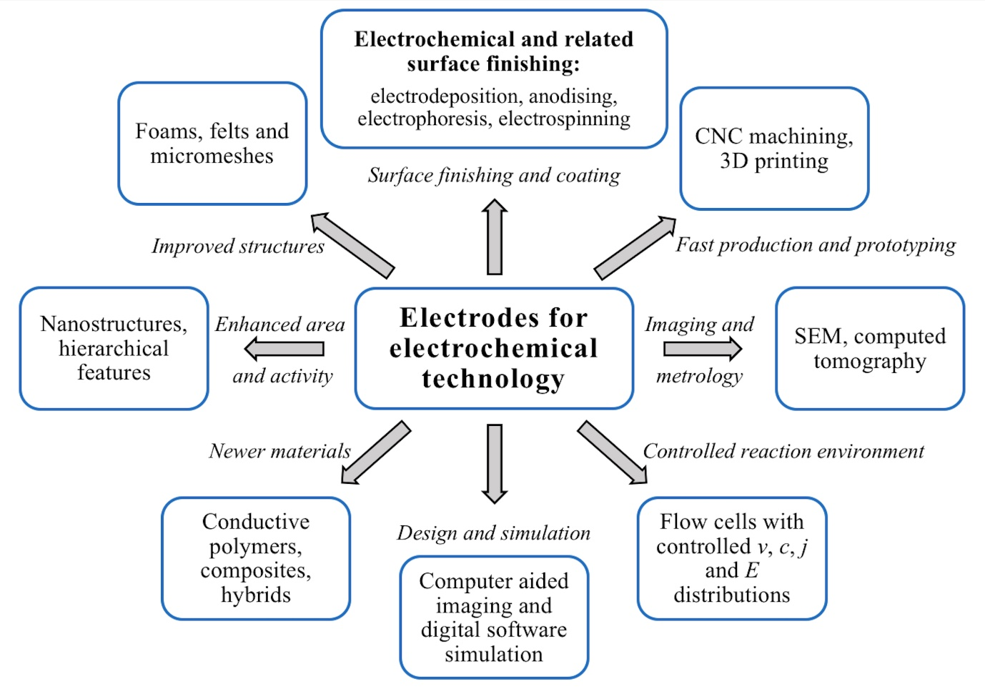Figure 3

Figure 4

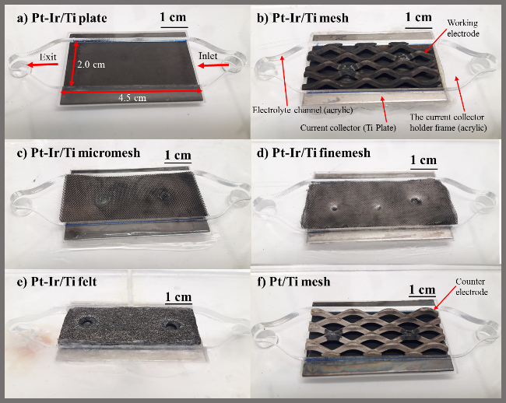
a)
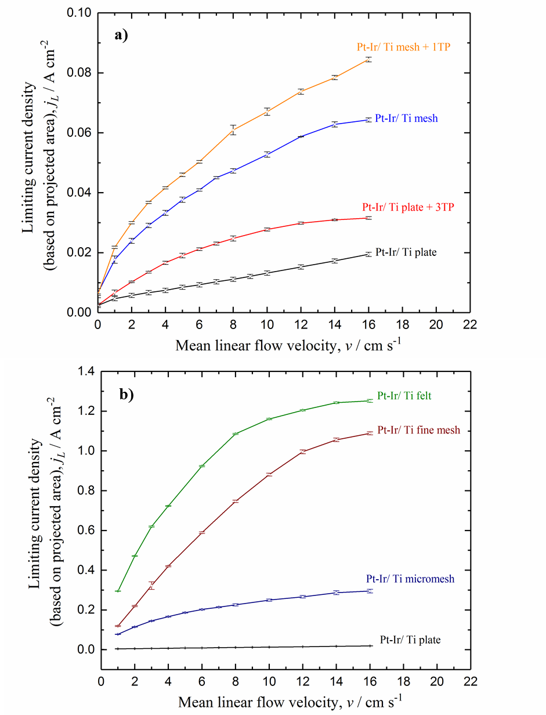

b)
Figure 5

a)
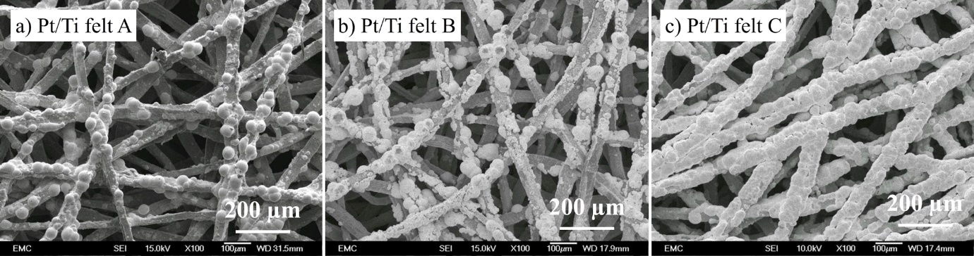

B)

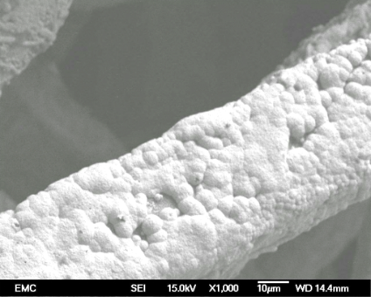
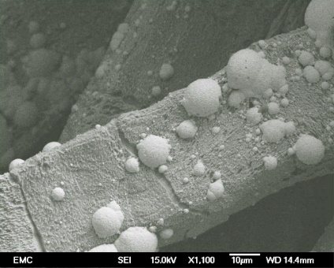
Figure 6
Partly-covered
18.6 mg cm⁻³

a)

j / mA cm⁻²
Frequency / Hz
Z’ / ohm
t / s
E_{cell} / V
Figure 7

a)
b)
c)
Figure 8
a)
b)

Figure 10

a)
b)
c)

Figure 11

Electrodes
for modern
technology
Corrosion protection
Tribology
Energy storage and conversion
Bioimplants and medical textiles
Electrosynthesis of chemicals
Sensors and monitoring

Figure 12

