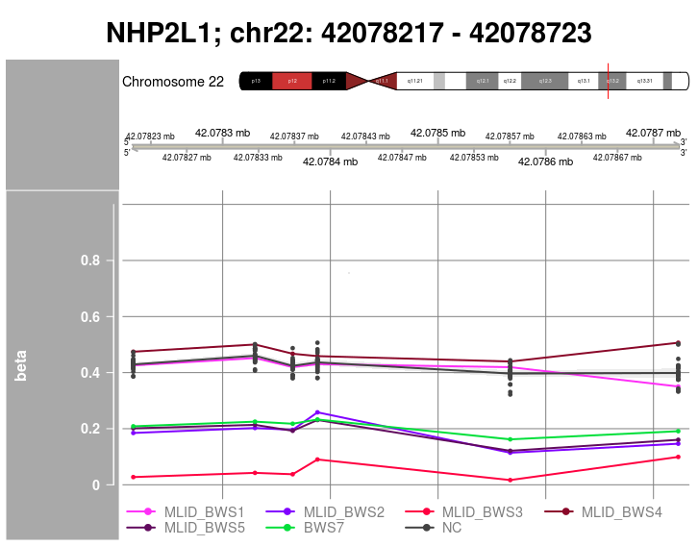 | 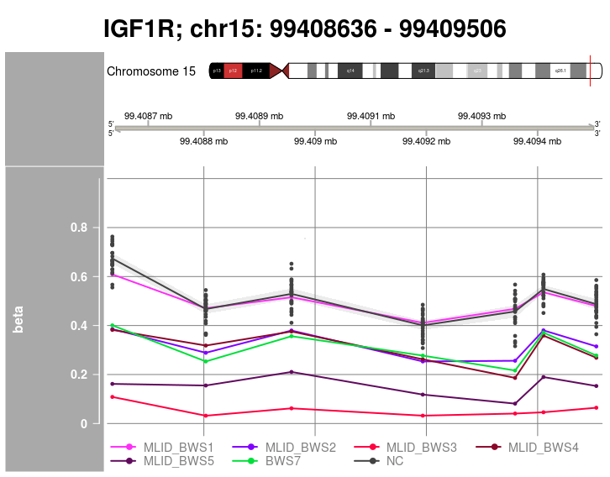
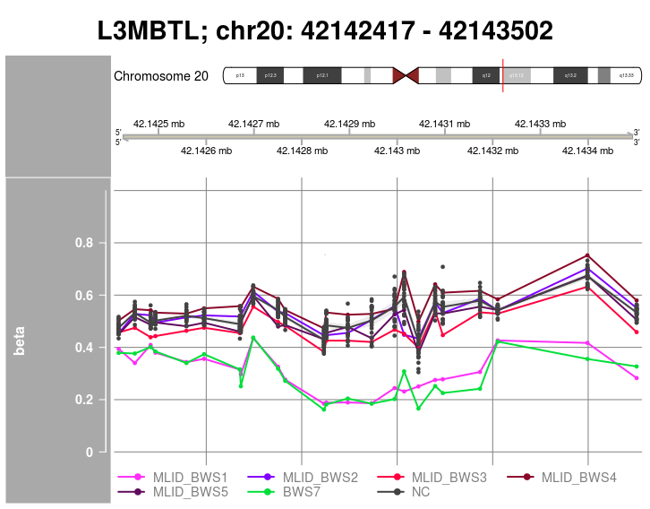 | 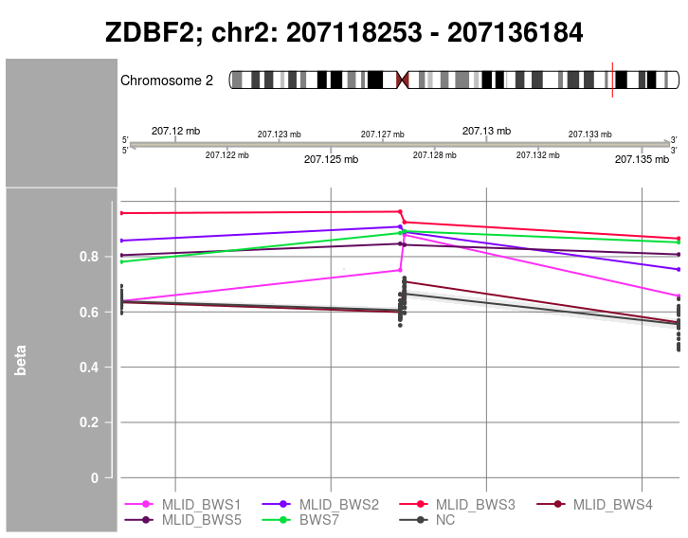
Figure 2. Aberrant methylated imprinted DMRs in BWS7 and MLID BWS patients. NC represents confidence interval of betas values in normal controls.

