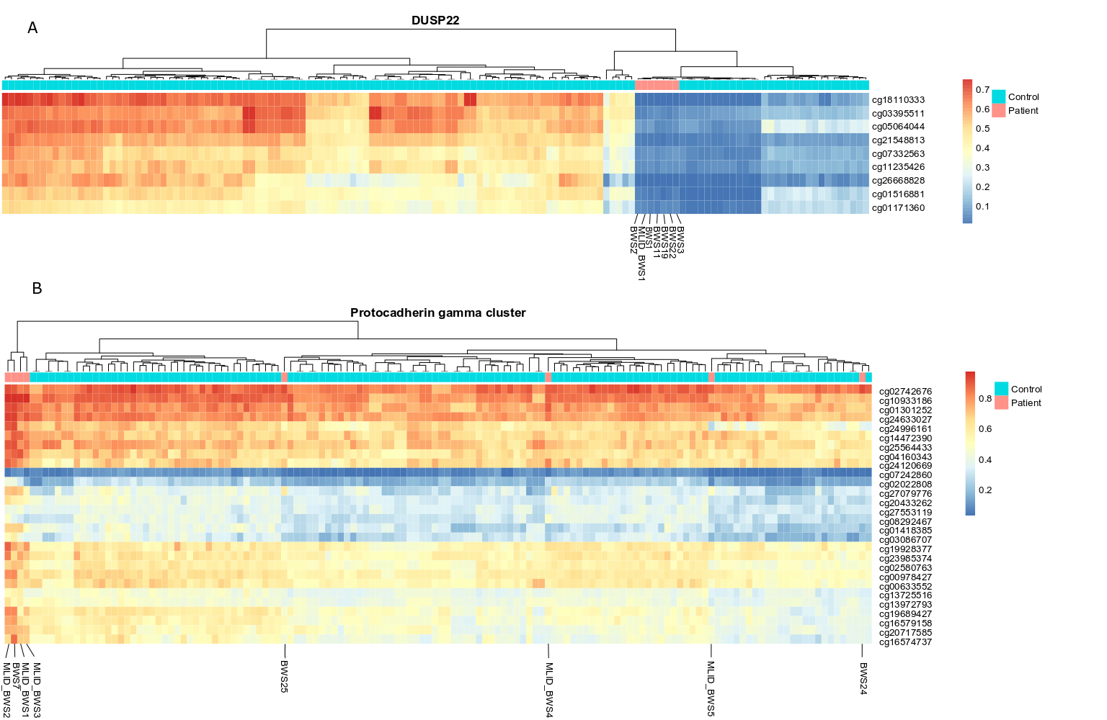
Figure 4. The heatmaps of altered methylated probes from the comparative analysis. The blue beam represents healthy individuals from three different cohorts, and the red beam represent BWS patients. NOTE: normal controls come from three different batches that are visible on the plots. A: Unsupervised hierarchical clustering of the beta values of the significantly hypomethylated probes annotated to the DUSP22 detected in the current study. B: Unsupervised hierarchical clustering of the beta values of the significantly hypermethylated probes annotated to the protocadherin gamma gene cluster detected in the current study.

