From the Simulator to the Road – Realization of an in-vehicle interface to support fuel-efficient eco-driving.
Craig Allison¹, James Fleming¹, Xingda Yan¹, Neville Stanton¹ and Roberto Lot¹

Faculty of Engineering and Physical Sciences, University of Southampton, Boldrewood Innovation Campus, Southampton, SO16 7QF, United Kingdom
{Craig.Allison, J.M.Fleming, X.Yan, N.Stanton, Roberto.Lot}@soton.ac.uk
Abstract. Motivated by the observation that modifying driver behavior can significantly reduce fuel usage and CO₂ emissions, this paper documents the development of a dedicated in-vehicle interface to support eco-driving. This visual interface has been tested in simulator conditions, demonstrating an 8.5% reduction in fuel use, and will soon be deployed on-road. Transitioning from simulator testing to on-road testing presents significant challenges to ensure driver safety and system effectiveness in the presence of changing road conditions and imperfect information about the current driving scenario.

Keywords: Human Factors · Interface Development · User Testing · Eco-Driving
- Introduction
The International Energy Agency estimates that transport accounts for 35% of overall global energy use [1], with passenger cars and light duty vehicles alone accounting for 21% of this. Such vehicles are also responsible for 24% of global carbon dioxide (CO₂) emissions. Considered within the context of global warming, it is estimated that 14% of global mean temperature change will be a direct consequence of transportation, with automobiles being the primary contributor [2]. Approaches to addressing the problem of high fuel use and high emission road transportation currently being promoted by governments include the use of alternative transportation schemes such as cycle to work events [3], and the development of alternative, environmentally friendly and fuel efficient vehicular drivetrains, including electric or hybrid vehicles [4]. Although these methods are demonstrating signs of success, the initial high investment cost and in some cases a lack of corresponding infrastructure [5] act as barriers to limit uptake

One alternative to such schemes, however, is the changing of driver behaviors to improve fuel-efficiency by employing eco-driving techniques [6]. Approximately 5% - 20% of CO₂ emissions can be eliminated if drivers drove in a more eco-friendly way [6]. Eco-driving is typified by behaviors such as gentle acceleration, prompt gear changes, limiting the engine to approximately 2,500 revolutions per minute (RPM), anticipating traffic flow to minimize braking, driving below the speed limit, and limiting unnecessary idling, with drivers who exhibit such behaviors recording dramatically reduced fuel use and greenhouse gas emissions [6]. Whilst eco-driving is, from the drivers’ perspective, a cost-effective approach to reduce fuel use [7], previous research has demonstrated that some eco-driving behaviors are difficult to maintain long term [8], with the majority of drivers returning to their previous driving style when not under direct observation [9]. One approach to supporting drivers in achieving greater fuel economy is via the use of in-vehicle interfaces [10]. The provision of feedback to driver actions has been essential in supporting eco-driving long-term [10].

However, questions remain regarding how to present this feedback information to drivers and the value that this can have in terms of overall fuel usage. To this end, a visual interface was developed that displays real-time speed recommendations to the driver. This interface forms part of a speed advisory system that attempts to coach the driver into more fuel-efficient behavior by computing the most fuel-efficient speed and acceleration choice given the current driving situation.
- Interface Display & Driving Simulator
A prototype of the described system was tested within the Southampton University Driving Simulator (SUDS), based at the University of Southampton, UK (Fig 1). SUDS comprises of a 2015 Land Rover Discovery Sport and a simulated roadway environment that is projected across three forward mounted screens. A fourth projector screen is situated behind the vehicle, and LCD screens are placed on each of the side-view mirrors to simulate the view in the rear-view and side view respectively. Engine noise is simulated using the vehicle’s internal audio system. The simulator uses the software package STISIM, which runs on a Windows 7 PC.

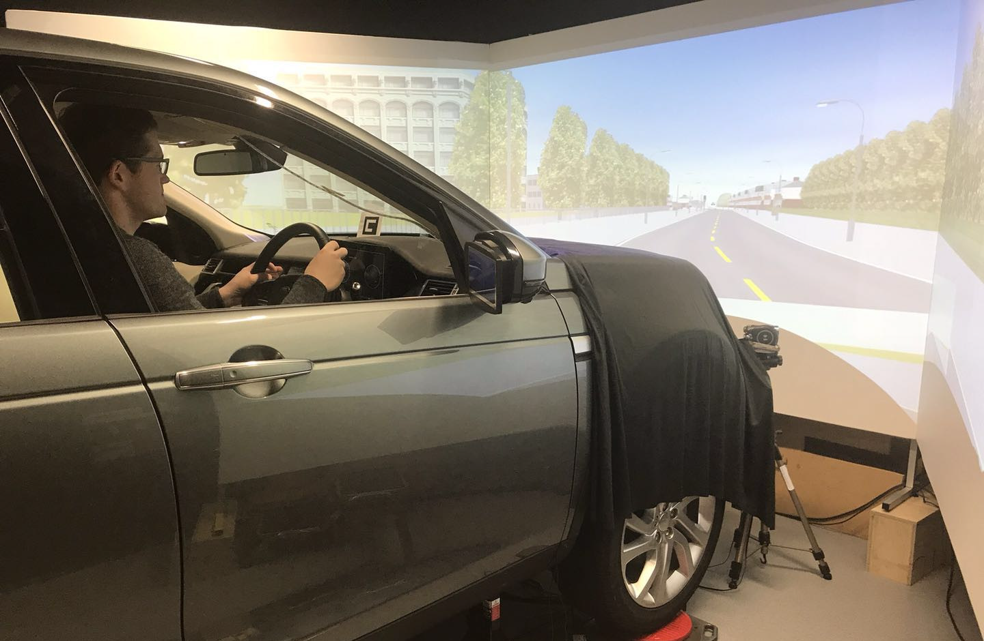
Fig. 1. Southampton University Driving Simulator (SUDS)

The speed advisory system calculates the most fuel-efficient speed for the current road environment based upon preceding vehicles, road curvature, road type and current vehicle speed. This speed recommendation is used to update the visual interface, which also receives the updated simulation state from STISIM in order to update the speedometer and RPM counter.

The visual interface was designed and developed in C# using Windows Forms as a graphical library. The resulting application was executed on a Microsoft Surface Pro tablet, which is placed directly behind the steering wheel of the car to replace the physical instrument cluster. The visual design of the interface is shown in Figure 2 and comprises of a speed and RPM display augmented with a green and yellow ‘eco-band’ to recommend a near-optimal speed range to the driver. The green-region provides the driver with a range of speeds recommended for fuel-efficient driving based on the current vehicle, road and traffic state. A further yellow region allows some margin for error and has a width chosen to correspond to typical speed variations observed in normal driving [11][12]. A similar ‘eco-speedometer’ design was rated highly in perceived usefulness and user acceptance in a previous study [10]. When in use, the interface updates in real-time with the green eco-band stretching from zero speed to the current recommendation. As the situation changes, this speed changes, which has the effect of smoothly interpolating between recommended speed values to gently ‘coach’ the driver into following the optimal speed profile. Technical details of the speed advisory system can be found in [13], while information regarding the design of the visual interface appears in [14].

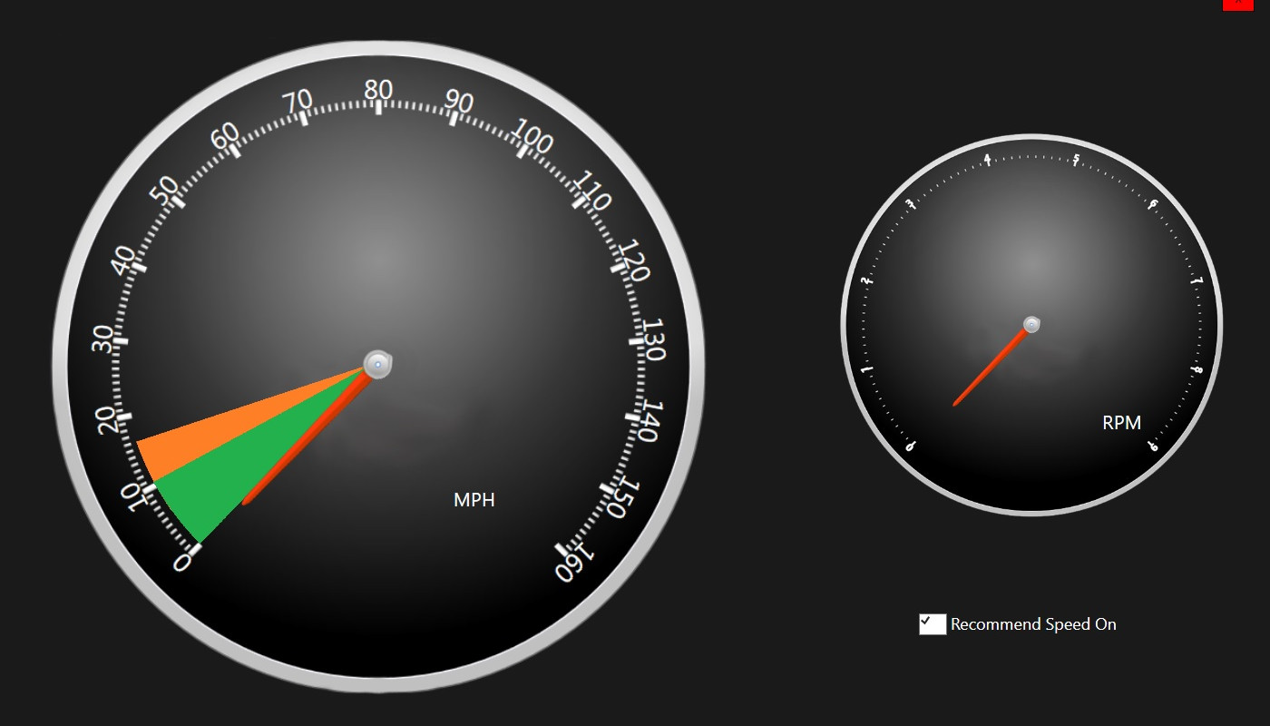
Fig. 1. Visual interface to speed advisory system
  - Initial Evaluation
To explore the effectiveness of the interface display, 36 participants (18 male, 18 female) completed a laboratory study within the SUDS laboratory. Participants were required to drive a 13-mile simulated route, based on roads in Southampton, UK. Each participant drove in three test conditions: normal driving, unassisted eco-driving, and driving with use of the speed-advisory system to support their driving. The order in which the different test conditions were completed was fully counterbalanced. A variety of objective data was collected during the simulated drives, including speed, acceleration, throttle position, brake pedal position and headway. This data was processed using detailed vehicle powertrain models to provide an accurate estimate of fuel consumption. In addition, participants were required to complete a variety of subjective measures for each of the three drives including the Dundee Stress State Questionnaire (DSSQ) [15][16], NASA Task load Index (NASA-TLX) [17] and the System Usability Scale (SUS) [18].

Results demonstrated that whilst participants used the least amount of fuel when asked to drive in a fuel-efficient way, saving approximately 11% in total fuel usage compared to normal driving, this driving style was associated with significantly greater workload. Use of the developed interface in contrast allowed participants to achieve an approximate 8.5% fuel saving, without the corresponding increase in workload, suggesting that drivers would be more able to use the developed system long term.

- Real Road System Adaption
Following the simulator study, the visual interface was adapted for installation within the University of Southampton Instrumented Vehicle in preparation for on-road testing. Three key challenges emerged, relating to driver safety, filtering of on-board sensor signals, and initiation of coasting by the driver.

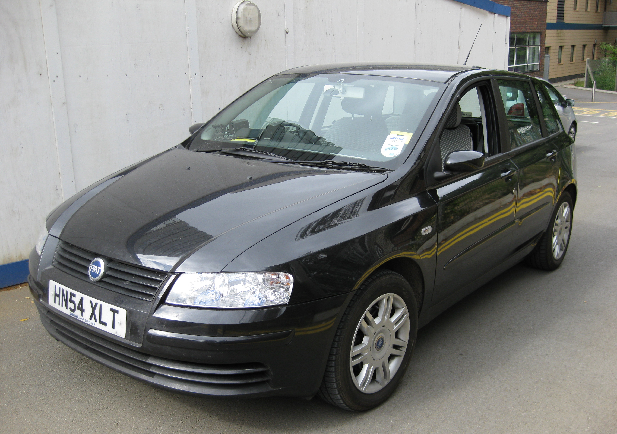
Fig. 3. University of Southampton Instrumented Vehicle
  - Safety
The foremost concern in moving from simulator testing to on-road testing is ensuring that the driver can operate the vehicle safely with the speed advisory system activated. Considered within this context, the interface developed should not be distracting to the driver and, should the system fail, a speedometer should still be available to the driver. To reduce this risk, the interface was modified so that the image is projected on the windscreen as a Head-Up Display (HUD), rather than as a Head-Down Display replacing the instrument cluster. This modification reduces the potential for distraction effects and ensures that the vehicle speedometer remains available to the driver.
  - Sensor signal filtering
A key technical challenge faced in a real vehicle is inaccuracy of measurements of the road and traffic state, in particular the headway distance to the leading vehicle which is processed to provide the speed recommendation. In the simulator, the position and velocity of all other road users are known precisely. However, in the real world this information must be estimated from vehicle sensors such as a front-mounted radar, the signal from which is noisy and corrupted by spurious measurements from other metallic objects. This necessitated a filtering strategy to provide a reliable measurement of lead vehicle position and velocity, in order that the speed recommendation shown to the driver varies smoothly without any abrupt jumps.
  - Initiation of coasting
One observation from the simulator study is that, although it is effective at reducing fuel consumption overall, the current visual interface is ineffective at promoting ‘coasting’ behaviors in which the driver reduces speed gradually by releasing the accelerator pedal rather than by braking. Future work carried out prior to the on-road test will consider adding an indicator to the visual interface, potentially combined with an audible notification, to tell the driver when they should release the accelerator pedal to coast to a halt.
- Conclusions
This paper documented the development of a speed advisory system designed to improve fuel efficiency, motivated by the observation that greater adoption of eco-driving can be achieved using dedicated in-vehicle interfaces. The interface documented within the current paper has been tested in simulator conditions, demonstrating an 8.5% reduction in fuel use, and will soon be deployed on-road. Transitioning from simulator testing to on-road testing presents significant challenges that must be overcome. Whilst on-road testing is an essential step in any interface designed to modify driver behavior, deployment of such technologies in the real-world presents challenges in ensuring safety of the driver, and in ensuring system effectiveness.

Acknowledgments. This work was funded by the UK Engineering and Physical Sciences Research Council (EPSRC) grant EP/N022262/1 “Green Adaptive Control for Future Interconnected Vehicles” (www.g-active.uk).
References
- International Energy Agency (IEA) Key world energy statistics. https://www.iea.org/publications/freepublications/publication/KeyWorld2017.pdf
- Skeie, R.B., Fuglestvedt, J., Berntsen, T., Lund, M.T., Myhre, G., & Rypdal, K. Global temperature change from the transport sectors: Historical development and future scenarios. Atmos Envir, 43, 6260-6270. (2009).
- Rose, G., & Marfurt, H. Travel behaviour change impacts of a major ride to work day event. Trans Res Part A: Pol and Prac, 41, 351-364. (2007).
- Lorf, C., Martı́nez-Botas, R. F., Howey, D. A., Lytton, L., & Cussons, B. Comparative analysis of the energy consumption and CO2 emissions of 40 electric, plug-in hybrid electric, hybrid electric and internal combustion engine vehicles. Tran Res D: Trans Env, 23, 12-19. (2013).
- Yilmaz, M., & Krein, P. T. Review of battery charger topologies, charging power levels, and infrastructure for plug-in electric and hybrid vehicles. IEEE Trans Power Elec, 28, 2151-2169, (2013).
- Barkenbus, J. N. Eco-driving: An overlooked climate change initiative. Energy Policy, 38, 762-769. (2010).
- Birol, F. CO2 emissions from fuel combustion-highlights. International Energy Agency. (2011).
- Delhomme, P., Cristea, M., & Paran, F. Self-reported frequency and perceived difficulty of adopting eco-friendly driving behavior according to gender, age, and environmental concern. Trans Res D: Trans Envir, 20, 55-58. (2013).
- Lai, W. T. The effects of eco-driving motivation, knowledge and reward intervention on fuel efficiency. Trans Res D: Trans Envir, 34, 155-160. (2015).
- Meschtscherjakov, A., Wilfinger, D., Scherndl, T., & Tscheligi, M.. Acceptance of future persuasive in-car interfaces towards a more economic driving behaviour. In Proceedings of the 1st International Conference on Automotive User Interfaces and Interactive Vehicular Applications (pp. 81-88). ACM. (2009)
- Yan, X. Fleming, J. Allison, C. and Lot, R. Portable Automobile Data Acquisition Module (ADAM) for naturalistic driving study. In 15th European Automotive Congress (2017).
- Fleming, J.M., Allison, C.K., Yan, X., Stanton, N.A., & Lot, R. Adaptive driver modelling in ADAS to improve user acceptance: A study using naturalistic data. Safety Sci. (2018).
- Fleming, J.M., Yan, X., Allison, C.K., Stanton, N.A., & Lot, R. (2018). Driver Modeling and Implementation of a Fuel-saving ADAS. IEEE Conference on Systems, Man and Cybernetics (SMC).
- Allison, C.K., Stanton, N.A., Fleming, J.M., Yan, X., Goudarzi, F., & Lot, R. Inception, Ideation and Implementation; Developing Interfaces to Improve Drivers’ Fuel Efficiency. Paper to be presented at Chartered Institute of Ergonomics and Human Factors (CIHEF) Ergonomics & Human Factors, Birmingham, UK (2018)
- Matthews, G., Joyner, L., Gilliland, K., Campbell, S., Falconer, S., & Huggins, J. Validation of a comprehensive stress state questionnaire: Towards a state big three. Pers Psych Eur, 7, 335-350. (1999).
- Matthews, G., Campbell, S. E., Falconer, S., Joyner, L. A., Huggins, J., Gilliland, K., ... & Warm, J. S. Fundamental dimensions of subjective state in performance settings: Task engagement, distress, and worry. Emotion, 2(4), 315. (2002).
- Hart, S.G., & Staveland, L.E. Development of NASA-TLX (Task Load Index): Results of empirical and theoretical research. In Advances in psychology (Vol. 52, pp. 139-183). Elsevier. (1988).
- Brooke, J. SUS: a “quick and dirty‟ usability scale. In P.W.Jordan, B. Thomas, B.A. Weerdmeester, and I.L. McClelland (Eds.) Usability Evaluation in Industry (189-194). London: Taylor and Francis. (1996)

