This document is the Accepted Manuscript version of a Published Work that appeared in final form in British Journal of Midwifery, copyright © MA Healthcare, after peer review and technical editing by the publisher. To access the final edited and published work see https://doi.org/10.12968/bjom.2019.27.1.15

LACK OF CARE?
WOMEN’S EXPERIENCES OF MATERNITY BLADDER MANAGEMENT

KEY POINTS
- This study addresses gaps in knowledge regarding women’s experiences in maternity bladder care.
- An evident mismatch exists between women’s expectations and reality, largely due to the lack of preparation and awareness regarding bladder health.
- Women and clinicians typically prioritise the baby’s wellbeing and mental health issues over physical concerns such as bladder care.
- An existing lack of understanding, information, and promotion regarding bladder care is aggravated by the use of an ambiguous language when enquiring about bladder health.

BACKGROUND
Although a healthy urinary system is vital aspect to every woman’s life, healthcare professionals often neglect bladder management during pregnancy, labour, and puerperium . The relationship between childbirth and bladder dysfunction is well documented in the medical literature (Chaliha, 2006). However, experiences in maternity bladder care have not been published, and no research has been developed to address this topic to date. Stress urinary incontinence is estimated to be present in over 150 million women worldwide by 2018 although childbirth is not the only risk factor (Stothers and Friedman, 2011). Modern Western lifestyle activities contribute to the development of SUI in young nulliparous women of childbearing age, such as certain forms of exercise, obesity, constipation, smoking, and caffeine and alcohol consumption (O'Connell et al., 2001). According to 2014/2015 statistics in England, approximately 58% of women were obese or overweight, 28% ate the recommended five portions of fruit and vegetable a day, 31% played sport at least once per week (HSCIC, 2016), and 44% had drank alcohol once a week or more (NHS digital, 2016). The global female population is currently facing a public health crisis, which is responsible for physical and psychological chronic morbidities, directly affecting their quality of life and negatively impacting socioeconomic outcomes . This situation is further aggravated by the normalization of urinary dysfunction , embarrassment, stigma, and the subjective nature of the topic, which means that prevalence is likely to be underestimated . Furthermore, the existence of research gender bias, which is reflected in the underrepresentation of female participants, facilitates the prioritisation of male issues to the detriment of female health issues (Ovseiko et al., 2016), such as urinary incontinence (UI).
It is therefore perhaps not surprising that there has been little focus on women’s experiences of bladder care during childbirth. This situation represents a squandered opportunity to inform, explore, and diagnose postnatal urinary incontinence , as well as chronic failure to promote healthy urinary systems and increase the degree of awareness and control of bladder health among females. This feeling of control (Bryanton et al., 2008), coupled with the level of childbirth preparation and expectation (Goodman et al., 2004), ultimately impacts woman satisfaction with maternity experiences. In order to highlight this important point, the present study provides insight into women’s knowledge, perceptions, and opinions of their maternity bladder care.

METHODS

Study aim
The aim of this study was to explore experiences of bladder care during pregnancy, labour, and after birth. Bladder care has a well-defined remit within midwifery practice.

Study design
A qualitative, exploratory, and descriptive approach was used.

Sampling and setting
A purposive sample of nine participants was sought from women who had received maternity care and given birth at one hospital in South England and/or its two associated birth centres.

Ethical approval
Ethical approval was granted by the London - City & East Research Ethics Committee (REC Ref: 16/LO/1182).

Funding sources
This research was part of a Health Education England/National Institute for Health Research Masters in Clinical Research Studentship for Non-medical Health Care Professionals.

Participants
Participants were eligible to join the study if they met the inclusion and exclusion criteria (Box 1 and 2).
Box 1: Inclusion criteria.

- Women who received antepartum, intrapartum, and postpartum care.
- Women who had birthed a live, singleton, term baby (37-42 weeks gestation) from two weeks to six months prior to the interview.

Box 2: Exclusion criteria.

- Women and newborns with serious medical and/or life-threatening conditions, stillbirths, neonatal deaths, or traumatic births.
- Lack of fluency in English or Spanish.
- Minors (under 18 years old).
- Inability to be interviewed due to cognitive impairment or disabilities.

Furthermore, in order to avoid biasing the participant-researcher interaction, participants were also excluded if the principal investigator had provided clinical midwifery care to them (Moch, 1999). Initially, postnatal midwives screened for potential participants prior to discharge. However, this strategy was unsuccessful. Therefore, additional ethics committee approval was obtained to recruit via the Facebook pages of local maternity groups, which proved to be a very effective approach. Additionally, a heterogeneous representation of different modes of birth was sought (Table 1).
Data collection

The Principal Investigator, a female practising midwife and Master’s degree student in Clinical and Health Research, undertook in-depth semi-structured interviews at a time and place of participants’ convenience (a participant’s home or the University). An interview guide (Table 2) was used to minimise the inclusion of interviewer bias, and to perform universal enquiry across all participants (McNamara, 2009). This interview guide was previously piloted, and the data collected was included for analysis. A total of nine women participated in the study. Interviews lasted from 15 to 54 minutes, were digitally recorded, and transcribed verbatim by the principal investigator. Data were collected between February and March 2017. Participants selected their own pseudonyms.

Data analysis
The data obtained were analysed following Pope et al.’s framework (2000) following an inductive perspective and assisted by a memoing technique (Birks et al. 2008). To ensure trustworthiness and to establish confirmability in the analytical process, an audit trail (Lincoln and Guba, 1985) was used (Table 3).

Table 1: Participant characteristics.
Participant | Parity | Mode of birth | Baby’s age at interview |  |  | Catheter required | Leaking episodes
Cally  Participant #1 | 2 | Water birth with perineal tear (repaired) | 6 months |  |  | No | After birth
Shannon  Participant #2 | 1 | Water birth with grazes (no repair needed) | 4 months |  |  | Unable to  urinate  after birth | After birth
Sarah  Participant #3 | 2 | Water birth with perineal tear (repaired) | 8 weeks |  |  | No | After birth
Halina  Participant #4 | 1 | Forceps, epidural and episiotomy | 6 weeks |  |  | With epidural | After birth
Alice  Participant #5 | 1 | Ventouse with episiotomy | 6 months |  |  | No | After birth
Abi  Participant #6 | 1 | Forceps, episiotomy, and epidural | 7 weeks |  |  | With epidural | In pregnancy
Karla  Participant #7 | 2 | Spontaneous vaginal birth with perineal tear (repaired) | Less than 6 weeks |  |  | No | None
Lisa  Participant #8 | 2 | Spontaneous vaginal birth (no perineal repair) | 19 weeks |  |  | Management of retained placenta | None
Anna  Participant #9 | 1 | Elective caesarean section | 7.5 weeks |  |  | At C-section | In pregnancy

Table 2. Extract of interview guide.
Q3. What is bladder care for you?
Q4. If you compare before pregnancy and after having your baby, have you noticed any changes when passing urine?
Q8. Tell me about your experience of passing urine during pregnancy/labour/postpartum.
Q11. How do you feel about the care you received regarding your bladder during pregnancy/labour/ after the birth of your baby?
Q18. Can you tell me what do you understand by pelvic floor exercises? How do you feel about them? Has anyone told you about them?

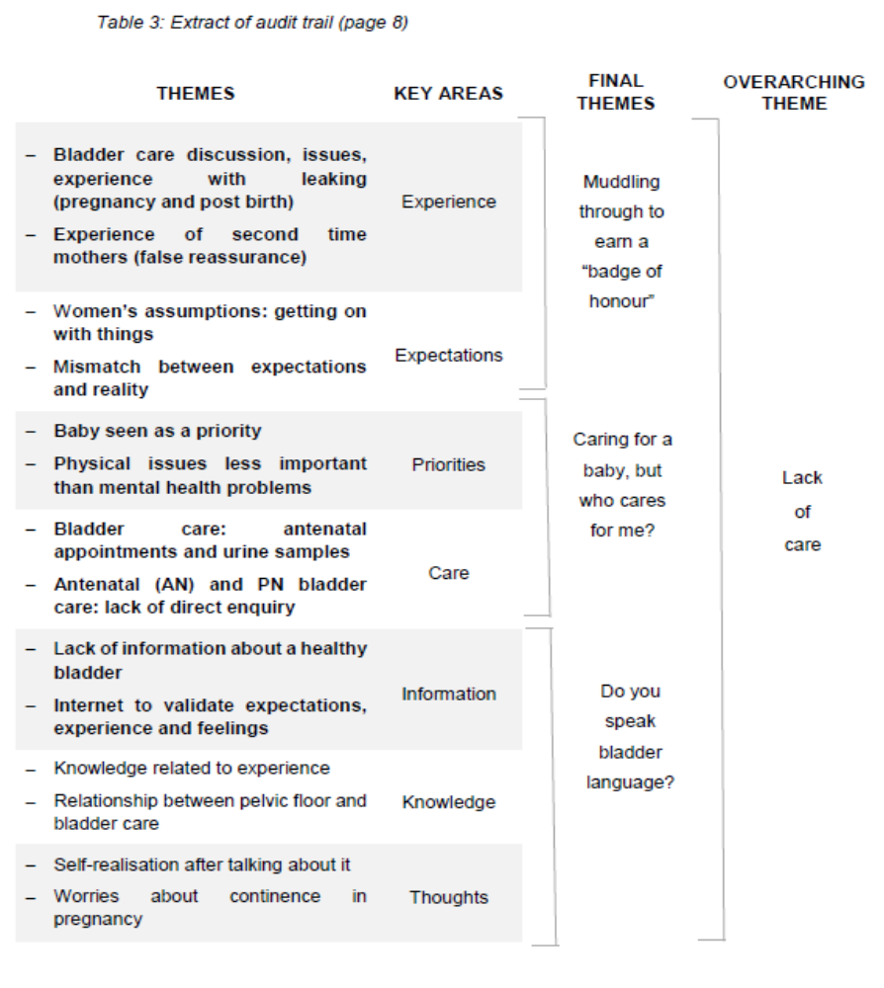
FINDINGS

This study was expecting to collect women’s experiences of bladder care during pregnancy, labour and after birth. However, women interviewed reported to have had limited maternity bladder care. Instead, they focused their attention on disclosing their experiences of bladder issues, particularly UI. Consequently, the main finding is that there was a scarcity of maternity bladder care received by the women interviewed.

Overall, of the nine women interviewed, five had experienced some degree of incontinence following birth and two during pregnancy. Initially seven themes emerged by applying the framework analysis. An amalgamation of common themes was undertaken following consensus with the principal investigator’s supervisor, resulting in four final themes (Table 2).

Muddling through to earn “a badge of honour”

Under this theme, several key areas have been identified: environment, mismatch of expectations and reality, false reassurance, lack of preparation, normalisation, and getting on with things (Figure 1).
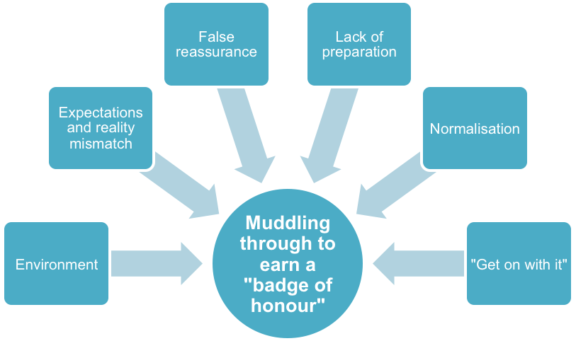
Figure 1. Muddling through to earn “a badge of honour”.

Although women recognised that their bodies had suffered changes following childbirth, those experiencing urinary leaking episodes did not regard them as a symptom of ill health, but rather a formality of the childbearing experience instead. Moreover, this formality of being incontinent after birth seemed to be translated into a “badge of honour”. One participant in particular realised that she was experiencing UI only after discussing her experience. Consequently, only three women had disclosed their symptomatology to a health care professional. By contrast, other women felt “lucky” regardless of whether they experienced incontinence or not:

Sarah/Participant #3: “That joke about how once you have a baby, things won’t be the same and all that, which nobody tells you before you have a baby – obviously. I suppose it’s almost like a badge of honour, isn’t it? Things definitely change […] I guess it’s just one of those things, isn’t it? There’s nothing you can do about it really […] and actually, until you came here today, I wouldn’t have said I had problems, which is quite interesting. I just agreed to do the study to help”.

The findings also revealed an evident mismatch between expectations and reality. This mismatch could be explained by a lack of expectations that the women interviewed possessed regarding maternity bladder care. One participant in particular did not expect young women to experience UI, largely due to the association of incontinence with older age and its normalisation of the through media, and the advertisement of incontinence pads on TV:

Sarah/ Participant #3: “Before I was pregnant it was... it was something definitely to happen to older people or disabled people”.

Interestingly, women’s expectations varied according to the number of babies they had, which highlights the learning-from-experience approach of these mothers. Based on this, second-time mothers who participated in the study were expected to have acquired knowledge from previous pregnancies – a fact that made them assume that they had to “get on with things”:

Karla/ Participant #7: “For second-time mums they just expect you to know, you know, kind of get on with it […] I was fine cos it’s your second one, you kind of just get on with it, you don’t worry about them things”.

The pressure that health care professionals exert onto second-time mothers could originate a false sense of reassurance, as they build their expectations from exposure, which could thereby offer a distorted sense of security. Therefore, if their expectations did not match their reality with their first baby, this false reassurance will be perpetuated in subsequent pregnancies. Another false reassurance was noted as a result of the ability to urinate ‘normally’ after birth in contrast with the appearance of UI months later:

Cally/ Participant #1: “I think perhaps it gave me like a false sense of security, like, after I had him that... because I was able to like pee like a bucket”.

Expectations about a healthy bladder were built from the environment and women, particularly those experiencing ‘leaking’ issues during the postpartum period, either normalised or worried about them depending on the experiences of their inner circle:

Halina/ Participant #4: “People laugh about, even if you sneeze you wet yourself, and, you know, sort of don't jump up and down and that sort of thing. So I guess it's just normal anyway”.

Although expecting certain degrees of adjustment in the postpartum period, women felt that the lack of preparation regarding bladder changes significantly impacted their ability to process the experience. Anticipation and forewarning would have been preferred as opposed to dealing with unforeseen issues during a vulnerable time:

Halina/ Participant #4: “I expected that to be some difference, but it did really sort of surprise me quite a lot, and they said because of the forceps can cause some trauma to the bladder […] I think there may be a bit more emphasis put on it to say, you know, at this extreme, this could happen, and it is quite normal […] because I only had that conversation really after it happened. But at that point, you sat there and cried about it and then you've got the advice and you are emotional anyway cos you've just given birth – and so it's not the best time for them to be told […] other people go through it, so to have been told before hand”.

Moreover, women did not seem to feel the need to practise pelvic floor exercises (PFE) despite the existence of leaking issues. Again, the ability to urinate in their habitual manner could have jeopardised their capacity to recognise UI:

Cally/ Participant #1: “It's not something that you need to do, like if you are hungry you need to eat and it's easy, you can fix your problem, but you don't need to do your PFE […] if it's working you don't sort of think about it”.

Caring for a baby, but who cares for me?

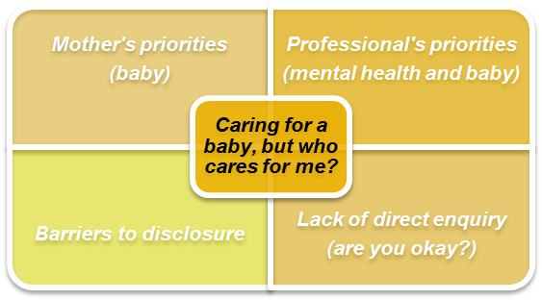

Figure 2. Caring for a baby, but who cares for me?

This theme covers mothers’ and professionals’ priorities, and barriers to disclose bladder problems were exacerbated by a lack of direct enquiry (Figure 2).
Women reported that all of their efforts shifted towards their babies, their families, and their houses to the detriment of themselves during the postnatal period.

Cally/ Participant #1: “I do think that sort of is more about them than it is about you […] I find self... like your care for yourself tends to go out the window”.

Lisa/ Participant #8: “[…] all you are thinking about is feeding and the baby. You don't really worry about yourself well… personally, I didn’t too much”.

Prioritising the needs of their baby before their own needs was perceived to have a prejudicial effect on their ability to maintain a healthy bladder. Despite prior or on-going incontinence, a fully functioning urinary system does not seem to be a priority for some women.

Sarah/ Participant #3: “Yes, I am at the moment (incontinent), so hopefully I will do something about that respect. It’s not… it’s not really in my mind to be honest, with these two.”

Abi/Participant #6: “Just when you have a baby… after the baby it's like... oh, everything is your baby and you just don't think to sit there and just do it for two minutes (PFE). You are thinking of doing something else, like oh the baby's asleep let's clean the house or make dinner, or like, do all the house, like, duties”.

Additionally, clinicians’ priorities perceived by women seem to reinforce the self-abandonment of care by moving attention away from physiological and pathological physical changes occurring during the postpartum period.

Halina/ Participant #4: “There's so much focus on the birth and what to do before... I think other than postnatal depression, which is, you know, heavily touched on, kind of what happens to your body and everything else is probably… there’s less emphasis on that because I think it's almost... there you go, you are fine, off you go. And I think that's probably where there needs to be more focus, so just... you've been all prepared for it”.

Sarah/ Participant #3: “When I saw the title of your paper I thought ‘that’s quite unusual’ because most postpartum care tends to focus on breastfeeding, periods, fertility, weight gain, depression, moods, and things. So that, to me, indicates that it’s quite low down in people’s list of priorities because it is all about how you and the baby are, if the baby is feeding, if the baby is growing, if you are healing, if you are depressed, how is your mood…”.

During the antenatal period, women do not feel any different regarding the prioritisation of care from health workers. Once more, health care providers are missing opportunities to enquire about, promote, and provide bladder care. Instead, any hint at bladder management ends at the collection of urine samples:

Anna/ Participant #9: “it's more about whether I had a urine infection rather than whether there was continence. That was more the question – whether I had cystitis, I suppose”.

Abi/ Participant #6: “I didn’t really think about bladder care during pregnancy to be honest, maybe she (midwife) should have mentioned... I don't know, asking more about how I was passing urine, if it hurts, you know, anything like that. But they mainly just took your urine sample every time you went in and just check, like, the protein and stuff”.

Due to the apparent lack of significance that bladder care is provided, women are led to believing that any bladder symptom lacks value compared to other areas of maternity care, which could be regarded as a barrier for disclosure. The women interviewed had also expressed their concerns about discussing their bladder status with health care professionals. One participant manifested her internal conflict between embarrassment and speaking up for the sake of her own health:

Halina/ Participant #4: “I’m quite relaxed about a lot of things […] I’m just trying to just get by and not mention stuff […] But it's when the doctor came around when I was in hospital and explained just how important it was. I think since then, it's been in my head, and I think people may not realise how important it is to say something or highlight that something is not normal […] I think maybe to educate people a bit or to put your hands up, you know […] I was about to be discharged actually, when I thought I’m not sure if, you know, I've got issues with my bladder […] but yeah that was only from them speaking to me that I kind of then understood really how important it was to say something […] The embarrassment and everything, you have to kind of get over that. Particularly, if I hadn't said anything, I could have gone home and had problems […] but I could see how people may get embarrassed or worried about talking about it”.

Other ‘barriers to disclose’ identified were related to how professionals – particularly General Practitioners at the routine six-week postnatal check – presented themselves and dealt with care, including clinician’s characteristics. Women also emphasised the lack of direct and specific enquiry regarding potential bladder problems, which is regarded as a preferable option to spontaneous disclosure:

Anna/ Participant #9: “I think he was a bit shy […] I didn't really get the impression like he was particularly confident talking about women's issues […] They could have been a bit more sort of specific, and the midwives or... you know, saying… covering the questions specifically – asking if there was a problem or not”.

Sarah/ Participant #3: “[…] it just didn’t feel like a natural situation to bring it back, but I had a few questions I would have liked to ask, but he couldn’t have been less interested really so… […] He didn’t have a great bedside manner so… it would have made more sense to me, I suppose, if they give you […] someone who perhaps has a bit of… you know, caring nature about them… So yeah, that’s probably why I didn’t bring it up then”.
Do you speak bladder language?
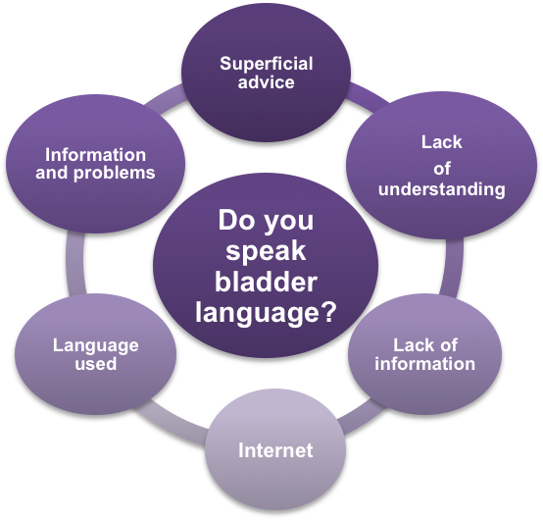

Figure 3. Do you speak bladder language?

This final theme encompasses issues surrounding information and advice provided to women, their lack of understanding, the language used to communicate with them, and use of Internet (Figure 3).

Women’s lack of understanding of bladder terminology such as bladder care, hesitancy, urine flow, and the link between pelvic floor (PF) muscles and continence uncovers a potential misinterpretation – and therefore miscommunication – between health care providers and women when discussing and reporting bladder health. The ambiguous approach and language used by clinicians to enquiry about bladder functioning aggravates this on-going lack of understanding. Therefore, assessment is narrowed to a woman’s ability to pass urine. For some women, this enquiry alone does not pose enough weight to trigger disclosure; thus, perhaps clinicians are not asking appropriate questions.

Alice/ Participant #5: “I was told to keep doing PFE after birth. I don't know if that was to do with my bladder and going to the toilet, or if that was to do with helping with the stitches to heal”.

Abi:/ Participant #6: “I think she (the midwife) asked if I have been passing urine, but... that's about it really”.

Moreover, if women are not familiarised and proactively informed about bladder care, inertia will lead them to normalise certain symptoms such as leaking urine after birth, and lack of sensation and control.

Some clinicians, likely intending provide reassurance, have also diminished women’s worries. This may contribute to why this common issue has been misinterpreted and normalised:

Shannon/ Participant #2: “I’ve been like, not able to make it to the toilet […] I know it's obviously a common thing that can happen […] cos I know it's common (leaking) short of like, I just put up with it […] My partner has said to go to the doctor but I’ll just see because I know it's quite a common thing after ... I’ve just short of been using like, a pad”.

Halina/ Participant #4: “I was... actually told this is quite common as well, you know (from clinicians)”.

Cally/Participant #1: “I said I’m a bit concerned, and she (Health Visitor/midwife) just went ‘oh you are goanna get some of that after’… it was like, but yeah, it's my second one and I kind of know what to expect. I know it's gonna going to be weak, but I’m saying I am actually worried about this, and yeah, one of them didn't really take it on board and I was a bit... I’m pretty sure that's not normal”.

Women have also expressed concern regarding the paucity of information they received related to bladder care, both during and after their pregnancy. By contrast, they felt overwhelmed about the amount of information at discharge, among which bladder care and PF promotion was not present:

Halina/ Participant #4: “I don't think it's addressed that much […] I think it would be good to incorporate that in sort of the midwife appointment or classes cos I think it's kind of not really touched on enough”.

Shannon/Participant #2: “I think it's one of those things, you just sort of – you know about this sort of thing. So it goes without saying, I guess”.

Information on and promotion of PFE is still far from a universal recommendation both during pregnancy and after birth. Women often receive such recommendations from non-health care providers such as yoga/Pilates classes or pregnancy books, and some women are concerned about the fact that PFE is generally not discussed in great detail:

Alice/Participant #5: “It's kind of just ‘oh don't forget to do your PF’ and it's like, ‘oh, how exactly should I be doing them?’ But I don't know. You do them, but you don't know if you do them effectively or if you are just sort of not doing it right at all”.

Anna/Participant #9: “They all sort of mentioned generally, ‘make sure you do PFE’, but they don’t really go into detail. Maybe they don’t want to embarrass people. I don’t know, or they just haven’t got time”.

All this uncertainty and lack of preparation and provision of information from clinicians could explain the increasing use of Internet resources, such as mothers’ forums and Facebook groups, in order to validate and ascertain their experiences, expectations, and feelings, and to compensate for the absence of professional input:

Halina/ Participant #4: “It's like anything. You can cope with anything, I think, if you just think you are not alone […] So not looking for advice, just reassurance I guess, of other people having had the same problems I had”.

Alice/Participant #5: “Looking for advice like Googling – is it normal for this?”

Although women felt uninformed about their maternity bladder care, they were generally quite satisfied with their degree of awareness related to the provision of information on ill health:

Alice/Participant #5: “There wasn't really that much information otherwise, but then I hadn't really had problems”.

In contrast, one participant that experienced incontinence and lack of control directly after birth believed in the importance of pre-emptively informing new mothers about the possibility of encountering bladder problems. Nevertheless, she was torn between informing and/or scaring her pregnant friends:

Halina/ Participant #4: I have tried not to scare them […] I have already spoken to them beforehand and just said, ‘just be aware that this can happen’ […] I think if someone said to me then, I might not have been quite so scared when it happened nobody at any point really says, you know, sort of... they talk about PF, you may lose a bit of feeling, but that's quite far from, you know, you might wet yourself, I think. But also, you don't want to scare somebody who is about to have a child, so I think it's just in a sensitive way to mention that, you know, this can happen. And as I said when I’ve heard after the event that other people have had the same issue, it's actually quite reassuring. I think just to hear you are not alone. And it does, you know – it does get better. It's not forever”.

DISCUSSION

This study portrays the first in-depth views of experiences in maternity bladder care. Although this investigation did not specifically aim to target participants with urinary symptoms, it appeared that women experiencing some degree of bladder and PF issues might have felt attracted to take part in the study. Moreover, although the focus of the study was to explore experiences of care during pregnancy, labour, and after birth, the postpartum and the antenatal period had centred the attention of the majority of women interviewed. This could be explained by the importance that labouring women may place on other areas of care, and the perception of being less autonomous regarding their bladder care during birth.

The results of this study revealed that women experiencing changes after birth, such as loss of control, lack of sensation, or leaking episodes, tend to normalise and accept them. They also use conservative measures or wait for a spontaneous resolution rather than seeking professional help. This attitude could be explained by their constructed expectations of the childbirth experience. This trend has also been identified in a study focusing on women experiencing urinary symptoms after childbirth (Wagg et al., 2017). Furthermore, Melville et al. (2008) also concluded that UI is understood as being beyond a person’s control and part of being female when interviewing non-pregnant women about their perception of the aetiology of UI. This attitude is reinforced by the lack of knowledge that women generally possess regarding maternity bladder physiology. As such, women face the dilemma of how to recognise when something is wrong if they remain unaware of what is right. Unfortunately, the majority of women interviewed in the present study felt disappointed by practitioners. Antenatally, clinicians seemed to focus on illness diagnosis through urinalysis, while postnatally they only seem to pay attention to babies and mental health issues. Therefore, it is evident that the postpartum period continues to be a neglected area of women’s health, fuelled by a “conspiracy of silence” (Strahle and Stainton, 2006). In order to break free of this vicious cycle, clinicians should actively discuss bladder care and look beyond a woman’s ability to pass urine. Promoting a healthy bladder during pregnancy and after birth should not be limited to checking urine samples and recommending PFE. This neglect of bladder care could be originated by a professional’s lack of knowledge (Williams et al. 2003) or even embarrassment among clinicians, which contrasts with women’s willingness to be openly asked about their bladder status.

Another neglected area intrinsically related to bladder care is PF health promotion. Most women in the present study expressed concerns regarding the lack of information on PFE, including frequency, techniques, and – most importantly – duration. It is worrying that some women in the present study did not relate continence with their PF, and were expected to undertake PFE for a limited period of time. It is vital that women embed PFE as part of their daily routine for the rest of their lives (IUGA, 2011), and more emphasis should be placed on this recommendation. Women would greatly benefit from a detailed explanation behind PFE rather than the omnipresent passing comment “don’t forget to do your PFE”.
Participants also strived for information regarding bladder/PF changes in both pregnancy and after birth in order to anticipate and prepare themselves, as opposed to dealing with an unexpected reality. In this context, multiparous women could also be at an increased risk for developing anxiety and frustration. The underestimation of multiparous needs (Cooke and Stacey, 2003), resulting from the “you-already-know” approach that professionals exercise over them, could be regarded as a barrier to disclosing bladder problems – which further reinforces the normalisation of symptoms. Consequently, the use of internet resources to compensate for a lack of professional guidance should not be a surprise. Clinicians should consider acknowledging this gap and evolve with the demands of those under their care in order to avoid service users’ anxiety caused by uncontrollably using the Internet to seek health-related information for self-reassurance purposes -cyberchondria (Starcevic and Berle, 2013).
Moreover, professional neglect is exacerbated by the self-neglect that women apply to themselves when a new baby becomes the primary focus of all of their attention. Haines et al. (2013; p.431) highlight that “women’s beliefs and attitudes regarding pregnancy and birth are likely to influence what aspects of care are important to them”. Haines et al.’s (2013) study demonstrated the minimal expectations that women have regarding their own bladder care, resulting in the devaluation of bladder changes in the postpartum period. The authors also identified three attitudinal profiles (self-determiners, take it as it comes, and fearful) based on attitudes and fear related to satisfaction with the quality of antenatal and intrapartum care received. These profiles could be extrapolated to the women interviewed, as their attitudes towards unforeseen events exhibited similar patterns according to their personal characteristics. Subsequently, women may benefit from tailored bladder care based on their particular attitudes and priorities. A flow chart summarising key characteristics of bladder care drawn from the literature (Lamb and Sanders, 2016) may help midwives and health care professionals to prepare for and engage in bladder care and is presented in Figure 4.

Figure 4. Key characteristics of maternity bladder care.
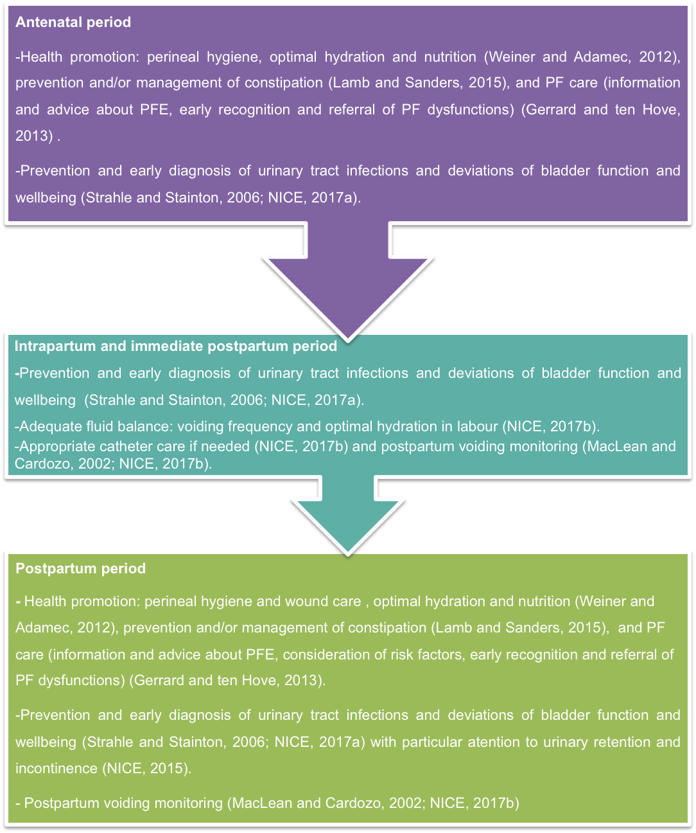
Limitations
Apart from one participant, all women recruited in this study were Caucasian and originally from the UK. This research could have been enriched by the inclusion of different cultural and ethnic backgrounds. This research encompassed women who had given birth up to six months prior to the interview. Hence, some recall and social desirability bias could have been included.

Implications for Practice
Best practice implies a proactive delivery of information and promotion of a healthy bladder during pregnancy, labour, after birth, and beyond. Bladder care represents an essential aspect of a holistic maternity package, and clinicians must incorporate strategies to improve the exploration of potential urinary problems. Special consideration should be given to the standardisation of bladder language used when communicating with women in a direct and unequivocal manner. More detailed information regarding the reasoning behind PFE is needed, as opposed to the current superficial recommendations. Clinicians must be reminded of the physiological changes related to childbirth, particularly in relation to the urinary system and PF, in order to prepare women for their body’s metamorphosis into motherhood.
The findings of this study could be taken a step further to develop a qualitative improvement strategy focused on health care professionals.

CONCLUSIONS

Three themes were identified in this study: ‘Muddling through to earn “a badge of honour”’, ‘Caring for a baby, but who cares for me?’ and ‘Do you speak bladder language?’, but the overarching theme was ‘Lack of care’. This study found that bladder care was very limited for women during the antepartum, intra partum and postpartum period although reports of urinary incontinence were frequent. These findings indicate that clinicians should become more proactive in delivering information and promoting bladder health during these periods but that attention needs to be paid to communication methods. A flow chart to encompass key priorities for bladder care is proposed. This study would suggest that there should be a more prominent focus on maternity bladder care into pre-registration midwifery education.

Reflective questions

- How do pregnancy and childbirth affect women’s bladder function and pelvic floor?
- What do you know about the promotion of a healthy bladder during and after pregnancy?
- What approaches can be taken into consideration to improve women’s bladder care experiences during pregnancy, birth, and postpartum period?
- Do you feel equipped to discuss and facilitate information regarding maternity bladder care with women? Do you feel midwives truly understand what pelvic floor muscle exercises are?

What are pelvic floor muscle exercises?
Pelvic floor muscle exercises, also known as Kegels, consist of “repeated voluntary pelvic floor muscle contractions taught and supervised by a health care professional” (Park and Kang, 2014). These exercises should include 10 long squeezes, held during 10 seconds each, followed by 10 short squeezes. Healthy pelvic floor muscles are not only key in supporting sexual, bladder and bowel functions, but also in maintaining an adequate posture (POGP, 2015).

REFERENCES
Avery JC, Braunack Mayer AJ, Duggan PM, Taylor AW, Stocks NP (2015) “It's our lot”: how resilience influences the experience of depression in women with urinary incontinence. Health Sociol Rev 24(1): 94-108
Birks M, Chapman Y, Francis K (2008) Memoing in qualitative research. Probing data and processes. J Res Nurs 13(1): 68–75. doi: 10.1177/ 1744987107081254
Bryanton J, Gagnon AJ, Johnston C, Hatem M (2008) Predictors of women's perceptions of the childbirth experience. J Obstet Gynecol Neonatal Nurs 37 (1): 24-34. doi:10.1111/j.1552-6909.2007.00203.x
Butterfield YC, O’Connell B, Phillips D (2007) Peripartum urinary incontinence: a study of midwives' knowledge and practices. Women Birth 20(2): 65-69
Carr D, Cook V (2009) Intrapartum and Postnatal Bladder Care: A survey of Midwives’ current practice. Paper presented at the International Continence Society. http://icsoffice.org/Abstracts/Publish/47/000255.pdf (accessed 30 January 2016)
Chaliha C (2006) Postpartum bladder dysfunction. Reviews in Gynaecological and Perinatal Practice 6(3-4): 133-139
Cooke M, Stacey T (2003) Differences in the evaluation of postnatal midwifery support by multiparous and primiparous women in the first two weeks after birth. Australian Midwifery 16: 18–24. doi: 10.1016/S1448-8272(03)80012-3
Gerrard J, ten Hove R (2013) RCM/CSP Joint statement on Pelvic Floor Muscle Exercises. Improving health outcomes for women following pregnancy and birth. https://www.csp.org.uk/system/files/csp_rcm_pelvicfloorstatement_2013.pdf (accessed 15 January 2016)
Goodman P, Mackey MC, Tavakoli AS (2004) Factors related to childbirth satisfaction. J Adv Nurs 46: 212–219. doi:10.1111/j.1365-2648.2003.02981.x
Haines HM, Hildingsson I, Pallant JF, Rubertsson C (2013) The role of women’s attitudinal profiles in satisfaction with the quality of their antenatal and intrapartum care. J Obstet Gynecol Neonatal Nurs 42(4):428–41. doi: 10.1111/1552-6909.12221
Health and Social Care Information Centre (2016) Statistics on Obesity, Physical Activity and Diet. http://content.digital.nhs.uk/catalogue/PUB20562/obes-phys-acti-diet-eng2016rep.pdf (accessed 17 July 2017)
International Urogynaecological Association (2011) Pelvic floor exercises. A guide for women. http://thepelvicfloorsociety.co.uk/budcms/includes/kcfinder/upload/files/eng_pfe.pdf (10 July 2018)
Irwin DE, Kopp ZS, Agatep B, Milsom I, Abrams P (2011) Worldwide prevalence estimates of lower urinary tract symptoms, overactive bladder, urinary incontinence and bladder outlet obstruction. BJU Int 108: 1132–1138. doi:10.1111/j.1464-410X.2010.09993.x
Israfil-Bayli F, Lowe S, Spurgeon L, Toozs-Hobson P (2015) Managing women presenting with urinary incontinence: is hardiness significant? Int Urogynecol J 26(10): 1437-144. doi: 10.1007/s00192-015-2739-0
Lamb K, Sanders R (2015) Constipation and haemorrhoids: A midwifery perspective for the childbearing continuum. British Journal of Midwifery 23(3): 171–7. doi: /10.12968/bjom.2015.23.3.171
Lamb K, Sanders R (2016) Bladder care in the context of motherhood: Ensuring holistic midwifery practice. British Journal of Midwifery 24(6):415-421. doi: 10.12968/bjom.2016.24.6.415
Lincoln YS, Guba EG (1985) Naturalistic Inquiry. Sage Publications: Newbury Park, CA
MacLean AB, Cardozo L (2002) Incontinence in Women. RCOG Press, London
McNamara C (2009) General guidelines for conducting interviews http://managementhelp.org/businessresearch/interviews.htm (accessed 10 January 2016)
Melville JL, Wagner LE, Fan MY, Katon WJ, Newton KM (2008) Women’s Perceptions about the Etiology of Urinary Incontinence. J Womens Health 17(7): 1093–1098. doi:10.1089/jwh.2007.0606
Minassian VA, Yan X, Lichtenfeld MJ, Sun H, Stewart WF (2012) The Iceberg of Health Care Utilization in Women with Urinary Incontinence. Int Urogynecol J 23(8): 1087–1093. doi:10.1007/s00192-012-1743-x
Moch SD (1999) The researcher experience in health care research. In: Moch SD, Gates MD, eds. The researcher experience in qualitative research. Sage Publications, Thousand Oaks, CA: 7–12
National Institute for Health and Care Excellence (2015) Postnatal care up to 8 weeks after birth. www.nice.org.uk/guidance/cg37 (accessed 17 July 2017)
National Institute for Health and Care Excellence (2017a) Antenatal Care for uncomplicated pregnancies. www.nice.org.uk/guidance/cg62 (accessed 17 July 2017)
National Institute for Health and Care Excellence (2017b) Intrapartum care for healthy women and babies. www.nice.org.uk/guidance/cg190 (accessed 17 July 2017)
NHS digital (2016) Health Survey for England, 2015: Health, social care and lifestyles. Summary of key findings. http://healthsurvey.hscic.gov.uk/media/37741/hse2015-summary.pdf (accessed 20 July 2017)
O'Connell H, Bennett G, Jarvis S (2001) Strengthen your inside: the importance of pelvic floor exercises for young women / - Melbourne: Women's Health Victoria and Women's Health Statewide. http://whv.org.au/publications-resources/publications-resources-bytopic/post/strengthen-your-inside-the-importance-of-pelvic-floor-exercisesforyoung-women/ (accessed 30 January 2016)
Ovseiko PV, Greenhalgh T, Adam P, et al (2016) A global call for action to include gender in research impact assessment. Health Research Policy and Systems 14:50. doi: 10.1186/s12961-016-0126-z
Park SH, Kang CB (2014) Effect of Kegel Exercises on the Management of Female Stress Urinary Incontinence: A Systematic Review of Randomized Controlled Trials. Adv Nurs vol. 2014, pp 1 -10. doi:10.1155/2014/640262
Peake S, Manderson L, Potts H (1999) Part and parcel of being a woman. Female Urinary Incontinence and Constructions of Control. Med Anthropol Q 13: 267–285. doi:10.1525/maq.1999.13.3.267
Pelvic Obstetric and Gynaecological Physiotherapy (2015) The Pelvic Floor Muscles- A Guide for Women. https://pogp.csp.org.uk/publications/pelvic-floor-muscle-exercises-women (accessed 29 September 2018)
Pope C, Ziebland S, Mays N (2000) Analysing qualitative data. BMJ 320 (7227): 114–116.
Seshan V, Muliira JK (2014) Dimensions of the impact of urinary incontinence on quality of life of affected women: a review of the English literature. Int J Urol Nurs 8(2): 62-70. doi:10.1111/ijun.12034
Starcevic V, Berle D (2013) Cyberchondria: towards a better understanding of excessive health-related Internet use. Expert Rev. Neurother. 13(2), 205-213. Doi: 10.1586/ern.12.162
Stothers L, Friedman B (2011) Risk factors for the development of stress urinary incontinence in women. Curr Urol Rep 12(5):363–369. doi:10.1007/s11934-011-0215-z
Strahle A, Stainton M (2006) Women’s experience of revealing perinatal bladder function-Implications for midwifery care. Women Birth 19(1): 17–21. doi:10.1016/j.wombi.2006.01.001
Wagg AR, Kendall S, Bunn F (2017) Women’s experiences, beliefs and knowledge of urinary symptoms in the postpartum period and the perceptions of health professionals: a grounded theory study. Prim Health Care Res Dev 18(5): 448-462. doi:10.1017/S1463423617000366
Weiner D, Adamec C (2012) The Encyclopaedia of Kidney Diseases and Disorders. Facts on File Inc, New York
Williams A, Taylor K, Bates C, Tincello D, Richmond D (2003) Knowledge of female bladder care among medical staff, nurses and midwives: results of a questionnaire survey. BJU Int 91(3):208-210. doi: 10.1046/j.1464-410X.2003.03080.x

