Rating a Stationary Energy Storage System within a Fast Electric Vehicle Charging Station Considering User Waiting Times
Special Issue on High-Power Fast Chargers and Wireless Charging
Thomas S. Brydenª*, George Hiltonª, Borislav Dimitrovª, Carlos Ponce de Leónª, Andrew Crudenª
ª Department of Engineering and the Environment, University of Southampton, Southampton, SO14 1BJ, United Kingdom
* Corresponding author: Mr Thomas Samuel Bryden
Email: t.s.bryden@soton.ac.uk
Telephone : +44 7875 232495
Keywords: Vehicles; Battery chargers; Energy Storage; Power system modeling

Abstract
The use of stationary energy storage at fast electric vehicle charging stations can buffer the energy between the electricity grid and electric vehicles, thereby reducing the maximum required grid connection power and potentially mitigating the need for grid infrastructure upgrade. In this paper, a method is presented that sizes the stationary energy storage based on an acceptable average waiting time of drivers arriving at a fast charging station. The novelty of the paper is the focus on the relationship between size of stationary energy store and user waiting time. This relationship is often ignored, however is critical to obtaining the optimum capacity of stationary energy store. An example charging station location is chosen where there are currently eight chargers capable of 120kW charging and a 500kW grid connection. It is demonstrated that the method can be used at this location to design a charging station with stationary energy storage to support future 400kW charging without upgrading the current grid connection infrastructure. With future charging, using a stationary energy storage with a capacity of 1,000kWh reduces the maximum grid power from 1,800kW to 500kW.

Introduction
The popularity of Electric Vehicles (EVs) has increased rapidly in recent years, with the number of EVs in the world increasing from 16 thousand in 2010 to over 2 million in 2017 [1]. One concern of potential EV owners preventing the sale of more EVs is the charging speed, potential EV owners worry that on long distance journeys they will run out of energy in the EV battery, so called ‘range anxiety’, and have to wait at a charging station for hours while their EV recharges [2]. Currently the fastest charging EVs are the Tesla Model S and Model X, both of which can recharge at 120 kW [3]. In the future, to combat potential EV owners concerns, EV charging powers are likely to increase, with 350-400 kW charging stations being proposed [4]. A summary of EV chargers can be seen in Table 1.
Table 1 Fast charging protocols
 | Combined Charging System | CHAdeMO | Tesla Supercharger | GB/T
Proposed by | Europe / USA | Japan | Tesla | China
Defined in IEC IEC61851-23 [7] | Yes | Yes | No | Yes
Current maximum power (kW) [8] | 60 | 50 | 120 | 50
Theoretical maximum power (kW) [8] | 100 | 62.5 | 145 | 180
Future perspective power (kW) [8] | 350 | 350 | Unknown | Unknown

With increasing numbers of EVs, meaning fast charging stations are used more frequently, and higher fast charging powers, issues can arise for the electricity grid infrastructure [5]. At the location where the fast charging station is required, the local electricity grid infrastructure may not be sufficient to accommodate the high power grid connection required. The long term solution is to upgrade the existing electricity grid infrastructure to facilitate higher powers at the fast charging station location, however this is likely to be costly due to infrastructure and civil works costs [6]. The new solution, investigated in this research and shown in Figure 1, is to use a stationary energy store at the fast charging station location to buffer the energy between the electricity grid and the EVs using the fast charging station. This solution means that the required power capacity from the electricity grid is lower and therefore costly electricity grid infrastructure upgrade may not be required. In this paper, the constraint of an acceptable average waiting time for EVs arriving at the fast charging station is used to design the number of charging points and size of stationary energy storage. The novelty of the paper is regarding this relationship between size of stationary energy storage and user waiting times and so a detailed power electronic analysis of the system is not conducted in this paper, however would be required during the detailed design of the system.
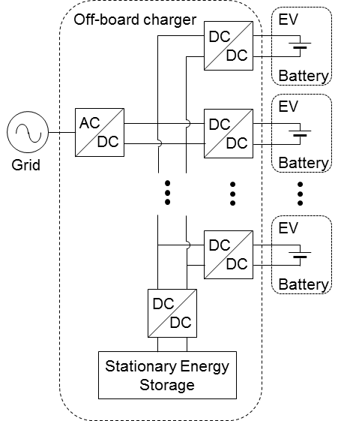
Figure 1 The proposed fast EV charging station with stationary energy storage
The idea of using stationary energy storage at fast EV charging stations has been investigated previously. In [9] it was proposed that the stationary energy storage could be provided by a battery and superconducting magnetic energy storage hybrid system, however the focus of the work was on the control strategy for the hybrid system and the capacities of the storage elements were not optimised. Similarly, in [10] flywheel energy storage was proposed for the stationary energy storage and the control strategy of the system investigated. In [11] the charging station and stationary energy storage were paired with photovoltaic electricity generation, again the focus was on the management of power flow and not minimising the stationary energy storage capacity. In [12] an optimisation method was proposed to determine the capacity of the stationary energy storage based on minimising capital costs and it was found that using stationary energy storage is not always the optimal solution but in some cases can reduce capital and operating costs and peak network load.
The rate that an energy storage device can accept or deliver energy is usually defined by the C-Rate, which is defined as the energy storage current (in Amps) divided by the capacity of the energy storage device (in Amp-hours). One critical feature evident in the research papers reporting on stationary energy storage at fast charging stations is the number of EVs that are to be charged in a given time period and therefore the capacity and C-Rate required of the stationary energy store. In [13] the stationary energy storage is used to smooth out grid demand power fluctuations as different numbers of EVs arrive to charge and this results in the use of a small capacity stationary energy store that can operate at high C-Rates, resulting in supercapacitors being used as the stationary energy store. At the other end of the spectrum, in [14] the stationary energy store is used to store energy during the night, when few EVs are charging through to the day when many EVs are charging, resulting in a large capacity but low C-Rate stationary energy storage. In between these two examples are cases such as [15] where the stationary energy store is used to store energy for one EV and then charges up once the EV leaves the fast charging station.
There are also some practical examples of fast charging stations being constructed and installed with stationary energy stores. In [16] a 64.2 kWh lithium-ion battery was used as the stationary energy storage for two 50 kW fast charging points in Japan. In Redwood City [17] energy storage has been installed with fast charging stations and is expected to save $7,000 per annum in demand charges. For fast charging of buses in Geneva [18] supercapacitors are used as the stationary energy storage to charge the buses at up to 400kW. It has also been announced that fast charging stations with energy storage will be installed along the Trans-Canada highway [19].
From these references it is clear there is a consensus that stationary energy storage can be used at fast charging stations to lower the impact on the electricity grid however there has been little research focus on optimising the capacity of the stationary energy store. Optimising the capacity of the stationary energy storage is key. It must be large enough to ensure EV drivers arriving at the fast charging station do not have to wait because there is insufficient energy or grid capacity available at the charging station to charge their EV but simultaneously small enough to make economic sense over a reasonable service life.
In this paper, a novel method to determine the optimum stationary energy storage capacity at a fast charging station is proposed based on acceptable average waiting times, the method can be used for any given fast charging station location. To develop a detailed model of a fast charging station with energy storage requires many models, including the waiting time model, a grid infrastructure model, power electronic models for the AC/DC and DC/DC convertors, models for the stationary energy store during operation and including degradation, models of the EV batteries and an economic model including varying electricity prices. Forecasting models are also required to predict future demand at fast charging stations, future electricity costs and future EV battery capacities and charging profiles. The novelty of this paper is regarding the waiting time model and so simplistic models are used for the other required models, it is envisaged that in future work the waiting time model described in this paper could be incorporated into detailed models of fast charging stations with energy storage.
The required inputs to the model are the predicted number of EVs that will use the fast charging station each day, the probability of an EV arriving at the fast charging station at each hour of the day, the charging time for one EV, and the available grid connection power at the fast charging station location. Then an acceptable average waiting time is chosen and the model is run to determine the size of energy store needed. Once the analysis described in the paper has been conducted an economic assessment could be undertaken. The economic assessment would compare the cost to upgrade the local electricity grid infrastructure versus the cost of the stationary energy storage to determine the best solution for the given location.

Method
The model consists of two parts: in the first part the number of fast charging connection points at the fast charging station is determined; in the second part the capacity of the stationary energy store is determined. This model structure is shown in the flow chart in Figure 2, and these two model parts now described in more detail.
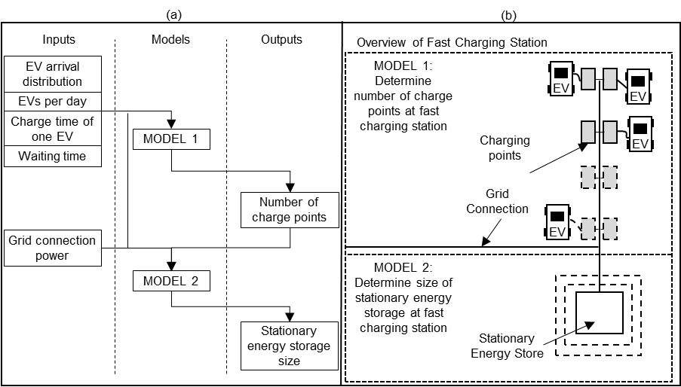
Figure 2 Flow chart demonstrating model inputs, outputs and stages (left) and illustration of different parts of the model (right)
To understand how the model works, the model is demonstrated in this method section with very basic assumptions before a more realistic scenario is demonstrated in Section 3. The basic assumptions include:
- Exactly 100 EVs use the fast charging station each day, this is the average fast charging station usage based on a calculation: the average number of fast chargers per million EVs per day is 24,000 [20], the number of UK gas stations per million vehicles is 236 (8,407 petrol stations [21] / 35.6 million vehicles [22]). If it is assumed the ratio of petrol stations to fast charging stations in the future is the same, the average number of fast charges per day per fast charging station is 100 (24,000 / 236).
- The probability of an EV arriving at a fast charging station during each hour of the day is seen in Figure 3, this is taken from previous research [20] looking at EV usage patterns using gasoline vehicle GPS data.
- The average acceptable waiting time is 15 seconds, this is chosen as, from the results shown later in the paper it means less than 1% of fast charging station users must wait more than 6 minutes. 6 minutes is a critical waiting time, previous research [23] has suggested that if people are waiting in a queue longer than 6 minutes they will leave the queue.
- The size of all EV batteries is 75 kWh, each EV charges at 360 kW from 0% to 80% state of charge, thereby taking exactly 10 minutes to charge. These assumption are made to make the demonstration of the model more clear, in the subsequent Section ‎‎3 these assumptions are made more reflective of reality.
- The available grid connection power at the fast charging station location is 720 kW. This is highly dependant on the fast charging station location and is assumed here for the demonstration of the model.
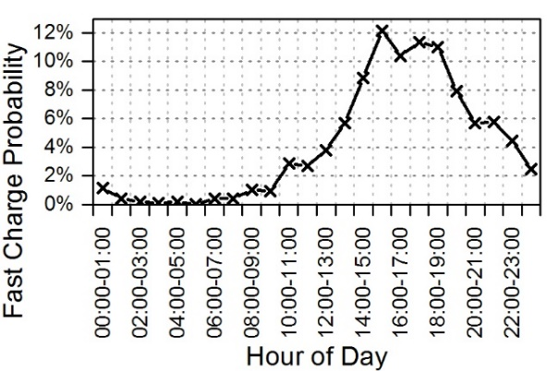
Figure 3 Probability of an EV arriving at the fast charging station in each hour of the day

Determining the Number of Charging Points (Model 1)
Similar to a conventional petrol station having multiple petrol pumps, a fast EV charging station will have multiple charging points. In this section the method to determine the number of charging points that should be installed at a fast charging station is described. The number of fast charging points required is determined based on the acceptable time that EV drivers arriving at the fast charging station may be required to wait. The waiting time is the total time spent at the fast charging station minus the time it would take to charge if a charge point is free on arrival and there is sufficient power to charge the EV at the maximum allowed power. A waiting time simulation is conducted and the output of the simulation is the expected waiting time versus the number of charging points. For example, if there is only one charging point, queues will develop and the average waiting time will be high however if there are tens of charging points nobody will have to wait and the average waiting time will be low.
The model for this section is created and coded in MATLAB and has a time length of one day and a time resolution of one second. The flow chart detailing the model and example sections of code can be seen in Figure 4. The model shown in Figure 4 is run multiple times varying the number of fast charging points at the fast charging station, starting at one fast charging point and increasing the number of fast charging points until the waiting time is acceptable.
The results of the analysis are highly dependent on the randomly generated, weighted according to Figure 3, arrival times, therefore a simulation using the Monte Carlo method is conducted [14]. This simulation involves running the analysis described above for many thousands of days and working out the average waiting time. For each run, the model creates a new arrival times vector and steps through each second in the day. To check that sufficient number of days are included in the Monte Carlo simulation, the model can be run multiple times with the same number of days and if the results are the same for each run, i.e. it converges, the simulation has been conducted with a sufficient number of days. For example, if the simulation was run three times, each for 500 days, and the average waiting time was determined in the first, second and third runs as 20.21 seconds, 45.03 seconds and 5.54 seconds respectively, it would mean that the simulation did not include enough days and the number of days would need to be increased. If however the same analysis was run three times but using 100,000 days and the average waiting time for each run was determined as 34.95 seconds, 34.93 seconds and 34.96 seconds it would mean the simulation included enough days.
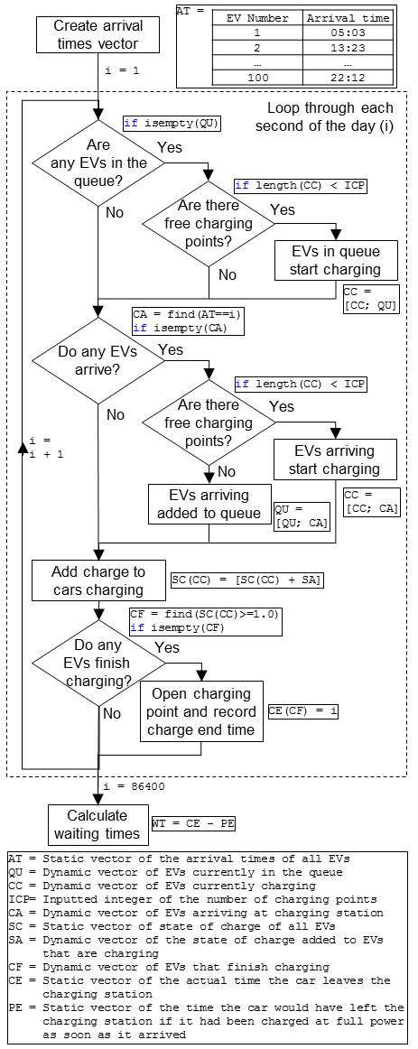
Figure 4 Flow chart detailing steps for models, variables are defined beneath the flow chart, static vectors are the length of the number of EVs that use the fast charging station each day while dynamic vectors change length each second
The results for model 1 include the number of charging points versus waiting time and an example can be seen in Table 2, created using the input assumptions detailed above. An appropriate number of charging points can then be chosen based on the acceptable waiting time. It is clear that if this fast charging station only had one charging point installed, the average waiting time is over 2 hours and 87 % of drivers arriving at the fast charging station will have to wait more than 6 minutes. With four charging points this drops to an average waiting time of 7.5 seconds and only 0.3%, or around 1 in 300 drivers, have to wait more than 6 minutes. The assumption for the average waiting time was that the average waiting time should be less than 15 seconds and so four charging points are chosen. The probability that an EV arriving at the fast charging station with four charging points will have to wait more than a few minutes is shown in Figure 5.
Table 2 Number of charging points and waiting time
Number of Charging Points | Average Waiting Time  (s) | Probability of Waiting More than 6 minutes
1 | 7,500 | 87 %
2 | 290 | 28 %
3 | 39 | 3.4 %
4 | 7.5 | 0.3 %

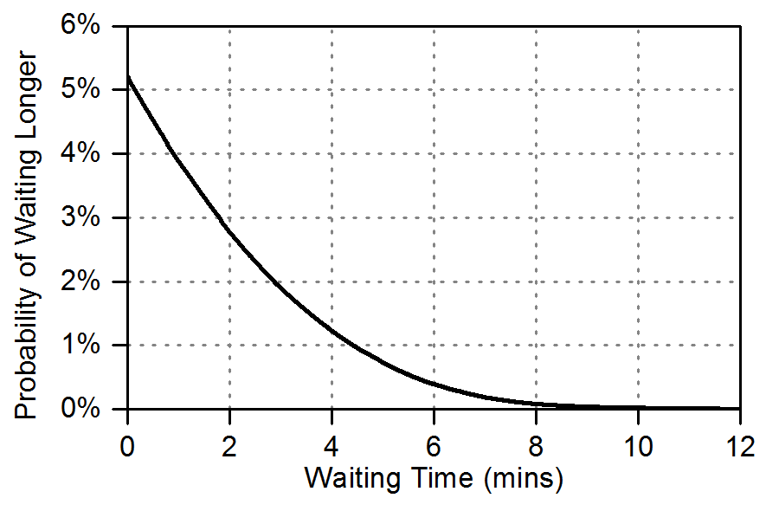
Figure 5 Probability of EV arriving at the charging station waiting longer than a certain time

Determining the Size of Stationary Energy Storage (Model 2)
The method above was conducted without the grid connection power, a similar method is now used to size the stationary energy storage. The output from model 1, the number of charging points, is used along with the user defined value for the maximum power available from the grid at the fast charging station location, in this case 720 kW. In the previous model it was assumed that there was always enough power from the grid to charge the EVs, irrespective of the number of charging points. In the model for this section an EV arriving at the fast charging station may have to wait either because there are not enough charging points or because there is not sufficient power or energy available to charge the EV. For the case described in this method there are four charging points, requiring 1,440 kW (360 kW × 4), however at the fast charger location only 720 kW can be taken from the electricity grid.
A stationary energy store can be used to charge EV’s at the fast charging station if there is not sufficient power capacity available from the grid. For example, if there are four EVs charging and the grid connection can only support two EVs charging, two of the EVs could be charged using the stationary energy storage. The EV waiting time due to insufficient power capacity therefore only occurs if the stationary energy store runs out of energy. The priority of the model is that EVs are charged first using the grid connection and then using the stationary energy storage if the grid connection is not sufficient. Any spare grid capacity is ultimately used to recharge the stationary energy storage. A Monte Carlo simulation is then run, similar model 1, but using the outputted number of charging points from the previous model and varying the capacity of the stationary energy storage.
The results then include the capacity of stationary energy storage versus the EV waiting time and an example results is given in Table 3, created using the input assumptions detailed above. An appropriate capacity of stationary energy store can then be chosen based on the acceptable waiting time. As shown in Table 3 to achieve an average waiting time of less than 15 seconds a stationary energy storage with the capacity of 350 kWh is required. Further for this location, using a stationary energy store with a capacity of 350 kWh reduces the average waiting time from almost 5 minutes, with no energy store, to less than 15 seconds. The last value in Table 3 shows the values for a very large stationary energy storage. This average waiting time value (7.5 s) is the same as for the four charging points case from Table 2, this is because for the case of a very large stationary energy storage all of the waiting is as a result of not enough charging points, there is always sufficient power.
Table 3 Size of stationary energy storage versus waiting time for a four charging point charging station where the grid connection is capable of providing 720 kW
Capacity of Stationary Energy Storage  (kWh) | Average Waiting Time  (s) | Probability of Waiting More than 6 minutes
0 | 290 | 28 %
50 | 160 | 16 %
100 | 110 | 11 %
150 | 73 | 7.2 %
200 | 43 | 4.3 %
250 | 29 | 2.7 %
300 | 20 | 1.7 %
350 | 15 | 1.1 %
10,000 | 7.5 | 0.3 %

Queuing Priority
One key aspect to be considered for this model is the queuing priority and how the available EV charging power is shared. Simply sharing all available power between all EVs using the fast charging station is the simplest method, however for the case of the fast charging station it will not be the most efficient method. This is demonstrated in Figure 6 where it can be seen that the average waiting time is decreased from 10 minutes to 5 minutes when using a first come first served algorithm (case 2) as opposed to a power sharing algorithm (case 1).
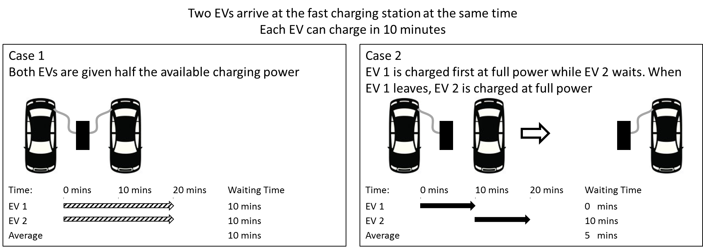
Figure 6 How different charging priorities effect average waiting times
The algorithm used for this model therefore charges EVs that arrive at the fast charging on a first come first served basis. As the model steps through each second, the energy capacity remaining in the stationary energy storage is determined. If there is not sufficient power capacity available from the grid or in the stationary energy storage to charge all the EVs at the fast charging station, the last EV to arrive is stopped from charging and the energy in the stationary energy storage and power from the grid are given to the first to arrive EVs.

2.2.2. Grid Connection Power
The analysis in this section undertakes a sensitivity study for the same fast charging station case as Section ‎2.2 but at different locations where the available grid connection powers are different. The inputs of 100 EVs/day, a charging time for one EV of 10 minutes and an acceptable average waiting time of 15 seconds are used and the grid connection is varied, between a power capable of charging 1 EV (360 kW) and 4 EVs (1,080 kW).
This sensitivity study is conducted to represent different locations on the electricity grid. The results are shown in Table 4 and it is clear that the lower the grid connection capacity, the larger the required stationary energy storage capacity. In other words, in a location where the electricity grid has very little spare capacity a large stationary energy storage is required and in areas where there is plenty of spare grid capacity smaller or no stationary energy storage is required. It should also be noted that the larger stationary energy stores are required to operate at lower C-Rates than the locations where there is a higher grid connection power and therefore smaller energy store.
Table 4 Required size of energy store for various grid connection powers to achieve an average waiting time of less than 15 seconds, each charging station has 4 charging points.
Grid connection  (kW) | Size of stationary energy store  (kWh) | Maximum C-Rate required for energy store
360 | 1,900 | 0.6
720 | 350 | 2.1
1,080 | 50 | 7.2
1,440 | 0 | -

Results for the Design of the Fast Charging Station with Energy Store in an Example Location
In its current state, the method proposed is clear but the inputs to the model are unlikely to reflect reality. For example, the EV charging power profile for all EVs using the fast charging station is simply constant 360 kW power for 10 minutes, which takes the battery from 0 to 100% state of charge. This will not be the case in reality because EV charging powers decrease as the state of charge of the EV battery increases. The state of charge that the EV will arrive at the fast charging station will also vary based on the preference of the driver of how much buffer energy they want in their battery and the journey being conducted, EVs will also have varying battery capacities. Figure 7 shows the current Tesla supercharging power profile [3] and it can be seen that there are in fact six variables required to define a fast charging power profile:
- Initial constant power value (P_{const} (W))
- The state of charge that this constant power can be applied until (s_{const})
- The exponential decay factor (k)
- The energy capacity of the EV battery (E (J))
- The state of charge that the EV arrives at the fast charging station (s_{init})
- The state of charge that the EV leaves the fast charging station (s_{fin})
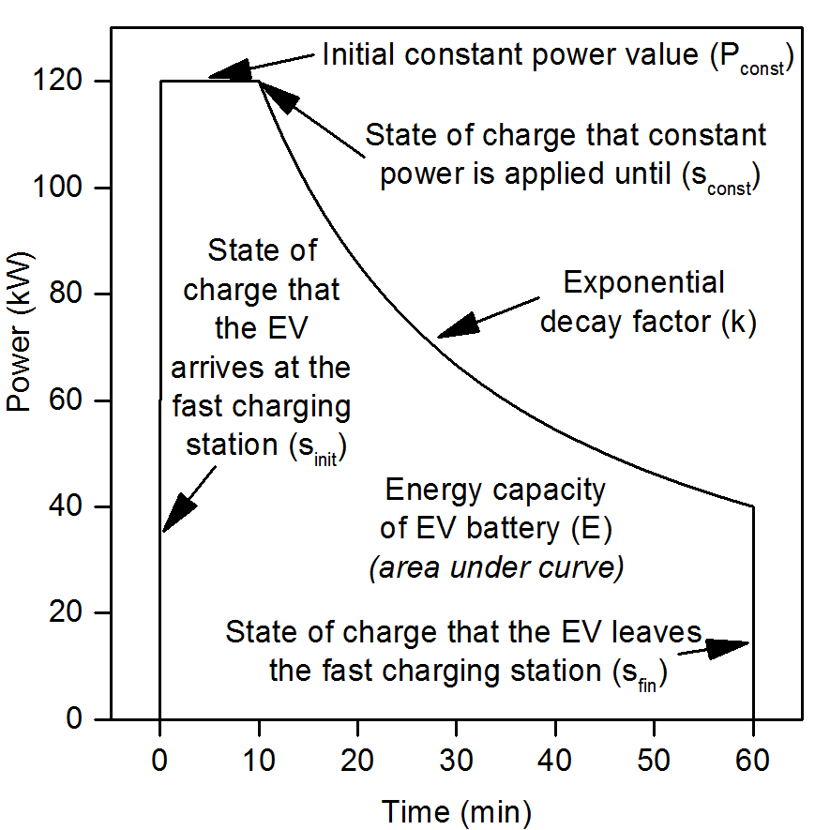
Figure 7 Tesla charging profile with variables required to define the charging profile
The section of the charging profile where the power is decaying is defined by Equation 1, relating the charging power (P (W)) to the EV state of charge (s) [3]:
Equation 1
To account for the variation in future EV charging power profiles, probability distributions are used in the model for all six variables. For example, for the initial state of charges, a normal probability distribution with an average value of 20% state of charge and 95% of data being between 0% and 40% state of charge can be used. Random number generation weighted to the normal distribution can then be used to determine the state of charge of each EV arriving at the fast charging station. In the method section, each EV arriving at the fast charging station was assigned a random arrival time weighted according to Figure 3. In this subsequent section, as well as this arrival time, each EV is randomly assigned a value for each of the six variables, defining the charging profile of each EV. The assumptions for each of the six variables are discussed in the following section.
To account for the variation in future EV charging power profiles, probability distributions are used in the model for all six variables. For example, for the initial state of charges, a normal probability distribution with an average value of 20% state of charge and 95% of data being between 0% and 40% state of charge can be used. Random number generation weighted to the normal distribution can then be used to determine the state of charge of each EV arriving at the fast charging station. In the method section, each EV arriving at the fast charging station was assigned a random arrival time weighted according to Figure 3. In this subsequent section, as well as this arrival time, each EV is randomly assigned a value for each of the six variables, defining the charging profile of each EV. The assumptions for each of the six variables are discussed in the following section.

Location inputs
To demonstrate the method with more realistic inputs an example location is chosen, in this case the Tesla Supercharger at Elveden Inn in Suffolk, UK. The site currently has eight superchargers, providing up to 120 kW each. The site has a 500 kVA transformer stepping the voltage down from 11 kV to 480 V [24], from this transformer size it is assumed that the maximum grid connection power is 500 kW. The analysis in this section is for a period in the future when EV charging speeds are higher and more EVs are on the roads. The analysis determines the size of stationary energy storage required at the Elveden Inn, Suffolk charging location to enable this future higher power and more frequent charging without upgrading the current grid connection infrastructure.
For each of the six variables, seen in Figure 7, assumptions are made for what they will be in future EV charging profiles. The initial constant power value is taken as 400 kW as in a previous study [20] this was found to be a charging power capable of satisfying 80% of long distance journeys. The state of charge that this constant power can be applied until and the exponential decay factor are dependant on the future battery chemistry, the values are taken from the current values for the Tesla EVs [3], 25% and 2 respectively. The future capacity of the EV battery is assumed to be 80 kWh, based on current lower cost EVs, such as the Chevrolet Bolt [25], having battery capacities of 60 kWh and the current trend of EV battery capacities increasing. The normal distributions for these variables can be seen in Table 5, with relative standard deviation being taken as 10% for all variables.
The arrival state of charge at the fast charging station and state of charge when an EV leaves the fast charging station will depend on the EV user behaviour. For this analysis it is assumed that the normal distribution means for the arrival and leaving state of charge will be 20% and 80% respectively with 95% of the data being between 0-40% and 60-100% respectively.
The number of cars (ncars) that will use the fast charging station each day is also hard to estimate and depends on the future penetration level of EVs and their range capabilities as well as the number of nearby fast charging stations. At the Elveden Inn site, 23,000 cars drove on the 10 miles stretch of road in a day during a 2016 survey [26]. A simple calculation shows that this is about the average for UK roads of 27,000 cars on a 10 mile stretch of road (244.4 billion miles travelled per year in the UK × 10 miles / 245,800 miles of road in the UK / 365 days per year [22]). Therefore, the average value of 100 cars per day calculated in Section ‎2 is assumed, with 95% of the days having between 80 and 120 cars per day.
Assumptions regarding efficiencies include, all power electronic converters seen in Figure 1 are 95% efficient, the EV battery charges at 95% efficiency and the stationary energy store charges at 95% efficiency and discharges at 95% efficiency.
Table 5 Assumed values for variables
Variable | Mean | 95% of data
P_{max} (kW) | 400 | 320 – 480
E (kWh) | 80 | 64 – 96
s_{const} | 25 % | 20 – 30 %
k | 2.0 | 1.6 – 2.4
s_{init} | 20 % | 0 – 40 %
s_{fin} | 80 % | 60 – 100 %
n_{cars} | 100 | 80 – 120

Location results
The same analysis described in the method section is conducted using these inputs, including:
- All variables seen in Table 5;
- The probability of an EV arriving at a fast charging station during each hour of the day, seen in Figure 3;
- The average acceptable waiting time is 15 seconds;
- The available grid connection power at the fast charging station location is 500 kW.
The results can be seen in Table 6 and the overall result is that the charging station requires five charging points and a stationary energy storage with a capacity of 1,000 kWh. Using the stationary energy storage at this location reduces the average waiting time from 20 minutes, without a stationary energy store, to 13 seconds. To accommodate 400 kW charging at this location therefore requires a 1,000 kWh energy store, an economic assessment could be conducted and the cost of this energy storage could be compared to the cost of upgrading the electricity grid infrastructure at the charging station location to determine the optimum solution.

Table 6 Results using the assumptions seen in Table 5
Number of Charging Points | Average Waiting Time  (s) | Probability of Waiting More than 6 minutes | Capacity of Stationary Energy Storage  (kWh) | Average Waiting Time  (s) | Probability of Waiting More than 6 minutes
1 | - | - | 0 | 1,100 | 56 %
2 | 1,400 | 59 % | 200 | 460 | 25 %
3 | 160 | 18 % | 400 | 200 | 12 %
4 | 31 | 4.1 % | 600 | 90 | 6.4 %
5 | 9.3 | 1.0 % | 800 | 28 | 2.3 %
 |  |  | 1,000 | 12 | 1.2 %

For this case the power from the grid and the state of charge of the stationary energy storage can be seen in Figure 8. Figure 8a shows the case for a day when the stationary energy storage is completely depleted while Figure 8b shows a day when the stationary energy storage is used less and always has above 70% of energy available. The fully depleted case occurs because for the day shown many EVs arrive in a short period of time, with 54 EVs arriving between 3 pm and 7 pm. For the day when the energy store is always above 70% state of charge the EV arrival times are more spread out throughout the day and only 24 EVs arrive between 3 pm and 7 pm.
As can be seen in Figure 8, for these days the maximum power that the EVs charging need is 1,800 kW however the use of the stationary energy store means that the grid connection power is never more than 500 kW. It can be seen that when the power required by the EVs is above 500 kW the energy store discharges while when the power required by the EVs is less than 500 kW the grid recharges the energy store.
Also in Figure 8 the waiting times for all EVs using the fast charging station can be seen. For the day when the stationary energy store is completely depleted, 16 cars have to wait with the longest waiting time being 9 minutes, while for the day when the energy store is used little only 3 cars need to wait, with the longest wait being 3 minutes. The average waiting time during the day from Figure 8a is 30 s, while for Figure 8b the average waiting time is 3.3 s.
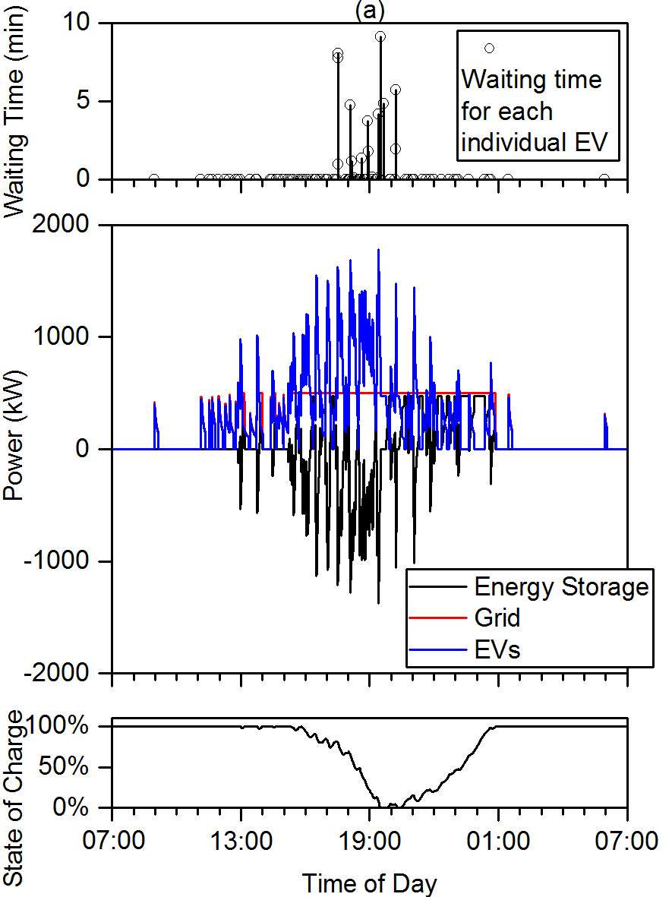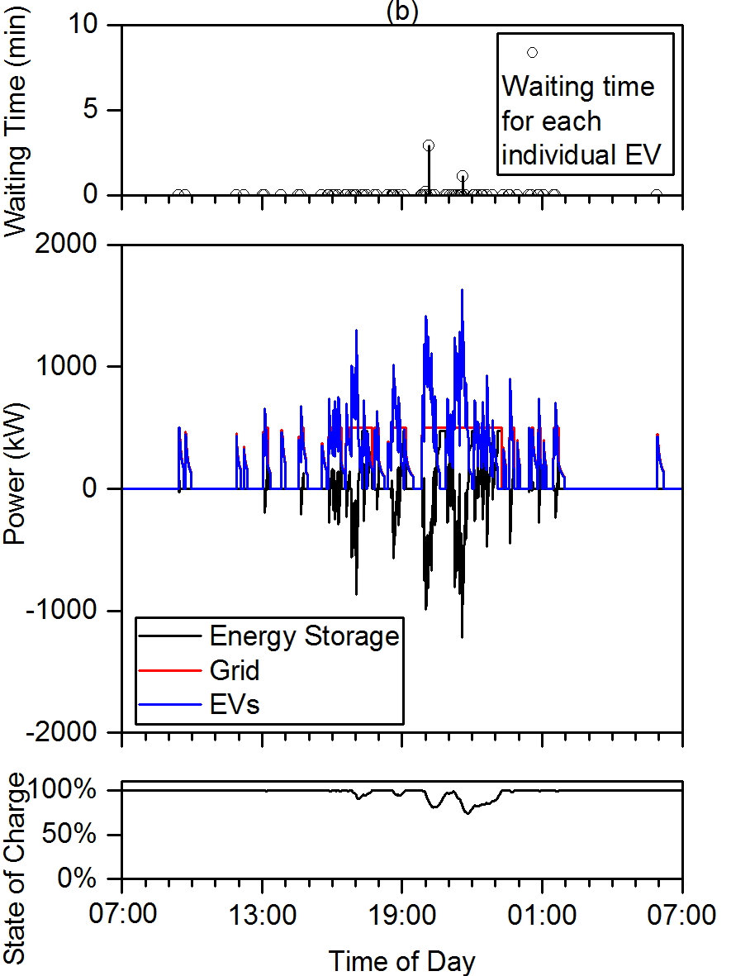
Figure 8 This Individual EV waiting times (top), power flows from stationary energy storage (negative is discharge), the grid and to the EVs (middle) and the state of charge of the stationary energy storage (bottom): (a) A day when the stationary energy storage is heavily used, (b) A day when the stationary energy store is slightly used centered.
To give a high level understanding of the design of such a system, if a lithium-ion battery was used for the stationary energy storage the battery could be roughly the size of a 20ft shipping container. For example the SAFT Intensium Max could be used, which stores up to 1,180 kWh and has charging and discharging powers of 900 kW and 2300 kW respectively [28]. It is difficult to perform a detailed economic analysis of such a system as the grid connection costs vary significantly at depending on the location. A McKinsey & Company report estimated that demand charges can vary from between $2/kW to $90/kW per month and for their analysis they used a price of $35/kW per month [29]. For the system described above the maximum grid connection is reduced from 2,000 kW to 500 kW, thereby saving 1,500 kW. Using the estimation of $35/kW per month the use of the stationary energy store could save demand charges of $630,000 per year. Using a US Energy Information Administration (EIA) estimate of total installed cost of large-scale battery storage systems of $1,100/kWh [30], the 1,000kWh battery may cost $1,100,000. From these estimates the payback period is less than 2 years ($1,100,000 / $630,000) and shows how the system may economically viable. This economic analysis is simplified and a detailed economic assessment should be undertaken when a location is chosen and grid infrastructure upgrade costs are known.
Also included a detailed economic model would be the detailed design of the stationary energy storage, i.e. a lithium-ion battery. The stationary lithium-ion battery would need to be oversized from the stated 1,000 kWh to lower the battery degradation and ensure the battery lasts the required system design life. From the model presented in this paper the battery operation results can be obtained, i.e. the charging and discharging powers with time as seen in Figure 8. These charging and discharging powers along with the required battery lifetime could be given to a company that specialises in providing batteries, the battery company could then provide a battery of the correct capacity to last the required design life. In many cases a battery is considered at the end of its life when it has 80% of its original capacity, therefore a 1,000 kWh battery would need to be sized at 1,250 kWh to ensure at the end of life it was still operational. Oversizing the battery will also help to improve the battery cycle life because it will not initially need to operate over the entire state of charge range. For example a 1,250 kWh battery could be operated between 10% and 90% state of charge to provide the required 1,000 kWh storage, which will provide a longer cycle life than a battery operated between 0% and 100% state of charge [28].

Sensitivity Study
The model has been demonstrated for a certain location however the results will vary depending on the location, for example the available grid connection power and the number of cars will vary from location to location. A sensitivity study was therefore undertaken varying the number of cars using the fast charging station each day while keeping the other assumptions the same. This represents other locations, where the grid connection power is 500 kW but the fast charging station is more or less busy because it is on larger or smaller roads, the results can be seen in Table 7. The results demonstrate how at busier locations the required number of charging points as well as the size of the stationary energy increase. The additional costs associated with more charging points and larger energy stores will be offset by the increased revenues from more vehicles using the fast charging station.
Table 7 Results using the assumptions seen in Table 5
Number of Cars per Day | Number of Charging Points | Size of Stationary Energy Store  (kWh)
50 | 4 | 150
100 | 5 | 1,000
150 | 6 | 2,800
200 | 8 | 4,400

Discussion
The decision whether to use stationary energy storage at a fast EV charging station will likely be driven by whole system economics, capital and operating costs. This will vary from location to location and will be a function of how many EVs require to be charged each day, the power capacity of the electricity grid connection and the cost to upgrade the electricity grid connection. The example location demonstrated in this paper shows how the method proposed can be used in an actual location to size the stationary energy storage. The method requires assumptions that have been justified throughout the paper however future work could look in more detail at any of these assumptions. For example, the acceptable waiting time could be made longer meaning a smaller, cheaper stationary energy store, however to encourage EV uptake short waiting times are critical. The length of time people are willing to wait is a psychological question and could be investigated in future work.
One of the most interesting results from this work is the queuing priority. It has been discussed how, when the constraint is the amount of power available to charge the EVs, it is better to charge the EVs using a first come first served algorithm rather than sharing all the power equally. This may be counterintuitive to think that curtailing power to some users can reduce average waiting times, however the first come first served algorithm results in a lower average waiting time. This is a key consideration that people installing fast charging stations with limited power must understand, that it is not always optimal to simply share the power equally.
The results from Table 4 show how the capacity and C-Rate of the stationary energy storage can vary significantly depending on the available grid connection power. This means that there is not simply one energy storage technology that can be used for all fast charging stations. For example, from the results of Table 4, when the grid connection is capable of charging one EV a very large stationary energy store that operates at low C-Rates is required. This may mean lead acid or flow batteries are used for the stationary energy storage device. While for the case when the grid connection is capable of charging three EVs a small stationary energy storage device that operates at high C-Rates is required and so supercapacitors or flywheels may be chosen due to their good rate ability [27].

Conclusions
At a fast EV charging station location without sufficient electricity grid connection capacity there are two options, either upgrade the power rating of the electricity grid connection or use a stationary energy store to buffer the energy between the electricity grid and the EV. In this research a method to size the stationary energy storage at fast EV charging stations has been proposed based on an acceptable waiting time of EVs arriving at the fast EV charging station. The results can be used in an economic assessment comparing the cost of the stationary energy storage to the costs of upgrading the electricity grid infrastructure at the fast EV charging station location to determine the most cost effective option.
The method proposed has been demonstrated for an actual charging station location where the grid connection infrastructure is rated at 500 kVA and the charging points rated at 120 kW. It has been shown how this site could be upgraded to support future 400 kW charging without upgrading the current grid connection infrastructure. The results are that a 1,000 kWh stationary energy store is required, this reduces the average waiting time from 20 minutes to 13 seconds. In future work, the cost of a 1,000 kWh energy store could be compared to the cost of upgrading the electricity grid infrastructure at the charging station location to determine the optimum solution.

Acknowledgements
This research was supported by funding from the EPSRC through two grants “EPSRC Centre for Doctoral Training in Energy Storage and its Applications” [grant number EP/L016818/1] and “ELEVATE (ELEctrochemical Vehicle Advanced TEchnology)” [grant number EP/M009394/1].

References
[1] IEA, Global EV Outlook 2017 Two million and counting, International Energy Agency, 2017. Accessed on 31 May 2018, https://www.iea.org/publications/freepublications/publication/GlobalEVOutlook2017.pdf
[2] Z. Moghaddam, I. Ahmad, D. Habibi, and Q. V. Phung, Smart Charging Strategy for Electric Vehicle Charging Stations, IEEE Transactions on Transportation Electrification, vol. 4, pp. 76-88, 2018. doi: 10.1109/TTE.2017.2753403
[3] T. S. Bryden, A. J. Cruden, G. Hilton, B. H. Dimitrov, C. Ponce de León, and A. Mortimer, Off-vehicle energy store selection for high rate EV charging station, in 6th Hybrid and Electric Vehicles Conference (HEVC 2016), 2016, doi: 10.1049/cp.2016.0986
[4] G. R. C. Mouli, P. Venugopal, and P. Bauer, Future of electric vehicle charging, in 2017 International Symposium on Power Electronics, 2017, doi: 10.1109/PEE.2017.8171657
[5] G. Hilton, M. Kiaee, T. Bryden, B. Dimitrov, A. Cruden, and A. Mortimer, A Stochastic Method for Prediction of the Power Demand at High Rate EV Chargers, IEEE Transactions on Transportation Electrification, vol. 4, pp. 744-756, 2018. doi: 10.1109/TTE.2018.2831003
[6] J. Eyer, Electric Utility Transmission and Distribution Upgrade Deferral Benefits from Modular Electricity Storage Sandia National Laboratories, Albuquerque, USA, 2009. Accessed on 2 Oct 2018, https://prod.sandia.gov/techlib-noauth/access-control.cgi/2009/094070.pdf
[7] International Electrotechnical Commission. (2014). IEC 61851-23:2014 Electric vehicle conductive charging system - Part 23: DC electric vehicle charging station
[8] Advertising Standards Authority Ltd. (2016). ASA Ruling on Tesla Motors Ltd [Online, Accessed on 19 Jul 2018]. Available: http://archive.is/MtgpR
[9] J. Deng, J. Shi, Y. Liu, and Y. Tang, Application of a hybrid energy storage system in the fast charging station of electric vehicles, IET Generation, Transmission & Distribution, vol. 10, pp. 1092-1097, 2016. doi: 10.1049/iet-gtd.2015.0110
[10] B. Sun, T. Dragičević, F. D. Freijedo, J. C. Vasquez, and J. M. Guerrero, A Control Algorithm for Electric Vehicle Fast Charging Stations Equipped With Flywheel Energy Storage Systems, IEEE Transactions on Power Electronics, vol. 31, pp. 6674-6685, 2016. doi: 10.1109/TPEL.2015.2500962
[11] M. O. Badawy and Y. Sozer, Power Flow Management of a Grid Tied PV-Battery System for Electric Vehicles Charging, IEEE Transactions on Industry Applications, vol. 53, pp. 1347-1357, 2017. doi: 10.1109/TIA.2016.2633526
[12] S. Negarestani, M. Fotuhi-Firuzabad, M. Rastegar, and A. Rajabi-Ghahnavieh, Optimal Sizing of Storage System in a Fast Charging Station for Plug-in Hybrid Electric Vehicles, IEEE Transactions on Transportation Electrification, vol. 2, pp. 443-453, 2016. doi: 10.1109/TTE.2016.2559165
[13] S. Bai, D. Yu, and S. Lukic, Optimum design of an EV/PHEV charging station with DC bus and storage system, in 2010 IEEE Energy Conversion Congress and Exposition, Atlanta, GA, USA, 2010, doi: 10.1109/ECCE.2010.5617834
[14] H. Höimoja, M. Vasiladiotis, and A. Rufer, Power interfaces and storage selection for an ultrafast EV charging station, in 6th IET International Conference on Power Electronics, Machines and Drives (PEMD 2012), Bristol, United Kingdom, 2012, doi: 10.1049/cp.2012.0309
[15] D. McPhail, Evaluation of ground energy storage assisted electric vehicle DC fast charger for demand charge reduction and providing demand response, Renewable Energy, vol. 67, pp. 103-108, 2014. doi: 10.1016/j.renene.2013.11.023
[16] M. Aziz, T. Oda, and M. Ito, Battery-assisted charging system for simultaneous charging of electric vehicles, Energy, vol. 100, pp. 82-90, 2016. doi: 10.1016/j.energy.2016.01.069
[17] City of Redwood City. (2015). Green Charge Networks and Chargepoint Partner to Combine Intelligent Energy Storage and Electric Vehicle Charge Networking [Online, Accessed on 12 Jul 2018]. Available: http://www.redwoodcity.org/Home/Components/News/News/111/874
[18] ABB. Taking charge [Online, Accessed on 4 Jan 2018]. Available: https://library.e.abb.com/public/ba824879a3b6dd2ec1257c5a0041be95/64-69%204m341_EN_72dpi.pdf
[19] A. Siekierska. (2017). Fast-charging stations for electric vehicles coming to Trans-Canada Highway [Online, Accessed on 4 Jan 2018]. Available: http://www.ecamion.com/fast-charging-stations-for-electric-vehicles-coming-to-trans-canada-highway/
[20] T. S. Bryden, G. Hilton, A. Cruden, and T. Holton, Electric vehicle fast charging station usage and power requirements, Energy, vol. 152, pp. 322-332, 2018. doi: 10.1016/j.energy.2018.03.149
[21] statistica. (2018). Petrol station sites in the United Kingdom (UK) from 2000 to 2017 [Online, Accessed on 4 Jul 2018]. Available: https://www.statista.com/statistics/312331/number-of-petrol-stations-in-the-united-kingdom-uk/
[22] Department for Transport. (2016). Road Use Statistics Great Britain 2016 [Online, Accessed on 22 Jun 2018]. Available: https://assets.publishing.service.gov.uk/government/uploads/system/uploads/attachment_data/file/514912/road-use-statistics.pdf
[23] BBC. (2017). British queuing and 'the power of six' [Online, Accessed on 4 Jul 2018]. Available: https://www.bbc.co.uk/news/uk-38990535
[24] Tesla Motors UK Limited. (2016). Detailed Site Plan for Tesla Supercharger Elveden Inn [Online, Accessed on 22 Jun 2018]. Available: https://planning.westsuffolk.gov.uk/online-applications/files/1EDDBA5F3AAA5380EBFB21CACD2C0137/pdf/DC_15_2587_FUL-DETAILED_SITE_PLAN-1038992.pdf
[25] Chevrolet. (2018). Bolt EV [Online, Accessed on 5 Mar 2018]. Available: http://www.chevrolet.com/bolt-ev-electric-vehicle
[26] Department for Transport. (2016). Traffic counts - Suffolk [Online, Accessed on 22 Jun 2018]. Available: https://www.dft.gov.uk/traffic-counts/cp.php?la=Suffolk
[27] F. Akar, Y. Tavlasoglu, and B. Vural, An Energy Management Strategy for a Concept Battery/Ultracapacitor Electric Vehicle With Improved Battery Life, IEEE Transactions on Transportation Electrification, vol. 3, pp. 191-200, 2017. doi: 10.1109/TTE.2016.2638640
[28] Saft. (2019). Intensium® Max, the megawatt energy storage system [Online, Accessed on 3 Feb 2019]. Available: https://www.saftbatteries.com/products-solutions/products/intensium%C2%AE-max-megawatt-energy-storage-system
[29] McKinsey & Company. (2019). How battery storage can help charge the electric-vehicle market [Online, Accessed on 3 Feb 2019]. Available: https://www.mckinsey.com/business-functions/sustainability-and-resource-productivity/our-insights/how-battery-storage-can-help-charge-the-electric-vehicle-market
[30] U.S. Energy Information Administration. (2018). U.S. Battery Storage Market Trends [Online, Accessed on 3 Feb 2019]. Available: https://www.eia.gov/analysis/studies/electricity/batterystorage/pdf/battery_storage.pdf

