Electrodeposition of Bismuth Telluride from a Weakly Coordinating, Non-aqueous Solution
Lingcong Meng, ª Katarina Cicvarić, ^{b} Andrew L. Hector, ª C. H. de Groot ^{b} and Philip N. Bartlett ª*
ª School of Chemistry, University of Southampton, Southampton, SO17 1BJ, UK
^{b} School of Electronics and Computer Science, University of Southampton, Southampton, SO17 1BJ, UK
*To whom correspondence may be addressed. E-mail: P.N.Bartlett@soton.ac.uk
To be submitted to J. Electroanal. Chem.

S1. Film thickness of electrodeposited Bi and Te.
S2. Voltammetry of the binary BiTe system on a 3 mm diameter GC electrode.
S3. Thickness of electrodeposited BiTe film.
S4. Morphology of the BiTe films electrodeposited in both 2.5 and 3 mM [N^{n}Bu₄][BiCl₄] at different potentials (fixed concentration of [N^{n}Bu₄]₂[TeCl₆]: 3 mM).
S5. EDX calibration using commercial Bi₂Te₃ powder.
S6. EDX data collected using accelerating voltages of 10 and 15 kV on the electrodeposited BiTe film.

S1. Film thickness of electrodeposited Bi and Te.
Current time transients for Bi and Te deposition on TiN electrodes were recorded during the deposition at - 2.0 V vs. Ag/AgCl for 600 s in either 2 mM [N^{n}Bu₄][BiCl₄] or 3 mM [N^{n}Bu₄]₂[TeCl₆] in 0.1 M [N^{n}Bu₄]Cl in CH₂Cl₂. Film thicknesses (Table S1) was estimated from the charge passed, assuming 100% faradaic efficiency.
Table S1. Estimated film thicknesses
Element | Charge (C) | Thickness (µm)
Bi | 0.11 | 0.64
Te | 0.12 | 0.51

.

Figure S1. Cross sectional SEM images after (a) Bi and (b) Te deposition on 4 mm TiN electrodes at -2 V vs. Ag/AgCl for 600 s in 0.1 M [N^{n}Bu₄]Cl solution in CH₂Cl₂ containing either (a) 2 mM [N^{n}Bu₄][BiCl₄] or (b) 3 mM [N^{n}Bu₄]₂[TeCl₆].

S2. Voltammetry of the binary BiTe system on a 3 mm diameter GC electrode.
Figure S2. Three consecutive CVs for the reduction of 2 mM [N^{n}Bu₄][BiCl₄] and 3 mM [N^{n}Bu₄]₂[TeCl₆] in 0.1 M [N^{n}Bu₄]Cl in CH₂Cl₂ solution on a 3 mm diameter GC electrode. Blue: 1st; red: 2nd; green: 3rd scan. Scan rate 50 mV s⁻¹.

S3. Estimated thickness of electrodeposited BiTe film.
Table S2. Estimated film thickness.
Deposition potential (V vs. Ag/AgCl) | Electrolyte ([N^{n}Bu₄][BiCl₄] ) concentration
 | 2 mM | 2.5 mM |  | 3 mM
 | Estimated film thickness (µm)
-2 | 0.76 |  | 0.66 |  | 0.56
-1.75 | 0.67 |  | 0.63 |  | 0.53
-1.5 | 0.60 |  | 0.57 |  | 0.52
-1 | 0.56 |  | 0.54 |  | 0.48
-0.75 | 0.55 |  | 0.52 |  | 0.41
-0.6 | 0.50 |  | 0.41 |  | 0.35

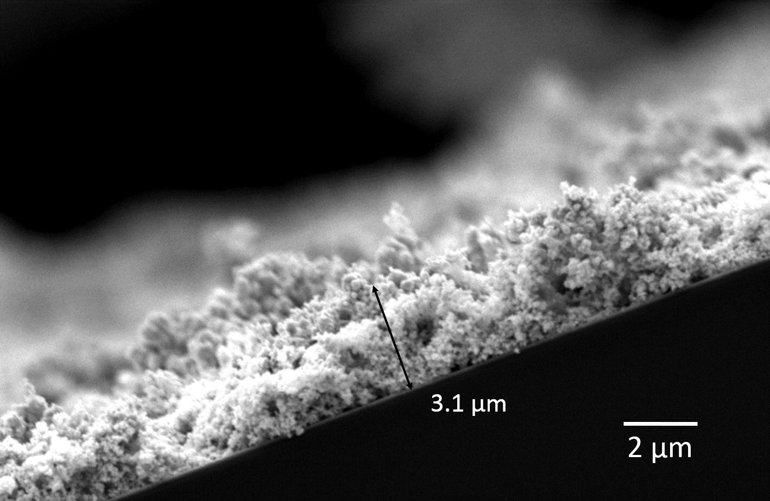
Figure S3. Cross sectional SEM images of the BiTe film after electrodeposition on 4 mm TiN electrodes at -2 V vs. Ag/AgCl for 600 s in 0.1 M [N^{n}Bu₄]Cl solution containing 2 mM [N^{n}Bu₄][BiCl₄] and 3 mM [N^{n}Bu₄]₂[TeCl₆].

S4. Morphology of the BiTe films electrodeposited in both 2.5 and 3 mM [N^{n}Bu₄][BiCl₄] at different potentials (fixed concentration of [N^{n}Bu₄]₂[TeCl₆]: 3 mM).
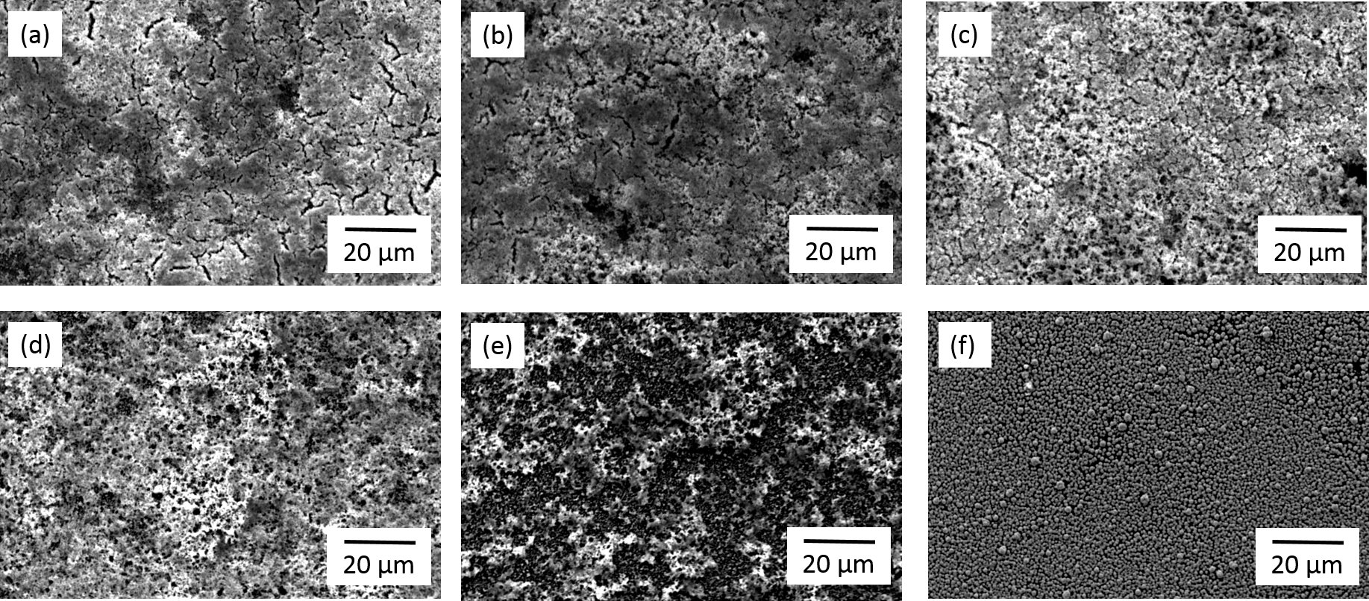
Figure S4. SEM images after the electrodeposition of bismuth telluride for 600 s from 2.5 mM [N^{n}Bu₄][BiCl₄] and 3 mM [N^{n}Bu₄]₂[TeCl₆] in 0.1 M [N^{n}Bu₄]Cl in CH₂Cl₂ at potentials of (a) - 2 V, (b) - 1.75 V, (c) - 1.5 V, (d) – 1.0 V, (e) - 0.75 V and (f) - 0.6 V vs. Ag/AgCl.
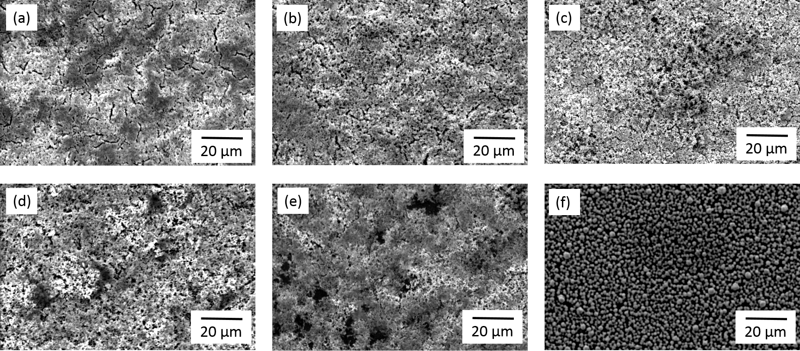
Figure S5. SEM images after the electrodeposition of bismuth telluride for 600 s from 3 mM [N^{n}Bu₄][BiCl₄] and 3 mM [N^{n}Bu₄]₂[TeCl₆] in 0.1 M [N^{n}Bu₄]Cl in CH₂Cl₂ at potentials of (a) - 2 V, (b) - 1.75 V, (c) - 1.5 V, (d) – 1.0 V, (e) - 0.75 V and (f) - 0.6 V vs. Ag/AgCl.

S5. EDX calibration using commercial Bi₂Te₃ powder.
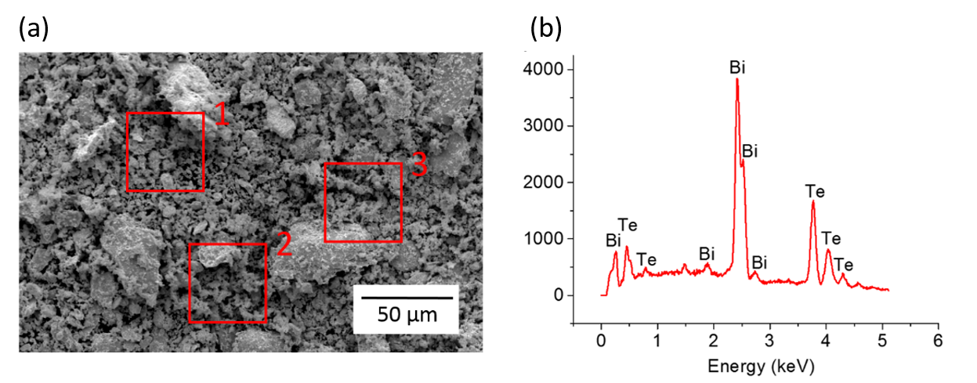Figure S6. (a) SEM image of Bi₂Te₃ powder and (b) the corresponding EDX spectrum collected at area 1.

Table S3. Quantitative EDX analysis on the three areas in the SEM image in Figure S3.
Area | Te-L | Bi-M
1 | 61.3 | 38.7
2 | 62.2 | 37.8
3 | 62.5 | 37.5

S6. EDX data collected using accelerating voltages of 10 and 15 kV on the electrodeposited BiTe film.
Figure S7. Bi content (EDX quantitative analysis) collected at two accelerating voltages: black 10 kV; pink 15 kV. Three replicate samples were prepared at each deposition potential, and EDX spectra were collected from three different locations for each sample. Conditions: 600 s deposition in 2.5 mM [N^{n}Bu₄][BiCl₄] and 3 mM [N^{n}Bu₄]₂[TeCl₆].

