Light-induced reversible DNA ligation of gold nanoparticle superlattices
Angela Federica De Fazio,ª Afaf H. El-Sagheer,^{b,c} Jason S. Kahn,^{d,e} Iris Nandhakumar,^{f} Matthew Burton,^{g} Tom Brown,^{b} Otto L. Muskens, ^{a,i} Oleg Gang,^{d,e,h*} and Antonios G. Kanaras. ^{a, i,}*
ª School of Physics and Astronomy, Faculty of Engineering and Physical Sciences, University of Southampton, Southampton, SO17 1BJ, U.K.
^{b} Department of Chemistry, University of Oxford, Chemistry Research Laboratory, 12 Mansfield Road, Oxford, OX1 3TA, UK.
^{c} Chemistry Branch, Department of Science and Mathematics, Faculty of Petroleum and Mining Engineering, Suez University, Suez 43721, Egypt.
^{d} Center for Functional Nanomaterials, Brookhaven National Laboratory, Upton, NY 11973, USA.
^{e} Department of Chemical Engineering, and Department of Applied Physics and Applied Mathematics, Columbia University, New York, NY 10027, USA.
^{f} School of Chemistry, Faculty of Engineering and Physical Sciences, University of Southampton, Southampton, SO17 1BJ, U.K.
^{g} SPECIFIC-IKC, Materials Research Centre, College of Engineering, Swansea University, Bay Campus, Fabian Way, Swansea, SA1 8EN, U.K.
^{h} Department of Applied Physics and Applied Mathematics, Columbia University, New York, NY 10027, USA.
^{i} Institute for Life Sciences, University of Southampton, Southampton, SO17 1BJ, U.K.

ABSTRACT: DNA-mediated self-assembly of nanoparticles has been of great interest because it enables access to nanoparticle superstructures that cannot be synthesized otherwise. However, the programmability of higher order nanoparticle structures can be easily lost under DNA denaturing conditions. Here, we demonstrate that light can be employed as an external stimulus to master the stability of nanoparticle superlattices (SLs) via the promotion of a reversible photoligation of DNA in SLs. The oligonucleotides attached to the nanoparticles are encoded to ligate using 365 nm light, effectively locking the SLs and rendering them stable under DNA denaturing conditions. The reversible process of unlocking these structures is possible by irradiation with light at 315 nm, recovering the structures to their natural state. Our work inspires a new research direction towards post-assembly manipulation of nanoparticle superstructures using external stimuli as a tool to enrich the library of new material forms and their application in different media and environments.

KEYWORDS: DNA, nanoparticles, photochemical ligation, self-assembly, superlattices

Bottom-up approaches for the 3D organization of nanoparticles into larger structures are of utmost importance for the fabrication of materials with new properties.¹ Such approaches can provide cost-effective and broader access to structures that are currently at the limit of our lithographic capabilities and could enable greater control over the fabrication of programmable and reconfigurable metamaterials.
Several methods for the organization of nanoparticles into larger structures have been reported, involving different types of weak nanoparticle interactions or application of external fields.^{2–4} For example, in 1995 the Pileni⁵ and Bawendi⁶ groups reported the discovery of electrostatically-directed superlattice assemblies of Ag₂S and CdSe respectively. Two- and three-dimensional superlattices were also obtained via molecular interactions⁷, for instance between alkylthiol-functionalized gold nanoparticles, as reported by Brust et al. ⁸ and Landman and co-workers. ⁹ Polymers and block-copolymers have also been extensively used to direct the ordered assembly of nanoparticles,^{10–13} while in other cases proteins,^{14,15} peptides,^{16,17} and enzymes,^{18,19} have been employed to organize nanostructures.
Among all these strategies, the use of oligonucleotides to assemble nanoparticles has been demonstrated to be powerful and versatile. Oligonucleotides possess high selectivity and specificity for complementary sequences, versatility in the structures that can be constructed and ability to be modified chemically with a variety of functional groups. The groups of Mirkin²⁰ and Alivisatos²¹ were the first to report the functionalization of gold nanoparticles with oligonucleotides in 1996. Further exploitation of oligonucleotide-coated nanoparticles allowed the formation of programmed nanoparticle assemblies, starting from nanoparticle dimers and trimers to larger structures. However, it was not until 2008 that SLs of oligonucleotide-coated gold nanoparticles were reported independently by the groups of Mirkin²² and Gang.²³ In those works, both groups described the experimental conditions and oligonucleotide design rules to form body-centred cubic and face-centred cubic organized gold nanoparticle assemblies.
Since then, a variety of SLs have been fabricated^{23–26} using nanoparticles of different chemical compositions, such as silver ²⁷ and cadmium selenide,²⁸ and different shapes, including cubes or octahedra, to guide binding interactions based on the topology of the particles.²⁹ Specifically-engineered oligonucleotides were also utilized to arrange NPs in previously unattainable particle arrangements not directly achievable through traditional means, such as the use of DNA origami frames to systematically collocate particles in a diamond lattice.³⁰ Another example was a convertible lattice obtained by means of reconfigurable DNA strands, which were able to switch between two states that yield two different lattice structures.³¹
Although a large variety of SLs has been reported, efforts have mostly focused on tuning the size, shape and composition of nanoparticles as well as simple oligonucleotide characteristics such as the length and the number of complementary base pairs. A common limitation of SLs reported to date is their inherent instability under DNA-denaturing conditions due to dehybridization of double-stranded DNA (dsDNA) into the component single strands (ssDNA). DNA-gold nanoparticle superlattices are readily disassemble in conditions that do not favour DNA hybridization such as elevated temperatures, low ionic strengths and other harsh environments such as low or high pH.
Attempts to tackle this issue have focused mainly on the intercalation of molecules³² or ions³³ within the DNA duplex. Alternatively, one could envisage methods to ligate the oligonucleotides within nanoparticle assemblies. Indeed, such methods have already been developed for nanoparticle oligomers and for amorphous DNA-nanoparticle aggregations. In 2003, the Brust group reported the use of ligase enzymes as biomolecular tools for the covalent linking of DNA-gold nanoparticle amorphous aggregates³⁴ while in 2008 the Alivisatos group¹⁹ reported the scaled-up production of covalently bound DNA gold nanoparticle dimers, also using DNA ligases. Recently, our group has developed two separate methods to chemically and photochemically ligate DNA, and used them to create gold nanoparticle dimers, trimers and tetramers. In the first method, copper-free click chemistry was utilized as a strategy to chemically ligate two oligonucleotides functionalized with an azide and a strained cyclooctyne group, respectively.³⁵ In the second method,³⁶ oligonucleotides were functionalized with a 3-cyanovinylcarbazole DNA nucleoside, which upon irradiation with λ = 365 nm light crosslinked the DNA strands. Subsequently, irradiation of the crosslinked DNA with λ = 312 nm light resulted in decrosslinking of the DNA strands.
Here we demonstrate the use of 3-cyanovinylcarbazole as a photochemical tool to reversibly ligate gold nanoparticle SLs using light. By employing this tool, we are able to successfully fabricate light-responsive materials with enhanced stability without losing the advantage of the reversible hybridization and programmable functionalities typical of complementary oligonucleotides. Tolerance against DNA denaturing conditions demonstrates the robust character and stability of the superlattices, providing a new programmable element and design tool that could potentially be exploited for a variety of applications, including on-demand destruction, local patterning and even structuring within the scale of single SLs.

RESULTS AND DISCUSSION
Scheme 1 shows the principle of our methodology, which is the ligation of the DNA in the formed nanoparticle SLs and the distinct role of this covalent cross-linking as a tool in combination with the thermal induction of nanoparticle crystal formation. The chemical modification introduced within one set of the ssDNA strands is a cyanovinylcarbazole, which is able to form a covalent bond with an adjacent activated double-bond upon irradiation with UV light. Stages (i) and (ii) represent the conventional phases of the reversible SLs formation using thermal control of DNA hybridization through a thermal annealing procedure. Stage (iii) is reached through the exposure of the SLs to UV light at λ = 365 nm, causing the formation of a cyclo-butane between the cyanovinyl moiety on the carbazole on one ssDNA of a dsDNA duplex and the 5,6-double bond on the thymine base on the secondary ssDNA of the duplex via a [2+2] photo-cycloaddition.^{37,38} In our work, the SLs were irradiated for 30 minutes at λ = 365 nm to induce crosslinking between two hybridized DNA strands. Reversibility of the ligation step (ii)-(iii) is achieved by illuminating the crosslinked DNA-AuNPs (phase (iii)) with light at λ = 312 nm to yield the non-ligated oligonucleotides. Under DNA denaturing conditions, the ligation between the DNA strands prevents a collapse of the crystal structure of the SLs, resulting in maintenance of the BCC crystal (phase (iv)) with dehybridized DNA strands.
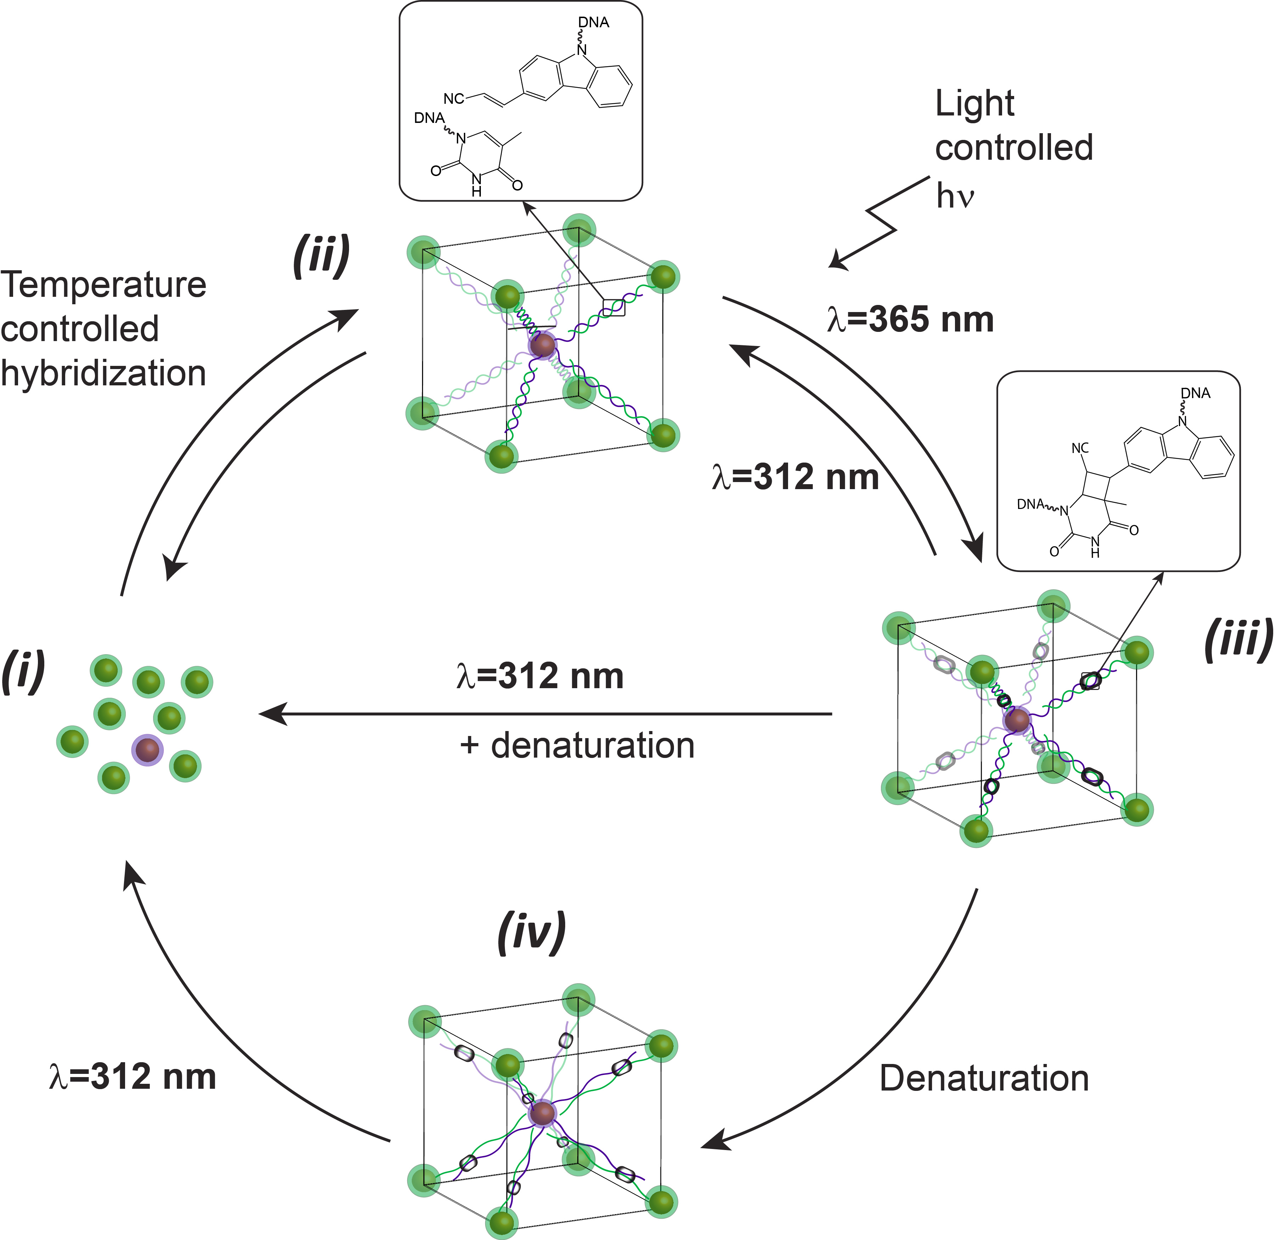
Scheme 1 Reversible photochemical ligation of nanoparticle superlattices. Nanoparticles conjugated with oligonucleotides are hybridized under the appropriate conditions to form superlattices. One batch of oligonucleotide coated nanoparticles contains a 3-cyanovinylcarbazole modification, which can react upon irradiation at λ = 365 nm with an adjacent thymine in the complementary strand, to form an interstrand chemical bond. This photochemical process can be reversed upon irradiation with light at λ = 312 nm.
Formation of DNA-nanoparticle superlattices. Following previously established protocols³⁹, we produced high-quality SLs consisting of gold nanoparticles functionalized with complementary DNA strands utilizing oligonucleotides that do not contain any chemical modification (see Table S1 and Figure S2 for the relevant DNA sequences and nanoparticle size distribution). Briefly, two batches of 14 nm AuNPs were functionalized⁴⁰ with a dense shell of complementary thiol-modified single-stranded DNA. The resulting DNA-AuNPs were mixed in equimolar amounts in buffer (10 mM phosphate buffer with 0.3 M NaCl) and were transferred to a ThermoCycler. Heating above the DNA melting temperature and a controlled cooling/annealing (0.1 ºC/10 min) yielded SLs with a body-centred cubic crystal structure. Figure 1 shows Scanning Electron Microscopy (SEM) images for a body-centred cubic SLs sample (the corresponding Small-Angle X-Ray Scattering Pattern is shown in Figure S3). In (a), a lower-magnification image shows the sharp facets of the crystals, while in (b) and (c) corresponding high-magnification pictures display ordered arrangements of the individual nanoparticles.
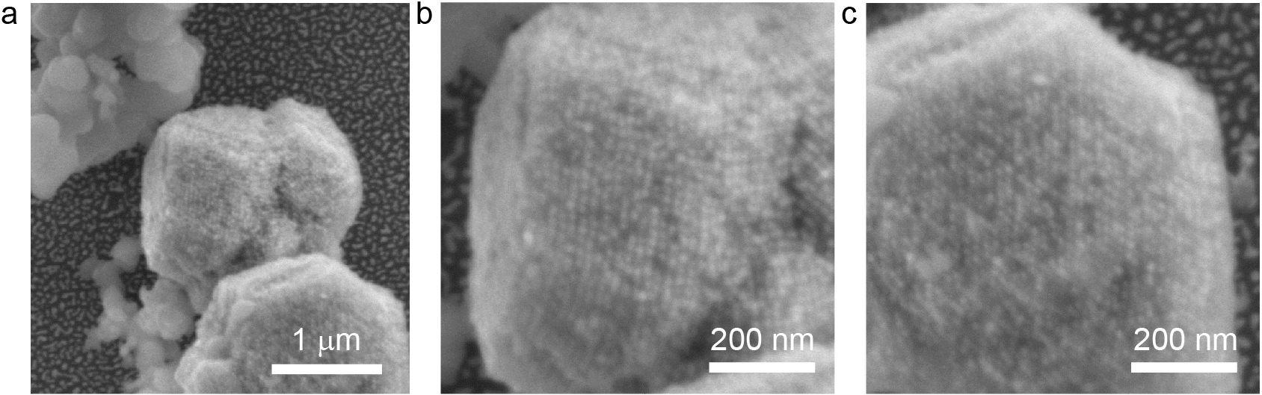
Figure 1 Scanning electron micrographs of gold nanoparticle-DNA superlattices (a) and higher magnification images where the organization of gold nanoparticles can be observed (b,c).

Stability of DNA-nanoparticle superlattices under DNA denaturing conditions. The same experimental protocol as above was followed to form SLs employing gold nanoparticles functionalized with cyanovinylcarbazole-modified DNA strands (Figure S1). Figure 2 shows a comparison between NPs assembled using non-modified and cyanovinylcarbazole-modified oligonucleotides, with corresponding schemes of the nanoparticles assemblies. After the crystallization procedure, both set of strands yielded a black aggregate that sediment at the bottom of the capillary (Figure 2a and b). Upon irradiation with light at λ = 365 nm and subsequent transfer to DNA denaturing conditions, the aggregated state is retained only for the assemblies composed of the modified DNA strands (the black pellet is still observed at the bottom of the capillary, Figure 2c), while the particles previously held together by the set of conventional strands are released in suspension, as observed by the absence of the pellet at the bottom and the red colour of the suspension, a typical property of 14 nm colloidal gold nanoparticles (Figure 2d).

Figure 2 Schematic illustration showing lattices produced from a set of oligonucleotides with cyanovinylcarbazole-modified strands (a), following light illumination at λ = 365, and without modification (b). Optical images of capillaries containing superlattices in native (a and b at the top) and denaturing (c and d at the bottom) conditions are also shown. While the crystals assembled with the carbazole-containing strands remain aggregated upon denaturation (c), the superlattices assembled with the conventional oligonucleotides yielded free NPs upon denaturation, as evidenced by the colour change observed in the unmodified sample (d).

Small-Angle X-Ray Scattering (SAXS) was employed to study the crystal structure of the nanoparticle assemblies in more detail. Figure 3 shows the SAXS patterns for the SLs made with the cyanovinylcarbazole-modified DNA strands (ii, black line). From the relative intensity and the position of the peaks it is possible to assign the pattern to a body-centred cubic configuration, where the lattice parameter a was calculated from the relation with the interplane distance d_{hkl} as $a= d_{hkl}\sqrt{h^{2}+k^{2}+l^{2}}$ In turn, d_{hkl} was calculated from Bragg’s Law as $d_{hkl}={2π}/{q_{hkl}}$ . The nearest neighbour distance, core-to-core, could be calculated from the cubic geometry of the configuration and it was found to be 27 nm, in agreement with the predicted value (28 nm) based on the NP diameters and the DNA length. An average crystallite size of ~0.4 μm was estimated from the scattering correlation length $ξ≈{2π}/{∆q}$ .⁴¹ Further SAXS measurements were carried out to test the effectiveness of the cyanovinylcarbazole-modified DNA nanoparticles in retaining their crystal structure. The scattering patterns of the superlattices after irradiation at λ = 365 nm and subsequent denaturation are shown by the curves labelled (iii, grey) and (iv, red). A marked difference was observed in the SAXS spectrum for SLs when applying denaturing conditions. In the case of the light-active SLs, after irradiation with light at λ = 365 nm and subsequent denaturation, the pattern shows the same number and intensity ratio of the peaks, demonstrating the integrity of the crystal structure. Interestingly, a noticeable shift of the peaks towards lower q-values was observed, which implies a wider distance between NPs in the lattice. We found that the nearest neighbour distance was shifted from 27 nm (in native conditions) to 31 nm for SLs in denaturing conditions. This observation is consistent with an interpretation of DNA de-hybridization induced by the denaturing conditions, which relaxes the oligonucleotide strands while the NPs are still held together by the crosslinking between the oligonucleotide strands. As a control, the SAXS profile for irradiated and denatured crystals formed by unmodified DNA strands is also reported in Figure S4, showing no signs of ordered structures, confirming that in the absence of the carbazole modification, irradiating with 365 nm light does not induce DNA crosslinking itself and thus all crystalline ordering is lost upon DNA dehybridization.

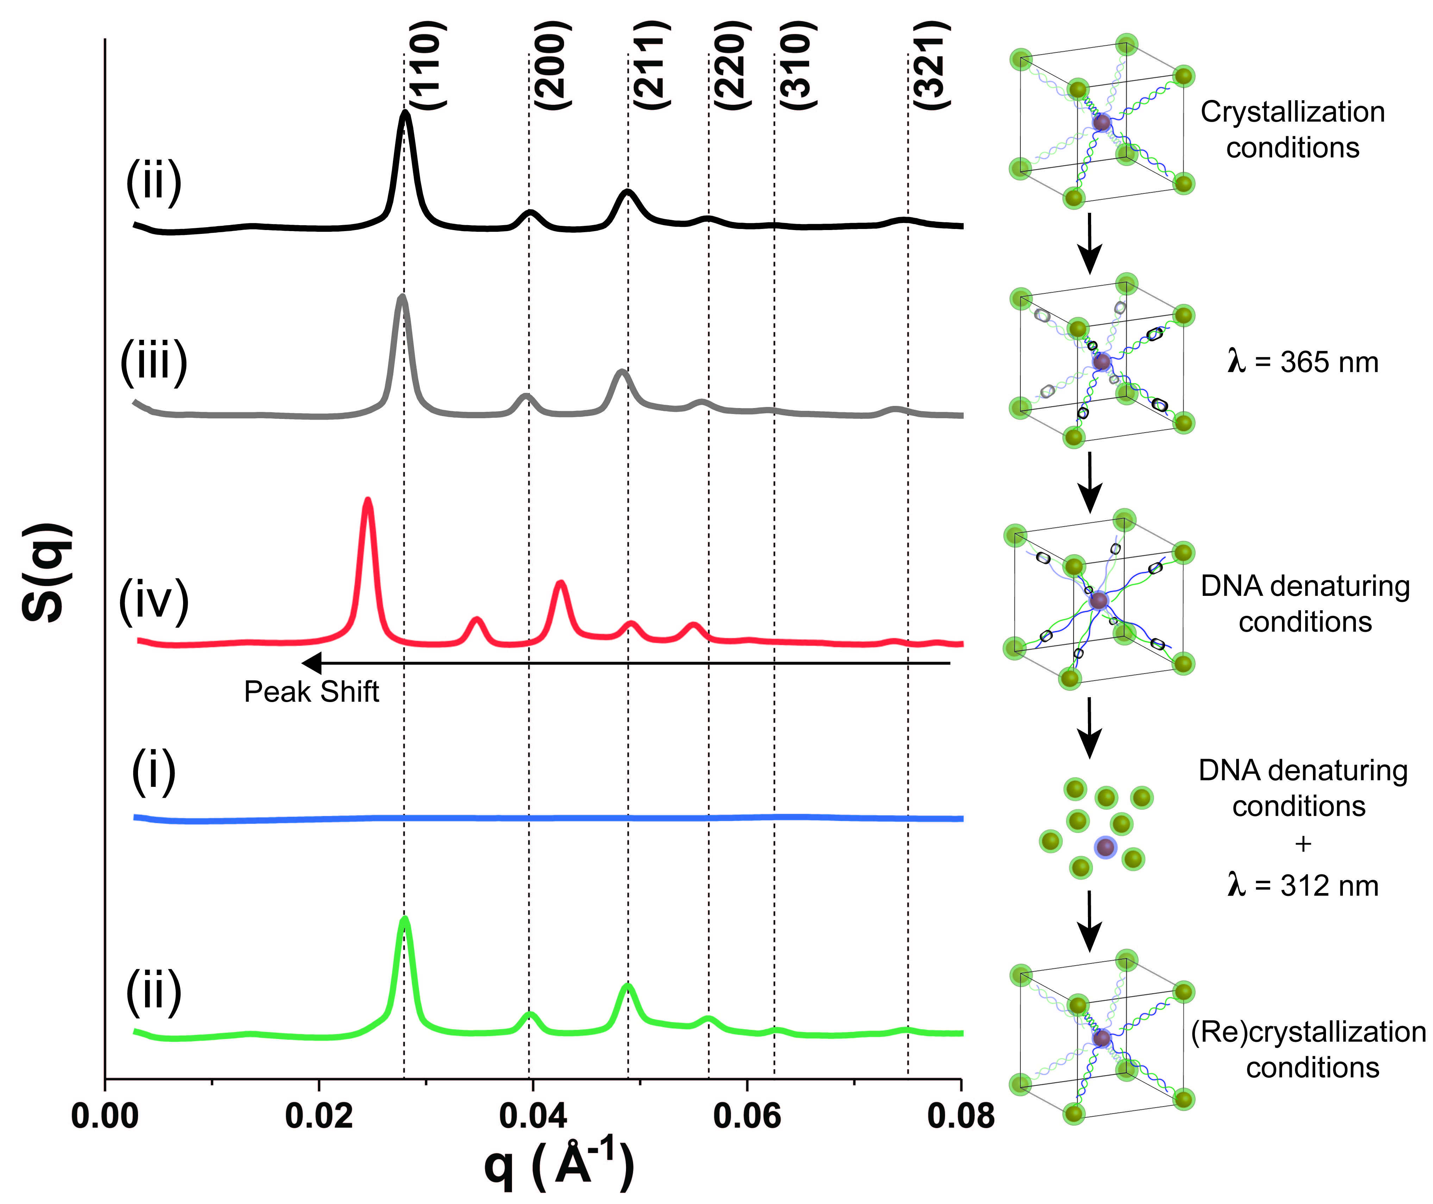

Figure 3 SAXS measurements for nanoparticle superlattices (ii, black), DNA-crosslinked nanoparticle superlattices (iii, grey), DNA-crosslinked nanoparticle superlattices under DNA denaturing conditions (iv, red), DNA-decrosslinked nanoparticle superlattices under DNA denaturing conditions (i, blue) and recrystallized nanoparticle superlattices (ii, green).
To test the reversibility of the process, DNA-crosslinked superlattices were irradiated with 312 nm light for 30 minutes and then subjected to DNA denaturing conditions. During this procedure, a colour change in the solution was observed indicating DNA dehybridization and therefore disassembly of the superlattices. As shown in Figure 3, the relevant SAXS pattern (blue line) of the laser irradiated SLs under DNA denaturing conditions did not show any peaks, which also confirmed the disassembly of the nanoparticles. Furthermore, the disassembled particles were optically characterized and their spectrum was compared to that of the AuNPs coated with oligonucleotides, recorded prior to the initial step of crystallization. As shown in Figure S5, the two spectra are superimposable, with no peak shift or broadening observed for the DNA-coated nanoparticles after UV light exposure, indicating that the short-term UV radiation did not affect the colloidal dispersibility of the nanoparticles.
The function of the oligonucleotides on the surface of the nanoparticles was confirmed by an additional crystallization step. The disassembled nanoparticles were purified and concentrated via centrifugation, redispersed in DNA hybridization buffer (0.01 M phosphate buffer, 0.3 M NaCl) and subjected to another thermocycle. The bottom curve (ii, green) in Figure 3 depicts the SAXS analysis of the recrystallized sample. The positions and relative intensity of the peaks are comparable to the corresponding ones for the pristine crystals, thus demonstrating the robust nature of the DNA strands on the nanoparticles after subsequent steps of heating/cooling and UV light irradiation.
To demonstrate the universal nature of our method, we performed a similar study using silver nanoparticles (AgNPs). AgNPs with a size of 15±6 nm were synthesised by slight modifications to previously reported protocols^{40,42} (Figure S6). These particles were coated with a dense shell of oligonucleotides (Table S1) and used in further experiments. Figure S7 shows SEM images obtained from AgNP superlattices (AgNP SLs). The SLs are single crystals of about 1 µm in size with sharp edges and well-defined facets. Figure S8 shows quartz capillaries containing AgNP SLs assembled with conventional (right) or carbazole-modified (left) oligonucleotides after irradiation at λ = 365 nm, with corresponding schemes of the structure. After transfer to DNA denaturing conditions, the SLs without the carbazole modification do not retain the aggregated state, yielding a yellow-colored suspension of free AgNPs in solution. SAXS data are shown in Figure S9. Similar peak patterns as for the gold SLs were obtained for the native SLs (Figure S9 (i)), the DNA-crosslinked SLs (ii) and the DNA-crosslinked and DNA-denatured SLs. In the latter, a slight shift towards lower q-values was observed, indicating a relaxation of the lattice due to DNA dehybridization. A similar observation was also found for AuNP SLs. Likewise, AgNP SLs irradiated at λ = 312 nm and transferred to DNA denaturing conditions did not show any peaks in SAXS, as expected for colloidal disassembled particles. The disassembled nanoparticles were also optically characterized (Figure S10) and compared to the pristine particles prior to assembly, confirming that neither the AgNPs nor the surface DNA strands were affected by the crystallization and irradiation procedure.

CONCLUSION
In conclusion, we have successfully developed a light-responsive approach to manipulate DNA-nanoparticle SLs. This approach enables the reversible DNA ligation of gold nanoparticle SLs, which retain their 3d structure in DNA denaturing conditions. The universal character of this method was demonstrated by the formation of DNA-ligated silver nanoparticle SLs. Future work could explore the transfer of cross-linked SLs to different liquid or solid-state environments, lifting some of the restrictions of conventional DNA-based technologies. In addition to improving robustness of the crystal as a whole, one can envisage new synthesis strategies involving partial incorporation of ligating groups into the crystal, for example to achieve hollow structures or even in the 3D printing of nanocrystals using direct laser writing.

EXPERIMENTAL METHODS
Commercially available reagents and solvents were purchased from Sigma-Aldrich and used without further purification. Standard DNA phosphoramidites, solid supports (controlled pore glass, CPG) and additional reagents were purchased from Link Technologies, Glen Research and Applied Biosystems. NAP Sephadex gel filtration columns were purchased from GE Healthcare and used according to the manufacturer’s instructions. Oligonucleotides were synthesized on an Applied Biosystems 394 automated DNA/RNA synthesizer using a standard 1.0 μmole phosphoramidite cycle of acid-catalyzed detritylation, coupling, capping, and iodine oxidation. Stepwise coupling efficiencies and overall yields were >98.0% as determined by the automated trityl cation conductivity monitoring facility. 3'-Thiol-modifier C6 S-S solid support (Catalogue No: 20-2938) and 3-cyanovinylcarbazole phosphoramidite (Catalogue No: 10-4960) were purchased from Glen Research. Assembly of the DNA-NPs was performed in an Applied BioSystems ProFlexTM PCR thermal cycler. TEM images were obtained on a Hitachi H7000 transmission electron microscope operating at a bias voltage of 75 kV. SEM images were obtained on a Jeol JSM 7500F Field-Emission Gun SEM, with resolution of 1 nm at 15kV, operating between 0.5 and 30kV. UV-Visible spectra were acquired using a UV – 1601 Shimadzu UV-Visible spectrophotometer over the range 200 to 800 nm. Small-Angle X-ray Scattering (SAXS) measurements were performed at the Complex Materials Scattering (CMS) beamline of the National Synchrotron Light Source II (NSLS-II, Brookhaven National Lab, Upton, USA). The scattering data were collected with a MAR CCD area detector and converted to 1D scattering intensity vs. wave vector transfer, q = (4π/λ) sin (θ/2), where λ= 0.8551 Å and θ, are the wavelength of incident X-ray and the scattering angle respectively. The scattering angle was calibrated using silver behenate as a standard. The structure factor S(q) was calculated as the ratio between the background corrected 1D scattering intensities extracted by angular averaging of CCD images for assembled systems and dissociated particles.
Synthesis of gold nanoparticles. The synthesis of 14±1 nm gold nanoparticles was carried out following previously reported protocols^{43,44}. A sodium tetrachloroaurate solution (1 mL, 100 mM) was brought to boil whilst stirring. To this, a sodium citrate solution (5 mL, 2%wt) was added, and the solution was stirred for a further 15 minutes. Then, the reaction mixture was left to cool down whilst stirring. Particles were purified by filtering the solution through a 0.45 Millipore filter and were redispersed in 10 mL of Milli-Q water.
Synthesis of silver nanoparticles. The synthesis of 15±6 nm AgNPs was performed with slight modifications of previously reported protocols.⁴² Sodium citrate (1 mL, 5 mM) and tannic acid (1 mL, 0.025 mM) were added to a flask containing 98 mL of MilliQ water. This solution was heated under vigorous stirring until boiling. AgNO₃ (1 mL, 25 mM) was injected to the boiling solution, which became bright yellow. After 15 minutes, particles of ~15 nm in size were obtained. Purification was performed by centrifugation (10000 rpm, 20 minutes, 3x) and the collected NPs were dispersed in 10 mL of MilliQ water.
Oligonucleotide functionalisation and assembly of NPs. In a typical experiment, citrate-coated NPs (10 pmol, 500 µl) were incubated overnight with thiol modified oligonucleotides (800 pmol, 40 µl) and phosphate buffer (60 µl, 0.1 M) was added to achieve a final concentration of 0.01 M. Six additions of a NaCl solution (106 µl, 2 M) over a period of 8 h were introduced to achieve a final salt concentration of 0.3 M. The resulting ssDNA-coated AuNPs were then purified by three subsequent centrifugation steps (16400 rpm, 10 minutes). Finally, the conjugates were stored in Milli-Q water at 4°C. Two batches of NPs decorated with complementary DNA strands were incubated in hybridization buffer (10 mM Phosphate buffer, 0.3 M NaCl ) at 70ºC (above the melting temperature of the DNA duplex) and slowly cooled down to 25ºC using a programmable thermal cycler (rate 0.1ºC/10 min). Nanoparticle assemblies were sediment at the bottom of the tube and the supernatant was clear.
Light-induced reversible DNA crosslinking between nanoparticles. DNA crosslinking was performed by transferring 200 µl of DNA-NPs crystals on a plate in an ice-bath and placed under UV-A light (centred at λ = 365 nm, 50 mW/cm², 30 minutes, at a distance of 4 cm from the UV lamp). DNA de-crosslinking was carried out under UV-B irradiation (centred at λ = 312 nm, 50 mW/cm², 30 minutes).
Denaturing conditions and re-crystallisation. DNA nanoparticle crystal samples were transferred to DNA denaturing conditions by addition of urea (7 M, 200 µl) followed by ultrasonication and heating above the DNA melting temperature (70ºC). DNA-functionalized NPs obtained from the decrosslinking/DNA denaturation procedure were purified by centrifugation (16400 rpm, 10 minutes), resuspended in 0.3 M NaCl, and annealed via a slow-cooling procedure as above to achieve recrystallization.
Preparation of samples for characterization
TEM imaging of nanoparticles. Nanoparticles size and morphology was assessed by Transmission electron microscopy. All samples were deposited as a droplet on carbon Film 400 mesh copper grids and the solvent was evaporated.
SEM imaging of superlattices. To prevent the superlattice collapsing under vacuum during SEM imaging, all the samples were encapsulated in a silica shell, following previously reported literature protocols.⁴⁵ After slow cooling, the samples were transferred to a 1.5 mL tube and reconstituted in a solution of NaCl (1mL, 0.3 M). The tube was sonicated at room temperature and N-trimethoxysilylpropyl-N,N,N-trimethylammonium chloride (2 µL) was added. After 20 minutes, 4 µL of a silica-growing agent, triethoxysilane, was added to the tube and allowed to stir for four days at room temperature. The mixture was purified by three rounds of centrifugation (700 rpm, 5 minutes) and redispersed in water. The sample for imaging was prepared by dropcasting 10 µL of the silica-embedded crystals onto a silicon wafer chip, which was left to dry.

ASSOCIATED CONTENT
Supporting information
The Supporting Information is available free of charge on the
ACS Publications website at DOI:
Additional experimental detail and data including oligonucleotide synthesis, nanoparticle characterization and superlattices characterization. The raw data of this work is available at DOI:

AUTHOR INFORMATION
Corresponding authors
*Emails: og2226@columbia.edu , A.Kanaras@soton.ac.uk

NOTES
The authors declare no competing financial interest.

AKNOWLEDGEMNTS
AGK and AFDF would like to thank DSTL for funding of this project. The authors would also like to acknowledge the assistance provided by the Swansea University AIM Facility funded in part by EPSRC (EP/M028267/1), European Regional Development Fund via the Welsh Government (80708) and Sêr Solar. OG and JK were supported by the US Department of Energy, Office of Basic Energy Sciences, Division of Materials Sciences and Engineering under grant DE-SC0008772. AHES was supported by UK BBSRC grant BB/J001694/2 (extending the boundaries of nucleic acid chemistry).

REFERENCES
(1) Nie, Z.; Petukhova, A.; Kumacheva, E. Properties and Emerging Applications of Self-Assembled Structures Made from Inorganic Nanoparticles. Nat. Nanotechnol 2010, 5, 15–25.
(2) Grzelczak, M.; Vermant, J.; Furst, E. M.; Liz-Marzán, L. M. Directed Self-Assembly of Nanoparticles. ACS Nano 2010, 4, 3591–3605.
(3) Pileni, M. P.; Cozzoli, D. P.; Pinna, N. Self-Assembled Supracrystals and Hetero-Structures Made from Colloidal Nanocrystals. CrystEngComm 2014, 16, 9365–9367.
(4) Boles, M. A.; Engel, M.; Talapin, D. V. Self-Assembly of Colloidal Nanocrystals: From Intricate Structures to Functional Materials. Chem. Rev. 2016, 116, 11220–11289.
(5) Pileni, M. P. Self-Assembly of Inorganic Nanocrystals: Fabrication and Collective Intrinsic Properties. Acc. Chem. Res. 2007, 40, 685–693.
(6) Murray, C. B.; Kagan, C. R.; Bawendi, M. G. Self-Organization of CdSe Nanocrystallites into Three-Dimensional Quantum Dot Superlattices. Science 1995, 270, 1335–1338.
(7) Baranov, D.; Manna, L.; Kanaras, A. G. Chemically Induced Self-Assembly of Spherical and Anisotropic Inorganic Nanocrystals. J. Mater. Chem. 2011, 21, 16694–16703.
(8) Brust, M.; Schiffrin, D. J.; Bethell, D.; Kiely, C. J. Novel Gold‐dithiol Nano‐networks with Non‐metallic Electronic Properties. Adv. Mater. 1995, 7, 795–797.
(9) Whetten, R. L.; Khoury, J. T.; Alvarez, M. M.; Murthy, S.; Vezmar, I.; Wang, Z. L.; Stephens, P. W.; Cleveland, C. L.; Luedtke, W. D.; Landman, U. Nanocrystal Gold Molecules. Adv. Mater. 1996, 8, 428–433.
(10) Boal, A. K.; Ilhan, F.; DeRouchey, J. E.; Thurn-Albrecht, T.; Russell, T. P.; Rotello, V. M. Self-Assembly of Nanoparticles into Structured Spherical and Network Aggregates. Nature 2000, 404, 746–748.
(11) Lopes, W. A.; Jaeger, H. M. Hierarchical Self-Assembly of Metal Nanostructures on Diblock Copolymer Scaffolds. Nature 2001, 414, 735–738.
(12) Costanzo, P. J.; Beyer, F. L. Thermally Driven Assembly of Nanoparticles in Polymer Matrices. Macromolecules 2007, 40, 3996–4001.
(13) Fernandes, R.; Li, M.; Dujardin, E.; Mann, S.; Kanaras, A. G. Ligand-Mediated Self-Assembly of Polymer-Enveloped Gold Nanoparticle Chains and Networks. Chem. Commun. 2010, 46, 7602–7604.
(14) Dickerson, M. B.; Sandhage, K. H.; Naik, R. R. Protein- and Peptide-Directed Syntheses of Inorganic Materials. Chem. Rev. 2008, 108, 4935–4978.
(15) Franzmann, E.; Khalil, F.; Weidmann, C.; Schröder, M.; Rohnke, M.; Janek, J.; Smarsly, B. M.; Maison, W. A Biomimetic Principle for the Chemical Modification of Metal Surfaces: Synthesis of Tripodal Catecholates as Analogues of Siderophores and Mussel Adhesion Proteins. Chem. Eur. J. 2011, 17, 8596–8603.
(16) Song, C.; Wang, Y.; Rosi, N. L. Peptide-Directed Synthesis and Assembly of Hollow Spherical CoPt Nanoparticle Superstructures. Angew. Chemie - Int. Ed. 2013, 52, 3993–3995.
(17) Coomber, D.; Bartczak, D.; Gerrard, S. R.; Tyas, S.; Kanaras, A. G.; Stulz, E. Programmed Assembly of Peptide-Functionalized Gold Nanoparticles on DNA Templates. Langmuir 2010, 26, 13760–13762.
(18) Kanaras, A. G.; Wang, Z.; Hussain, I.; Brust, M.; Cosstick, R.; Bates, A. D. Site-Specific Ligation of DNA-Modified Gold Nanoparticles Activated by the Restriction EnzymeStyI. Small 2007, 3, 67–70.
(19) Claridge, S. A.; Mastroianni, A. J.; Au, Y. B.; Liang, H. W.; Micheel, C. M.; Fréchet, J. M. J.; Alivisatos, A. P. Enzymatic Ligation Creates Discrete Multinanoparticle Building Blocks for Self-Assembly. J. Am. Chem. Soc. 2008, 130, 9598–9605.
(20) Mirkin, C. A.; Letsinger, R. L.; Mucic, R. C.; Storhoff, J. J. A DNA-Based Method for Rationally Assembling Nanoparticles into Macroscopic Materials. Nature 1996, 382, 607–609.
(21) Alivisatos, A. P.; Johnsson, K. P.; Peng, X.; Wilson, T. E.; Loweth, C. J.; Bruchez, M. P.; Schultz, P. G. Organization of “nanocrystal Molecules” Using DNA. Nature 1996, 382, 609–611.
(22) Park, S. Y.; Lytton-Jean, A. K. R.; Lee, B.; Weigand, S.; Schatz, G. C.; Mirkin, C. a. DNA-Programmable Nanoparticle Crystallization. Nature 2008, 451, 553–556.
(23) Nykypanchuk, D.; Maye, M. M.; van der Lelie, D.; Gang, O. DNA-Guided Crystallization of Colloidal Nanoparticles. Nature 2008, 451, 549–552.
(24) O’Brien, M. N.; Lin, H. X.; Girard, M.; Olvera De La Cruz, M.; Mirkin, C. A. Programming Colloidal Crystal Habit with Anisotropic Nanoparticle Building Blocks and DNA Bonds. J. Am. Chem. Soc. 2016, 138, 14562–14565.
(25) Zhang, C.; Macfarlane, R. J.; Young, K. L.; Choi, C. H. J.; Hao, L.; Auyeung, E.; Liu, G.; Zhou, X.; Mirkin, C. A. A General Approach to DNA-Programmable Atom Equivalents. Nat. Mater. 2013, 12, 741–746.
(26) Macfarlane, R. J.; O’Brien, M. N.; Petrosko, S. H.; Mirkin, C. a. Nucleic Acid-Modified Nanostructures as Programmable Atom Equivalents: Forging a New “Table of Elements.” Angew. Chemie Int. Ed. 2013, 52, 5688–5698.
(27) Young, K. L.; Ross, M. B.; Blaber, M. G.; Rycenga, M.; Jones, M. R.; Zhang, C.; Senesi, A. J.; Lee, B.; Schatz, G. C.; Mirkin, C. A. Using DNA to Design Plasmonic Metamaterials with Tunable Optical Properties. Adv. Mater. 2014, 26, 653–659.
(28) Sun, D.; Gang, O. Binary Heterogeneous Superlattices Assembled from Quantum Dots and Gold Nanoparticles with DNA. J. Am. Chem. Soc. 2011, 133, 5252–5254.
(29) Lu, F.; Yager, K. G.; Zhang, Y.; Xin, H.; Gang, O. Superlattices Assembled through Shape-Induced Directional Binding. Nat. Commun. 2015, 6, 6912.
(30) Liu, W.; Tagawa, M.; Xin, H. L.; Wang, T.; Emamy, H.; Li, H.; Yager, K. G.; Starr, F. W.; Tkachenko, A. V; Gang, O. Diamond Family of Nanoparticle Superlattices. Science (80-. ). 2016, 351, 582–586.
(31) Kim, Y.; Macfarlane, R. J.; Jones, M. R.; Mirkin, C. A. Transmutable Nanoparticles with Reconfigurable Surface Ligands. Science 2016, 351, 579–582.
(32) Seo, S. E.; Wang, M. X.; Shade, C. M.; Rouge, J. L.; Brown, K. A.; Mirkin, C. A. Modulating the Bond Strength of DNA–Nanoparticle Superlattices. ACS Nano 2015, 10, 1771–1779.
(33) Oh, T.; Park, S. S.; Mirkin, C. A. Stabilization of Colloidal Crystals Engineered with DNA. Adv. Mater. 2018, 1805480.
(34) Kanaras, A. G.; Wang, Z.; Bates, A. D.; Cosstick, R.; Brust, M. Towards Multistep Nanostructure Synthesis: Programmed Enzymatic Self-Assembly of DNA/Gold Systems. Angew. Chemie - Int. Ed. 2003, 42, 191–194.
(35) Heuer-Jungemann, A.; Kirkwood, R.; El-Sagheer, A. H.; Brown, T.; Kanaras, A. G. Copper-Free Click Chemistry as an Emerging Tool for the Programmed Ligation of DNA-Functionalised Gold Nanoparticles. Nanoscale 2013, 5, 7209.
(36) Harimech, P. K.; Gerrard, S. R.; El-Sagheer, A. H.; Brown, T.; Kanaras, A. G. Reversible Ligation of Programmed DNA-Gold Nanoparticle Assemblies. J. Am. Chem. Soc. 2015, 137, 9242–9245.
(37) Yoshimura, Y.; Fujimoto, K. Ultrafast Reversible Photo-Cross-Linking Reaction: Toward in Situ DNA Manipulation. Org. Lett. 2008, 10, 3227–3230.
(38) Sakamoto, T.; Tanaka, Y.; Fujimoto, K. DNA Photo-Cross-Linking Using 3-Cyanovinylcarbazole Modified Oligonucleotide with Threoninol Linker. Org. Lett. 2015, 17, 936–939.
(39) Auyeung, E.; Li, T. I. N. G.; Senesi, A. J.; Schmucker, A. L.; Pals, B. C.; de la Cruz, M. O.; Mirkin, C. a. DNA-Mediated Nanoparticle Crystallization into Wulff Polyhedra. Nature 2013, 505, 73–77.
(40) Hurst, S. J.; Lytton-Jean, A. K. R.; Mirkin, C. A. Maximizing DNA Loading on a Range of Gold Nanoparticle Sizes. Anal. Chem. 2006, 78, 8313–8318.
(41) Warren, B. E. X-Ray Diffraction; Dover Publications, New York, 1990.
(42) Bastús, N. G.; Merkoçi, F.; Piella, J.; Puntes, V. Synthesis of Highly Monodisperse Citrate-Stabilized Silver Nanoparticles of up to 200 nm: Kinetic Control and Catalytic Properties. Chem. Mater. 2014, 26, 2836–2846.
(43) Turkevich, J.; Stevenson, P. C.; Hillier, J. A Study of the Nucleation and Growth Processes in the Synthesis of Colloidal Gold. Discuss. Faraday Soc. 1951, 55, 55–75.
(44) Schulz, F.; Homolka, T.; Bastús, N. G.; Puntes, V.; Weller, H.; Vossmeyer, T. Little Adjustments Significantly Improve the Turkevich Synthesis of Gold Nanoparticles. Langmuir 2014, 30, 10779–10784.
(45) Auyeung, E.; Macfarlane, R. J.; Choi, C. H. J.; Cutler, J. I.; Mirkin, C. A. Transitioning DNA-Engineered Nanoparticle Superlattices from Solution to the Solid State. Adv. Mater. 2012, 24, 5181–5186.

